Supplementary Information to
Phase-dependent growth of Pt on MoS₂ for highly efficient H₂ evolution
Zhenyu Shi^{1,2†}, Xiao Zhang^{3†}, Xiaoqian Lin^{4†}, Guigao Liu^{1†}, Chongyi Ling^{5†}, Shibo Xi^{6†}, Bo Chen¹, Yiyao Ge¹, Chaoliang Tan¹, Zhuangchai Lai¹, Zhiqi Huang¹, Xinyang Ruan¹, Li Zhai^{1,7}, Lujiang Li¹, Zijian Li¹, Xixi Wang¹, Gwang-Hyeon Nam², Jiawei Liu², Qiyuan He⁸, Zhiqiang Guan^{1,9}, Jinlan Wang⁵, Chun-Sing Lee^{1,9}, Anthony R. J. Kucernak⁴* and Hua Zhang^{1,7,10}*
¹Department of Chemistry, City University of Hong Kong, Hong Kong, China.
²Center for Programmable Materials, School of Materials Science and Engineering, Nanyang Technological University, Singapore, Singapore.
³Department of Mechanical Engineering, Research Institute for Advanced Manufacturing, The Hong Kong Polytechnic University, Hong Kong, China.
⁴Department of Chemistry, Molecular Science Research Hub, Imperial College London, London, UK.
⁵School of Physics, Southeast University, Nanjing, China.
⁶Institute of Sustainability for Chemicals, Energy and Environment (ISCE2), A*STAR (Agency for Science, Technology and Research), Singapore, Singapore.
⁷Hong Kong Branch of National Precious Metals Material Engineering Research Center (NPMM), City University of Hong Kong, Hong Kong, China.
⁸Department of Materials Science and Engineering, City University of Hong Kong, Hong Kong, China.
⁹Center of Super-Diamond and Advanced Films (COSDAF), City University of Hong Kong, Hong Kong, China.
¹⁰Shenzhen Research Institute, City University of Hong Kong, Shenzhen, China.

*Correspondence author. Email: hua.zhang@cityu.edu.hk, anthony@imperial.ac.uk
†These authors contributed equally to this work.

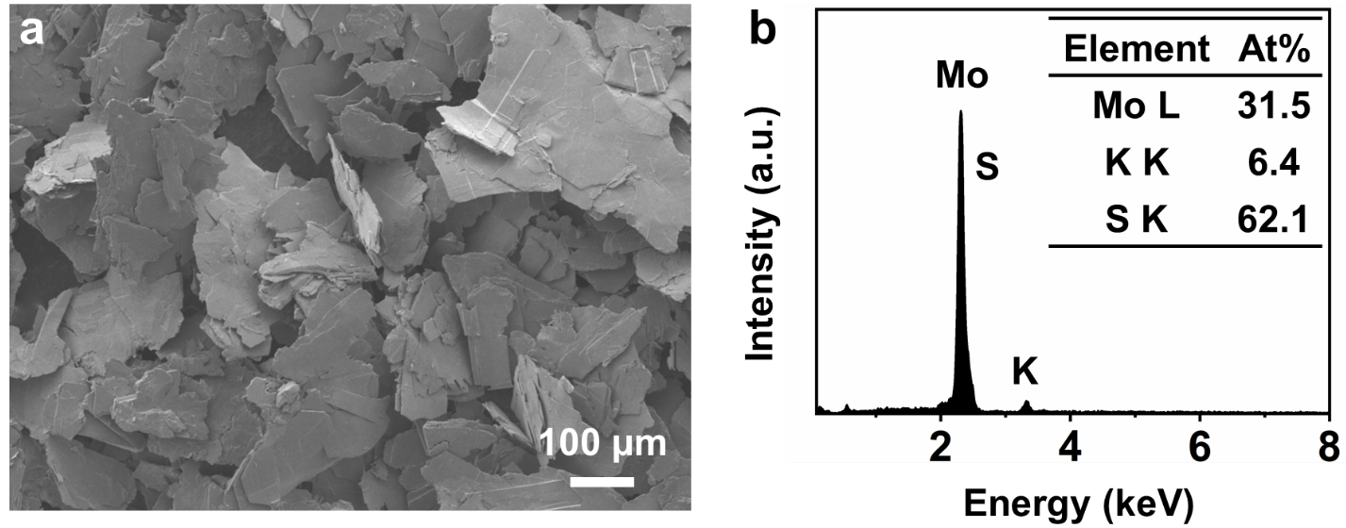

Supplementary Fig. 1 | Characterizations of K_{x}MoS₂ crystals. a, Scanning electron microscope (SEM) image, and b, Energy-dispersive X-ray spectroscopy (EDS) spectrum of the prepared K_{x}MoS₂ crystals. Inset in (b): the corresponding element percentages of the prepared K_{x}MoS₂ crystals.

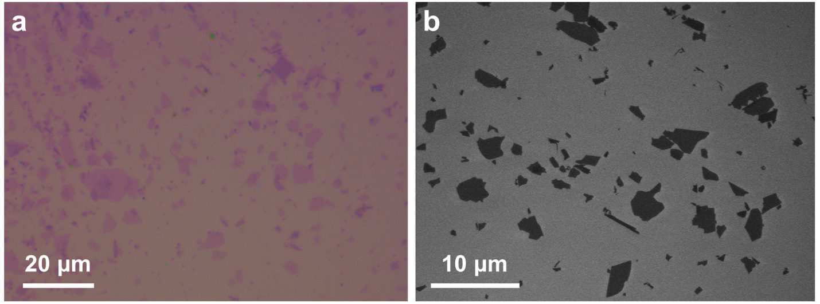

Supplementary Fig. 2 | Characterizations of obtained 1T′-MoS₂ nanosheets (NSs). a, Optical microscopy, and b, SEM images of the obtained 1T′-MoS₂ NSs.
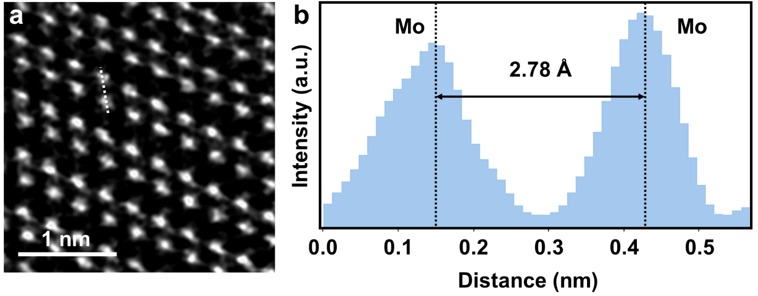

Supplementary Fig. 3 | High-angle annular dark-field scanning transmission electron microscopy (HAADF-STEM) image analysis of 1T′-MoS₂ NS. a, HAADF-STEM image of 1T′-MoS₂ NS. b, The corresponding line scan intensity profile obtained from the white dotted line in (a).

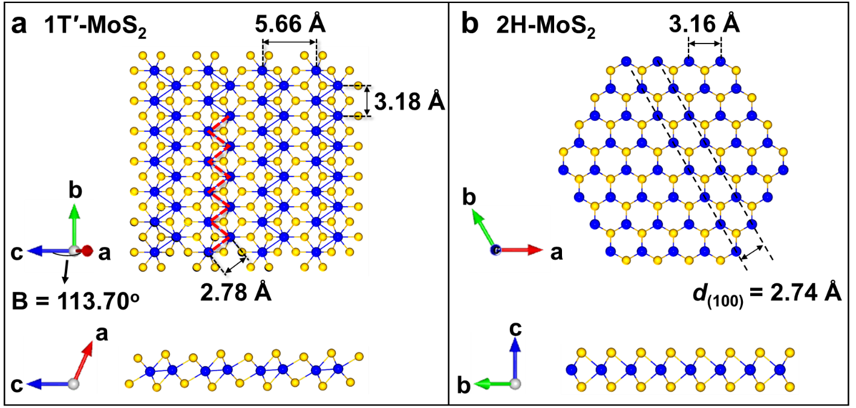

Supplementary Fig. 4 | Atomic structures of 1T′-MoS₂ and 2H-MoS₂. a,b Schematic illustrations of the atomic structures of 1T′-MoS₂ (ref. ¹) (a) and 2H-MoS₂ (b). The red dashed lines in (a) show the zig-zag chain of Mo atoms in 1T′-MoS₂ with a shortest Mo-Mo distance of 2.78 Å. The black dashed lines in (b) show the (100) planes of 2H-MoS₂ with a theoretical interlayer spacing of 2.74 Å.
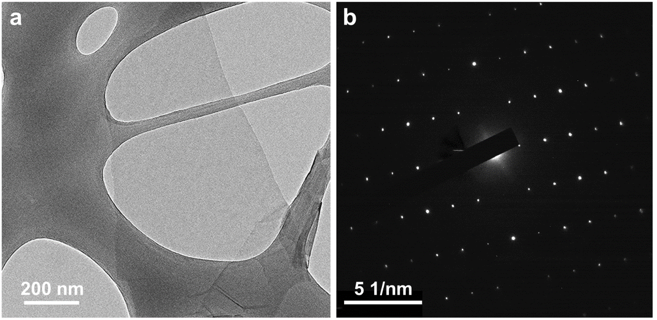

Supplementary Fig. 5 | Transmission electron microscopy (TEM) analysis of 1T′-MoS₂ NS. a, TEM image of a representative 1T′-MoS₂ NS. b, The corresponding selected area electron diffraction (SAED) pattern obtained from the 1T′-MoS₂ NS in (a).

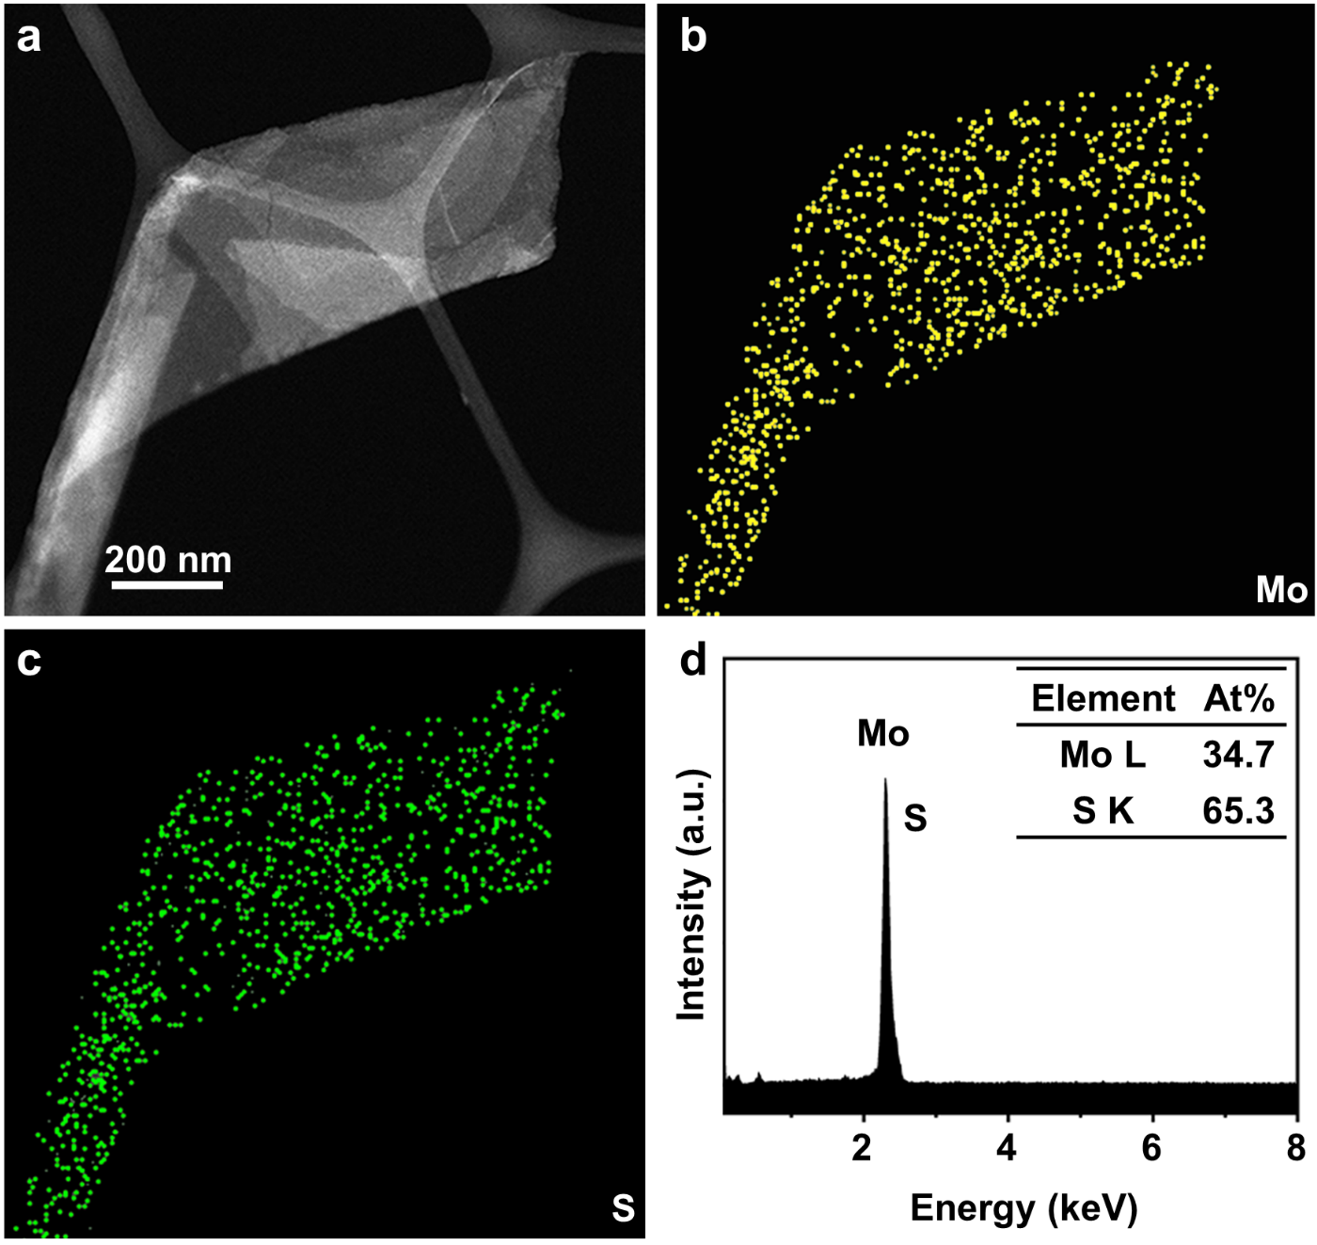

Supplementary Fig. 6 | STEM-EDS analysis of 1T′-MoS₂ NS. a, STEM image, and b,c, the corresponding EDS mappings of a representative 1T′-MoS₂ NS. d, EDS spectrum of the 1T′-MoS₂ NSs, indicating no detectable potassium (Kα 3.31 eV), bromide (Lα 1.48 eV), and other residues in 1T′-MoS₂ NSs. Inset in (d): the corresponding element percentages.

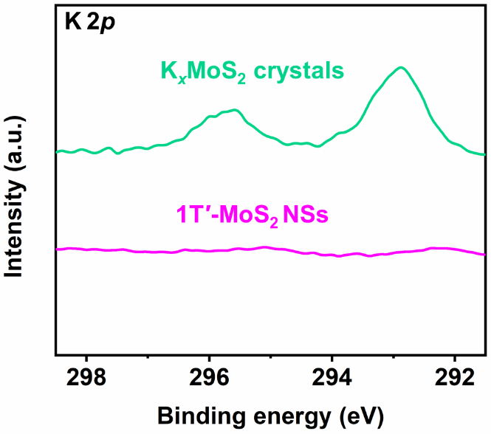

Supplementary Fig. 7 | K 2p X-ray photoelectron spectroscopy (XPS) spectra of the K_{x}MoS₂ crystals and the obtained 1T′-MoS₂ NSs.

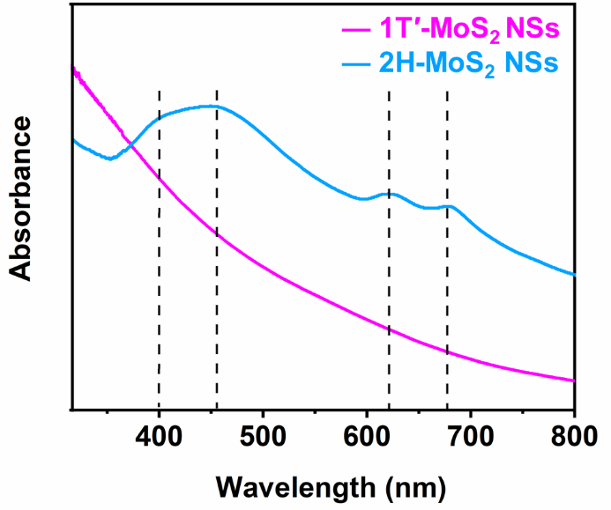

Supplementary Fig. 8 | Ultraviolet-visible (UV-Vis) absorption spectra of the exfoliated 1T′-MoS₂ NSs and 2H-MoS₂ NSs dispersed in N,N-dimethylformamide. Four featured peaks are clearly observed in the UV-Vis absorption spectrum of 2H-MoS₂ NSs as indicated by the black dashed lines.

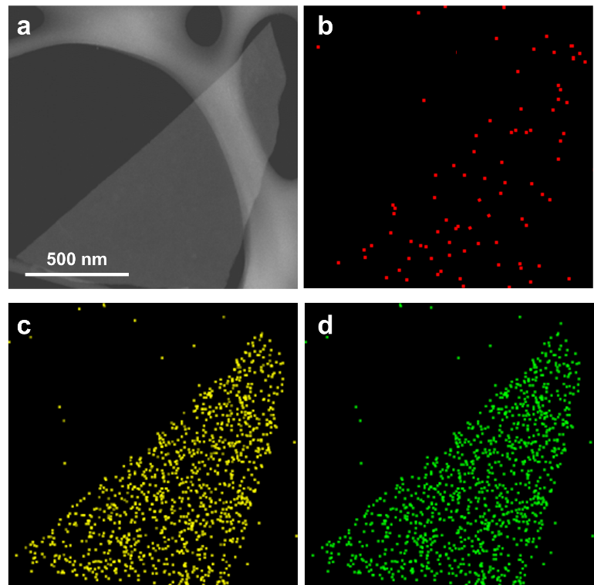

Supplementary Fig. 9 | EDS mapping results of Pt nanoparticles (PtNPs)/2H-MoS₂. a-d, STEM image (a) and the corresponding EDS mappings (b-d) of PtNPs/2H-MoS₂.

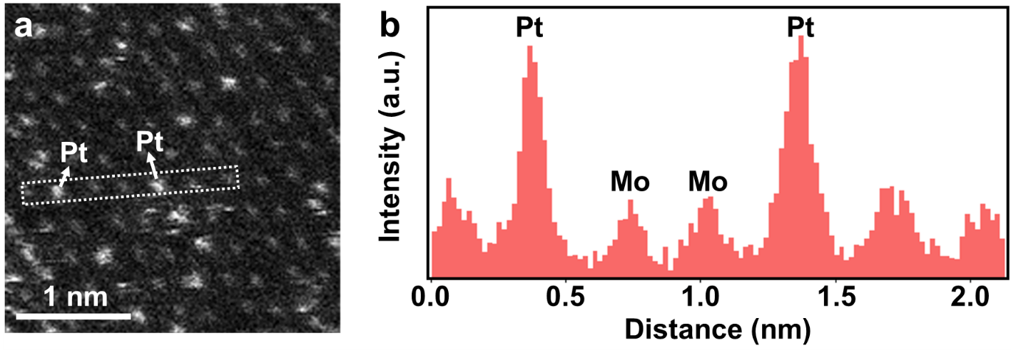

Supplementary Fig. 10 | HAADF-STEM analysis of single-atomically dispersed Pt (s-Pt)/1T′-MoS₂. a, HAADF-STEM image of s-Pt/1T′-MoS₂. b, The corresponding line scan intensity profile obtained from the white dotted rectangle in (a).
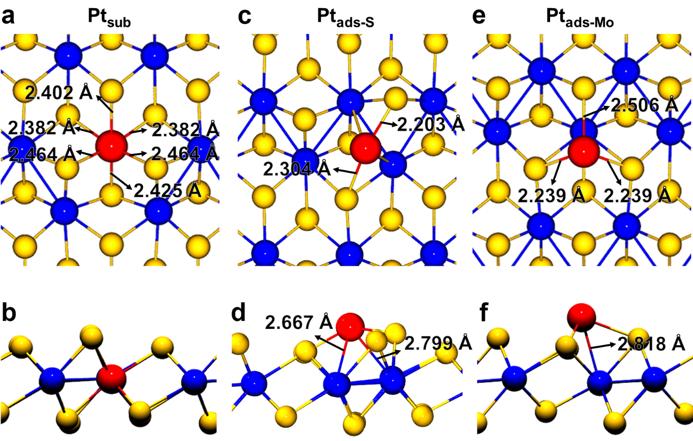

Supplementary Fig. 11 | Atomic structural models of Pt substituting Mo site (Pt_{sub}), Pt adsorbed on the top site of S (Pt_{ads-S}), and Pt adsorbed on the top site of Mo (Pt_{ads-Mo}) showing the bonding environment of Pt. a, Top view, and b, side view of Pt_{sub}. The Pt_{sub} is located in the 1T′-MoS₂ lattice, substituting the Mo site, and coordinated with six surrounding S atoms. c, Top view, and d, side view of Pt_{ads-S}. The Pt_{ads-S} is located on the top site of S in 1T′-MoS₂ and coordinated with two adjacent S atoms. e, Top view and f, side view of Pt_{ads-Mo}. The Pt_{ads-Mo} is located on the top site of Mo in 1T′-MoS₂ and coordinated with three adjacent S atoms. The yellow, blue, and red balls represent the S, Mo, and Pt atom, respectively.

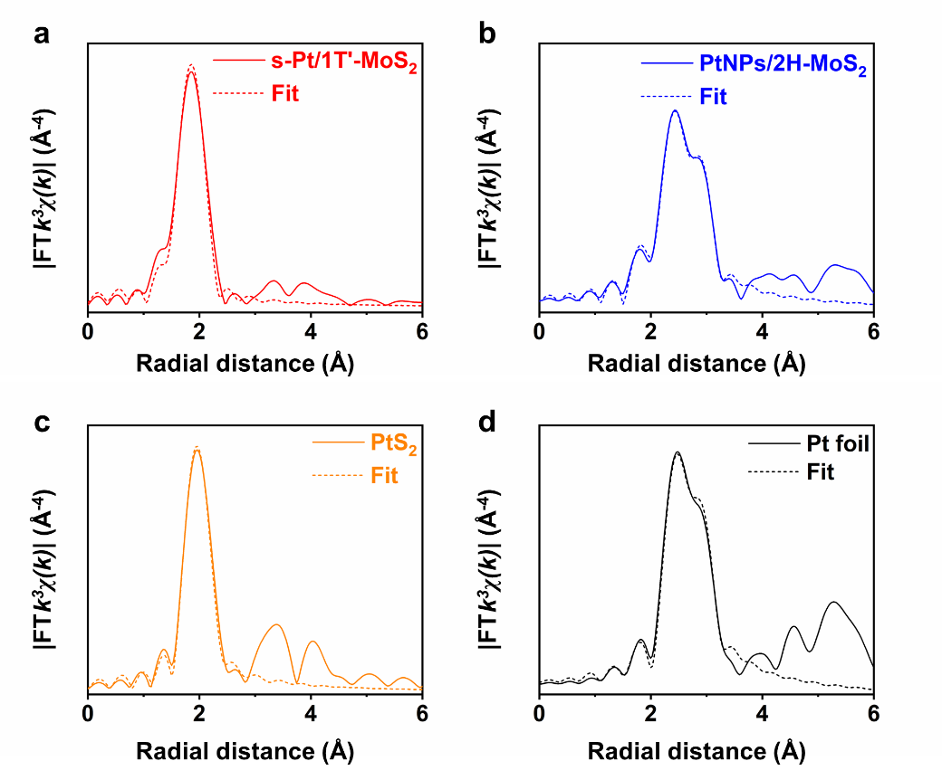

Supplementary Fig. 12 | Fitting curves for the extended X-ray absorption fine structure (EXAFS) profiles of the Fourier transform at Pt L₃-edge. a-d, Pt L₃-edge EXAFS spectra and the corresponding fitting curves of s-Pt/1T′-MoS₂ (a), PtNPs/2H-MoS₂ (b), commercial PtS₂ powder (c), and Pt foil (d). The fitting results are summarized in Supplementary Table 2.

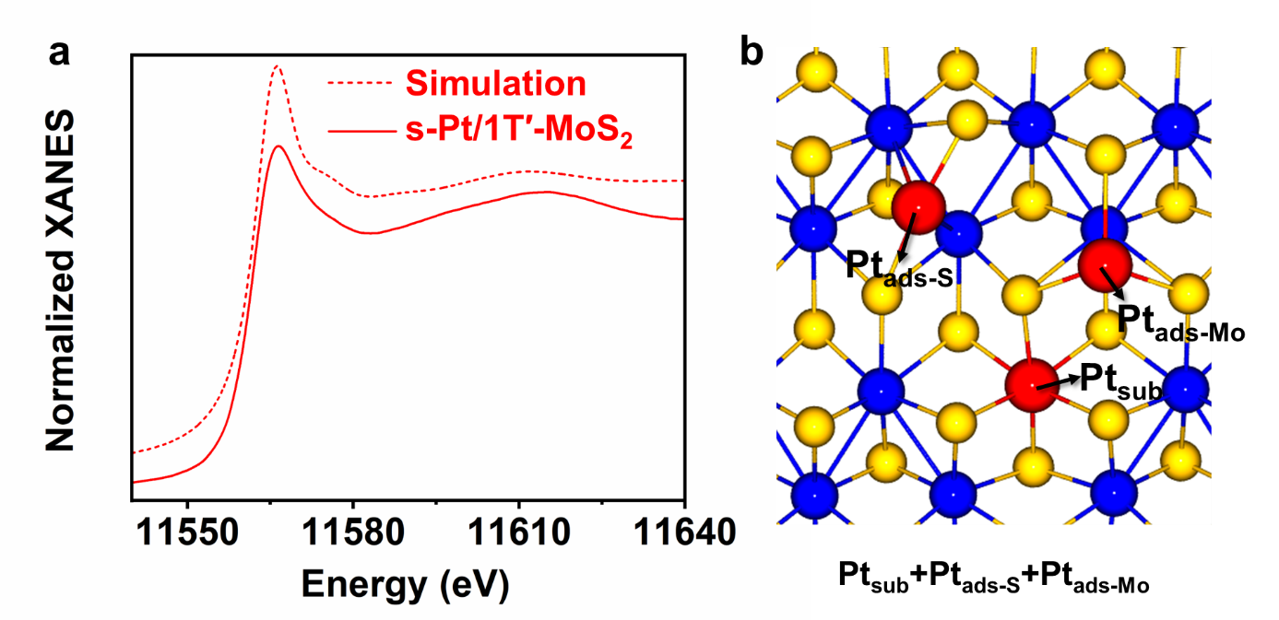

Supplementary Fig. 13 | Pt L₃-edge X-ray absorption near-edge spectroscopy (XANES) spectra and structural model of s-Pt/1T′-MoS₂. a, Pt L₃-edge XANES spectrum of s-Pt/1T′-MoS₂ and the simulated spectrum using b, the simulated density functional theory (DFT) model with the coexistence of Pt_{sub}, Pt_{ads-S}, and Pt_{ads-Mo} on 1T′-MoS₂ (denoted as Pt_{sub}+Pt_{ads-S}+Pt_{ads-Mo}). The yellow, blue, and red balls in (b) represent the S, Mo, and Pt atoms, respectively.

The Pt L₃-edge XANES spectrum of s-Pt/1T′-MoS₂ (Fig. 3a and Supplementary Fig. 13a) shows that the Pt is single-atomically dispersed on 1T′-MoS₂ NSs. The HAADF-STEM analysis and the DFT calculation results (Fig. 2c-f and Supplementary Fig. 11) indicate that the s-Pt/1T′-MoS₂ contains three kinds of Pt atomic structures, i.e., Pt_{sub}, Pt_{ads-S}, and Pt_{ads-Mo}. After a systematic screening, a DFT model containing Pt_{sub}, Pt_{ads-S}, and Pt_{ads-Mo} was established, which is denoted as Pt_{sub}+Pt_{ads-S}+Pt_{ads-Mo} (Supplementary Fig. 13b). The simulated Pt L₃-edge XANES spectrum based on this model matches well with the experimental curve of s-Pt/1T′-MoS₂ (Supplementary Fig. 13a). This result reveals the coexistence of Pt_{sub}, Pt_{ads-S}, and Pt_{ads-Mo} in the prepared s-Pt/1T′-MoS₂, which is consistent with the HAADF-STEM analysis (Fig. 2c-f).

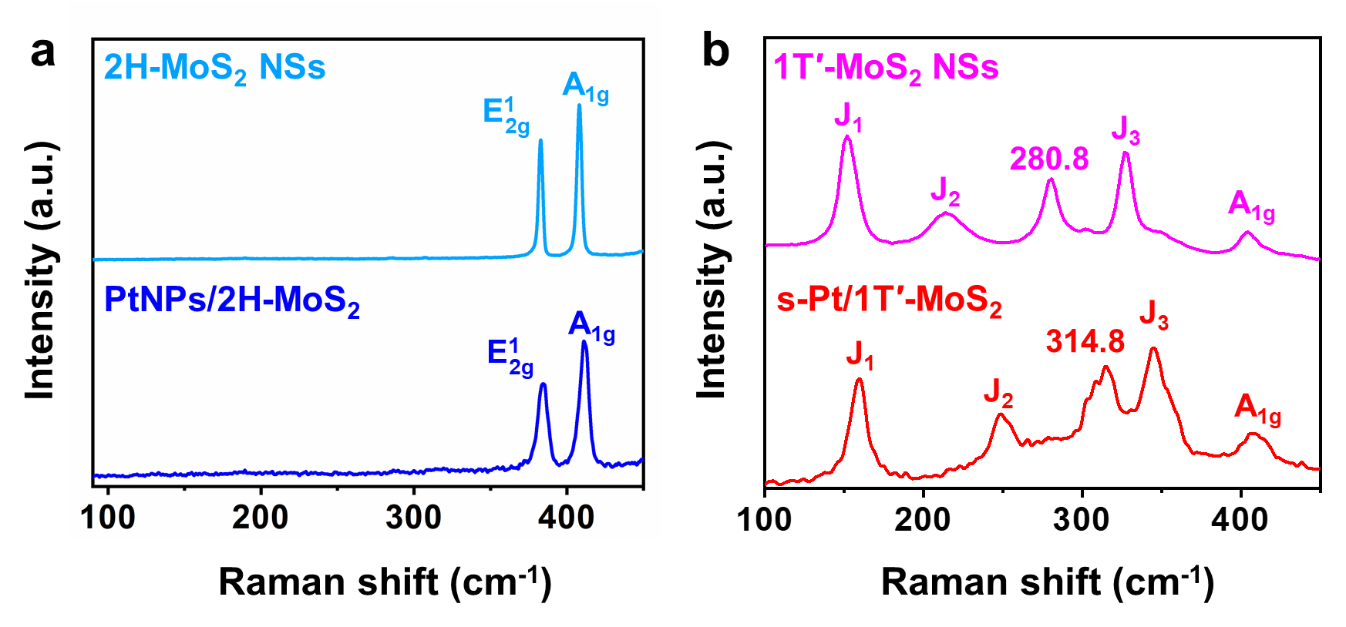

Supplementary Fig. 14 | Raman characterization of as-prepared samples. a, Raman spectra of 2H-MoS₂ NSs and PtNPs/2H-MoS₂. b, Raman spectra of 1T′-MoS₂ NSs and s-Pt/1T′-MoS₂.

As shown in Supplementary Fig. 14a, the phase of 2H-MoS₂ maintained after the growth of Pt on 2H-MoS₂ to form the PtNPs/2H-MoS₂, although the Raman peaks of PtNPs/2H-MoS₂ slightly shifted to higher wavenumbers compared to the 2H-MoS₂ NSs, which could be ascribed to the interaction between the 2H-MoS₂ and PtNPs (ref.^{2,3}). Similarly, all the Raman peaks of s-Pt/1T′-MoS₂ also shift to higher wavenumbers compared to the 1T′-MoS₂ NSs (Supplementary Fig. 14b). Importantly, the characteristic ${\text{E}}_{\text{2g}}^{\text{1}}$ peak of 2H-MoS₂ located at 382.8 cm⁻¹ cannot be observed, indicating that no 1T′-to-2H phase transition occurred after the growth of Pt on 1T′-MoS₂.

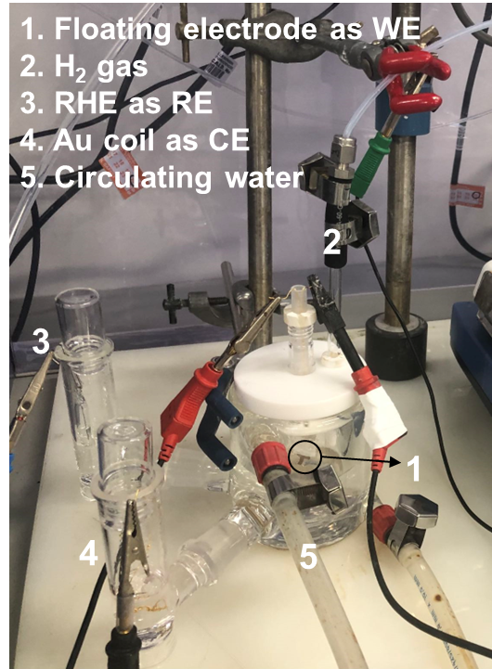

Supplementary Fig. 15 | Photograph of the floating electrode setup. Abbreviations: WE, working electrode; RE, reference electrode; CE, counter electrode.
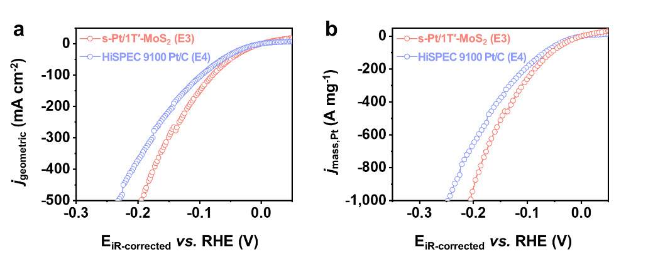

Supplementary Fig. 16 | Measurements of electrocatalytic hydrogen evolution reaction (HER) on the second batch of floating electrodes. a, HER polarization curves for s-Pt/1T′-MoS₂ (Electrode 3, denoted as E3) and HiSPEC 9100 Pt/C (Electrode 4, denoted as E4), showing the geometric current densities (j_{geometric}). b, HER polarization curves for s-Pt/1T′-MoS₂ and HiSPEC 9100 Pt/C, showing the mass-normalized current densities (j_{mass,Pt}).

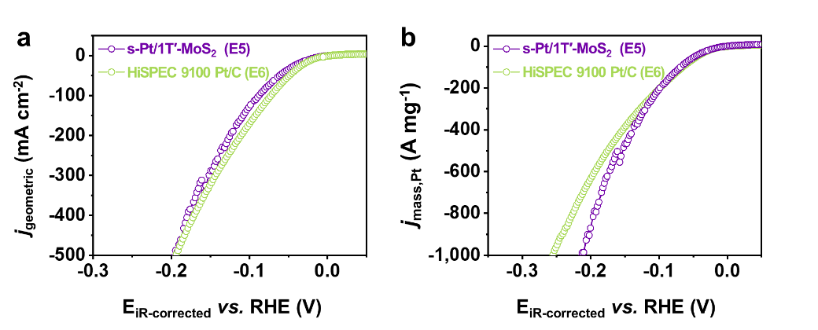

Supplementary Fig. 17 | Measurements of electrocatalytic HER on the third batch of floating electrodes. a, HER polarization curves for s-Pt/1T′-MoS₂ (Electrode 5, denoted as E5) and HiSPEC 9100 Pt/C (Electrode 6, denoted as E6), showing the j_{geometric}. b, HER polarization curves for s-Pt/1T′-MoS₂ and HiSPEC 9100 Pt/C, showing the j_{mass,Pt}.

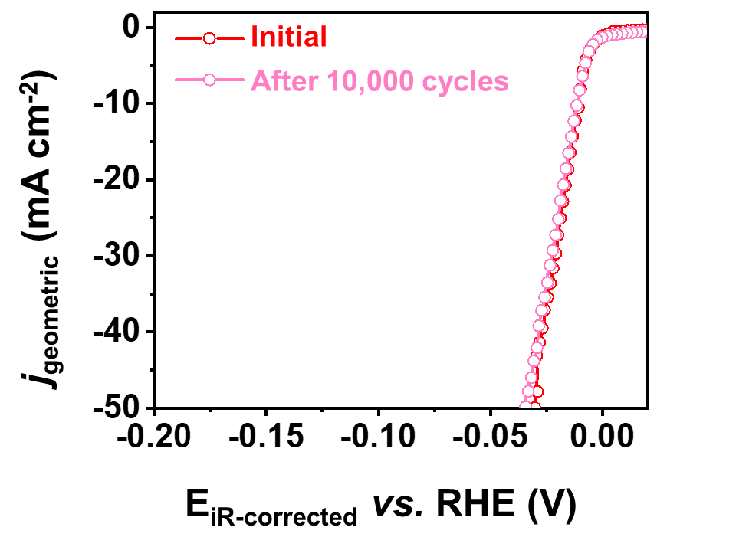

Supplementary Fig. 18 | Durability test of s-Pt/1T′-MoS₂. The polarization curves were recorded before and after 10,000 cyclic voltammetry cycles.
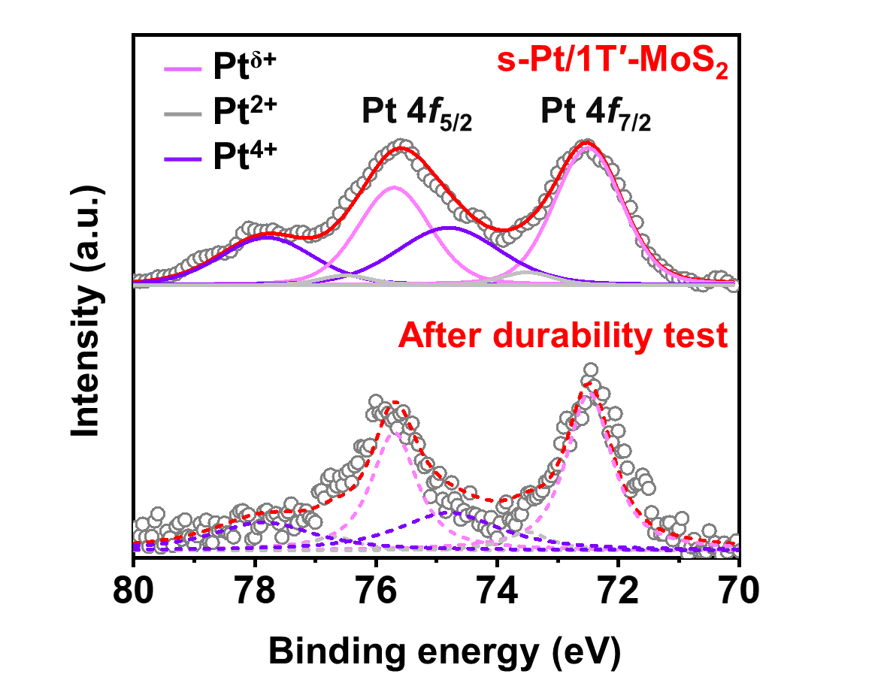

Supplementary Fig. 19 | Pt 4f spectra of s-Pt/1T′-MoS₂ before and after the durability test. The empty dots and curves show the experimental XPS data and the corresponding deconvoluted spectra, respectively.

The Pt 4f XPS data in Supplementary Fig. 19 shows a negligible difference after the durability test. No Pt⁰ peak can be assigned which indicates that the Pt species are not in the metallic state.
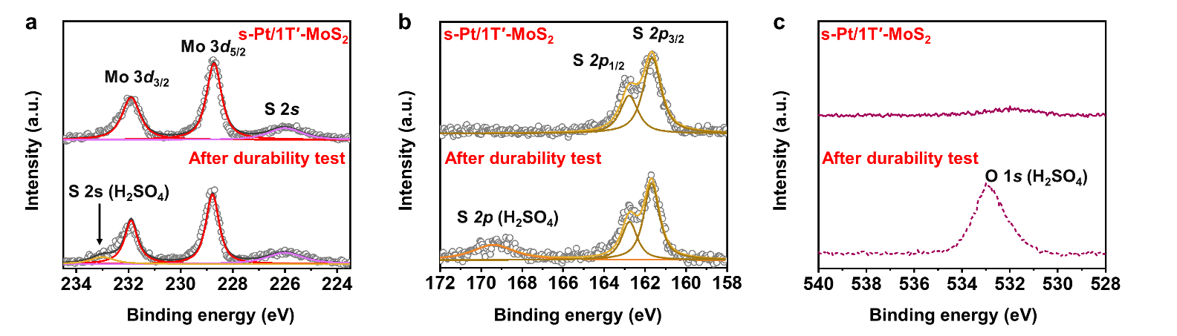

Supplementary Fig. 20 | XPS spectra of s-Pt/1T′-MoS₂ before and after the durability test. a, Mo 3d spectra, b, S 2p spectra, and c, O 1s spectra of s-Pt/1T′-MoS₂ before and after the durability test. The empty dots and curves show the experimental XPS data and the corresponding deconvoluted spectra, respectively.

The Mo 3d, S 2p XPS spectra in Supplementary Fig. 20a,b show no shift after the durability test, indicating the structure of the 1T′-MoS₂ still maintained. A small peak in Mo 3d, located at ~233 cm⁻¹, (pointed out by the black arrow in Supplementary Fig. 20a), can be attributed to the remained electrolyte (0.5 M H₂SO₄)⁴. In addition, the broad S 2p peak located at ~169 cm⁻¹ in Supplementary Fig. 20b and the O 1s peak in Supplementary Fig. 20c can also be assigned to the remained electrolyte (0.5 M H₂SO₄)⁵.

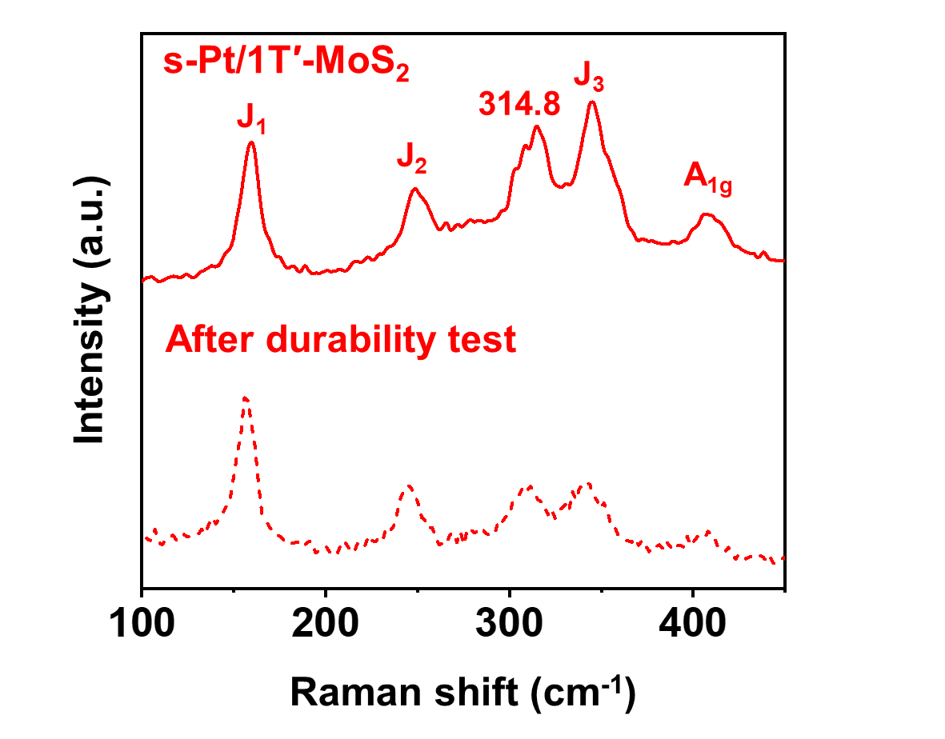

Supplementary Fig. 21 | Raman spectrum of s-Pt/1T′-MoS₂ before (solid curve) and after (dashed curve) the durability test.

The Raman spectrum of the s-Pt/1T′-MoS₂ after the durability test (Supplementary Fig. 21) shows the same five characteristic peaks as compared with the original s-Pt/1T′-MoS₂, and no 2H peak can be detected. It confirms that no phase transition of 1T′-MoS₂ NSs occurred in the s-Pt/1T′-MoS₂ after the durability test.

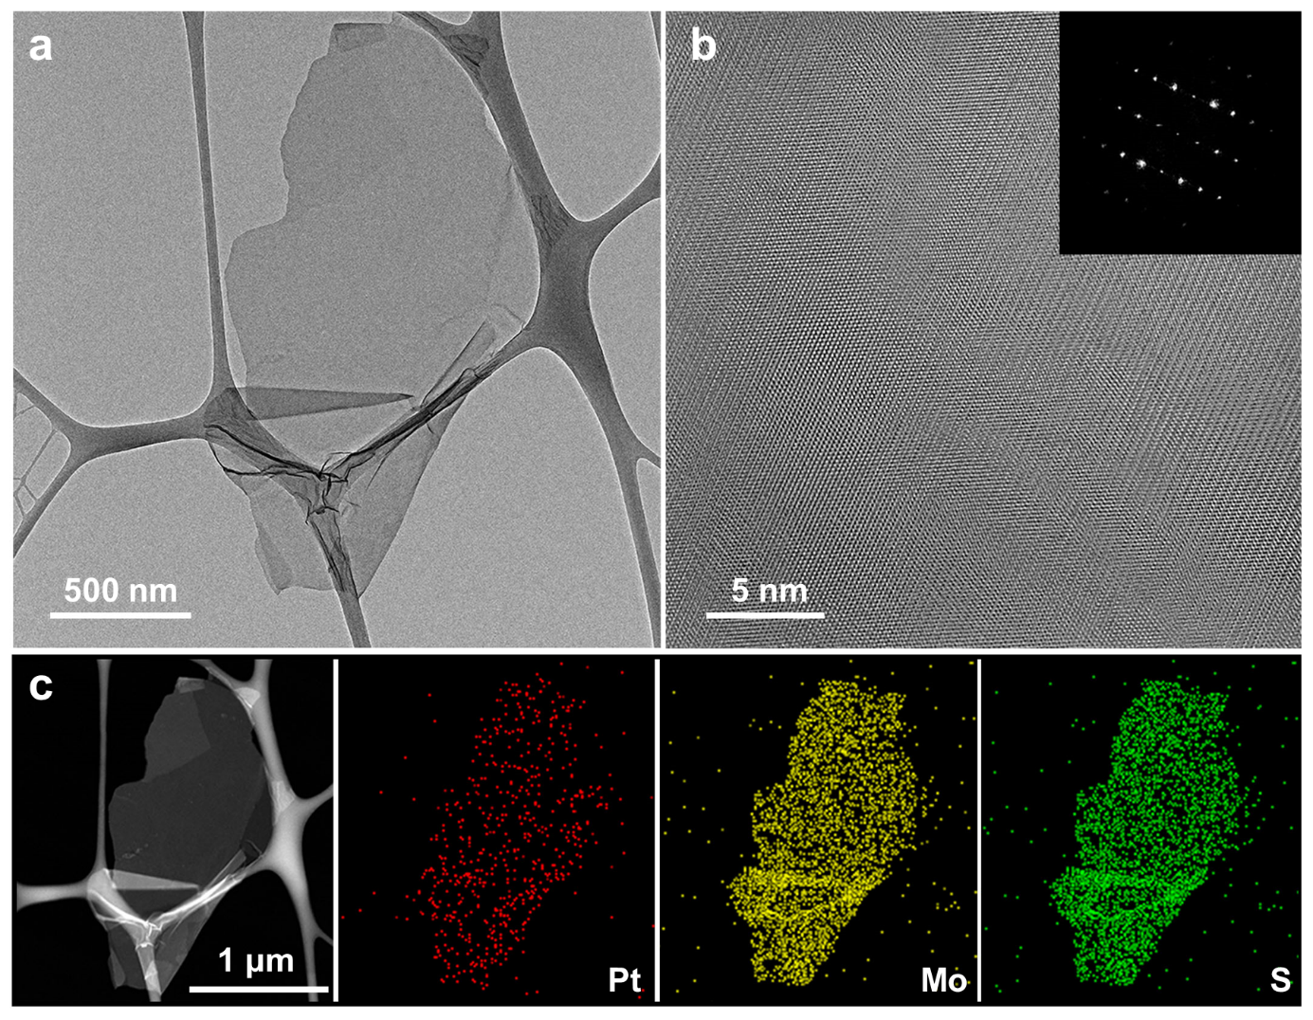

Supplementary Fig. 22 | Structural characterization of s-Pt/1T′-MoS₂ after the durability test. a, TEM and b, High-resolution TEM (HRTEM) images. Inset in (b): the corresponding fast Fourier transform (FFT) pattern of s-Pt/1T′-MoS₂. c, STEM image and the corresponding EDS mappings of s-Pt/1T′-MoS₂.

The s-Pt/1T′-MoS₂ after the durability test was characterized by TEM and EDS mapping. Obviously, no PtNPs are observed in the TEM and HRTEM images (Supplementary Fig. 22a,b). The FFT pattern (inset in Supplementary Fig. 22b) shows the featured pattern of 1T′-MoS₂, in which no diffraction spot can be assigned to the PtNP. In addition, the EDS mappings (Supplementary Fig. 22c) show the dispersion of Pt, Mo, and S elements.

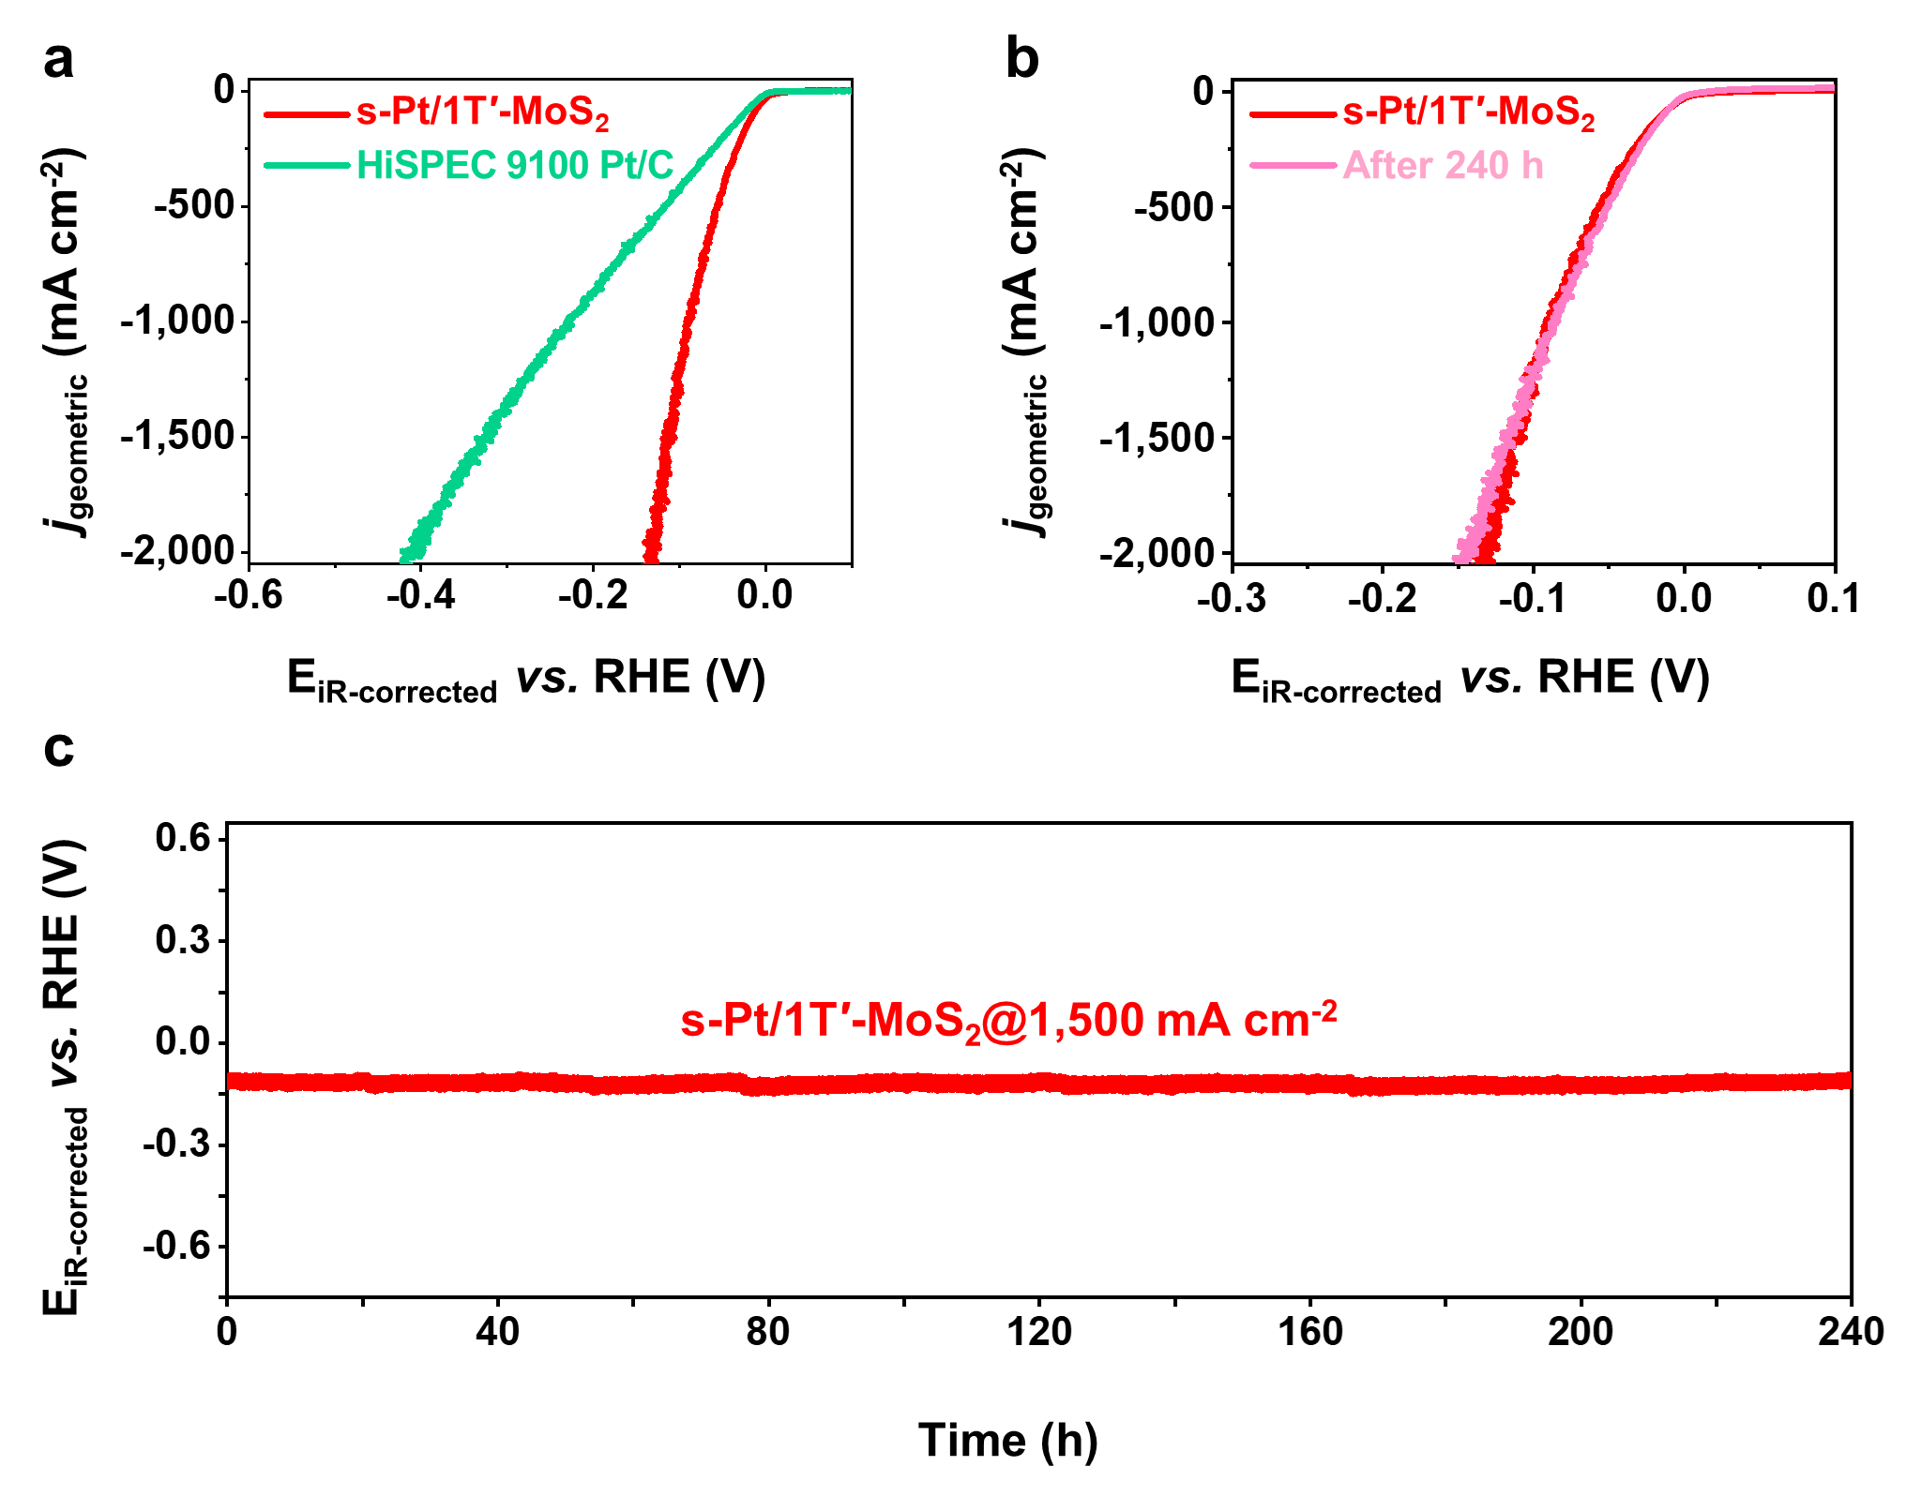

Supplementary Fig. 23 | Characterizations of the activity and stability of s-Pt/1T′-MoS₂ during HER in an H-type cell. a, Polarization curves of s-Pt/1T′-MoS₂ and commercial HiSPEC 9100 Pt/C loaded on carbon fiber paper and tested in an H-type cell. b, The polarization curves of s-Pt/1T′-MoS₂ recorded initially and after the 240-h test at a current density of 1,500 mA cm⁻². c, Chronopotentiometry curve of the s-Pt/1T′-MoS₂ catalyst used as cathode, tested in H-type cell at a current density of 1,500 mA cm⁻². All the HER measurements in H-type cell were conducted in 0.5 M H₂SO₄ aqueous solution. All the current densities were normalized by the geometric area of the electrode. The scan rate is 5 mV s⁻¹. Note: The Pt loadings for s-Pt/1T′-MoS₂ and HiSPEC 9100 Pt/C were kept at 0.0175 mg cm⁻².

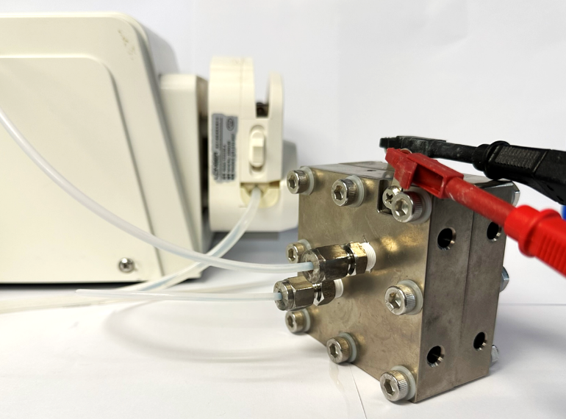

Supplementary Fig. 24 | Photograph of the prototype PEM electrolyser.

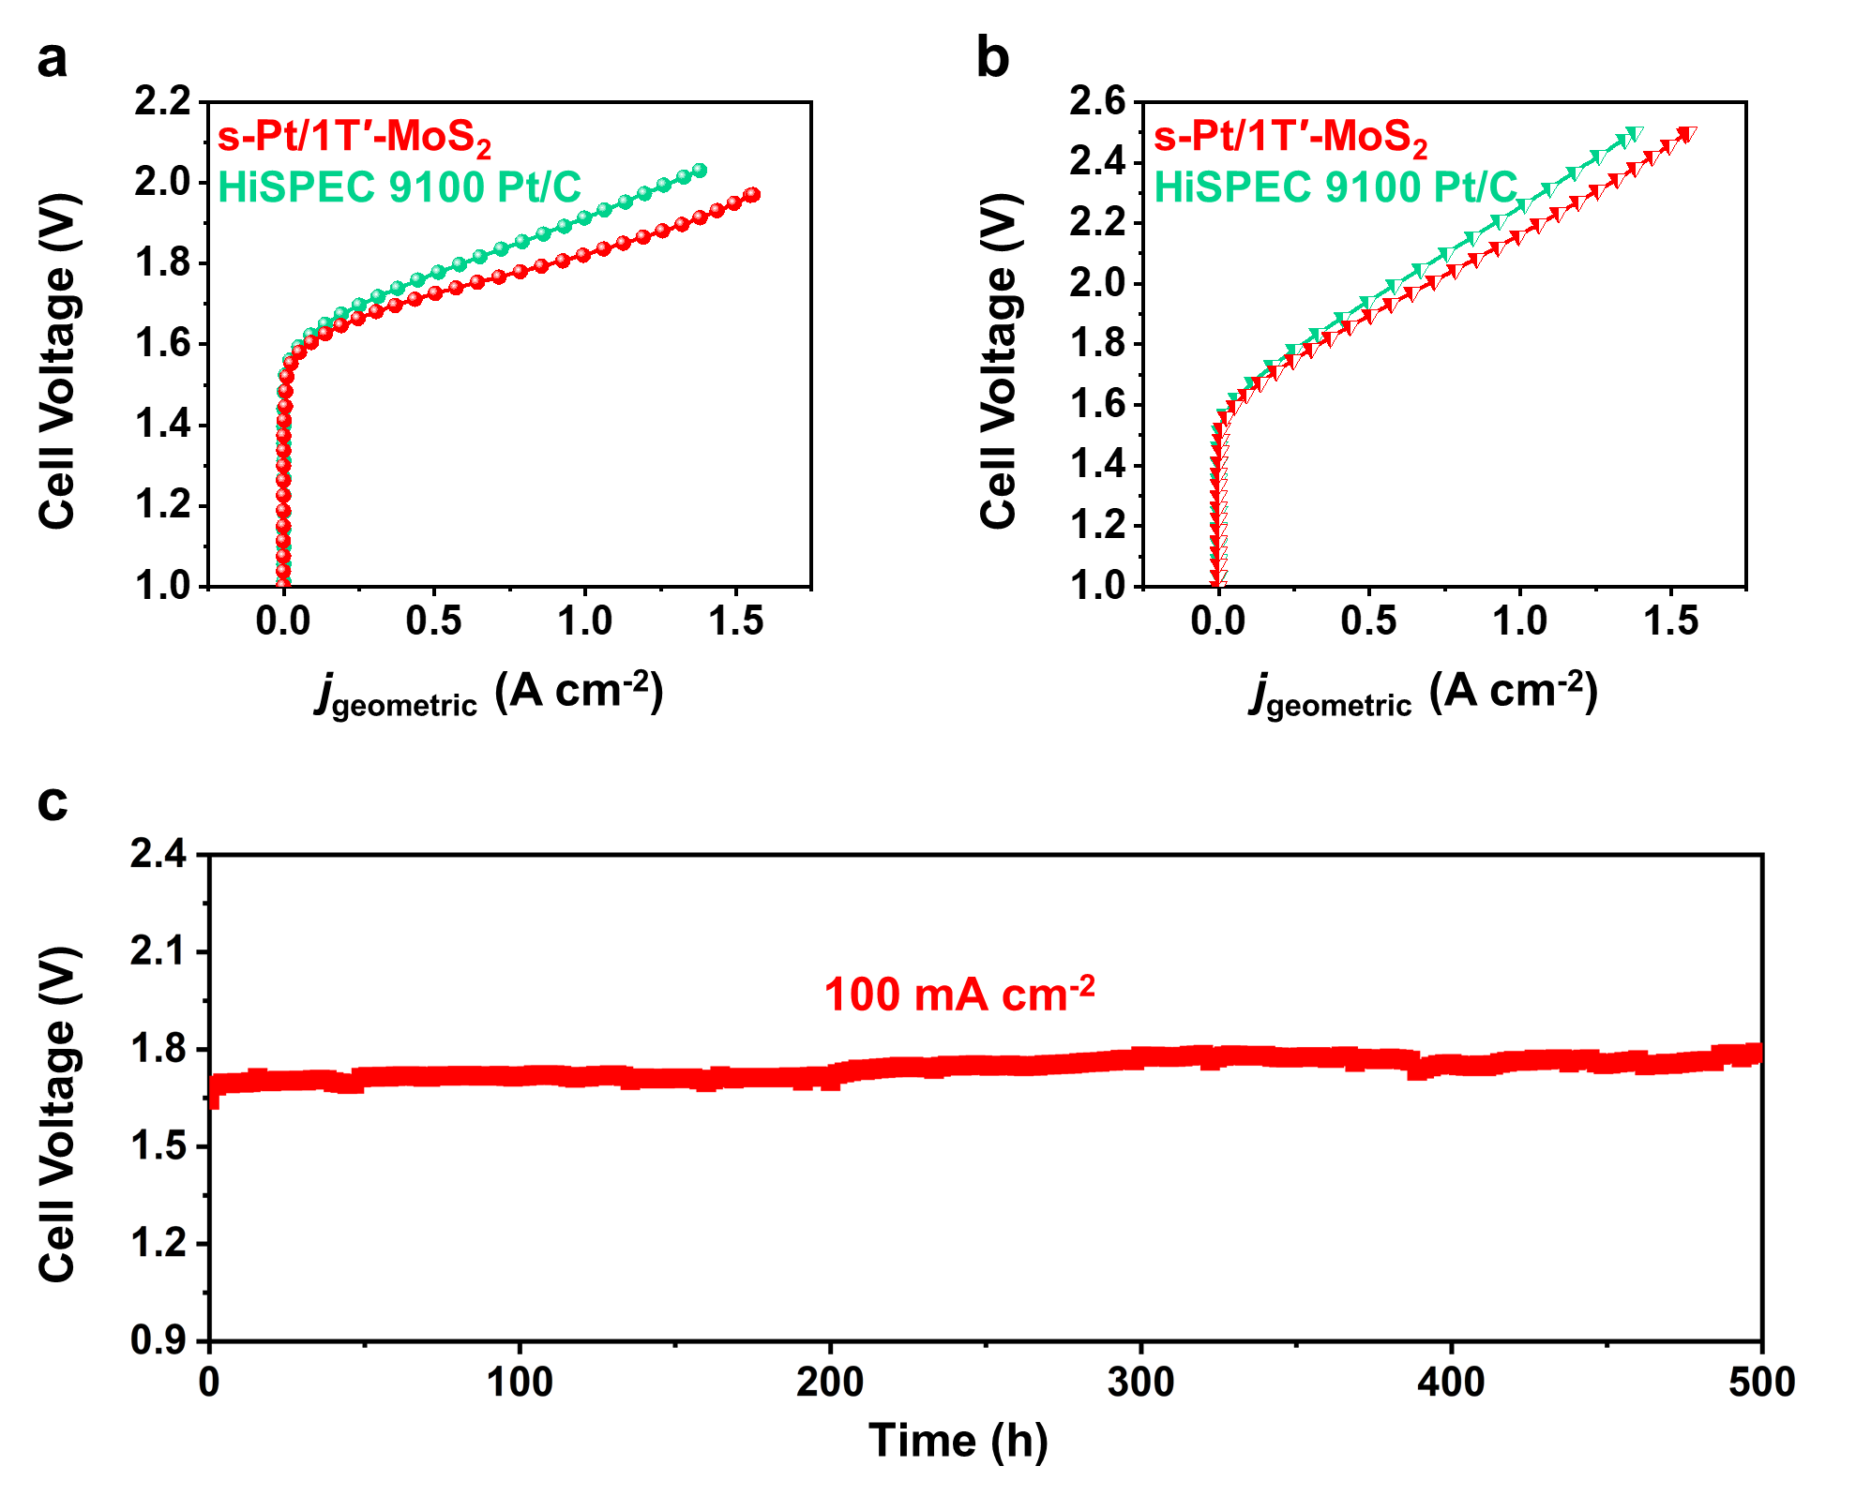

Supplementary Fig. 25 | Characterizations of the activity and stability of s-Pt/1T′-MoS₂ during water splitting in a proton exchange membrane (PEM) electrolyser. a,b, Polarization curves with iR-correction (a) and without iR-correction (b) of the PEM electrolyser using s-Pt/1T′-MoS₂ and commercial HiSPEC 9100 Pt/C catalyst as cathode material. c, Chronopotentiometry curve of the PEM electrolyser using s-Pt/1T′-MoS₂ catalyst as cathode material at a current density of 100 mA cm⁻². Note: The Pt loadings for s-Pt/1T′-MoS₂ and HiSPEC 9100 Pt/C were kept at 0.04 mg cm⁻².

Supplementary Table 1 | Inductively coupled plasma-optical emission spectrometry (ICP-OES) results and the corresponding Pt mass loadings in the as-synthesized samples.
Sample | Mo concentration (ppm) | Pt concentration (ppm) | Pt wt%
PtNPs/2H-MoS₂ | 6.760 | 1.190 | ~9.6
s-Pt/1T′-MoS₂ | 7.757 | 1.434 | ~10.0
s-Pt-4/1T′-MoS₂ | 12.360 | 0.925 | ~4.3
s-Pt-6/1T′-MoS₂ | 9.647 | 1.106 | ~6.4
PtNPs-12/1T′-MoS₂ | 2.480 | 0.574 | ~12.2
PtNPs-15/1T′-MoS₂ | 2.327 | 0.714 | ~15.5

The obtained samples were first washed three times by Milli-Q water, and then re-dispersed in Milli-Q water. 10 μl of the obtained dispersion of samples were dissolved in 1 ml of aqua regia. The obtained solution was diluted to 10 ml with Milli-Q water, which was then used for the ICP-OES analysis to determine the Mo and Pt concentrations. The Pt mass loadings in the as-synthesized samples were calculated based on the ICP-OES results.

Supplementary Table 2 | The fitting parameters of Pt L₃-edge EXAFS curves showing the structure parameters around Pt in the s-Pt/1T′-MoS₂, commercial PtS₂ powder, PtNPs/2H-MoS₂, and Pt foil.
Material | Path | CN | σ² (Å²) | R (Å) | R factor*
s-Pt/1T′-MoS₂ | Pt-S | 4.2(±0.8) | 0.0079(±0.0025) | 2.30(±0.01) | 0.014
PtS₂ | Pt-S | 4.2(±0.3) | 0.0033(±0.0007) | 2.36(±0.01) | 0.006
PtNPs/2H-MoS₂ | Pt-Pt | 8.9(±1.2) | 0.0070(±0.0008) | 2.75(±0.01) | 0.006
Pt foil | Pt-Pt | 12 | 0.0044(±0.0002) | 2.76(±0.01) | 0.005
Abbreviations: CN, coordination number; σ², the Debye-Waller factor; R, average bond length. *R factor indicates the percentage misfit between the data and theory.

Supplementary Table 3 | The mass loadings of Pt on different floating electrodes tested by inductively coupled plasma mass spectrometry (ICP-MS).
 | Samples | Loading (ng cm⁻²)
Batch 1 | s-Pt/1T′-MoS₂ (Electrode 1, denoted as E1) | 398
Batch 1 | HiSPEC 9100 Pt/C (Electrode 2, denoted as E2) | 286
Batch 2 | s-Pt/1T′-MoS₂ (Electrode 3, denoted as E3) | 583
Batch 2 | HiSPEC 9100 Pt/C (Electrode 4, denoted as E4) | 570
Batch 3 | s-Pt/1T′-MoS₂ (Electrode 5, denoted as E5) | 618
Batch 3 | HiSPEC 9100 Pt/C (Electrode 6, denoted as E6) | 833
Average | s-Pt/1T′-MoS₂ | 533±118*
Average | HiSPEC 9100 Pt/C | 563±273*
*The errors of Pt loadings are the standard deviations obtained from the separate ICP-MS tests on three batches of floating electrodes, i.e., E1, E3, E5 for s-Pt/1T′-MoS₂ and E2, E4, E6 for HiSPEC 9100 Pt/C.

Supplementary Table 4 | Comparison of HER activities of s-Pt/1T′-MoS₂ and HiSPEC 9100 Pt/C with some representative reported Pt-based catalysts tested in acidic media.
Catalysts | Pt loading  (μg cm⁻²) | Pt weight percentage (wt%) | Overpotential (mV)@10 mA cm⁻² | Mass activity  (A mg⁻¹) | Tafel slope  (mV dec⁻¹) | References
s-Pt/1T′-MoS₂ | 0.533±0.118 | 10.0 | -19±5* | 11±5@-10 mV*  22±9@-20 mV*  39±12@-30mV*  57±17@-40 mV* 85±23@-50 mV*  150±29@-70 mV* | 118 | This work
HiSPEC 9100 Pt/C | 0.563±0.273 | 60.0 | -24±3* | 8±4@-10 mV*  19±8@-20 mV*  32±10@-30 mV*  50±12@-40 mV*  70±17@-50 mV*  121±26@-70 mV* | 118 | This work
Pt/C | 3.7 | 47.8 wt% | N/A | 142@-70 mV† | N/A | 6
PtRu/C | 8.2 | 54 wt% Pt:Ru 1:1.5 | N/A | 75.2@-70 mV† | N/A | 6
PtNi/C | 10.1 | 40 wt% Pt:Ni 3:1 | N/A | 43.1@-70 mV† | N/A | 6
ALD50Pt/N-doped graphene | 76 | 2.1 | -50 mV to reach 16 mA cm⁻² | 10.1@-50 mV | 31 | 7
1Pt/VS₂/carbon paper | 3.25 | 0.65 | -77 | 22.88@-200 mV | 39.46 | 8
Pt-single atoms/WS₂ | 0.45 | 4.1 | -32 | 130.2@-100 mV | 28 | 9
Pt-single atoms/MoS₂ | 0.45 | 5.1 | -59 | 17.14@-50 mV | 31 | 10
Pt-doped 1T-MoS₂ | N/A | 3 | -140 | N/A | 57 | 11
K₂PtCl₄/N-doped carbon | 5.5 | 1.92 | -11 | 5.5@-20 mV | 21 | 12
Pt-single atoms/N-carbon framework | 6.25 | 2.5 | -19 | N/A | 14.2 | 13
Pt-single atoms decorated Co_{0.85}Se | 20.4 | 1.03 | -55 | 1.32@-100 mV | 37 | 14
Pt-single atoms/curved carbon | 1.68 | 0.33 | -38 | 7.4@-30 mV | 35 | 15
Pt-single atoms/MoS₂ | 18 | 1.7 | -150 | N/A | 96 | 16
Pt₁^{O1}/Ti_{1-x}O₂ | 3.81 | 1.27 | -20.6 | 23.92@-50 mV | 31 | 17
Pt-single atoms/MoO₂ | 6.16 | 1.1 | -9.3 | 69.5@-300 mV | 28.78 | 18
Pt/TiO₂-OVs | 0.12 | 0.77 | -60 | 62.34@-50 mV | 34 | 19
Pt/TiO_{2-X} | 0.072 | 1.69 | -95 | 39.1@-50 mV | 34.3 | 20
1.2%PtCo/N-doped graphite porous carbon | 1.3 | 1.2 | -14 | 13.83@-20 mV | 21.2 | 21
Pt/tungsten oxide/ reduced graphene oxide aerogel | 0.81 | 0.8 | -40 | 28.70@-50 mV | 30 | 22
Mo₂TiC₂T_{x}-Pt_{SA} | 12 | 1.2 | -30 | 8.3@-77 mV | 30 | 23
400-single-walled carbon nanotube/Pt | 0.57 | 0.75 at% | -27 | N/A | 38 | 24
Pt-single atoms/graphene | 7.07 | 0.44 | -12 | 22.4@-50 mV | 29.3 | 25
Pt-graphitic tubes-FeCo/Cu | 1.4 | 0.5 | -18 | N/A | 24 | 26
PtNPs/MoS₂ | 27 | 36 | -80 | N/A | 40 | 27
Pt/TiS₂ | N/A | N/A | -70 | N/A | 40.6 | 28
Pt clusters/carbon spheres | 7.6 | 5.08 | -20 | N/A | 28.3 | 29
Abbreviation: N/A, not available in the listed reference.
*The errors of overpotentials and mass activities are the standard deviations obtained from separate HER measurements on three batches of floating electrodes, i.e., E1, E3, E5 for s-Pt/1T′-MoS₂ and E2, E4, E6 for HiSPEC 9100 Pt/C.
†Mass activities of these samples are obtained by using floating electrode techniques.

Supplementary Table 5 | Comparison of exchange current densities of s-Pt/1T′-MoS₂ and HiSPEC 9100 Pt/C with some representative Pt-based catalysts in acidic HER.
Catalysts | Condition | Pt loading  (ug_{Pt} cm⁻²) | j_{0,spec}  (mA ${\text{cm}}_{\text{Pt}}^{\text{-2}}$) | j_{0,mass}  (A ${\text{mg}}_{\text{Pt}}^{\text{-1}}$) | References
s-Pt/MoS₂ | Floating electrode, 1M HClO₄, 25 ºC | 0.533±0.118 | N/A | 127 | This work
HiSPEC 9100 Pt/C | Floating electrode, 1M HClO₄, 25 ºC | 0.563±0.273 | 147 | 131 | This work
3.8 nm Pt nanoparticles | RDE (1600 r.p.m.), H₂-saturated 0.5 M H₂SO₄ | 0.013 | 140 | 77* | 30
Pt/C | H₂ pump, 313 K | 3 | 216±50 | 237.6±55* | 31
Pt/C | Floating electrode, 1 M HClO₄, 25 ºC, Fit 1 | 0.84 | 86 | 76.54* | 32
Pt/C | Floating electrode, 1 M HClO₄, 25 ºC, Fit 2 | 0.84 | 101 | 89.89* | 32
Pt/C | H₂ pump, 313 K, Butler-Volmer fit | 2 | 120±10 | 132±11* | 33
Pt/C | H₂ pump, 313 K, Micropolarization fit | 2 | 135±40 | 148±44* | 33
Pt/C | H₂ pump, 80 ºC | N/A | 235-300 | 211.5-276* | 34
Pt/C | H₂ pump, 30 ºC | N/A | 100 | 92* | 34
Pt/C | Single particle microelectrode, 0.1 M H₂SO₄, 23 ºC | N/A | 24 | N/A | 35
0.25 ML Pt/TiWC | Gas diffusion electrodes,  1.0 M HClO₄, 30 ºC | 0.63 | N/A | 30.2±0.8 | 36
Pt/C | Gas diffusion electrodes,  1.0 M HClO₄, 30 ºC | 51 | N/A | 2.3±0.1 | 36
Pt-Ru/CNT | GCE, N₂-saturated 0.5 m H₂SO₄, RT | N/A | 2.43 | 2.28* | 37
Pt NP/N-graphene | GCE, N₂-saturated 0.5 m H₂SO₄, RT | 5.65 | 0.989 | 0.90* | 38
Pt-MoS₂ | GCE, N₂-saturated 0.5 m H₂SO₄, RT | 13 | 0.373 | 0.276* | 39
Pt/C | RDE, N₂-saturated 0.5 m H₂SO₄, RT | 88.7 | 0.27 | 0.19* | 40
Pt/C | RDE, 0.5 M H₂SO₄, 25 ºC | 1 | 1 | N/A | 41
PtRu₂₀ | RDE, 0.5 M H₂SO₄, 25 ºC | 1 | 1.14 | N/A | 41
Pt/C | RDE, 0.1 M HClO₄, 25 ºC | 0.032 | 27.2±3.5 | N/A | 42
Pt₁^{O1}/Ti_{1-x}O₂ | GCE, 0.5 M H₂SO₄, RT | 3.81 | 1.74 | N/A | 17
Pt/C | GCE, 0.5 M H₂SO₄, RT | N/A | 0.63 | N/A | 17
Pt-single atoms/MoO₂ | GCE, 0.5 M H₂SO₄, RT | 6.16 | 4.75 | N/A | 18
Pt/C | GCE, 0.5 M H₂SO₄, RT | 112 | 2.95 | N/A | 18
Pt/TiO₂-OVs | 0.5M H₂SO₄ (H₂ saturated electrode), 25 ºC | 0.12 | 0.45 | N/A | 19
Pt/C | 0.5M H₂SO₄ (H₂ saturated electrode), 25 ºC | 3.1 | 0.56 | N/A | 19
Mo₂TiC₂T_{x}-Pt_{SA} | Carbon paper electrode, 0.5M Ar-saturated H₂SO₄, RT | 12 | 1.54 | N/A | 23
Pt/C | Carbon paper electrode, 0.5M Ar-saturated H₂SO₄, RT | 400 | 1.4 | N/A | 23
400-single-walled carbon nanotube/Pt | GCE, 0.5 M H₂SO₄ saturated with N₂ | 0.114 | 1.94 | N/A | 24
Pt/C | GCE, 0.5 M H₂SO₄ saturated with N₂ | 38 | 1.22 | N/A | 24
Abbreviations: RT, room temperature. j_{0,spec}, electrochemically active surface area (ECSA)-normalized exchange current density. j_{0,mass}, mass-normalized exchange current density. RDE, rotating disk electrode. GCE, glassy carbon electrode; N/A, not available in the listed reference.
*The j_{0,mass} value was calculated from j_{0,spec} by using the ECSA value in the listed reference.

Supplementary Table 6 | Comparison of high-current-density HER performance of s-Pt/1T′-MoS₂ and HiSPEC 9100 Pt/C with the previously reported catalysts in acid media.
Catalysts | Total mass loading  (mg cm⁻²) | Overpotential (η, mV)  at different current density |  |  | Stability test | References
Catalysts | Total mass loading  (mg cm⁻²) | η@1,000 mA cm⁻² | η@1,500 mA cm⁻² | η@2,000 mA cm⁻² | Stability test | References
s-Pt/1T′-MoS₂ | 0.175 | -91 | -112 | -131 | 240 h@1,500 mA cm⁻² | This work
HiSPEC 9100 Pt/C | 0.175 | -227 | -325 | -419 | N/A | This work
CH₄/H₂ treated Mo₂S/Mo₂C | 10 | -412 | N/A | N/A | 24 h@500 mA cm⁻² | 43
20 wt% Pt/C | 2 | -500 | N/A | N/A | N/A | 43
α-MoB₂ | N/A | -334 | N/A | N/A | 60 h@1,500 mA cm⁻² | 44
20 wt% Pt/C | 0.2 | -898 | N/A | N/A | N/A | 44
Rh/Si nanowire | 0.193 | -950 | N/A | N/A | ~138 h@-0.1 V (~25 mA cm⁻²) | 45
40 wt% Pt/C | 0.193 | -1,120 | N/A | N/A | N/A | 45
MoS₂/Mo₂C | 0.3 | -227 | N/A | N/A | 24 h@200 mA cm⁻² | 46
Pt foil | N/A | N/A | N/A | N/A | N/A | 46
20 wt% Pt/C/Nafion | 0.2 | N/A | N/A | N/A | N/A | 46
N and P codoped MoS₂/carbon cloth | 1.2 | N/A | N/A | N/A | 20 h@1,000 mA cm⁻² | 47
Co(10.4)/Se-MoS₂-nanofoam | 0.5 | -382 | N/A | N/A | 360 h@1,000 mA cm⁻² | 48
40 wt% Pt/C | 0.5 | -671 | N/A | N/A | N/A | 48
2H Nb_{1+x}S₂ | N/A | -370 | N/A | N/A | 120 h (Current density not available) | 49
Pt | N/A | N/A | N/A | N/A | N/A | 49
Abbreviation: N/A, not available in the listed reference.

Supplementary Table 7 | Summary of two-dimensional (2D) electrocatalysts used as cathode materials in PEM electrolyser.
2D electrocatalyst | PEM setup |  | Performance | Test condition | References
2D electrocatalyst | Cathode | Anode | Performance | Test condition | References
s-Pt/1T′-MoS₂ | s-Pt/1T′-MoS₂ dropped on carbon cloth (0.025 mg_{pt} cm⁻²) | IrO₂ (Dioxide Materials, USA) | 1.61 V@100 mA cm⁻²,  1.82 V@1,000 mA cm⁻²,  500 h stability@100 mA cm⁻² | RT, 1 M H₂SO₄ on the anode, 8 ml min⁻¹ | This work
1T-2H MoS₂ nanosheet | 1T-2H MoS₂/CP (0.14 mg cm⁻²) | IrRuO_{x} | 1.96 V@1,000 mA cm⁻² | 80 ºC | 50
Transition metal-doped (Fe, Co, Ni, Cu) single-layer MoS₂ | Fe, Co, Ni, Cu-MoS₂ (single layer) on CP (4.5±0.25 mg cm⁻²), hot-pressed | IrO₂ | 2.4 V@1,000 mA cm⁻² | 80 ºC, 20 ml min⁻¹ | 51
FeMoS_{(mw)} | FeMoS_{(mw)} on CP (2 mg cm⁻²), hot-pressed | A Pt-coated titanium mesh (FuelCellStore, USA) | 1.77 V@500 mA·cm⁻² and 1.85 V@1,000 mA cm⁻² | 80 °C | 52
Greigite Fe₃S₄ | Greigite Fe₃S₄ on CP (~3.52 mg cm⁻²), hot-pressed | IrO₂ | 2.13 V@1,000 mA cm⁻² | 80 °C, 3.33 mL min⁻¹ | 53
Abbreviations: RT, room temperature. CP, carbon paper.

References
1 Lai, Z. et al. Metastable 1T′-phase group VIB transition metal dichalcogenide crystals. Nat. Mater. 20, 1113-1120 (2021).
2 Zuo, P. et al. Metal (Ag, Pt)-MoS₂ hybrids greenly prepared through photochemical reduction of femtosecond laser pulses for SERS and HER. ACS Sustain. Chem. Eng 6, 7704-7714 (2018).
3 Gong, C. et al. Metal contacts on physical vapor deposited monolayer MoS₂. ACS Nano 7, 11350-11357 (2013).
4 Strohmeier, B. R. & Hercules, D. M. Surface spectroscopic characterization of manganese/aluminum oxide catalysts. J. Phys. Chem. 88, 4922-4929 (1984).
5 Chastain, J. & King Jr, R. C. Handbook of X-ray photoelectron spectroscopy. Perkin-Elmer Corporation 40, 221 (1992).
6 Jackson, C., Raymakers, L. F. J. M., Mulder, M. J. J. & Kucernak, A. R. J. Assessing electrocatalyst hydrogen activity and CO tolerance: Comparison of performance obtained using the high mass transport ‘floating electrode’ technique and in electrochemical hydrogen pumps. Appl. Catal. B 268 (2020).
7 Cheng, N. et al. Platinum single-atom and cluster catalysis of the hydrogen evolution reaction. Nat. Commun. 7, 13638 (2016).
8 Zhu, J. et al. Enhanced electrocatalytic hydrogen evolution activity in single-atom Pt-decorated VS₂ nanosheets. ACS Nano 14, 5600-5608 (2020).
9 Shi, Y. et al. Electronic metal-support interaction modulates single-atom platinum catalysis for hydrogen evolution reaction. Nat. Commun. 12, 3021 (2021).
10 Shi, Y. et al. Site-specific electrodeposition enables self-terminating growth of atomically dispersed metal catalysts. Nat. Commun. 11, 4558 (2020).
11 Lau, T. H. M. et al. Engineering monolayer 1T-MoS₂ into a bifunctional electrocatalyst via sonochemical doping of isolated transition metal atoms. ACS Catal. 9, 7527-7534 (2019).
12 Jin, H. et al. Simple and scalable mechanochemical synthesis of noble metal catalysts with single atoms toward highly efficient hydrogen evolution. Adv. Funct. Mater. 30, 2000531 (2020).
13 Fang, S. et al. Uncovering near-free platinum single-atom dynamics during electrochemical hydrogen evolution reaction. Nat. Commun. 11, 1029 (2020).
14 Jiang, K. et al. Single platinum atoms embedded in nanoporous cobalt selenide as electrocatalyst for accelerating hydrogen evolution reaction. Nat. Commun. 10, 1743 (2019).
15 Liu, D. et al. Atomically dispersed platinum supported on curved carbon supports for efficient electrocatalytic hydrogen evolution. Nat. Energy 4, 512-518 (2019).
16 Deng, J. et al. Triggering the electrocatalytic hydrogen evolution activity of the inert two-dimensional MoS₂ surface via single-atom metal doping. Energy Environ. Sci. 8, 1594-1601 (2015).
17 Lu, F. et al. Engineering platinum-oxygen dual catalytic sites via charge transfer towards highly efficient hydrogen evolution. Angew. Chem. Int. Ed. 59, 17865-17871 (2020).
18 Qiu, Y. et al. Synergistic effect between platinum single atoms and oxygen vacancy in MoO₂ boosting pH-Universal hydrogen evolution reaction at large current density. Chem. Eng. J. 427, 131309 (2022).
19 Cheng, X. et al. Engineering local coordination environment of atomically dispersed platinum catalyst via lattice distortion of support for efficient hydrogen evolution reaction. Mater. Today Energy 20, 100653 (2021).
20 Tian, Y., Yu, L., Zhuang, C., Zhang, G. & Sun, S. Fast synthesis of Pt single-atom catalyst with high intrinsic activity for hydrogen evolution reaction by plasma sputtering. Mater. Today Energy 22, 100877 (2021).
21 Guo, F. et al. Confined sub-nanometer PtCo clusters as a highly efficient and robust electrocatalyst for the hydrogen evolution reaction. J. Mater. Chem. A 9, 5468-5474 (2021).
22 Li, Y. et al. Tungsten oxide/reduced graphene oxide aerogel with low-content platinum as high-performance electrocatalyst for hydrogen evolution reaction. Small 17, e2102159 (2021).
23 Zhang, J. et al. Single platinum atoms immobilized on an MXene as an efficient catalyst for the hydrogen evolution reaction. Nat. Catal. 1, 985-992 (2018).
24 Tavakkoli, M. et al. Electrochemical activation of single-walled carbon nanotubes with pseudo-atomic-scale platinum for the hydrogen evolution reaction. ACS Catal. 7, 3121-3130 (2017).
25 Ye, S. et al. Highly stable single Pt atomic sites anchored on aniline-stacked graphene for hydrogen evolution reaction. Energy Environ. Sci. 12, 1000-1007 (2019).
26 Tiwari, J. N. et al. Multicomponent electrocatalyst with ultralow Pt loading and high hydrogen evolution activity. Nat. Energy 3, 773-782 (2018).
27 Huang, X. et al. Solution-phase epitaxial growth of noble metal nanostructures on dispersible single-layer molybdenum disulfide nanosheets. Nat. Commun. 4, 1444 (2013).
28 Zeng, Z., Tan, C., Huang, X., Bao, S. & Zhang, H. Growth of noble metal nanoparticles on single-layer TiS₂ and TaS₂ nanosheets for hydrogen evolution reaction. Energy Environ. Sci. 7, 797-803 (2014).
29 Wan, X. K., Wu, H. B., Guan, B. Y., Luan, D. & Lou, X. W. D. Confining sub-nanometer Pt clusters in hollow mesoporous carbon spheres for boosting hydrogen evolution activity. Adv. Mater. 32, e1901349 (2020).
30 Hansen, J. N. et al. Is there anything better than Pt for HER? ACS Energy Lett. 6, 1175-1180 (2021).
31 Durst, J. et al. New insights into the electrochemical hydrogen oxidation and evolution reaction mechanism. Energy Environ. Sci. 7, 2255-2260 (2014).
32 Zalitis, C. M., Sharman, J., Wright, E. & Kucernak, A. R. Properties of the hydrogen oxidation reaction on Pt/C catalysts at optimised high mass transport conditions and its relevance to the anode reaction in PEFCs and cathode reactions in electrolysers. Electrochim. Acta 176, 763-776 (2015).
33 Durst, J., Simon, C., Hasché, F. & Gasteiger, H. A. Hydrogen oxidation and evolution reaction kinetics on carbon supported Pt, Ir, Rh, and Pd electrocatalysts in acidic media. J. Electrochem. Soc. 162, F190-F203 (2015).
34 Neyerlin, K. C., Gu, W., Jorne, J. & Gasteiger, H. A. Study of the exchange current density for the hydrogen oxidation and evolution reactions. J. Electrochem. Soc. 154, B631-B635 (2007).
35 Song, C. et al. PEM fuel cell reaction kinetics in the temperature range of 23-120°C. Electrochim. Acta 52, 2552-2561 (2007).
36 Hunt, S. T., Milina, M., Wang, Z. & Román-Leshkov, Y. Activating earth-abundant electrocatalysts for efficient, low-cost hydrogen evolution/oxidation: sub-monolayer platinum coatings on titanium tungsten carbide nanoparticles. Energy Environ. Sci. 9, 3290-3301 (2016).
37 Zhang, D. et al. Noble metal (Pt, Rh, Pd, Ir) doped Ru/CNT ultra-small alloy for acidic hydrogen evolution at high current density. Small 18, e2104559 (2022).
38 Jiang, B., Liao, F., Sun, Y., Cheng, Y. & Shao, M. Pt nanocrystals on nitrogen-doped graphene for the hydrogen evolution reaction using Si nanowires as a sacrificial template. Nanoscale 9, 10138-10144 (2017).
39 Li, S., Lee, J. K., Zhou, S., Pasta, M. & Warner, J. H. Synthesis of surface grown Pt nanoparticles on edge-enriched MoS₂ porous thin films for enhancing electrochemical performance. Chem. Mater. 31, 387-397 (2019).
40 Esparbé, I. et al. Structure and electrocatalytic performance of carbon-supported platinum nanoparticles. J. Power Sources 190, 201-209 (2009).
41 Wang, J. X., Brankovic, S. R., Zhu, Y., Hanson, J. C. & Adz̆ić, R. R. Kinetic characterization of PtRu fuel cell anode catalysts made by spontaneous Pt deposition on Ru nanoparticles. J. Electrochem. Soc. 150, A1108-A1117 (2003).
42 Sun, Y., Lu, J. & Zhuang, L. Rational determination of exchange current density for hydrogen electrode reactions at carbon-supported Pt catalysts. Electrochim. Acta 55, 844-850 (2010).
43 Zhang, C. et al. High-throughput production of cheap mineral-based two-dimensional electrocatalysts for high-current-density hydrogen evolution. Nat. Commun. 11, 3724 (2020).
44 Chen, Y. et al. Highly active, nonprecious electrocatalyst comprising borophene subunits for the hydrogen evolution reaction. J. Am. Chem. Soc. 139, 12370-12373 (2017).
45 Zhu, L. et al. A rhodium/silicon co-electrocatalyst design concept to surpass platinum hydrogen evolution activity at high overpotentials. Nat. Commun. 7, 12272 (2016).
46 Luo, Y. et al. Morphology and surface chemistry engineering toward pH-universal catalysts for hydrogen evolution at high current density. Nat. Commun. 10, 269 (2019).
47 Sun, K. et al. Design of basal plane active MoS₂ through one-step nitrogen and phosphorus co-doping as an efficient pH-universal electrocatalyst for hydrogen evolution. Nano Energy 58, 862-869 (2019).
48 Zheng, Z. et al. Boosting hydrogen evolution on MoS₂ via co-confining selenium in surface and cobalt in inner layer. Nat. Commun. 11, 3315 (2020).
49 Yang, J. et al. Ultrahigh-current-density niobium disulfide catalysts for hydrogen evolution. Nat. Mater. 18, 1309-1314 (2019).
50 Xie, Z. et al. MoS₂ nanosheet integrated electrodes with engineered 1T-2H phases and defects for efficient hydrogen production in practical PEM electrolysis. Appl. Catal. B 313, 121458 (2022).
51 Mo, J. et al. Transition metal atom-doped monolayer MoS₂ in a proton-exchange membrane electrolyzer. Mater. Today Adv. 6, 100020 (2020).
52 Morozan, A. et al. Nonprecious bimetallic iron-molybdenum sulfide electrocatalysts for the hydrogen evolution reaction in proton exchange membrane electrolyzers. ACS Catal. 10, 14336-14348 (2020).
53 Giovanni, C. D. et al. Low-cost nanostructured iron sulfide electrocatalysts for PEM water electrolysis. ACS Catal. 6, 2626-2631 (2016).

