Supplementary Information

Diverse resistant fates emerge upon drug treatment of isogenic cancer cells

Yogesh Goyal, Gianna T. Busch, Maalavika Pillai, Jingxin Li, Ryan H. Boe, Emanuelle I. Grody, Manoj Chelvanambi, Ian P. Dardani, Benjamin Emert, Nicholas Bodkin, Jonas Braun, Dylan Fingerman, Amanpreet Kaur, Naveen Jain, Pavithran T. Ravindran, Ian A. Mellis, Karun Kiani, Gretchen M. Alicea, Mitchell E. Fane, Syeda Subia Ahmed, Haiyin Li, Yeqing Chen, Cedric Chai, Jessica Kaster, Russell G. Witt, Rossana Lazcano, Davis R. Ingram, Sarah B. Johnson, Khalida Wani, Margaret C. Dunagin, Alexander J. Lazar, Ashani T. Weeraratna, Jennifer A. Wargo, Meenhard Herlyn, and Arjun Raj

Table of Contents
Supplementary Discussion… 2
Supplementary Figures… 6

Supplementary Discussion

- Quantifying transcriptional diversity across datasets.
We used principal component analysis to compare the gene expression diversity of resistant cells with that of drug-naive, non-resistant cells using an approach defined in¹. We found that the diversity in gene expression profiles of resistant cells was greater than that of drug-naive, non-resistant cells¹, although the additional principal components comprise only a small fraction of the variance (Extended Data Figure 1D,E). We also reached similar conclusions when comparing drug-naive and resistant datasets with two other metrics (Euclidean distance and total shared nearest neighbor clusters) of population heterogeneity (Extended Data Figure 1G,H).

- FateMap barcoding approach.
Our FateMap approach relied on the fact that the single-cell RNA sequencing cDNA library contained the GFP mRNA with both the clone barcode information and the cell identifier, which we selectively amplified and sequenced to connect the clone and the single-cell transcriptome information (see Methods). In this way, FateMap enabled simultaneous extraction of transcriptomic profile and clone identity information for individual cells within the resistant population.

- Quantifying transcriptional homogeneity within clones.
To more formally quantify the degree to which each clone was transcriptionally homogeneous, we calculated, for each clone, the fraction of cells from the most dominant transcriptional cluster (clusters are identified from the neighbor graph on the principal component space) within the clone (e.g., 72% of cells from clone 1 belonged to cluster 8 at a cluster resolution of 0.6) (Supplementary Figure 3). As a baseline for comparison, we randomly sampled groups of cells matching the size of each observed clone (“pseudo-clones”) from the single-cell RNA sequencing dataset and similarly calculated the fraction of the most dominant cluster. We found that the mean fraction of the dominant cluster for the experimentally observed clones was 3.4-fold-higher than the randomly sampled clones (mean experimentally observed fraction = 0.44 and mean randomly sampled fraction = 0.13) (Supplementary Figure 3), showing that clones largely consisted of transcriptionally similar cells. This conclusion held for a large range of resolution values to identify clusters using the shared nearest neighbor (SNN) modularity optimization-based clustering algorithm within Seurat (Supplementary Figure 3). It is important to note, however, that cluster designation requires somewhat arbitrary choices as to the number of clusters; hence, the majority of our subsequent analyses were independent of cluster designation per se. For example, we used mixing coefficients (see Methods) derived from the principal component space to measure clonal restriction in transcriptional space. We reasoned that for randomly sampled barcode clones, the mixing coefficient would be close to 1 because two randomly sampled clones would have a high likelihood of each being spread out uniformly throughout the principal component space. In contrast, the mixing coefficient would be lower than 1 for experimentally observed clones if they each marked different transcriptional spaces and were not randomly distributed. Our results from this clustering-independent analysis indeed corroborated our hypothesis that clones were relatively transcriptionally homogeneous as compared to the overall population (Supplementary Figure 3). We reached similar conclusions leveraging several other statistical metrics for high dimensional datasets, including using pairwise gene correlations, Shannon Diversity ², Phenotypic Volume ², and by training a support vector machine model ³ on a subset of clonal data (Supplementary Figure 4).

- Expanded discussion on FateMap experiments with other cancer cell lines.
We asked whether the diversity of resistant clones was specific to the melanoma cell line we studied (WM989 A6-G3) or if it was a more general property of resistant cancer cells. We first checked whether other melanoma cell lines showed similar diversity in resistant cell states by performing FateMap on a single-cell-derived clone of another patient-derived melanoma cell line (BRAF^{V600E} WM983B E9-C6) that we also treated with vemurafenib. Brightfield imaging of the resistant clones emerging from vemurafenib treatment revealed morphological and proliferative differences between resistant clones, similar to what we observed for WM989 A6-G3 cells (Extended Data Figure 4A).
Applying FateMap to these resistant populations of cells, we similarly observed single-cell transcriptional diversity (Extended Data Figure 4B,C). Moreover, we observed that many transcriptional signatures overlapped with those observed in WM989 A6-G3 cells, including neural crest-like markers (e.g., NGFR, S100B), melanocytic markers (e.g. MLANA, SOX10), type-1 interferon signaling markers (e.g. IFIT2, DDX58), and general resistance-associated markers (e.g. AXL, VCAM1) (Extended Data Figure 4C). Analysis of individual resistant clones via barcoding also revealed a similar diversity in their proliferative properties as observed in the WM989 A6-G3 line. We again found that resistant clones were present in many different sizes, from singletons to small colonies to large colonies, and the clones typically demarcated particular regions of transcriptional space (Extended Data Figure 4D, E). Both the neural crest-like clones (NGFR-high) and the melanocytic-like clones (MLANA-high) appeared to be either singletons or small colonies, also similar to what we observed for WM989 A6-G3 cells (Extended Data Figure 4D-F). We wondered whether the heterogeneity in resistant clone fate type was specific to BRAF mutant melanomas or more generally true for melanoma. We performed FateMap analysis on two NRAS mutant cell lines (NRAS^{Q61K} WM3451 P2G7 and NRAS^{Q61K} WM3623 P4E7), and demonstrated that the diversity of fate types in resistant clones to be a property of melanoma cell lines carrying driver mutations (Extended Data Figure 4H-K and Extended Data Figure 5). Furthermore, FateMap revealed extensive transcriptional diversity in clones of expanded primary human melanocytes (Extended Data Figure 6) (also observed in⁴), suggesting transcriptional diversity may be a general feature of the melanocyte lineage.

Next, we wondered if other cancers subjected to therapies with different mechanisms of action would also give rise to a diversity of resistant cell fate types. We used another single-cell-derived cell line, MDA-MB-231-D4 ⁵, which is a triple negative breast cancer cell line (i.e., does not express high levels of HER2, estrogen receptors, or progesterone receptors). Treatment of these cells with the chemotherapy drug paclitaxel, a common line of treatment for such breast cancers, killed most of the cells, leaving behind rare cells (~1:1000, see Methods) that proliferated to form resistant clones (Extended Data Figure 7A). Similar to the melanoma cell lines, brightfield imaging revealed that the morphologies of cells were different between drug-resistant colonies, and that the size of the resistant colonies varied widely (Extended Data Figure 7B,C). Applying FateMap to the resistant population of MDA-MB-231-D4 cells revealed transcriptional diversity in resistant fate types (Extended Data Figure 7D). Analyzing clones using barcodes, we found that certain clones were far more proliferative than others (Extended Data Figure 7F,G). The cells comprising clones were not as clearly confined to particular transcriptional clusters as in the melanoma cell lines (Figure 1G), but they were still more confined than random (Extended Data Figure 7F-H), and different clones still had distinct molecular expression profiles (Extended Data Figure 7F-H). This smaller degree of within-clone transcriptional homogeneity may be a property of the cell type (breast cancer vs melanoma) and/or type of treatment (chemotherapy vs. targeted therapy). Together, our results establish that the emergence of cell fate

type diversity upon treatment of single-cell-derived cancer cell lines can occur in multiple contexts, suggesting mechanisms that may operate more broadly.

- Expanded discussion on effects of changing therapy types on resistant fate type outcomes To investigate how different MAPK inhibitors affect resistant fate type outcomes, we performed FateMap on a population split between exposure to We next wondered what happens to the ensemble of fate types when we expose the cells to different inhibitors of MAPK signaling. We used a FateMap design similar to previous sections and exposed the split populations A and B to BRAF inhibitor vemurafenib (1µM) and MEK inhibitor trametinib (5nM), respectively. We found again that while many resistant cells from each drug had similar transcriptional profiles (Extended Data Figure 9A), there were significant differences as well (Extended Data Figure 9A,B). Of particular interest, we saw a depletion of MLANA-high cells (cluster 3) in trametinib compared to vemurafenib (Extended Data Figure 9B,F). Cells from this cluster largely existed as singletons, i.e. non-colony forming resistant cells, at this dose of vemurafenib, so we wondered if trametinib treatment resulted in fewer singleton cells in general. Looking at cluster 3, we saw that the number of singletons were significantly higher in vemurafenib compared to trametinib (Extended Data Figure 9C), confirmed by imaging. To confirm the sequencing-based results, we used imaging to verify the reduction in the number of singletons (Extended Data Figure 9D; Supplementary Video 1,3), which revealed that while the number of colonies was similar in each condition (fold change = 1.23), the singletons, were about 3-fold higher in vemurafenib compared to trametinib (Extended Data Figure 9D,E). This observation shows that trametinib, a MEK inhibitor, selectively inhibits the formation of the singleton cell fate type i.e.
MLANA-high cells (Extended Data Figure 9F). Most of the vemurafenib cluster 3 clones (95.2% of all clones) did not have corresponding twins in trametinib (Extended Data Figure 9G), suggesting that those cells were actually killed by trametinib as opposed to just being converted to a different resistant fate type, in stark contrast to the fate type of a missing cluster (NGFR-high cells) when comparing across low and high dose of vemurafenib (25.3% of twin clones survived survived across doses) (Figure 5G). Those few clones present (~4.8%) tend to largely adopt a fate type in the similar UMAP regions (clusters 3 and 4), although some do end up adopting a completely different fate type (Extended Data Figure 9H-I,O).

With FateMap, we also found the NGFR-high cluster 4 was to be relatively more populated in the trametinib-treated cells as compared to vemurafenib treatment (Extended Data Figure 9B,J,K), which we verified by imaging (Extended Data Figure 9P,Q). Unlike the MLANA-high cells in cluster 3, for which FateMap clone barcodes appearing in the vemurafenib-treated split population were not generally found in the trametinib-treated population (Extended Data Figure 9G), we found that for the NGFR-high cluster 4, a much higher percentage of barcodes from the trametinib-treated split population (20.7%) were also present in the vemurafenib-treated split population. The twins of these trametinib-treated NGFR-high cells adopted either the same fate type (NGFR-high) or in some cases MLANA-high fate type in vemurafenib (Extended Data Figure 9L-N). Additionally, we found that the transcriptional profiles of resistant fate types in dual treatment are virtually indistinguishable from that of trametinib alone (Extended Data Figure 9R,S).

- Expanded discussion on how inhibition of DOT1L alters resistance frequency and fate types. We next wondered how the fate type outcomes are affected upon altering the intrinsic molecular state of cells prior to exposing them to therapies. Genetic screening from our lab identified DOT1L, a histone methyltransferase, as a modulator of single-cell variability ⁶. Inhibition of DOT1L prior to

application of the drug increasing the frequency of resistant clones. We asked whether the additional resistant colonies appearing with DOT1L inhibition adopted new fate types than without inhibition.

We first compared the survival of resistant clones between DOT1L inhibitor-pretreated and DMSO-pretreated (control) conditions. We found that many more barcoded clones survived
vemurafenib treatment following pretreatment with a DOT1L inhibitor (pinometostat) compared to the control (DMSO) (Extended Data Figure 10A) ⁷. Therefore, increased resistance in DOT1L inhibitor condition is at least partially due to the survival of barcoded clones that otherwise do not survive in the control condition.

Upon performing FateMap, we found that DOT1L inhibition prior to treatment with vemurafenib did not change most of the resultant resistant fate types (Extended Data Figure 10B,C). However, the
MLANA-high transcriptional cluster (Extended Data Figure 10H), corresponding to largely singletons in control, had a significantly smaller number of resistant cells from DOT1L inhibitor-pretreated cells (Extended Data Figure 10D,E). The resistant colonies that emerged from the DOT1L
inhibitor-pretreatment cells adopted resistant fate types similar to the control condition (Extended Data Figure 9T and Extended Data Figure 10E), in contrast to what we observed when comparing low dose to high dose (Figure 5). We confirmed these observations by direct imaging (Extended Data Figure 10F,G). Since the overall resistant tumor growth in DOT1L inhibited xenograft mice models is higher as compared to the control ⁶, the effect of increased resistant colonies overrides the effect of the depletion of the MLANA singleton sub-cluster.

Given that the MLANA-high cells are depleted in DOT1L inhibitor-pretreated cells (cluster 2), we wondered what fate types did cluster 2 twins in control, if present, adopt in the DOT1L
inhibitor-pretreated condition (Extended Data Figure 10H). We collected all the barcoded clones in
MLANA-high cluster 2 and found that a majority of them (96.9%) are not present in the DOT1Li-pretreated condition, suggesting that these singletons largely don’t survive the
DOT1Li-pretreated condition (Extended Data Figure 10I). Those present (3.1%) tended to span the entirety of the transcriptional space (Extended Data Figure 10J,K), unlike the case with altering drug dose, where we observed a clear fate type switch.

- Expanded discussion on RAF/MEK inhibitors and regulation by epigenetic factors
An important therapeutic implication of our work is that different treatments can lead to subtle but important differences in drug-resistant fate types. For instance, we showed that treatment with trametinib, a MEK inhibitor, was able to eliminate specific resistant fate types that otherwise continue to persist in treatment with the canonical drug vemurafenib, a BRAF inhibitor (both of which impinge on the same molecular pathway ⁸). The observed differences in the composition of resistant fate types between vemurafenib and trametinib-treated cells is perhaps surprising, given that both drugs target the same pathway. Such differences may arise from the fact that vemurafenib affects multiple kinases beyond its primary target of BRAF^{V600E} ⁹. Furthermore, these differences may in some way relate to the effectiveness of newer dual therapy regimens combining both MEK and BRAF inhibition in melanoma patients¹⁰, although considerable further work would be required to establish such a mechanism.

Little is known about the regulatory state of the cell that permits cells to occupy the variable states that lead to these varied resistant fate types. Previous work from our lab suggests that many regulatory

factors, including epigenetic factors, can affect priming ⁶, and our whole genome sequencing analysis in this study revealed mutations in ten epigenetic modifier genes, including in the gene EZH2, in the WM989 A6-G3 cell line (Extended Data Figure 2E,F). We note here that clonal memory and heterogeneity was a common feature across several cell lines, including primary melanocytes and breast cancer cells, suggesting that the mechanisms that allow for such variability may be at play more broadly. Given that we observed transcriptional restriction in clones in both NRAS and even primarily melanocytes, these results may hold more broadly.

Supplementary Figures.

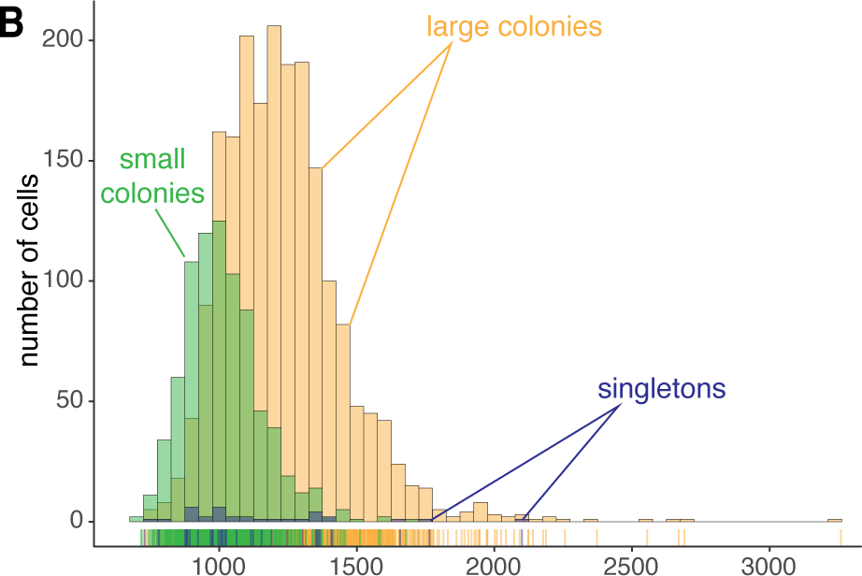
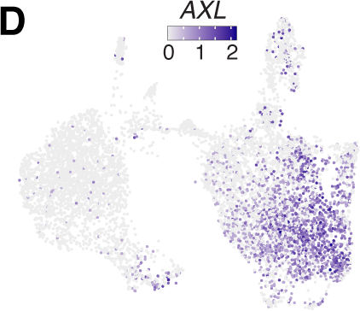
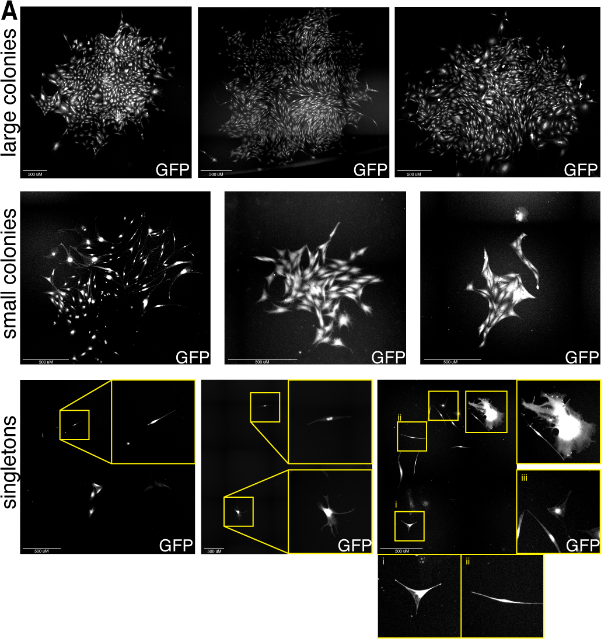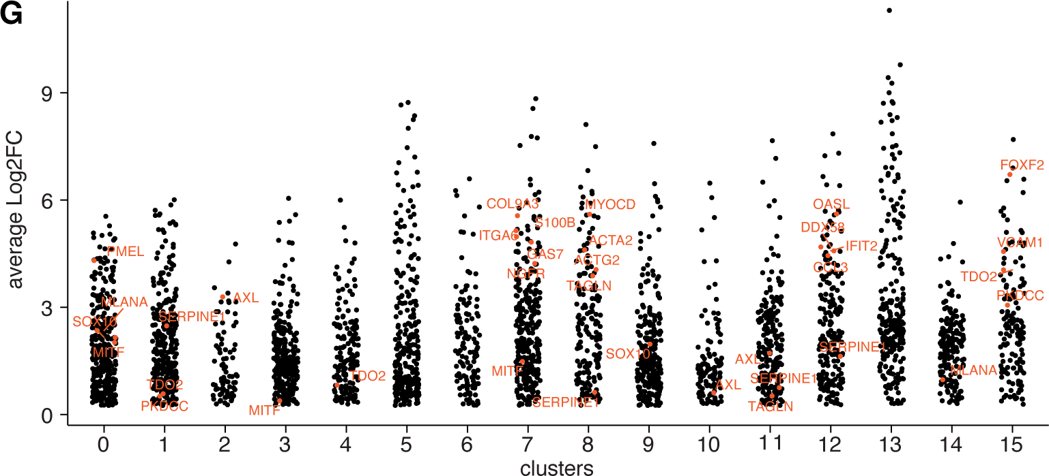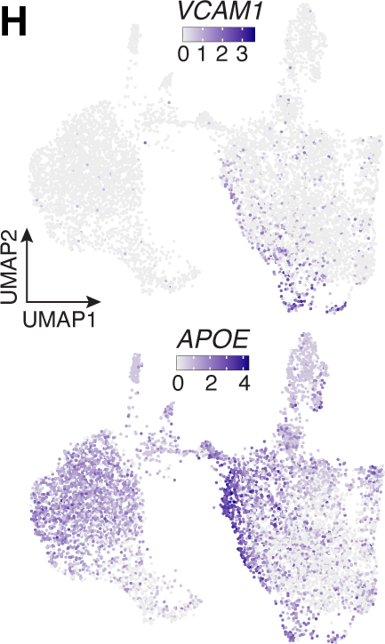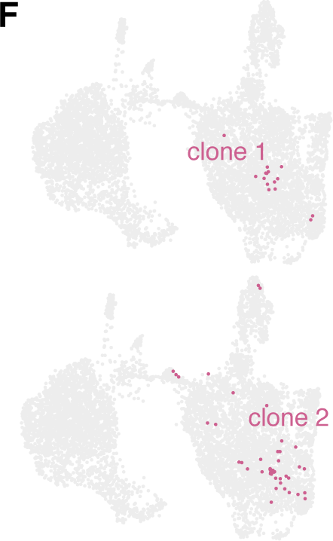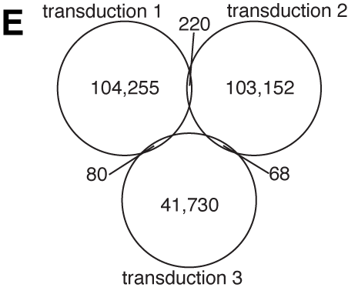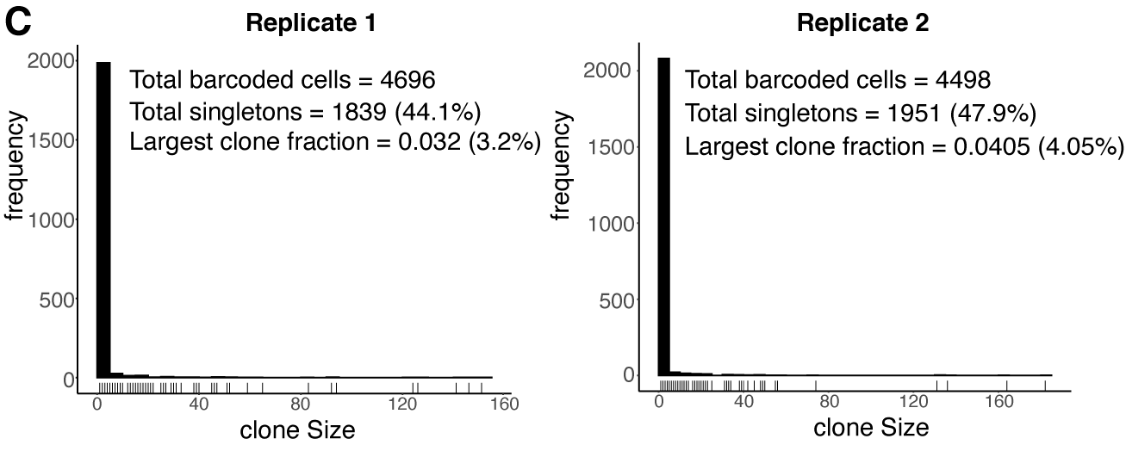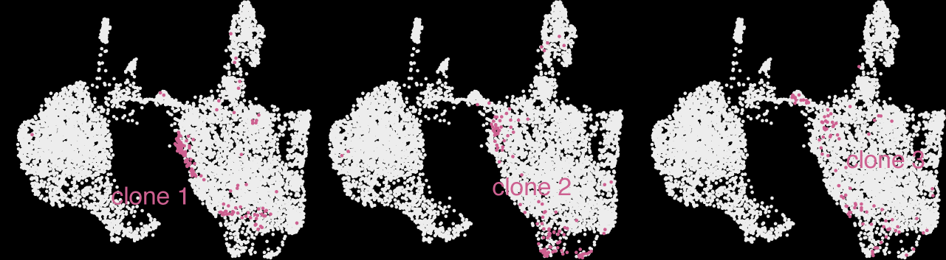

Supplementary Figure 1. FateMap barcode silencing and analysis of variable genes in WM989 A6-G3 melanoma cells.
  - Representative fluorescent images of GFP intensity (barcodes are in the 3’ UTR of GFP) from large sized colonies, medium sized colonies, and singletons.
  - Quantification of signal intensity from each of the three categories reveals that there is no significant difference in distribution of GFP intensity (proxy for transcribed barcodes) GFP intensity (proxy for transcribed barcodes) between clone sizes.
  - Distribution of clone size for biological biological replicates 1 and 2 from FateMap on WM989 A6-G3 cells exposed to 1uM vemurafenib from FateMap on WM989 A6-G3 cells exposed to 1uM vemurafenib. Singletons constitute approximately 39% of all clones. No single clone comprises more than 5% of the total population.
  - On the UMAP, we recolored each cell by its expression for a select subset of genes that were identified as differentially expressed via the Seurat pipeline and marked different clusters. AXL, which is a canonical resistance marker, was found spread across Seurat clusters 1,2, and 11 (snn 0.6).
  - A Venn diagram measuring overlap of barcodes between three independent transductions to estimate the barcode diversity of FateMap to estimate the barcode diversity of FateMap. No barcode overlap was observed across all three transductions.
  - Two examples demonstrate that clones high for the canonical resistance marker AXL (and SERPINE1) are constrained largely in specific clusters.
  - Differentially expressed genes per cluster were determined using Seurat’s FindAllMarkers command at a resolution of 0.6.
  - VCAM1 and APOE were predominantly present in discontiguous clusters 15 and 6 respectively on UMAP.
  - Three clones high for VCAM1 (cluster 15) are also high for APOE (cluster 6).

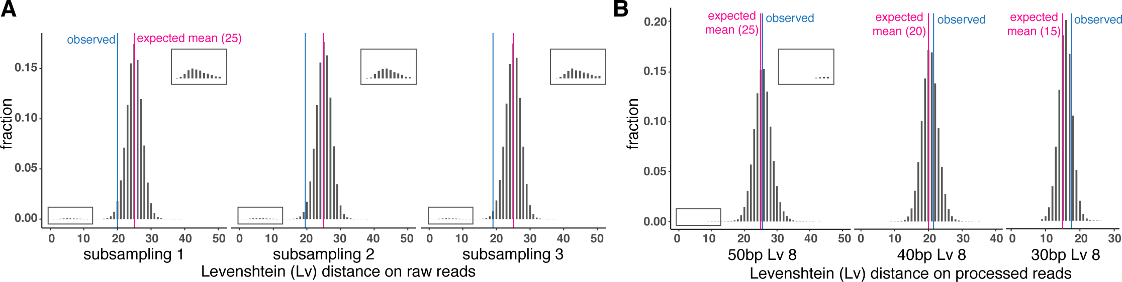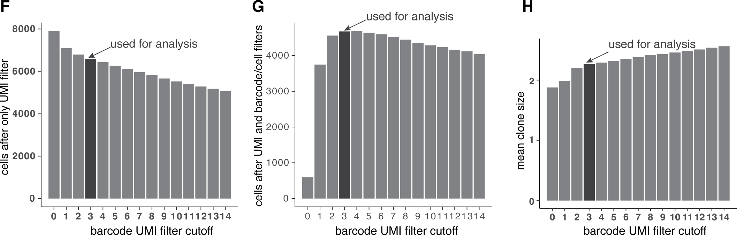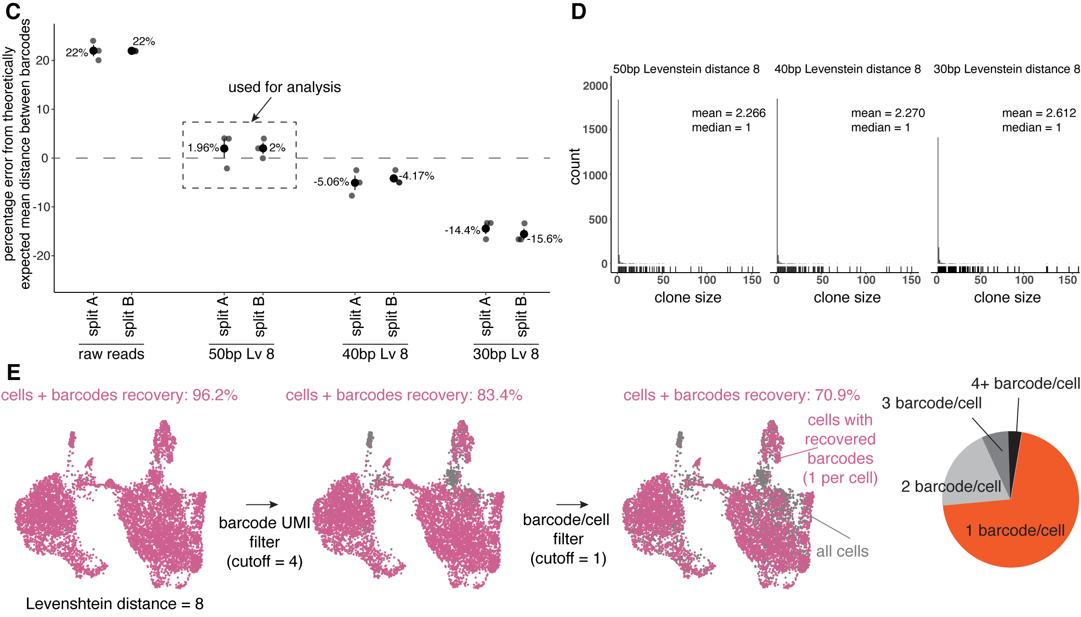

Supplementary Figure 2. Quality control and filtering steps for mapping single cell IDs with FateMap barcodes.
- Plots of Levenshtein distances for all barcodes sequenced including the expected and observed means. The additional small peak shown in the inset indicates PCR amplification or sequencing errors likely introduced during the various FateMap steps. Pink vertical line represents expected/theoretical mean (25) and the blue vertical line represents the observed mean. The pink vertical line represents the expected/theoretical mean (25) and the blue vertical line represents the observed mean.
- Plots of different amounts of Levenshtein distances tested in order to collapse highly similar barcodes (of different base-pair (bp) size) detected in a (of different base-pair (bp) size) detected in a. We found that collapsing them progressively brought the experimentally observed mean closer to the theoretical mean and overshot beyond a certain distance and overshot beyond a certain distance.
- Plot of percentage error from the theoretically expected mean distance between barcodes for different amounts of Levenshtein distances. We found that a Levenshtein distance of 8 for a 50 base-pair (bp)base-pair (bp) barcode resulted in the smallest percent difference between the theoretically expected (25) and observed mean.
- Plots of clone size per count for different amounts of Levenshtein distances. This result, along with the analysis shown in Panel C, informed our decision to use a Levenshtein distance of 8.
- (left) Stepwise quality control process to recover barcoded cells (pink) with only a single barcode associated with them for downstream analysis. Barcoded cells exhibit no clear recovery bias for particular resistant types. (right) A pie chart showing the number of barcodes detected for each cell after the UMI cutoff WC step showing. (left) Stepwise quality control process to recover barcoded cells (pink) with only a single barcode associated with them for downstream analysis. Barcoded cells exhibit no clear recovery bias for particular resistant fate types. (right) A pie chart showing the number of barcodes detected for each cell after the UMI cutoff WC step showing.
- Plot of cells after the UMI filter only for various barcode UMI filter cutoffs, indicating the cutoff value that was used for downstream analysis in the study for downstream analysis in the study.
- Plot of cells after both UMI and barcode/cell filters for various barcode UMI filter cutoffs, indicating the cutoff value that was used for downstream analysis in the study for downstream analysis in the study.
- Plot of the average clone size for various barcode UMI filter cutoffs, indicating the cutoff value that was used for downstream analysis in the study for downstream analysis in the study

Supplementary Figure 3. Quantifying and validating FateMap reveals between-clone diversity of resistant fate types.
- Clones from distinct regions/clusters of the UMAP are enriched for expression of specific genes that characterize those regions.
- We quantified the preference for a specific cluster across all barcode clones (clone size>4). Specifically, we calculated the fraction of dominant clusters for each clone and found it to be significantly higher than that of randomly selected cells (resolution = 0.8). Representative examples of clones covering different fractions of most and second most dominant clusters.
- We formulated a quantitative metric, the mixing coefficient, to calculate the transcriptional relatedness of different clones to each other. For each pair of barcoded clones, we calculated the nearest neighbors for each cell in the 50-dimensional principal component space. We then classified the neighbors as “self” if the neighbors are from the same barcode clone or “non-self” if they belong to another barcode clone. The mixing coefficient is the ratio of the averaged fraction of self-neighbors to the averaged fraction of non-self-neighbors. The higher the mixing coefficient, the higher the transcriptional relatedness of the barcoded clones analyzed (a value of 1 corresponds to perfect mixing, and a value of 0 corresponds to no mixing). We reasoned that for randomly sampled barcode clones, the mixing coefficient will be close to 1 because two randomly sampled clones will have a high likelihood of each being spread out uniformly throughout the principal component space. In contrast, the mixing coefficient will be lower than 1 for experimentally observed clones if they each mark different clusters and are not randomly distributed. We found that this was indeed the case where the mixing coefficient was close to 1 for randomly sampled pseudo-clones, which was much higher than the mixing coefficient for experimentally observed clones, suggesting that each clone is constrained in the transcriptional space.
- We quantified the preference for a specific cluster across all barcode clones (clone size>4). Specifically, we calculated the fraction of dominant clusters for each clone and found it to be significantly higher than that of randomly selected cells (resolution = 1.2).
- We quantified the preference for a specific cluster across all barcode clones (clone size>4). Specifically, we calculated the fraction of dominant clusters for each clone and found it to be significantly higher than that of randomly selected cells (resolution = 0.6).
- We quantified the preference for a specific cluster across all barcode clones (clone size>4). Specifically, we calculated the fraction of dominant clusters for each clone and found it to be significantly higher than that of randomly selected cells (resolution = 0.4).

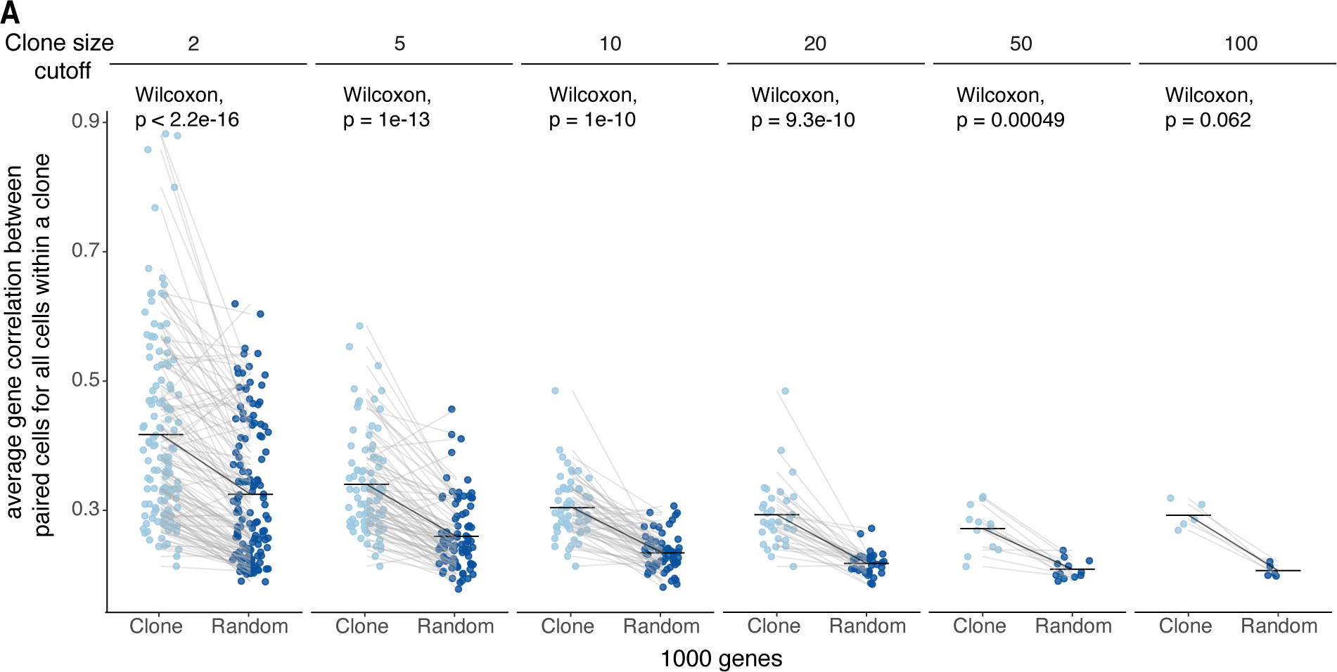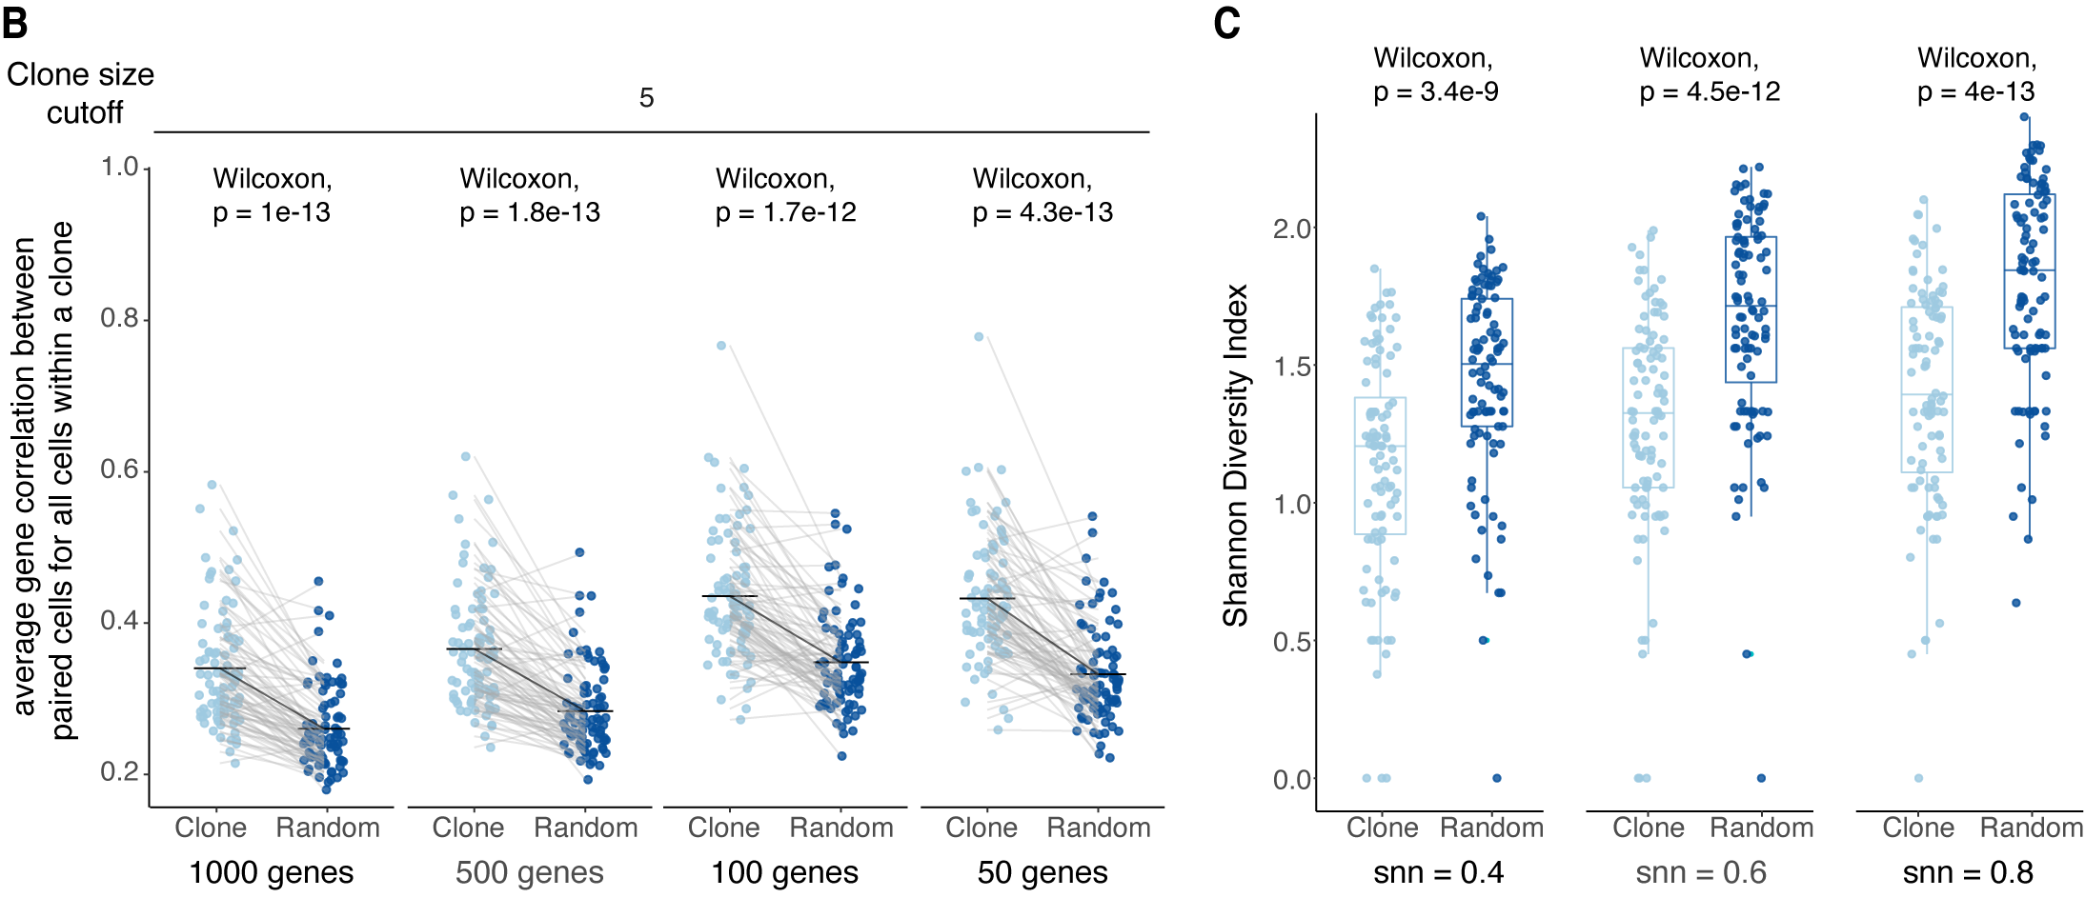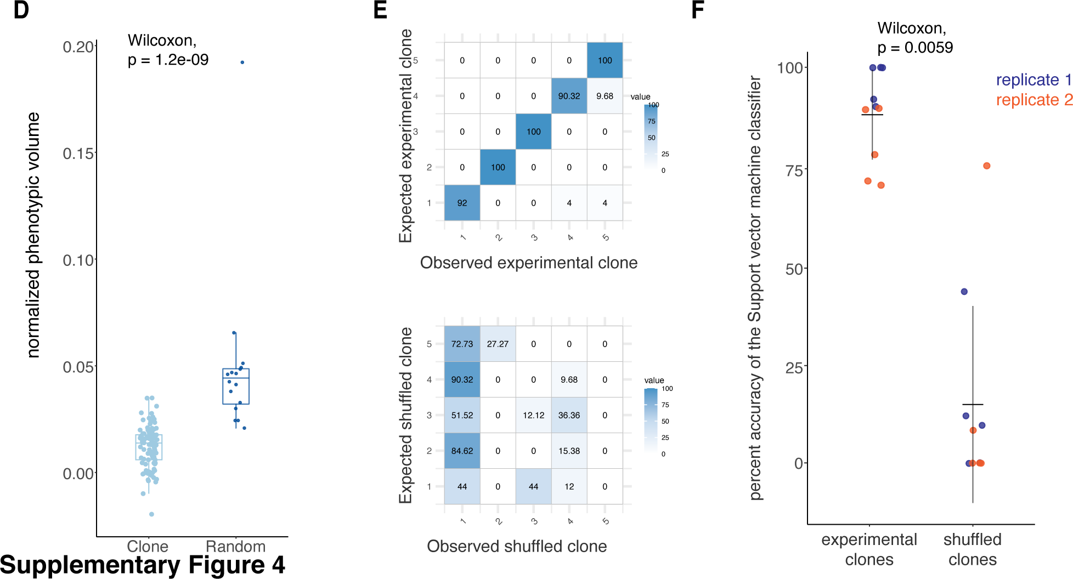

Supplementary Figure 4: Quantification of transcriptional homogeneity and diversity within FateMap-identified clones in WM989 A6-G3 cells.

- Average pairwise correlation between cells within a clone was estimated based on the expression levels of the top 1000 most variable genes. Each point represents the average value for Spearman’s correlation coefficient for all possible pairs of cells within a clone. For each clone, a paired control was created by randomly sampling an equivalent number of cells from the entire population. Higher average correlation coefficient in clones indicates higher transcriptional similarity among cells within a clone, as compared to cells that are not clones. Wilcoxon Signed Rank test was used to compare the difference in average correlation coefficient. We confirmed that these results were invariant of the clone size.
- Average gene correlation was higher within a clone than for randomly sampled cells of the same size for clone size cutoff at 5. This pattern recurred across several different numbers of top differentially expressed gene sets.
- Shannon Diversity Index for gene expression is lower within a clone than across randomly sampled cells of the same size from the resistant population for resolutions of 0.4, 0.6, and 0.8, indicating that the diversity within clones was smaller than the diversity between randomly sampled cells. Wilcoxon Signed Rank test was used to compare the difference in Shannon Diversity Index across conditions.
- Normalized phenotypic volume was lower for clones than for clusters visualized on UMAP with snn = 0.6. Wilcoxon Signed Rank test was used to compare the difference in Normalized Phenotypic volume across conditions.
- SVM classifier plots of observed and expected experimental and shuffled clones. The model was trained on expression levels of clonal genes. As a control, clone labels were shuffled for the training samples, and a support vector machine was trained on the randomized data. We found that the accuracy of prediction was much higher for testing data from experimental clones as compared to the shuffled counterparts.
- Plot showing percent accuracy of the support vector machine classifier for experimental and shuffled clones. We found that this value was significantly higher for experimental than shuffled clones, and this result was consistent across two replicates. Wilcoxon Signed Rank test was used to compare the difference in percentage accuracy across experimental and shuffled clones.

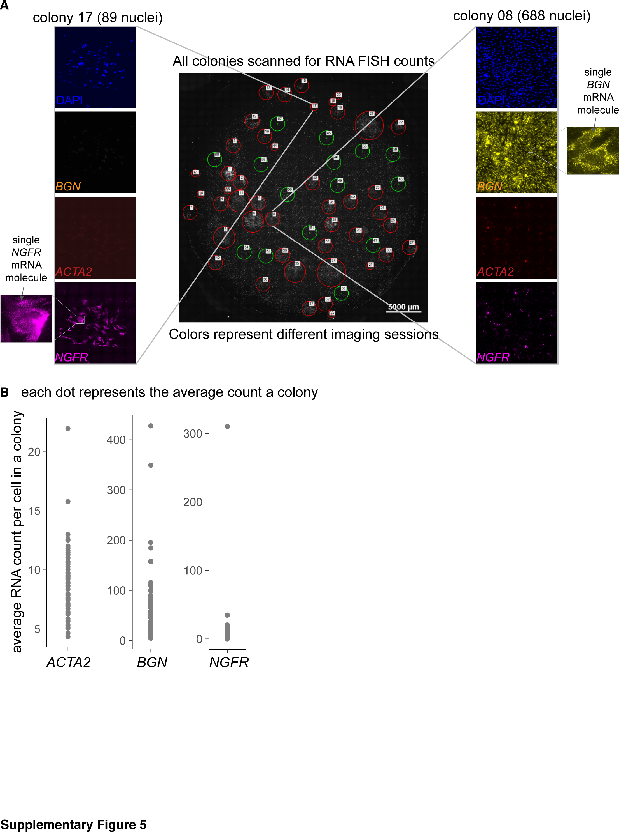

Supplementary Figure 5. Representation and quantification of RNA FISH of FateMap-identified marker genes on resistant colonies.
- We performed RNA FISH imaging and analysis for a subset of genes (NGFR, ACTA2, and BGN) that marked different resistant colonies in the results from FateMap. Representative images of individual colonies are shown for DAPI (for nuclei count) as well as the three fluorescence channels for genes, including zoomed in images showing individual mRNA molecules.
- Average RNA counts per cell for each colony across the three genes that were analyzed.

Supplementary Figure 6. Characterization and validation of FateMap-identified molecular and phenotypic features.
- Absolute number of clones marking resistant fate type clusters and their associated proliferative capacities. Because a large fraction of the clones in clusters 0 and 3 exist as singletons, these clusters contain the most number of unique surviving clones.
- Boxplot of colony size distributions for markers associated with different fate types for biological replicate 2. Clusters corresponding to each marker are indicated on the plot.
- A Chi-square test of Independence was used to test the null hypothesis that the marker-based clusters are independent of colony size. The test was run on a contingency matrix consisting of the number of singleton (colony size = 1), small (1< colony size < 4) and large (colony size ≥ 4) colonies for each marker-based cluster. Pearson residuals were estimated to quantify the deviation of colony size distribution from the null hypothesis. .
- Table showing number of colonies positive for a series of markers (ACTA2, NGFR, AXL, and SOX10) for the parental WM989 A6-G3 cell line as well as two subclones of this line (A10 and A11). The distribution of colony sizes was qualitatively similar for each marker across the three lines.
- Replicate 1 boxplot of colony size distributions for markers associated with different fate types with singletons removed. Clusters corresponding to each marker are indicated on the plot. Statistically significant differences were calculated based on Mann Whitney/U test and the intervals were based on p-value thresholds = 0, 0.0001 (****), 0.001 (***), 0.01 (**), 0.05 (*).
- Replicate 2 boxplot of colony size distributions for markers associated with different fate types with singletons removed. Clusters corresponding to each marker are indicated on the plot. We found that the distribution was qualitatively similar to Replicate 1 shown in Panel E. Statistically significant differences were calculated based on Mann Whitney/U test and the intervals were based on p-value thresholds = 0, 0.0001 (****), 0.001 (***), 0.01 (**), 0.05 (*).
- UBC, a housekeeping gene, was expressed ubiquitously throughout the UMAP.
- UMAP recolored for combined resistant cells from splits A (dark blue) and B (light blue) of the same drug condition of vemurafenib. The two splits were interspersed on the UMAP.
- UMAP obtained from applying another data integration method, scanorama, on
identically-treated samples (split A and B) which produced qualitatively similar results, such that the two splits had a similar distribution of cells in each of the single-cell clusters.
- UMAP obtained from scanorama is recolored for combined resistant cells from splits A (dark blue) and B (light blue) for the same drug condition (vemurafenib). The two splits were interspersed on the UMAP.
Supplementary Figure 7. ROIs selected for GeoMx and downstream analysis from patient samples.
All punch biopsies collected (the same as in Main Figure 3) with individual regions of interest numbered to match the included metadata.

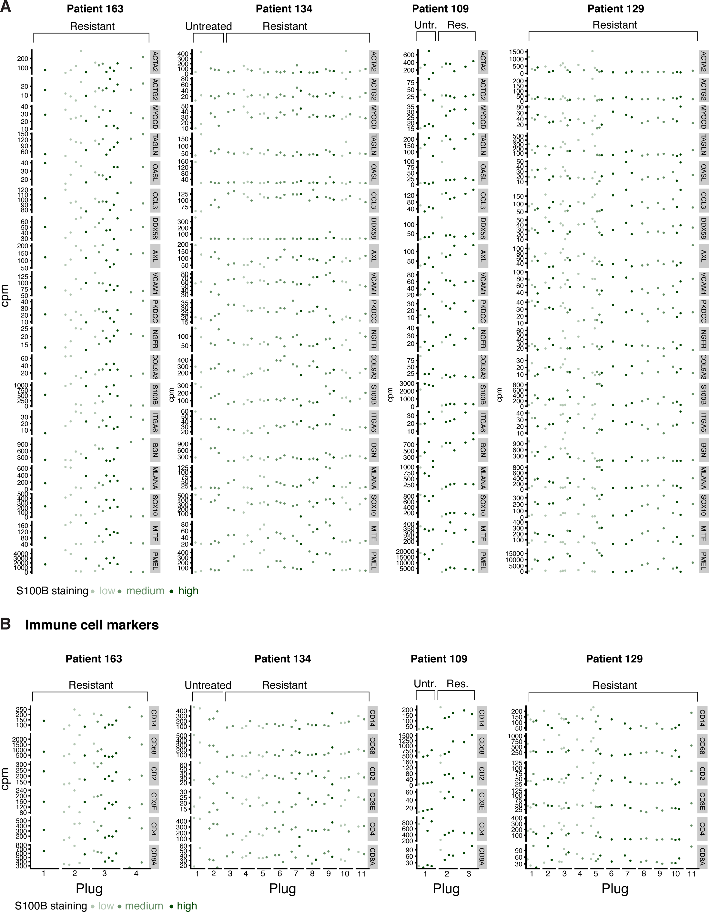

Supplementary Figure 8. Representation of gene expression counts for selected markers across GeoMx ROIs.
- Dotplot related to Main Figure 4 in which each dot is a single region of interest, dots are faceted by containing punch biopsy, and are colored by qualitative S100B staining level. Analysis of more marker genes confirmed co-expression of markers from the same resistant fate types, such as ACTA2 and ACTG2.
- Selected immune analysis also showed nearby regions with heterogeneous macrophages or T cell marker expression.

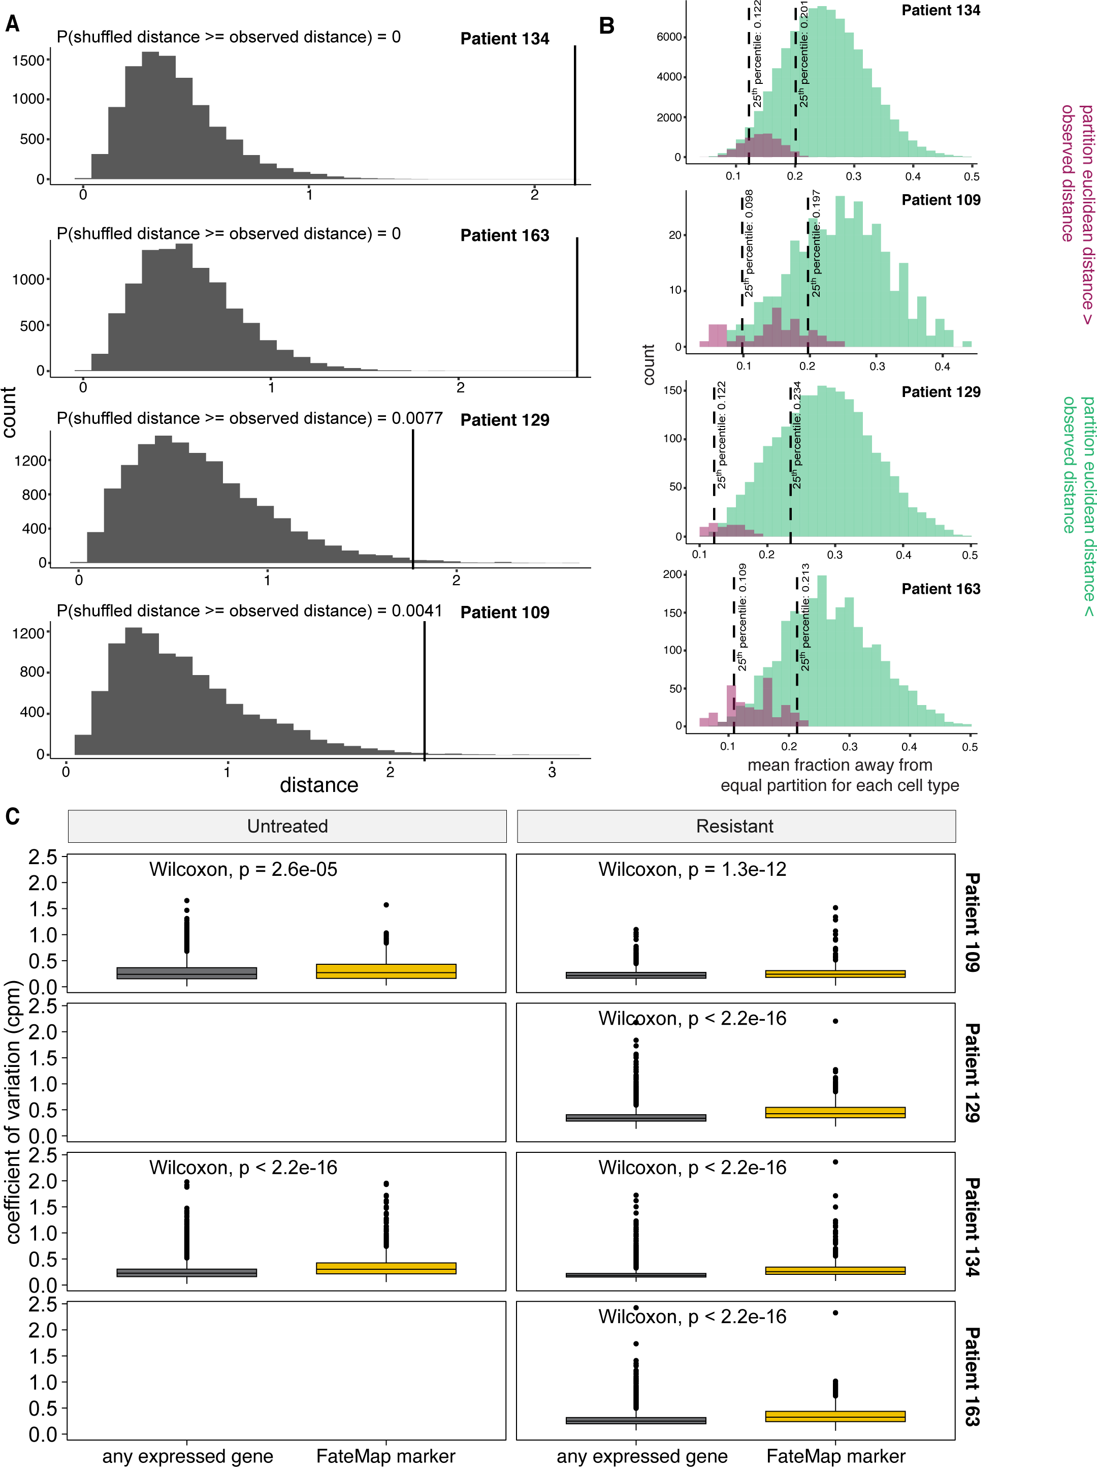

Supplementary Figure 9. Spatial analysis of GeoMx data to identify clonal structures within ROIs.
- Distribution of transcriptional euclidean distances for 10,000 random samplings under the null hypothesis that resistant cell fate types are randomly binomially distributed in each pair of adjacent GeoMx regions for each patient. Vertical line is the observed transcriptional distance after reversing deconvolution on the original regions. P values were calculated empirically.
- Histograms of simulated unequal partitioning of resistant cell fate types that do or do not capture the observed transcriptional distance between adjacent sampled regions, where each set of histograms corresponds to a single patient. After computationally combining two adjacent GeoMx samples and deconvoluting the resistant cell fate types contained within, we calculated the transcriptional distance between all partitionings of cell fate types into two samples. Shown are the distributions of mean absolute deviation from equal partition across each cell fate type, colored by whether the transcriptional distance of the sample was at least that of the observed. The dotted line represents the 25th percentile of each distribution of mean absolute deviations.
- Boxplots of the coefficients of variation (in counts per million) in the GeoMx data, across each patient, for either all genes that are expressed in WM989 cells (grey) or genes that marked resistant cell fate types in FM01 (yellow).

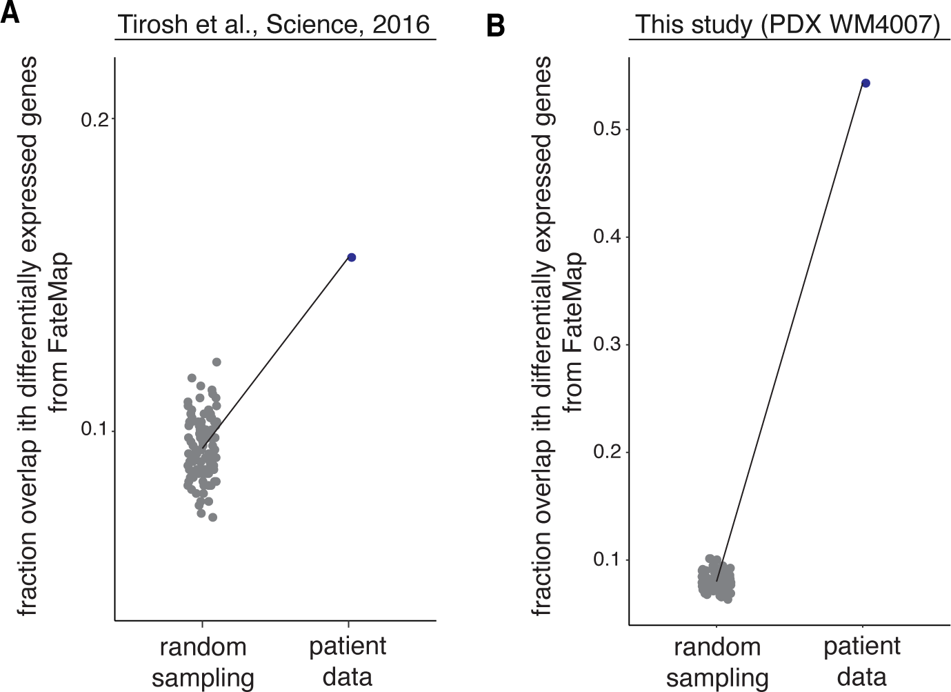
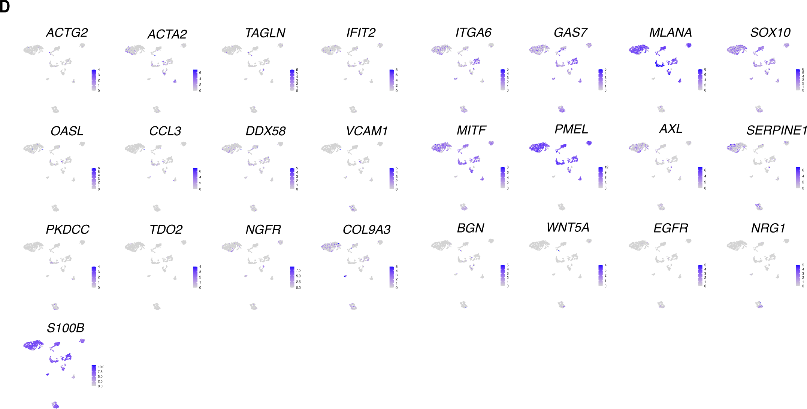

Supplementary Figure 10. Comparison of FateMap-identified melanoma marker genes from other single-cell melanoma datasets.
- Fraction overlap between top 1000 most variable genes identified from FateMap and spatial transcriptomics tumor samples compared to 100 sets of 1000 randomly sampled genes.
- Overlap between differentially expressed genes identified from cell lines and patient-derived samples for GSE72065 from ¹¹. p-values were calculated using Fisher’s exact test. Each randomly sampled gene set comprises n genes, where n is the number of differentially expressed genes identified in the patient derived samples.
- Overlap between differentially expressed genes identified from FateMap on WM989 cells and patient-derived xenograft sample WM4007 compared to 100 sets of randomly sampled genes. Each randomly sampled gene set comprises n genes, where n is the number of differentially expressed genes identified in the patient derived samples.
- Representative Uniform Manifold Approximation and Projections (UMAPs) of select genes differentially expressed from the FateMap dataset onto the GSE72065 dataset from Tirosh et al. 2016.

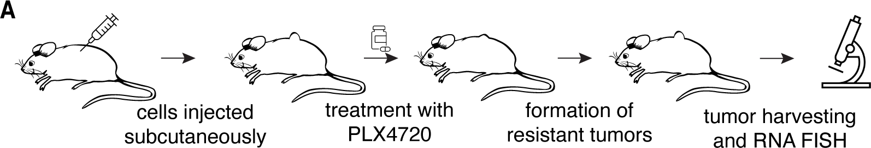
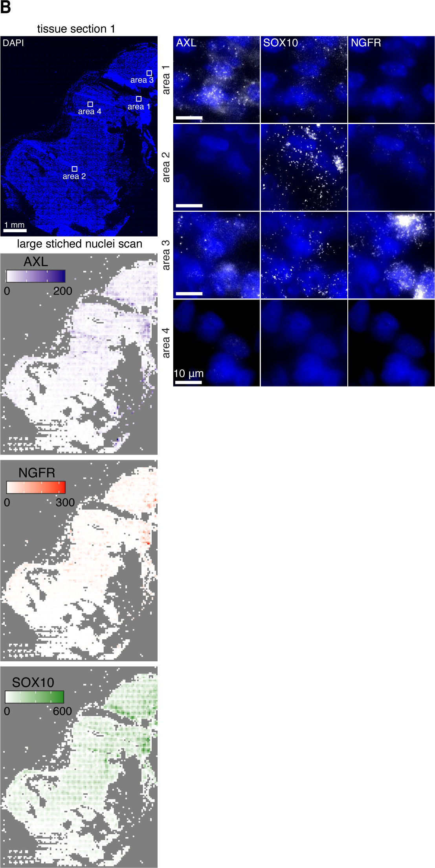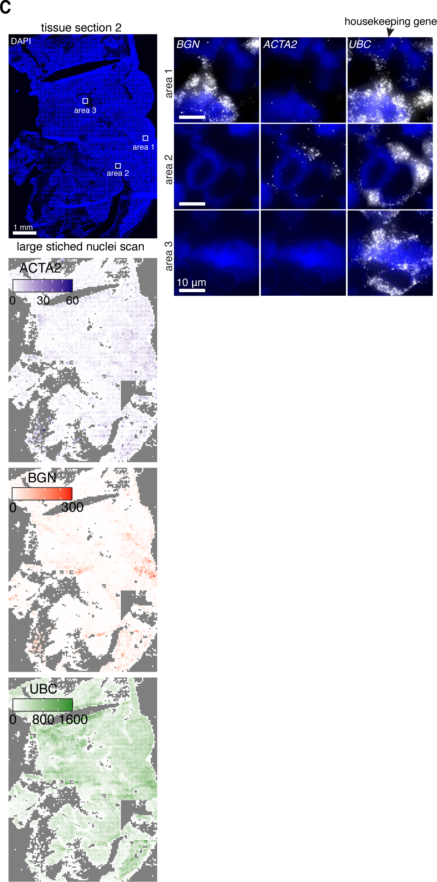

Supplementary Figure 11. Mouse xenograft models confirm transcriptional diversity and its spatial patterns.
- We used cells from another single-cell-derived cell line from WM989 A6-G3 cells, WM989
A6-G3 5a3 ¹² injected them subcutaneously into mice, subjected the mouse to targeted therapy, harvested the resistant tumors and sectioned them, and performed large RNA FISH tissue scans.
- (left) A large-scale scan for DAPI-stained nuclei of a resistant tumor tissue section. (right) RNA FISH imaging of three gene markers (AXL, NGFR, SOX10) from four different areas on the tissue section, quantified via heatmap for RNA counts for each gene throughout the tissue. Each of these markers were selectively expressed in distinct regions of the sections, with some regions lacking all three markers.
- (left) A large-scale scan for DAPI-stained nuclei of another resistant tumor tissue section. (right) RNA FISH imaging of three gene markers (BGN, ACTA2, UBC) from three different areas on the tissue section, quantified via a heatmap for RNA counts for each gene throughout the tissue. While BGN and ACTA2, two differentially expressed genes observed in FateMap, were selectively expressed in distinct regions of the sections, the housekeeping gene UBC was relatively homogeneous.

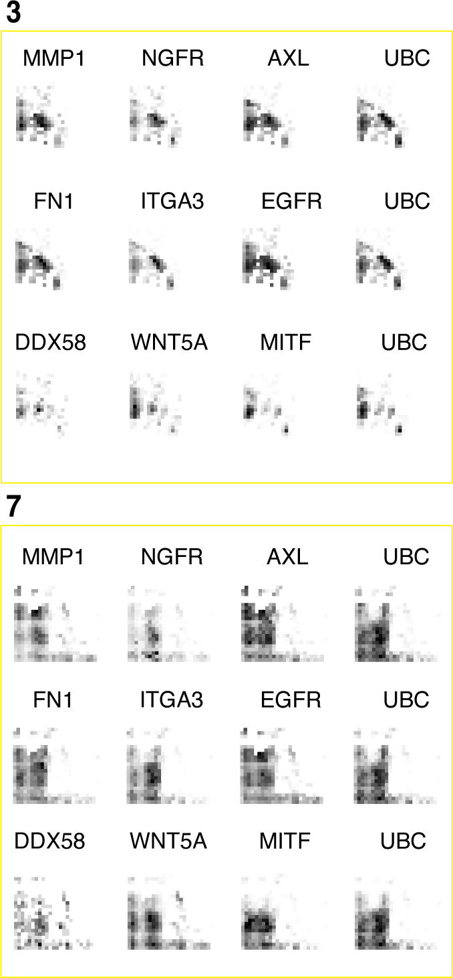
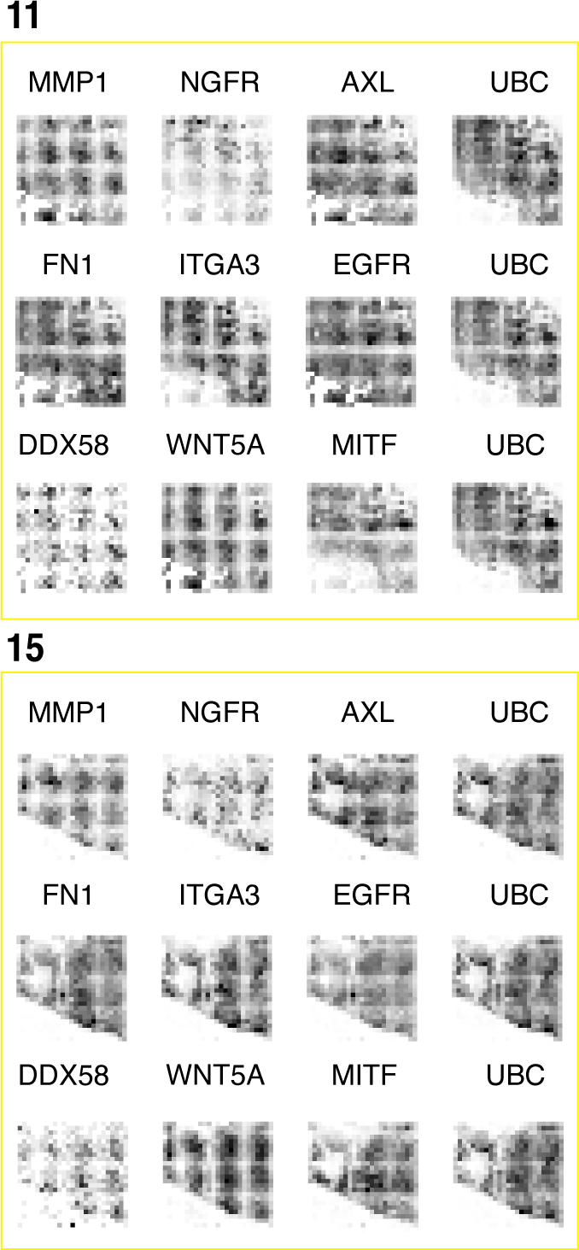
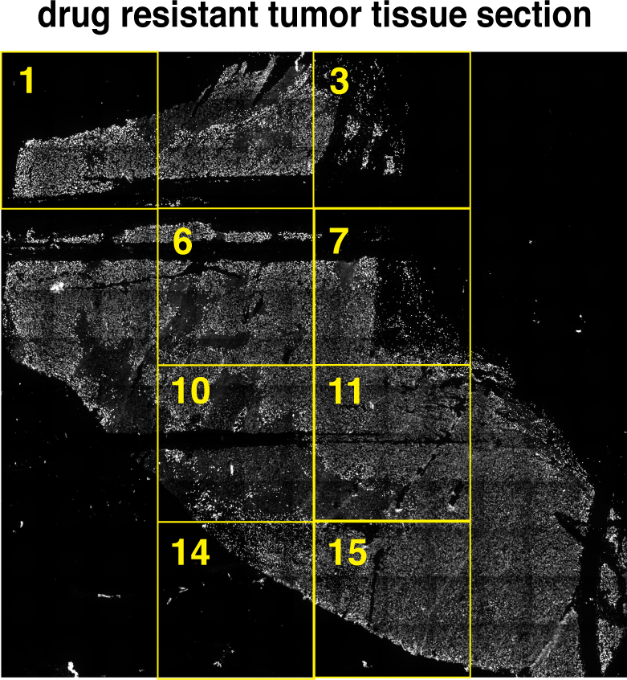
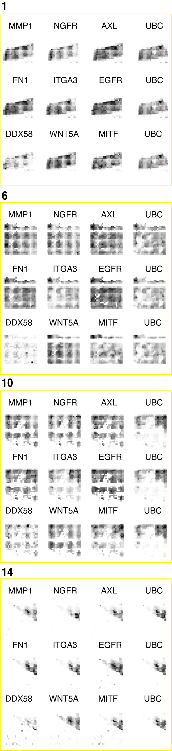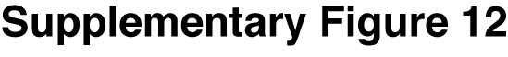

Supplementary Figure 12. clampFISH on therapy-resistant melanoma tumors from mouse xenograft models.
We used cells from a single-cell-derived cell line from WM989 A6-G3 cells, injected them subcutaneously into mice, subjected the mouse to targeted therapy, harvested the resistant tumors and sectioned them, and performed large tissue scans with our newly developed RNA amplification and visualization ClampFISH ¹³ to measure RNA expression for 12 genes (of which 9 were unique genes, and rest were used for UBC as control for each iterative round of imaging).

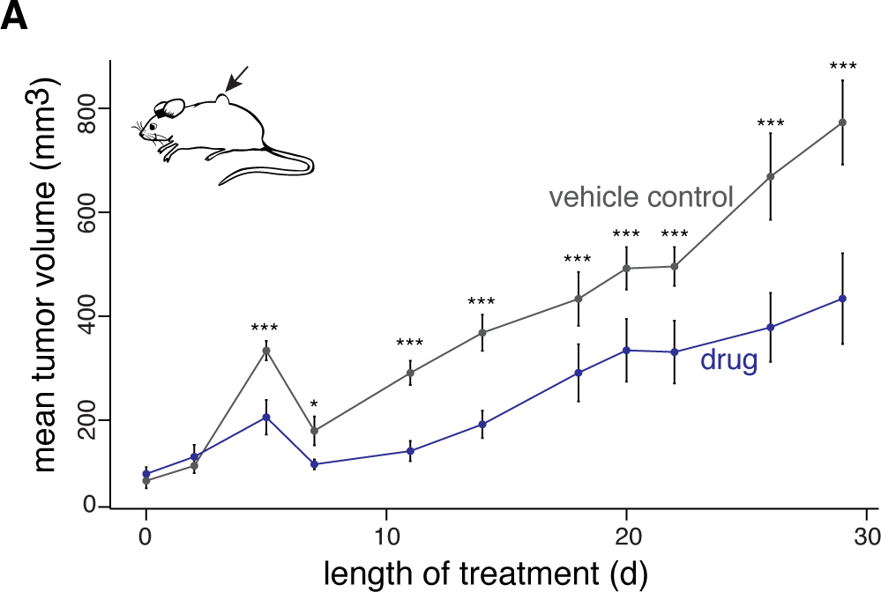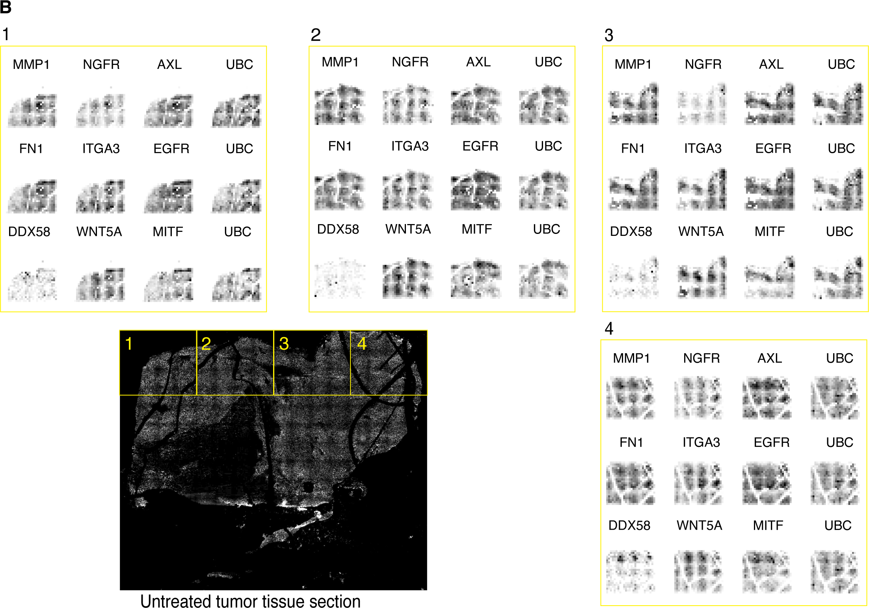

Supplementary Figure 13. Quantification of tumor volume and clampFISH on therapy-resistant tumors harvested from mouse xenograft models.
- The naive, untreated tumors grew faster as compared to mice with tumors treated with targeted therapy (417 mg PLX4720/kg). (t-test, *** = p < 0.05; * = 0.1 > p >0.05). Error bars represent standard error of the mean.
- We used cells from another single-cell-derived cell line from WM989 A6-G3 cells, injected them subcutaneously into mice, let the tumor grow, harvested the naive untreated tumors and sectioned them, and performed large tissue scans with our newly developed RNA amplification and visualization ClampFISH ¹³ to measure RNA expression for 12 genes (of which 9 were unique genes, and rest were used for UBC as control for each iterative round of imaging).

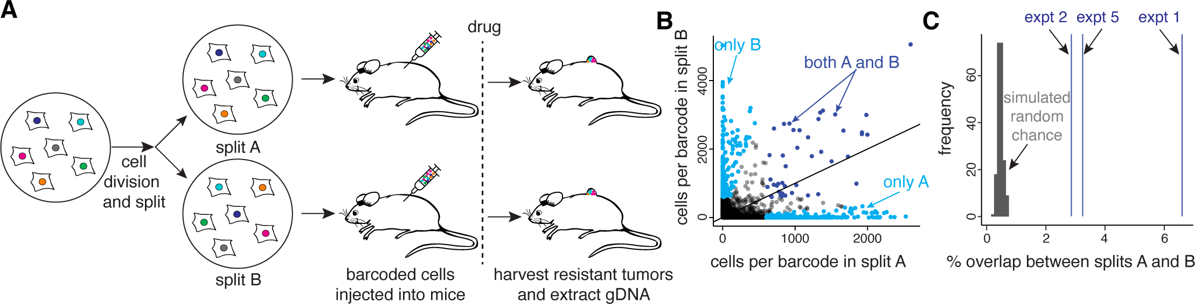
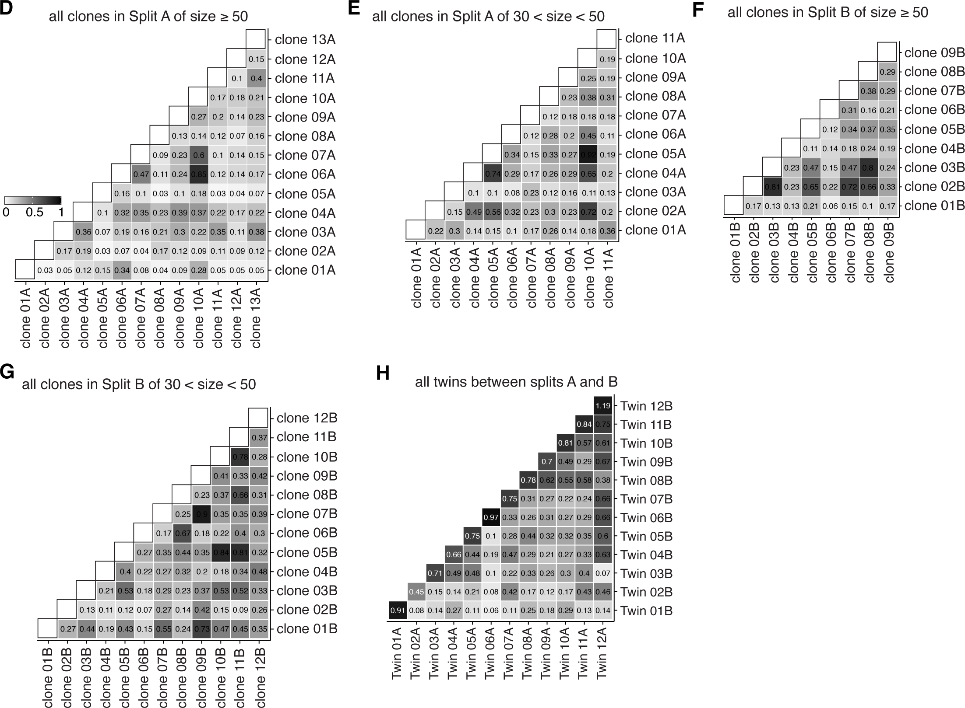

Supplementary Figure 14. Quantification of predestination of resistant fate types in mouse xenograft models and in vitro.
- Schematic of experimental design for following the barcodes that survive and develop resistance in mice. For the experiment shown, we transduced WM989 A6-G3 with a barcode library similar to that described in ¹⁴ and after 4-5 divisions, we sorted the successfully barcoded population (GFP positive), divided the culture in splits (A and B), and injected them subcutaneously in different mice, which were then treated with a 417 mg PLX4720/kg diet. The resistant tumors were harvested and the barcode containing genomic DNA was simplified and sequenced for all mice.
- For each barcode identified by sequencing of the genomic DNA, we plotted its abundance in corresponding splits A and B. Those present in both splits are colored in dark blue, and those present only in either A or B are colored in cyan.
- Comparison of the observed overlap between the shared barcodes (twins) surviving across splits with a simulation for a random chance of survival (simulated 1,000 times). Mouse xenograft studies showed a lower but still statistically significant overlap as well (Supplementary Figure 14) (4.24% +- 1.19% (SEM); null estimate 0.46% +- 0.00% (SEM)).
- We formulated a quantitative metric, the mixing coefficient, to calculate the transcriptional relatedness of different clones to each other. For each pair of barcoded clones, we calculated the nearest neighbors for each cell in the 50-dimensional principal component space. We then classified the neighbors as “self” if the neighbors are from the same barcode clone or “non-self” if they belong to another barcode clone. The mixing coefficient is the ratio of averaged fraction of self neighbors to averaged fraction non-self neighbors. The higher the mixing coefficient, the higher the transcriptional relatedness of the barcoded clones analyzed (a value of 1 corresponds to perfect mixing, and a value of 0 corresponds to no mixing). Pairwise calculation of the mixing coefficient for all split A clones of size greater than or equal to 50.
- Pairwise calculation of the mixing coefficient for all split A clones of size between 30 and 50.
- Pairwise calculation of the mixing coefficient for all split B clones of size greater than or equal to 50.
- Pairwise calculation of the mixing coefficient for all split B clones of size between 30 and 50.
- The mixing coefficient for twin and non-twin clones across splits A and B is presented with representative examples on the UMAP.

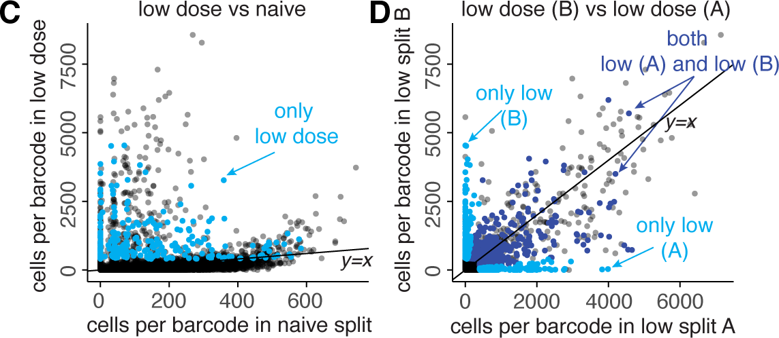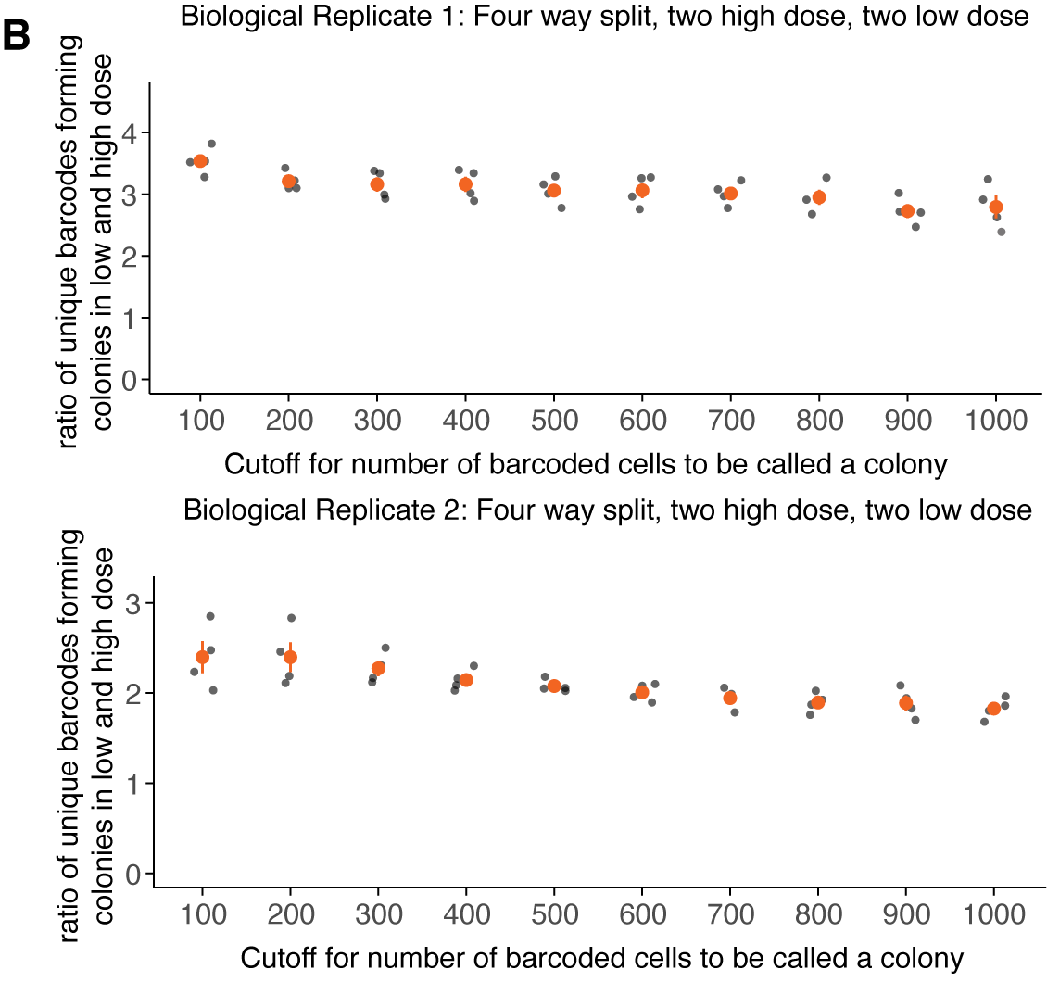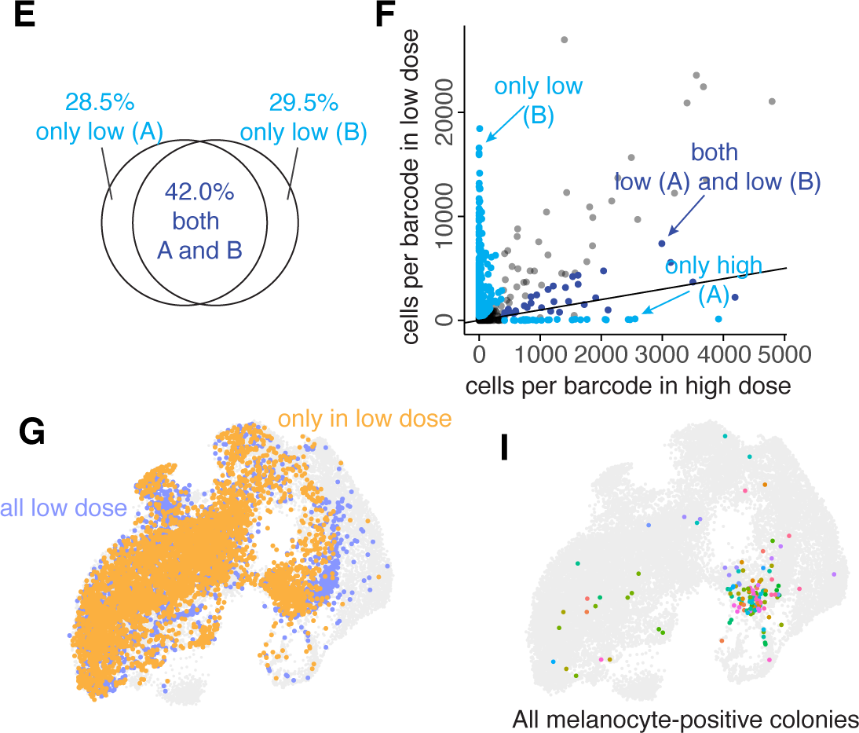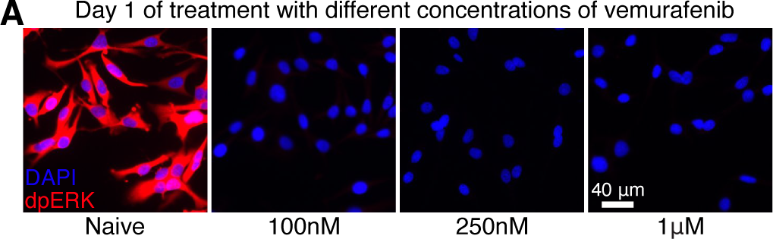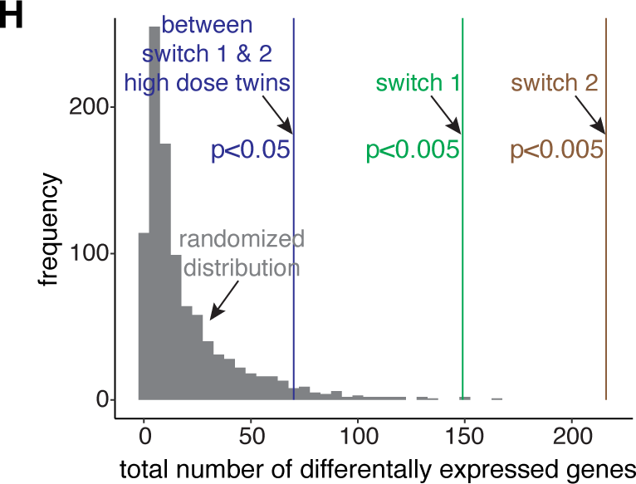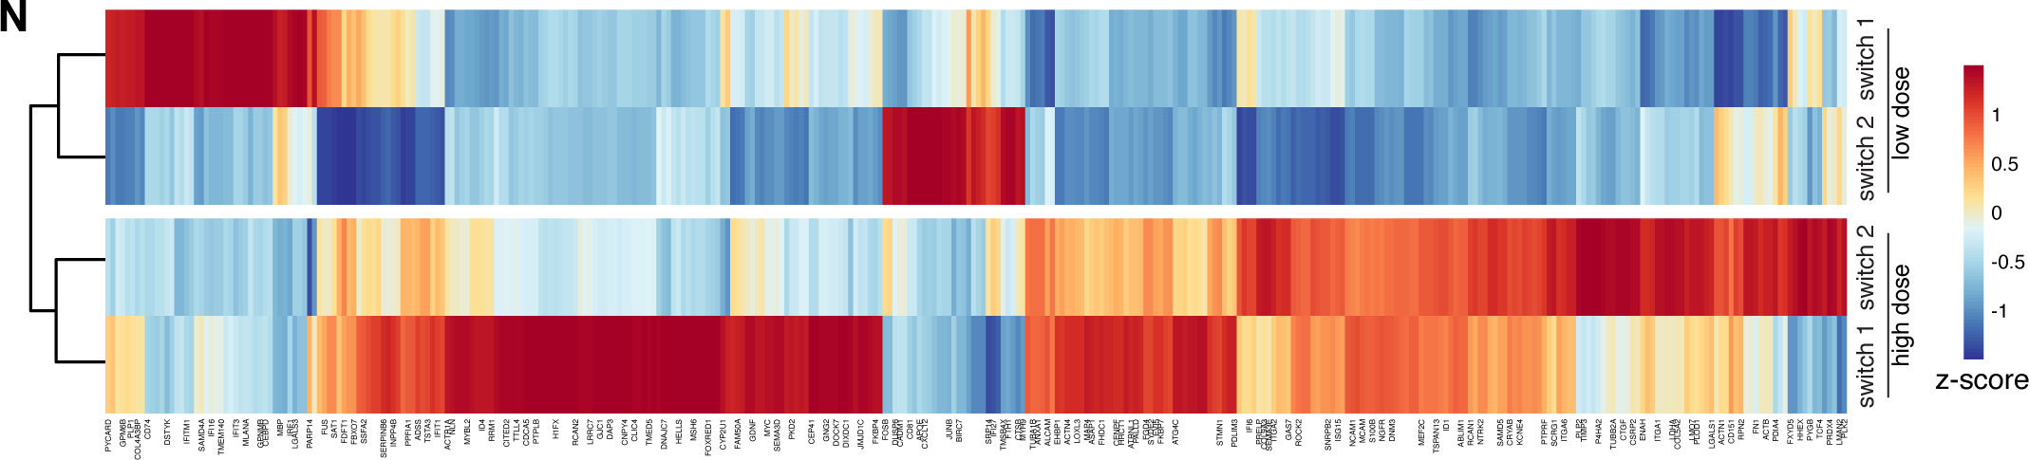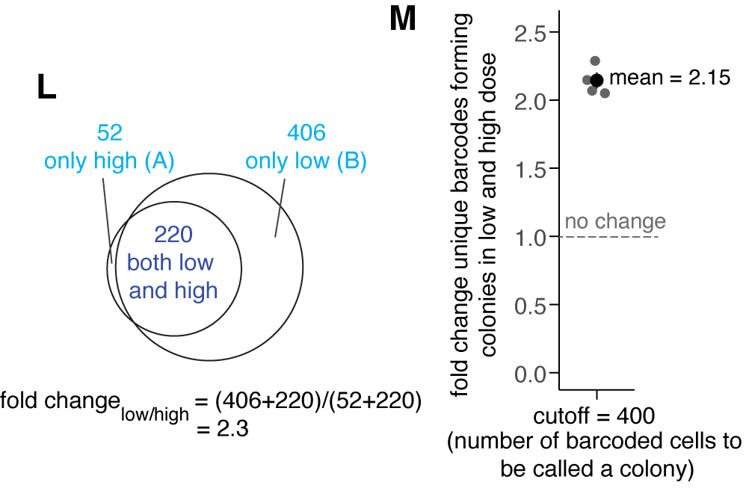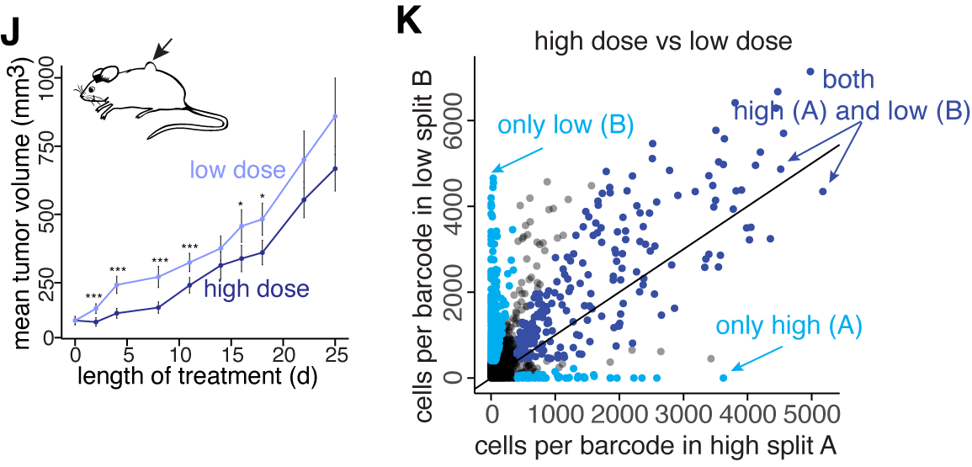

Supplementary Figure 15. FateMap to quantify the effect of drug dose on the resistant fate types in WM989 A6-G3 cells.
- We performed antibody stainings for the active, dually phosphorylated form of ERK on WM989 A6-G3 cells, either naive or treated with different doses of vemurafenib. Treated cells were fixed and imaged after 1 day of treatment. All doses of vemurafenib tested (100nM-1uM) eliminated the Ras/ERK signaling compared to the naive cells.
- Quantification of the total number of unique barcodes forming colonies from each dose across biological replicates. Since this analysis can be dependent on where we define the cutoff for a barcode to be considered as a colony forming barcode, we used a range of cutoffs to show that the fold-change in unique barcodes for the low dose compared to the high dose treatment remains largely invariant of the cutoff. Therefore, changing the cutoff for minimum cell count does not affect our conclusions.
- We observed no correlation between the cell count (as measured by gDNA sequencing of the barcodes) of low dose only resistant clones (light blue) and their counterparts in the initial population from another split. This result rules out the possibility that the additional new clones could have been a result of faster dividing cells in the initial population.
- We compared the clones that only survived at the low dose across two different low dose splits. For this, we collected the barcodes that only survived in two different low dose splits compared to the high dose splits and plotted them against each other. We found that many clones present in only the low dose also tended to show up across the two low dose splits (dark blue), showing that these low-dose only clones are also the result of intrinsic pre-existing differences between initial cells.
- A venn diagram showing that, amongst the barcodes surviving only in low doses, there is a significant fraction of overlap when comparing across the two low dose splits.
- gDNA barcode sequencing on the cells remaining after performing FateMap on a subset of resistant cells. For each barcode identified by sequencing, we plotted its abundance in corresponding splits A (high dose) and B (low dose). Those present in both high and low dose splits are colored in dark blue, and those present only in either A (high) or B (low) are colored in cyan. Those present in both (dark blue) exhibited a strong correlation, suggesting that their ability to survive and become resistant is invariant of drug dose. For those present only in either (cyan), we found them to be much more abundant in low dose (split B), suggesting that new barcodes that are otherwise unable to survive in the high dose become drug resistant in the low dose. The high number of cells on each axis compared to on the y=x axis is likely because of losses incurred during the preparation of the FateMap experiment.
- Painting of all barcode clones on UMAP that were present only in the low dose split B from panel F (yellow), compared to all the low dose resistant clones detected by FateMap. We find that while many of the low dose only clones occupy regions interspersed with high dose cells, there are specific non-overlapping regions as well.
- Comparison of the total number of differentially expressed genes for three pairwise comparisons: 149 genes for switch 1, 216 genes for switch 2, and 70 genes for comparison within the high dose for switch 1 and switch 2. The total number of differentially expressed genes for each comparison was significantly more than the number of genes for randomly sampled cells from the NGFR-high cluster 9 (simulation ran 1000 times). Comparing the 38 clones with the remaining 8 clones within the high dose, 70 genes were differentially expressed at high dose, a gene count higher than comparing randomly sampled cells from NGFR-high cluster 9 (median gene count = 11; p-value <0.05) (Supplementary Figure 15).

- Painting of colony forming barcodes within the MLANA-high cluster 5, which is largely occupied by cells from the low dose of vemurafenib. Therefore, there are several large colony-forming clones that come from MLANA-high cells, which is not the case for MLANA-high cells in the high dose where these cells largely exist as singletons.
- The resistant tumors grew faster early on in the low dose (41.7 mg PLX4720/kg) as compared to the high dose (417 mg PLX4720/kg). (t-test, *** = p < 0.05; * = 0.1 > p >0.05). Error bars represent standard error of the mean.
- For each barcode identified by sequencing, we plotted its abundance in corresponding splits A (high dose) and B (low dose). Those present in both high and low dose splits are colored in dark blue, and those present only in either A (high) or B (low) are colored in cyan. Those present in both (dark blue) exhibited a strong correlation, suggesting that their ability to survive and become resistant is invariant of drug dose. For those present only in either (cyan), we found them to be much more abundant in low dose (split B), suggesting that new barcodes that are otherwise unable to survive in the high dose become drug-resistant in the low dose.
- A venn diagram showing that while there is a significant fraction of overlap between barcode clones present in both high and low dose splits (dark blue), those present in only low (B) comprise a significant fraction as well.
- Quantification of the total number of unique barcodes forming colonies from each dose across biological replicates shows a 2.15 average fold increase in colonies in the low dose as compared to the high dose. This ratio is close to what is observed from imaging experiments in A, suggesting that additional independent clones in the low dose alone can explain the increased number of colonies in the low dose.
- A heatmap of differentially expressed genes for fate type switch 1, fate type switch 2, and between NGFR-high clones exhibiting fate type switches 1 and 2. Several genes were differentially expressed in pairwise comparisons across the fate type switches as compared to the corresponding twins within the high dose NGFR cluster (149 and 216 genes for switch 1 and 2, respectively) (Supplementary Figure 15; Supplementary Table 8).

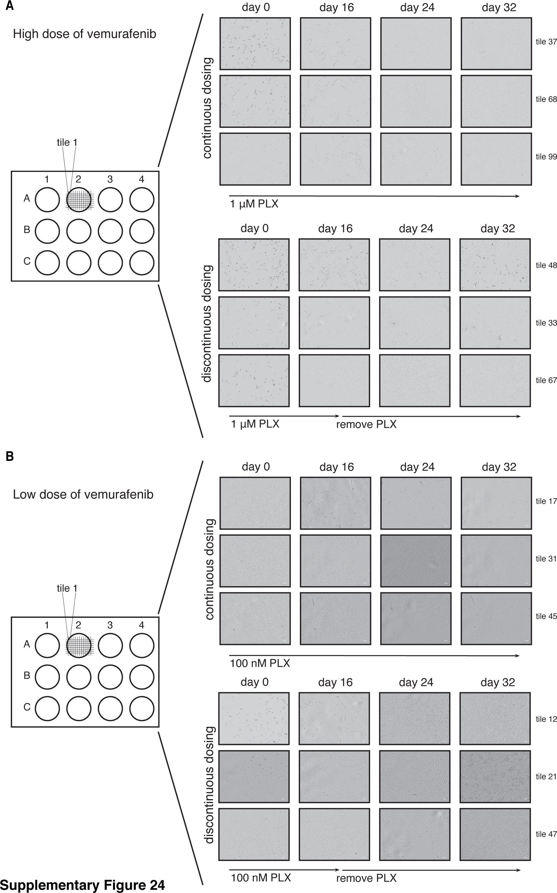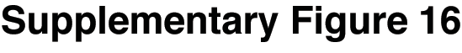

Supplementary Figure 16. Time-lapse brightfield imaging of melanoma cells exposed to either continuous or discontinuous vemurafenib dosing.
- Live imaging of WM989 A6-G3 cells exposed to high dose (1uM) vemurafenib treatment either continuously (top) or discontinuously where vemurafenib is removed at day 16. Cells that survive as singletons in continuous vemurafenib exposure tend to start dividing again when vemurafenib is removed.
- Live imaging of WM989 A6-G3 cells exposed to low dose (100nM) vemurafenib treatment either continuously (top) or discontinuously where vemurafenib is removed at day 16. Cells that survive as singletons in continuous vemurafenib exposure tend to start dividing again when vemurafenib is removed.
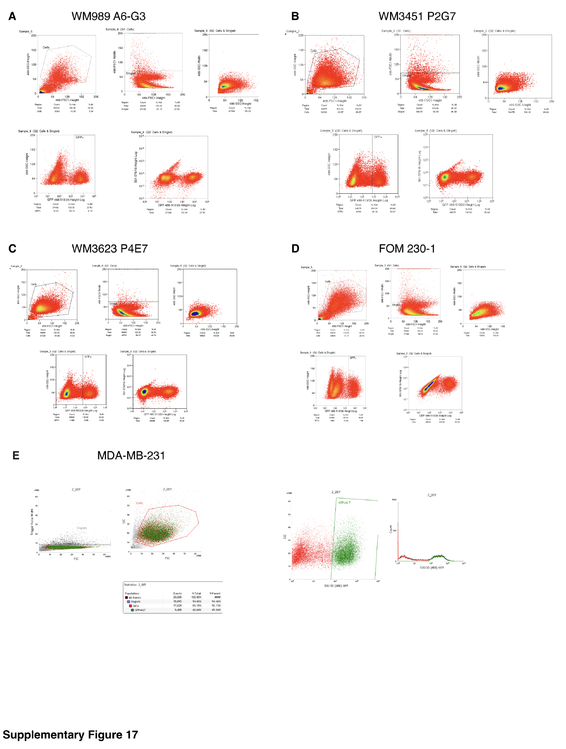

Supplementary Figure 17. Gating strategy for barcoded (GFP+) cell lines used in FateMap and other experiments.
- Flow cytometry plots and gating strategy for WM989 A6-G3 melanoma cells.
- Flow cytometry plots and gating strategy for WM3451 P2G7 melanoma cells.
- Flow cytometry plots and gating strategy for WM3623 P4E7 melanoma cells.
- Flow cytometry plots and gating strategy for FOM 230-1 melanocytes.
- Flow cytometry plots and gating strategy for MDA-MB-231 breast cancer cells.
References for SI:

1. Jiang, C. L. et al. Cell type determination for cardiac differentiation occurs soon after seeding of human-induced pluripotent stem cells. Genome Biol. 23, 90 (2022).
2. Fennell, K. A. et al. Non-genetic determinants of malignant clonal fitness at single-cell resolution. Nature 601, 125–131 (2022).
3. Mold, J. E. et al. Clonally heritable gene expression imparts a layer of diversity within cell types. bioRxiv 2022.02.14.480352 (2022) doi:10.1101/2022.02.14.480352.
4. Shaffer, S. M. et al. Rare cell variability and drug-induced reprogramming as a mode of cancer drug resistance. Nature 546, 431–435 (2017).
5. Shaffer, S. M. et al. Memory Sequencing Reveals Heritable Single-Cell Gene Expression Programs Associated with Distinct Cellular Behaviors. Cell 182, 947-959.e17 (2020).
6. Torre, E. A. et al. Genetic screening for single-cell variability modulators driving therapy resistance. Nat. Genet. 53, 76–85 (2021).
7. Emert, B. L. et al. Variability within rare cell states enables multiple paths toward drug resistance. Nat. Biotechnol. 39, 865–876 (2021).
8. Goyal, Y. et al. Divergent effects of intrinsically active MEK variants on developmental Ras signaling. Nat. Genet. 49, 465–469 (2017).
9. Klaeger, S. et al. Chemical Proteomics Reveals Ferrochelatase as a Common Off-target of Kinase Inhibitors. ACS Chem. Biol. 11, 1245–1254 (2016).
10. Robert, C. et al. Five-Year Outcomes with Dabrafenib plus Trametinib in Metastatic Melanoma. N. Engl. J. Med. 381, 626–636 (2019).
11. Tirosh, I. et al. Dissecting the multicellular ecosystem of metastatic melanoma by single-cell RNA-seq. Science 352, 189–196 (2016).
12. Torre, E. A. et al. Genetic screening for single-cell variability modulators driving therapy resistance. Nat. Genet. 53, 76–85 (2021).
13. Dardani, I. et al. ClampFISH 2.0 enables rapid, scalable amplified RNA detection in situ. Nat. Methods 19, 1403–1410 (2022).
14. Emert, B. L. et al. Variability within rare cell states enables multiple paths toward drug resistance. Nat. Biotechnol. 39, 865–876 (2021).

