Supplementary Figures

Transposon-encoded nucleases use guide RNAs to promote their selfish spread

Chance Meers¹, Hoang Le^{2,4}, Sanjana R. Pesari¹, Florian T. Hoffmann¹, Matt W.G. Walker³, Jeanine Gezelle¹, Stephen Tang¹, and Samuel H. Sternberg¹

¹Department of Biochemistry and Molecular Biophysics, Columbia University, New York, NY.
²Department of Biology, University of Pennsylvania, Philadelphia, PA.
³Department of Biological Sciences, Columbia University, New York, NY.
⁴Present address: Department of Biochemistry and Molecular Biophysics, Columbia University, New York, NY.

Correspondence and requests for materials should be addressed to S.H.S. (shsternberg@gmail.com).

Supplementary Figure 1 | Uncropped images of electrophoretic separation assays and LB-agar culture plates.
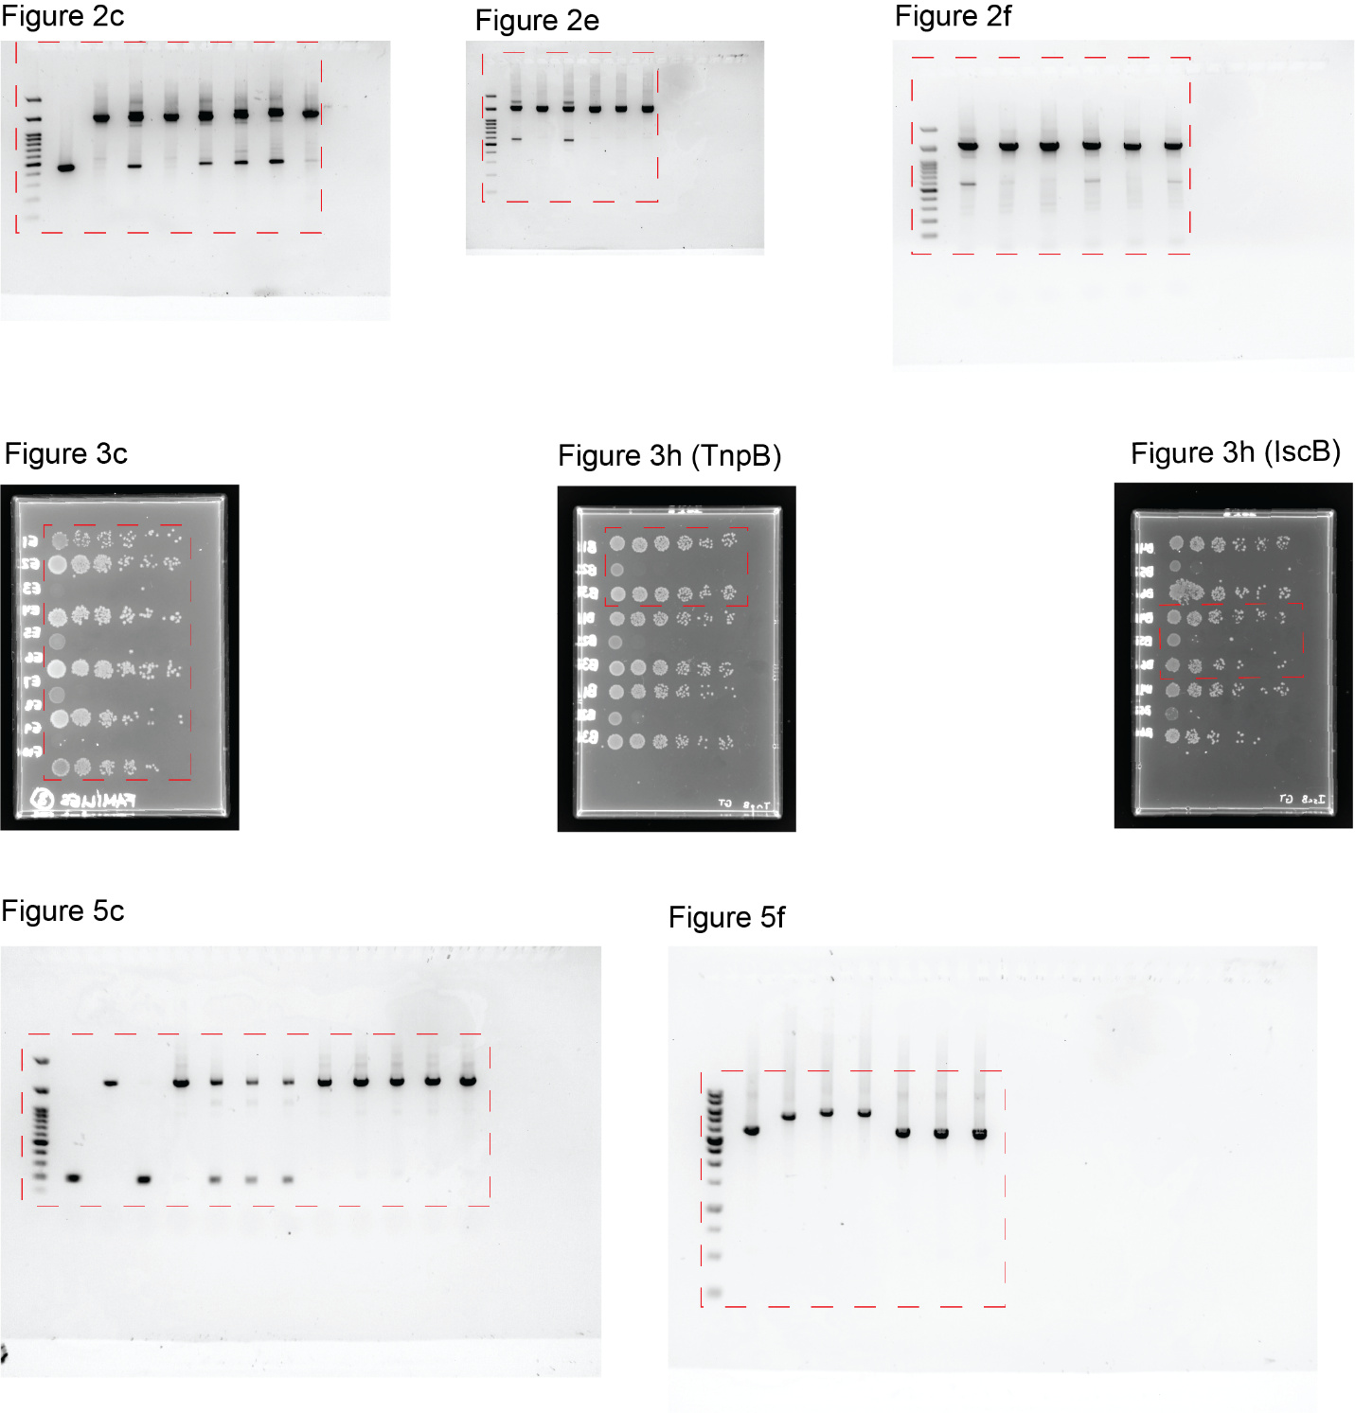
Red dashed boxes indicate the cropped area used in the figures.

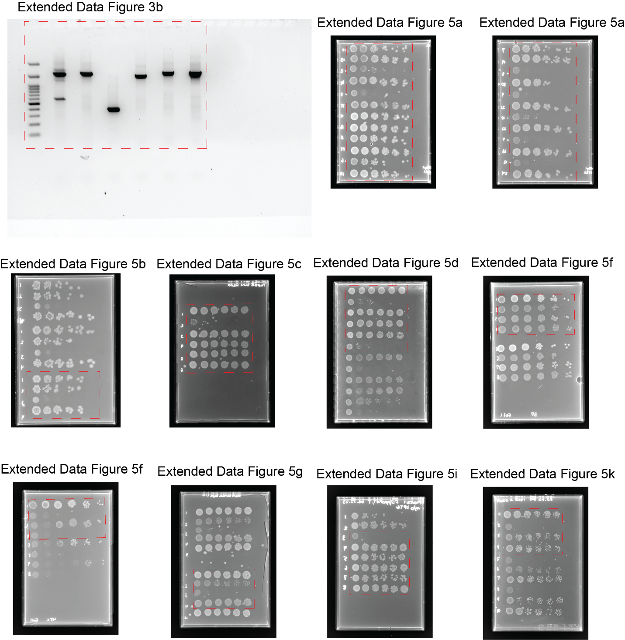

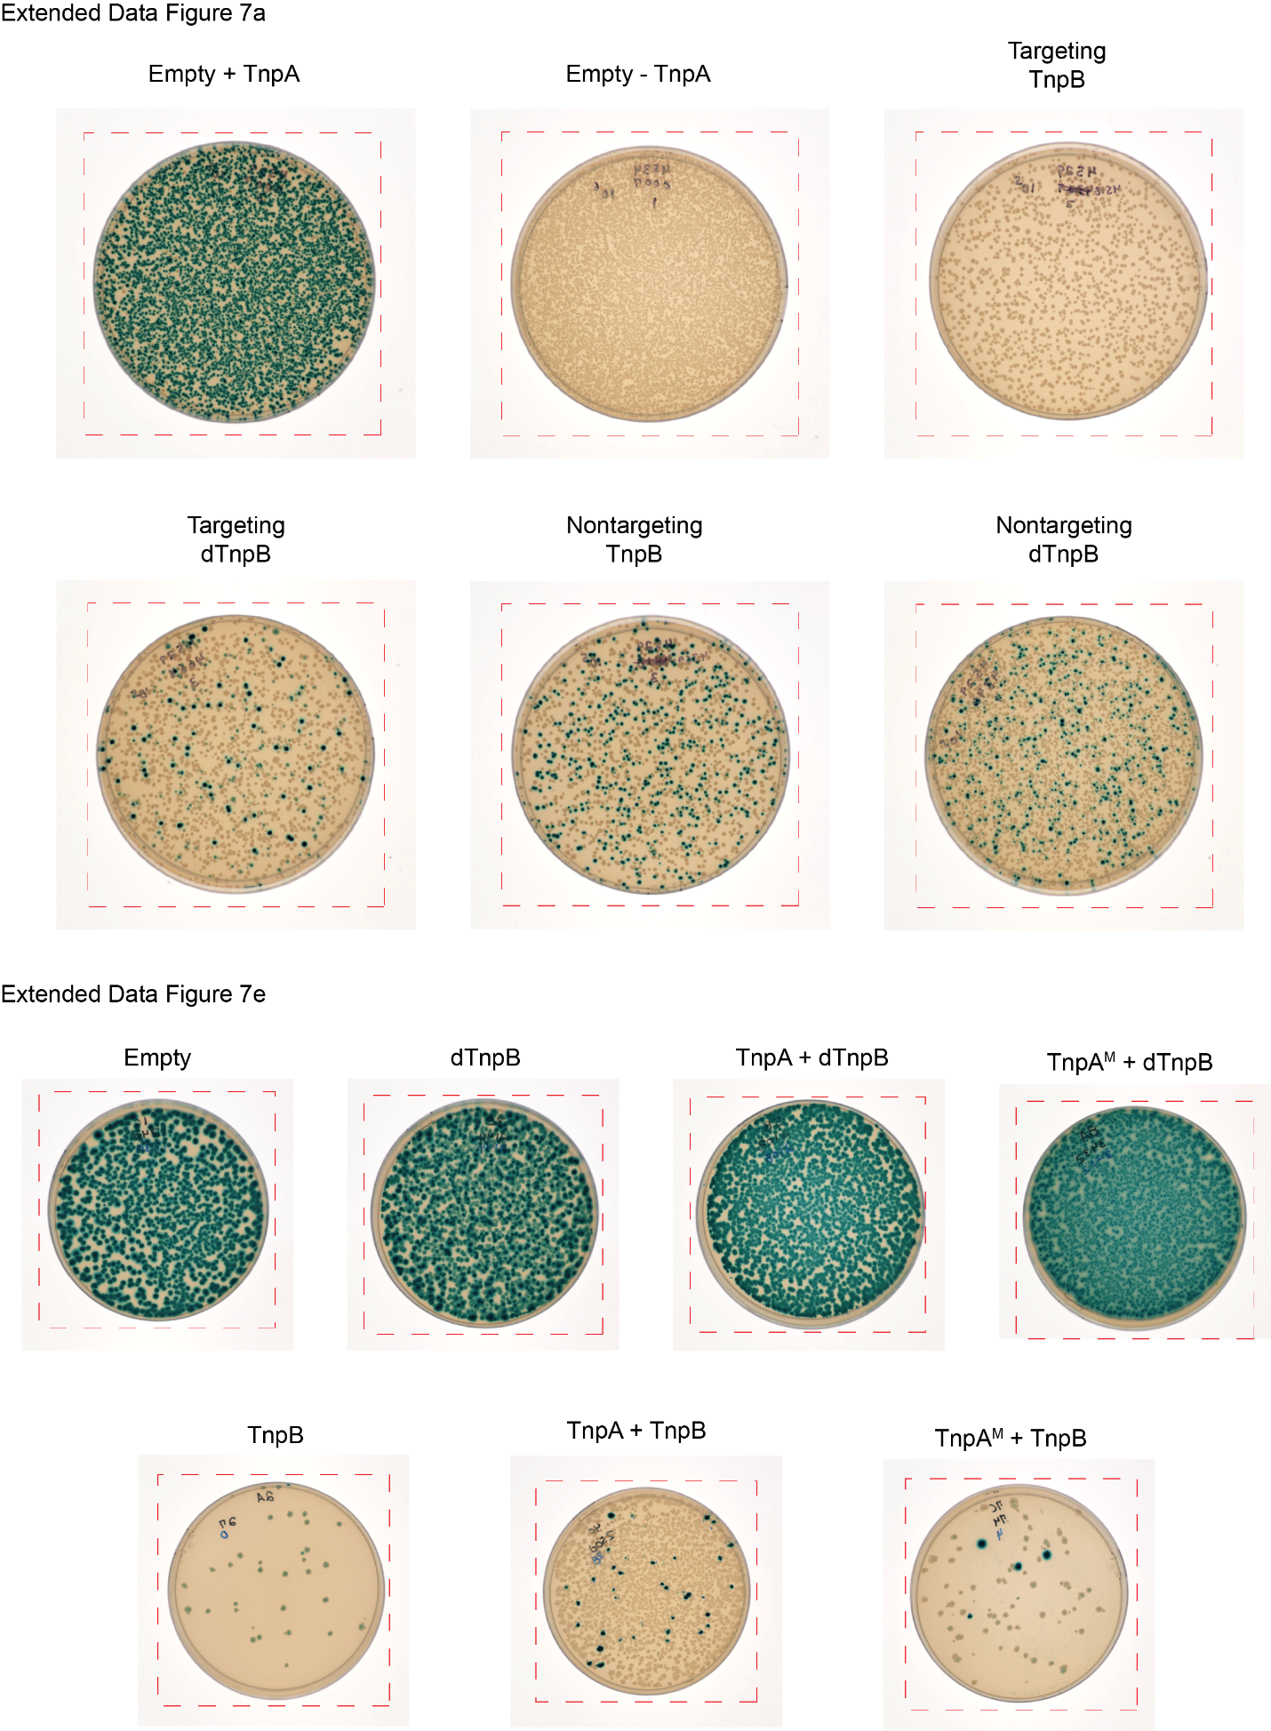
Supplementary Figure 2 | Multiple sequence alignment of transposon left ends.
The transposon boundary is delineated by a dotted line, and the transposon family is indicated on the right. Percent similarity is indicated at each position by color: Dark green (100% similarity), light green (80–99% similarity), and yellow (60–79% similarity).

Supplementary Figure 3 | Multiple sequence alignment of transposon right ends.
The transposon boundary is delineated by a dotted line, and the transposon family is indicated on the right. Percent similarity is indicated at each position by color: Dark green (100% similarity), light green (80–99% similarity), and yellow (60–79% similarity).

