Ladders:
L1) WesternSure Pre-stained Chemiluminescent Protein Ladder (#926-98000, LICOR Biosciences)
L2) Precision Plus Protein Dual Color Standards (#1610374, Bio-rad)

Figure 3

b) AMPA Receptor 4 - GluA4 (#8070, Cell Signaling Technology)
Total Protein
Cell Surface
+
5m
-
BDNF
+
30m
+
15m
-
+
5m
+
15m
+
30m
kDa
250

125

90
L2
70
L1

GAPDH (#5174, Cell Signaling Technology) (Run on the same gel)
Cell Surface
+
5m
-
Total Protein
+
30m
+
15m
BDNF
-
+
5m
+
15m
+
30m
kDa
50
38
25
15

L2
L1

d) AMPA Receptor 3 – GluA3 GAPDH (#5174, Cell Signaling Technology)
(#4676, Cell Signaling Technology) (Run on the same gel)

BDNF
-
Cell Surface
-
Total Protein
Total Protein
-
Cell Surface
-
kDa
+
+
+
+
BDNF
L2
L1
L2
L1
15
38
25
50
250
125
90
70
100
75
150
250
kDa
kDa

f) AMPA Receptor 4 - GluA4 (#8070, Cell Signaling Technology)
250
-
+
Total Protein
-
Cell Surface
125
NLGN3
+

250

125
90
70
L1

GAPDH (#5174, Cell Signaling Technology) (Run on the same gel)
NLGN3
-
+
Cell Surface
-
+
Total Protein

50
15
25
38

L1

Extended Data Figure 1

g) TrkB (#4606, Cell Signaling Technology) MW 140 kDa Full Length, ~90 kDa Truncated-SHC, Truncated T1.
pcGBM2
DIPGXIII
DIPGVI
L2
L1
WT KO
WT KO
WT KO
70
125
250
90
250

150
100

b-actin (#4970, Cell Signaling Technology) (Run on the same gel).
L2
L1
WT KO
pcGBM2
DIPGXIII
DIPGVI
WT KO
WT KO
38
50
25

Extended Data Figure 2

- pTrkB (pTyr515) – (NB100-92656, Novus Biologicals) MW 140 kDa Full Length, ~90 kDa Truncated-SHC, Truncated T1.
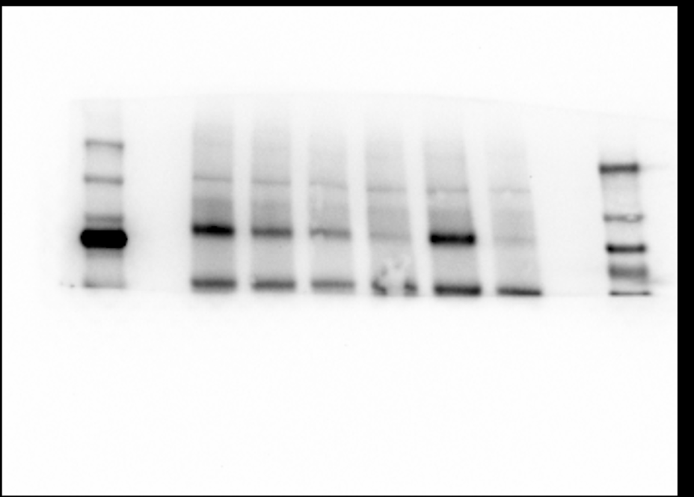
2h
4h
30m
Veh Ent
Veh Ent
Veh Ent
75
250
150
100
70
90
125
250

L2
L1

TrkB (#4606, Cell Signaling Technology) MW 140 kDa Full Length, ~90 kDa Truncated-SHC, Truncated T1. Same sample run on separate gel to phospho antibody.
Left, blot used in Figure (ladders covered to expose blots), right is the same blot without ladders covered.
30m
2h
4h
Veh Ent
Veh Ent
Veh Ent
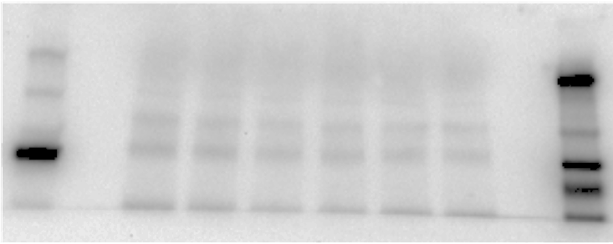
250
125
70
90
Veh Ent
Veh Ent
Veh Ent
30m
2h
4h
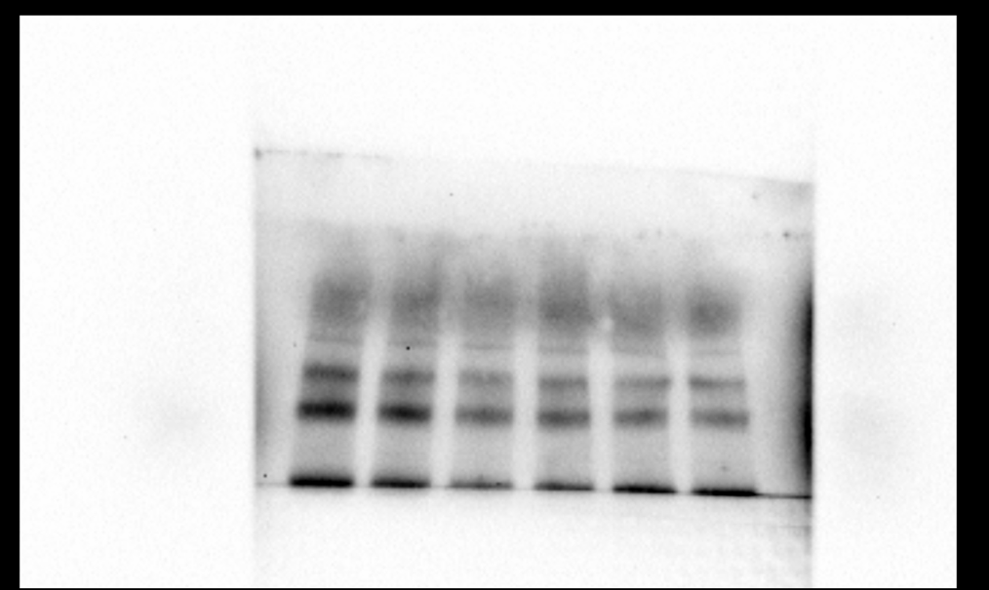
L1
L2

Phospho-p44/42 MAPK (ERK1/2) (Thr202/Tyr204) – (#4370, Cell Signaling Technology)
Veh Ent
30m
Veh Ent
4h
2h
L2
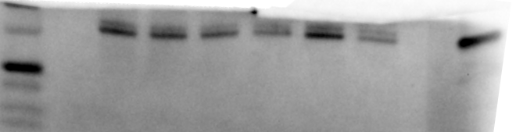
25
50
37
Veh Ent

p44/42 MAPK (Erk1/2) – (#9102, Cell Signaling Technology)
(left ladder not in the image frame). Same sample run on separate gel to phospho antibody.
Veh Ent
Veh Ent
30m
2h
4h
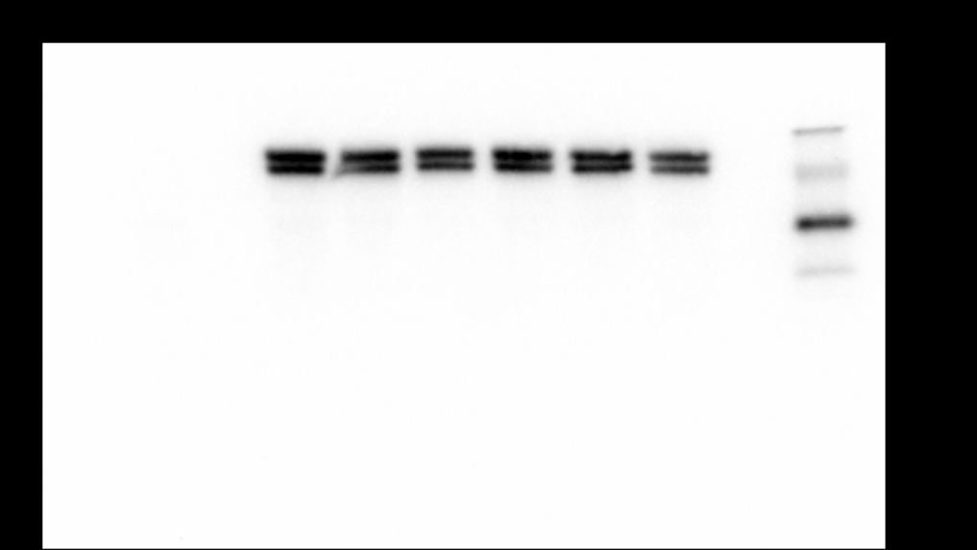
L1
38
50
25
Veh Ent

b-actin (#4970, Cell Signaling Technology)
Same gel as phospho TrkB.
Veh Ent
Veh Ent
30m
2h
4h
Veh Ent
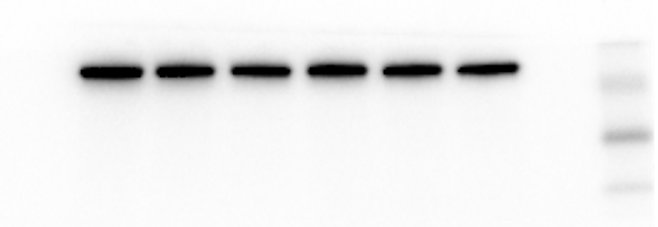
L1
50
25
38

Extended Data Figure 8

- *These are the same experimental samples/lysates used in Ext Data Fig 8e.
** The same protein lysate sample (+load and SRA) was used for all blots.
Phospho-p44/42 MAPK (ERK1/2) (Thr202/Tyr204) – (#4370, Cell Signaling Technology)
BDNF
+
15m
+
5m
-
+
30m
25
38
50
L1

p44/42 MAPK (Erk1/2) – (#9102, Cell Signaling Technology)
Same sample run on separate gel to phospho antibody.
+
30m
+
15m
+
5m
-
BDNF
L1
25
38
50

Phospho-AKT (Ser473) – (#4060, Cell Signaling Technology)
+
30m
+
15m
+
5m
-
BDNF

90
70
25
50
38

L1

AKT antibody (#9272, Cell Signaling Technology)
*First blot exhibited sample depletion, membrane was striped and re-probed with reduced antibody concentration. Striped blot lost chemiluminescent ladder. Right, initial blot, left re-probed blot used in Figure. *note presence of lower non-specific bands in both blots.
Same sample run on separate gel to phospho antibody.

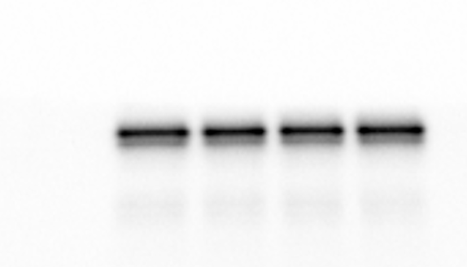
*
*
BDNF
-
+
15m
+
30m
+
5m
BDNF
-
+
5m
+
15m
+
30m
125
38
50
70
90

L1

phospho-CAMKII (Thr286) – (#12716, Cell Signaling Technology)
MW 50 kDa CAMKII-α (analyzed), 60 kDa CAMKII-β
+
5m
+
15m
+
30m
BDNF
-
L1

50

38

25

CAMKII (#4436, Cell Signaling Technology)
MW 50 kDa CAMKII-α (analyzed), 60 kDa CAMKII-β. Same sample run on separate gel to phospho antibody.
+
30m
+
15m
+
5m
-
BDNF

L1

50
70
38
25

b-actin (#4970, Cell Signaling Technology)
+
15m
+
5m
-
+
30m
BDNF
L1
38
25
50

e) *These are the same experimental samples/lysates used in Ext Data Fig 8a.
** The same protein lysate sample (+load and SRA) was used for all blots.

Phospho-GluA4 (Ser862) – (PA5-36807, Invitrogen)
250
125
90
BDNF
-
+
5m
+
15m
+
30m
L1

AMPA Receptor 4 - GluA4 (#8070, Cell Signaling Technology)
Same sample run on separate gel to phospho antibody.
BDNF
-
+
5m
+
15m
+
30m

250

125

90

b-actin (#4970, Cell Signaling Technology)
+
30m
+
15m
+
5m
-
BDNF

25
38
50

L1

g) Phospho-GluA4 (Ser862) – (PA5-36807, Invitrogen)
+
+
-
BDNF
+
-
-
Entrectinib

90
250
125

L1

AMPA Receptor 4 - GluA4 (#8070, Cell Signaling Technology)
Same sample run on separate gel to phospho antibody.
+
-
-
Entrectinib
+
+
-
BDNF

125
90
250

L1

b-actin (#4970, Cell Signaling Technology)

-
-
Entrectinib
+
+
-
BDNF
+
70
L1
25
38
50

Supplementary Figure 1: All full western blots. Molecular weight ladder on left (lane 1, L1) of all western blots. The bands of interest highlighted in red.

