Supplementary Information
This file contains full and detailed legends for Main Figure 1-4; Supplementary Figure 1-3 with legends and Supplementary Table 1-2 with legends.
Full and detailed legends for Main Figure 1-4:
Figure 1. iMac become microglia-like cells in brain organoids. a, Schematic overview of the generation of microglia-sufficient brain organoids. iMac and brain organoid are obtained 26 days after initial iPSC culture and constitute day 0 iMac and organoids. Co-cultured organoids are analysed from 15 days onward (day 15) after co-culture of day 0 iMac and organoids. Unless otherwise stated, the KYOU1 iPSC line is used throughout the study. b, Brain organoids were co-cultured with or without iMac for 18 days, cleared and imaged in 3D. Scale bar, 300 µm. Boxed area highlighted on the right. Arrowhead, a cluster of iMac on organoid. Scale bar, 100 µm. (Representative of n=3). c, Sectioning and immunofluorescence staining of brain organoid co-cultured with or without iMac for 18 days. Scale bar, 100 µm. Boxed area highlighted on the right. Scale bar, 20 µm. (Representative of n=4). d, RT-qPCR data showing the expression levels of microglia-specific markers in iMac alone (n=3) or iMac co-cultured with brain organoids (n=3) for 15 or 30 days. Statistical analysis, one-way ANOVA. e, Flow cytometry data showing the expression levels of microglia-specific markers in day 18 iMac (n=3) and iMac co-cultured with brain organoids (n=3) for 18 days. f, tSNE plots showing the gene set score for canonical markers used to define four different cell types (neurons, NPC, iMac and mesenchymal cells) under the various organoid culture conditions obtained at day 18 (concatenated representation). g, tSNE plots showing the projection (on a concatenated representation) of the four different cell types coming from organoids cultured in the presence (co-culture) and absence (organoid alone) of iMac for 18 days. Co-cultured iMac were magnified and highlighted in the right panel. h, Heatmap showing the expression levels of regulons involved in the acquisition of microglia identify in iMac and co-cultured iMac (co-iMac). i, Violin plots comparing the expression levels of regulons involved in the acquisition of microglia identity between iMac and co-iMac. Statistical analysis, Mann-Whitney test. j, Representative voltage responses obtained from whole-cell patch-clamp recordings at -50 pA, 0 pA and maximum action potential (AP) firing (bottom to top). k, Analysis of the first, second and third AP observed during maximum AP firing of organoid alone (n=8) and co-culture (n=12). Statistical analysis, Mann-Whitney U test. l, Characterization of AP firing patterns in organoid alone and co-cultured with iMac. Example traces representing firing patterns used for the characterization are shown (left panel). Distribution of AP firing patterns for neurons from control (n=40) and co-culture (n=66) organoids. m, Representation of intrinsic properties of neurons from each organoid alone (n=20) and co-culture organoids (n=23). Statistical analysis, Mann-Whitney test. Error bars, mean +/- s.e.m.

Figure 2. iMicro promote the maturation of neuronal cells in the organoids. a, Left Panel, representative 3D images of brain organoids cultured in the absence and presence of iMac for 18 days. Scale bar, 300 µm. Right panel, changes in organoid size measured over time in the absence and presence of iMac. Statistical analysis, 2-way ANOVA test. (For each organoid culture: n=10 from day 0 to day 10, n=7 at day 12, n=3 at day 18). b, Representative flow cytometry data showing makers used to define iMicro, NPC, neurons and glial progenitor cells from co-cultured organoids at day 18. The number and proportion (%) of each cell type within each organoid were obtained by flow cytometry. Organoids were cultured either in the absence or presence of iMac for 15 days. Statistical analysis, Mann-Whitney test (n=3). c, Heatmap showing the genes involved in neurogenesis and axon development whose expression is higher in co-NPC; and those involved in proliferation, whose expression is lower in co-NPC compared to NPC (day 18). d, Heatmap showing the genes involved in neurogenesis and axon development that are both more- and less-expressed in neurons and co-neurons. e, Alluvial plot showing the GO terms for NPC, co-NPC, neurons and co-neurons. The ribbon (alluvial) thickness represents the number of genes used for inferring each GO term. f, Proliferative activity (EdU incorporation) of NPC and neuron from day 14 organoid alone (n=11) and co-cultures (n=11) expressed as %. Statistical analysis, Mann-Whitney U test. g, Volcano plot of proteomic data showing PRPH as one of the highest expressed in co-NPC compared to NPC. Three independent samples (3 co-cultured organoids and 3 organoids) from the same experiment were sorted for proteomic analysis and each sample was run in triplicate. h, Levels of expression of PRPH in neuronal cells from day 18 organoid alone (n=3) and co-cultures (n=3). Statistical analysis, one-way ANOVA test. Three independent samples (3 co-cultured organoids and 3 organoids) from the same experiment were sorted for proteomic analysis and each sample was run in triplicate. i, Representative immunostaining of FACS-sorted NPC and co-NPC from the organoids in the absence and presence of iMac for 18 days respectively. Scale bar, 100 µm. Boxed area highlighted immediately below the corresponding image. Scale bar, 50 µm. Right panel: Blinding was used to measure the axon lengths and numbers for each cell using the Imaris software. Statistical analysis, Mann-Whitney test. Number of cells in which the number of axons was measured: NPC (n=493), co-NPC (n=896). Number of axons measured: NPC (n=286), co-NPC (n=628). Two independent experiments were combined. j, Heatmap of the expression of genes involved in neurogenesis, axon development, phagocytosis, neuronal death that were highly expressed in day 18 iMicro. k, Heatmap of the expression of proteins involved in neurogenesis and axon development which are more abundant in day 18 iMicro. l, Representative immunofluorescence staining showing IBA1+ iMicro in proximity to TUJ1⁺ neuronal axons in the organoid (18 days after co-culture). Scale bar, 30 µm (n=3). m, Representative immunofluorescence staining showing IBA1⁺ iMac in proximity to Ki67⁺ SOX2+ NPC in 18-day co-cultured organoid. Scale bar, 50 µm (n=3). n, Representative immunofluorescence staining showing the detection of traces of SOX2+ NPC in IBA1⁺ iMicro from organoid co-culture at day 18. Scale bar, 50 µm. (n=5). Error bars, mean +/- s.e.m.
Figure 3. Lipid-enriched iMicro transport cholesterol and its esters to neuronal cells in organoids. a, Volcano plot of transcriptomic data showing PLIN2 as the highest DEG overexpressed in day 18 iMicro compared to iMac. Data displayed correspond to data analysis from RNA-seq performed on cells obtained from day 18 organoid (n=3), and co-culture organoids (n=3) and iMac (n=2). b, Representative immunofluorescence staining of day 18 IBA1⁺ iMac for the expression of PLIN2 and staining with Lipid-spot 610 (n=4). 100% of IBA1⁺ iMac were PLIN2⁺ Lipid-spot 610⁺. c, Representative immunofluorescence staining of day 18 co-cultured organoid for the microglial marker IBA1, nuclear marker DAPI, the lipid-droplet marker (PLIN2) and neutral lipids (Lipid-spot 610). Scale bar, 15 μm. (n=4). Statistical analysis, Mann-Whitney U test. d, Flow cytometry data showing the level (MFI) of neutral lipids (stained by BODIPY^{493/503}) in co-NPC, co-neurons, co-glial and iMicro within day 18 co-cultured organoids. Statistical analysis, One-way ANOVA (n=3). e, Flow cytometry data showing the level of neutral lipids (stained by BODIPY^{493/503}) in NPC and co-NPC. Statistical analysis, Mann-Whitney test (n=3). f, Left panel, iMac were pulsed with BODIPY^{CE} overnight and the integration of labelled cholesterol-esters assessed by flow cytometry. Statistical analysis, Mann-Whitney test (n=3). Right panel, integration of BODIPY^{CE} into lipid droplets was further confirmed by immunofluorescence staining for perilipin-2 (PLIN2), IBA1 and DAPI (nucleus). Scale bar, 30 µm. (n=5). g, Transfer of cholesterol-ester (BODIPY^{CE}) from iMicro to co-NPC in organoids was assessed by flow cytometry and immunofluorescence staining on FACS-sorted co-NPC, and 7 days after BODIPY^{CE+} iMac were added to the organoid. Scale bar, 25 µm. Statistical analysis, Mann-Whitney test (n=4). h, Ability of NPC to take up free cholesterol-esters was assessed by flow cytometry analysis. Statistical analysis, Mann-Whitney test (n=3). i, Transwell culture-assay to assess transfer of cholesterol from iMicro to neuronal cells in co-cultured organoids. Statistical analysis, Mann-Whitney test (n=3). j, Changes in organoid size over time in the absence and presence of iMac conditioned medium replaced every 2 days (grey arrows). Co-culture organoids were used as control. Statistical analysis, 2-way ANOVA. (n=12 in 3 independent experiments). k, Lipid profiles of the culture medium (cM) from iMac, organoid and co-culture organoids were assessed by mass spectrometry analysis. Concentration in μM. Statistical analysis, one-way ANOVA with Tukey’s multiple comparisons tests (n=4, n=2 for control medium). l, Volcano plot of proteomic data between iMac and iMicro (day 18) showing AIBP and APOE as key differentially expressed proteins (DEP). Three independent samples (3 co-cultured organoids and 3 organoids) from the same experiment were sorted for proteomic analysis and each sample was run in triplicate). m, Level of expression of APOE by western-blot in the conditioned medium (cM) from day 18 organoid alone and co-culture organoids (n=2). Individual gels are shown in Supplementary Fig. 1b. n, Left panel: Level of expression of ABCA1 mRNA between iMac and iMicro (day 18) (n=3). Right panel: Flow cytometry analysis of the expression of ABCA1 by iMicro, co-NPC and co-neuron from day 18 co-culture organoid. (1 representative of several observations). o, Representative immunofluorescence staining for Lipid-spot 610 of day 18 IBA1⁺ iMac in the presence or absence of ABCA1 inhibitor (probucol). Quantification using the Imaris software and represented as number of Lipid-spot 610⁺ droplets per iMac (n=14). Statistical analysis, Mann-Whitney U test. p, Quantification of cholesteryl-esters in the culture medium (cM) from iMac treated or not probucol were assessed by mass spectrometry analysis. Statistical analysis, one-way ANOVA with Tukey’s multiple comparisons tests (n=3 for each sample type) q, Impact of probucol on the ttransfer of cholesterol-ester (BODIPY^{CE}) from iMicro to co-NPC in organoids was assessed by flow cytometry staining 5 days after BODIPY^{CE+} iMac were added to the organoid. Statistical analysis, one-way ANOVA (n=3). r, Impact of probucol (added every 3 days, grey arrows) on the size of organoid and co-culture over time. Untreated organoids were used as control. Statistical analysis, 2-way ANOVA. (Representative of 3 independent experiments with n=4 each). s, Proliferative activity (EdU incorporation) of NPC and neuron from day 14 organoid alone (n=11) and co-cultures (n=11) with or without treatment with probucol. Result is expressed as %. Statistical analysis, one-way ANOVA. Error bars: mean +/- s.e.m.
Figure 4. Embryonic microglia express APOE, PLIN2 and high levels of neutral lipid. a, Transcriptomic heatmap of genes involved in cholesterol synthesis, regulation, esterification and storage in mouse microglial cells through fetal development until adulthood (Thion et al., 2018). b, Immunofluorescence analysis showing the co-localization of microglia (IBA1), perilipin-2 (PLIN2) and neutral lipids (Lipid-spot 610) in E13.5 roof plate region of mouse embryonic brains (Scale bar, 200 μm, 100 μm, n=5), newborn (n=4) and 15-week-old (n=5) mouse brains. c, Immunofluorescence analysis showing the co-localization of microglia (IBA1), perilipin-2 (PLIN2) and neutral lipids (Lipid-spot 610) in 15-weeks-of-gestation human embryonic brains. (Representative of several observations put in Extended Data Fig. 10e). b, c, Quantification performed using the Imaris imaging software. Mean is represented. d, UMAP clustering analysis of the projection of iMicro (day 18) transcriptome onto human fetal and adult microglia transcriptome data from the Allen human brain atlas. Identity Score comparing profile of iMicro transcriptome with fetal microglial transcriptomic signature. e, UMAP clustering analysis of the transcriptome of human fetal microglia from the Allen human brain atlas and depicting the expression of PLIN2 and ABCA1.Statistical analysis, one-way ANOVA (b). Scale bars, 200μm (b, left panel), 100μm (b, boxed-left panel), 50μm (c), 30μm (b, middle and right panels).

Supplementary Figures and Legends
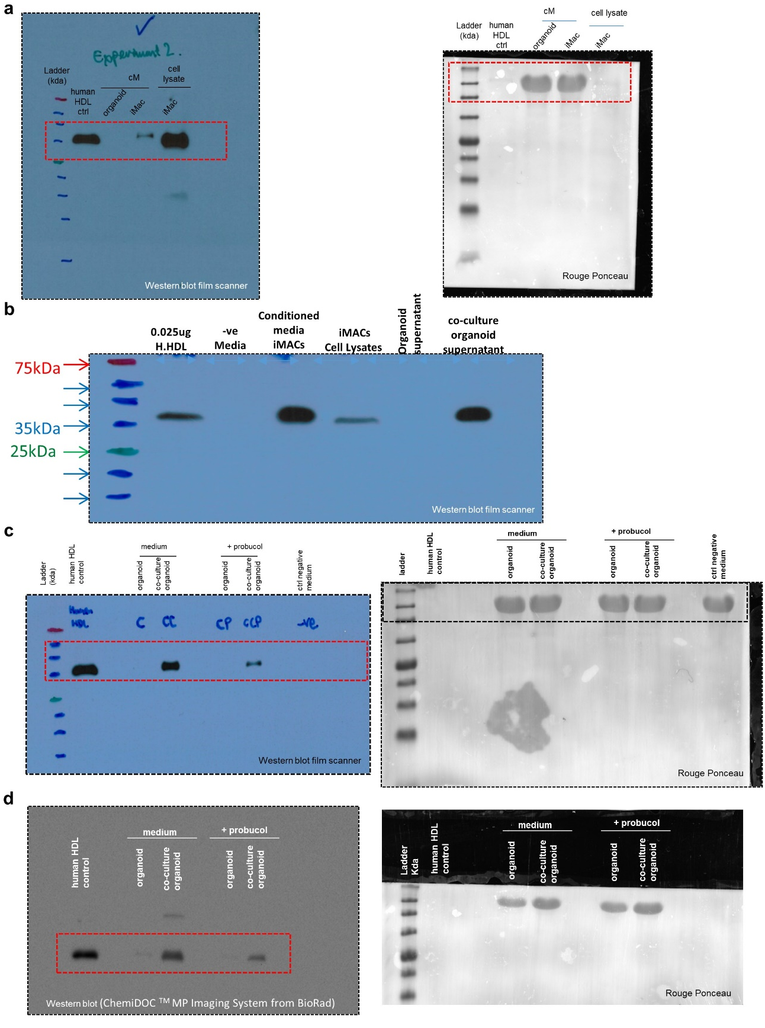
Supplementary Figure 1. Western blot and Ponceau Red gels referring to Figure 3 and Extended Data Figure 9.

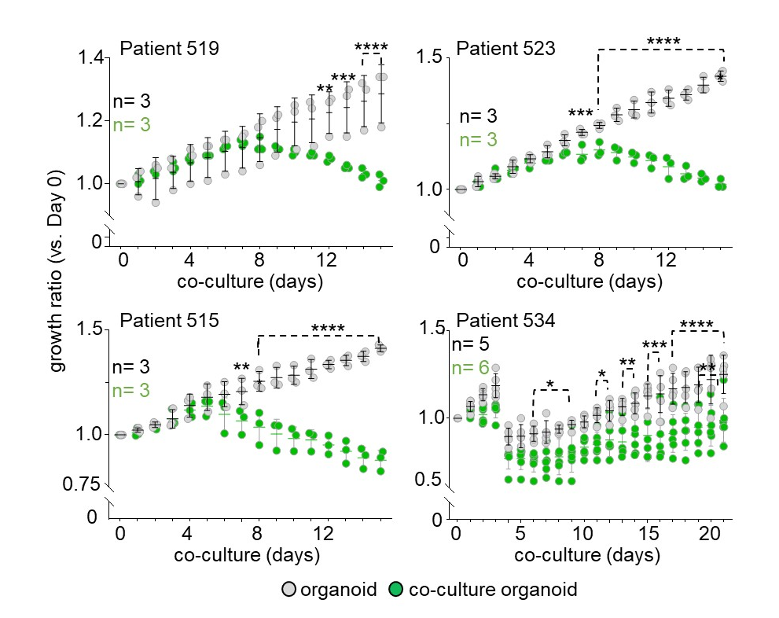
Supplementary Figure 2. Evolution of the size of organoids generated from iPSC of 4 distinct patients (pediatric brain cancer) over 15 days with and without iMac (n=3 for each condition). Statistical analysis, 2-way ANOVA. Statistical analysis reported on the plot are between organoids and co-culture organoids for each day under the ashed bracket.

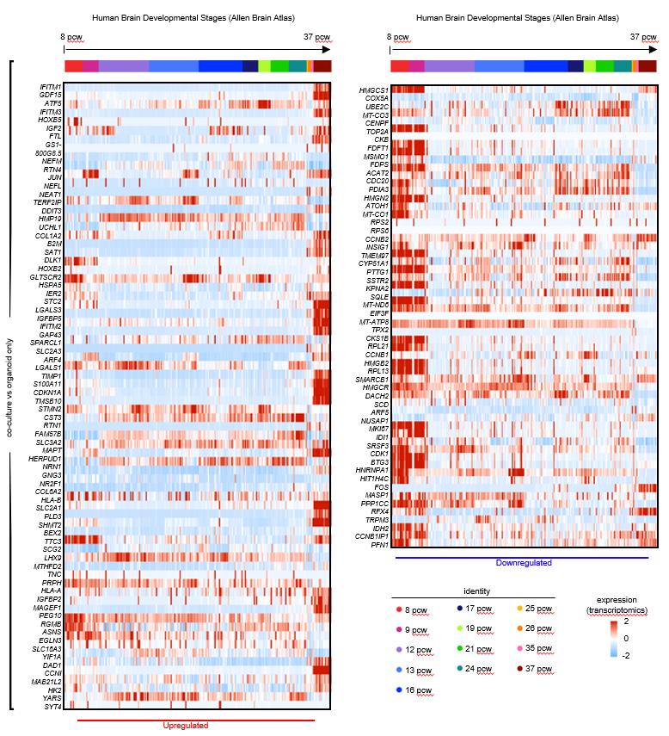
Supplementary Figure 3. Heatmap showing the expression levels of genes across different stages of early brain development (before birth, from 8 to 37 pcw, Allen brain Atlas). The selected genes are either more- or less- highly expressed in co-NPC and co-neurons.

Supplementary Tables and Legends

Stempro Medium
Stempro-34 SFM (GIBCO, #10639-011), supplemented with 200 µg/mL Human Transferrin (Roche, #10-652-202-001), 2 mM L-Glutamine (GIBCO, #25030-081), 1x Pen/Strep (GIBCO, #15140-122), 0.5 mM Ascorbic Acid (Sigma, #A4544) and 0.45mM MTG (Sigma, #M6145).
Serum-Free Differentiation Medium (SF-Diff)
75% IMDM with Glutamax (GIBCO, #31980-030), 25% F12 (GIBCO, #11765-047), 1x N2 supplement (GIBCO, #17502-048), 1x B27 Supplement (GIBCO, #17504-001), 0.05% BSA (GE Healthcare, #SH30574) and 1x Pen/Strep.
hESC medium
400ml DMEM-F12 (GIBCO, #11320-032) + 100ml of KOSR (GIBCO, #10828-038) + 15ml FBS (GIBCO, #10270-106) + 5ml GlutaMAX (GIBCO, #35050-038) + 5ml MEM-NEAA (GIBCO, #11140-050) +3.5ul mercaptoethanol (GIBCO, #21985023). Filtered using a vacuum-driven 0.2µl Stericup filter unit.
Neural Induction Medium
DMEM-F12 containing 1% N2 + 1% GlutaMAX + 1% MEM-NEAA + 1ug/ml Heparin (Sigma-Aldrich, #H4784-250MG). Filtered using a vacuum-driven 0.2µl Stericup filter unit.
Cerebral Organoid Medium
125ml DMEM-F12 + 125ml Neurobasal medium (GIBCO, #21103049) + 1.25ml of N2 + 62.5ul of insulin (Sigma-Aldrich, #I9278-5ML) + 2.5ml GlutaMAX + 1.25ml MEM-NEAA + 2.5 ml P/S + 87.5ul of 2-mercaptoethanol + 2.5ml B27 without vitamin A (GIBCO, #12587010) during stationary culture and B27 with vitamin A (GIBCO, #17504044) during orbital shaking. Filtered using a vacuum-driven 0.2µl Stericup filter unit.

Supplementary Table 1. Composition of mediums used throughout the study.

Reagent or Resource | Source | Catalogue Number
Antibodies
Rabbit anti-Iba1 | Wako | Cat # 019-19741
Chicken anti-Iba1 | Synaptic System | Cat# 234009
Goat anti-Iba1 | Abcam | Cat# ab5076
Mouse anti-ABCA1 | Abcam | Cat# ab18180
Goat anti-Sox2 | RnD | Cat # AF2018
Rabbit anti-Sox2 | Abcam | Cat # AB97959
Mouse anti-Tuj1 | Abcam | Cat # AB78078
Mouse anti-Tuj1 | Promega | Cat # G712A
Mouse anti-Nestin | Merck | Cat # MAB5326
Mouse anti-Ki67 | Biolegend | Cat # 350514
Mouse anti-Ki67 | DAKO | Cat # M7240
Rabbit anti-Ki67 | Abcam | Cat # AB15580
Mouse anti-Plin2 | Proteintech | Cat # ABIN1724917
Rabbit anti-Plin2 | Antibodies-online | Cat # 15294-1-AP
Mouse anti-CD45 | Biolegend | Cat # 368516
Mouse anti-CD14 | Biolegend | Cat # 325604; 301834
Mouse anti-CD11b | BD Biosciences | Cat # 557918
Mouse anti-CD11b | eBioscience | Cat # 25-0118-42
Mouse anti-CD163 | BD Biosciences | Cat # 562670
Mouse anti-CXCR4 | Biolegend | Cat # 306516
Mouse anti-CD44 | Biolegend | Cat # 338806
Mouse anti-CD271 | BD Biosciences | Cat # 743358
Mouse anti-CD24 | BD Biosciences | Cat # 561646
Mouse anti-CD15 | Biolegend | Cat # 323034
Mouse anti-P2RY12 | Biolegend | Cat # 392104
Rat anti-CX3CR1 | Biolegend | Cat # 341626, 341608
Rabbit anti-Tmem119 | Sigma-Aldrich | Cat # HPA051870-100UL
Mouse anti-CD80 | BD Pharmingen | Cat# 557227
Mouse anti-CD86 | BD Pharmingen | Cat# 555665
Mouse anti-CD68 | Biolegend | Cat# 333808
Mouse anti-HLA-DR | Biolegend | Cat# 327014
Mouse anti-b3tubulin | Promega | Cat # G712A
Mouse anti-NeuN | Sigma | Cat # MAB377
Alexa-Fluor488-conjugated donkey anti-mouse | Jackson ImmunoResearch | Cat# 715545150
Cy3-conjugated donkey anti-rabbit | Jackson ImmunoResearch | Cat# 711165152
Cy5-conjugated donkey anti-chicken | Jackson ImmunoResearch | Cat# 703175155
Donkey anti-Goat IgG (H+L) Cross-Adsorbed Secondary Antibody, Alexa Fluor 488 | Invitrogen | Cat # A-11055
APC Conjugation Kit | (LNK03)- | BioRad | Cat# LNK032APC
Chemicals, Peptides, and Recombinant Proteins
1-Thioglycerol (MTG) | Sigma-Aldrich | Cat # M6145
Ascorbic Acid | Sigma-Aldrich | Cat # A4544
CHIR99021 | TOCRIS | Cat # 4423
Recombinant Human FGF2 | RnD | Cat # 233-FB
Recombinant Human BMP4 | RnD | Cat # 314-BP
Recombinant Human VEGF | RnD | Cat # 293-VE
Recombinant Human CSF-1 | RnD | Cat # 216-MC
Recombinant Human IL-3 | RnD | Cat # 203-IL
Recombinant Human IL-6 | RnD | Cat # 206-IL
Recombinant Human SCF | RnD | Cat # 255-SC
Recombinant Human DKK-1 | RnD | Cat # 5439-DK
ROCK Inhibitor (Y-27632) | Merck Millipore | Cat # SCM075
Matrigel | Corning | Cat # 354277
Matrigel | Corning | Cat # 354234
Matrigel | Corning | Cat # 356237

Supplementary Table 2. List of antibodies, chemicals, peptides and recombinant proteins used in the study.

Supplementary Data Tables 1-11 (Supplied separately):

Supplementary Table. 1, iMicro versus iMac DEG analysis of single-cell RNAseq data (composed of 961 genes).

Supplementary Table. 2, iMicro versus iMac regulon analysis of single-cell RNAseq data (composed of 17590 genes).

Supplementary Table. 3, Electrophysiology data of patch-clamp between organoids and co-culture organoids.

Supplementary Table. 4, Table depicting the number of repeats for each iPSC and each condition used in this study.

Supplementary Table. 5, co-NPC versus NPC DEG analysis of single-cell RNAseq data (composed of 180 genes).

Supplementary Table. 6, co-neuron versus neuron DEG analysis of single-cell RNAseq data (composed of 128 genes).

Supplementary Table. 7, Proteomic analysis of purified iMac, iMicro, NPC, co-NPC, neuron and co-neurons.

Supplementary Table. 8, NPC versus co-NPC DEP analysis of bulk mass-spectrometry proteomic analysis on cell population purified by Flow Cytometry Sorting.

Supplementary Table. 9, Proteomic analysis of laser micro-dissected neural rosettes from organoids and co-culture organoids at Day 18.

Supplementary Table. 10, Mass-spectrometry lipidomic analysis of culture medium from iMac, organoid and co-culture organoids at day 18.

Supplementary Table. 11, Mass-spectrometry lipidomic analysis of culture medium from iMac, organoid and co-culture organoids at day 18 with or without Probucol.

