Supplementary material for

Ultra-high mobility semiconducting epitaxial graphene on silicon carbide

Section 1: SEG growth analysis p2
Section 2: SEG growth in various face-to-face configurations p7
Section 3 Variable Range Hopping Conduction in the Epitaxial
Graphene Buffer Layer on SiC(0001), p11
Excerpts from J-P Turmaud PhD thesis 2019
Section 4: Towards super-large single domain graphene-like semiconductor,
TICNN Report. Jan. 4, 2022 p16

Sec. 1 SEG growth analysis
Noel Dudeck, Will Griffin, Walt de Heer

Confirmation of uniform terrace coverage

Here, we investigate the amount of buffer layer coverage on a single terrace. We expect the buffer layer to be either undergrown (indicated by patches of silicon carbide on the surface), overgrown (indicated by patches of graphene on the surface), or optimally grown. Scanning electron microscopy reveals consistent contrast across the entire terrace surface at large scale (Fig. S1a) or small scale (Fig. S1c). If silicon carbide was present on the terrace, we would see bright features, and if patches of graphene were present, dark features would be readily apparent. Their differences in contrast can be seen in figure S1d. The steps themselves are silicon carbide, as shown in figure S1b, in contrast to typical graphene growth, where the step edges are more heavily graphitized than the step surfaces.
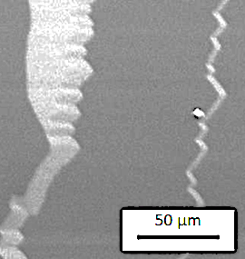
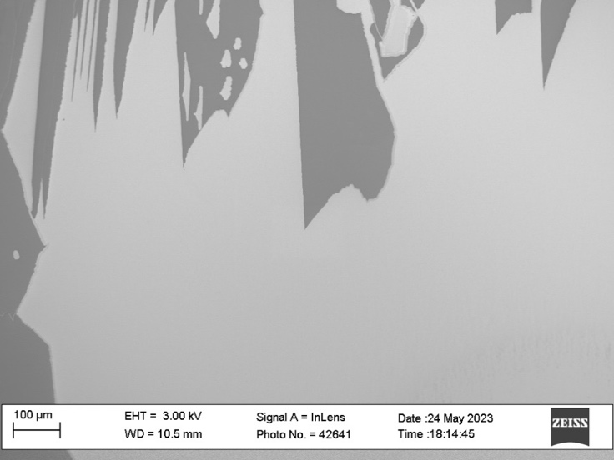
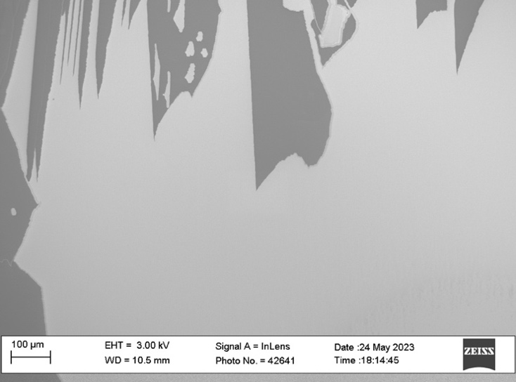
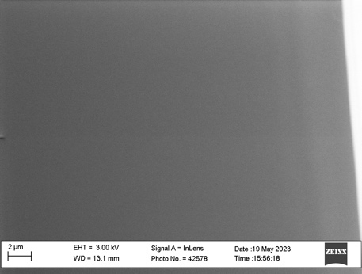
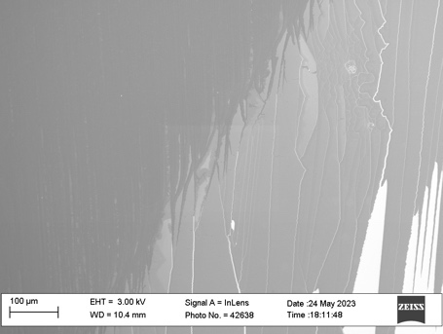
(a)
(b)
(c)
(d)
Figure S1. SEM images of buffer terraces showing uniform, defect-free coverage. (a,b) Example of a large terrace with uniform coverage with a (c) zoomed in image (3KV, WD = 13.1mm). Changes in contrast occur due to the edges of the terrace. (d) Boundary of chip overlap showing changes in contrast from dark grey (graphene) to light grey (buffer) to white (silicon carbide). Darker colors in the images correspond to higher conductivities.

Lateral force microcopy further supports the claim of continuous, uninterrupted growth. Measurements along a terrace edge (Fig. S2a) and center (Fig. S2b) have substantial changes in frictional force only along the step edge due to the presence of large topographical changes. SiC, buffer, and graphene have different frictional forces which can be easily distinguished in LFM measurements (Fig.S2e,f). Non-contact AFM phase images can also distinguish between buffer and SiC.

Uniform coverage is further supported in the main text by SEM (Fig 2a), Raman mapping (Fig 2d) of a 50x50µm area with little variation, and LEED (Fig 2c) showing no graphene spots.

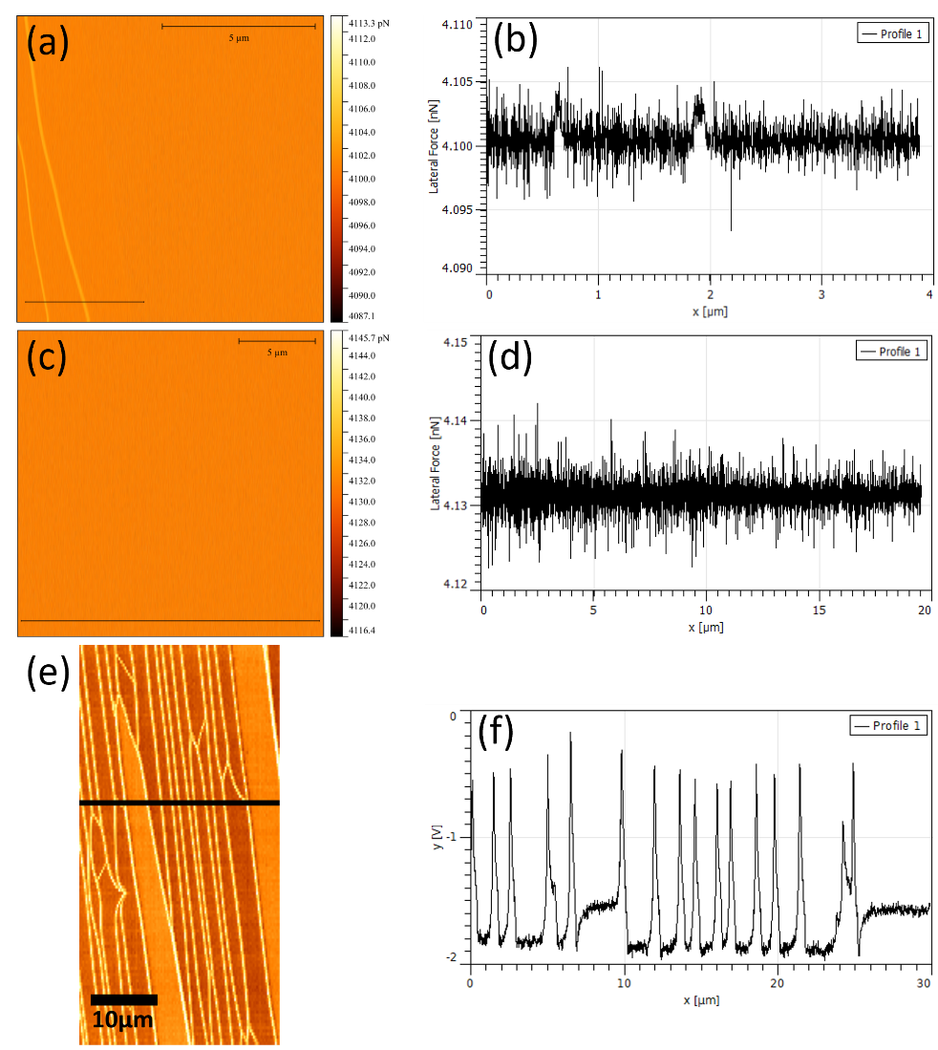
Figure S2. LFM Measurements of buffer terraces and linescans close to step edge (a,b), away from a step (c,d), and across the top of two small buffer steps (e,f), buffer is brighter orange.

Terrace Formation

The redistribution of material during terrace growth leads to mirrored features on the source and seed chips. Although some material escapes from between the two chips, most must stay within due to the high confinement.

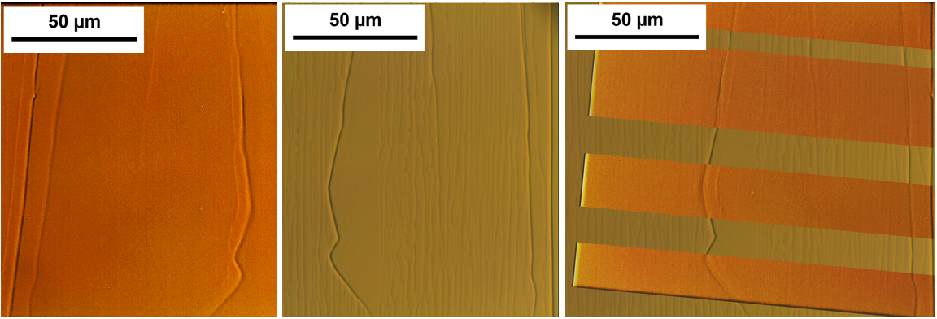
(a)
(c)
(b)

Figure S3. Optical images of a single terrace interface. (a) is the C Face feature (b) the Si-face feature, and (c) shows the C-face overlaid on the Si-face to show the matching. To make the C-Face steps clear, the image contrast and sharpness were increased, and sections were cutout in the overlay to make it easier to see the matching. This sample was grown with reversed temperature gradient in a horizontal furnace, but the effect is the same in the standard growths, though the C face terraces have less defined edges.

At the growth temperature, material must evaporate from the hot chip and absorb on the cool one. The uniform coverage of the buffer layer on individual terraces implies a partially covered terrace is very unstable, and once buffer growth begins, it quickly spreads over the terrace. When the silicon face is hotter, this suggests a possible growth mechanism. If the evaporation rate of silicon and carbon off the buffer is negligible compared to evaporation of the steps next to it (which is reasonable given the stability of the buffer), then SiC steps higher than the terrace will evaporate until they are the same height as the terrace. This creates an unstable, partially covered terrace which quickly forms buffer over the new area. As the process repeats, the terraces grow. In Fig S4, the steps to the right of the terrace evaporate off and become part of it, while those to the left evaporate to form a single large step.
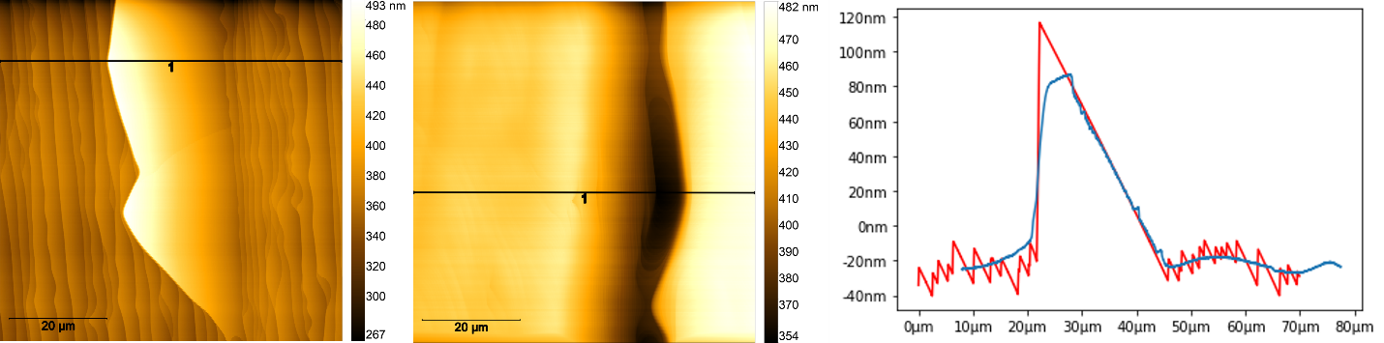
(c)
(b)

(a)
Figure S4 AFM topography images of the Si face (a) and C face (b) terrace in S3, with equivalent vertical profiles. (c) has the two topographical profiles shown on (a) and (b) overlaid, Si face profile is in red. The C face profile coordinates are negative the original so as to match the Si face orientation, re-creating the alignment during the growth. Both normalized to 0 average height.

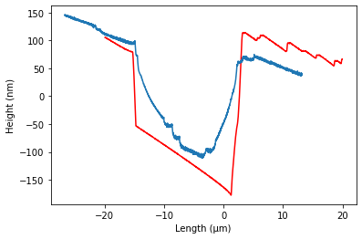
(c)
(b)
(a)
When the chips are flipped (C face is hotter), the Si face terrace is indented, and the C face terrace sticks
out, shown in Fig S5. If the previous process is correct, it’s possible the reverse happens here – material evaporates from the C face but either bounces off or slides to the side of the buffer portion, while growing new SiC on top of the steps around it. Once the steps reach the terrace’s height buffer covers them. Large steps built up on both sides of this terrace. This is sometimes seen on chips grown above 1730C and may Figure S5. (a) Si face and (b) C face terraces grown with the C face at a hotter temperature, with a crucible temperature of 1735C. (c) shows the two equivalent profiles overlaid, C face in blue. C face image and profile were flipped to match the Si face.

be caused by material growing on the buffer layer or SiC forming too fast for the buffer to cover it.
The growth of a buffer layer on the silicon face of the seed chip implies there is a net silicon loss from that chip at the interface – either to the C face chip or to the crucible. While measurements of the C face on some chips did find silicon, on others no silicon was found, making it unclear which loss route is more important.

We now analyze the various factors in this growth process.

Temperatures and times
The terrace size is primarily affected by temperature while the number of terraces (and therefore the overall buffer coverage) is affected by time. Note the total material flow required to form a terrace is quadratic in the terrace width (perpendicular to the natural step direction). The terraces’ size appears to saturate, while new terraces continue to form. As growth time increase, terraces cover nearly the entire chip, however they do not increase much in size.
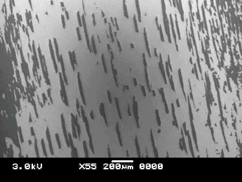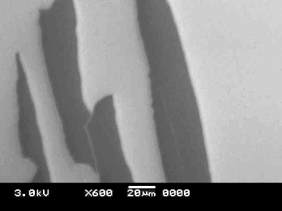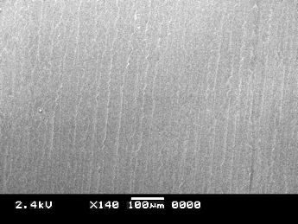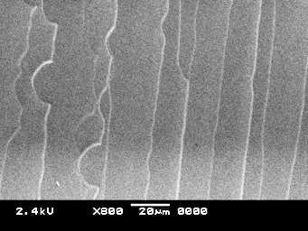
(a)
(b)
(c)
(d)

Figure S6. (a,b) show a sample grown for 1 hour at 1700C in horizontal furnace, with isolated buffer terraces. (c,d) show a sample grown for 8 hours at 1700C. (c) shows nearly complete buffer coverage. Both samples have terraces of about 20 microns. Scale bars are 200µm, 20µm, 100µm, and 20µm for (a), (b), (c), and (d) respectively.

After an 8-hour growth (S6c,d) we observed nearly complete buffer coverage and graphene was not observed anywhere in the chip interior. This agrees with quasi equilibrium buffer growth. The relatively uniform widths of the observed terraces implies that terraces grow to their maximum width rather quickly compared to the hour-long growth time, since we expect to see a proportion of partially grown terraces equal to the ratio of the individual terrace growth time over the total growth time. In addition, the ‘seeding’, or the start of new terrace formation, must be slow, and must be suppressed to get large terraces. If the seeding happens much faster than the terrace growth, then adjacent terraces will grow simultaneously and run into each other, which will stop their growth. Finally, while higher temperatures and temperature gradients can increase the terrace size, if these get too high, seeded SiC growth occurs across the terraces, the chip surfaces can become fused together, and while buffer is still found on much of the surface, it is not step free.
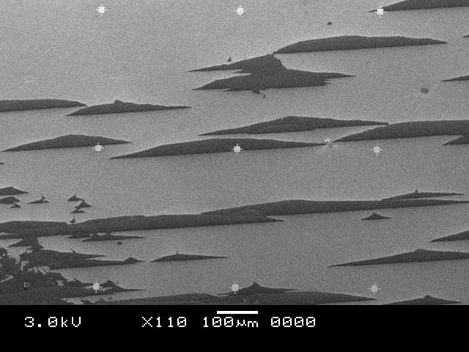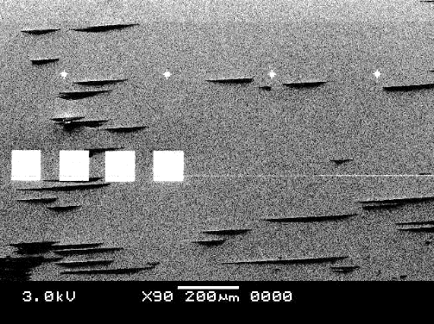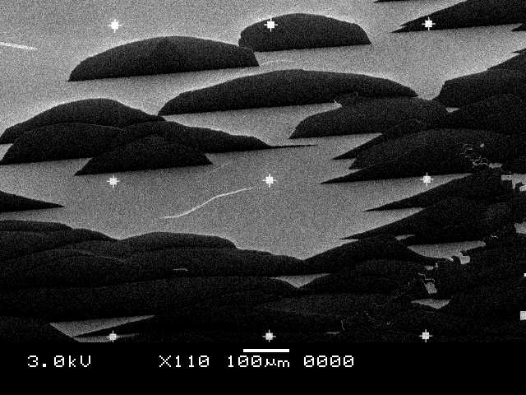
(b)
(c)
(d)
(e)
(a)
Figure S7. SEM Images of various sample growths in the vertical furnace. (a) Reference sample with low terrace growth and small size. Terrace density increases when time is increased by (b) one hour and (c) two hours. Terrace size increases with temperature when increased by (d) 25C and (e) 75C.

Si Saturation
Several face-to-face growths were done in a silicon saturated crucible created by melting a silicon piece into the graphite at 1500C. The terrace formation and buffer growth seem unaffected, the chips in figure S6 were grown with silicon saturation. The silicon face of the source ship forms buffer layer, similar to the single chip Si saturated growths in the main paper.
(c)
(b)
(a)

Figure S8. SEM images of growths completed in the vertical crucible with (a) sealed cap and (b,c) cap with 1mm hole. Scale bars are 100µm for (a) and (b) and 10µm for (c)

To lower the silicon vapor pressure outside of the chip interface, a hole was drilled in the cap of the vertical furnace crucible. What started as uniform terrace growth quickly turned into seeded silicon carbide growth. The original steps of the seed chip quickly formed a buffer layer halting step flow (Fig S8c). Material escapes too quickly from the source chip and deposits directly on the seed chip.

Miscut Angle
The wafer dicing cuts the surface at a slight angle to the (0001) plane, creating a somewhat even stepped surface. The miscut angle directly affects the growth of step free terraces since the higher the miscut, the more silicon carbide must flow to get the same terrace width. On the wafer with a 0.1% miscut (AI), large terraces were formed at 1600C. On the 0.4% miscut wafer (AJ), large terraces only started to form above 1650C, with best results at 1700-1735C.

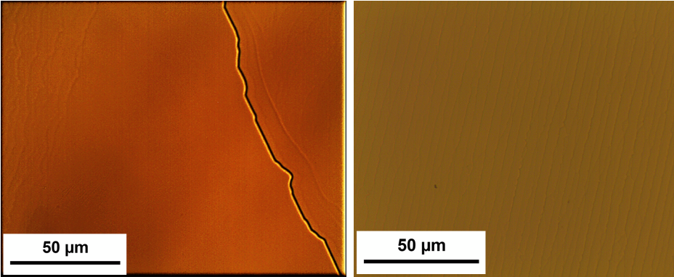
(b)
(a)

Fig S9. Optical images of chips grown face to face at 1600C for one hour. (a) chip is from a wafer with 0.1% miscut and (b) is from a wafer with 0.4% miscut.

Section 2 SEG growth in various face-to-face configurations

Jian Zhao, Peixun Ji, Yaqi Li, Rui Li, Kaiming Zhang, Hao Tian, Kaichen Yu, Boyue Bian, Luzhen Hao, Xue Xiao, Lei Ma

A comprehensive account of the SEG face-to-face production method and analysis

- Face-to-face configurations

SEG growth was accomplished in a variety of chip configurations. In the following tables the top row gives the placement and the polytypes involved. Measurements Seed chip (cooler of the two) are given. For example, in the left the column of measurements in Table 1, the Seed is the Si face of an N doped 6H polytype chip, and the source is the C-face of a 4H polytype N doped chip.

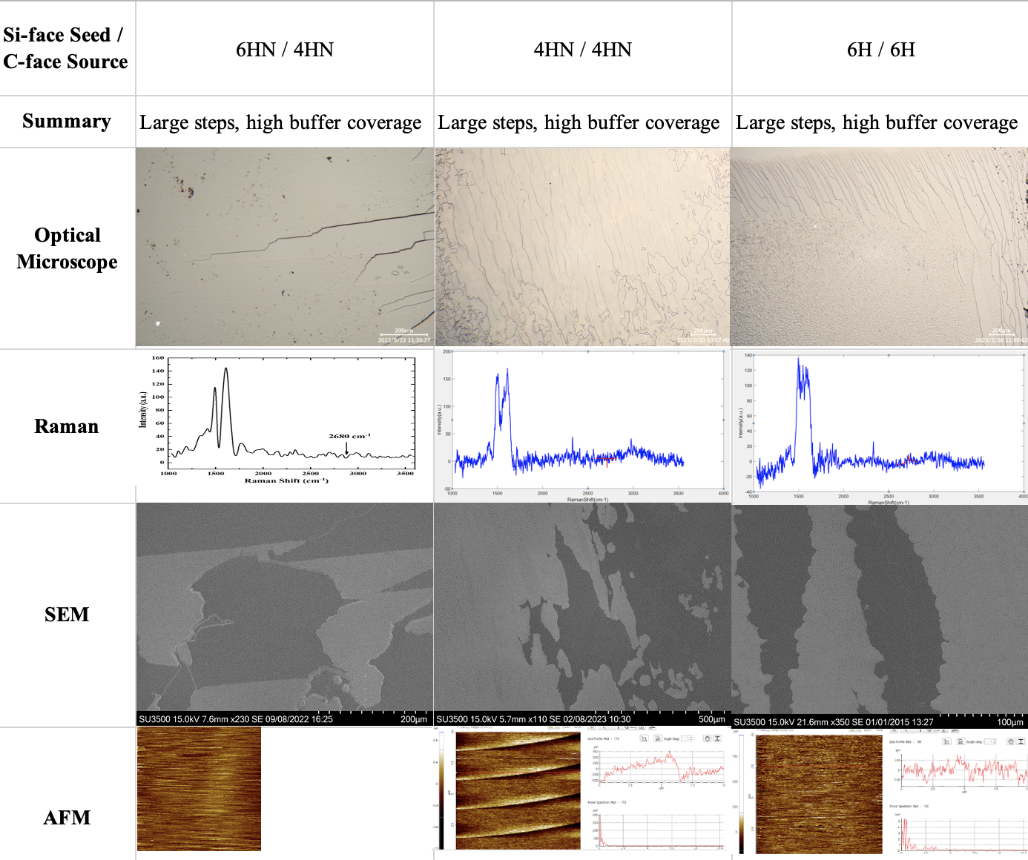

Table 1. Standard growths done with various SiC polytypes.
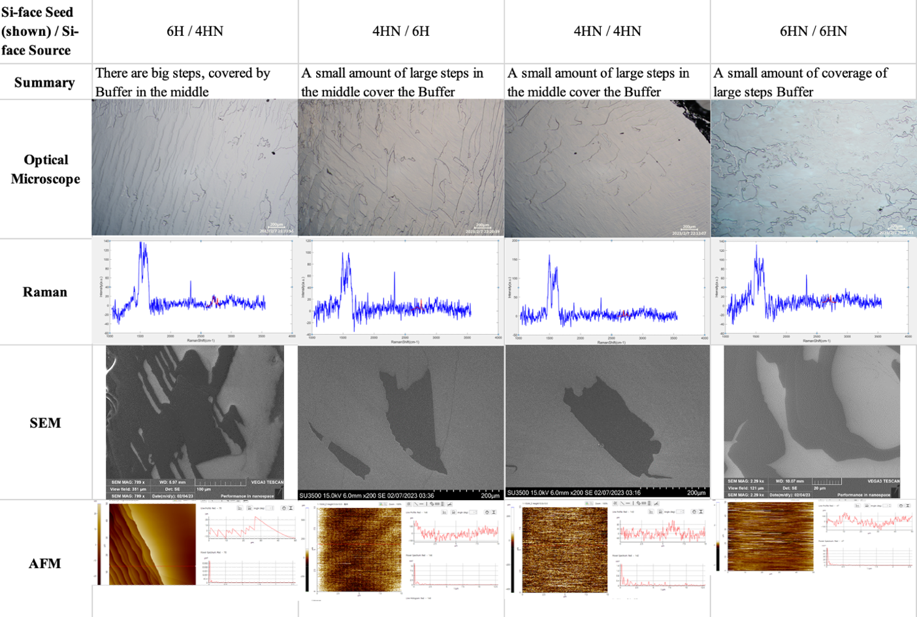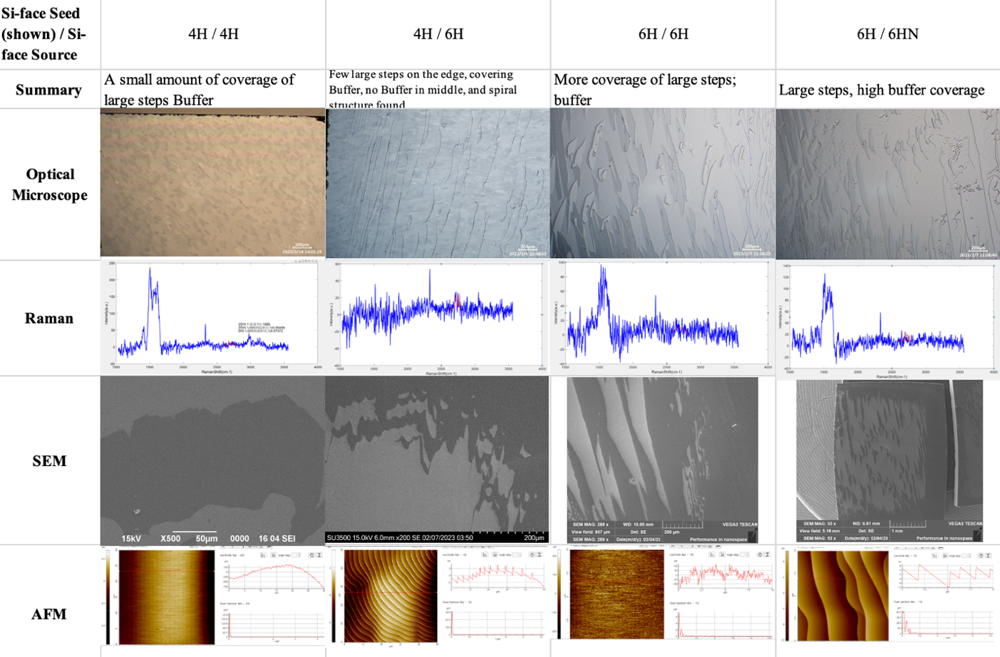

Table 2 top; Table 3 bottom 3. Si-face-to-Si-face growths done with various SiC polytypes.

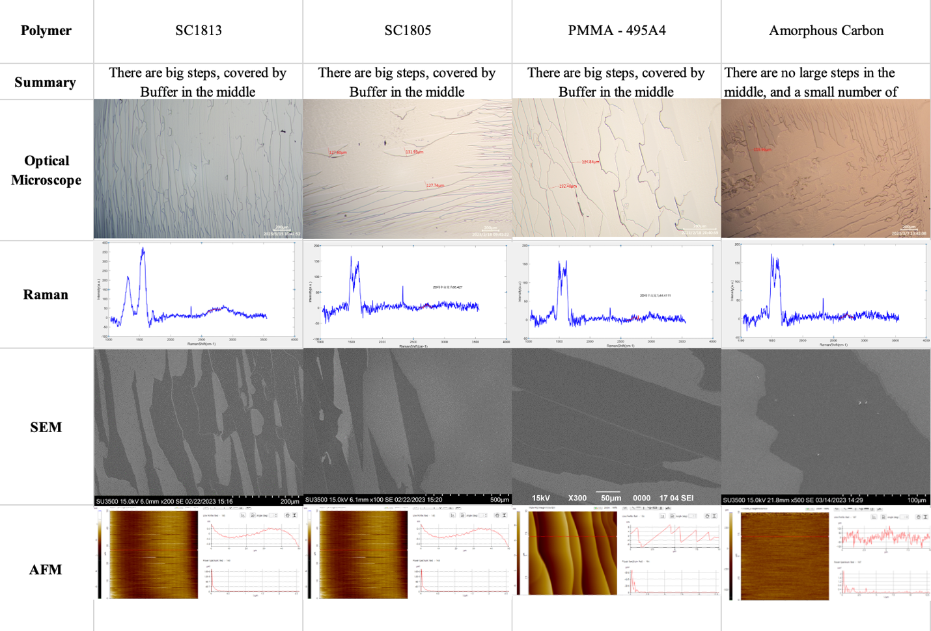

Table 4. Standard growths (Si face to C face) done with various polymers coating the silicon face of the source chip and the associated growth on the silicon face of the seed chip.

High SEG covered chips.
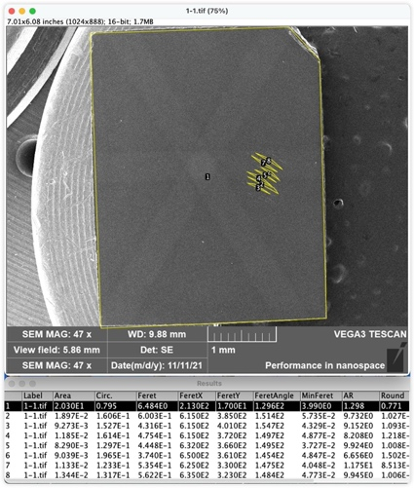
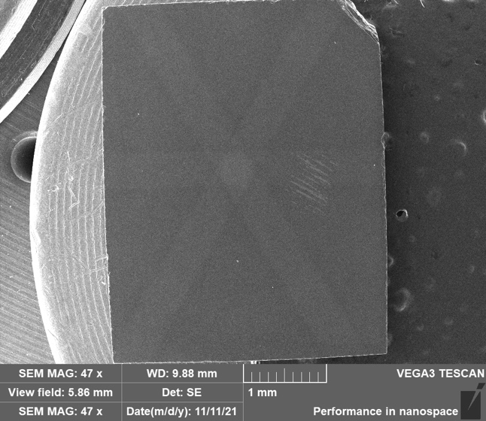
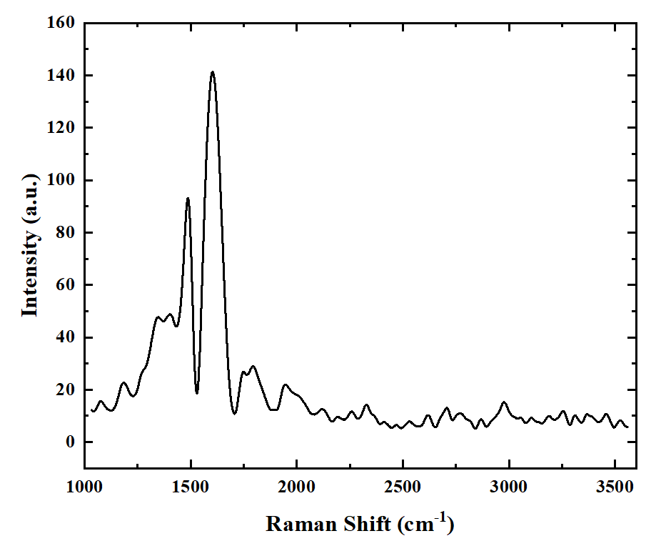
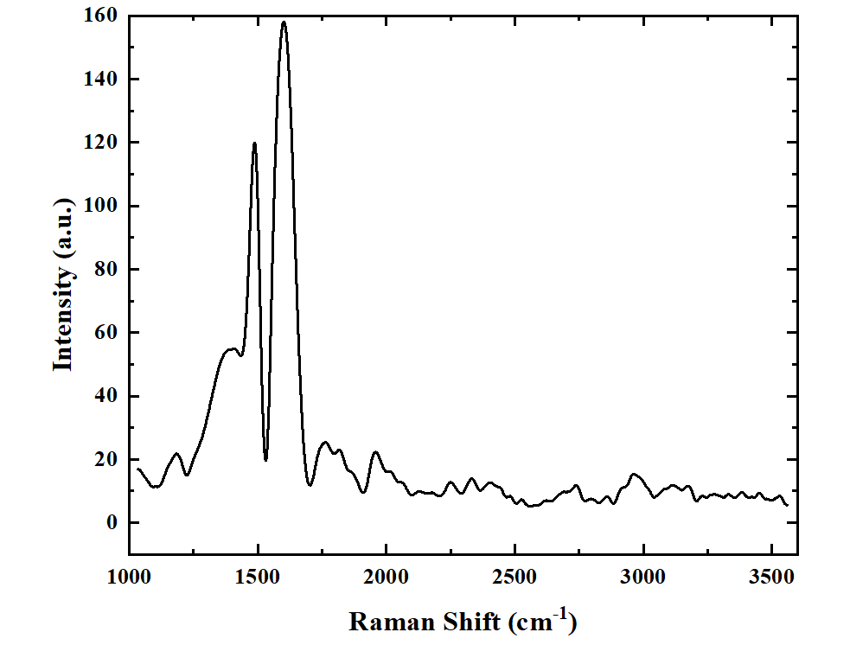
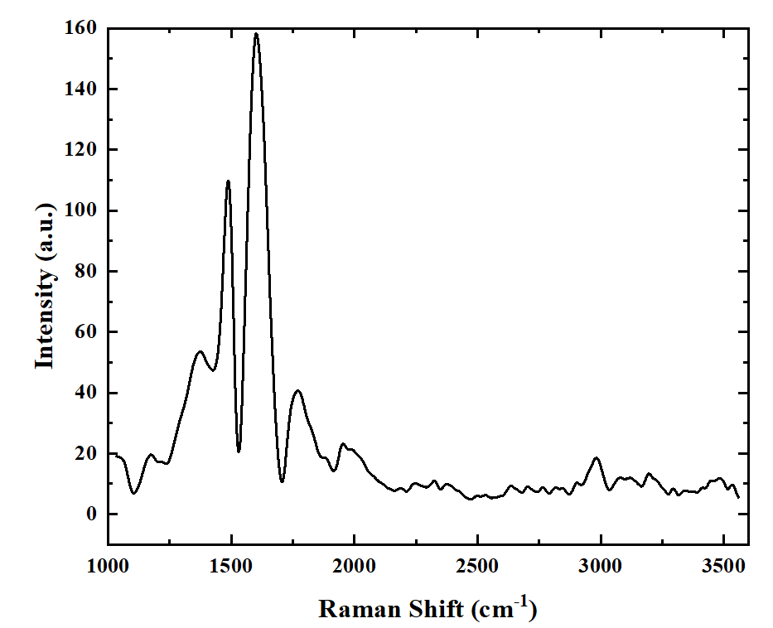
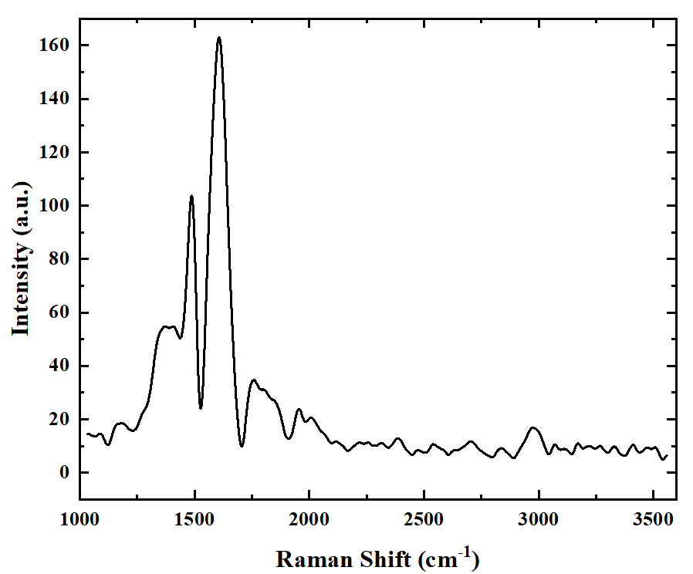
(a)
(b)
(c)
(d)
(e)
(f)

Figure S10. (a,b) SEM images of completely covered SEG samples with (c-f) sampled Raman spectra. The coverage rate of SEG was calculated using values at the bottom of (b) (20.3-0.019-0.009-0.0118-0.009-0.0113-0.01344)/20.3 = 99.63% coverage. The feature of this sample of that SEG patch is rather small.
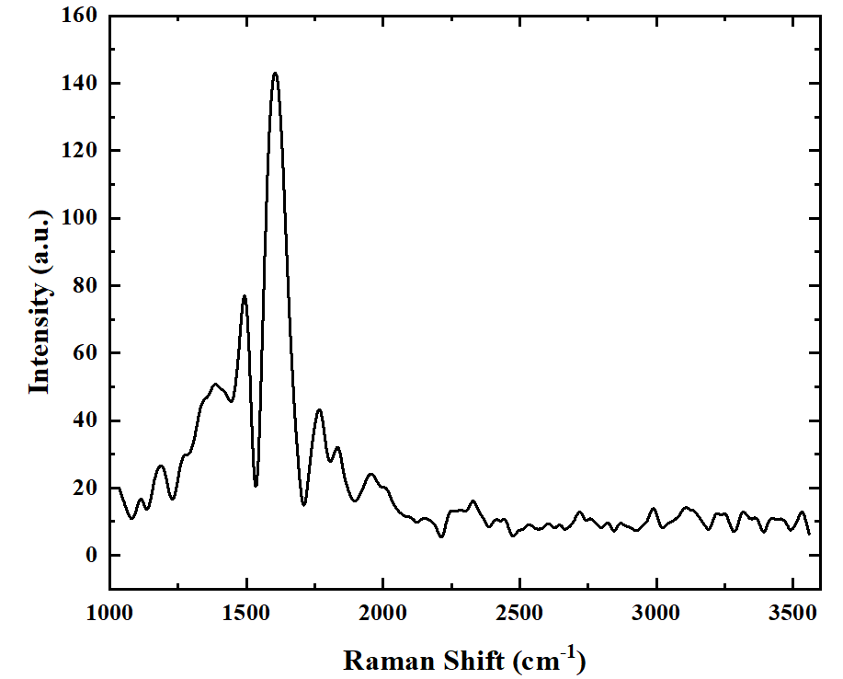
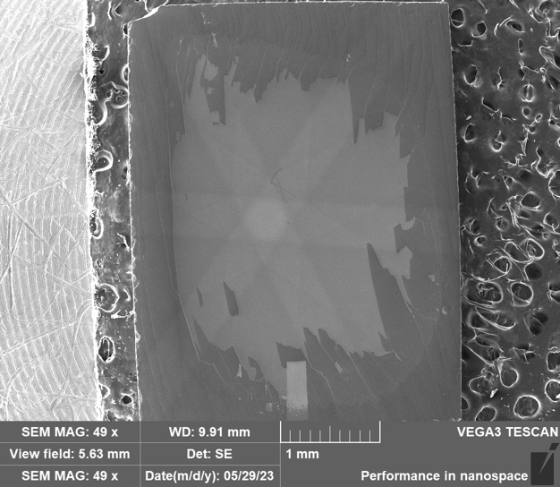
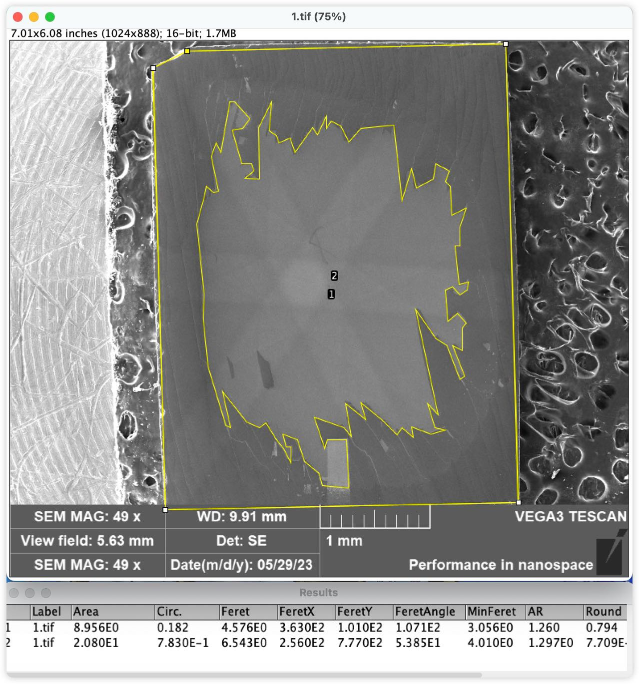
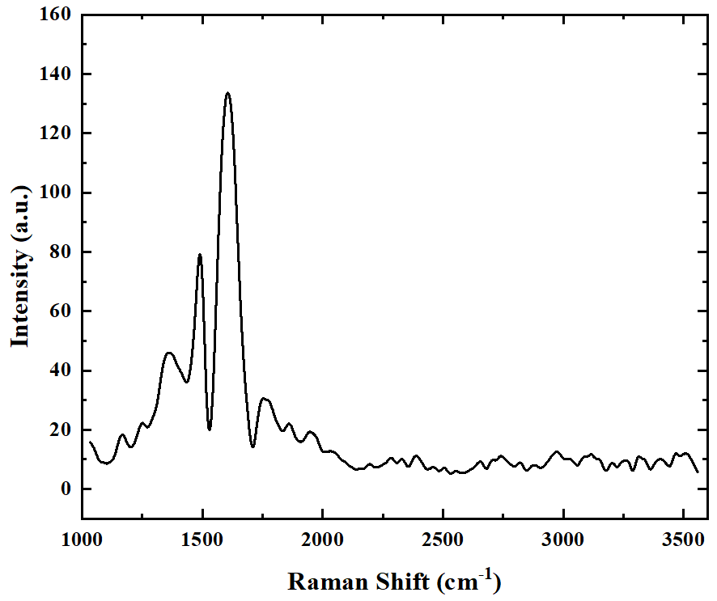
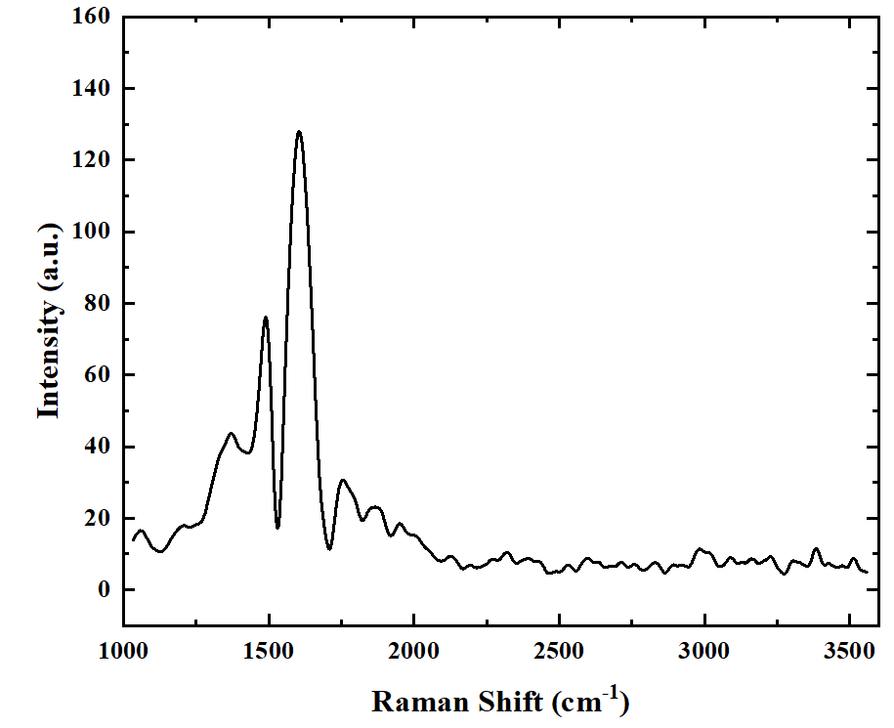
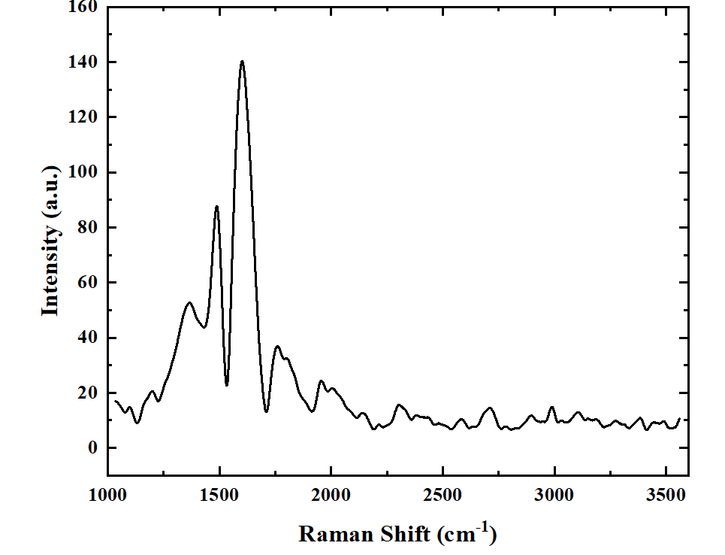
(a)
(b)
(c)
(d)
(e)
(f)

Figure S11. (a,b) SEM images highly covered SEG samples with (c-f) sampled Raman spectra. The coverage rate of SEG was calculated using values at the bottom of (b) (20.8-8.95)/20.8=56.97% percent coverage. The feature is that all SEG patch is on the order of several hundred micrometer. Dark areas are SEG, light areas are SiC.

Section 3 Excerpts from J-P Turmaud PhD thesis
Edited, selected excerpts from Jean Phillipe’s PhD thesis with the authors permission. Edits indicated by []. Here we contrast results from CCS buffer with SEG, clearly showing disorder in the former, leading to variable range hopping transport and low mobility SEG. Here we also demonstrate a seamless graphene/buffer/graphene device.
Variable Range Hopping Conduction in the Epitaxial Graphene Buffer Layer on SiC(0001)
Jean-Philippe Turmaud: [1]

Georgia Tech. June 2019

Face-to-Face growth
Step flow and step bunching naturally occur on the Si-face of SiC during graphene growth [2]. To gain a control of the step flow, amorphous carbon corrals have been proposed as a mean to pin the SiC surface during growth, forcing the steps to bunch at those carbon barriers and creating large flat terraces during graphene or buffer layer growth [3] . In a more general manner, promoting a large step bunching during or before graphene growth allows to produce large step free buffer layer areas. We adopted a method along those lines, referred to as ”face-to-face” annealing. It consists of stacking two (or more) pieces of SiC in a closed (no leak hole) graphite crucible, with their (0001) surfaces facing each other. Due to this confinement and the exchange of Si atoms from one surface to the other, graphene growth is inhibited up to at least 1700○ in an argon background pressure above 1 atm. Step flow and step bunching on the two (0001) surfaces are then largely promoted: Fig. S12 shows the result of such an annealing for two hours for (a) a 4○ off-axis SiC wafer and (b) an on-axis wafer. The smaller the miscut angle is, the larger the terraces can be obtained.
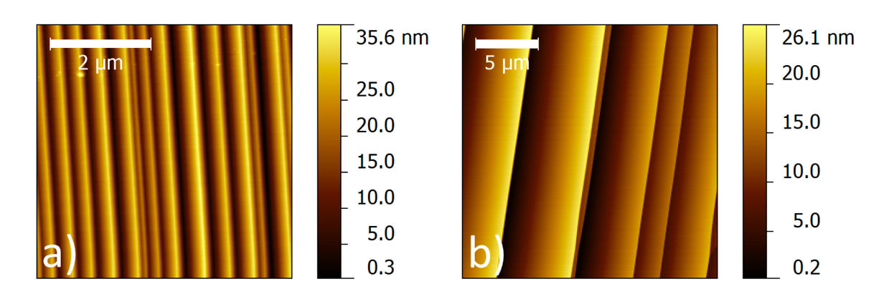
Figure S12: NC-AFM topography images of SiC surface after face-to-face annealing for a) 4○ off-axis 4H SiC and b) on-axis 4H SiC.
CCS production of the buffer layer
The buffer layer sample is grown at 1350◦ C for 30 minutes in a CCS furnace, like Fig. 1a (main text), where Si evaporates from the SiC surface, so that the surface becomes carbon rich and forms a buffer layer. In contrast to SEG growth, only a single SiC chip is used after the face-to-face treatment above, to produce 5 µm scale terraces.
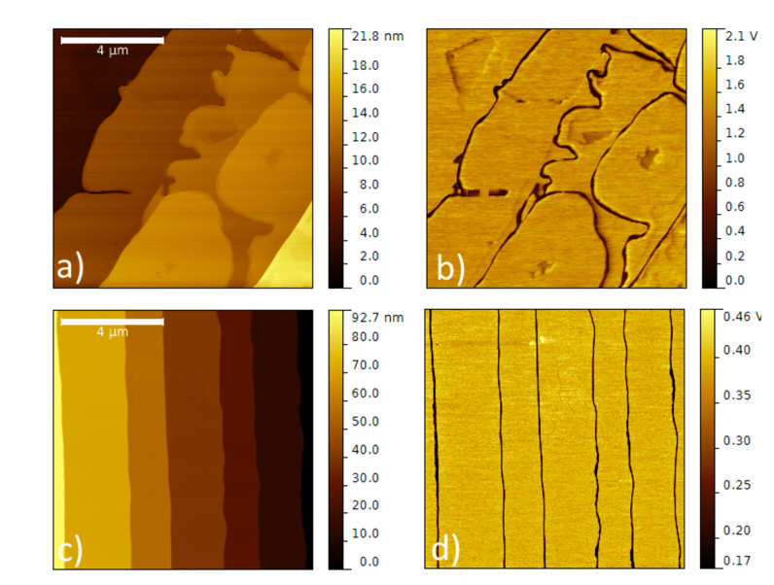
Figure S13: Fig. S13 a) and b) shows the meandering of steps due to the buffer growth process, and ”canyons” forming inside the terraces for steps averaging around 5 nm high. The surface structure has a much higher probability to be preserved when the steps are higher than 10 nm, as shown in Fig. S13 c) and d).
STM and STS of CCS produced buffer layer.

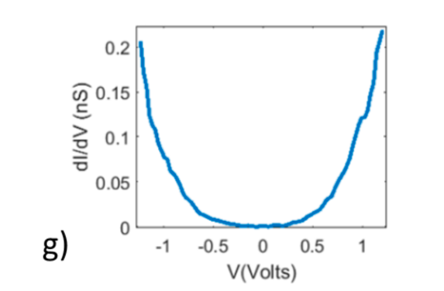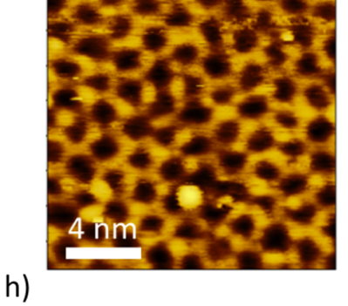

Figure S14: STS and STM images taken on the [CCS produced] buffer layer… . g) STS and h) STM tunneling voltage Vt=1V and current It=100pA .
Note the disorder in the STM image compare with Fig. 2a (Main text) and the large density of state in the band gap measured by STS. Similar results have been reported on free sublimation produced buffer layer by others [4] [5].
Graphene to buffer layer to graphene device
Single wall graphene ribbons (SWGNR) form on the sidewall of natural SiC steps [and etched trenches] [6]. These nanoribbons can be grown in a controlled manner and utilized as electrical leads to inject current in the buffer layer, as SWGNR are seamlessly connected to the buffer layer on top of the trenches Fig. S15 shows a proposed geometry for a top gated buffer layer device, where the channel is made of the buffer layer grown on top of an etched trench. The seamlessly connected SWGNRs act as source and drain for the device. Alternatively, devices can be built with Pd/Au contacts directly deposited on a SiC step free buffer layer area.

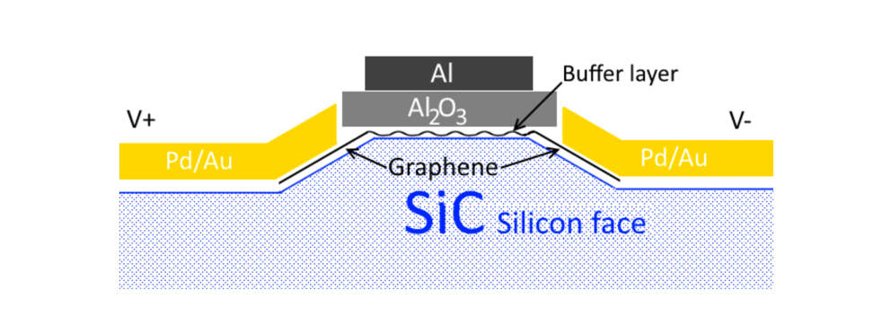
Figure S15: SWGNRs and buffer layer seamlessly connected in a top gated device geometry.

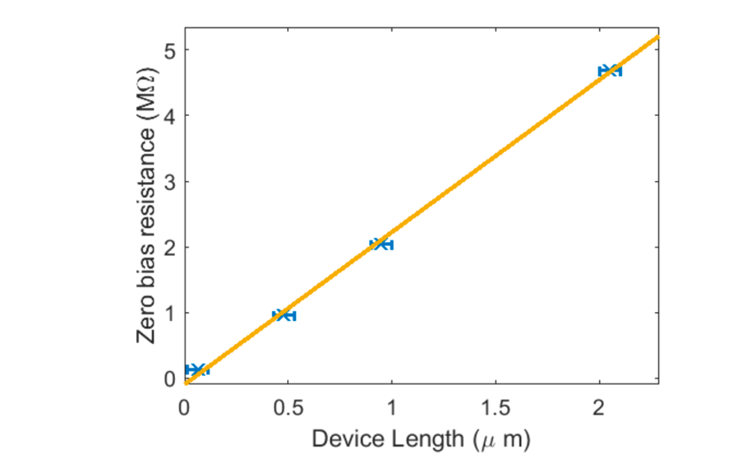
Figure S16: Zero bias resistance of a series of graphene contacted buffer layer devices (Fig. S15) plotted versus the length of the devices.
[2 point resistance measurements of several devices with 4µm wide buffer layer channels and several length show that] the resistance is clearly an increasing function of the channel length, and an estimate of the contact resistance can be extracted from the intercept at zero length. In both cases, it is virtually negligible compared to the 10 to 20 MΩ bulk resistivity (extracted from the slope).

Oxygen p-doping of the buffer layer
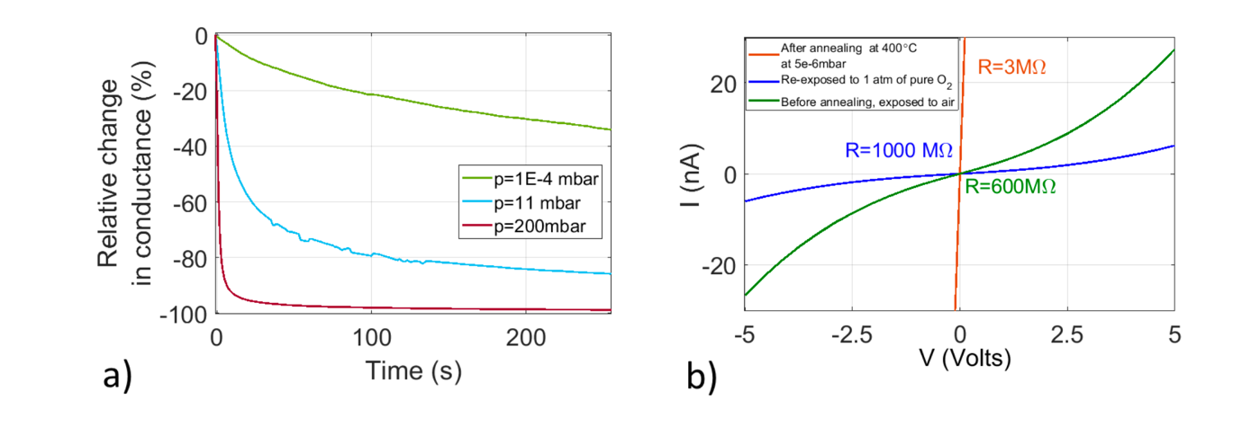Figure S17: Effect of oxygen adsorption on a metal contacted buffer layer device (Fig. S14). a) Relative change of conductance after introduction of oxygen at time t=0s. b) IV curves of the devices in different conditions.
A survey is performed to identified some of the gases influencing the buffer layer devices uncovered by any protective layer. The devices are first annealed in vacuum to desorb the loosely bound contaminants. Upon cooling down to room temperature, a constant bias voltage is applied to the two-terminal device and the current is measured with a lock-in over time. A certain pressure of pure gas is then introduced into the chamber as the current is still measured over time. The introduction of 99.999% pure nitrogen, helium, or hydrogen at room temperature does not affect the conductance of the devices at pressures up to several hundreds of millibar. However, Fig. 4.11a shows the relative change in conductance over time of a metal contacted buffer layer device when a pressure of 99.999% pure oxygen gas is introduced in the transport measurement chamber (probe station). Qualitatively, the rate of the process is an increasing function of the oxygen pressure.
Fig S17b shows the IV curves of the same device in air, after annealing in vacuum, and after exposure to 1 atm of oxygen until saturation of the conductance. The inset indicates the resistance at zero bias for each curve. The resistance is the highest for the sample exposed to 1 atm of pure oxygen. This shows that oxygen is most likely the main component of air influencing the behavior of buffer layer devices exposed to ambient conditions.
4.3.2 Gated devices
The change in conductance of buffer layer devices in response to the adsorption of gases indicates that the Fermi level is not pinned and can shift. In this section, we address the field effect in the devices by fabricating and measuring top gated buffer layer devices. A thin film of Al2O3 is deposited on top of SWGNR contacted buffer layer devices, as described in section 4.1.3. The film thickness is about 30 nm in total (10 nm deposited by thermal evaporation and 20 nm of ALD). A trilayer Al/Pd/Au is deposited and patterned on top of the devices to produce the gate metal. IV curves are recorded for different gate voltages and temperature. Fig. S18 shows how the current changes with the applied gate voltage in a top gated SWGNR contacted buffer layer device for temperatures between 50 K and 300 K. The bias voltage is held constant at 1 V. The measurement is performed in DC conditions. For temperatures under 50 K, the conduction is below the minimum current measurable by the Keithley 2400. A positive voltage applied on the gate enhances the current while a negative voltage reduces it, which is consistent with electrons being the charge carriers in the device. The highest current ratio between Vgate = -10 V and Vgate = 10 V is Ion/off = 20 at 100 K. The electron mobility μ can also be estimated using the relation:
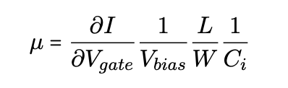
where L and W are the channel length and width, and Ci is the capacitance per unit area of the gate dielectric. In our case, Ci = 29.5 nFcm−2 for 30 nm thick Al2O3. The device is 1.2 μm long and 5 μm wide. From the measurement at 300K in Fig. 4.13, this gives a mobility μ = 0.97 cm2V−1s−1. As a comparison, the monolayer graphene grown on top of the buffer layer has a typical mobility μ > 1000 cm2V−1s−1. This poor mobility combined with a relatively low on/off ratio makes the as grown buffer layer a less than ideal candidate for transistor applications. The origin of the low mobility of the electrons is investigated in the rest of this chapter. [The transport is found to be dominated by variable range hopping, consistent with considerable disorder].
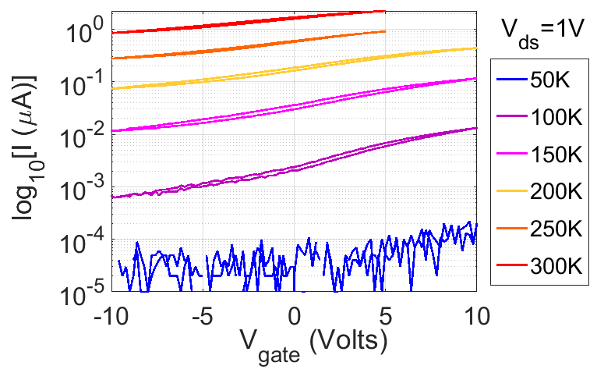
Figure S18: Log plot of the current versus gate voltage for Vbias = 1 V, measured at various temperatures.
References
1. Turmaud, J.-P., Variable range hopping conduction in the epitaxial graphene buffer layer on SiC(0001). Georgia Tech Library Archive, 2018: p. http://hdl.handle.net/1853/60254.
2. Borovikov, V. and A. Zangwill, Step bunching of vicinal $6H\text{-SiC}{0001}$ surfaces. Physical Review B, 2009. 79(24): p. 245413.
3. Palmer, J., et al., Controlled epitaxial graphene growth within removable amorphous carbon corrals. Applied Physics Letters, 2014. 105(2).
4. Goler, S., et al., Revealing the atomic structure of the buffer layer between SiC(0001) and epitaxial graphene. Carbon, 2013. 51: p. 249-254.
5. Rutter, G.M., et al., Imaging the interface of epitaxial graphene with silicon carbide via scanning tunneling microscopy. Physical Review B, 2007. 76(23): p. 235416.
6. Prudkovskiy, V.S., et al., An epitaxial graphene platform for zero-energy edge state nanoelectronics. Nature Communications, 2022. 13(1): p. 7814.

Section 4
TICNN Report. Jan. 4, 2022 (unpublished)

Towards super-large single domain graphene-like semiconductor

Jian Zhao, Peixun Ji , Yaqi Li , Rui Li , Kaiming Zhang , Hao Tian , Kaichen Yu, Boyue Bian, Luzhen Hao, Xue Xiao, Ramiro Moro, Lei Ma

Tianjin International Center for Nanoparticles and Nanosystems. Tianjin University. Tianjin. PR. China

Abstract

Achieving highly uniform large graphene domains with an open energy gap has long been a primary goal of graphene electronics research. The carbonaceous buffer layer, grown between SiC (0001) and epi-graphene, has been proven genuinely semiconducting or so called semiconductor graphene (SG). It is much easier to be functionalized than epi-graphene benefitting from its strong interactions with the substrate. In this work, we present a polymer - polar face - polar face method (PPP) that employs a polymer thin film assisted growth and realizes highly uniform SG flakes which reach a width of more than 200 µm and length of several millimeters on a SiC substrate. They are three orders larger than previously reported ones with very high quality and unipolar p-type semiconductivity. A prototype SG based top gate field effect transistor was made and reaches10⁴ on/off ratio and a mobility of 22.5 cm²V⁻¹s⁻¹.

Introduction
Silicon-based technology, which has almost perfectly followed the trend of Moore’s law in the past half century, undoubtedly will encounter physical and technical limits within the next decade, so it is pressingly needed to find successive materials to continue the advance in electronics [1-2]. Graphene has become a prominent subject of research in the fields of chemistry, physics, materials science, electronics and optical engineering owing to its exceptional and unique properties [3-15]. It already plays an important role in academic research and is predicted to have a £150 million market by 2022 [16]. However, there are still two major challenges: Engineering the 2D structures with suitable band gaps for electronic and photonic devices, and synthesizing high-quality graphene on an industrial scale [17-20]. Graphene has a linear gapless dispersion relation, and therefore exhibits metallic conductivity even in the limit of nominally zero carrier concentration [21]. The absence of a gap makes the design of transistors and other electrical on/off switching devices extremely challenging [8, 22], which is essential to make digital electronic circuits [23]. Several strategies to open the gap in graphene have been proposed, including functionalization by atom decorations [24-31], introducing defects [32-41], exploiting the interactions with substrates [43-46] and applying external fields [46-47]. Although these strategies provide several means to create and tune the gap, there are still some highly challenging hurdles need to be overcome [48]. Therefore, finding a graphene with intrinsic band gap is highly desirable [49].
Successful development of graphene-based electronic devices relies on the capability of a large-scale high quality graphene production [50]. More importantly, direct preparation of graphene on a desired dielectric substrate could completely resolve the problems of needing an additional transfer process [51]. Therefore, the technique of high-temperature decomposition of silicon carbide (SiC) by preferential atomic Si sublimation [52-55] is considered to be the most promising one. Where, SiC crystal acts as both substrate and precursor. In addition, SiC can be either conductive or semi-insulating, offering various options for electronic device architectures [56-57].
The question is: Is it possible to grow semiconducting graphene directly on an insulating substrate without additional treatment? A positive answer would have promising prospects for applications. Actually, the so called buffer layer has been recently proven to be a true semiconductor with a band gap of 0.5 - 1 eV [58-66], which is so called semiconductor graphene (SG). It is the first grown carbon-layer (6$\sqrt{\text{3}}$×6$\sqrt{\text{3}}$)R30° on the SiC and strongly bond to it (20%–30% bound to SiC) [58-59, 67-70] which is an intermediate step in synthesis of silicon face epi-graphene [60, 67, 71]. However, its size of electrically uniform domains is limited by the width of the terraces, which only extend up to a few microns. Besides, carrier scattering near vicinal steps and excess bilayer stripes also creates electrical inhomogeneity [72-74].
Since step flow control is the key for growing large terraces, several techniques have been proposed, including applying amorphous carbon corrals pining to bunch the steps to those barriers and create large terraces [75] and so-called “face to face” method limiting Si sublimation by forming a thin cavity between growing faces of stacked SiC substrates [76]. So far, the largest reported domain size of SG on SiC (0001) is not more than 10 µm in width and a few tens of µm in length [55,75-76].
Here, we report the success of a novel polymer assisted “face to face” method to grow super-large SG flakes three orders larger in area than the previously reported ones. Different from the conventional polymer-assisted sublimation growth (PASG) [77-78], the core of our method is using the underlying SiC substrate as a sacrificial layer and breeding ground assisted with an enhanced step bunching process with the decomposed polymer as carbonaceous resource. The method could be called “polymer - polar face - polar face” (PPP).

Experimental

The substrates used here are prepared by chemical mechanical polishing (CMP) of 6H/4H-SiC (0001) with miss-cut angles of no more than 0.5º. In order to study the factors that affect the growth of the terraces, two control experiments were conducted. One is to employ two different types of SiC (6H and 4H) to investigate the substrate effect and the other directly grows on the single crystal 6H-SiC substrate without polymer using the original face-to-face method [76]. All other conditions in the subsequent sample growth processes are kept the same in the three experiments.
Figure 1. Diagram of the PPP growth method. (a) SiC (0001) was homogeneously spin-coated with polymer (AZ5214) on one of its surfaces. (b) SG growth temperature as function of time (Growth process of super-large terraces, and atomic force microscopy (AFM) images of three stages).

As shown in figure 1(a), polymer AZ5214 diluted in isopropyl alcohol was uniformly spin-coated (4000 rpm, 45 seconds) on the surface of SiC (0001) to cover one side of a face-to-face substrate. Then it was rapidly transferred to a graphite crucible as shown in figure S5(a) where it faces the second substrate, which is not spin-coated. Notice that the spin coated side faces downward. This sandwich structure is composed of a polymer face - polar face - polar face.
In figure 1(b), the first stage of growth, the vacuum was 3.0×10⁻⁶ mbar and the temperature was maintained at 900 ºC for 30 mins when the polymer decomposes completely. In the second stage, within a flow of argon (400 sccm) at 1atm, the temperature is risen to 1300 ºC and kept for 20 minutes. Finally, SG patches are grown at 1540 ºC-1650 ºC for 60-120 minutes. More details can be found in the supporting information (SI).
Due to the high temperature and long annealing time, the morphology of the polymer coated Si-face of the bottom substrate becomes very rough. It serves as a carbon resource for the growth process on the top substrate. The resulting sample is cleaned by ultrasound for 30 minutes in acetone, ethanol, deionized water, and finally dried up by N₂ blowing.
The surface morphologies of the SG samples were characterized using an AFM (NX10 from Park Systems with 50×50 µm scanning range) in non-contact mode and scanning electron microscopy (SEM, Hitachi SU3500, 15kV). AFM topography revealed SG domain sizes that far exceeded the limit of the scanning area of the equipment, as shown in figure S4. The surfaces of the terraces demonstrate the desired atomic level uniformity for device fabrication. The high differentiation SEM images between SG and substrates allow the measurement of the dimension of the samples [79-81], as shown in figure 2(b) and figure 4(a, b, c). Friction of SG on terraces and steps was investigated by lateral force microscopy (LFM). The height of the super-large terraces was more than 100 nm, some even above 200 nm. LFM is able to accurately image the uniformity of terraces and differentiate the terraces from steps. The quality and homogeneity of single domain SG were characterized by a Raman spectrometer using a 532 nm laser with a lateral resolution of ~1 μm. Further scanning tunneling microscopy (STM) and scanning tunneling spectroscopy (STS) measurements confirm the authenticity of the SG and its intrinsic semiconductivity, as shown in figure 3.

Results and Discussion
Figure 2. (a) Schematic side view of SG (6H-SiC). (b) SEM image of a sample. (c) Raman spectra selected from three different areas of (b). (d) Raman spectra of the SG with fitting using four Gaussian functions.

Figure 2(a) shows a schematic side view of the SG. As the first graphitized layer, it is partially covalent with silicon (Si) atoms. Excess Si atoms have dangling bonds. Figure 2(b) shows an SEM image of the sample morphology. The dark area constitutes a uniform, wrinkle-free, impurity-free, and ultra-flat surface with a width of more than 200 µm. It is distinguishable from the bare SiC substrate, but a carbon-rich material, although whether this is epitaxial graphene or other matter is not confirmed yet at this point. The bare SiC substrate region shows light color, and the darker one corresponds to SG. Through adjusting the acceleration voltage (V_{acc}) and working distance (WD), better contrast can be achieved in the SEM images [81]. The calculated numerical contrast value (CV=0.44) inside the blue rectangle shows great consistence with the previous reported results of SG [81-82]. This demonstrates the capability of recognition of SEM, enabling terrace boundaries to be revealed, e.g. the red dotted line represents the boundary of a patch in figure 2(b). Raman spectra (obtained by subtracting a SiC spectrum from the experimental data) of three selected areas are shown in figure 2(c) corresponding to the pink, blue and purple rectangles in figure 2(b). The spectrum of the blue rectangle from the terrace is consistent with SG [83-84]. After subtraction of the bulk SiC signal, a four Gaussian-function fitting was applied as shown in figure 2(d). It has a broad peak around 1368 cm⁻¹ which corresponds to the D peak, two broad peaks around 1500 cm⁻¹ and 1611cm⁻¹ and a non-zero intensity is present between those two peaks [85]. Only the blue area has the SG featured signal, while the other two do not. For further investigation of the uniformity of the SG, the Raman mapping was applied on a 50×50 µm² area, as shown in figure S1. A rather constant value of the ${\text{I}}_{{\text{G}}_{\text{B}}}$ / ${\text{I}}_{{\text{D}}_{\text{B}}}$ in most of the area indicates the high homogeneity of SG.
Figure 3. (a) The quasi- (6 × 6) periodicity (red rhombus) of SG on SiC substrate is shown in STM morphology image (V = 1.72 V, I = 300 pA, Temperature = 12 K, Pressure = 2×10⁻¹⁰ mbar). The little green hexagons denote graphene honeycomb structure without defects. Moiré pattern is clearly observed in STM image (blue hexagons). (b) Fourier transformed image of the total charge density with the white dashed arrow pointing to diffraction points from SiC and solid white arrows to those 6$\sqrt{\text{3}}$ × 6$\sqrt{\text{3}}$-SG.

To complement the Raman spectroscopy measurements of the SG, further STM and STS measurements on those areas were conducted, as shown in figure 3. The quasi-(6×6)_{SiC} honeycomb periodicity of moiré pattern in STM image signals graphene-like SG without defects as shown in figure 3(a) [64]. The diffraction points of the Fourier transformed STM image exhibits 6$\sqrt{\text{3}}$ × 6$\sqrt{\text{3}}$-SG periodicity as demonstrated in figure 3(b) which is consistent with previously reported LEED results [86]. Further, the STS spectrum shows an intrinsic 1 eV bandgap as indicated in figure S2.
Further LFM investigation has been conducted on the sample, again which demonstrates the uniformity of the terraces, consistent with the Raman measurements, more details can be found in SI. This evidences the realization of a 200 µm wide and several millimeters long monolayer single crystal SG patch, which is more than 3 orders larger in area than previously reported as shown in figure 2(b) and figure 5(b) [55, 75-76].
Figure 4. SG grown on 6H-SiC and 4H-SiC. (a) SEM image of SG grown on 6H-SiC. (b) Close-up SEM image of SG from the red dotted box in (a). (c) Image of SG grown on 4H-SiC. (d) AFM image of the SG grown on 6H-SiC without polymer (the terraces were too small to be observed with SEM).

In order to unveil the mechanism of super-large terraces formation, two control experiments were conducted. SEM images of SG grown on 6H-SiC are displayed in figure 4(a), (b), which show stripes with length of millimeters span. As discussed above, the light-colored area is bare SiC, and the dark part is SG, with stripes widths over 100 µm which were characterized by Raman spectra measurements. Figure 4(c) shows overall and local morphologies of the sample on 4H-SiC. It is found that the width of the SG stripe (terrace) was significantly reduced. Statistics of multiple samples (4H-SiC) show that the width of the terraces do not exceed 50 µm, which were obtained under the same growth conditions as the 6H-SiC. It implies the influence of different decomposition energies of those two polytype materials to the SG growth [87].
The results with conventional face to face method without polymer on 6H-SiC are shown in figure 4(d), which was similar to the ones reported before [76]. These results can be understood by the rule that large miss-cuts form larger step bunching [88-90]. However, 6H-SiC with polymer assistance larger miss-cut produces larger terraces, which indicates the essential role of polymer addition for promoting the step bunching.
The mechanism of the large-domain SG growth can be tentatively interpreted as follows: Different from the conventional "face-to-face" method, instead of stacking Si terminated face (STF) to STF, we put the carbon terminated face (CTF) on top of STF; Since the sublimation rate of silicon atoms from CTF is higher than that of STF, it will be much faster to reach Si saturation in the gap between CTF and STF than that of STF and STF. This is very similar to the case of epitaxial graphene growth in an argon (Ar) atmosphere. More detailed discussion of growth process can be found in SI
In this way, the amount of carbon precipitation will be largely limited, so the interface reconstruction is first dominated by Induced Giant Steps (IGS), and this promotes step bunching. At the same time, the organic matter of the lower face is decomposed into carbon-containing material, which will be transported to the upper face of the sample by Ar. The rapidly formed SG will inhibit step bunching and hinders surface reconstruction. It is evidenced by the absence of featured Raman signal of SG at the step indicating the Terrace Nucleation (TN) instead of Step Nucleation (SN).
The presence of polymer may cause the following two effects. First is that polymer participates in the second stage of morphological reconstruction, and these uniform atomic steps are the basis for the formation of subsequent large terraces; also the remained decomposition material is transported to the interface of the two substrates with Ar as the carrier gas, which influences the nucleation and growth of the subsequent SG. This is consistent with the report of SiC morphology reconstruction with large miss-cut [91]. The combination of the double restriction of Si sublimation and large miss-cut makes it difficult to have carbon-containing materials to nucleate along the steps, making the terrace continue to grow. Figure S5(c) shows that the direction of the argon flow outside the graphite crucible is perpendicular to the growth direction of the terrace. This implies that the growth of the terrace may be affected by other factors. The issue of completing the full mechanism of the process is not closed yet.

Figure 5. (a) Schematic of field effect transistor with SG as channel. (b) Transfer characteristics (I_{ds}-V_{gs}) at bias voltage of 0, 1 and 2 V. (c) Transfer characteristic curve of the device at V_{ds}=1 V and corresponding logarithmic plot. (d) Output characteristic curves of the device.

The electrical properties of the SG were measured by characterizing a fabricated top-gated monolayer SG field-effect transistor (more details can be seen in SI). Figure 5(a) shows a schematic drawing of a SG field-effect transistor (FET). The transfer curves are plotted in figure 5(b) with V_{ds} of 0, 1.0 and 2.0 V. The device displayed unipolar conduction and typical p-type behavior. As V_{ds} increases, both I_{on} and I_{off} monotonically rise. As shown in Figure 5(c), the device exhibits excellent switching performance with an on/off ratio of ∽10⁴ at V_{ds}=1 V and I_{on}=15 nA, which is similar to the FET made of 7-armchair graphene nanoribbons[92]. The threshold voltage (V_{Th}) is -0.21 V which is extracted by extrapolating the linear regime of the transfer curve to the gate voltage axis. The subthreshold swing (SS) calculated using the expression SS=dV_{gs} / d(logI_{ds}) is 155 mV·dec⁻¹[23]. Figure 5(d) shows the output curve of the device. There is a Schottky barrier (SB), which is noticeable from the non-linear behavior of I_{ds} at high V_{ds}. Improving the metal contacts and quality of dielectric layer may further enhance the device performance.

Conclusion
Here, we demonstrate a newly developed PPP method that can successfully grow uniform single-crystalline SG with an unprecedented large size of several hundred micrometers by several millimeters. It also indicates a dependence of the maximum patch size to the substrate polytype. The PPP method opens a door for the growth of semiconducting epi-graphene thin films as large as the size of CVD single-domain graphene but without need of catalysis and extra transfer procedures for following up electronics device fabrication. A 0.21 V gating threshold and 10⁴ switching ratios of SG FET indicate its great potential for electronic device applications. Although the mobility of the presently obtained SG is still rather low (22 cm²V⁻¹s⁻¹), prospectively, further atomic intercalation could turn the SG into quasi-free-standing graphene, where much higher mobility is expected.

References

[1] A. Lanzara. Graphene Gets a Good Gap. Physics, 8, 91 (2015).
[2] K. S. Novoselov, et. al. A roadmap for graphene. Nature, 490, 192–200 (2012).
[3] K. S. Novoselov, et. al. Electric field effect in atomically thin carbon films. Science, 306, 666–669 (2004).
[4] A. K. Geim, K. S. Novoselov. The rise of graphene. Nat. Mater., 6, 183–191 (2007).
[5] C. Lee, et. al. Measurement of the Elastic Properties and Intrinsic Strength of Monolayer Graphene. Science, 321, 385–388 (2008).
[6] A. A. Balandin. Thermal properties of graphene and nanostructured carbon materials. Nat. Mater., 10, 569–581 (2011).
[7] F. Guinea, M. I. Katsnelson, A. K. Geim. Energy gaps and a zero-field quantum Hall effect in graphene by strain engineering. Nat. Phys., 6, 30–33 (2010).
[8] M. I. Katsnelson, K. S. Novoselov, A. K. Geim. Chiral tunnelling and the Klein paradox in graphene. Nat. Phys., 2, 620–625 (2006).
[9] Z. Lin, et. al. Competing Gap Opening Mechanisms of Monolayer Graphene and Graphene Nanoribbons on Strong Topological Insulators. Nano Lett., 17, 4013–4018 (2017).
[10] Y. W. Tan, et. al. Measurement of Scattering Rate and Minimum Conductivity in Graphene. Phys. Rev. Lett., 99, 246803 (2007).
[11] K. Sugihara, K. Kawamura, T. Tsuzuku. Temperature Dependence of the Average Mobility in Graphite. J. Phys. Soc. Japan, 47, 1210-1215 (1979).
[12] J. H. Chen, et. al. Charged-impurity scattering in graphene. Nature Phys., 4, 377 (2008).
[13] C. Jang, et. al. Tuning the Effective Fine Structure Constant in Graphene: Opposing Effects of Dielectric Screening on Short-and Long-Range Potential Scattering. Phys. Rev. Lett., 101, 146805 (2008).
[14] M. Ishigami, et. al. Atomic Structure of Graphene on SiO₂. Nano Lett., 7,1643-1648 (2007).
[15] J. H. Chen, et. al. Intrinsic and extrinsic performance limits of graphene devices on SiO₂. Nat. Nanotechnol., 3 206-209 (2008).
[16] Graphene Market (Mono-Layer & Bi-Layer Graphene, Few Layer Graphene, Graphene Oxide and Graphene Nano Platelets) for Composites, Energy Storage, Electronics and Others Applications: Global Industry Perspective, Comprehensive Analysis, and Forecast, 2016–2022 (Zion Market Research, 2017).
[17] F. Qing, et. al. Catalytic substrates for graphene growth. MRS Bull., 42, 819-824 (2017).
[18] D. Luo, et. al. Adlayer-Free Large-Area Single Crystal Graphene Grown on a Cu (111) Foil. Adv. Mater., 31, 1903615 (2019).
[19] S. Sahu, G. C. Rout. Band gap opening in graphene: a short theoretical study. Int. Nano Lett., 7, 81–89 (2017).
[20] X. Z. Xu, et. al. Interfacial engineering in graphene bandgap. Chem. Soc. Rev., 47, 3059-3099 (2018).
[21] K. Novoselov. Mind the gap. Nature Mater., 6, 720–721 (2007).
[22] A. H. Castro Neto, et. al. The electronic properties of graphene. Rev. Mod. Phys., 81, 109–162 (2009).
[23] F. Schwierz. Graphene transistors. Nat. Nanotechnol., 5, 487–496 (2010).
[24] C. F. Lin, et. al. Direct Observation of Ordered Configurations of Hydrogen Adatoms on Graphene. Nano Lett., 15, 903–908 (2015).
[25] D. K. Samarakoon, X. Q. Wang. Tunable Band Gap in Hydrogenated Bilayer Graphene. ACS Nano, 4, 4126–4130 (2010).
[26] J. Balakrishnan, et. al. Colossal enhancement of spin–orbit coupling in weakly hydrogenated graphene. Nat. Phys., 9, 284–287 (2013).
[27] D. K. Samarakoon, et. al. Structural and Electronic Properties of Fluorographene. Small, 7, 965–969 (2011).
[28] K. J. Jeon, et. al. Fluorographene: A Wide Bandgap Semiconductor with Ultraviolet Luminescence. ACS Nano, 5, 1042–1046 (2011).
[29] A. N. Enyashin, A. L. Ivanovskii. Layers and tubes of fluorographene C₄F: Stability, structural and electronic properties from DFTB calculations. Chem. Phys. Lett., 576, 44–48 (2013).
[30] Z. P. Xu, K. Xue. Engineering graphene by oxidation: a first-principles study. Nanotechnology, 21, 045704 (2010).
[31] N. T. T. Tran, et. al. Adatom doping-enriched geometric and electronic properties of pristine graphene: a method to modify the band gap. Struct. Chem., 28, 1311–1318 (2017).
[32] P. Kim. Across the border. Nat. Mater., 9, 792–793 (2010).
[33] O. V. Yazyev, Y. P. Chen. Polycrystalline graphene and other two-dimensional materials. Nat. Nan0otechnol., 9, 755–767 (2014).
[34] O. V. Yazyev, S. G. Louie. Electronic transport in polycrystalline graphene. Nat. Mater., 9, 806–809 (2010).
[35] R. B. Kaner, et. al. Boron-carbon-nitrogen materials of graphite-like structure. Mater. Res. Bull., 22, 399–404 (1987).
[36] A. Lherbier, et. al. Charge Transport in Chemically Doped 2D Graphene. Phys. Rev. Lett., 101, 036808 (2008).
[37] Y. W. Son, M. L. Cohen, S. G. Louie. Half-metallic graphene nanoribbons. Nature, 444, 347–349 (2006).
[38] D.V. Kosynkin, et. al. Longitudinal unzipping of carbon nanotubes to form graphene nanoribbons. Nature, 458, 872–876 (2009).
[39] J. M. Cai, et. al. Atomically precise bottom-up fabrication of graphene Nanoribbons. Nature, 466, 470–473 (2010).
[40] J. M. Cai, et. al. Graphene nanoribbon heterojunctions. Nat. Nanotechnol., 9, 896–900 (2014).
[41] Z. N. Lin, et. al. Competing Gap Opening Mechanisms of Monolayer Graphene and Graphene Nanoribbons on Strong Topological Insulators. Nano Lett., 17, 4013–4018 (2017).
[42] R. Raccichini, et. al. The role of graphene for electrochemical energy storage. Nat. Mater., 14, 271–279 (2015).
[43] A. Varykhalov, et. al. Tunable Fermi level and hedgehog spin texture in gapped graphene. Nat. Commun., 6, 7610 (2015).
[44] G. Bertoni, et. al. First-principles calculation of the electronic structure and EELS spectra at the graphene/Ni (111) interface. Phys. Rev. B: Condens. Matter Mater. Phys., 71, 075402 (2005).
[45] S. J. Zhu, et. al. The photoluminescence mechanism in carbon dots (graphene quantum dots, carbon nanodots, and polymer dots): current state and future perspective. Nano Res., 8, 355–381(2015).
[46] E. V. Castro, et. al. Biased Bilayer Graphene: Semiconductor with a Gap Tunable by the Electric Field Effect. Phys. Rev. Lett., 99, 216802 (2007).
[47] K. F. Mak, et. al. Observation of an Electric-Field-Induced Band Gap in Bilayer Graphene by Infrared Spectroscopy. Phys. Rev. Lett., 102, 256405 (2009).
[48] B. S. Jessen, et. al. Lithographic band structure engineering of Graphene. Nat. Nanotechnol., 14, 340–346 (2019).

[49] J. Park, et. al. Observation of the intrinsic bandgap behaviour in as-grown epitaxial twisted graphene. Nat. Commun. 6, 5677 (2015).
[50] X. Sun, et. al. Low-temperature and Rapid Growth of Large Single-crystalline Graphene with Ethane. Small, 14(3), 1702916 (2018).
[51] X. Chen, B. Wu, Y. Q. Liu. Direct preparation of high quality graphene on
dielectric substrates, Chem. Soc. Rev., 45, 2057 (2016).
[52] C. Berger, et. al. Electronic confinement and coherence in patterned epitaxial graphene, Science, 312, 1191–1196 (2006).
[53] T. Ohta, et. al. Controlling the electronic structure of bilayer graphene, Science, 313, 951–954 (2006).
[54] C. Riedl, et. al. Structural properties of the graphene-SiC (0001) interface as a key for the preparation of homogeneous large-terrace graphene surfaces. Phys. Rev. B, 76, 245406 (2007).
[55] K. V. Emtsev, et. al. Towards wafer-size graphene layers by atmospheric pressure graphitization of silicon carbide. Nat. Mater., 8, 203–207 (2009).
[56] B. Ziaie, A. Baldi, M. Atashbar. Introduction to micro/nanofabrication, in Springer Handbook of Nanotechnology, B. Bhushan (Ed.), Springer-Verlag Berlin Heidelberg 231–269, (2007).
[57] C. Riedl, C. Coletti, U. Starke. Structural and electronic properties of epitaxial of epitaxial graphene on SiC (0001): A review of growth, characterization, transfer doping and hydrogen intercalation. J. Phys. D Appl. Phys., 43, 374009 (2010).
[58] S. Goler, et. al. Revealing the atomic structure of the buffer layer between SiC (0 0 0 1) and epitaxial graphene. Carbon, 51, 249 (2013).
[59] M. S. Nevius, et. al. Semiconducting Graphene from Highly Ordered Substrate Interactions. Phys. Rev. Lett., 115, 136802 (2015).
[60] T. Cavallucci, V. Tozzini. Intrinsic structural and electronic properties of the Buffer Layer on Silicon Carbide unraveled by Density Functional Theory. Sci. Rep., 8,13097 (2018).
[61] J. Baringhaus, et. al. Exceptional ballistic transport in epitaxial graphene nanoribbons. Nature, 506, 349-354 (2014).
[62] J. Baringhaus, et. al. Growth and characterization of sidewall graphene nanoribbons. Appl. Phys. Lett. 106, 043109 (2015).
[63] M. Conrad, et. al. Wide Band Gap Semiconductor from a Hidden 2D Incommensurate Graphene Phase. Nano Lett.,17, 341−347 (2017).
[64] M. N. Nair, et. al. Band Gap Opening Induced by the Structural Periodicity in Epitaxial Graphene Buffer Layer. Nano Lett., 17, 2681−2689 (2017).
[65] M. Conrad, et. al. Structure and evolution of semiconducting buffer graphene grown on SiC (0001). Phys. Rev. B, 96, 195304 (2017).
[66] S. Kolev, et. al. Band gap modulation of graphene on SiC. Eur. Phys. J. B 91, 272 (2018).
[67] K. V. Emtsev, et. al. Interaction, growth, and ordering of epitaxial graphene on SiC {0001} surfaces: A comparative photoelectron spectroscopy study. Phys. Rev. B, 77, 155303 (2008).
[68] W. Strupinski, et. al. Formation mechanism of graphene buffer layer on SiC (0 0 0 1). Carbon., 81, 63-72 (2015).
[69] C. Riedl, et. al. Quasifree-standing epitaxial graphene on SiC obtained by hydrogen intercalation. Phys. Rev. Lett., 103, 246804 (2009).
[70] G. Sclauzero, A. Pasquarello. Carbon rehybridization at the graphene/SiC (0001) interface: Effect on stability and atomic-scale corrugation. Phys. Rev. B, 85, 161405 (2012).
[71] D. A. Schmidt, T. Ohta, T. E. Beechem. Strain and charge carrier coupling in epitaxial graphene. Phys. Rev. B, 84, 235422 (2011).
[72] P. Mallet, et. al. Electron states of mono- and bilayer graphene on SiC probed by scanning-tunneling microscopy. Phys. Rev. B 76, 04140, 2007.
[73] S. H. Ji, et. al. Atomic-scale transport in epitaxial graphene. Nat. Mater., 11, 114–119 (2012).
[74] C. Shen, et. al. Criteria for the growth of large-area adlayer-free monolayer graphene films by chemical vapor deposition. J. Materiomics, 5 (2019) 463-470.
[75] J. Palmer, et. al. Controlled epitaxial graphene growth within removable amorphous carbon corrals. Appl. Phys. Lett., 105, 023106 (2014).
[76] X. Yu, et. al. New synthesis method for the growth of epitaxial graphene. J. Electron Spectros. Relat. Phenomena, 184, 36, 100-106, (2011).
[77] M. Kruskopf, et. al. Comeback of epitaxial graphene for electronics: large-area growth of bilayer-free graphene on SiC. 2D Mater., 3, 041002 (2016).
[78] D. M. Pakdehi, et. al. Minimum Resistance Anisotropy of Epitaxial Graphene on SiC. ACS Appl. Mater. Interfaces, 10, 6039−6045 (2018).
[79] A. W. Robertson, J. H. Warner. Hexagonal Single Crystal Domains of Few-Layer Graphene on Copper Foils. Nano Lett., 11, 1182-1189 (2011).
[80] Y. B. Zhou, et. al. Quantitative secondary electron imaging for work function extraction at atomic level and layer identification of graphene. Sci. Rep. 6, 21045 (2016).
[81] Li Huang, et. al. High-Contrast SEM Imaging of Supported Few-Layer Graphene for Differentiating Distinct Layers and Resolving Fine Features: There is Plenty of Room at the Bottom. Small, 14, 1704190 (2018).
[82] J. I. Goldstein, et. al. Scanning Electron Microscopy and X-ray Microanalysis. Fourth Edition, Klewer Academic/Plenum, New York 2003
[83] L. M. Malarda, et. al. Raman spectroscopy in graphene. Phys. Rep., 473, 51-87 (2009).
[84] J. Kunc, et. al. A method to extract pure Raman spectrum of epitaxial graphene on SiC. Appl. Phys. Lett., 103, 201911 (2013).
[85] F. Fromm, et. al. Contribution of the buffer layer to the Raman spectrum of epitaxial graphene on SiC (0001). New J. Phys. 15 043031 (2013).
[86] A. V. Bommel, J. Crombeen, A. V. Tooren. LEED and Auger electron observations of the SiC (0001) surface. Surf. Sci., 48, 463- 472 (1975).
[87] F. R. Chien, et. al. Terrace growth and polytype development in epitaxial α-SiC on β–SiC (6H and 15R) substrates. J. Mater. Res., 9, 940–954 (1994).
[88] M. H. Oliveira, et. al. Influence of the silicon carbide surface morphology on the epitaxial graphene formation. Appl. Phys. Lett., 99, 111901 (2011).
[89] C. Virojanadara, et. al. Substrate orientation: a way towards higher quality monolayer graphene growth on 6H-SiC (0001). Surf. Sci., 603, L87–L90 (2009).
[90] C. Virojanadara, et. al. Large homogeneous mono-/bi-layer graphene on 6H-SiC and buffer layer elimination. J. Phys. D. Appl. Phys. 43, 374010 (2010).
[91] T. Ohta, et. al. Role of carbon surface diffusion on the growth of epitaxial graphene on SiC. Phys. Rev. B, 81, 121411 (2010).
[92] Z. Mutlu, et. al. Transfer-Free Synthesis of Atomically Precise Graphene Nanoribbons on Insulating Substrates. ACS Nano, 15, 2635–2642 (2021).

