Supplementary information
Digital Colloids-Enhanced Raman Spectroscopy by Single-Molecule Counting
Xinyuan Bi,† Daniel M. Czajkowsky,† Zhifeng Shao,^{†,φ} and Jian Ye^{*,†,‡,Δ,φ}
†State Key Laboratory of Systems Medicine for Cancer, School of Biomedical Engineering, Shanghai Jiao Tong University, Shanghai 200030, P. R. China
‡Institute of Medical Robotics, Shanghai Jiao Tong University, Shanghai 200127, P. R. China
^{Δ}Shanghai Key Laboratory of Gynecologic Oncology, Ren Ji Hospital, School of Medicine, Shanghai Jiao Tong University, Shanghai 200127, P. R. China
^{φ}National Engineering Research Center of Advanced Magnetic Resonance Technologies for Diagnosis and Therapy, School of Biomedical Engineering, Shanghai Jiao Tong University, Shanghai 200030, China
*To whom correspondence should be addressed. E-mail: yejian78@sjtu.edu.cn

Contents:
Supplementary Note: SERS with dry chips 2
Supplementary Figure S1: Measurement of crystal violet (CV) on the Klarite® chip 4
Supplementary Figure S2: Measurement of CV on the self-assembled Ag chip 5

Supplementary Note: SERS with dry chips

In the long-term pursuit of the true application of SERS quantification, there has been a great deal of effort directed toward improving the uniformity of the SERS substrates, particularly with regards to the hotspot distribution. Many state-of-the-art techniques have been examined especially with dry chips since colloidal systems based on wet chemistry were generally regarded as difficult to control. However, SERS uniformity remained challenging in real applications due to the difficulty in precisely controlling the hotspot distribution and the molecular deposition within one chip. While there is some data showing uniformity within a limited mapped area of a chip, there is little information available so far of the uniformity over large areas which, however, is ultimately required for reliability since sampling areas are usually randomly chosen during manual operations. Apart from the above-mentioned obstacle, the reproducibility between different substrates is another important issue for quantification, because pre-calibration performed with separate chips is commonly a pre-requisite to convert the measured values into quantitative measurements. To determine the uniformity of typical substrates, we examined two different solid chips (the commercial Klarite® chip and self-assembled Ag chip) for their quantification capability with CV as the target molecule.
The commercial Klarite® chip is an array of inverted Au pyramids, fabricated by semiconductor manufacturing methods. We found that this chip showed quite high uniformity, as judged by scanning electron microscope (SEM) or bright-field images (Figure S1a-c). Chips were pre-primed and treated with CV at concentrations of 10⁻⁵, 10⁻⁶ or 10⁻⁷ M. Each chip was measured at a total size of 201 × 201 voxels (2 × 2 mm). As shown in Figure S1d, despite the aforementioned highly uniform structures, the SERS signals were spatially varied with only some quite limited areas of uniformity in SERS intensity. Figure S1g provides a detailed distribution of the signal intensities of the sampled areas with the deviations among different sampled areas of about 25%. No obvious improvement was observed by expanding the mapped size from 1,800 to 3,600 voxels (Figure S1j). We speculate that this variation is primarily owing to an uneven molecular absorption during sample preparation. For lower concentrations (i.e., 10⁻⁶ and 10⁻⁷ M) where only a portion of voxels show detectable signals, the positive voxels were also not distributed evenly over the whole mapping area (Figure S1e-f). Indeed, we found that the relative standard deviation varied widely from the counting error (Figure S1h-i), which was estimated from the expectation of the number of positive measurements, indicating significant heterogeneity in the molecular adsorption onto different areas on the chip (Figure S1k-l). This is quite different from the results of dCERS described in the main text, in which the relative standard deviation follows Poisson statistics.
With the self-assembled Ag chips, we fabricated the substrates with the same Hya-Ag colloids used in this work following conventional methods. We then incubated the chips at CV concentrations of 10⁻⁴, 10⁻⁶ or 10⁻⁸ M (n = 3 each). Figure S2a shows the measurement procedure of the 2D point-by-point SERS mapping to collect a set of spectra after an overview on the chip was determined in advance for the selection of mapping areas (Figure S2b). As seen from the heatmap for the 10⁻⁴ M CV sample (Figure S2c), there are significant signal fluctuations from voxel-to-voxel, with some spots showing extremely high intensities. A long-tail behavior can be observed from the signal distribution (Figure S2f), indicating a large signal deviation in the signals among voxels due to unevenly deposited molecules and hotspot density/strength. Also, the relative standard deviation among the 3 sampled areas was as large as 37%, with no improvement even when more voxels were included (Figure S2k), indicating unreproducible results even on one specific substrate. Both data exceeded the requirement of any digital method that “SERS substrates with reasonable SERS intensity spatial variations (< 20% RSD)” as proposed by A. G. Brolo, et al. in Analytica Chimica Acta, 2020, 1097, 1-29. For lower concentrations (i.e., 10⁻⁶ and 10⁻⁸ M), there was also an uneven distribution of positive signals (Figure S2d-e) with the relative standard deviation even exceeding 100% and dramatically larger than the estimated counting error (Figure S2i-m). Further, no improvement in reproducibility was found by mapping more voxels for each area (from 1,800 voxels to 3,600 voxels) to accumulate more positive voxels (Figure S2l-m). Therefore, it can be concluded that dry substrates, especially such self-assembly chips, are not of sufficient quality for practical applications, even ignoring potential irreproducibility in fabrication and sample preparation between chips.
Together, these results illustrate that quantification is relatively unreliable on dry substrates prepared by optimized top-down techniques and conventional self-assembly methods, prohibiting accurate measurements of molecular quantity from a limited mapped area, even if with a digital method. As a consequence, any pre-established calibration curves would not be sufficiently robust to quantify unknown samples in practice.

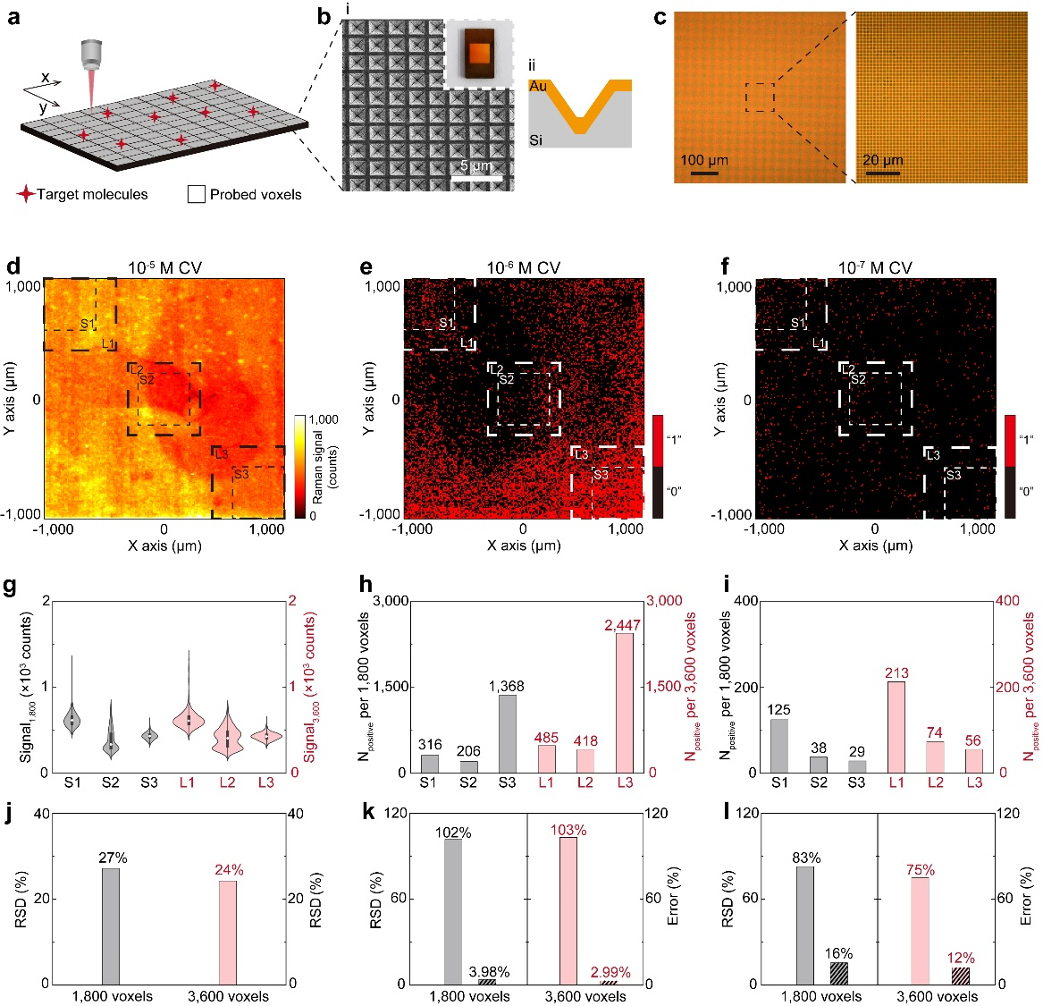
Figure S1| Measurement of crystal violet (CV) on the Klarite® chip. (a) Schematic procedure of the SERS measurement on the Klarite chip. The substate was immersed in the CV-ethanol solution for 1 hour and dried within seconds by mild N₂ flow. For measurement, a confocal Raman system was used to scan over the substrate in a 2-dimention pointwise mode. (b) (i) SEM image of the Klarite chip (Inset: photograph of the entire chip). (ii) Side-view schematic diagram of the inverted pyramid structure of each pit on the chip. (c) Bright-field image taken by the confocal system using a 10× objective lens (left) and a magnified image using a 60× objective lens (right). Three samples were prepared with a CV-ethanol solution of 10⁻⁵, 10⁻⁶ or 10⁻⁷ M. (d) The heatmap is displayed according to the peak intensities from 780 to 820 cm⁻¹. (e), (f) In digital maps, the positive voxels were assigned when the target intensity was higher than ($\overline{x}+10σ$) from the noise region (1,700 to 1,740 cm⁻¹) for each spectrum. Three thick loosely dashed large squares (L1, L2 and L3 with 3,600 voxels/area) and three thin densely dashed small squares (S1, S2 and S3 with 1,800 voxels/area) were selected for each sample. (g) The violin plot of the SERS intensities from the 10⁻⁵ M CV sample. (h), (i) Histograms of the number of positive voxels in the sampling areas for the 10⁻⁶ and 10⁻⁷ M CV samples. (j) The relative standard deviation of the mean intensities among the different areas on one sample (RSD, n = 3). (k), (l) The RSD of RPV from different areas (n = 3, solid-colored bar) and the statistical counting error computed with the expectation of positive voxels (Error, diagonal-striped bar). Laser wavelength: 638 nm; laser power: 12.67 mW; objective lens: 10×; mapping step size: 10 μm.

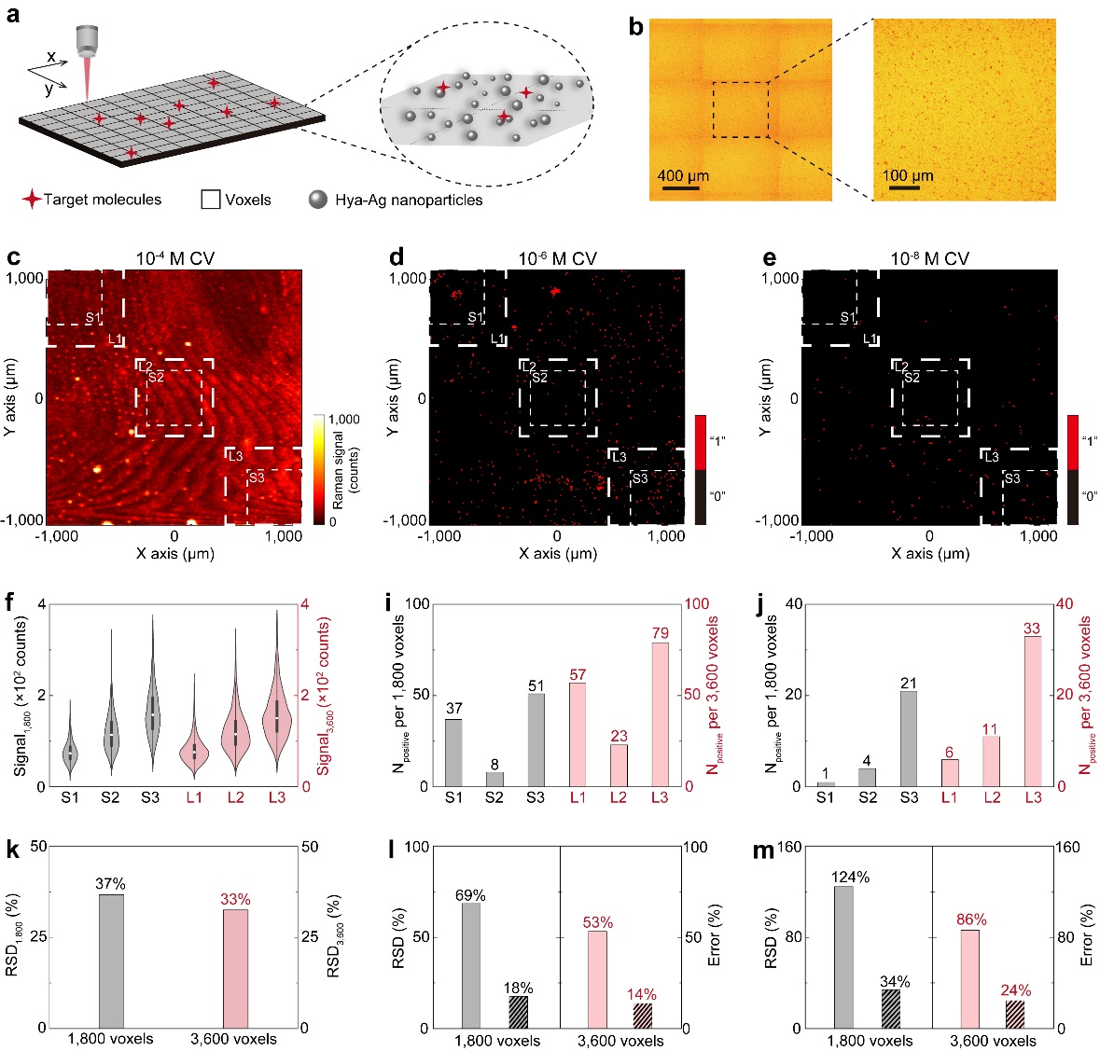
Figure S2| Measurement of CV on the self-assembled Ag chip. (a) Measurement procedure. Samples were prepared by immersion in the CV-ethanol solution (i.e., 10⁻⁴, 10⁻⁶ and 10⁻⁸ M) and measured in a 2-dimension pointwise mode. (b) The bright-field image taken by the confocal system with the 10× objective lens (left) and a magnified image using a 60× objective lens (right). Multiple images were combined to get an overview covering a larger area. (c) The heatmap and (d), (e) the digital maps corresponding to the samples with 10⁻⁴, 10⁻⁶ or 10⁻⁸ M CV. Three thick loosely dashed large squares (L1, L2 and L3 with 3,600 voxels/area) and three thin densely dashed small squares (S1, S2 and S3 with 1,800 voxels/area) were selected for each sample. (f) The violin plot of the SERS intensities in the 10⁻⁴ M CV sample. (i), (j) Histograms of the positive measurements in the sampled areas corresponding to 10⁻⁶ or 10⁻⁸ M CV. (k) The RSD of the mean intensities among different areas (RSD, n = 3). (l), (m) RSD of the RPVs from different areas (RSD, n = 3, solid-colored bar) and the statistical counting error computed with the expectation of positive number (Error, diagonal-striped bar). Laser wavelength: 638 nm; laser power: 12.67 mW; objective lens: 10×; mapping step size: 10 μm.

