Supplementary Information

Genome organization around nuclear speckles drives mRNA splicing efficiency
Prashant Bhat^{1,2}, Amy Chow¹, Benjamin Emert¹, Olivia Ettlin¹, Sofia A. Quinodoz^{1,3}, Mackenzie Strehle¹, Yodai Takei¹, Alex Burr¹, Isabel Goronzy^{1,2}, Allen Chen¹, Wesley Huang¹, Jose Lorenzo M. Ferrer¹, Elizabeth Soehalim¹, Say-Tar Goh¹, Tara Chari¹, Delaney K. Sullivan^{1,2}, Mario R. Blanco¹, Mitchell Guttman^{1,†}

- Division of Biology and Biological Engineering, California Institute of Technology, Pasadena CA 91125, USA
- David Geffen School of Medicine, University of California, Los Angeles, Los Angeles CA 90095, USA
- Current address: Department of Chemical and Biological Engineering, Princeton University, Princeton, NJ 08544, USA

† To whom correspondence should be addressed (mguttman@caltech.edu)

Supplementary Video 1 | Co-localization of RNA FISH spots (cyan) and SRRM1 (red) speckles in 3D. MS2-containing reporter RNA preferentially co-localizes with nuclear speckles when co-expressed with SRRM1+MCP using RNA FISH coupled with fluorescence microscopy of mCherry (for SRRM1).

Supplementary Tables
- Supplementary Table 1 | Speckle distances computed from seqFISH or TSA-seq and correlation with SPRITE.
- Supplementary Table 2 | Speckle distances computed from SPRITE and associated speckle hubs in mouse and human.
- Supplementary Table 3 | snRNA density, gene length, and expression metrics for each genomic bin.
- Supplementary Table 4 | Splicing efficiency measured by chromatin RNA-seq, 5EU-seq, and RD SPRITE.
- Supplementary Table 5 | Differences in Pol II and SPRITE speckle contact between different cell types.

Supplementary Figures
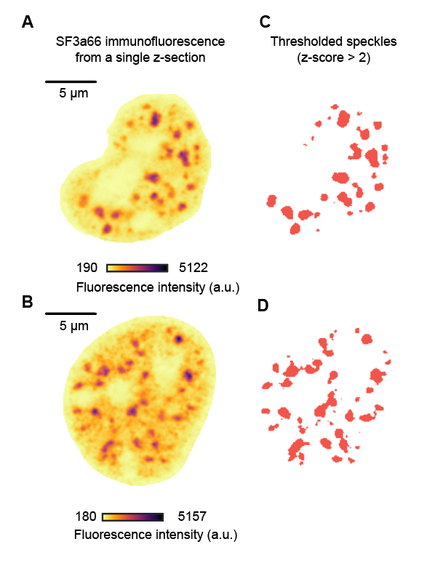
Supplementary Figure 1 | SF3a66 immunofluorescence pre and post segmentation. a, b, Two representative images of raw SF3a66 immunofluorescence from single z-sections (pre-segmentation). n = 446 cells from 2 biological replicates re-analyzed from Takei et al 2021³⁸. c, d, Post segmentation thresholded speckles with z-score > 2 for images in A and B, respectively.

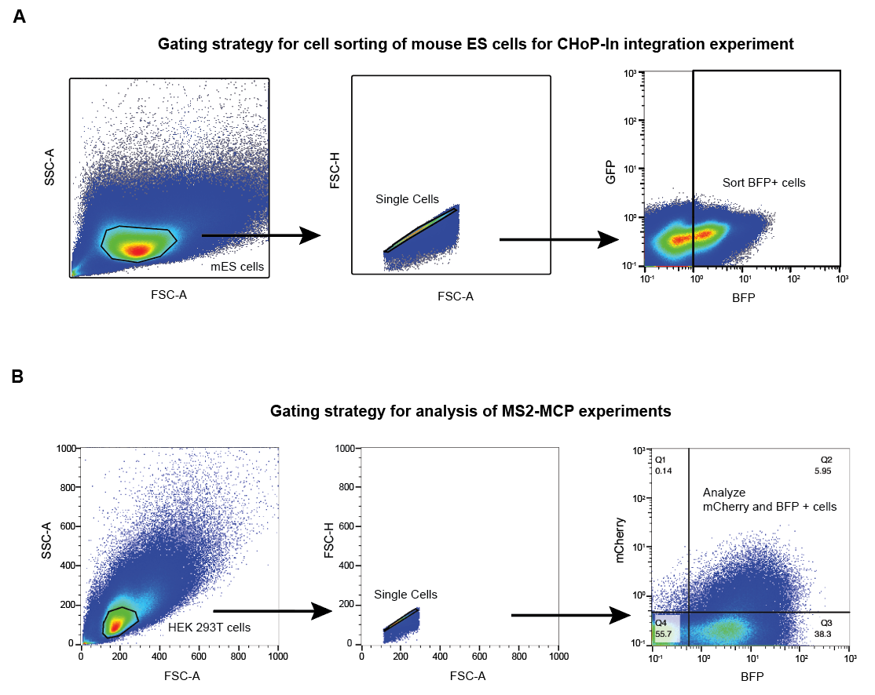Supplementary Figure 2 | Gating strategy for flow cytometry experiments. a, Representative gating strategy for cell sorting of mouse ES cells for CHoP-In integration experiments. b, Representative gating strategy for the analysis of HEK293T cells for MS2-MCP transient transfection assays.

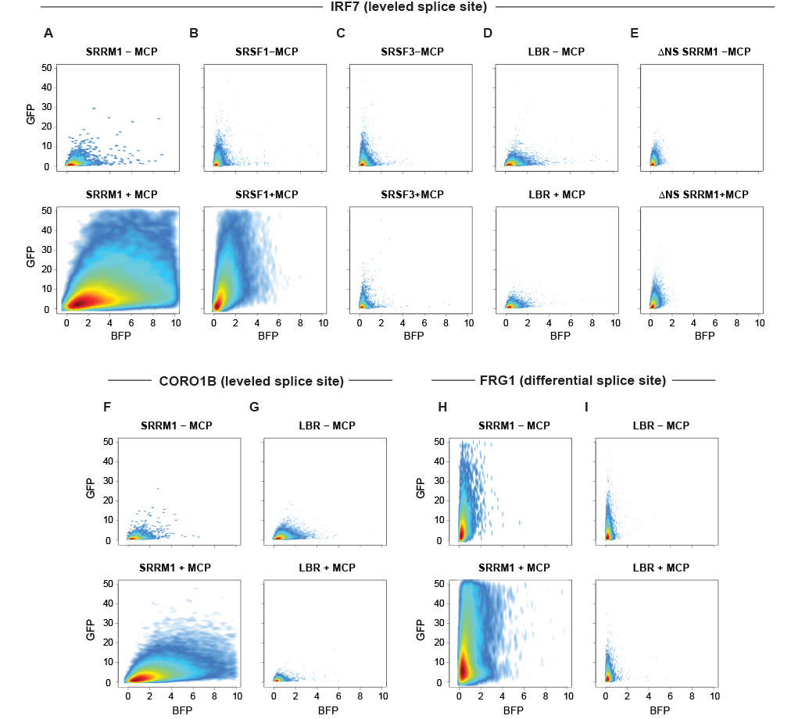
Supplementary Figure 3 | 2D FACS scatter plots of MS2 MCP assay experiments. 2D FACS scatter plots shown for IRF7 leveled intron reporter with the following proteins with and without the MCP tag: a, SRRM1. b, SRSF1. c, SRSF3. d, LBR. e, ∆NS SRRM1. 2D FACS scatter plots shown for CORO1B leveled intron reporter with the following proteins with and without the MCP tag: a, SRRM1. b, LBR. 2D FACS scatter plots shown for FRG1 differential intron reporter with the following proteins with and without the MCP tag: a, SRRM1. b, LBR.

