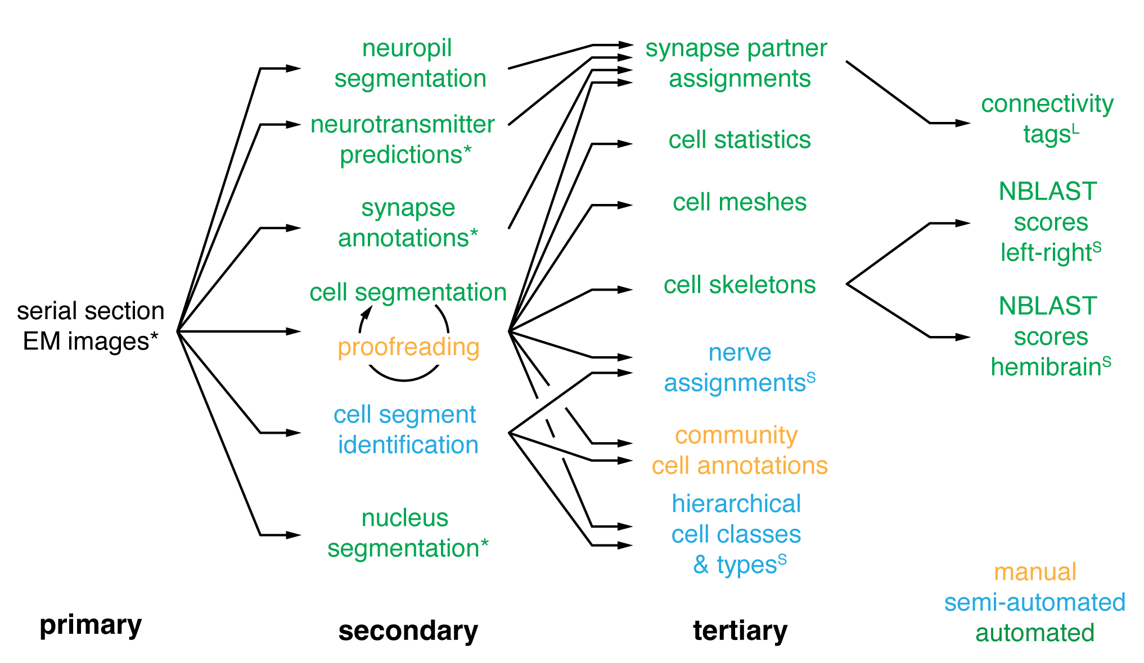Supplementary Figure 1 | Flow of data products. All data was derived from the original EM images but some data resources built on intermediate products. This diagram shows how different data products build on each other. Data products annotated with a “*” were published previously and made publicly available^{7,9,10}. Those annotated with an “S” are described in more detail by Schlegel et al.¹², those annotated with an “L” are described in Lin et al.⁴⁰.
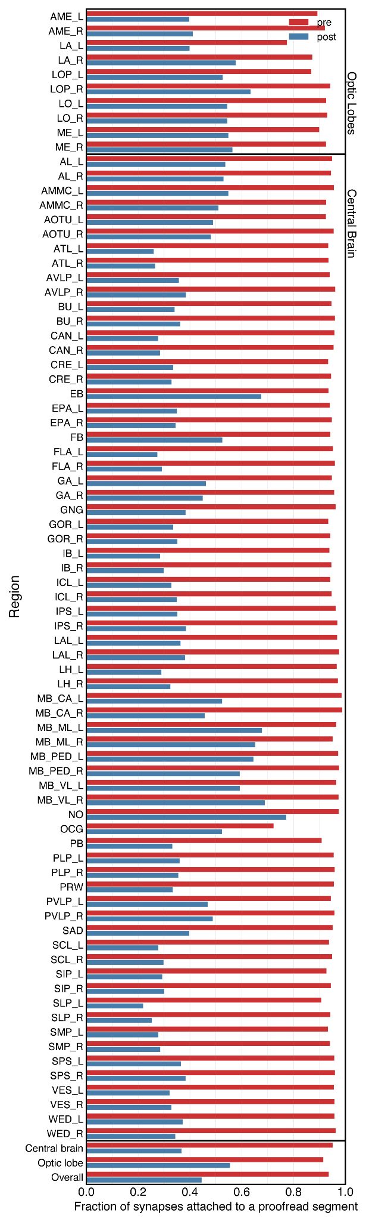
Supplementary Figure 2 | Completion rates by neuropil.
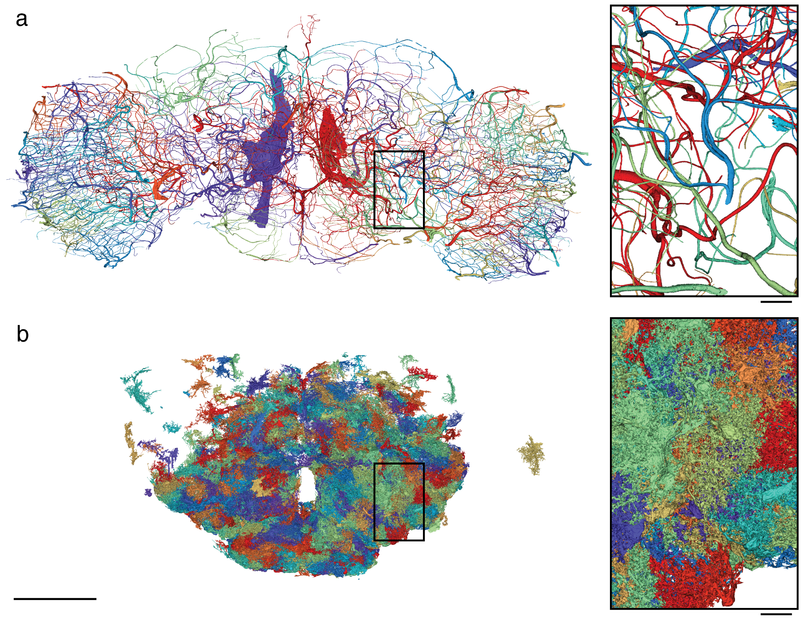
Supplementary Figure 3 | Trachea and glia cells. (a) Rendering of all trachea segments in the FlyWire dataset. (b) Rendering of some reconstructed glia cells in the FlyWire dataset. At the time of writing, only a subset of the glia cells, with bias towards the central brain, have been proofread and labeled. Scale bar: 100 µm; insets: 10 µm.
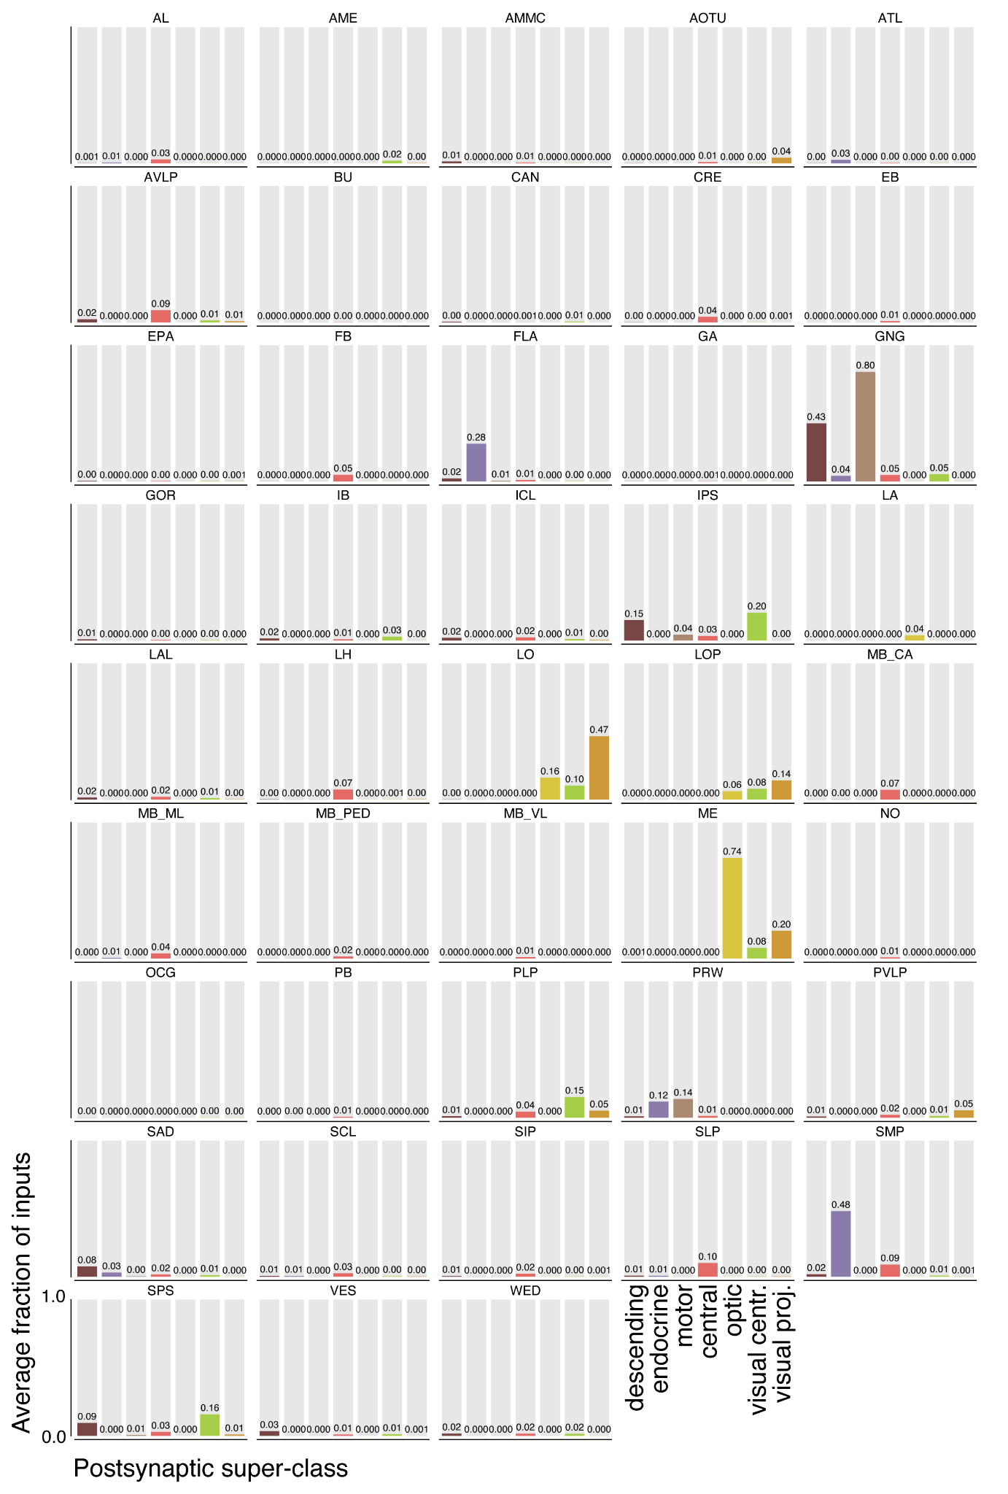
Supplementary Figure 4 | Average input fraction for each super-class by neuropil. Average input fractions were computed by summing the row values for each neuropil in the super-class specific projection matrices. Mirrored neuropils were added to one.
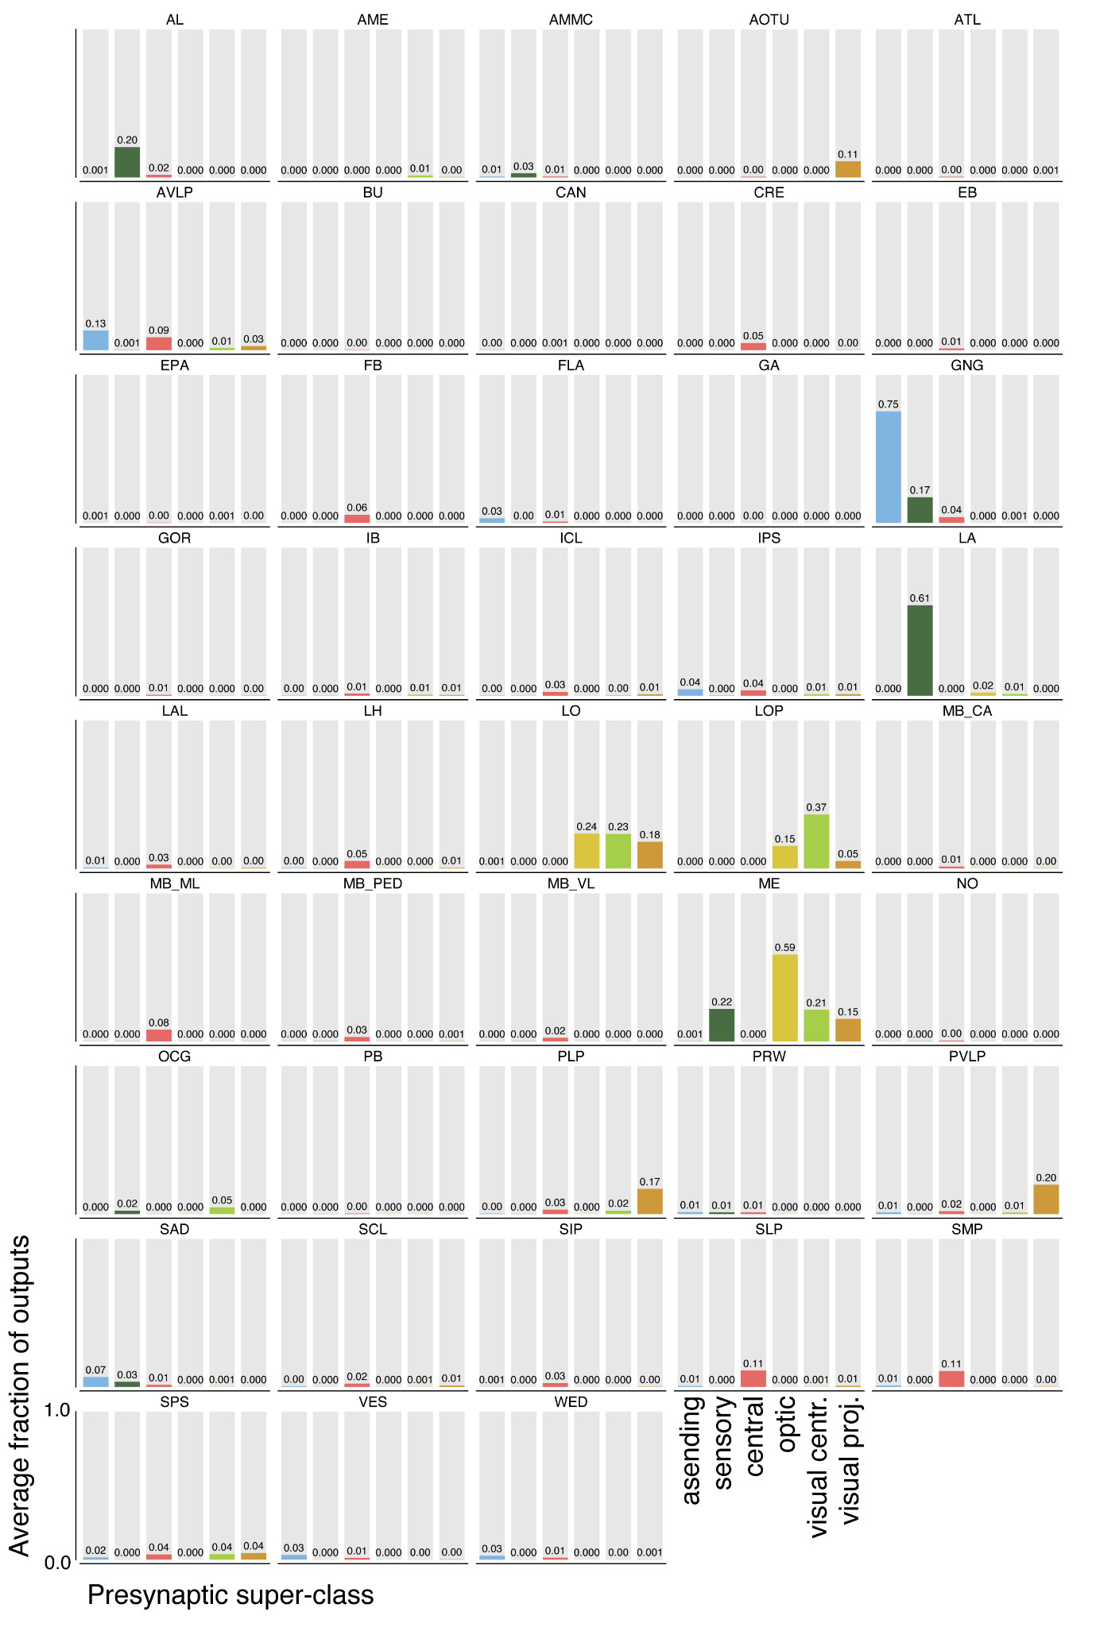
Supplementary Figure 5 | Average output fraction for each super-class by neuropil. Average output fractions were computed by summing the column values for each neuropil in the super-class specific projection matrices. Mirrored neuropils were added to one.
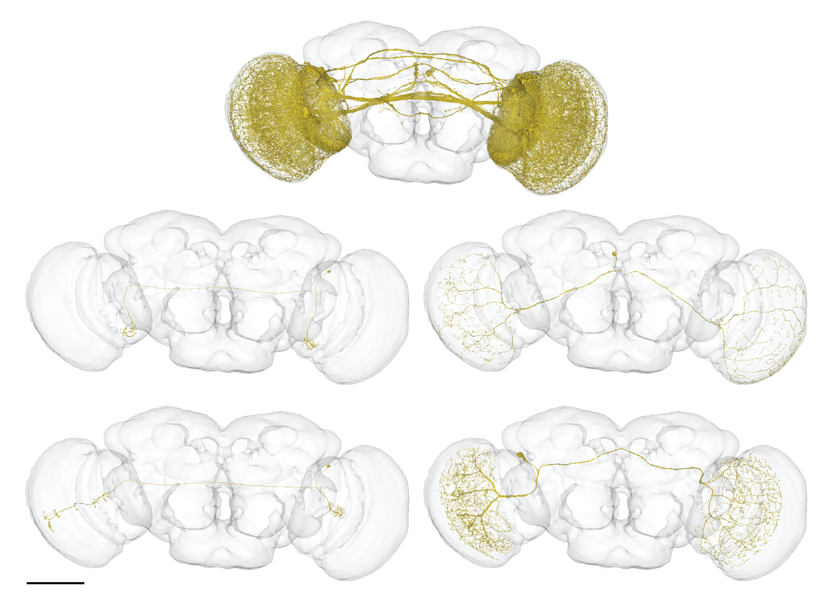
Supplementary Figure 6 | Bilateral optic lobe neurons. On the left: putative LC14 (top) and putative LC14b (bottom). Scale bar: 100 µm
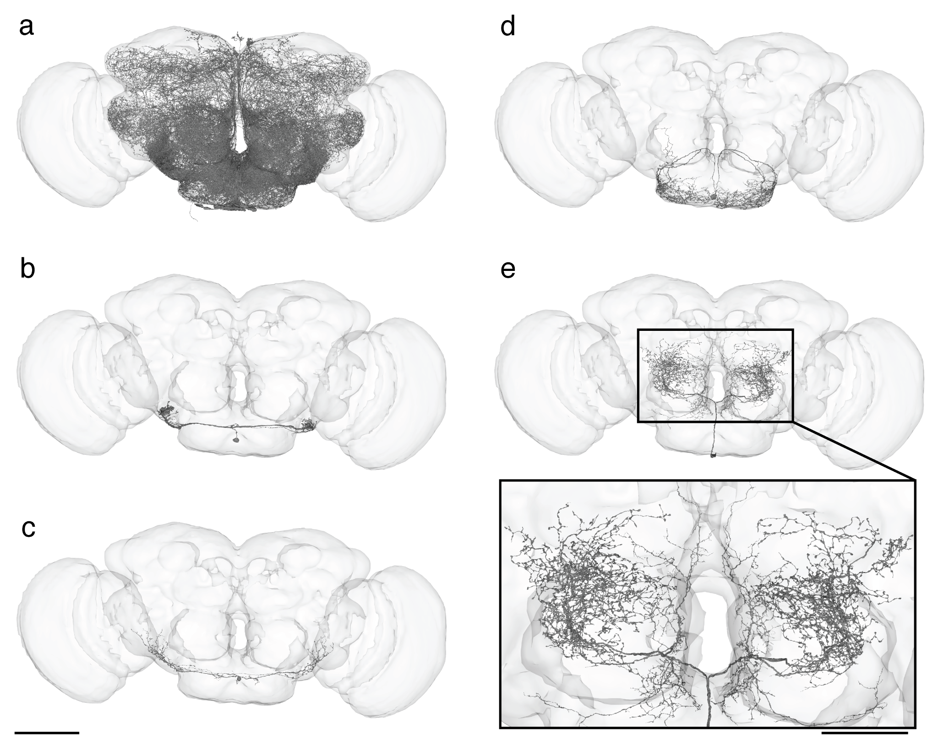
Supplementary Figure 7 | Neurons on the midline with dendrites in both hemispheres. (a) All symmetric neurons with a cell body on the midline. (b-e) examples of individual neurons. Scale bar: 100 µm, inset: 50 µm
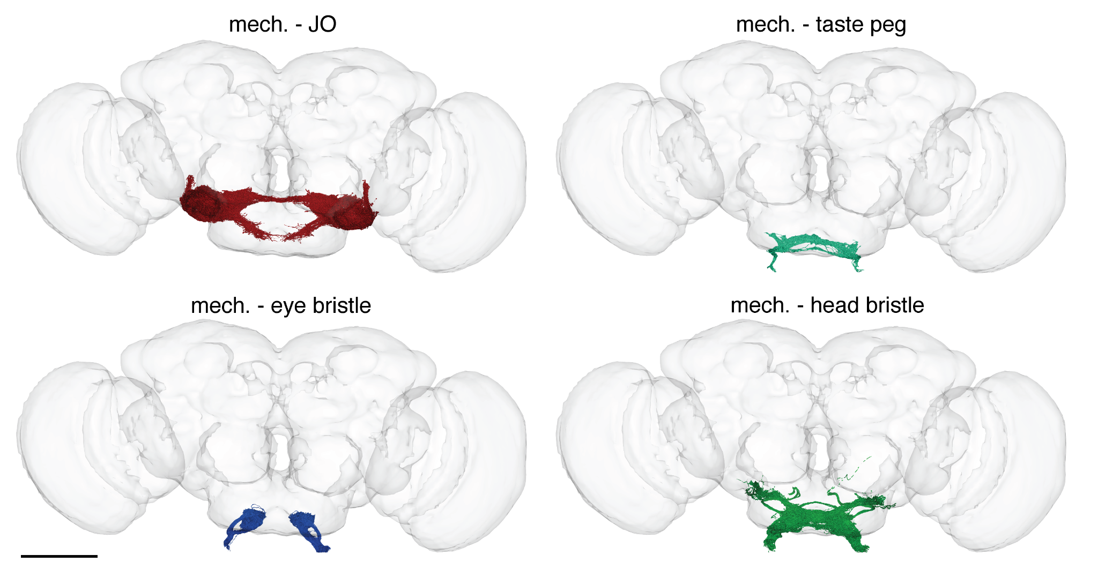
Supplementary Figure 8 | Mechanosensory neuron subtypes. Scale bar: 100 µm
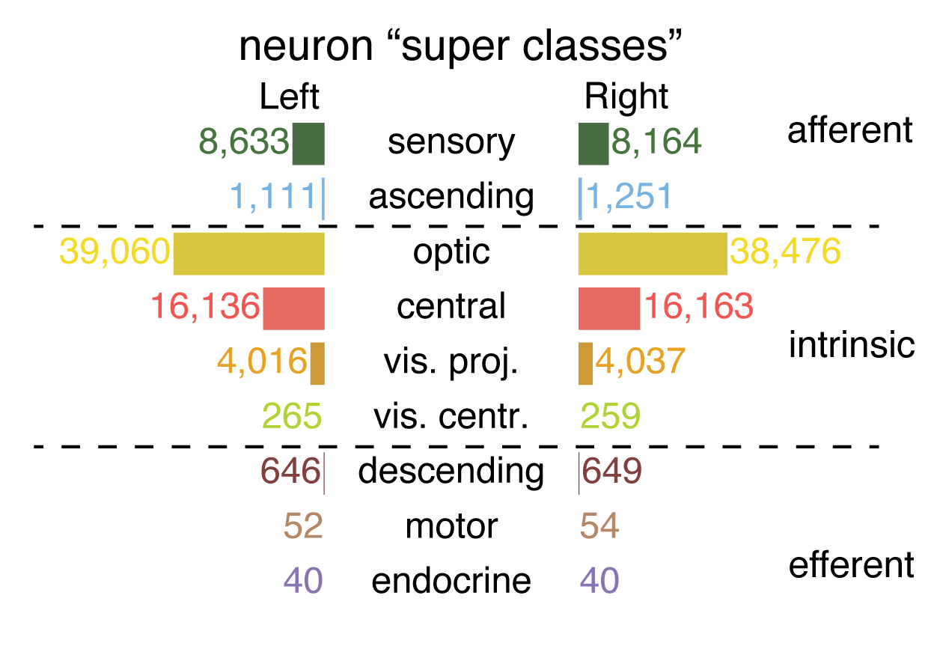
Supplementary Figure 9 | Distribution of community annotations by super class

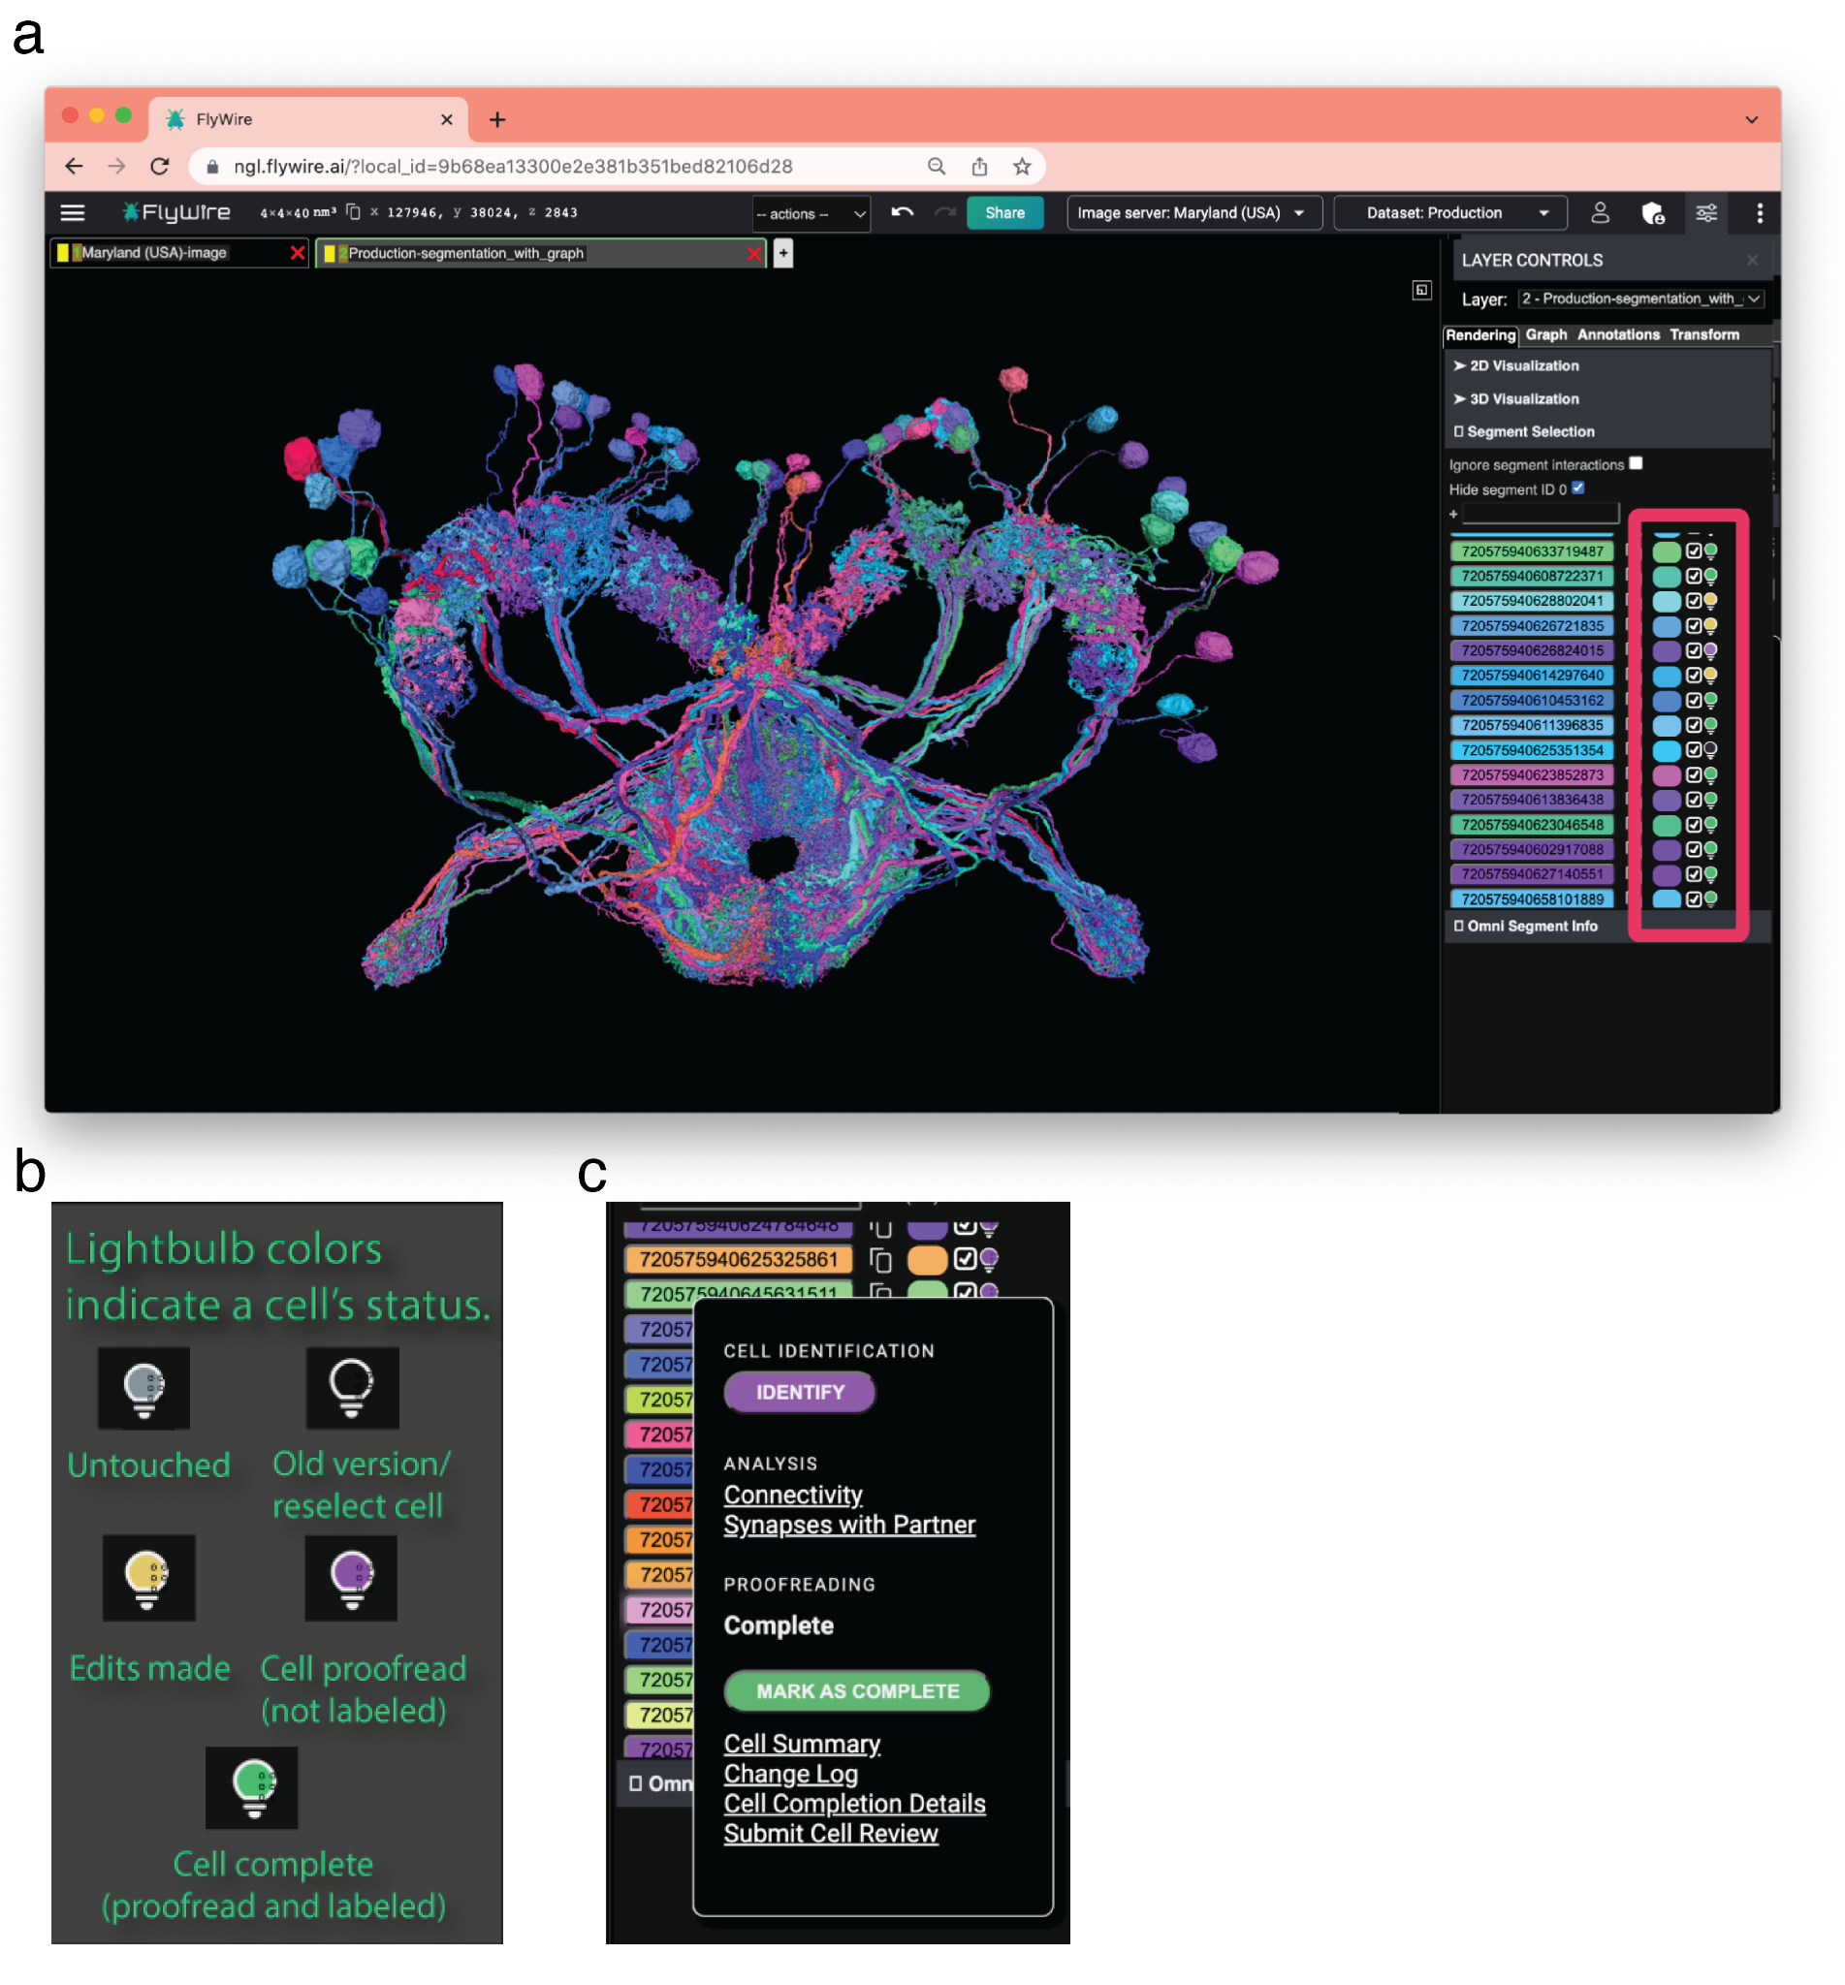
Supplementary Figure 10 | Neuroglancer Interface and Lightbulb. (a) FlyWire's lightbulb menu displays the proofreading and annotation status of every segment (red box). (b) It is color coded for easy reference (yellow: cell has not been declared complete; purple: complete but not labeled; green: proofread and labeled; black: out of date segmentation). (c) Users can load cell identification directly within the FlyWire editor, perform basic connectivity analysis, and view a cell's edit history.

Name | Lab Affiliation | total edits | specific contributions
Doug Bland | Mala Murthy Lab, Sebastian Seung Lab | 295,202
Zairene Lenizo | Mala Murthy Lab, Sebastian Seung Lab | 127,401
Nseraf | Flyers (citizen scientist) | 110,082
Nashra Hadjerol | Mala Murthy Lab, Sebastian Seung Lab | 92,883
Kyle Patrick Willie | Mala Murthy Lab, Sebastian Seung Lab | 92,695
Austin T Burke | Mala Murthy Lab, Sebastian Seung Lab | 85,953
Ryan Willie | Mala Murthy Lab, Sebastian Seung Lab | 80,595
John Anthony Ocho | Mala Murthy Lab, Sebastian Seung Lab | 75,794
Joshua Bañez | Mala Murthy Lab, Sebastian Seung Lab | 69,225
Rey Adrian Candilada | Mala Murthy Lab, Sebastian Seung Lab | 60,158
Nelsie Panes | Mala Murthy Lab, Sebastian Seung Lab | 59,560
Arti Yadav | Greg Jefferis Lab | 59,394
Shirleyjoy Serona | Mala Murthy Lab, Sebastian Seung Lab | 57,085
Yijie Yin | Greg Jefferis Lab | 50,858
Jet Ivan Dolorosa | Mala Murthy Lab, Sebastian Seung Lab | 50,655
Remer Tancontian | Mala Murthy Lab, Sebastian Seung Lab | 46,931
Ariel Dagohoy | Mala Murthy Lab, Sebastian Seung Lab | 46,169
Regine Salem | Mala Murthy Lab, Sebastian Seung Lab | 45,090
Kendrick Joules Vinson | Mala Murthy Lab, Sebastian Seung Lab | 44,771
Mendell Lopez | Mala Murthy Lab, Sebastian Seung Lab | 43,885
Laia Serratosa Capdevila | Greg Jefferis Lab, Rachel Wilson Lab | 41,723
Griffin Badalamente | Greg Jefferis Lab | 41,674
Krzysztof Kruk | Flyers (citizen scientist) | 40,752
Anjali Pandey | Greg Jefferis Lab | 37,344
Ben Silverman | Mala Murthy Lab, Sebastian Seung Lab | 37,016
Darrel Jay Akiatan | Mala Murthy Lab, Sebastian Seung Lab | 36,987
Dustin Garner | Sung Soo Kim Lab | 36,815
Dharini Sapkal | Greg Jefferis Lab | 31,244
annkri (Anne Kristiansen) | Flyers (citizen scientist) | 29,345
Jay Gager | Mala Murthy Lab, Sebastian Seung Lab | 29,242
Shaina Mae Monungolh | Mala Murthy Lab, Sebastian Seung Lab | 28,721
Miguel Albero | Mala Murthy Lab, Sebastian Seung Lab | 26,831
Mark Lloyd Pielago | Mala Murthy Lab, Sebastian Seung Lab | 26,831
Jacquilyn Laude | Mala Murthy Lab, Sebastian Seung Lab | 26,006
Katharina Eichler | Greg Jefferis Lab, Seeds Hampel Lab | 24,481
Zeba Vohra | Greg Jefferis Lab | 24,431
Allien Mae Gogo | Mala Murthy Lab, Sebastian Seung Lab | 24,202
Emil Kind | Mathias Wernet Lab | 24,062
Alvin Josh Mandahay | Mala Murthy Lab, Sebastian Seung Lab | 24,062
Varun Sane | Greg Jefferis Lab | 23,762
Chereb Martinez | Mala Murthy Lab, Sebastian Seung Lab | 22,540
John David Asis | Mala Murthy Lab, Sebastian Seung Lab | 21,894
Chitra Nair | Greg Jefferis Lab | 21,696
Márcia dos Santos | Greg Jefferis Lab | 21,610
Dhwani Patel | Greg Jefferis Lab | 20,389
Marchan Manaytay | Mala Murthy Lab, Sebastian Seung Lab | 20,277
Thomas Stocks | Flyers (citizen scientist) | 20,176
Imaan F. M. Tamimi | Greg Jefferis Lab | 19,937
Clyde Angelo Lim | Mala Murthy Lab, Sebastian Seung Lab | 19,877
James Hebditch | Mala Murthy Lab, Sebastian Seung Lab | 19,666
Philip Lenard Ampo | Mala Murthy Lab, Sebastian Seung Lab | 19,132
Michelle Darapan Pantujan | Mala Murthy Lab, Sebastian Seung Lab | 18,915
Alexandre Javier | Greg Jefferis Lab | 17,813
Daril Bautista | Mala Murthy Lab, Sebastian Seung Lab | 17,555
Rashmita Rana | Greg Jefferis Lab | 17,547
Jansen Seguido | Mala Murthy Lab, Sebastian Seung Lab | 17,407
Bhargavi Parmar | Greg Jefferis Lab | 17,133
John Clyde Saguimpa | Mala Murthy Lab, Sebastian Seung Lab | 16,656
Merlin Moore | Mala Murthy Lab, Sebastian Seung Lab | 16,590
AzureJay (Jaime Skelton) | Flyers (citizen scientist) | 15,825
Mark Larson | Wei-Chung Lee Lab | 15,692
Joseph Hsu | Greg Jefferis Lab, Scott Waddell Lab | 15,496
Itisha Joshi | Greg Jefferis Lab | 14,717
Dhara Kakadiya | Greg Jefferis Lab | 14,544
Cathy Pilapil | Mala Murthy Lab, Sebastian Seung Lab | 13,558
Kaushik Parmar | Greg Jefferis Lab | 13,136
Philipp Schlegel | Greg Jefferis Lab | 12,846
Irene Salgarella | Greg Jefferis Lab | 12,475
Chan Hyuk Kang | Jinseop Kim Lab | 11,129
Markus William Pleijzier | Greg Jefferis Lab | 10,498 | Reconstruction of Mushroom Body neurons, Lateral Horn Neurons and Lateral Horn Centrifugal Neurons
Marina Gkantia | Greg Jefferis Lab | 10,260
Jinmook Lee | Jinseop Kim Lab | 9,887
Quinn Vanderbeck | Rachel Wilson Lab | 8,845
Yashvi Patel | Greg Jefferis Lab | 8,485
Eva Munnelly | Greg Jefferis Lab | 8,120
Olivia Sato | Wei-Chung Lee Lab | 8,055
Siqi Fang | Greg Jefferis Lab | 7,981
Janice Salocot | Mala Murthy Lab, Sebastian Seung Lab | 7,463
Paul Brooks | Greg Jefferis Lab | 6,840
Claire E. McKellar | Mala Murthy Lab, Sebastian Seung Lab | 6,802
Christopher Dunne | Greg Jefferis Lab | 6,308
Mai Bui | Ken Colodner Lab | 6,228
JousterL (Matthew Lichtenberger) | Flyers (citizen scientist) | 5,883
edmark tamboboy | Mala Murthy Lab, Sebastian Seung Lab | 5,801
Mareike Selcho | Mareike Selcho Lab | 5,756
Lucia Kmecova | Seeds Hampel Lab | 5,665
Katie Molloy | Wei-Chung Lee Lab | 5,492
Alexis E Santana-Cruz | Seeds Hampel Lab | 5,274
Farzaan Salman | Andrew Dacks Lab | 5,092
Steven Calle | Seeds Hampel Lab | 4,927
Kfay | Flyers (citizen scientist) | 4,886
Seongbong Yu | Jinseop Kim Lab | 4,832
Arzoo Diwan | Greg Jefferis Lab | 4,787
Celia David | Mala Murthy Lab, Sebastian Seung Lab | 4,546
Monika Patel | Greg Jefferis Lab | 4,482
Gregory S.X.E. Jefferis | Greg Jefferis Lab | 4,474
Szi-chieh Yu | Mala Murthy Lab, Sebastian Seung Lab | 4,468
Sarah Morejohn | Mala Murthy Lab, Sebastian Seung Lab | 4,090
Sanna Koskela | Michael Reiser Lab | 3,822
bl4ckscor3 (Daniel Lehmann) | Flyers (citizen scientist) | 3,735
Sangeeta Sisodiya | Greg Jefferis Lab | 3,493
Tansy Yang | Janelia | 3,422
Selden Koolman | Mala Murthy Lab, Sebastian Seung Lab | 3,384
Christa Baker | Mala Murthy Lab | 3,381
Gerit A. Linneweber | Gerit Linneweber Lab | 3,237
Amalia Braun | Alexander Borst Lab | 3,125
Marissa Sorek | Mala Murthy Lab, Sebastian Seung Lab | 3,030
Sky Cho | Ken Colodner Lab | 2,972
Wolf Huetteroth | Wolf Huetteroth Lab | 2,846
Brian Reicher | Wei-Chung Lee Lab | 2,794
TR77 | Flyers (citizen scientist) | 2,775
Marlon Blanquart | Greg Jefferis Lab | 2,662
Hyungjun Choi | Jae Young Kwon Lab | 2,373
Li Guo | Julie Simpson Lab | 2,095
Forrest Collman | Forrest Collman Lab | 2,016
Joanna Eckhardt | Mala Murthy Lab | 1,995
Alisa Poh | Barry Dickson Lab | 1,922
Marina Lin | Ken Colodner Lab | 1,920
Stefanie Hampel | Seeds Hampel Lab | 1,645
Wes Murfin | Citizen scientist | 1,578
Peter Gibb | Rachel Wilson Lab | 1,448
Zhihao Zheng | Sebastian Seung Lab | 1,421
Nidhi Patel | Greg Jefferis Lab | 1,394
Lucy Houghton | Sung Soo Kim Lab | 1,357
Álvaro Sanz Díez | Rudy Behnia Lab | 1,317
Devon Jones | Mala Murthy Lab, Sebastian Seung Lab | 1,296
Annalena Oswald | Marion Silies Lab | 1,214
Lucas Encarnacion-Rivera | Mala Murthy Lab | 1,164
Akanksha Jadia | Greg Jefferis Lab | 1,141
Nik Drummond | Alexander Borst Lab | 1,104
Leonie Walter | Mathias Wernet Lab | 1,102
Xin Zhong | Mathias Wernet Lab | 1,083
Benjamin Gorko | Sung Soo Kim Lab | 1,064
Jonas Chojetzki | Marion Silies Lab | 1,060
Fernando J Figueroa Santiago | Seeds Hampel Lab | 1,049
István Taisz | Greg Jefferis Lab | 1,043
Urja Verma | Greg Jefferis Lab | 1,033
Annika Bast | Marion Silies Lab | 1,031
Ibrahim Tastekin | Carlos Ribeiro Lab | 1,025 | Tracing taste peg gustatory neurons and downstream neurons
Sandeep Kumar | Mala Murthy Lab | 987
Yuta Mabuchi | Nilay Yapici Lab | 963
Nick Byrne | Wei-Chung Lee Lab | 951
Edda Kunze | Gerit Linneweber Lab | 907
Thomas Crahan | Sung Soo Kim Lab | 901
Hewhoamareismyself (Ryan Margossian) | Flyers (citizen scientist) | 874
Maria Ioannidou | Marion Silies Lab | 848
Iliyan Georgiev | Flyers (citizen scientist) | 825
Fabianna Szorenyi | Seeds Hampel Lab | 817
Atsuko Adachi | Richard Mann Lab, Rudy Behnia Lab | 745
Tomke Stuerner | Greg Jefferis Lab | 736
Minsik Yun | Young-Joon Kim Lab | 625
Andrearwen | Flyers (citizen scientist) | 607
Robert Turnbull | Greg Jefferis Lab | 586
Eleni Samara | Alexander Borst Lab | 546
Sebastian Molina-Obando | Marion Silies Lab | 545
Alexander Thomson | Janelia, Michael Reiser Lab | 527
a5hm0r | Flyers (citizen scientist) | 516
Lena Lörsch | Marion Silies Lab | 497
Connor Laughland | Janelia, Michael Reiser Lab | 469
Suchetana B. Dutta | Bassem Hassan Lab | 458
Paula Guiomar Alarcón de Antón | Mathias Wernet Lab | 426
Patricia Pujols | Seeds Hampel Lab | 423
Binglin Huang | Sung Soo Kim Lab | 423
Kenneth J. Colodner | Ken Colodner Lab | 421
Isabel Haber | Rachel Wilson Lab | 392
Albert Lin | Mala Murthy Lab | 362
Daniel T. Choe | Jinseop Kim Lab | 340
Alexander Shakeel Bates | Greg Jefferis Lab, Rachel Wilson Lab | 340
Veronika Lukyanova | Jenny Read Lab | 337
Marta Costa | Greg Jefferis Lab | 334
Zequan Liu | Xueying "Snow" Wang | 317
Haley Croke | Katie von Reyn Lab | 308
Gizem Sancer | Mathias Wernet Lab | 308
Tatsuo Okubo | Rachel Wilson Lab | 306
Miriam A. Flynn | Janelia, Michael Reiser Lab | 297
Meghan Laturney | Kristin Scott Lab | 274
Benjamin Bargeron | Salil Bidaye Lab | 273
Davi D. Bock | Davi Bock Lab | 255
Hyunsoo Yim | Jinseop Kim Lab | 240
Anh Duc Le | Denise Garcia Lab | 237
Seungyun Yu | Jae Young Kwon Lab | 224
Yeonju Nam | Jinseop Kim Lab | 221
Mavil | Flyers (citizen scientist) | 217
Audrey Francis | Gaby Maimon Lab | 196
Jesse Gayk | Greg Jefferis Lab | 195
Zepeng Yao | Kristin Scott Lab | 194
Sommer S. Huntress | Ken Colodner Lab | 192
Carolina Manyari-Diaz | Salil Bidaye Lab | 191
Raquel Barajas | Carlos Ribeiro Lab | 186
Mindy Kim | Wei-Chung Lee Lab | 185
Burak Gür | Marion Silies Lab | 182
Nils Reinhard | Charlotte Helfrich-Forster Lab | 177 | Tracing of clock and AME neurons
Amanda Abusaif | Kristin Scott Lab | 176
Anna Li | Rachel Wilson Lab | 173
Sven Dorkenwald | Sebastian Seung Lab | 171
Fred W Wolf | Fred Wolf Lab | 163
Keehyun Park | Jae Young Kwon Lab | 155
Xinyue Cui | Nilay Yapici Lab | 152
Haein Kim | Nilay Yapici Lab | 145
Georgia Dempsey | Greg Jefferis Lab, Scott Waddell Lab | 143
Alan Mathew | Greg Jefferis Lab | 141
Jinseong Kim | Jinseop Kim Lab | 141
Taewan Kim | Jinseop Kim Lab | 135
Guan-ting Wu | National Hualien Senior High School | 124
Margarida Brotas | Eugenia Chiappe Lab | 112
Cheng-hao Zhang | National Hualien Senior High School | 109
Philip K. Shiu | Kristin Scott Lab | 108
Shanice Bailey | Greg Jefferis Lab | 102

Supplementary Table 1 | Number of proofreading edits by consortium members. Only members with ≥100 edits are shown.

Name | Lab Affiliation | total labels | specific contributions
Krzysztof Kruk | Flyers (citizen scientist) | 44,579
Volker Hartenstein | Volker Hartenstein Lab | 13,762
Alexander Shakeel Bates | Greg Jefferis Lab, Rachel Wilson Lab | 11,260
Sven Dorkenwald | Sebastian Seung Lab | 6,375
Katharina Eichler | Greg Jefferis Lab, Seeds Hampel Lab | 6,366
Ben Silverman | Mala Murthy Lab, Sebastian Seung Lab | 4,624
Doug Bland | Mala Murthy Lab, Sebastian Seung Lab | 4,182
Philipp Schlegel | Greg Jefferis Lab | 3,754
Austin T Burke | Mala Murthy Lab, Sebastian Seung Lab | 3,242
Jay Gager | Mala Murthy Lab, Sebastian Seung Lab | 3,175
annkri (Anne Kristiansen) | Flyers (citizen scientist) | 3,057
Stefanie Hampel | Seeds Hampel Lab | 2,859
AzureJay (Jaime Skelton) | Flyers (citizen scientist) | 2,845
Celia David | Mala Murthy Lab, Sebastian Seung Lab | 2,685
Kyle Patrick Willie | Mala Murthy Lab, Sebastian Seung Lab | 2,566
David Deutsch | Mala Murthy Lab | 2,549
Kaiyu Wang | Barry Dickson Lab | 2,443
Yijie Yin | Greg Jefferis Lab | 2,354
Thomas Stocks | Flyers (citizen scientist) | 1,964
Dustin Garner | Sung Soo Kim Lab | 1,788
James Hebditch | Mala Murthy Lab, Sebastian Seung Lab | 1,667
Wolf Huetteroth | Wolf Huetteroth Lab | 1,524
Nashra Hadjerol | Mala Murthy Lab, Sebastian Seung Lab | 1,315
Ryan Willie | Mala Murthy Lab, Sebastian Seung Lab | 1,308
Joshua Bañez | Mala Murthy Lab, Sebastian Seung Lab | 1,160
Rey Adrian Candilada | Mala Murthy Lab, Sebastian Seung Lab | 1,117
Amalia Braun | Alexander Borst Lab | 1,107
Kendrick Joules Vinson | Mala Murthy Lab, Sebastian Seung Lab | 1,058
Remer Tancontian | Mala Murthy Lab, Sebastian Seung Lab | 1,029
Lena Lörsch | Marion Silies Lab | 1,009
Gizem Sancer | Mathias Wernet Lab | 942
Regine Salem | Mala Murthy Lab, Sebastian Seung Lab | 914
Jenna Joroff | Wei-Chung Lee Lab | 900
Zairene Lenizo | Mala Murthy Lab, Sebastian Seung Lab | 738
Gregory S.X.E. Jefferis | Greg Jefferis Lab | 716
Sebastian Molina-Obando | Marion Silies Lab | 676
Christa Baker | Mala Murthy Lab | 622
Jet Ivan Dolorosa | Mala Murthy Lab, Sebastian Seung Lab | 621
Claire E. McKellar | Mala Murthy Lab, Sebastian Seung Lab | 612
John Anthony Ocho | Mala Murthy Lab, Sebastian Seung Lab | 570
Markus William Pleijzier | Greg Jefferis Lab | 541 | Reconstruction of Mushroom Body neurons, Lateral Horn Neurons and Lateral Horn Centrifugal Neurons
Christopher Dunne | Greg Jefferis Lab | 517
Szi-chieh Yu | Mala Murthy Lab, Sebastian Seung Lab | 509
Ariel Dagohoy | Mala Murthy Lab, Sebastian Seung Lab | 493
Márcia dos Santos | Greg Jefferis Lab | 448
Varun Sane | Greg Jefferis Lab | 442
Quinn Vanderbeck | Rachel Wilson Lab | 424
Lucia Kmecova | Seeds Hampel Lab | 412
Steven Calle | Seeds Hampel Lab | 408
Marion Silies | Marion Silies | 379
Philip K. Shiu | Kristin Scott Lab | 321
Eva Munnelly | Greg Jefferis Lab | 312
Marina Gkantia | Greg Jefferis Lab | 300
Jonas Chojetzki | Marion Silies Lab | 254
Jonas Chojetzki | Marion Silies | 254
Farzaan Salman | Andrew Dacks Lab | 234
Matt Collie | Rachel Wilson Lab | 223
Annika Bast | Marion Silies Lab | 193
Marissa Sorek | Mala Murthy Lab, Sebastian Seung Lab | 179
Kenneth J. Colodner | Ken Colodner Lab | 161
Gerit A. Linneweber | Gerit Linneweber Lab | 157
Mareike Selcho | Mareike Selcho Lab | 155
TR77 | Flyers (citizen scientist) | 147
Maria Ioannidou | Marion Silies Lab | 144
Nils Reinhard | Charlotte Helfrich-Forster Lab | 134 | Identification of clock and AME neurons
Megan Wang | Mala Murthy Lab | 130
Meet Zandawala | Zandawala Lab | 128 | Identification of peptidergic and gustatory neurons
Lucy Houghton | Sung Soo Kim Lab | 123
Mert Erginkaya | Eugenia Chiappe Lab | 110 | Identification and annotation of several cell types in the IPS-SPS-GNG regions
Benjamin Gorko | Sung Soo Kim Lab | 107
Nseraf | Flyers (citizen scientist) | 107
Haein Kim | Nilay Yapici Lab | 72
Minsik Yun | Young-Joon Kim Lab | 71
Damian Demarest | Michael Pankratz Lab | 70
István Taisz | Greg Jefferis Lab | 66
Andrea Sandoval | Kristin Scott Lab | 58
Anthony Moreno-Sanchez | Katie von Reyn Lab | 56
Diego A. Pacheco | Mala Murthy Lab | 55
Zhihao Zheng | Sebastian Seung Lab | 51
Burak Gür | Marion Silies Lab | 49
Benjamin Bargeron | Salil Bidaye Lab | 47
Sandeep Kumar | Mala Murthy Lab | 40
Tansy Yang | Janelia | 37
Amanda González-Segarra | Kristin Scott Lab | 36
Nino Mancini | Salil Bidaye Lab | 33
Gianna Vitelli | Salil Bidaye Lab | 29
Feng Li | Janelia | 26
Joanna Eckhardt | Mala Murthy Lab | 26
Shuo Cao | David Anderson Lab | 24
Álvaro Sanz Díez | Rudy Behnia Lab | 24
Haley Croke | Katie von Reyn Lab | 22
Stéphane Noselli | Stéphane Noselli Lab | 20
Nelsie Panes | Mala Murthy Lab, Sebastian Seung Lab | 18
Gabriella R. Sterne | Gabriella Sterne Lab | 18
Kate Maier | Salil Bidaye Lab | 16
Amy R Sterling | Sebastian Seung Lab | 15
Allien Mae Gogo | Mala Murthy Lab, Sebastian Seung Lab | 13
Yuta Mabuchi | Nilay Yapici Lab | 12
Cathy Pilapil | Mala Murthy Lab, Sebastian Seung Lab | 11
Zepeng Yao | Kristin Scott Lab | 10
Alexander Del Toro | Kristin Scott Lab | 10
Jacquilyn Laude | Mala Murthy Lab, Sebastian Seung Lab | 10
Lucas Encarnacion-Rivera | Mala Murthy Lab | 10
Supplementary Table 2 | Number of annotations by consortium members. Only members with ≥10 annotations are shown.

First author | Title | Year | DOI
Deutsch et al. | The neural basis for a persistent internal state in Drosophila females | 2020 | https://doi.org/10.7554/eLife.59502
Schlegel et al. | Information flow, cell types and stereotypy in a full olfactory connectome | 2021 | https://doi.org/10.7554/eLife.66018
Sterne et al. | Classification and genetic targeting of cell types in the primary taste and premotor center of the adult Drosophila brain | 2021 | https://doi.org/10.7554/eLife.71679
Kind et al. | Synaptic targets of photoreceptors specialized to detect color and skylight polarization in Drosophila | 2021 | https://doi.org/10.7554/eLife.71858
Zhao et al. | Eye structure shapes neuron function in Drosophila motion vision | 2022 | https://doi.org/10.1101/2022.12.14.520178
Zheng et al. | Structured sampling of olfactory input by the fly mushroom body | 2022 | https://doi.org/10.1016/j.cub.2022.06.031
Shiu et al. | Taste quality and hunger interactions in a feeding sensorimotor circuit | 2022 | https://doi.org/10.7554/eLife.79887.sa0
Chou et al. | Mating-driven variability in olfactory local interneuron wiring | 2022 | https://doi.org/10.1126/sciadv.abm7723
Israel et al. | Olfactory stimuli and moonwalker SEZ neurons can drive backward locomotion in Drosophila | 2022 | https://doi.org/10.1016/j.cub.2022.01.035
Task et al. | Chemoreceptor co-expression in Drosophila melanogaster olfactory neurons | 2022 | https://doi.org/10.7554/eLife.72599
Schlegel et al. | Whole-brain annotation and multi-connectome cell typing quantifies circuit stereotypy in Drosophila | 2023 | https://doi.org/10.1101/2023.06.27.546055
Matsliah et al. | Neuronal "parts list" and wiring diagram for a visual system | 2023 | https://doi.org/10.1101/2023.10.12.562119
Jacobs et al. | Overlap and divergence of neural circuits mediating distinct behavioral responses to sugar | 2023 | https://doi.org/10.1101/2023.10.01.560401
Reinhard et al. | Synaptic and peptidergic connectomes of the Drosophila circadian clock | 2023 | https://doi.org/10.1101/2023.09.11.557222
Frantzmann et al. | Neuronal correlates of time integration into memories | 2023 | https://doi.org/10.1101/2023.09.12.557375
Braun et al. | Networks of descending neurons transform command-like signals into population-based behavioral control | 2023 | https://doi.org/10.1101/2023.09.11.557103
Ros et al. | Descending control and regulation of spontaneous flight turns in Drosophila | 2023 | https://doi.org/10.1016/j.cub.2023.12.047
Shiu et al. | A leaky integrate-and-fire computational model based on the connectome of the entire adult Drosophila brain reveals insights into sensorimotor processing | 2023 | https://doi.org/10.1101/2023.09.06.555791
González-Segarra et. al. | Hunger- and thirst-sensing neurons modulate a neuroendocrine network to coordinate sugar and water ingestion | 2023 | https://doi.org/10.7554/eLife.88143.3
Braun et al. | Disynaptic inhibition shapes tuning of OFF-motion detectors in Drosophila | 2023 | https://doi.org/10.1016/j.cub.2023.05.007
Christenson et al. | Hue selectivity from recurrent circuitry in Drosophila | 2023 | https://doi.org/10.1101/2023.07.12.548573
Eckstein et al. | Neurotransmitter Classification from Electron Microscopy Images at Synaptic Sites in Drosophila Melanogaster | 2023 | https://doi.org/10.1101/2020.06.12.148775
Mabuchi et al. | Visual Feedback Neurons Fine-Tune Drosophila Male Courtship via GABA-Mediated Inhibition | 2023 | https://doi.org/10.1016/j.cub.2023.08.034
Eichler et al. | Somatotopic organization among parallel sensory pathways that promote a grooming sequence in Drosophila | 2023 | https://doi.org/10.7554/eLife.87602.1
Baker et al. | Neural network organization for courtship-song feature detection in Drosophila | 2023 | https://doi.org/10.1016/j.cub.2022.06.019
Sapkal et al. | Neural circuit mechanisms underlying context-specific halting in Drosophila | 2023 | https://doi.org/10.1101/2023.09.25.559438
Cornean et al. | Heterogeneity of synaptic connectivity in the fly visual system | 2023 | https://doi.org/10.1101/2023.08.29.555204
Ganguly et al. | Diversity of visual inputs to Kenyon cells of the Drosophila mushroom body | 2023 | https://doi.org/10.1101/2023.10.12.561793
Zhao et al. | A comprehensive neuroanatomical survey of the Drosophila Lobula Plate Tangential Neurons with predictions for their optic flow sensitivity | 2023 | https://doi.org/10.1101/2023.10.16.562634
Yang et al. | Fine-grained descending control of steering in walking Drosophila. | 2023 | https://doi.org/10.1101/2023.10.15.562426
Pospisil et al. | From connectome to effectome: learning the causal interaction map of the fly brain | 2023 | https://doi.org/10.1101/2023.10.31.564922
Seung | Insights into vision from interpretation of a neuronal wiring diagram | 2023 | https://doi.org/10.1101/2023.11.15.567126
Garner et al. | Connectomic reconstruction predicts the functional organization of visual inputs to the navigation center of the Drosophila brain | 2023 | https://doi.org/10.1101/2023.11.29.569241
Lin et al. | Network Statistics of the Whole-Brain Connectome of Drosophila | 2023 | https://doi.org/10.1101/2023.07.29.551086
Supplementary Table 3 | Publications utilizing FlyWire before publication
Supplementary Video 1 | Rendering of all neurons in the fly brain. All neurons in the fly brain are shown in different colors. Then, neurons belonging to each super class (Fig. 2 a-c) are shown.

Supplementary Video 2 | Neuropils of the fly brain. All neuropils are shown. See Ext. Data Fig. 1 for color key.

