Supplementary Figure 1. Variograms of spatial autocorrelation effect across three droughts. The variance of the difference of MAIAC EVI anomalies between shallow and deep water tables against distance between pairs of pixels from shallow and deep water tables for the whole basin (a, e, and h), southern Amazon (b, f, and i), everwet Amazon (c, g, and j) and Guiana shield (d and k), respectively. Variance was lower (indicating spatial autocorrelation) for pairs formed from nearby pixels, but tended to reach a sill (plateau) at around 40 km, indicating a scale at which spatial autocorrelation weakened, and samples could be treated as independent for purposes of statistical analysis.
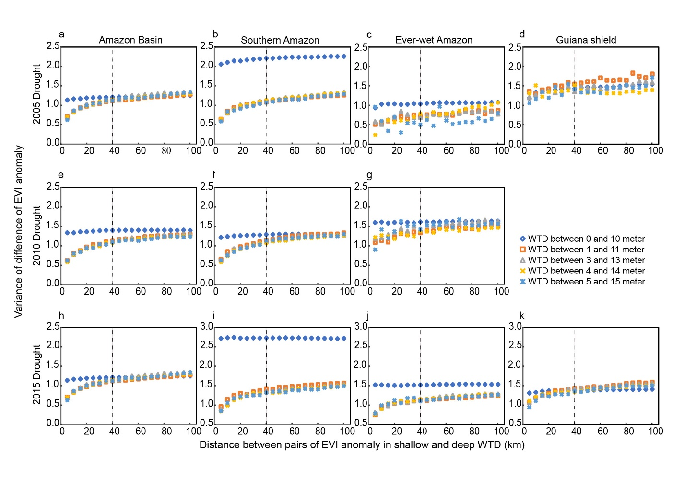

Supplementary Table 1. Generalized Additive Models (GAM) for: (a) the southern Amazon, (b) the everwet Amazon, (c) the Guiana shield (all droughts combined), and for (d) the whole basin (2015 drought only), all on a 0.4 degree spatial grid. The ∆AIC is the difference from the lowest AIC (selected) model (∆AIC=0), relative to a “full model” defined in columns 2-3. For details, see the ‘AIC-selected GAMs for hypothesis testing and prediction’ section of Methods.

Region  (Droughts) | Variables (standardized)  ($∆=anomalies vs mean)$ |  | Interactions among  Variables |  |  | sub-model R² $∆$AIC | Figures
(a) Southern Amazon  (2005, 2010, 2015) |  | Climate: $∆PAR$, $∆VPD,$ $∆$P,  $∆$MCWD, $DL$ + HAND |  | All pairwise  interactions |  | Climate only 0.32 386.9  Climate+ HAND: 0.39 0 | --  Fig. 3
(b) Everwet Amazon  (2005, 2010, 2015) |  | Climate: $∆PAR$, $∆VPD,$ $∆$P,  $∆$MCWD, $DL$ + HAND |  | All pairwise  interactions |  | Climate only: 0.47 35.83  Climate+ HAND 0.50 0  (except $∆$P-$∆$MCWD) | –  Extended Data Fig. 5
(c) Guiana Shield  (2005, 2015) |  | Climate: $∆PAR$, $∆VPD,$ $∆$P,  $∆$MCWD, $DL$ + HAND |  | All pairwise  interactions |  | Climate only: 0.45 12.02  Climate+ HAND: 0.47 0  (except HAND-$∆$P) | --  Extended Data Fig. 5
(d) Whole Basin  (2015) |  | Climate: $∆PAR$, $∆VPD,$  $∆$P, $∆$MCWD, $DSL$  + Ecotope: HAND, SoilFertility,  SoilTexture, ForestHeight |  | Pairwise interaction  of HAND with: ∆PAR,  SoilFertility, SoilTexture, ForestHeight, + all pairwise climate interactions |  | Climate only: 0.25 479.7  Climate+Ecotopes 0.37 0  (Full model) | --  Fig. 4

Supplementary Table 2. Variable inflation factors (VIF, top row) and pearson correlation coefficients (matrix) among climate and ecotope variables in drought-affected regions, across all droughts (first number in each entry) and in the 2015/16 drought only (second number). Variable inflation factors measure the severity of multicollinearity of a variable with all other independent variables jointly in a multiple regression, with VIFs of 5 or less often considered acceptable (O'brien, 2007).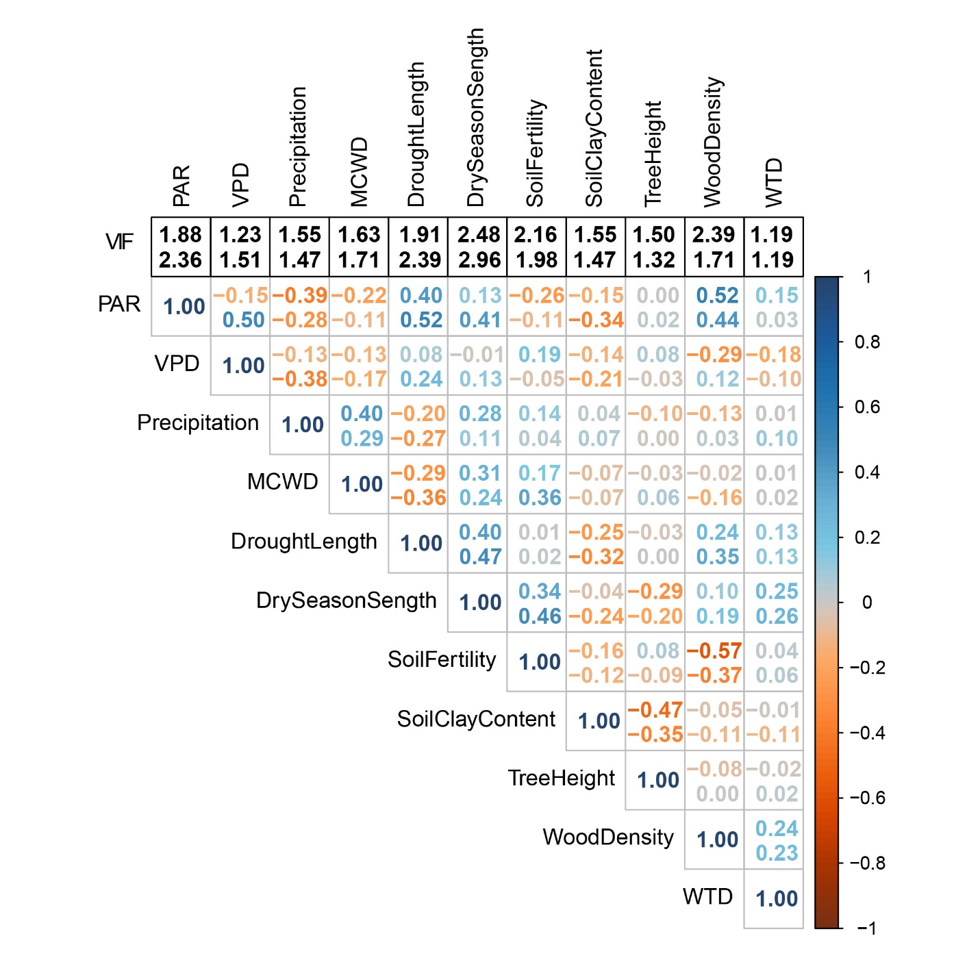

O’brien, R. M. A Caution Regarding Rules of Thumb for Variance Inflation Factors. Qual. Quant. 41, 673–690 (2007).
Supplementary Note 1: The analysis of main text Fig 3, panel a, is based on the following number of data points (pixels): the bottom right axis represents a distribution of N=1,384, 1,673, and 1,837 0.4° pixels for 2005, 2010, and 2015 droughts, respectively. The analysis of Figure 3, Panel d is based on the following number of data points (forest plots) analyzed in each drought: N= 158 plots (2005); N=133 plots (2010).

