Gut Microbiome Strain-Sharing Within Isolated Village Social Networks
Francesco Beghini^{1†}, Jackson Pullman^{1,2†}, Marcus Alexander¹, Shivkumar Vishnempet Shridhar^{1,3}, Drew Prinster⁴, Adarsh Singh⁵, Rigoberto Matute Juárez⁶, Edoardo M. Airoldi^{7,8}, Ilana L. Brito⁵, Nicholas A. Christakis^{1,2,3,9}*

¹ Yale Institute for Network Science, Yale University; New Haven, CT, USA
² Department of Statistics and Data Science, Yale University; New Haven, CT, USA
³ Department of Biomedical Engineering, Yale University; New Haven, CT, USA
⁴ Department of Computer Science, Johns Hopkins University; Baltimore, MD, USA
⁵ Meinig School of Biomedical Engineering, Cornell University; Ithaca, NY, USA
⁶ Soluciones para Estudios de la Salud; Copán, Honduras
⁷ Department of Statistical Science, Fox School of Business, Temple University; Philadelphia, PA, USA
⁸ Data Science Institute, Temple University, Philadelphia, PA, USA.
⁹ Department of Medicine, Yale School of Medicine; New Haven, CT, USA

Table of Contents
Supplementary Figures 3
Supplementary Figure 1 3
Supplementary Figure 2 4
Supplementary Figure 3 5
Supplementary Figure 4 6
Supplementary Figure 5 7
Supplementary Figure 6 8
Supplementary Figure 7 9
Supplementary Figure 8 10
Supplementary Figure 9 11
Supplementary Figure 10 12
Supplementary Tables 13
Supplementary Data 14

Supplementary Figures

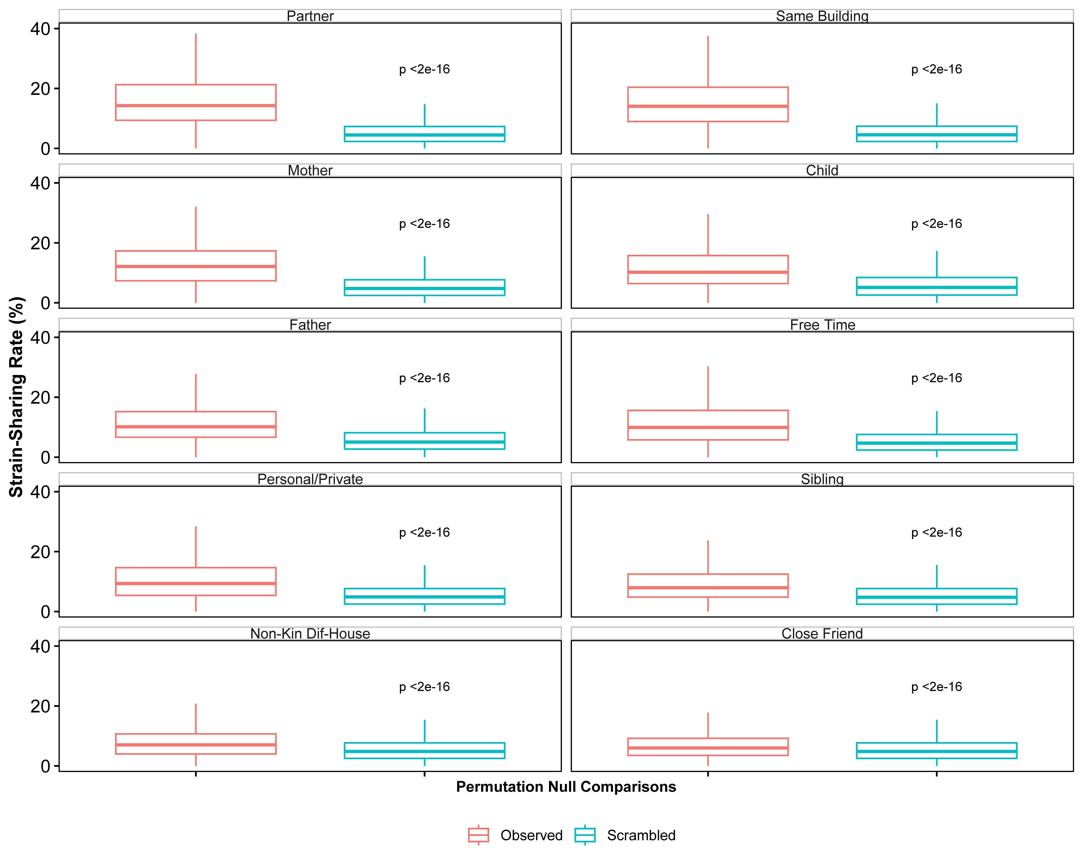

Supplementary Figure 1: Strain-Sharing by Relationship Permutation P-values. Observed strain-sharing rates for each relationship compared to 100 draws from a within-village relationship permutation. For example, the red distribution would contain the strain-sharing rate between an individual and their mother, and the blue distribution contains the strain-sharing rate for the same individual with 100 random mothers in the same village. All observed relationships have a significantly higher strain-sharing rate than the scrambled networks, with the adjusted P-value reported in each figure (two-sided Wilcoxon rank-sum tests). Data is represented as boxplots where the middle line is the median and the lower and upper hinges correspond to the first and third quartiles; the whiskers extend from the hinge to the largest or smallest value, but no further than 1.5 * IQR from the hinge.

Supplementary Figure 2: Species-Level Sharing (Jaccard). (A) The distribution of Jaccard similarity based on relationship type. The final two boxes contain the strain-sharing rates between individuals living in the same village without an identified relationship, and all pairs of individuals living in different villages, respectively. (B) Observed Jaccard similarity for each relationship compared to 100 draws from a within-village relationship permutation. All observed relationships have a significantly higher Jaccard similarity than the scrambled networks with the adjusted P-value reported in each figure (two-sided Wilcoxon rank-sum tests). (C) Jaccard similarity based on how often a pair spends free time together. (D) Jaccard similarity based on how often a pair shares meals together. (E) Jaccard similarity based on greeting type. Data is represented as boxplots where the middle line is the median and the lower and upper hinges correspond to the first and third quartiles; the whiskers extend from the hinge to the largest or smallest value, but no further than 1.5 * IQR from the hinge. The median values for each distribution are also reported at the top of each box for panel A, C-E.
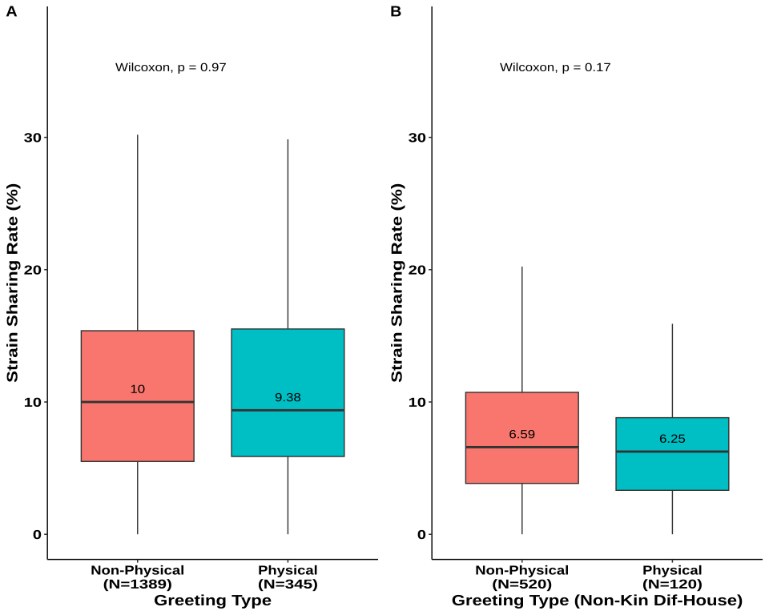

Supplementary Figure 3: Strain-Sharing by Physical versus Non-Physical Greetings. (A) Strain-sharing rates by dichotomized greeting type (physical versus non-physical) for all relationships. (B) Strain-sharing rates by dichotomized greeting type (physical versus non-physical) for all non-kin different-household relationships. Data is represented as boxplots where the middle line is the median and the lower and upper hinges correspond to the first and third quartiles; the whiskers extend from the hinge to the largest or smallest value, but no further than 1.5 * IQR from the hinge. The median values for each distribution are also reported near the median line.

Supplementary Figure 4: Parent-Child Microbiome Sharing. Parent-child microbiome strain-sharing rates decrease as children age. The trend is seen for both mothers (n = 632, top row) and fathers (n = 324, middle row) based on strain-sharing rates (A and D); species Bray-Curtis similarity (B and E); and species Jaccard index (C and F) (Pearson correlation coefficient, two-sided correlation test). On average, mothers have a higher strain-sharing rate with their children than fathers do (G, Wilcoxon rank-sum test, two sided), but this trend is not observed at the species level (H and I, Wilcoxon rank-sum test, two sided). The gray shaded area around the regression line represents the 95% confidence interval.

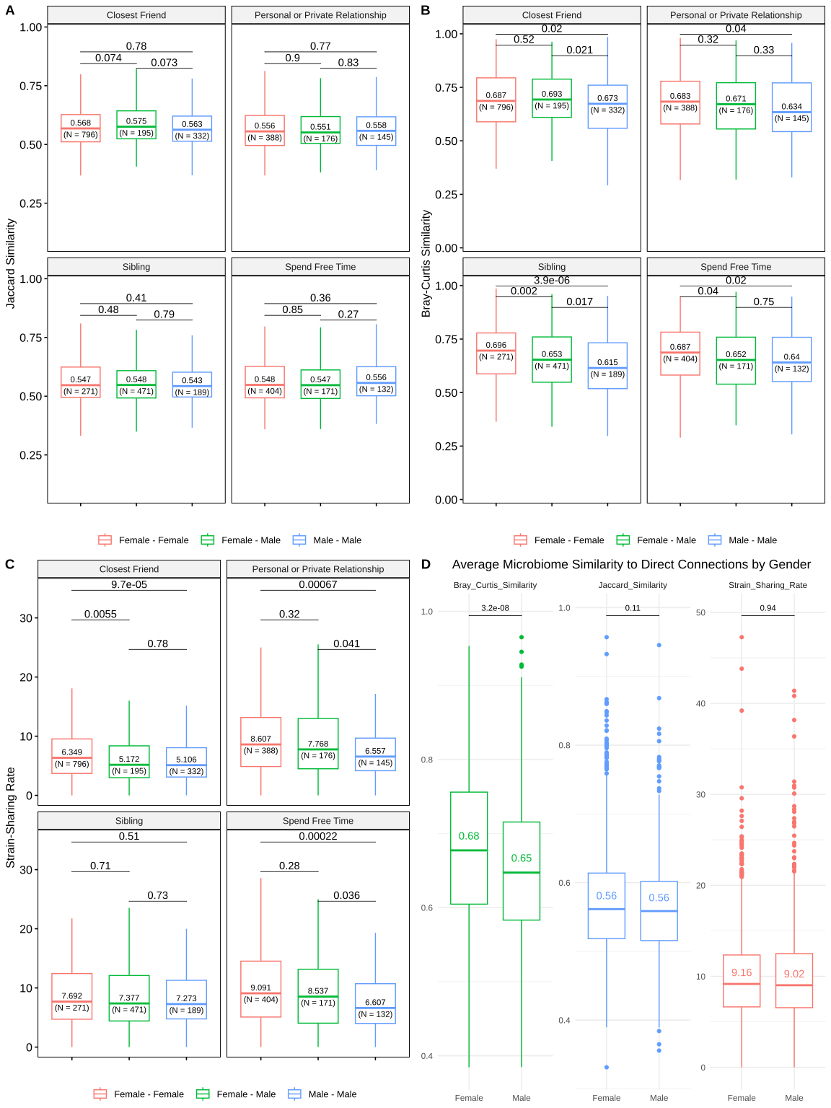

Supplementary Figure 5: Microbiome Sharing by Gender and Relationship. Microbiome sharing stratified by relationship and genders involved based on (A) Jaccard similarity, (B) Bray-Curtis similarity, and (C) Strain-sharing rate. (D) Microbiome similarity to direct connections based on host gender. Men tend to have a higher Bray-Curtis similarity with their direct connections than women. P-values based on two-sided Wilcox Rank Sum tests are shown at the top of each comparison. Data is represented as boxplots where the middle line is the median and the lower and upper hinges correspond to the first and third quartiles; the whiskers extend from the hinge to the largest or smallest value, but no further than 1.5 * IQR from the hinge. The median values and the sample size for each distribution are also reported near the median line.

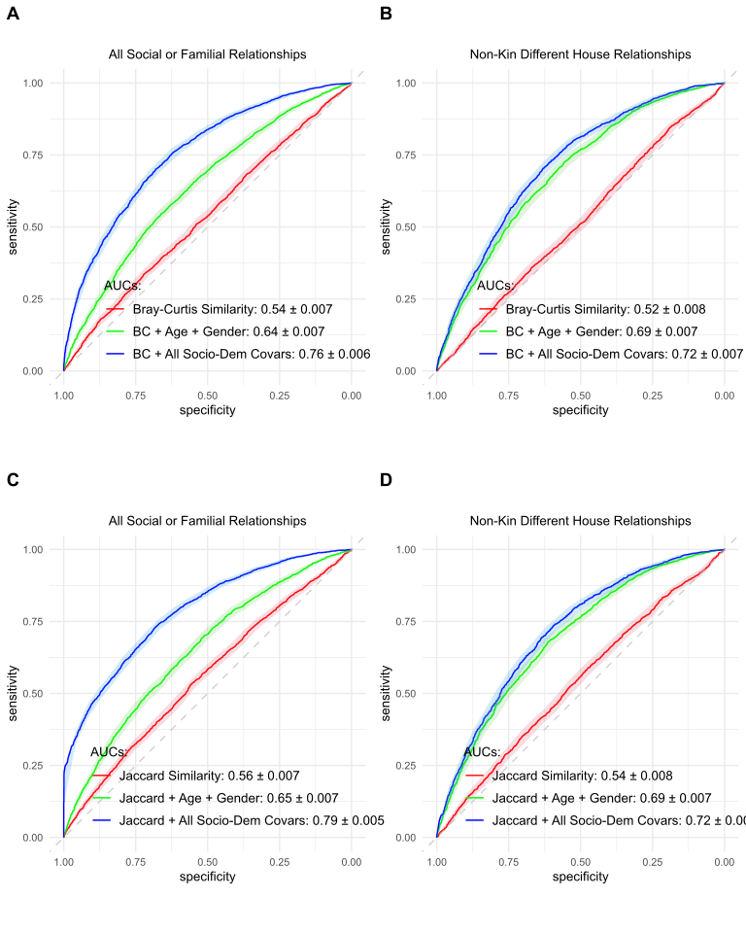

Supplementary Figure 6: Species-Based Relationship Prediction Model. Social network prediction model results using species-level data with Bray-Curtis (top row) and Jaccard similarity (bottom row) for all relationship types (left column) and non-kin different-household relationships (right column). 95% DeLong confidence intervals are shaded surrounding each line. The diagonal dotted line indicates an AUC of 0.50, which corresponds to a “test” no better than chance. Legends report the means and standard deviations for each classifier’s AUC.

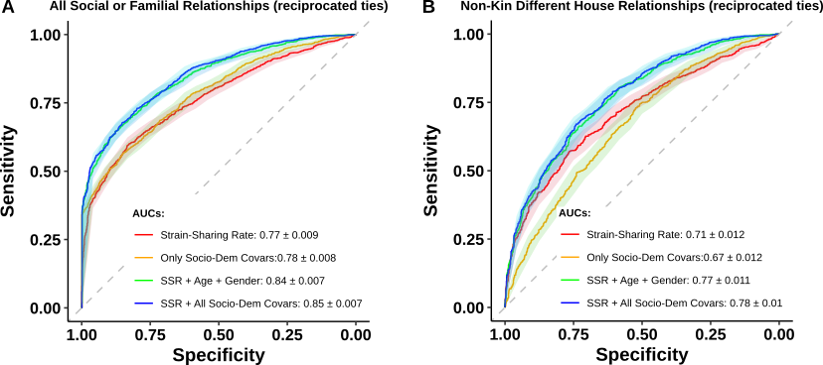

Supplementary Figure 7: Strain-Level Model Predicting Reciprocated Ties. Area under ROC curves (AUC) predicting a social or familial relationships (A), or only non-kin, different-household relationships (B), compared to un-nominated pairs living in the same village. AUC performance in predicting both familial or friendship (non-kin) ties is comparable to the full or stable ties models (Figure 3). 95% DeLong confidence intervals are shaded surrounding each line. The diagonal dotted line indicates an AUC of 0.50, which corresponds to a “test” no better than chance. Legends report the means and standard deviations for each classifier’s AUC. SSR: Strain-Sharing Rate.

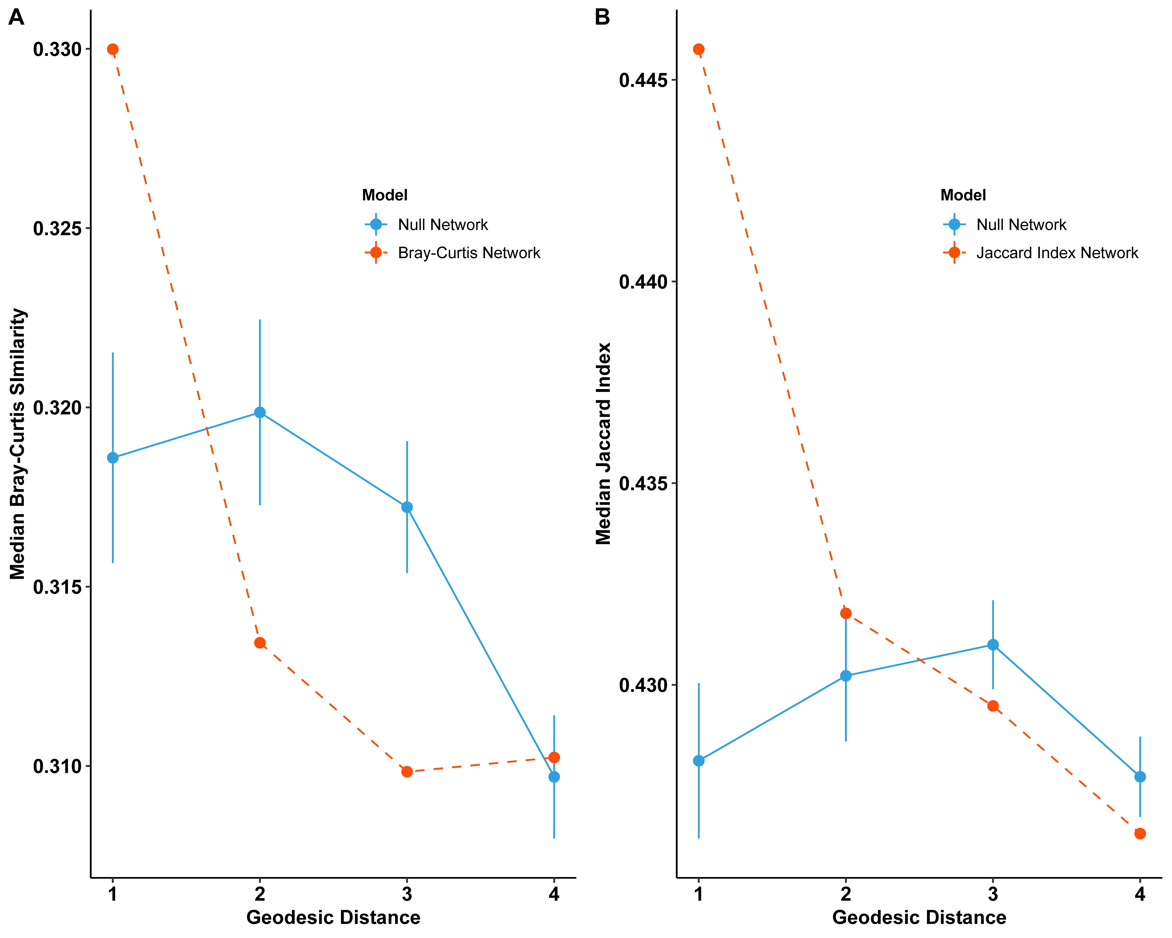

Supplementary Figure 8: Species-Level Sharing by Geodesic Distance. Average Bray-Curtis similarity (A) and Jaccard similarity (B) by geodesic distance in the social network. Bray-Curtis similarity is only significantly elevated for first-degree connections, while Jaccard similarity is elevated for first-degree and second-degree connections. 95% Confidence intervals are plotted around the null distributions.

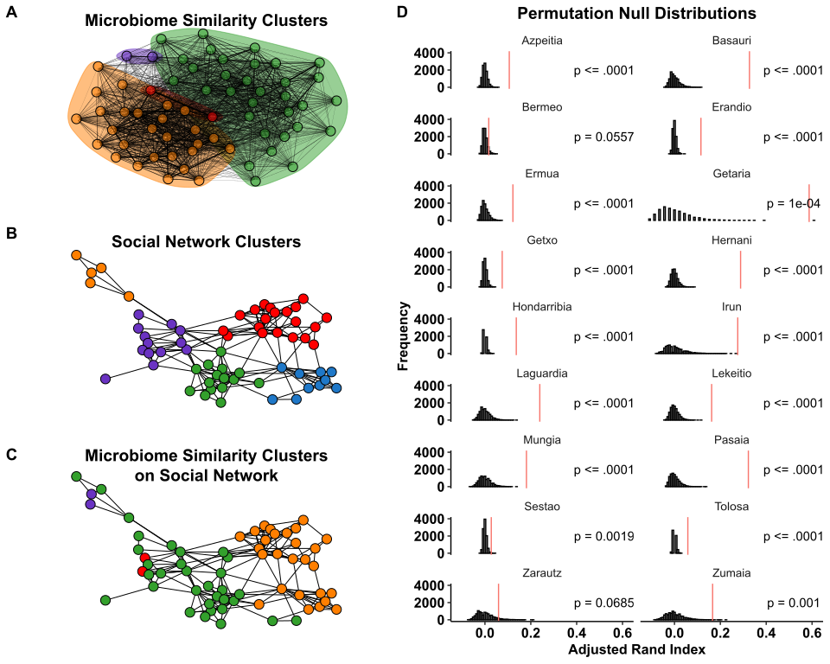

Supplementary Figure 9: Social and Microbiome Strain Niches. (A) Microbiome strain-sharing-rate Leiden clusters for the village of Basauri. Nodes are colored by their microbiome network community identified by this method. Ties are weighted and sized according to the strain-sharing rate between the pair (Modularity = 0.18) (B) Social network Leiden clusters for the village of Basauri (Modularity = 0.58). Nodes are colored by their social network community identified by this method (C) Microbiome cluster membership painted onto the social network. There is visual overlap between communities detected solely on the basis of shared microbe sets and communities detected based solely on social connections. (D) Permutation test p-value distributions for clustering results. Histograms represent the null distribution of adjusted Rand index values from 10,000 microbiome permutations. All villages, except Zarautz, are significant, with the observed overlap metric represented by the vertical red line.

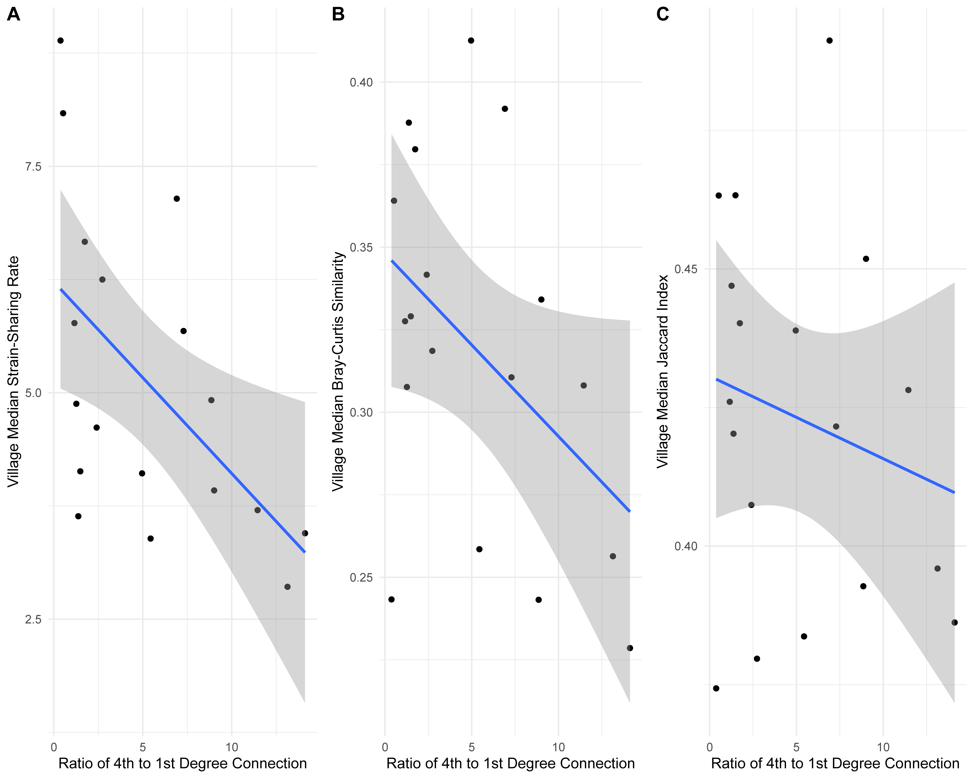

Supplementary Figure 10: Decline in Average Microbiome-Sharing with Network Size. As the ratio of fourth to first degree connections increases (which reflects village size), the average level of microbiome sharing among all individuals in a village tends to decrease. Consequently, the null distributions for microbiome-sharing (measured by strain sharing (A), Bray-Curtis Dissimilarity (B), and Jaccard Index (C)) by geodesic distance tend to dip downwards, since larger villages have a higher ratio of fourth degree connections. Larger villages also have higher village-level microbial diversity. The gray shaded area around the regression line represents the 95% confidence interval.

Supplementary Tables

Kin Ties | General Ties (Kin and Non-Kin )
- Does your mother live in this town? What is the name of your mother?  - Does your father live in this town? What is the name of your father?  - How many siblings do you have? How many are brothers? How many are sisters?  - How many of these siblings are over the age of 12 and currently living or working in this village? What are the names of your siblings over the age of 12 that live or work here?  - Do you have any children who don’t live with you but do live in this village, over the age of 12? What are their names?  - Are you married or living in a civil union? What is the name of your partner? | - Who do you trust to talk to about something personal or private?  - With whom do you spend free time?  - Besides your partner, parents or siblings, who do you consider to be your closest friends?

Supplementary Table 1: Name Generators used to map Networks in the Present Study

Supplementary Table 2: Village-level demographics and summary characterization of the 1,787 participants in the study.

Supplementary Table 3: Summary and per-village performance metrics of the mixed-effect logistic regression model using all socio-demographic covariates predicting all ties, stable ties, reciprocated ties.

Supplementary Table 4: Social network and strain-sharing network comparison metrics. Clustering coefficient, degree distribution, and fraction of shared edges were compared for each villages’ networks.

Supplementary Data

Supplementary Data 1
Summary information of the mixed-effects model used in the strain-sharing regression analysis.

Supplementary Data 2
Summary information of the mixed-effects models used in the longitudinal analysis regressions.

Supplementary Data 3
Summary information of the mixed-effects models used for for the centrality measures regressions.

Supplementary Data 4
MetaPhlAn 4 relative abundance table for the 1,787 analyzed samples.

