Supplementary information

Pangenome bridges wheat structural variations with habitat and breeding

Chengzhi Jiao et al.

Corresponding authors: Rajeev K. Varshney, rajeev.varshney@murdoch.edu.au, Weilong Guo, guoweilong@cau.edu.cn, Xueyong Zhang, zhangxueyong@caas.cn

Contains Supplementary Figures 1-16 and Supplementary Tables 1-29.

Supplementary Figures 1-16
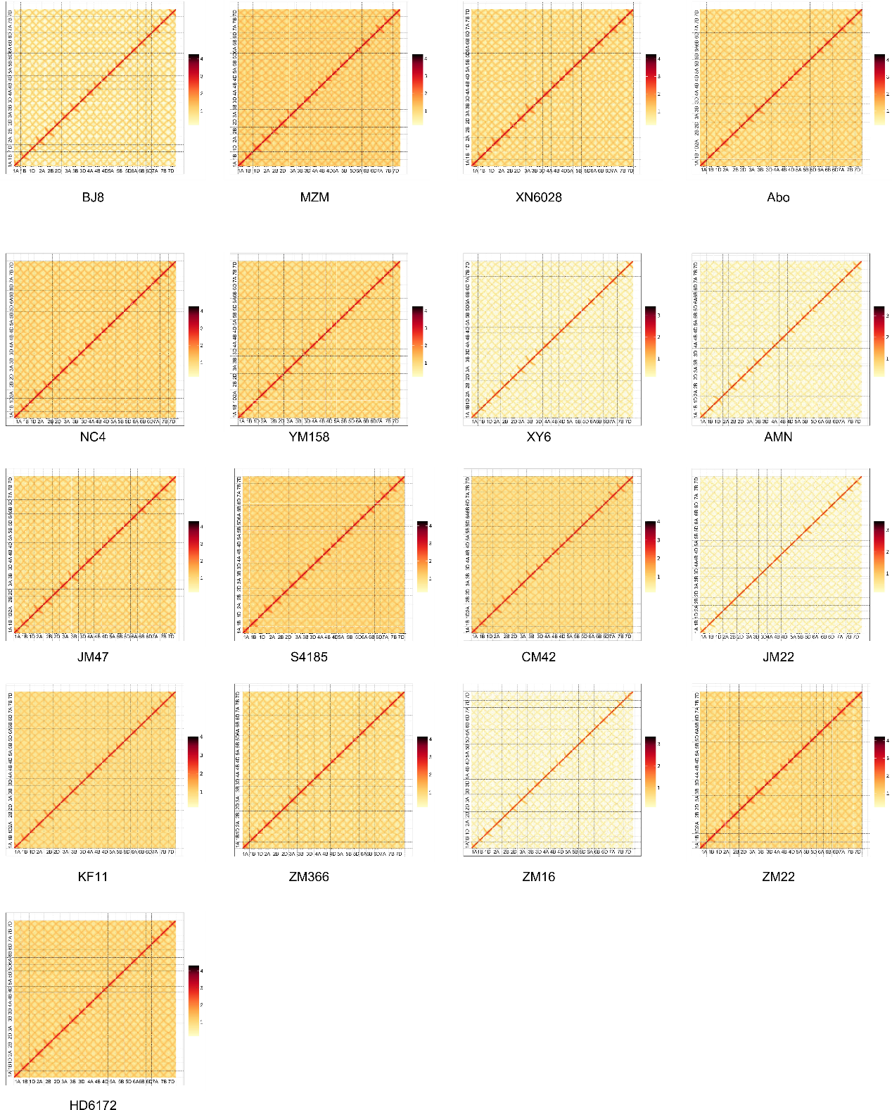
Supplementary Figure 1. Heatmaps represent the chromatin interaction matrix of Hi-C pseudo-chromosomes in the 17 de novo assembled genomes.
The heatmaps visualize the Hi-C contact matrices at a resolution of 500kb window, providing a comprehensive overview of the chromatin interactions across the genomes. Each heatmap corresponds to an individual genome, with rows and columns representing different regions of the pseudo-chromosomes. The color intensity in the heatmap indicates the strength of chromatin interactions, with darker colors representing stronger or more frequent interactions. Within each heatmap, diagonal blocks of intense color represent intra-chromosomal interactions, while off-diagonal blocks represent inter-chromosomal interactions. Patterns of interactions can provide insights into the three-dimensional organization of the genome and potential functional relationships between different regions. These heatmaps demonstrate the accuracy of the assembly of 17 genomes.

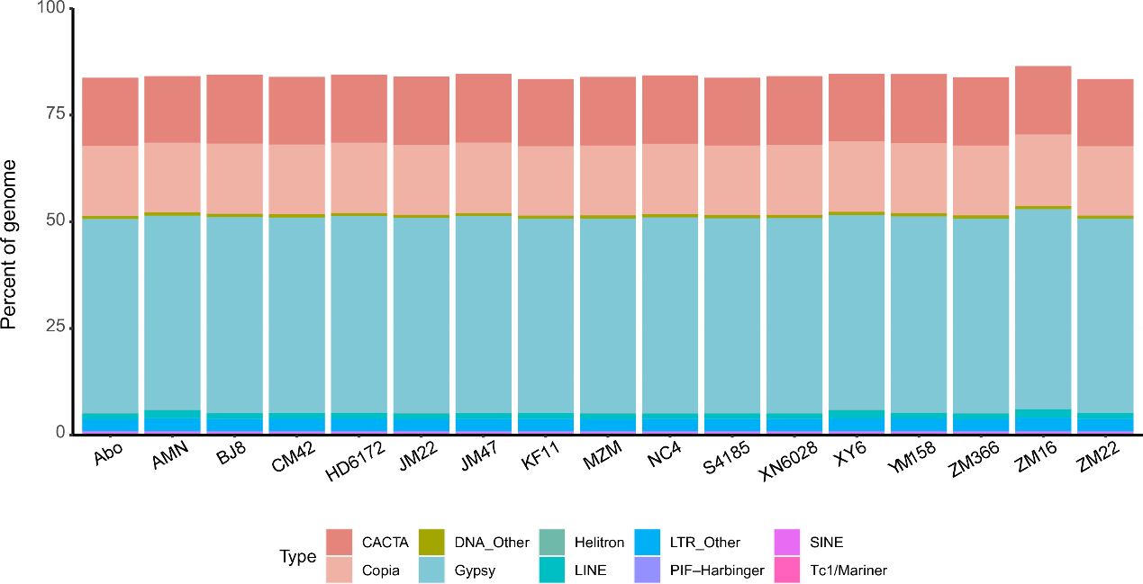

Supplementary Figure 2. Transposable element (TE) content distribution in the 17 de novo assembled wheat genomes. Each genome is represented by a distinct color-coded bar, with the length of each bar indicating the relative abundance of TEs in that particular genome. Within each bar, different segments of color represent various TE types or categories, such as Helitron, DNA transposons, LTR retrotransposons, and others. The legend at the bottom of the figure provides a key to interpret the color coding, indicating which color corresponds to which TE type. Relatively stable TE content among the 17 cultivars indicates the absence of significant TE burst events in breeding of common wheat.

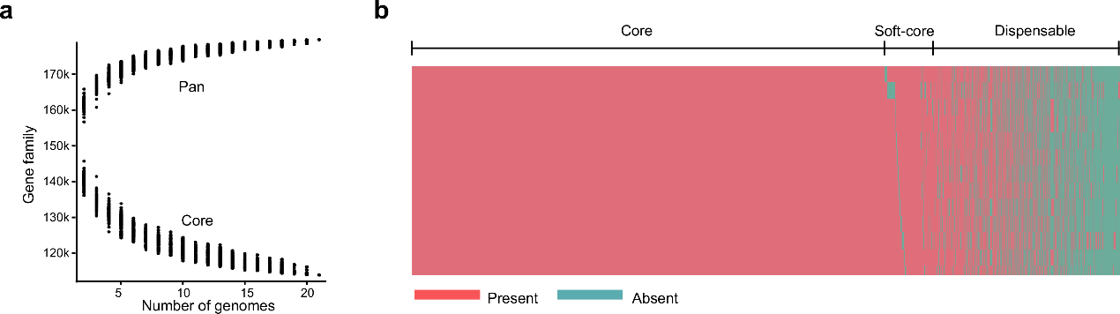

Supplementary Figure 3. Pan and core gene families in wheat pangenome.
a, Variation of gene families in the pan-genome and core genome along with an additional wheat genome. The x-axis represents the sequential addition of wheat genomes, while the y-axis represents the number of gene families. The curve representing the pan-genome shows an increasing trend as more genomes are added, indicating the expansion of the overall gene pool. Conversely, the curve for the core genome initially decreases but plateaus at a certain point, indicating that the core set of gene families remains relatively stable despite the inclusion of additional genomes. This observation suggests that the core genome comprises genes that are essential and conserved across wheat varieties. b, Presence and absence information of pan gene families in the wheat genomes. Each row corresponds to a different wheat genome, and each column represents a different gene family type. The color coding indicates the presence (red) or absence (green) of a specific gene family in a given genome.

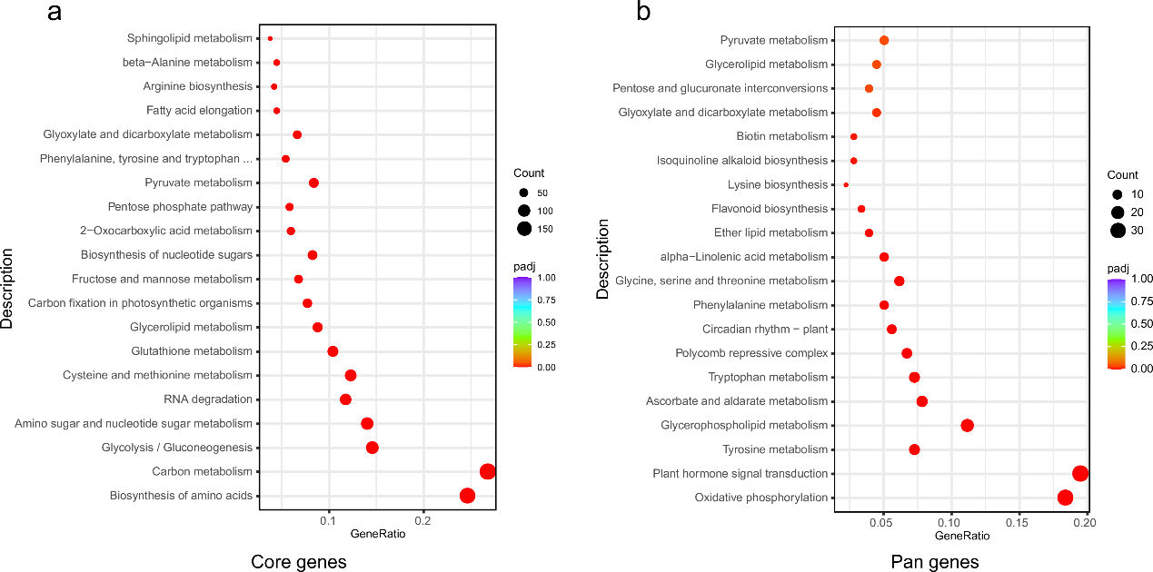
Supplementary Figure 4. Bubble plot of KEGG enrichment for Core genes and Pan genes. The KEGG enrichment analysis showed that core genes are mostly associated with basic metabolism, while pan genes are mainly involved in pathways such as plant resistance regulation.

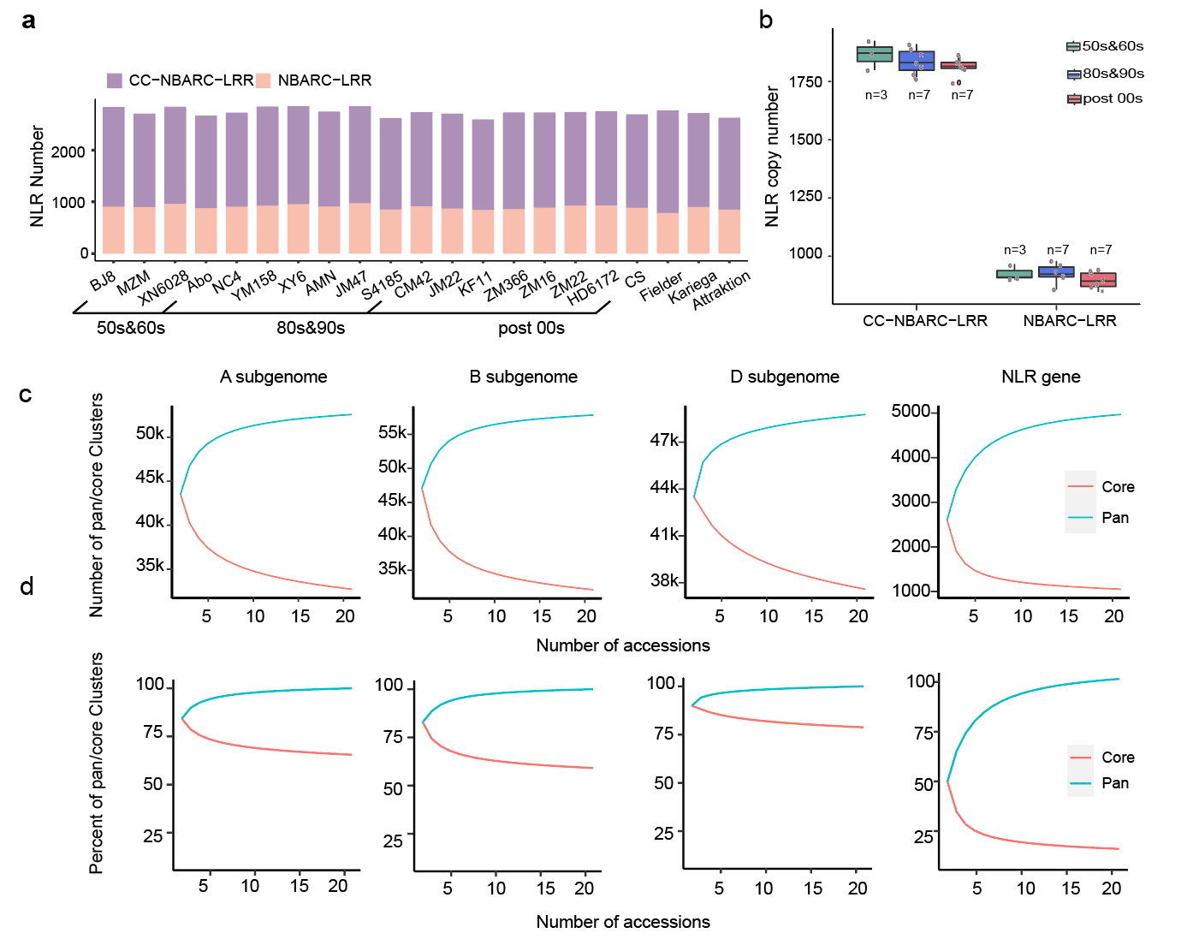
Supplementary Figure 5. NLR genes in wheat pangenome.
a, Comparison of NLR copy numbers among different accessions. The various color backgrounds indicate accessions from different clades. b, Canonical nucleotide-binding domain and leucine-rich repeat(NLR) copy number in different wheat breeding ages. The box plot depicts the interquartile range (IQR), with the box edges representing the 25th and 75th percentiles. The whiskers extend to 1.5 times the IQR, and the centerline represents the median value. Each NLR class contains data from 17 wheat genomes, reflecting the variation in NLR copy number within the pangenome. c, Simulation of pan- and core-genome sizes based on genes present in the three sub-genomes(A, B, and D), and NLR genes with every additional genome. d, Simulation of pan- and core-genome percentage in three sub-genome genes and NLR genes with every additional genome.c and d provide insights into the dynamics of the wheat pangenome, highlighting the complexity and diversity of NLR genes across breeding ages and genomes.

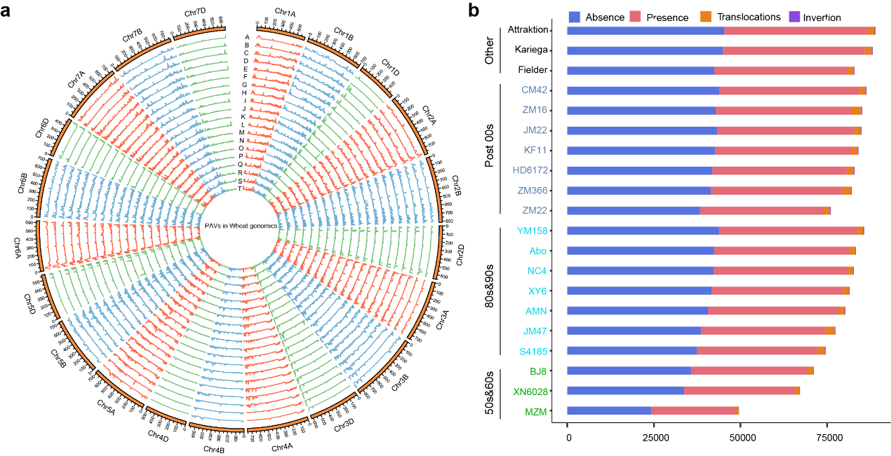
Supplementary Figure 6. Features of SVs in the pangenome consisted of 20 wheat cultivars.
a, Distribution of pan-PAVs in the 17 wheat cultivars in comparison with CS references (CS v2.1). Each cultivar is represented by a segment of the circle, BJ8 (A), MZM (B), XN6028 (C), Abo (D), NC4 (E), YM158 (F), XY6 (G), AMN (H), JM47 (I), S4185 (J), CM42 (K), JM22 (L), KF11 (M), ZM366 (N), ZM16 (O), ZM22 (P), HD6172 (Q), Fielder (R), Kariega (S), Attraktion (T).
b, The number of SVs in terms of four types of SVs in each wheat genome.

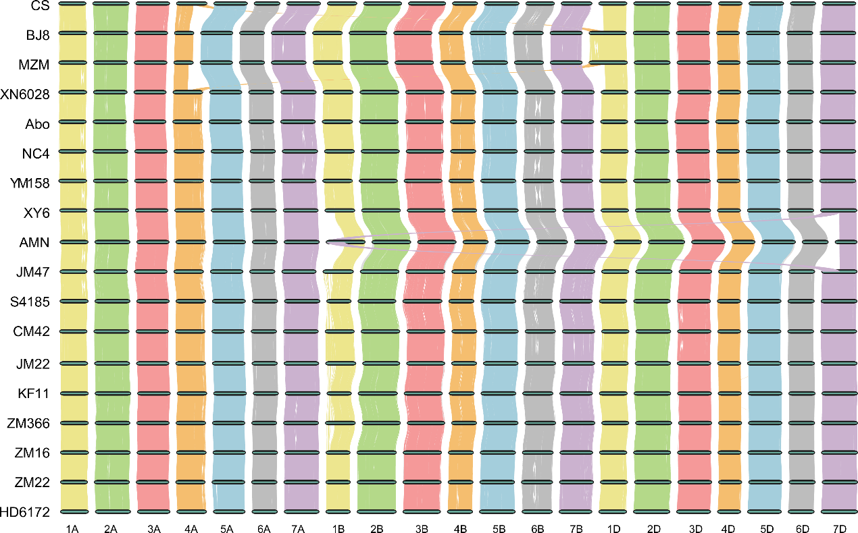

Supplementary Figure 7. Whole genome collinearity plot between the 17 de novo assembled genomes and the CS reference (RefSeq v2.1).

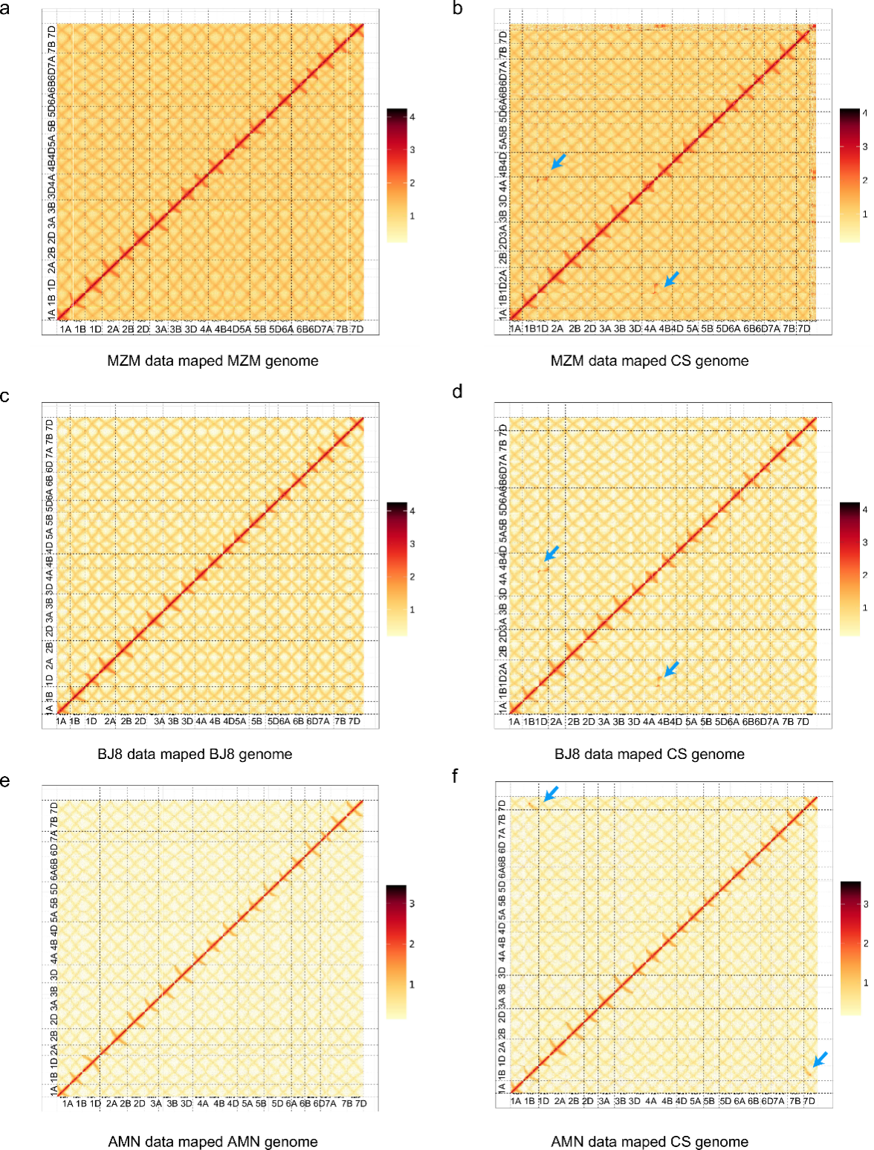

Supplementary Figure 8. Validating translocation between chr4A and chr1D using HIC data.
a, The Hi-C data from MZM did not reveal any abnormal interactions when aligned to the MZM genome. b, The Hi-C data from MZM, when aligned to the CS genome, showed a clear interaction signal between Chr4A and Chr1D. c, The Hi-C data from BJ8 did not reveal any abnormal interactions when aligned to the BJ8 genome. d, The Hi-C data from BJ8, when aligned to the CS genome, showed a clear interaction signal between Chr4A and Chr1D. e, The Hi-C data from AMN did not reveal any abnormal interactions when aligned to the AMN genome. f, The Hi-C data from AMN, when aligned to the CS genome, showed a clear interaction signal between Chr4A and Chr1D.
When the HIC data of these cultivars are aligned to the CS genome, the distinct interaction signals indicated by the blue arrows provide evidence for the presence of translocation events.
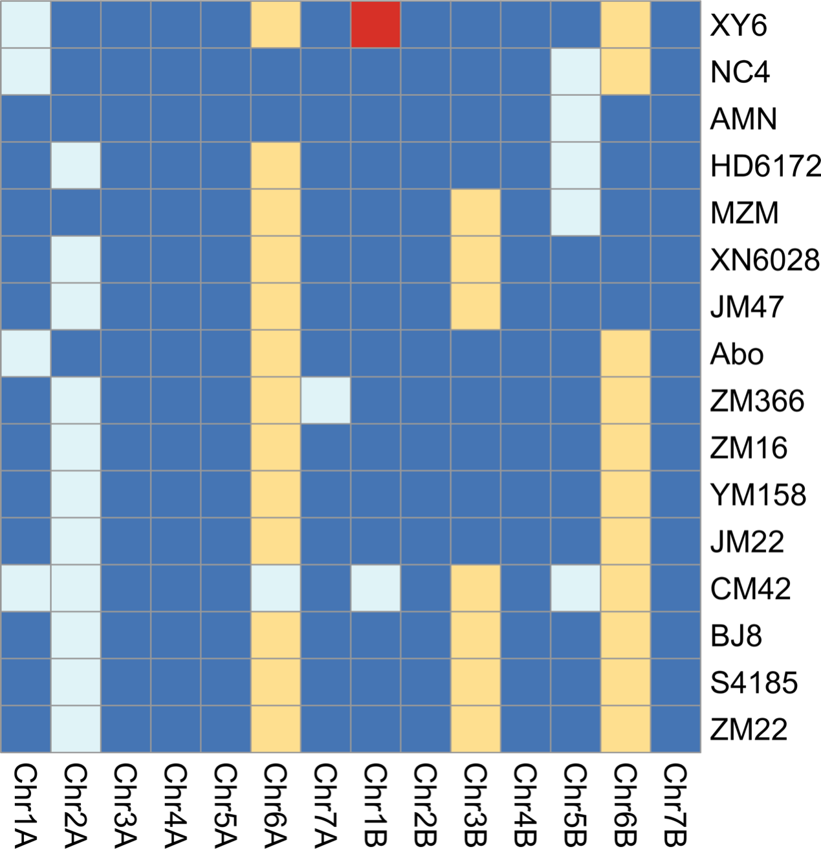

Supplementary Figure 9. Types of centAHG of the 17 de novo assembled genomes on the 14 chromosomes in the A- and B-subgenomes. Colors distinguish different types of centAHG. On chromosome 3A, 4A, 5A 2B, 4B an 7B, centAHGs are the same among all genomes.

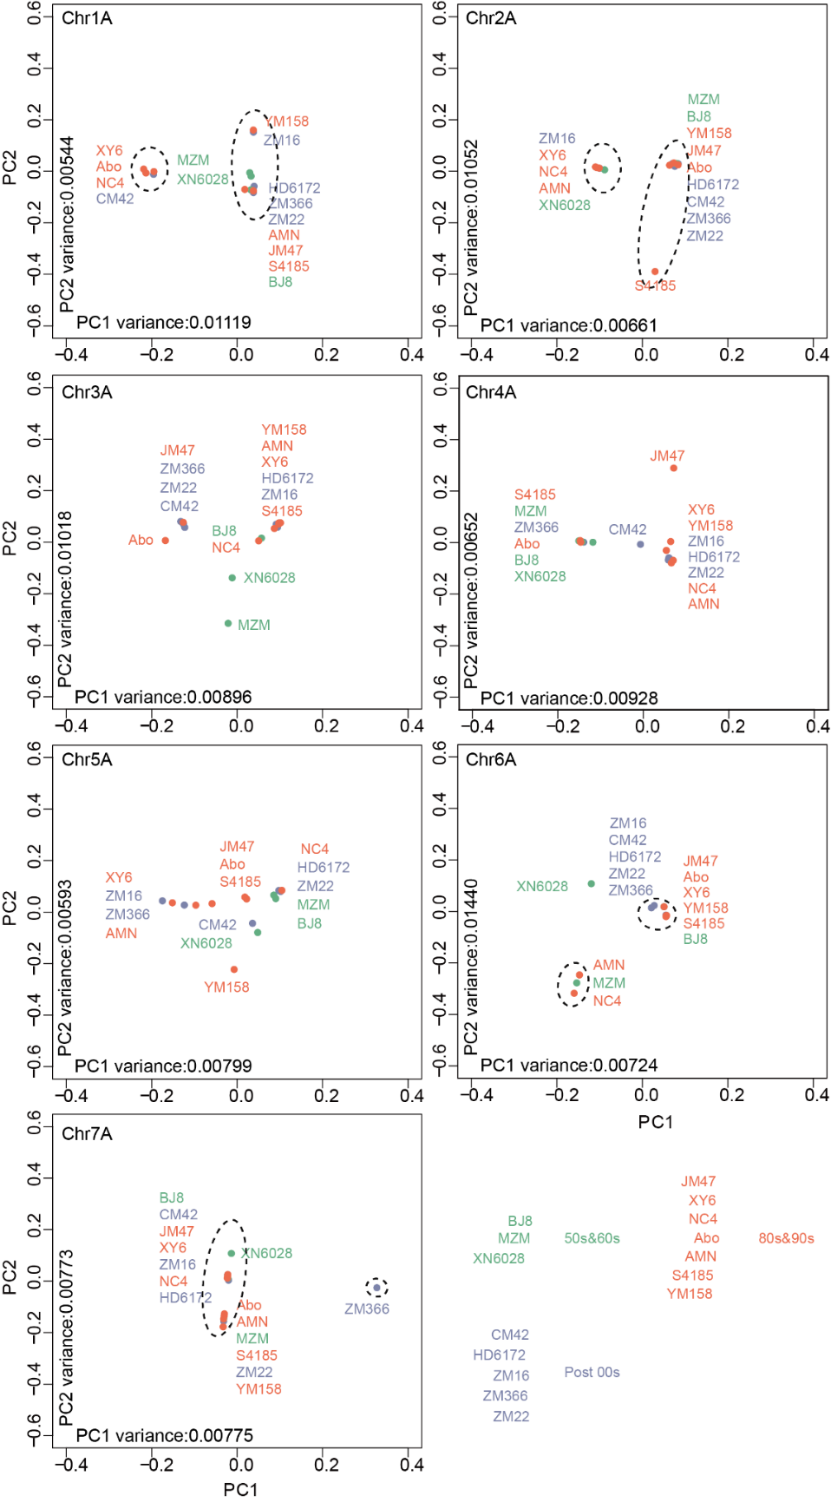

Supplementary Figure 10. PAV-based PCA for each of the A chromosomes chromosomes among 17 de novo assembled genomes. They could be grouped into two basic clusters on chromosomes 1A, 2A, 6A, and 7A, which were consistent with their centAHG types, respectively.

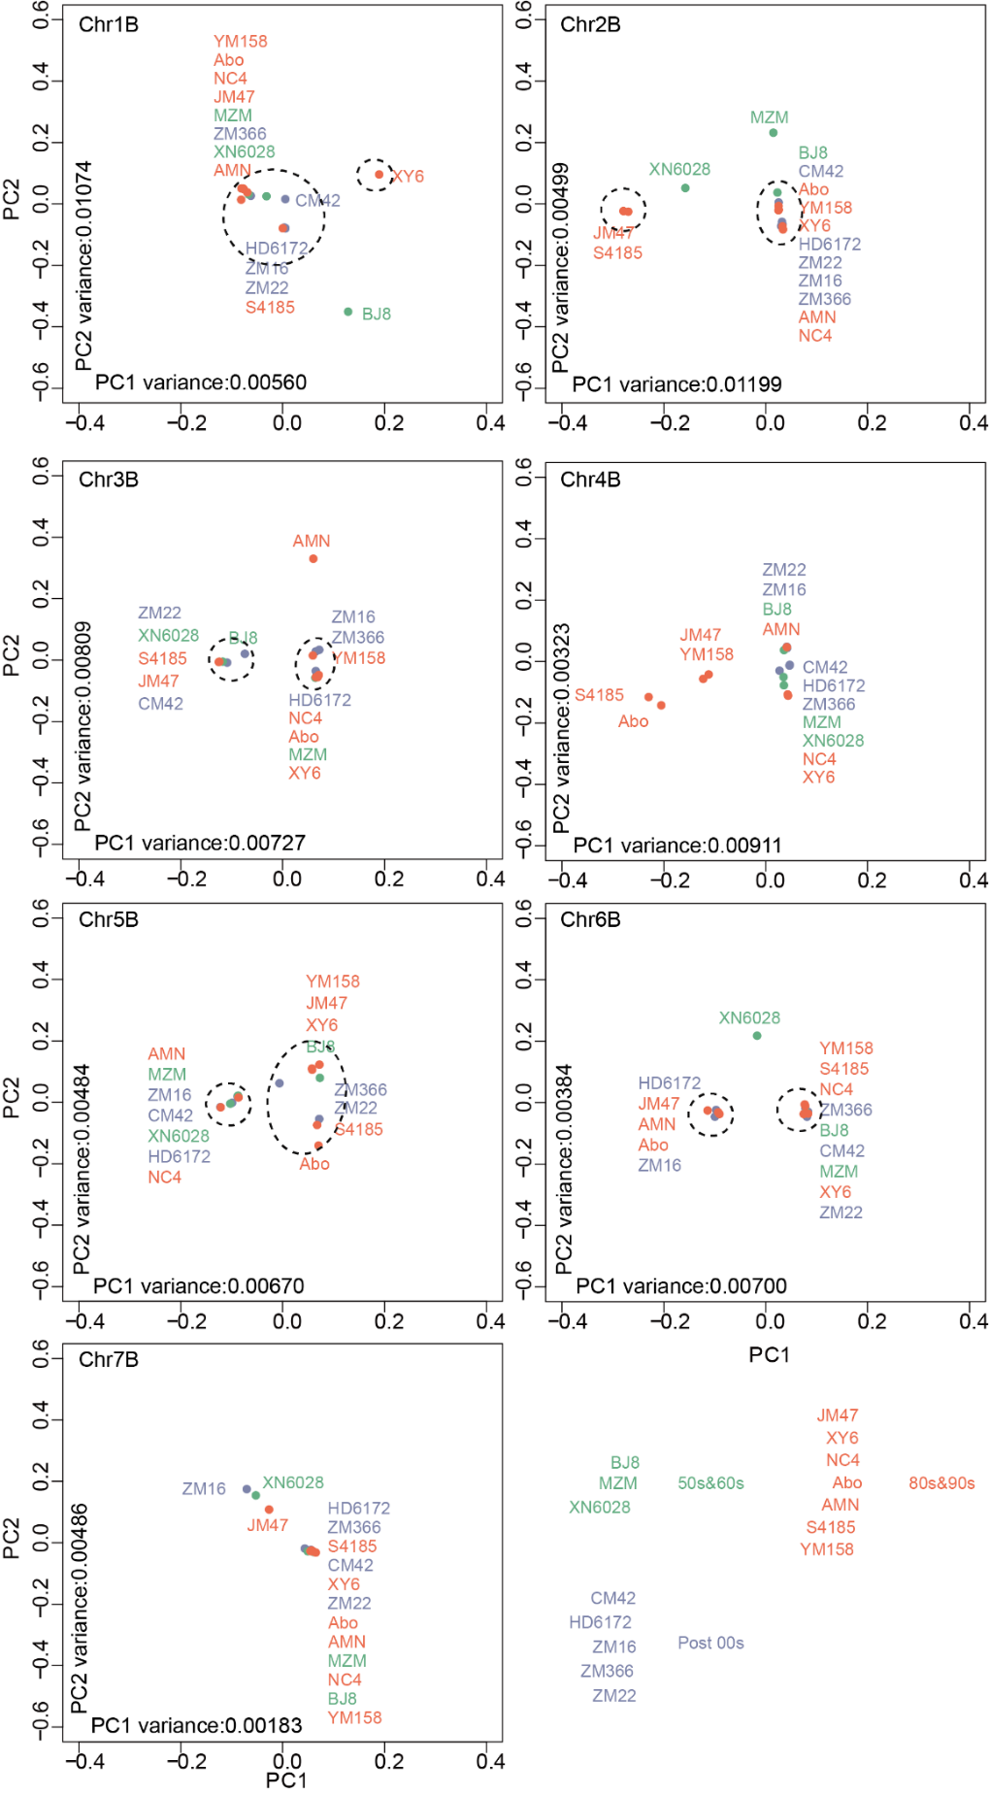
Supplementary Figure 11. PAV-based PCA for each of the B chromosomes among 17 de novo assembled genomes. They could be grouped into two basic clusters on chromosomes 1B, 2B, 3B, 5B and 6B, which were consistent with their centAHG types, respectively.

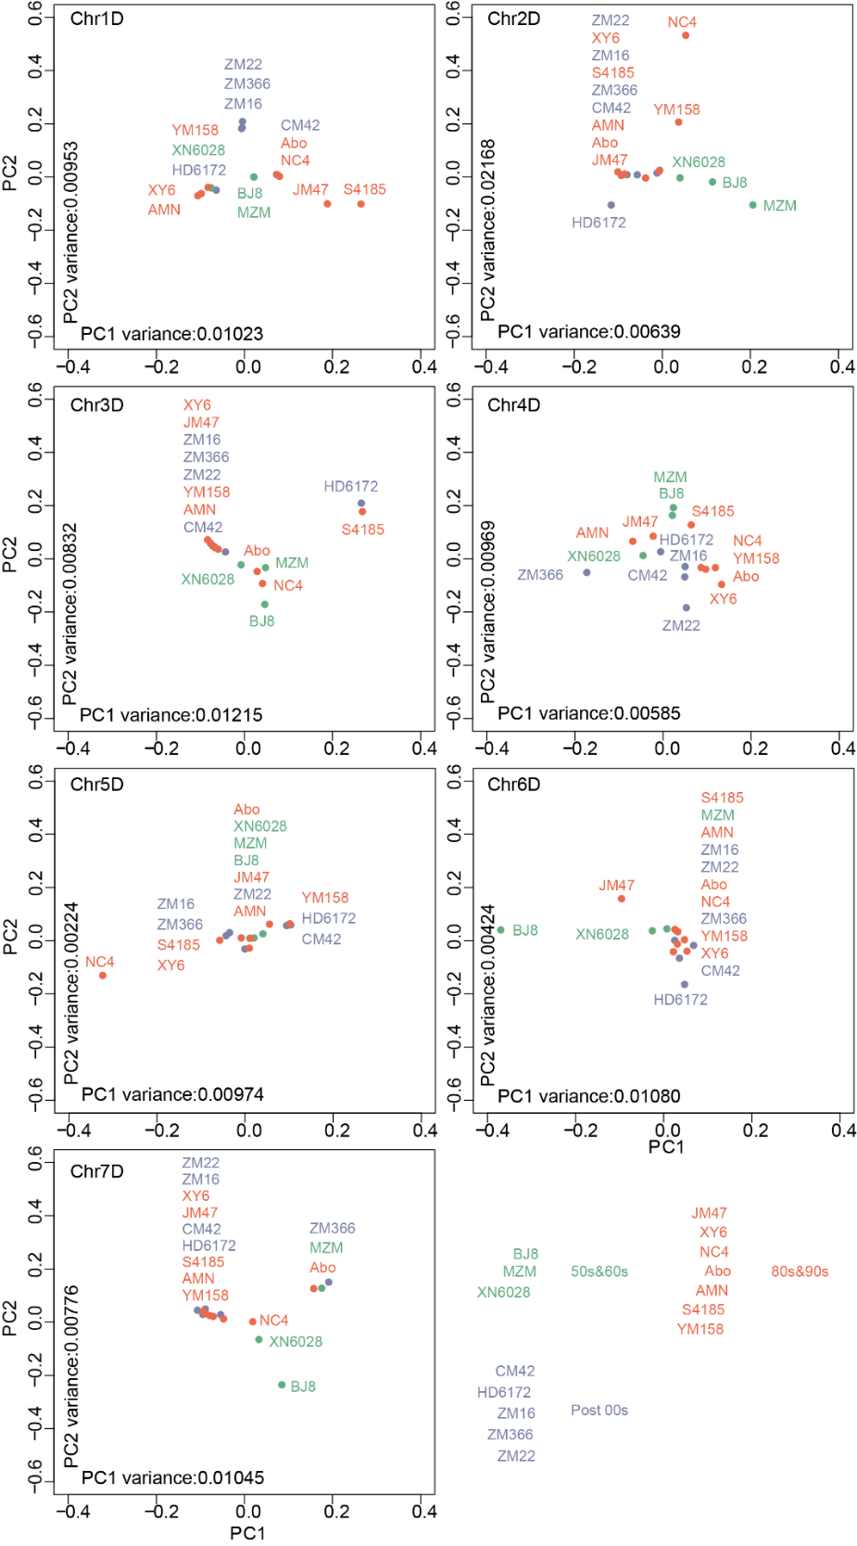
Supplementary Figure 12. PAV-based PCA for each of the D chromosomes among 17 de novo assembled genomes. No clear clustering trend was identified on all chromosomes except chr7D.

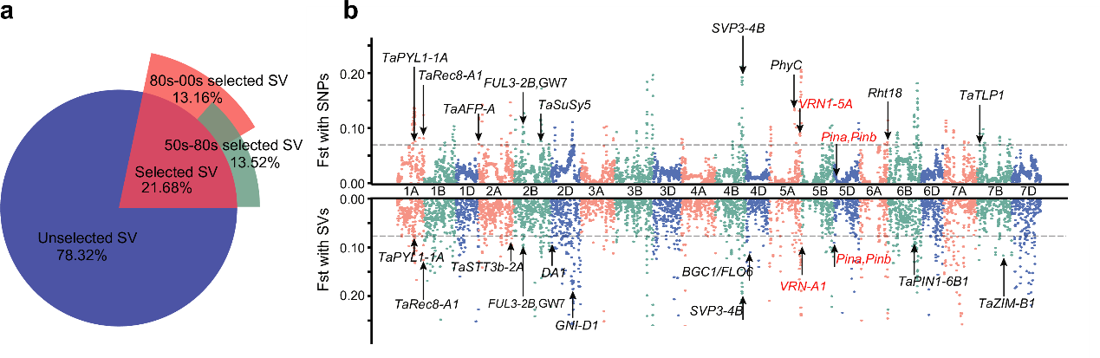
Supplementary Figure 13. Selective Signals during Modern Breeding History
a, The percentage of selected PAVs in different breeding periods of wheat. 13.52% of PAVs were under selection during the breeding process from the 1950s to the 1980s, and 13.16% of PAVs were under selection during the breeding process from the 1980s to the 2000s. Overall, 21.68% of PAVs have been under selection in modern breeding processes. b, Genome-wide distribution of selective sweeps identified through comparisons between 80s and 00s using FST values with SNP and SV, respectively. VRN-A1 was under selection in both SNP and SV selection analyses, while PIN genes were only under selection in the SV selection analysis.

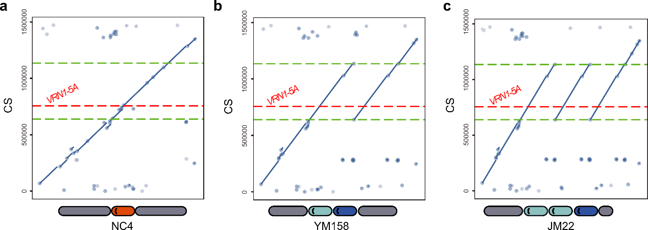
Supplementary Figure 14. Dot plots between the two genomes of Chinese Spring and NC4, YM158 and KF11, respectively.
The interval framed by the green dashed line is a fragment repeat about 500 Kb, and the red dashed line is the position of the VRN-A1 in Chinese Spring. The pattern diagram at the bottom represents the types of VRN-A1 contained on the different repeat fragments.

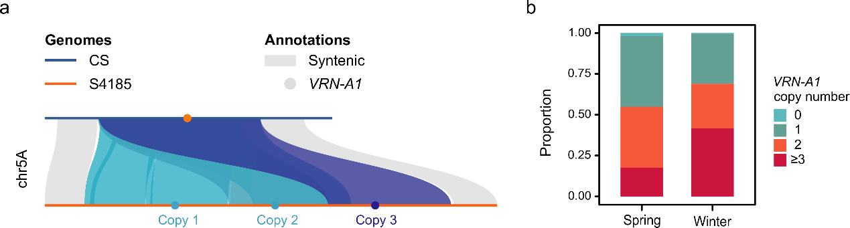

Supplementary Figure 15. CNV of the VRN-A1 gene in the pangenome.
a, Triple duplications were found in the ~500k interval where VRN-A1 is located between CS and S4185. Blue blocks represent duplications, orange and blue dots represent VRN-A1 gene. The bright and dark blue dots mean Winter (Hap-III) and strong Winter copy (Hap-II) respectively in S4185. b, The proportion of different copy numbers of the VRN-A1 gene in different ecotypes (Spring/Winter) rsequenced. Blue, green, orange, and red represent 0, 1, 2 and >= 3 copies, respectively.
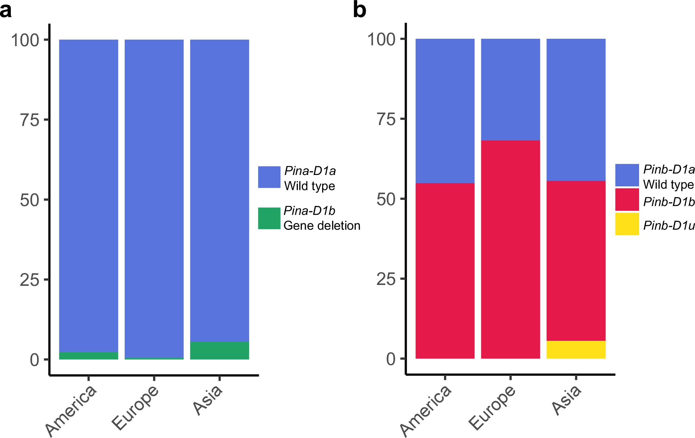

Supplementary Figure 16. Haplotype of Pina-D1 and Pinb-D1 in modern cultivars. The haplotype of cultivars from America and Europe were genotyped with the markers in Supplementary Table 27. The haplotype of cultivars from Asia were genotyped by the re-sequencing data.

Supplementary Tables 1-29

Supplementary Table 1. Accessions used in t-SNE analysis
Supplementary Table 2. Summary of HiFi reads
Supplementary Table 3. Summary of Hi-C reads
Supplementary Table 4. Summary of RNA reads sequenced on Illumina platform
Supplementary Table 5. Summary of RNA reads sequenced on PacBio platform
Supplementary Table 6. Assessment of the core gene coverage rate in assemblies using BUSCO
Supplementary Table 7. Assessment of the LTR completeness using LAI
Supplementary Table 8. Summary of the transposon elements in the 17 de novo assembled genomes
Supplementary Table 9. Summary of the gene structure annotation for 4 genomes
Supplementary Table 10. Summary of the post-standardized gene structure annotation for the 21 genomes
Supplementary Table 11. Assessment of the core gene coverage rate in Pre- and post-standardization cds using BUSCO
Supplementary Table 12. Summary of the post-standardized gene function annotation for 20 genomes
Supplementary Table 13. Statistics of the Pan-gene set of 21 wheat genomes
Supplementary Table 14. KEGG enrichment of core gene families
Supplementary Table 15. KEGG enrichment of pan gene families
Supplementary Table 16. Summary of predicted NLRs in de novo assembled wheat genomes
Supplementary Table 17. Statistics of SNPs in the 145 wheat landmarker cultivars
Supplementary Table 18. Statistics of the indels in the 145 re-seq landmarker wheat cultivars
Supplementary Table 19. Statistics of the PAVs in wheat pan genome
Supplementary Table 20. Three big translocation in wheat genomics
Supplementary Table 21. The centAHG block types in the 17 de novo assembled cultivars
Supplementary Table 22. The centAHG-block types in the 17 de novo assemblies
Supplementary Table 23. Identified VRN genes in different genomes
Supplementary Table 24. Wheat ecotypes and VRN1 alleles based on re-seq assemblies
Supplementary Table 25. Ecotypes and VRN1 alleles based on de novo assembled wheat genomes
Supplementary Table 26. The variations of pina and pinb genes and grain hardness in 33 wheat genomes
Supplementary Table 27. Alleles at pina and pinb loci in Eastern and Western wheat cultivars with assembled genome
Supplementary Table 28. Primers used for verification variation at Pina and Pinb
Supplementary Table 29. National GeneBank DataBase (CNGBdb) database ID of genome sequences and annotations

1 Wang, Z. et al. Dispersed emergence and protracted domestication of polyploid wheat uncovered by mosaic ancestral haploblock inference. Nat. Commun. 13, 3891 (2022). https://doi.org:10.1038/s41467-022-31581-0

