SUPPLEMENTARY INFORMATION (SI)

Bat genomes illuminate adaptations to viral tolerance and disease resistance

Ariadna E. Morales ^{1,2,3,}*, Yue Dong ^{4,5,}*, Thomas Brown ^{6,7}, Kaushal Baid ⁸, Dimitrios - Georgios Kontopoulos ^{1,2,3}, Victoria Gonzalez ^{8,9}, Zixia Huang ¹⁰, Alexis-Walid Ahmed ^{1,2,3}, Arkadeb Bhuinya ^{8,9}, Leon Hilgers ^{1,2,3}, Sylke Winkler ^{6,7}, Graham Hughes ¹⁰, Xiaomeng Li ^{5,4}, Ping Lu ⁵, Yixin Yang ⁵, Bogdan M. Kirilenko ^{1,2,3}, Paolo Devanna ¹¹, Tanya M. Lama ^{12,$,}, Yomiran Nissan ^{13,14}, Martin Pippel ^{6,7}, Liliana M. Dávalos ^{12,15}, Sonja C. Vernes ^{11,16}, Sebastien J. Puechmaille ^{17,18}, Stephen J. Rossiter ¹⁹, Yovel Yossi ^{14,15}, Joseph B. Prescott ²⁰, Andreas Kurth ²⁰, David A. Ray ²¹, Burton K. Lim ²², Eugene Myers ^{6,7}, Emma C. Teeling ¹⁰, Arinjay Banerjee ^{8,9,23,24,25}, Aaron T. Irving ^{26,5,4,#}, Michael Hiller ^{1,2,3,#}

The Supplementary Materials contain
- Supplementary Figures 1 – 23,
- Supplementary Data showing FACS gating strategy and uncropped, unannotated, original Western blot images,
- Supplementary References.

Supplementary Tables 1 - 27 are provided as sheets in a separate Excel file.
Supplementary Videos are provided as separate files.

Supplementary Figures
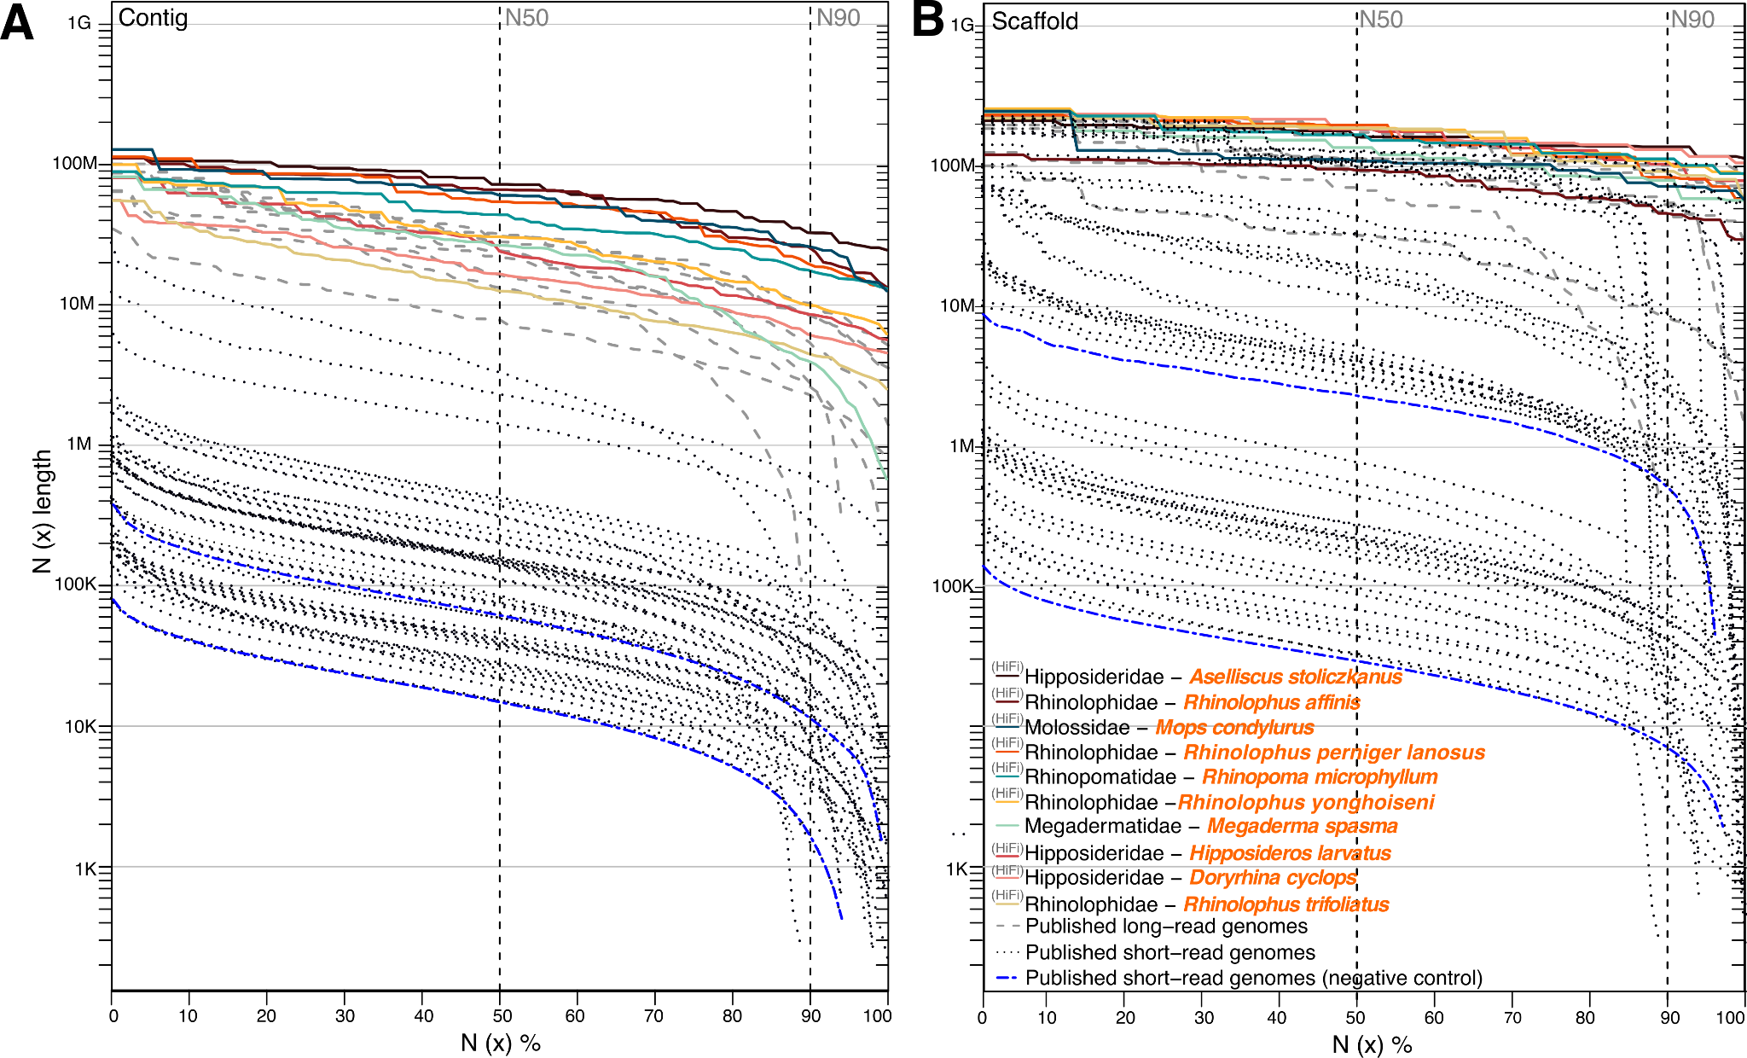

Supplementary Figure 1. Assembly contiguity comparison across 52 bat genomes.
This figure expands on Fig. 1c-d by showing short-read based genome assemblies used in phylogenetic inferences (30 genomes shown in black dotted lines) and as negative control for gene selection screens (2 genomes shown in blue dotted lines). These assemblies were omitted from the main text figure to improve clarity. The 10 newly-generated (colored solid lines) and 10 published (grey dashed lines) long-read based assemblies are reproduced for comparability. N(x) % graphs show contig (A) and scaffold (B) sizes (y-axis), in which x percent of the assembly consists of contigs and scaffolds of at least that size. Short-read based assemblies consistently have shorter contigs, and also tend to have shorter scaffolds.

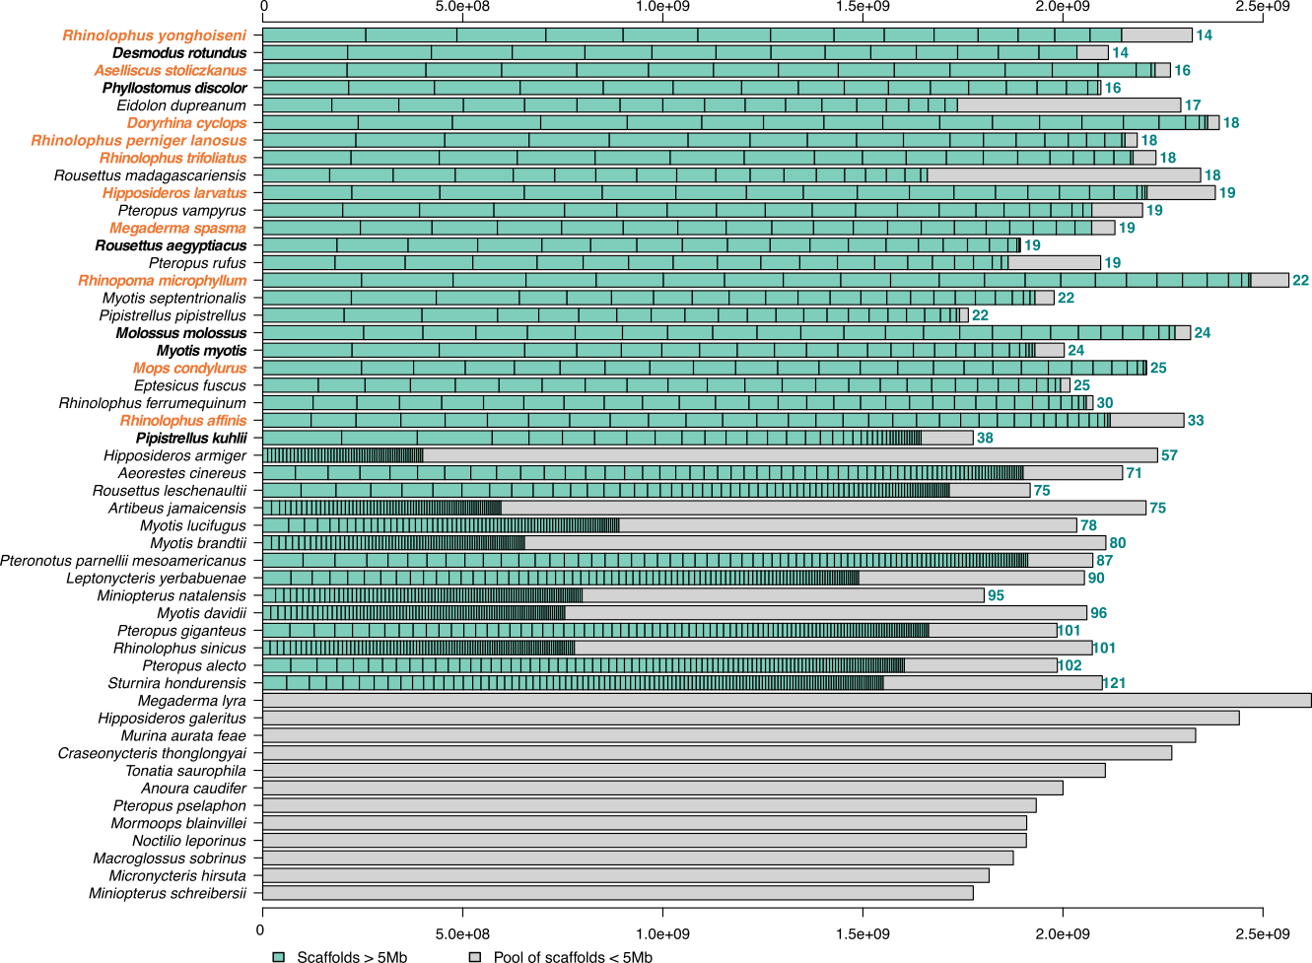

Supplementary Figure 2. Scaffold size distribution across 50 bat genomes.
Visualization of scaffold lengths in 50 bat genomes. The ten newly-generated genomes in orange font, assemblies that are based on long reads are in bold. All assemblies are sorted by number of scaffolds larger than 50 Mb and by the median scaffold length. Scaffolds shorter than 50 Mb were pooled into the grey box on the right end.

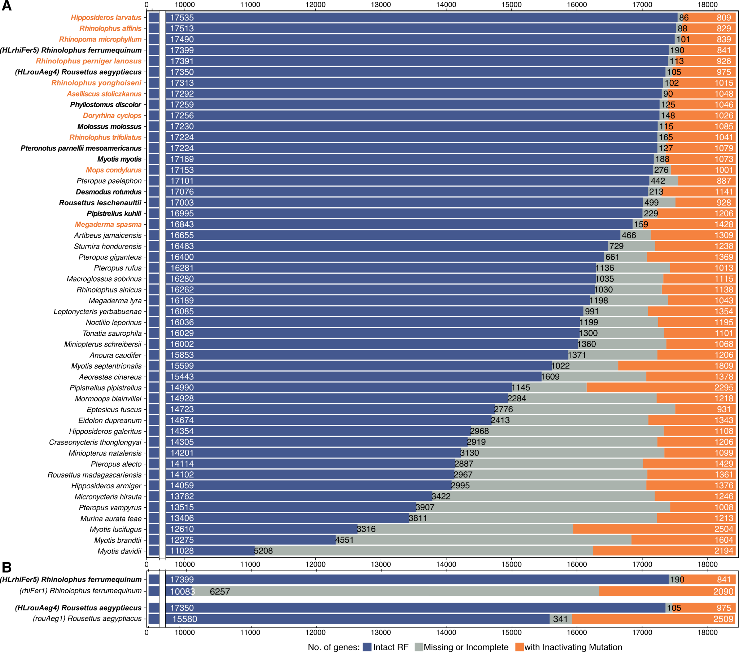

Supplementary Figure 3. Status of 18,430 ancestral placental mammalian genes in bat genomes.
(A) 50 bat genomes used for phylogenetic inference.
(B) Bat genomes that we used to explore the effect of genome quality on selection screens.
This figure expands on Fig. 1e by showing additional bat genomes. Ancestral genes are classified by TOGA (using human hg38 as the reference) into those with an intact reading frame (blue), gene-inactivating mutations (premature stop codons, frameshifts, splice site disruptions, and deletions of exons or entire genes; shown in orange) or missing or incomplete coding sequences due to assembly gaps or fragmentation (grey). An excess of genes with missing sequences indicates a lower assembly completeness and an excess of genes with inactivating mutations indicates a lower base accuracy. The ten newly-generated genomes in orange font and assemblies that are based on long reads are in bold. All assemblies in panel A are sorted by the number of intact genes. Long-read based assemblies tend to have more intact genes and fewer genes with missing coding parts.

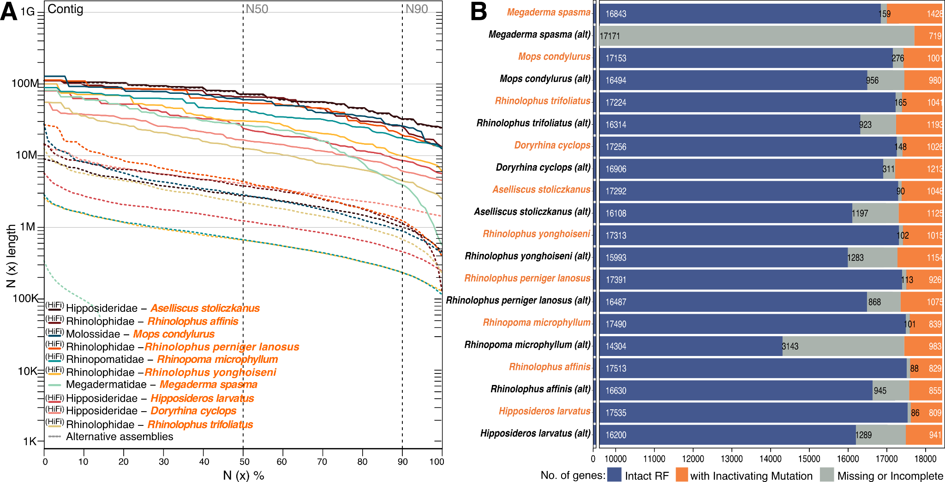

Supplementary Figure 4. Comparison of primary vs. alternative bat assemblies.
For our 10 new bat genomes, we compared contiguity (A) and status of 18,430 ancestral mammalian genes inferred with TOGA (B) between the primary assembly (solid lines in A, orange in B) and their respective alternative assemblies (dashed lines in A, black in B). As expected, alternative assemblies are less contiguous. Nevertheless, many alternative assemblies have more than 16,000 intact genes. Megaderma spasma was sequenced using ONT data and only has a 311 Mb alternative assembly.

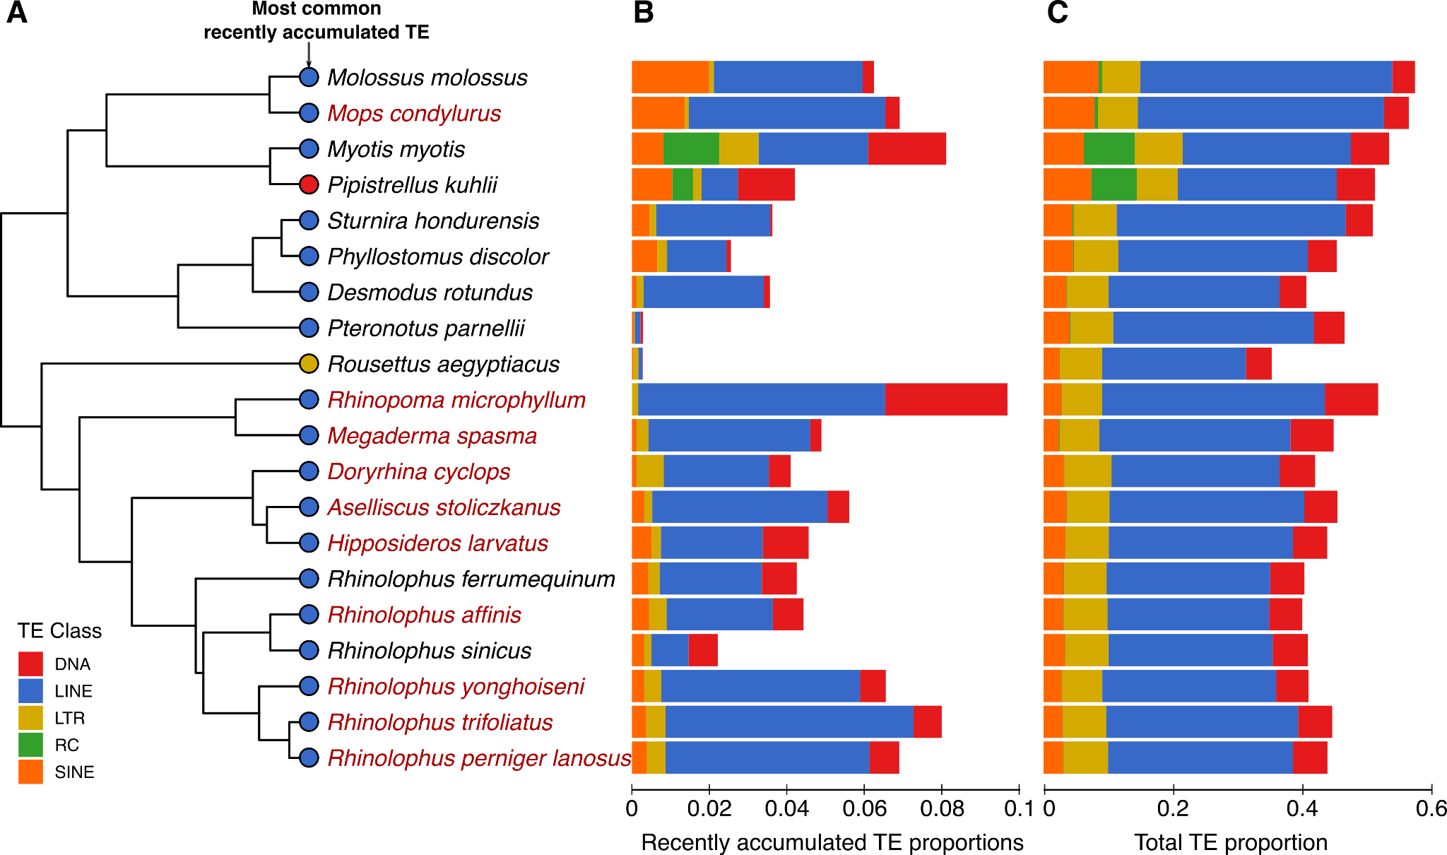

Supplementary Figure 5. Transposon content in the genomes of 20 bats.
(A) Phylogeny of examined species with circles at the tips indicating the class of the most common recently-accumulated TEs, defined as having <6% divergence from the respective consensus. The ten newly-generated genome assemblies are indicated in red font.
(B) Bar plots indicating the class and proportion of recently-accumulated TEs.
(C) Bar plots indicating the class and proportion of all TEs detected in the genomes.
Compared with most other mammals, the newly sequenced bat genomes show an accumulation of recent DNA transposon insertions, similar to previous observations made for other bats ¹.

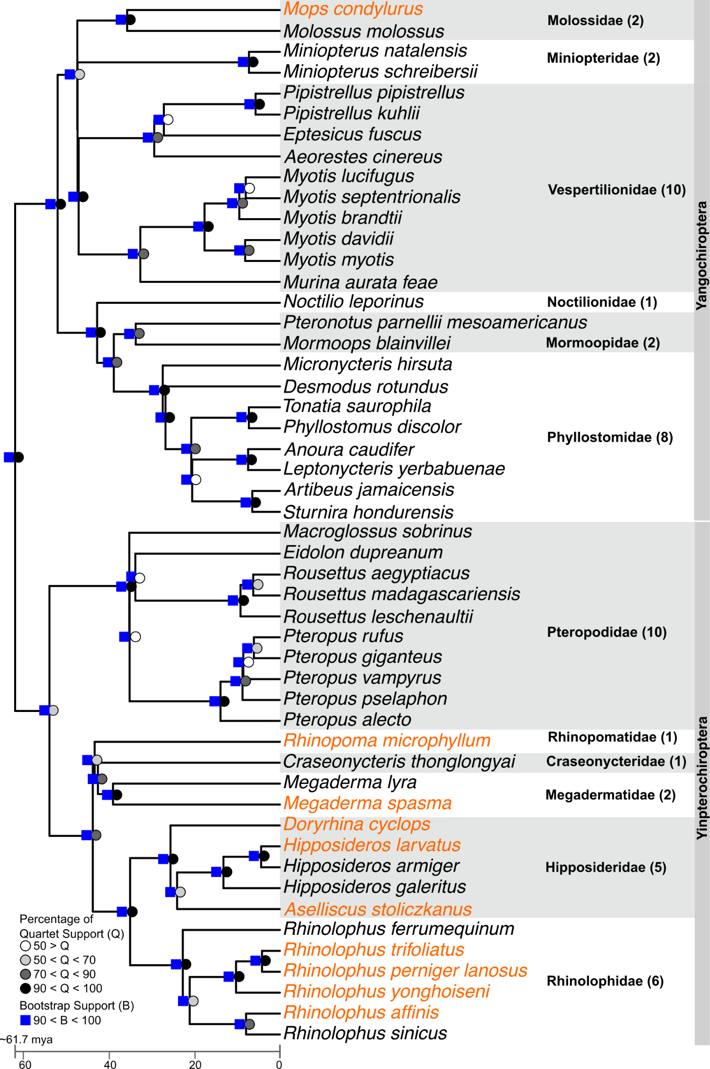

Supplementary Figure 6. Time-calibrated phylogeny of 50 bat species covering 12 families.
Phylogenetic reconstruction was performed using 16,860 gene trees (representing 30,354,372 bp) estimated with RAxML followed by inferring a species tree using ASTRAL. Orthologous genes were inferred and annotated with TOGA using human as the reference. Multiple codon alignments were generated with TOGA’s “exon-by-exon” alignment procedure with MACSE2. Node support values were estimated using quartet scores (circles) and 100 Transfer Bootstrap Expectation replicates (squares). The ten newly-generated genomes in orange font.

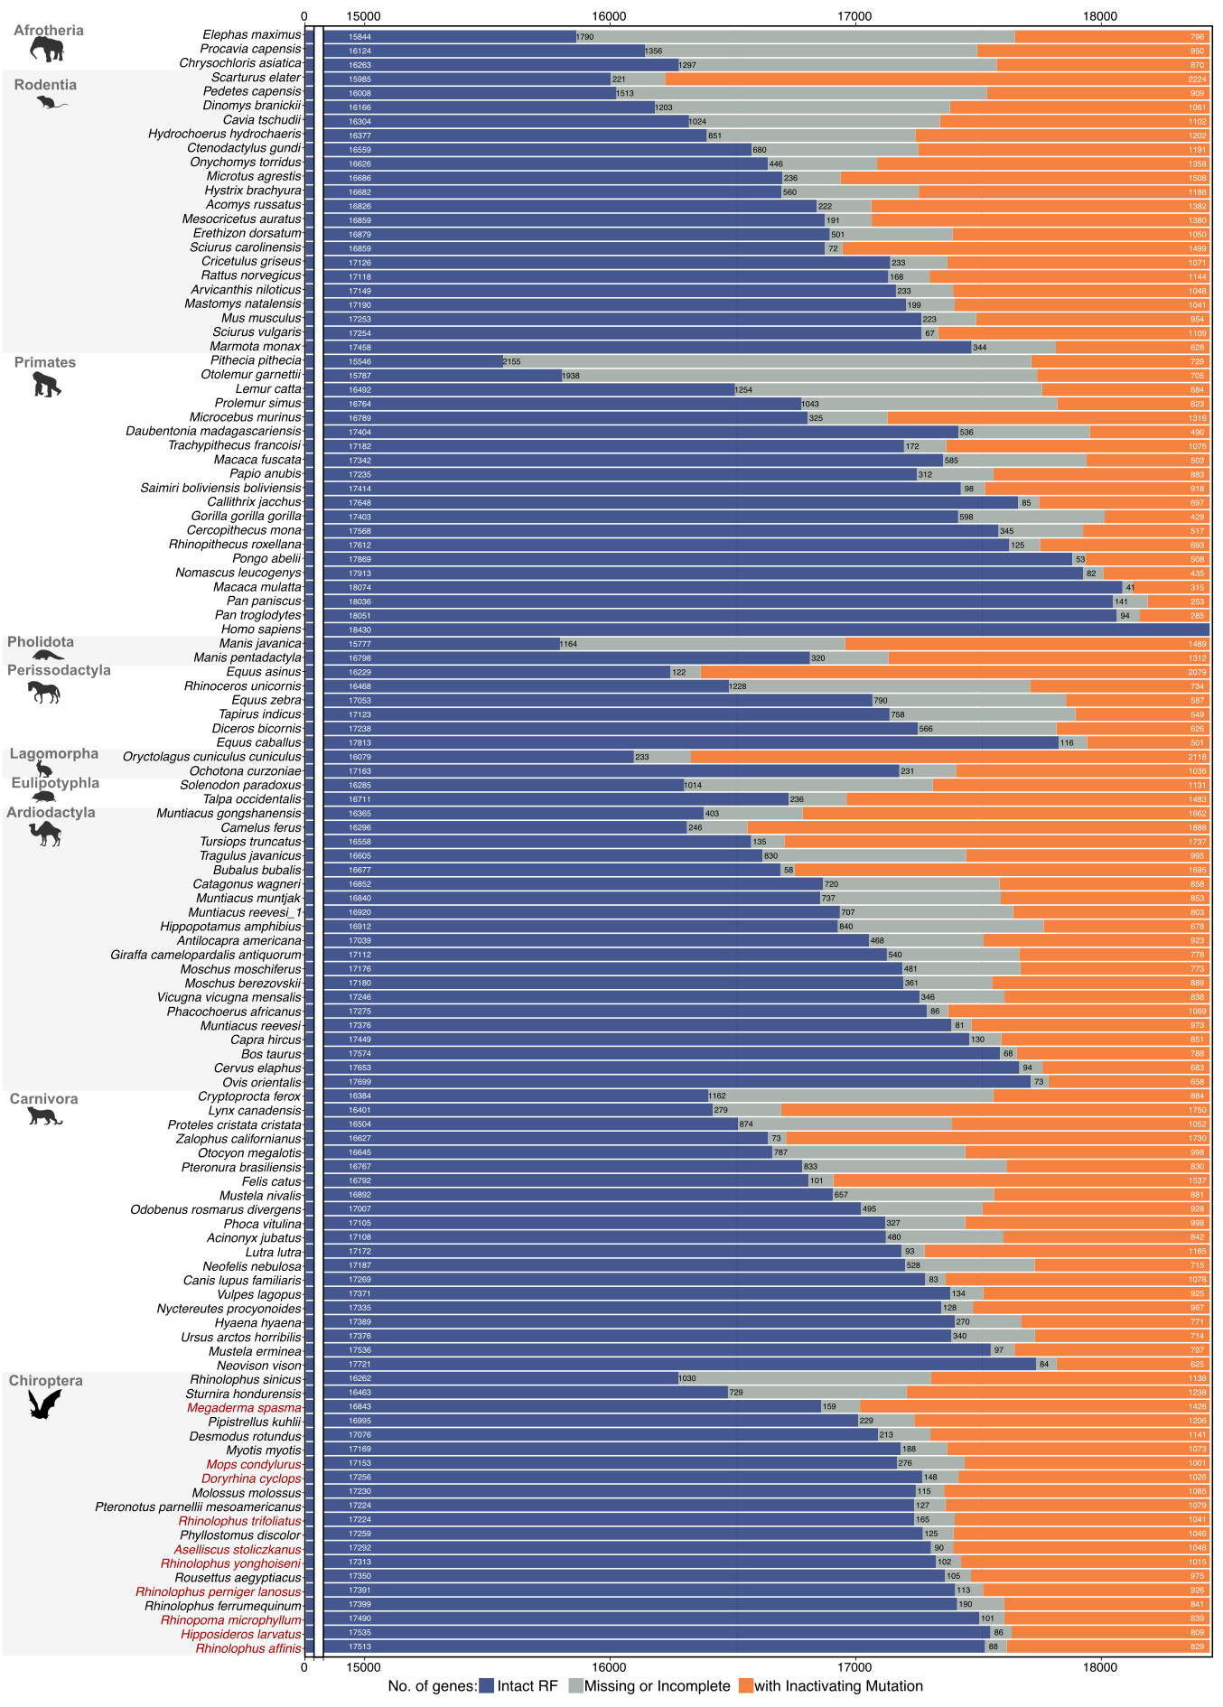

Supplementary Figure 7. Status of 18,430 ancestral mammalian genes in 115 mammalian genomes.
As in Fig. 1e, ancestral genes are classified by TOGA into those with an intact reading frame (blue), gene-inactivating mutations (orange) or missing or incomplete coding sequences due to assembly gaps or fragmentation (grey). Here, all 115 mammals included in our selection screen are shown. Where possible, we included up to 20 species per order, selecting assemblies with at least 16,000 intact orthologs. In each mammalian order, genomes are reverse-sorted by the number of genes with intact reading frames. The ten newly-generated bat genomes are in orange font.

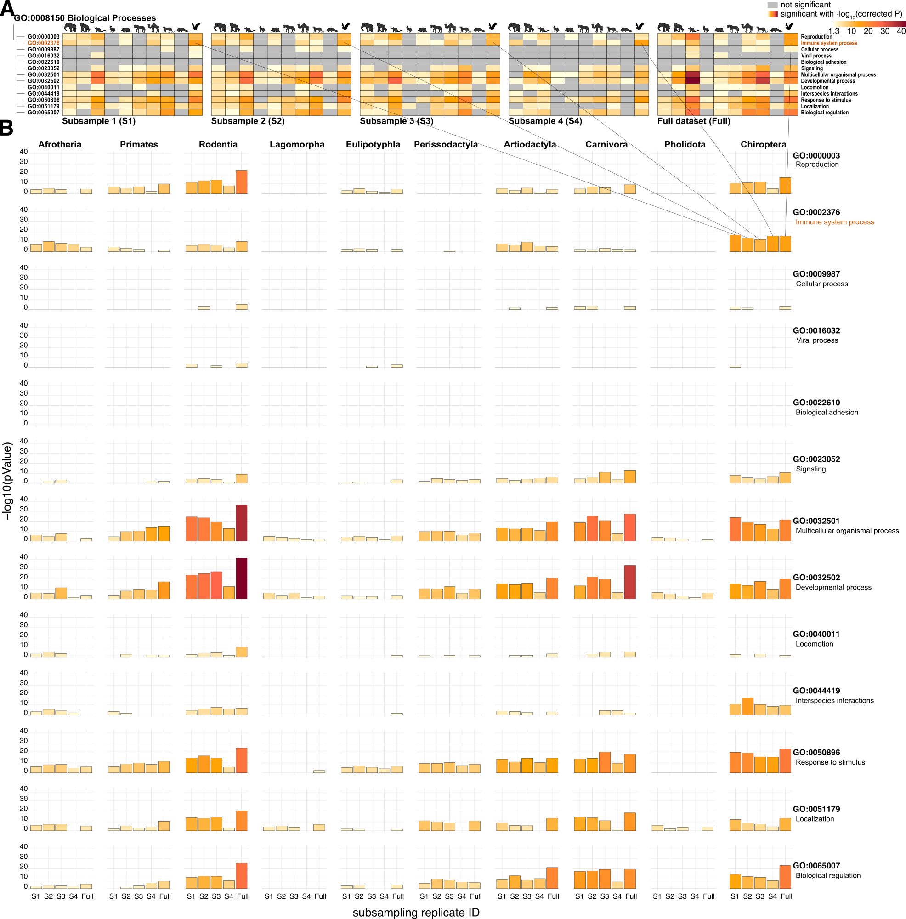

Supplementary Figure 8. Enrichments of genes under positive selection in four subsampled datasets for high-level GO terms of “Biological Process”.
To explore whether functional enrichments of positively selected genes in mammalian clades are driven by individual species rather than being representative for the clade, we ran four additional screens for positive selection by subsampling 65 species from all 115 mammals, as explained in the Methods. In subsample 1-3, we randomly selected 10 of the 20 species in each clade that is represented by 20 species in the full dataset (Chiroptera, Primates, Rodentia, Artiodactyla, Carnivora). Subsample 4 includes all species left out in subsample 1 from the 20-species clades. Clades with less than 20 species were not subsampled. Enrichments were performed in gProfiler and categorized following the nested GO structure.
(A) Heatmaps show those direct child terms of GO Biological Process (GO:0008150) that have a significant p-value in at least one clade. Columns represent mammalian groups (Afrotheria, Primates, Rodentia, Lagomorpha, Eulipotyphla, Perissodactyla, Artiodactyla, Carnivora, Pholidota, and Chiroptera). Rows represent child terms of GO:0008150. Colors indicate statistical significance based on -log₁₀(p-value) with light yellow indicating a low significance, dark red strong significance and grey non-significance.
(B) For a direct comparison of the enrichment significance, bar plots visualize the -log₁₀(p-value) for the four subsamples (first four bars) in comparison to the full dataset (fifth bar). For consistency, the bar color is the same as in (A).
Importantly, the chiropteran enrichment “immune system process” is robustly observed across the subsamples, and no other mammalian group exhibits an enrichment as strong as in Chiroptera. It should be noted that the high-level GO process “response to stimulus” (GO:0050896) is robustly enriched in Chiroptera because the term “immune response”, which has by far the strongest enrichment in bats, is a direct child term.

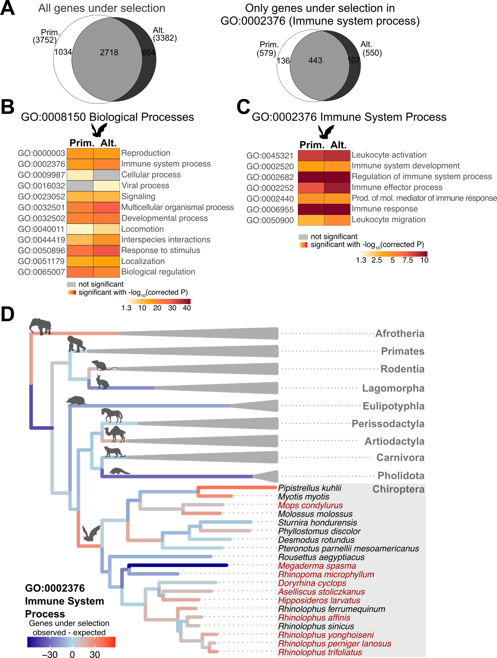

Supplementary Figure 9. Enrichment results for genes under selection in bats and GO terms for biological processes and immune system process, comparing values when primary or alternative genome assemblies are used on selection screen.
We investigated whether a selection screen produces concordant results when using gene sequences from the alternative assemblies. To this end, we replaced the 10 primary bat assemblies by their alternative assemblies, keeping all other 105 mammalian genomes.
We then re-ran the genome-wide screen for positive selection, performed the same gene set enrichment analyses and explored the number of selected genes per branch. Since the gene sequences of non-Chiroptera species have not changed, we show only enrichments for Chiroptera, showing the values from Fig. 2 that were obtained with the primary assemblies again for the purpose of a side by side comparison.
(A) Venn diagrams show the number of genes under selection when using primary vs. alternative bat assemblies. Importantly, the majority of the genes is under selection in Chiroptera irrespective of whether the primary or alternative assemblies are used. However, using primary assemblies, we found more genes under selection, likely because alternative assemblies do not contain all genes, as shown in Supplementary Figure 4.
(B, C) Heatmaps show enrichments of high-level GO terms (B) and child terms of “immune system process” (C). Enrichments are highly similar when using the primary or alternative bat assemblies, corroborating that immune gene selection is most prevalent in bats. In particular, bats have the strongest enrichment for “immune system process”, also when using the alternative assemblies. Some terms like “Immune effector process” (GO:0002252) are more enriched when using the alternative bat assemblies (158 of 2865 selected genes are annotated with GO:0002252) compared to using the primary assemblies (165 of 3207 selected genes are annotated with GO:0002252); this is because a higher proportion of selected genes is annotated with the GO term (5.51% for alternative vs. 5.14% for primary assemblies) despite fewer genes are under selection (158 vs. 165).
(D) As for primary assemblies (Fig. 2e), the ancestral bat branch has more immune genes under selection than expected based on its length when using alternative assemblies. Branch lengths are ASTRAL coalescent units as in Fig. 2c.
Together, this analysis further supports that the key results of our screen are robust and not affected by intra-species divergence that is partially captured in the alternative assemblies.

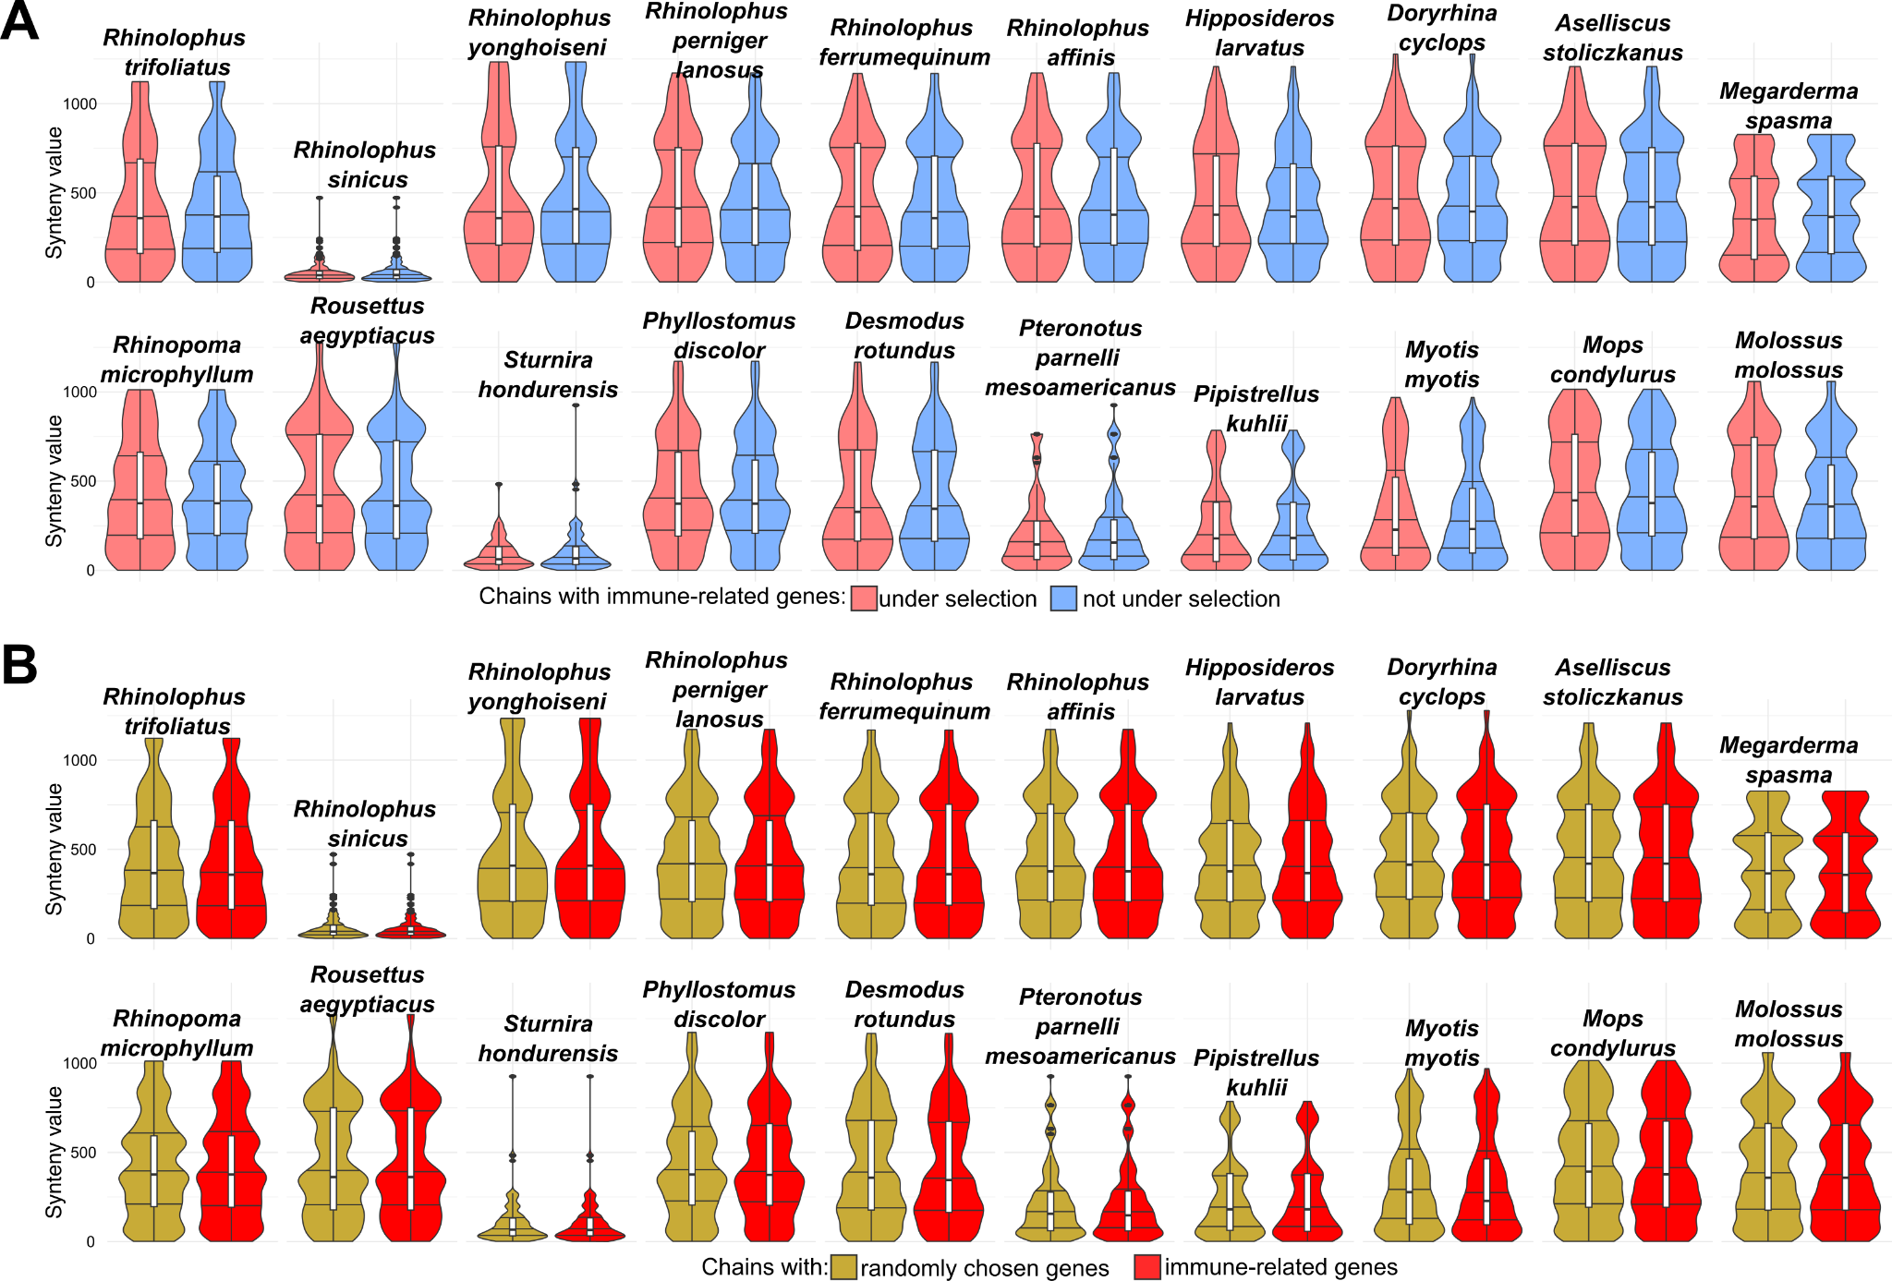

Supplementary Figure 10. Selected immune-related genes do not undergo rearrangements more frequently than other genes.
To explore whether structural rearrangements affect immune genes that are under positive selection in bats more often than other genes, we leveraged TOGA’s ability to accurately detect orthologs of genes that underwent genomic rearrangements such as inversions or translocations ². If a group of genes is more prone to undergo structural genome rearrangements, we expect these genes to have lower synteny values. We use the term synteny here as conserved gene order, i.e. the number of genes that align in co-linearity in the same alignment chain. A translocation or inversion of a single gene results in a synteny value of 1 for this gene.
(A) We divided the 2,821 “immune system process” (GO:0002376) genes into those that are and are not under selection in bats. For each bat species and each gene, we plotted the synteny value of the respective orthologous chain.
(B) As in (A) but comparing all “immune system process” genes to control genes, obtained by randomly sampling 2,821 genes from the 17,130 genes included in our screen.
White box plots show the median, first and third quartile values. Barplots below each violin plot represent the total number of chains. For all 20 bat species, the distributions of the synteny values are highly similar, indicating that selected immune-related genes or immune genes in general are not more prone to undergo structural rearrangements in bats. As expected, genomes with lower scaffold N50 values (e.g. Rhinolophus sinicus or Sturnira hondurensis) have generally lower synteny values, as alignment chains by definition cannot extend across scaffolds.
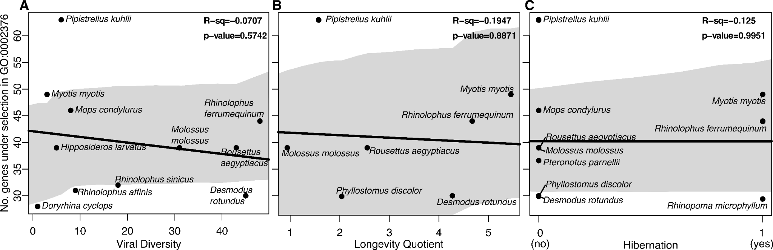

Supplementary Figure 11. Correlations between number of selected immune genes and other traits in bats.
Dispersion plots showing correlations between other relevant traits such as viral diversity, longevity or hibernation and the number of immune-related genes (GO “immune system process”) under selection in the terminal species branches. Grey shading shows 95% confidence intervals.
All correlations are slightly negative but non-significant. This is potentially due to the low sample size and because trait information is not available for every species in our dataset; therefore this analysis should be repeated in the future with an expanded species dataset.
(A) Viral diversity was estimated as the number of viral families reported by the ZOVER database, identified using metagenomics or high-throughput sequencing approaches (http://www.mgc.ac.cn/DBatVir/, last accessed January 25, 2023).
(B) Longevity was measured by the longevity quotient calculated as the ratio of the observed to predicted lifespan, where predicted lifespan is based on a fitted model between longevity (measured in years) and adult body mass (measured in grams) across bats, taken from reference ³. Data was acquired from the AnAge database (https://genomics.senescence.info/species/index.html, last accessed August 1, 2023)
(C) Hibernation was considered as 0 (no) or 1 (yes) based on published reports.

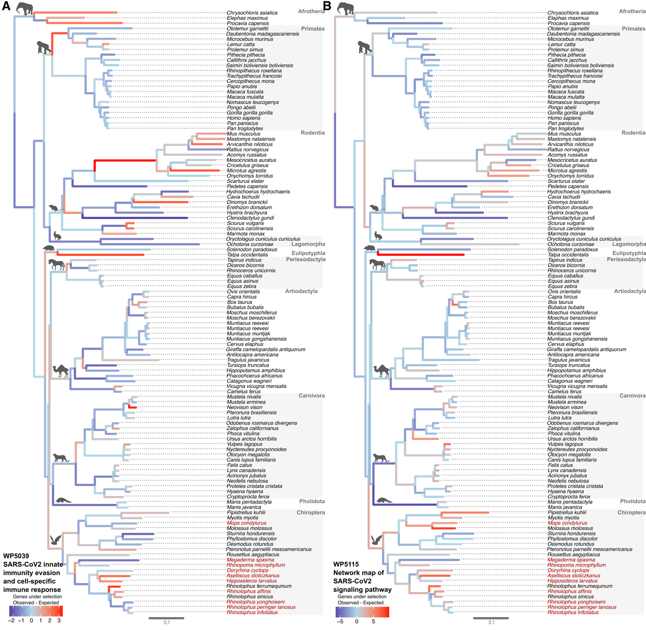

Supplementary Figure 12. Per-branch signal of “SARS-CoV-2 innate immunity evasion and cell-specific immune response” (WP5039) and “Network map of SARS-CoV-2 signaling pathway” (WP5115) selection on phylogeny for 115 mammals.
Branches are color-coded based on the difference between the observed and expected number of selected genes in the gene set. Color scale goes from negative residual values indicating less genes under selection than expected (blue) to the positive residual values indicating more genes than expected in a single branch (red). Expected numbers were calculated from the regression models shown in Supplementary Tables 8-9. Ancestral branches for mammalian groups are indicated with icons as Afrotheria, Primates, Rodentia, Lagomorpha, Eulipotyphla, Perissodactyla, Artiodactyla, Carnivora, Pholidota, and Chiroptera. New Bat1K genomes are in red font. Branch lengths in trees are in coalescent units as estimated by ASTRAL.
(A) Genes that are part of the “SARS-CoV-2 innate immunity evasion and cell-specific immune response” (Homo sapiens; https://www.wikipathways.org/index.php/Pathway:WP5039, last access, July 20th, 2022). The ancestral Chiroptera branch has a higher difference between the observed and expected number of selected genes compared to other mammalian groups.
(B) Genes that are part of the Network map of the “SARS-CoV-2 signaling pathway” (Homo sapiens; https://www.wikipathways.org/index.php/Pathway:WP5115, last access, July 20th, 2022). The ancestral Chiroptera branch has the highest difference between the observed and expected number of selected genes annotated for this pathway.

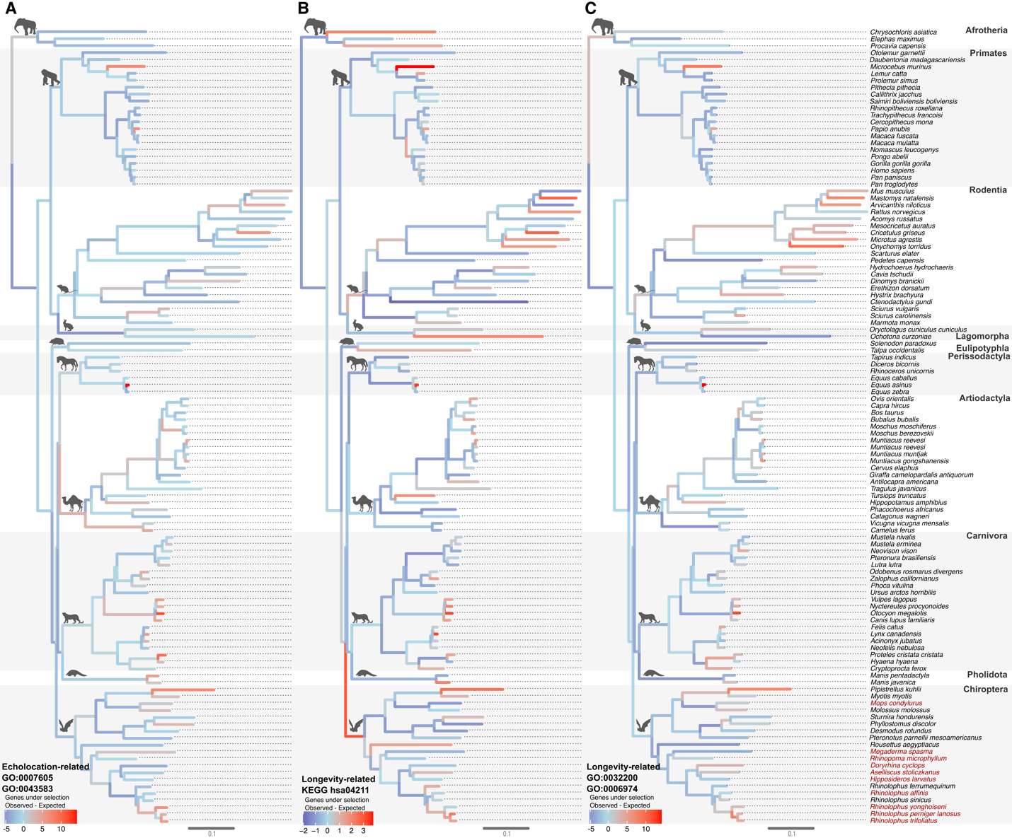

Supplementary Figure 13. Per-branch signal of selection for genes with functions potentially relevant for echolocation and longevity.
Expected numbers of selected genes in the given gene set were calculated from the regression models shown in Supplementary Tables 8-9. Branches are color-coded based on the difference between the observed and expected number of selected genes. New Bat1K genomes are in red font. Branch lengths in trees are in coalescent units as estimated by ASTRAL.
(A) Genes with functions potentially relevant for echolocation, defined as genes with GO terms “sensory perception of sound” (GO:0007605) and “ear development” (GO:0043583).
(B) Genes with functions potentially relevant for longevity, taken from the KEGG “Longevity regulating pathway” (hsa04211: https://www.genome.jp/entry/pathway+hsa04211 last access November 15, 2023), which contains 89 genes. Interestingly, the ancestral Chiroptera branch shows a higher than expected number of genes under selection (4 observed vs. 1.3 expected). However, the hsa04211 pathway also includes 30 immune-related genes (genes that are also annotated with GO:0002376 “Immune system process”). Therefore, we tested if this signal is still present when removing the 30 immune-related genes. After removing these genes and fitting the regression model for the reduced gene set, we found that the ancestral Chiroptera branch has still more genes under selection than expected (2 observed vs. 0.8 expected), but it should be noted that the overall gene number is low and the F-statistic of such regression model is not significant (Supplementary Table 9).
(C) Genes involved in “telomere organization” (GO:0032200) and “DNA damage response” (GO:0006974) are also relevant for longevity, as both processes play a role in aging. In contrast to the KEGG “Longevity regulating pathway”, genes with these GO terms do not have an excess of selection on the ancestral Chiroptera branch.

Supplementary Figure 14. (continued below)
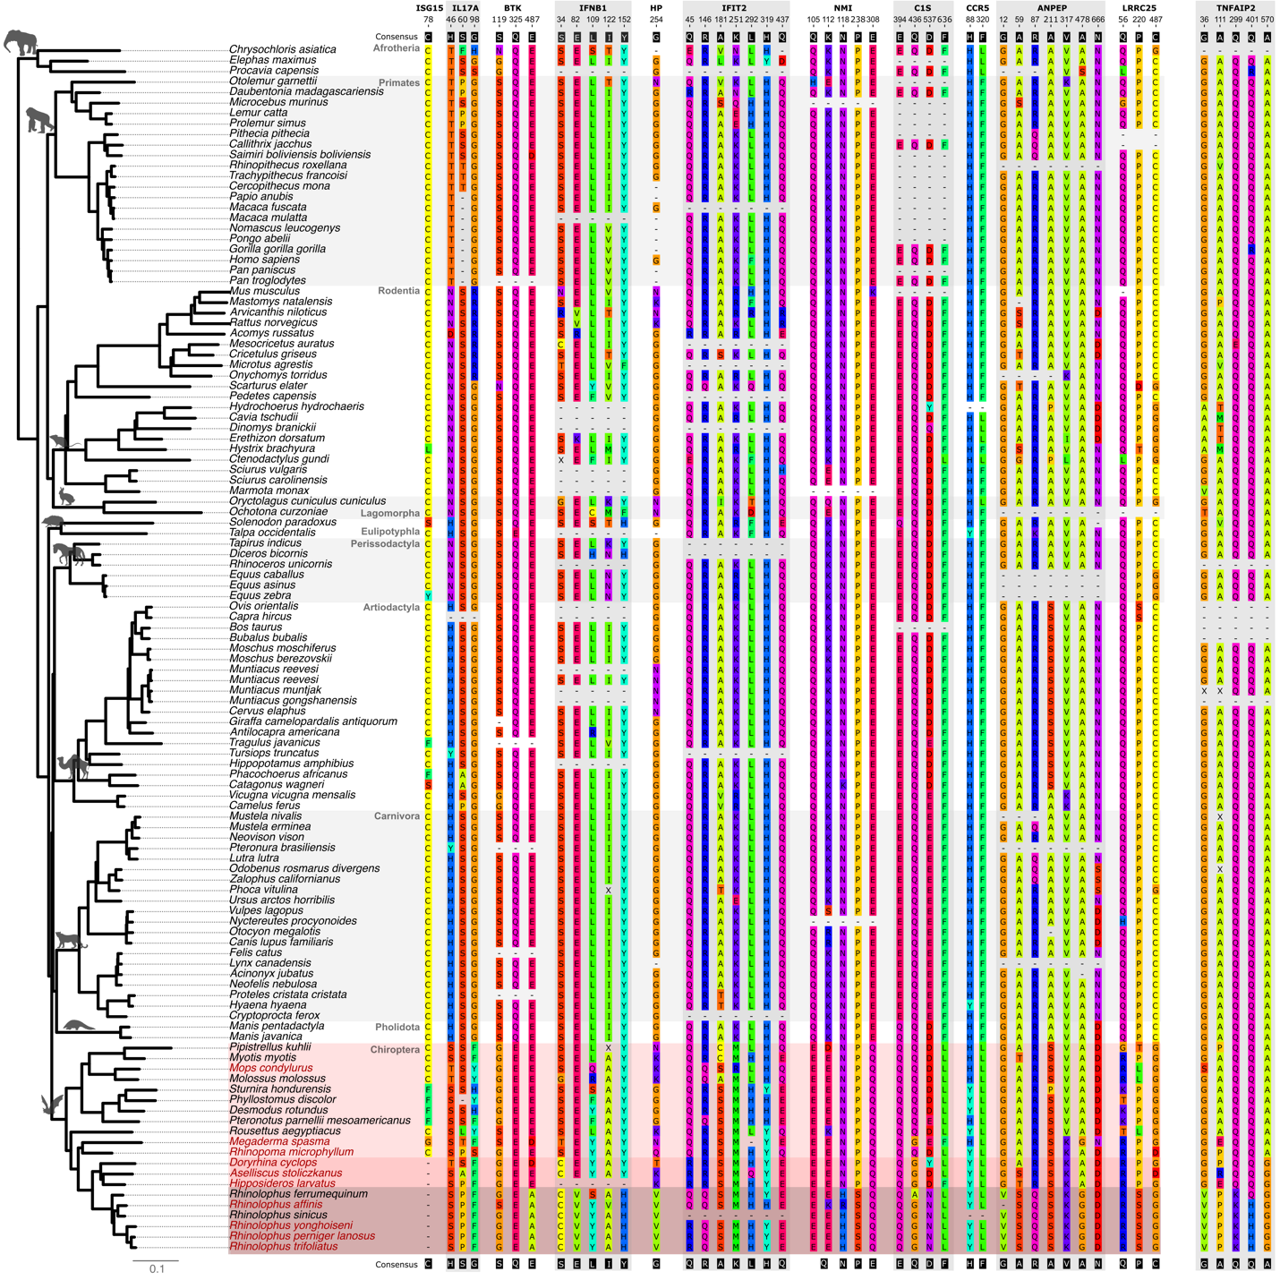

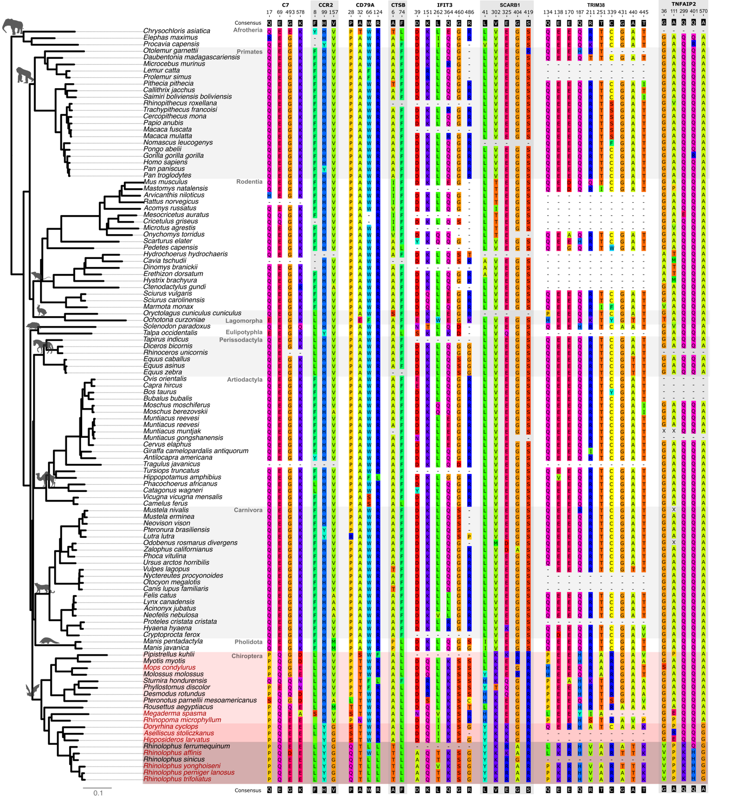

Supplementary Figure 14. Amino acid alignments highlighting residue changes in bats.
Protein alignments of ISG15 and of genes under selection, highlighting residues with bat-specific mutations. Residue numbers correspond to positions in the filtered alignments we used as input for aBSREL. Since we only included 1:1 orthologous genes with intact reading frames (TOGA status intact, meaning the middle 80% of the reading frame lacks inactivating mutations) in the screen, dashes correspond to non 1:1 orthologs in our annotations either because they are duplicated genes, inactivating mutations near the N- or C-terminus, or missing genomic sequences. Full raw and filtered alignments are available at http://genome.senckenberg.de/download/Bat1KImmune/. Branch lengths are in coalescent units as estimated by ASTRAL.
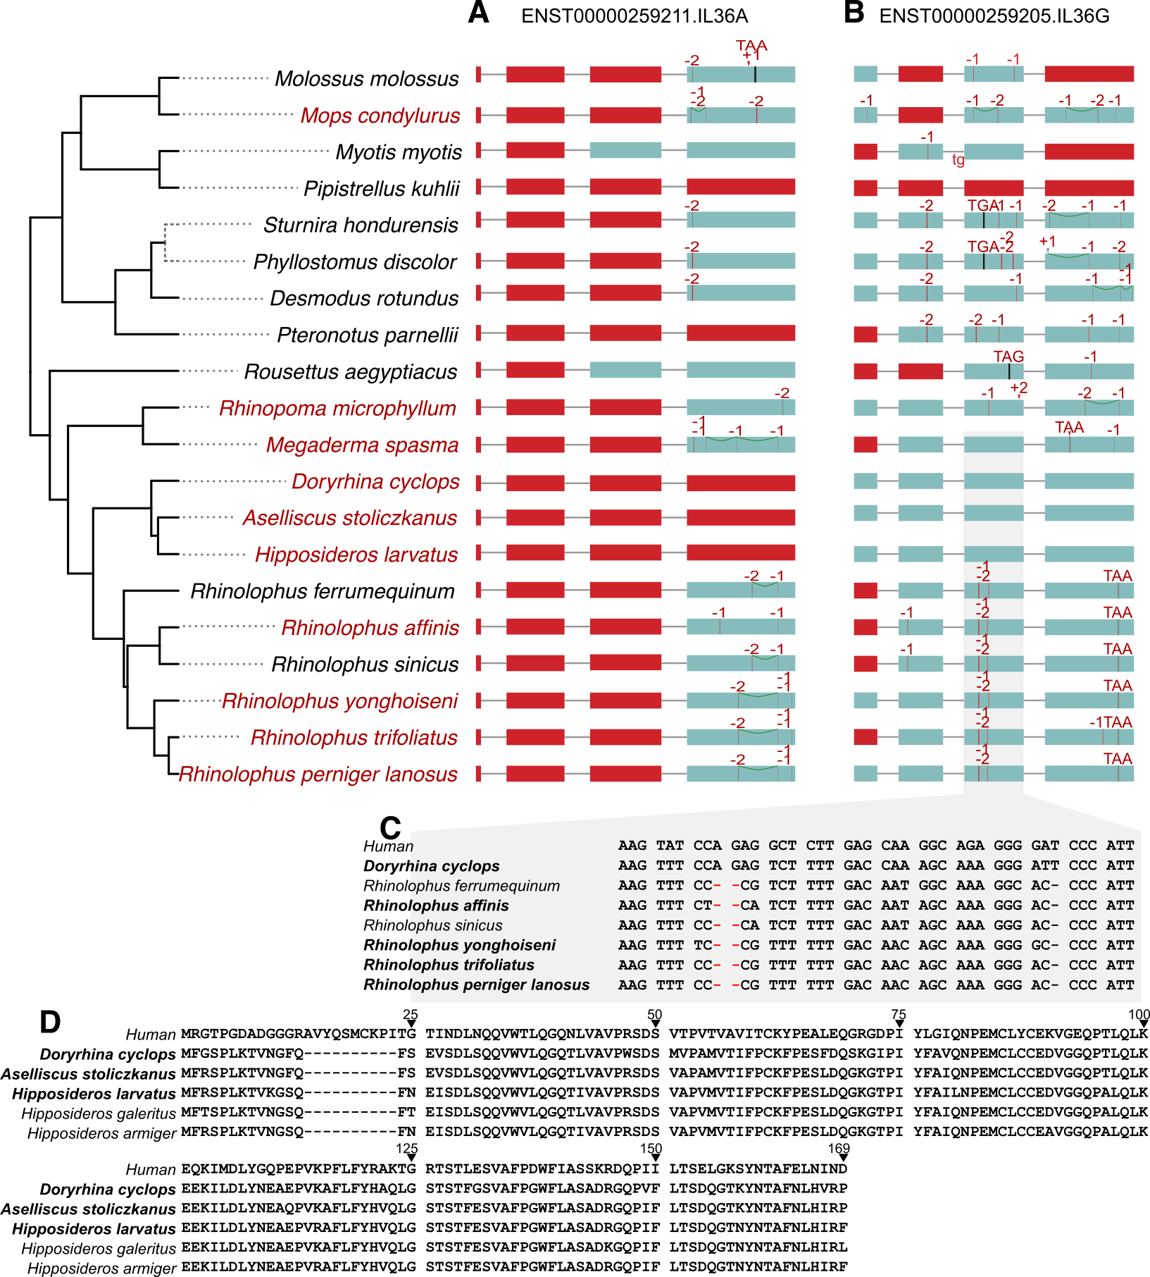

Supplementary Figure 15. Inactivating mutations and deletions of IL36A and IL36G in bats.
(A) The deletion of IL36A exons 1-3 shares the same downstream breakpoint in rhinolophid bats and in Rhinopoma microphyllum, which indicates that this deletion already occurred in the common ancestor of Hipposideridae, Megadermatidae, Rhinolophidae, and Rhinopomatidae (Rhinolophoidea superfamily). Thus, loss of IL36A predates the split of Rhinolophoidea. In Megaderma spasma and R. yonghoiseni, additional deletions occurred secondarily. All analyzed hipposiderid bats additionally exhibit a genomic rearrangement in this locus and do not exhibit any traces of IL36A.
(B) Extending previous findings ⁴, IL36G was independently lost in several bat families. Shared frameshifts in exon 3 indicate that IL36G was inactivated in the common ancestor of rhinolophid bats. In contrast, IL36G maintains an intact reading frame in all investigated Hipposideridae.
(C) Codon alignment of IL36G exon 3 showing the shared -2 and -1 bp frameshifting deletions (red font) in rhinolophid bats in comparison with human and hipposiderid bats (represented by Doryrhina cyclops).
(D) Amino acid alignment of IL36G of human and hipposiderid bats shows divergence at the N-terminus. However, the IL36G protein shows many conserved residues, indicating that the gene encodes a functional protein in hipposiderid bats.
In (A) and (B), coding exons are represented as boxes, superimposed with inactivating mutations. Vertical red lines are frameshifting deletions and arrowheads indicate frameshifting insertions. Red boxes indicate complete exon deletions. The size of deletions or insertions are given on top of the mutation. Premature stop codons are shown as black vertical lines with the corresponding triplet. An acceptor splice site mutation (tg) is shown by red letters at the beginning of IL36G exon 3.
Genome assemblies produced in this study are in red font in (A) and (B) and in bold font in (C) and (D).

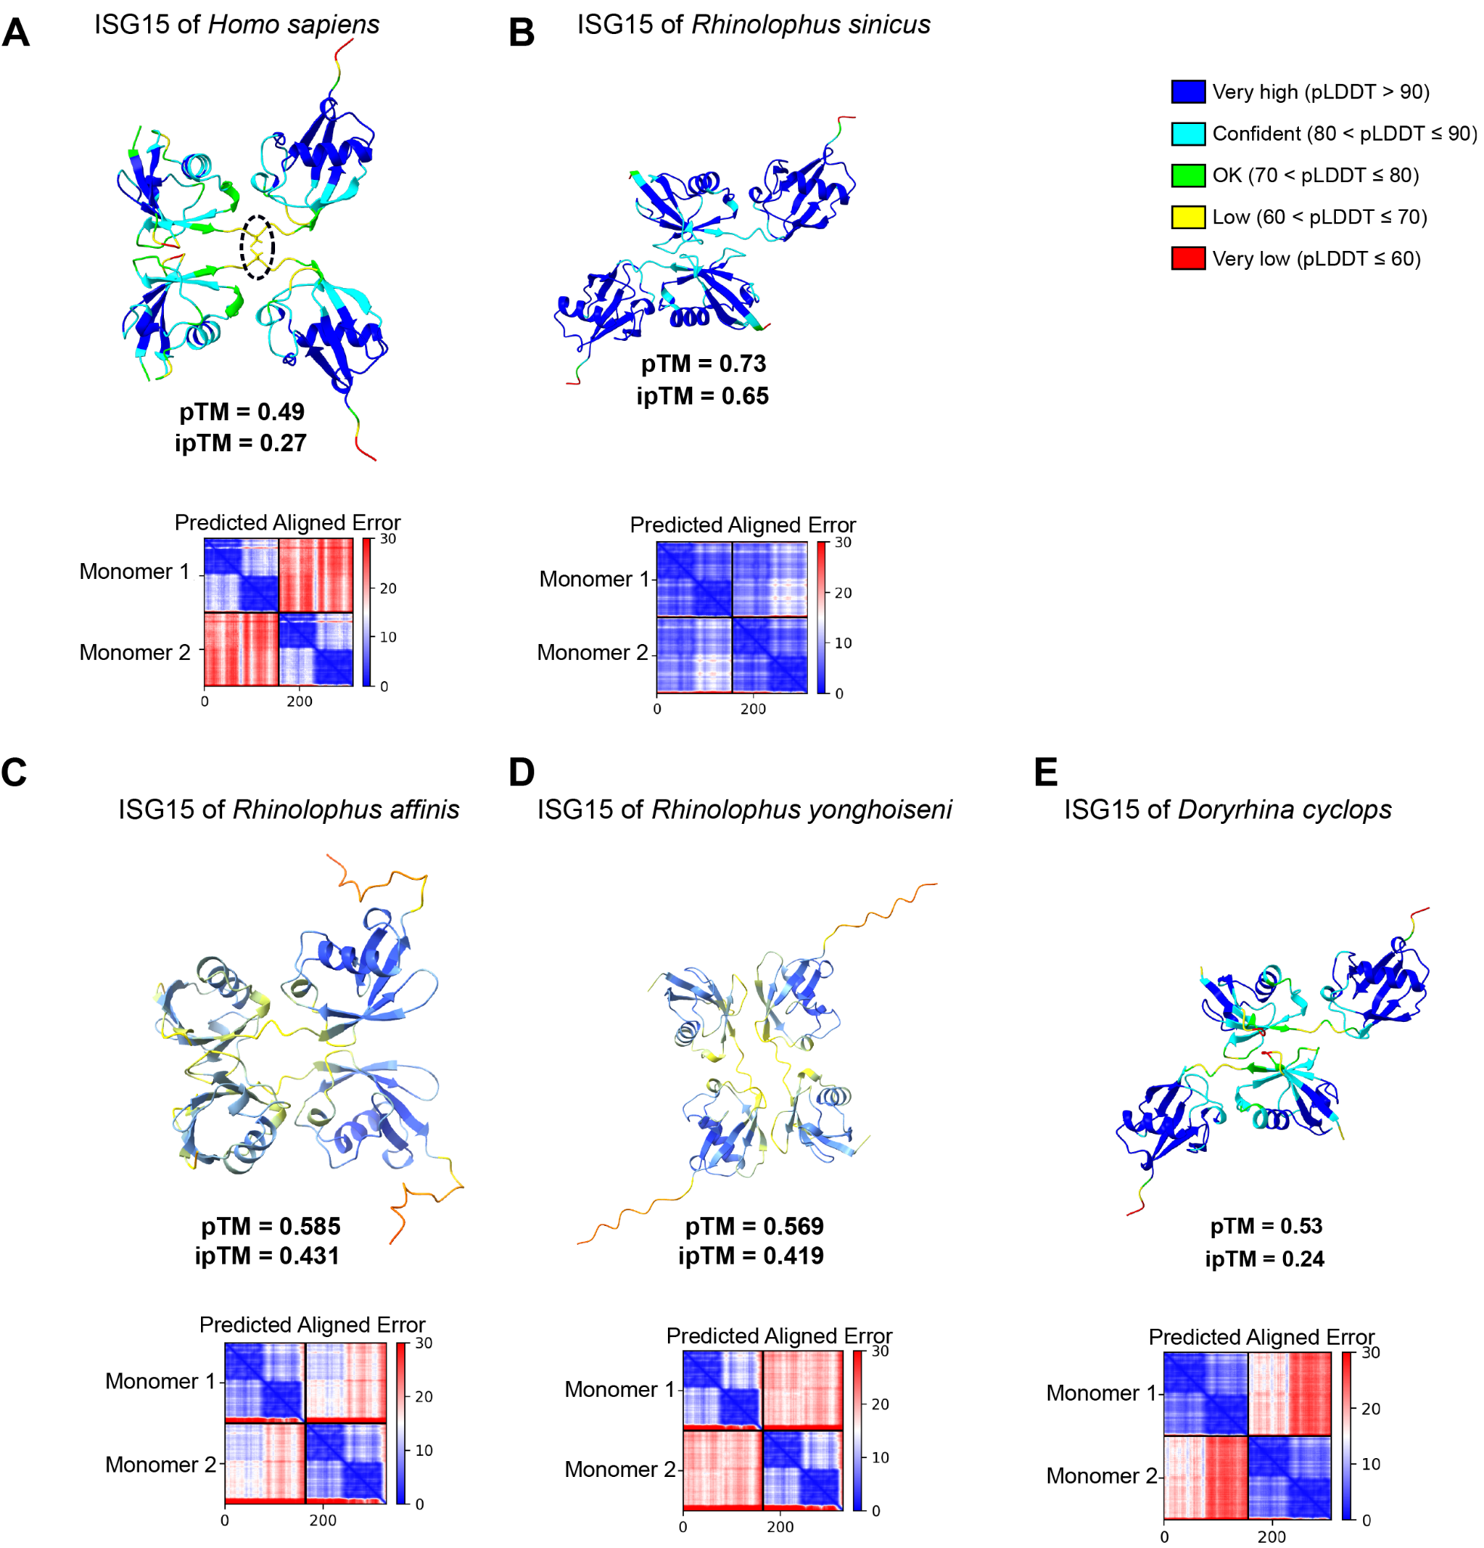

Supplementary Figure 16. ISG15 dimer structures of five species estimated with AlphaFold and the reported confidence scores.
(A) Human ISG15. The pTM (predicted Template Modeling) score of 0.49 is close to the commonly used TM cutoff of 0.5. Furthermore, the pLDDT (predicted Local Distance Difference Test) scores along the structure of each monomer indicate a high or acceptable confidence. Together, this indicates that the overall quality of the structural ISG15 monomer model is acceptable. On the other hand, the low ipTM (predicted interface Template Modeling, values below 0.4 often indicate incorrect multimer structures) value as well as the existence of high PAE (Predicted Aligned Error, red values in the inset plot) values indicate that there is a lot of uncertainty as to whether human ISG15 can form dimers. In particular, while AlphaFold placed the Cys residues from the two monomers within range for forming a potential disulfide bond, it estimated low pLDDT scores (yellow) in the region around the Cys residues. Consequently, based on the low confidence scores, one would conclude that the human ISG15 is not able to form stable dimers. This clearly contrasts with the results of previous experimental studies ^{5,6}, which have shown that the Cys78-mediated disulfide bond (dashed circle) is necessary and sufficient for the formation of human ISG15 homodimers.
(B) as per A for Rhinolophus sinicus ISG15. The pTM and pLDDT scores indicate that the quality of the monomer model is acceptable. Furthermore, the high ipTM score and the PAE inset matrix suggest that R. sinicus ISG15 likely forms more stable homodimers than its human ortholog, despite lacking the disulfide bond due to the Cys78 deletion.
(C) as per A for Rhinolophus affinis ISG15. The pTM and pLDDT scores indicate an acceptable monomer model. Higher ipTM scores indicate a potentially more stable dimer interaction for R. affinis ISG15 than for human ISG15, although there is a noticeably larger distance in the central core where human ISG15 contains a Cys78 residue.
(D) as per A for Rhinolophus yonghoiseni ISG15. Acceptable pTM and pLDDT scores are very similar to Rhinolophus affinis ISG15, although the monomers align in antiparallel orientation.
(E) as per A for Doryrhina cyclops ISG15 shows an acceptable quality model for the monomer model. Notably, while AlphaFold predicted very similar dimer structures for R. sinicus and D. cyclops ISG15 that both lack Cys78, it estimated a much lower ipTM and higher PAE values (inset) for D. cyclops ISG15, suggesting that the D. cyclops ISG15 is not able to form stable dimers, similar to the predictions of human ISG15.
Given that experiments have shown the importance of Cys78-mediated disulfide bond for ISG15 dimerization and given that human but not ISG15 of the Rhinolophus species and D. cyclops has Cys78, the AlphaFold dimer predictions are likely not reliable. We therefore decided not to draw any conclusions from the AlphaFold scores, and to instead conduct molecular dynamics simulations to understand whether the AlphaFold structures remain stable over time.

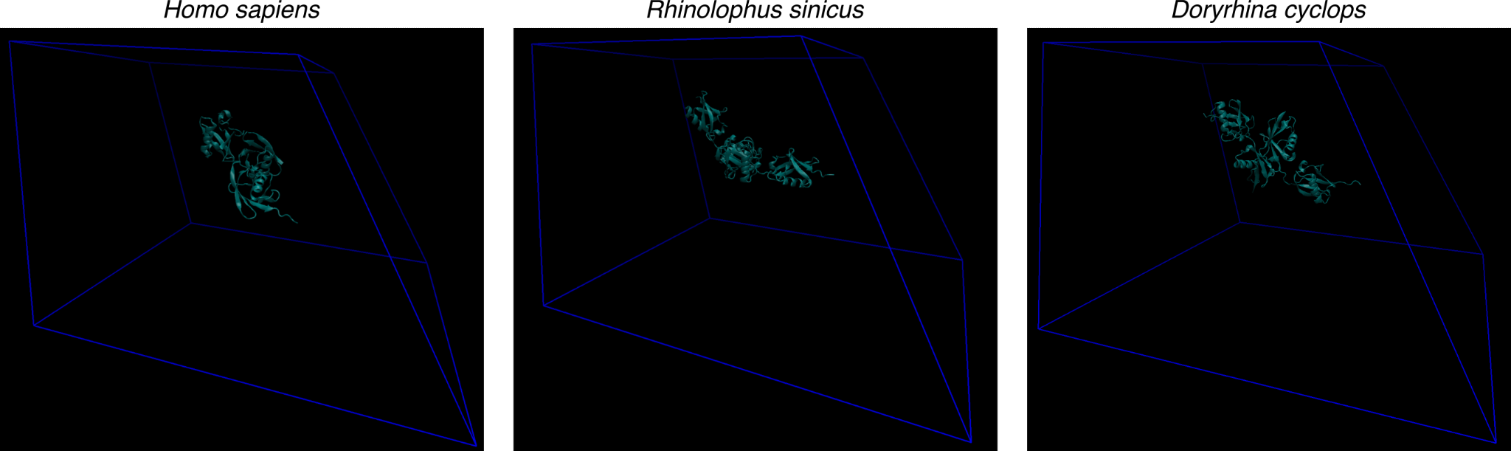

Supplementary Figure 17. Snapshots of the initial simulation boxes.
We enforced a minimum distance of 2.5 nm between the protein and the edges of the box, which is sufficient to prevent simulation artifacts. The panels were rendered with VMD v. 1.9.4a57.

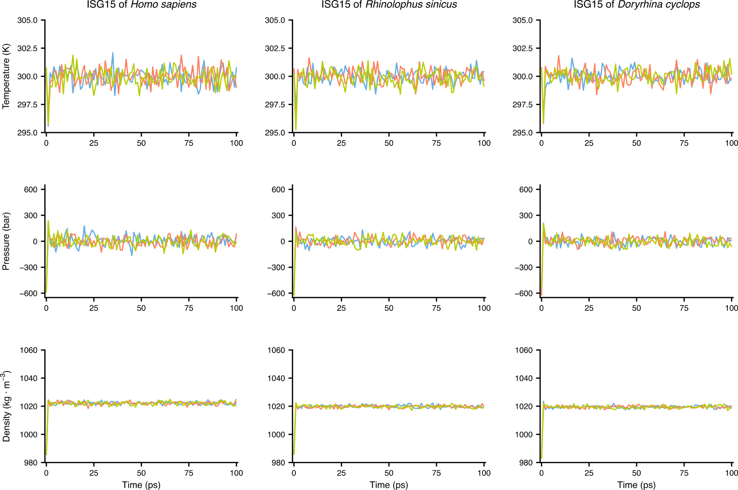

Supplementary Figure 18. Temperature, pressure, and density of the ISG15 systems during the equilibration phase of molecular dynamics simulations with low salt concentration.
Each replicate simulation is shown in a different color. The systems appear to be successfully equilibrated within less than 25 picoseconds (ps). We conservatively set the duration of each equilibration step to 100 ps.

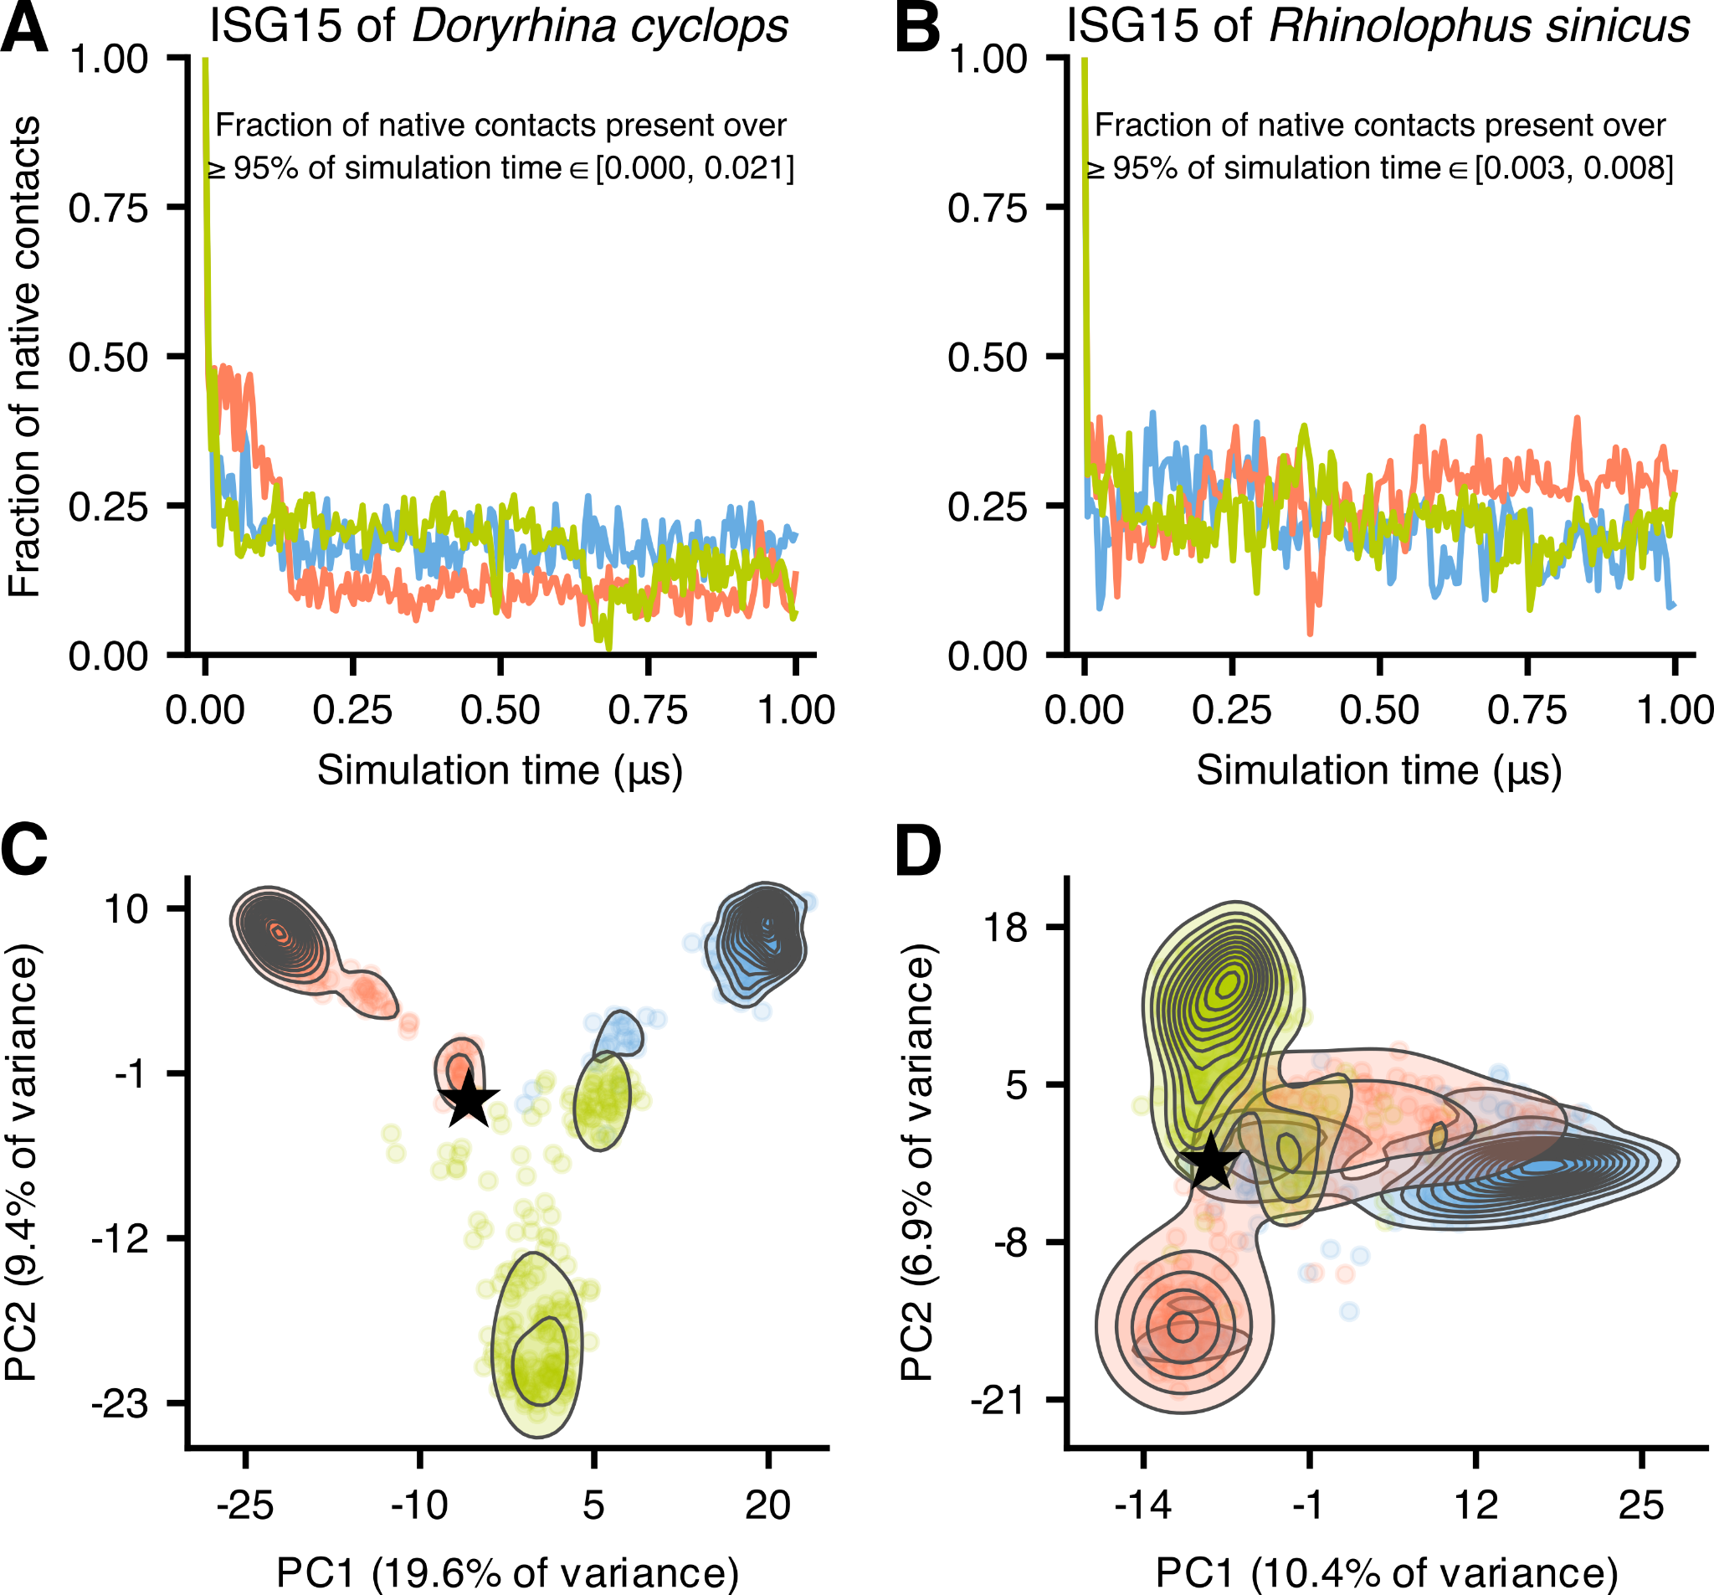

Supplementary Figure 19. Contacts between the ISG15 monomers of Doryrhina cyclops (A,C) and Rhinolophus sinicus (B,D) observed during the molecular dynamics simulations.
(A,B) Fraction of native contacts (those present in the AlphaFold models) between the two ISG15 monomers. The three colors represent the three replicate simulations. For both species, the fraction of native contacts decreases rapidly in the beginning of the simulations but does not reach zero because the simulations get trapped in different local energy minima for various time periods. Nevertheless, while different native contacts break and re-form during the simulation time, the fraction of native contacts that are maintained in at least 95% of simulation time is not higher than 0.021 and 0.008 for Doryrhina cyclops and Rhinolophus sinicus, respectively.
(C,D) First two principal components of PCAs of the presence/absence matrices of all contacts (not only native ones) between the two monomers, observed during the simulations. Contour lines denote areas of high density of data points, whereas the stars represent the origin of the three replicate simulations. The contacts formed during each simulation ultimately differ remarkably from those of the AlphaFold models and from each other. This pattern further supports the inability of ISG15 of the two bats to form stable dimers.

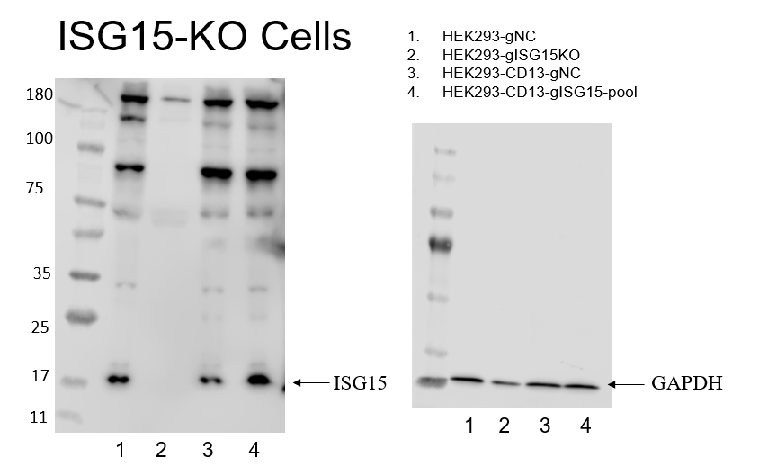

Supplementary Figure 20. Western blot of ISG15-KO cells.
HEK293 cells were transfected with a negative control (gNC) or ISG15 targeting gRNA (gISG15) and underwent two rounds of selection with puromycin for stable cell line generation. Western blot confirms ISG15 endogenous antibody labeling (Aviva Systems Biology rabbit anti-isg15 polyclonal antibody) gNC (scrambled negative control), gISG15 (ISG15 gRNA1), HEK293-CD13 cells visible in the western blot are initial pool cells prior to selection (not used in paper).

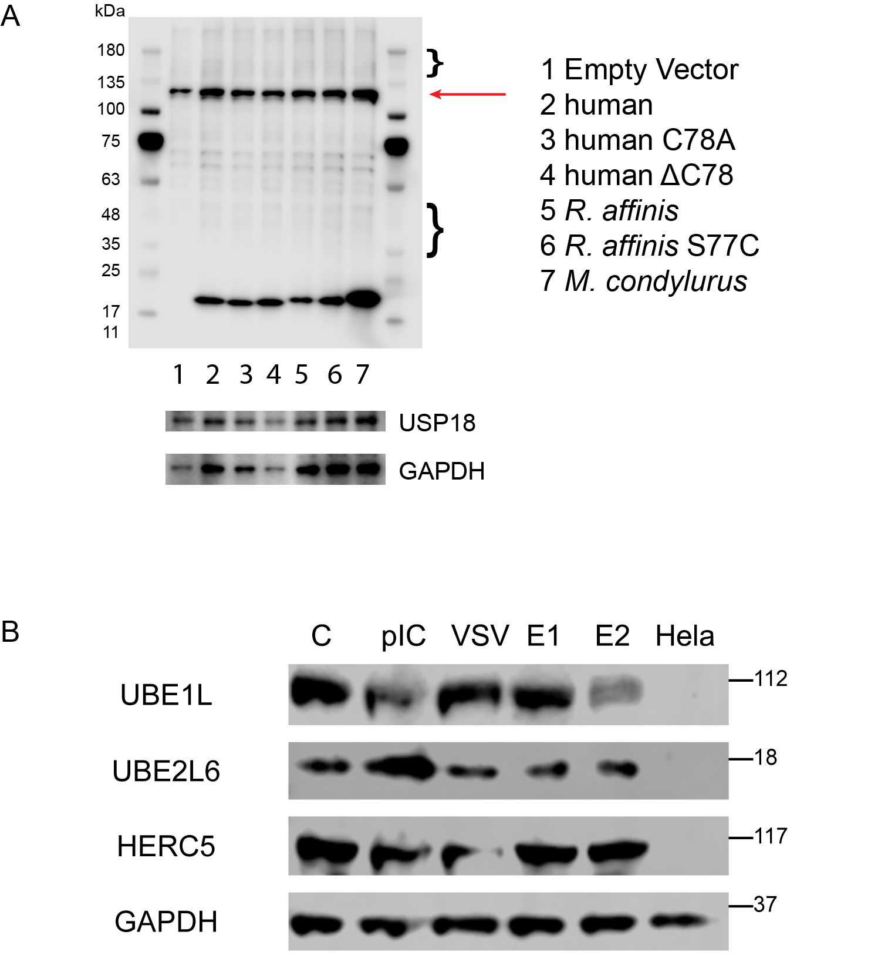

Supplementary Figure 21. Conjugation of ISG15 in bat RSKT.01 cells and ISGylation machinery validation in HEK293-subclone-ΔISG15 cells.
(A) Conserved ISGylation machinery in bat cells. Western blot of Rhinolophus sinicus kidney epithelial cells (RsKT.01) transduced with myc-ISG15 constructs, treated with poly:IC (as previously) for 24 hours and western blotted for myc-tag ISG constructs. Lane order as indicated, red arrow indicating a background band present in empty vector control (SV40T-myc oncogene from cell immortalization). The brackets indicate ISG15-conjugated bands, showing that the ISGylation machinery is conserved in R. sinicus cells. Bottom bands indicate USP18 (endogenous expression after polyI:C treatment) and GAPDH loading control.
(B) Presence of the full ISGylation machinery (E1/E2/E3 ligases encoded by UBE1L/UBE2L6/HERC5) in HEK293-subclone-ΔISG15 cells. While most HEK293 cells are not known to express E1 (UBE1L) and E2 (UBE2L6) ligases, the Western blots show the presence of E1/E2/E3 ligases in our HEK293-subclone-ΔISG15 cells (first lane, labeled C). Furthermore, upregulation of the ISGylation machinery is seen after poly:IC or VSV treatment (as indicated), or with 50 ng of E1 (UBE1L) or E2 ligase (UBE2L6) overexpression in the HEK293-subclone-ΔISG15 cells. Hela cells (last lane) are deficient in the ISGylation machinery ⁷ and serve as a negative control. HERC5 is commonly expressed in a range of cell types with multiple publications showing that only transfection of E1/E2 is sufficient ^{7–9}, so no induction is required. Note that HERC5 levels in Hela cells are low, but can be seen at higher exposures. Antibodies are not fully compatible in RsKT cell lines and require further validation in bat cells. Western blots performed as per Extended Data Figure 10.

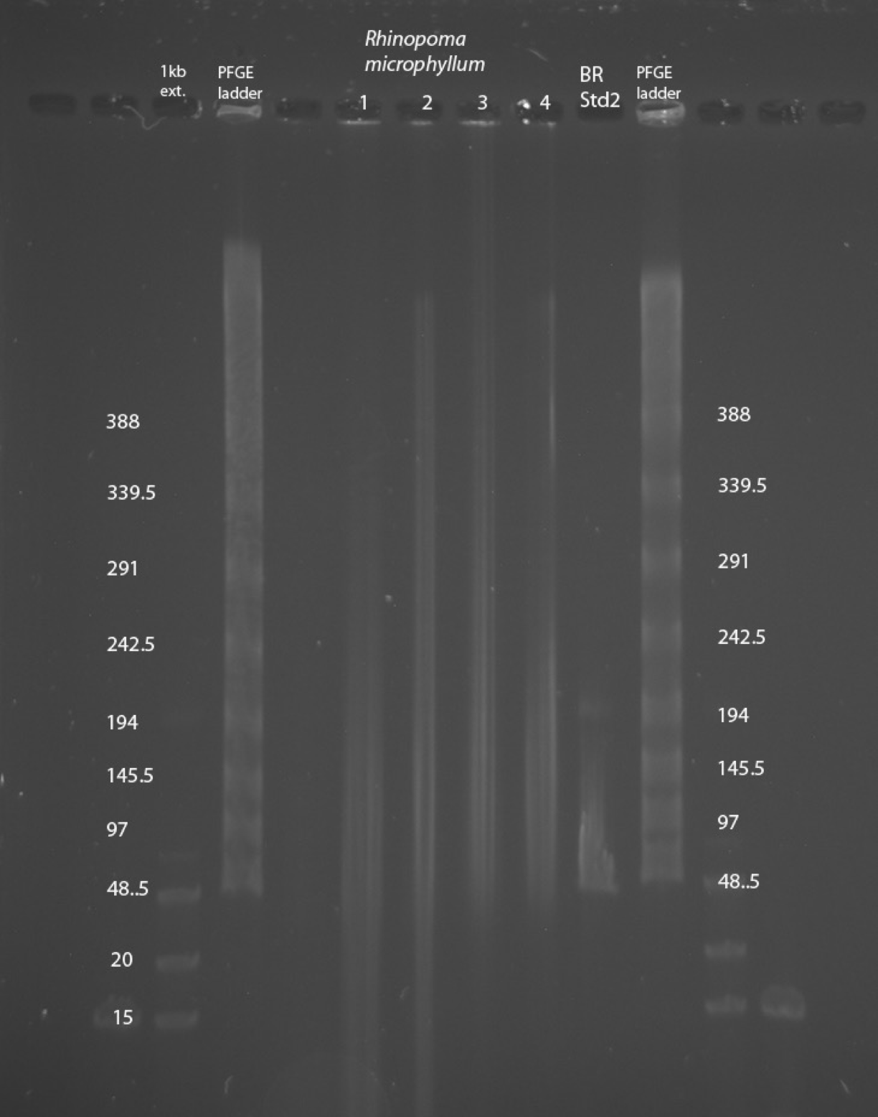

Supplementary Figure 22. High molecular weight DNA extraction.
Example of a modified pulsed-field gel electrophoresis (PFGE) showing high molecular weight DNA extracted from a Rhinopoma microphyllum sample that was collected in January 2013. The Rhinopoma gDNA is found in lane 2, HMW marker lanes are indicated, fragment sizes are in Kb.

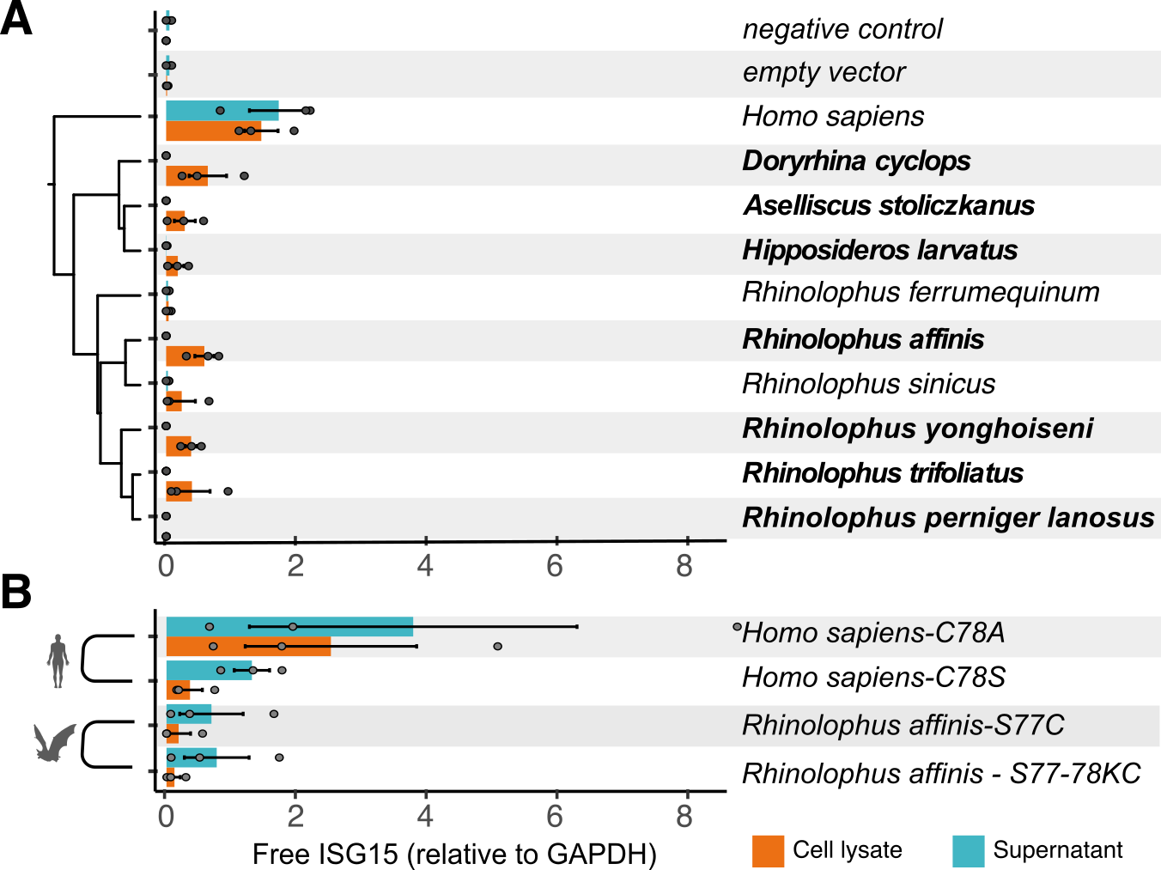

Supplementary Figure 23. Quantification of free ISG15.
Western blot quantifications of cell lysates and supernatants of un-tagged ISG15 transfected HEK293-ANPEP cells after infection with HCoV-229E for detection of cytoplasmic vs. secreted ISG15. Mean intensity was measured with the FiJI ImageJ software, as previously described (background was subtracted and then normalized relative to GAPDH). Similar secretion and conjugation was observed compared to myc-tagged constructs (Fig. 3b,c).
(A) Cells transfected with wildtype ISG15 of multiple species (as indicated).
(B) Cells transfected with mutant Homo sapiens or Rhinolophus affinis ISG15 constructs that remove or restore the equivalent human Cys78 residue.
Three biological replicates are indicated by grey dots and black bars show standard error per treatment. New Bat1K genomes in bold font. Raw data are provided in Supplementary Table 26. Homo sapiens silhouette by Katy Lawler with license to PhyloPic CC BY 4.0 (https://www.phylopic.org/images/036b96de-4bca-408e-adb6-2154fcd724ef/homo-sapiens-sapiens).

Supplementary Data
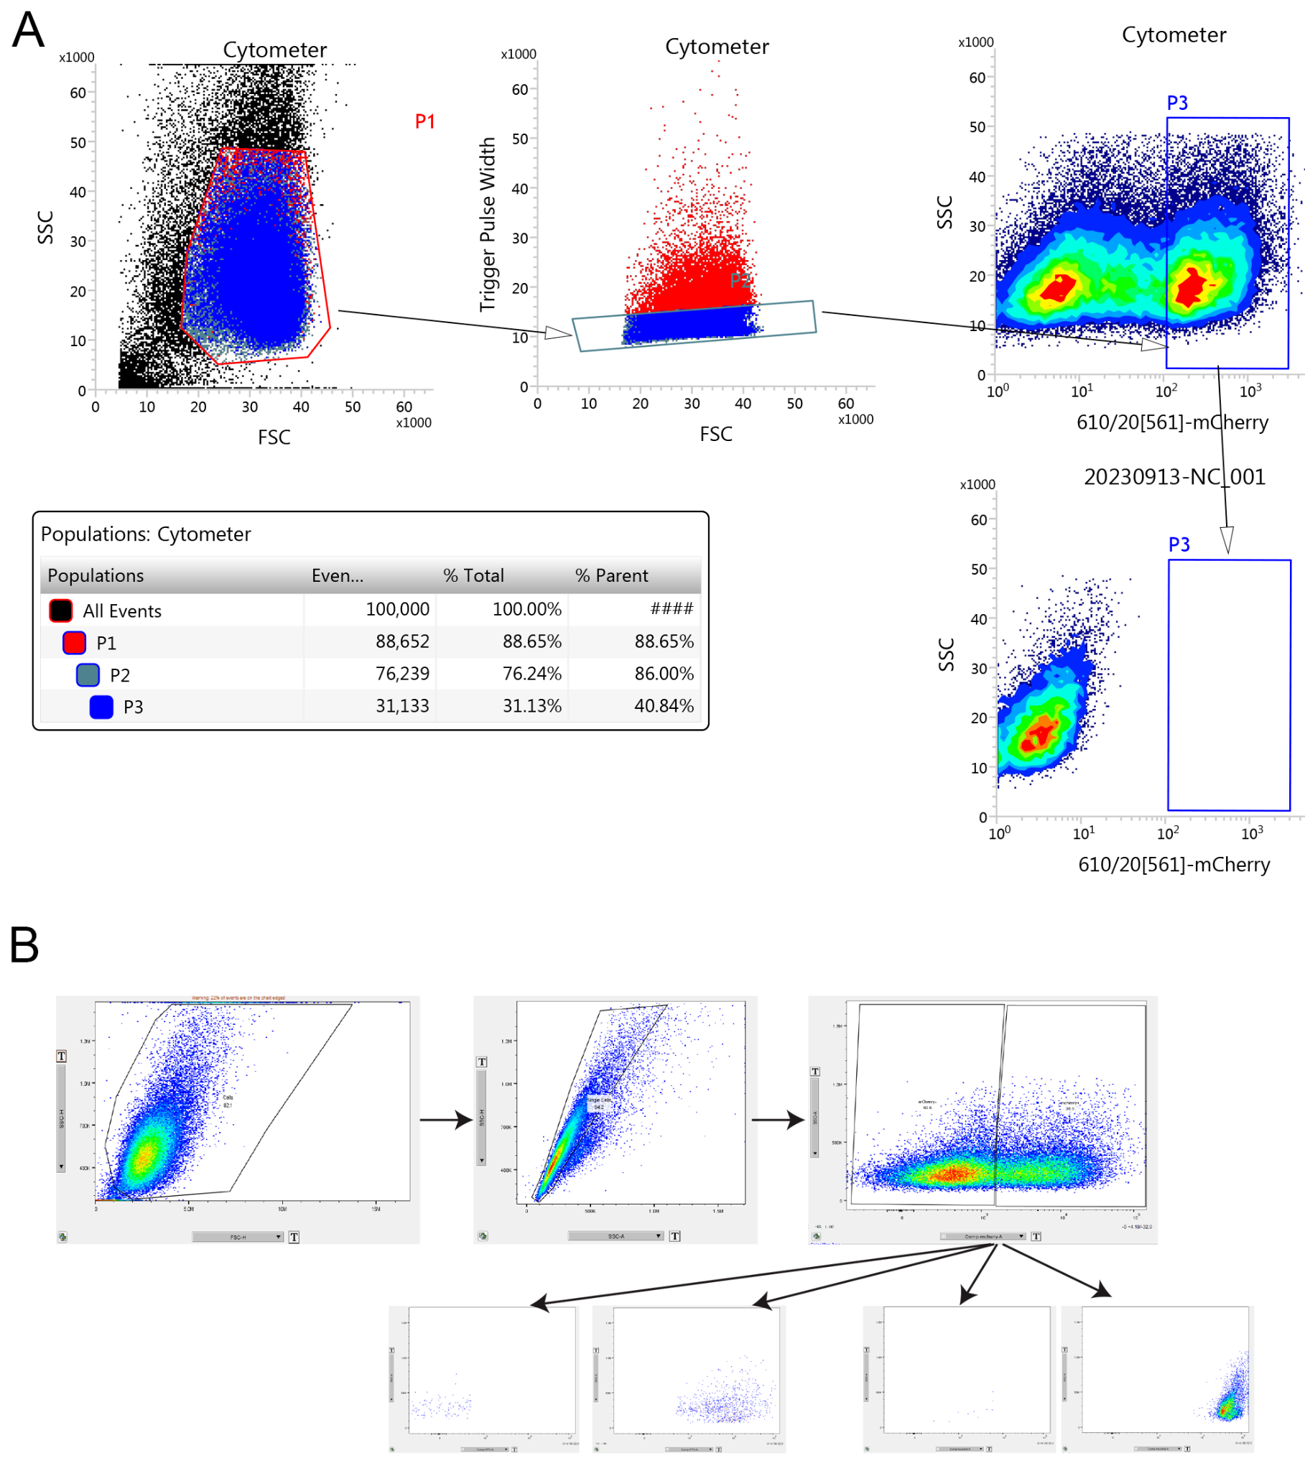

FACS gating strategy
(A) mCherry-sorting of ISG15 expressing cells. Live cells were gated using FSC/SSC, followed by pulse width gating of FSC for single cells, then mCherry gating was selected based on mcherry-negative control cells.
(B) Similarly for infected cell staining, live cells were selected using SSC/FSC, followed by single cell staining, coupled to mCherry gating for transfected cells. After this, consequent staining for 488/647 was selected against negative (2' only antibody) controls.

Uncropped, unannotated, original Western blot images.
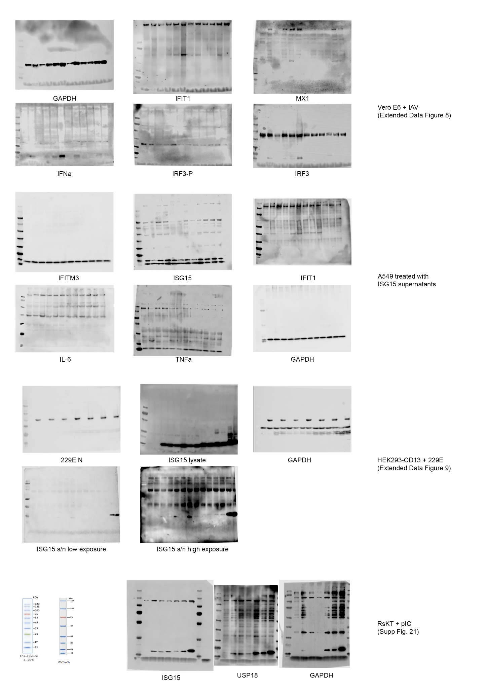
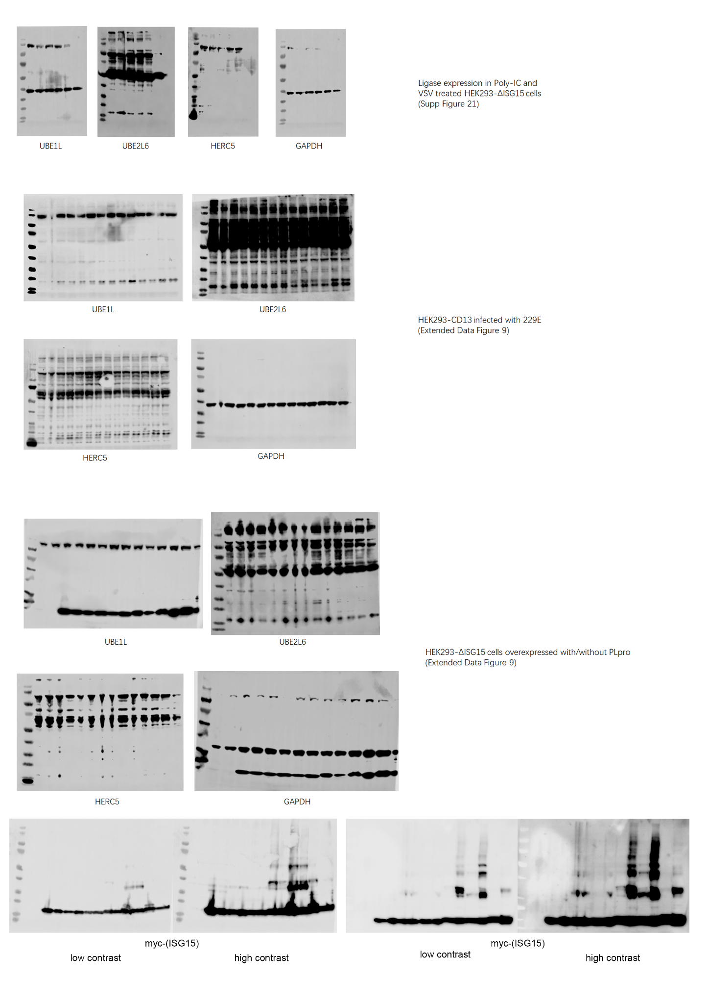

Supplementary References
1. Osmanski, A. B. et al. Insights into mammalian TE diversity through the curation of 248 genome assemblies. Science 380, (2023).
2. Kirilenko, B. M. et al. Integrating gene annotation with orthology inference at scale. Science 380, eabn3107 (2023).
3. Wilkinson, G. S. & Adams, D. M. Recurrent evolution of extreme longevity in bats. Biol. Lett. 15, 20180860 (2019).
4. Jebb, D. et al. Six reference-quality genomes reveal evolution of bat adaptations. Nature 583, 578–584 (2020).
5. Okumura, F., Lenschow, D. J. & Zhang, D.-E. Nitrosylation of ISG15 prevents the disulfide bond-mediated dimerization of ISG15 and contributes to effective ISGylation. J. Biol. Chem. 283, 24484–24488 (2008).
6. Napolitano, A. et al. Cysteine-Reactive Free ISG15 Generates IL-1β-Producing CD8α+ Dendritic Cells at the Site of Infection. J. Immunol. 201, 604–614 (2018).
7. Uhlen, M. et al. A pathology atlas of the human cancer transcriptome. Science 357, eaan2507 (2017).
8. Sun, X. et al. HERC5: a comprehensive in silico analysis of its diagnostic, prognostic, and therapeutic potential in cancer. APMIS (2024) doi:10.1111/apm.13462.
9. Schneegans, S. et al. HERC5 downregulation in non-small cell lung cancer is associated with altered energy metabolism and metastasis. J. Exp. Clin. Cancer Res. 43, 110 (2024).

