Supplementary Information for:

Regulated somatic hypermutation enhances antibody affinity maturation
Julia Merkenschlager#,*^{,1,8}, Andrew G.T. Pyo^{#,2}, Gabriela S. Silva Santos¹, Dennis Schaefer-Babajew¹, Melissa Cipolla¹, Harald Hartweger¹, Alexander D. Gitlin^{3,4}, Ned S. Wingreen^{*,5,6}, and Michel C. Nussenzweig^{*,1,7}

#Co–first authors
¹Laboratory of Molecular Immunology, The Rockefeller University, New York, NY 10065, USA
²Department of Physics, Princeton University, Princeton, New Jersey, 08544, USA
³Immunology Program and Department of Pathology and Laboratory Medicine, Memorial Sloan Kettering Cancer Center, New York, NY, USA
⁴Immunology and Microbial Pathogenesis Graduate Program, Weill Cornell Graduate School, New York, NY
⁵Department of Molecular Biology, Princeton University, Princeton, New Jersey, 08544, USA
⁶Lewis-Sigler Institute for Integrative Genomics, Princeton University, Princeton, New Jersey 08544, USA
⁷Howard Hughes Medical Institute, The Rockefeller University, New York, NY 10065, USA
⁸Laboratory of Lymphocyte collaboration and competition, Harvard Medical School, Boston, MA 02115.

* address correspondence to: julia_merkenschlager@hms.harvard.edu , nussen@rockefeller.edu and wingreen@princeton.edu

Supplementary Data Inventory

Table 1. Parameters used in the agent-based models.

Table 2. Table summarizes the average percentage of nodes (across all mice) as in Fig.2c.

Table 3. Table summarizes the average number of sequences (across all mice) as in Fig. 2d.

Table 4. Table summarizes the average percentage of nodes (across all mice) as in Fig. 3c.

Table 5. Table summarizes the average number of sequences as in Fig. 3d.

Table 6. Table summarizes the antibodies used in the study.

Tables

Parameter | Description | Value | Reference
$$τ_{B}$$ | B cell lifetime in LZ | 8 h | Thomas et al., 2019¹Meyer-Hermann, Maini & Iber 2006²
$$τ_{div}$$ | B cell division time | 5 h | Gitlin et al., 2015³
$$τ_{LZ→DZ}$$ | Duration of LZ B cell to DZ B cell differentiation | 2.04 h | Victora et al., 2010⁴
$$τ_{DZ→LZ}$$ | Duration of DZ B cell to LZ B cell differentiation | 5.88 h | Victora et al., 2010⁴
$$D_{max}$$ | Maximum number of divisions in the DZ | 6 | Gitlin et al., 2014⁵
$$r_{TFH}$$ | T_{FH} cell – B cell interaction rate | 0.4 h⁻¹ | Thomas et al., 2019¹; Meyer-Hermann Maini & Iber 2006²
$$r_{FDC}$$ | Maximum B cell – FDC interaction rate | 0.75 h⁻¹ | N/A
$$A_{min}$$ | Selection stringency | 2 | N/A
$$A_{0}$$ | Selection stringency scale | 5 | N/A

Table 1. Simulation parameters. Values of parameter used in the simulation with a brief description and references. Parameters determining the selection stringencies were chosen to maintain the total number of B cells in the GC at approximately 3000. The value of maximum B cell – FDC interaction rate $r_{FDC}$ was chosen such that a B cell expressing BCRs with affinity $a=\left\langle a\right\rangle$ will divide twice on average upon selection by a T_{FH} cell.

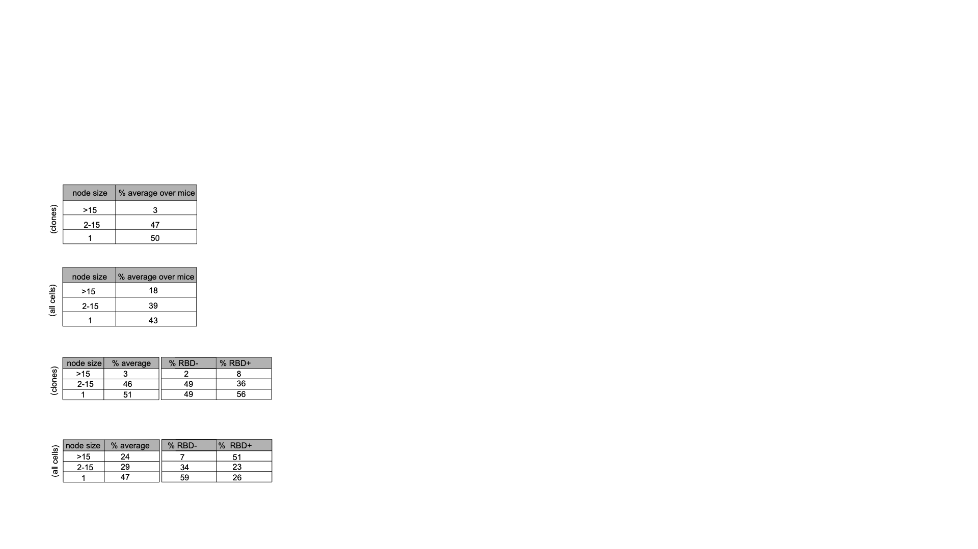
Table 2. Table summarizes the average percentage of nodes (across all mice) made up of 1, 2-15 or >15 identical sequences, when only considering expanded clones (excluding singles) as in Fig.2c.
Table 3. Table summarizes the average number of sequences (across all mice) that contributed to nodes containing 1, 2-15 or >15 identical sequences when all cells were considered (i.e. clones and singles) as in Fig. 2d
Table 4. Table summarizes the average percentage of nodes (across all mice) made up of 1, 2-15 or >15 identical sequences in sum or RBD+ and RBD- compartments, when only considering expanded clones (excluding singles) as in Fig. 3c.
Table 5. Table summarizes the average number of sequences (across all mice) that contributed to nodes containing 1, 2-15 or >15 identical sequences in the sum, or RBD+ and RBD- compartments when all cells were considered (i.e. clones and singles) as in Fig. 3d.

Antibodies (Name, Clone, Cat/Lot, Company, Dilution)
anti-mouse CD45.1PE/Cyanine7, Clone A20, Cat: 110729, Biolegend 1/200
anti-mouse CD45.1 FITC, Clone A20, Cat: 11-0453-82, Invitrogen, 1/200
anti-mouse CD45.1 BV421, Clone A20, Lot B376745, Biolegend. 1/200
anti-mouse CD45.1 BV711, Clone A20, Lot B376745, Biolegend. 1/200
anti-mouse CD45.2 FITC, Clone 104, Cat: 553772, BD, 1/ 200
anti-CD45.2 Mouse Monoclonal Antibody PE, Clone 104, Cat 109808, 1/200
anti-mouse CD45.2, Clone 104, Cat 109808, Lot B271929, eBioscience, 1/200
anti-mouse CD45.2, BV421, Clone 104, Cat 109832, Lot B357158, Biolegend ,1/200
anti-mouse CD45.2 APC-Cyanine, clone 104, Cat 109824, Biolegend 1/200
anti-mouse/human PE CD45R/B220, Clone RA3-6B2, Cat 103208, Biolegend 1/200
anti mouse CD45R/B220, Cat 563793, Lot 3135095, BD 1/200
anti mouse CD45R/B220 FITC, Cat 110-0452-85, Invitrogen, 1/200
anti mouse CD45R/B220 BV421, Cat 103240, Biolegend, 1/200
anti mouse CD45R/B220 BUV395, Cat 563793, Lot 3135095, BD, 1/200
anti-mouse CD38, Clone 90/CD38, Cat 553764, BD Bioscience, 1/200
anti-mouse CD38, Clone 90/CD38, Cat 553764, BD Bioscience, 1/200
anti-mouse GL7 PB, Clone GL7, Cat 144614, Biolegend, 1/200
anti-mouse GL7 FITC, Clone GL7, Cat 144603, Biolegend, 1/200
anti-mouse Pecy7 CD95, Clone Jo2, Cat 557653, lot 2145378, BD, 1/200
anti-mouse DEC205R BV421, Clone V18-9449, Cat: 566376,1/200
anti-mouse Igm[a] FITC, Clone: DS-1 Cat 553516, Lot 2026902, BD, 1/200
anti-mouse Ig light chain PE, Clone:RML-41,Cat 407308, Biolegend, 1/200
anti-mouse Ig light chain APC, Clone:RML-41, Cat: 407306, Biolegend, 1/200
anti-mouse CD38 APC, Clone 90Cat 102712, BD Bioscience, 1/200
anti-mouse CD38, Clone 90. Cat 553764, BD Bioscience 1/200
anti-mouse CD38, Clone 90, Cat 102719, Lot B371397, Biolegend 1/200
anti-mouse CD86 APC, Clone GL-1, Cat 4332810, Biolegend 1/200
anti-mouse CXCR4 APC, Clone GL-1, Cat 4332810, Biolegend 1/200
anti-mouse CXCR4 APC, Clone 2B11 Cat 146507 BD Bioscience 1/200
DAP solution, Clone 2B11, Cat 564907, BD Bioscience, 1/200
TotaISeq™--C0301 anti-mouse Hashtag 1 Antibody 155861, Biolegend 1ug
TotaISeq™--C0302 anti-mouse Hashtag 2 Antibody 155863, Biolegend 1ug
TotalSeq™--C0303 anti-mouse Hashtag 3 Antibody 155865, Biolegend 1ug
TotalSeq™--Co304 anti-mouse Hashtag 4 Antibody 155867, Biolegend 1ug
TotalSeq™--C0305 anti-mouse Hashtag 5 Antibody, Biolegend 1ug
TotaISeq™--C0306 anti-mouse Hashtag 6 Antibody, Biolegend 1ug
TotalSeq™--C0307 anti-mouse Hashtag 7 Antibody, Biolegend 1ug
TotaISeq™--C0308 anti-mouse Hashtag 8 Antibody, Biolegend 1ug
TotalSeq™--C0309 anti-mouse Hashtag 9 Antibody, Biolegend 1ug
TotaISeq™--C0310 anti-mouse Hashtag 10 Antibody, Biolegend 1ug
TotalSeq™--C0096 anti-mouse CD45 Antibody, Biolegend 1ug

Table 6. Table summarizes the antibodies used in the study.

1 Thomas, M. J., Klein, U., Lygeros, J. & Rodríguez Martínez, M. A Probabilistic Model of the Germinal Center Reaction. Front Immunol 10, 689 (2019). https://doi.org:10.3389/fimmu.2019.00689
2 Meyer-Hermann, M. E., Maini, P. K. & Iber, D. An analysis of B cell selection mechanisms in germinal centers. Math Med Biol 23, 255-277 (2006). https://doi.org:10.1093/imammb/dql012
3 Gitlin, A. D. et al. HUMORAL IMMUNITY. T cell help controls the speed of the cell cycle in germinal center B cells. Science 349, 643-646 (2015). https://doi.org:10.1126/science.aac4919
4 Victora, G. D. et al. Germinal Center Dynamics Revealed by Multiphoton Microscopy with a Photoactivatable Fluorescent Reporter. Cell 143, 592-605 (2010). https://doi.org:https://doi.org/10.1016/j.cell.2010.10.032
5 Gitlin, A. D., Shulman, Z. & Nussenzweig, M. C. Clonal selection in the germinal centre by regulated proliferation and hypermutation. Nature 509, 637-640 (2014). https://doi.org:10.1038/nature13300

