Supplementary File 1

Contents
Supplementary Figures 2
Supplementary Figure 1: Gating strategies for flow cytometry 2
Supplementary Figure 2 – Uncropped blots and gel scans 3
Supplementary Figure 2 (continued) – Uncropped blots and gel scans 4
Supplementary Figure 2 (continued) – Uncropped blots and gel scans 5
Supplementary Figure 2 (continued) – Uncropped blots and gel scans 6
Supplementary Methods – modified GEMINI calculate LFC function 10

Supplementary Figures

Supplementary Figure 1: Gating strategies for flow cytometry
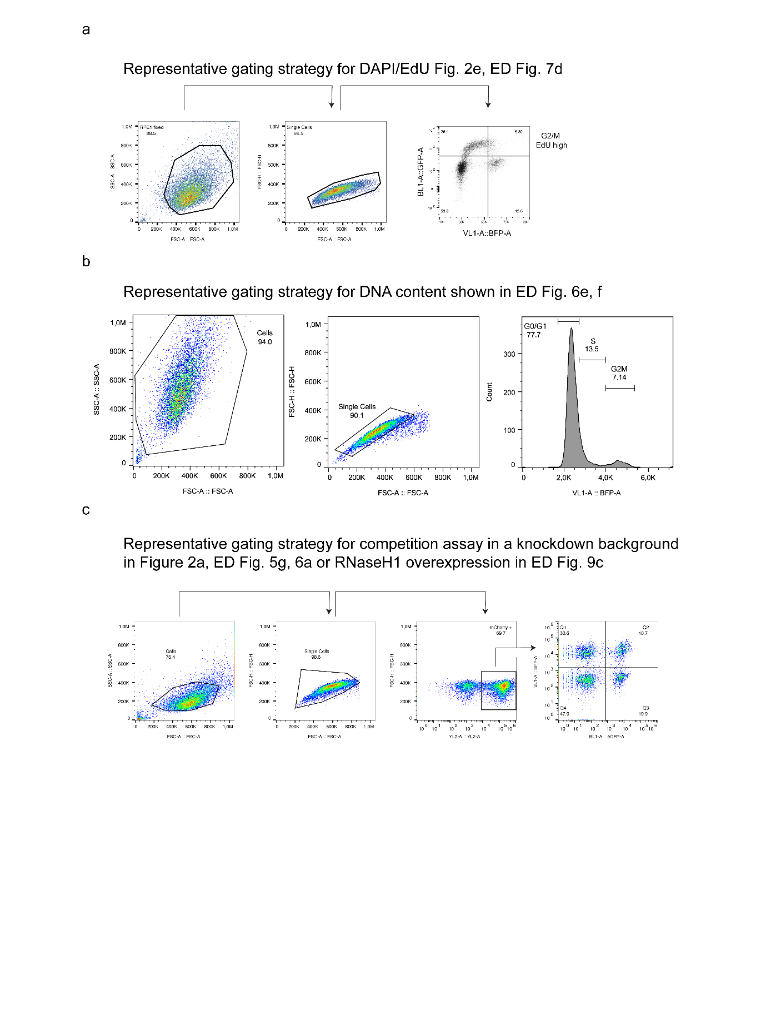
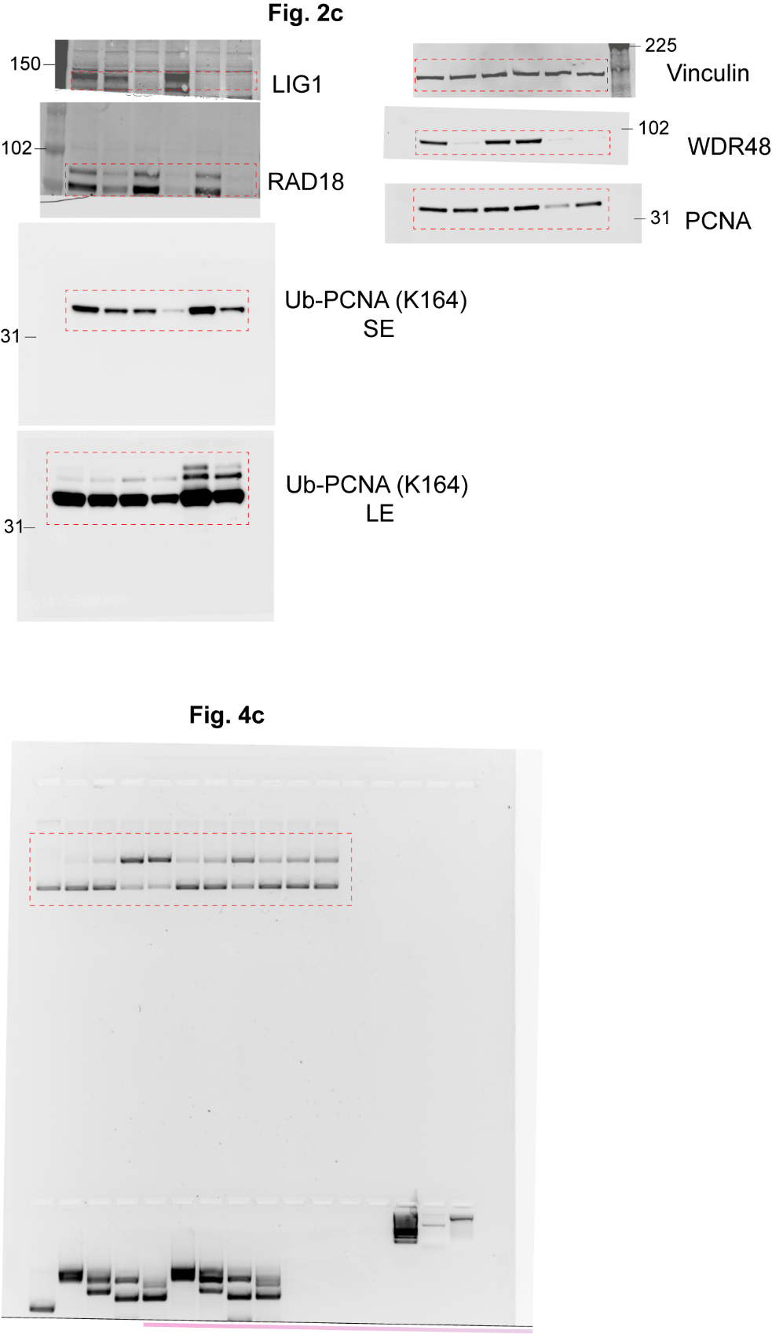

Supplementary Figure 2 – Uncropped blots and gel scans

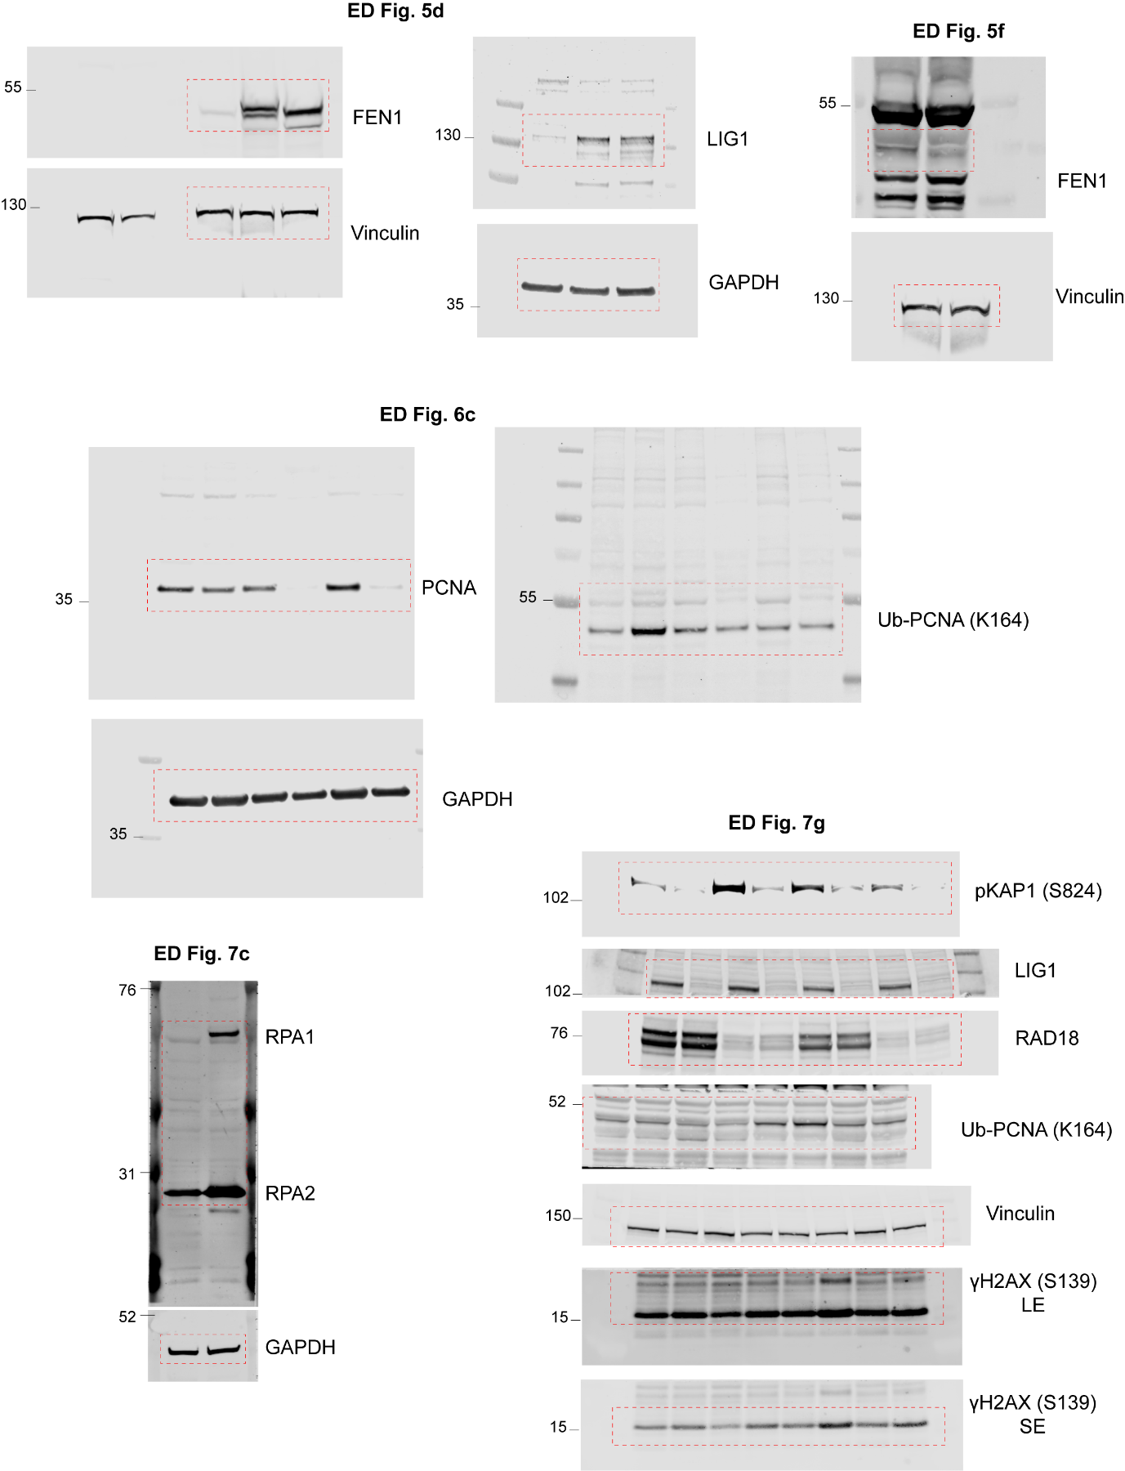

Supplementary Figure 2 (continued) – Uncropped blots and gel scans

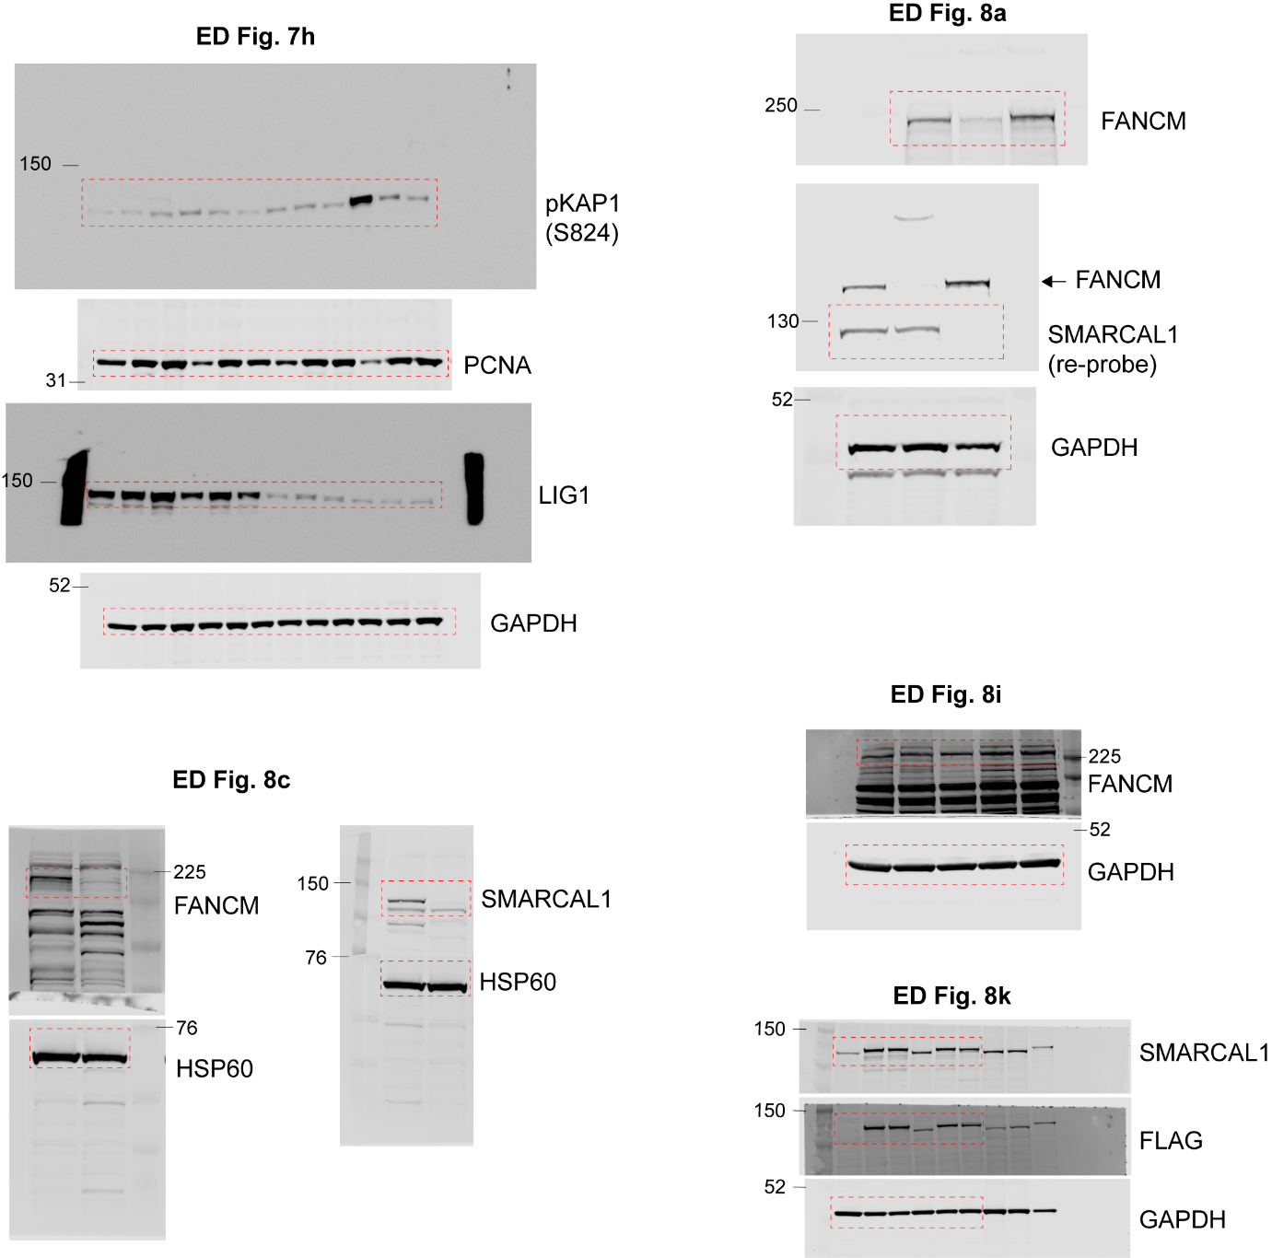

Supplementary Figure 2 (continued) – Uncropped blots and gel scans

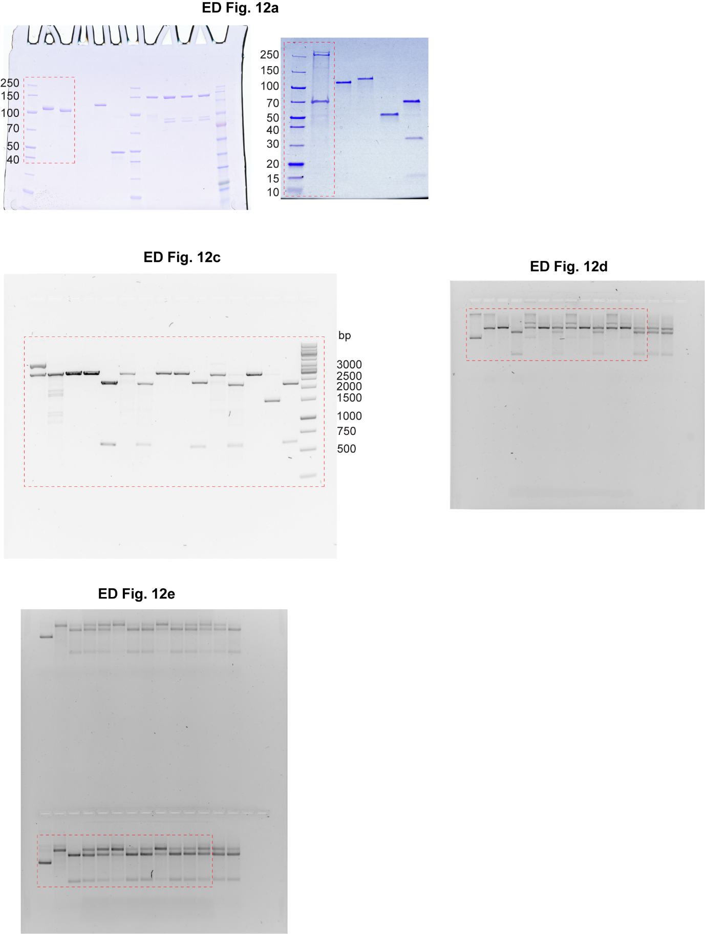

Supplementary Figure 2 (continued) – Uncropped blots and gel scans

gemini_calculate_lfc_mod <- function(Input,
counts = "counts",
sample.column.name = "samplename",
normalize = TRUE,
CONSTANT = 10) {
stopifnot("gemini.input" %in% class(Input))
stopifnot(counts %in% names(Input))

# normalize and scale counts
mat <- Input[[counts]]
total.counts = sum(mat, na.rm = TRUE)
SCALE = (total.counts / ncol(mat))
if (normalize) {
norm.mat = apply(mat, 2, function(x) {
x = ((x / sum(x, na.rm = TRUE)) * SCALE) + CONSTANT
})
Input[[paste0("normalized_", counts)]] <- norm.mat

# compute median-normalized log counts
data <- norm.mat
} else{
data <- mat
}

data = apply(data, 2, function(x) {

## Removed - stats::median(log2(x), na.rm = TRUE) from the original function and added + CONSTANT to include the pseudocount of 10 to all counts

log2(x + CONSTANT)
})

# compute log-fold changes
ETP.cols <- which(Input$replicate.map$TP == "ETP")
ETP.samples <-
unique(Input$replicate.map[ETP.cols, ][[sample.column.name]])
if (length(ETP.cols) == 0) {
stop(
"No ETP samples identified. Make sure at least one ETP column is specified in Input$replicate.map$TP"
)
} else if (length(ETP.cols) == 1) {
# If only 1 ETP column specified
ETP = data[, ETP.cols]
} else if (length(ETP.cols) > 1 &
!any(ETP.samples %in% Input$replicate.map[-ETP.cols, ][[sample.column.name]])) {
# If multiple ETP replicates belonging to only 1 sample (which is not found in LTP samples, i.e. pDNA)
ETP = data[, ETP.cols] %>%
as.data.frame() %>%
rowMeans(na.rm = TRUE)
}

# If ETPs match LTPs by sample, that is handled here:
LTP.cols <- which(Input$replicate.map$TP == "LTP")
LTP <- as.matrix(data[, LTP.cols])
colnames(LTP) <- Input$replicate.map$colname[LTP.cols]
LTP_df <-
lapply(unique(Input$replicate.map[[sample.column.name]][Input$replicate.map$TP == "LTP"]), function(x) {
if (!exists('ETP')) {
# Check if an ETP dataframe has been established
ETP.cols = which(Input$replicate.map$TP == "ETP" &
Input$replicate.map[[sample.column.name]] == x)
if (!length(ETP.cols) > 0)
stop("No ETP specified for ", x)
ETP = data[, ETP.cols] %>%
as.data.frame() %>%
rowMeans(na.rm = TRUE) # Create ETP df for this sample
}
cols <-
Input$replicate.map$colname[Input$replicate.map[[sample.column.name]] ==
x & Input$replicate.map$TP == "LTP"]
LFC <- LTP[, match(cols, colnames(LTP), nomatch = 0)] %>%
as.data.frame(optional = TRUE) %>%
rowMeans(na.rm = TRUE) %>%
magrittr::subtract(ETP)
return(LFC)
}) %>%
magrittr::set_names(unique(Input$replicate.map[[sample.column.name]][Input$replicate.map$TP == "LTP"])) %>%
dplyr::bind_cols() %>%
as.data.frame(optional = TRUE, stringsAsFactors = FALSE) %>%
magrittr::set_rownames(Input$guide.pair.annot[, 1])

# Consolidate LFC to sample level
unique.to.sample <-
names(which(
apply(Input$replicate.map, 2, function(x)
length(unique(x))) == length(unique(Input$replicate.map[[sample.column.name]]))
))
Input$sample.annot <- Input$replicate.map %>%
dplyr::filter(.$`TP` == "LTP") %>%
dplyr::select(dplyr::all_of(c(sample.column.name, 'TP', unique.to.sample))) %>%
unique() %>%
magrittr::set_rownames(seq(from = 1, to = nrow(.))) %>%
dplyr::mutate(rowname = colnames(LTP_df))

Input[["LFC"]] <- LTP_df %>%
dplyr::select(unique(Input$replicate.map[[sample.column.name]][Input$replicate.map$TP != "ETP"])) %>%
as.matrix()

# Return object
Output <- Input
class(Output) <- c(class(Output), "gemini.input")
return(Output)
}

Supplementary Methods – modified GEMINI calculate LFC function

