Sub-nanosecond flash memory enabled by 2D-enhanced hot carrier injection
(Supplementary Information)
Yutong Xiang^{1,§}, Chong Wang^{1,§}, Chunsen Liu^{1,§,*}, Tanjun Wang¹, Yongbo Jiang¹, Yang Wang^{1,2}, Shuiyuan Wang¹, Peng Zhou^{1,2,*}
¹State Key Laboratory of Integrated Chips and Systems, School of Microelectronics, Frontier Institute of Chip and System, Zhangjiang Fudan International Innovation Center, Fudan University, Shanghai 200433, China
²Shaoxin Laboratory, Zhejiang, China
§These authors contributed equally: Yutong Xiang, Chong Wang and Chunsen Liu
*Correspondence should be addressed to Chunsen Liu: chunsen_liu@fudan.edu.cn, Peng Zhou: pengzhou@fudan.edu.cn

S1. Device fabrication process and characterization
The devices and specific parameters described in the figures of the manuscript are summarized in Table S1. These include the channel length, channel thickness, hBN thickness, and so on. The hBN and channel thickness here are measured using an atomic force microscopy (AFM) instrument.
Table S1 | List of the fabricated devices presented in the main text.
Device number | Presented in which figure of the manuscript | Device type | Channel material | Channel length (μm) | Channel thickness (nm, # layers) | hBN thickness (nm)
IG_D7S8 | Fig. 1e | Transistor | WSe₂ | 1.0 | 3 | 10
IL_D3S4 | Fig. 1f | Transistor | Graphene | 1.5 | 2 | 12.5
KH_D1S2 | Fig. 3b | Flash memory | Graphene | 0.7 | Bilayer | 6
JJ_D1S2 | Fig. 3c,d  Fig. 4 | Flash memory | Graphene | 0.2 | 1.0 | 6.5
IJ_D3S4 | Fig. 3e | Flash memory | Graphene | 0.44 | 1.2 | 7
HK_D4S5 | Fig. 3f | Flash memory | Graphene | 0.4 | 1.5 | 8
FJ_D4S5 | Fig. 4 | Flash memory | WSe₂ | 0.8 | 3 | 7
KI_D1S2 | Fig. 4 | Flash memory | Graphene | 0.34 | 1.8 | 6

Figure S1 illustrates the detailed fabrication process of the device. The bottom control gates (5/15 nm Cr/Au) were patterned by e-beam lithography (EBL) with a bilayer photoresist process followed by a deposition of metal by e-beam evaporation (EBE) on SiO₂ (300 nm)/Si substrates. For the flash memory, following the preparation of the bottom gates, an Al₂O₃ blocking oxide and an HfO₂ trap layer were grown by thermal atomic layer deposition (ALD) at 250 ℃. During the ALD process, Trimethylaluminum and Tetrakis(ethylmethylamino)hafnium react with water to form Al₂O₃ and HfO₂, respectively. This ALD process is only necessary for flash fabrication. WSe₂, graphene, and hBN bulk crystals were purchased from HQ Graphene and the heterostructure of 2D materials was prepared using mechanical exfoliation and a dry-transfer approach. The hBN flake was first transferred to the bottom gate, and then the thin-body material was transferred onto the hBN flake. The adhesion of the heterostructure on the substrate was improved by heat annealing for more than 2 hours at 200 ℃ under an N₂ atmosphere. Next, drain-source contacts were patterned by EBL, and a metal stack (WSe₂, 10/12 nm Sb/Pt; graphene, 5/60 nm Cr/Au stack) was deposited using EBE. After the standard lift-off approach, devices with Sb/Pt contact were annealed by the hot plate in the glove box (200℃, 2 hours) to form the alloy. The different process between the transistor and flash memory is the extra memory stack ALD process in the flash, while the remaining steps are the same. Besides, to conduct the sub-1 ns flash memory test, metal wires and pads matched with the radio frequency (RF) probes were patterned by EBL, and 5/60 nm Cr/Au was deposited by EBE.
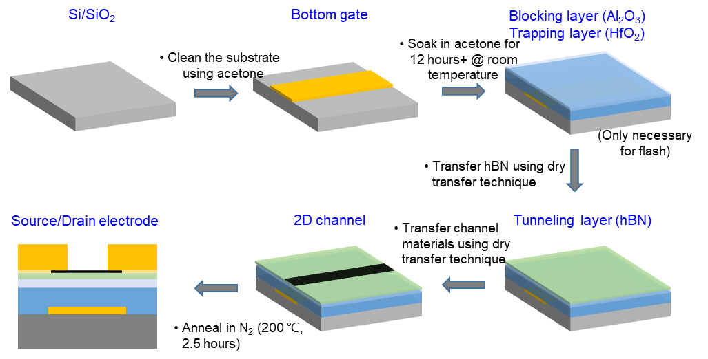
Figure S1 | Fabrication process of the device based on the 2D-HCI mechanism. The fabrication of flash memory needs an additional ALD process to construct a memory stack. The remaining steps are the same regardless of the transistor or the flash device.
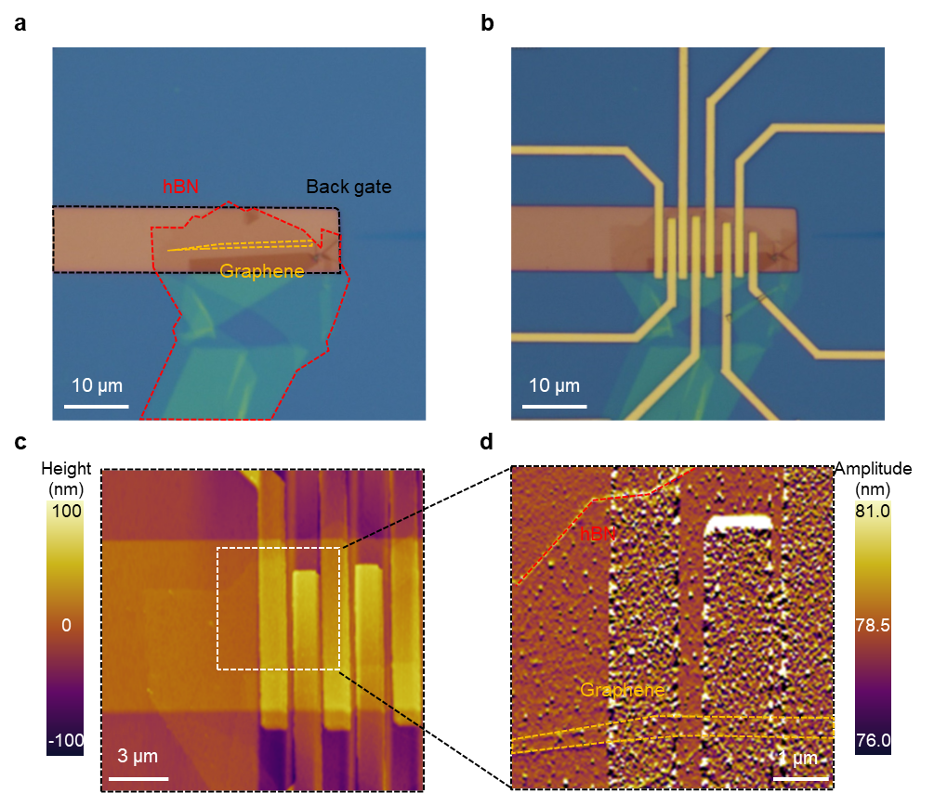
Figure S2 | Characterization of a typical device in this work. a, b, Optical images of the device before (a) and after source/drain contacts (b). AFM height (c) and amplitude (d) images to illustrate the thin-body channel and clean interface.

Optical and AFM images of a typical device are shown in Fig. S2. The AFM images of the device can provide strong evidence to verify its cleanliness.
Figures S3 and S4 display the optical images and AFM characterization in some of our devices. As we can see, the thickness of the graphene channel is below 2 nm and the thickness of the WSe₂ channel is around 3 nm. Taking the graphene flash device (device number: KH_D1S2) as an example, the thickness of the hBN and graphene used in this device is around 6 nm and 1 nm, respectively, which are almost identical to the thickness shown in the TEM image of this device in the manuscript (Fig. 3b). All the channel thickness is below the silicon thickness limit.

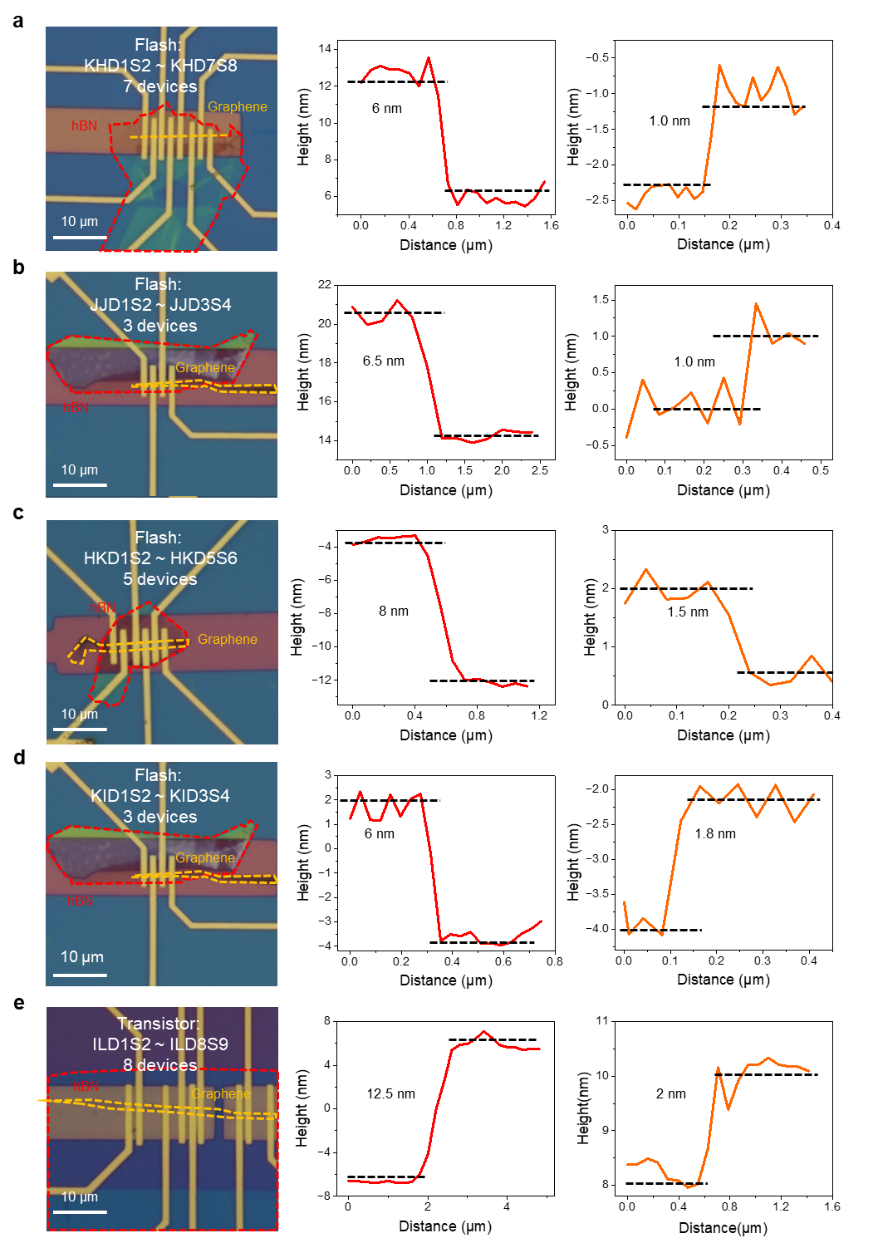
Figure S3 | Thickness characterization of some of the graphene transistors and flash devices. a, b, c, d, e, The left row is the optical microscope photograph of our different devices shown in the manuscript. The red and orange dashed lines represent the dielectric hBN and channel graphene, respectively. The scale bar is 10 μm. The middle and right rows indicate the thickness of hBN and graphene, respectively.
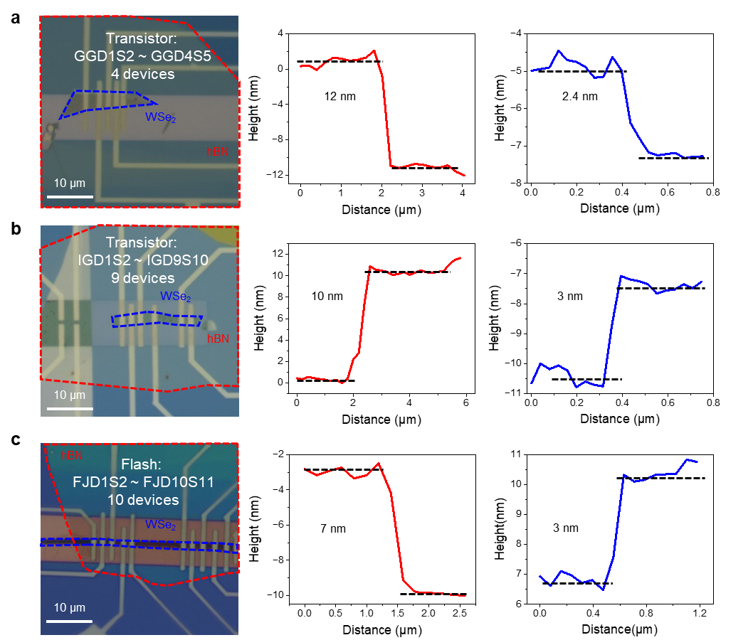
Figure S4 | Thickness characterization of some of the WSe₂ transistors and flash devices. a, b, c, The left row is the optical microscope photograph of devices shown in the manuscript, and the red and blue dashed lines represent the dielectric hBN and channel WSe₂, respectively, corresponding to the thickness in the middle and right rows. Scale bar, 10 μm.

S2. Mechanism discussion and verification in 2D transistors
A comprehensive analysis of the stark increase in E_{y} of WSe₂ near the drain compared to graphene has been provided here, including the difference in conductance response to V_{GS} and polarity between the two materials.
- Greater conductance response to V_{GS} in WSe₂
The applied voltage to the channel material is given by $(V_{GS}-V_{y})$. Along the source to the drain, the $|V_{GS}-V_{y}|$ decreases due to the increase in |V_{y}| (Fig. 1c,d), which means conductance will decrease along the channel. On the other hand, the larger bandgap in WSe₂ enables regulation of the carrier distribution over a wide range rather than a limited range in graphene, giving rise to a larger conductance difference between the source and the drain. Therefore, even under the same V_{GS}, V_{DS} condition, the conductance difference of the WSe₂ channel is much larger than that of the graphene channel, leading to a stark increase in E_{y} near the drain in the WSe₂ channel.
We have further provided simulation results to prove the perspective. Figure S5 demonstrates that under the same electrical condition, the hole density distribution along the WSe₂ channel is more variable, whereas that in graphene is more even. The larger difference of hole density in WSe₂ leads to a greater variation of channel resistance. This is consistent with the stark increase of E_{y} near the drain in the WSe₂ channel.
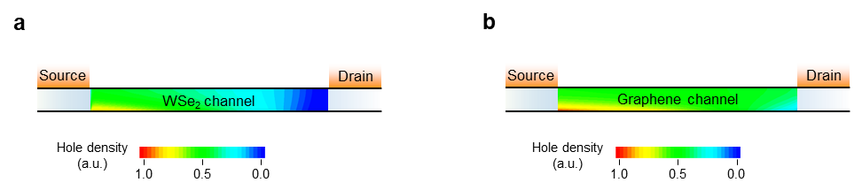
Figure S5 | Hole density distribution in a simulated WSe₂ and graphene transistor. a, The hole density distribution in the WSe₂ transistor b, The hole density distribution in the graphene transistor. The hole density values are normalised to each maximum hole density under the electrical condition: V_{GS} – V_{th} = V_{GS} – V_{Dirac} = -1.5 V, V_{DS} = -2.5 V. The channel thickness is 1 nm, and the channel length is 0.2 μm. The contour plots are stretched 20 times in the vertical direction for better viewing.

- Unipolar characteristics of WSe₂
The high-resistance (pinch-off) region of unipolar WSe₂ is formed under the electrical condition $\left|V_{GS}-V_{th}\right|<{|V}_{DS}|$. This is different from the phenomenon observed in bipolar graphene, where no high-resistance region is generated because of the inversion of electrons¹. Figure S6 shows the carrier distribution in WSe₂ and graphene at the same electrical condition. The high-resistance region in the WSe₂ transistor gives rise to the stark increase of E_{y} near the drain.
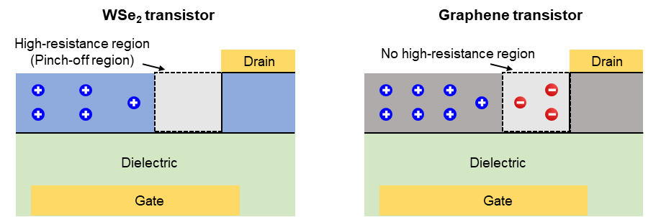
Figure S6 | Schematic demonstration of the carrier distribution under the same electrical condition in the WSe₂ and graphene transistor.

The specific locations of hot carrier injection can be identified through the carrier temperature distribution. The carrier temperature means the average kinetic energy of carriers in a system. Since hot carrier injection occurs when carriers gain sufficient kinetic energy to become high-energy state through channel acceleration, the temperature distribution along the channel is considered to facilitate the analysis of the potential locations of hot carrier injection. Figure S7 shows that the temperature of the hot carriers increases gradually from the source along the channel, reaching its highest point near the E_{ymax}, which means this area of the channel is the most probable location for the occurrence of hot carriers.
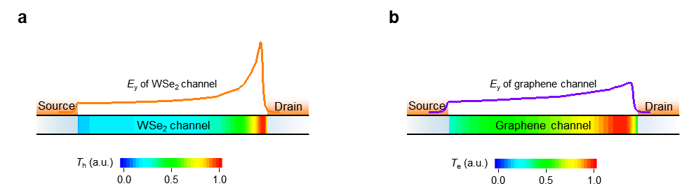
Figure S7 | Carrier temperature (T) contour plots for a simulated transistor. a, Hole temperature (T_{h}) distribution in the WSe₂ transistor under the same simulation condition as Fig. 1c. The orange line represents the E_{y} distribution of WSe₂ channel. b, Electron temperature (T_{e}) distribution in the graphene transistor. The purple line represents the E_{y} distribution of graphene channel under the same simulation condition as Fig. 1d. The carrier temperature of both materials reaches its highest point near the E_{ymax}. Note that the T_{h} in WSe₂ and T_{e} in graphene are normalised to each maximum value, and the contour plots are stretched 10 times in the vertical direction for better viewing.

To further prove the 2D-HCI mechanism experimentally, we built WSe₂ transistors for analysis. Figure S8 displays that by utilising the semi-metal technology², we could obtain the p-type (Sb/Pt) contact. Additionally, the linear, symmetric output characteristics indicate the quasi-ohmic contact property.
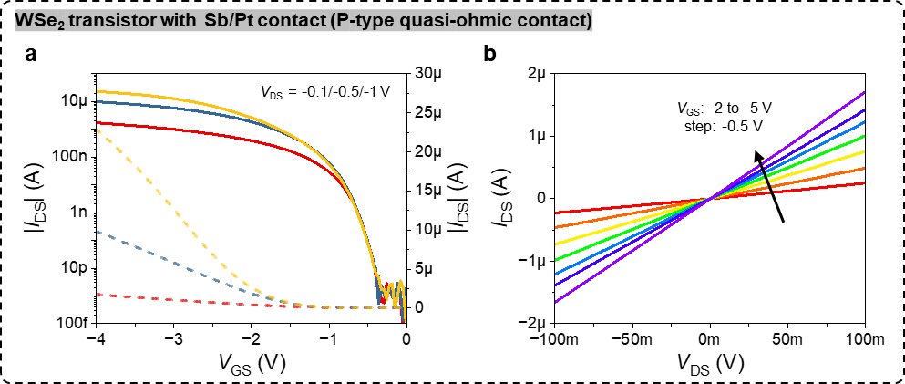
Figure S8 | Basic electric performance of WSe₂ transistor. a, b, WSe₂ transistor with Sb/Pt contact (device number: IG_D7S8), demonstrating a p-type quasi-ohmic contact. It shows the transfer characteristics (a) and the nearly linear, symmetric output characteristic curves (b).

As hBN films have a small density of the interface states with 2D channels, the utilisation of hBN dielectric avoids the hysteresis effect³. As illustrated in Fig. S9, in the WSe₂ and graphene transistor, the hysteresis is found to be negligible. It contributes to the direct measurement of the injection current.
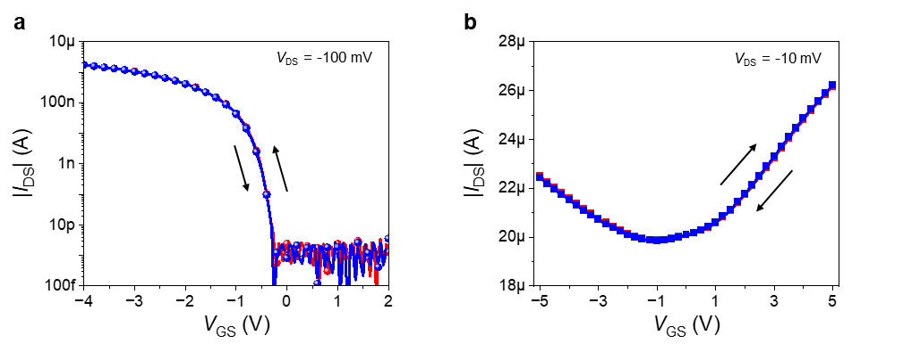
Figure S9 | Hysteresis curves of the 2D transistors. a, b, The forward and backward transfer curves the WSe₂ transistor (device number: IG_D7S8) (a), and the graphene transistor (device number: IL_D3S4) (b).

To certify the injection current measured is not gate leakage based on FN tunnelling, we have conducted the measurement, as shown in Fig. S10. It demonstrates the difference between gate leakage and the injection current. As known that |I_{GS}| is determined by the potential between gate and drain/source, this device shows no gate leakage in Fig. S10a (|I_{GS}| < 10 pA @ |V_{GSmax}| = 5 V). However, under the combination of V_{GS} and V_{DS}, |I_{GS}| shows a larger value than 10 pA at a smaller potential between gate and drain/source (≤ 5 V), indicating the presence of injection current at this condition.
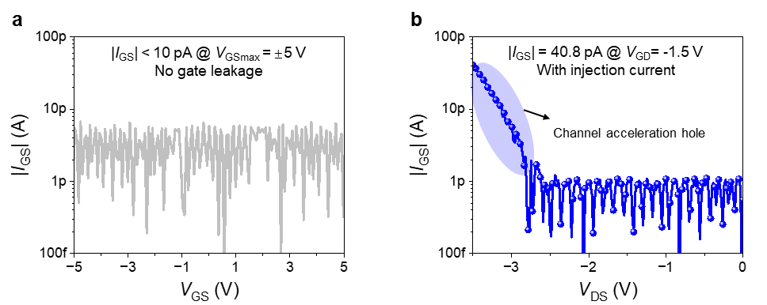
Figure S10 | Comparison between gate leakage and carrier injection current. a, |I_{GS}| versus V_{GS} at V_{DS} = -100 mV in the WSe₂ transistor (device number: IG_D3S4). The device shows no leakage (|I_{GS}| < 10 pA) even at V_{GS} = ± 5V. This leakage is caused by FN tunnelling. b, 2D-HCI in the WSe₂ transistor. It demonstrates that although the potential between gate and drain is smaller than -5 V, the injection current appears (|I_{GS}| > 10 pA).

In terms of the channel acceleration effect in 2D semiconductors, we define V_{peak}, as the gate voltage where the injection current peaks and find that all maximum points of the curves in Fig. 1e follow the relationship ${|V}_{peak}-V_{th}|=|V_{DS}|$ (Fig. S11). What’s more, we find the output |I_{GS}|-V_{DS} curves also follow the relationship (Fig. S12c). This relationship indicates the disappearance of the pinch-off region, which is consistent with the silicon hot electron injection. Additionally, as the temperature rises, the maximum injection current will decline due to increasing the holes scattering in the WSe₂ channel (Fig. S13).
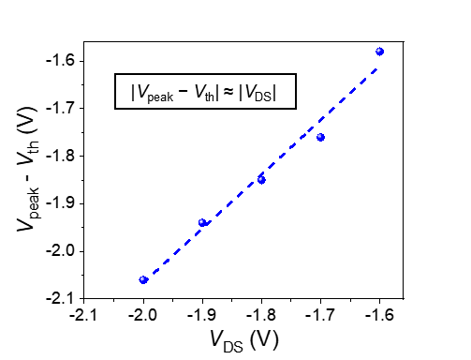
Figure S11 | The relationship between ${|V}_{peak}-V_{th}|$ and $\text{|}{\text{V}}_{\text{DS}}\text{|}$ in the WSe₂ transistor (device number: IG_D7S8). The data are extracted from Fig. 1e. V_{peak} is defined as the gate voltage where the injection current peaks. It follows ${|V}_{peak}-V_{th}|≈|V_{DS}|$, where the injection current peaks in 2D semiconductors.

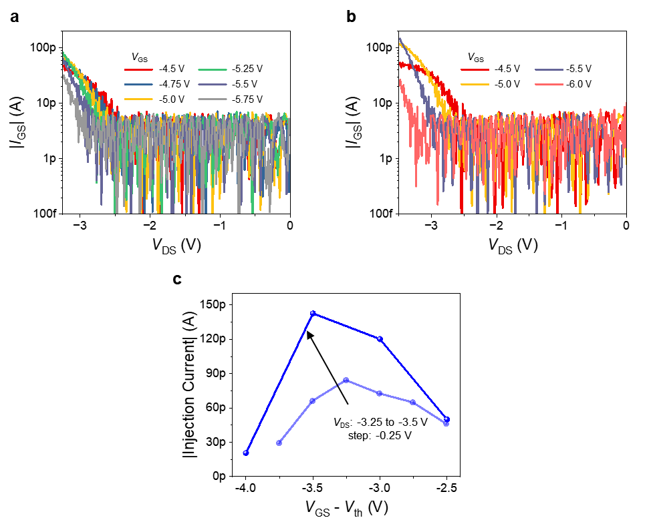
Figure S12 | 2D-HCI observed in |I_{GS}|-V_{DS} curves (device number: IG_D9S10). a, b, |I_{GS}| versus V_{DS} at different V_{GS}. c, The extracted injection current from a @ V_{DS} = -3.25 V and b @ V_{DS} = -3.5 V. Note that the injection current extracted from |I_{GS}|-V_{DS} curve peaks at ${|V}_{GS}-V_{th}|=|V_{DS}|$, V_{th} = -2 V, consistent with the relationship observed in |I_{GS}|-V_{GS}.

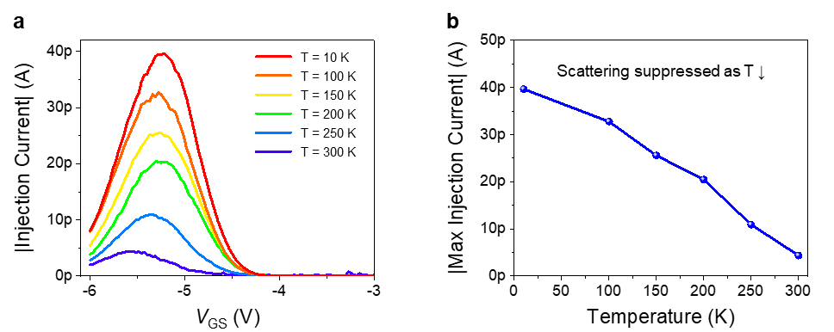
Figure S13 | The channel acceleration effect under varying temperatures in the WSe₂ transistor (device number: IG_D8S9). a, The hole injection current of channel acceleration effect at V_{DS} = -1.8 V. b, The correlation between max injection current and temperature for the channel acceleration effect. As temperature decreases, the max injection current increases due to scattering suppression.

As shown in Fig. S14, we can manipulate V_{GS} to generate channel acceleration electrons regardless of when $V_{DS}<0$ or $V_{DS}>0$ in the bipolar graphene transistor. Similarly, channel acceleration holes can be also observed when $V_{DS}>0$.
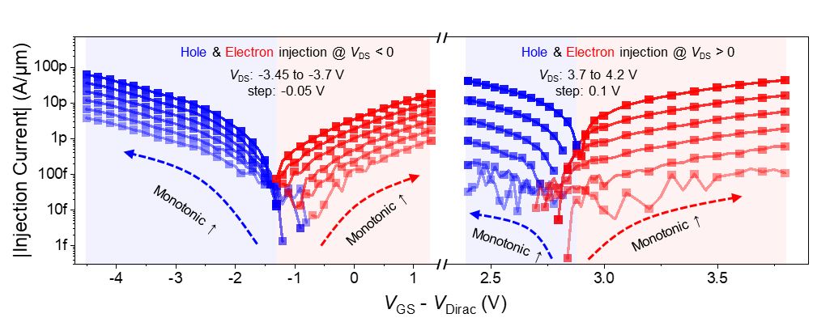
Figure S14 | 2D-HCI behaviour in the 2D Dirac transistor (device number: IL_D3S4). Injection current of channel acceleration electron (solid red squares) and hole (solid blue squares) in the graphene transistor (L_{ch} = 1.5 μm, Cr/Au contact; V_{DS}: -3.45 to -3.7 V, step: -0.05 V, and V_{DS}: 3.7 to 4.2 V, step: 0.1 V, from bottom to top). The injection current shows a monotonic trend as the function of $(V_{GS}-V_{Dirac})$.

We have also fabricated a batch of WSe₂ and graphene transistors with different channel lengths and find the scaling down of the device can increase carrier injection current with a fixed |V_{DS}| or decrease the required |V_{DS}| to reach the same injection current (Fig. S15).
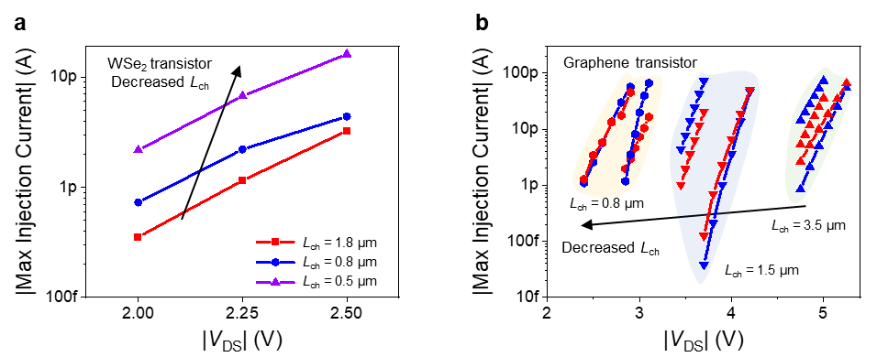
Figure S15 | Size effect of the 2D-HCI mechanism. a, The maximum value of injection current of the measured WSe₂ transistor (device number: GG_D1S2/GG_D2S3/GG_D3S4). The channel length is 0.5, 0.8, and 1.8 μm. It shows that the smaller channel length, the larger injection current. b, The maximum value of injection current of the measured graphene transistor (device number: IL_D2S3/IL_D3S4/IL_D4S5). The channel length is 3.5, 1.5, and 0.8 μm. It shows that the smaller channel length, the less |V_{DS}| required to achieve the same injection current.

The proposed mechanism’s broad applicability is also observed in other two 2D semiconductors, e.g., MoSe₂ and ReSe₂, as shown in Fig. S16.
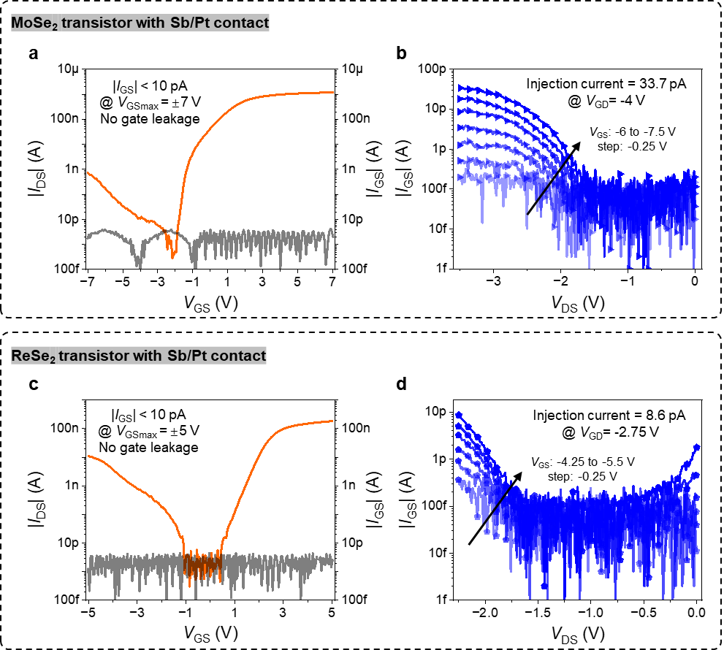
Figure S16 | 2D-HCI in other 2D semiconductors. a, Transfer characteristics of the MoSe₂ transistor @ V_{DS} = -100 mV. |I_{GS}| < 10 pA @ V_{GSmax} = ±7 V (device number: CA_D7S8). b, |I_{GS}|-V_{DS} relationship in the MoSe₂ transistor. It shows the channel acceleration injection current (> 10 pA) with the potential between gate and drain less than 7 V. c, Transfer characteristics of the ReSe₂ transistor @ V_{DS} = -100 mV. |I_{GS}| < 10 pA @ V_{GSmax} = ±5 V (device number: EA_D7S8). d, |I_{GS}|-V_{DS} relationship in the ReSe₂ transistor. It shows the channel acceleration injection current (> 10 pA) with the potential between the gate and drain less than 5 V.

S3. Simulation parameters for the 2D-HCI mechanism
The parameters used for the technology computer aided design tool are listed in Table S2. The parameters of silicon use the built-in parameters of the tool. In the simulated transistor, the channel length is 0.2 μm, the hBN thickness is 10 nm, and the contact is ohmic. In Fig. 1c,d, the channel thickness is 2 nm. In Fig. 1c, we apply V_{GS} – V_{th} = -1.8 V, V_{DS} = -2 V. In Fig. 1d, we apply V_{GS} – V_{Dirac} = 1.8 V, V_{DS} = 2 V. In Fig. 2b, we apply V_{GS} – V_{th} = -1.8 V, V_{DS} = -2 V, and the WSe₂ channel thickness is 1 nm and 2 nm. In Fig. 2c, the electrical condition is V_{GS} – V_{th} = -1.8 V, V_{DS} = -2 V; V_{GS} – V_{Dirac} = 1.8 V, V_{DS} = 2 V; and V_{GS} – V_{th} = 1.8 V, V_{DS} = 2 V for the WSe₂, graphene and silicon transistor, respectively.
Table S2 | The detailed parameters used for simulations.
Parameters | hBN | ML-Graphene | 1L-WSe₂ | 2L-WSe₂ | 3L-WSe₂ | 4L-WSe₂ | > 4L-WSe₂
E_{g} (eV) | 5.9 | 10⁻⁴ | 2.01 | 1.83 | 1.75 | 1.69 | 1.63
ε | 3.7 | 6 | 4.5 | 6.3 | 8 | 8 | 9
χ (eV) | 1.1 | 4.6 | 3.37 | 3.57 | 3.69 | 3.76 | 3.89
m_{e} (m₀) | N/A | 0.031 | 0.345 | 0.412 | 0.434 | 0.434 | 0.434
m_{h} (m₀) | N/A | 0.031 | 0.348 | 0.348 | 0.368 | 0.368 | 0.368
* Here, E_{g} is the bandgap, ε is the permittivity, χ is the electron affinity, m_{e} is the electron effective mass, m_{h} is the hole effective mass, ML is the multilayer, 1L is the monolayer, 2L is the bilayer, 3L is the trilayer, 4L is the four-layer. The simulation parameters refer to refs.⁴⁻¹⁰.

- Simulation details
The computer aided design tool is employed to obtain the E_{y} and V_{y}. The simulation method is consistent with our previous works^{11,12} and other reported works^{13,14}. In detail, the simulated device structure is the same as the actual device structure. The carrier transport process in the channel is modelled using the drift-diffusion approximation. The high-field saturation model is used for velocity saturation in the high horizontal field. The Shockley-Read-Hall recombination model and the Auger recombination model are included to describe the process of carrier exchange between the conduction band and the valence band. By taking V_{GS} and V_{DS} as boundary conditions, the E_{y} and V_{y} can be obtained through the numerical calculation of the Poisson equation, the carrier continuity equation, and the carrier transport equation.
After E_{ymax} under varying t_{ch} was obtained by exact numerical solution, an allometric fitting function ($E_{ymax}=a*{t_{ch}}^{b}$) and Levenberg-Marquardt optimisation algorithm were employed to obtain this relation. The parameters are $a$ = 0.24 and $b$ = -0.4 in graphene, and $a$ = 0.56 and $b$ = -0.5 in WSe₂.

S4. Relationship between the injection current and E_{y}
To figure out how E_{y} influences the injection current more clearly, we first analysed the relationship between E_{y} and carrier density/mobility, which directly affects the current.
- Relationship between E_{y} and carrier density
In a transistor, the voltage $(V_{GS}-V_{th})$ determines the carrier density that the source side can provide. The larger V_{DS} (E_{y}) will increase the number of carriers entering the channel per unit time and allow the carriers to gain more kinetic energy, which contributes to carriers having a better acceleration effect. This results in a greater high-energy carrier density and larger hot injection current.
- Relationship between E_{y} and mobility
The effective mobility ($μ_{eff}$) in a transistor is referred to the mobility ($μ$) at low E_{y}. Under the influence of strong E_{y}, there is a typical relationship between the mobility and E_{y}¹⁵: $μ=\frac{μ_{eff}}{{[1+{\left(\frac{μ_{eff}E_{y}}{v_{sat}}\right)}^{2}]}^{1/2}}$, where “$v_{sat}$” is the saturation velocity. It can be observed that as E_{y} increases, the mobility decreases due to the scattering effect. However, it should be noted that the kinetic energy obtained by hot carriers depends on the velocity ($v$), which can be expressed as: $v=μE_{y}=\frac{μ_{eff}E_{y}}{{[1+{\left(\frac{μ_{eff}E_{y}}{v_{sat}}\right)}^{2}]}^{1/2}}$. When E_{y} increases, the velocity of carriers increases, increasing the kinetic energy of the carriers and giving rise to a better acceleration effect. What’s more, in graphene, due to the suppressed scattering effect, E_{y} can better improve the acceleration process of carriers in the whole channel.
In addition, based on the quantitative discussion of the pinch-off region in Methods and the channel resistance model in Fig. 2b, the relationship between injection current and E_{y} can be explained more clearly. As |V_{DS}| rises, the overall E_{y} also rises, and carriers can obtain more acceleration energy in the entire channel region. Furthermore, an increase in |V_{DS}| will lead to an expansion of the high-resistance (high-E_{y}) region, as shown in Fig. S17. Both can facilitate the acceleration of carriers, increasing the probability of hot carrier injection and consequently increasing the injection current.
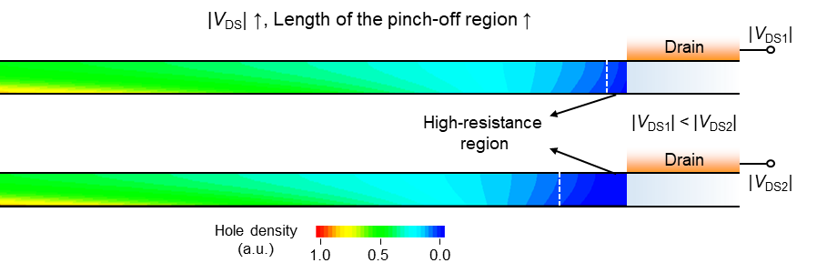
Figure S17 | Hole density contour plot for a simulated WSe₂ transistor under different V_{DS} conditions. An increase of |V_{DS}| will result in a more region with low hole density, consequently extending the length of the pinch-off region. The white dashed lines approximately distinguish the high-resistance region and the other parts of the channel. The electrical condition is V_{GS} – V_{th} = -1.5 V, V_{DS1} = -1.6 V, V_{DS2} = -2 V.

It should be noted that even under the strong E_{y}, hot carriers are more likely to inject into the gate, rather than transport through the VSR region. Taking the WSe₂ transistor as an example, when hot holes are formed in the WSe₂ transistor, which means that the hole energy has exceeded the barrier height, holes can be collected by the drain along the channel (horizontal direction) or injected into the gate along the dielectric (vertical direction), as shown in Fig. S18. In terms of horizontal electric field (E_{y}), for instance, E_{ymax} is less than 0.5 MV/cm (Fig. 1c,d), while the vertical electric field (E_{dielectric}) is typically stronger, exceeding 1 MV/cm. Consequently, the collection efficiency of the gate is larger than that of the drain. Furthermore, the vertical thickness of the dielectric (t_{dielectric}) is approximately 10 nm, which is considerably less than the channel length (L_{ch}). Therefore, regardless of the electric field strength or the carrier migration distance, the majority of high-energy (hot) holes will be collected by the gate.
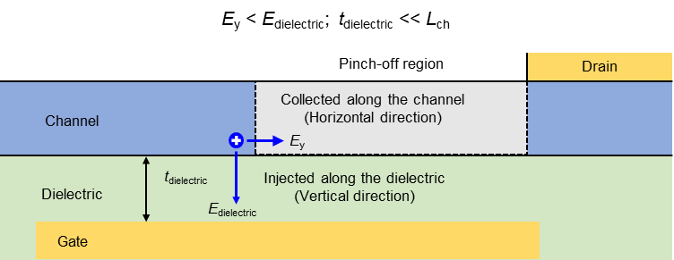
Figure S18 | Schematic diagram of the behaviours of hot holes under vertical and horizontal electric fields. The hot holes are either collected by the drain due to V_{DS} < 0 or injected into the gate due to V_{GS} < 0. Due to the larger vertical electric field and thinner dielectric compared to the horizontal electric field and channel length, the majority of hot holes will be collected by the gate.

S5. Sub-1 ns measurement system
In the previous work of flash memory, the program speed is constrained to tens of nanoseconds due to the limitation of the pulse generator (B1500A’s SPGU) and the DC probes. Here, we developed a high-speed system that enables the sub-1 ns measurement, as shown in Fig. S19. The voltage pulses are generated using the arbitrary waveform generator (AWG5204, Tektronix), connected with the ground-signal-ground (GSG) structure driver amplifier (PSPL5865, Tektronix). The GSG probe eliminates parasitic capacitances of the cables, needles, and pads. The driver amplifiers are supplied by the triple channel DC power (2230G-30-1, Keysight). The RF probes (T26A-GSG100, MPI) are used as the output port to enable the application of voltage pulses achieving sub-1 ns. The cables used in the transmission process are identical to those employed in device testing. For example, when the arbitrary waveform generator outputs the sub-1 ns pulse, the signals captured by the oscilloscope are shown in Fig. S20, demonstrating minimal loss of pulse regardless of the pulse width or amplitude. By employing the low-latency measurement system that we have developed, the program pulse width has been decreased to ascertain the storage speed of the flash device.
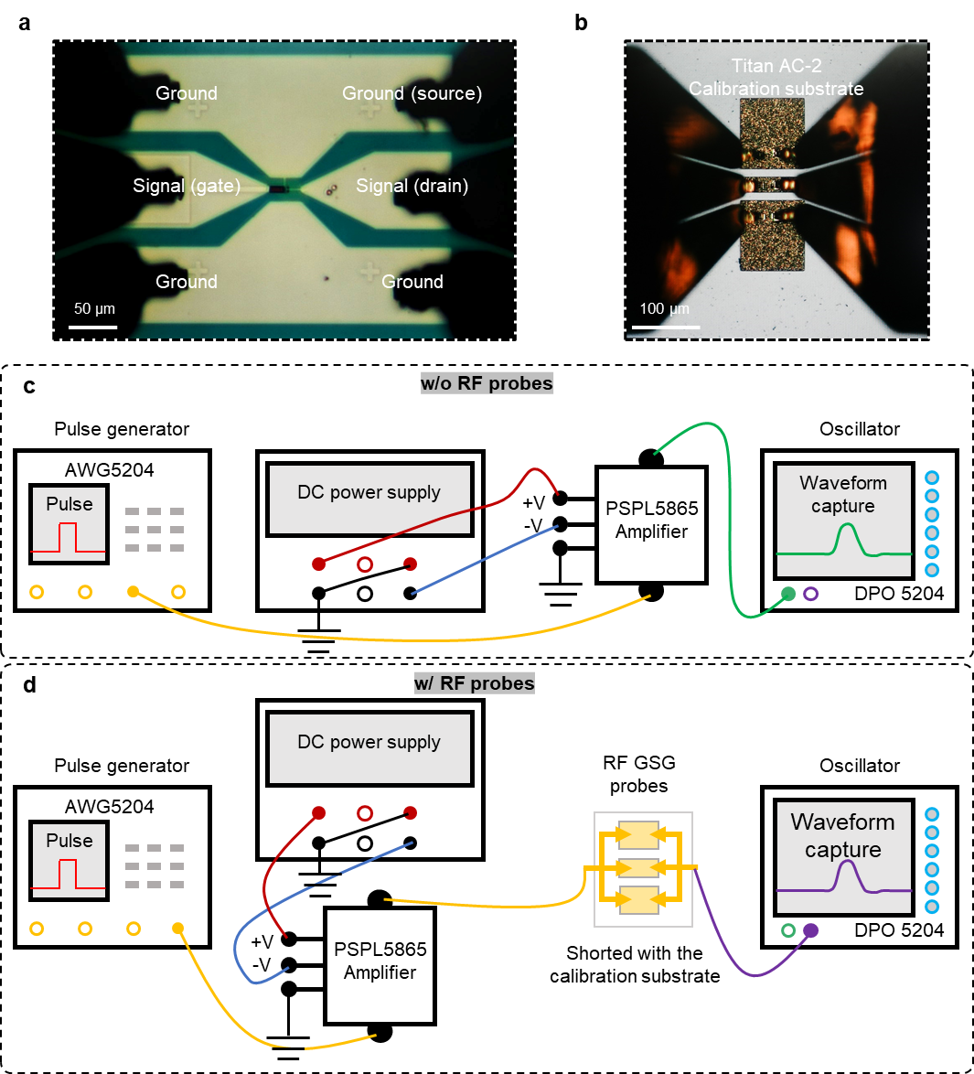
Figure S19 | High-speed test system. a, Optical image of the RF probes connected with our flash device. b, The RF probes are shorted with the calibration substrate to calibrate the sub-1 ns waveform. c, d, Schematic diagrams of the pulse waveform capture method. The pulse generator generates voltage pulses which are amplified and transmitted through the cable path (c) or the cable-RF probes-calibration substrate-cable path (d), and finally captured by the oscilloscope.
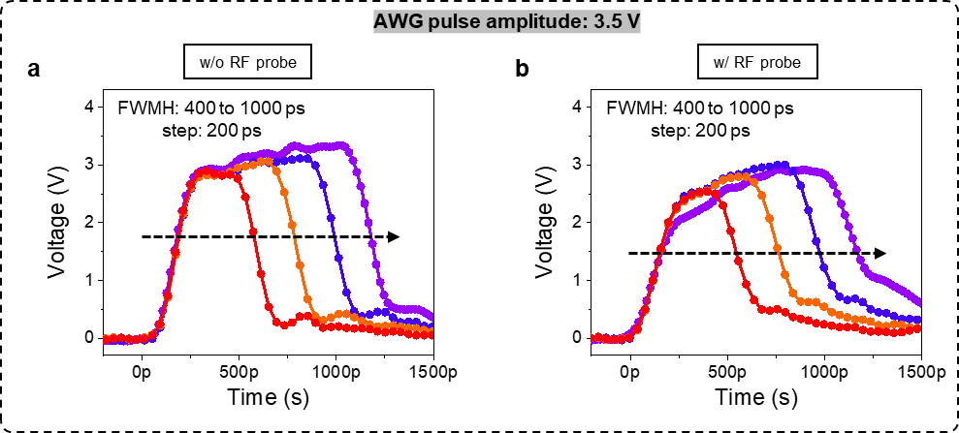
Figure S20 | The output voltage pulses after the transmission process. a, b, All the pulse amplitude is 3.5 V, with 400 ps to 1 ns full width at half maximum. The waveforms only show slight differences between without-RF-probe (a) and with-RF-probe (b) conditions.

S6. Sub-1 ns flash performance
Utilising the 2D-HCI mechanism, the reproducible sub-1 ns performance displays the full switching characteristics. Following a sub-1 ns pulse, the Dirac point of the graphene flash memory could be switched back to the initial state. Figure S21 illustrates the potential for a graphene flash device to be switched back and forth under programming speeds ranging from 600 ps to 1 ns. The memory window exhibits an upward trend with the increasing sub-1 ns program pulse width from the original state, as shown in Fig. S22. The transfer characteristic curves correspond to the shift of V_{th} in Fig. 3d. The negligible hysteresis before and after the 400 ps program demonstrates the stability of the flash memory (Fig. S23).
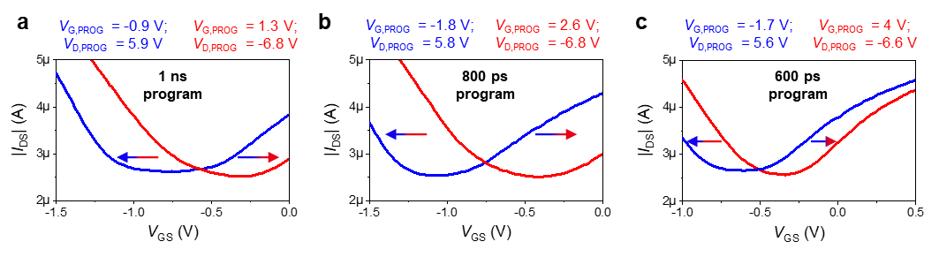
Figure S21 | The sub-1 ns operation of the full switching characteristics (device number: KI_D1S2). a, b, c, The shift of transfer curves in the graphene flash memory under the sub-1 ns pulse at V_{DS} = -10 mV, including 1 ns (a), 800 ps (b), and 600 ps (c) program.
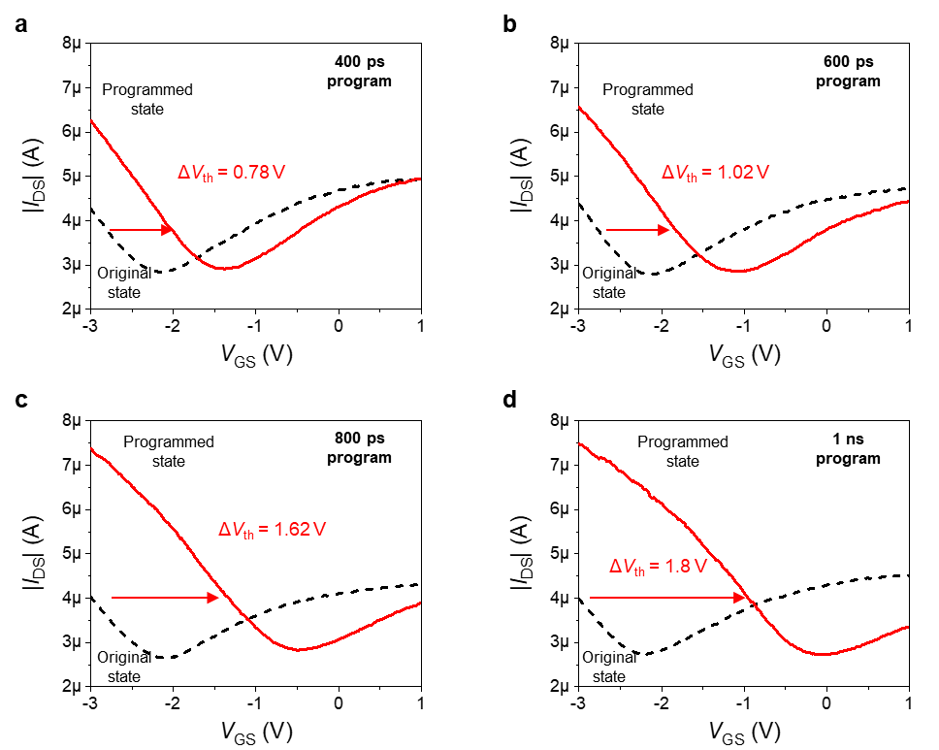
Figure S22 | Transfer curves of the graphene flash device under different sub-1 ns program pulse width (device number: JJ_D1S2). a, b, c, d, As the program pulse width increases, a corresponding increase in the shift of transfer curves is observed at V_{DS} = -10 mV. The memory window is 0.78 V, 1.02V, 1.62 V, and 1.8 V for the 400 ps (a), 600 ps (b), 800 ps (c), and 1 ns (d) pulse width, respectively, with a fixed program pulse V_{D,PROG} = -5 V and the grounded gate and source.

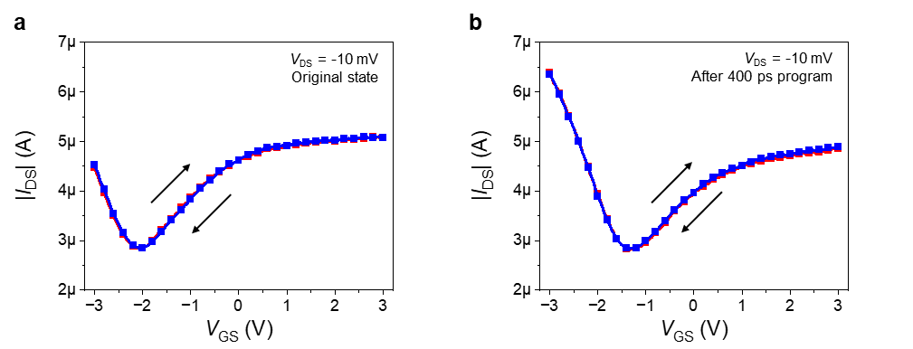
Figure S23 | Forward and backward transfer curves of the graphene flash device before and after 400 ps program (device number: JJ_D1S2). a, b, It shows negligible hysteresis regardless of the original state or the programmed state.

In addition to the programming-electrons performance using sub-1 ns V_{D,PROG} (grounded gate and source terminals), the holes can also be sub-1 ns programmed in this way. Figure S24 shows the performance of repeated three-times programming holes using sub-1 ns V_{D,PROG} with the grounded gate and source. This shift in the threshold voltage under the 800 ps program is because the positive V_{D,PROG} not only provides a horizontal electric field for holes to acquire enough energy, but also generates a vertical electric field for holes to be collected.
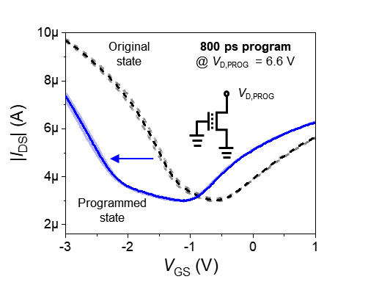
Figure S24 | The repeated sub-1 ns hole programming operation using V_{D,PROG} with gate and source grounding (device number: KI_D3S2). Transfer curves at V_{DS} = -10 mV show a large memory window achieved by V_{D,PROG} = 6.6 V, 800 ps.

To illustrate the superiority of the 2D-HCI mechanism compared with the FN tunnelling mechanism, Figure S25 has provided the hole/electron programming performance using sub-1 ns V_{G,PROG} with the grounded drain and source. It demonstrates that the electrons or holes cannot be sub-1 ns programmed under such electrical operation (FN tunnelling mechanism), which is due to the limited efficiency of the electric field-assisted program. Based on the FN tunnelling mechanism, program speeds cannot reach the sub-1 ns range and remain tens of nanoseconds with high program voltages.
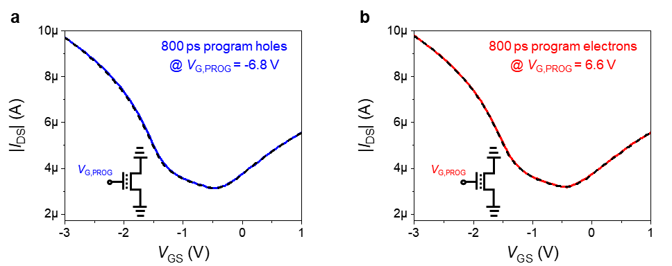
Figure S25 | The sub-1 ns program operation using V_{G,PROG} with drain and source grounding (device number: KI_D3S2). a, b, Transfer curves at V_{DS} = -10 mV show no shift in the threshold voltage when applying V_{G,PROG} = -6.8 V, 800 ps for programming holes (a) and V_{G,PROG} = 6.6 V, 800 ps for programming electrons (b). The black dashed, blue solid, and red solid line represents the original, hole-programmed, and electron-programmed state, respectively.

We have also measured the retention performance after sub-1 ns hole/electron program operation at a different time interval, as shown in Fig. S26. The device still has two distinguishable states after 10 years, which indicates the non-volatility of our sub-1 ns flash memory. The transfer characteristic curves correspond to the shift of V_{th} in Fig. 3e.
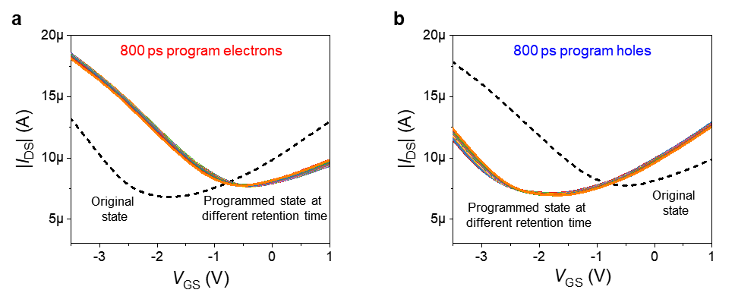
Figure S26 | Stable retention performance of the sub-1 ns flash memory under 800 ps program operation (device number: IJ_D3S4). a, b, Transfer characteristic curves at V_{DS} = -10 mV after electron program (a; V_{G,PROG} = 3.5 V, V_{D,PROG} = -6.8 V, 800 ps, with the grounded source) and hole program (b; V_{G,PROG} = -1.8 V, V_{D,PROG} = 6.6 V, 800 ps, with the grounded source) at a different time interval. The black dashed line is the original state.

We also checked the speed potential of WSe₂ flash memory. Figures S27 and S28 show the WSe₂ flash memory can be programmed and erased by 2D-enhanced hot hole injection and FN tunnelling mechanism, respectively. The WSe₂ flash memory can be programmed to obtain a memory window of 1.3 V and a large ON/OFF ratio of 10³ under the 1 ns program pulse.
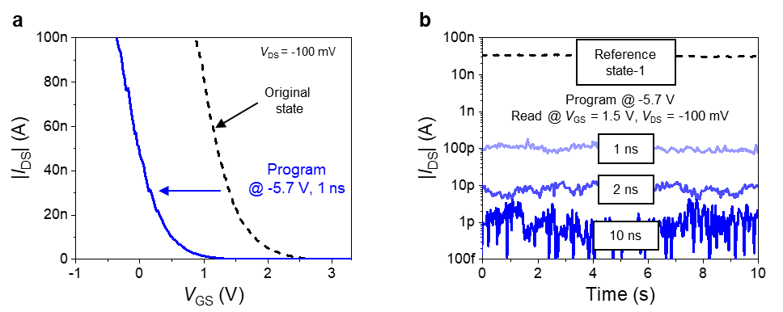
Figure S27 | 2D-enhanced hot hole injection effect in the sub-1 ns WSe₂ flash memory (device number: FJ_D4S5). a, The transfer curves before and after the channel acceleration hole programming. The device is programmed at V_{G,PROG} = V_{D,PROG} = -5.7 V, 1 ns, with the grounded source, demonstrating a memory window of 1.3 V. b, Time dependence of the different program pulse widths.

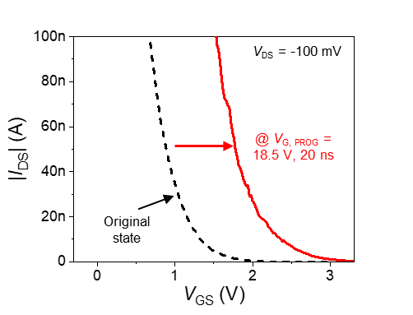
Figure S28 | The process of discharging holes in the WSe₂ flash memory (device number: LJ_D5S6). The transfer curves of erasing holes at V_{G, PROG} = 18.5 V, 20 ns, with the grounded drain and source. The black dashed line denotes the original state.

S7. The discussion of the minimum program time
In our device, the process of 2D-HCI is that carriers obtain sufficient energy through the channel acceleration to go across the channel/hBN barrier. Once the hot carriers have crossed the barrier, they will screen part of the gate voltage, resulting in the V_{th} shift. The V_{th} shift ($\text{Δ}{\text{V}}_{\text{th}}$) is only affected by the total amount of injected charges ($n$), which can be estimated as¹⁶: $Q=nq=C_{blocking}{ΔV}_{th}$, where “$\text{Q}$” is the injected charges, “${\text{C}}_{\text{blocking}}$” is the capacitance of the blocking layer, and “$\text{q}$” is the elementary charge (~1.6 × 10⁻¹⁹ C). Therefore, the minimum pulse width is limited by the carrier injection time. As shown in Fig. S29, the carrier injection time (t_{inj}) includes the carrier acceleration time in the channel (t_{acc}) and the time to cross the barrier (t_{cross}). Considering the mobility of carriers and the magnitude of electric fields, the carrier injection time is much less than 1 ns.
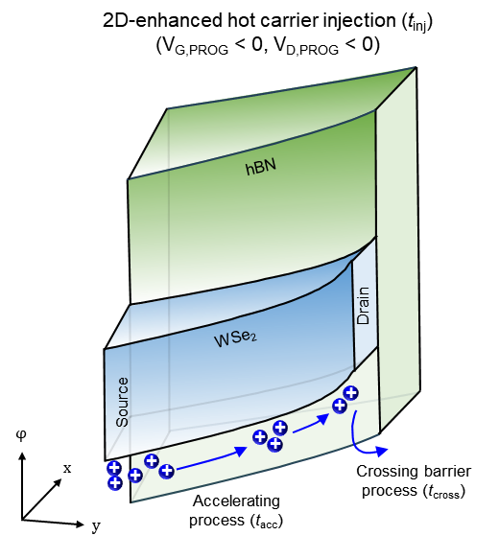
Figure S29 | Schematic diagrams of the energy bands of 2D-HCI. The holes are accelerating along the WSe₂ channel and injected across the channel/hBN barrier under V_{G,PROG} < 0, V_{D,PROG} < 0. The diagrams consider three dimensions: x direction, defined as the channel to gate vertically; y direction defined as the source to the drain horizontally; φ direction defined as the potential energy. The carrier injection time (t_{inj}) includes the carrier accelerating time (t_{acc}) and the time for crossing the barrier (t_{cross}), i.e., t_{inj} = t_{acc} + t_{cross}.

In fact, to realise sub-1 ns program speed while maintaining a large memory window, the magnitude of injection current should be considered. As discussed above, the memory window ($\text{Δ}{\text{V}}_{\text{th}}$) is decided by the number of injected charges ($\text{n}$). Furthermore, the injected charges are determined by the injection current (${\text{I}}_{\text{inj}}$) and program time (${\text{t}}_{\text{PROG}}$), as: $Q=I_{inj}t_{PROG}$. For a given number of injected charges, a higher injection current is required to reduce the program time. Since the injection current in 2D transistors is orders of magnitude higher than that of silicon, allowing for a significant improvement of program speed to 400 ps. Actually, the pulse rise time of our arbitrary waveform generator (AWG) is around 159 ps (Fig. S30), which is the equipment bottleneck to limit us to further explore a faster speed regime.
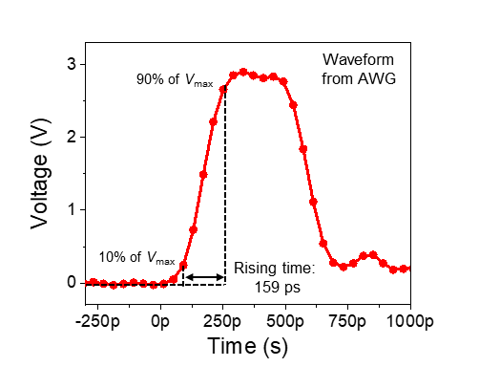
Figure S30 | The pulse rise time in our pulse generator. The rise time is defined as the time required for the response to rise from 10% to 90% of the maximum amplitude of the applied voltage (V_{max}). This waveform was measured by the oscilloscope from our arbitrary waveform generator (AWG).

S8. Reliability of flash device based on the 2D-HCI mechanism
In terms of the retention of flash memory after 20 ns program pulses, it remains a large memory window even after 60,000 seconds after electron or hole trapping, illustrated in the transfer characteristic curves (Fig. S31), with a 7.8% loss of holes and an 8.7% loss of electrons. Through the linear extrapolation method, a projected 13.4%/12.9% drop in the shift of V_{th} (hole/electron loss) from its initial value after 10 years, demonstrating the flash device has long-time retention at room temperature. In addition to the device depicted in Fig. 3f, we have also evaluated the endurance cycles of other graphene flash memory (Fig. S32). All of them exhibited a robust endurance (> 10⁵ cycles). It is expected that the endurance would be improved in the sub-1 ns program range due to the reduced stress time and less destructive effect on the dielectric.
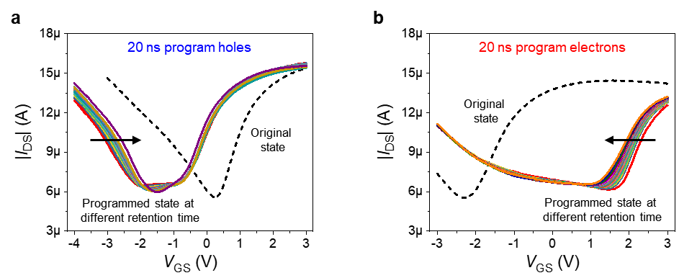
Figure S31 | Stable retention performance of the flash memory at room temperature (device number: HK_D4S5). a, b, Transfer characteristic curves at V_{DS} = -10 mV after hole (a) and electron (b) programming operation at a different time interval. The holes were programmed at V_{D,PROG} = 4.76 V, 20 ns, while the electrons were programmed at V_{D,PROG} = -5.2 V, 20 ns, with the gate and source grounding.

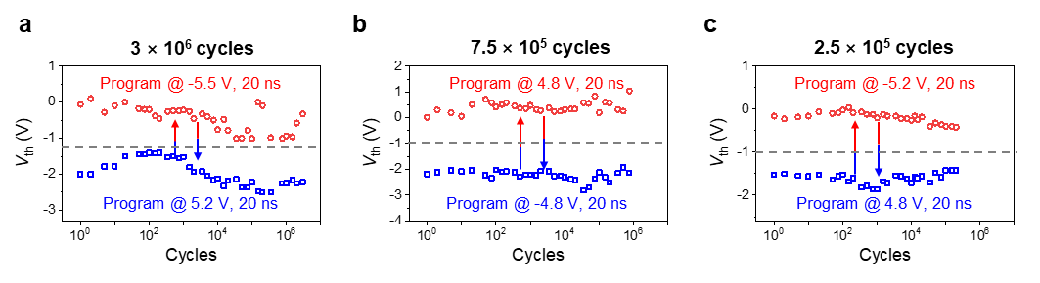
Figure S32 | Endurance performance of other graphene flash memory. a, The device was programmed with electrons at V_{D,PROG} = -5.5 V, 20 ns, and holes at V_{G,PROG} = 5.2 V, 20 ns, with the grounded gate and source. It worked well after 3×10⁶ cycles (device number: CE_D3S4). b, The device was programmed with electrons at V_{G,PROG} = V_{D,PROG} = 4.8 V, 20 ns, and holes at V_{G,PROG} = V_{D,PROG} = -4.8 V, 20 ns, with the grounded source. It worked well after 7.5×10⁵ cycles (device number: HE_D3S4). c, The device was programmed with electrons at V_{D,PROG} = -5.2 V, 20 ns, and holes at V_{G,PROG} = 4.8 V, 20 ns, with the grounded gate and source. It worked well after 2.5×10⁵ cycles (device number: IH_D1S2).

To demonstrate the reproducible performance based on the 2D-HCI mechanism, a quantity of graphene flash memory was prepared for analysis. Given the complexity of testing at sub-1 ns, it is not feasible to program every device for 1 ns. To facilitate the testing process, we utilised the previously reported test system to program back and forth at a programming speed of 20 ns. Figure S33 depicts an example of the operational sequence for the programming process. Under this circumstance, the electrons are programmed at first and then followed by the hole program. Figure S34 illustrates the statistical data based on 18 devices. It can be observed that all 18 devices exhibit a bidirectional V_{th} shift exceeding ±1 V when programmed around ±5 V, 20 ns. As described in Supplementary Information Section 1, the mechanical exfoliated materials give rise to variations in different devices. In the future, the use of high-quality chemical vapour deposition (CVD) materials and large-scale integration process will further improve the uniformity of our devices and pave the way to practical applications.
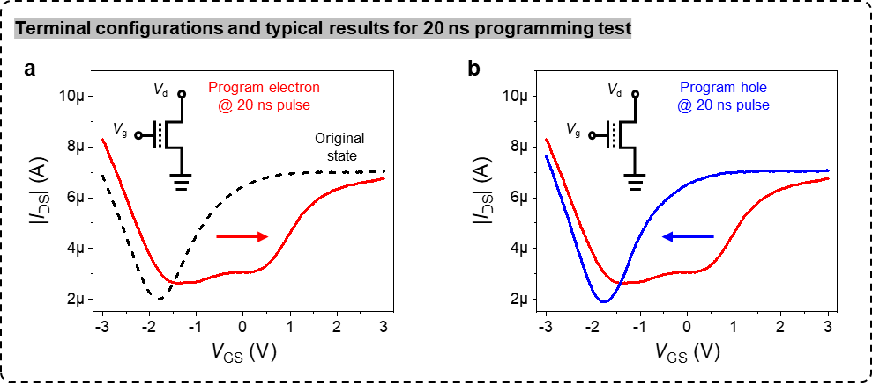
Figure S33 | Programming process for the statistic results of the graphene flash memory. a, Transfer characteristic curves at V_{DS} = -10 mV for programming electrons, from the original state (black dashed line) to the electron programmed state (red solid line). b, Transfer characteristic curves at V_{DS} = -10 mV for programming holes, from the electron-programmed state to the hole-programmed state (blue solid line). The insets show the 20 ns programming terminal configurations, denoted V_{G,PROG} and V_{D,PROG} as V_{g} and V_{d}, respectively.
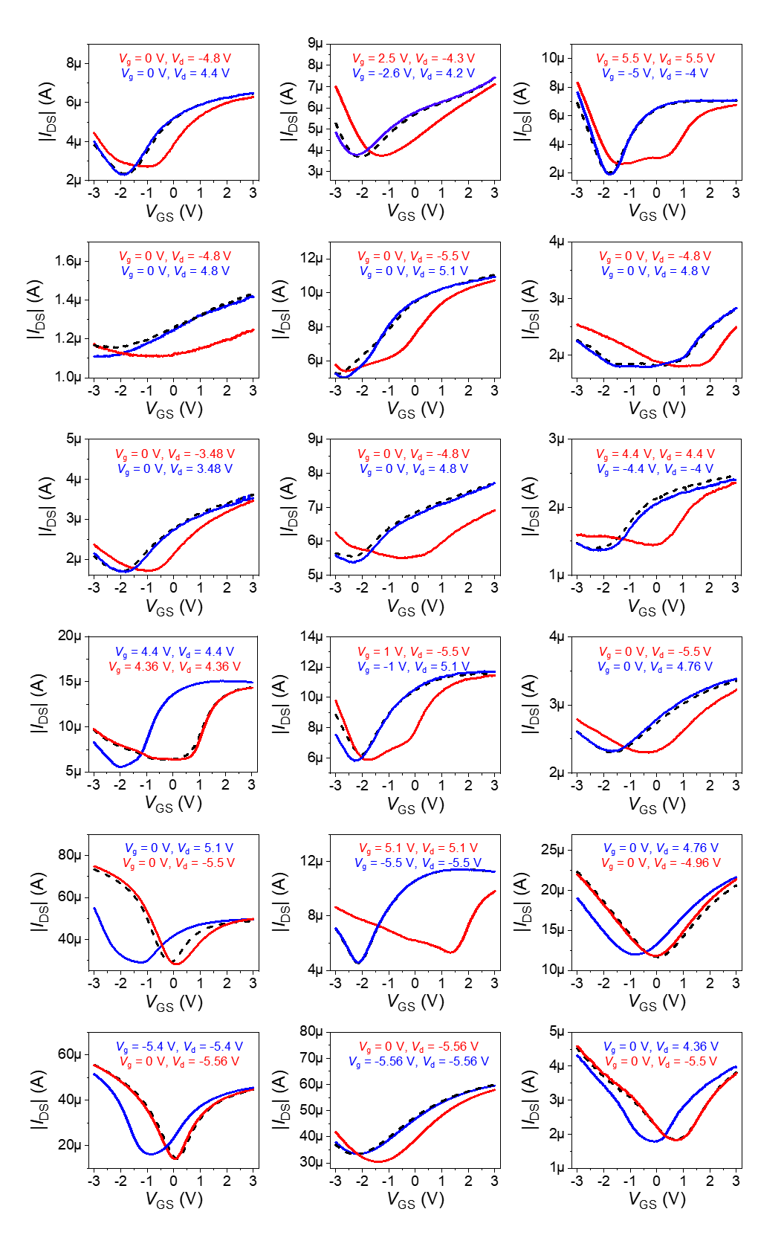
Figure S34 | Statistic programming results of the graphene flash memory based on the channel acceleration effect. All 18 devices were programmed at a speed of 20 ns, with a low program voltage of around ±5 V. During the programming, the source was always grounded. All the results are obtained at V_{DS} = -10 mV.

The memory window ($\text{Δ}{\text{V}}_{\text{th}}$) in the flash memory could reflect how the trapped charge density evolves. There is a quantified relationship between the evolution of trapped charge density ($\text{ρ}$) and $\text{Δ}{\text{V}}_{\text{th}}$¹⁶: $ρ=(ΔV_{th}×{C'}_{blocking})/q$, where “${\text{C'}}_{\text{blocking}}$” is the capacitance of the blocking layer per unit area. Both CV characteristics and transfer curves can be used to obtain how the trapped charge density evolves after the program pulse. The CV characteristics are adopted in the two-terminal capacitor devices¹⁷, while the transfer curves are widely used in three-terminal transistors due to the simple process. Figure S35 displays the transfer curves and the corresponding CV characteristics in WSe₂ flash memory before and after nanosecond programming. $\text{Δ}{\text{V}}_{\text{th}}$ is approximately the same in Fig. S35a and Fig. S35b. The evolution of the trapped charge density is calculated as 3.23 × 10¹² cm⁻².
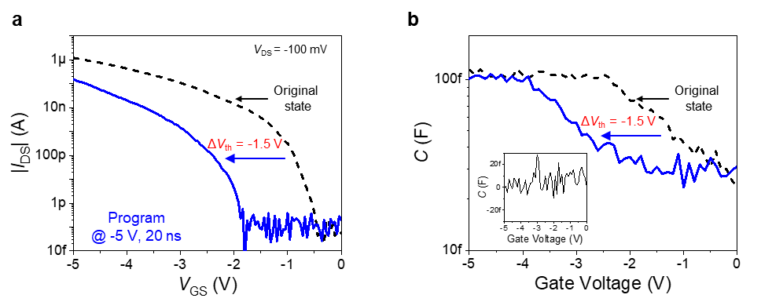
Figure S35 | Transfer curves and CV characteristics in the WSe₂ flash memory before and after nanosecond programming (device number: HF_D11S12). a, The transfer curves before and after the channel acceleration hole programming. The device was programmed at V_{G,PROG} = V_{D,PROG} = -5 V, 20 ns, with the grounded source, demonstrating ΔV_{th} = -1.5 V. b, The corresponding CV characteristics of a. The same value of ΔV_{th} can be observed. The inset shows the noise during the CV test.

While the shift of V_{th} is widely used in flash memory tests^{18,19} to quantify the memory effect, the channel current is used for the output signal. As for the output signal, flash memory adopts its channel current as a typical output signal. As long as there is enough shift of V_{th} (ΔV_{th}), there will be two different current states as the output signals, as shown in Fig. S36.
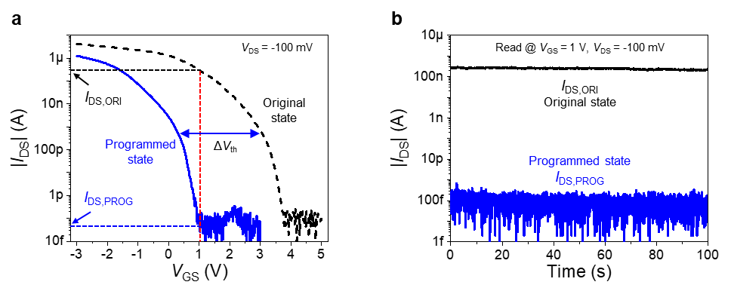
Figure S36 | The output signals in the WSe₂ flash memory (device number: FJ_D3S4). a, Transfer curves of the original state (black dashed line) and programmed state (blue solid line). The device was programmed at V_{G,PROG} = V_{D,PROG} = -6 V, 50 ns, with the grounded source. b, Two different current states correspond to the transfer curves in a when reading at V_{GS} = 1 V, V_{DS} = -100 mV. I_{DS,ORI} denotes the reading current from the original state, and I_{DS,PROG} denotes the reading current from the programmed state.

Furthermore, as shown in Fig. S37b, the channel current can also be used as the output signal of graphene flash memory. Figure S37a illustrates the shift of V_{th} in the corresponding graphene flash. The V_{th} was extracted from the transfer characteristic curves. This extracted method is based on finding I_{DS} that corresponds to the maximum transconductance value within the transfer characteristic curve. A tangent line is then drawn at this point, and the corresponding V_{GS}, intersecting the epitaxial line of the lowest point of |I_{DS}| in the horizontal direction, is called V_{th}.
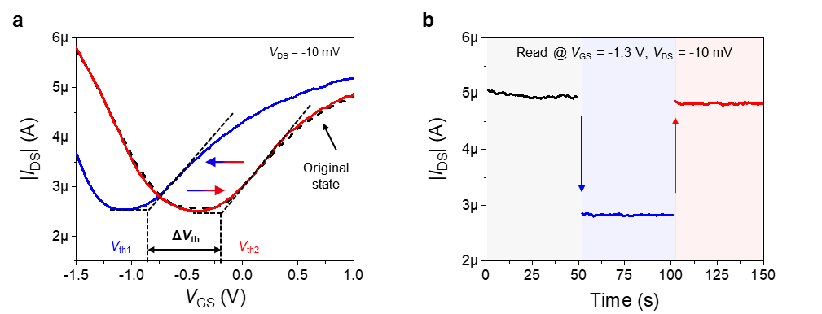
Figure S37 | The output signals in the graphene flash memory (device number: KID1S2). a, The threshold voltage (V_{th}) extract method in graphene flash memory. The difference value between V_{th1} and V_{th2} is the memory window (ΔV_{th}). b, The operation sequence of the graphene flash device using the 800 ps pulse. The channel current was read under the condition V_{GS} = -1.3 V, V_{DS} = -10 mV. The device was programmed using V_{G,PROG} = -1.8 V, V_{D,PROG} = 5.8 V, 800 ps (blue arrow), and V_{G,PROG} = 2.6 V, V_{D,PROG} = -6.8 V, 800 ps (red arrow), respectively, while the source grounding.

S9. Mechanism validation in flash memory
Quasi-ohmic contact was employed in this study to clearly clarify the underlying mechanism. The 2D-HCI mechanism is based on the carrier acceleration under the E_{y} to realise sub-1 ns program speed, and quasi-ohmic contact can minimize its influence on the E_{y} distribution of the channel. Figure S38 illustrates the output characteristic graphene device under varying V_{GS}. The output characteristic of the WSe₂ device is shown in Fig. S8b. The linear, symmetric output characteristics indicate the quasi-ohmic contact property.
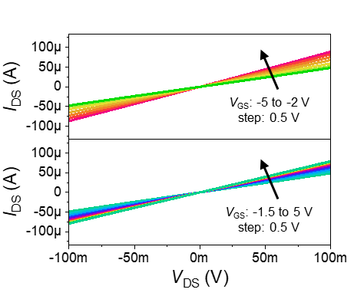
Figure S38 | Output characteristics of graphene device under varying V_{GS} (device number: HE_D2S1). V_{GS} ranges from -5 to -2 V for p-type and -1.5 to 5 V for n-type in increments of 0.5 V.
To illustrate how the V_{G,PROG} and V_{D,PROG} together affect the final memory states, we have provided the measurement of the shift of the threshold voltage (ΔV_{th}) in WSe₂ and graphene flash memory under different V_{G,PROG} and V_{D,PROG}. Figure S39 demonstrates the channel acceleration effect, which is consistent with the injection behaviours observed in the transistor. In terms of V_{G,PROG}, it determines the magnitude of E_{dielectric}, which not only affects the electrostatic doping of carriers and the E_{y} distribution together with V_{D,PROG}, but also determines the collection efficiency of carriers in the vertical direction. On the other hand, V_{D,PROG} directly influences the magnitude of energy that the carriers acquire.
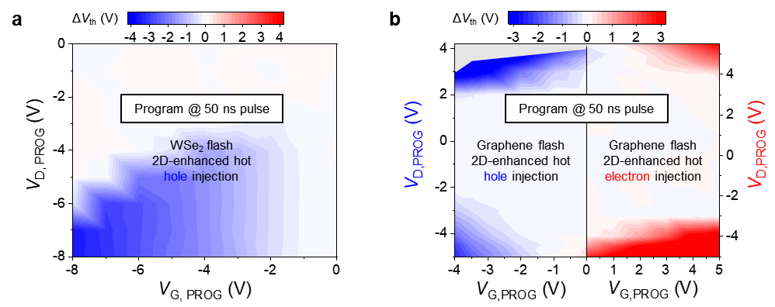
Figure S39 | The shift of the threshold voltage (ΔV_{th}) versus V_{G,PROG} and V_{D,PROG.} a, ΔV_{th} versus 50 ns V_{G,PROG} and V_{D,PROG} in WSe₂ flash memory (device number: FJ_D3S4). It shows the 2D-enhanced hot hole injection behaviours based on the channel acceleration effect, as the same as in the WSe₂ transistor. The largest ΔV_{th} is observed at ${|V}_{G, PROG}-V_{th}|=\left|V_{D,PROG}\right|$. The programming behaviours are distinct from the monotonic trend in FN tunnelling flash memory. b, ΔV_{th} versus 50 ns V_{G,PROG} and V_{D,PROG} in graphene flash memory (device number: KH_D1S2). The left panel corresponds to channel acceleration hole programming (ΔV_{th} < 0), and the right panel represents channel acceleration electron programming (ΔV_{th} > 0). There is a grey region that we didn’t test since |ΔV_{th}| was already larger than 3 V.

To further explore the 2D-HCI mechanism in the flash memory, we conducted a study examining the influence of the hBN thickness, as shown in Fig. S40. Devices with different hBN thicknesses were fabricated, while the channel length and the channel thickness remaining relatively consistent. It is observed that as the thickness of hBN increases, the electron and hole program voltages based on the FN tunnelling increase, demonstrating a strong dependence. Nevertheless, the program voltage based on the channel acceleration effect exhibits a relatively weak thickness dependence.
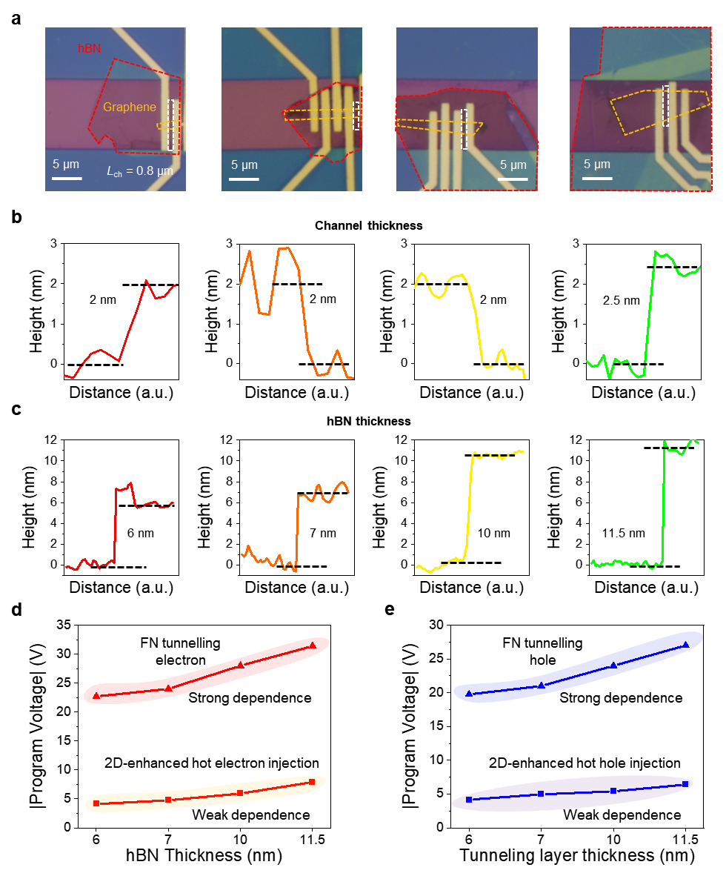
Figure S40 | The hBN thickness dependence with the 2D-HCI mechanism. a, Optical images of four fabricated graphene flash memory with different hBN thickness (device number: GG_D1S2/HK_D6S5/IG_D5S6/FK_D1S2). The channel length of these devices is 0.8 μm. Scale bar, 5 μm. b, The heights of the channel thickness in the four devices. c, The heights of the hBN thickness in the four devices. d, The electron program voltage needed to obtain a memory window of 1 V in flash memory with different hBN thickness. e, The hole program voltage needed to obtain a memory window of -1 V in flash memory with different hBN thickness. The program voltage refers to V_{G,PROG}, 50 ns for FN tunnelling, and V_{D,PROG}, 20 ns for 2D-HCI.

In terms of the size effect, verification was also conducted on the flash device, demonstrating that a smaller channel length resulted in a reduced voltage requirement for carrier injection, as shown in Fig. S41. In addition to the charge-trapping flash memory, the WSe₂ floating-gate flash based on the hBN/Pt/Al₂O₃ memory stack displays the channel acceleration hole injection under varying program pulse widths, as shown in Fig. S42.
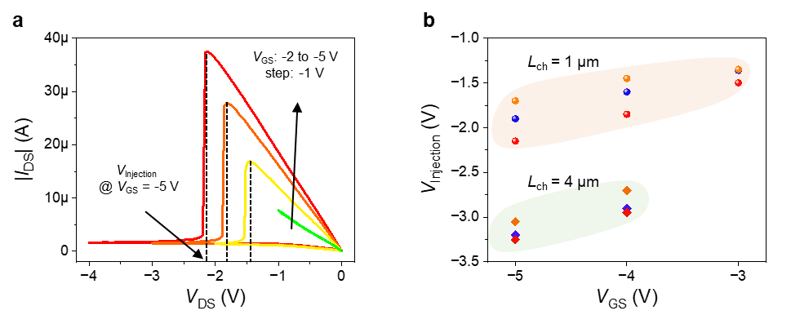
Figure S41 | The size effect of 2D-HCI mechanism in the flash memory. a, The hole injection while scanning |I_{DS}|-V_{DS} curves in the WSe₂ flash memory (device number: FJ). We define the voltage for hole injection as V_{injection}. b, The V_{injection} extracted at varying V_{GS} with different channel lengths. It is observed that a smaller channel length leads to a smaller V_{injection}. Note that when V_{GS} = -3 V, the device at L_{ch} = 4 μm would not lead to the hole injection. A total of six devices were tested, comprising three with L_{ch} = 4 μm and three with L_{ch} = 1 μm.

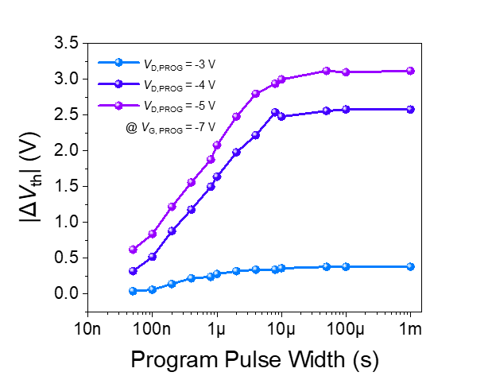
Figure S42 | The memory window under different program pulse widths in the WSe₂ floating-gate flash memory (device number: EE_D1S2). A larger memory window is obtained with the larger program pulse width and V_{D,PROG} at a fixed V_{G,PROG}.

S10. Benchmark of sub-1 ns 2D flash memory
Table S3 | The performance metrics of other charge-based memory and this work.
References | Channel  material | Program  speed (ns) | Program  gate  voltage (V) | Program  drain  voltage (V) | Channel length (μm) | Mechanism
(11) | MoS₂ | 20 | ±30 | Grounded | 3 | Flash  (FN tunnelling)
(20) | InSe | 21 | 20.2  -20.8 | Grounded | 24 | Flash  (FN tunnelling)
(21) | MoS₂ | 100  10 | 15  -15 | Grounded | 2 | Flash  (FN tunnelling)
(22) | WSe₂  MoS₂ | 30/20  30 | 33/-30  ±15 | Grounded | 3 | Flash  (FN tunnelling)
(12) | MoS₂ | 30/20  50  20 | 26/-24  ±15  14 | Grounded | < 0.01,  2.5 | Flash  (FN tunnelling)
(23) | MoS₂ | 100 | -12 | Grounded | 2.8 | Flash  (FN tunnelling)
(24) | Silicon | 7.5×10⁴ | 12 | Grounded | N/A | Flash  (FN tunnelling)
(25) | Silicon | 10⁵ | 17 | Grounded | N/A | Flash  (FN tunnelling)
(26) | Silicon | 10⁵ | 10 | 9 | 1 | Flash  (Hot electron injection)
(27) | Silicon | 5×10³ | 11.5 | 5.5 | 0.65 | Flash  (Hot electron injection)
(28) | Silicon | 100 | 7 | 4.5 | 0.22 | Flash  (Hot electron injection)
(29) | Silicon | 10³ | 7 | 4 | 0.22 | Flash  (Hot electron injection)
(30) | Silicon | 200 | 8 | 4 | 0.22 | Flash  (Hot electron injection)
(31,32) | Silicon | 20  15  10  5  3.4  2.2  1 | N/A | 5  4  3.3  3.3  2  2  1.75 | 1  0.8  0.6  0.5  0.25  0.25  0.18 | SRAM
(33-36) | Silicon | 22  14  6.8  6.7 | N/A | 5  3.6  3.3  3.3 | 1  0.7  0.25  0.13 | DRAM
This work | Graphene | 0.4  0.6  0.8  1 | 0 | -5 | 0.2 | Flash  (2D-enhanced hot electron injection)
This work | Graphene | 0.6  0.8  1 | 4  2.6  1.3 | -6.6  -6.8  -6.8 | 0.34 | Flash  (2D-enhanced hot electron injection)
This work | Graphene | 0.4  0.6  0.8  1 | -2.9  -1.7  -1.8  -0.9 | 5  5.6  5.8  5.9 | 0.34 | Flash  (2D-enhanced hot hole injection)
This work | WSe₂ | 20 | 18.5 | Grounded | 0.8 | Flash  (Erased by FN tunnelling)
This work | WSe₂ | 1 | -5.7 | -5.7 | 0.8 | Flash  (Programmed by 2D-enhanced hot hole injection)
* Given that the scaling down of the device will yield enhanced injection efficiency of sub-1 ns flash memory and that the shortest channel length of our sub-1 ns flash memory is 0.2 μm, comparisons are made with the SRAM/DRAM no advanced than 0.18/0.13 μm node. N/A: Not available.
Table S4 | The comparisons of sub-1 ns emerging memory and our sub-1 ns flash memory.
References | Memory type | |Program voltage| (V) | Program  speed (ps) | Retention | ON/OFF Ratio | Memory window (V)
Science 2024³⁷ | Sliding ferroelectrics | 3.3 | 1000 | > One month  @ RT | ~5 | 0.24
Science 2012³⁸ | PCM (GST) | 1/6.5 | 500 | N/A | 10-100 | N/A
Science 2017³⁹ | PCM (SST) | 5.7/7.5 | 700 | 10 years  @ 87℃ | ~100 | N/A
Science Advances 2021⁴⁰ | RSM  (MAPbI₃ NW) | 4.1/5.6 | 200 | 1.62 years  @ RT | > 10⁴ | N/A
VLSI 2022⁴¹ | SOT-MRAM | 2 | 400 | 10 years  @ RT | 2.5 | N/A
Nat. Commun. 2020⁴² | Ferroelectric tunnel junction | 14/15 | 600 | 100 years  @ RT | ~10 | N/A
Nat. Commun. 2022⁴³ | Ferroelectric tunnel junction | 6.0/6.5  12.7 | 630  300 | > 10⁴ s  @ RT | ~10 | N/A
This work | Flash  (WSe₂) | 5.7 | 1000 | 10 years  @ RT | 10³ | 1.3
This work | Flash (Graphene) | 5 | 400 | 10 years  @ RT | < 5 | 0.78
* N/A: Not available. PCM: Phase change memory. RSM: Resistive switching memory. SOT-MRAM: Spin-orbit torque magnetoresistive random-access memory. RT: Room temperature. GST: Ge₂Sb₂Te₅. SST: Sc_{0.2}Sb₂Te₃. NW: Nanowire.

Supplementary References
1 Meric, I. et al. Current saturation in zero-bandgap, top-gated graphene field-effect transistors. Nat. Nanotechnol. 3, 654-659 (2008).
2 Chou, A.-S. et al. High-performance monolayer WSe₂ p/n FETs via antimony-platinum modulated contact technology towards 2D CMOS electronics. In 2022 International Electron Devices Meeting (IEDM), 7.2.1-7.2.4 (IEEE, 2022).
3 Chen, T.-A. et al. Wafer-scale single-crystal hexagonal boron nitride monolayers on Cu (111). Nature 579, 219-223 (2020).
4 Kim, H.-g. & Choi, H. J. Thickness dependence of work function, ionization energy, and electron affinity of Mo and W dichalcogenides from DFT and GW calculations. Phys. Rev. B 103, 085404 (2021).
5 Kumar, A. & Ahluwalia, P. Tunable dielectric response of transition metals dichalcogenides MX₂ (M= Mo, W; X= S, Se, Te): Effect of quantum confinement. Physica B: Condensed Matter 407, 4627-4634 (2012).
6 Wickramaratne, D., Zahid, F. & Lake, R. K. Electronic and thermoelectric properties of few-layer transition metal dichalcogenides. J. Chem. Phys. 140, 124710 (2014).
7 Santos, E. J. & Kaxiras, E. Electric-field dependence of the effective dielectric constant in graphene. Nano Lett. 13, 898-902 (2013).
8 AlZahrani, A. & Srivastava, G. Graphene to graphite: electronic changes within DFT calculations. Brazilian Journal of Physics 39, 694-698 (2009).
9 Laturia, A., Van de Put, M. L. & Vandenberghe, W. G. Dielectric properties of hexagonal boron nitride and transition metal dichalcogenides: from monolayer to bulk. npj 2D Mater. Appl. 2, 6 (2018).
10 Yan, S. et al. Filter‐Free UV Photodetectors Based on Unipolar Barrier Van der Waals α‐In₂Se₃/h‐BN Heterostructures. Small, 2401996 (2024).
11 Liu, L. et al. Ultrafast non-volatile flash memory based on van der Waals heterostructures. Nat. Nanotechnol. 16, 874-881 (2021).
12 Jiang, Y. et al. A scalable integration process for ultrafast two-dimensional flash memory. Nat. Electron. 7, 868-875 (2024).
13 Fan, D. et al. Two-dimensional semiconductor integrated circuits operating at gigahertz frequencies. Nat. Electron. 6, 879-887 (2023).
14 Lu, Y.-C., Huang, J.-K., Chao, K.-Y., Li, L.-J. & Hu, V. P.-H. Projected performance of Si- and 2D-material-based SRAM circuits ranging from 16 nm to 1 nm technology nodes. Nat. Nanotechnol. 19, 1066-1072 (2024).
15 Neamen D. A., Biswas D. Semiconductor physics and devices: Basic Principles. (McGraw-Hill; 4th edition, 2011).
16 Sze, S. M. & Ng, K. K. Physics of Semiconductor Device. (Wiley, 2006).
17 Maikap, S. et al. High-κ HfO₂/TiO₂/HfO₂ multilayer quantum well flash memory devices. In 2007 International Symposium on VLSI Technology, Systems and Applications (VLSI-TSA), 1-2 (IEEE, 2007).
18 Chou, Y. et al. A target-read retry scheme for 3D charge trap NAND flash memory. In 2023 International Electron Devices Meeting (IEDM), 1-4 (IEEE, 2023).
19 Jung, W. et al. 13.3 A 280-layer 1Tb 4b/cell 3D-NAND flash memory with a 28.5 Gb/mm² areal density and a 3.2 GB/s high-speed IO rate. In 2024 IEEE International Solid-State Circuits Conference (ISSCC), 236-237 (IEEE, 2024).
20 Wu, L. et al. Atomically sharp interface enabled ultrahigh-speed non-volatile memory devices. Nat. Nanotechnol. 16, 882-887 (2021).
21 Yu, J. et al. Simultaneously ultrafast and robust two-dimensional flash memory devices based on phase-engineered edge contacts. Nat. Commun. 14, 5662 (2023).
22 Huang, X. et al. An ultrafast bipolar flash memory for self-activated in-memory computing. Nat. Nanotechnol. 18, 486-492 (2023).
23 Zha, J. et al. A 2D heterostructure‐based multifunctional floating gate memory device for multimodal reservoir computing. Adv. Mater. 36, 2308502 (2024).
24 Kouchi, T. et al. 13.5 A 128Gb 1b/Cell 96-word-line-layer 3D flash memory to improve random read latency with t_{PROG} = 75 µs and t_{R} = 4 µs. In 2020 IEEE International Solid-State Circuits Conference (ISSCC), 226-228 (IEEE, 2020).
25 Chen, G. et al. Metal floating gate memory device with SiO₂/HfO₂ dual-layer as engineered tunneling barrier. IEEE Electron Device Lett. 35, 744-746 (2014).
26 Chan, T., Young, K. & Hu, C. A true single-transistor oxide-nitride-oxide EEPROM device. IEEE Electron Device Lett. 8, 93-95 (1987).
27 Chung, S. S. et al. N-channel versus P-channel flash EEPROM-which one has better reliabilities. In 2001 IEEE International Reliability Physics Symposium Proceedings. 39th Annual (Cat. No. 00CH37167), 67-72 (IEEE, 2001).
28 Wu, J.-Y. et al. A novel P-poly gate PNOS device featuring high 2nd-bit operation window for multi-bit/cell flash memory applications. In 2007 International Symposium on VLSI Technology, Systems and Applications (VLSI-TSA), 1-2 (IEEE, 2007).
29 Choi, S.-J. et al. High injection efficiency and low-voltage programming in a dopant-segregated Schottky barrier (DSSB) FinFET SONOS for NOR-type flash memory. IEEE Electron Device Lett. 30, 265-268 (2009).
30 Mahapatra, S., Shukuri, S. & Bude, J. CHISEL flash EEPROM. I. Performance and scaling. IEEE Trans. Electron Devices 49, 1296-1301 (2002).
31 Intel® Product Specifications. https://ark.intel.com/content/www/us/en/ark.html#@Processors
32 Sawada, K. et al. A 5 ns 369 kb port-configurable embedded SRAM with 0.5 μm CMOS gate array. In 1990 37th IEEE International Conference on Solid-State Circuits, 226-227 (IEEE, 1990).
33 Lu, N.-C. et al. A 22-ns 1-Mbit CMOS high-speed DRAM with address multiplexing. IEEE Journal of Solid-State Circuits 24, 1198-1205 (1989).
34 Kirihata, T. et al. A 14-ns 14-Mb CMOS DRAM with 300-mW active power. IEEE Journal of Solid-State Circuits 27, 1222-1228 (1992).
35 Kimuta, T. et al. 64 Mb 6.8 ns random ROW access DRAM macro for ASICs. In 1999 IEEE International Solid-State Circuits Conference. Digest of Technical Papers. ISSCC. First Edition (Cat. No. 99CH36278), 416-417 (IEEE, 1999).
36 Noh, K. et al. A 130 nm 1.1 V 143 MHz SRAM-like embedded DRAM COMPILER with Dual Asymmetric bit line Sensing Scheme and quiet unselected IO scheme. In 2004 Symposium on VLSI Circuits. Digest of Technical Papers (IEEE Cat. No. 04CH37525), 190-191 (IEEE, 2004).
37 Yasuda, K. et al. Ultrafast high-endurance memory based on sliding ferroelectrics. Science 385, 53-56 (2024).
38 Loke, D. et al. Breaking the speed limits of phase-change memory. Science 336, 1566-1569 (2012).
39 Rao, F. et al. Reducing the stochasticity of crystal nucleation to enable subnanosecond memory writing. Science 358, 1423-1427 (2017).
40 Zhang, Y. et al. Three-dimensional perovskite nanowire array-based ultrafast resistive RAM with ultralong data retention. Sci. Adv. 7, eabg3788 (2021).
41 Song, M. et al. High speed (1 ns) and low voltage (1.5 V) demonstration of 8Kb SOT-MRAM array. In 2022 IEEE Symposium on VLSI Technology and Circuits (VLSI Technology and Circuits), 377-378 (IEEE, 2022).
42 Ma, C. et al. Sub-nanosecond memristor based on ferroelectric tunnel junction. Nat. Commun. 11, 1439 (2020).
43 Luo, Z. et al. High-precision and linear weight updates by subnanosecond pulses in ferroelectric tunnel junction for neuro-inspired computing. Nat. Commun. 13, 699 (2022).

