Supplementary Information Guide
Single-cell transcriptomic and chromatin dynamics of the human brain in PTSD
Ahyeon Hwang^{1,2,#} Mario Skarica^{3,#}, Siwei Xu^{2,#}, Jensine Coudriet³, Che Yu Lee², Lin Lin³, Rosemarie Terwilliger³, Alexa-Nicole Sliby³, Jiawei Wang³,Tuan Nguyen³, Hongyu Li³, Mini Wu³, Yi Dai², Ziheng Duan², Shushrruth Sai Srinivasan^{1,2}, Xiangyu Zhang⁴, Yingxin Lin⁴, Dianne Cruz^{5,6}, PJ Michael Deans³, Traumatic Stress Brain Research Group, Bertrand R. Huber⁶, Daniel Levey³, Jill R. Glausier⁷, David A. Lewis⁷, Joel Gelernter^{3,6}, Paul E. Holtzheimer^{6,8}, Matthew J. Friedman^{6,8}, Mark Gerstein^{9,10,11,12}, Nenad Sestan¹³, Kristen J. Brennand^{3,14}, Ke Xu^{3,6}, Hongyu Zhao⁴, John H. Krystal^{3,6}, Keith A. Young^{15,16}, Douglas E. Williamson^{6,7}, Alicia Che³, Jing Zhang^{1,*}, Matthew J. Girgenti^{3,6,13*}

AFFILIATIONS
¹Mathematical, Computational and Systems Biology Program, University of California, Irvine, California, USA.
²Department of Computer Science, University of California, Irvine, California, USA.
³Department of Psychiatry, Yale University School of Medicine, 34 Park Street, New Haven, CT 06520, USA.
⁴Department of Biostatistics, Yale University School of Public Health, New Haven, CT 06510, USA.
⁵Department of Psychiatry and Behavioral Sciences, Duke University Medical Center, 300 North Duke St, Durham, NC 27701, USA.
⁶National Center for PTSD, U.S. Department of Veterans Affairs.
⁷Department of Psychiatry, University of Pittsburgh School of Medicine, Pittsburgh, PA 15213, USA.
⁸Department of Psychiatry, Geisel School of Medicine at Dartmouth, Lebanon, NH 03756, USA
⁹Department of Molecular Biophysics and Biochemistry, Yale University, New Haven, Connecticut 06520, USA.
¹⁰Program in Computational Biology and Bioinformatics, Yale University, New Haven, Connecticut 06520, USA
¹¹Department of Computer Science, Yale University, New Haven, Connecticut 06520, USA.
¹²Department of Statistics and Data Science, Yale University, New Haven, Connecticut 06520, USA.
¹³Department of Neuroscience, Yale School of Medicine, New Haven, CT 06510, USA
¹⁴Department of Genetics, Yale School of Medicine, New Haven, CT 06510, USA
¹⁵Central Texas Veterans Health Care System, Research Service, Temple, Texas, 76504 USA,
¹⁶Texas A&M University College of Medicine, Department of Psychiatry and Behavioral Sciences, Bryan, Texas, 77807 USA

# These authors contributed equally to the preparation of this manuscript
* Correspondence: matthew.girgenti@yale.edu (M.J.G.) or zhang.jing@uci.edu (J.Z.)

Table of Contents

3 Supplementary Data Figures 1-5
8 Statistics and Reproducibility
9 Supplementary Data Tables 1-41 (captions included, tables in separate CSV files)
11 Source Data File 1 (captions included, data in separate CSV file)
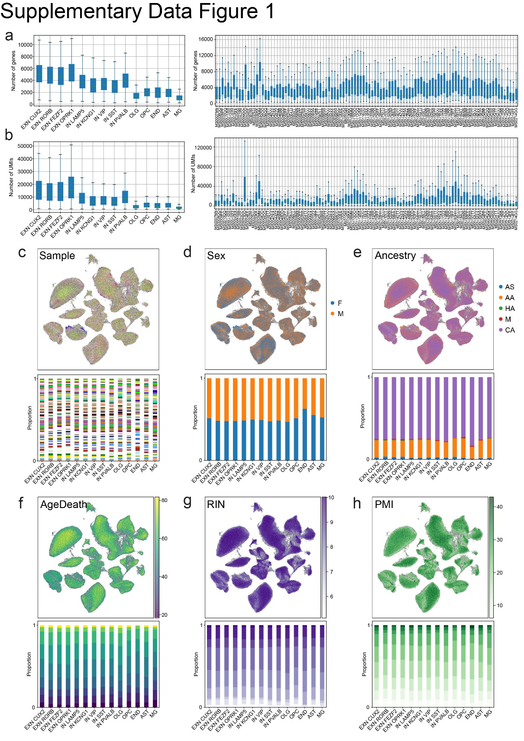
Supplementary Data Figure 1: snRNA-seq data quality and metadata. a, Boxplot of the number of genes across 14 subtypes and 105 samples. b, Boxplot of the number of UMIs across 14 subtypes and 105 samples. c, UMAP colored by Sample (top) and Sample cell proportion per subtype (bottom). d, UMAP colored by Sex metadata (top) and Sex cell proportion per subtype (bottom). F: female, M: male. e, UMAP colored by Ancestry metadata (top) and Ancestry cell proportion per subtype (bottom). AS: Asian American, AA: African American, HA: Hispanic American, M: Mixed Ancestry, CA: Caucasian American. f, UMAP colored by AgeDeath metadata (top) and AgeDeath cell proportion per subtype in 10 bins (bottom). g, UMAP colored by RIN metadata (top) and RIN cell proportion per subtype in 10 bins (bottom). h, UMAP colored by PMI metadata (top) and PMI cell proportion per subtype in 10 bins (bottom).
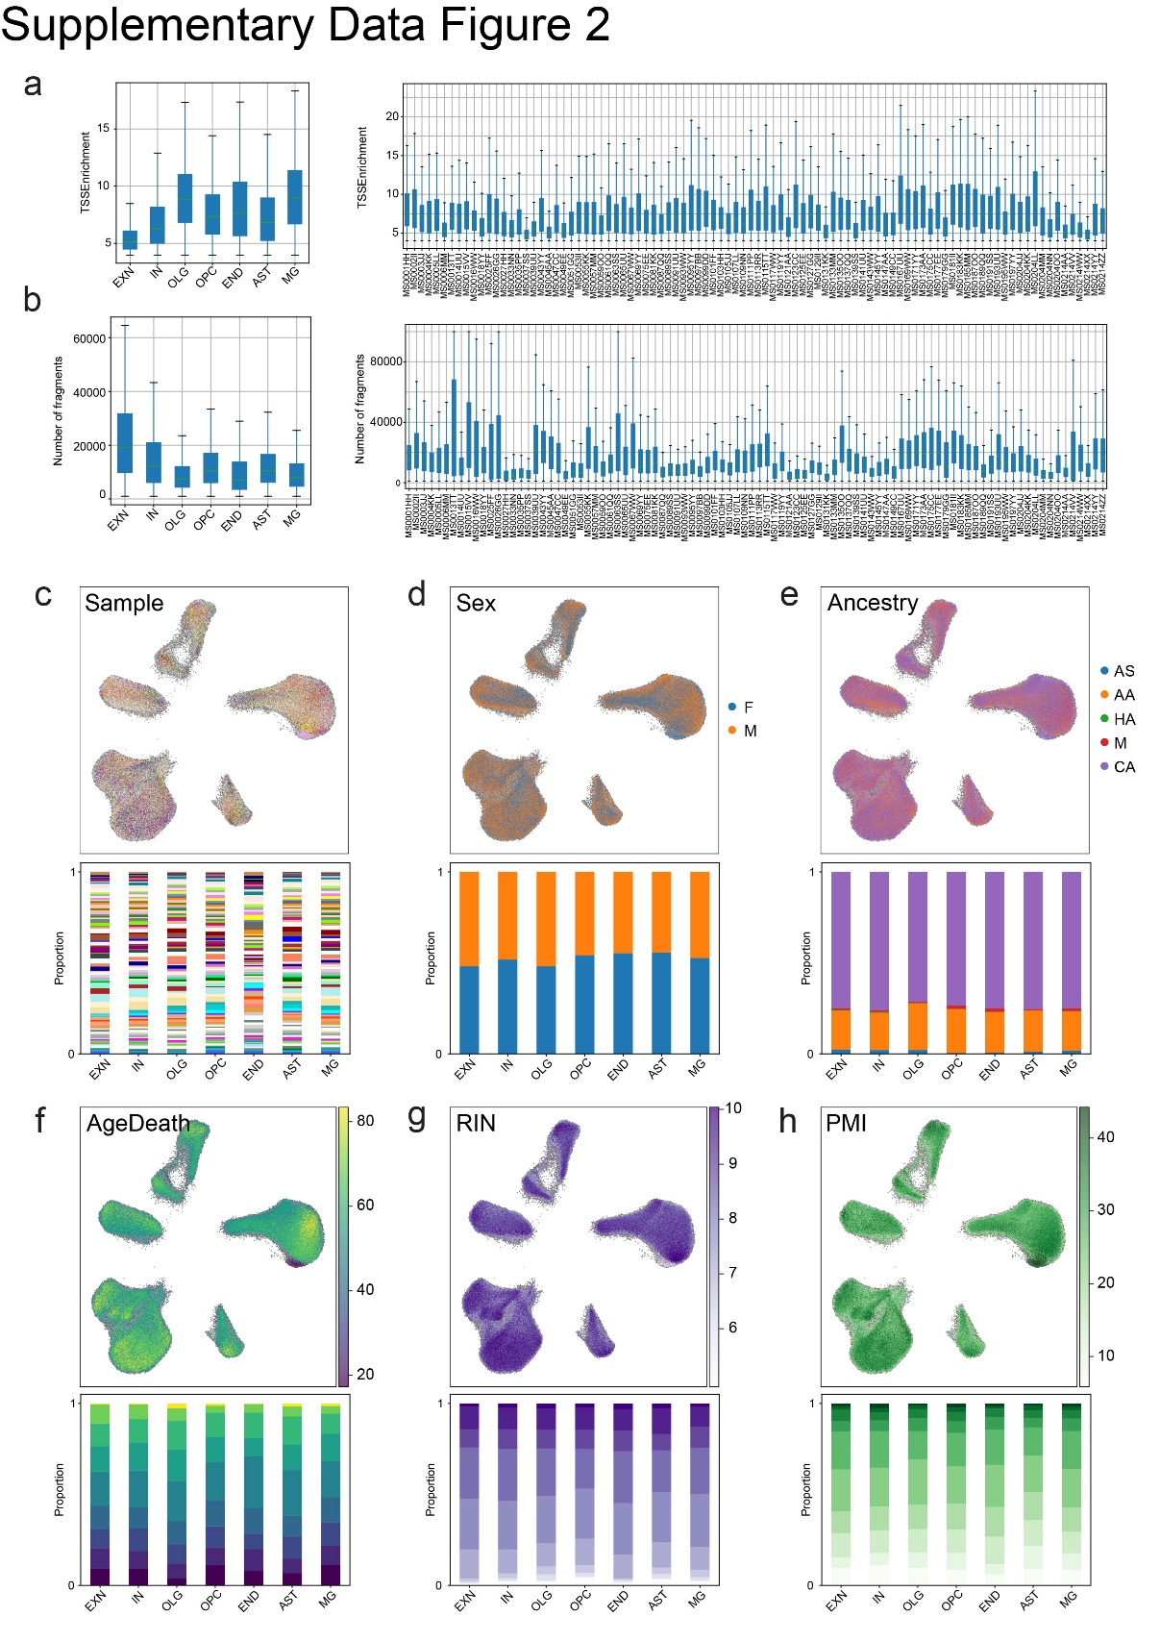
Supplementary Data Figure 2: snATAC-seq data quality and metadata. a, Boxplot of TSS enrichment across 7 cell types and 94 samples. b, Boxplot of the number of fragments across 7 cell types and 94 samples. c, UMAP colored by Sample (top) and Sample cell proportion per cell type (bottom). d, UMAP colored by Sex metadata (top) and Sex cell proportion per cell type (bottom). F: female, M: male. e, UMAP colored by Ancestry metadata (top) and Ancestry cell proportion per cell type (bottom). AS: Asian American, AA: African American, HA: Hispanic American, M: Mixed Ancestry, CA: Caucasian American. f, UMAP colored by AgeDeath metadata (top) and AgeDeath cell proportion per cell type in 10 bins (bottom). g, UMAP colored by RIN metadata (top) and RIN cell proportion per cell type in 10 bins (bottom). h, UMAP colored by PMI metadata (top) and PMI cell proportion per cell type in 10 bins (bottom).
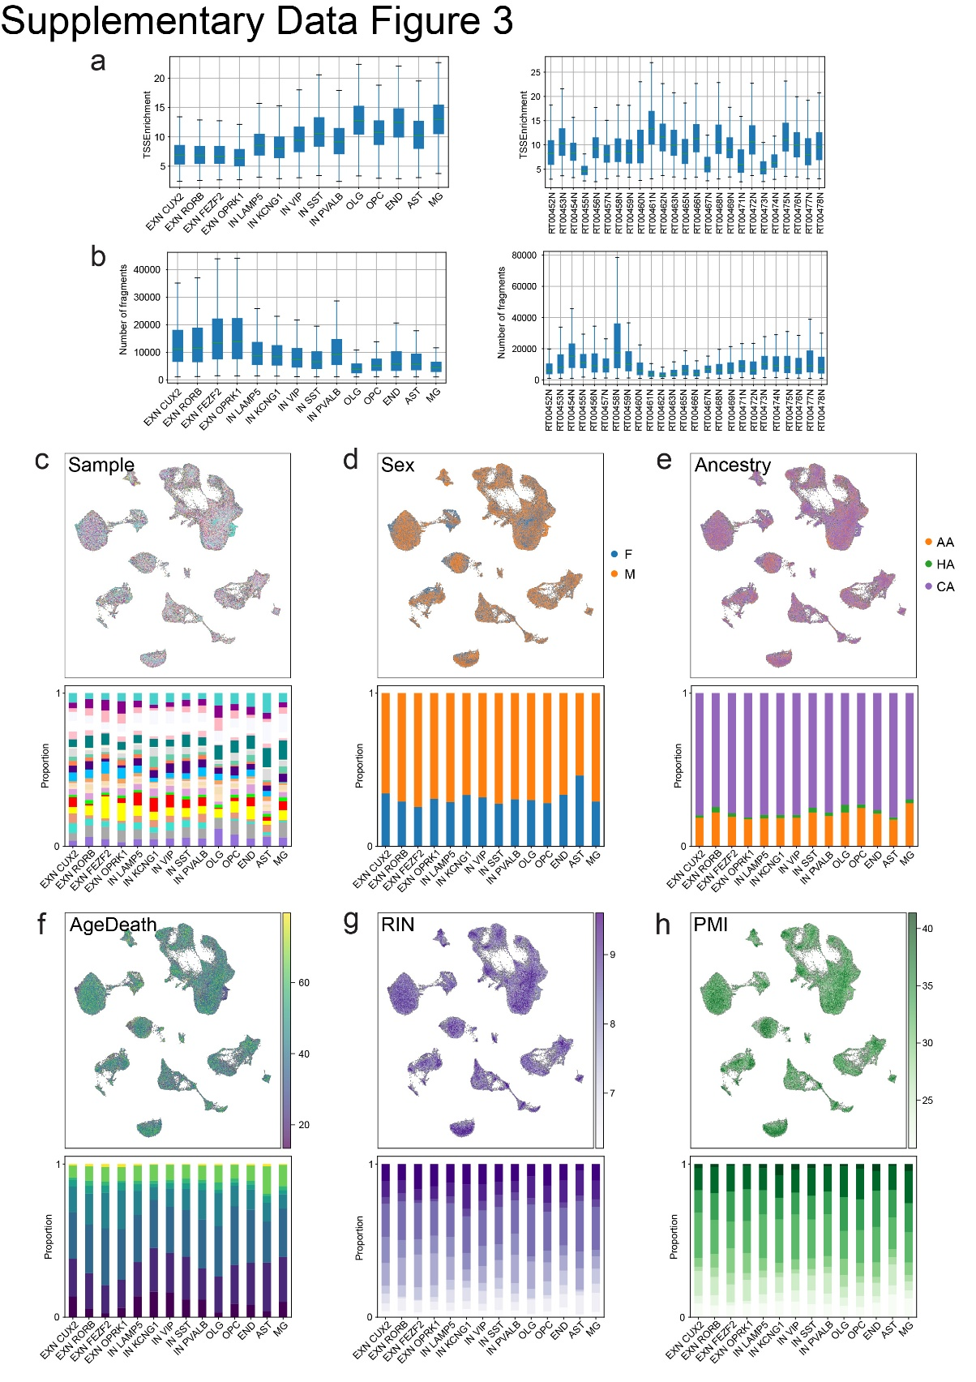
Supplementary Data Figure 3: snMultiome data quality and metadata. a, Boxplot of TSS enrichment across 14 subtypes and 25 samples. b, Boxplot of the number of fragments across 14 subtypes and 25 samples. c, UMAP colored by Samples(top) and Sample cell proportion per subtype (bottom). d, UMAP colored by Sex metadata (top) and Sex cell proportion per subtype (bottom). F: female, M: male. e, UMAP colored by Ancestry metadata (top) and Ancestry cell proportion per subtype (bottom). AA: African American, HA: Hispanic American, CA: Caucasian American. f, UMAP colored by AgeDeath metadata (top) and AgeDeath cell proportion per subtype in 10 bins (bottom). g, UMAP colored by RIN metadata (top) and RIN cell proportion per subtype in 10 bins (bottom). h, UMAP colored by PMI metadata (top) and PMI cell proportion per subtype in 10 bins (bottom).
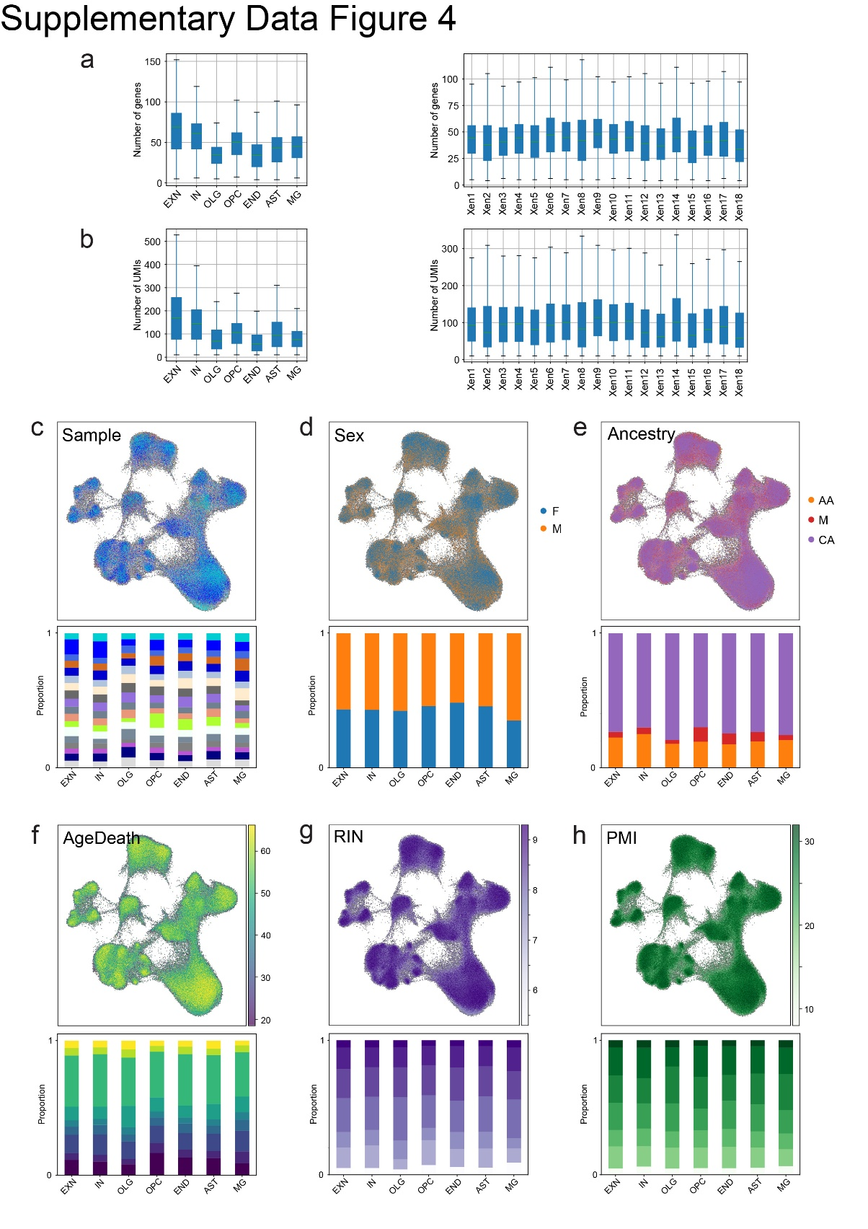
Supplementary Data Figure 4: snXenium data quality and metadata. a, Boxplot of the number of genes across 7 cell types and 18 samples. b, Boxplot of the number of UMIs across 7 cell types and 18 samples. c, UMAP colored by Sample (top) and Sample cell proportion per cell type (bottom). d, UMAP colored by Sex metadata (top) and Sex cell proportion per cell type (bottom). F: female, M: male. e, UMAP colored by Ancestry metadata (top) and Ancestry cell proportion per cell type (bottom). AA: African American, HA: Hispanic American, CA: Caucasian American. f, UMAP colored by AgeDeath metadata (top) and AgeDeath cell proportion per cell type in 10 bins (bottom). g, UMAP colored by RIN metadata (top) and RIN cell proportion per cell type in 10 bins (bottom). h, UMAP colored by PMI metadata (top) and PMI cell proportion per cell type in 10 bins (bottom).
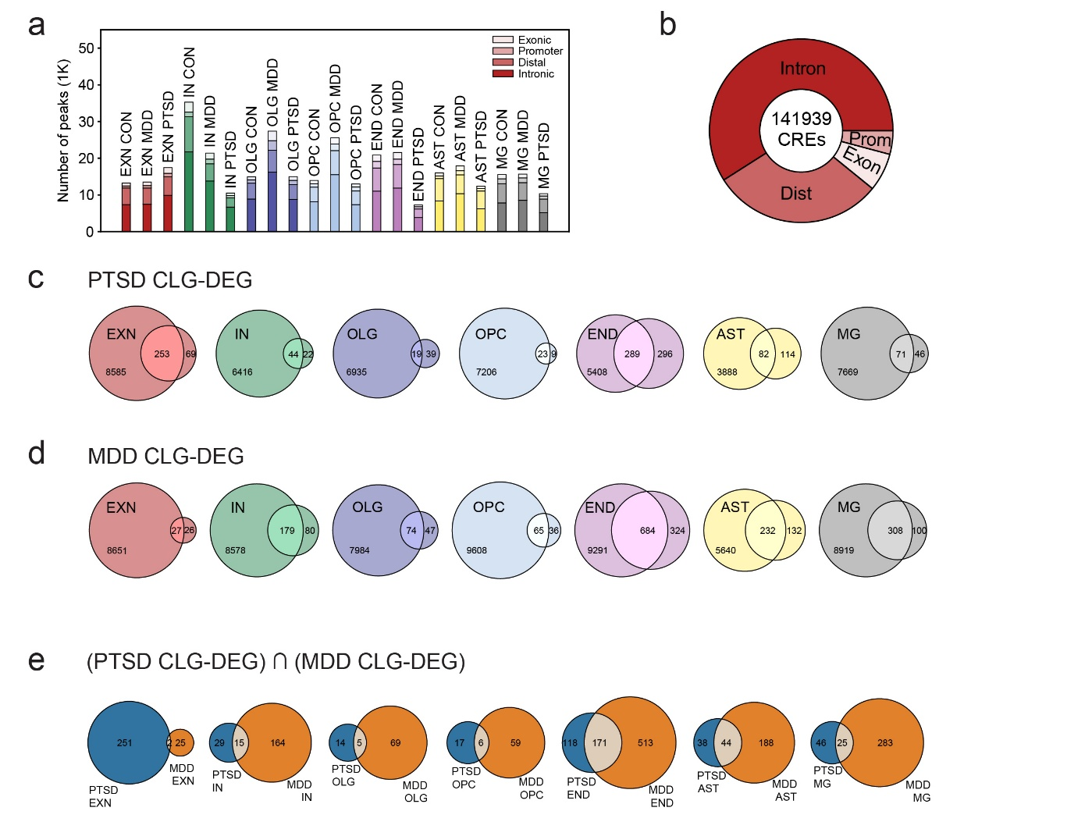
Supplementary Data Figure 5: Condition-specific CRE analysis. a, Stacked barplot of condition-specific peaks across 7 cell types by genomic category (Intronic, Distal, Promoter, Exonic) from snATAC-seq. b, Composition of condition-specific CREs (n = 141,939) with peak-to-gene correlation > 0.4 and FDR < 0.05 separated by genomic category. c, Overlap between PTSD CLGs and PTSD DEGs across cell types. The overlapping region is defined as PTSD CLG-DEGs. d, Overlap between MDD CLGs and MDD DEGs across cell types. The overlapping region is defined as MDD CLG-DEGs. e, Overlap between PTSD CLG-DEGs and MDD CLG-DEGs across cell types.

Statistics and Reproducibility

Figure | Description | # of times repeated
Fig. 2h, 3d, Extended Data Fig. 5c (left panel), 5h | 10X snXenium experiment for CON | 10
Fig. 2i, 3e, Extended Data Fig. 5c (right panel), 5i, Supplementary Data Table 24, 25 | 10X snXenium experiment for PTSD | 4
Supplementary Data Table 24, 25 | 10X snXenium experiment for MDD | 4

Supplementary Data Tables 1-41

Supplementary Data Table 1: Sample metadata of 111 RNA/ATAC, 25 Multiome, and 18 Xenium samples
Supplementary Data Table 2: Number of cells in each dataset by cell type and/or subtype
Supplementary Data Table 3: MAST results for differentially expressed genes in PTSD and MDD
Supplementary Data Table 4: Wilcoxon results of differentially expressed genes in PTSD and MDD
Supplementary Data Table 5: Nebula results of differentially expressed genes in PTSD and MDD
Supplementary Data Table 6: DESeq2 pseudobulk results of differentially expressed genes in PTSD and MDD
Supplementary Data Table 7: PTSD differentially expressed gene overlap between MAST and Wilcoxon
Supplementary Data Table 8: GO analysis of 1,184 PTSD snDEGs
Supplementary Data Table 9: GO analysis of PTSD cell type-specific DEGs
Supplementary Data Table 10: GO analysis of 437 Nebula PTSD DEGs
Supplementary Data Table 11: GO analysis of 472 DESeq2 PTSD DEGs
Supplementary Data Table 12: Differentially expressed genes between control males and control females
Supplementary Data Table 13: Differentially expressed genes between PTSD males and control males
Supplementary Data Table 14: Differentially expressed genes between PTSD females and control females
Supplementary Data Table 15: Differentially expressed genes between MDD males and MDD controls
Supplementary Data Table 16: Differentially expressed genes between MDD females and control females
Supplementary Data Table 17: MDD Differentially expressed gene overlap between MAST and Wilcox
Supplementary Data Table 18: PTSD differentially expressed genes that are non-overlapping with MDD
Supplementary Data Table 19: MDD differentially expressed genes that are non-overlapping with PTSD
Supplementary Data Table 20: GO analysis of PTSD DEGs that are non-overlapping with MDD
Supplementary Data Table 21: PTSD (-MDD) versus control differentially expressed genes

Supplementary Data Table 22: PTSD (+MDD) versus control differentially expressed genes
Supplementary Data Table 23: 366 genes included in in Xenium Human Brain Panel and 99 add-on genes
Supplementary Data Table 24: MAST results for differentially expressed genes in PTSD and MDD scXenium
Supplementary Data Table 25: MAST results for differentially expressed genes in PTSD and MDD snXenium
Supplementary Data Table 26: Cell-to-cell communication interactions using CellChat
Supplementary Data Table 27: Cell-to-cell communication interactions using NeuronChat
Supplementary Data Table 28: Cell type specific cis-regulatory element metadata
Supplementary Data Table 29: List of CRE-Gene links
Supplementary Data Table 30: Condition cell type specific cis-regulatory element metadata
Supplementary Data Table 31: List of EXN TF-CRE-Gene links
Supplementary Data Table 32: List of IN TF-CRE-Gene links
Supplementary Data Table 33: List of OLG TF-CRE-Gene links
Supplementary Data Table 34: List of OPC TF-CRE-Gene links
Supplementary Data Table 35: List of END TF-CRE-Gene links
Supplementary Data Table 36: List of AST TF-CRE-Gene links
Supplementary Data Table 37: List of MG TF-CRE-Gene links
Supplementary Data Table 38: List of top 20 enriched TFs ranked by number of downstream DEGs by cell type
Supplementary Data Table 39: Differentially expressed genes in TF infected iPSC derived EXNs
Supplementary Data Table 40: LDSC analysis of SNP enrichments in cell type specific ATAC peaks
Supplementary Data Table 41: List of all Fine-mapped SNPs

Source Data Files
Source Data File 1: Mouse SPS behavior and electrophysiology

