Supplementary Information for “Ongoing genome doubling shapes evolvability and immunity in ovarian cancer”

Table of contents

1. Glossary of Terms 3
2. scWGS cell filtering examples 5
2.1. Supporting evidence for S-phase filtering 5
2.2. Example cells by filtering classification 6
2.2.1. Example normal cells 8
2.2.2. Example aberrant normal cells 10
2.2.3. Example S-phase cells 12
2.2.4. Example doublets (identified from manual review of spotter images) 14
2.2.5 Example cells without a ≥10MB segment of copy 1, 3, or 5 16
2.2.6. Example filter-pass cells 18
3. Validation for WGD classification heuristic 20
3.1. WGD classification in existing simulated data 20
3.2. Comparing repeated gains to WGD using simple model 20
3.3. Chromosome-specific doubleTime timing results 21
3.4. Downsampling read counts to evaluate WGD heuristic 22
4. Mixed WGD multiplicities 24
4.1. Support for mixed WGD multiplicities 24
4.2. Mixed WGD across anatomical sites 24
5. Discerning parallel WGD from shared WGD using SNVs 25
5.1 Method 25
5.2. Validating parallel WGDs in patient OV-045 27
5.3 Sensitivity evaluation using simulated data 28
6. Benchmarking estimation of chromosomal instability using simulations 30
6.1 Generation of simulated data 30
6.2 Results on simulated data 32
7. Extended SBMClone results and validation 33
7.1. SBMClone block density matrices 33
7.2. Confidence in SBMClone clone assignments 35
7.3. Consistency between SBMClone clusters and copy-number states 37
8. Extended doubleTime results 39
8.1. Normalizing branch lengths to account for SNV detection sensitivity 39
8.2. Assignment of SNVs to clone tree branches 39
8.3. SNV VAFs by doubleTime-assigned clade 42
9. Multi-modal sample matching 42
10. Residual 0×WGD cells 42
11. Legends for Supplementary Data files 43
11.1 Supplementary Data 1 legend 43
11.1 Supplementary Data 2 legend 43

1. Glossary of Terms
Whole-genome doubling (WGD): a phenomenon in which a cell doubles the number of copies of all chromosomes.

Clone: A group of cells with shared genetic origin. Includes all cells derived from a single common ancestor.

Subclone: A clone that does not comprise all cells in a tumor.

Truncal WGD: A whole-genome doubling (WGD) event that is ancestral to all cells in a tumor. Also a category of tumor characterized by this WGD event.

WGD clone: A clone whose most recent common ancestor (MRCA) has at least one ancestral WGD event. (General term, does not necessarily have to be a clone that comprises all cells in a tumor.)

WGD subclone: A WGD clone that does not comprise all cells in a tumor.

Subclonal WGD: A WGD event that is ancestral to a WGD subclone (which coexists with another WGD population or a non-WGD population). Also a category of tumor characterized by this WGD event.

Parallel WGD: A phenomenon in which multiple distinct WGD subclones coexist in a tumor. Also a category of tumor characterized by these WGD subpopulations.

Unexpanded WGD: A phenomenon in which WGD arises in individual cells that do not appear to share a common ancestor (i.e., do not meet the definition of “clone”). Also a category of tumor without WGD clones.

Clonal expansion: the process by which a cell becomes a clone (i.e., by replicating to the point where multiple cells that appear identical can be detected). Says nothing about the absolute or relative size of the resulting clone.

WGD multiplicity: For a cell or clone, the number of WGD events that have occurred in the evolutionary history of that cell or clone.

Majority WGD cells: The cells that are in the majority WGD multiplicity (i.e., representing >50% of cells being considered). Not necessarily clonally related cells.

Minority WGD cells: The cells that are not in the majority WGD multiplicity.

Additional-WGD cells: Cells that have 1 more WGD than the majority.

Divergent cells: cells that sufficiently different from all other cells from the same patient to be considered outliers

Residual-0xWGD cells: Non-divergent 0xWGD cells in a majority >=1xWGD population.

Age of WGD: number of somatic C>T CpG SNVs accumulated between the WGD event and the time of sequencing.

Early WGD: describes a patient whose WGD occurred relatively early in the tumor’s history according to SNV-based timing.

Late WGD: describes a patient whose WGD occurred relatively recently according to SNV-based timing.

2. scWGS cell filtering examples

2.1. Supporting evidence for S-phase filtering
Here we show an example of the 3 statistics used to identify S-phase cells for patient OV-002 (Supplementary Fig. 1-2). The thresholds for each statistic were tuned manually for each patient to account for the varying aneuploidy in typical tumor cells. A cell was called S-phase if it was outside the thresholds for at least 2 out of the 3 statistics.
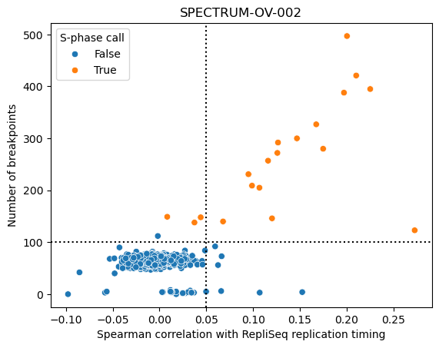
Supplementary Figure 1. Replication timing and total breakpoints for cells from patient OV-002. This figure shows two S-phase statistics for cells from patient OV-002: Spearman correlation with replication timing (x-axis) and number of breakpoints (y-axis). Cells are colored by the ultimate S-phase call, which requires that 2 of the 3 S-phase statistics exceed the manually determined patient-specific thresholds.
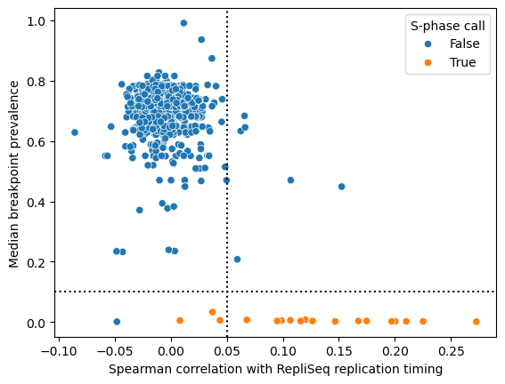
Supplementary Figure 2. Replication timing and median breakpoint prevalence for cells from patient OV-002. This figure shows Spearman correlation with replication timing (x-axis) and the median prevalence of copy-number breakpoints present in the cell (y-axis). Cells are colored by the ultimate S-phase call, which requires that 2 of the 3 S-phase statistics exceed the manually determined patient-specific thresholds.

2.2. Example cells by filtering classification
For each filtering step, we show 4 example cells (Supplementary Fig. 3-12) that were identified as violating the filter (or passing all filters, for the “filter-pass” section: Supplementary Fig. 13-14). For a description of the filtering steps used to identify these cells for removal, see Methods.

For each cell, we show 3 views:
- GC-corrected and ploidy-scaled read counts across the genome (left, “copy”) colored by the total copy-number state assigned by HMMCopy.
- Phased BAF across the genome (right, “BAF”) inferred by signals colored by the minor copy number inferred by signals.
- Image from the DLP+ cell spotter. The ejection nozzle is to the left of the region shown in this image. The left vertical line indicates the rightmost edge of the ejection zone (fluid that is guaranteed to be ejected), and the right vertical line indicates the rightmost edge of the sedimentary zone (fluid that may or may not be ejected). Ejection into a well occurs only if exactly 1 cell is identified in either of these regions. The green cross indicates the object that was identified as a cell by the automated imaging pipeline.

2.2.1. Example normal cells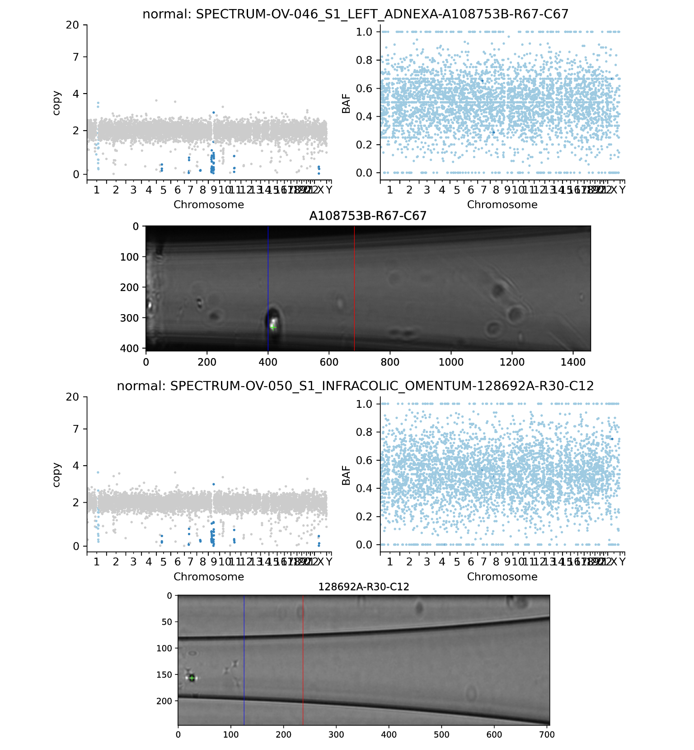
Supplementary Figure 3. Two example cells classified as normal by the QC pipeline. Scatterplots show the normalized and ploidy-scaled read-depth of each bin colored by HMMCopy-inferred copy-number state (left) and B-allele frequency of each bin colored by signals-inferred minor copy-number state (right). Images for each cell (center) show the image taken through the DLP+ nozzle where a green cross indicates the detected cell object, the left vertical line indicates the rightmost edge of the ejection zone, and the right vertical line indicates the rightmost edge of the sedimentary zone.
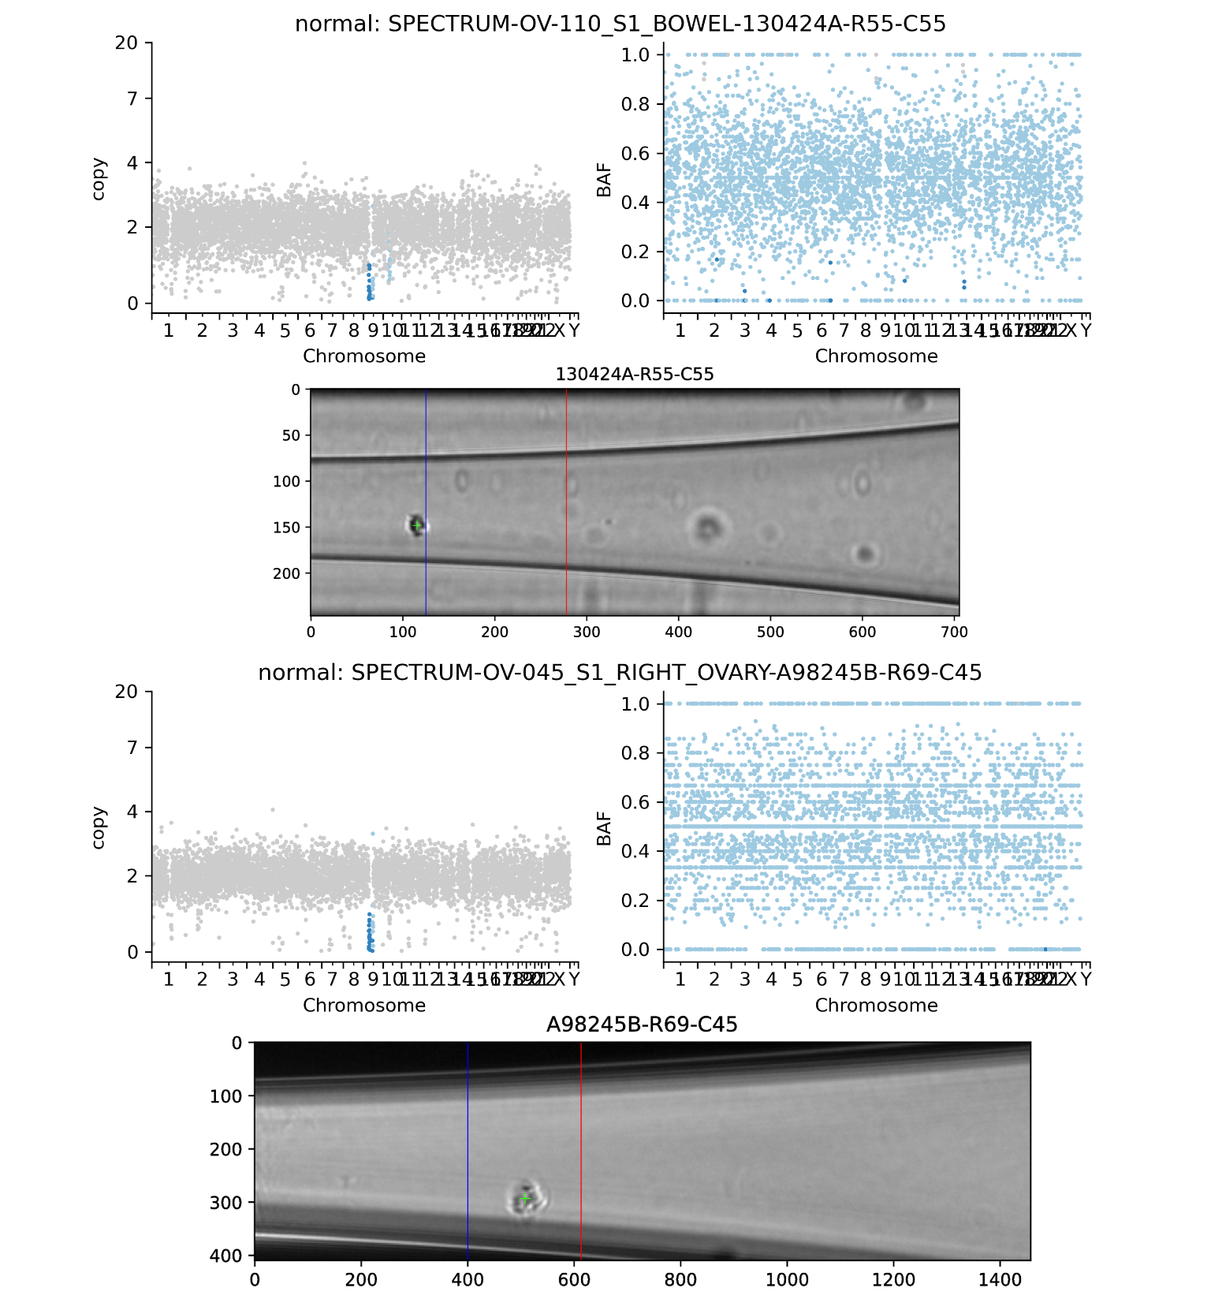
Supplementary Figure 4. Two example cells classified as normal by the QC pipeline. Scatterplots show the normalized and ploidy-scaled read-depth of each bin colored by HMMCopy-inferred copy-number state (left) and B-allele frequency of each bin colored by signals-inferred minor copy-number state (right). Images for each cell (center) show the image taken through the DLP+ nozzle where a green cross indicates the detected cell object, the left vertical line indicates the rightmost edge of the ejection zone, and the right vertical line indicates the rightmost edge of the sedimentary zone.

2.2.2. Example aberrant normal cells
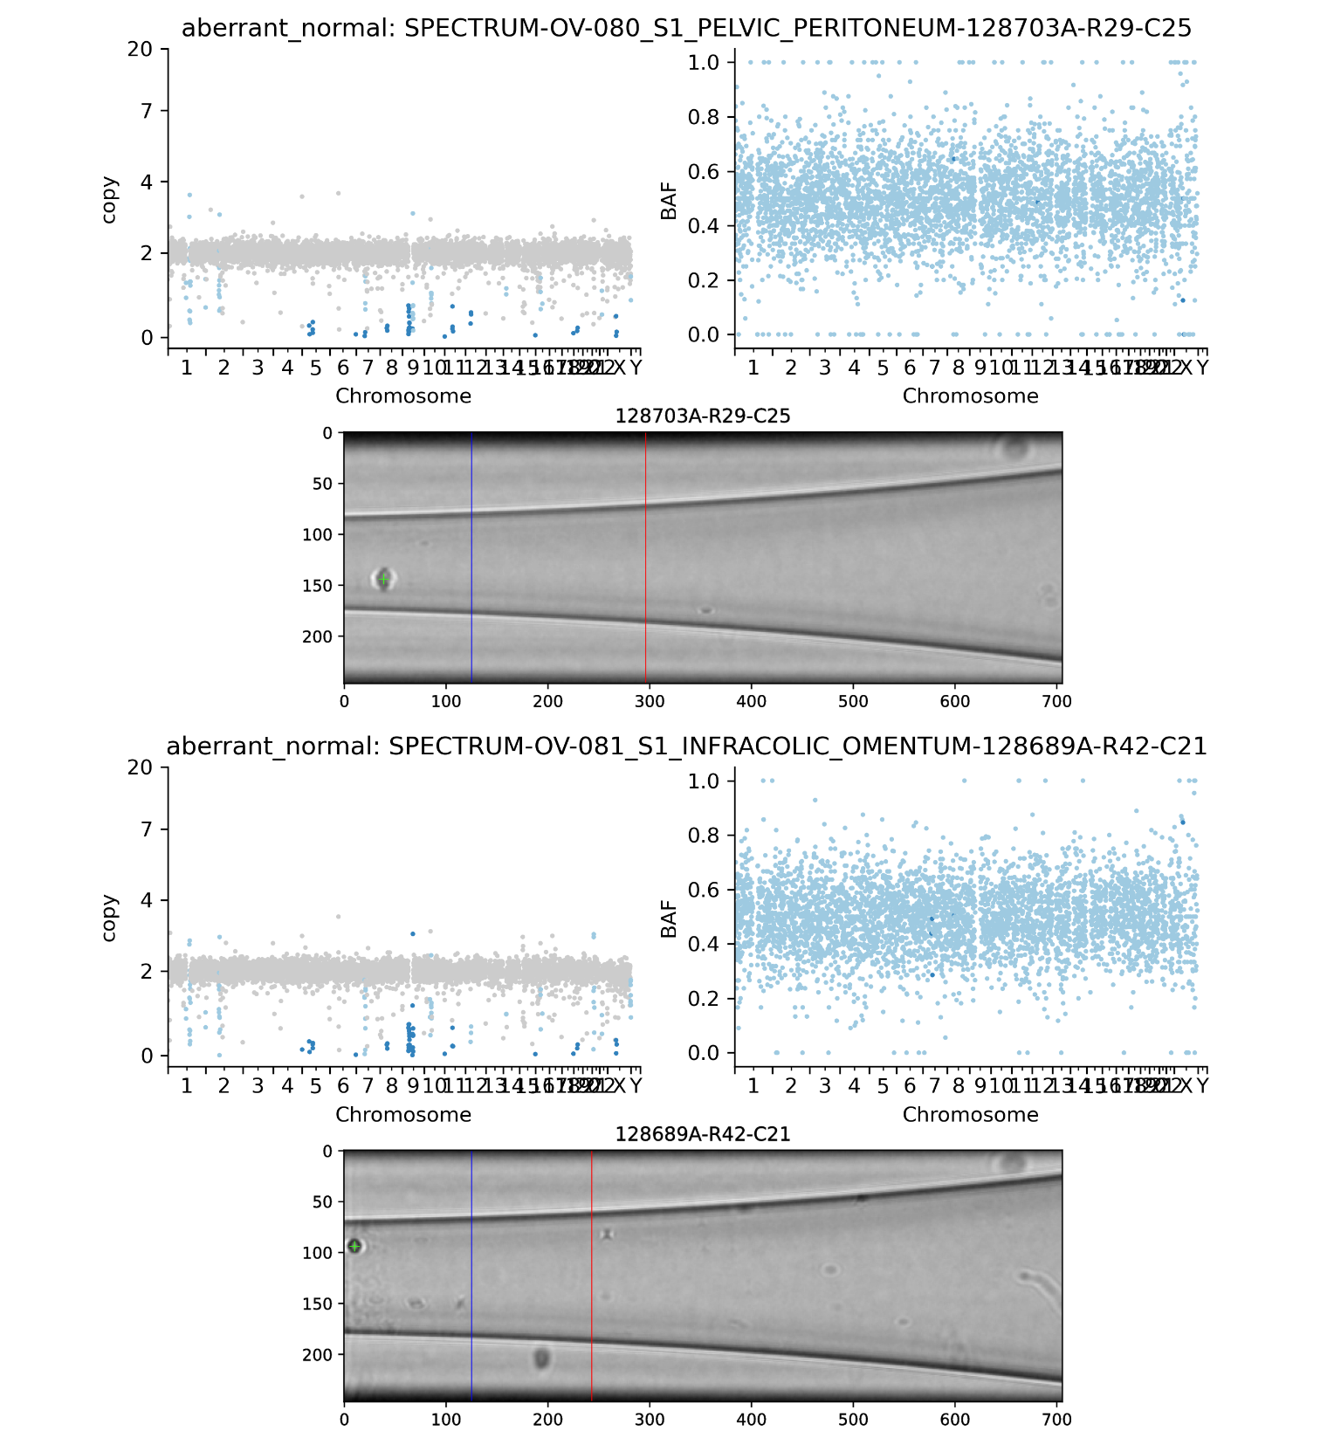
Supplementary Figure 5. Two example cells classified as aberrant normal by the QC pipeline. Scatterplots show the normalized and ploidy-scaled read-depth of each bin colored by HMMCopy-inferred copy-number state (left) and B-allele frequency of each bin colored by signals-inferred minor copy-number state (right). Images for each cell (center) show the image taken through the DLP+ nozzle where a green cross indicates the detected cell object, the left vertical line indicates the rightmost edge of the ejection zone, and the right vertical line indicates the rightmost edge of the sedimentary zone.
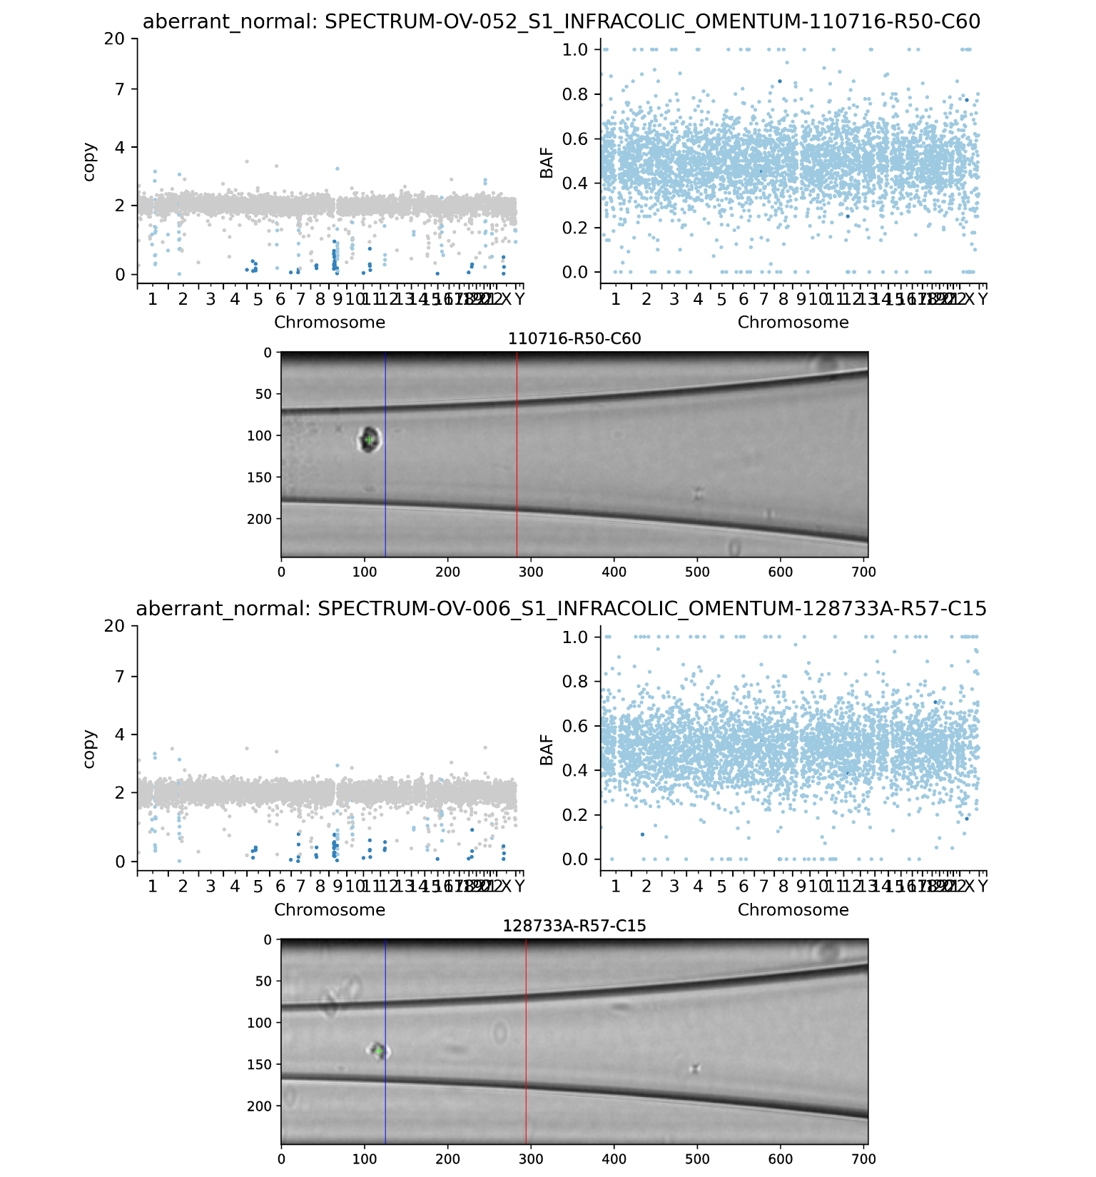
Supplementary Figure 6. Two example cells classified as aberrant normal by the QC pipeline. Scatterplots show the normalized and ploidy-scaled read-depth of each bin colored by HMMCopy-inferred copy-number state (left) and B-allele frequency of each bin colored by signals-inferred minor copy-number state (right). Images for each cell (center) show the image taken through the DLP+ nozzle where a green cross indicates the detected cell object, the left vertical line indicates the rightmost edge of the ejection zone, and the right vertical line indicates the rightmost edge of the sedimentary zone.

2.2.3. Example S-phase cells
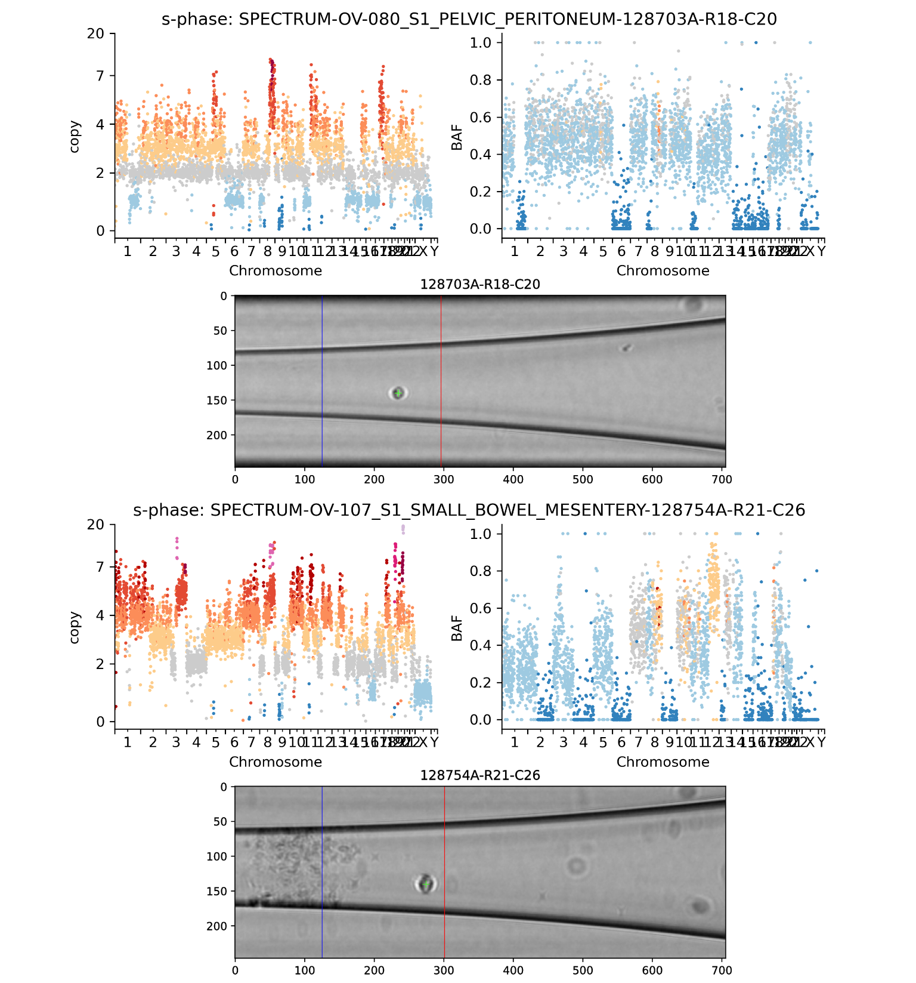
Supplementary Figure 7. Two example cells classified as S-phase by the QC pipeline. Scatterplots show the normalized and ploidy-scaled read-depth of each bin colored by HMMCopy-inferred copy-number state (left) and B-allele frequency of each bin colored by signals-inferred minor copy-number state (right). Images for each cell (center) show the image taken through the DLP+ nozzle where a green cross indicates the detected cell object, the left vertical line indicates the rightmost edge of the ejection zone, and the right vertical line indicates the rightmost edge of the sedimentary zone.
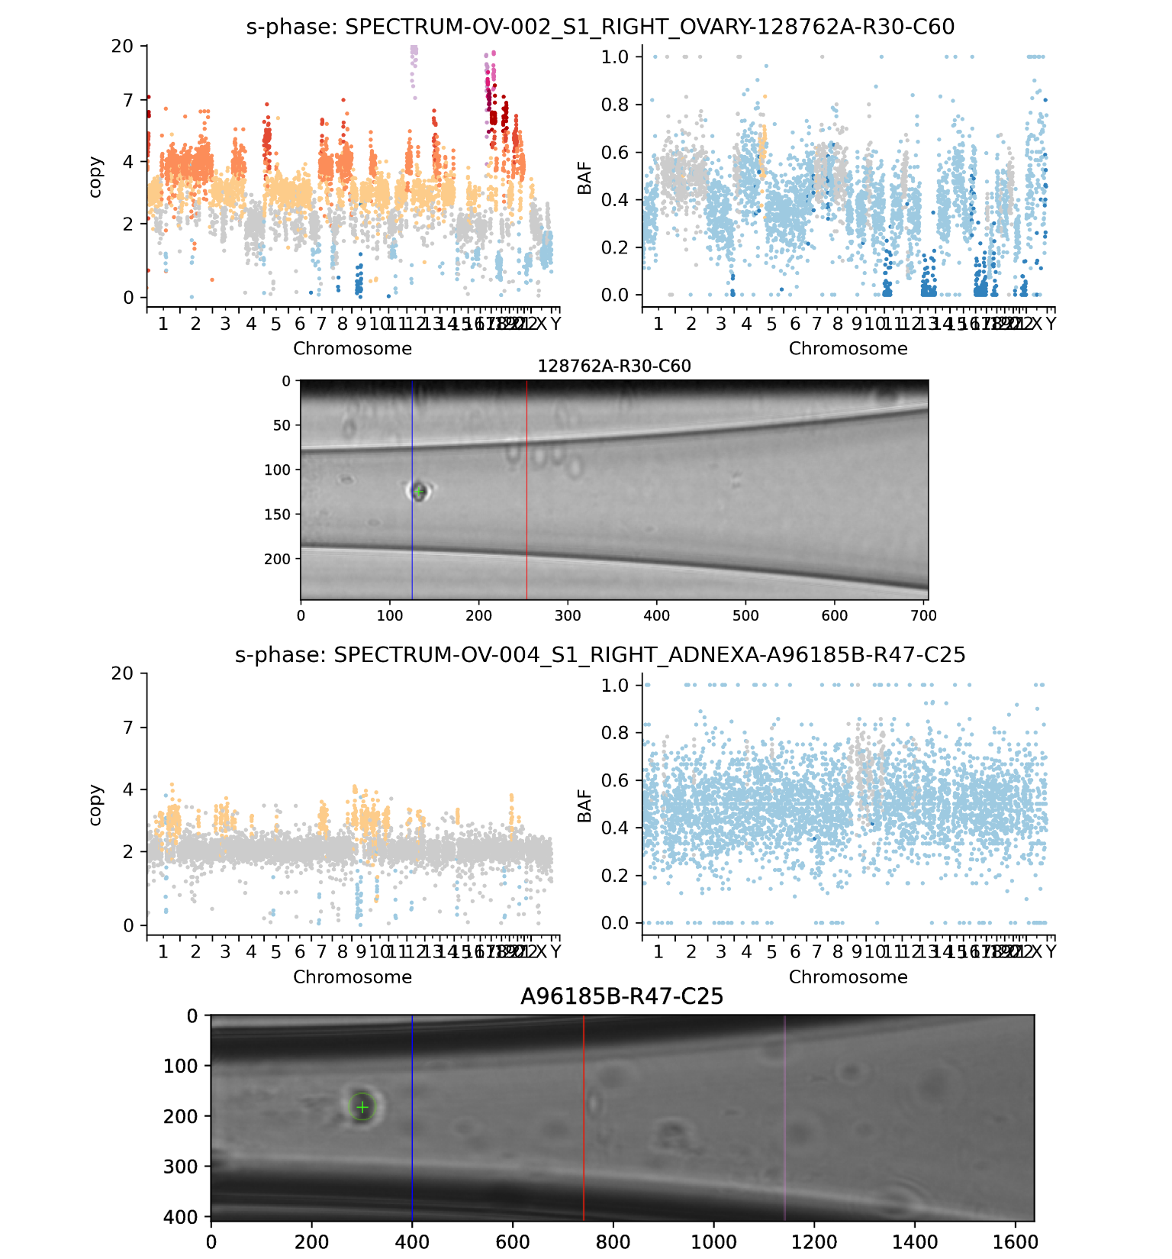
Supplementary Figure 8. Two example cells classified as S-phase by the QC pipeline. Scatterplots show the normalized and ploidy-scaled read-depth of each bin colored by HMMCopy-inferred copy-number state (left) and B-allele frequency of each bin colored by signals-inferred minor copy-number state (right). Images for each cell (center) show the image taken through the DLP+ nozzle where a green cross indicates the detected cell object, the left vertical line indicates the rightmost edge of the ejection zone, and the right vertical line indicates the rightmost edge of the sedimentary zone.

2.2.4. Example doublets (identified from manual review of spotter images)
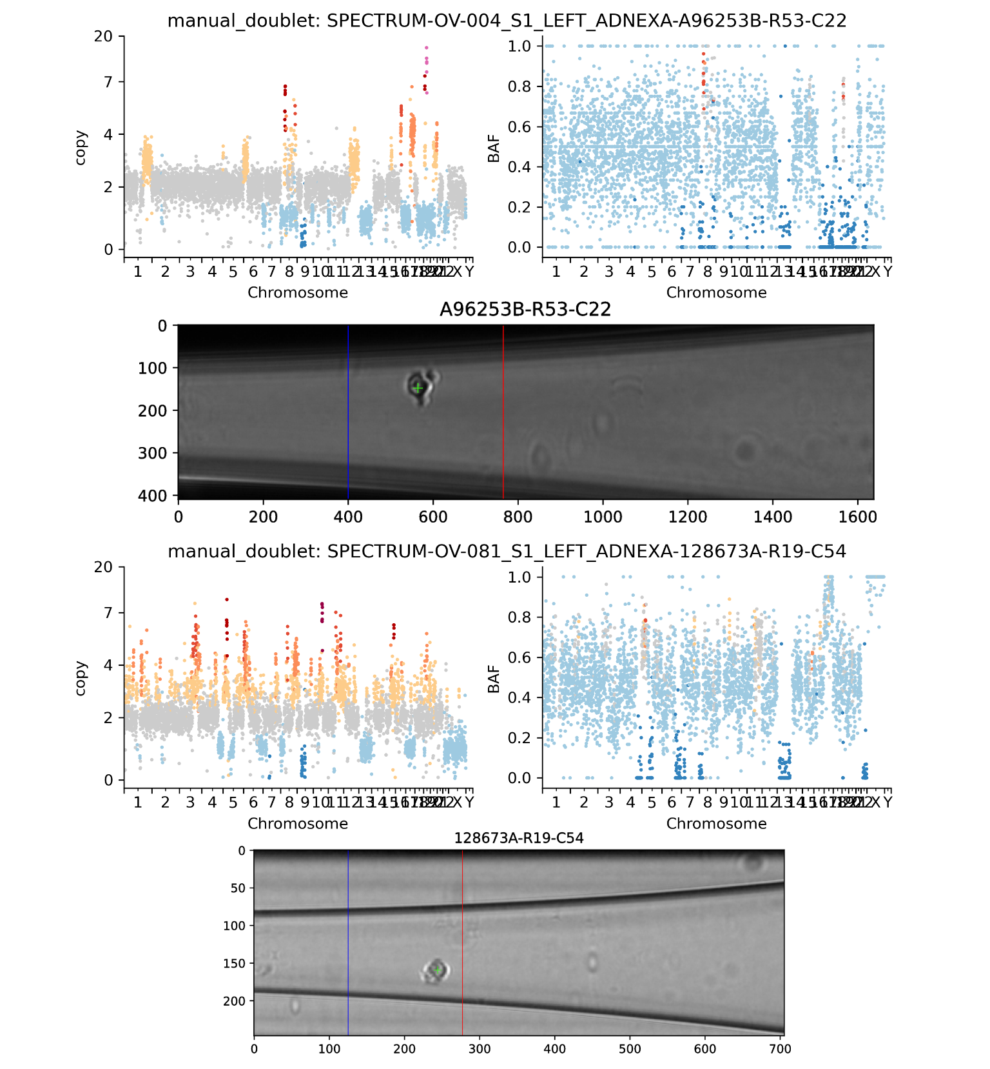
Supplementary Figure 9. Two example cells classified as doublets based on manual review of the spotter images. Scatterplots show the normalized and ploidy-scaled read-depth of each bin colored by HMMCopy-inferred copy-number state (left) and B-allele frequency of each bin colored by signals-inferred minor copy-number state (right). Images for each cell (center) show the image taken through the DLP+ nozzle where a green cross indicates the detected cell object, the left vertical line indicates the rightmost edge of the ejection zone, and the right vertical line indicates the rightmost edge of the sedimentary zone.
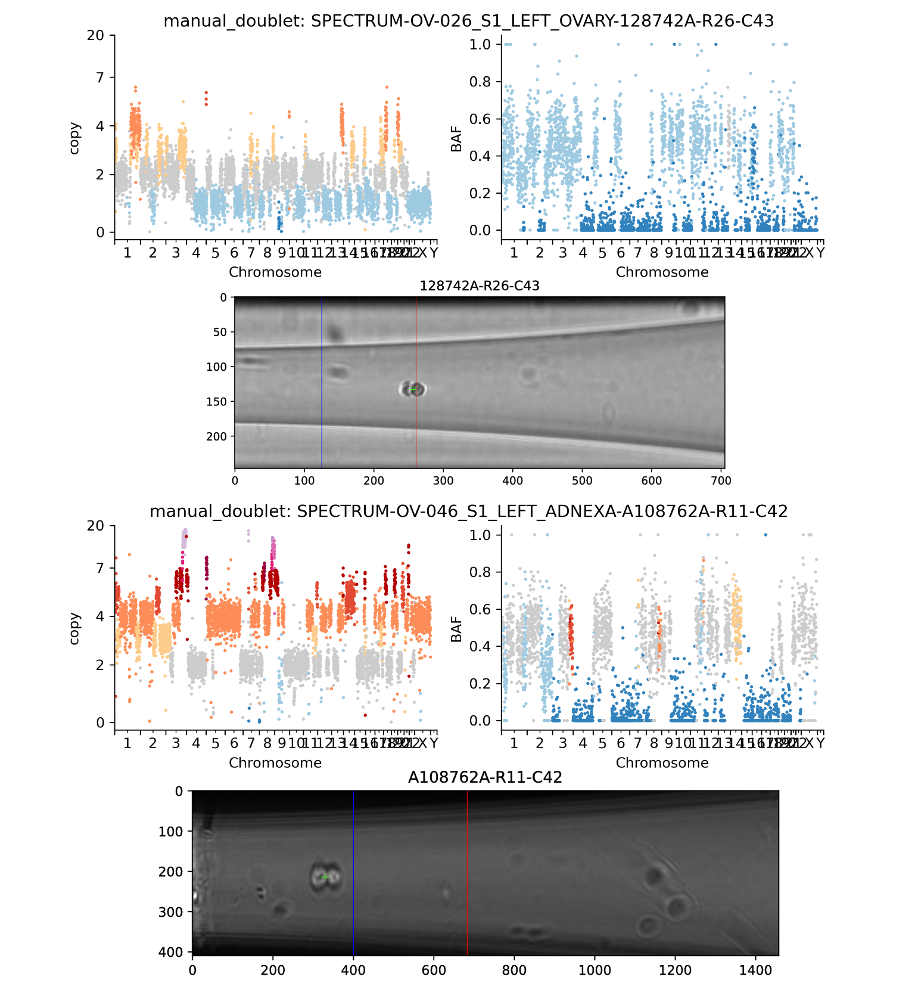
Supplementary Figure 10. Two example cells classified as doublets based on manual review of the spotter images. Scatterplots show the normalized and ploidy-scaled read-depth of each bin colored by HMMCopy-inferred copy-number state (left) and B-allele frequency of each bin colored by signals-inferred minor copy-number state (right). Images for each cell (center) show the image taken through the DLP+ nozzle where a green cross indicates the detected cell object, the left vertical line indicates the rightmost edge of the ejection zone, and the right vertical line indicates the rightmost edge of the sedimentary zone.

2.2.5 Example cells without a ≥10MB segment of copy 1, 3, or 5
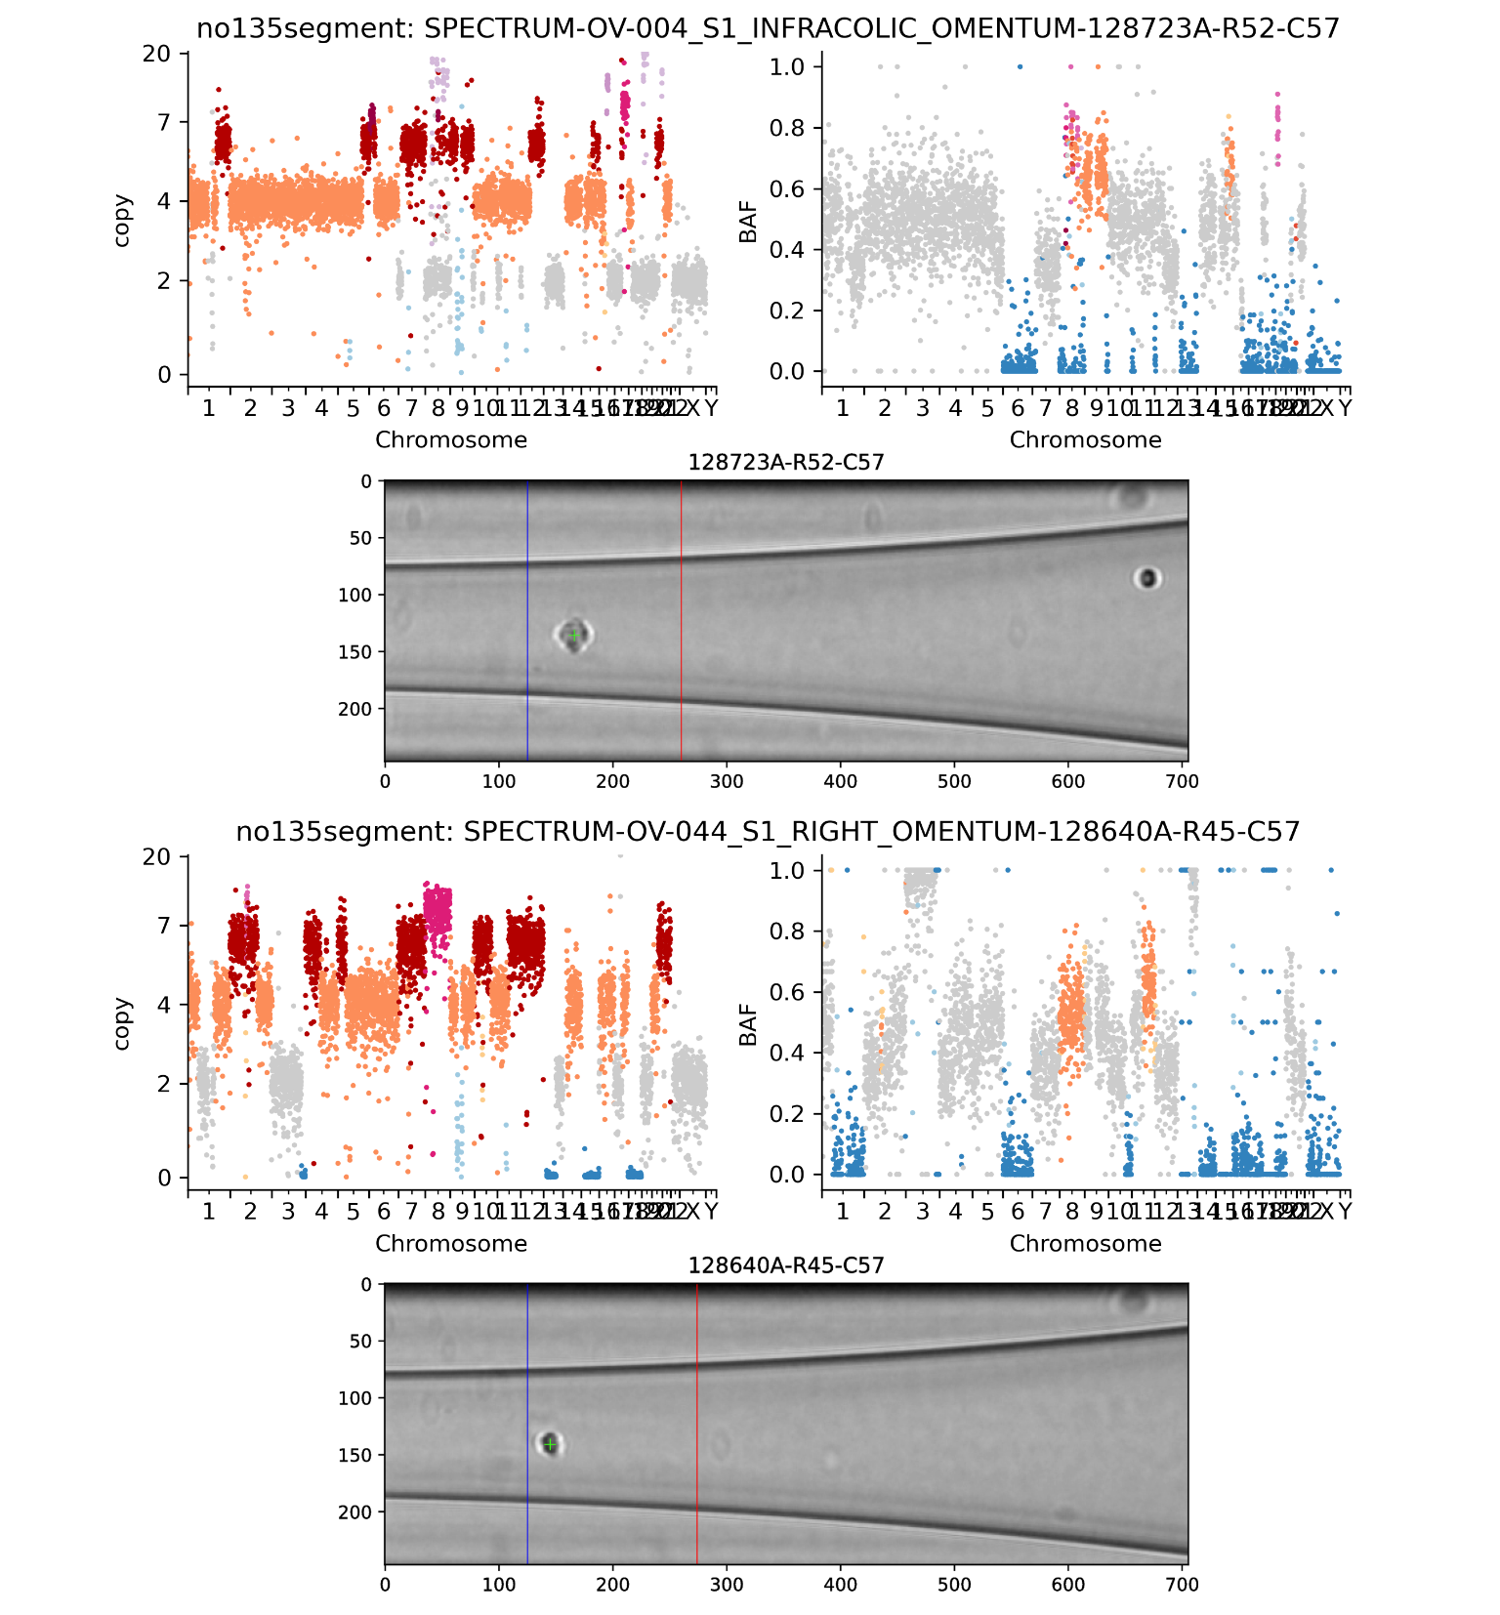
Supplementary Figure 11. Two example cells lacking a ≥10MB segment assigned to copy number 1, 3, or 5. Scatterplots show the normalized and ploidy-scaled read-depth of each bin colored by HMMCopy-inferred copy-number state (left) and B-allele frequency of each bin colored by signals-inferred minor copy-number state (right). Images for each cell (center) show the image taken through the DLP+ nozzle where a green cross indicates the detected cell object, the left vertical line indicates the rightmost edge of the ejection zone, and the right vertical line indicates the rightmost edge of the sedimentary zone.

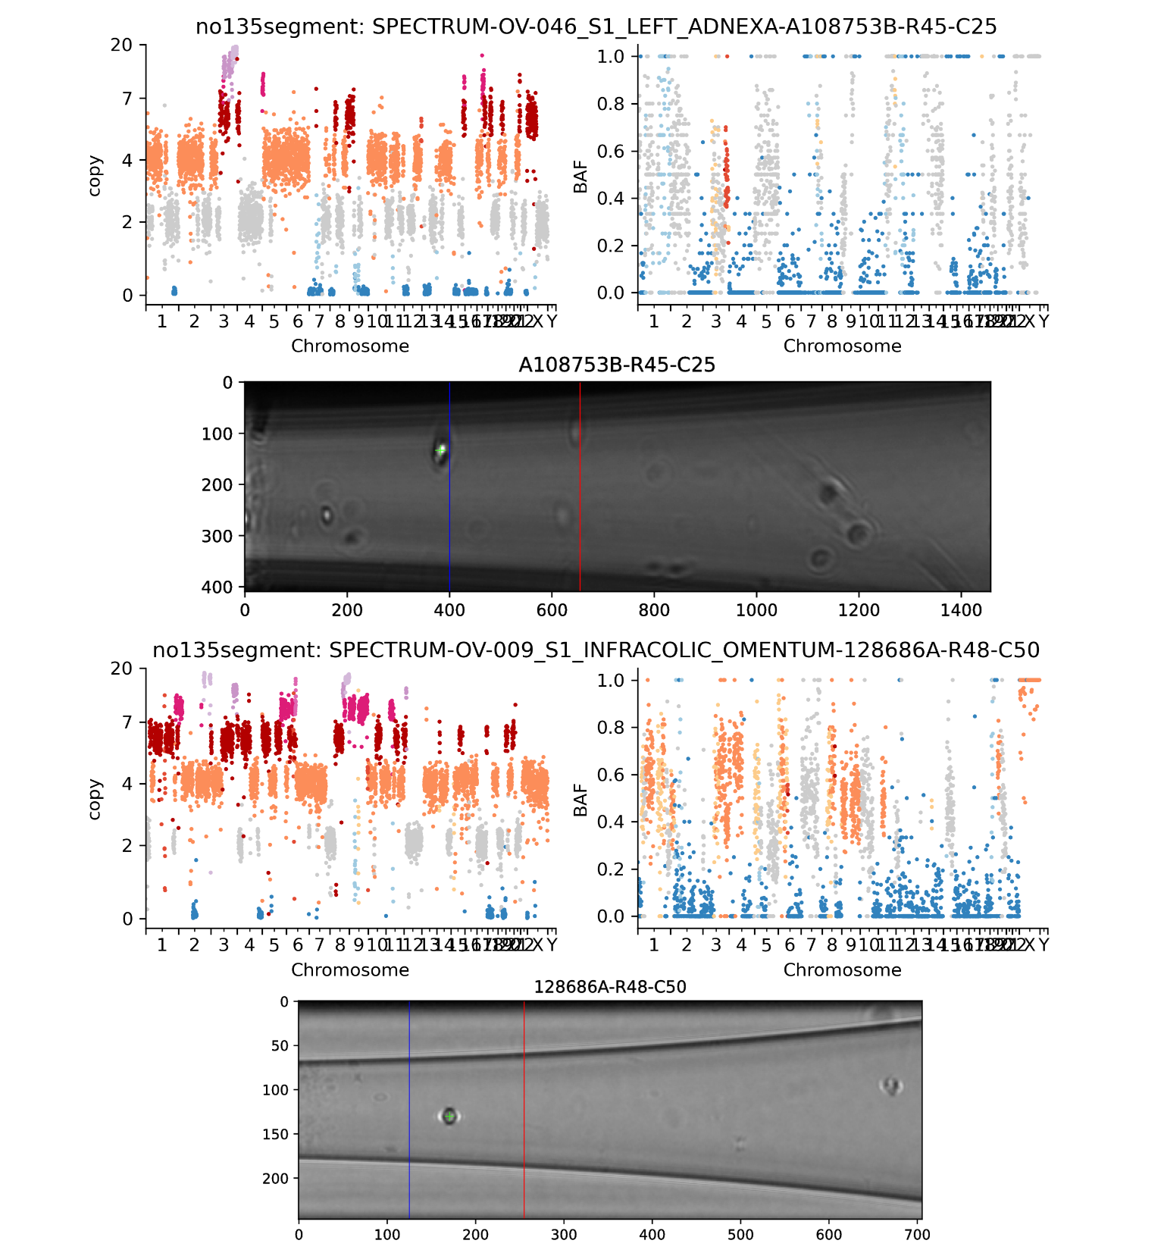
Supplementary Figure 12. Two example cells lacking a ≥10MB segment assigned to copy number 1, 3, or 5. Scatterplots show the normalized and ploidy-scaled read-depth of each bin colored by HMMCopy-inferred copy-number state (left) and B-allele frequency of each bin colored by signals-inferred minor copy-number state (right). Images for each cell (center) show the image taken through the DLP+ nozzle where a green cross indicates the detected cell object, the left vertical line indicates the rightmost edge of the ejection zone, and the right vertical line indicates the rightmost edge of the sedimentary zone.

2.2.6. Example filter-pass cells
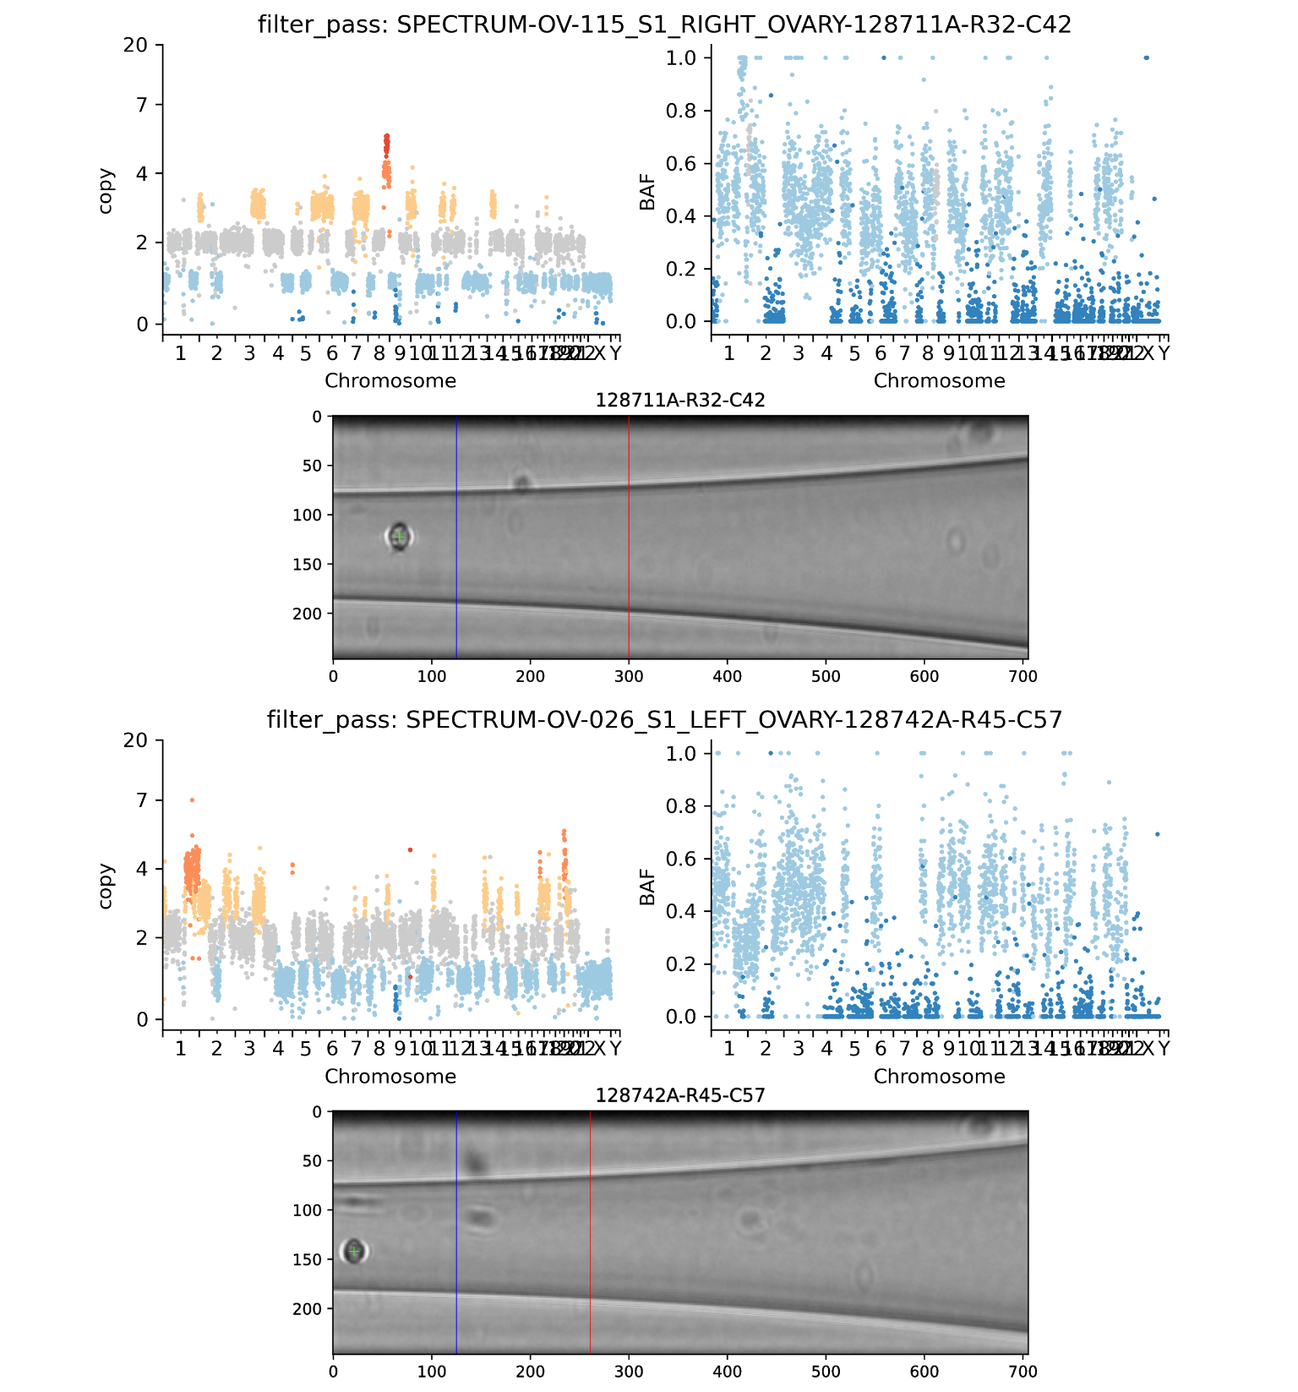
Supplementary Figure 13. Two example cells that passed all QC filters. Scatterplots show the normalized and ploidy-scaled read-depth of each bin colored by HMMCopy-inferred copy-number state (left) and B-allele frequency of each bin colored by signals-inferred minor copy-number state (right). Images for each cell (center) show the image taken through the DLP+ nozzle where a green cross indicates the detected cell object, the left vertical line indicates the rightmost edge of the ejection zone, and the right vertical line indicates the rightmost edge of the sedimentary zone.
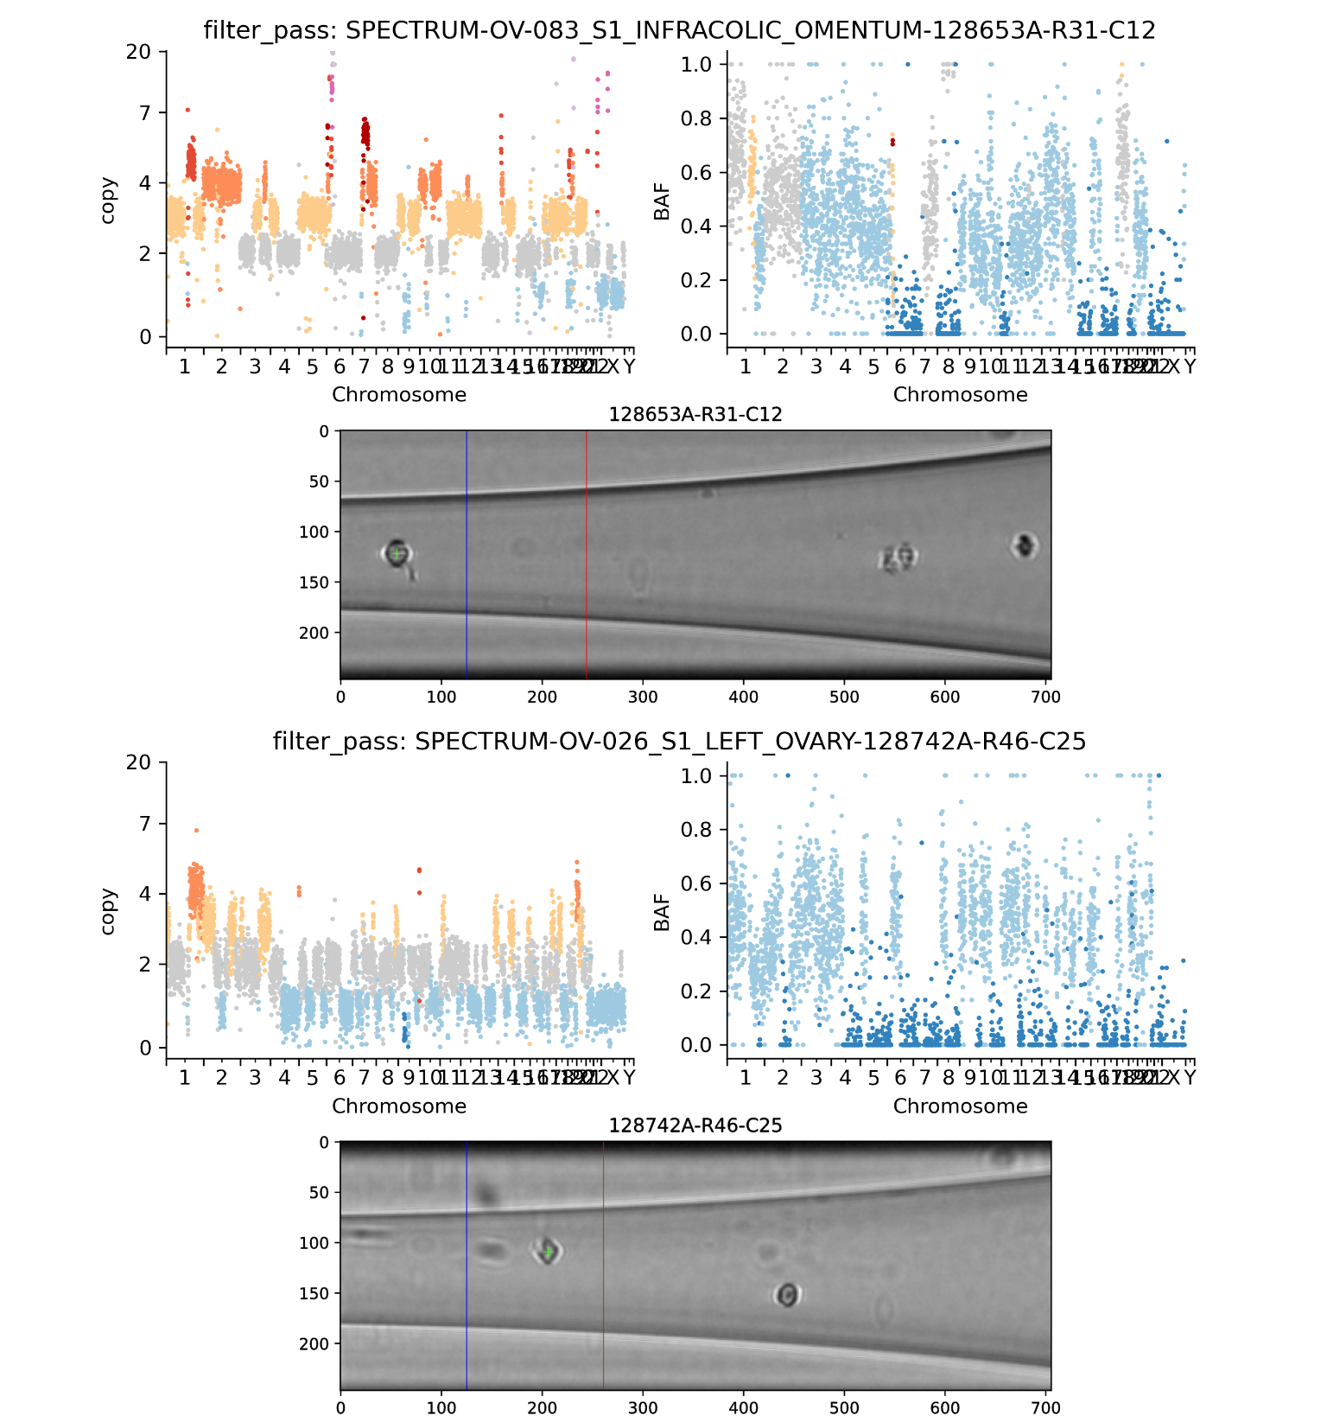
Supplementary Figure 14. Two example cells that passed all QC filters. Scatterplots show the normalized and ploidy-scaled read-depth of each bin colored by HMMCopy-inferred copy-number state (left) and B-allele frequency of each bin colored by signals-inferred minor copy-number state (right). Images for each cell (center) show the image taken through the DLP+ nozzle where a green cross indicates the detected cell object, the left vertical line indicates the rightmost edge of the ejection zone, and the right vertical line indicates the rightmost edge of the sedimentary zone.

3. Validation for WGD classification heuristic

3.1. WGD classification in existing simulated data
In the existing simulated data (see Supplementary Note section 6 for details), we assessed the performance of the WGD heuristic in identifying cells that had been affected by an ancestral WGD. We found that in this application, the WGD heuristic achieved an accuracy of
%. While these are relatively simple simulations with only chromosome-level events, the chromosome-level event rates that we estimated from the simulated data are representative of the range of chromosome-level event rates estimated from real data: real data chromosome gains 0.0016-0.52 per cell vs. simulated data chromosome gains 0.003-0.54 per cell, and real data chromosome losses 0.003-0.67 per cell vs. simulated data chromosome losses 0.003-0.39 per cell (Supplementary Fig. 15).

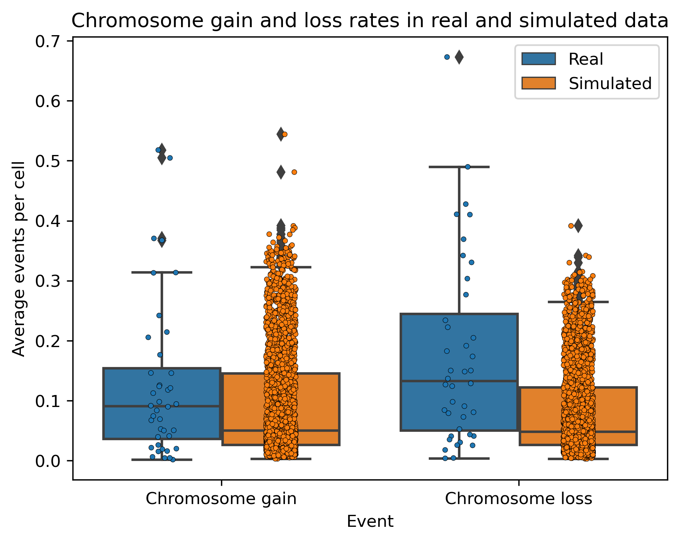
Supplementary Figure 15: Distribution of chromosome-level gain (left) and loss (right) rates for simulated data (blue) vs. real data (orange). Simulated data values are ground truth whereas real data values are inferred.

3.2. Comparing repeated gains to WGD using simple model
To further assess the plausibility of independent chromosome gains, we implemented a very simple model of chromosome amplification in which all chromosomes were treated equally: each chromosome was given equal length in the WGD heuristic, and gain events were uniformly distributed over all chromosomes on both haplotypes. We simulated 100,000 cells in this manner and counted the number of amplifications required before the WGD heuristic would call a cell as WGD (i.e., false positive as no WGD was implemented in the simulation). We found that at least 12 events and an average of 27.5 amplification events were required before a cell reached the threshold for the WGD heuristic (Supplementary Fig. 16). Note that this model did not include counteracting deletions, so this is an underestimate of the number of independent events required for a false positive WGD call. Under the principle of maximum parsimony, a cell that is called WGD is much more likely to have undergone a WGD than to have undergone over 20 independent chromosome gains with no counteracting deletions.
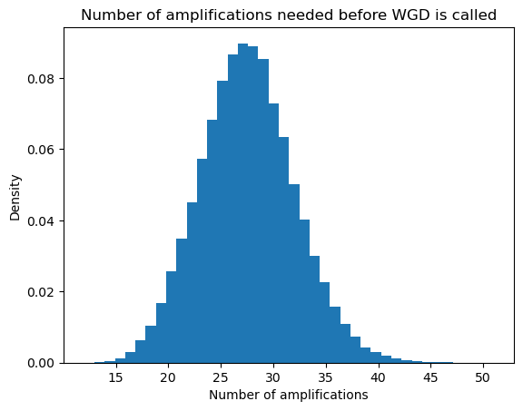
Supplementary Figure 16: Distribution of the number of distinct chromosome-level amplifications required before the WGD classification heuristic incorrectly calls WGD, under a simple model of uniformly random amplifications.

3.3. Chromosome-specific doubleTime timing results
For the 23 patients analyzed with doubleTime, we inspected the timing inferred by doubleTime on a per-chromosome basis to evaluate the SNV support for WGD, which would be reflected in similar timing estimates for all chromosomes. If instead chromosomes had been gained separately at different times, the doubleTime WGD timing estimates should differ. For each chromosome, we estimated the relative WGD timing on the branch with WGD using the same formula that doubleTime uses internally, but considering only the SNVs located on that chromosome. We found that these estimates were highly concordant, suggesting that the copy-number gains on these chromosomes are likely the result of a single simultaneous event – i.e., WGD (Supplementary Fig. 17).
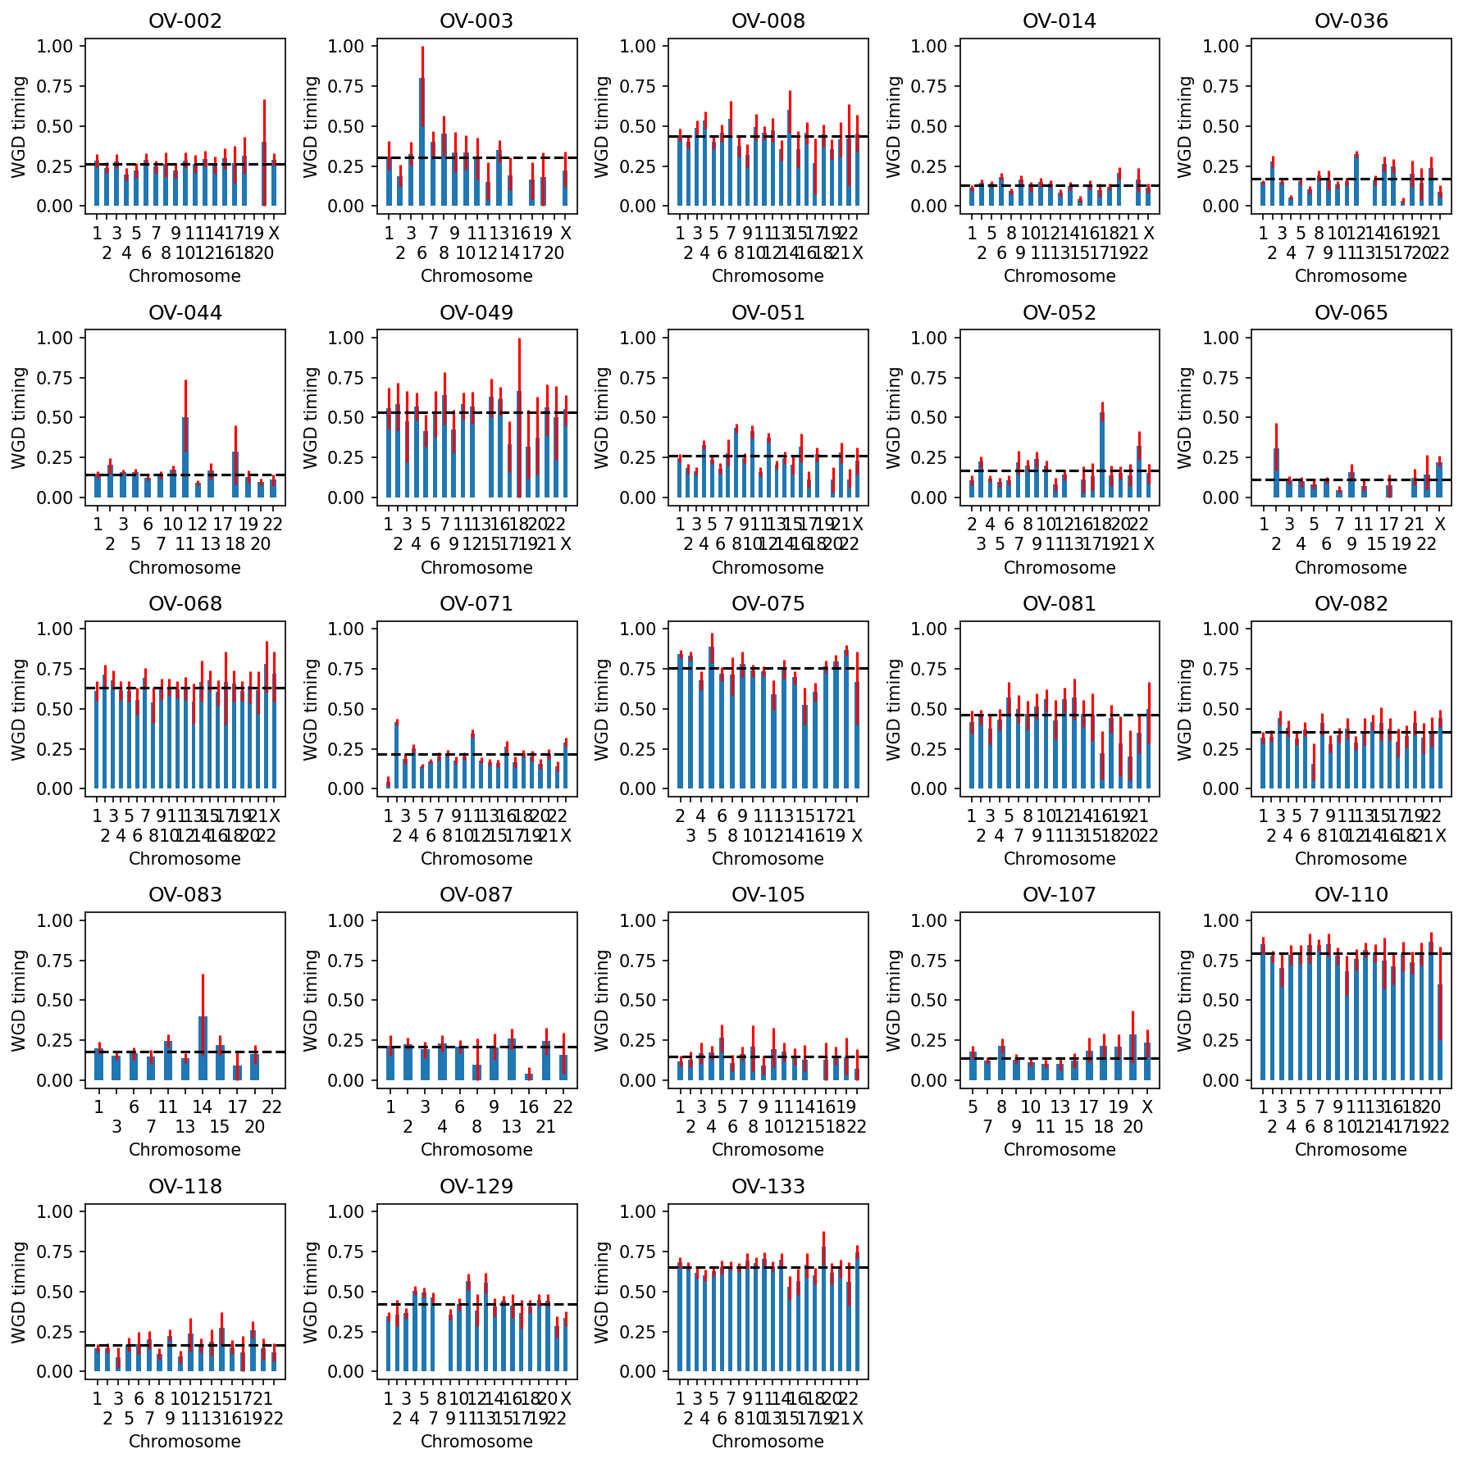
Supplementary Figure 17: doubleTime WGD timing estimates split by chromosome. Only those chromosomes with clonal SNVs that can be used for doubleTime are shown (see Methods for details). Red lines show bootstrapped 95% confidence intervals. Horizontal dashed black lines indicate the overall timing inferred by doubleTime for each patient from SNVs across the genome.

3.4. Downsampling read counts to evaluate WGD heuristic
To evaluate the robustness of WGD calls to downsampling, we performed an in silico experiment in which we downsampled read counts from all filter-passing cells for the 10 patients with the highest per-cell coverage, then ran our copy number calling pipeline including WGD calling. We then evaluated the WGD calls from downsampled data, using the original WGD calls as ground truth. We found that the accuracy of WGD calling remained above 80% and the precision remained above 92% at coverage as low as 0.025X (Supplementary Fig. 18A). The number of false positive WGD calls was fairly high at the lowest coverage we tested (0.01X-0.03X), but decreased dramatically as coverage increased: no simulated dataset with mean coverage above 0.11X had a single false positive WGD call, and no simulated dataset with mean coverage above 0.06X had more than 1 false positive WGD call (Supplementary Fig. 18B). For reference, in the real scWGS data, 41/41 patients have mean coverage above 0.025X, 39/41 patients have mean coverage above 0.05X, and 35/41 patients have mean coverage above 0.06X. Note that this experiment omits the post-hoc filtering that we applied to the real dataset (e.g., inspecting DLP images, requiring a sufficiently large odd-copy-number segment, etc.).

We also examined how “mixed WGD” status changed as a function of coverage in this downsampling experiment. 9/10 patients were estimated to have mixed WGD in the original dataset, and for these patients all simulated datasets also yielded mixed WGD. The exception was patient OV-065 whose samples originally consisted entirely of 1xWGD cells, whereas we incorrectly identified 2xWGD cells in 25/36 (70%) of simulated datasets from this patient.

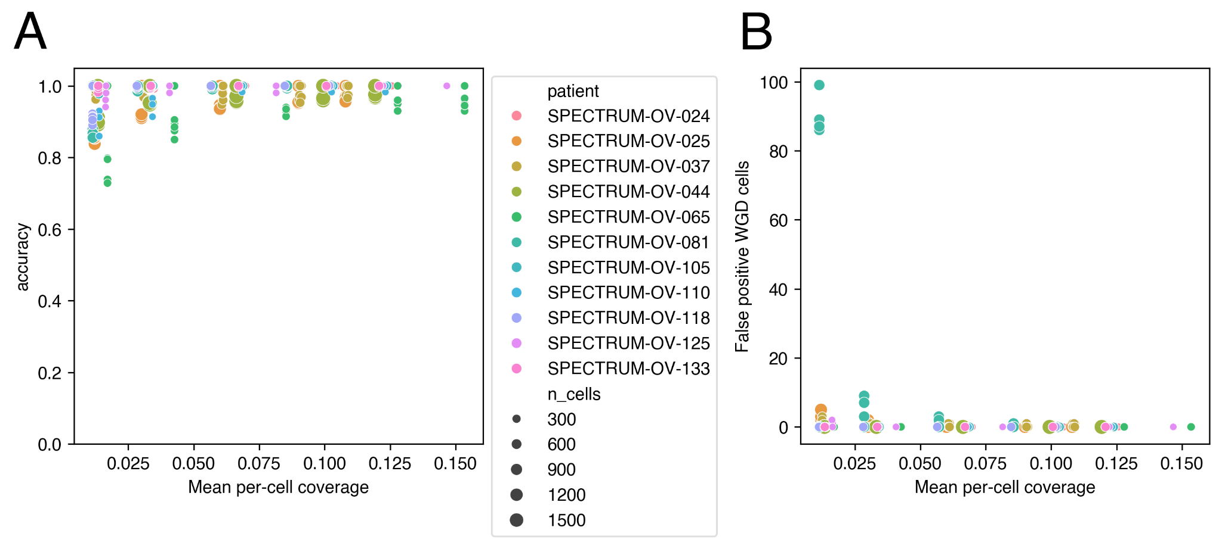
Supplementary Figure 18: Results from calling WGD on downsampled read counts as measured by accuracy (left y-axis) and the number of false positive WGD cells (right y-axis) compared to the mean per-cell coverage for the simulated dataset (x-axis). The 10 patients with the highest per-cell coverage were included. The size of each point indicates the total number of cells included in the simulated dataset.

4. Mixed WGD multiplicities

4.1. Support for mixed WGD multiplicities
While 40/41 patients had at least 1 cell in the non-majority WGD multiplicity, most patients had multiple cells supporting their “mixed WGD” status: 37/41 patients had at least 2 cells that are not in the most-abundant WGD multiplicity, 30/41 patients had at least 5 cells, 21/41 patients had at least 10 cells, and 12/41 patients had at least 25 cells (Supplementary Fig. 19).
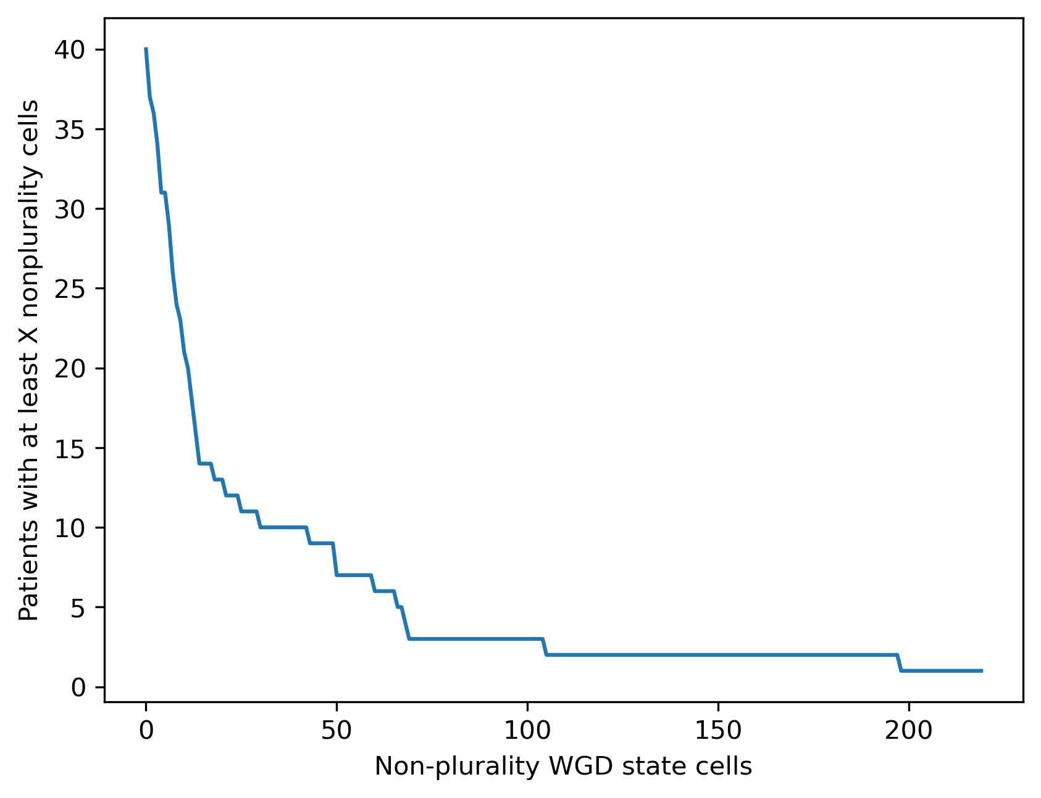
Supplementary Figure 19: Number of cells supporting mixed WGD multiplicities. The x-axis shows the number of non-plurality cells, and the y-axis shows the number of patients with at least x cells in the non-plurality WGD multiplicity.

4.2. Mixed WGD across anatomical sites
The patients in our cohort exhibit varying levels of WGD heterogeneity across sites. 21/41 patients have more than 1 site with filter-passing scWGS tumor cells, and all of these patients have mixed WGD multiplicities (Extended Data Fig. 3h). 16/21 patients with mixed WGD multiplicities have mixed WGD represented in more than 1 site, and 15/21 patients have mixed WGD represented in all sites (although 12/15 of these patients have only 2 sites). 11/21 patients have 3 WGD multiplicities represented, and 4/11 of these patients have all 3 WGD multiplicities represented in more than 1 site. Overall, mixed WGD multiplicities tend to be common across multiple sites, consistent with ongoing WGD. Interestingly, the only patient whose WGD classification would vary if sites were processed independently is OV-081: the infracolic omentum sample has 93% ≥1 WGD cells which would be classified as WGD-high, whereas the left adnexa sample has 99.5% nWGD cells which would be classified as WGD-low.

5. Discerning parallel WGD from shared WGD using SNVs

5.1 Method
Given two clones (i.e., sets of cells from the same patient) where all cells in both clones appear to have undergone WGD, we used SNVs in 2-copy LOH regions shared among nearly all cells to distinguish whether the cells likely underwent the same WGD event or distinct, parallel WGD events. This distinction is equivalent to the question of whether clonal divergence preceded WGD (requiring two distinct WGD events; “parallel WGD”) or followed WGD (supporting a single shared WGD event; “shared WGD”). Under the assumption that the 2-copy LOH regions common to all cells result from pre-WGD LOH that was followed by doubling to reach 2 copies, the two scenarios can be distinguished by the variant copy numbers of SNVs in these regions (Supplementary Fig. 20): if the WGD event is shared, then there should be some SNVs present at 1 variant copy in both clones, which were acquired after the WGD but before clonal divergence. However, if there are two distinct WGD events, then each clone should have exclusive mutations at 2 variant copies that were acquired after clonal divergence but before their respective WGDs (note that these may be vastly different in number between the two clones depending on the relative timing of the WGDs in each clones’ ancestry post-divergence). SNVs with other combinations of variant multiplicities do not distinguish between the two scenarios. SNVs at 1 variant copy in one clone and 2 variant copies in the other are discordant with both scenarios, and may suggest that our assumption about the origin of the LOH containing these SNVs is false.
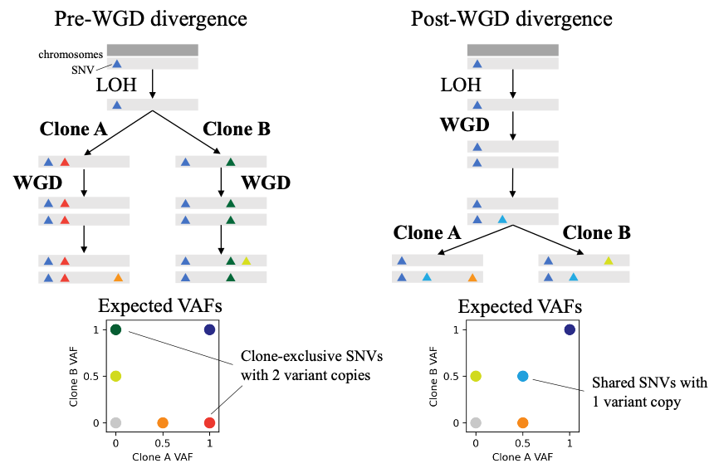
Supplementary Figure 20. Model for using SNVs in snLOH regions to distinguish between pre-WGD divergence of two clones (left) and post-WGD divergence (right). Rectangles indicate chromosomes and colored triangles indicate SNVs. The red and dark green SNVs that are each exclusive to a single clone at VAF=1 (2/2 copies) are not possible in the right model, whereas the blue SNVs that are present in both clones at VAF=0.5 (1/2 copies) are not possible in the left model.

For each pair of SBMClone clones inferred for each patient, using a simple binomial model of alternate read counts, we estimated the likelihood of each scenario by inferring the most likely variant copy numbers of each SNV using the respective scenario’s permitted combinations of variant copy numbers for the two clones: both scenarios include SNVs with copies 2/2 (shared pre-WGD), 1/0 or 0/1 (exclusive post-WGD), 0/0 (rare or absent); shared WGD includes 1/1 (shared post-WGD pre-divergence), and parallel WGD includes 2/0 and 0/2 (exclusive post-divergence post-WGD). We tested the relative fit of these two scenarios using a likelihood ratio test. To evaluate how significantly the observed counts different from the shared-WGD scenario, we generated a null distribution by resampling alternate counts given the observed total read counts under the assumption that the best-fitting variant copy number states under the shared-WGD hypothesis were correct. We then computed a z-score by comparing the observed test statistic to this empirical null distribution. In Supplementary Fig. 21, we show these two statistics for the best-scoring bipartition of SBMClone clones for each patient (excluding 2 patients with low cell counts, 15 low-WGD patients, and 8 patients in which SBMClone did not identify multiple SNV clones).
​​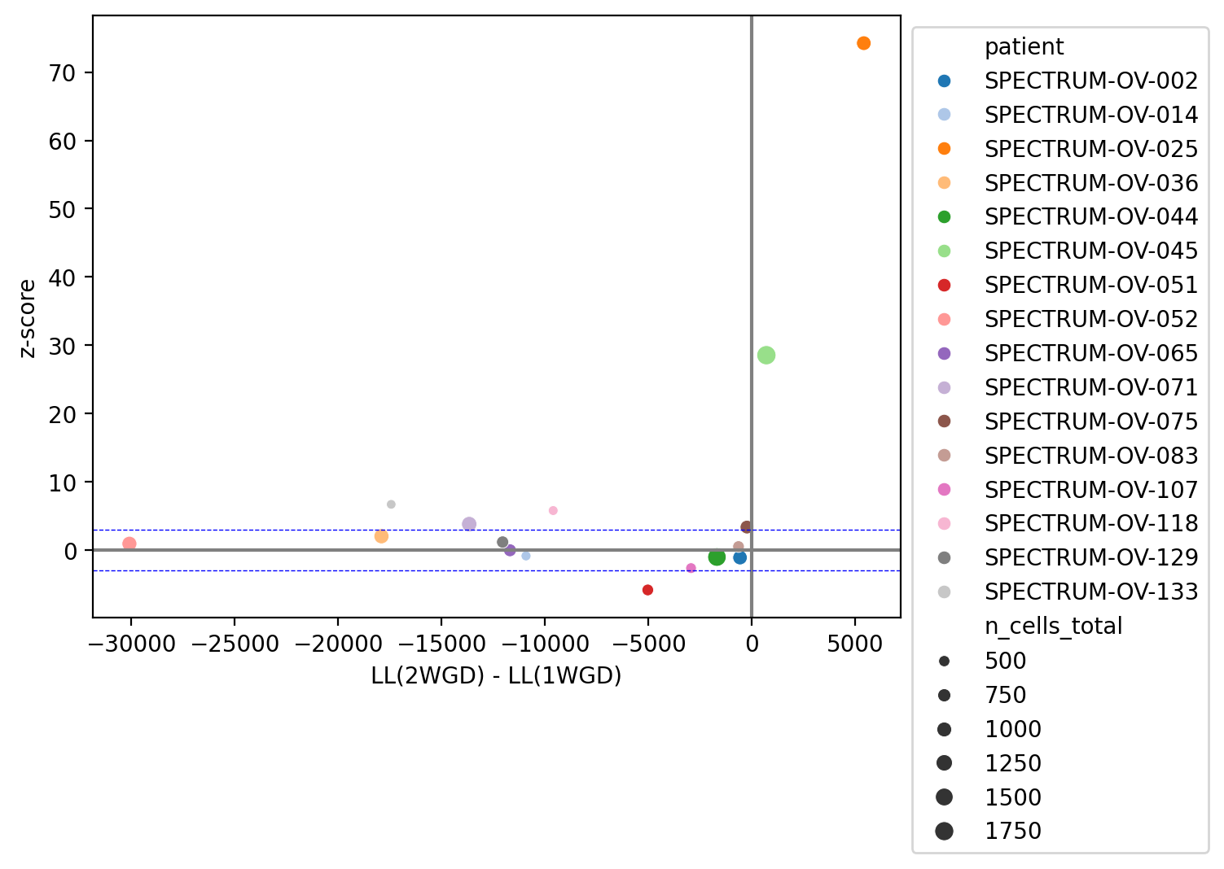
Supplementary Figure 21. Results from applying likelihood ratio test to SNVs in cnLOH regions in WGD-high tumors. The x-axis shows the difference between the log-likelihood of the parallel-WGD scenario (“2-WGD”, i.e., pre-WGD divergence) and the log-likelihood of the shared-WGD scenario (“1-WGD”, i.e., post-WGD divergence), and the y-axis shows the z-score of the test statistic compared to the empirical distribution.

We found that two patients, patient OV-025 and patient OV-045, showed evidence for multiple WGD events. When we tested all pairs of clones for these two patients to better resolve the WGD events, we found that patient OV-045 showed evidence for 3 parallel WGD events.

5.2. Validating parallel WGDs in patient OV-045
In patient OV-045, Clone 0 and Clone 2 were each distinguished from the other clones by a large number of mutually exclusive SNVs in the upper left and bottom right corners (91 and 101 SNVs, respectively), and the small number of SNVs shared at intermediate VAF in the center (54 and 25 SNVs, respectively) were likely affected by subclonal or small undetected copy-number events (Supplementary Fig. 22). Support for or against independent WGD depends also on the number of SNV-covering reads for the respective SNV in the relevant clones, which is not shown.
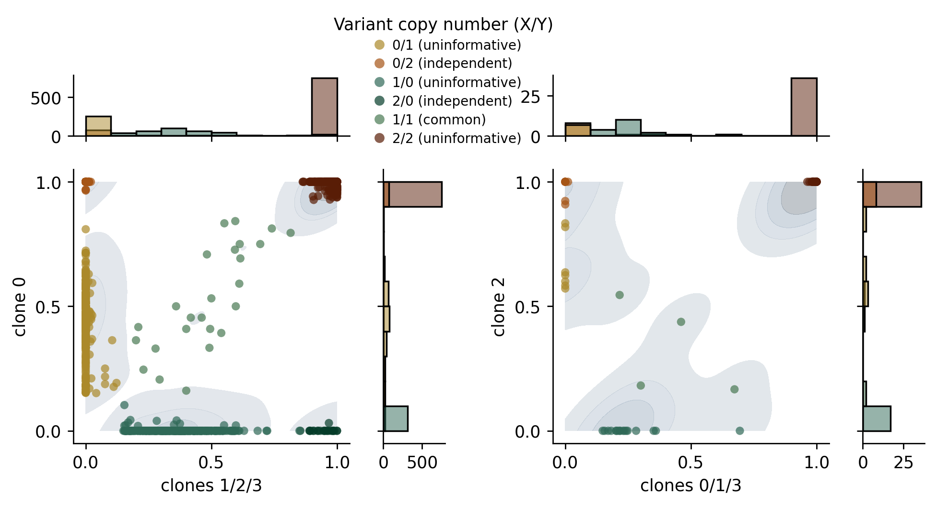
Supplementary Figure 22. Pairwise VAFs between parallel WGD events for patient OV-045. Each plot shows a clone inferred to have undergone a unique WGD event on the y-axis, clone 0 (left y-axis) and clone 2 (right y-axis), compared to the remaining 3 clones (x-axis). Each point is an SNV colored by its most likely variant copy number in each partition: mutually exclusive SNVs with 2 variant copies (2/0 or 0/2) support independence, while shared SNVs with 1 variant copy in each partition (1/1) oppose independence. Marginal histograms show total numbers of SNVs. Only those SNVs with at least 10 covering reads in both partitions are shown. SNVs that are assigned variant copy numbers 0/0 (absent from both clones) or 2/1 or 1/2 (inconsistent with the simple cnLOH WGD model) are omitted.

However, the above analysis overestimated the number of shared SNVs, as it relied on genotyping SNVs in groups of clone(s) rather than individual clones. When we instead examined the 2-variant-copy SNVs at the clone level (Supplementary Fig. 23), we found 171 SNVs (supported by 17,812 SNV-covering reads) that distinguished clone 1 from clones 0/2/3 (rows 0 and 2), and 93 SNVs (supported by 9,723 SNV-covering reads) that distinguished clone 0 from clones 1/3 (rows 1 and 3). The lower 4 rows of the table are inconclusive as they include few SNVs and few supporting reads.

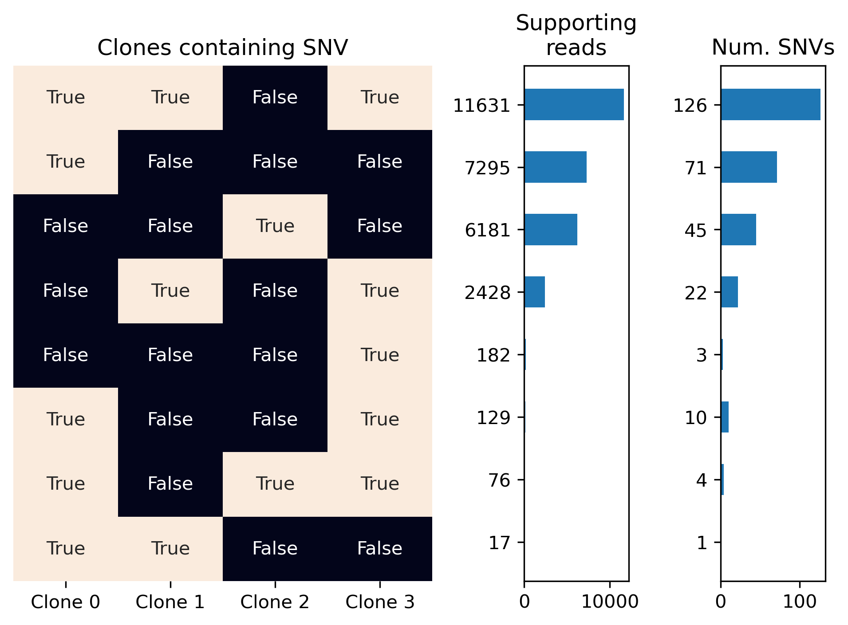
Supplementary Figure 23: For patient OV-045, the SNVs present at either 0 or 2 copies for all SBMClone clones are grouped by the subset of clones that harbors them. The left subplot indicates the subset of clones containing each set of SNVs, the left barplot shows the total number of SNVs in the set, and the right barplot shows the supporting reads, i.e., the total number of reads overlapping the SNV positions for all cells. This figure omits the set of 521 SNVs present at 2 copies in all clones with a total of 64,339 supporting reads.

5.3 Sensitivity evaluation using simulated data
To evaluate the sensitivity of our parallel WGD test to the number of sequenced cells, we subsampled cells from patients OV-025 and OV-045 and evaluated how many cells were required to arrive at a significant result. Specifically, for each bipartition, we randomly sampled 1%-50% of the cells, aggregated their SNV counts, and recomputed the log-likelihood ratio score and its p-value and z-score using the same permutation test described in Methods. We found that the statistical test consistently produced a significant result (z > 2.33, which corresponds to a p-value of 0.01 under the assumption that the sampling distribution is normal) with as few as 200 total cells and as few as 45 cells in the smaller partition (Supplementary Fig. 24).
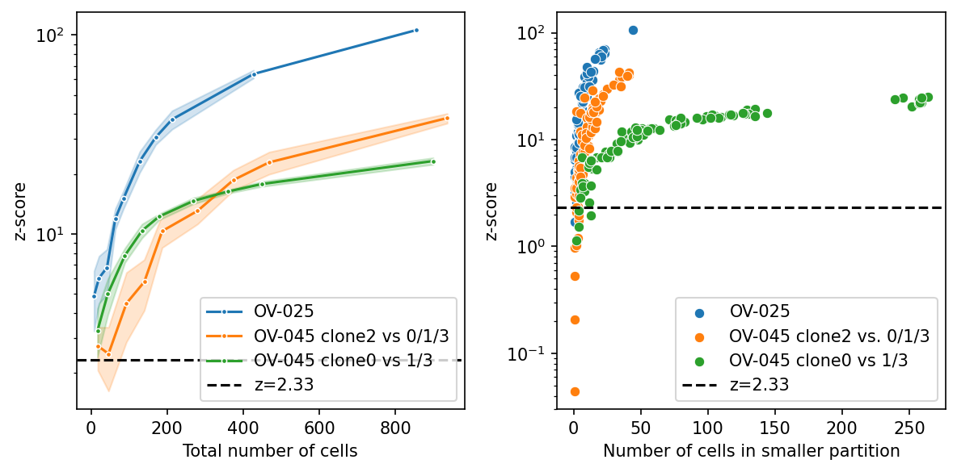
Supplementary Figure 24. Results from applying parallel WGD test on a subset of cells from each clone. The y-axis shows the z-score for the permutation test statistic, and the x-axis shows the total number of cells (left) and the number of cells in the smaller partition (right). The dashed black line indicates a z-score of 2.33 which would correspond to the 99th percentile of scores in a standard normal distribution. OV-045 clone 0 is the larger of the two clones with an isolated (clone-specific) WGD event.

6. Benchmarking estimation of chromosomal instability using simulations

6.1 Generation of simulated data

We used CINner²⁵, a simulation framework for single-cell copy number evolution, to benchmark our method for estimation of rates of chromosomal instability. Every CINner simulation starts with 1,000 diploid cells. Cell lifetimes are exponentially distributed with the same rate. Cell $i$ has fitness $f^{i}$ and either divides with probability $p(div)^{i}$ or dies with probability $1-p(div)^{i}$ at the end of its life. The formulae for $f^{i}$ and $p(div)^{i}$ follow below.
- Formula for $f^{i}$ for cell $i$ with CN profile $\left\{c_{k}\right\}$ (where $c_{k}$ is the count of chromosome $k$) and ploidy $p$ (average of $\left\{c_{k}\right\}$ weighted for chromosomes’ lengths):
  - $f^{i}=0$ if any of the following conditions is satisfied: (viability checkpoints)
    - $c_{k}=0$ for any $k$.
    - $c_{k}>8$ for any $k$.
    - $p>4.5$.
  - Otherwise, $f^{i}=\prod_{k}{}{s_{k}}^{2c_{k}/p}$.
- Formula for $p(div)^{i}$:
  - $p(div)^{i}=\frac{N}{1000+N}⋅\frac{f^{i}⋅N}{\sum_{j=1,⋯,N}{}f^{i}}$ where $N$ is the total cell count.
  - The first fraction is to ensure the total population does not diverge from 1,000.
  - The second fraction models the selection.
- Variables:
  - $p_{WGD}$ = probability that a WGD event occurs in a cell division.
  - $p_{misseg}$= probability that a selective missegregation event occurs in a cell division. If the event happens, a chromosome chosen at random (with uniform distribution) is gained in one daughter cell and lost in the other. These events are “selective” because they change the cell’s $f^{i}$ and therefore its $p(div)^{i}$, detailed below.
  - $p_{neu-misseg}$= probability that a neutral missegregation event occurs in a cell division.
  - $s$ = selection rate.
- Role of selection rate $s$:
  - Every chromosome $k$ is assigned a selection rate $s_{k}$.
  - For a random half of the chromosomes (“OG chromosomes”), $s_{k}=1+s$. Gains of these chromosomes increase $f^{i}$ (therefore rendering the cell more selective), and their losses decrease $f^{i}$.
  - For the other chromosomes (“TSG chromosomes”), $s_{k}=\frac{1}{1+2⋅s}$. Losses and gains of TSG chromosomes increase and decrease $f^{i}$ respectively.
  - Note that losses of TSG chromosomes are “twice as selective” compared to gains of OG chromosomes (although all events are equally likely to occur). Therefore, TSG chromosome losses are more likely to be fixed, i.e. becoming clonal.
- Simulation process:
  - Step 1 – clonal evolution: Clonal populations are simulated in forward time. At any step, a given clone might give rise to new subclones at given rates of $p_{WGD}$ and $p_{misseg}$. Note that here only the dynamics of clonal cell counts is simulated. Also recorded is the division count in each clone during each time step.
  - Step 2 – sample phylogeny: Once the clonal populations at the final time are known, their phylogeny is simulated in backward time. At each time step, nodes belonging to the same clone are sampled using the clone’s division count from step 1 for coalescence.
  - Step 3 – neutral variations: Once the phylogeny of the final cell population is finished, the algorithm simulates neutral missegregations in forward time from the MRCA node to the leaves. At each edge, the count of neutral missegregations is simulated with rate $p_{neu-misseg}$ and count of cell divisions along the edge. Neutral missegregations do not have any role in $f^{i}$ and therefore do not affect selection forces (already simulated in step 1). However, they are conditioned to not violate the 3 viability checkpoints, or alter the CN in any chromosome that will be changed in a selective event further down the branch in the phylogeny. If no chromosome qualifies, then no neutral missegregations are allowed on the edge.
  - Step 4 – readcounts: Let $\left\{n_{j}\right\}$ be the vectorized CN profile of a given cell, where $n_{j}=$ CN in bin $j$, and $\left\{g_{j}\right\}$ be the vector of GC content per bin and $r$ be the total read count per cell ($\left\{g_{j}\right\}$ and $r$ are the same for all cells). Then with variables $s$and $σ$, the readcounts per bin of the cell $\left\{r_{j}\right\}$ are simulated as below:
    - $\left\{n_{j}'\right\}=s⋅\left\{n_{j}\right\}⊗\left\{g_{j}\right\}$, where $⊗$ denotes element-wise product
    - $\left\{n_{j}''\right\}∼Gamma\left(shape=\frac{\left\{n_{j}'\right\}}{σ},scale=σ\right)$
    - $\left\{r_{j}\right\}∼Multinomial\left(size=r,probabilities=\frac{\left\{n_{j}''\right\}}{\sum{}|n_{j}''|}\right)$
In the simulations, we use $s=3906632$ and $σ=0.02642392$ (from previous fitting for OV2295 sample).
Simulation ends after an average of 300 generations, and cell population is expected to stay constant throughout. All cells at the end are sampled, and their CN profiles are recorded.

6.2 Results on simulated data
To assess the accuracy of our approach for estimating the rate of chromosome-level copy-number changes from a population of cells, we generated 1,000 simulated datasets varying the missegregation rate and WGD rate (Supplementary Fig. 25). We applied the same approach for inferring chromosomal instability rates as was used on real data in the main text: we reconstructed phylogenetic trees using MEDICC2, then applied the Sankoff algorithm to reconstruct ancestral copy-number profiles using an independent-bin maximum-parsimony model, and finally called events on each branch using a greedy approach (see Methods for details).

Both the inferred chromosome event rate and the inferred WGD rate were strongly correlated with the corresponding simulation parameters (Pearson correlation $p<10^{-63}$), although the coefficient of determination for chromosome events ($R^{2}=0.852$) was much higher than that for WGD ($R^{2}=0.496$ for WGD), likely because not all WGD events are detectable or distinguishable from chromosome-level events in sample cells.

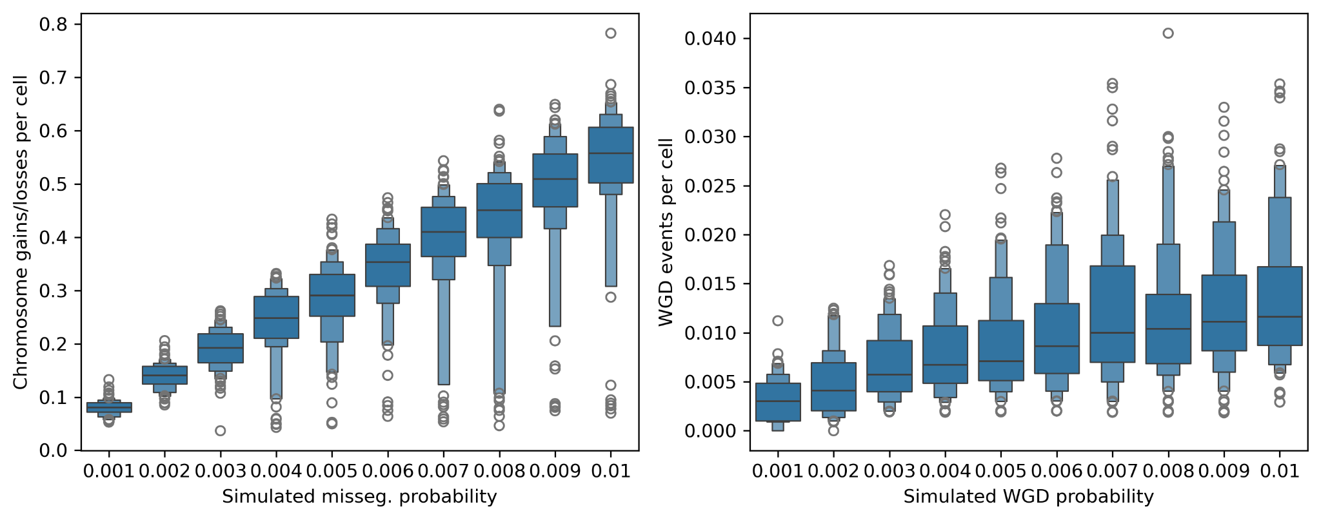
Supplementary Figure 25. Chromosomal instability rate inference benchmarking results. Benchmarking inferred chromosome gain/loss rates (y-axis, left) and WGD rates (y-axis, right) using simulated data with varying missegregation probability (x-axis, left) and varying WGD probability (x-axis, right).

7. Extended SBMClone results and validation

7.1. SBMClone block density matrices
SBMClone takes as input a matrix of cells by SNVs and groups cells into clones (y-axis) and SNVs into SNV blocks (x-axis). In Supplementary Fig. 26, for each patient, each entry is the percentage of nonzero values in the submatrix whose rows consist of the cells assigned to the corresponding clone and whose columns consist of the SNVs assigned to the corresponding SNV block. Only the 31 patients for which SBMClone identified more than 1 clone are shown.
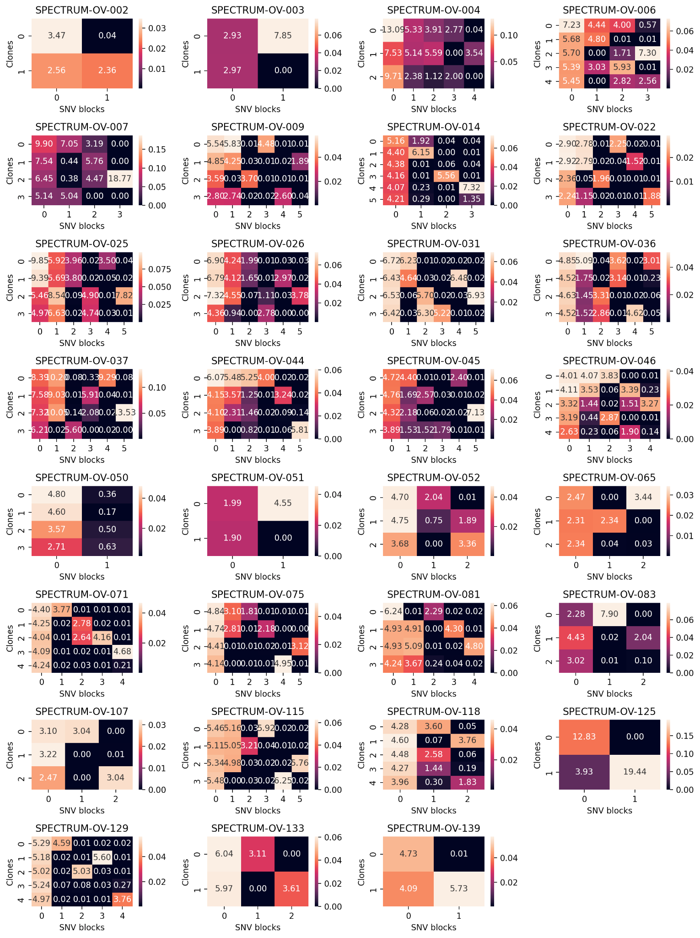
Supplementary Figure 26. SBMClone results for all patients. For each clone (set of cells) and SNV block (set of SNVs) inferred by SBMClone, we show the percentage of positive entries in the submatrix whose rows correspond to cells in the clone and whose columns correspond to SNVs in the SNV block.

7.2. Confidence in SBMClone clone assignments
To assess the strength of the assignment of each cell to its SBMClone clone, we evaluated the silhouette score of the SBMClone clusters in SNV space as follows (Supplementary Fig. 27). For each cell, we computed the proportion of SNVs in each SBMClone SNV block for which it had alternate reads – i.e., we computed the density of each SNV block in each cell. Then, using these density vectors to represent each cell, we computed the silhouette score of the SBMClone clone assignment (with Euclidean distance). Each cell (y-axis) is colored and labeled by the SBMClone block to which it was assigned. Positive silhouette coefficients correspond to cells that are nearby others in the same clone and distant from cells in different clones, whereas negative values represent cells that are no more likely than by chance to be placed in their respective clusters.
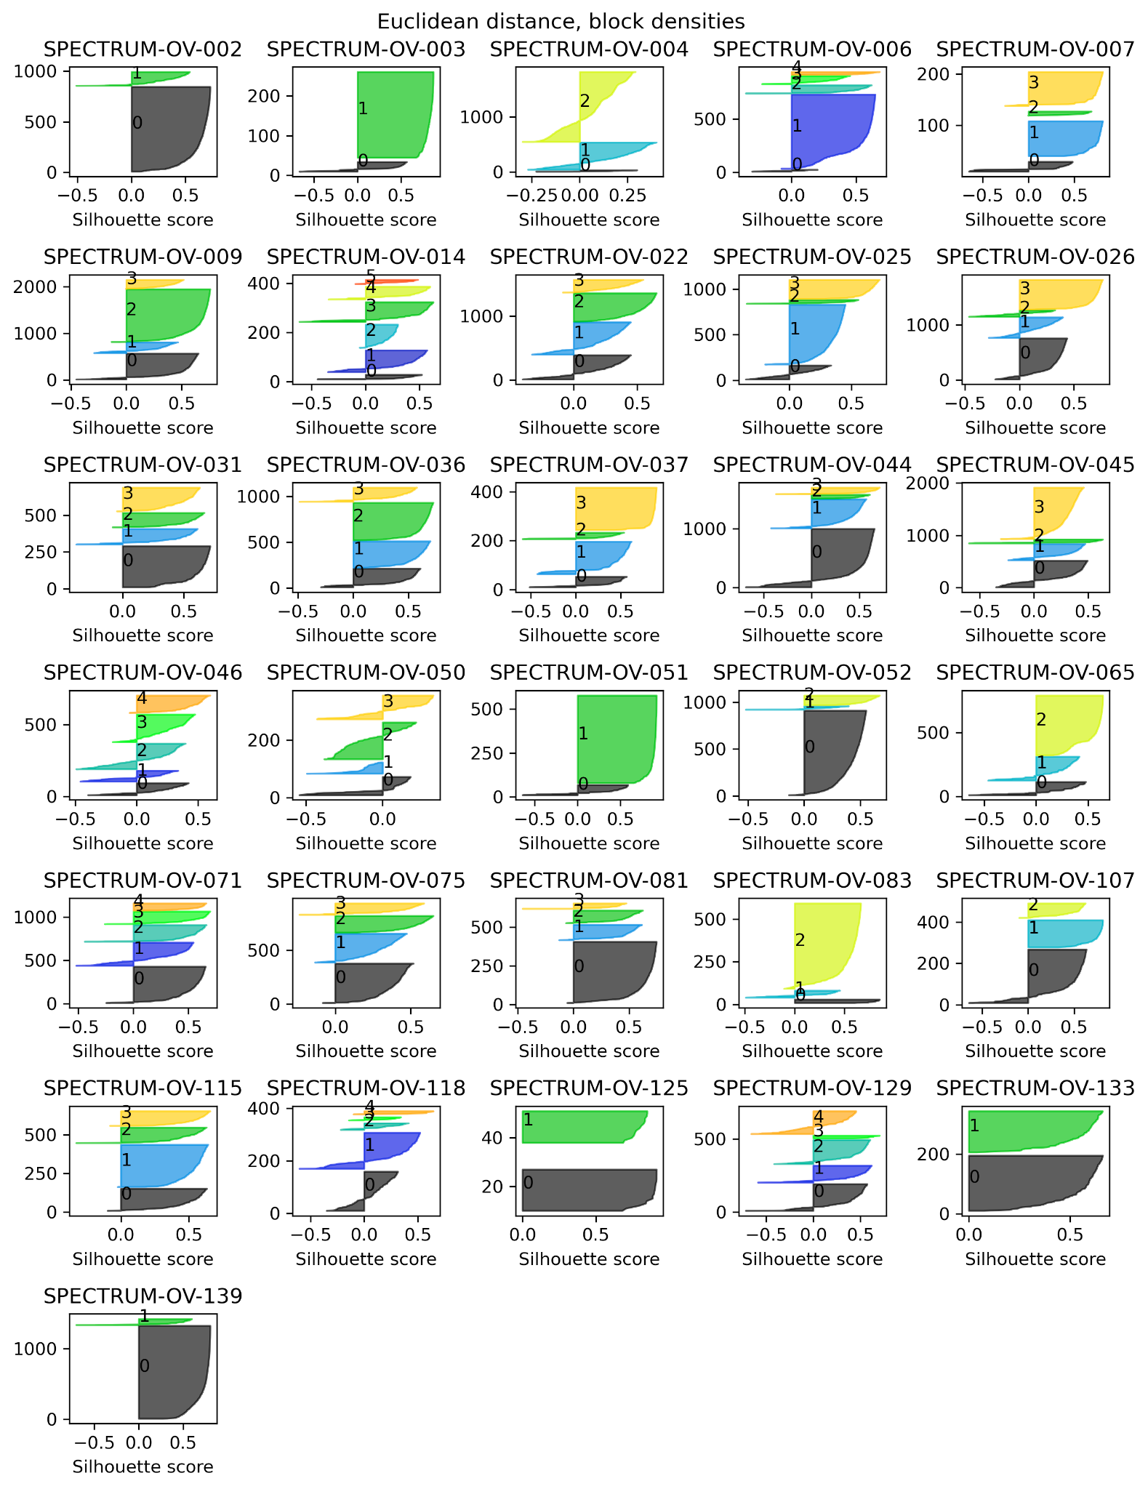
Supplementary Figure 27. Silhouette scores evaluating the consistency between the SBMClone clones and the cells’ SNV block density profiles.

7.3. Consistency between SBMClone clusters and copy-number states
To evaluate the consistency between SNV-based SBMClone clones and cell copy numbers, we examined the copy-number profiles for the 31 patients in which SBMClone inferred more than 1 clone. Specifically, for each of these patients, we computed the silhouette score of the SBMClone cluster labels using Euclidean distance on the cells’ haplotype-specific copy-number profiles (Supplementary Fig. 28). Positive silhouette scores indicate cells whose SBMClone clone is dense and well-separated in copy-number space, and negative scores indicate cells that are not associated with a well-defined cluster in copy-number space. Overall, most clusters for most patients are fairly consistent between these orthogonal mutation signals, and exceptions often correspond to patients without obvious copy-number subclones (e.g., patient OV-007).
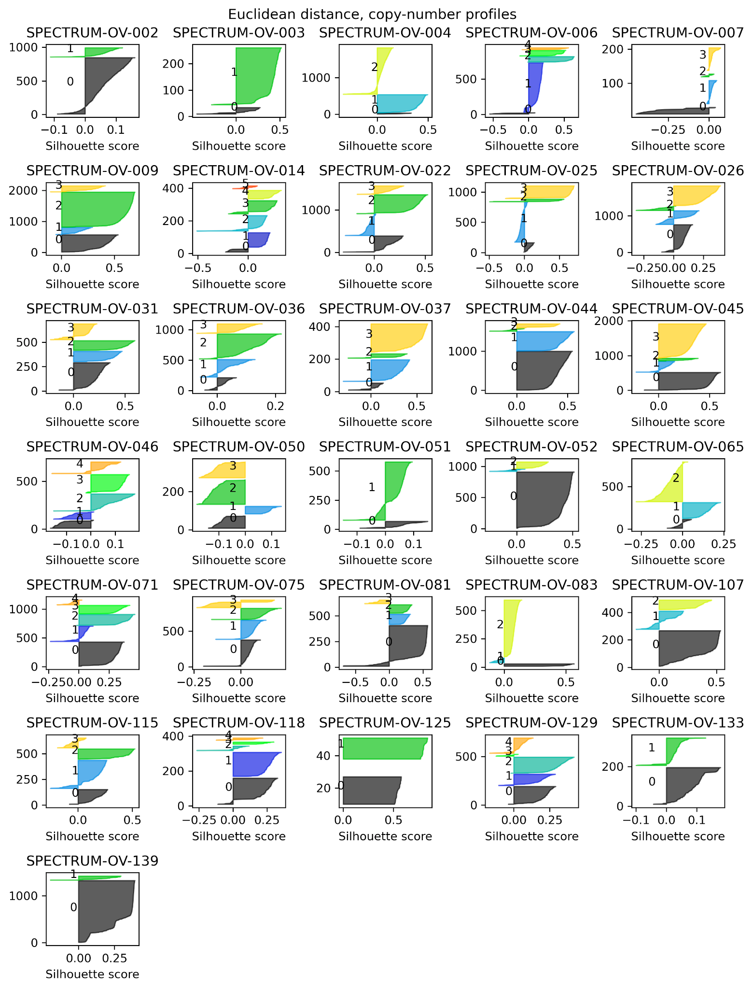
Supplementary Figure 28. Silhouette scores evaluating the consistency between the SBMClone clones and the cells’ haplotype-specific copy-number profiles.

8. Extended doubleTime results

8.1. Normalizing branch lengths to account for SNV detection sensitivity
To evaluate the impact of clone size on the number of clone-specific SNVs recovered, we conducted a simulation experiment in which we randomly subsampled cells, reran our mutation calling pipeline for each random subsample, and then evaluated how many SNVs that were clonal in the original sample were recovered in the subsample. Specifically, for 4 patents with the most cells (OV-004, OV-009, OV-022, and OV-026), we performed the following:
- Randomly sample [20, 40, 80, 120, 160, 300, 500, 750, 1000] cells 20 times each.
- For each sample:
  - Combine reads from sampled cells into a new BAM file.
  - Call SNVs using Mutect.
  - Filter SNVs using ArtiCull.
  - Measure the proportion of clonal SNVs originally identified in the patient that passed ArtiCull filtering in the new sample.

We then computed the haploid coverage for each of these samples, and estimated the relationship between haploid coverage and sensitivity by fitting a logistic curve (Fig. 2a, right side). We used this curve to adjust the branch lengths of the doubleTime trees shown in Fig. 2 to account for the haploid coverage of each leaf (i.e., by dividing the assigned number of mutations by the expected sensitivity to detect mutations at the corresponding coverage).

8.2. Assignment of SNVs to clone tree branches
To assess how well SNVs were assigned to clone tree branches (see Methods for details), we grouped all (SNV, clone) pairs for each patient into those in which the SNV was inferred to be present in the clone (i.e., the SNV was assigned to a branch ancestral to the clone) and those in which the SNV was inferred to be absent (i.e., the SNV was assigned elsewhere on the tree or inferred to be absent from all clones). Supplementary Fig. 29 shows the SNV VAFs in clones in which the corresponding SNV was inferred to be present, colored by the clone. Supplementary Fig. 30 shows VAFs for those (SNV, clone) pairs in which the SNV was inferred to be absent.
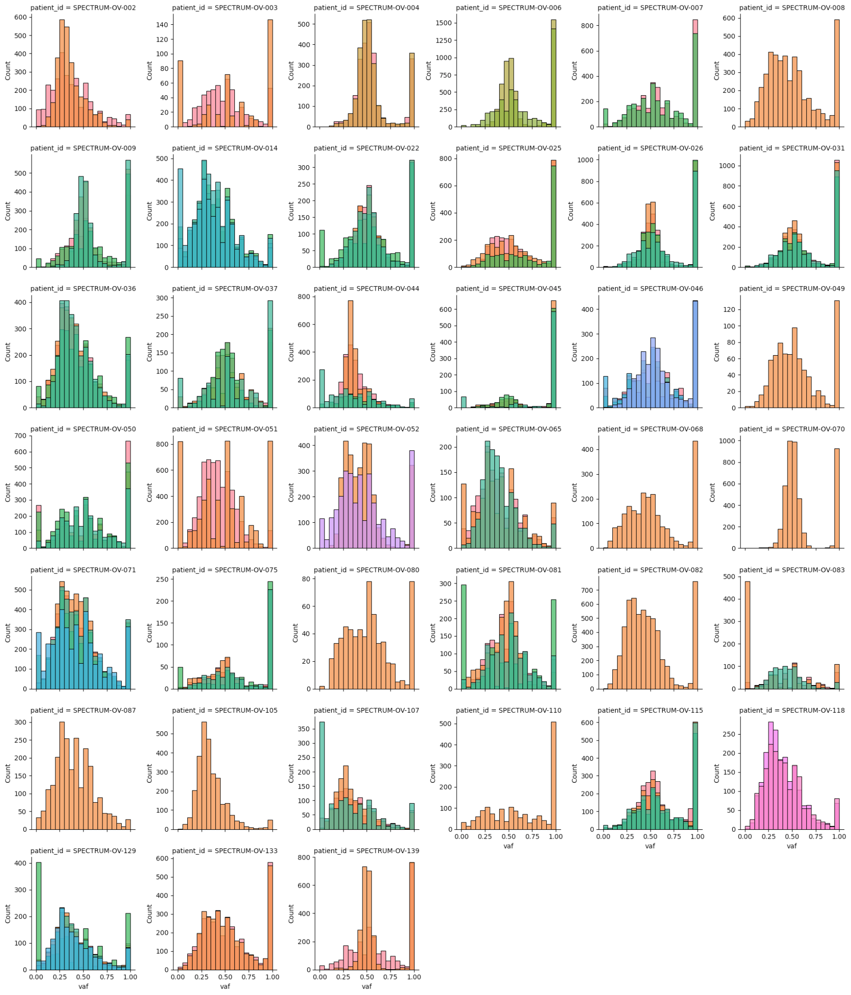
Supplementary Figure 29. VAFs for SNVs inferred to be present in the corresponding clone for each patient.

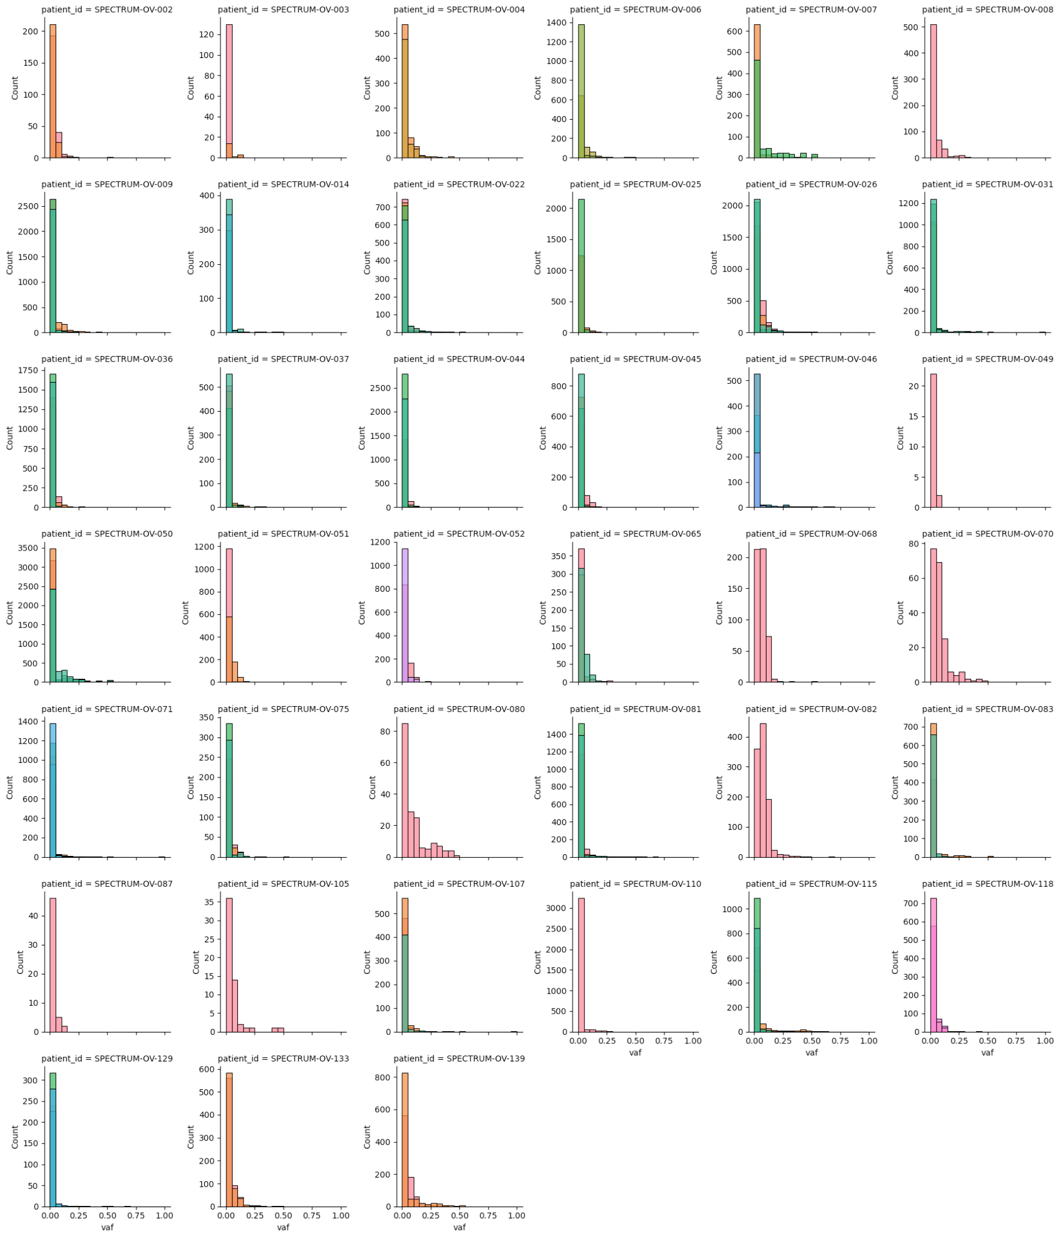
Supplementary Figure 30: VAFs for SNVs inferred to be absent in the corresponding clone for each patient.

8.3. SNV VAFs by doubleTime-assigned clade
In Supplementary File 2 we include a plot for each patient showing the distribution of VAFs for all SNVs assigned to branches of clone trees, faceted by both the branch to which the SNVs were assigned (row) and the clone in which their VAFs are measured (column). In each facet, SNVs are split by the allele-specific copy number of the overlapping region, and vertical lines denote the expected mean of the VAF distribution for each copy-number state.

9. Multi-modal sample matching
For integrative genotype-phenotype analyses, we utilized scRNA-seq data patient-matched with scWGS to profile cell type-specific abundance and gene/pathway activity changes in the context of WGD (Fig. 6). Given the clonal nature of each sample’s WGD status, we reasoned that tumor cells identified in scRNA-seq within each patient would likewise be mostly clonal WGD or not, allowing for direct comparisons across all tumor cells in each patient. Indeed, site-matched scWGS and scRNA-seq derived estimates of copy number were highly concordant (Supplementary Fig. 31A), with UMI count ratios between tumor and normal cells being significantly elevated in WGD-high compared to WGD-low cases as expected (Supplementary Fig. 31B).

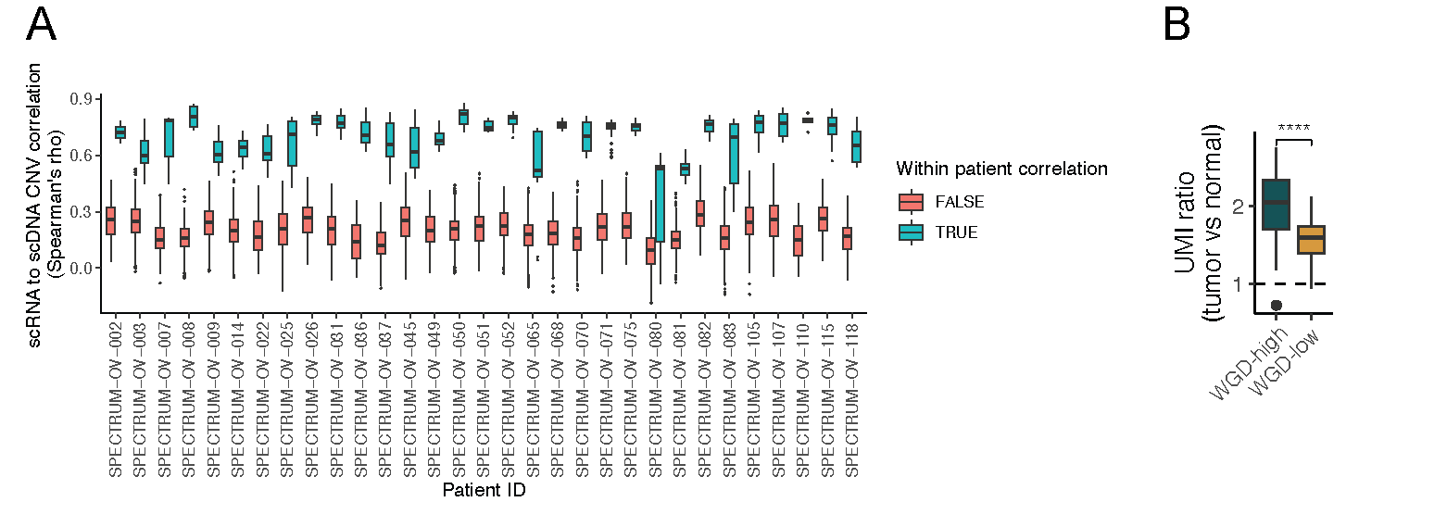
Supplementary Figure 31: Comparison between scRNA and scDNA. A. Correlation between DLP+ and scRNA based copy number. Data points for box plots are scRNA inferCNV copy number clusters. The y-axis shows correlation between each DLP+ SBMClone cluster and each scRNA copy number cluster from the same patient (blue). As a comparator we show the same correlation computed with each DLP+ SBMClone cluster from any other patient (red). B. Ratio of cancer cell UMI counts to fibroblast and endothelial cell UMI counts, averaged within each patient. Patients are grouped by WGD-low vs WGD-high.

10. Residual 0×WGD cells
We inspected all 0xWGD cells in WGD-high tumors to determine which cells were likely to represent “residual” cells that shared a pre-WGD MRCA with the predominant WGD population, rather than those that had experienced post-WGD chromosomal instability and/or multipolar cell division to the extent that they were falsely classified as 0xWGD. Cells in this latter category are likely to be classified as divergent (i.e., having high dissimilarity with the most similar cell; Fig 3B, Methods).

There were 8 WGD-high tumors with 0xWGD cells, 4 of which had only divergent 0xWGD cells. Of the patients with non-divergent 0xWGD cells, patients OV-045 and OV-075 each had multiple 0×WGD cells that shared similar profiles which closely resembled a halved version of the corresponding pseudobulk copy number profile (Extended Data Fig. 8a,c). Patient OV-081 had a large population of 0xWGD cells, also resembling a halved version of the 1xWGD populations, and strong sample-specific WGD patterns (Fig. 2B). The remaining patient OV-125 with non-divergent 0xWGD cells had too few cells to be included in doubleTime analysis (i.e., no SBMClone clones with at least 20 cells) and was thus omitted from related analysis of residual cells. We deemed all non-divergent cells from OV-045, OV-075, and OV-081 to be high-confidence residual 0×WGD cells which likely shared a pre-WGD MRCA with the WGD cells.

By contrast, the 0×WGD cells for OV-087, OV-051, OV-107 and OV-110 were all classified as ‘divergent’. Patient OV-087 harboured 5 0×WGD cells, each of which was distinct, and all had sustained appreciable amounts of homozygous deletion (Extended Data Fig. 6d). We suspect these cells were more likely to be the result of multipolar cell division than sharing a pre-WGD MRCA. Patients OV-051, OV-107 and OV-110 harboured 2, 1, and 1 0×WGD cells respectively (Extended Data Fig. 8b,e,f).

11. Legends for Supplementary Data files

11.1 Supplementary Data 1 legend
To support the shared WGD in WGD-high tumors besides OV-025 and OV-045, in Supplementary Data 1 we include pairwise VAF plots for clonal cnLOH SNVs plotted for each pair of SBMClone clones for the 13 WGD-high tumors with sufficient data. In order for a WGD-high tumor to be included, it must have multiple SBMClone clones, and it must have at least 100 cnLOH SNVs each with at least 10 covering reads for the corresponding pair of clones. Each SNV is colored by its doubleTime-inferred variant copy number for the two clones considered in the subplot: e.g., in the legend, “1/0” indicates a variant copy number of 1 for the clone on the x-axis and a variant copy number of 0 for the clone on the y axis.

11.1 Supplementary Data 2 legend
Supplementary Data 2 includes plots for each patient showing the distribution of VAFs for all SNVs assigned to branches of clone trees, faceted by both the branch to which the SNVs were assigned (row) and the clone in which their VAFs are measured (column). In each plot, SNVs are faceted by their clonal allele-specific copy-number state (color), and for each such state, a vertical dotted line in the same color indicates the expected VAF for variants in the corresponding state on the corresponding branch. SNVs assigned to a 2:1 state exhibit a bimodal distribution (accompanied by two dotted expected VAF lines) to reflect the ambiguity in assigning individual SNVs to pre-WGD or post-WGD in this case (i.e., there are multiple ways that SNVs can get to 1 variant copy – pre-WGD followed by loss on the allele with 1 remaining copy, or post-WGD on either allele).

