Supplementary information
Nanobody immunotherapy rescues behavioral deficits resulting from NMDA receptor hypofunction

Mathieu Oosterlaken ^{1,#}, Angelina Rogliardo ^{1,#}, Tatiana Lipina ^{2,#}, Pierre-André Lafon ^{1,#}, Mireille Elodie Tsitokana ¹, Mathilde Keck ³, Héloïse Cahuzac ³, Pierre Prieu-Sérandon ¹, Séverine Diem ¹, Cécile Derieux ¹, Célia Camberlin ¹, Chrystel Lafont ¹, Damien Meyer ⁴, Patrick Chames ⁴, Franck Vandermoere ¹, Philippe Marin ¹, Laurent Prézeau ¹, Denis Servent ³, Ali Salahpour ², Amy J Ramsey ², Carine Bécamel ¹, Jean-Philippe Pin ^{1,}*,@, Julie Kniazeff ^{1,$,}*,@ and Philippe Rondard ^{1,}*,@
¹ Institut de Génomique Fonctionnelle, Université de Montpellier, CNRS, INSERM, 34094 Montpellier Cedex 5, France.
² Department of Pharmacology & Toxicology, University of Toronto, Toronto, ON M5S 1A8, Canada
³ Département Médicaments et Technologies pour la Santé (DMTS), SIMoS, Université Paris Saclay, CEA, 91191 Gif-sur-Yvette, France.
⁴ Institute Paoli-Calmettes, CRCM, Aix Marseille University, CNRS, INSERM, 13009 Marseille, France.

# These authors contributed equally to this work
* These authors jointly supervised this work
$ Present address: Institut des Biomolécules Max Mousseron, Université de Montpellier, CNRS, ENSCM, 34294 Montpellier Cedex 5, France.
@ Authors to whom correspondence may be addressed. Email: jean-philippe.pin@igf.cnrs.fr, julie.kniazeff@cnrs.fr or philippe.rondard@igf.cnrs.fr

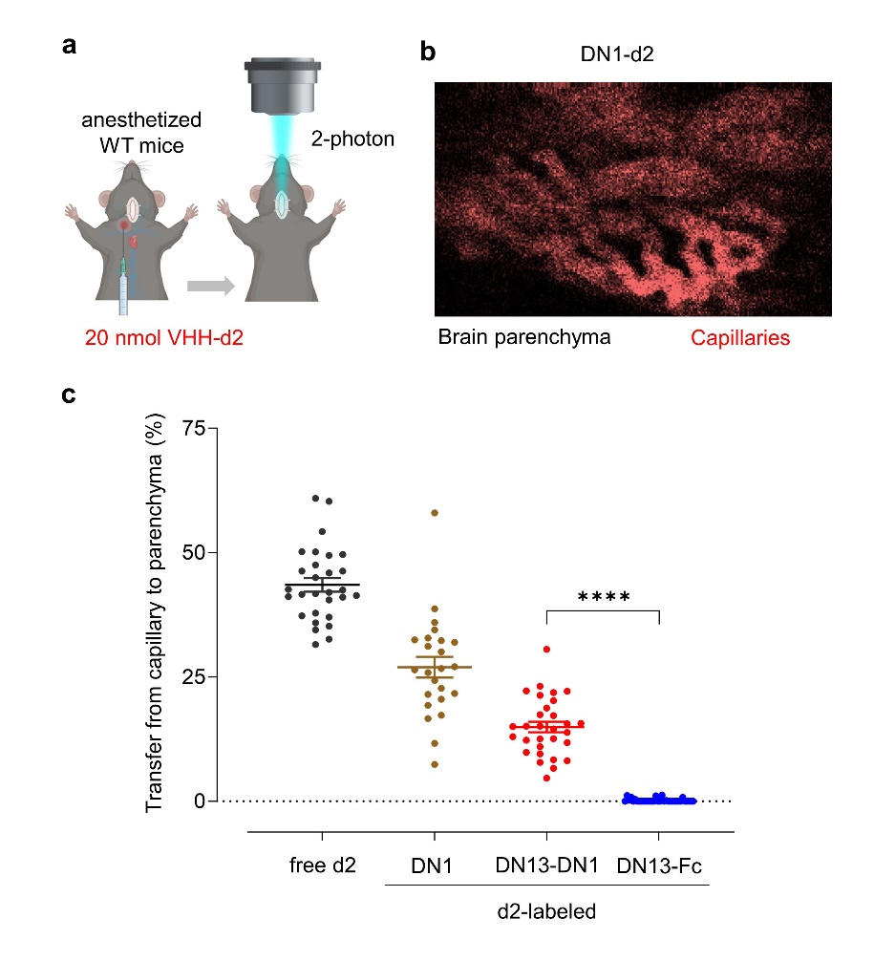

Supplementary information Figure 1
Escape of the indicated nanobody-derivatives from blood vessels to brain parenchyma in the median eminence of wild-type mouse, measured by two-photon microscopy. a, Schematic representation of the imaging setup to record the transfer of molecules from the median eminence fenestrated vessels to the brain parenchyma. The median eminence is surgically exposed in anesthetized WT mice. Nanobodies coupled to the red fluorophore d2 are then administered intravenously. The extravasation is recorded under a bi-photon microscope. b, Representative image of the fluorescence signal in the median eminence (ventral view) acquired at 8 seconds after intravenous administration of DN1-d2. The brain parenchyma is in black. The regions where the DN1-d2 is located, mainly in the capillary, appear in red. c, Percentage of nanobody transfer from capillary to the brain parenchyma of the median eminence. One dot corresponds to one spot monitored in the brain parenchyma. DN13-Fc (blue) does not reach the brain parenchyma unlike DN1 (brown) and DN13-DN1 (red). Results are presented as mean ± s.e.m. of n=4 animals at least per condition. Statistics were calculated using two-way ANOVA followed by Tukey’s multiple comparison test, **** represents p < 0.0001 in comparison with the DN13-DN1. Parts of panel a were created in Biorender. Rondard, P. (2025) https://BioRender.com/aorwzux.

Supplementary information Figure 1 Text
We investigated nanobody passage into the brain parenchyma through the fenestrated blood vessels of the median eminence, using real-time two-photon imaging. Interestingly, we demonstrated that both fluorescently labeled DN1 (15 kDa) and DN13-DN1 (30 kDa) escape blood vessels, whereas fluorescent DN13-Fc do not reach the brain parenchyma (Supplementary information 1c). We hypothesize that this rapid entry of monovalent and bivalent nanobodies occurs via passive diffusion through the fenestrated blood vessels present in the median eminence according to their size (Lee et al. Front. Neurosci 2014 – PMID 24982613; Stan J. Cell. Mol. Med. (2007) – doi: 10.1111/j.1582-4934.2007.00075.x).

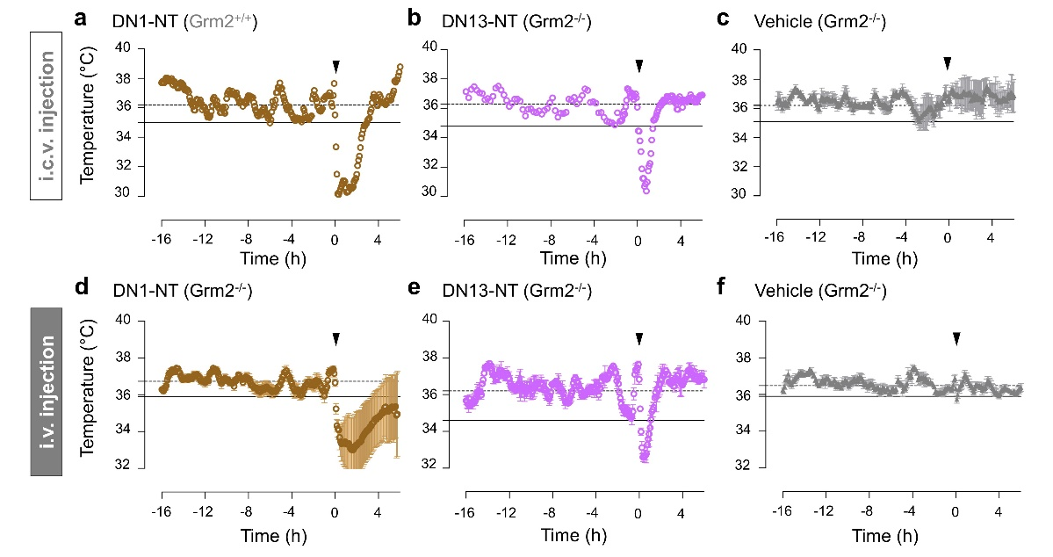

Supplementary information Figure 2
Central action of administered nanobody-neurotensin fusions on body temperature is independent of mGlu₂ receptor expression. To automatically monitor the body temperature of mice, the Anipill® (BodyCap) system was implanted after opening the abdomen. Intracerebroventricular (i.c.v.) or intravenous (i.v.) injections of DN1 (a, 5 pmol, n=1; d, 17 mg/kg, n=9; brown) and DN13 (b, 5 pmol, n=2; e, 17 mg/kg, n=2; purple) coupled to neurotensin (NT) decreases body temperature in Grm2^{-/-} mice. No decrease of temperature was observed after i.c.v. (c) or i.p. (f) injection of vehicle in Grm2^{-/-} mice. Data are presented as mean ± s.e.m.

Supplementary information Figure 2 Text
To determine whether mGlu₂ receptor was critical for brain penetration, we set up a new physiological assay based on the nanobody fusion to neurotensin (Wouters et al., Fluids Barriers CNS, 2020 – doi: 10.1128/jb.169.9.4041-4048.1987). We indirectly measured nanobody penetration into the brain by the change in body temperature induced by the peptide neurotensin when fused to our mGlu₂ nanobodies. Isolated neurotensin is not able to penetrate the brain, but when directly delivered into the brain, it induces a rapid and significant decrease in mouse body temperature. A recent study shows that intravenous (i.v.) administration of a fusion of neurotensin peptide to brain penetrating nanobodies decreases mouse body temperature, a phenomenon that can be followed by telemetry (Wouters et al., Fluids Barriers CNS, 2020 – doi: https://doi.org/10.1186/s12987-020-00226-z). By applying this method to either DN13 or DN1, i.v. administration of the neurotensin fusions led to a decrease in body temperature both in wild-type and in Grm2^{-/-} mice that do not express the mGlu₂ receptor (Supplementary information 2). This demonstrates that neither the expression of the target nor its activation (as DN1 is neutral) are necessary for the penetration of the nanobody into the brain.

Supplementary methods

Ethics
Animal care and surgical procedures were performed according to the Directive 2010/63/EU
of the European Parliament, which had been approved by the Ministry of Agriculture, France. The project was approved by the French National Ethics Committee for Animal Experimentation (CEEA) under the number APAFIS #31981-2021060423426200 v3 (for telemetry procedure) and APAFIS #45155-2023070716532519 v5 (for multiphoton in vivo imaging). All experiments were performed in accordance with relevant named guidelines and regulations.

Surgery procedures
Both male and female mice ageing 2-6 months were used to perform the in vivo experiments.
Anipill® implantation. Wild-type or Grm2^{-/-} mice were injected with buprenorphine (0.05 mg/kg, s.c.) and saline to prevent pain and dehydratation, followed by lidocaine (6 mg/kg, s.c.) before starting surgery. They were anesthetized with 5% isoflurane and placed in a stereotaxic frame with 1-2% isoflurane. To automatically measure the body temperature of socially housed mice, the Anipill® (BodyCap) system was implanted after opening the abdomen. The muscle layer was sutured with absorbable sutures (Vicryl) and the skin closed with Prolène sutures. Vetramyl was applied on top to help healing. The animals were placed in a heated recovery chamber. Additional injections of buprenorphine (0.1 mg/kg) were administered the following days of the post-op follow-up. Mice were allowed to recover for a week before any experimentation.

Guide-cannula implantation
Wild-type or Grm2^{-/-} mice were injected with buprenorphine (0.05 mg/kg, s.c.) and saline to prevent pain and dehydratation before starting surgery. They were anesthetized with 5% isoflurane and placed in a stereotaxic frame with 1-2% isoflurane. They were placed on a stereotaxic machine on which anaesthesia was maintained with 1-2% isoflurane for the duration of the surgical procedure. Once the skull was toned and lidocaine administered (6 mg/kg, s.c.), a stainless-steel guide cannula (22 G, 5.00 mm, World Precision Instruments, USA) was implanted vertically into the ventricle at the following cranial coordinates: A/P = -0.5 mm; M/L = 1.1 mm; D/V = -2.2 mm). It was then fixed to the skull using a light-curing dental cement kit (OptiBond, Kerr, USA) following the manufacturer’s recommendation. The mice were allowed to recover for a week before any experimentation.

Median eminence exposition
The median eminence (ME), at the ventral surface of the brain of 8- to 12-weeks old mice, was exposed through the palate bone using a surgery approach. Mice were anesthetized by inhalation of isoflurane [1.5% to 2% (vol/vol) in O2]. After removing the larynx, palatal periosteal bone was exposed, drilled and partly removed over a small area. The exposed area of the ME was irrigated with 0.9% saline solution continuously.

Intravenous and intracerebroventricular injections
Intravenous injection. Mice were anesthetized during 2-3 minutes with 5% isoflurane to keep the animal still during the injection. Then, 150 μl of nanobody coupled or not with neurotensin,
or vehicule was injected retro-orbitally.
Intracerebroventircular injection. Mice were anesthetized during 2-3 minutes with 5% isoflurane to keep the animal still while inserting the cannula. The intracerbroventricular administration of nanobodies coupled or not with neurotensin (5 pmol in 5 μL; at a flow rate of 1 μL/min, or vehicle was done in a free moving animal. Five minutes after the end of the injection, the cannula was carefully removed, and the animals placed back in their housing.

Multiphoton in vivo imaging of fluorescent VHH access to the brain
Real-time imaging. Imaging of fluorescent molecule diffusion from fenestrated capillaries towards the ME parenchyma in vivo was performed using a multiphoton microscope (FVMPE-RS, Olympus) fitted with a longworking distance objective M Plan Apo NIR 20×, 0.4 NA, 2.0-cm WD (Mitutoyo). Multiphoton excitation was achieved using a Ti:Sapphire Insight Laser (SpectraPhysics) tuned to 1080 and 1200 nm for Rhodamine and d2 excitation respectively. Emitted fluorescence was captured using highly sensitive photomultiplier tubes and recorded from 580 to 638 nm for rhodamine and from 660 to 740 nm for d2. First, vessels were labeled with 150-kDa dextran-Rhodamine. Then, free d2 and d2-labeled nanobodies (50 μL of 200-264 μM) were injected through a jugular catheter during multiphoton recording.
Analysis. Tissue movement was corrected in X and Y axes using Non-Rigid Motion Correction
(NoRMCorre) algorithm in Matlab (The MathWorks, Inc.). On each movie, several pairs of regions of interest (ROIs) were selected over both fenestrated capillaries and their adjacent parenchyma to measure mean fluorescence intensity inside and outside capillaries, respectively. Using Graph Pad Prism software, AUCs (Area Under the Curve) were calculated during a 20-sec period upon the arrival of fluorescent compounds in each pair of neighboring ROIs. Percentage transfer of fluorescent compounds from capillary lumen to the extracellular space within the neighboring parenchyma was determined by the ratio of parenchyma AUC/capillary AUC. Transfer of fluorescent molecules throughout capillaries were compared using 2way-ANOVA Tukey’s multiple comparisons test.

