SUPPLEMENTARY INFORMATION

Description of stone artefacts

Artefact 1

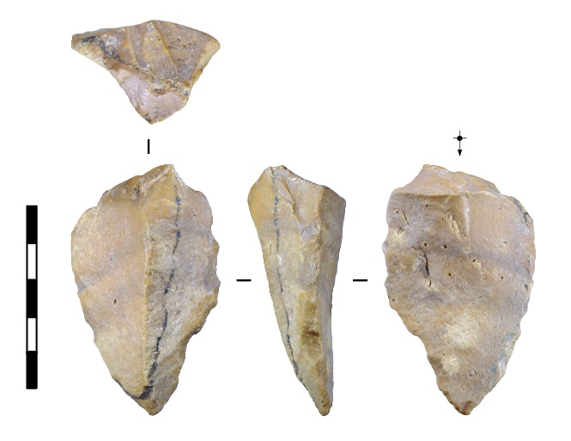
Supplementary Information Fig. 1| Artefact 1. Scale bar 50 mm.

3D model: https://une.pedestal3d.com/r/vinlHbuezr

This large flake was discovered partially exposed on the surface. A black linear mineral stain marks the boundary between the exposed part of the flake and the portion that was embedded in the sandstone. The flake is lightly abraded, but the flake’s edges are moderately to heavily damaged by taphonomic flaking to both faces. Most of the taphonomic scars are themselves lightly abraded, although one of these scars is relatively fresh.

The flake was struck directly behind a prominent ridge on the core face from a cortical platform. One side of the ridge is a flat cortical facet formed when the cobble was split by weathering. The cortex on the platform surface is heavily water-worn, indicating the core was made on a section of a water-rolled chert cobble. The other side of the ridge is a negative scar from a flake struck from the same platform edge and in the same direction as Artefact 1. The stoneworker struck almost 20 mm back from the core edge to remove a substantial part of the angular mass from the core face, producing a thick, pointed flake with (originally) sharp lateral edges.

Artefact 2

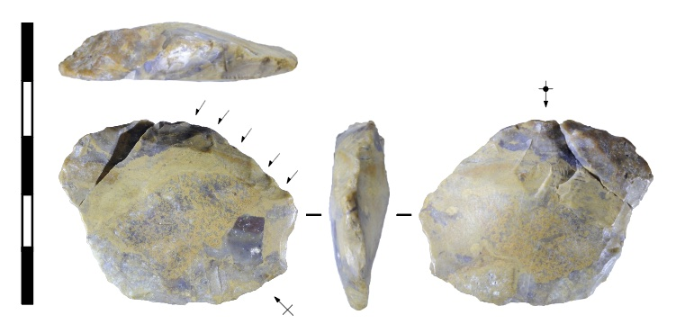
Supplementary Information Fig. 2| Artefact 2. Arrows indicate retouching scars. Cross-arrow indicates direction of detachment scar. Scale bar 50 mm.

3D model: https://une.pedestal3d.com/r/eOCKQIpLH_

This medium-sized flake was struck from a core made from brecciated chert. The flake is moderately to heavily abraded and the flake’s edges are moderately damaged by taphonomic flaking to both faces. The taphonomic scars are themselves lightly to moderately abraded, although one of these scars is relatively fresh.

The platform surface includes a facet of heavily abraded cortex, indicating that the original stone was a water-rolled chert cobble. The percussion blow was struck onto a single-facet platform adjacent to the cortical facet, but the platform was damaged in excavation, fracturing the flake and eliminating most of this surface. The flake’s right margin is broken, and the break-surface is heavily abraded and damaged by taphonomic flaking, suggesting the break was contemporaneous with flake discard.

The dorsal surface of the flake is smooth. The slightly convex morphology and slight undulations suggest that this surface is the former ventral surface of a large flake, an attribute referred to as a ‘detachment scar’. This indicates that Artefact 2 was struck onto the ventral surface of the large flake. Artefacts with these attributes are referred to as ‘Kombewa’ flakes by some analysts.

The flake’s proximal end/left lateral margin appears to have been unifacially retouched towards the dorsal surface (indicated by black arrows). The retouching scars are flatter in profile than the markedly concave taphonomic scars on this and the other artefacts. The retouching scars are regularly spaced, are similar in length, and are oriented less steeply than the taphonomic scars.

Artefact 3
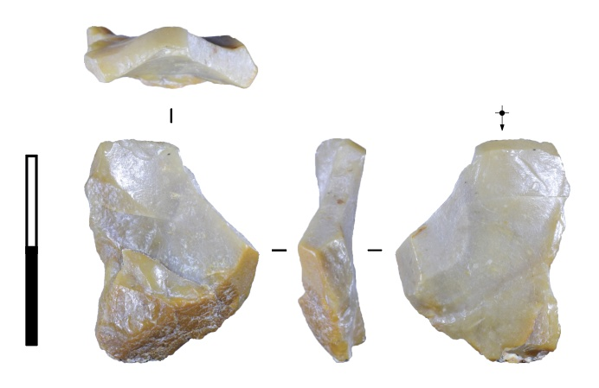
Supplementary Information Fig. 3| Artefact 3. Scale bar 20 mm.

3D model: https://une.pedestal3d.com/r/F7ADyINJr_

This small flake was struck from a water-rolled chert cobble and a facet of cortex is present on the flake’s distal end. The surfaces are moderately abraded and taphonomic flaking is present to both faces on the right margin. The left margin is broken and the break-surface is also moderately abraded; the break likely occurred as a spin-off fracture during detachment from the core. A clear lance and eraillure scar crosses the bulb of percussion. These features are diagnostic of conchoidal crack initiation.

The flake was struck directly behind a prior flake scar, and it is possible that this flake and the prior flake were detached by the same blow—referred to as ‘secondary multiple’ flakes. The flake’s platform is single-facet and convex, and undulations are visible on one side of the platform. This suggests that the flake was struck from the dorsal side of a larger flake by striking that flake’s ventral surface. The platform is a detachment scar.

Artefact 4

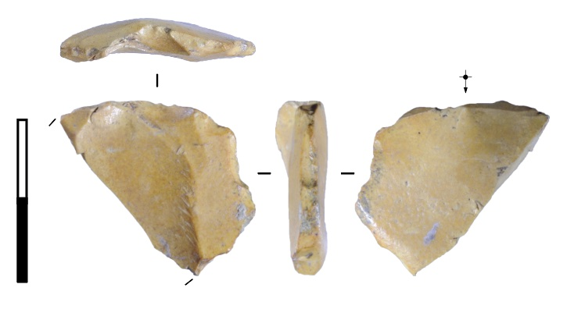
Supplementary Information Fig. 4| Artefact 4. Scale bar 20 mm.

3D model: https://une.pedestal3d.com/r/2PmfBjVkhs

This small flake is lightly abraded with moderate taphonomic flaking to both faces. It is broken diagonally, and the break surface is fresh and unabraded. The flake was struck behind, but offset slightly from, a prior flake scar. This prior flake was struck from the same platform edge and in the same direction as Artefact 4. The platform is a single facet and the surface has been partly removed by a taphonomic flake scar to the dorsal face. The flake ended in a hinge termination, which has been damaged by taphonomic flaking.

Artefact 5
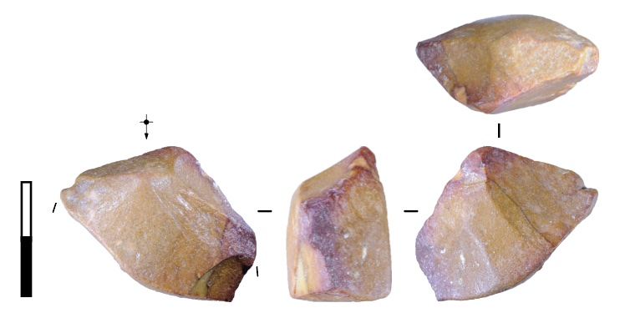
Supplementary Information Fig. 5| Artefact 5. Scale bar 20 mm.

3D model: https://une.pedestal3d.com/r/_euR_RjhW6

Artefact 5 is the proximal end of a large flake broken by weathering. The surfaces of the flake and the break are moderately to heavily abraded. Taphonomic edge-damage consists of one steep scar with a fresh, unabraded surface and sharp edges. A relatively large umbo is present, marking the flake’s PFA, and lances are present on right-hand periphery of the bulb of percussion.

The flake was struck well-back from the platform edge to target a linear zone of high mass created by prior flaking. The flake’s percussion axis is oriented at about 25 degrees to the zone of high mass, resulting in a crossways orientation. The blow was struck on a single negative flake scar facet, although a second adjacent scar was removed as part of the platform. The core platform edge was relatively acute and, judging from this and the dorsal scar orientations, the core was bifacial and centripetally reduced.

Artefact 6

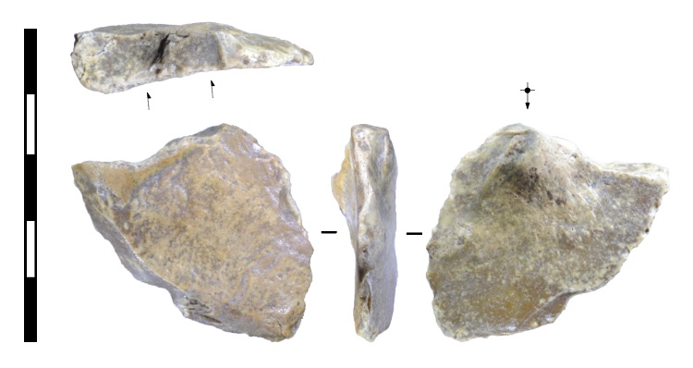
Supplementary Information Fig. 6| Artefact 6. Scale bar 50 mm. Arrows indicate scars struck from prior platform edge.

3D model: https://une.pedestal3d.com/r/NHDyYLMuim

This medium-sized flake was struck onto a relatively flat cortical surface of a water-worn chert cobble. The surfaces are moderately to heavily abraded and the edges are moderately damaged by taphonomic flaking to both faces. It was struck from a single-facet platform. The bulb of percussion is small and pronounced, as is typical of flakes struck behind relatively flat core surfaces. The flake propagated laterally and removed part of the core’s platform surface, cutting through the proximal ends of two flake scars struck to an adjacent core face. The platform for these prior flakes was the flat cortical surface. Flakes with these attributes are referred to as a ‘redirecting’ by some analysts because it documents the redirection of core flaking to a different platform.

Artefact 7

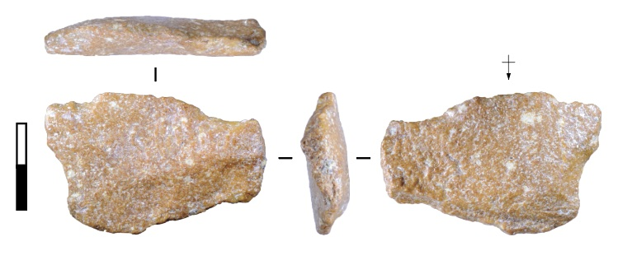
Supplementary Information Fig. 7| Artefact 7. Scale bar 20 mm.

3D model: https://une.pedestal3d.com/r/2eTBhL0tkC

This flake is heavily abraded with moderate to heavy taphonomic flaking to both faces. The flake is wider than long. It was struck onto a relatively flat surface on the core face, ending in a hinge termination with a thick and pronounced inflexed finial. The finial was broken from the flake, either at the time it was struck from the core (as often occurs) or from subsequent taphonomic flaking. The proximal end of the flake is marked by a large, wide scar on the dorsal surface. The platform is missing, and it is possible that the large flake scar was created at the same time the flake was detached due to platform collapse towards the flake’s dorsal surface. The proximal end of the flake is damaged by taphonomic flaking to both surfaces, obscuring the platform features.

Supplementary Information Fig. 8| A comparison of the sizes of all pebbles recovered from the site. The longest dimension is measured irrespective of the percussion axis, so may be either the ‘technological length’ or the ‘technological width’ of the artefacts, depending on which dimension is greater.

Supplementary Information Table 1: Table of artefact measurements and features.
Online supplementary material.

US-ESR dating results
The US-ESR dating results are central to establishing the age of Calio deposit. The results are obtained under several assumptions, for which the rationale will be discussed in the subsequent sections. First, the uranium distribution reflects a complex diffusion history within the dental tissues, which is also indicative of several water incursions within the tooth. Water content is important in transporting soluble isotopes like uranium, but it also impacts the dose rate by attenuating radiations. This is reflected in the large errors associated with the water content in the enamel, dentine and sediment (100% error taken into account as a percentage of wet weight). Here, to maintain a conservative approach we have measured and assumed a low water content of 15 ± 15% and 5 ± 5% in sediment and dentine respectively. Using the extreme scenario of 30 ± 30% and 15 ± 15% water, the ages would be shifted to older ages by approximately 200 ka.

Secondly, the uneven distribution of uranium in the dental tissues necessitated the use of average values from both the dentine and enamel for age estimation. While not without problems, this approach allows us to approximate the dose contribution without introducing the bias of choosing lower or higher uranium values, especially as the uranium hotspots (high concentrations) are localised mid-dentine. High uranium levels could potentially affect the accuracy of ESR dose recovery, resulting in an underestimated age compared to the actual deposition age. However, from experience, this issue typically only appears to impact ESR dating when uranium is concentrated in the enamel region²⁷. In this study, where the enamel of both Celebochoerus teeth have a low uranium content (<1 ppm), this is unlikely to be a problem. Such high concentration in the dentine prompted us to completely remove the first 100 microns of enamel directly in contact with the EDJ in order to avoid the potential impact of alpha particles on the dose estimates. Therefore, as the early part of the enamel (EDJ zone), as well as the upper part in contact with the sediment, were removed prior to the DRC measurements, the uranium contribution from both sections was excluded from the average enamel values calculation.

Similarly, the complex depositional history at Calio, including depth and sediment remodelling, clearly impacts the annual dose assessment, necessitating the use of an external dose contribution modelled on the sediment content and assuming a homogenous distribution. To model the depth accurately, we calculated the Cosmic Dose Rate (CDR) for depths extending to several metres, using the mean value alongside maximum and minimum values to establish boundaries for our associated error. While this method increases our associated error, it enhances the accuracy of our dating results. The location of the Celebochoerus maxilla and teeth, at 30 cm depth below the present-day ground surface, does not represent the burial deposition of the sample, with several metres of sediment likely to have eroded over time. The exact thickness of denuded sediment above the sample is difficult to estimate. Therefore, to maintain a conservative approach in our age calculation, we have used the cosmic dose rate relevant to the current depth of 30 cm. The age corresponds to the minimum possible age for the dated fossil teeth with regards to the cosmic dose rate, yet still above 1 Ma for both samples. Therefore, in any scenario (30 cm or deeper), the age obtained systematically supports the Early Pleistocene antiquity of the Celebochoerus fossil.

This complex depositional history and the heterogeneous nature of the sediment surrounding the sample also have important implications on U, Th and K distribution and calculation of the external dose rate. Since in situ dosimetry could not be performed (and regardless, it is not without limitations), we had to favour the use of a large amount of breccia—about 35-cm-thick blocks directly encasing the fossil—to estimate the sediment content. A large portion (30%) of bulk heterogenous breccia was pulverised and homogenised before being divided into three batches that were then analysed by ICPMS. The resultant values were averaged and used to extrapolate the radionuclide content and the external dose rate component assuming a 4π geometry. The heterogeneity of the sediment samples varies across elements, with potassium (3.9%) and thorium (5.56%) showing low variability and relative homogeneity, while uranium (22.7%) exhibits moderate to high variability among the samples.

Finally, the ESR signal and the associated equivalent dose estimation have limits that require some consideration. Firstly, two separate approaches were used in this study to estimate the dose equivalent. A multi-aliquot additive dose method was applied to the enamel powder for the molar, and a single-aliquot additive method was applied to an enamel fragment of the premolar. Both have merits and limits. First, multi-aliquot powder irradiated with gamma is a well-established protocol that has been proven reliable against other dating techniques. Yet, NOCORs concentration cannot be estimated using this method and can lead to significant underestimation of the equivalent dose and subsequent age calculation (Grün 2011). However, the bias is not systematic but instead strongly sample dependant (Grün 2011; Joannes-Boyau et al., 2010a and b). On the other hand, protocols using irradiated fragments have been used in the past decade successfully and provide a way of estimating and correcting for unstable radicals (Zhang et al., 2024; Freidline et al., 2023). However, using x-rays as an irradiation source does not create unstable radicals to the proportion of gamma, and the mechanism behind them is still poorly understood (Yu et al., 2022). Additionally, the use of highly anisotropic fragments propagates errors from the imperfect merged spectra approximating powder signal. Altogether, by simultaneously conducting both approaches we can be more confident in the age estimation for the Calio site. The US-ESR ages obtained from powder could be underestimated by a factor proportional to the number of unstable radicals created by gamma irradiation. The percentage varies from sample to sample, with values observed as low as 10% (Grün 2011) and up to 30% and over (Richter et al., 2017). Since x-ray does not trigger the creation of unstable radicals in the fragment, no correction is required. The age difference between the two methods (M³ = 1202 ± 176 ka and P⁴ = 1428 ± 208 ka) could be explained, at least partly, by NOCORs created by gamma irradiation. In this case, this would approximately correspond to a total of ~15% to 20% unstable component, a value frequently observed in bovid teeth (Joannes-Boyau et al., 2010a-b). That said, both ages are largely overlapping (M³ ages range from 1026 ka to 1378 ka (1σ), while P⁴ ages range from 1220 ka to 1636 ka (1σ)), advocating for the robustness of the age calculated by two separate approaches of two distinct teeth belonging to the same specimen. A mean value of 1.26 ± 0.22 Ma can be estimated by averaging the ages calculated on both Celebochoerus teeth using the two US-ESR programs and propagating the error using the square root of each relative error squared, particularly suited to combine the uncertainties from multiple independent measurements with asymmetrical associated errors. This combined value indicates a high probability of representing the correct age of the fossil and its deposition. The ages calculated by both the USESR and DATA programs are very similar, which is expected given that they are based on the same underlying algorithm for US-ESR age determination. The key difference lies in the fact that US-ESR uses a Monte Carlo method, which refines the estimation of uncertainty, while DATA uses an iteration process. Tests on numerous samples have shown that both US-ESR and DATA produce reliable age estimates. Yet, US-ESR also tolerates U-series disequilibrium better than the other program. In essence, while both programs deliver comparable results under normal conditions, US-ESR appears to be more robust when dealing with more challenging disequilibrium scenarios, which could explain some of the minor discrepancies we see in this study.

Supplementary Information Table 2: Calculation of average age for the Calio site.

US-ESR Ages (ka) | + err (ka) | - err (ka) | Central values  (ka) | CV ± error (ka) | Relative error squared
1140 | 155 | 273 | 1081 | 214 | 0.039
1202 | 176 | 176 | 1202 | 176 | 0.021
1368 | 207 | 306 | 1319 | 257 | 0.038
1428 | 208 | 208 | 1428 | 208 | 0.021
Average age |  |  | 1257* | 218**

* Obtained by calculating the average of the CV ages.
** Obtained by calculating the square root of the sum of all the squared relative errors, multiplied by the average age, and divided by two. ${\sqrt{(sum of the squared relative error*average age)}}/2$

References
Freidline, S.E., et al. Early presence of Homo sapiens in Southeast Asia by 86–68 kyr at Tam Pà Ling, Northern Laos. Nature Communications 14(1), 3193 (2023).

Grün, R. A comprehensive model for CO2− radicals in fossil tooth enamel: Implications for ESR dating. Quaternary Geochronology 6, 82–97 (2011).

Joannes-Boyau, R. et al. Decomposition of the angular ESR spectra of fossil tooth enamel fragments. Radiation Measurements 45, 887–898 (2010a).

Joannes-Boyau, R. et al. Decomposition of the laboratory irradiation component of angular ESR spectra of fossil tooth enamel fragments. Applied Radiation and Isotopes 68, 1798–1808 (2010b).

Richter, D. et al. The Age of the Jebel Irhoud (Morocco) hominins and the origins of the Middle Stone Age. Nature 546, 293–296 (2017).

Yu, W, et al. Using X-rays as an irradiation source for direct ESR dating of fossil teeth
Quaternary Geochronology 72, 101372 (2022).

Zhang, Y. et al. The demise of the giant ape Gigantopithecus blacki. Nature 625 (7995), 535–539 (2024).

