Supplementary Information for
Population-Specific Polygenic Risk Scores
Developed for the Han Chinese
Table of Contents
Genotyping 1
Study data 1
Samples 1
Genetic variants 1
Pre-imputation quality control 1
Per-batch filtering 1
Merged batch filtering 10
Ancestry estimation 10
Post-ancestry filtering 11
Array merging 13
Post-imputation quality control 15
Population structure and relatedness estimation 15
Phenotyping 17
Red blood cell 17
White blood cell 18
Body height 19
Body mass index 20
Blood lipids 21
Blood glucose traits 23
Liver-related measurements 23
Kidney-related measurements 25
Vital signs 25
SNP-based heritability for quantitative traits 27
References 29

Genotyping

Study data

Samples
The Taiwan Precision Medicine Initiative (TPMI) has recruited over half a million participants through the collaboration of sixteen medical centers across Taiwan. By the end of 2023, a total of 508,914 samples had been genotyped at six genotyping centers, including the National Center of Genomic Medicine (NCGM), Taichung Veterans General Hospital (TCVG), Kaohsiung Medical University Hospital (KMUH), Changhua Christian Hospital (CHCH), Linkou Chang Gung Memorial Hospital (LKCG), and Hualien Tzu Chi Hospital (HLTC).

Genetic variants
Two customized high-density Axiom SNP arrays produced by Thermo Fisher (Waltham, MA, USA), TPMv1 (n=168,375) and TPMv2 (n=340,537), were used. The TPMv1 array is designed for typing 686,439 genetic variants, while the TPMv2 array is for 725,699 variants. A total of 494,968 genetic variants are shared between the two versions of the genotyping arrays. The details about the array comparison have been described in Yang et al.

Pre-imputation quality control

Per-batch filtering
To minimize the effect of genotyping batches, we first performed quality control for each batch. Due to the wide range of sample sizes for each TPMv1 batch, we merged batches based on the following criteria: 1) they came from the same genotyping center, and 2) the experiments were conducted within six months. As a result, we combined 101 TPMv1 batches into 16, each with a minimum sample size of 2,000, along with 114 batches of TPMv2 (Fig. S1). Next, we excluded variants with more than 5% missingness in any batch and subjects with greater than 10% missingness. We also compared missingness and allele frequencies between batches and removed variants with inconsistent missingness and frequencies (Fig. S2 and S3). As a result, no subjects were excluded in this step, and we kept 536,616 variants from TPMv1 and 664,376 variants from TPMv2.

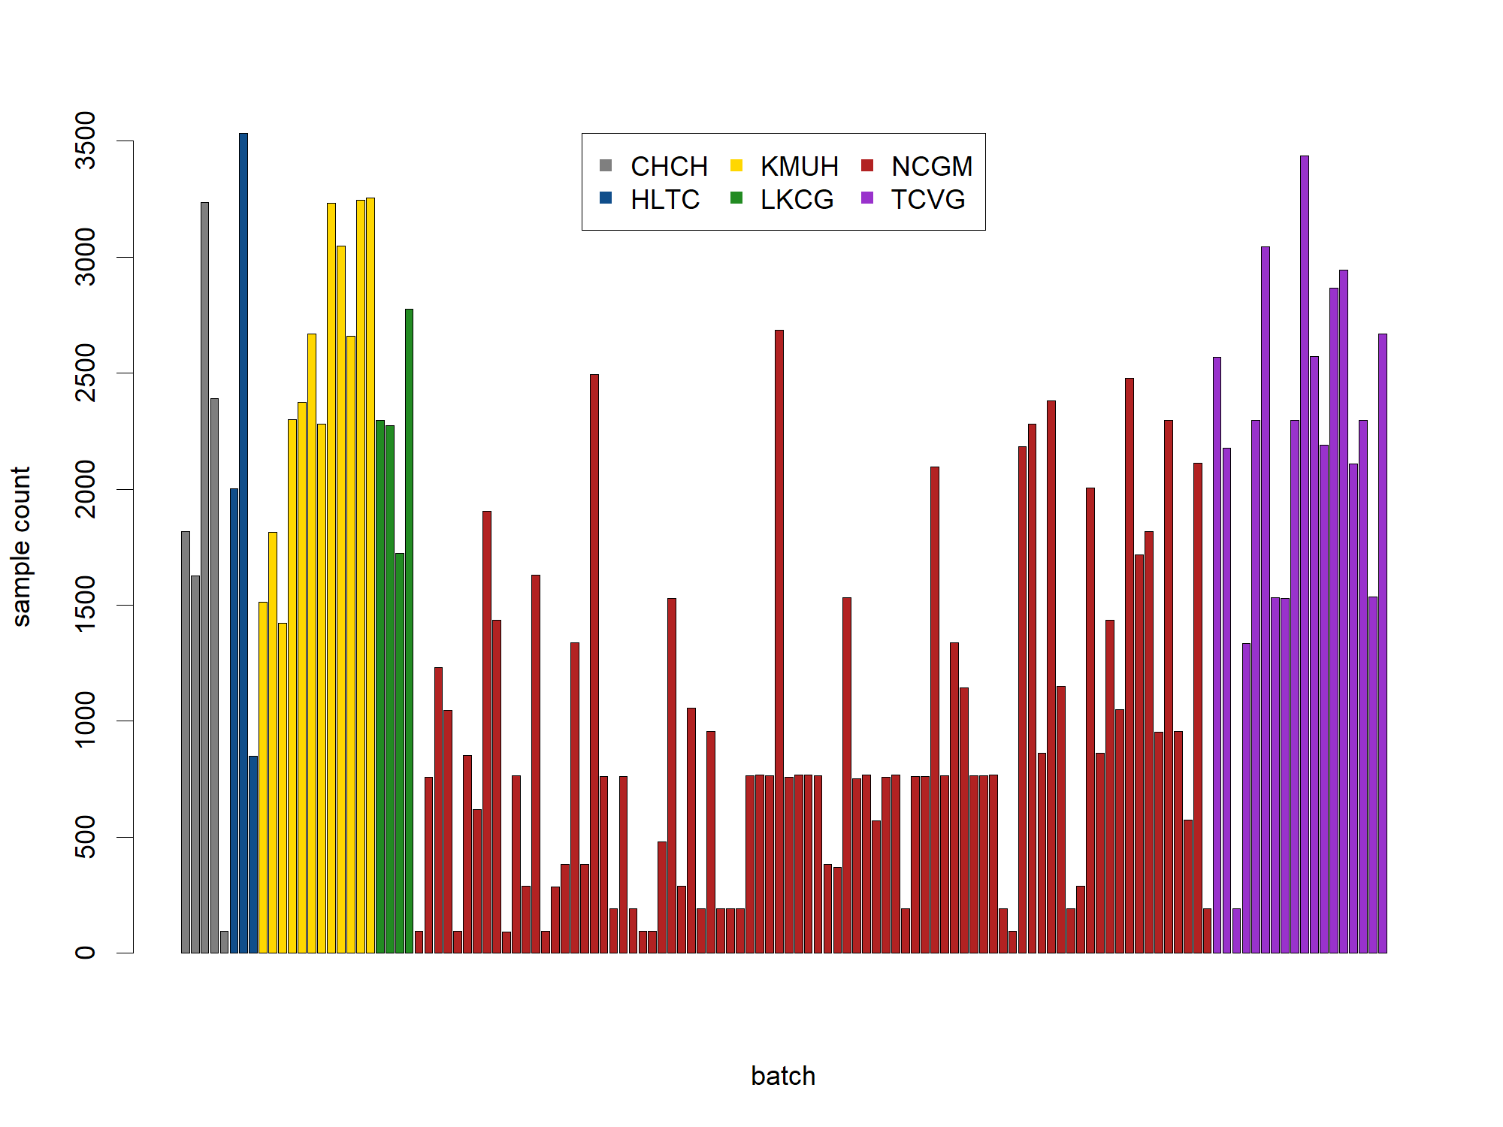
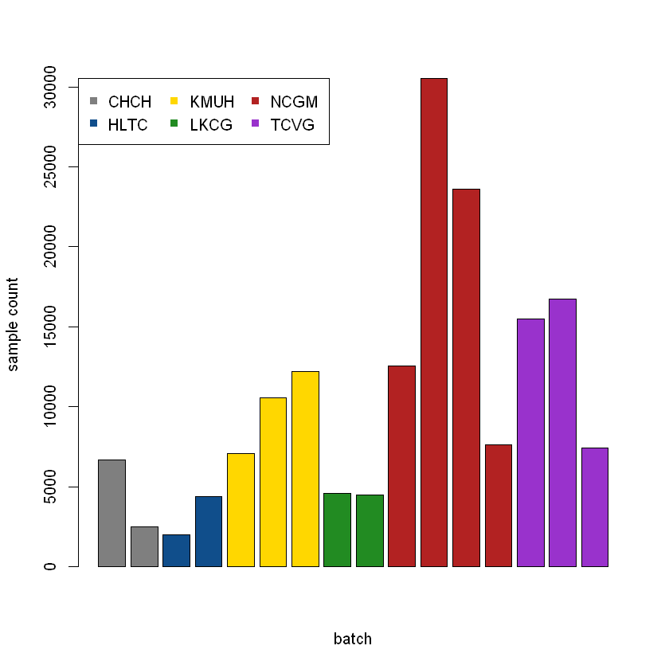
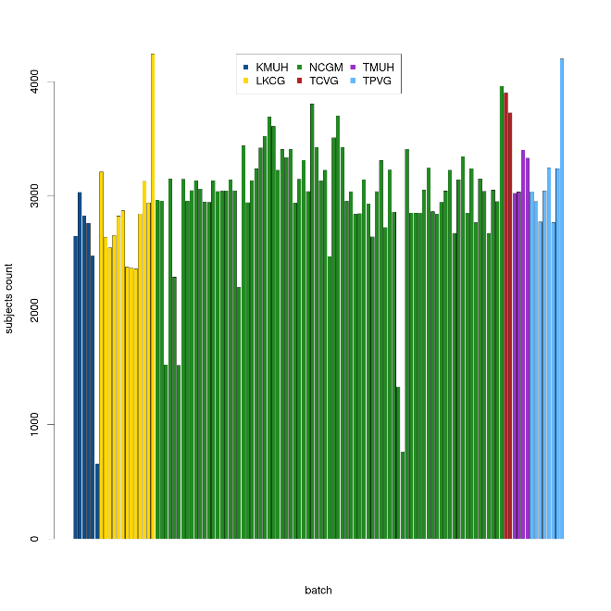
Figure S1. Bar chart of sample size for each batch for TPMv1 before merging (A) and after merging (B), and for TPMv2.
A
B
C
TPMv1 before batch merging
TPMv1 after merging
TPMv2

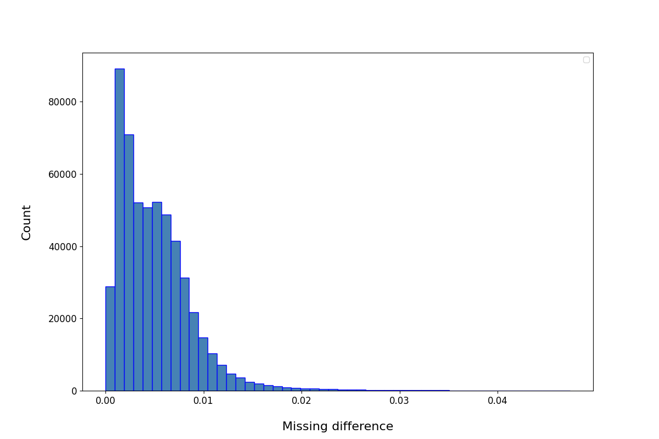
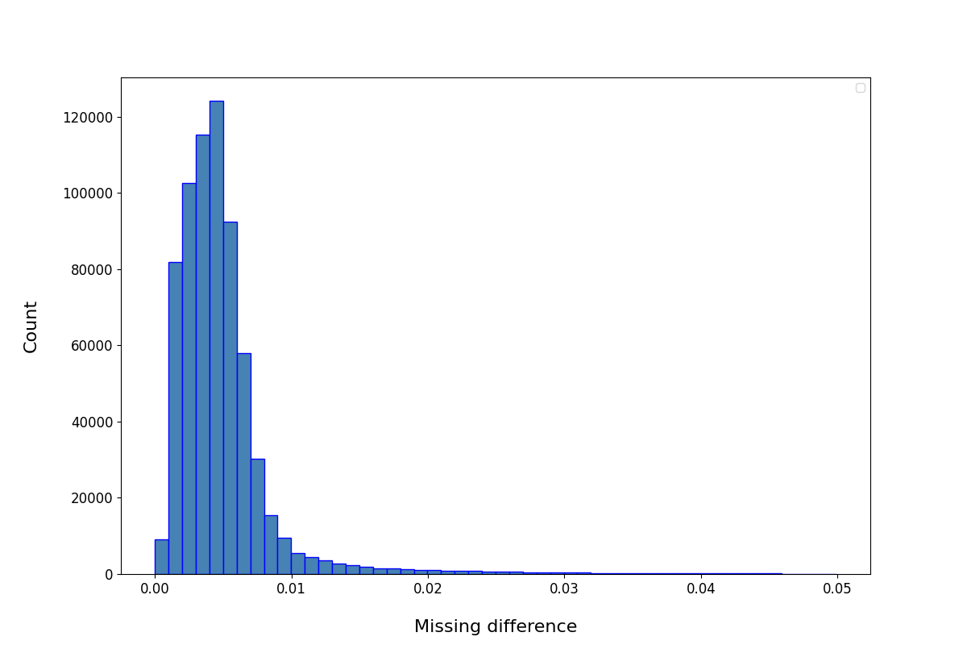
Cut-off: 0.02
4,686 SNPs removed
A
TPMv1
Cut-off: 0.02
10,137 SNPs removed
B
TPMv2
Figure S2. Histogram of differences of missingness between batches of TPMv1 (A) and TPMv2 (B)

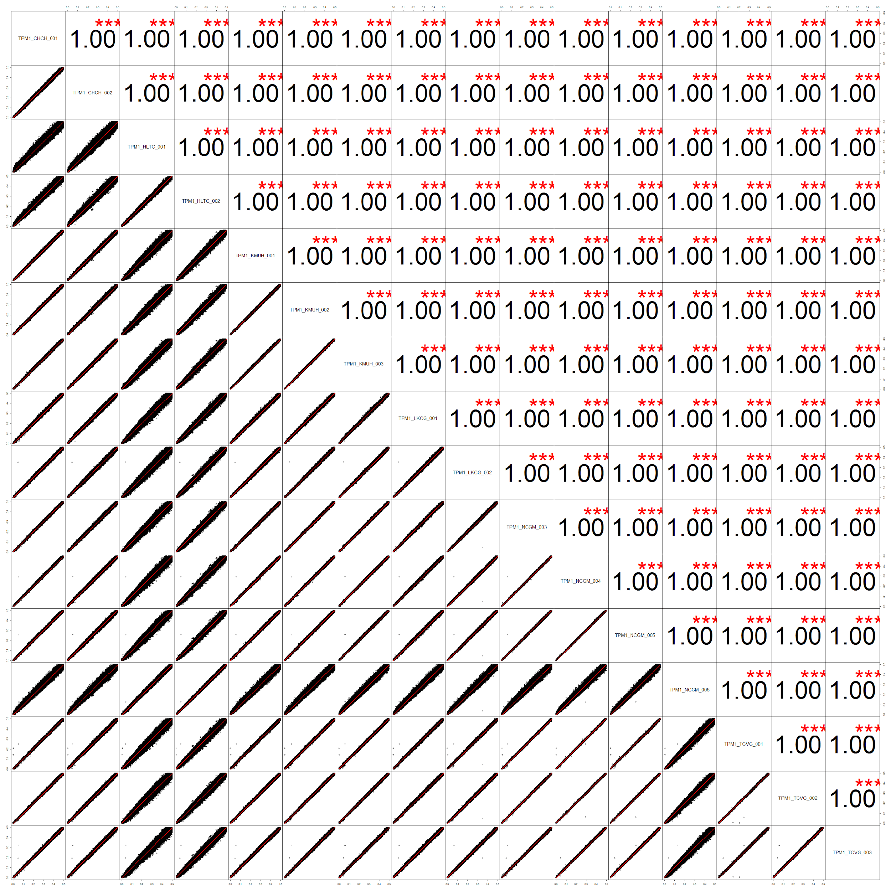
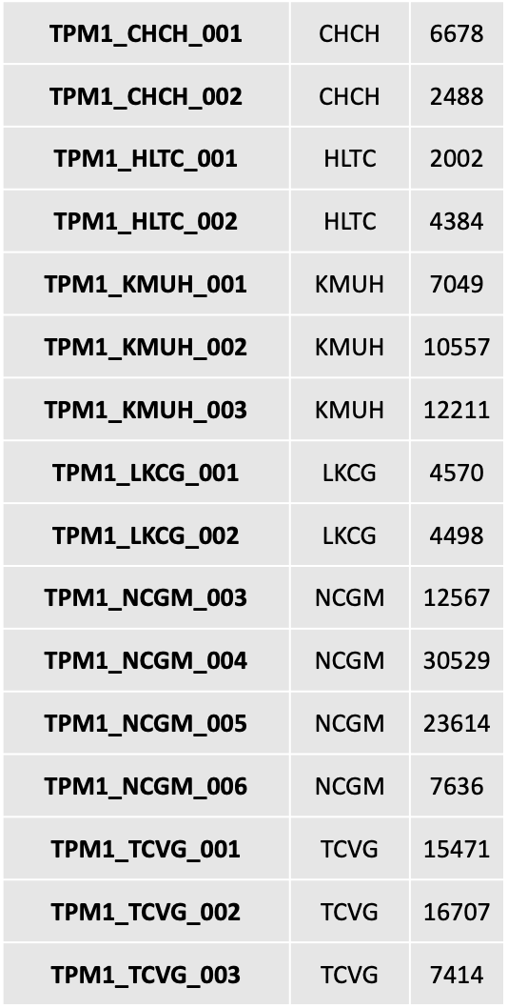
Fig. S3A
Figure S3. The scatter plot of allele frequencies between batches of TPMv1 (A) and TPMv2 (B-F). The colored sample size indicates the sample size recruited from HLTC.
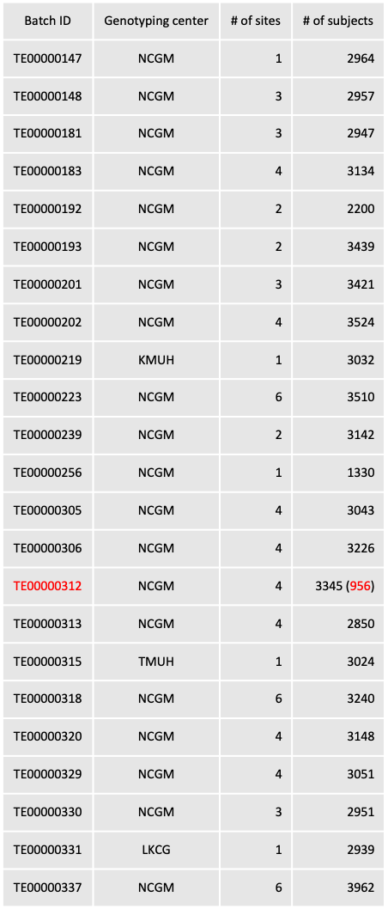
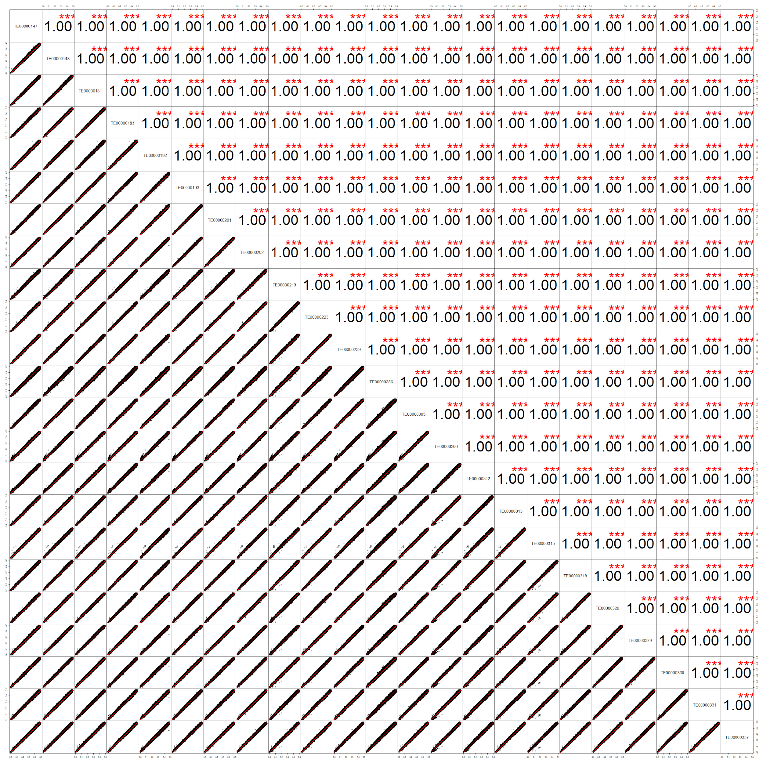
Fig. S3B

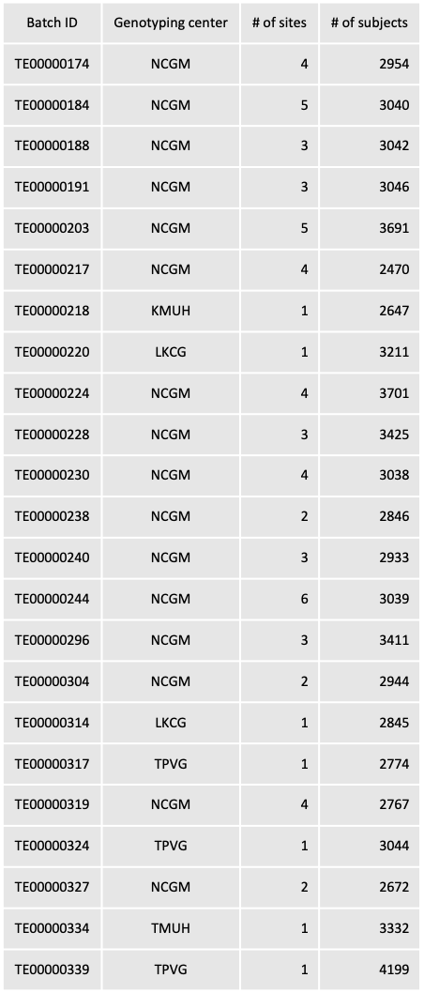
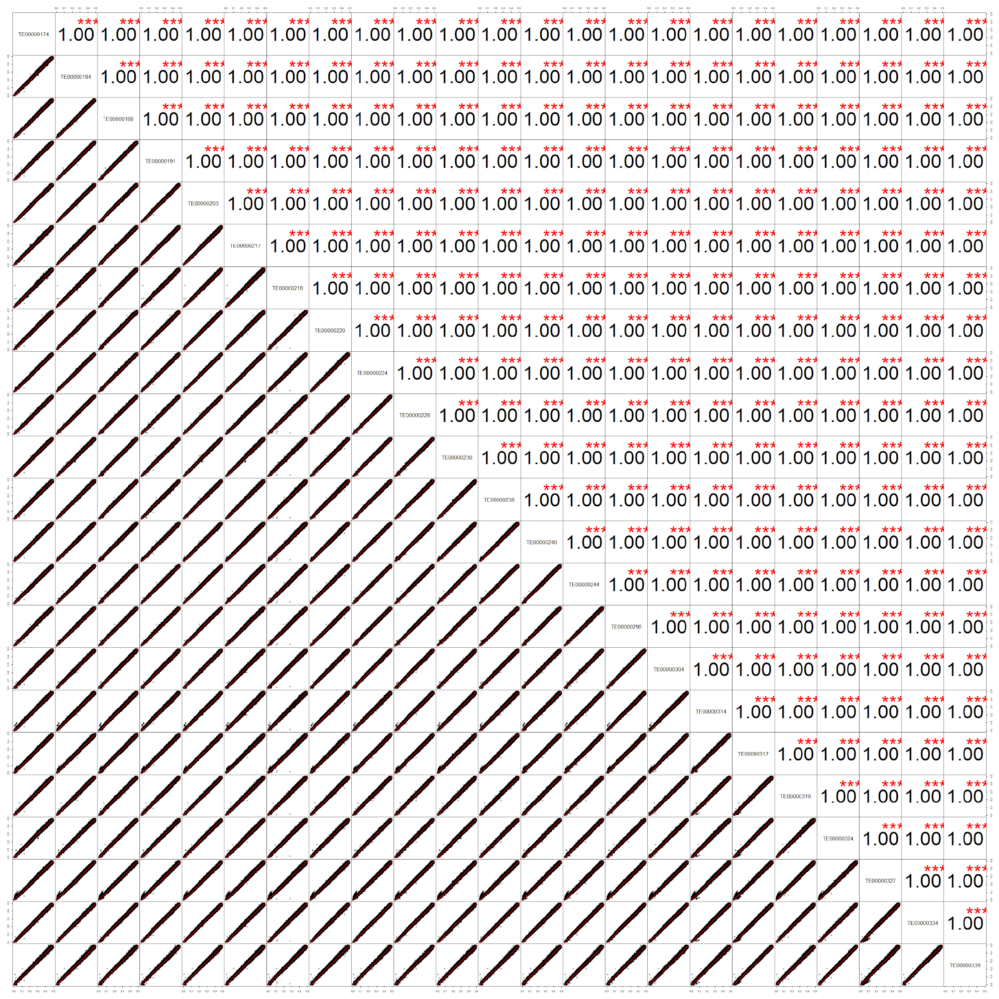
Fig. S3C

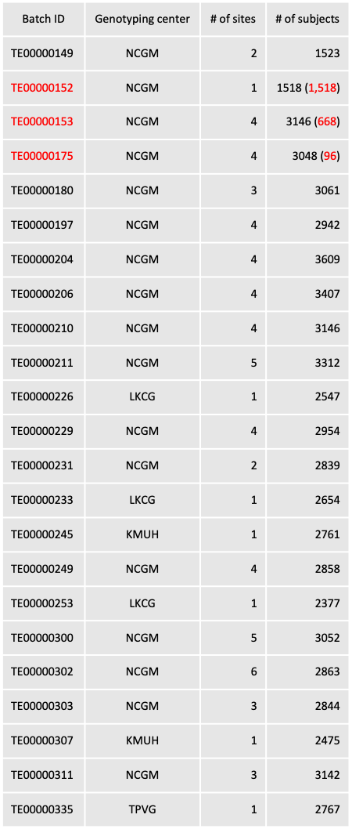
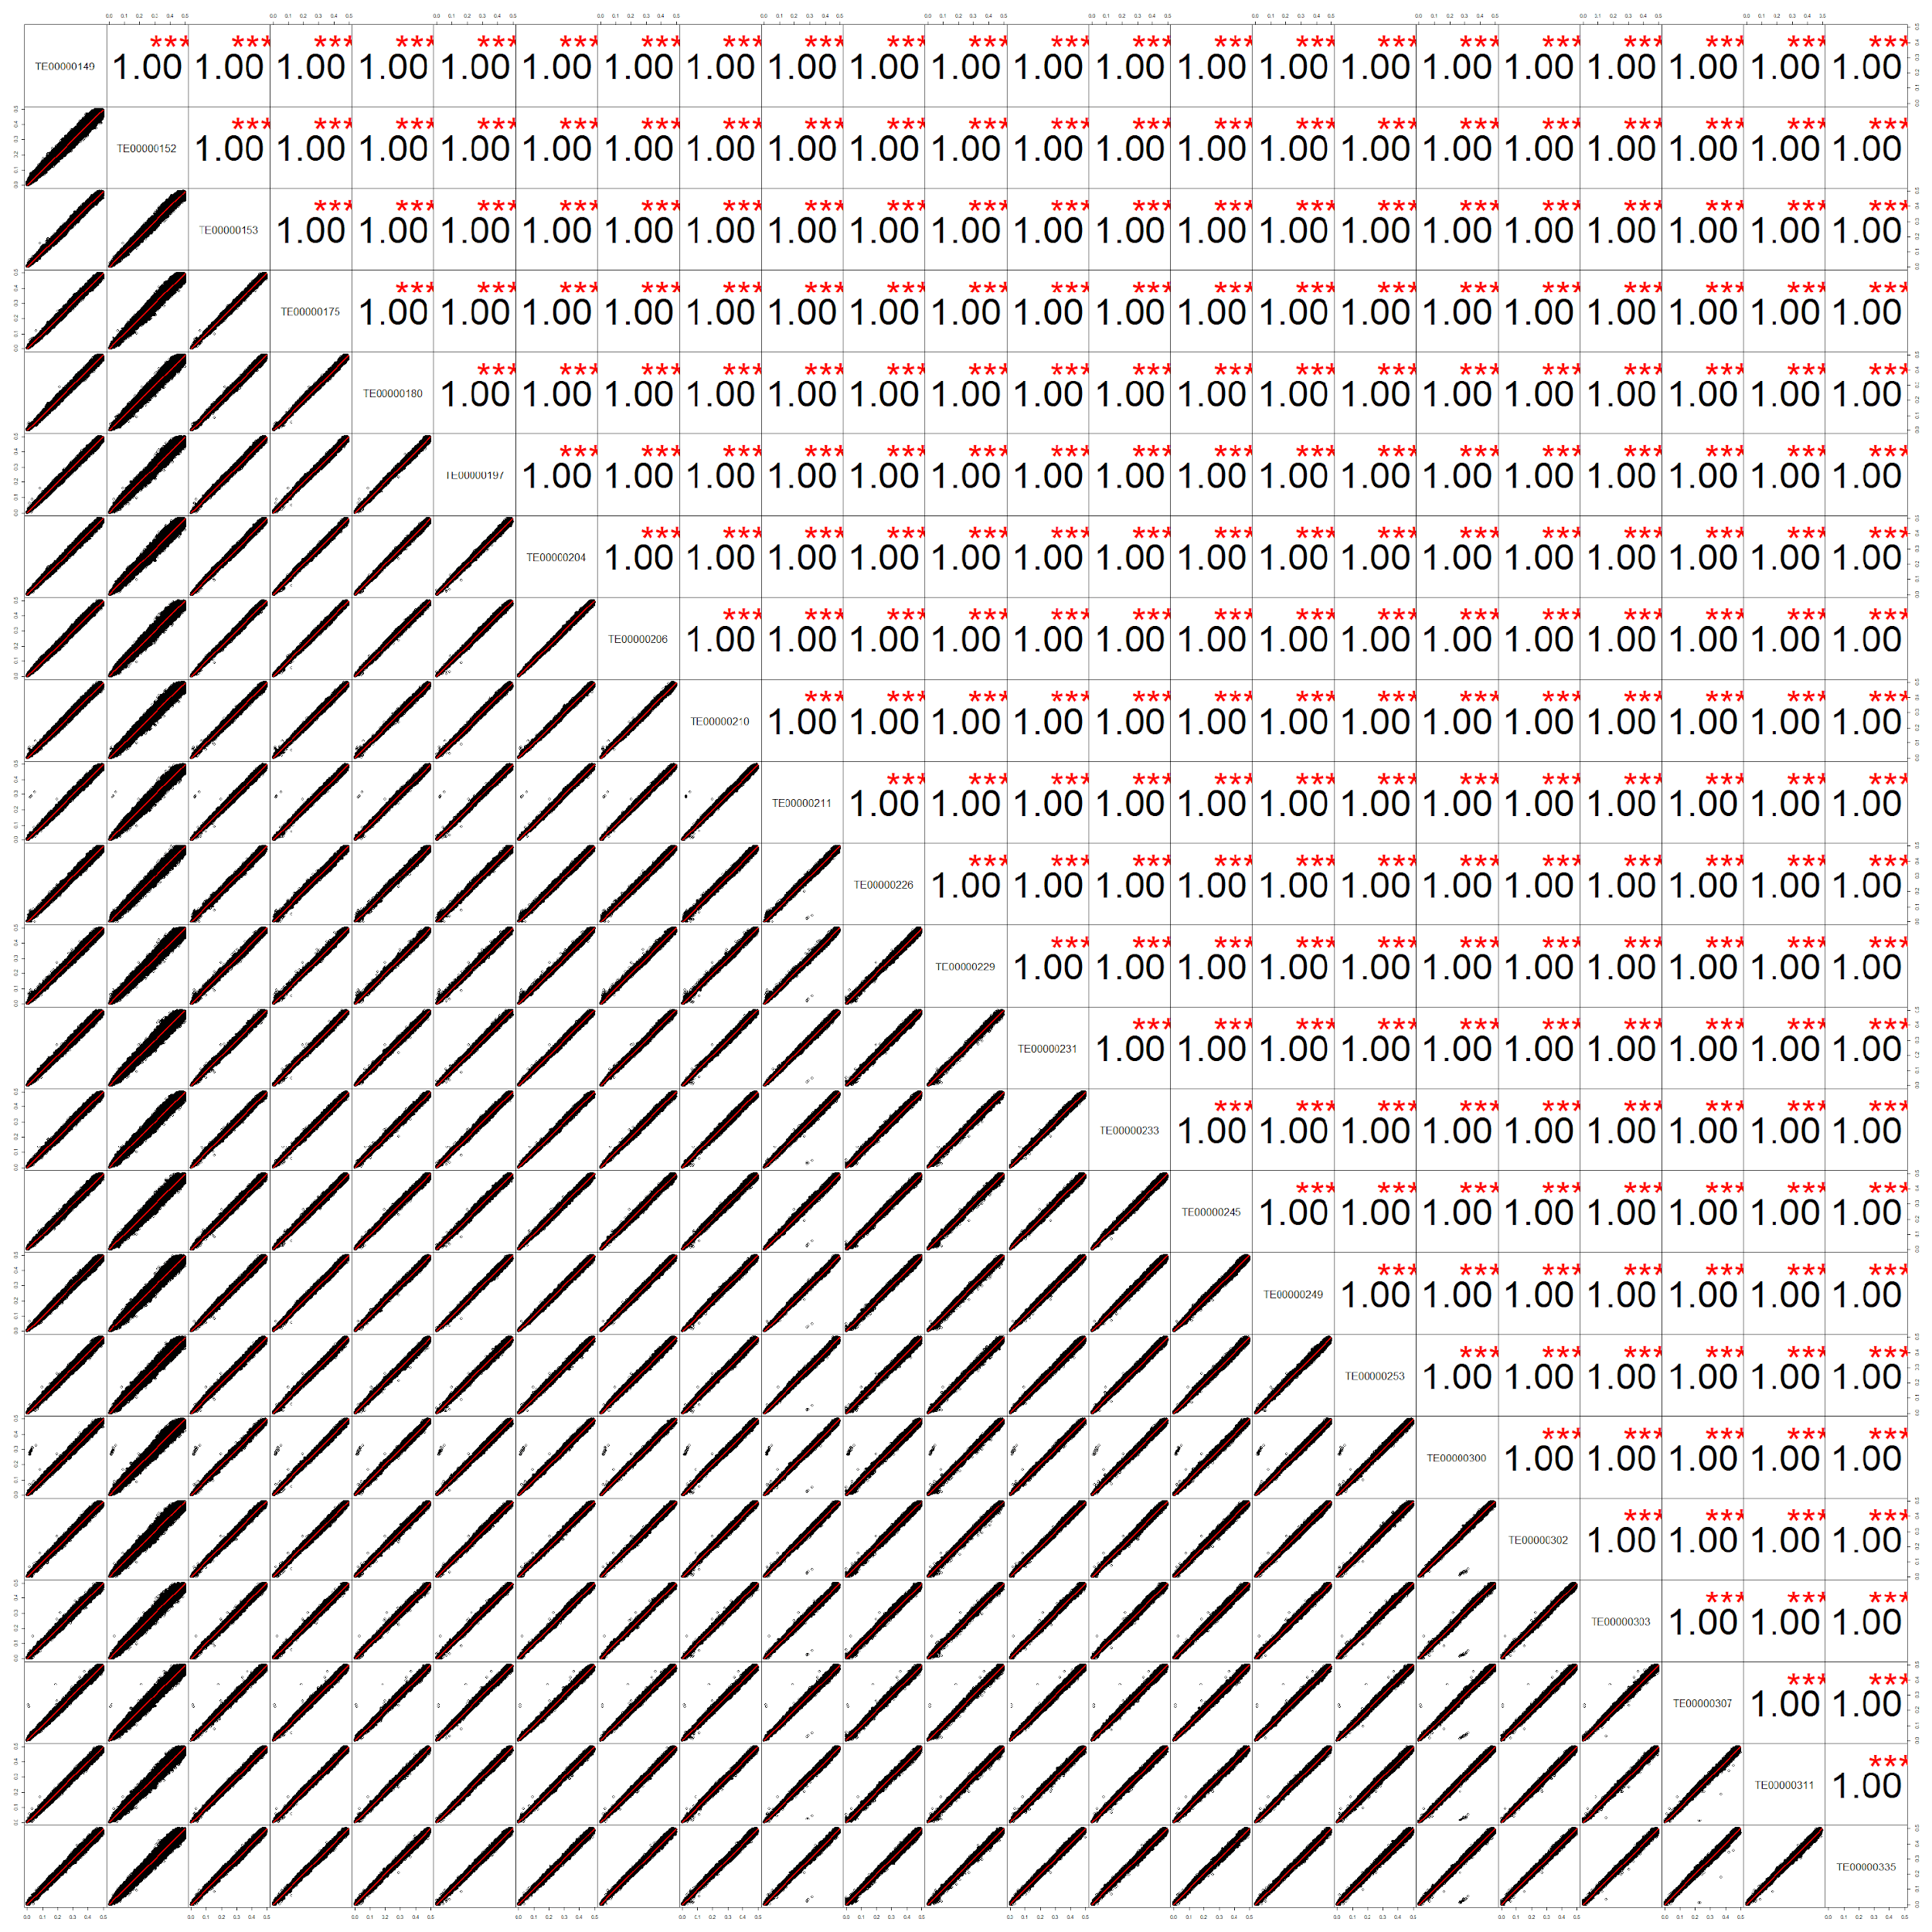
Fig. S3D

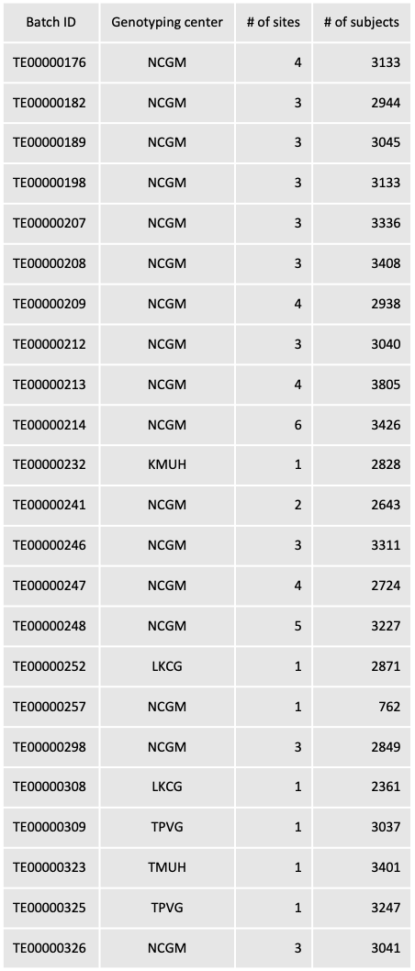
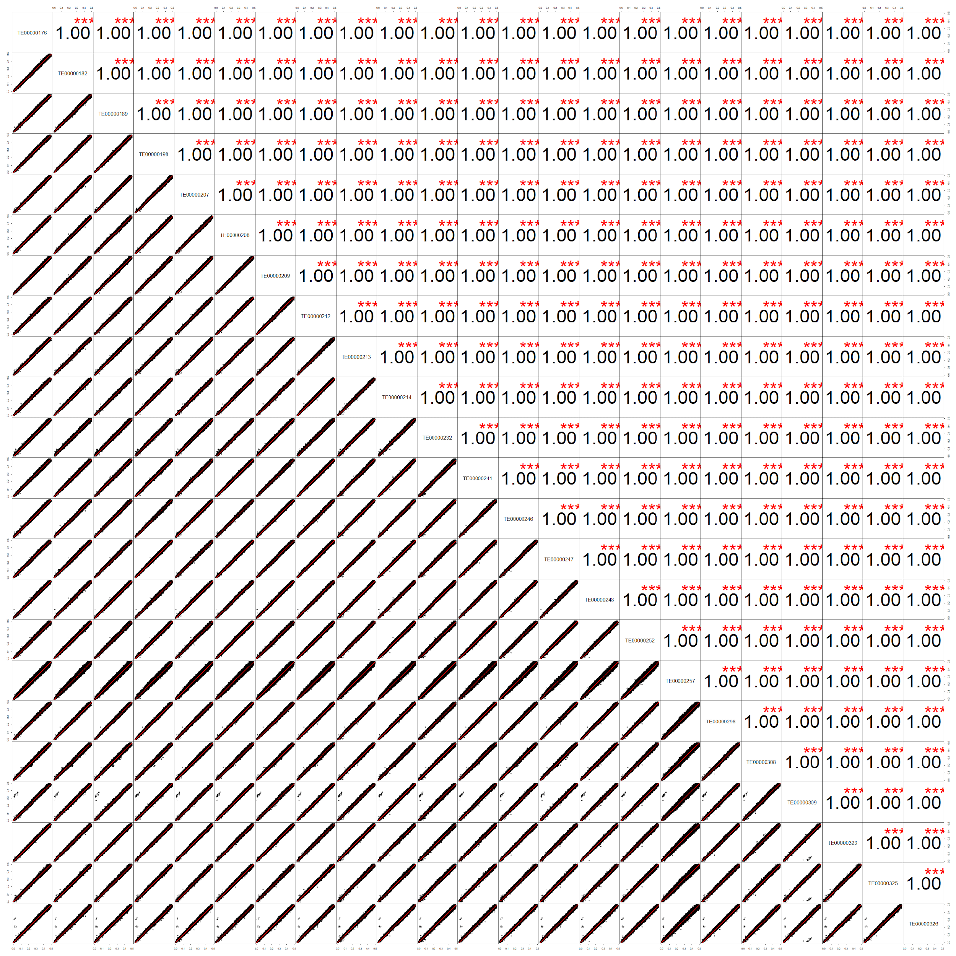
Fig. S3E

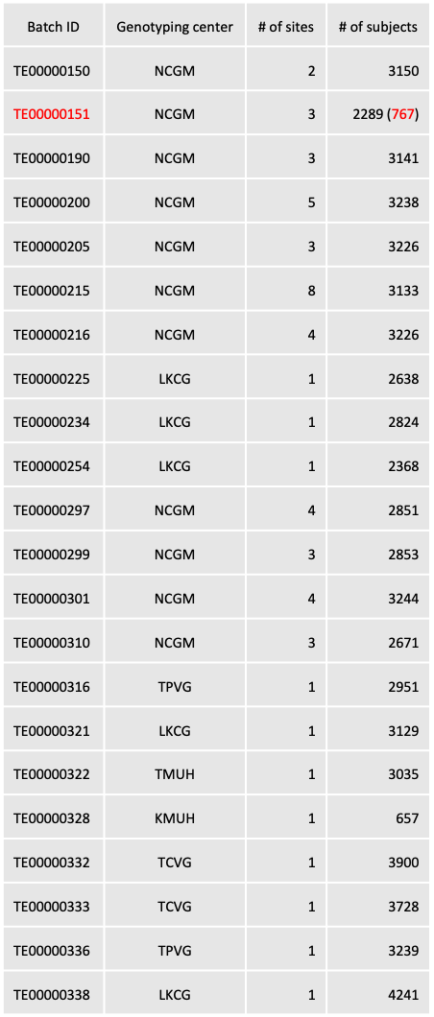
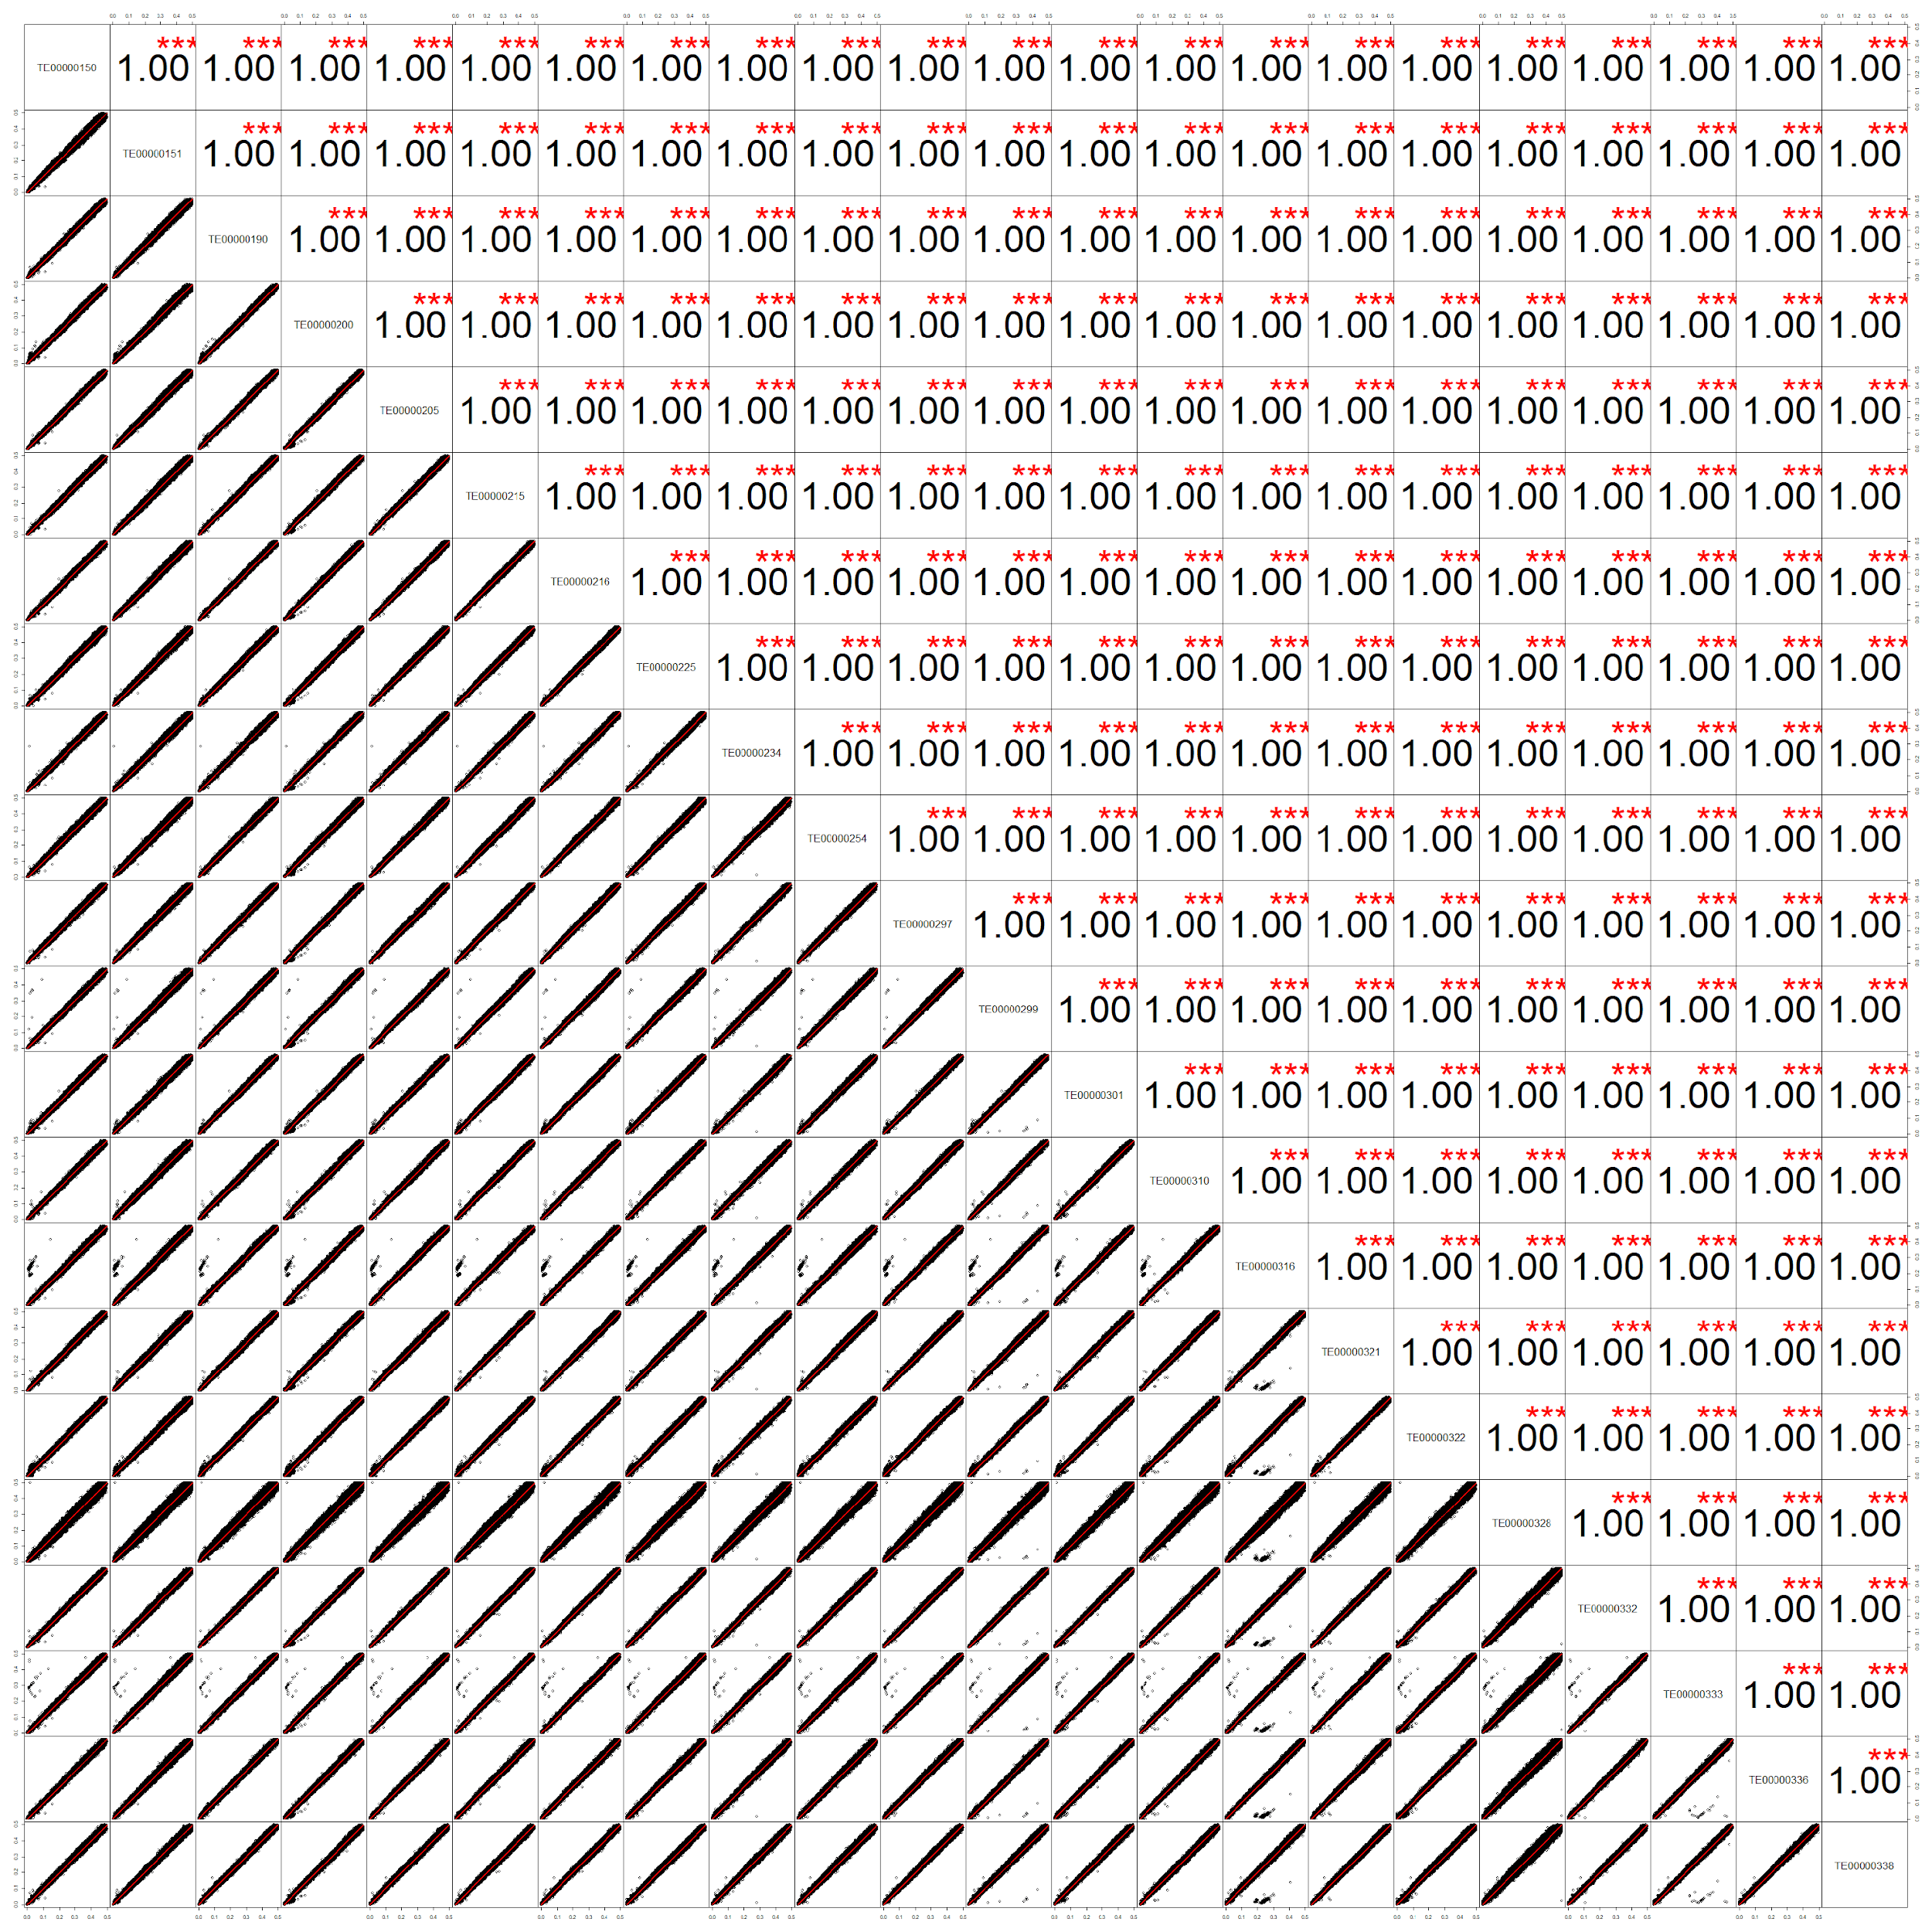
Fig. S3F

Merged batch filtering
After ensuring the minimized batch effect, we merged different genotyping batches for each array and conducted following quality control. We further removed the duplicated and disqualified variants, as well as variants with missingness greater than 2%. In addition, we excluded samples with missingness greater than 5%. In this step, we removed 12 subjects from TPMv1 and 1 subject from TPMv2, and 535,727 variants from TPMv1 and 638,013 variants from TPMv2 were passed to the next step.

Ancestry estimation
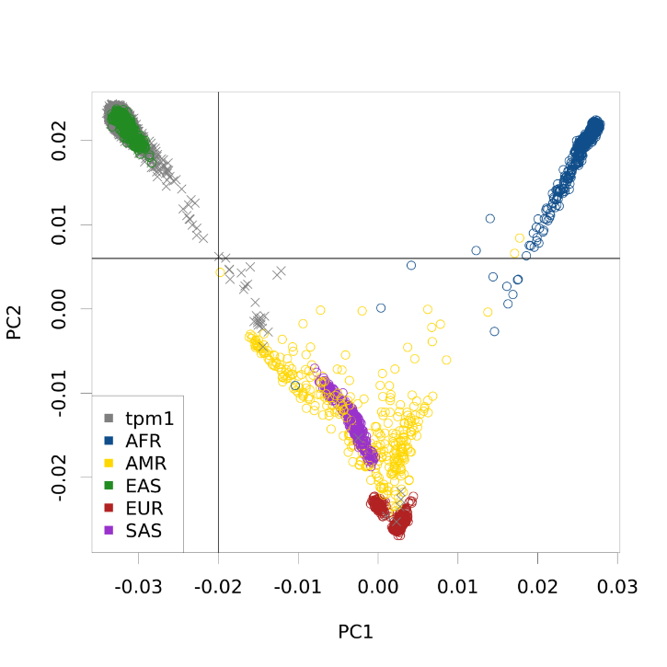
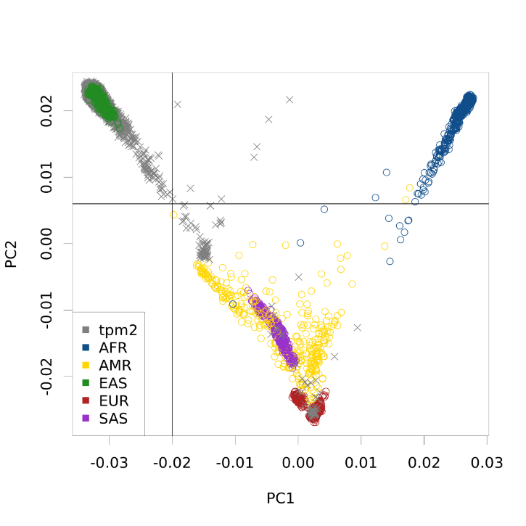
To determine the ancestral population of each sample, we used both principal component analysis (PCA) and ADMIXTURE, with the 1000 Genomes Project as the reference panel^{1,2}. We included 88,695 linkage disequilibrium (LD)-pruned common variants (minor allele frequency, MAF > 0.05) across the five superpopulations of the 1000 Genomes Project: European (EUR), East Asian (EAS), South Asian (SAS), Admixed American (AMR), and African (AFR). The PCA was conducted with unrelated subjects from the 1000 Genomes Project, and then all TPMI genotyped samples were projected based on the weightings from 1000 Genomes PCA (Fig. S4). The first two principal components separated EAS from the other superpopulations, and 168 subjects were excluded due to their genetic distance from the EAS cluster. We then applied ADMIXTURE to quantify the proportion of genetic ancestry among EAS, resulting in the inclusion of 161,194 subjects from TPMv1 and 328,307 subjects from TPMv2 with high genetic similarity to Han Chinese in further analyses (Table S17 and S18).
A
B
Figure S4. 1000 Genomes PCA results for TPMv1 (A) and TPMv2 (B)

Table S17. ADMIXTURE result for TPMv1
Est. proportion | v1 | v2 | v3 | v4 | v5 | -
CDX | 0.041 | 0.014 | 0.839 | 0.081 | 0.025
CHB | 0.264 | 0.018 | 0.123 | 0.571 | 0.024
CHS | 0.132 | 0.025 | 0.286 | 0.509 | 0.049
JPT | 0.916 | 0.007 | 0.016 | 0.051 | 0.009
KHV | 0.083 | 0.018 | 0.727 | 0.145 | 0.027
 | JPT | TW2* | CDX + KHV | Han | TW1* | NOS
TPMv1 (n) | 27 | 1,228 | 391 | 161,194 | 2,741 | 2,749
Table S18. ADMIXTURE result for TPMv2
Est. proportion | v1 | v2 | v3 | v4 | v5
CDX | 0.011 | 0.858 | 0.045 | 0.020 | 0.066
CHB | 0.016 | 0.135 | 0.255 | 0.024 | 0.569
CHS | 0.022 | 0.308 | 0.130 | 0.047 | 0.492
JPT | 0.007 | 0.016 | 0.918 | 0.010 | 0.049
KHV | 0.016 | 0.741 | 0.084 | 0.023 | 0.137
 | TW2* | CDX + KHV | JPT | TW1* | Han | NOS
TPMv2 (n) | 936 | 1,396 | 99 | 2,731 | 328,307 | 6,932
* The ancestral populations in Taiwan other than Han Chinese

Post-ancestry filtering
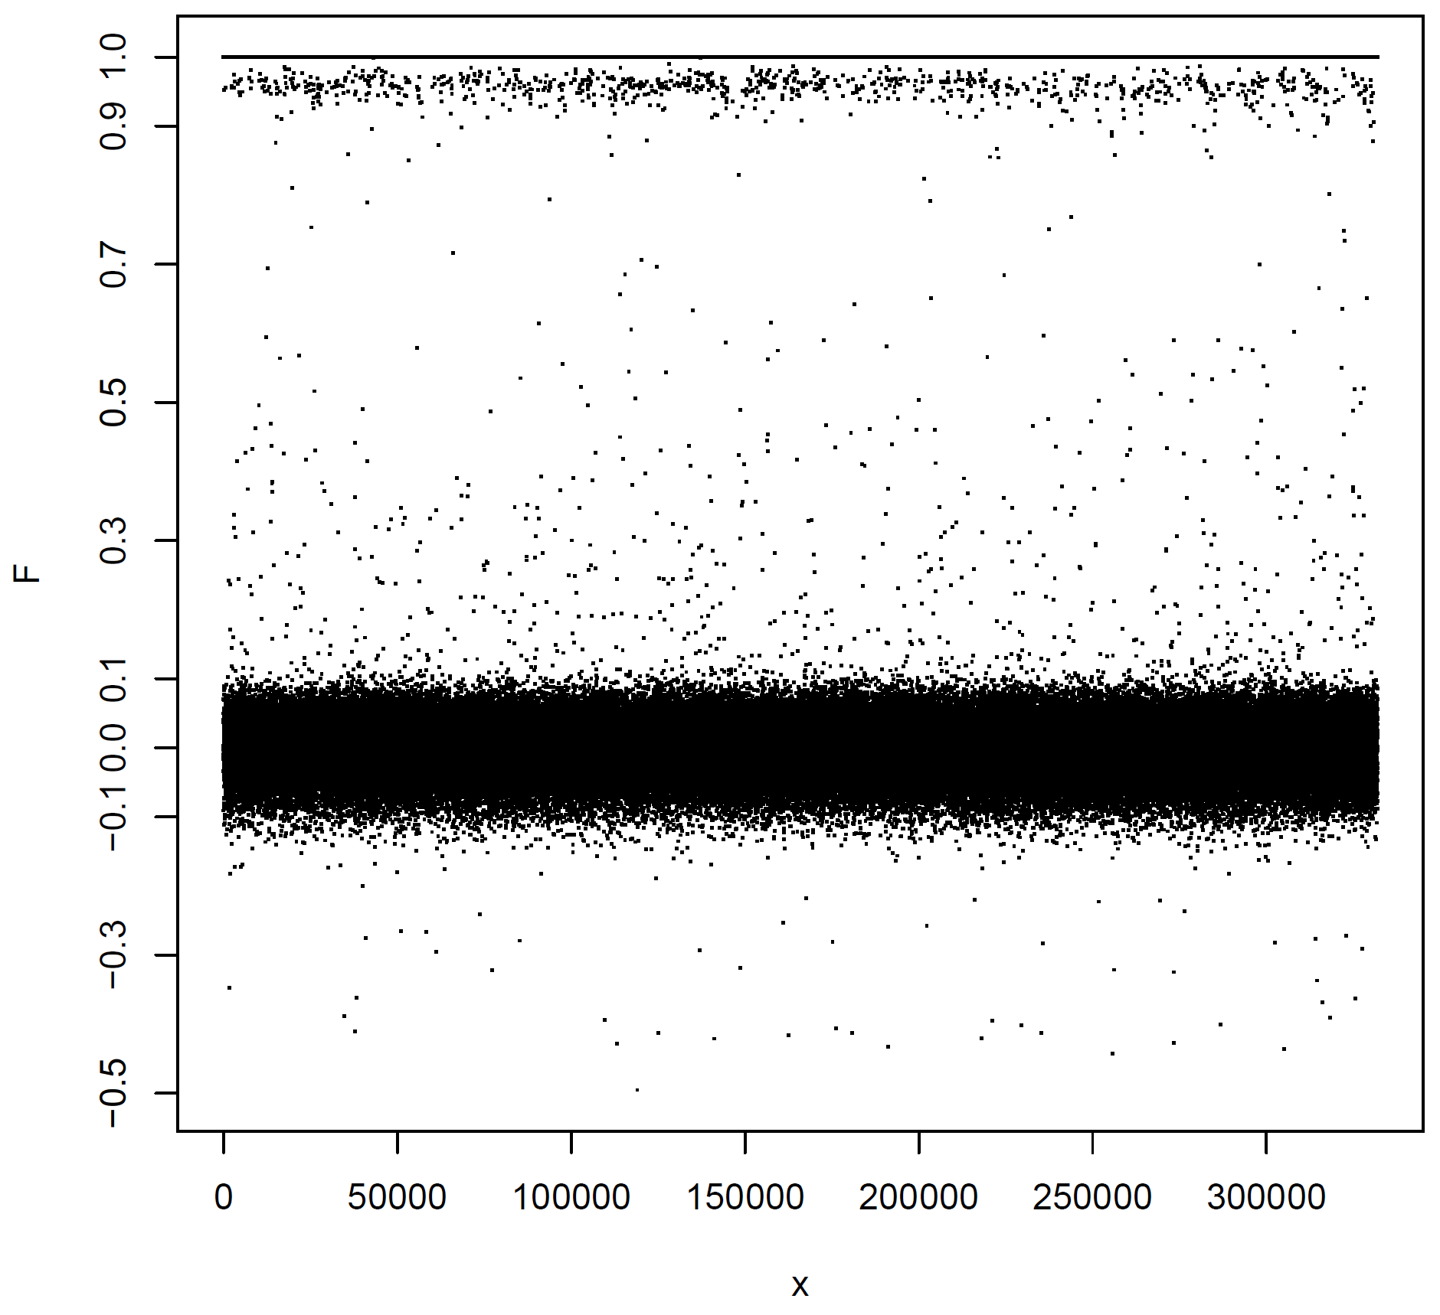
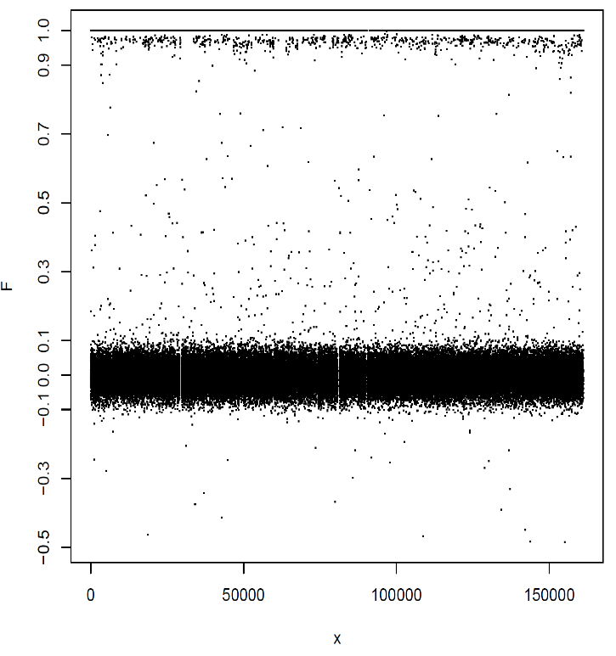
Population-specific quality control was conducted in previously identified Han Chinese. We excluded variants with high missingness (> 2%), rare variants (MAF < 1%), and multiallelic variants. Additionally, we performed a sex check (removed ambiguous subjects with F statistics between 0.2 and 0.8 and inconsistent sex with EMR) and a heterozygosity rate check (excluded subjects with F statistic > 0.2 or < -0.2) for each sample (Fig. S5 and S6). We then removed variants that were not on autosomes and conducted a Hardy-Weinberg equilibrium test for autosomal variants, excluding those with a p-value < 1 × 10⁻⁶. Moreover, we then examined the difference of allele frequency between genotyping batches with a linear mixed effect model, SAIGE³ to further remove the genotyping batch effects. As a result, 160,612 samples with 442,517 variants from TPMv1 and 327,430 samples with 584,676 variants from TPMv2 were kept (Table S19).
A
B
Figure S5. The scatter plots of sex-check F statistics for TPMv1 (A) and TPMv2 (B)
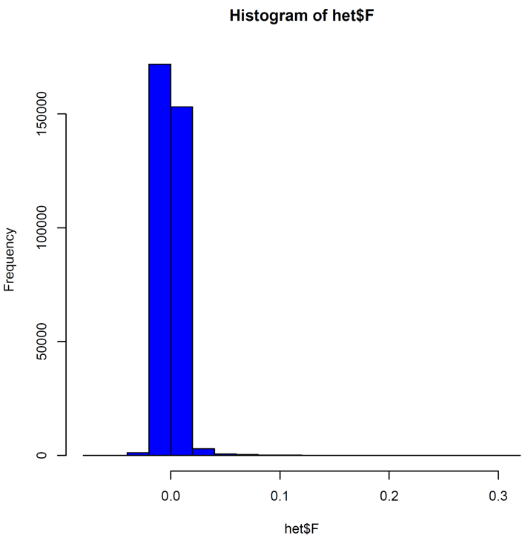
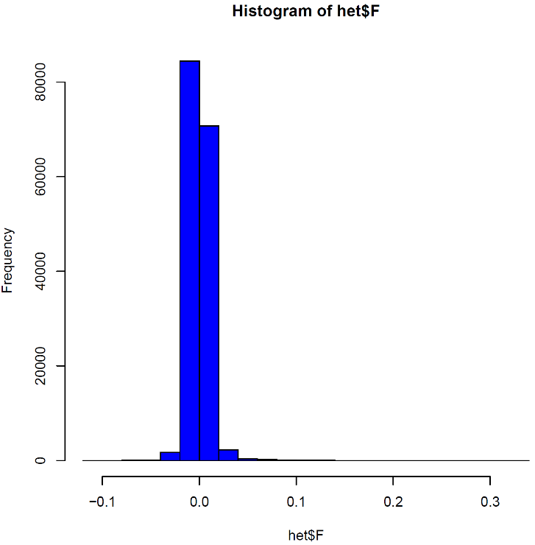
A
B
Figure S6. The histograms of heterozygosity check F statistics for TPMv1 and TPMv2

Array merging
Among the QC-passed variants, 401,777 were genotyped by both TPMv1 and TPMv2. After merging these two different versions of the genotyping arrays, we investigated any potential effects between arrays with a genome-wide association study, removing any variants with a p-value less than 1×10⁻⁵ (Fig. S7). We then identified genetic duplicated samples among the TPMI participants and kept only the EMR-confirmed homozygosity twins. Finally, we included 483,653 individuals and 401,710 genotyped variants for genome imputation (Table S19).

Table S19. Summary table for genotyping QC
 | TPMv1 |  | TPMv2 |  | Combined
 | Subjects | Variants | Subjects | Variants | Subjects | Variants
Raw number | 168,375 | 686,439 | 340,537 | 725,699
Step 1 per-batch filtering
Missing rate by batch |  | -145,132 |  | -50,955
After QC by Batch (intersect) | 168,375 | 541,307 | 340,537 | 674,744
SNP-level missingness difference |  | -4,686 |  | -10,137
Difference of allele frequency between batches |  | -5 |  | -231
After stage 1 filtering | 168,375 | 536,616 | 340,537 | 664,376
Step2 merged-batch filtering
Remove disqualified variants |  | -704 |  | -2
Remove duplicate variants |  | -73 |  | 0
Remove samples > 5% missing | -12 |  | -1 | 0
Remove variants > 2% missing |  | -112 |  | -89
After stage 2 filtering | 168,363 | 535,727 | 340,536 | 638,013
Step 3 ancestry determination
East Asian | 168,330 | 535,727 | 340,401 | 664,285
Han Chinese | 161,194 | 535,727 | 328,307 | 664,285
Step 4 post-ancestry filtering
Remove variants > 2% missing |  | -3 |  | 0
Remove rare variants (MAF<1%) |  | -63,730 |  | -26,231
Check sex (F coefficient) | -336 |  | -530
Opposite sex with EHR | -240 |  | -431
Heterozygosity filter | -6 |  | -6
Remove rare variants (MAF<1%) |  | -34 |  | -30
After Sex/Het checking | 160,612 | 471,960 | 327,340 | 638,024
Non-autosome |  | -11,093 |  | -21,672
HWE <1e-6 |  | -16,662 |  | -21,759
After Autosome/HWE | 160,612 | 444,205 | 327,340 | 594,593
Batch GWAS |  | -947 |  | -9,440
Multiallelic |  | -741 |  | -477
Han after QC by Array | 160,612 | 442,517 | 327,340 | 584,676 | 487,952 | 401,777
Step 5 Array merging
Effect of array version |  |  |  |  |  | -67
Duplicate |  |  |  |  | -4,299
Han after QC |  |  |  |  | 483,653 | 401,710
Han with EMR (EMR n=500,081) |  |  |  |  | 463,447 | 401,710

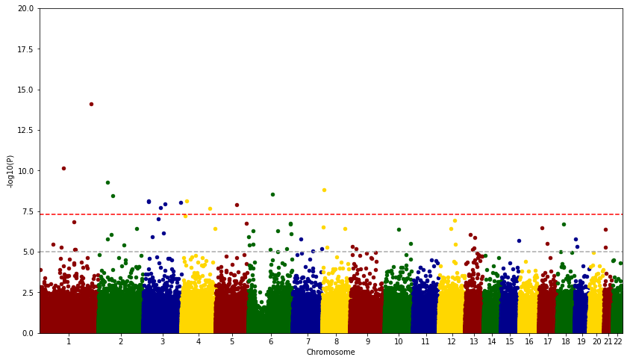
Figure S7. The Manhattan plot of the comparison between TPMv1 and TPMv2
TPMv1 vs. TPMv2

Post-imputation quality control
We performed SHAPEIT5 for phasing and IMPUTE5 for genome imputation, using 1,498 whole genome-sequenced subjects from the Taiwan Biobank as the reference panel⁴⁻⁶. Our genome imputation resulted in 22,446,974 genetic variants. We then conducted post-imputation filtering, removing poorly imputed variants (imputation INFO score < 0.7) and rare variants (MAF < 1%). Additionally, we performed a GWAS comparing the two arrays and excluded any variant with a p-value less than 1 × 10⁻⁵ (Fig. S8). As a result, 8,046,864 genetic variants were used in the main analysis.
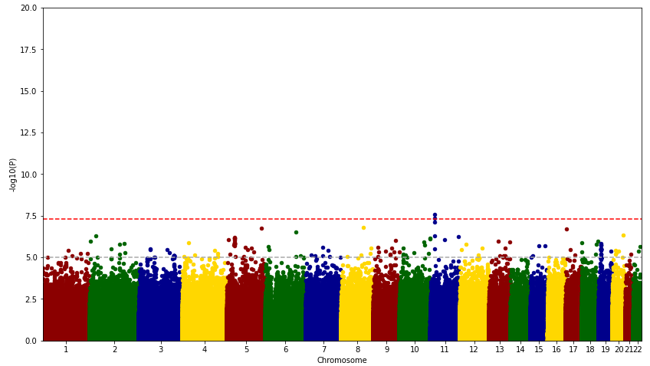
TPMv1 vs. TPMv2
Figure S8. The post-imputation Manhattan plot of the comparison between TPMv1 and TPMv2

Population structure and relatedness estimation
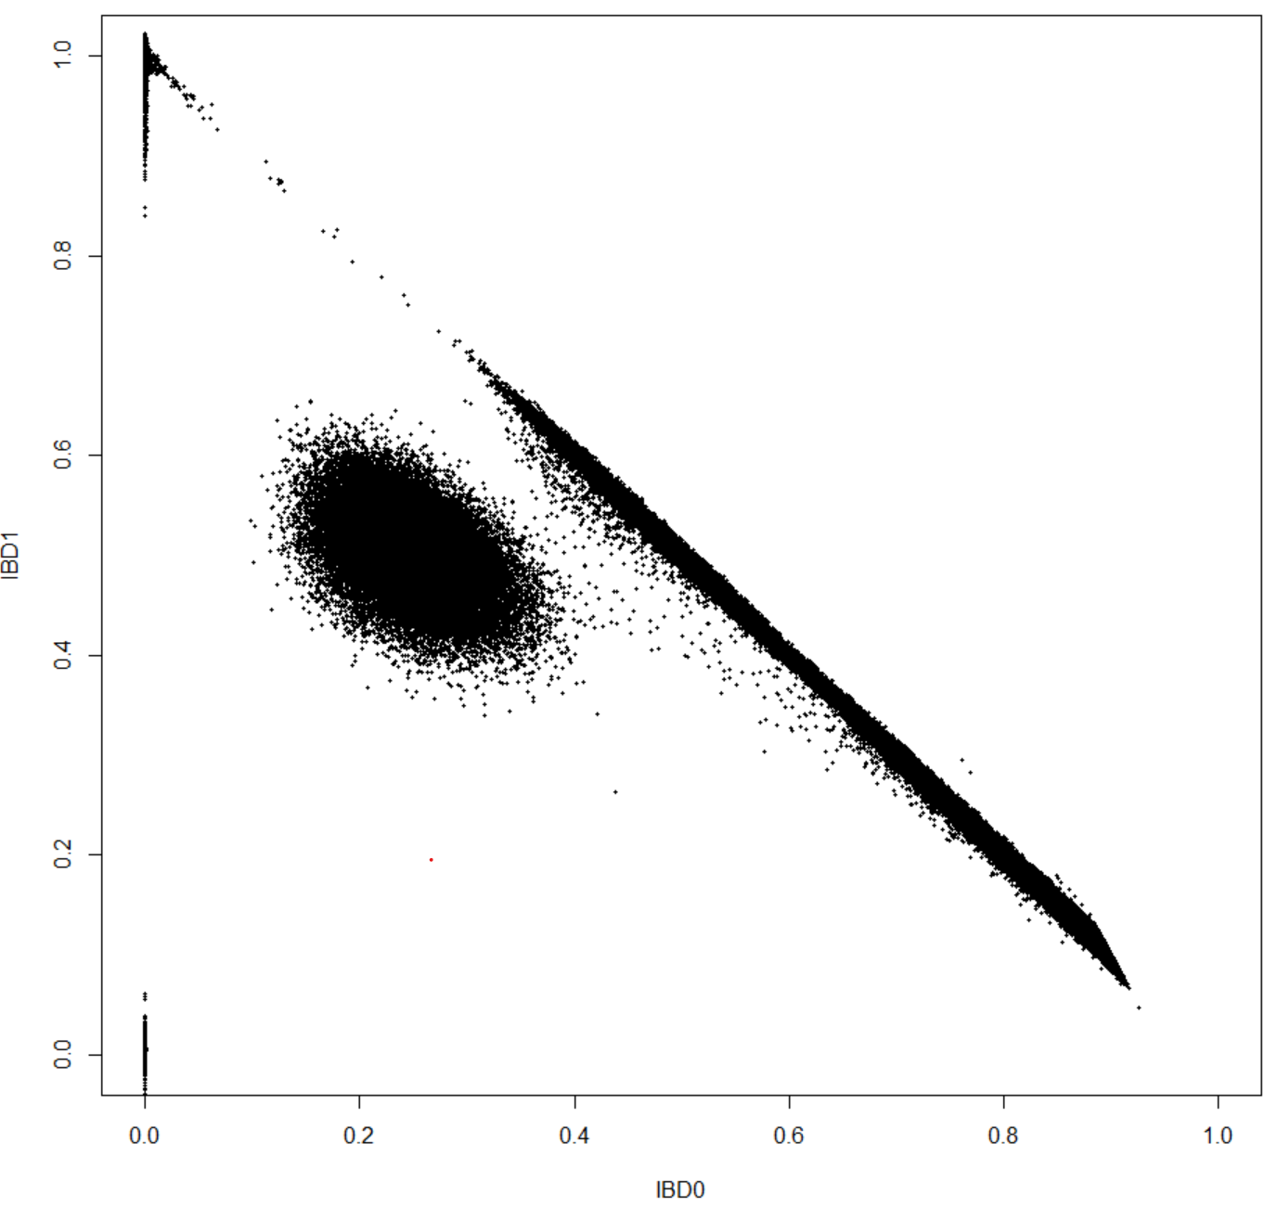
To avoid the bias of potential population stratification and remove the close genetic relatedness among TPMI, we leverage the principal component analysis (PCA) and proportion of identity-by-descent (IBD) to capture the population-level genetic structure and close genetic relatives. We firstly identified ancestry representative unrelated subset and conducted PCA among the identified subset for obtaining the robust PC weightings. Then, we predicted the PC scores for all remaining individuals. Following, we estimated the proportion of IBD and kinship with 20 genetic PCs for the adjustment of population structure. The PCA and relatedness estimation was performed with PCAiR and PC-Relate. As a result, we detected 80,699 pairs of 1st degree of relatives ($\hat{π}>0.375$), 82,487 pairs of 2nd degree ($0.375≥\hat{π}>0.1875$), and 186,173 pairs of 3rd degree ($0.1875≥\hat{π}>0.1$) (Fig S9). In terms of individuals, we have 123,277 individuals (26.6%) have at least one first degree relatives in the cohort, 207,578 individuals (44.8%) have at least one first and/or second degree relatives, and 321,755 individuals (69.4%) have at least one relatives closer then third degree in the cohort.
Figure S9. The scatter plot of IBD0 versus IBD1 shows pairwise relationships of close and distant relatives ($\hat{π}>0.05$) in TPMI.

Phenotyping
In general, we only used records from individuals aged 18 to 85 years who passed genotype quality control for all traits and excluded any measures from inpatient or the emergency department. For multiple measurements taken on a single day, we used their median. Then, we conducted a quality control process to remove or adjust the measures with relevant treatments or medications. Finally, we calculated the median value for each subject and excluded outliers greater than 4 standard deviations from the mean.

Red blood cell
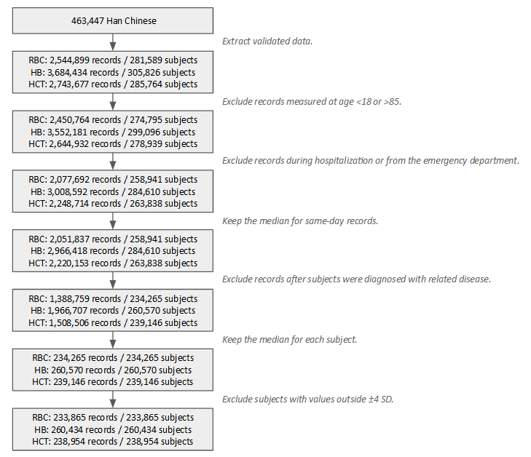
The red blood cell related traits, including red blood cell count (RBC), hemoglobin (HB), and hematocrit (HCT), were analyzed in this study. A total of 2,544,899 measurements of RBC from 281,589 individuals; 3,684,434 measures of HB from 305,826 subjects; and 2,743,677 records of HCT from 285,764 participants were extracted from the TPMI-linked EMR. First, we removed measurements at ages younger than 18 or older than 85 and removed records measured during hospitalization or the emergency department. Then, we excluded measurements recorded after the diagnosis of hereditary anemias, cancer, or organ transplantation. Any measurement within two months before or after chemotherapy or immunotherapy was also excluded, as well as any within three months after general anesthesia refers to Kullo et al⁷. As a result, 233,865 individuals of RBC; 260,434 individuals of HB; and 238,954 individuals of HCT were retained in the analysis.
Figure S10. Flow chart of quality control for red blood cell related measurements.

White blood cell
A total of 3,499,219 measurements of white blood cell count (WBC) from 308,238 individuals and 3,331,285 measurements of platelet count (PLT) from 294,453 individuals were extracted from the TPMI-linked EMR. In addition to general process, we also used following exclusion criteria^{8,9}: (1) samples from individuals diagnosed with HIV, myelodysplastic syndrome, leukemia, severe hereditary anemia, Alzheimer’s disease, undergoing kidney dialysis, or who had splenectomy surgery; (2) measurements taken within 30 days before or after a diagnosis of anemia or active infections; (3) measurements taken within 30 days after using methotrexate or prednisone; (4) measurements taken within 6 months before or 3 months after chemotherapy or immunotherapy; (5) measurements taken within one year before or after pregnancy; and (6) measurements taken within 2 years before or after a cancer diagnosis. We transformed WBC and PLT measurements using logarithms, extracted the median values for subjects with multiple measurements, and removed outliers (±4 SD). After these processes, we kept data for 242,748 individuals for WBC and 227,633 individuals for PLT in the analysis.
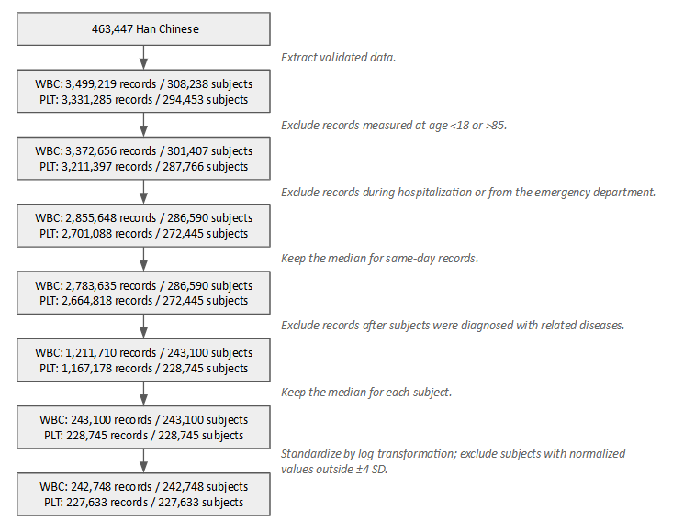
Figure S11 Flow chart of quality control for white blood cell related measurements.

Body height
We extracted 4,527,287 measurements of body height (HT) from 300,153 individuals. First, we removed measurements from individuals younger than 18 or older than 85, as well as those smaller than 100 cm or larger than 230 cm. To examine the consistency of height records for each subject, we utilized a published cleansing algorithm¹⁰. The height records were categorized into three age groups: 18-24, 25-50, and 51-85 for comparison. We compared all records from the same individual both within and across age groups. A difference greater than 5 cm was considered an error and was excluded. The median value was used for subjects with multiple measurements, and outliers (±4 SD) were removed. This process resulted in data for 287,045 individuals for further analysis.
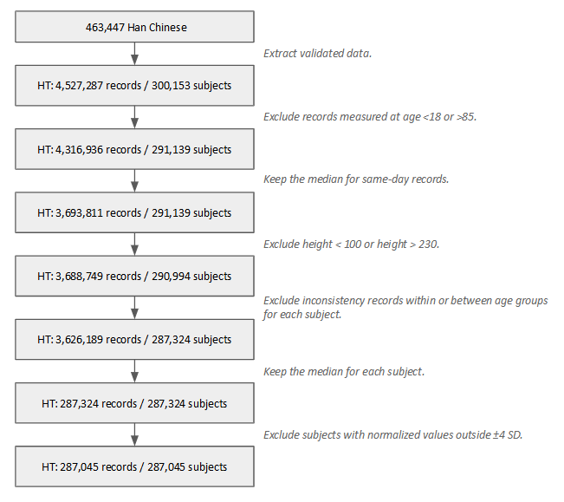
Figure S12.Flow chart of quality control for body height

Body mass index
A total of 3,258,387 body mass index (BMI) values from 274,199 individuals were extracted from the linked EMR. First, we excluded measures from individuals younger than 18 or older than 85. Next, we removed measurements with incorrect height and unrealistic value (< 10 or > 100 kg/m²), resulting in 2,453,477 measurements from 262,885 subjects. We also excluded BMI measurements taken during pregnancy and after bariatric surgery¹¹. To address inconsistencies, we applied a published algorithm¹² for each subject. The median value was used for subjects with multiple measurements, and outliers (±4 SD) were removed. As a result, 257,607 individuals were used for further analysis.

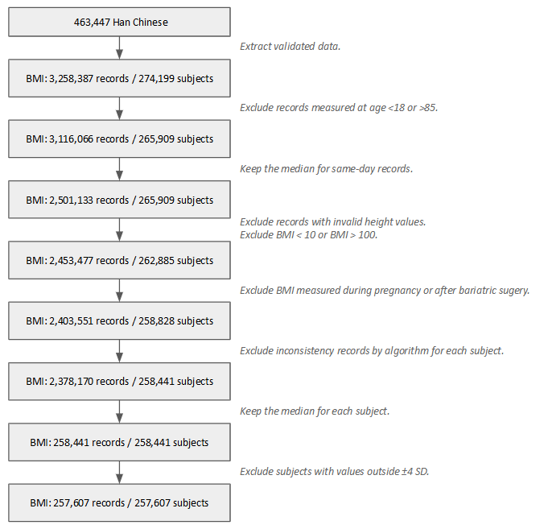
Figure S13. Flow chart of quality control for body mass index

Blood lipids
We studied 4 lipid-related traits including total cholesterol (TC), high-density lipoprotein cholesterol (HDL-C), low-density lipoprotein cholesterol (LDL-C), and triglycerides (TG). From linked EMR, we extracted 1,746,586 measures of TC from 233,309 individuals; 1,204,076 measures of HDL-C from 205,718 individuals; 2,027,144 measures of LDL-C from 236,749 individuals; and 1,819,294 measures of TG from 233,358 individuals. We removed measurements at ages younger than 18 or older than 85 and any record from hospitalization and the emergency department. Each kind of lipid value was adjusted by adding different constants for taking different medications¹³. We extracted the median value for subjects with multiple measurements and removed outliers (±4 SD), resulting a total of 222,588 individuals for TC; 196,719 for HDL-C; 228,980 for LDL-C; and 222,723 for TG.
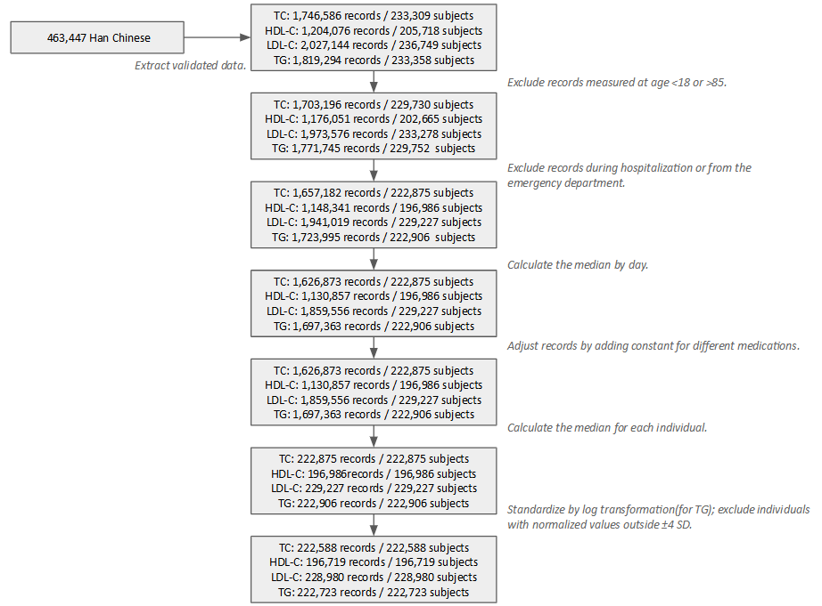
Figure S14. Flow chart of quality control for blood lipids

Blood glucose traits
We obtained 1,899,545 fasting glucose (FG) measures from 212,908 individuals and 1,635,271 glycated hemoglobin (HbA1c) measures from 84,503 individuals from the TPMI-linked EMR. First, we performed the general exclusion criteria for age and measurement source, inpatient and emergency department. Then, measures after the diagnosis of diabetes (ICD-10: E08–E12) or the occurrence of renal insufficiency (eGFR < 15) were excluded¹⁴. eGFR were calculated using the CKD-EPI equation based on serum creatinine¹⁵. Finally, we extracted the median value for each subject and excluded the outliers (±4 SD). As a result, 153,044 individuals for FG and 128,540 individuals for HbA1c were used in the analysis.
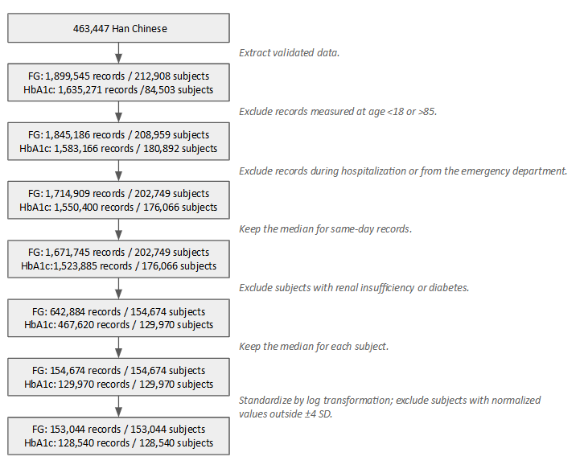
Figure S15. The flow chart of quality control for blood glucose traits

Liver-related measurements
In this study, we included three liver-related indices, such as alanine aminotransferease (ALT), aspartate aminotransferase (AST) and total bilirubin (T-BIL). From EMR, we extracted 3,931,958 values of ALT from 307,222 subjects, 2,086,779 AST from 246,330 subjects and 1,302,090 T-BIL from 161,184 subjects. In addition to age and source exclusion, measurements after the diagnosis of hepatitis B, hepatitis C, cirrhosis, or hepatocellular carcinoma were also excluded¹⁴. For T-BIL data, values greater than 30 mg/dL were also removed¹⁶. The median value was used for subjects with multiple measurements, and outliers (±4 SD) were removed. As a result, 275,492 subjects were kept for ALT, 208,120 for AST and 126,872 for T-BIL.
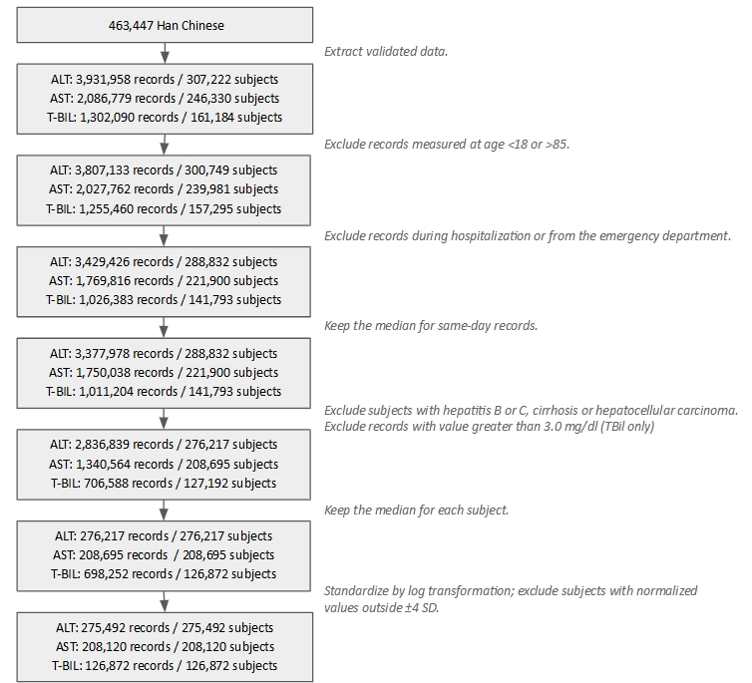
Figure S16. The flow chart of quality control for liver-related traits

Kidney-related measurements
Three kidney-related measures were investigated, including blood urea nitrogen (BUN), serum creatinine (sCR), and uric acid (UA). A total of 2,048,959 measures of BUN from 224,910 individuals, 4,481,580 measures of sCR from 316,939 individuals and 1,285,013 measures of UA from 187,996 individuals were extracted. After age and source exclusion, we further removed measures after the first record of renal insufficiency (eGFR < 15)¹⁴. For UA, we also removed measures after the first recorded of using urate-lowering medication (allopurinol, febuxostat, probenecid, or benzbromarone). Finally, we kept the median value and removed the outliers (±4 SD), resulting in 192,478 individuals for BUN, 296,867 individuals for sCR and 162,674 individuals for UA in the analysis.

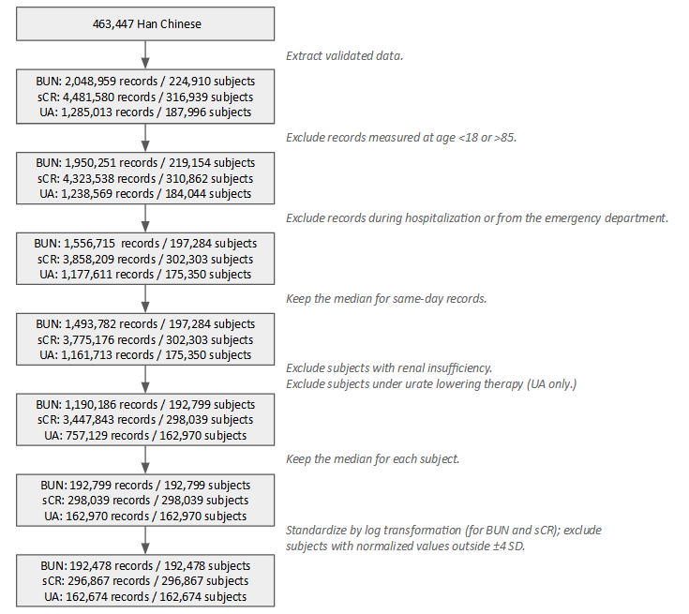
Figure S17. The flow chart of quality control for kidney-related traits

Vital signs
A total of 3,724,305 heart rate (HR) measurements from 212,908 subjects and 4,893,884 blood pressure (BP) measurements from 308,684 subjects were extracted from the linked EMR. We excluded measurements taken at ages younger than 18 or older than 85, as well as records collected during hospitalization or emergency department visits. For the HR trait, measurements were excluded after subjects were diagnosed with atrial fibrillation, second- or third-degree atrioventricular block, required a pacemaker, had prevalent myocardial infarction or heart failure, or were using beta-adrenergic blocking agents, non-dihydropyridine calcium antagonists, or digoxin¹⁷. For the BP traits, systolic blood pressure (SBP) and diastolic blood pressure (DBP) were used to obtain pulse pressure (PP = SBP - DBP) and mean arterial pressure (MAP = ⅓ SBP + ⅔ DBP). Measurements were excluded after subjects were diagnosed with chronic kidney disease, secondary hypertension, or heart failure. BP values were adjusted for subjects on hypertensive medications: SBP (+15), DBP (+10), PP (+5), and MAP (+11.667)¹⁸ . The median value was used for subjects with multiple measurements, and outliers (±4 SD) were removed. The final dataset includes 191,335 subjects for HR, 265,727 for SBP, 265,652 for DBP, 265,515 for PP, and 265,723 for MAP.
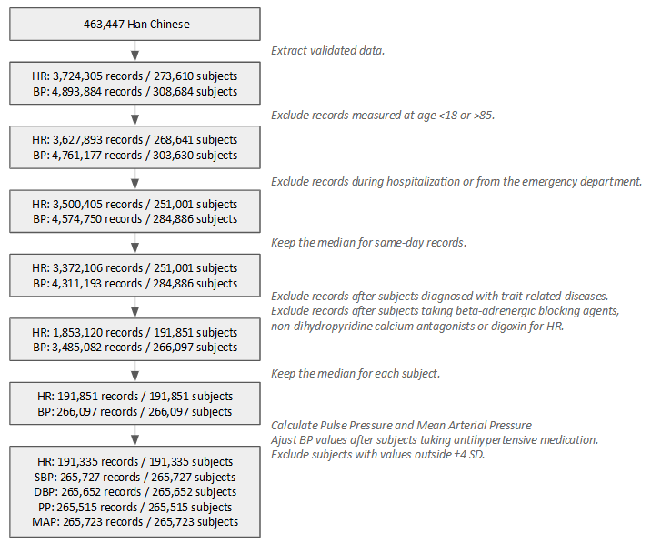
Figure S18. The flow chart of quality control for vital signs

SNP-based heritability for quantitative traits
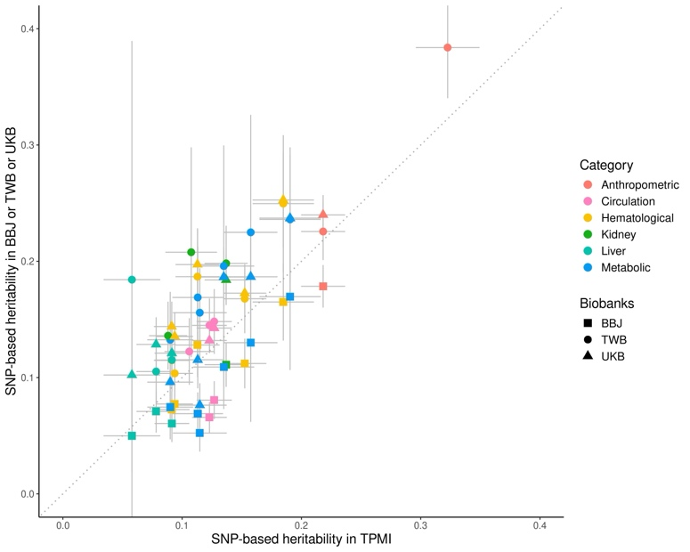
We performed the linkage disequilibrium score regression (LDSC) for estimating the SNP-based heritability for all 24 quantitative traits¹⁹. The GWAS summary statistics from the linear regression with TPMI unrelated set (p̂<0.09375 [3rd degree of relatedness], n = 248,754) were used. The estimated heritability from TPMI ranged from 0.088±0.008 for BUN to 0.323±0.014 for HT. To assess the robustness of our estimates, we compared our results with reported heritability values from the Taiwan Biobank (TWB), Biobank Japan (BBJ), and UK Biobank (UKB)²⁰. We observed strong and statistically significant correlations between TPMI and the other three biobanks (r = 0.88 and p-value = 1.05x10⁻⁵ with TWB; r = 0.90 and p-value = 1.12x10⁻⁶ with BBJ; and r = 0.84 and p-value = 2.56x10⁻⁵ with UKB, Fig. S19 and Table S20). However, the heritability estimate for HT from TPMI (h² = 0.323 ± 0.014) was slightly lower than that from TWB (h² = 0.384 ± 0.022; Fig. S19 and Table S20). This may be explained by the fact that the EMR-extracted body height includes both self-reported and measured values, which may introduce greater phenotypic variation compared to the Taiwan Biobank, where measurements were conducted by trained personnel using a standardized protocol.
Figure S19. The estimates of heritability for 24 quantitative traits in TPMI (x-axis) and other biobanks (y-axis), including Taiwan Biobank (TWB, circle), Biobank Japan (BBJ, square), and UK Biobank (triangle). The bars indicate the 95% confidence interval.
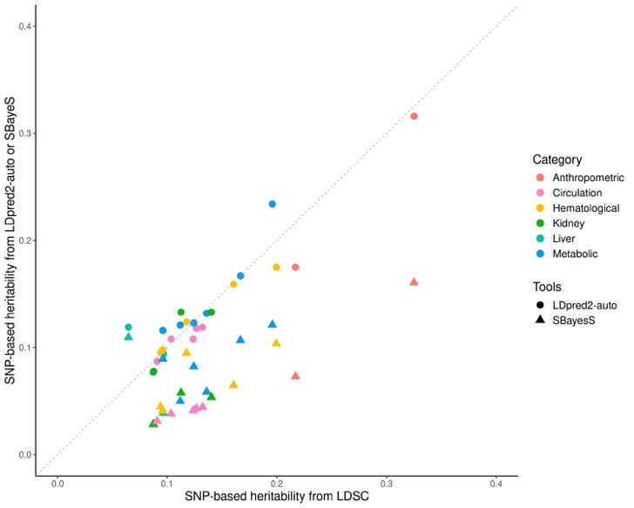
We then further investigated the effect of parameter settings and statistical approaches on heritability estimation. First, we applied stricter thresholds for defining the unrelated set (p̂<0.0442 and p̂<0.0221), resulting in sample sizes of n = 237,987 and n = 179,977, respectively. The results indicated no significant differences across these thresholds. (HT: h²=0.323±0.013 for p̂<0.09375, 0.334±0.015 for p̂<0.0442, and 0.346±0.018 for p̂<0.0221; BMI: h2=0.218±0.009 for p̂<0.09375, 0.220±0.011 for p̂<0.0442, and 0.218±0.012 for p̂<0.0221). Next, we used different software tools for heritability estimation, including LDPred2-auto²¹ and SBayesS²², which incorporate a non-infinitesimal prior. We found high concordance between the estimates from LDSC and LDPred2-auto, while SBayesS consistently produced lower heritability estimates (Fig. S20 and Table S20).
Figure S20. The scatter plot of comparison of heritability estimation between LDSC (x-axis) and LDpred2-auto (circle) and SBayesS (triangle).
Lastly, differences in the degree of assortative mating across populations may also impact heritability estimation. A previous study in the UK Biobank showed that assortative mating can inflate heritability estimates for height by 14–23%⁵. However, among Han Chinese, a modest spousal correlation for height (r = 0.141) and a non-significant spousal correlation for BMI have been reported²³. We also applied the method of Yengo et al. in TPMI, and we found no significant correlation between odd- and even-chromosome PRS for height (θ = 0.013, p = 0.067) or BMI (θ = 0.010, p = 0.155), in contrast to the stronger effect observed in Europeans (θ = 0.032, p = 6.5x10⁻⁸⁹)²⁴. These results suggest minimal assortative mating bias in our heritability estimates.

Table S20. The estimated heritability of 24 quantitative traits accoss biobanks and approaches
 | TPMI |  |  |  |  | Taiwan Biobank²⁰ |  | Biobank Japan²⁰ |  | UK Biobank²⁰
Trait | LDSC |  | LDPred2 | SbayesS |  | LDSC |  | LDSC |  | LDSC
ALT | 0.091 | ±0.007 | 0.094 | 0.039 | ±0.002 | 0.115 | ±0.014 | 0.061 | ±0.008 | 0.121 | ±0.010
AST | 0.078 | ±0.008 | 0.077 | 0.028 | ±0.002 | 0.105 | ±0.016 | 0.071 | ±0.009 | 0.129 | ±0.012
T-BIL | 0.058 | ±0.012 | 0.119 | 0.110 | ±0.003 | 0.184 | ±0.105 | 0.050 | ±0.016 | 0.102 | ±0.024
BMI | 0.218 | ±0.009 | 0.175 | 0.073 | ±0.003 | 0.226 | ±0.013 | 0.179 | ±0.009 | 0.240 | ±0.009
BUN | 0.088 | ±0.008 | 0.078 | 0.028 | ±0.002 | 0.136 | ±0.015
DBP | 0.123 | ±0.007 | 0.108 | 0.041 | ±0.002 | 0.145 | ±0.012 | 0.066 | ±0.007 | 0.132 | ±0.006
FG | 0.115 | ±0.012 | 0.121 | 0.050 | ±0.003 | 0.156 | ±0.020 | 0.052 | ±0.008 | 0.076 | ±0.010
HbA1c | 0.135 | ±0.013 | 0.132 | 0.059 | ±0.003 | 0.196 | ±0.053 | 0.109 | ±0.018 | 0.187 | ±0.013
HB | 0.091 | ±0.008 | 0.095 | 0.045 | ±0.002 | 0.115 | ±0.012 | 0.073 | ±0.008 | 0.144 | ±0.011
HCT | 0.094 | ±0.008 | 0.098 | 0.041 | ±0.002 | 0.104 | ±0.010 | 0.077 | ±0.009 | 0.135 | ±0.010
HDL-C | 0.191 | ±0.013 | 0.234 | 0.121 | ±0.003 | 0.236 | ±0.032 | 0.170 | ±0.032 | 0.237 | ±0.028
HT | 0.323 | ±0.014 | 0.316 | 0.161 | ±0.004 | 0.384 | ±0.022
HR | 0.106 | ±0.011 | 0.108 | 0.038 | ±0.002 | 0.122 | ±0.015
LDL-C | 0.090 | ±0.010 | 0.116 | 0.089 | ±0.002 | 0.133 | ±0.021 | 0.0746 | ±0.0141 | 0.0961 | ±0.0124
MAP | 0.132 | ±0.008 | 0.119 | 0.044 | ±0.002
PLT | 0.185 | ±0.013 | 0.175 | 0.104 | ±0.003 | 0.250 | ±0.030 | 0.165 | 0.017 | 0.253 | ±0.021
PP | 0.092 | ±0.006 | 0.087 | 0.031 | ±0.002
RBC | 0.113 | ±0.009 | 0.124 | 0.095 | ±0.002 | 0.187 | ±0.021 | 0.128 | ±0.014 | 0.197 | ±0.015
SBP | 0.127 | ±0.008 | 0.118 | 0.043 | ±0.002 | 0.148 | ±0.014 | 0.081 | ±0.008 | 0.143 | ±0.006
sCR | 0.137 | ±0.009 | 0.133 | 0.054 | ±0.002
TC | 0.113 | ±0.011 | 0.123 | 0.082 | ±0.002 | 0.169 | ±0.022 | 0.069 | ±0.009 | 0.115 | ±0.013
TG | 0.158 | ±0.011 | 0.167 | 0.107 | ±0.003 | 0.225 | ±0.052 | 0.130 | ±0.035 | 0.187 | ±0.021
UA | 0.108 | ±0.011 | 0.133 | 0.058 | ±0.002 | 0.208 | ±0.046
WBC | 0.153 | ±0.009 | 0.159 | 0.065 | ±0.003 | 0.168 | ±0.015 | 0.112 | ±0.011 | 0.173 | ±0.012

References
1 Genomes Project Consortium et al. A global reference for human genetic variation. Nature 526, 68-74 (2015). https://doi.org/10.1038/nature15393
2 Alexander, D. H., Novembre, J. & Lange, K. Fast model-based estimation of ancestry in unrelated individuals. Genome Res 19, 1655-1664 (2009). https://doi.org/10.1101/gr.094052.109
3 Zhou, W. et al. Efficiently controlling for case-control imbalance and sample relatedness in large-scale genetic association studies. Nat Genet 50, 1335-1341 (2018). https://doi.org/10.1038/s41588-018-0184-y
4 Hofmeister, R. J., Ribeiro, D. M., Rubinacci, S. & Delaneau, O. Accurate rare variant phasing of whole-genome and whole-exome sequencing data in the UK Biobank. Nat Genet 55, 1243-1249 (2023). https://doi.org/10.1038/s41588-023-01415-w
5 Rubinacci, S., Delaneau, O. & Marchini, J. Genotype imputation using the Positional Burrows Wheeler Transform. PLoS Genet 16, e1009049 (2020). https://doi.org/10.1371/journal.pgen.1009049
6 Wei, C. Y. et al. Genetic profiles of 103,106 individuals in the Taiwan Biobank provide insights into the health and history of Han Chinese. NPJ Genom Med 6, 10 (2021). https://doi.org/10.1038/s41525-021-00178-9
7 Kullo, I. J., Ding, K., Jouni, H., Smith, C. Y. & Chute, C. G. A genome-wide association study of red blood cell traits using the electronic medical record. PLoS One 5 (2010). https://doi.org/10.1371/journal.pone.0013011
8 Crosslin, D. R. et al. Genetic variants associated with the white blood cell count in 13,923 subjects in the eMERGE Network. Hum Genet 131, 639-652 (2012). https://doi.org/10.1007/s00439-011-1103-9
9 Hu, Y. et al. Multi-ethnic genome-wide association analyses of white blood cell and platelet traits in the Population Architecture using Genomics and Epidemiology (PAGE) study. BMC Genomics 22, 432 (2021). https://doi.org/10.1186/s12864-021-07745-5
10 Muthalagu, A. et al. A rigorous algorithm to detect and clean inaccurate adult height records within EHR systems. Appl Clin Inform 5, 118-126 (2014). https://doi.org/10.4338/ACI-2013-09-RA-0074
11 Hoffmann, T. J. et al. A Large Multiethnic Genome-Wide Association Study of Adult Body Mass Index Identifies Novel Loci. Genetics 210, 499-515 (2018). https://doi.org/10.1534/genetics.118.301479
12 Schlauch, K. A. et al. A Comprehensive Genome-Wide and Phenome-Wide Examination of BMI and Obesity in a Northern Nevadan Cohort. G3 (Bethesda) 10, 645-664 (2020). https://doi.org/10.1534/g3.119.400910
13 Graff, M. et al. Genetic architecture of lipid traits in the Hispanic community health study/study of Latinos. Lipids Health Dis 16, 200 (2017). https://doi.org/10.1186/s12944-017-0591-6
14 Kanai, M. et al. Genetic analysis of quantitative traits in the Japanese population links cell types to complex human diseases. Nat Genet 50, 390-400 (2018). https://doi.org/10.1038/s41588-018-0047-6
15 Levey, A. S. et al. A new equation to estimate glomerular filtration rate. Ann Intern Med 150, 604-612 (2009). https://doi.org/10.7326/0003-4819-150-9-200905050-00006
16 Kim, S. W. et al. Association Between Serum Bilirubin and Atrial Fibrillation: A Mendelian Randomization Study. Korean Circ J 53, 472-479 (2023). https://doi.org/10.4070/kcj.2023.0003
17 Eijgelsheim, M. et al. Genome-wide association analysis identifies multiple loci related to resting heart rate. Hum Mol Genet 19, 3885-3894 (2010). https://doi.org/10.1093/hmg/ddq303
18 Kato, N. et al. Trans-ancestry genome-wide association study identifies 12 genetic loci influencing blood pressure and implicates a role for DNA methylation. Nat Genet 47, 1282-1293 (2015). https://doi.org/10.1038/ng.3405
19 Bulik-Sullivan, B. K. et al. LD Score regression distinguishes confounding from polygenicity in genome-wide association studies. Nat Genet 47, 291-295 (2015). https://doi.org/10.1038/ng.3211
20 Chen, C.-Y. et al. Analysis across Taiwan Biobank, Biobank Japan, and UK Biobank identifies hundreds of novel loci for 36 quantitative traits. Cell Genomics 3, 100436 (2023). https://doi.org/https://doi.org/10.1016/j.xgen.2023.100436
21 Prive, F., Albinana, C., Arbel, J., Pasaniuc, B. & Vilhjalmsson, B. J. Inferring disease architecture and predictive ability with LDpred2-auto. Am J Hum Genet 110, 2042-2055 (2023). https://doi.org/10.1016/j.ajhg.2023.10.010
22 Zeng, J. et al. Widespread signatures of natural selection across human complex traits and functional genomic categories. Nat Commun 12, 1164 (2021). https://doi.org/10.1038/s41467-021-21446-3
23 Li, M. X. et al. A major gene model of adult height is suggested in Chinese. J Hum Genet 49, 148-153 (2004). https://doi.org/10.1007/s10038-004-0125-8
24 Yengo, L. et al. Imprint of assortative mating on the human genome. Nat Hum Behav 2, 948-954 (2018). https://doi.org/10.1038/s41562-018-0476-3

