Supplementary Information
New discoveries of Australopithecus and Homo from Ledi-Geraru, Ethiopia

Authors:
Brian Villmoare¹, Lucas K. Delezene², Amy L. Rector³, Erin N. DiMaggio⁴, Christopher J. Campisano⁵, David A. Feary⁶, Baro’o Mohammed Ali⁷, Daniel Chupik⁶, Alan L. Deino⁸, Dominique I. Garello⁹, Mohammed Ahmeddin Hayidara^{10†}, Ellis M. Locke¹¹, Omar Abdulla Omar^{7†}, Joshua R. Robinson¹², Eric Scott¹³, Irene E. Smail¹⁴, Kebede Geleta Terefe¹⁵, Lars Werdelin¹⁶, William H. Kimbel^{5†}, J Ramón Arrowsmith¹⁷ & Kaye E. Reed⁵

¹Department of Anthropology, University of Nevada Las Vegas, Las Vegas, Nevada, USA. ²Department of Anthropology, University of Arkansas, Fayetteville, Arkansas, USA. ³Anthropology, Virginia Commonwealth University, Richmond, Virginia, USA. ⁴Department of Geosciences, Pennsylvania State University, University Park, Pennsylvania, USA. ⁵Institute of Human Origins and School of Human Evolution and Social Change, Arizona State University, Tempe, Arizona, USA. ⁶School of Earth and Space Exploration, Arizona State University, Tempe, Arizona, USA. ⁷Ledi-Geraru Research Project Field Team, 1/2 Hadar Kebele, Mille Woreda, Afar Region, Ethiopia. ⁸Berkeley Geochronology Center, 2455 Ridge Road, Berkeley, California, USA. ⁹Department of Geology and Geophysics, Louisiana State University, E209 Howe-Russell, Baton Rouge, Louisiana, USA. ¹⁰Afar Tourism Bureau, Semera, Afar Region, Ethiopia. ¹¹Department of Anatomy, Idaho College of Osteopathic Medicine, Meridian, Idaho, USA. ¹²Archaeology Program, Boston University, 675 Commonwealth Avenue, Boston, Massachusetts, USA. ¹³Department of Biology, College of Natural Sciences, California State University, San Bernardino, 5500 University Parkway, San Bernardino, California, USA. ¹⁴Department of Biomedical Sciences, West Virginia School of Osteopathic Medicine, Lewisburg, West Virginia, USA. ¹⁵Techno Link College Burayu Campus, PO Box 20, Shager City, Burayu, Ethiopia. ¹⁶Department of Palaeobiology, Swedish Museum of Natural History, Box 50007, SE-10405 Stockholm, Sweden. ¹⁷School of Earth and Space Exploration and Institute of Human Origins, Arizona State University, Tempe, Arizona, USA. †Deceased

Supplementary Table pg. 3
Supplementary Figures pg. 4
Supplementary Data pg. 9
Supplementary Video pg. 10
Supplementary Table S1: ⁴⁰Ar/³⁹Ar analytical data. Data derived from individual grain analysis with the SCIH approach. https://tinyurl.com/LediGeraru40Ar39Ar

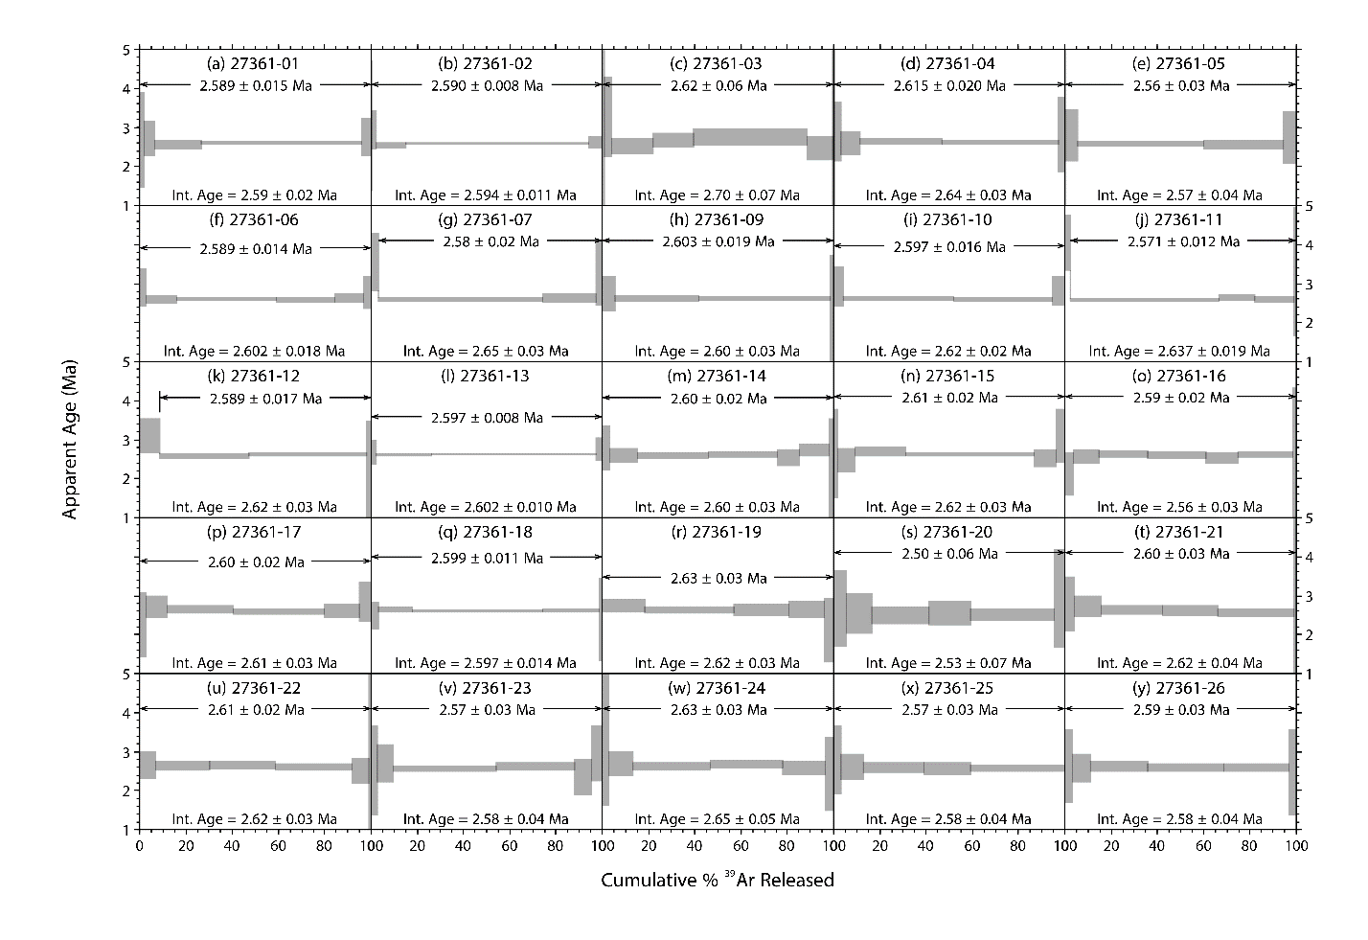
Supplementary Fig. S1: Incremental heating ³⁹Ar release spectra from individual K-feldspar grains (SCIH experiments). The horizontal axis of each subplot is the cumulative percent release of ³⁹Ar during the course of the experiment. ‘Int. Age’ is the ‘integrated,’ or total-gas age, obtained by isotopically summing the individual steps weighted by the inverse variance, with the error calculated as the modified standard error (MSE) at 1s (standard error of the weighted mean multiplied by the square root of the MSWD when MSWD >1). The apparent age plateau is calculated as the mean age weighted by the inverse variance, with the error as the 1 𝜎 MSE.
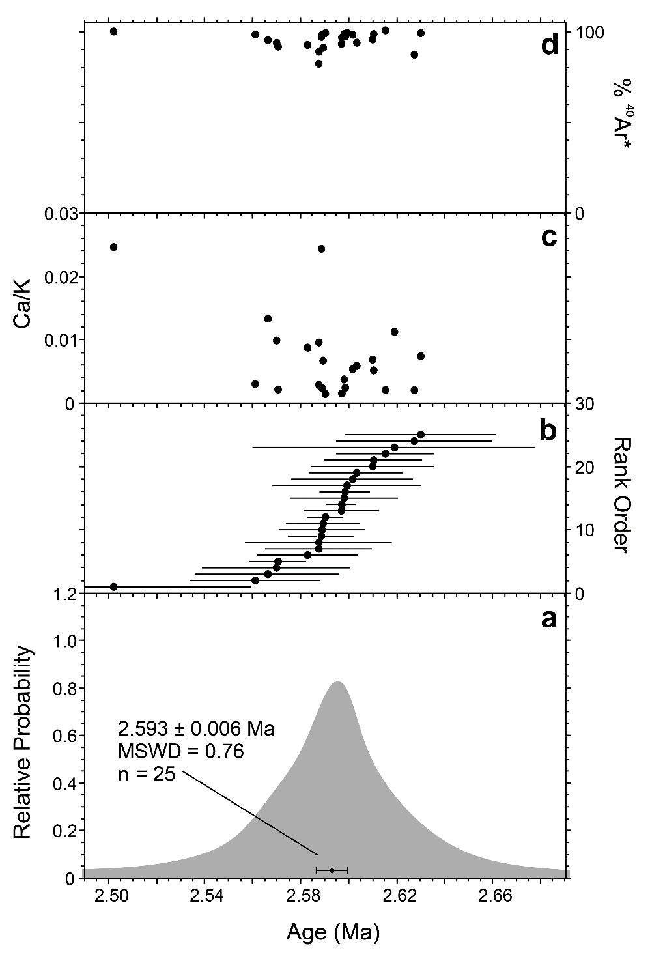
Supplementary Fig. S2: ⁴⁰Ar/³⁹Ar SCIH plateau age analysis. a: Probability density plots of the feldspar phenocryst ⁴⁰Ar/³⁹Ar SCIH plateau ages. The vertical scale is the relative likelihood of a given age occurring in the sample population. b: Rank-order plot of individual crystal ages with 1σ analytical uncertainty. c: Log of the median Ca/K atomic ratio derived from ³⁷Ar/³⁹Ar measurements. d: Percent radiogenic ⁴⁰Ar of total ⁴⁰Ar.
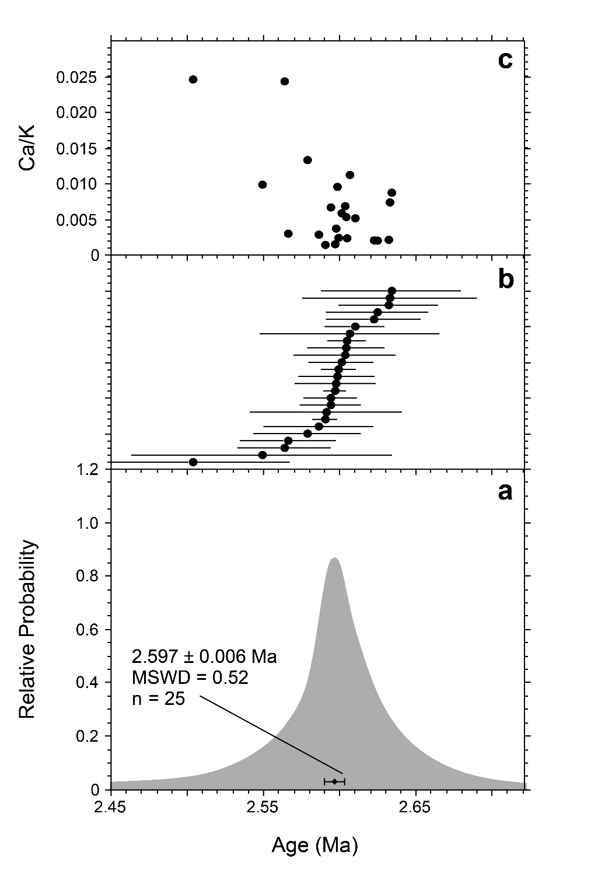
Supplementary Fig. S3: ⁴⁰Ar/³⁹Ar isochron analysis. a: Probability-density plot of isochron ages from the feldspar phenocryst ⁴⁰Ar/³⁹Ar SCIH plateau steps. The vertical scale is the relative likelihood of a given age occurring in the sample population. b: Rank-order plot of individual crystal ages with 1σ analytical uncertainty. c: Log of the median Ca/K atomic ratio derived from ³⁷Ar/³⁹Ar measurements.
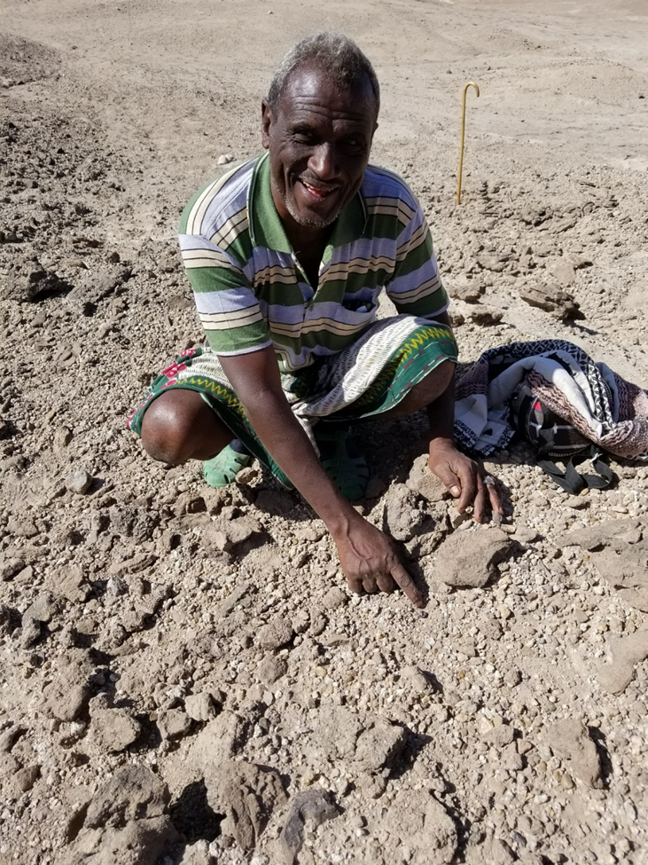
Supplementary Fig. S4: Premolar recovered from LD 750 by Omar Abdulla Omar. Credit: Amy L. Rector.
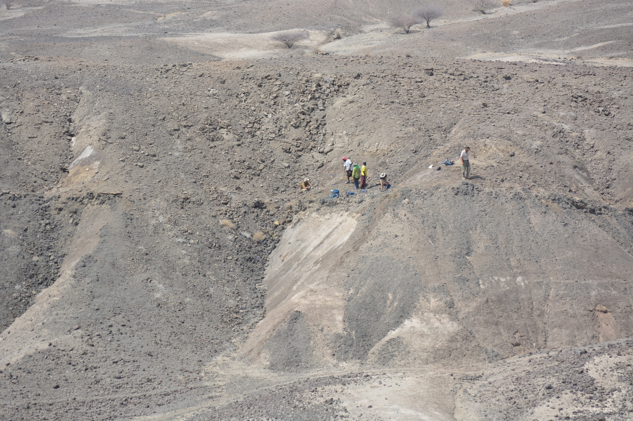
Supplementary Fig. S5: Sample collection at the AS 100 locality. Credit: David A. Feary.
Supplementary Data S1. Hominin dental metrics including Ledi-Geraru and comparative specimens. https://tinyurl.com/LediGeraru
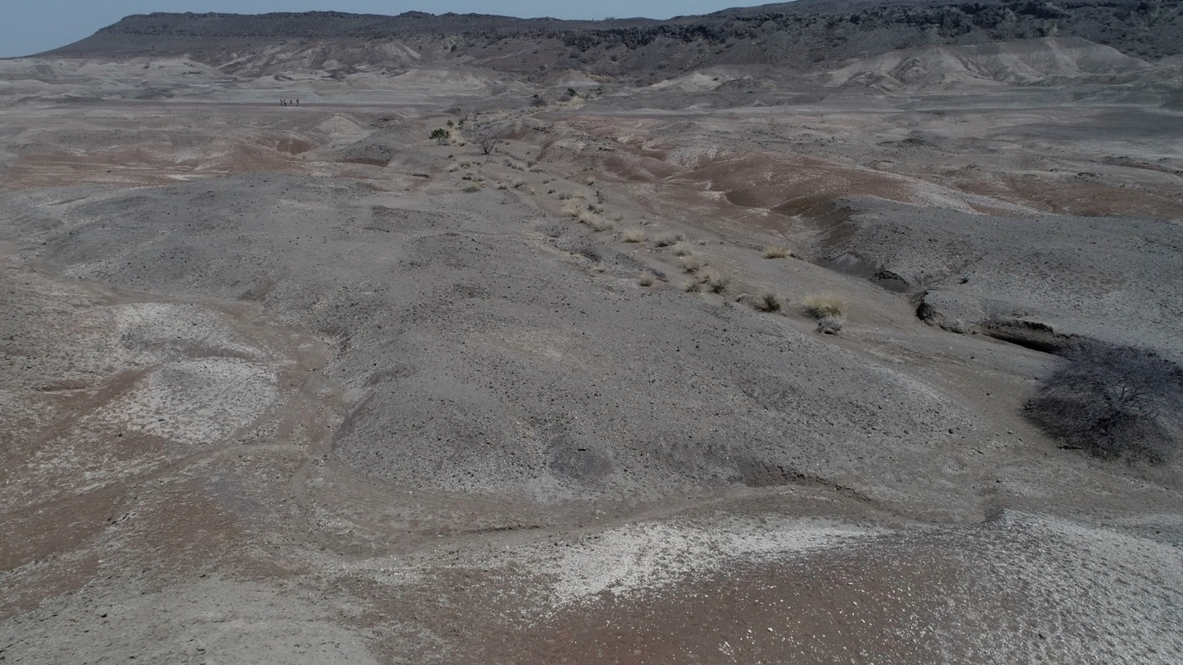
Supplementary Video S1: Survey, collection, and screening at Lee Adoyta localities. UAV video footage showing paleontologists surveying west of the LD 750 locality (start to 0m32sec), fossil collection at the LD 760 locality (0m32s to 1m24s), and screening at the LD 760 locality (1m24s to end). https://tinyurl.com/LediGeraru760 Credit: David A. Feary.

