Supplementary Information File for:
Redox-Driven Mineral and Organic Associations in Jezero Crater, Mars
Joel A. Hurowitz¹, M.M. Tice², A.C. Allwood³, M.L. Cable³, K.P. Hand³, A.E. Murphy⁴, K. Uckert³, J.F. Bell III⁵, T. Bosak⁶, A.P. Broz⁷, E. Clavé⁸, A. Cousin⁹, S. Davidoff³, E. Dehouck¹⁰, K.A. Farley¹¹, S. Gupta¹², S-E Hamran¹³, K. Hickman-Lewis¹⁴, J.R. Johnson¹⁵, A.J. Jones¹², M.W.M. Jones¹⁶, P.S. Jørgensen¹⁷, L.C. Kah¹⁸, H. Kalucha¹¹, T.V. Kizovski¹⁹, D.A. Klevang¹⁷, Y. Liu³, F. M. McCubbin²⁰, E.L. Moreland²¹, G. Paar²², D.A. Paige²³, A.C. Pascuzzo²⁴, M. S. Rice²⁵, M.E. Schmidt¹⁹, K.L. Siebach²¹, S. Siljeström²⁶, J.I. Simon²⁰, K.M. Stack³, A. Steele²⁷, N.J. Tosca²⁸, A.H. Treiman²⁹, S.J. VanBommel³⁰, L.A. Wade³, B.P. Weiss⁶, R.C. Wiens³¹, K.H. Williford³², R. Barnes¹², P.A. Barr²⁴, A. Bechtold³³, P. Beck³⁴, K. Benzerara³⁵, S. Bernard³⁶, O. Beyssac³⁷, R. Bhartia³⁸, A.J. Brown³⁹, G. Caravaca⁴⁰, E.L. Cardarelli²³, E.A. Cloutis⁴¹, A.G. Fairén⁴², D.T. Flannery⁴³, T. Fornaro⁴⁴, T. Fouchet⁴⁵, B. Garczynski²⁵, F. Goméz⁴², E.M. Hausrath⁴⁶, C.M. Heirwegh³, C.D.K. Herd⁴⁷, J.E. Huggett²⁴, J.L. Jørgensen¹⁷, S.W. Lee³, A.Y. Li⁴⁸, J.N. Maki³, L. Mandon⁴⁹, N. Mangold⁵⁰, J.A. Manrique⁵¹, J. Martínez-Frías⁵², J. I. Núñez¹⁵, L.P. O’Neil², B.J. Orenstein⁴³, N. Phelan²⁴, C. Quantin-Nataf⁵³, P. Russell,²³ M.D. Schulte⁵⁴, E. Scheller⁶, S. Sharma²⁷, D.L. Shuster⁵⁵, A. Srivastava²⁷, B.V. Wogsland¹⁸, Z.U. Wolf⁵⁶
¹Corresponding author, Department of Geosciences, Stony Brook University, Stony Brook, NY 11794-2100, USA, joel.hurowitz@stonybrook.edu
²Department of Geology & Geophysics, Texas A&M University, College Station, TX 77843, USA
³Jet Propulsion Laboratory, California Institute of Technology, 4800 Oak Grove Drive, Pasadena, CA 91109, USA
⁴Planetary Science Institute, 1700 East Fort Lowell, Suite 106, Tucson, AZ 85719, USA
⁵School of Earth and Space Exploration, Arizona State University, Tempe, AZ, 85287, USA
⁶Department of Earth, Atmospheric and Planetary Sciences, Massachusetts Institute of Technology, Cambridge, MA 02139, USA
⁷Department of Earth, Atmospheric, and Planetary Sciences, Purdue University, West Lafayette, IN 47907, USA
⁸Deutsches Zentrum für Luft- und Raumfahrt (DLR), Institute of Optical Sensor Systems, DE
⁹Institut de Recherche en Astrophysique et Planétologie, CNRS, Univ. Toulouse, CNES, Toulouse, FR
¹⁰Université Claude Bernard Lyon 1, ENS de Lyon, CNRS, UJM, LGL-TPE, UMR 5276, F-69622, Villeurbanne cedex, FR
¹¹Division of Geological and Planetary Sciences, California Institute of Technology, Pasadena, 91125, USA
¹²Department of Earth Science and Engineering, Imperial College London, SW7 2AZ, UK
¹³Center for Space Sensors and Systems, University of Oslo, NO
¹⁴School of Natural Sciences, Birkbeck, University of London, Malet Street, WC1E 7HX, London, UK
¹⁵Johns Hopkins University Applied Physics Laboratory, 11101 Johns Hopkins Road 200-W230, Laurel, MD 20723-6005, USA
¹⁶Central Analytical Research Facility, Queensland University of Technology, Brisbane, 4000, AUS
¹⁷Technicial University of Denmark, DTU Space, DK
¹⁸Earth, Environmental and Planetary Sciences, University of Tennessee, Knoxville, TN 37992, USA
¹⁹Department of Earth Sciences, Brock University, St. Catharines, Ontario, Canada L2S 3A1
²⁰Astromaterials Research & Exploration Science Division, NASA Johnson Space Center, Houston, TX, 77058, USA
²¹Department of Earth, Environmental, and Planetary Sciences, Rice University, Houston, TX 77005, USA
²²Joanneum Research Institute for Digital Technologies, Steyrergasse 17, A-8010 Graz, AT
²³Dept. of Earth, Planetary and Space Sciences, University of California Los Angeles, Los Angeles, CA 90095, USA
²⁴Malin Space Science Systems, San Diego, California, USA
²⁵Geology Department, Western Washington University, Bellingham, WA, USA
²⁶RISE Research Institutes of Sweden, Stockholm, SE
²⁷Carnegie Science Earth & Planets Laboratory, Washington DC 20015, USA
²⁸Department of Earth Sciences, University of Cambridge, Cambridge, CB2 3EQ, UK
²⁹Lunar and Planetary Institute, 3600 Bay Area Blvd., Houston TX 77058 USA
³⁰Department of Earth, Environmental, and Planetary Sciences, Washington University in St. Louis, St. Louis, MO, 63130, USA
³¹Department of Earth, Atmospheric, and Planetary Sciences, Purdue University, West Lafayette, IN 47907 USA
³²Blue Marble Space Institute of Science; Seattle, 98104, USA
³³Department of Lithospheric Research, University of Vienna, AT
³⁴Institut d’astrophysique et de planétologie de Grenoble/ISTerre, 414 Rue de la Piscine, 38041 Grenoble cedex 09, FR
³⁵IMPMC, UMR 7590 SU, CNRS, MNHN, IRD Biomineralogy Team Jussieu Campus, 4 Place Jussieu 75252 Paris Cedex, FR
³⁶Museum National d'Histoire Naturel, CNRS UMR 7590, Sorbonne Université, IMPMC, Paris, FR
³⁷Institut de Minéralogie, de Physique des Matériaux et de Cosmochimie, CNRS UMR 7590, Sorbonne Université, Muséum National d'Histoire Naturelle, 75005 Paris, FR
³⁸Photon Systems Inc. Covina, CA, 91722, USA
³⁹Plancius Research, Manlius, NY, USA
⁴⁰Géosciences Environnement Toulouse, UMR 5563 Université de Toulouse, CNRS, IRD, CNES, Toulouse, FR
⁴¹Centre for Terrestrial and Planetary Exploration, University of Winnipeg, Winnipeg, MB, Canada R3B 2E9
⁴²Centro de Astrobiología (CAB), CSIC-INTA, 28850 Madrid, ES
⁴³School of Earth and Atmospheric Sciences, Queensland University of Technology, Brisbane, Queensland, AUS
⁴⁴INAF-Astrophysical Observatory of Arcetri, Largo E. Fermi 5, 50125 Florence, IT
⁴⁵Observatoire de Paris, PSL, 61 avenue de l'Observatoire, 75014 Paris, FR
⁴⁶Department of Geoscience, UNLV, Las Vegas, Nevada, USA
⁴⁷Department of Earth and Atmospheric Sciences, University of Alberta, Edmonton, Alberta, Canada T6G 2E3
⁴⁸Department of Earth and Space Sciences/Astrobiology Program, University of Washington, Seattle, WA 98105, USA
⁴⁹Univ. Grenoble Alpes, CNRS, IPAG, 38000 Grenoble, FR
⁵⁰Laboratoire Planétologie et Géosciences, CNRS UMR6112, Nantes Université, Univ Angers, 44322 Nantes, FR
⁵¹ERICA Research Group and LaDIS Laboratory, University of Valladolid, Valladolid, ES
⁵²Institute of Geosciences, CSIC-UCM, Madrid, ES
⁵³Université Claude Bernard Lyon 1, ENS de Lyon, CNRS, UJM, LGL-TPE, UMR 5276, F-69622, Villeurbanne cedex, FR
⁵⁴Mars Exploration Program, NASA Headquarters, 300 E St SW, Washington, DC 20546, USA
⁵⁵Department of Earth and Planetary Science, University of California, Berkeley, CA 94720-4767, USA
⁵⁶Los Alamos National Laboratory, Los Alamos, NM, USA

SI Text:
Mass balance calculation for closed system phosphate redistribution. In this example, we use the PIXL targets Walhalla Glades and Mt. Spoonhead as examples. Each is characterized by large amounts of a fine-grained muddy facies (manuscript text, Figs. S6, S19) with high bulk Fe and P abundances (SI Tables), but in Walhalla Glades, the P has been redistributed into authigenic Fe-phosphate nodules (Fig S13H, S19, S21F) and the target contains organic matter (Fig. 3D), whereas in Mt. Spoonhead, no P redistribution has occurred (i.e, no authigenic nodules or reaction fronts are present). Thus, Mt. Spoonhead is taken as representative of the chemistry of Walhalla Glades in the absence of redox reactions that produce Fe-phosphate nodules. For the simple mass balance calculation, we used PIXLISE^{1,2} to determine the diffraction and topography corrected bulk P₂O₅ abundance for Mt. Spoonhead = 0.8 ± 0.2 wt.% (SI Tables). We then determined the areal abundance of Fe-phosphate nodules in Walhalla Glades by counting the number of PIXL Motion Counter (PMCs) positions¹ in the Walhalla Glades scan that have P₂O₅ > 2 wt. % (SI Tables), all of which have the visible appearance of Fe-phosphate nodules. These account for 7% of PMCs in the scan. The nodule-free component of Walhalla Glades therefore represents 93% of the PIXL XRF scan points. We then determined the average P₂O₅ abundance in PMCs with and without Fe-phosphate nodules = 3.3 ± 0.4 wt.% and 0.8 ± 0.2 wt. %, respectively. Setting up a mass balance mixing relationship:
Bulk P₂O_{5, Mt. Spoonhead, calc.} = x(Matrix P₂O_{5, Walhalla Glades, meas.}) + (1-x)(Nodule P₂O_{5, Walhalla Glades, meas.})
0.8 ± 0.2 wt. % = 0.93(0.8 ± 0.2 wt. %) + 0.07(3.3 ± 0.4 wt. %)
We calculate an expected bulk P₂O₅ content for Walhalla Glades of 1.0 ± 0.2 wt. % which is identical within uncertainty to what is measured in Mt. Spoonhead. Therefore, mass balance closes with respect to measured bulk P₂O₅ abundance of the Mt. Spoonhead target, consistent with closed system redistribution of P from the mudstone into authigenic Fe-phosphate nodules.

SI TABLES:
Table S1A: Definitions of spectral band parameters shown in Figures S9-11
Figure | Parameter | Formula* | Mineralogic Indicator
S9A | 528 nm band depth | 1 – R₅₂₈ / (0.472R₄₄₂ + 0.528R₆₀₅) | Degree of ferric iron contribution to Mastcam-Z spectra
S9A | 754 nm / 442 nm ratio | R₇₅₄ / R₄₄₂ | Spectral “redness”; larger values are consistent with higher degrees of ferric iron in Mastcam-Z spectra
S10 | BD545 | 1 – R₅₄₅ / (0.324R₄₃₀ + 0.676R₆₀₀) | Degree of ferric iron contribution to SuperCam visible-wavelength spectra
S10 | R6744 | R₆₇₀ / R₄₄₀ | Spectral “redness”; larger values are consistent with higher degrees of ferric iron in SuperCam visible-wavelength spectra
S11 | 1.92 um (1920 nm) band depth | 1 – R₁₉₂₀ / (0.697R₁₈₂₀ + 0.303R₂₁₅₀) | Abundance of structural water in SuperCam near-infrared-wavelength spectra
* After Rice et al.³. R_{N} is the reflectance value at wavelength position N nm.

Table S1B: Details for Mastcam- Z and laboratory spectra presented in Figure S9
No. | Spectrum Type | Class | Target or Mineral Name | Source  (Sol+ Sequence Identifier or Reference*) | Offset in Fig. S9B (Reflectance Units)
1 | Mastcam-Z | Masonic Temple (MT) | Malgosa Crest Abrasion (abraded surface) | sol 1242, zcam03962 | +0.65
2 | Mastcam-Z | Masonic Temple (MT) | Malgosa Crest Abrasion (tailings) | sol 1242, zcam03962 | +0.60
3 | Mastcam-Z | Bright Angel (BA) | Sapphire Canyon Borehole | sol 1217, zcam03939 | +0.20
4 | Mastcam-Z | Bright Angel (BA) | Apollo Temple Abrasion | sol 1212, zcam03937 | 0.00
5 | Mastcam-Z | Bright Angel (BA) | Steamboat Mountain Abrasion | sol 1192, zcam03930 | 0.00
6 | Mastcam-Z | Bright Angel (BA) | Walhalla Glades Abrasion | sol 1180, zcam03921 | 0.00
 | Laboratory | Ferric mineral | JSC-Mars1 (palagonitic Mars analog soil) | Johnson & Grundy (2021)⁴ | +0.60
 | Laboratory | Ferric mineral | Ferrihydrite | Kokaly et al. (2017)⁵ | +0.75
 | Laboratory | Ferric mineral | Hematite | Kokaly et al. (2017) ⁵ | +0.30
 | Laboratory | Ferric mineral | Goethite | Kokaly et al. (2017) ⁵ | +0.45
 | Laboratory | Ferric mineral | Nanohematite | Kokaly et al. (2017) ⁵ | 0.00
 | Laboratory | Ferric mineral | Maghemite | Kokaly et al. (2017) ⁵ | +0.15
 | Laboratory | Ferrous mineral | Diopside | U. Winn PSF | +0.50
 | Laboratory | Ferrous mineral | Olivine (Fo66) | Kokaly et al. (2017) ⁵ | +0.40
 | Laboratory | Ferrous mineral | Olivine (Fo1) | RELAB | +0.30
 | Laboratory | Ferrous mineral | Ferrosilite | RELAB | +0.20
 | Laboratory | Ferrous mineral | Augite | U. Winn PSF | +0.10
 | Laboratory | Ferrous mineral | Pigeonite | U. Winn PSF | 0.00
* RELAB is NASA’s Reflectance Experiment Laboratory, spectra are available via: https://pds-speclib.rsl.wustl.edu/ ; U. Winn PSF is the University of Winnipeg Planetary Spectroscopy Facility, spectra are available via: https://psf.uwinnipeg.ca

Table S2: Summary of PIXL diffraction results with percentages calculated for the Ca-sulfate PMCs.
Scan | Ca-sulfate PMCs/Scan PMCs | Non-diffracting PMCs | Diffracting PMCs | Anhydrite | Gypsum | Not indexed
Apollo Temple | 695/4871 | 625 (89.9%) | 70 (10.1%) | 39 (5.6%) | 9 (1.3%) | 22 (3.2%)
Apollo Temple 1 | 231/2339 | 199 (86.2%) | 32 (13.8%) | 25 (10.8%) | 2 (0.9%) | 5 (2.2%)
Apollo Temple 2 | 430/1651 | 392 (91.2%) | 38 (8.8%) | 14 (3.3%) | 7 (1.6%) | 17 (3.9%)
Apollo Temple 3 | 34/827 | 34 (100%) | 0 | NA | NA | NA
Walhalla Glades | 631/2339 | 596 (94.5%) | 35 (5.5%) | 19 (3.0%) | 5 (0.8%) | 11 (1.7%)
Steamboat Mountain | 187/2339 | 97 (51.9%) | 90 (48.1%) | 28 (14.9%) | 25 (13.4%) | 37 (19.8%)

 |  | Layered | Faintly layered to structureless | Nodular | Coarse Granular | Conglomeratic | Fe-phosphate nodules | Reaction Fronts | Fig. #
Outcrop Area | Target ID | GDRT Cleaned Surfaces
Bright Angel | Grapevine Canyon |  | X | X |  |  | X |  | S3B, S20
Bright Angel | Cheyava Falls¹ | X |  |  |  |  | X | X | 3A-C, 5A,  S17A-C
Masonic Temple | Mount Spoonhead |  | X |  |  |  |  |  | S4, S5, S6
Masonic Temple | Wallace Butte² |  |  |  |  | X |  |  | S4, S8A, B
 |  | Abraded Surfaces
Bright Angel | Walhalla Glades |  | X | X |  |  | X |  | S3A, S9B, S11A, S12A4, S13D, H, S14H, I, S19A-C, S21
Bright Angel | Apollo Temple¹ | X |  |  |  |  | X |  | S9B, S11B, S12A5, S13C, G, S14A-D, S22A-C, S25
Bright Angel | Steamboat Mountain |  |  |  | X |  | X |  | S9B, S12A3, S13B, F, S15A, B, S18A-C
Masonic Temple | Malgosa Crest² |  |  |  |  | X | ? | ? | S4, S9B, S12A6, S13A, E, S23A-C
 |  | Natural Surfaces
Bright Angel | Kolb Arch¹ | X |  |  |  |  |  |  | S11C
Bright Angel | Tanner Canyon | ? |  |  |  |  |  |  | S12A2
Masonic Temple | Bass Camp |  |  |  |  | X |  |  | S4, S7
Table S3: Outcrop area and target names, their outcrop-scale textural expressions, whether authigenic Fe-phosphate nodules or reaction fronts were observed, and figures where the targets are shown.
¹Cheyava Falls, Apollo Temple and Kolb Arch are in the same outcrop block.
²Wallace Butte and Malgosa Crest are in the same outcrop block. Malgosa Crest contains mm-scale green-blue features that may be reduction features of a different style than is represented by the nodules and reaction fronts seen in the Bright Angel outcrop area.

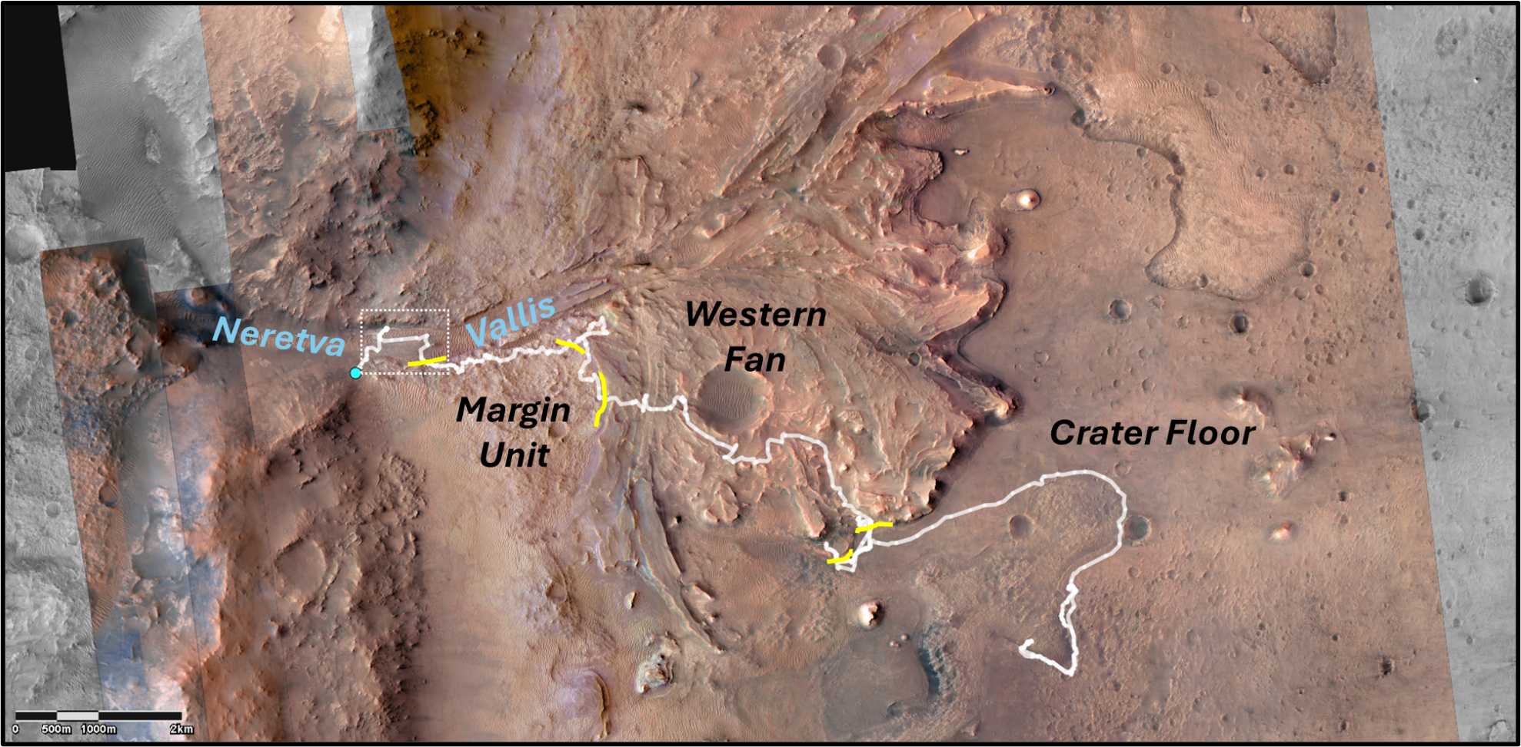
SI FIGURES:

Figure S1: Orbital context image with rover traverse overlain in white. Major geologic units indicated by bold italicized text. Short yellow lines indicate locations where the rover traversed across unit boundaries. White dashed box shows approximate location of zoomed up image on manuscript Figure 1. Blue dot is the location of the Perseverance rover on ~sol 1250.

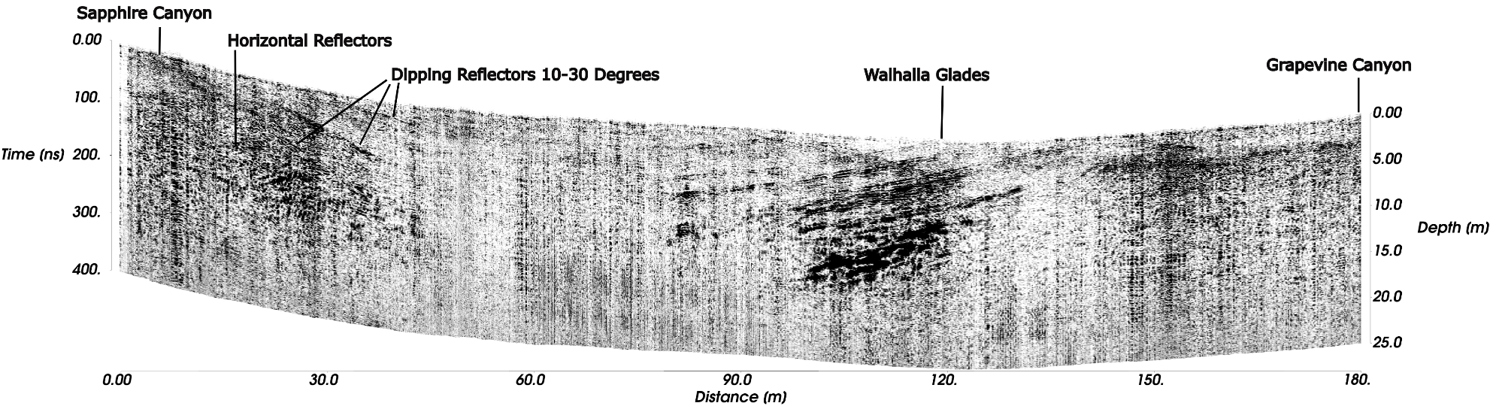
Figure S2: RIMFAX ground penetrating radar projected cross-section acquired on Sols 1204, 1206, 1210, 1219, and 1220 as the rover drove southward across the exposed Bright Angel section from Sapphire Canyon to Grapevine Canyon. The radargram reveals the presence of a thick concave-upward section of layered Bright Angel formation rock that is truncated at the surface, between the Sapphire Canyon and Walhalla Glades target locations. The radargram also reveals a flatter-lying section of layered rock, also part of the Bright Angel formation, between the Walhalla Glades and Grapevine Canyon targets. Depths are calculated from the two-way travel times assuming a velocity of 0.125 m/ns (see Hamran et al⁶ for radargram processing details). All original data used in this study are available through the NASA Planetary Data System Geoscience Node:
https://pds-geosciences.wustl.edu/missions/mars2020/rimfax.htm⁷ and were processed as described in previous publications^{6,8}.

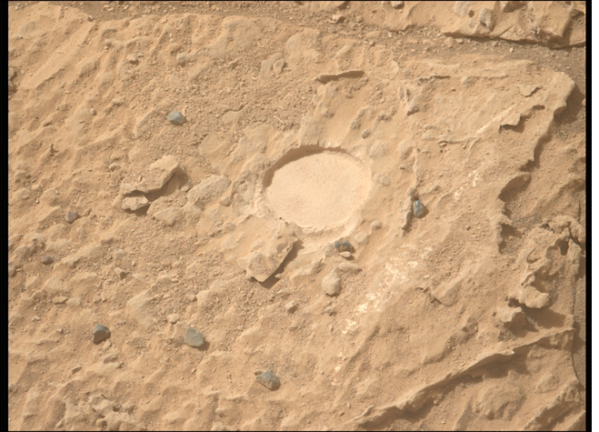
Figure S3A (left): Mastcam-Z image of the outcrop containing the Walhalla Glades abrasion on sol 1180. The outcrop displays a massive and wind-fluted appearance, with erosionally-resistant veins cutting across the outcrop at the lower right. Abrasion patch diameter is approximately 5cm⁹. Image sequence ID zcam3921. NASA/JPL-Caltech/ASU/MSSS.
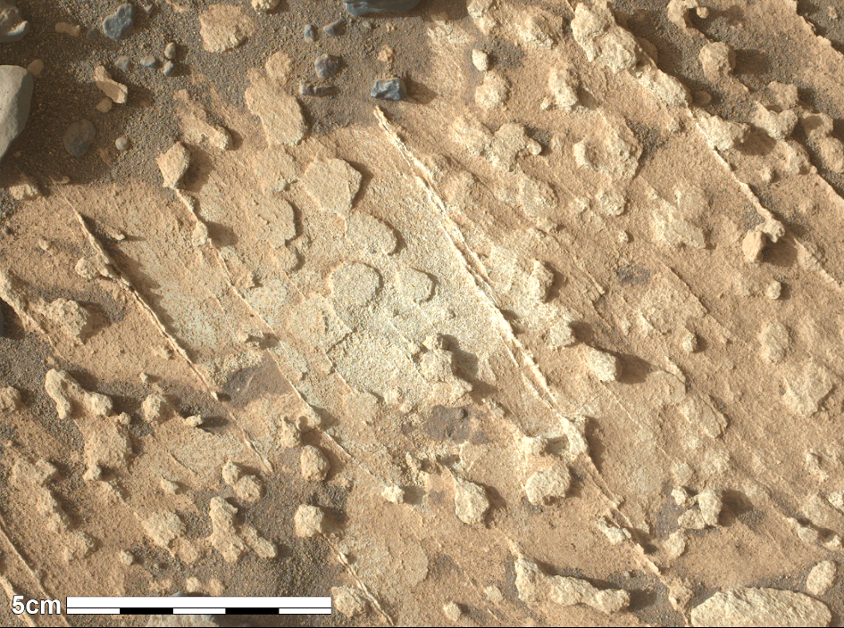
Figure S3B (right): WATSON daytime image collected on sol 1221 at a standoff distance of 25.79 cm of the outcrop containing the proximity science target Grapevine Canyon after removal of surface dust by the GDRT. The outcrop displays a nodular texture with abundant cross-cutting mineralized veins. Image resolution: 99.5 μm/pixel. NASA/JPL-Caltech/MSSS.

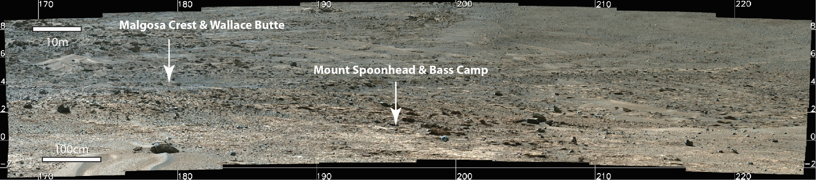
Figure S4: Mastcam-Z image mosaic looking up at light- and dark-toned, layered to massive rocks in the Masonic Temple outcrop area on sol 1227. The white arrows point to the approximate locations of the Mount Spoonhead, Bass Camp, Wallace Butte and Malgosa Crest targets, which are approximately 21m and 85m from the location where this mosaic was collected. Scale bars (white) shown with indicated lengths. Image sequence ID zcam9276. NASA/JPL-Caltech/ASU/MSSS.

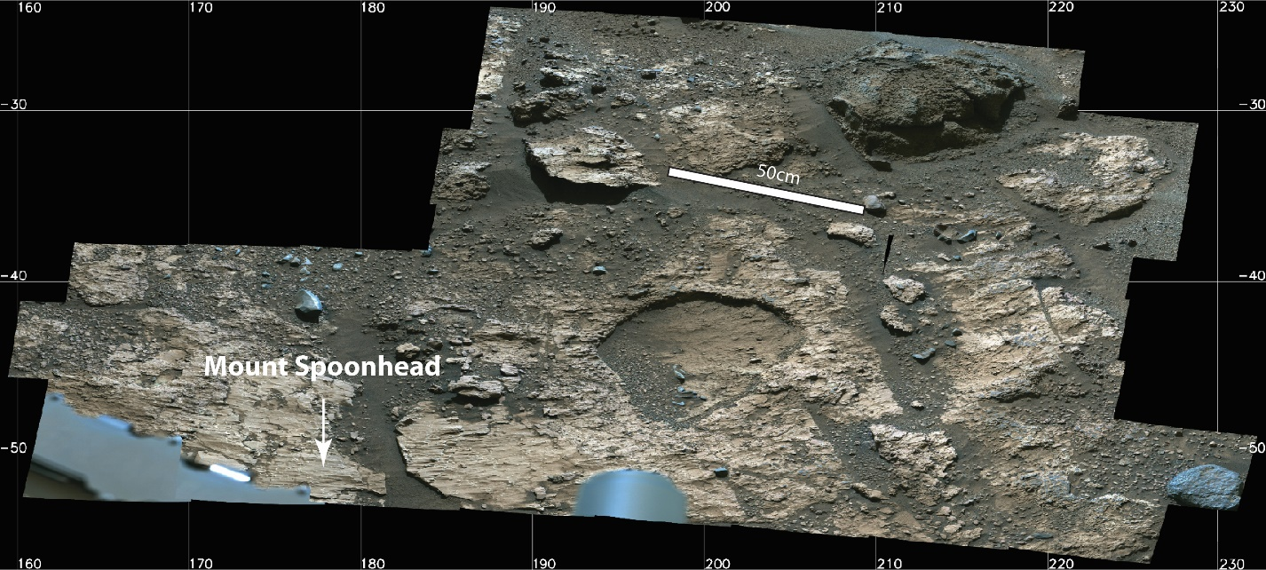
Figure S5: Mastcam-Z image mosaic of the Mount Spoonhead proximity science workspace collected on sol 1228 showing light toned, faintly layered to wind-fluted bedrock in the foreground and darker-toned, more massive outcrop to the upper right of the workspace. The bedrock target “Bass Camp” (not visible in this image) is just off to the right of the workspace, outboard of Perseverance’s right front wheel, and is shown in Figure S7. Image sequence ID zcam9278. NASA/JPL-Caltech/ASU/MSSS.
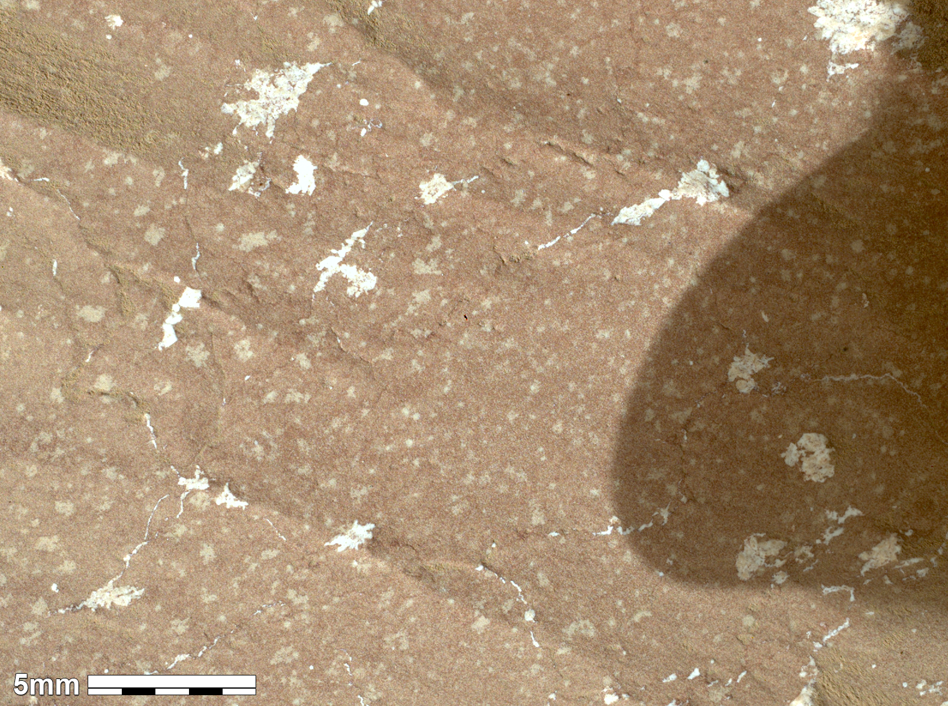
Figure S6: WATSON daytime image collected on sol 1228 at a standoff distance of 3.07 cm of the wind-fluted surface of the proximity science target Mount Spoonhead after removal of surface dust by the GDRT. Sunlight is coming in from the bottom left. The reddish-toned outcrop displays a massive texture with light mottling associated with Ca-sulfate and silica-enriched blebs. Image resolution: 17.9 μm/pixel. NASA/JPL-Caltech/MSSS.
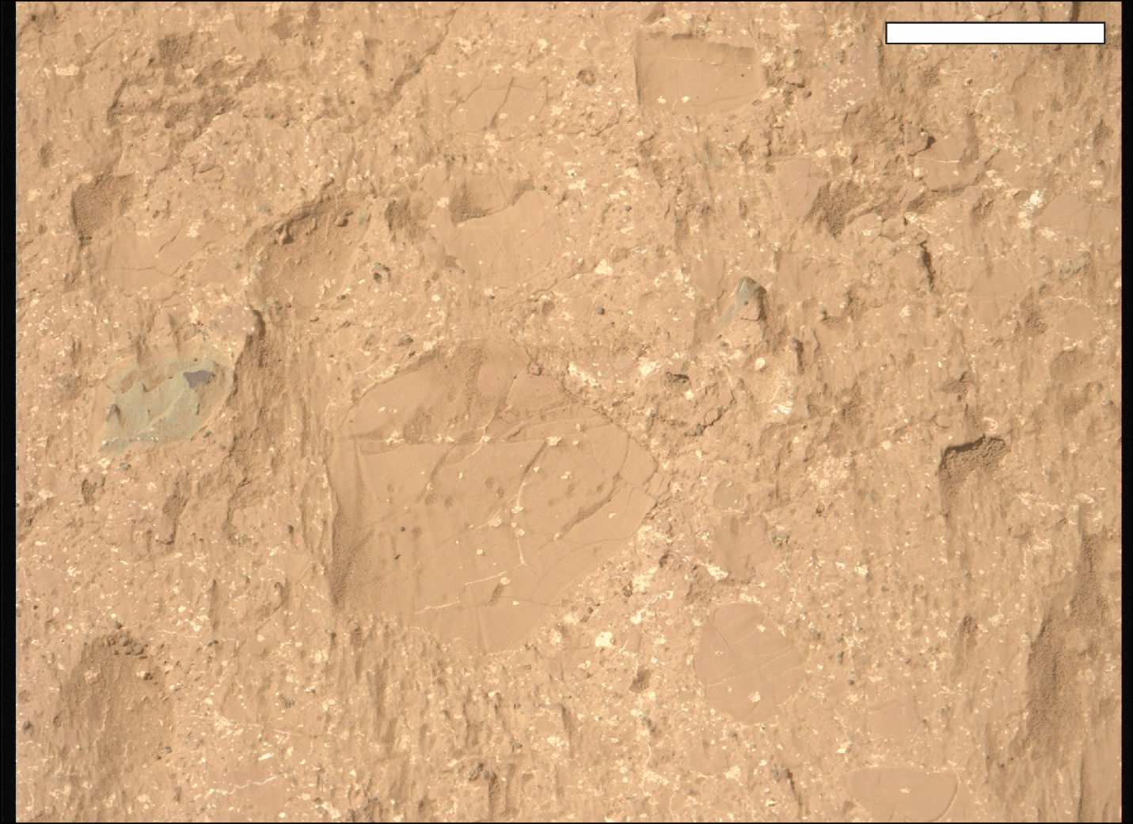
Figure S7: Mastcam-Z image collected on sol 1228 of the target Bass Camp, which is located immediately adjacent to the Mount Spoonhead proximity science workspace showing cm-scale rounded to angular clasts in a fine-grained matrix cross-cut by light-toned materials that likely represent Ca-sulfate vein and void fills. Scale bar is 5cm. Image sequence ID zcam1228 9278. NASA/JPL-Caltech/ASU/MSSS.

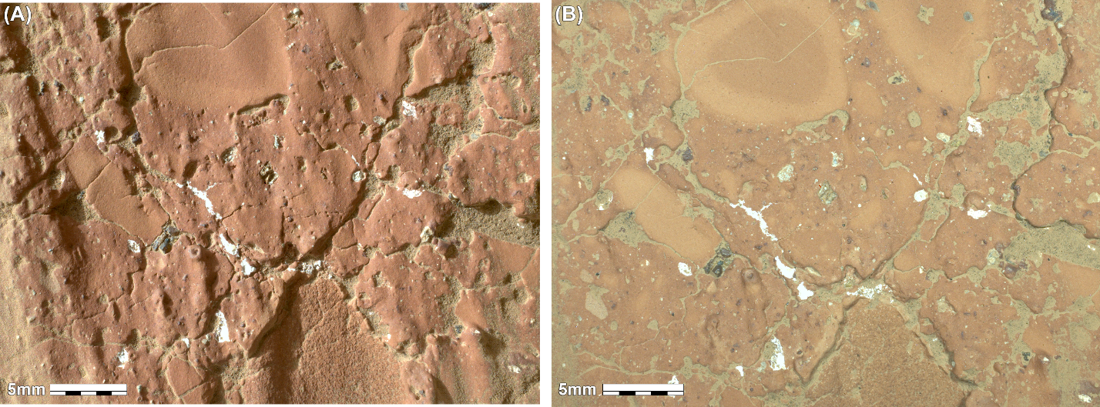
Figure S8: WATSON daytime (A) and nighttime (B) images collected on sols 1234 and 1233 at a standoff distance of 4.25 cm and 3.96 cm, respectively, of the proximity science target Wallace Butte after removal of surface dust by the GDRT. The nighttime image was collected under white light LED illumination. The outcrop displays rounded to angular clasts ranging up to multiple cm in diameter, some of which exhibit reaction rims. Clasts are set in a fine-grained matrix. Fractures in the outcrop are mineralized in places and filled with loose surface regolith in others.: Image resolutions are 22.3 μm/pixel and 21.2 μm/pixel, respectively. Image credit: NASA/JPL-Caltech/MSSS.
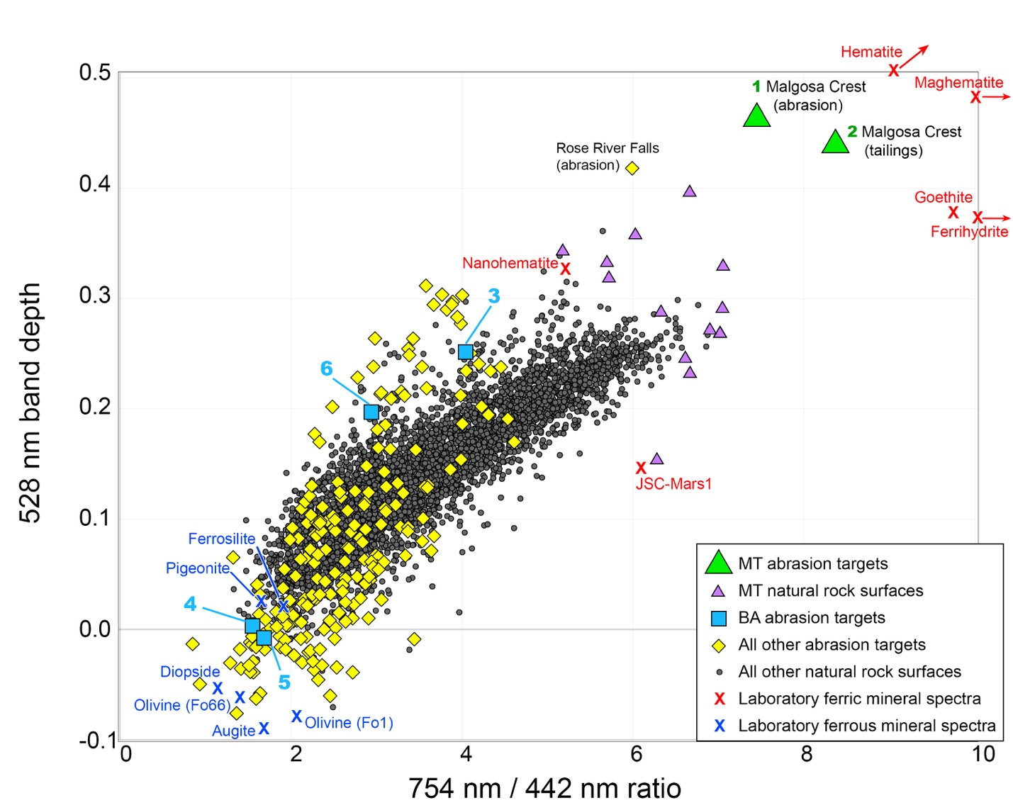

Figure S9A: Mastcam-Z spectra from Masonic Temple (MT) show large contributions of ferric oxides, with the abraded Malgosa Crest surface and tailings having significantly stronger Fe³⁺ signatures than any other rocks yet observed in Jezero crater. For context, laboratory spectra of ferric mineral spectra (red X’s) have large 528 nm band depths and 754 nm / 442 nm ratios, while ferrous mineral spectra (blue X’s) have small values of both parameters. Mastcam-Z spectra from Bright Angel (BA) are more consistent with ferrous minerals or a mixture of phases. Small gray dots represent all Mastcam-Z rock spectra from sols 0-1250, and larger yellow symbols correspond to abraded surfaces and tailings (from abrading and coring activities); all data are available in Rice et al.¹⁰ Full spectra of the laboratory mineral examples and the MT and BA abrasion and coring targets are shown in Fig. S9B.

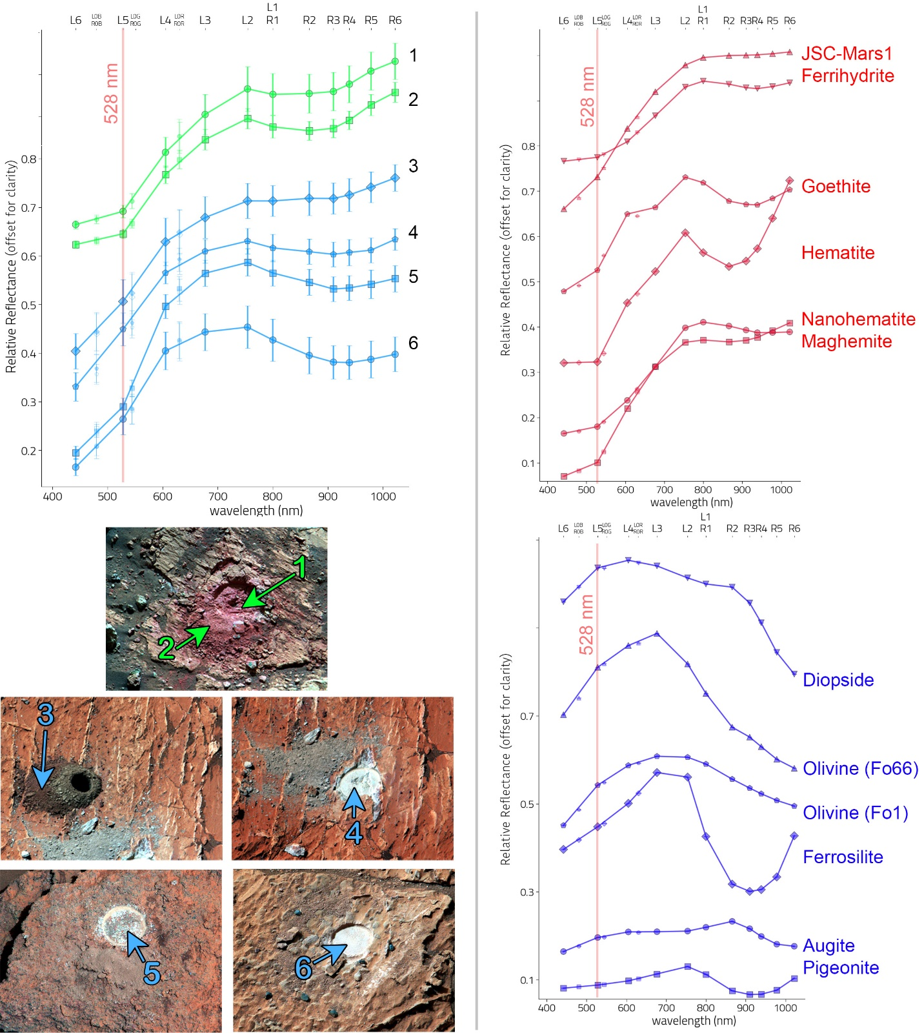
Figure S9B: Mastcam-Z spectra from Masonic Temple (MT, green in upper left plot) and Bright Angel (BA, light blue in upper left plot) compared to laboratory mineral spectra of ferric minerals (red in upper right plot) and ferrous minerals (dark blue in lower right plot). The MT spectra from Malgosa Crest (1-2) exhibit deep 528 nm band depths, consistent with a strong ferric contribution; the BA spectra (3-6) have weak to no 528 nm bands, consistent with ferrous minerals or a mixture of phases. Enhanced color images (lower left) are made with the L2 (754 nm), L5 (528 nm) and L6 (442 nm) filters, and arrows indicate the locations of regions of interest (ROIs) from which spectra were extracted. Spectra are shown with error bars indicating the standard deviation of the pixels in each ROI. Numbered spectra correspond to numbered points on the parameter space in Fig. S9A. Details of the spectral data shown are provided in Table S1, and the convolutions of laboratory mineral spectra to Mastcam-Z bandpasses are available in Rice et al.¹¹.

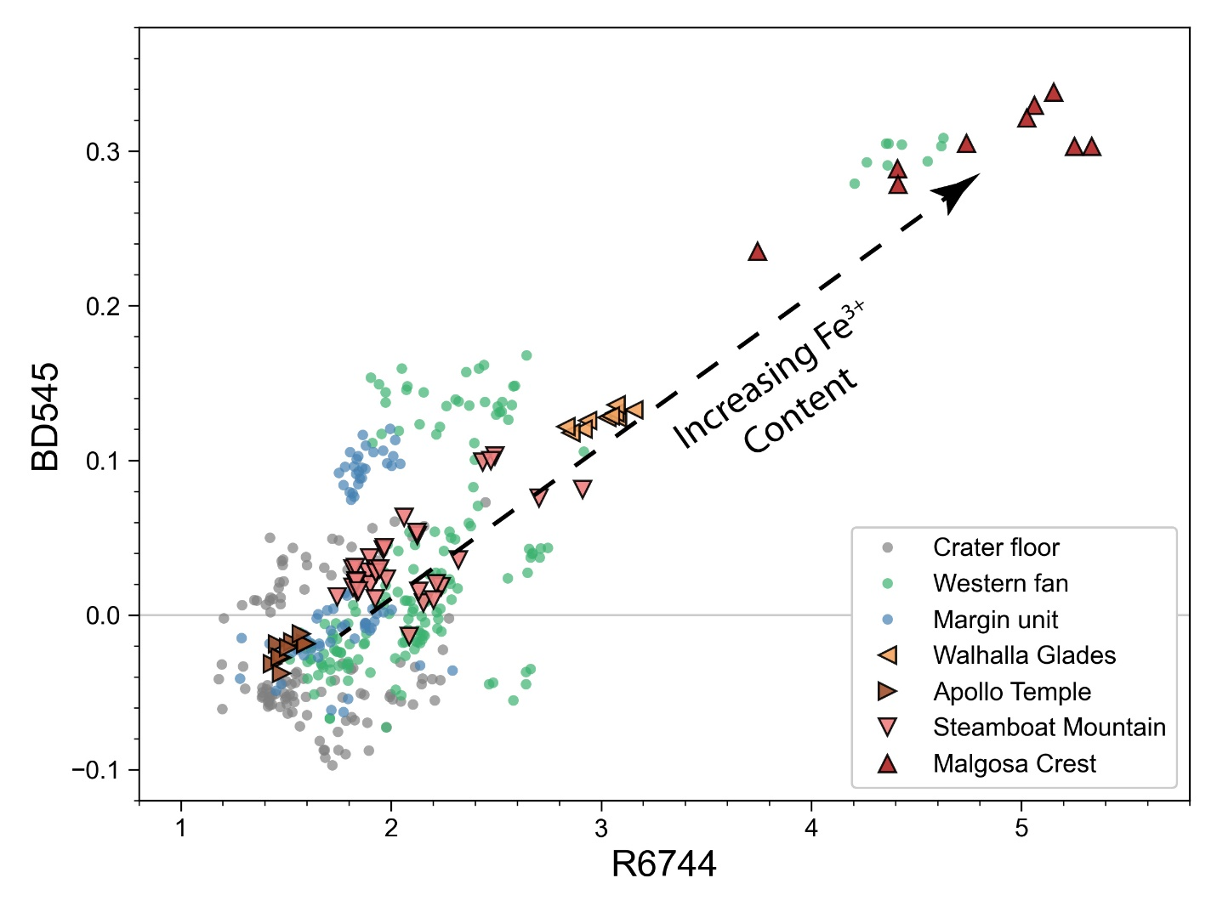
Figure S10: SuperCam visible-wavelength spectral parameters demonstrating variable degrees of oxidation among the abraded patches of the BA-MT region (triangles). Data from previous abraded patches in the mission are shown for comparison (circles). The R6744 parameter corresponds to the reflectance at 670 nm divided by the reflectance at 440 nm and is an indicator of overall oxidation. The BD545 parameter (545-nm band depth) is sensitive to the presence of ferric oxides such as hematite. Strongly oxidized targets thus appear toward the upper right corner of the plot. See Table S1 for the parameter formulas used in the construction of this figure.

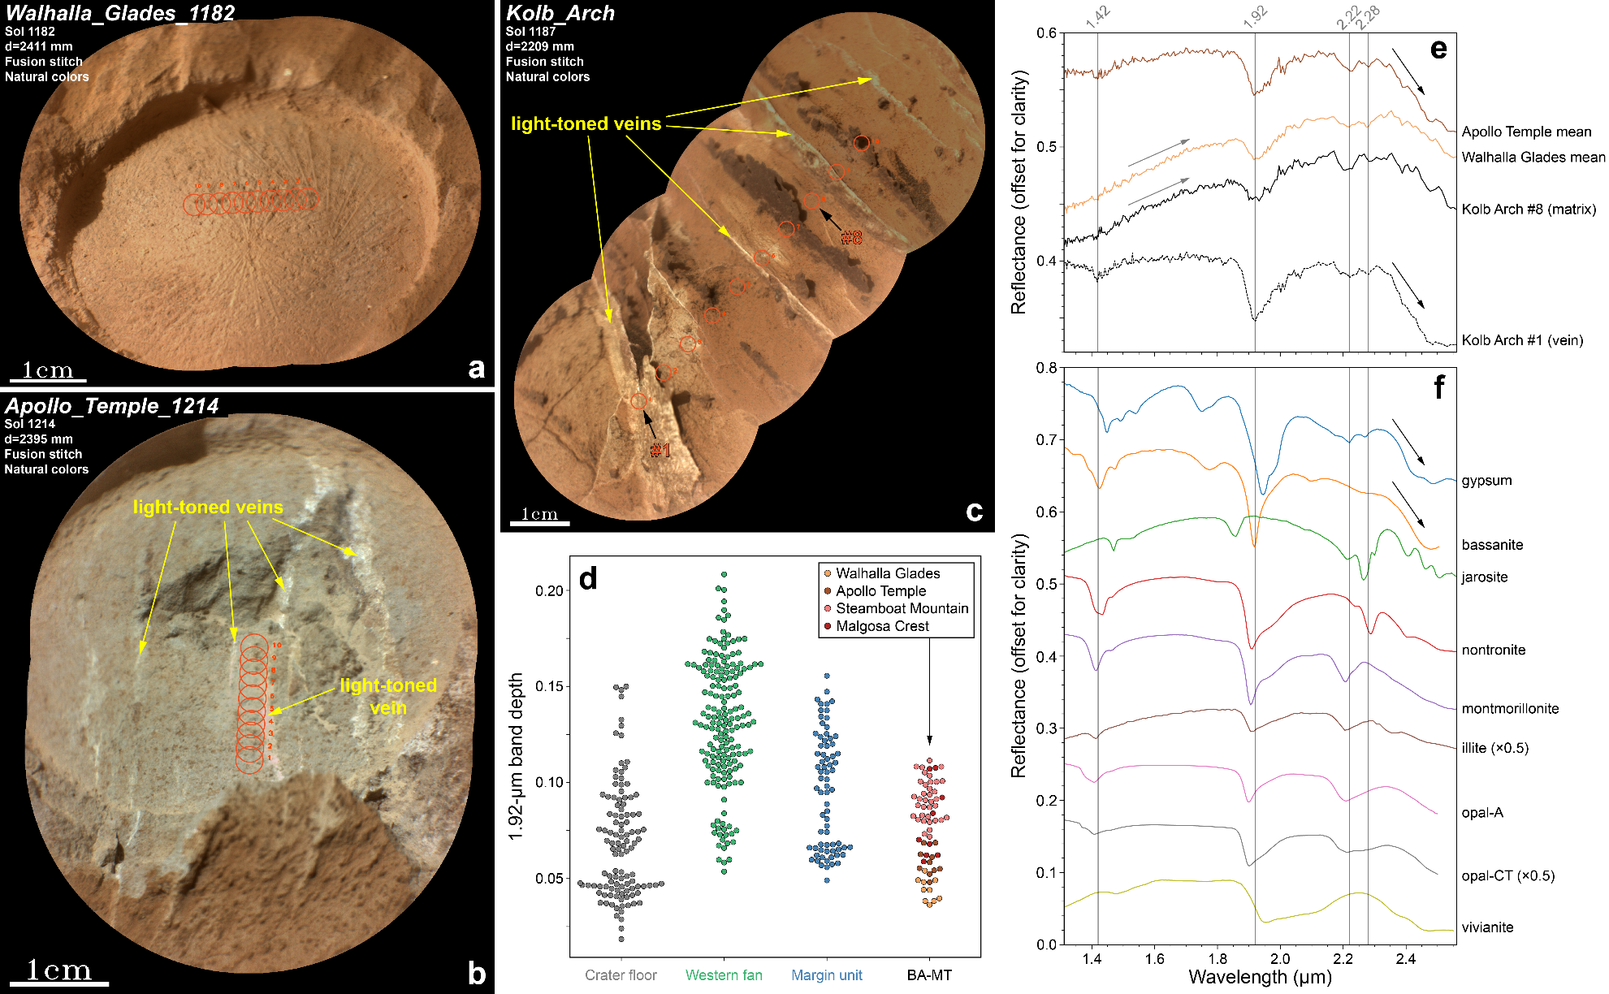

Figure S11 A-F: SuperCam near-infrared reflectance^{12,13} spectral observations of the BA-MT rocks. (A) Remote Micro-Imager (RMI) context mosaic of abraded target Walhalla Glades. The red circles show the ten locations where spectra were collected. Each circle represents the field of view accounting for 68% of the signal in the corresponding spectrum. (B) RMI context mosaic of abraded target Apollo Temple. Note the presence of multiple light-toned veins in this abraded patch, including one in the area where the SuperCam spectra were collected. (C) RMI context mosaic of natural target Kolb Arch. This target is located on the same bedrock block as the Apollo Temple and Cheyava Falls targets (Fig. 2). SuperCam spectrum #1 is taken directly on a light-toned vein, whereas spectrum #8 is taken on the matrix material. (D) Swarm plot of the 1.92-µm band depth observed in the abraded patches of the BA-MT region. A deeper band indicates a greater abundance of structural water in the rock. Data from previous abraded patches in the mission are shown for comparison. (E) SuperCam near-infrared spectra collected from targets Apollo Temple (mean of the ten locations), Walhalla Glades (mean of the ten locations) and Kolb Arch (individual spectra from locations #1 and #8). The deeper 1.92-µm band and bigger drop of reflectance starting at ~2.35 µm in the spectra of Apollo Temple and Kolb Arch #1 (black arrows) is best explained by the presence of hydrated Ca-sulfates in the light-toned veins. The spectra of Walhalla Glades and Kolb Arch #8, which do not appear to be contaminated by any light-toned vein, show a positive slope from 1.3 to ~1.8 µm, which could be due to the presence of an undefined Fe²⁺-bearing species. (F) Laboratory spectra of various mineral phases that could potentially explain some of the features observed in the BA-MT spectra. Unless otherwise noted, the spectra are scaled vertically by a factor of 0.25 to fit in the figure. The spectra of gypsum (caec05), jarosite (casf29), nontronite (cbjb26), montmorillonite (c1ea28a) and vivianite (c1jbg65) are from the RELAB spectral library¹⁴. The spectrum of illite (IL105) is from the USGS spectral library¹⁵. The spectrum of bassanite is from Crowley¹⁶. The spectra of opal-A (SIL115) and opal-CT (OPA002y) are from Rice et al. ¹⁷. Other candidate phases not shown here include Fe-bearing phosphates such as gormanite, strengite or strunzite¹⁸, and ferrous phyllosilicates such as chamosite or glauconite¹⁴.
Note for panel (D): A challenge in representing categorical data with a scatter plot is that all the points belonging to one category would fall on the same position along the axis corresponding to the categorical variable. Swarm plots solve this problem by adjusting the points along the categorical axis using an algorithm that prevents them from overlapping, thus providing a better representation of the distribution of observations. The swarm plot algorithm is part of the Seaborn Python data visualization library (https://seaborn.pydata.org/index.html).

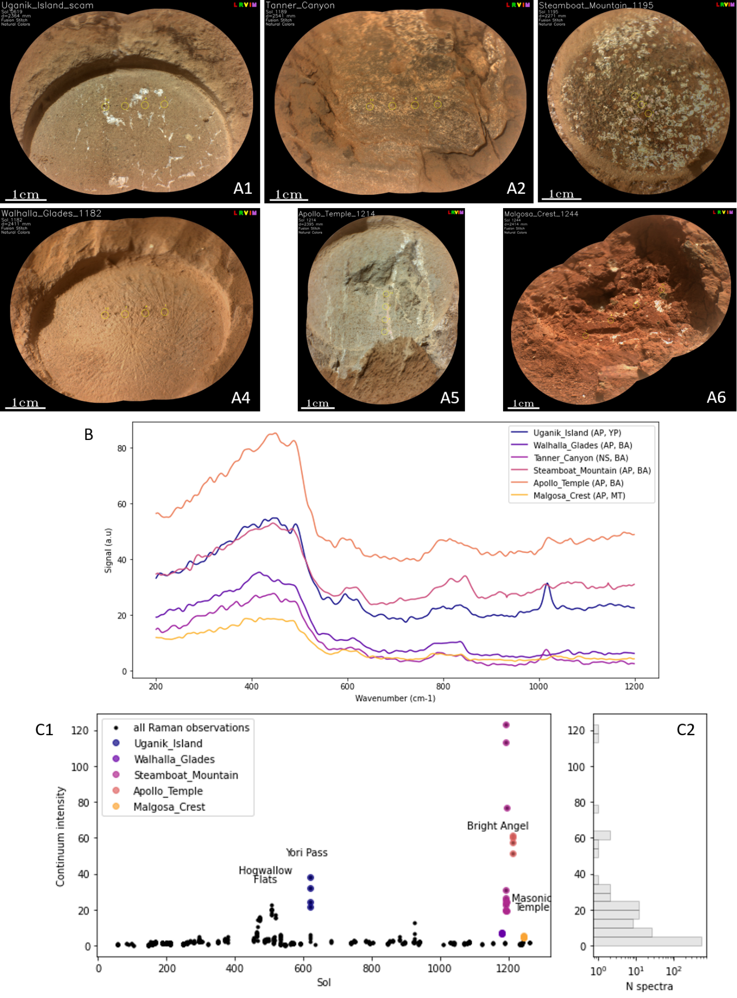
Figure S12: Continuum signal in SuperCam Raman spectra at Bright Angel (BA) and Masonic Temple (MT), compared to previously highest signals at Hogwallow Flats and Yori Pass (YP) along the frontal scarp of the Western Fan. (A1-A6) RMI mosaics with footprints of Raman observations. (B) Average spectra per target (no offset was applied). (C) Distribution of continuum signal values for all SuperCam Raman spectra collected during the mission, with continuum intensity for individual points on the targets of interest here shown with colored markers. High continuum signal was detected in two abraded patches (AP) at BA: Steamboat_Mountain (sols 1191, 1192, 1193 and 1195; mosaic A3) and Apollo_Temple (sol 1214, mosaic A5); weaker continuum signal was detected in one AP at BA: Walhalla_Glades (sol 1182, mosaic A4) and one AP at MT: Malgosa_Crest (sol 1244, mosaic A6). No continuum signal was observed in natural surface (NS) targets at BA (e.g., Tanner_Canyon, sol 1189, mosaic A2) or MT (not shown here). Similar continuum signal had been observed before in the Hogwallow Flats and Yori Pass members in the Fan Front¹⁹; the spectra acquired on the Uganik_Island AP are shown for comparison (sol 619, mosaic A6). Properties that could produce the continuum signal include i) fine-grain scattering; ii) luminescence related to impurities or radiation-induced defects, possibly in sulfates; iii) organic fluorescence.

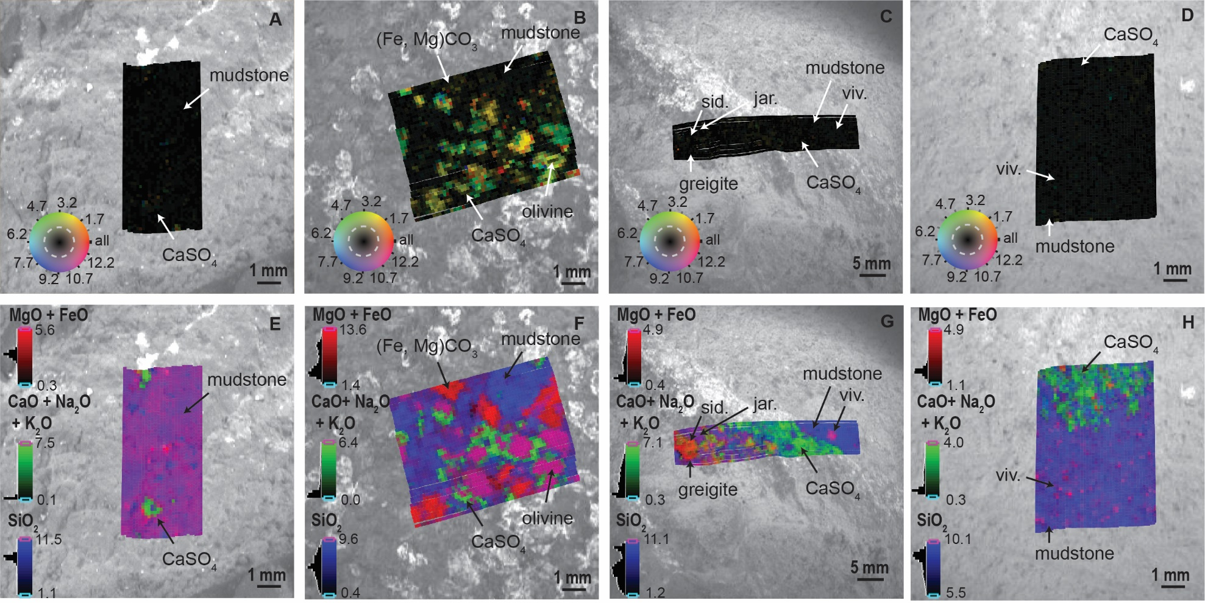
Figure S13 A-D: PIXL scan maps displaying the locations of coherently diffracting domains in PIXL scans. (A) Sol 1242 Malgosa Crest scan, (B) Steamboat Mountain, (C) Sol 1213 Apollo Temple scan, (D) Walhalla Glades. Color tone variations, displayed on the inset color wheel, reflect differences in the locations of diffraction peaks in each PIXL X-ray spectrum between 0.2-13.7keV; large regions having the same color tone have the same diffraction peaks, and thus are derived from the same crystal. Color intensity reflects the intensity of the diffraction peaks in each X-ray spectrum; brighter tones (near the outer edge of the inset color wheel) represent X-ray spectra with more intense diffraction peaks; duller tones (closer to the center of the inset color wheel) represent X-ray spectra with less intense diffraction peaks. Rock component and mineral identifications shown on the diagram are based on chemical relationships displayed on Figure S13 E-H, and on manuscript Figures 4A-D. Areas identified as mudstone are generally characterized by a lack of coherent intense diffraction as compared to, e.g., olivine and carbonate grains in Steamboat Mountain.
Figure S13 E-H: PIXL RGB maps displaying the molar concentration (mmol/g) of the indicated element oxides and oxide sums for the same scans as shown in Figure S13 A-D. These RGB maps correspond to the apices of the ternary diagram displayed on manuscript Figure 4A. Rock component and mineral identifications shown on the diagram are based on chemical relationships displayed here and on manuscript Figures 4A-D, and include silica-rich mudstone (blue, except in Malgosa Crest, where it ranges to magenta due to its more Fe-rich nature), olivine (magenta in Steamboat Mountain), carbonate (red in Steamboat Mountain), CaSO₄ (green in all scans), vivianite (magenta in Apollo Temple and Walhalla Glades), greigite, sideritic carbonate, and jarosite (various color tones, all in Apollo Temple).

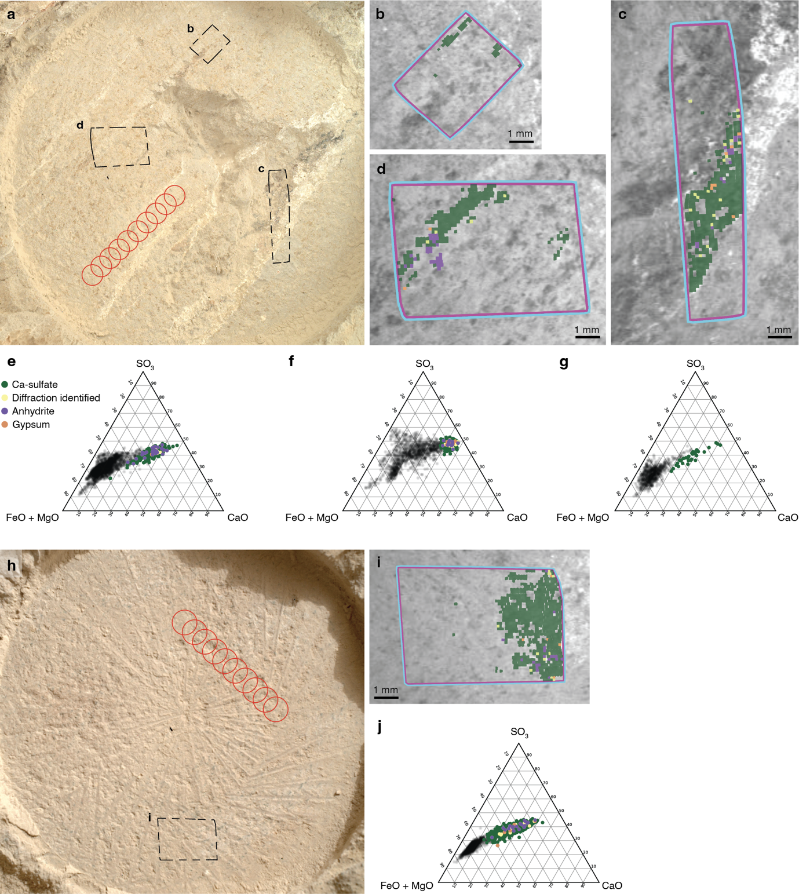

Figure S14 (A-J): (A) WATSON image (SIF_1212_0774538403_218FDR_N0560000SRLC09911_0000LMJ01) of the Apollo Temple abrasion with PIXL scan locations (black dashed boxes) and SuperCam near infrared reflectance observations (red circles). Note that the locations of the NIR observations are manual translations from the images in Fig. S11 and not as accurate as the locations shown in Fig. S11. (B-C) Apollo Temple 1, 2, and 3 PIXL maps showing regions: Ca-sulfate-rich (dark green) without observed diffraction, Ca-sulfate-rich with observed diffraction that was unable to be indexed or indexed as bassanite (yellow; see Methods), and Ca-sulfate-rich with observed diffraction that was indexed as anhydrite (purple) and gypsum (orange)²⁰. (E-G) Ternary diagrams using molar abundances for Apollo Temple 1, 2, and 3 using the same colour markers. Scan locations not rich in Ca-sulfate are shown in black. (H-J) as above for the Walhalla Glades abrasion (WATSON image SIF_1179_0771616596_632FDR_N0540000SRLC01022_0000LMJ01). PIXL diffraction analysis indicates that the Ca-sulfate in the Apollo Temple and Walhalla Glades abrasions are predominantly fine grained, with grain size less than ~40 μm²¹ (green; 90% and 95% of Ca-sulfate-rich regions without diffraction, respectively). Ca-sulfate-rich regions with observed diffraction index as anhydrite (purple; 54% and 56% of diffracting PMCs), gypsum (orange; 13% and 14% of diffracting PMCs), and the remaining locations not able to be indexed or indexed as bassanite (yellow).

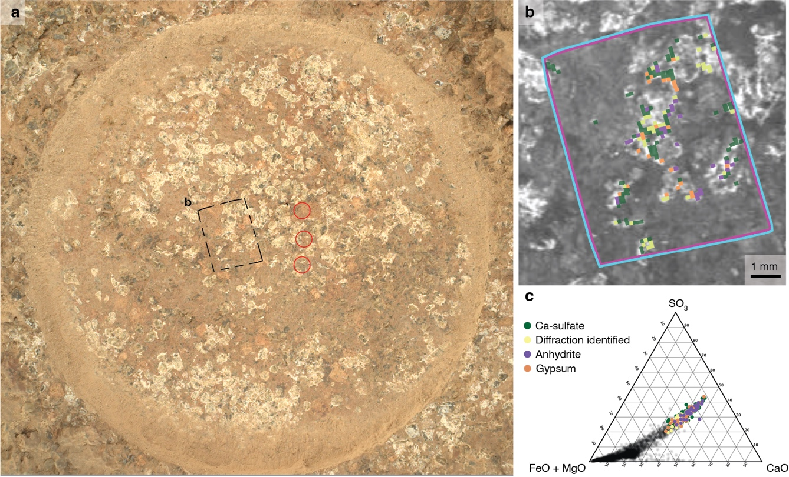

Figure S15 (A-C): (A) WATSON image (SIF_1191_0772675257_281FDR_N0541152SRLC01028_0000LMJ01) of the Steamboat Mountain abrasion with PIXL scan locations (black dashed box) and SuperCam near infrared reflectance observations (red circles). Note that the locations of the NIR observations are manual translations from the images in Fig. S11 and not as accurate as the locations shown in Fig. S11. (B) PIXL maps showing regions: Ca-sulfate-rich (dark green) without observed diffraction, Ca-sulfate-rich with observed diffraction that was unable to be indexed or indexed as bassanite (yellow; see Methods), and Ca-sulfate-rich with observed diffraction that was indexed as anhydrite (purple) and gypsum (orange)²⁰. (C) Ternary diagram using molar abundances from the Steamboat Mountain PIXL scan using the same colour markers. Scan locations not rich in Ca-sulfate are shown in black. PIXL diffraction analysis indicates that 52% of the Ca-sulfate in the Steamboat Mountain abrasion is fine grained, with a grain size less than ~40 μm²¹. Ca-sulfate-rich regions with observed diffraction index as anhydrite (purple; 31% of diffracting PMCs) or gypsum (orange; 28% of diffracting PMCs), with the remaining locations not able to be indexed or indexed as bassanite (yellow; 41% of diffracting PMCs).
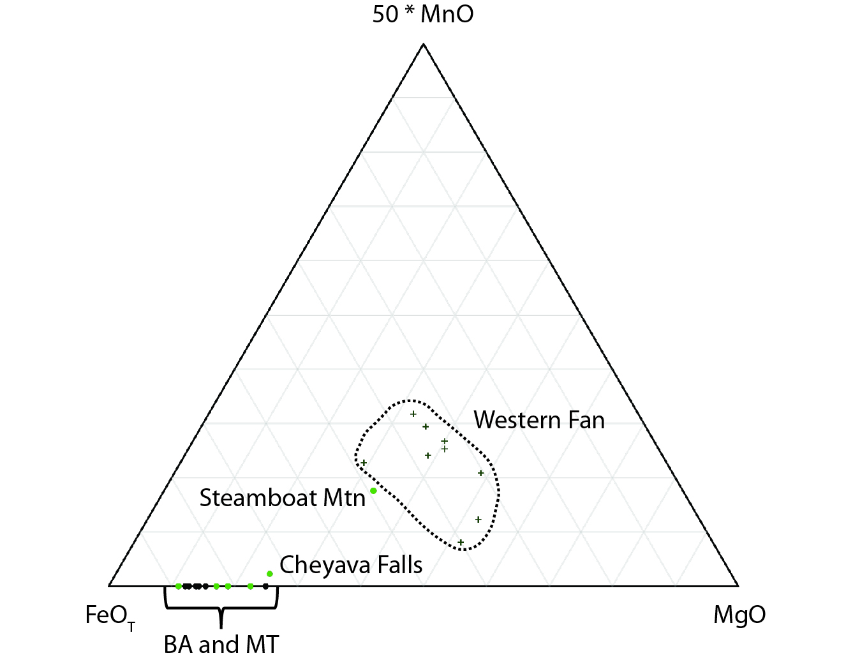
Figure S16: Ternary diagram plotting molar proportions of the indicated oxides. The MnO apex is multiplied by 50. Circles represent the average chemical compositions of targets from Bright Angel (BA, green) and Masonic Temple (MT, black) analyzed by PIXL. Crosses represent the average chemical compositions of sedimentary rock targets analyzed by PIXL on the Western Fan. The targets Cheyava Falls and Steamboat Mountain are offset towards higher MgO and (MnO*50) because olivine is present in the scan areas for these targets, and because (Mg,Fe)CO₃ is included in the Steamboat Mountain scan area (Fig. S15B, F). The BA-MT targets are highly depleted in MgO and MnO and enriched in FeOT relative to Western Fan sedimentary rocks as a result of oxidative chemical weathering of the sources of BA-MT sediments, as described in the text.

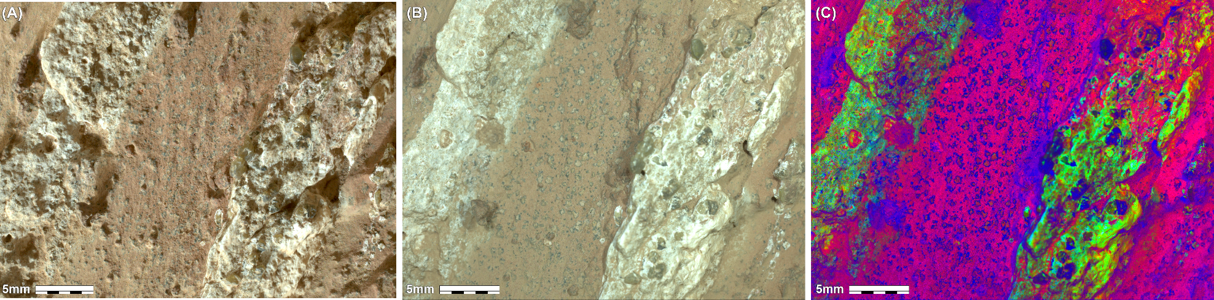
Figure S17 A-C: WATSON images of the target Cheyava Falls collected after gGDRT cleaning of the natural surface of the rock. (A) Sol 1188 daytime, sunlit image collected at 4.1 cm standoff (21.7 μm/pixel image resolution); (B) Sol 1188 nighttime image collected with white LED illumination at 3.91 cm standoff (21.0 μm/pixel image resolution); (C) Decorrelation stretch of the Sol 1188 nighttime image in which Fe-phosphate nodules and reaction front rims appear blue colored against the magenta-hued matrix material they are distributed in. Image credit: NASA/JPL-Caltech/MSSS.

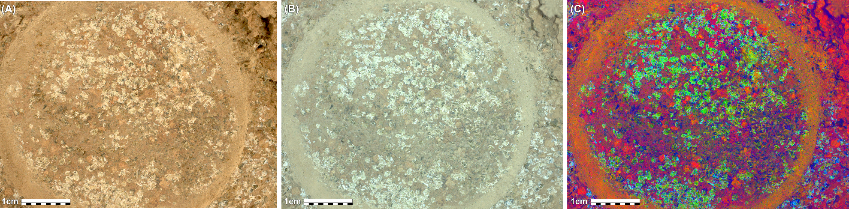
Figure S18 A-C: WATSON images of the target Steamboat Mountain collected after abrasion of the surface of the rock. (A) Sol 1191 daytime, fully shadowed image collected at 7.98 cm standoff (35.9 μm/pixel image resolution); (B) Sol 1191 nighttime image collected with white LED illumination at 8.03 cm standoff (36.1 μm/pixel image resolution); (C) Decorrelation stretch of the Sol 1191 nighttime image in which Fe-phosphate nodules appear blue colored against the magenta hued matrix material they are distributed in. In the DCS image, olivine grains and Ca-sulfate appear green, and carbonate grains appear red. Image credit: NASA/JPL-Caltech/MSSS.

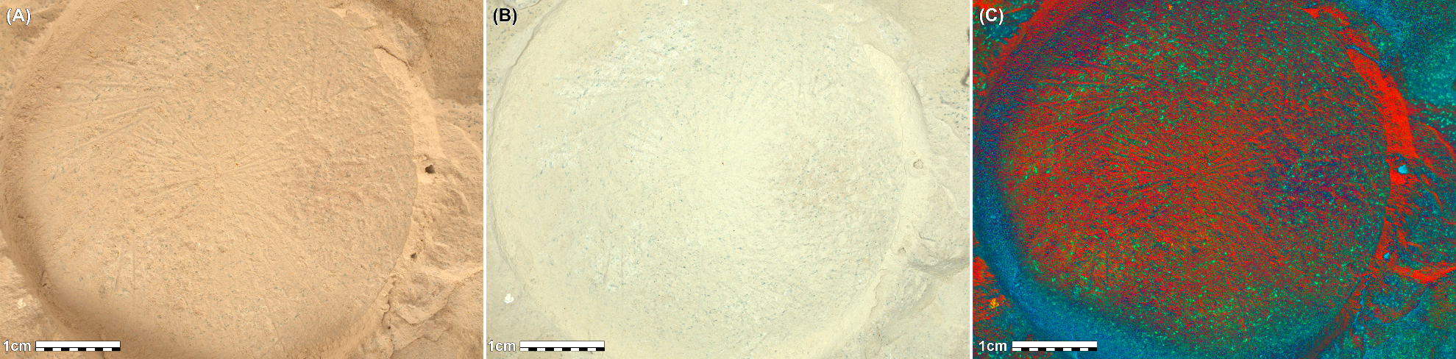
Figure S19 A-C: WATSON images of the target Walhalla Glades collected after abrasion of the surface of the rock. (A) Sol 1179 daytime, fully shadowed image collected at 7.93 cm standoff (35.7 μm/pixel image resolution); (B) Sol 1179 nighttime image collected with white LED illumination at 7.93 cm standoff (35.7 μm/pixel image resolution); (C) Decorrelation stretch of the Sol 1179 daytime, fully shadowed image in which Fe-phosphate nodules appear green and blue colored against the red-hued matrix material they are distributed in. Image credit: NASA/JPL-Caltech/MSSS.

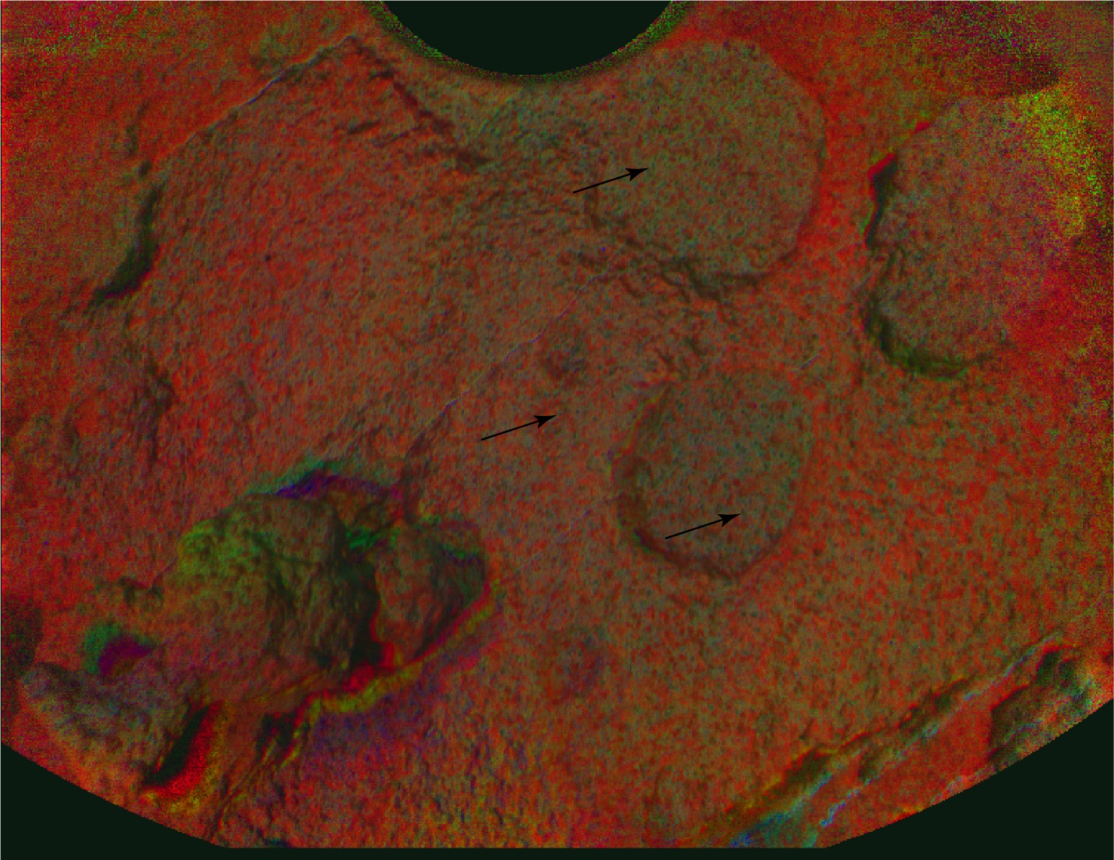
Figure S20: PIXL Micro-Context Camera (MCC) Red-Green-UV DCS image of the target Grapevine Canyon collected on sol 1221 after GDRT cleaning of the natural surface of the rock. Large ~0.5cm circular features are erosionally resistant Ca-sulfate nodules. Fe-phosphate nodules appear green and blue colored against the red-hued matrix material they are distributed in. Black arrows point to two examples of Fe-phosphate nodules encased in Ca-sulfate nodules and another example where Fe-phosphate nodules are present in the mudstone. Image credit: NASA/JPL-Caltech/DTU.
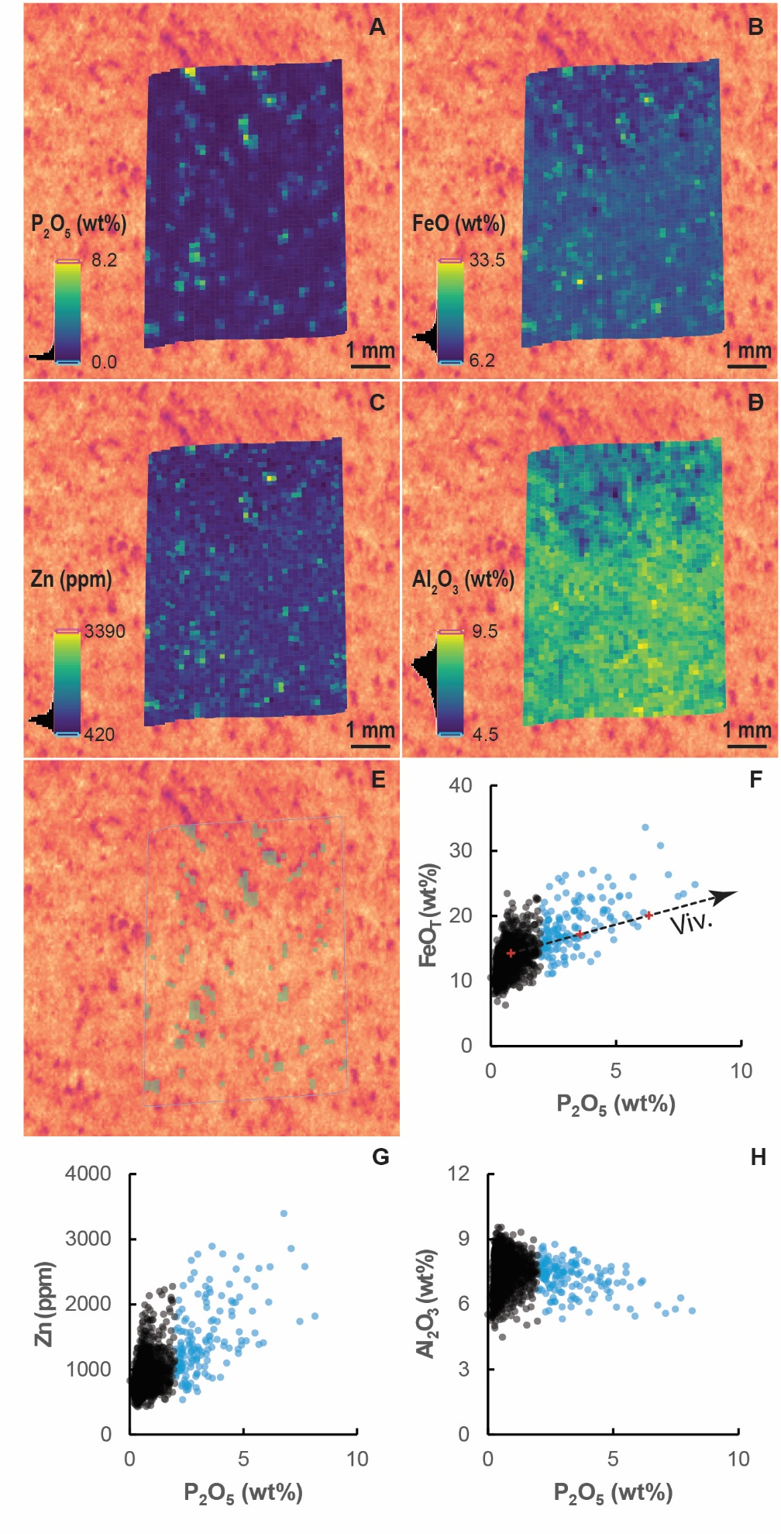
Fig S21 (A-H): Maps of the concentration (wt. % or ppm) and spatial distribution of (A) P₂O₅, (B) FeO, (C) Zn and (D) Al₂O₃ for the target Walhalla Glades, which contains representative examples of Fe-phosphate nodules in an abraded surface. Selected points shown in (E) are those with P₂O₅ > 2 wt. %, used in the mass balance model described in SI Text. Binary plots of P₂O₅ vs. each element are also shown to demonstrate the correlation between (F) P₂O₅ and FeO (G) P₂O₅ and Zn, and (H) the anticorrelation between P₂O₅ and Al₂O₃. The underlying image behind each element map is a PIXL MCC near infrared/green reflectance ratio image, where the spatial distribution of Fe-phosphate nodules across a larger region of the abrasion patch can be seen; Fe-phosphate nodules appear purple in the image owing to their low NIR/G ratio. In panel (F) the dashed arrowheaded line shows the result of a mixing calculation between Fe-phosphate free mudstone and vivianite, with the red crosses representing 10% mixing increments. The calculations are included in SI Tables.

Figure S22 A-C: WATSON images of the target Apollo Temple collected after abrasion of the surface of the rock. (A) Sol 1211 daytime image collected at 8.08 cm standoff (36.3 μm/pixel image resolution); (B) Sol 1211 nighttime image collected with white LED illumination at 8.08 cm standoff (36.3 μm/pixel image resolution); (C) Decorrelation stretch of the nighttime image in which Fe-phosphate masses appear red against the green/blue hued matrix material they are distributed in. Image credit: NASA/JPL-Caltech/MSSS.
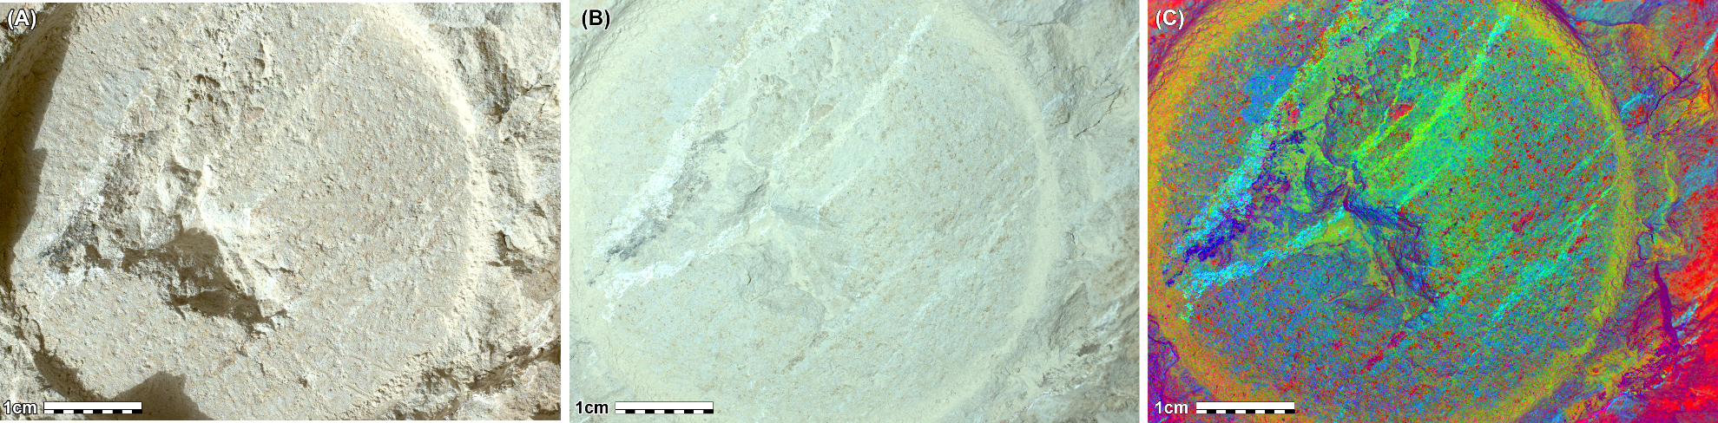

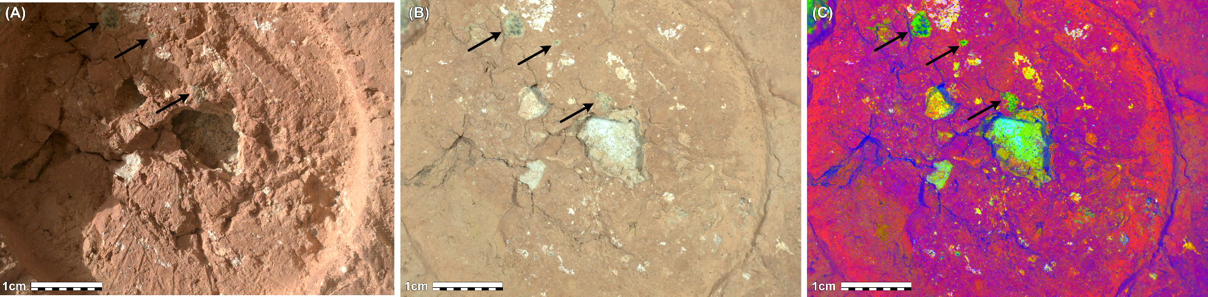
Figure S23 A-C: WATSON images of the target Malgosa Crest collected after abrasion of the surface of the rock. (A) Sol 1240 daytime image collected at 7.78 cm standoff (35.2 μm/pixel image resolution); (B) Sol 1240 nighttime image collected with white LED illumination at 7.93 cm standoff (35.7 μm/pixel image resolution); (C) Decorrelation stretch of the Sol 1240 nighttime image. Arrows point to possible Fe-phosphate nodules or clasts. Image credit: NASA/JPL-Caltech/MSSS.

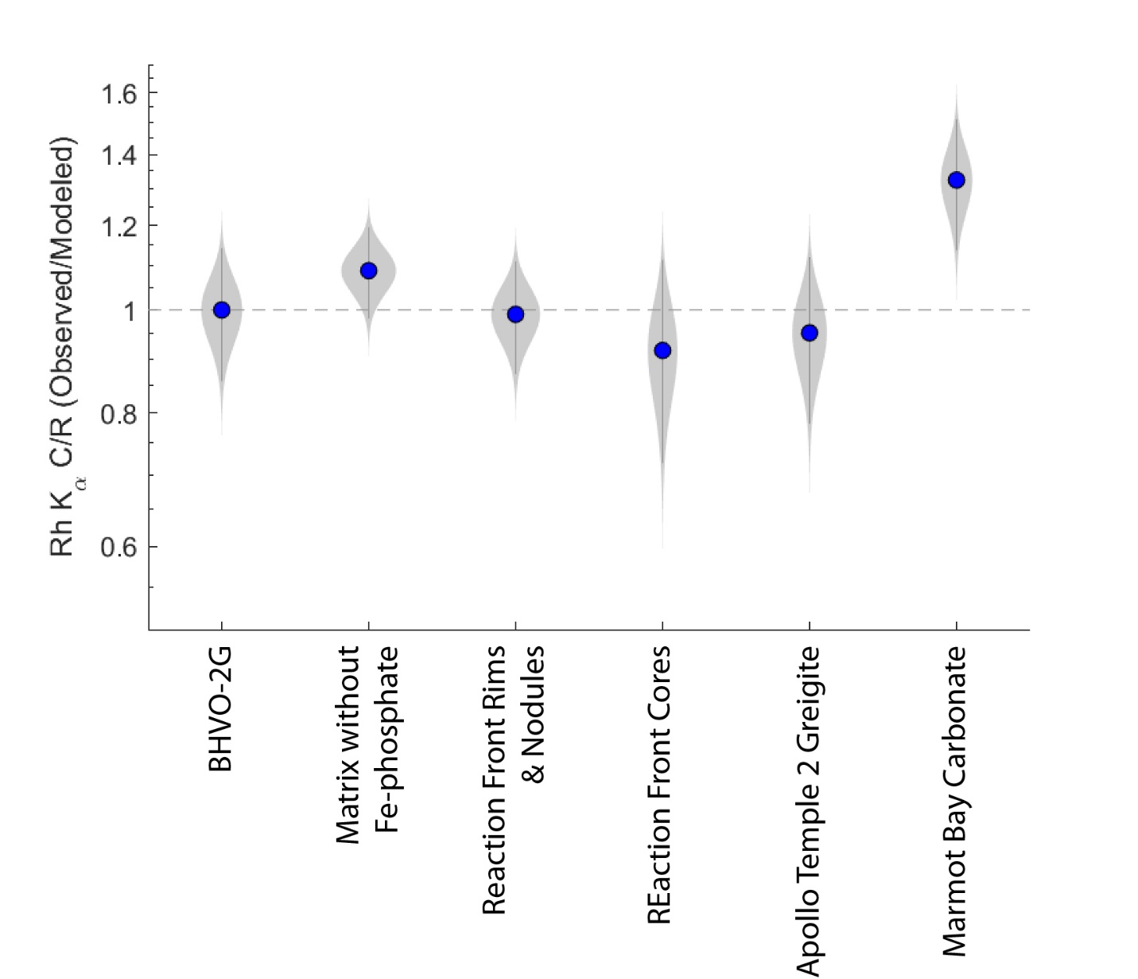
Figure S24: Plot of Observed/Modeled Rh K Compton/Rayleigh X-ray scattering ratio where the modeled C/R ratio is for a substrate in which all measured elements are paired with oxygen atoms in assumed proportions (e.g., SiO₂, FeO, CaO, SO₃, etc.). To first order, C/R scales with the average atomic number of the sample. When compared to predicted (i.e., modeled) values based on observed stoichiometry and assumed oxidation states, an Observed/Modeled C/R ratio below unity is suggestive of an O-deficient matrix material, such as expected for sulfide minerals, whereas a ratio above unity could indicate a substrate with elevated concentrations of O, C, and H, as might be expected for carbonate minerals or hydrated substrates^{22,23}. BHVO-2PG is a USGS glass standard mounted on the PIXL calibration target. The bulk composition of ROIs from Cheyava Falls (Matrix without Fe-phosphate, Reaction Front Rims and Nodules, and Reaction Front Cores) and the Apollo Temple 2 Greigite ROI are shown in SI Tables. Marmot Bay Carbonate is a carbonate-rich regolith grain in a PIXL scan of the regolith target Marmot Bay, collected on sol 601²⁴. Error bars have been plotted with varying thickness to capture the relative probability distribution within the range of uncertainty.
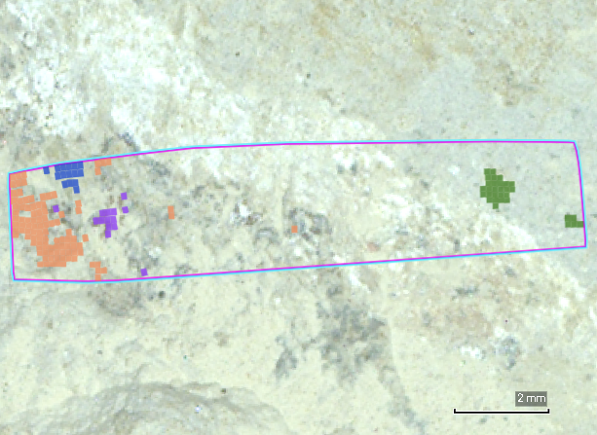
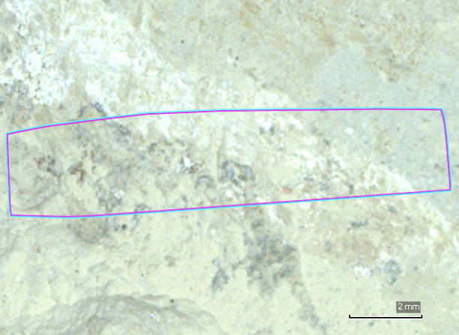
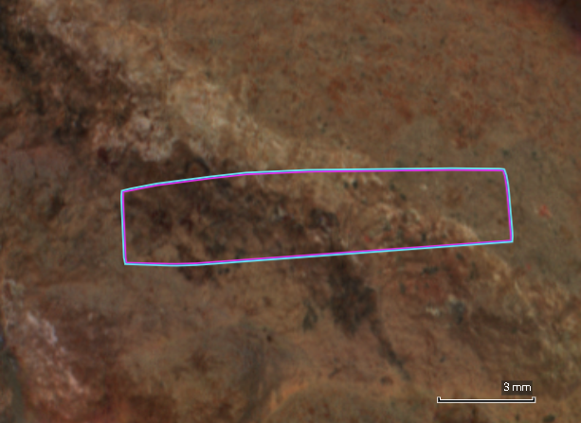
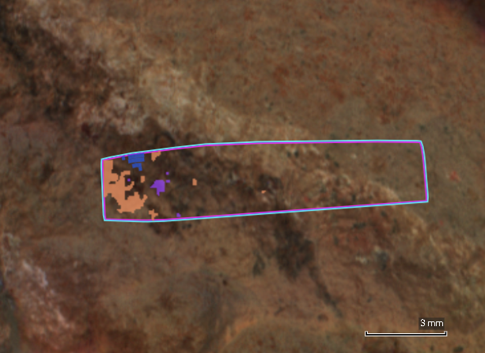
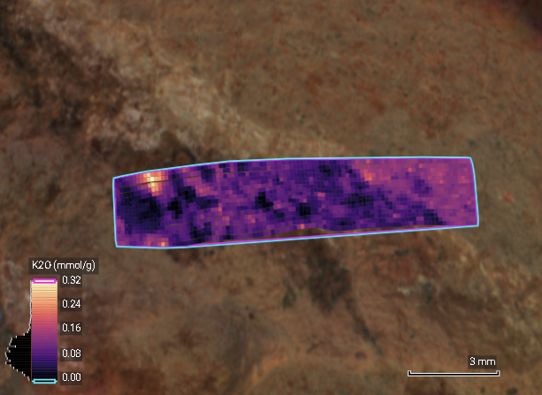
A.
B.
C.
D.
E.

Figure S25: (A) WATSON image of the target Apollo Temple collected after abrasion of the surface of the rock reproduced from Figure S22B. PMCs associated with inferred greigite (orange), siderite (purple), jarosite (blue), and vivianite (green) are shown. (B) The same image without the colored PMC overlay. (C) PIXL MCC color image of the target Apollo Temple with PMCs associated with inferred greigite (orange), siderite (purple), jarosite (blue), and vivianite (green) overlain. (D) The same image without the colored PMC overlay. Note the deep red-brown color associated with PMCs identified as siderite and tan to brown coloration associated with PMCs identified as greigite. (E) The same image with an overlay of K₂O abundance (mmol/g) derived from PIXL XRF data showing the correspondence between an area of high K₂O and PMCs associated with inferred jarosite.

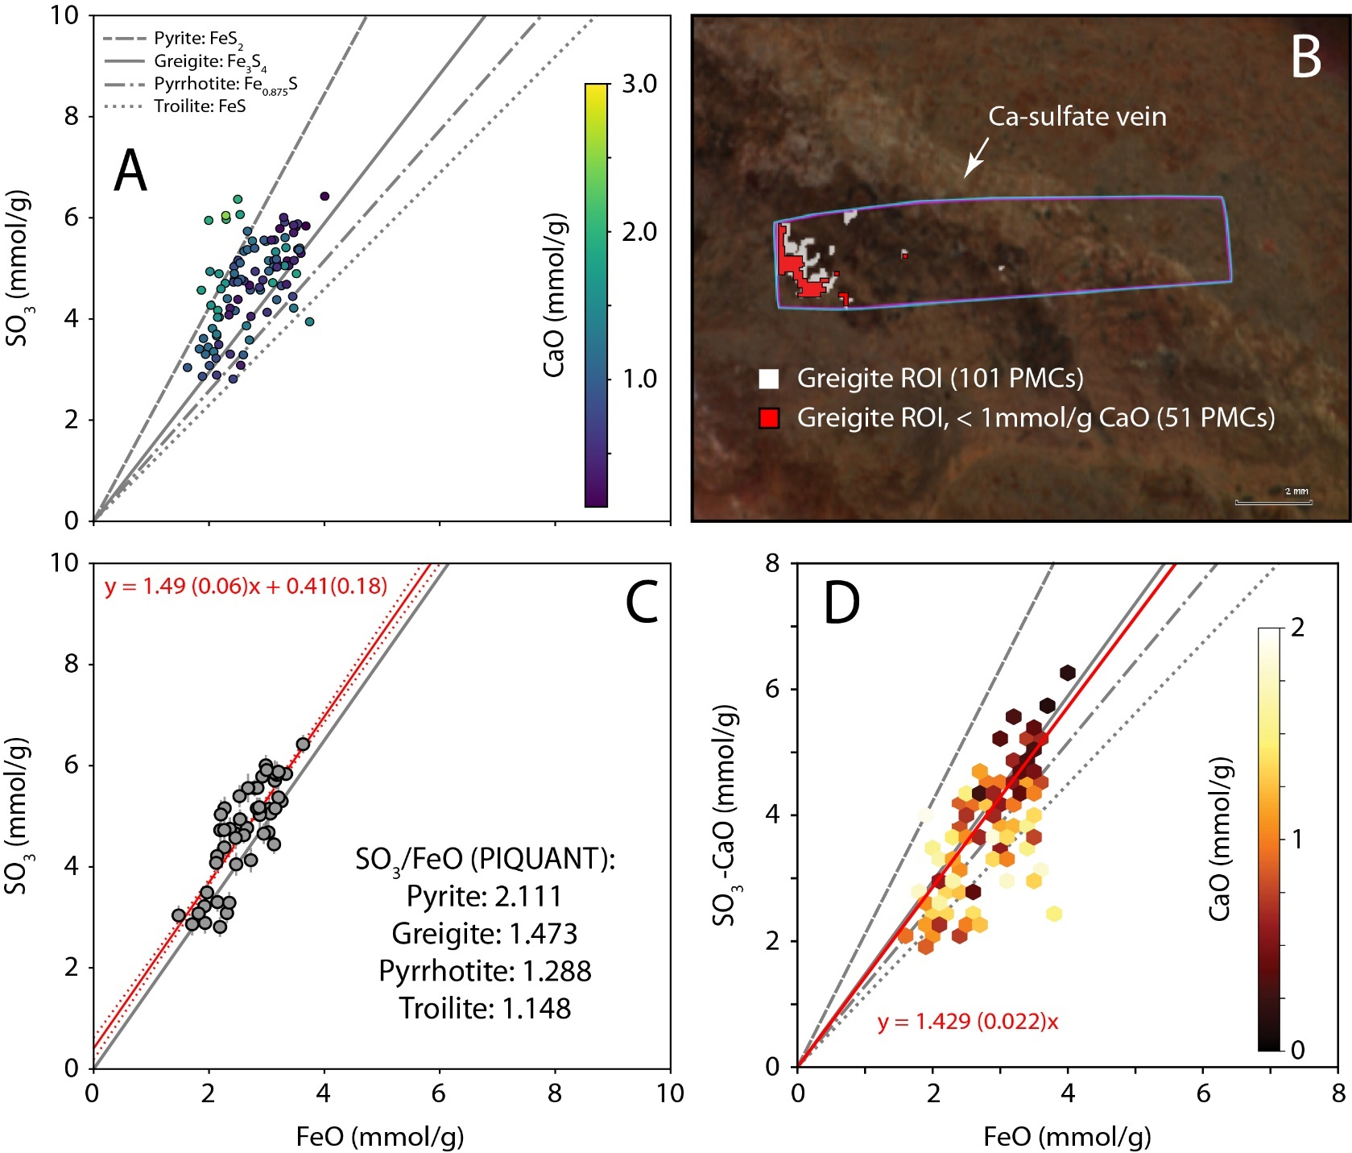

Figure S26: (A) Molar abundances of FeO vs. SO₃ for the 101 PMCs associated with the ROI named “Greigite” from the Apollo Temple PIXL XRF scan collected on sol 1213 (SI Tables). Gray lines are plotted at the appropriate SO₃:FeO ratio for a PIQUANT calculation of the FeO and SO₃ abundances of the indicated sulfide minerals (Methods): Troilite (FeS; dotted line; PIQUANT SO₃:FeO = 1.148), pyrrhotite (Fe_{0.875}S; dash-dot line; PIQUANT SO₃:FeO = 1.288), greigite (Fe₃S₄; dashed line; PIQUANT SO₃:FeO = 1.473), and pyrite (FeS₂; solid line; PIQUANT SO₃:FeO = 2.111). The scatter data are color coded by their CaO abundance (mmol/g), shown on the color scale bar at right. On this binary plot, mixtures between Fe-sulfide and Ca-sulfate will tend to draw the data points horizontally towards the y-axis. (B) PIXL MCC image showing the location of the PIXL scan footprint (pink and blue rectangle), the 101 PMCs associated with the greigite ROI (white boxes), and the location of 51 PMCs (red boxes) from this ROI with CaO < 1mmol/g. As shown, these low-CaO PMCs are located furthest from the nearby Ca-sulfate vein. (C) Molar abundances of FeO vs. SO₃ for the 51 PMCs with < 1 mmol/g CaO. The gray line is the expected slope for greigite, the red line is a bivariate linear regression weighted by the X- and Y-uncertainties on the individual data points. The dotted red lines correspond to the 2-sigma uncertainty on this regression. The slope and intercept values, with 2-sigma uncertainties are also shown, and indicate correspondence with the expected slope for greigite, and not with any of the other indicated sulfide minerals. (D) An alternative approach in which all 101 PMCs from the greigite ROI are plotted on a binary chart of the molar abundances of FeO vs. SO₃-CaO. A linear regression through the origin with normalized weighting by 1/CaO is shown in red, and again, demonstrates close correspondence to the expected slope for greigite. In this plot, the data points are plotted as hex bins, which represent the mean CaO concentration of the points that lie within each hexagon. The color scale for the hex bins is shown as an inset on the plot.
References:
1 Allwood, A. C. et al. PIXL: Planetary Instrument for X-Ray Lithochemistry. Space Science Reviews 216, 134 (2020). https://doi.org/10.1007/s11214-020-00767-7
2 Schurman, D. et al. in AbSciCon 2019 (Seattle, WA, 2019).
3 Rice, M. S. et al. Spectral Diversity of Rocks and Soils in Mastcam Observations Along the Curiosity Rover's Traverse in Gale Crater, Mars. J Geophys Res-Planet 127 (2022). https://doi.org/10.1029/2021JE007134
4 Johnson, J. R. et al. Spectrophotometric properties of materials observed by Pancam on the Mars Exploration Rovers: 4. Final mission observations. Icarus 357 (2021). https://doi.org/10.1016/j.icarus.2020.114261
5 Kokaly, R. F. et al. USGS Spectral Library Version 7. Report No. 1035, 68 (Reston, VA, 2017).
6 Hamran, S. E. et al. Ground penetrating radar observations of subsurface structures in the floor of Jezero crater, Mars. Science Advances 8 (2022). https://doi.org/ARTNeabp856410.1126/sciadv.abp8564
7 Hamran, S. E. & Paige, D. A. (ed NASA Planetary Data System) (2021).
8 Paige, D. A. et al. Ground penetrating radar observations of the contact between the western delta and the crater floor of Jezero crater, Mars. Science Advances 10 (2024). https://doi.org/ARTNeadi833910.1126/sciadv.adi8339
9 Moeller, R. C. et al. The Sampling and Caching Subsystem (SCS) for the Scientific Exploration of Jezero Crater by the Mars 2020 Perseverance Rover. Space Science Reviews 217, 5 (2020). https://doi.org/10.1007/s11214-020-00783-7
10 Rice, M. S. et al. (Database. WWU Geology Faculty Publications, ed 109. https://cedar.wwu.edu/geology_facpubs/109, 2025).
11 Rice, M. S. et al. Spectral Variability of Rocks and Soils on the Jezero Crater Floor: A Summary of Multispectral Observations From Mastcam-Z Instrument. J Geophys Res-Planet 128 (2023). https://doi.org/ARTNe2022JE00754810.1029/2022JE007548
12 Fouchet, T. et al. The SuperCam infrared spectrometer for the perseverance rover of the Mars2020 mission. Icarus 373, 114773 (2022). https://doi.org/https://doi.org/10.1016/j.icarus.2021.114773
13 Royer, C. et al. Reflectance of Jezero Crater Floor: 1. Data Processing and Calibration of the Infrared Spectrometer (IRS) on SuperCam. Journal of Geophysical Research: Planets 128, e2022JE007481 (2023). https://doi.org/https://doi.org/10.1029/2022JE007481
14 Milliken, R. RELAB spectral library bundle. NASA Planetary Data System, 98 (2020).
15 Kokaly, R. F. et al. USGS spectral library version 7. Report No. 2327-638X, (US Geological Survey, 2017).
16 Crowley, J. K. Visible and near‐infrared (0.4–2.5 μm) reflectance spectra of playa evaporite minerals. Journal of Geophysical Research: Solid Earth 96, 16231-16240 (1991).
17 Rice, M. et al. Reflectance spectra diversity of silica-rich materials: Sensitivity to environment and implications for detections on Mars. Icarus 223, 499-533 (2013).
18 Bishop, J. L., Lane, M. D. & Dyar, M. D. in EGU General Assembly 2025 (Vienna, Austria, 2025).
19 Clave, E. et al. in 54th Lunar and Planetary Science Conference (LPI, Houston, TX, 2023).
20 Jones, M. W. M. et al. In situ crystallographic mapping constrains sulfate precipitation and timing in Jezero crater, Mars. Science Advances 11, eadt3048 (2025). https://doi.org/doi:10.1126/sciadv.adt3048
21 Tice, M. M. et al. Alteration history of Seitah formation rocks inferred by PIXL x-ray fluorescence, x-ray diffraction, and multispectral imaging on Mars. Science Advances 8 (2022). https://doi.org/10.1126/sciadv.abp9084
22 Campbell, J. L. et al. Quantitative in situ determination of hydration of bright high-sulfate Martian soils. Journal of Geophysical Research: Planets 113 (2008). https://doi.org/https://doi.org/10.1029/2007JE002959
23 Mittlefehldt, D. W. et al. Geology and Geochemistry of Noachian Bedrock and Alteration Events, Meridiani Planum, Mars: MER Opportunity Observations. Journal of Geophysical Research: Planets 126, e2021JE006915 (2021). https://doi.org/https://doi.org/10.1029/2021JE006915
24 Hausrath, E. M. et al. Collection and In Situ Analyses of Regolith Samples by the Mars 2020 Rover: Implications for Their Formation and Alteration History. Journal of Geophysical Research: Planets 130, e2023JE008046 (2025). https://doi.org/https://doi.org/10.1029/2023JE008046

