Supplementary Information

Engineered prime editors with minimal genomic errors

Vikash P. Chauhan ^{1,2*}, Phillip A. Sharp ^{1,2*}, and Robert Langer ^{1,3*}

¹ Koch Institute for Integrative Cancer Research, Massachusetts Institute of Technology, Cambridge, Massachusetts, USA.
² Department of Biology, Massachusetts Institute of Technology, Cambridge, Massachusetts, USA.
³ Department of Chemical Engineering, Massachusetts Institute of Technology, Cambridge, Massachusetts, USA.
* Correspondence to: vpc@mit.edu (VPC), sharppa@mit.edu (PAS), rlanger@mit.edu (RL)
Supplementary Information

Supplementary Tables 3
Sequences 4
Supplementary Figure 5
Supplementary Competing Interests 6

Supplementary Tables

Supplementary Table 1. Oligodeoxynucleotide sequences used for mutagenesis and cloning.
Supplementary Table 2. Oligodeoxynucleotide sequences used for pegRNA and ngRNA cloning.
Supplementary Table 3. Oligodeoxynucleotide sequences used for next-generation sequencing.
Supplementary Table 4. Sequencing read data.

Data are available in a supplementary table file.

Sequences

Sequences of prime editor variants used in this study are included in a supplementary table file. The variants listed are PEmax, PE, pPE, xPE, PE7, and vPE.
Supplementary Figure
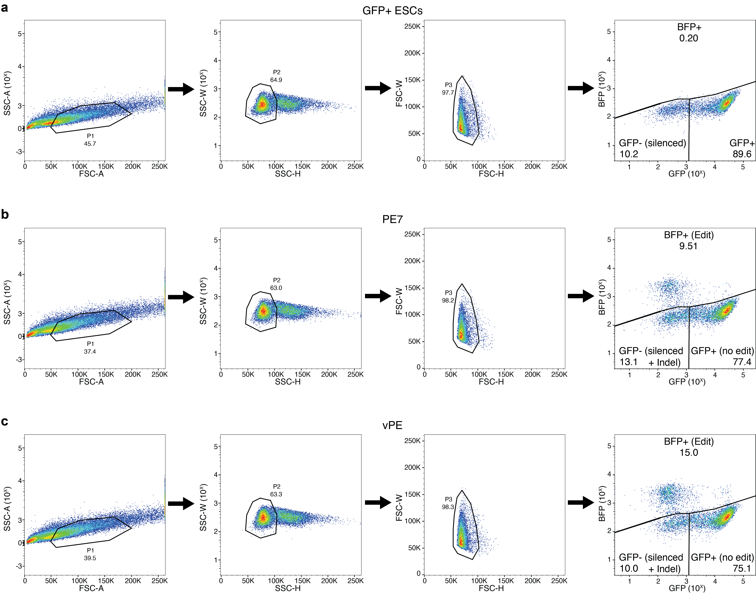
Supplementary Figure 1. Gating strategy for flow cytometry analysis of mouse embryonic stem cells. a-c, Examples of gating used to analyze editing of GFP+ ESCs to convert the GFP transgene to BFP. Cells were first gated on SSC-A/FSC-A, second on SSC-W/SSC-H, and third on FSC-W/FSC-H to eliminate debris and identify single cells. These single cells were then gated on BFP and GFP to quantify editing outcomes.

Supplementary Competing Interests
2025 Potential Competing Interests Disclosure
From FY 2020 to the present, Dr. Robert Langer received licensing fees (to patents in which he was an inventor on) from, had equity in, consulted (or was on Scientific Advisory Boards or Boards of Directors) for, lectured to or received awards from (and received a fee), conducted sponsored research at MIT for, or provided services for which he was not paid for the following entities:
1. | 611 Therapeutics |  | 31. | Entrega
2. | Abpro International |  | 32. | EpiBone
3. | Alkermes |  | 33. | Establishment Labs, SA.
4. | Allurion |  | 34. | Everlywell
5. | Alnylam Pharmaceuticals, Inc |  | 35. | Evox Therapeutics, Ltd.
6. | aMoon |  | 36. | Genemedicine Co Ltd
7. | Aptar |  | 37. | Genuv
8. | Arsenal Medical |  | 38. | Glycobia
9. | Bai Biosciences |  | 39. | HERVolution Therapeutics
10. | BeSound; |  | 40. | HCR (HealthCare Royalty Partners)
11. | Bexson Biomedical |  | 41. | Immunai
12. | Bilayer Therapeutics |  | 42. | InVivo Therapeutics;
13. | BioInnovation Institute (Novo Nordisk Fonden) |  | 43. | IxBio
14. | Blackstone (Formerly Clarus) |  | 44. | Jimini Health, Inc.
15. | Boehringer Ingelheim |  | 45. | Johnson & Johnson
16. | Boston Children's Hospital |  | 46. | Kala Pharmaceuticals
17. | Cantor Fitzgerald |  | 47. | Kendall Capital
18. | Celero |  | 48. | Kensa
19. | ClavystBio |  | 49. | Klotho Neuro
20. | Clontech Laboratories |  | 50. | Landsdowne Labs;
21. | Combined Therapeutics ("CTx") |  | 51. | LikeMinds;
22. | Conference Forum |  | 52. | Lindus Health
23. | Coregen |  | 53. | Luminopia, Inc.
24. | CyMon Bio |  | 54. | Lyndra Therapeutics
25. | Daré Biosciences |  | 55. | Lyra Therapeutics (Formerly 480 Biomedical)
26. | Decoy Therapeutics |  | 56. | Marble Therapeutics
27. | Dewpoint Therapeutics |  | 57. | Matrisome Bio;
28. | Duracyte |  | 58. | McGovern Institute
29. | Earli |  | 59. | Moderna Therapeutics
30. | ELC (Esteé Lauder Companies) |  | 60. | Nanobiosym

2025 Potential Competing Interests Disclosure
From FY 2020 to the present, Dr. Robert Langer received licensing fees (to patents in which he was an inventor on) from, had equity in, consulted (or was on Scientific Advisory Boards or Boards of Directors) for, lectured to or received awards from (and received a fee), conducted sponsored research at MIT for, or provided services for which he was not paid for the following entities:
61. | Neochromosome |  | 91. | T.Rx Capital, LLC
62. | Neoteny 4 LLP |  | 92. | Unilever (Living Proof)
63. | NextRNA |  | 93. | VasoRX
64. | Noveome Biotherapeutics, Inc. |  | 94. | Verseau Therapeutics, Inc.
65. | Novo Nordisk |  | 95. | VitaKey
66. | Okinawa Institute of Science and Technology (OIST) Graduate School (Japan) |  | 96. | Vivtex Corporation
67. | OmniPulse |  | 97. | WearOptimo
68. | OrthoBio Therapeutics |  | 98. | World Chemical Engineering Council
69. | Ovid Therapeutics |  | 99. | Xenter
70. | Particles for Humanity |  | 100. | YourBio (Formerly 7th Sense Biosystems)
71. | Placon Therapeutics |  | 101. | ZWI Therapeutics
72. | Polaris Partners
73. | Portal Instruments
74. | PrognomIQ Inc.
75. | PureTech
76. | Quris
77. | ReLive
78. | Department of Chemical and Biological Engineering Rensselaer Polytechnic Institute
79. | Replay Bio
80. | Sail Biosciences (Formerly Senda)
81. | Seer, Inc.
82. | Sethera Therapeutics
83. | Sio2
84. | Souffle Therapeutics
85. | Solvandria Foundation
86. | StemBioSys, Inc.
87. | Syntis Bio, Inc
88. | T2 Biosystems
89. | Teal Bio
90. | TISSIUM (Formerly Gecko)

