Supplemental Results and Discussion
Time-calibrated phylogeny and systematics of Scleractinia
The ages recovered in the time-calibrated phylogeny using penalized likelihood method were younger than those recovered from BEAST analyses (see trees on figshare). Results from the “Sampling from the prior” run in BEAST indicated that the ages determined from the BEAST analyses were driven by the data and not solely from the prior fossil calibration data (see [90]) (see Supplementary Figure 7). The most recent common ancestors of both scleractinian crown groups (i.e., suborders Vacatina and Refertina) were placed in the Devonian (412 and 388 Ma, respectively). Indeed, the Triassic origin of the order Scleractinia has been long in debate. Although the sudden appearance of a myriad of fossil records around 14 Ma after the Permian/Triassic extinction event ([36], [46], [47], [76] to cite a few), there are Paleozoic fossils ([26], [27], [28]) that have no specific morphologies or biogeochemistry characteristics that deny scleractinian affinities ([8]). Furthermore, Ordovician fossils of Kilbuchophyllia, which are preserved as highly detailed moulds (but lacking identifiable skeletal mineralogy), exhibit a unique pattern of septal insertion that is both identical to and diagnostic of Scleractinia (see Figure 3 in Stolarski et al. [8]). By confirming an Ordovician origin of the order, our phylogeny supports the taxonomic validity of Kilbuchophyllia discoidea and K. clarksoni as representatives of the earliest known scleractinians, and links them to the broader fossil record of the group. Interestingly, our results indicate that the family Caryophylliidae (sensu Seiblitz et al. [59]) is the oldest extant valid family (218 Ma). Although the oldest known scleractinian fossils (Kilbuchophyllia) have occasionally been compared to members of Fungiacyathidae (Fungiacyathus symmetricus), solitary Dendrophylliidae (Balanophyllia (Eupsammia) zelandiae) [26], or Micrabaciidae [8], their features – such as the presence of an epithecal wall and relatively simple septal structures – suggest they are unlikely representatives of these evolutionary lineages. Instead, they most likely exhibit convergent traits, a common phenomenon within Scleractinia (e.g., [97], [98]). Although Micrabaciidae, a basal clade within Vacatina, have not been identified in the fossil record prior to the Cretaceous, this absence may be attributed to the extremely delicate skeletons of these corals, particularly in deep-water forms (e.g., Leptopenus), which significantly reduces their fossilization potential. The rise of the family Gardineriidae in the Jurassic period is also debatable since representatives of this family show “primitive” morphological characters with evident similarities to ancient fossil corals ([99]). This result could have been limited by the low number of gardineriid species that could be included in the phylogeny. A global comparison between crown ages of all main Scleractinia families recovered in this study (Supplementary Table 4) and the dating of the oldest fossil representative of respective lineages show that, for the majority of the clades, these two line of data are in agreement (see Supplementary Table 2). Moreover, the coloniality state of the representative fossil always mirror (with only two exceptions) the ancestral coloniality state recovered for the most recent common ancestor of each family included in the Supplementary Table 2. While there are several challenges in the use of scleractinian fossil records – as acknowledged before – these comparisons corroborate the results obtained through the molecular clock of the phylogeny and subsequent analyses.
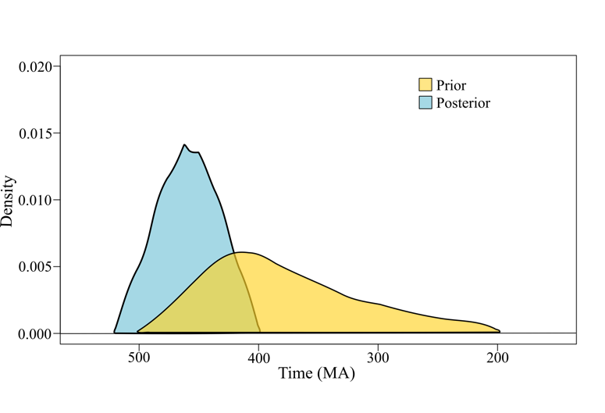
Supplementary Figure 7 | Shapes for the 95% highest prior and posterior densities for the most recent common ancestor of Scleractinia node. The mismatch between the two distributions shows that data contains sufficient information to not be overruled by the prior.
Relationships within the two suborders resemble that from previous comprehensive phylogenies (e.g., [17], [100], [101], [102]) with some important novelties. The families included in the so-called “Basal” group (i.e., Micrabaciidae and Gardineriidae), retrieved in multiple previous studies in a monophyletic lineage sister to the two suborders, were recovered in the present study – the first to include both “Basal” families in a phylogenomic reconstruction (i) inside the Vacatina clade and (ii) as polyphyletic instead of in a monophyletic clade – as in Kitahara et al. [78] and Stolarski et al. [8]–, the latter result mirroring findings obtained by Seiblitz et al. [103] through the analysis of complete mitochondrial genomes. One of the most comprehensive trees to date for stony corals is a supertree retrieved by Huang & Roy [102] using both molecular and morphological data. Some important differences between the supertree and our UCEs plus exons tree – beside the already mentioned position of the families Micrabacidae and Gardineriidae – can be observed, especially in the relation at deep nodes of the phylogenies. Some examples include (i) the family Deltocyathidae is retrieved as sister to the rest of the Vacatina lineages in the supertree while we recovered the family Stephanocyathidae together with several clades formerly belonging to the family Caryophylliidae as early diverging within the suborder; (ii) the families Turbinoliidae and Fungiacyathidae are sister in the super tree, while Turbinoliidae is sister to a lineage compose by the families Fungiacyathidae and Flabellidae in the present study. Additional differences are listed in the paragraph below.
Our results showed some incongruencies with the known systematics of some Scleractinia lineages. The family Turbinoliidae, previously thought to be monophyletic [104], was recovered in three separate clades, two within the Vacatina and one in the Refertina. Likewise, the family Anthemiphylliidae was recovered as polyphyletic with one of the two clades occupying a very early diverging position inside the Vacatina. Anthemiphylliidae was already recovered as polyphyletic by Stolarski et al. [8] but, contrary to the present results, one species was retrieved within the Refertina clade. Together with one of the Vacatina turbinoliid clade and anthemiphylliids, several previously classified caryophylliids grouped in novel lineages (Group A in Fig. 2) that do not correspond to any extant family, forming a large clade sister to the remaining Vacatina. Generally, our phylogenetic reconstruction confirmed the polyphyly of the family Caryophylliidae – already uncovered in several other studies (e.g., [17], [59], [100]) – with additional diverging lineages retrieved both in the Vacatina and Refertina suborder (e.g., genus Distolotrochus). Another novel clade was recovered that do not correspond with any of the extant families, that include the species Oulastrea crispata and Heterocyathus sulcatus, which show very different morphological traits. Species belonging to the genus Trochocyathus were recovered in six phylogenetically distant lineages, uncovering an extreme case of morphological convergence at the macromorphological level. Moreover, our phylogeny solved with confidence the relationship of some lineages for which the phylogenetic position was still uncertain (e.g., genus Madrepora, see also Capel et al. [105]). In the light of the above-mentioned results, our phylogeny highlights a strong need for a systematic revision of many lineages but, at the same time, the strong support of most nodes and completeness of the phylogeny coupled with robust age estimation provide a strong basis for the systematic revision of several lineages and the study of the evolution of species traits.
Supplementary Table 4 | Age estimates (million years) of crown scleractinian clades and families, and corresponding Geological Periods. See also Supplementary Table 2.
Clade | Mean Age (95% HPD) | Geological Period
Scleractinia | 460 (405-519) | Ordovician (Devonian - Cambrian)
Vacatina | 412 (357-471) | Devonian (Carboniferous - Ordovician)
Refertina | 388 (327-455) | Devonian (Carboniferous - Ordovician)
Caryophylliidae | 218 (188-257) | Triassic (Jurassic - Permian)
Acroporidae | 197 (150-252) | Jurassic (Jurassic - Permian)
Pocilloporidae | 172 (120-231) | Jurassic (Cretaceous - Triassic)
Poritidae | 165 (114-219) | Jurassic (Cretaceous - Triassic)
Dendrophylliidae | 140 (188-318) | Cretaceous (Jurassic - Carboniferous)
Group A | 135 (92 - 189) | Cretaceous (Cretaceous - Jurassic)
Micrabaciidae | 133 (80-198) | Cretaceous (Cretaceous - Jurassic)
Merulinidae | 129 (103-157) | Cretaceous (Cretaceous - Jurassic)
Flabeliidae | 121 (90 - 156) | Cretaceous (Cretaceous - Jurassic)
Deltocyathidae | 119 (45 - 205) | Cretaceous (Paleogene - Triassic)
Fungiacyathidae | 118 (72 - 173) | Cretaceous (Cretaceous - Jurassic)
Agariciidae | 106 (49 - 171) | Cretaceous (Tertiary - Jurassic)
Gardineriidae | 105 (23 - 220) | Cretaceous (Tertiary - Triassic)
Euphylliidae | 100 (54 - 149) | Cretaceous (Tertiary - Jurassic)
Lobophylliidae | 99 (68 - 131) | Cretaceous (Cretaceous - Cretaceous)
Fungiidae | 73 (48 - 98) | Cretaceous (Tertiary - Cretaceous)
Turbinoliidae | 71 (40 - 105) | Cretaceous (Paleogene - Cretaceous)
Faviidae | 70 (42 - 100) | Cretaceous (Tertiary - Cretaceous)
Meandrinidae | 63 (30 - 103) | Tertiary (Tertiary - Cretaceous)

Additional references
- Benzoni, F., Arrigoni, R., Stefani, F. & Stolarski, J. Systematics of the coral genus Craterastrea (Cnidaria, Anthozoa, Scleractinia) and description of a new family through combined morphological and molecular analyses. Syst. Biodivers. 10(4), 417-433 (2012).
- Vaga, C. F. et al. 300 million years apart: the extreme case of macromorphological skeletal convergence between deltocyathids and a turbinoliid coral (Anthozoa, Scleractinia). Invertebr. Syst. 38, IS23053 (2024).
- Stolarski, J. Gardineria - a scleractinian living fossil. Acta Palaeontol. Pol. 41(4), 339-367 (1996).
- Kitahara, M. V., Fukami, H., Benzoni, F. & Huang, D. The new systematics of Scleractinia: integrating molecular and morphological evidence. In: Goffredo, S., Dubinsky, Z. (Eds.), The Cnidaria, Past, Present and Future. Springer International Publishing Cham pp. 41–59 (2016).
- Quek, Z. R. et al. A hybrid-capture approach to reconstruct the phylogeny of Scleractinia (Cnidaria: Hexacorallia). Mol. Phylogenetics Evol. 107867 (2023).
- Huang, D., & Roy, K. The future of evolutionary diversity in reef corals. Philos. Trans. R. Soc. B, Biol. Sci. 370(1662), 20140010 (2015).
- Seiblitz, I. G. L. et al. The earliest diverging extant scleractinian corals recovered by mitochondrial genomes. Sci. Rep. 10(1), 20714 (2020).
- Cairns, S. D. A generic revision and phylogenetic analysis of the Turbinoliidae (Cnidaria: Scleractinia). Smithsonian Contribution to Zoology 591:1-55 (1997).
- Capel, K. C. et al. How long have we been mistaken? Multi-tools shedding light into the systematics of the widespread deep-water genus Madrepora Linnaeus, 1758 (Scleractinia). Mol. Phylogenetics Evol. 191, 107994 (2024).

