A full-featured 2D flash chip enabled by system integration

(Supplementary Information)
Chunsen Liu^{1,§,*}, Yongbo Jiang^{1,§}, Boqian Shen^{1,§}, Shengchao Yuan^{1,§}, Zhenyuan Cao^{1,§}, Zhongyu Bi¹, Chong Wang¹, Yutong Xiang¹, Tanjun Wang¹, Haoqi Wu¹, Zizheng Liu¹, Yang Wang^{1,2}, Shuiyuan Wang¹, Peng Zhou^{1,2,*}
¹State Key Laboratory of Integrated Chips and Systems, College of Integrated Circuits and Micro-Nano Electronics, Frontier Institute of Chip and System, Zhangjiang Fudan International Innovation Center, Fudan University, Shanghai 200433, China
²Shaoxin Laboratory, Zhejiang, China
§These authors contributed equally: Chunsen Liu, Yongbo Jiang, Boqian Shen, Shengchao Yuan, Zhenyuan Cao
*Correspondence should be addressed to Chunsen Liu: chunsen_liu@fudan.edu.cn, Peng Zhou: pengzhou@fudan.edu.cn

Table of content
S1. Characterisations and working principles of CMOS circuitry 3
S2. Characterisations of 2D planar integration 9
S3. 2D-specialised non-destructive packaging technique 12
S4. Verification of damage-free 2D flash integration to CMOS 14
S5. 2D flash performance and reliability issue 16
S6. 2D circuit design 25
S7. Circuit simulations for compatibility verification 28
S8. Testing for the 2D flash chip 30
S9. Discussion on the failure analysis of the 2D flash cells 33
S10. Discussion on 2D flash performance 34
S11 Discussion on the scalability of 2D flash chip 36

S1. Characterisations and working principles of CMOS circuitry
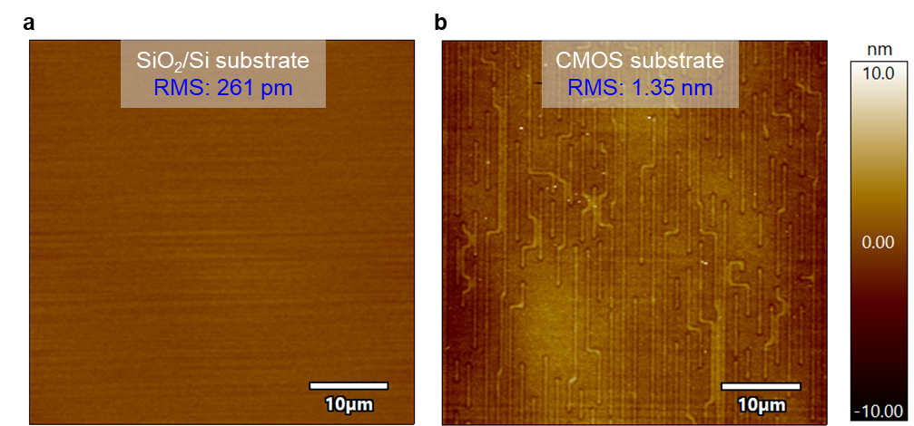
Supplementary Fig. 1| Comparison between SiO₂/Si substrate and CMOS substrate. The root mean square (RMS) of the surface roughness for the CMOS substrate (right panel) is significantly higher than that of the SiO₂/Si substrate (left panel) due to the underlying large-area circuits.

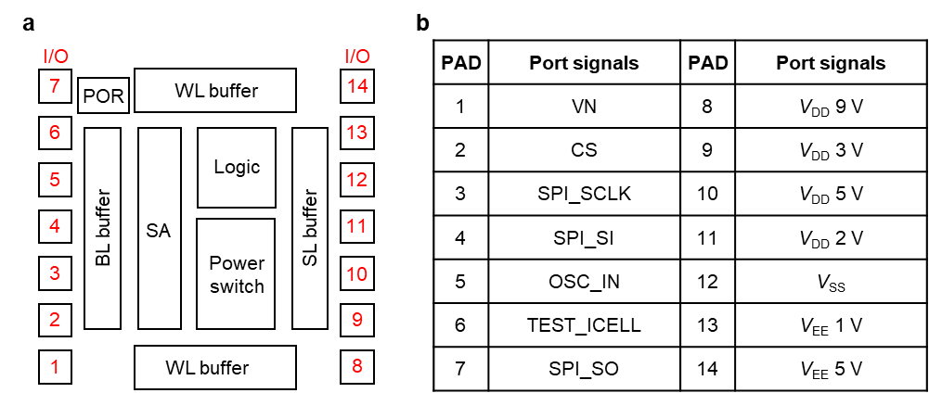
Supplementary Fig. 2| Port function of the I/O module. a, The relative positions of the I/O module in the 2D flash chip. b, Port signals of the I/O module. The specific functions of each port signal are as follows: VN: External resistor used to adjust reference current. CS: Chip select signal. SPI_SCLK: Serial clock. SPI_SI: Serial data input. OSC_IN: External clock. TEST_ICELL: Test port used for measuring cell current. SPI_SO: Serial data output. VDD 9 V, 3 V, 5 V, and 2 V are +9 V, +3 V, +5 V, and + 2 V power supply, respectively. VSS: Ground. VEE 1 V and 5 V are -1 V and -5 V power supply, respectively.

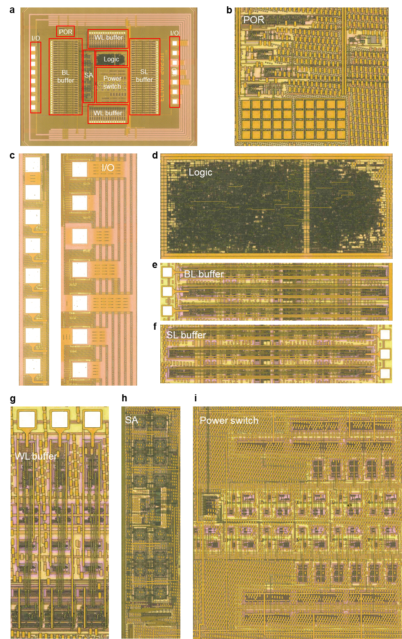
Supplementary Fig. 3| CMOS modules. a, Global view of the CMOS modules. b, Power-on reset (POR) circuit. c, I/O. d, Logic control circuit. e, BL buffer. f, SL buffer. g, WL buffer. h, Sense amplifier (SA). i, Power switch.

The following is the function description of the CMOS modules of the chip, including I/O, power switch, WL/SL/BL buffer, SA, POR. The corresponding schematics are shown in Supplementary Figs. 4-7.
I/O module: To implement the standard SPI protocol, ensuring proper interaction between the CS, SCLK, SI, and SO signals and the internal digital circuit. Additionally, the I/O module supports the input of various power supplies, the external clock, and the external resistor.
Power switch module and WL/SL/BL buffer module: (1) Power Switch. A power voltage switching circuit. Since the CMOS process we used does not provide high-voltage tolerant devices, 5 V devices are used to ensure that the circuit operates within a reasonable voltage range. (2) WL/SL/BL Buffer. They accept pulses provided by the digital circuit. The pulses are driven by a series of inverters and finally reach the WL/SL/BL mini pads.
SA module: The sense amplifier (SA) is a current-mode sense amplifier. During read operations, the read voltage is applied to the BL, generating the cell current. Then, SA compares the cell current with a reference current (I_{ref}) to read out the data.
POR module: Power-On Reset (POR) outputs the POR_N signal to the digital circuit to ensure that all internal nodes of the digital circuit are reset during the power-on process, preventing operational instability in the digital circuit.
The basic design process of the CMOS module is as follows: Analyse design requirements; Design the chip architecture; Perform circuit design to meet the specifications for each module defined in the architecture; Conduct full-chip pre-layout simulation; Create the layout and verify it using DRC (Design Rule Check) and LVS (Layout Versus Schematic); Perform post-layout simulation for each analogue module; Conduct full-chip simulation; Tape-out the chip.
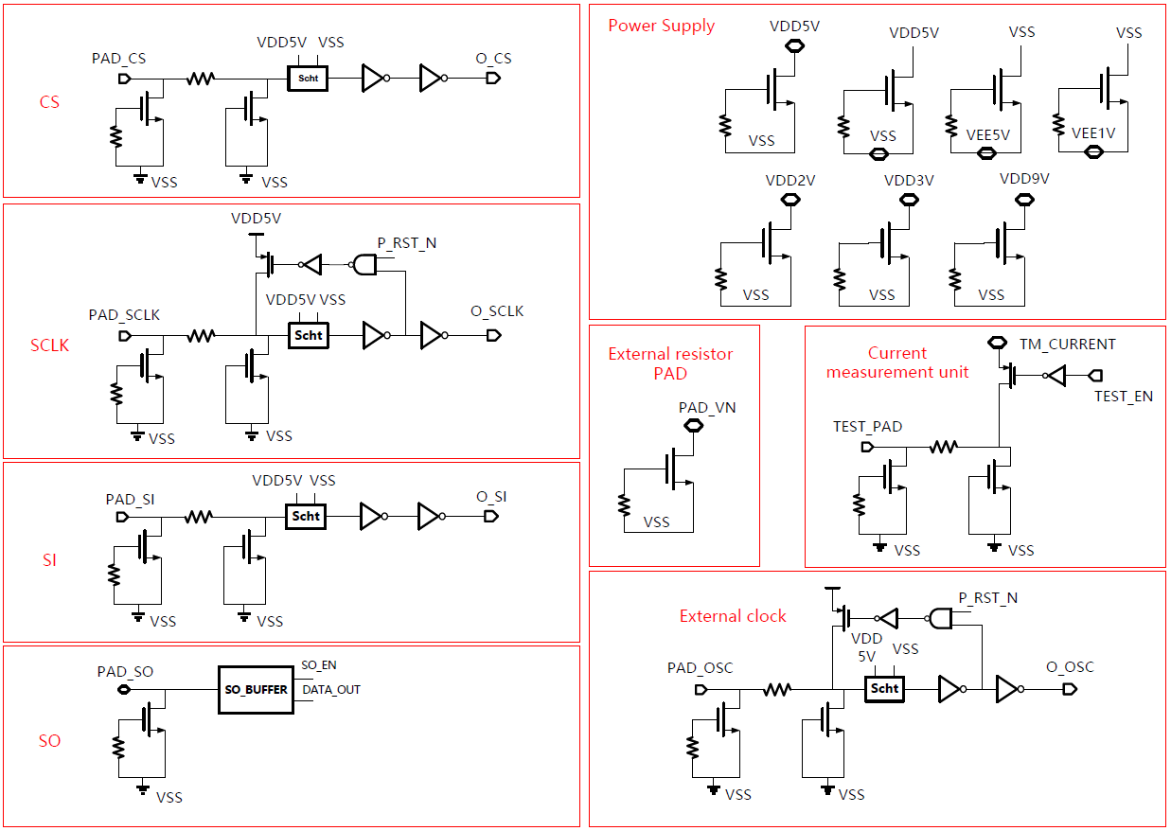
Supplementary Fig. 4| Circuit schematic of I/O module. The CS, SCLK, SI, and OSC signals pass through two levels of electrostatic discharge (ESD) circuit protection and are then shaped by a Schmitt trigger before entering the digital circuit. All other signals pass through ESD protection before being used for input or output.

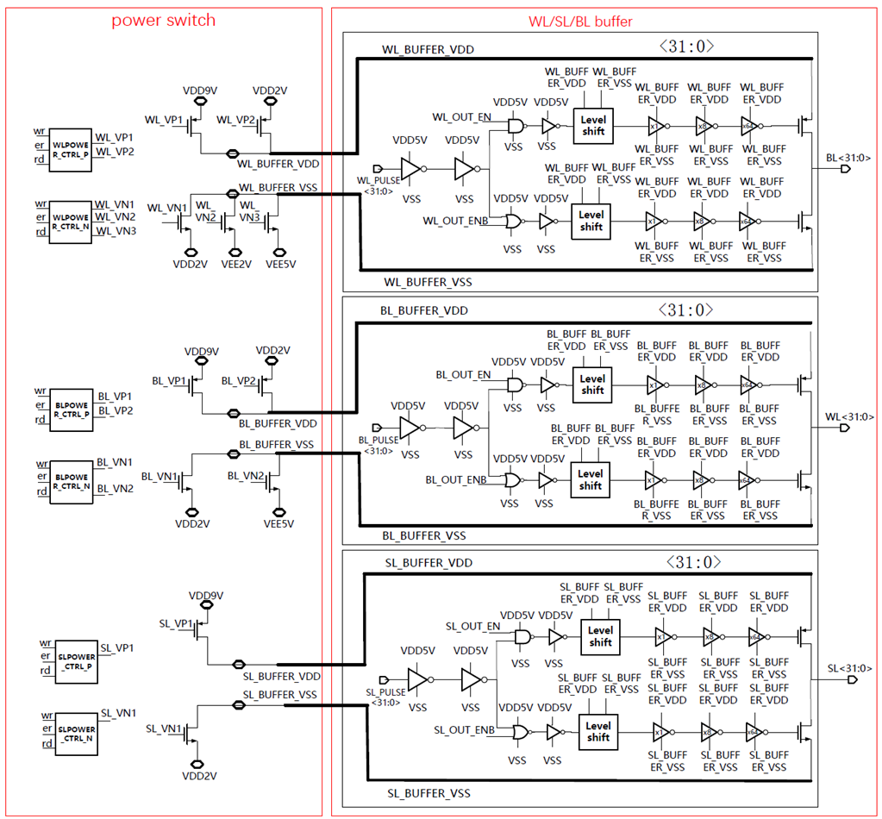
Supplementary Fig. 5| Circuit schematic of power switch module and WL/SL/BL buffer module. The power switch module is controlled by wr (programming), er (erasing), and rd (reading) signals. It provides different voltages to the output buffer path in each mode, ensuring the generation of the corresponding pulses for the three modes. The WL/SL/BL buffer module receives pulse signals from the digital circuit, converts them to the corresponding voltage domains via a level shifter, and then drives the signals through a series of buffers to output them to the WL/SL/BL mini pads.

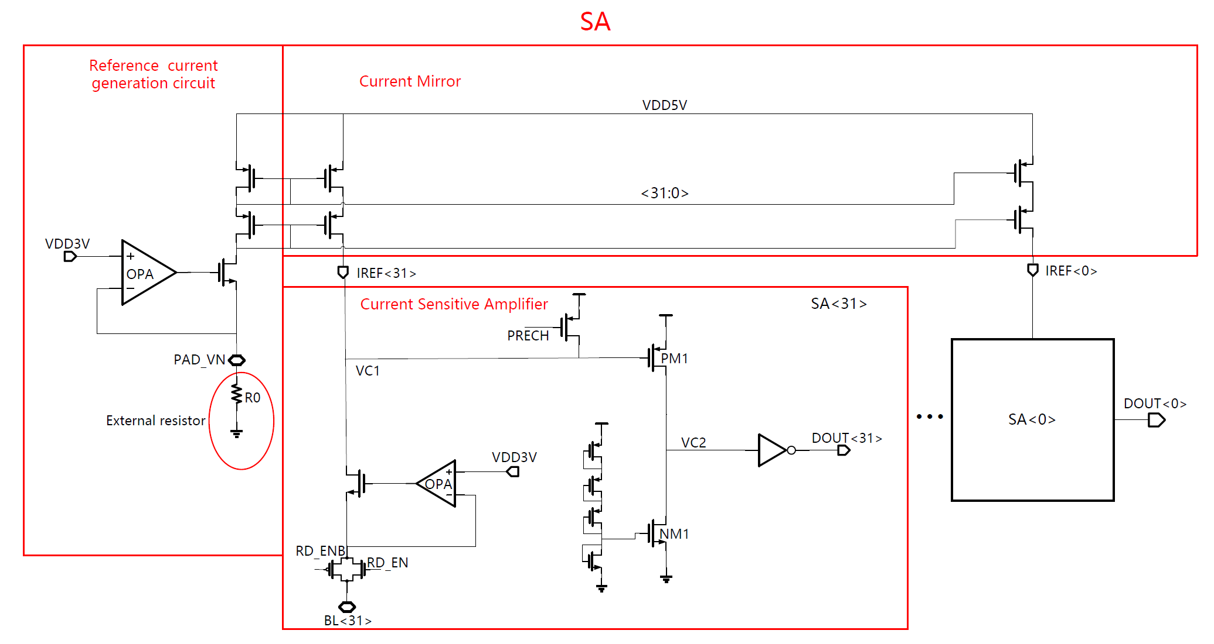
Supplementary Fig. 6| Circuit schematic of SA module. The I_{ref} generation circuit consists of an operational amplifier and an external resistor. The reference current can be adjusted by changing the value of the external resistor. A current mirror replicates the reference current into 32 parallel paths, supplying it to 32 sense amplifiers. This enables simultaneous reading of data from 32 BLs, latching the results into the digital circuit, and finally outputting the data serially.

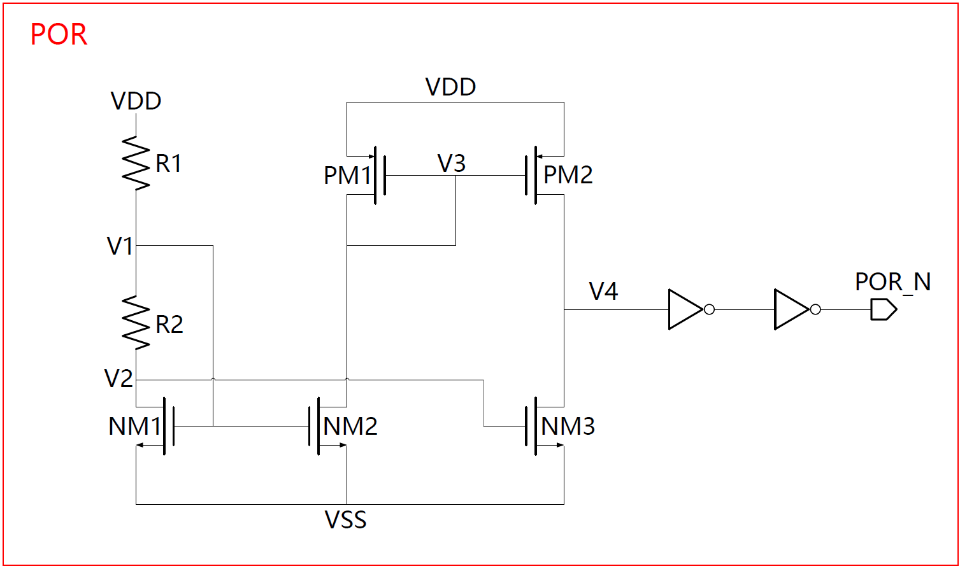
Supplementary Fig. 7| Circuit schematic of POR module. Resistors R1 and R2 form a voltage divider, causing node voltages V1 and V2 to rise with increasing input voltage, with V1 > V2. When V1 exceeds NM1’s threshold voltage, NM1 turns on, pulling V3 low. This lowers V4 through the PM1-PM2 current mirror, and the output driver circuit generates a low-level reset signal, POR_N. As VDD continues to rise, NM1 enters saturation, and V2 exceeds NM3’s turn-on voltage, activating NM3. Since NM2 has a higher gate voltage than NM3, its current is larger, charging V4 to a high level. The output driver then raises POR_N to indicate release.

S2. Characterisations of 2D planar integration
Before 2D planar integrating, we performed Polymer-Mediated Delamination treatment with high resolution to pre-clean the CMOS substrate. As is shown in Supplementary Fig. 8, the CMOS substrate initially contained numerous nanoparticles with heights of tens of nanometres, while most of these nanoparticles were successfully removed after cleaning, confirmed by atomic force microscopy (AFM) image (Supplementary Fig. 1).
The 1Kb 2D flash was then fabricated onto the CMOS substrate, and the CMOS die pads are revealed with through glass vias (TGVs). Here, TGV1 is for CMOS die I/O interface, and TGV2 is for 2D-CMOS interlayer communication. The resistance of these TGVs is confirmed to be <10 Ω, acceptable for connection, as is shown in Supplementary Fig. 9.
Supplementary Fig. 10 and 11 show the scanning electron microscope images of the 2D flash chip cross-section and the energy dispersive spectroscopy (EDS) mapping image of the 2D flash chip cell cross-section. The 2D channel is well-adhesive to CMOS substrate with no bubbles and air gaps, confirming the conformal adhesion of 2D materials on the rough CMOS die through our planar integration.
By optimizing our planar integration, we realized the integration with high yield and low variation. Compared with integration on ideal SiO₂ substrate, little degradation is witnessed, as is shown in Extended Data Fig. 1 a, b.
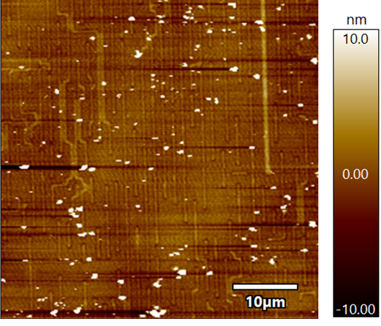
Supplementary Fig. 8| AFM image of the CMOS substrate before the pre-cleaning treatments. There are numerous nanoparticles with heights of tens of nanometres on the CMOS substrate.

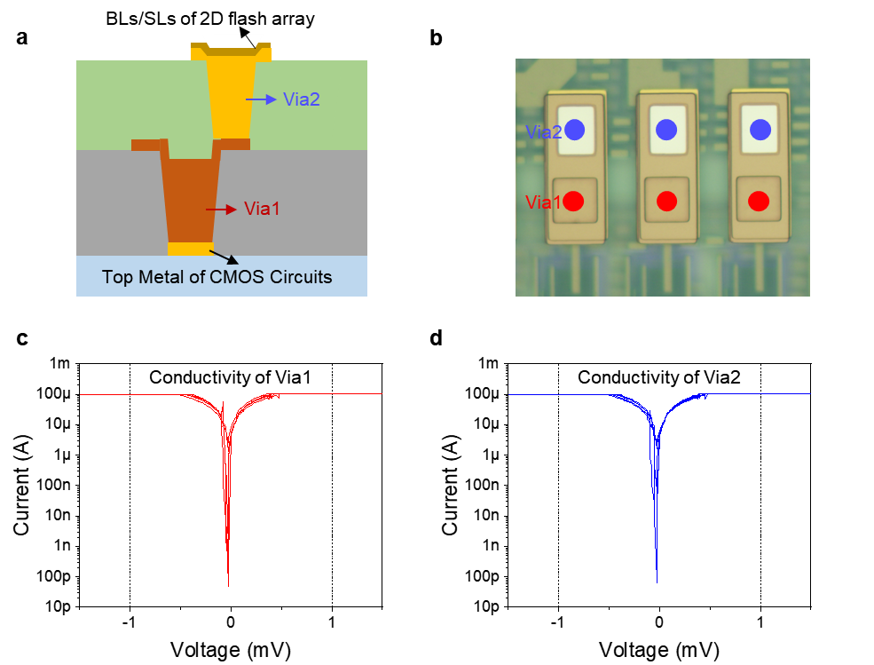
Supplementary Fig. 9| Conductivity of Via1 and Via2. Via2 connects to Via1 through the memory stack, and Via1 connects to CMOS WL/SL/BL pads through the passivation layer. a, Schematic diagram of the relative vertical positions of Via1 and Via2 in the ports region of BL/SL buffer (the WL buffer port region contains only Via1 and no Via2.). b, Optical image of Via1 and Via2. c, d, Five test points were measured for both Via1 (c) and Via2 (d), showing excellent electrical conductivity with resistance less than 10 Ω.
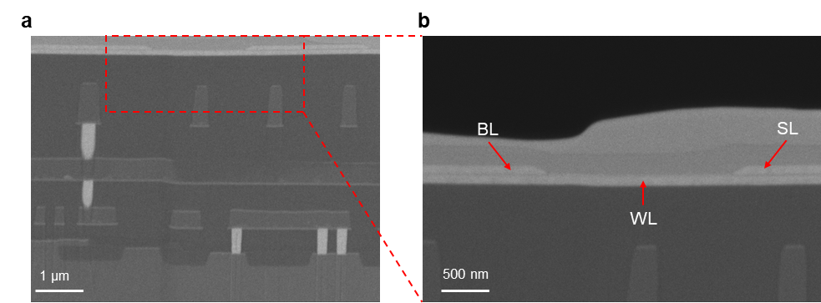
Supplementary Fig. 10| SEM images of the 2D flash chip TEM specimen during the thinning process. It can be observed that the 2D flash cell is integrated above the CMOS circuitry.

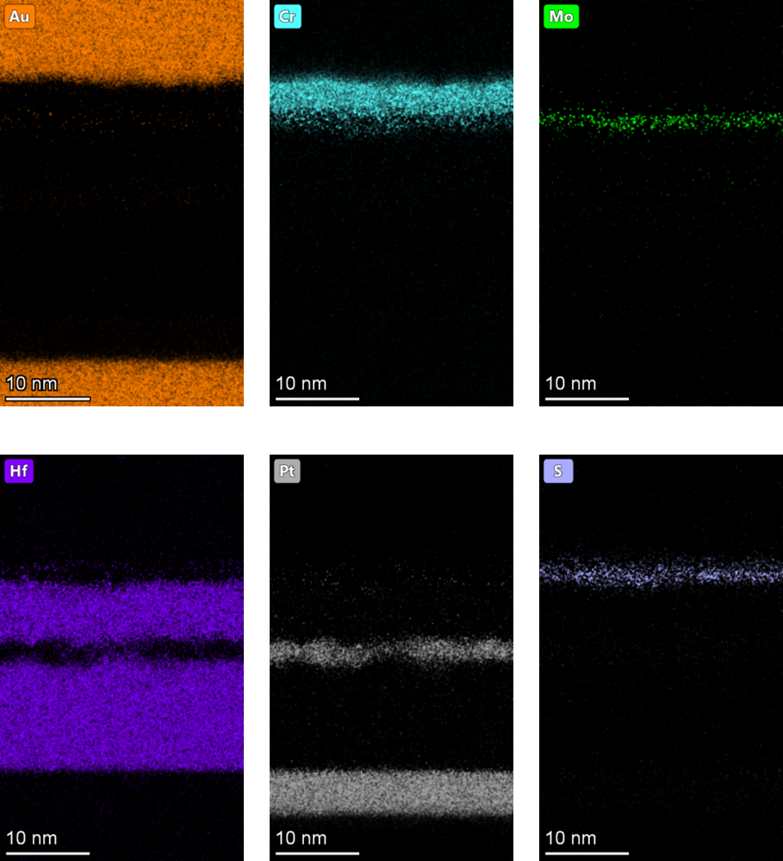
Supplementary Fig. 11| EDS mapping of a 2D flash cell. Elements of gold (Au), chromium (Cr), molybdenum (Mo), hafnium (Hf), platinum (Pt), and sulfur (S) are confirmed.

S3. 2D-specialised non-destructive packaging technique
The fundamental ESD protective component is the gate-grounded NMOS transistor, which can divert electrostatic currents through parasitic bipolar junction transistor conduction. The region-specific ESD protection design takes into account the ESD risks and protection requirements in different regions. For I/O pads (including power supply, ground, input and output pads), the main ESD events originate from external shocks during packaging and testing, which can result in voltages of hundreds of volts. The ESD protection cells utilise a large size to enhance the protection effect. For WL/BL/SL mini pads, the main ESD events originate from charge and ion accumulation induced by 2D integration, resulting in a mild impact. To avoid a large additional load, small ESD protection cells are used to provide sufficient protection. The ESD configurations and strain tests for all pads are summarised in Supplementary Table 1.
In conventional thermocompression wire bonding, the operating temperature typically exceeds 300°C, and high compression stress is required¹. Specialised room temperature ultrasonic bonding reduces both the thermal and mechanical stress budgets. Meanwhile, conventional die attach requires heating to cure the adhesive; for example, epoxy requires 150–200 °C and solder requires 200–350 °C. In our 2D-specialised approach, a solvent-based insulating adhesive composed of synthetic resin is used which cures at room temperature. These methods reduce damage to sensitive 2D materials. Supplementary Figure 12 shows the gate leakage current of 2D flash cells using different approaches and demonstrates that our technology, which has a low thermal and mechanical stress budget, is 2D-friendly.
2D flash chip is encapsulated with photoresist layer to avoid environmental impact including dust, water vapour, and other external factors. Supplementary Fig. 13 shows the good time stability of the encapsulated 2D flash performance.
Supplementary Table 1| ESD configuration and ESD strain test for all pads. Every pad may suffer electrostatic shock with positive or negative voltage. We design ESD protection for each pad. To minimize the extra load for 2D flash circuit and protect CMOS during 2D planar integration, the ESD protection for mini pads is special designed. The circuit size and load for each ESD protection is listed below. Besides, we test the ESD stress test for each pad, by applying positive and negative ESD stresses to each combination of pads separately. The test result is listed below by the maximum voltage stress that won’t breakdown the pad.
position | type | size | load | Protect ability
VDD 5 V | DC power | 40 μm × 500 nm × 12 | 2 pF | ±8000 V
VSS 0 V | DC power | 40 μm × 500 nm × 12 | 2 pF | ±5000 V
VEE 1 V | DC power | 40 μm × 500 nm × 12 | 2 pF | ±5000 V
VEE 5 V | DC power | 40 μm × 500 nm × 12 | 2 pF | ±8000 V
VDD 2 V | DC power | 40 μm × 500 nm × 12 | 2 pF | ±1000 V
VDD 3 V | DC power | 40 μm × 500 nm × 12 | 2 pF | ±8000 V
VDD 9 V | DC power | 40 μm × 500 nm × 12 | 2 pF | ±6000 V
SPI_SI | input | 40 μm × 500 nm × 12 | 2 pF | ±6500 V
SPI_SCLK | input | 40 μm × 500 nm × 12 | 2 pF | ±7000 V
CS | input | 40 μm × 500 nm × 12 | 2 pF | ±7000 V
OSC_IN | Input | 40 μm × 500 nm × 12 | 2 pF | ±6500 V
VN | Input | 40 μm × 500 nm × 12 | 2 pF | ±7000 V
SPI_SO | Output | 40 μm × 500 nm × 24 | 4 pF | ±8000 V
TEST_ICELL | Output | 40 μm × 500 nm × 24 | 4 pF | ±7000 V
mini pad | Mini pad | 5 μm × 500 nm | 20 fF | *
* ESD protection for mini pads are actually designed to eliminate electrical damage from charges and ions induced by 2D integration with lower amount instead of external electrostatic shock, therefore their size is smaller for lower extra load. In addition, they are effective in electrical protection because no damage is applied to CMOS during 2D integration.

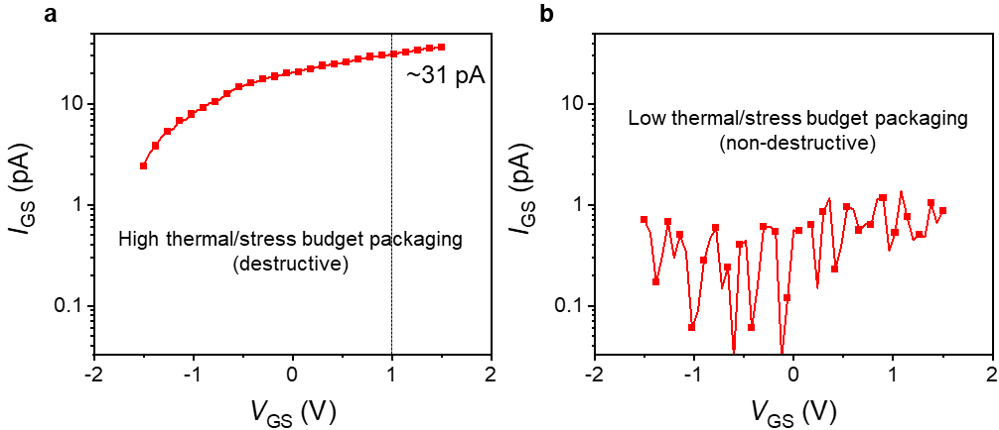
Supplementary Fig. 12| Comparison between high thermal/stress budget packaging and optimized low thermal/stress budget packaging. Gate leakage current I_{GS} with gate voltage V_{GS} is extracted at V_{DS}=0.5 V. High thermal/stress budget from packaging would damage the 2D devices and induce a higher leakage.
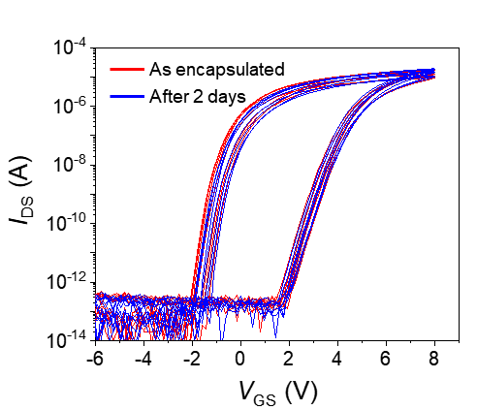
Supplementary Fig. 13| Stability of the S1818 photoresist encapsulation. Dual sweep transfer curves of eight 2D flash cells as encapsulated (red lines) and after 2 days (blue lines) were tested.

S4. Verification of damage-free 2D flash integration to CMOS
In the 2D flash chip, the CMOS modules are responsible for providing the requisite voltage signals for reading, programming, and erasing operations of the 2D NOR flash module, in accordance with the instructions. To ascertain that the 2D flash integration process does not result in damage to the underlying CMOS modules, the output voltage waveforms of the CMOS modules were subjected to testing before and after the integration of the 2D flash memory. The test results are presented in Supplementary Fig. 14.
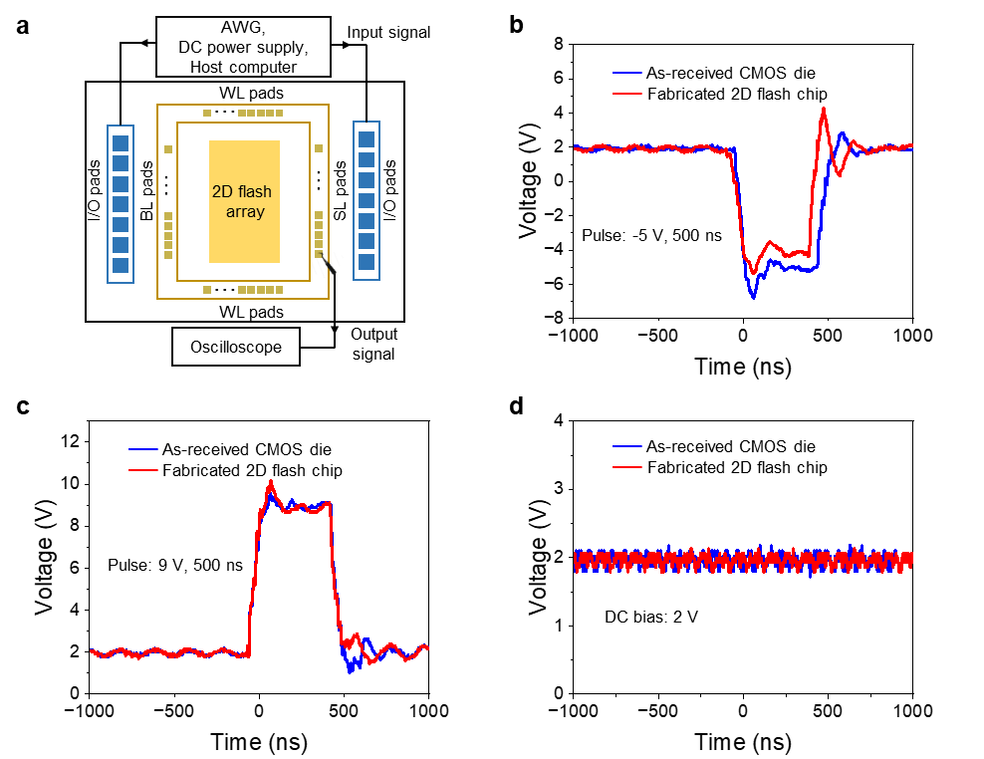
Supplementary Fig. 14| The CMOS module functionality before and after the 2D flash module fabrication. a, Schematic of the testing process. The CMOS modules generate the corresponding voltage waveform at the pads connected to the 2D flash module, based on commands sent by the host, the clock signal provided by the arbitrary waveform generator (AWG), and the input voltage from the DC voltage supply. This voltage waveform can be monitored using an oscilloscope. b-d, Comparison of generated voltage waveforms between the as-received CMOS modules and the CMOS modules after integration with the 2D flash module. This includes a -5 V, 500 ns voltage pulse (b), a 9 V, 500 ns voltage pulse (c), and the 2 V DC bias (d).

S5. 2D flash performance and reliability issue
Supplementary Fig. 15 shows the progressive amplitude pulses scheme to achieve the desired programming and erasing of the 2D flash threshold within the specified target range (used for Extended Data Fig. 1c, d and Supplementary Fig. 18). The preset V_{th} ranges for state-OFF and state-ON in progressive amplitude pulses scheme are 0.9 to 1.3 V and -0.9 to -1.3 V, respectively. During the initial programming stage, a primary pulse is applied to the gate terminal with the source and drain grounded. For programming, the amplitude of the primary pulse is 16 V. Once the V_{th} falls within the target range for state-OFF, the programming process is considered complete. If these conditions are not met, subsequent pulses with incremental amplitudes (step = 0.5 V, starting from 14 V) are applied for fine-tuning. When the V_{th} reaches the target range for state-OFF, programming is finalized. Then, to erase the 2D flash cell to state-ON, the primary pulse amplitude is set to -16 V, with subsequent pulses starting from -12 V. The pulse width for both programming and erasing are 20 ns.
Once the V_{th} reaches the preset ranges for state-OFF and state-ON, the corresponding transfer characteristic curve (I_{DS}-V_{GS}, at V_{DS} = 0.5 V) and output characteristic curve (I_{DS}-V_{DS}, at V_{GS} = 0 V) are measured. If the amplitude of the subsequent pulses used for programming or erasing exceeds 20 V or -20 V and the V_{th} of the 2D cell still does not fall within the preset range, the cell is considered as failed.
To ensure that the test can truly reflect the performance of 2D flash circuit on the 2D flash chip, we have taken full account of the wire delay. We applied voltage signals at the connections (Vias) of CMOS modules and 2D flash module during 2D flash circuit test, as shown in Supplementary Fig. 16, so the signal paths were the same as those in the chip test. Supplementary Fig. 17 gives the actual waveform considering transmission process. The 20 ns pulses are actually triangle waveforms with some amplitude loss.
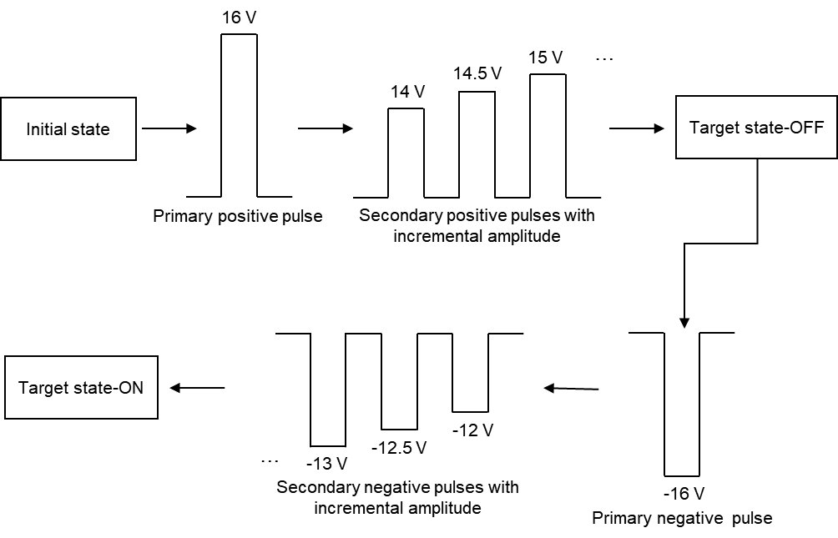
Supplementary Fig. 15| Simplified programming/erasing procedure of the statistical performance test. The pulse width is 20 ns and the maximum of the pulse amplitude is 20 V for programming and –20 V for erasing.

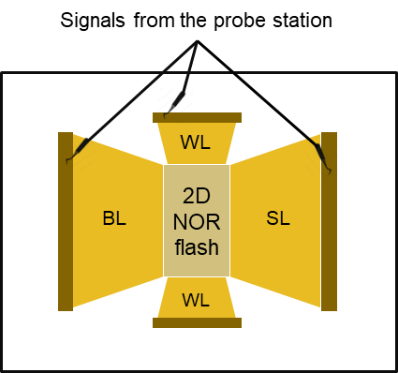
Supplementary Fig. 16| Location of signal application during 2D flash circuit test.

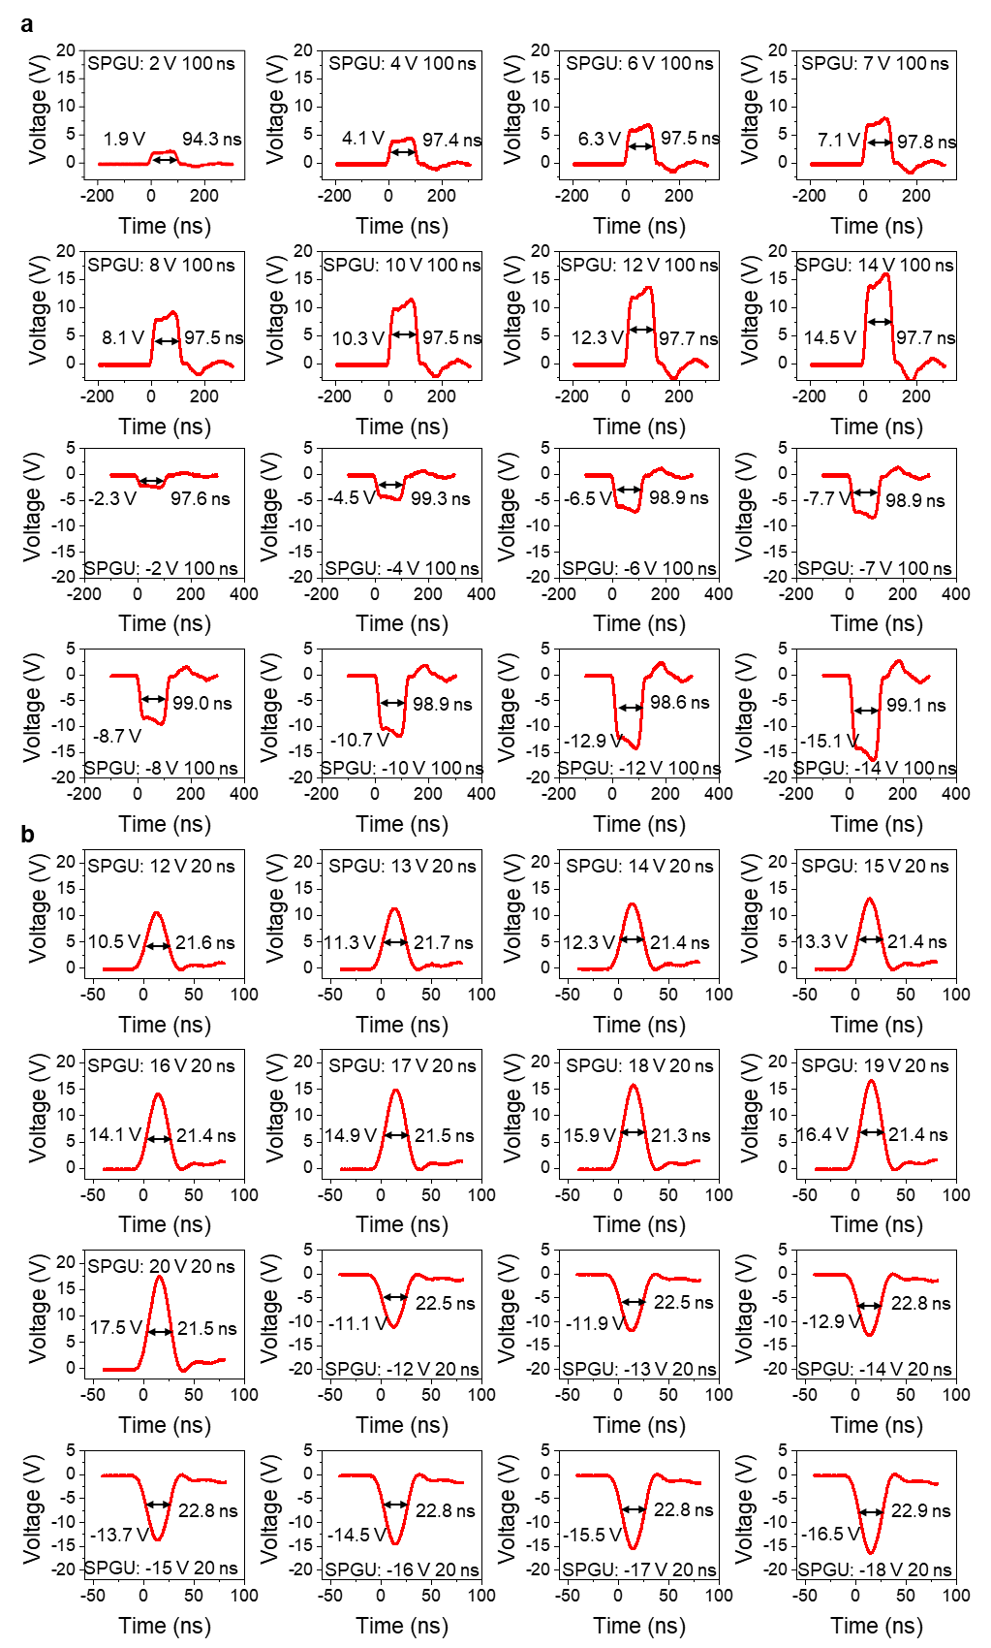
Supplementary Fig. 17| The output voltage pulses after the transmission process. The B1500's SPGU generates voltage pulses which are transmitted through the switching matrix and metal pad, and captured by the oscilloscope (DPO 5204). a, Pulse waveforms with an amplitude from 14 V to -14 V and a pulse width of 100 ns. b, Pulse waveforms with amplitudes from 12 V to 20 V and from -12 V to -18 V, with a pulse width of 20 ns.
The performance results for 2D flash cells are shown as below.
Transfer characteristic curves of 16 typical devices fabricated on rough CMOS die operated using the progressive amplitude pulse scheme is shown in Supplementary Fig. 18. The results show the similar performance of devices are achieved fabricated on different substrate, which is also demonstrated in dual sweep transfer characteristic curves in Extended Data Fig. 1a.
We also verified the operation effect of single voltage pulse. With a single pulse of ±14 V, 20 ns, the 2D flash achieves two distinguishable states with a memory window about 1.42 V, as is shown in Supplementary Fig. 19.
To demonstrate the speed advantage of 2D flash cell, MoS₂ channel flash with SiO₂ tunnelling layer and silicon-channel flash with HfO₂ tunnelling layer are fabricated to illustrate the contribution of 2D channel and HfO₂ tunnelling layer separately. The results are shown in Supplementary Figs. 20 and 21, respectively. MoS₂ channel flash with HfO₂ tunnelling layer enables the much faster operation speed (14 V, 20 ns) over silicon-flash with HfO₂ tunnelling layer (14 V, 5 µs). Meanwhile, the HfO₂ tunnelling layer supports the lower operation voltage, as MoS₂ channel flash with SiO₂ tunnelling layer requires much higher 20 V, 20 ns programming. The 2D material channel enhances tunnelling efficiency through lower the effective barrier height. Details about the ultrafast programming mechanism can be found in our previous study².
The retention performance of MoS₂ channel flash with HfO₂ tunnelling layer and SiO₂ tunnelling layer is also compared, as shown in Extended Data Fig. 2 and Supplementary Fig. 22, respectively. The V_{th} shift with time for state-ON and state-OFF after program and erase were measured to first determine the acceleration ratio at varied temperature, 55 ℃, 85 ℃ and 125 ℃. The total memory window lost considers both V_{th} shift from state-ON and state-OFF. The retention lifetime is considered as when the extrapolation of memory window lost by half. Arrhenius equation³ is used to fit the data and get the retention lifetime.
The SiO₂ tunnelling layer affords better retention performance of 10-year non-volatile @91.4 ℃ with a higher barrier, while the HfO₂ tunnelling layer also support 10-year non-volatile @54.8 ℃. Due to the reduced operation voltage, which improve the compatibility with CMOS platforms, and the 10-year non-volatile retention, we adopt MoS₂ with HfO₂ tunnelling layer for the 2D flash chip.

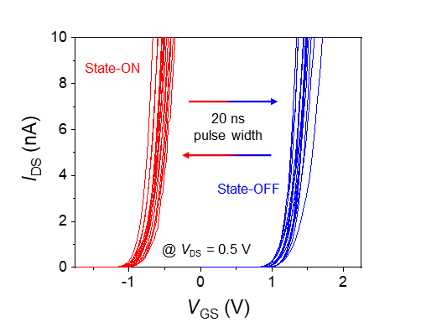
Supplementary Fig. 18| Typical transfer characteristic curves of 2D flash fabricated on CMOS substrate. Voltage pulses by progressive amplitude pulses with 20 ns duration were applied for programming and erasing. 16 typical cells are measured.

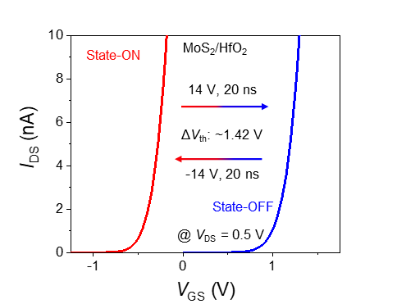
Supplementary Fig. 19| Programming/erasing characteristics of the 2D flash cell with HfO₂ tunnelling layer fabricated on CMOS die using pulses of ±14 V, 20 ns. The memory window of 1.42 V is achieved.

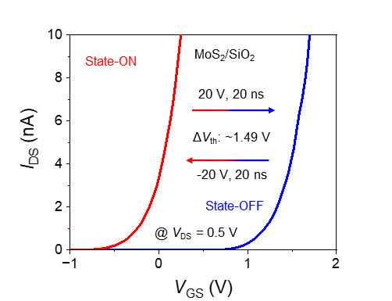
Supplementary Fig. 20| Programming/erasing characteristics of the 2D flash cell with SiO₂ tunnelling layer. The cell shares the fabrication process of 2D flash cell with HfO₂ tunnelling layer, except for the tunnelling layer is replaced with SiO₂ of the same thickness. To achieve the same memory window of about 1.4 V, a higher operation voltage of ±20 V, 20 ns pulse is required.

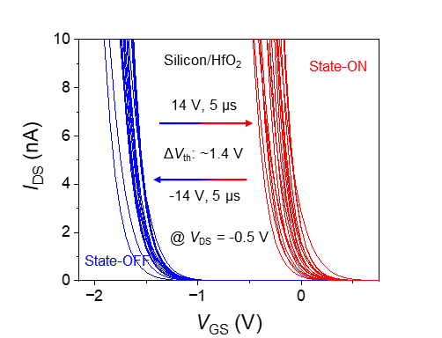
Supplementary Fig. 21| Programming/erasing characteristics of the silicon flash cell with HfO₂ tunnelling layer. The silicon flash cell shares the identical memory stack and layout with 2D flash cell with HfO₂ tunnelling layer, and is fabricated on a FDSOI wafer. To achieve the same memory window of about 1.4 V, ±14 V, 5 μs pulse is required, much slower than 2D flash cells.

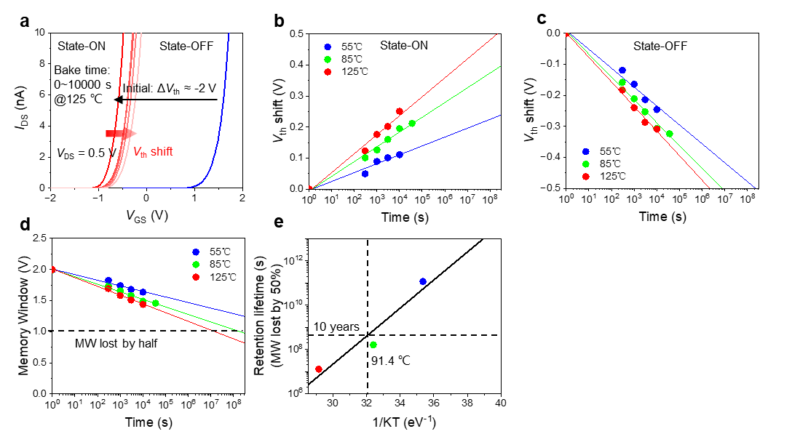
Supplementary Fig. 22| Retention performance for 2D memory cells with SiO₂ tunnelling layer under different temperatures. a, Retention test for state-ON under 125 ℃ as an example. Test methods are all the same with that in 2D flash cell with HfO₂ tunnelling layer, including V_{th} extracted at V_{DS}= 0.5 V and I_{DS}=100 pA; the initial memory window of 2 V; baking at 125 ℃ for 10000 s; and the retention loss extracted by V_{th} variation between the as-programmed cell and cell after baking. Retention performance for state-ON (b) and state-OFF (c) at 55 ℃, 85 ℃ and 125 ℃ are extracted. d, total memory window with different bake temperature and time considering both the retention loss from state-ON and state-OFF in (b) and (c). e, the temperature of retention lifetime extrapolated from (d) at the point MW lost by half. A 10 years lifetime at 91.4 ℃ is extracted with Arrhenius model.

The ISPP slope is shown in Supplementary Fig. 23 to demonstrate the multi-level cell application potential. 20 ns pulses are used. The program voltage increases from 10 V to 20 V with a step (V_{step}) of 0.5 V. The V_{th} variation between initial state and programmed state (ΔV_{th}) is extracted after each program pulse is applied. The ISPP slope is extracted as the function⁴: $ISPP slope=\frac{ΔV_{th}\left(V_{program}+V_{step}\right)-ΔV_{th}\left(V_{program}\right)}{V_{step}}$. The result shows the ISPP slope of about 0.6 V/V
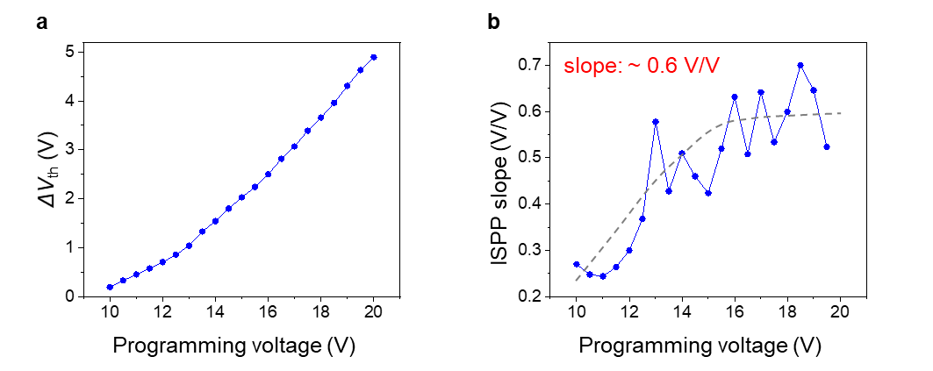
Supplementary Fig. 23| Extracted V_{th} shift of program pulse amplitude. a, Threshold voltage shift of programming voltage with gradual amplitude. b, Extracted ISPP slope from (a). With 20 ns waveform operation, the ISPP slope saturate with around 0.6 V/V.

The energy consumption of the 2D flash cell is evaluated based on the operating current, voltage, and speed. Regarding the operating current, due to the extremely short time frame in which tunnelling occurs and the small current involved, it cannot be accurately measured. Therefore, we performed the TCAD simulation with well-established FN tunnelling theory to assess the FN operating current precisely through theoretical simulations.
The FN tunnelling follows the equation⁵ $J_{FN}=AE_{ins}^{2}exp⁡(-\frac{B}{E_{ins}})$, where J_{FN} is the current density, E_{ins} is the electric field in the insulator, A and B are materials dependent coefficients. For the MoS₂/HfO₂ interface in the 2D flash cell, we calibrated coefficients A and B as 1.845×10⁻⁷ A/V² and 1.043×10⁸ V/cm, respectively, based on the measured tunnelling current data in a MoS₂ transistor and TCAD simulations. The simulated FN tunnelling current was found to match the experimental FN tunnelling current well, as shown in Supplementary Fig. 24.
Subsequently, A and B were applied to the simulation of 2D flash cell to evaluate the programming current as shown in Extended Data Fig. 1e, f. Detailed parameters for the simulation are shown in Supplementary Table 2. The FN programming current result is 2.3 μA/bit in our analysis derived from TCAD simulations. Therefore, for the 2D flash cell, energy consumption is calculated to be 0.644 pJ/bit (14 V × 2.3 μA × 20 ns).
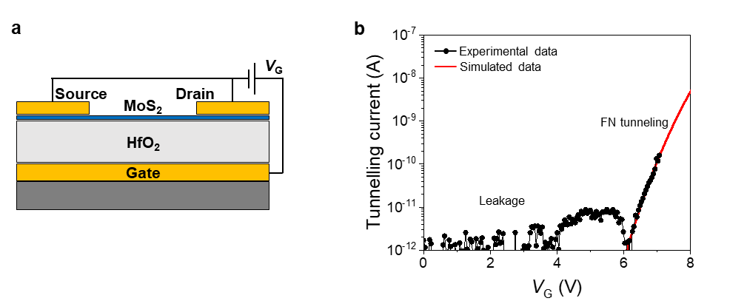
Supplementary Fig. 24| Tunnelling current of a simulated MoS₂ transistor. a, Diagram of the MoS₂ transistor. b, The FN tunnelling characteristics for the MoS₂ transistor. The simulated data matches the experimental data in the FN tunnelling region.

Supplementary Table 2| The materials parameters used for TCAD simulation. Here, T is the material thickness, E_{g} is the bandgap, ε is the relative dielectric constant, and χ is the electron affinity.
Parameters | MoS₂ | HfO₂ | Pt
T (nm) | 0.65 | Tunnelling:7; Blocking:13 | 3
E_{g} (eV) | 1.8 | 5.9 | \
ε | 4 | 22 | \
χ (eV) | 4.2 | 2.5 | \

Read disturb and endurance performance are analysed. For read disturb, the 5 MHz clock (400 ns read pulse) is utilised, with each read cycle has V_{GS} = 0 V and V_{DS} = 1 V to simulate the real on-chip read condition. The result is shown in Supplementary Fig. 25a, demonstrate the read disturb immunity for over 10⁶ read cycles. The endurance performance is analysed by switching the cell with ±14 V, 20 ns pulses. The cells can endurance over 10⁴ cycles without breakdown and keeps distinguishable two states, as is shown in Supplementary Fig. 25b.
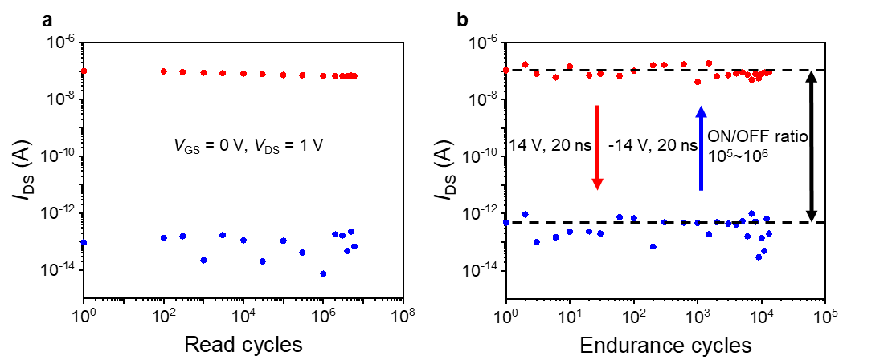
Supplementary Fig. 25| Read disturb and endurance performance for 2D memory array. a, the cell stressed by read operation with V_{GS} = 0 V and V_{DS} = 1 V. The memory state keeps unchanged with more than 10⁶ read cycles. b, the cell stressed by ±14 V, 20 ns Programming/Erasing cycle. The 2D memory cells underwent 10⁴ ~ 10⁵ operation cycles without breakdown and shown still distinguishable 2 states.

S6. 2D circuit design
There are two distinct schemes for applying the programming/erasing voltage based on the FN tunnelling mechanism. The first scheme applies the entire voltage to the gate of the 2D flash cells, a method predominantly employed in previous studies. In contrast, the alternative scheme allocates a portion of the voltage to the gate (V_{G}) and the remainder to both the drain (V_{D}) and source (V_{S}). We have verified the consistency of the programming effects achieved by the two schemes. If the potential difference between the gate and the channel is the same, the voltage assignment between them will not affect the memory window, as is shown in Supplementary Figs. 26-28
We designed the half-select scheme based on the voltage allocation method. The voltage is allocated evenly at WL (gate) and BL/SL (drain/source). The voltage configurations under different operation modes are summarised in Supplementary Table 3.
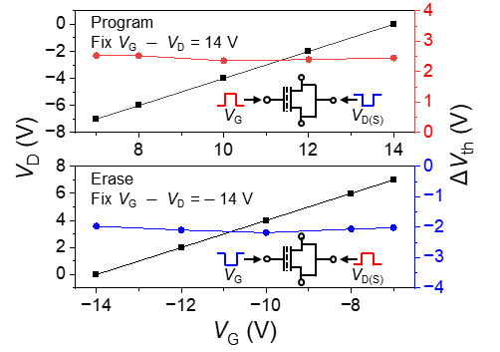
Supplementary Fig. 26| V_{th} shift of different programming/erasing voltage assignments. The potential difference between gate and drain-source is fixed at 14 V and -14 V for programming (upper panel) and erasing (lower panel), respectively. The voltage pulse width is 100 ns. Insets: the corresponding port voltage configurations. V_{th} was extracted at a constant drain-source current (I_{DS}) of 100 pA.

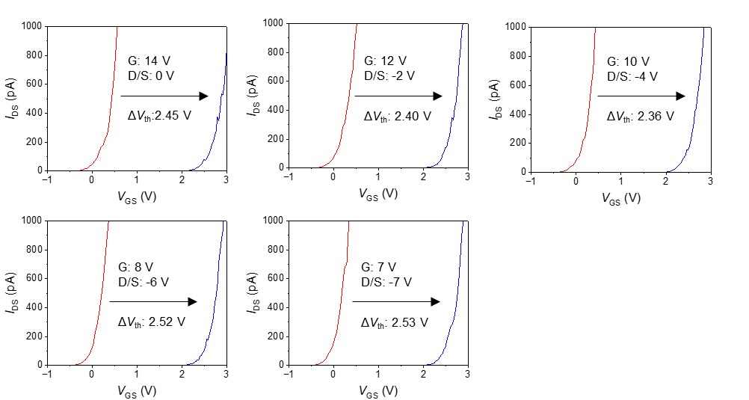
Supplementary Fig. 27| Transfer curves of before and after programming under different voltage assignments. G, D, and S refer to the gate, drain, and source terminals, respectively.
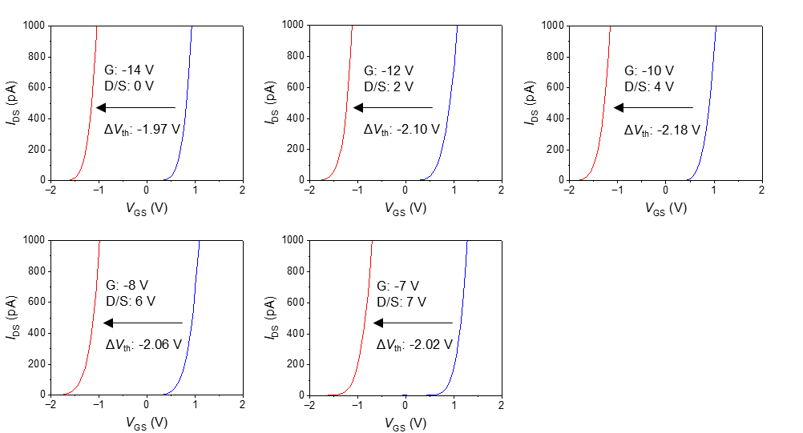
Supplementary Fig. 28| Transfer curves of before and after erasing under different voltage assignments. G, D, and S refer to the gate, drain, and source terminals, respectively.

Supplementary Table 3| Voltage configurations for a 2D flash cell (at row m and column n) in programming, erasing and reading process. To accommodate the voltage tolerance characteristics of the devices in the CMOS circuitry, 0 V is used as the ground for the digital circuit, and 2 V is used as the ground for the analogue circuit. SLs are floated during programming, and are forced to -5V/2V by BL_{n}/other BL, respectively.
 | WL_{m} | Other WL | BL_{n} | Other BL | SL_{n} | Other SL
Program cell_{mn} | 9 V | 2 V | -5 V | 2 V | Floating | Floating
Erase cell_{mn} | -5 V | 2 V | 9 V | 2 V | 9 V | 2 V
Read cell_{mn} | 2 V | -1 V | 3 V | 2 V | 2 V | 2 V

We extract capacitance by theoretical calculations and experimental tests.
Single unit capacitance follows the equation $C=\frac{ε_{0}ε_{1}S}{d}$, where $ε_{0}$ is the vacuum dielectric constant, $ε_{1}$is the relative dielectric constant, $S$is the overlapping area of the upper and lower plates of the capacitor, $d$ is the distance between the upper and lower plates of the capacitor. Single device capacitance on WL is calculated as the equation $C=\frac{C_{blocking}*C_{tunneling}}{C_{blocking}{+C}_{tunneling}}$, see as the series of two capacitances, where $C_{blocking}$ is the capacitance between floating gate and gate (WL), and $C_{tunneling}$ is the capacitance between floating gate and channel, source (BL) and drain (SL). Total capacitance on WL is the sum of all device capacitance on WL, and the total capacitance on BL/SL is approximately half of WL. Based on the above equation, we calculated that the total capacitance of WL is 6 pF and the total capacitance of BL/SL is 3 pF.
We also tested the capacitance in the 2D module. We tested the capacitance of 32 device on the same WL/BL with an average value 235/110 fF and a total value (the sum of 32 device) of 7.5/3.5 pF, which is very similar to the theoretically calculated values. The result for capacitance extraction is listed as follow in Supplementary Table 4
Supplementary Table 4| Extracted 2D flash circuit capacitance through theory theoretical calculations and experimental tests
Calculation of 2D circuit capacitance/impedance
S_{Block} | S_{Tunnel} | t_{Block} | t_{Tunnel} | C_{Gate} | C_{WL-calc} | C_{BL-calc} | C_{WL-test} | C_{BL-test}
45 μm² | 25 μm² | 15 nm | 10 nm | 188 fF | 6 pF | 3 pF | 7.5 pF | 3.5 pF

S7. Circuit simulations for compatibility verification
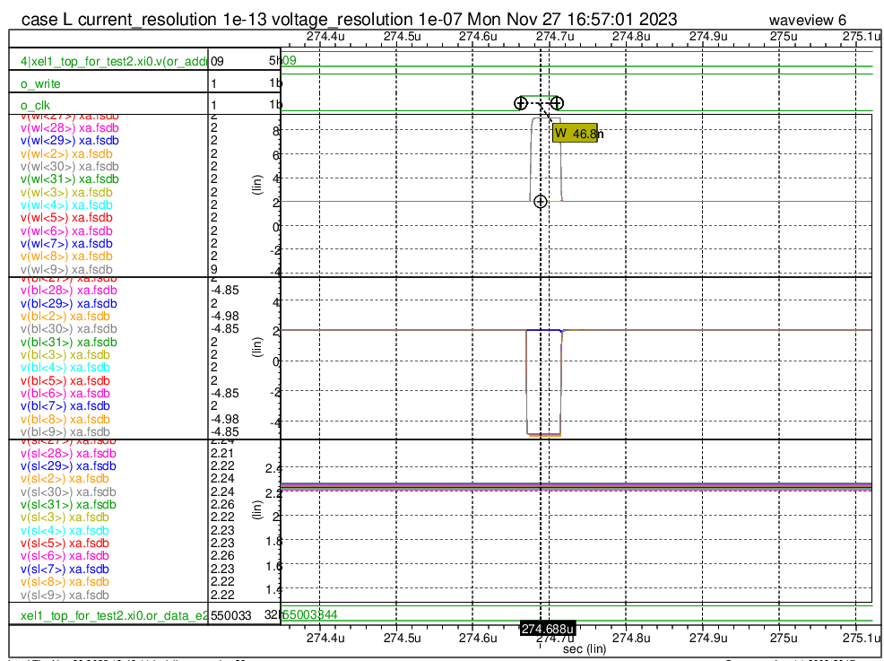
Supplementary Fig. 29| Signal waveforms in programming mode. In the programming mode, the program control signal o_write is 1 (high) and the clock O_CLK used to synchronize the voltage pulses is 1 (high). Here the address is 09H, i.e., the memory cell corresponding to WL<9> is selected for programming. Voltage of 9 V is applied to WL<9>. In WL<9>, BLs of cells to be programmed are supplied with -5 V while BLs of other cells are supplied with 2 V.
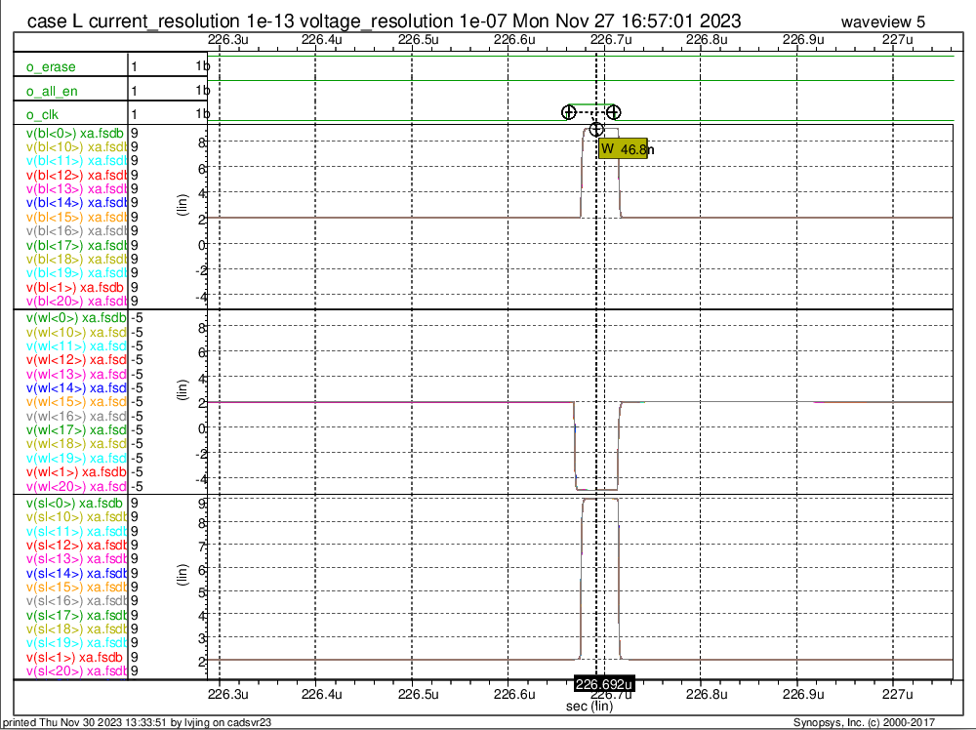
Supplementary Fig. 30| Signal waveforms in erasing mode. In the erasing mode, the erase control signal o_erase is 1 (high), the entire chip erase control signal o_all_en is 1 (high), and the clock O_CLK used to synchronize the voltage pulse is 1 (high). After the three key control signals are changed to 1, it can be seen that all the WLs are supplied with -5 V, and all the BLs/SLs are supplied with 9 V for a full chip erasing.

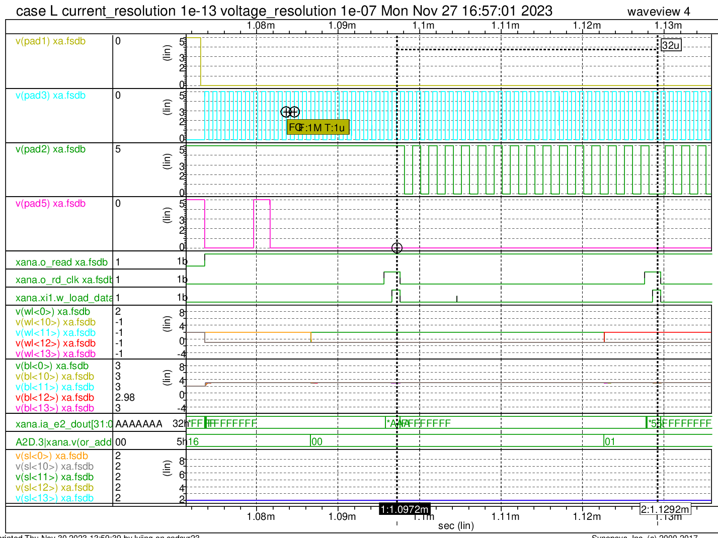
Supplementary Fig. 31| Signal waveforms in reading mode. In reading mode, the read control signal o_read is 1 (high). Here, the read address 00H, i.e., read the data of WL<0>. The voltage of 2 V is applied to WL<0>, and -1 V is applied to other unselected WLs. The reading mode is 32-column parallel reading, thereby 3 V is applied to all BLs, and 2 V is applied to all SLs.

S8. Testing for the 2D flash chip
The 2D flash chip supports three operations: 32-bit programming, full-chip erasing and 32-bit reading. The data of the memory state is read with 32-bit parallelism and transmitted to the logic control module, where it is converted from parallel to serial based on the SPI protocol. In the software interface of the host computer, the readout data is displayed in hexadecimal format. For purposes of clarity, the data has been converted to binary for presenting the test results.
The pulse amplitudes for programming and erasing are 14 V and -14 V, respectively, and are equally divided into two parts, applied to the WL and BL/SL. During testing, the clock frequency is 5 MHz. Considering that one pulse lasts for 2.5 clock cycles in CMOS circuitry design, the pulse width for programming and erasing is 500 ns. The CMOS circuitry can generate voltage pulses with an amplitude of 7 V (the programming voltage) with the rise time (10% to 90%) and fall time (90% to 10%) of about 60 ns (Supplementary Fig. 15c). The 20 ns ultrafast pulse is usually a triangular waveform with some amplitude decay, as shown in Supplementary Fig. 17. To ensure the reliability of the chip system tests, we selected 500 ns pulses for the tests, which have waveforms that are closer to square waves. The 500 ns speed is much faster than the FN programming speed in Si flash and it is not the speed bottleneck of the 2D NOR flash.
During on-chip test, the host computer sends the programming instructions to select each WL according to its address and to program the 32 cells of that WL alternately. Once all 32 rows have been programmed, the host computer sends the reading instructions to read out the data row by row. Supplementary Table 5 shows the full-chip programming and erasing operation at a 32×32 scale. Supplementary Table 6 shows the checkerboard programming operation. After the full-chip programming operation, 94.92% of the cells were successfully at state-1. Following the full-chip erasing operation, 99.41% of the cells were at state-0. Excluding the two instances where the memory state was unable to transform from state-0 to state-1 or from state-1 to state-0, the overall accuracy of the full-chip operation is 94.34%, which gives a yield assessment of the 2D flash chip.

Supplementary Table 5| Datasheet for full chip programming and erasing of the 2D flash chip at a 32 × 32 scale. After programming all cells, 94.92% of the cells were successfully at state-1. After erasing all cells, 99.41% of the cells were successfully at state-0. Excluding the two instances where the memory state was unable to transform from state-0 to state-1 or from state-1 to state-0, the overall accuracy is 94.34%.
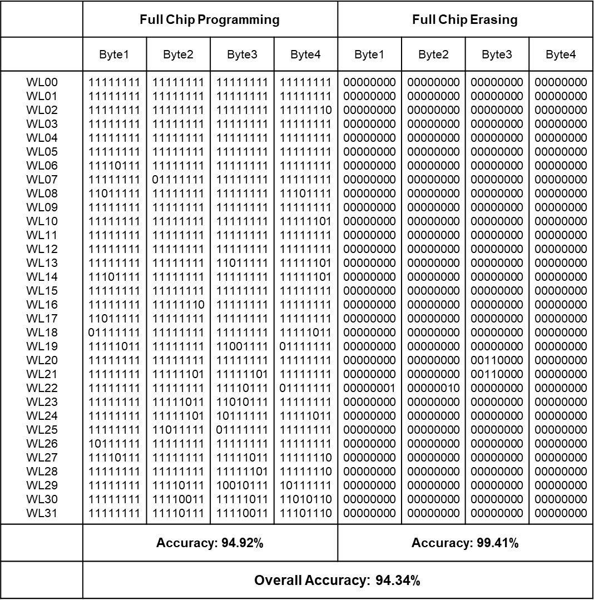

Supplementary Table 6| Datasheet for checkerboard programming of the 2D flash chip at a 32 × 32 scale. After checkerboard programming, 93.55% of the cells are in the correct states corresponding to the checkerboard pattern.
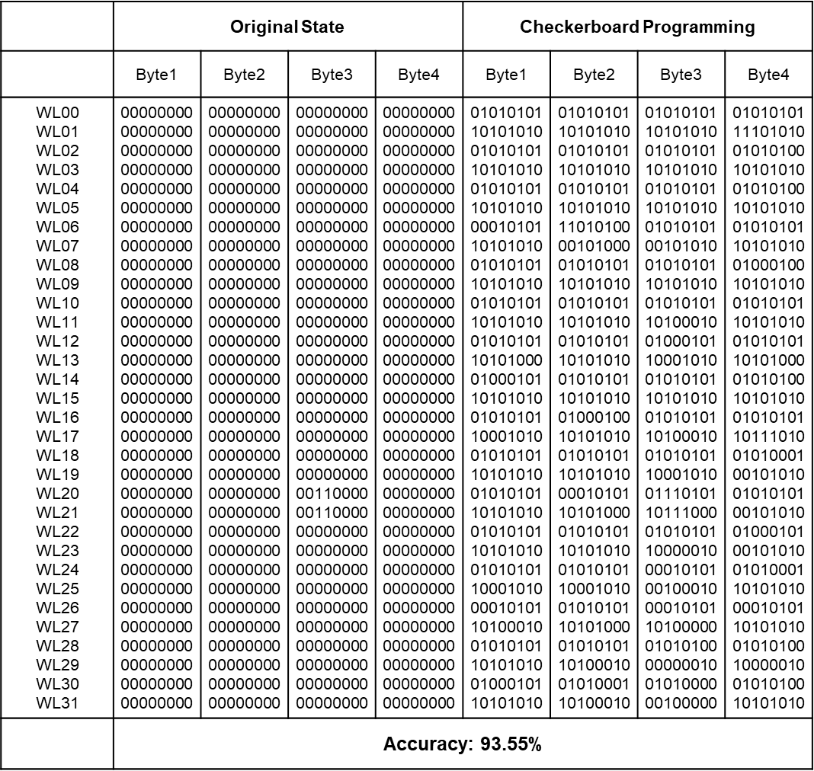

S9. Discussion on the failure analysis of the 2D flash cells
The atomic thin 2D semiconductor is sensitive with the potential damage induced in the process, especially integration on a CMOS die with random topographical variations. Additionally, although improved through ultrasonic bonding with low thermal/strain budget, residual stress during the bonding process still may result in potential damage to parts of devices. These unintended random damages from process may lead to a broken 2D channel. As is shown in Supplementary Fig. 32, the 2D channels of 4 cells, 0.39%, are cracked, resulting in such cells has no current (state-1) during the full-chip erasing test. Besides, due to device variation, and thus a non-ideal origin threshold voltage range, 52 cells, 5.08%, cannot properly programmed to state-0 in full-chip programming test, and 2 cells, 0.18% cannot properly erased to state-1. We assess our yield by cells that can correctly program and erase during full-chip programming and erasing, and get the yield of 94.34%.
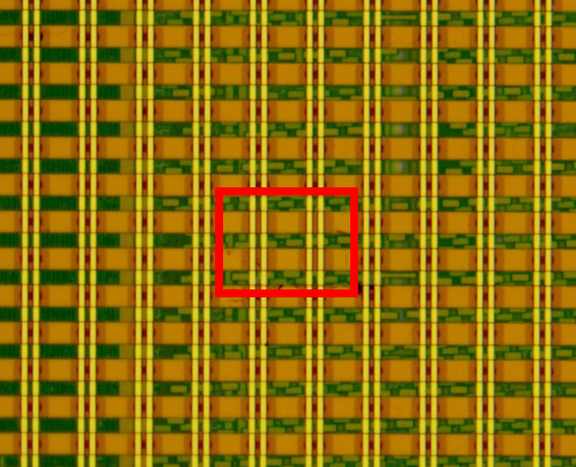
Supplementary Fig. 32| Optical images of the 2D flash array in the tested chip. The 2D channel of 4 cells are cracked and such cells keeps state-1 in full-chip test.

S10. Discussion on 2D flash performance
Supplementary Table 7 compares our 2D flash and conventional silicon flash in core memory array. In convention silicon flash memory array, FN tunnelling mechanism enables high energy efficiency, but falls short in operation speed. Channel hot electron injection mechanism, on the other hand, can achieve high operation speed, but has increased energy consumption with high channel current during programming. Through the 2D enhanced FN tunnelling mechanism, 2D flash memory core has breakthrough in both operation speed and energy consumption compared to conventional silicon flash memory core.
Supplementary Table 8 provides a comparison of the peripheral circuit energy consumption of this work and some commercial NOR flashes, demonstrating the similarity in peripheral consumption.

Supplementary Table 7| The comparison of our 2D flash and Si flash in core memory array. Programming mechanism, architecture, operation mode, speed and energy consumption are listed.
Ref. | Channel materials | Programming mechanism | Architecture | Programming voltage (V) |  |  | Speed | Programming energy consumption
 |  |  |  | Gate | Darin | Source | Speed | Programming energy consumption
(6) | Si | FN tunnelling | N/A | 12 to17 | 0 | 0 | 10 ms | N/A
(7) | Si | FN tunnelling | NAND | 12 | 0 | 0 | 75 μs | N/A
(8) | Si | FN tunnelling | NAND | 16 to 19 | 0 | 0 | 200 μs | N/A
(9) | Si | FN tunnelling | N/A | 15 to 23 | 0 | 0 | 100 μs | N/A
(10) | Si | FN tunnelling | NAND | 20 | 0 | 0 | 100 μs to 1 ms | 10 fJ/bit
(10) | Si | CHE | NOR | 12 | 6 | 0 | 10 μs to 1 ms | 100 pJ/bit
(11) | Si | CHE | NOR | 9 | 5 | 0 | 20 ns | N/A
(12) | Si | CHE | NOR | 7 | 4 | 0 | 350 ns | N/A
(13) | Si | CHE | NOR | N/A | N/A | N/A | 10 μs | 27 pJ/bit
This work | MoS₂ | 2D FN tunnelling | NOR | 7 | -7 | -7 | 20 ns | 0.644 pJ/bit

Supplementary Table 8| The comparison of 2D NOR flash chip and commercial Si flash chip
Memory type |  | Read energy consumption | Write energy consumption | Erase energy consumption | Ref.
NOR | LE25U20AMB | 6 mA | 15 mA | 15 mA | (14)
NOR | GT25Q05D | 2.2 mA | 1.2 mA | 1.3 mA | (15)
NOR | S29JL032J | 10 mA | 15 mA | 15 mA | (16)
2D NOR flash | This work | 1.14 mA | 1.04 mA | 1.25 mA

S11 Discussion on the scalability of 2D flash chip
Scalability is a critical issue in both academia and industry, especially in the field of memory. 2D flash memory has great potential for future scaling and higher integration for the 2D flash chip.
The 2D material based flash can break the scaling limit of silicon flash due to its immunity to short channel effects (SCEs). According to the scale length ($λ$) theory, the SCEs are exponentially dependent on the gate length (L_{g}) when it is close to $λ$, and the scale length is positively correlated with the thickness of the semiconductor channel. Therefore, the atomic thin 2D materials can facilitate device scaling by significantly reducing SCEs. It has been demonstrated that 2D ultrafast flash can maintain stable memory performance even after channel length scaling to sub-10 nm¹⁷, while state-of-the-art planar silicon flash has stopped scaling at channel length ~15 nm^{18,19}. Therefore, 2D flash technology has a promising future of high bit-density integration according to the fundamental law of physics.
The further scaling up of 2D flash chip requires the co-optimisation of process, circuit and architecture.
At the process level, wafer-scale high-quality 2D material growth and transfer provide a solid foundation for high yield and uniformity in large arrays. Single-crystal MoS₂ with good performance has been demonstrated on 4-inch wafers using hypotaxy²⁰, and atomic-layer MoS₂ films have also been realised on 12-inch wafers^{21,22}. In terms of transfer, yields above 97% have been achieved on 2-inch and 4-inch wafers by optimising the stamp design^{23,24}, while robotic automation further improves uniformity and repeatability²⁵. These advances can support the current use of 4-inch single-crystal MoS₂ in 2D flash chips and offer a path toward scaling to larger wafers such as 8-inch.
At the circuit level, scaling down the 2D flash cell pitch using industrial lithography (e.g., to ~180 nm) significantly reduces array size and load capacitance and simplifies design. The gate capacitance decreases from 188 fF to ~1.5 fF, reducing the load on the CMOS driver and sense amplifier. For example, in a 128 Kb array with 256 cells per WL, the WL capacitance is only ~0.4 pF. Even taking into account the parasitic capacitance of adjacent metal lines, the capacitance is lower than 1 pF—much lower than the current 7.5 pF—enabling compact and efficient peripheral circuits. These reductions support both high-speed operation and simplified layout, and future scale-up to larger memory capacities can adopt standard block/page partitioning as in conventional flash.
Energy consumption can also be reduced. For example, the stored charges required for the same memory window is reduced for a smaller cell with reduced gate capacitance (decrease by a factor of ~123 considering pitch size decreases from 2 μm to 180 nm). Therefore, the energy required to program/erase a cell is decreased by 123 times. Additionally, the reduced burden on peripheral circuits, particularly driver circuits, can effectively reduce the dynamic energy consumption with the smaller load capacitance to charge.
At the architecture level, the modular 3D design facilitates scalable integration by reducing cross-platform interconnect complexity. Compared with direct cell-to-cell connections requiring ~3000 vias for a 1 Kb array, the modular approach uses only 96 vias. Even at 128 Kb scale, only 1024 vias are needed (512 WLs, 256 BLs, 256 SLs), which is well within standard fabrication capability (~5000 TSVs)²⁷. Moreover, our vias traverse only an 800 nm passivation layer, unlike TSVs that typically extend through significantly thicker silicon. So, our modular architecture ensures compatibility with further scale-up while maintaining integration efficiency.

References
- Pan, J. & Fraud, P. Wire bonding challenges in optoelectronics packaging. Proceedings of the 1st SME Annual Manufacturing Technology Summit: Dearborn, MI (2004).
- Liu, L. et al. Ultrafast non-volatile flash memory based on van der Waals heterostructures. Nat. Nanotechnol. 16, 874-881 (2021).
- B. De Salvo et al. Experimental and theoretical investigation of nonvolatile memory data-retention. In IEEE Transactions on Electron Devices, 46, 1518-1524 (1999).
- Kihoon et al. Origin of Incremental Step Pulse Programming (ISPP) slope degradation in charge trap nitride based multi-layer 3D NAND flash. Solid-State Electronics, 175, Art. no. 107930, (2021).
- Sze, S. M. & Ng, K. K. Physics of semiconductor devices. (Wiley, 2006).
- Chen, G. et al. Metal Floating Gate Memory Device With SiO₂/HfO₂ Dual-Layer as Engineered Tunneling Barrier. IEEE Electron Device Lett. 35, 744-746 (2014).
- Kouchi, T. et al. A 128Gb 1-bit/Cell 96-Word-Line-Layer 3D Flash Memory to Improve the Random Read Latency With tProg = 75 μs and tR = 4 μs. IEEE J. Solid-State Circuits 56, 225-234 (2021).
- Jong-Ho, P. et al. 8 Gb MLC (multi-level cell) NAND flash memory using 63 nm process technology. In IEDM Technical Digest. IEEE International Electron Devices Meeting, 2004., 873-876 (IEEE, 2004).
- Tang, B. et al. Evaluation and Solutions for P/E Window Instability Induced by Electron Trapping in High-κ Intergate Dielectrics of Flash Memory Cells. IEEE Trans. Electron Devices 61, 1299-1306 (2014).
- Yu, S. Semiconductor Memory Devices and Circuits. (CRC Press, 2022).
- Feng, Y. et al. Operation Scheme Optimizations to Achieve Ultrahigh Endurance (10¹⁰) in Flash Memory. IEEE Trans. Electron Devices 71, 7195-7198 (2024).
- Choi, S. J. et al. High Injection Efficiency and Low-Voltage Programming in a Dopant-Segregated Schottky Barrier (DSSB) FinFET SONOS for nor-type Flash Memory. IEEE Electron Device Lett. 30, 265-268 (2009).
- Dong, Q. et al. 11.2 A 1Mb embedded NOR flash memory with 39µW program power for mm-scale high-temperature sensor nodes. In 2017 IEEE International Solid-State Circuits Conference (ISSCC), 198-199 (IEEE, 2017).
- Onsemi intelligent technology, Inc. Serial Flash Memory 2 Mb (256K x 8). (2017). https://www.onsemi.com/
- Giantec Semiconductor Corp., Inc. 4M/2M/1M/512K Bits SPI Nor Flash. (2022). https://www.giantec-semi.com/
- Cypress Semiconductor Corp., Inc. S29JL032J, 32-Mb (4M × 8-Bit/2M × 16-Bit), 3 V, Simultaneous Read/Write Flash. (2019). https://www.infineon.com/
- Y. Jiang et al., A scalable integration process for ultrafast two-dimensional flash memory. Nat. Electron. 7, 868-875 (2024).
- M. Helm et al., "19.1 A 128Gb MLC NAND-Flash device using 16nm planar cell" in 2014 IEEE International Solid-State Circuits Conference Digest of Technical Papers (ISSCC) (IEEE, 2014), pp. 326-327.
- S. Lee et al., "A 128Gb 2b/cell NAND flash memory in 14nm technology with tPROG= 640µs and 800MB/s I/O rate" in 2016 IEEE International Solid-State Circuits Conference (ISSCC) (IEEE, 2016), pp. 138-139.
- Moon, D., Lee, W., Lim, C. et al. Hypotaxy of wafer-scale single-crystal transition metal dichalcogenides. Nature 638, 957–964 (2025).
- Xia, Y., Chen, X., Wei, J. et al. 12-inch growth of uniform MoS2 monolayer for integrated circuit manufacture. Nat. Mater. 22, 1324–1331 (2023).
- Xue, G. et al. Modularized batch production of 12-inch transition metal dichalcogenides by local element supply. Sci. Bull. 68, 1514–1521 (2023).
- Nakatani, M., Fukamachi, S., Solís-Fernández, P. et al. Ready-to-transfer two-dimensional materials using tunable adhesive force tapes. Nat Electron 7, 119–130 (2024).
- Liu, L., Cai, Z., Xue, S. et al. A mass transfer technology for high-density two-dimensional device integration. Nat Electron 8, 135–146 (2025).
- Zhao, Y., Liao, J., Bu, S. et al. Automated processing and transfer of two-dimensional materials with robotics. Nat Chem Eng 2, 296–308 (2025).
- International Roadmap for Devices and Systems 2020 Edition, Packaging Integration White Paper

