Supplementary information
for

From genotype to phenotype with 1,086 near telomere-to-telomere yeast genomes

Victor Loegler¹, Pia Thiele¹, Elie Teyssonnière¹, Andreas Tsouris¹, Gauthier Brach¹, Corinne Cruaud², Emilie Payen², Stefan Engelen², Maitreya J. Dunham³, Jing Hou¹, Anne Friedrich¹, and Joseph Schacherer ^{1,4}

¹ Université de Strasbourg, CNRS, GMGM UMR 7156, Strasbourg, France.
² Genoscope, Institut François Jacob, CEA, CNRS, Univ Evry, Université Paris-Saclay, Evry 91057, France.
³ Genome Sciences Department, University of Washington, Seattle, Washington, United States of America.
⁴ Institut Universitaire de France (IUF), Paris, France.

Table of Contents
Supplementary figures 2
Supplementary notes 25
Supplementary note 1 - Haplotype resolution among genome assemblies 25
Supplementary note 2 - Contiguity and completeness of genome assemblies 26
Supplementary note 3 - Validation of SV calls 28
Supplementary note 4 - Graph pangenome analysis 31
References 34

Supplementary figures
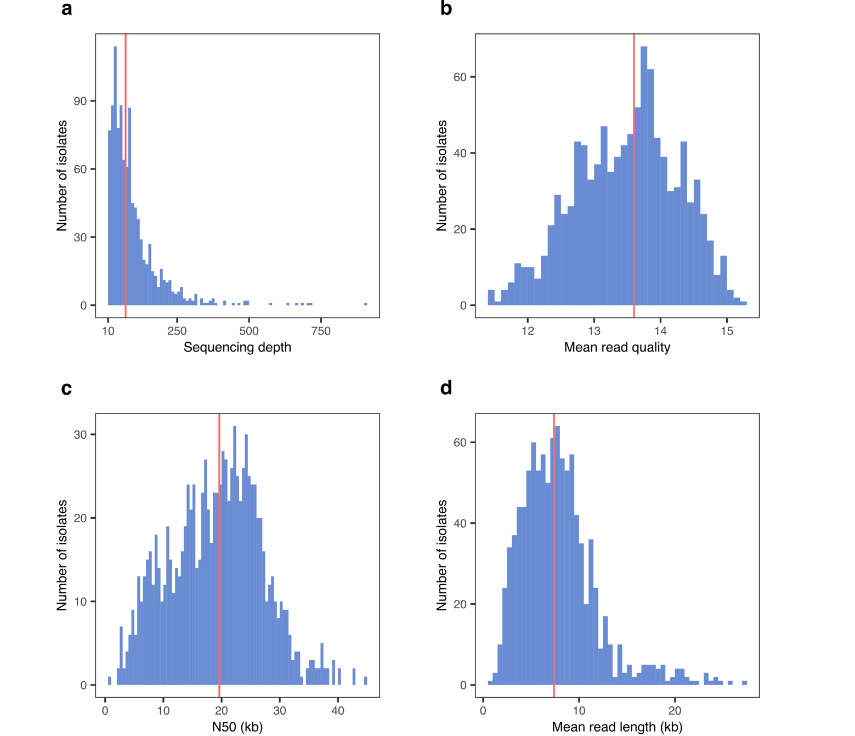
Fig. S1 | Sequence reads for 1,027 isolates. a. Distribution of the sequence depth per isolate. b. Distribution of the mean read quality per isolate. c. Distribution of the N50 value per isolate, which represents the shortest read length in the group of the longest reads that cover 50% of the sequenced bases. d. Distribution of mean read length per isolate. The red vertical line indicates the median value for each metric.

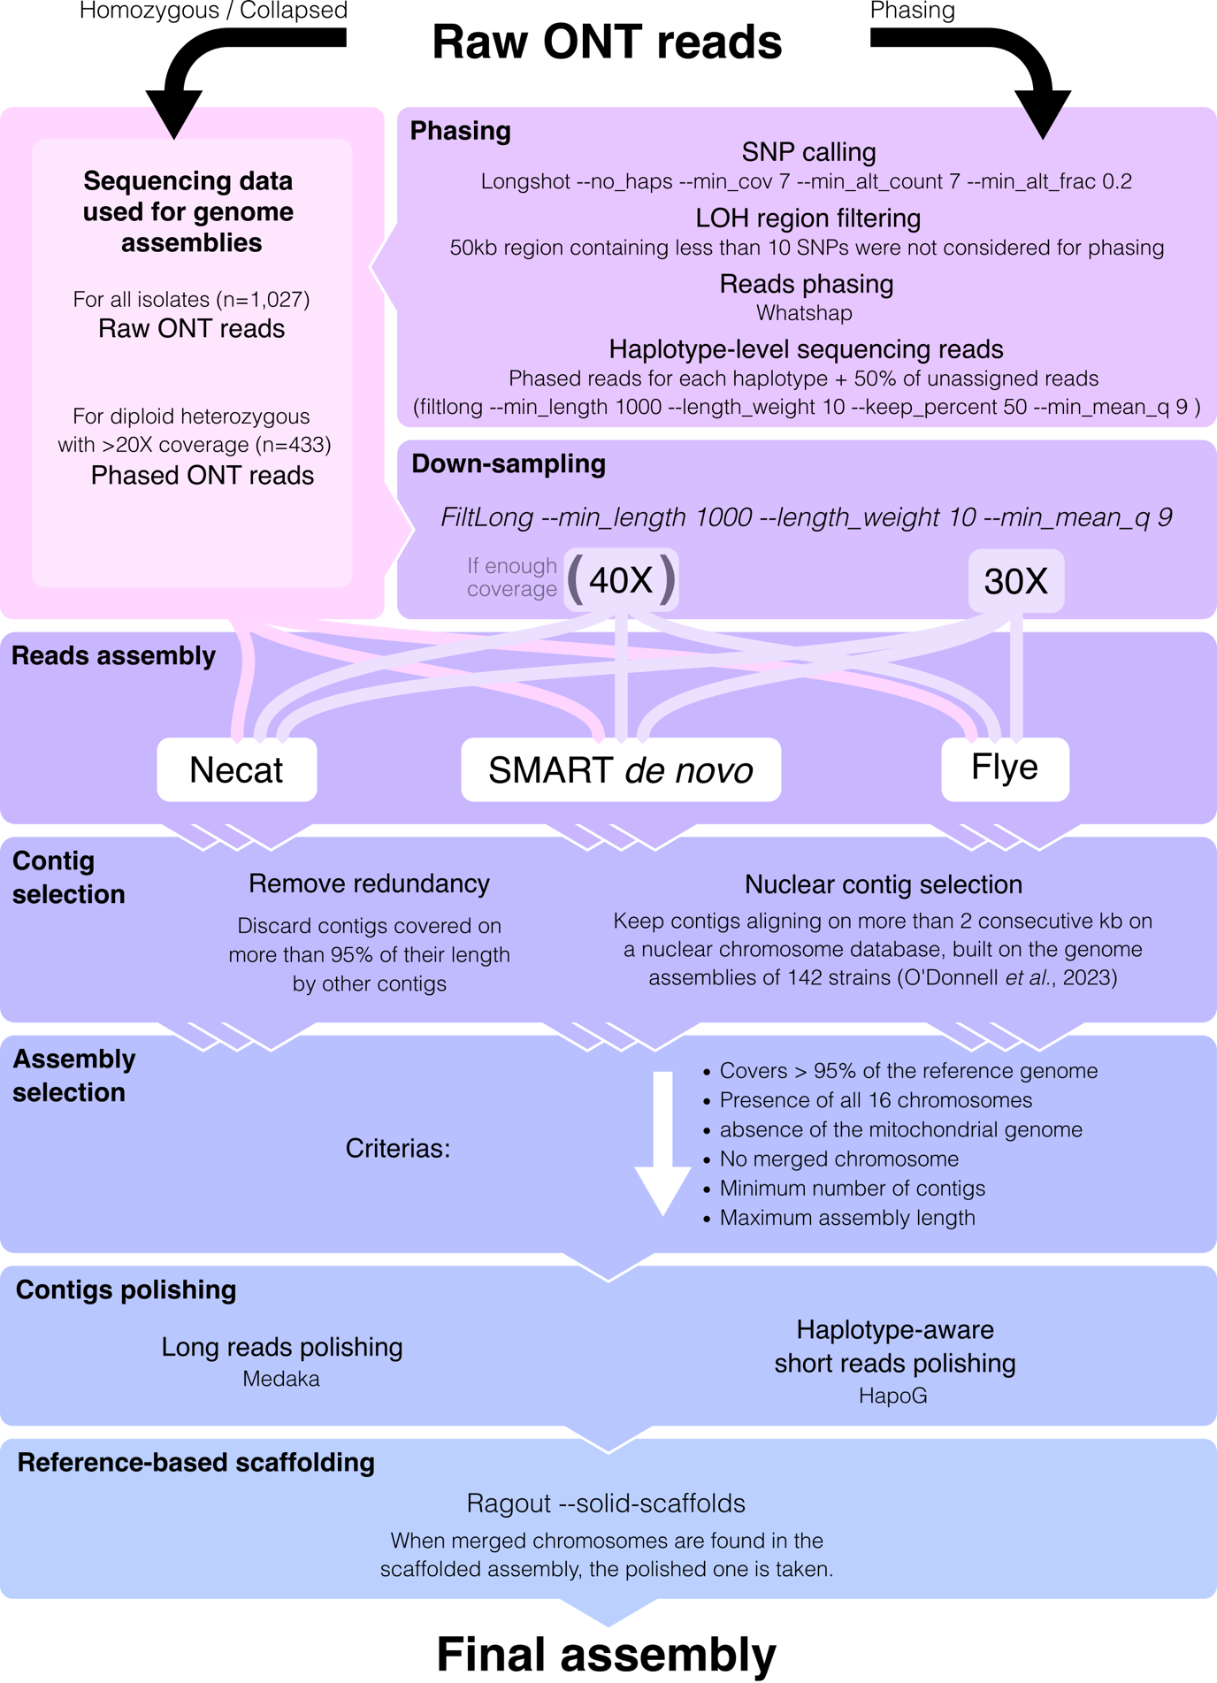
Fig. S2 | Schematic representation of the genome assembly pipeline. The homozygous/collapsed pipeline was applied to each of the 1,027 isolates, and the phasing pipeline was only applied to non-polyploid heterozygous isolates with a sequencing depth higher than 20X. When genome assemblies for the phased haplotypes did not pass the criteria, the collapsed assembly was taken.

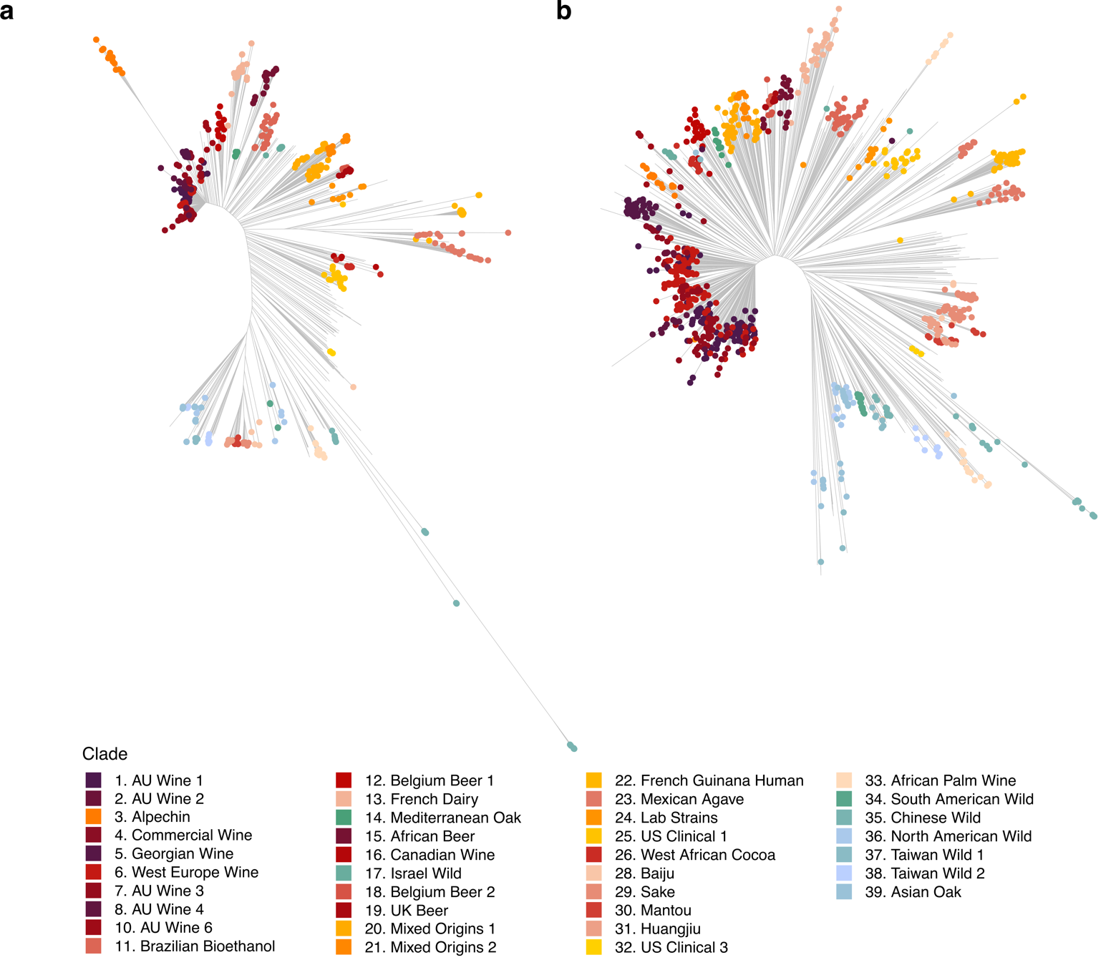
Fig. S3 | Phylogeny of 1,086 isolates. Phylogenies were built using a neighbor-joining strategy using SNP markers (a) and SV markers (b). Isolates are colored depending on the clades defined in Loegler et al. (2024)¹.

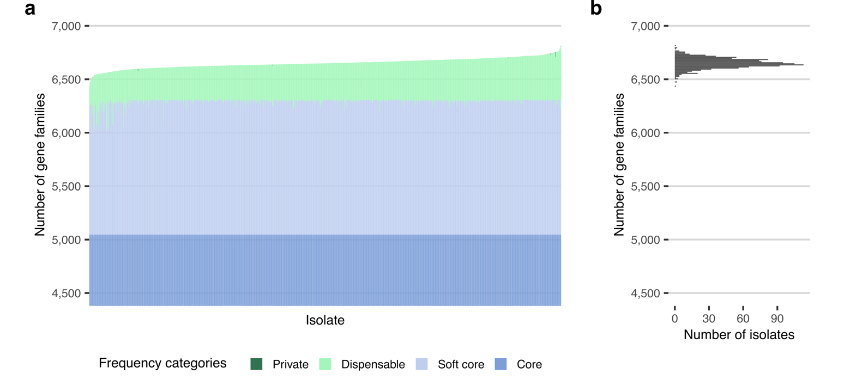
Fig. S4 | Number of gene families per isolate. a. Number of gene families for each isolate, colored according to their frequency category (core, soft-core, dispensable, and private). b. Distribution of the number of gene per isolate.


Fig. S5 | Transcript level for core, soft-core, dispensable, and private genes. Transcriptomes from 969 isolates were considered (Caudal et al., 2024). Letters discriminate groups between which a two-sided Mann-Whitney-Wilcoxon test with FDR correction is significant with P < 0.05. The middle bar of the box plots corresponds to the median; the upper and lower bounds correspond to the third and first quartiles, respectively. The whiskers correspond to the upper and lower bounds 1.5 times the interquartile range (IQR).

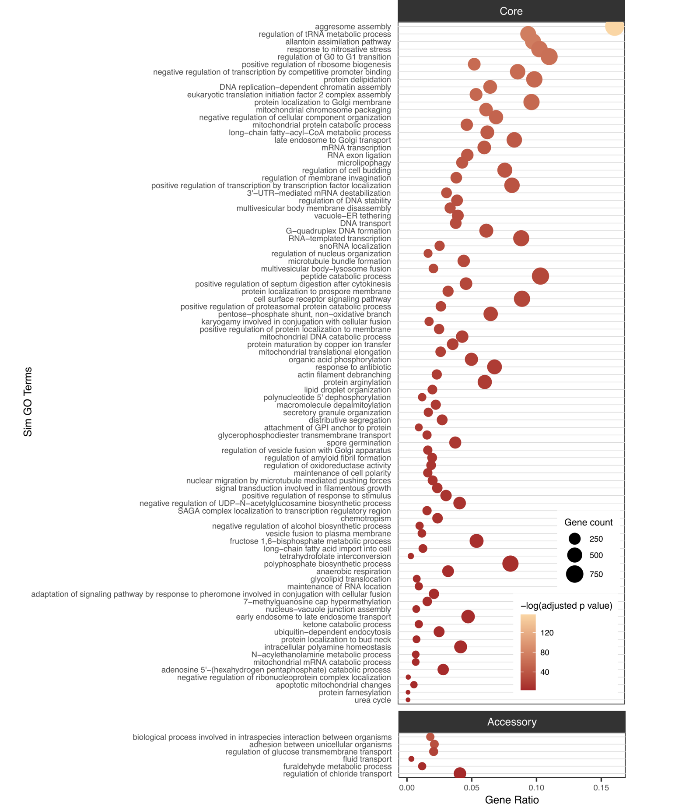
Fig. S6 | Semantic similarity GO term enrichment for core and accessory genes. Gene count correspond to the total number of genes assigned to the term. Gene ratio is the ratio between the number of core or accessory genes associated with the term over the total number of core or accessory genes.

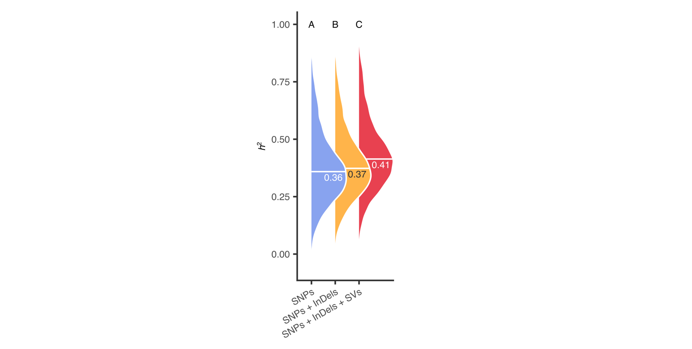
Fig. S7 | Heritability estimations using diﬀerent combinations of variants for 8,155 complex traits. The text and middle line indicate the median heritability. Letters discriminate groups between which a two-sided Mann-Whitney-Wilcoxon test with FDR correction is significant with P < 0.05.

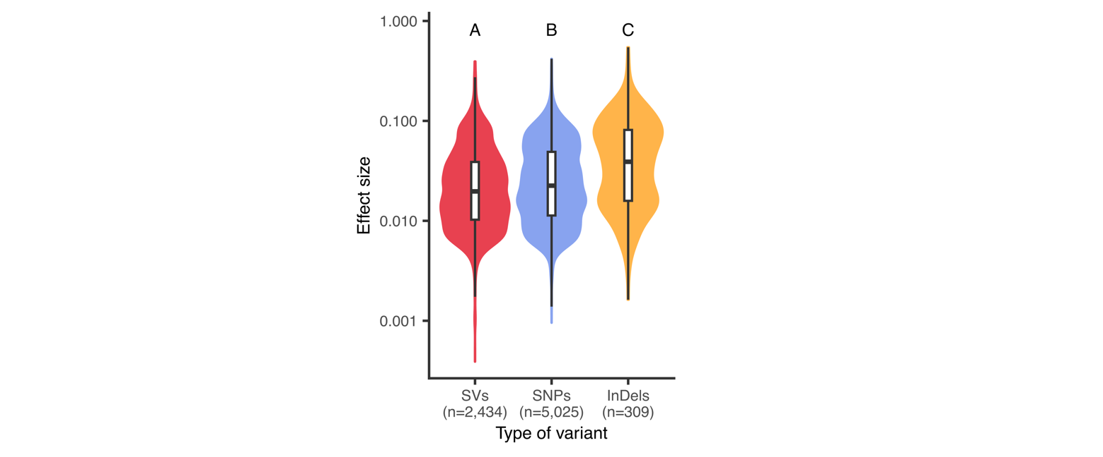
Fig. S8 | Effect size according to the type of variants. Letters discriminate groups between which a two-sided Mann-Whitney-Wilcoxon test with FDR correction is significant with P < 0.05. The middle bar of the box plots corresponds to the median; the upper and lower bounds correspond to the third and first quartiles, respectively. The whiskers correspond to the upper and lower bounds 1.5 times the interquartile range (IQR).

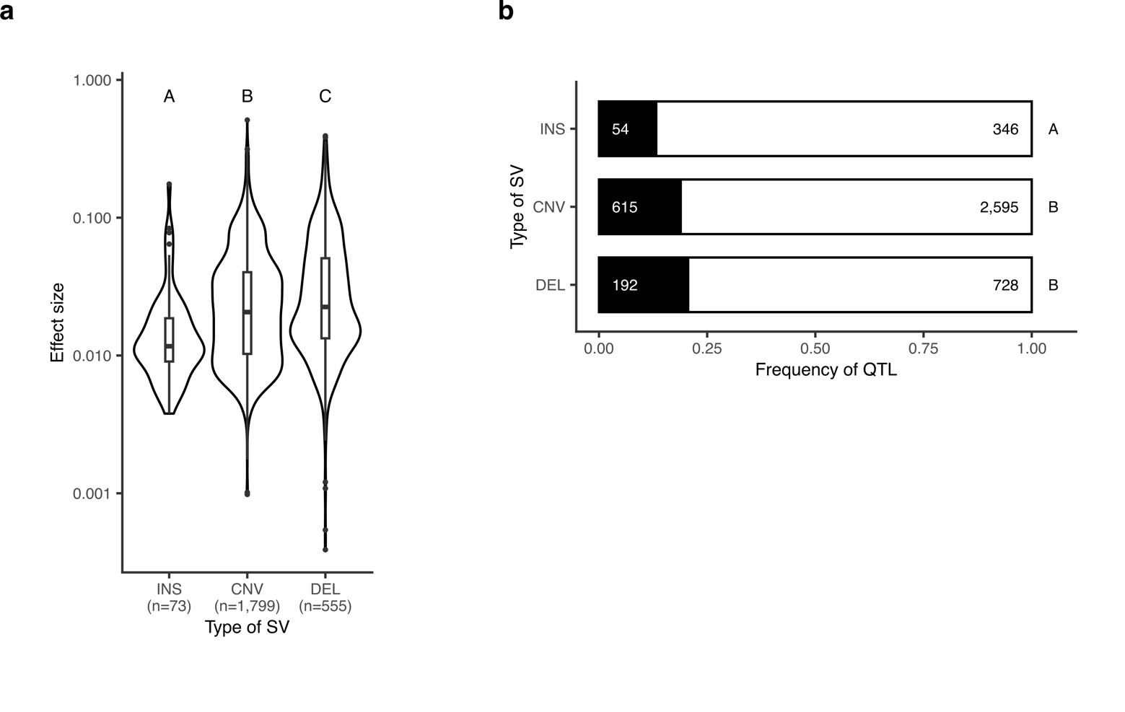
Fig. S9 | Phenotypic associations of different types of SVs. a. Effect size according to the type of SV. Letters discriminate groups between which a two-sided Mann-Whitney-Wilcoxon test with FDR correction is significant with P < 0.05. The middle bar of the box plots corresponds to the median; the upper and lower bounds correspond to the third and first quartiles, respectively. The whiskers correspond to the upper and lower bounds 1.5 times the interquartile range (IQR). b. Fraction of variants identified as QTL for each type of SV. Letters discriminate groups between which a two-sided Fisher’s exact test with FDR correction is significant with P < 0.05.

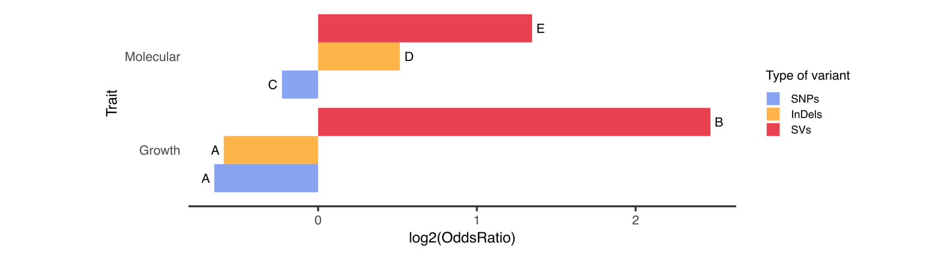
Fig. S10 | Odds ratio between the frequency of a variant type within QTL and within all variants tested for association, according to the type of trait. Variant type is color-coded. Letters discriminate groups between which a two-sided Fisher’s exact test with FDR correction is significant with P < 0.05.

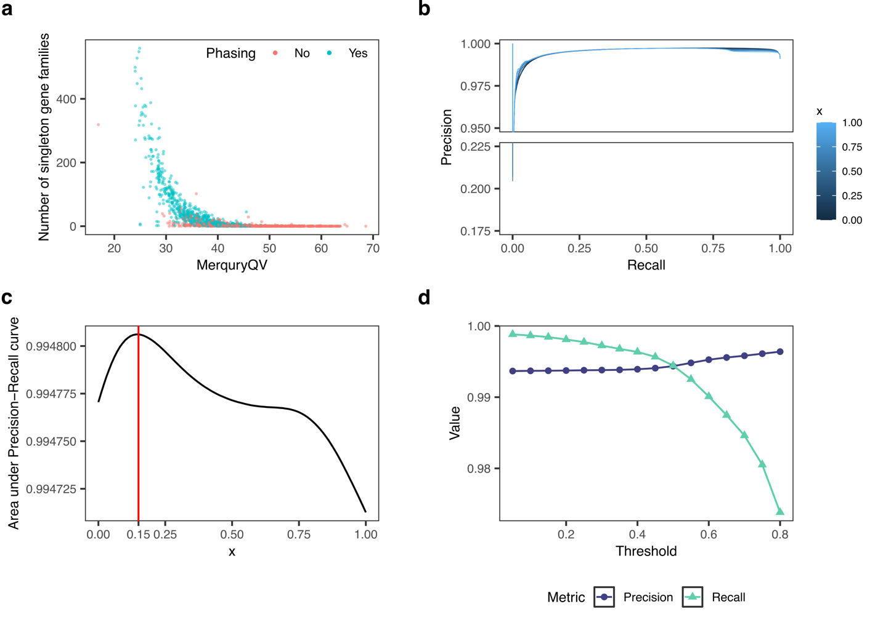
Fig. S11 | Threshold selection for gene-based pangenome construction. a. Number of singleton gene families per genome assembly, according to their Merqury quality value. Singletons correspond to gene families found in a single genome assembly. b. Precision-recall curve for gene presence estimation based on reads depth and ploidy, using the equation presence ∝ depth×ploidy^{x}. c. Area under the precision-recall curve in b, depending on the value chosen for x. The red vertical line corresponds to the chosen value of x = 0.15. d. Precision and recall for the estimation of gene presence using the equation presence ∝ depth×ploidy^{0.15} using different threshold values to attest gene presence.

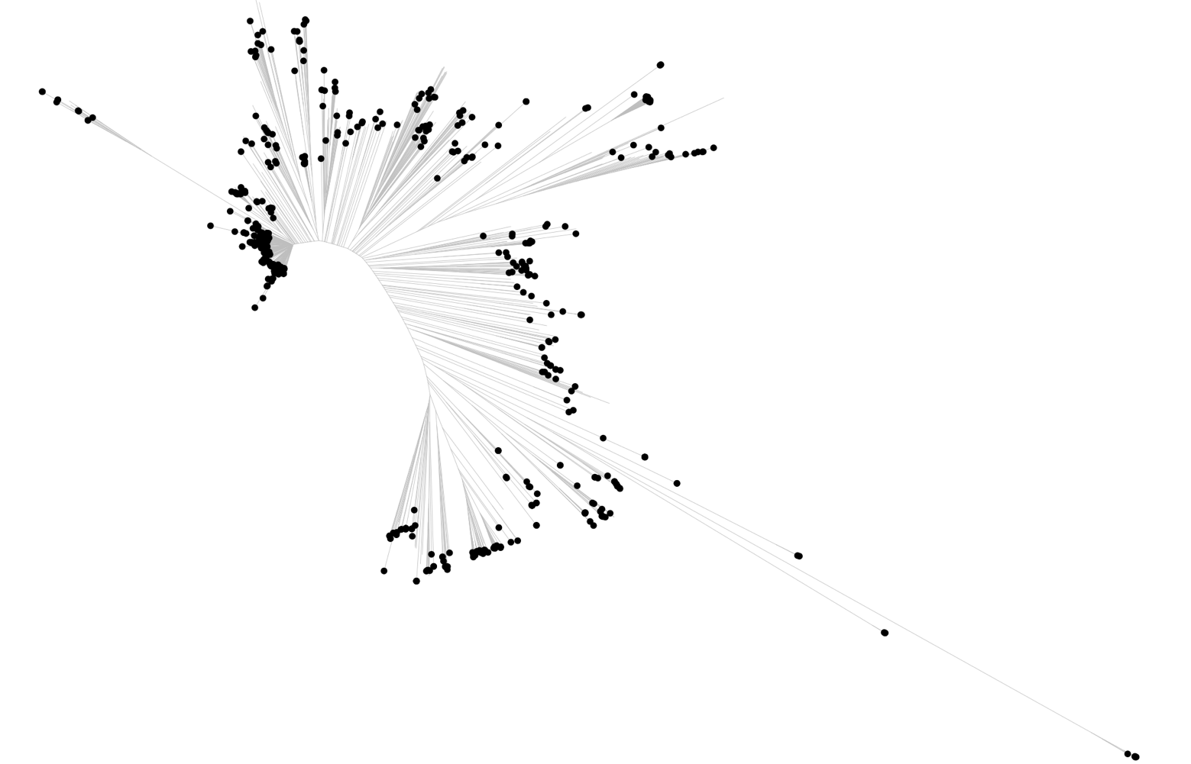
Fig. S12 | Isolates selected for the gene-based pangenome construction. The tree was constructed using a neighbor joining method for 1,086 isolates based on SNPs. Isolates whose genome was used in the construction of the gene-based pangenome are indicated by black points.

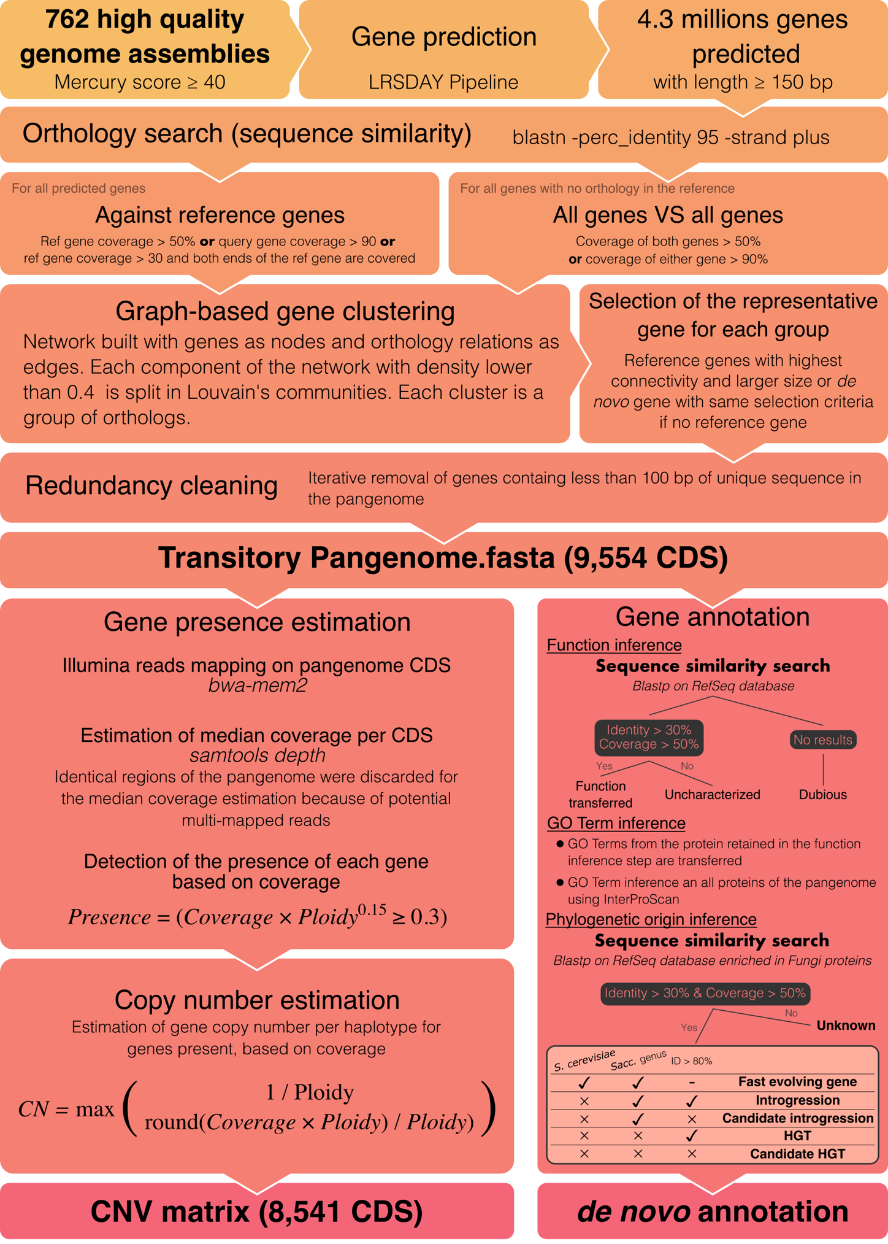
Fig. S13 | Schematic representation of the gene-based pangenome construction.

Supplementary notes

Supplementary note 1 - Haplotype resolution among genome assemblies

Our genome assembly collection includes newly generated assemblies for 1,015 isolates, as well as previously generated assemblies for 71 strains², reaching a total of 1,086 isolates (Table S2). Of these, 186 are haploids, 814 are diploids, 42 are triploids, 29 are tetraploids, and three are pentaploids. The ploidy of 12 isolates could not be determined due to their complete homozygosity, which precludes allele-frequency-based inference. In total, 527 isolates are homozygous, comprising seven haploids with a heterozygous aneuploid chromosome, 449 diploids, 40 triploids, 28 tetraploids, and three pentaploids.
Due to the variation in ploidy and the presence of heterozygosity in many isolates, we attempted to obtain haplotype-resolved (phased) genome assemblies when possible, to enable accurate structural variant genotyping. Collapsed assemblies, which represent one consensus haplotype capturing a random allele at each heterozygous locus, may miss some structural variants when haplotypes diverge. However, phased assemblies often exhibited reduced contiguity and completeness compared to collapsed assemblies. Poor assembly quality in phased assemblies can hinder SV detection, necessitating a trade-off between haplotype resolution and assembly quality.
Since polyploid genome phasing using ONT remains a considerable challenge, often at the expense of assembly contiguity, we opted for collapsed assemblies for the 71 heterozygous polyploid isolates. These were generated by assembling all sequencing reads from an isolate into a single collapsed haplotype. For haploid and diploid heterozygous isolates, haplotype-resolved assemblies were considered when both haplotype assemblies met the quality threshold defined in the genome assembly pipeline (Methods). If one or both haplotypes failed to meet these criteria, the corresponding collapsed assembly was used instead. Therefore, phased assemblies were retained for six out of seven heterozygous haploids with aneuploid chromosomes and 390 out of 449 heterozygous diploids. Collapsed assemblies were retained for the remaining 60 isolates.

Supplementary note 2 - Contiguity and completeness of genome assemblies

A total of 1,482 genome assemblies were generated from 1,086 natural isolates. Haplotype-resolved assemblies were obtained for 396 out of 456 non-polyploid heterozygous isolates. The median N50 per assembly is comparable to that of the S288c reference genome (910 vs. 924 kb).
To quantify the number of chromosomes assembled into a single contig, we considered a set of 22,635 chromosomes that do not carry reciprocal translocations, as these events complicate chromosome contiguity evaluation. A total of 22,008 (97.2%) chromosomes were assembled in a single contig (Fig. S14). The rDNA locus, located on chromosome 12, often caused discontiguity in the assemblies due to the significant copy number variation of this locus. This led to a reduced frequency of chromosome-scale contigs for chromosome 12, with 92.6% of the chromosomes assembled into a single contig.

Fig. S14 | Number of chromosomes assembled. Only chromosome without reciprocal translocation were considered. The number of contigs associated to each assembled chromosome is color-coded.

Rigorous quality control measures were implemented to ensure the integrity of the genome assemblies, including the requirement that each assembly attain a minimum coverage of 95% of the S288c reference genome and include all chromosomes. However, this does not guarantee the achievement of telomere-to-telomere (T2T) status, which refers to a gapless assembly with the resolution of the 32 telomeric sequences present per haplotype. To assess telomeric completeness, we used Telofinder² to identify resolved telomeres within the assembly collection. Of the 47,424 anticipated telomeres, 36,411 (76.8%) were successfully resolved. In total, 14,840 chromosomes (62.6%) were fully assembled into a single T2T contig, thereby capturing the entire chromosome sequence.
Although our assemblies exhibit high contiguity and completeness, it would be inaccurate to describe them as telomere-to-telomere assemblies. It is therefore more accurate to describe them as near-T2T assemblies.
Since SV detection relies on assembly comparisons, a lack of assembly contiguity could result in SVs being overlooked. This is particularly relevant for regions that are difficult to resolve, such as subtelomeric sequences and the rDNA locus. The contiguity of genome assemblies (as measured by the N50 value) shows a weak correlation with the number of SVs detected per isolate (Fig. S15a; Pearson correlation, R = 0.058, P = 0.026). This weak correlation is primarily driven by outlier assemblies with an N50 value lower than 750 kb, which exhibit an average of 15% fewer SVs than other assemblies (215 vs. 253 SVs on average). Since the 27 outlier isolates are evenly distributed within the phylogeny (Fig. S15b), they are unlikely to affect downstream analyses, such as genome-wide associations, and were not discarded.

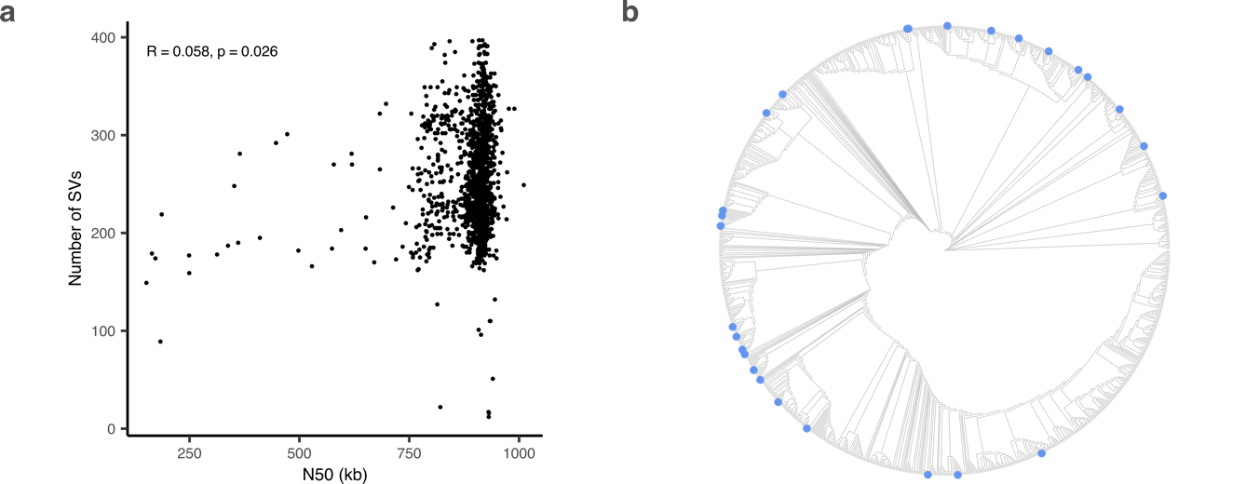
Fig. S15 | Assembly contiguity and structural variants (SVs). a. Number of SVs per assembly depending on the assembly N50. The correlation was computed using a Spearman correlation test. b. Neighbor-joining tree of the 1086 isolates that constitute the genome assembly collection. Isolates with a genome assembly of low contiguity (N50 lower than 750 kb) are indicated by a blue dot.

Supplementary note 3 - Validation of SV calls

To assess the reliability of SV calls inferred from genome assembly comparisons, we performed validation using both Illumina and ONT sequencing reads mapped to the reference genome. Illumina reads were aligned with bwa-mem2³, and ONT reads with Minimap2⁴.
We randomly selected 500 SVs for systematic inspection in IGV⁵ (Fig. S16). Our validation set includes 252 insertions, 104 deletions, 79 duplications, 24 contractions, 16 inversions, and 25 translocations. These numbers are proportional to the fraction of each type of SV in the total set of SV calls.
Disrupted short-read alignments supported the presence of structural variation in 474 of 500 cases (94.8%). The 26 unsupported cases were predominantly insertions (19/26), consistent with the known limitations of short-read technologies in detecting such events⁶.

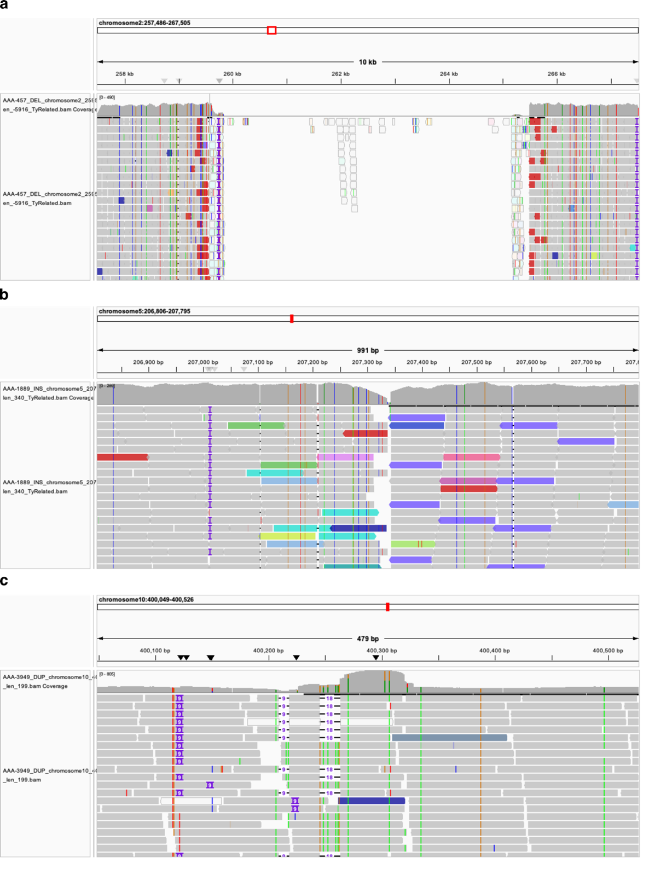
Fig. S16 | Disruption of short-read alignments in the presence of structural variants. Examples include a deletion (a), an insertion (b) and a duplication (c).

Long-reads alignments on the reference genome allowed to further validate the type and length of variant detected. Visual inspection of ONT reads mapping confirmed 441 out of 500 SVs (88.2%). Validation was considered as read alignment disruption for long and complex SVs such as inversions and translocations, or within-read insertion or deletion for other SVs (Fig. S17). Unconfirmed cases were significantly enriched near chromosome ends (within 1 kb of termini; Fisher’s exact test, P = 0.039), likely due to increased sequence complexity and reduced mapping accuracy in these regions. A total of 9 out of 25 translocations were not confirmed by long read mapping, often because of read discrepancies: most of the unconfirmed translocation cases exhibit a few reads confirming the translocation, while many does not, resulting in difficult SV validation for these types of SVs.
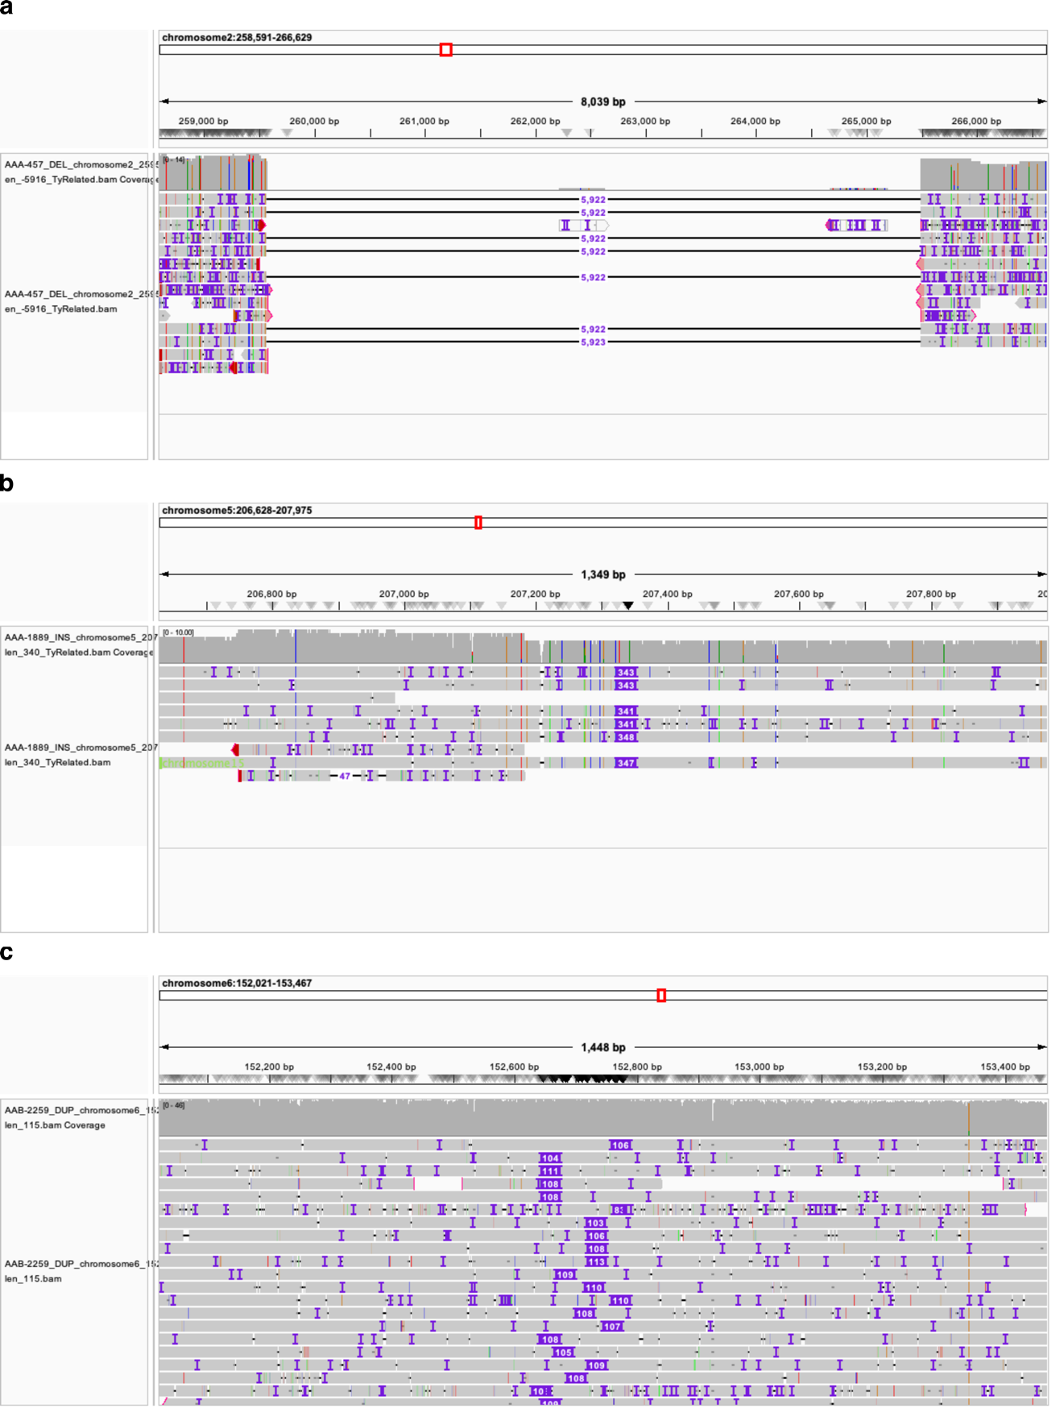
Fig. S17 | Validation of SVs using long-read alignments. Examples include a deletion (a), an insertion (b) and a duplication (c).

Together, this systematic inspection of sequencing reads supports the presence of the majority (94.8%) of SVs in the selected cases.

Supplementary note 4 - Graph pangenome analysis

Description of the graph pangenome
We used 500 haplotypes selected to maximize the structural diversity to build a graph pangenome. Two graphs were built using (i) Minigraph⁷, which captures only SVs and (ii) Minigraph-Cactus (MC)⁸, which includes SNPs, InDels and SVs, but results in a graph of much higher complexity. Although the size of the graphs differs, they are both much larger than the linear reference (Table S13). The main reason for this increase in size is the large redundancy present in the graph, caused by non-collapsed CNVs. Out of 34,319 segments larger than 100 bp in the Minigraph pangenome (for a cumulative length of 47,416,522 bp), 19,276 segments (cumulative length of 41,783,718 bp) align back to the reference genome. Some regions of the linear reference are present more than a hundred times in the graph, mostly corresponding to Ty elements or long terminal repeats (LTR) (Fig. S18). We used the Minigraph pangenome to quantify the non-redundant length of the graph and identify non-reference sequences. The graph displays a total non-redundant length of 11.9 Mb, of which 2.5 Mb are not present in the linear reference. A total of 267 kb was subsequently identified as introgressed sequences.

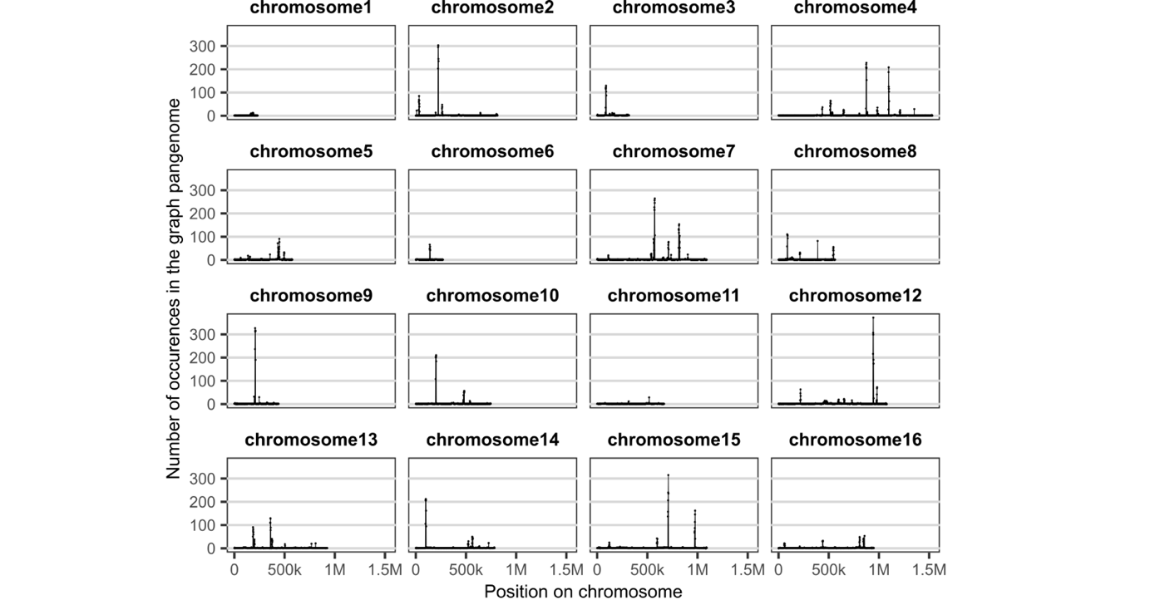
Fig. S18 | Number of occurrences of linear reference segments in the Minigraph pangenome. The pangenome segments were mapped against the linear reference to identify regions highly redundant in the graph.

Genotyping SVs in an extended population
We genotyped 2,874 isolates¹ using the MC pangenome to characterize SVs in a larger population. The increased population was genotyped for 2,081,695 snarls, corresponding to bubbles along the graph. These contain alleles for 2,190,642 SNPs, 293,367 InDels and 13,877 SVs, with some highly multiallelic snarls. The reference allele is major in 1,989,499 snarls (95.6%), first minor in 85,170 snarls (4.1%) and second or more minor in 7,026 snarls (0.3%). We kept the reference allele and the most frequent alternative allele of each site to build a neighbor joining tree (based on 1,926,578 SNPs, 152,796 InDels and 2,321 SVs), which shows a structure highly similar to that obtained from SNP calling on the linear reference (Fig. S19).
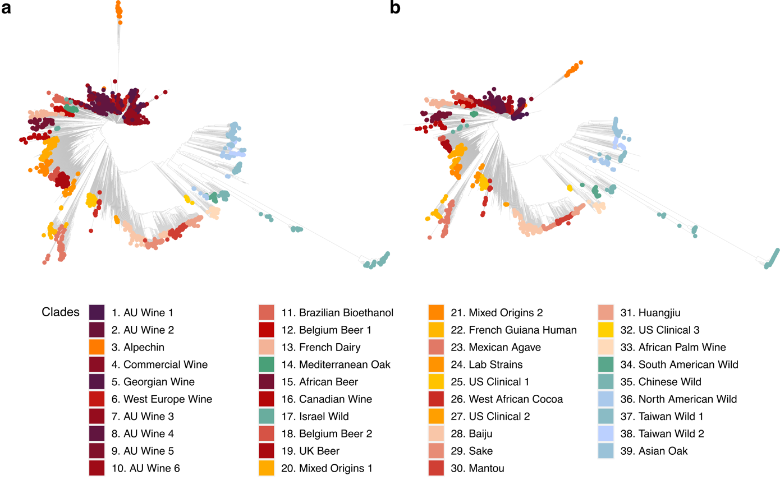
Fig. S19 | Neighbor joining tree of 2,874 isolates of Sacharomyces cerevisiae. Trees were constructed from variants detected from the graph-pangenome (a) or from the linear reference (b).

The graph pangenome enhances heritability estimations
We estimated the narrow-sense heritability of 8,153 complex traits using three kinship matrices: a first one based on SNPs called using a linear reference; a second one built from the exhaustive catalog of variants we constructed from high quality genome assemblies, containing SNPs, InDels and SVs; and a third one built using the MC graph pangenome reference. The average heritability using the MC graph pangenome is 10.6% higher than SNP-based estimates, but 3.2% lower than catalog estimates (Fig. S20).
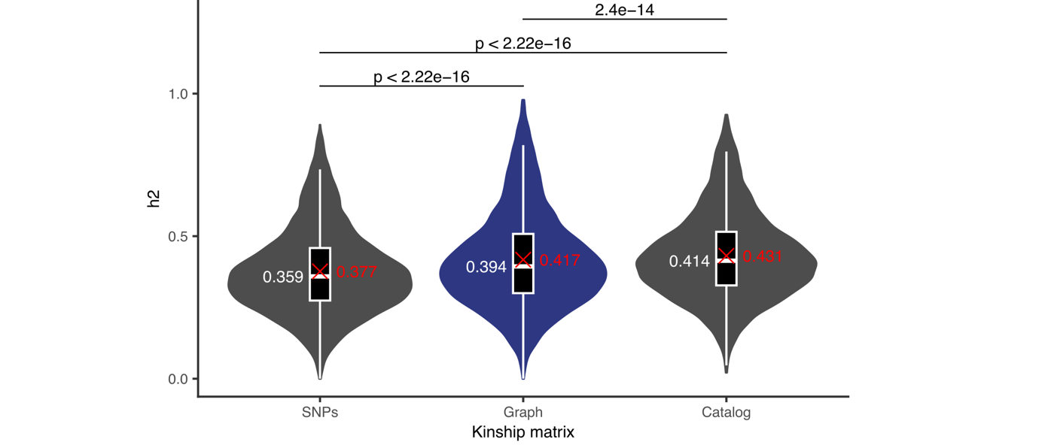
Fig. S20 | Heritability estimates for 8,153 complex traits. Heritability was estimated using SNPs inferred from the linear reference, variants inferred from the graph pangenome and a catalog of SNPs, InDels and SVs inferred from high quality genome assemblies. P values were calculated using Wilcoxon signed-rank tests. The median and average heritability are indicated in white and red, respectively.

Comparisons between SNP, graph and catalog estimates indicate that the enhancement of heritability of the graph and catalog method have different origins. On the one hand, catalog estimates are increased for certain traits, mainly InDel and SV-dominant traits, whereas estimates for SNP-dominant traits are less increased (Fig. S21a). On the other hand, graph estimates are increased globally, and the difference between SNP, InDel and SV-dominant traits is weaker, although significant (Fig. S21b). This suggests that the increase in heritability obtained from the graph pangenome is less related to specific types of variants, but more globally to the consideration of a pangenome reference. One explanation for the observed difference between catalog and graph estimates may be that the graph pangenome has difficulty capturing copy-number variation, which accounts for a substantial part of heritability in many traits.

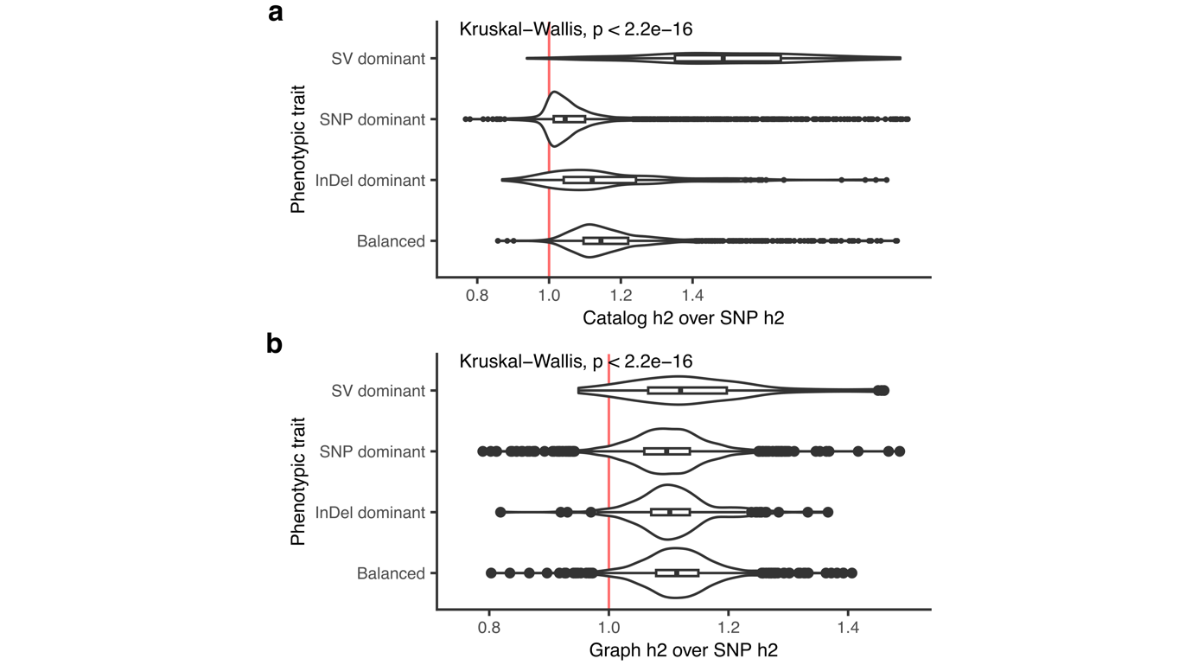
Fig. S21 | Comparison of heritability estimates depending on traits categories. a. Ratio of the catalog heritability to the SNP heritability for SNP, InDel, SV dominant and balanced traits. b. Ratio of the graph heritability to the SNP heritability for SNP, InDel, SV dominant and balanced traits.

References
1. Loegler, V., Friedrich, A. & Schacherer, J. Overview of the Saccharomyces cerevisiae population structure through the lens of 3,034 genomes. G3 Genes|Genomes|Genetics 14, jkae245 (2024).
2. O’Donnell, S. et al. Telomere-to-telomere assemblies of 142 strains characterize the genome structural landscape in Saccharomyces cerevisiae. Nat Genet 55, 1390–1399 (2023).
3. Vasimuddin, Md., Misra, S., Li, H. & Aluru, S. Efficient Architecture-Aware Acceleration of BWA-MEM for Multicore Systems. in 2019 IEEE International Parallel and Distributed Processing Symposium (IPDPS) 314–324 (2019). doi:10.1109/IPDPS.2019.00041.
4. Li, H. Minimap2: pairwise alignment for nucleotide sequences. Bioinformatics 34, 3094–3100 (2018).
5. Robinson, J. T. et al. Integrative genomics viewer. Nat Biotechnol 29, 24–26 (2011).
6. Delage, W. J., Thevenon, J. & Lemaitre, C. Towards a better understanding of the low recall of insertion variants with short-read based variant callers. BMC Genomics 21, 762 (2020).
7. Li, H., Feng, X. & Chu, C. The design and construction of reference pangenome graphs with minigraph. Genome Biology 21, 265 (2020).
8. Hickey, G. et al. Pangenome graph construction from genome alignments with Minigraph-Cactus. Nat Biotechnol 42, 663–673 (2024).

