Supplementary Note

Whole-genome landscapes of 1,364 breast cancers
Ryul Kim, Jonghan Yu, Joonoh Lim, Brian Baek-Lok Oh, Seok Jin Nam, Seok Won Kim, Jeong Eon Lee, Byung Joo Chae, Ji-Yeon Kim, Ga Eun Park, Bong Joo Kang, Pill Sun Paik, Soo Yeon Bae, Chang Ik Yoon, Young Joo Lee, Dooreh Kim, Kabsoo Shin, Ji Eun Lee, Jun Kang, Ahwon Lee, Erin Connolly-Strong, Sangmoon Lee, Bo Rahm Lee, Yuna Lee, Ki Jong Yi, Young Oh Kwon, In Hwan Chun, Junggil Park, Jihye Kim, Chahyun Choi, Jong Yeon Shin, Hyungjung Lee, Minji Kim, Hansol Park, Ilecheon Jeong, Boram Yi, Won-Chul Lee, Jeong Seok Lee, Woo Chan Park, Sung Hun Kim, Yoon-La Choi, Jeongmin Lee, Young Seok Ju, and Yeon Hee Park

Supplementary Note 1
Supplementary Methods 3
Study design and patient cohorts 3
Study cohort and sample processing overview 6
Clinical characteristics of the study cohort 6
Supplementary Discussions 9
Supplementary Discussion 1. Distinct genomic and clinical characteristics of Korean breast cancer 9
Supplementary Discussion 2. Cohort-specific differences in the prognostic role of MATH and TP53 status 11
Supplementary Discussion 3. Orthogonal validation of mutational signature analysis 13
Supplementary Discussion 4. BRCA1/2 germline point mutations identified in WGS-based HRD-positive samples 14
Supplementary Discussion 5. Clinical utility perspectives of WGS-based predictive biomarkers 16
Supplementary Discussion 6. Addressing left truncation bias in survival analyses 19
Supplementary Figures 25
Supplementary Fig. 1. CONSORT diagram of the study cohort. 25
Supplementary Fig. 2. Comprehensive overview of the genomic and molecular characteristics of 1,364 breast cancer samples sorted by PAM50 subtype. 26
Supplementary Fig. 3. Comprehensive overview of the genomic and molecular characteristics of 1,364 breast cancer samples sorted by IntClust subtype. 28
Supplementary Fig. 4. Comparison of mutational signature contributions estimated by our method, SigProfiler, and SignatureAnalyzer. 30
Supplementary Fig. 5. Circos plots of tumors with extremely high tumor mutational burden (TMB). 31
Supplementary Fig. 6. Whole-genome sequencing for homologous recombination deficiency (HRD) and a representative case.. 32
Supplementary Fig. 7. BRCA1/2 germline point mutations identified in whole-genome sequencing (WGS)-based homologous recombination-deficient (HRD) samples. 33
Supplementary Fig. 8. Chromothripsis in a HER2-positive breast cancer patient. 34
Supplementary Fig. 9. Sensitivity analyses of survival outcomes in prospective cohorts. 35
Supplementary Table Legends 37
Supplementary references 40

Supplementary Methods

Study design and patient cohorts
This study was conducted using patient samples and clinical data from four independent studies at two institutions: Samsung Medical Center (Seoul, Korea) and Seoul St. Mary’s Hospital (Seoul, Korea). The cohort from Samsung Medical Center consists of both a retrospective and a prospective cohort, with the prospective cohort specifically designed to construct the genomic landscape of refractory metastatic breast cancer, a population with significant clinical unmet needs. In the retrospective cohort, case enrollment was independent of death status at the time of study accrual. Each study had distinct inclusion and exclusion criteria, as detailed below.

1) Radiogenomics of Breast Cancer in Patients Under 40 Years: Pilot Study
- Institution: Seoul St. Mary’s Hospital
- IRB code: KC21TISI0007
- Study type: Prospective
- Accrual period: February 2021 - February 2023
- Inclusion criteria:
  - Patients who provided informed consent after understanding the study.
  - Female patients diagnosed with invasive breast cancer aged 19–75 years.
    - Young breast cancer group: patients aged 19-40 years
    - Average-aged group: patients aged 40-75 years, who were enrolled as an internal control group for comparative analysis with the young breast cancer group.
  - Patients with a pre-treatment breast MRI available in the institutional PACS system.
  - Patients scheduled for breast cancer surgery with tumor specimens available.
  - Patients who underwent breast cancer surgery and had at least two years of follow-up.
  - Patients undergoing neoadjuvant chemotherapy, with tumor tissue available from marker insertion.
- Exclusion criteria:
  - Patients diagnosed with ductal carcinoma in situ.
  - Patients younger than 19 years old.

2) Breast Cancer Cohort: Radiogenomics of Breast Cancer
- Institution: Seoul St. Mary’s Hospital
- IRB code: KC22TISI0292
- Study type: Prospective
- Accrual period: July 2022 - November 2023
- Inclusion criteria:
  - Female patients with primary invasive breast cancer aged 19–74 years.
  - Patients who provided informed consent after understanding the study.
- Exclusion criteria:
  - Patients diagnosed with ductal carcinoma in situ or other high-risk breast lesions.
  - Patients who did not consent to participate.
  - Patients with cognitive impairment or severe psychiatric disorders.
  - Other cases deemed ineligible by the investigator.

3) Whole-Genome Sequencing in Breast Cancer
- Institution: Samsung Medical Center
- IRB code: SMC 2022-05-050
- Study type: Prospective & Retrospective
- Prospective cohort
  - Accrual period: August 2022 - November 2023
  - Inclusion criteria:
    - Patients who provided written informed consent.
    - Patients aged ≥19 years at the time of consent.
    - Patients who are able to voluntarily participate and provide consent.
    - Patients with tumor specimens available for analysis.
    - Patients with histologically confirmed breast cancer or a radiological suspicion of malignancy requiring biopsy.
  - Exclusion criteria:
    - Patients who did not consent to genetic testing.
    - Patients with insufficient tissue samples for analysis.
- Retrospective cohort
  - Inclusion criteria:
    - Patients with histologically confirmed breast cancer.
    - Patients whose breast cancer tissue was collected and stored in Samsung Medical Center’s Biobank from 2012 to 2023.
    - Patients who were alive at the time of tissue acquisition.
  - Exclusion criteria:
    - Patients with insufficient tissue samples for analysis.

4) Prospective Cohort Study for Development of Personalized Treatment Strategies in Young Breast Cancer Patients
- Institution: Samsung Medical Center
- IRB code: SMC 2013-04-005
- Study type: Prospective
- Accrual period: May 2013 - November 2023
- Inclusion criteria:
  - Patients meeting at least one of the following criteria:
    - Aged ≤40 years and newly diagnosed with breast cancer without prior treatment.
    - Diagnosed with breast cancer during pregnancy, regardless of age.
    - Diagnosed with breast cancer within one year postpartum.
  - Patients who provided written informed consent for study participation.
- Exclusion Criteria:
  - Patients who did not understand or consent to the study.
  - Patients who refused consent for blood collection, tissue biopsy, genetic testing, or survey participation.

Study cohort and sample processing overview
This study cohort was derived from a total of 3,514 screened patients (Prospective [P]: 2,828; Retrospective [R]: 686; Supplementary Figure 1). Of these, 3,467 patients were enrolled in the study, while 47 patients failed screening due to: absence of malignancy or low tumor cell fraction upon pathological review (n=26), failure to obtain tissue (n=15), withdrawal of consent (n=6).
Among the enrolled patients, sequencing was successfully performed for 1,536 patients (P=974, R=562), while 233 patients were not yet sequenced at the cutoff date.
Additionally, 1,304 patients were deemed insufficient for sequencing due to various reasons, including: insufficient sample quality (n=1,304), pending shipment (n=2), withdrawal of consent (n=16), follow-up loss (n=312), failure to obtain blood samples (n=1), duplicate registration (n=2), quality control failure (n=61).
From the 1,536 sequenced samples, 1,364 tumor-normal (T-N) pairs underwent whole-genome sequencing (WGS, n=1,364), and 1,209 samples underwent whole-transcriptome sequencing (WTS, n=1,209). A total of 117 cases had not yet been analyzed as of the cutoff date. Furthermore, 23 tumor-normal swaps and 32 cases with no detectable somatic mutations were excluded from further analysis.

Clinical characteristics of the study cohort
The study cohort consists of 1,364 breast cancer patients, with 904 patients from a prospective cohort and 460 patients from a retrospective cohort (Supplementary Table 1). The retrospective cases predominantly had early-stage disease and underwent tumor sampling shortly after initial diagnosis, with sequencing performed on surgical specimens obtained during curative-intent surgery. Key clinical characteristics are:

- Age: The median age of participants was 44.0 years (range: 21.0–85.0), with significant differences between the two cohorts (prospective: 39.0.3 years, retrospective: 51.0 years; p<0.001).
- Gender: All patients were female.
- Menopausal status: 69.4% of patients were premenopausal, with a significantly higher proportion in the prospective cohort (78.8%) compared to the retrospective cohort (50.9%).
- Biopsy site: The majority of samples were obtained from the breast (93.0%), with other sites including lymph nodes, liver, lung, pleura, brain, and bone.
- Histological subtypes: The most common subtype was invasive ductal carcinoma (86.4%), followed by invasive lobular carcinoma (3.8%) and mucinous carcinoma (1.9%).
- Hormone receptor/HER2 status: Patients were classified as hormone receptor-positive, HER2-negative (63.4%), HER2-positive (20.9%), and triple-negative breast cancer (15.7%), with no significant differences between the two cohorts (p=0.185).
- Initial clinical stage: There was a significant difference in clinical stage distribution (p<0.001), with a higher proportion of early-stage patients (stage I-II) in the retrospective cohort, while more advanced stages (stage III-IV) were seen in the prospective cohort. Notably, two patients in the cohort (cases #729 and #1289) were initially diagnosed with ductal carcinoma in situ (DCIS) based on surgical pathology. However, case #729 later developed a metastatic lesion in the lung, which was collected and subjected to whole-genome sequencing. In the other case (#1289), although the tumor retained a non-invasive histologic classification, it exhibited an high somatic mutation burden (carrying 3,213 point mutations) and extensive copy number alterations, suggesting a biologically more advanced disease state. Although genomes of these cases were included in this study, they were excluded from all outcome-related analyses.
- Curative surgery: The majority of patients (92.9%) underwent curative surgery, with higher rates in the retrospective cohort (98.9%) compared to the prospective cohort (89.8%) (p<0.001).
- Distant metastasis: Among 1,364 patients, 247 (18.1%) developed distant metastasis, while metastatic status remained unknown for 1,117 (81.9%). A higher proportion of patients in the prospective cohort (20.9%) developed distant metastasis compared to the retrospective cohort (12.6%; p<0.001). This difference is likely due to the higher inclusion of initially late-stage breast cancer patients in the prospective cohort, which inherently carries a greater risk of disease progression and metastasis.
- Follow-up duration: The follow-up duration was measured from the time of diagnosis. The median follow-up duration from diagnosis was 54.8 months (range: 0.4–215.0 months), with a significantly shorter follow-up period in the prospective cohort (23.3 months) compared to the retrospective cohort (54.5 months; p<0.001).

Supplementary Discussions

Supplementary Discussion 1. Distinct genomic and clinical characteristics of Korean breast cancer
Breast cancer incidence has been rising across Asian populations, particularly among premenopausal women^{1,2}. In Korea, breast cancer is now the most commonly diagnosed malignancy among women, with epidemiological data from 2000 to 2013 indicating that this increase is predominantly driven by hormone receptor-positive/HER2-negative subtypes, while the incidence of other molecular subtypes has remained relatively stable³.
Genomic studies have identified distinct somatic features in Korean breast cancers compared to European cohorts⁴. Korean patients exhibit a higher prevalence of HER2+ and Luminal B subtypes, whereas Caucasian women have a greater proportion of Luminal A cases, which are associated with a more favorable prognosis. Additionally, Korean breast cancers tend to have lower ESR1 (estrogen receptor) expression, suggesting potential differences in endocrine therapy response. Mutational signature analysis has revealed specific patterns, including a predominance of age-related signature SBS1 and homologous recombination deficiency (HRD)-associated signature SBS3. Notably, APOBEC-driven mutagenesis (SBS2, SBS13) appears more pronounced in Korean breast cancers, particularly in younger patients. Korean breast tumors also exhibit higher immune cell infiltration, suggesting a potential differential response to immunotherapy.
Beyond somatic alterations, germline-somatic interactions may contribute to the distinct clinical characteristics observed in Korean breast cancer patients. BRCA1/2 germline pathogenic mutations appear to be more prevalent in Korean breast cancer patients (10.8%) compared to Caucasian patients (4.7% in TCGA), with an even higher frequency in younger Korean patients (13.7%) than in older Korean (4.8%) and Caucasian (3.4%) breast cancer patients⁴. This may not only contribute to the increased incidence of aggressive subtypes and early-onset disease but also shape the somatic mutational landscape in Korean populations. These alterations, in turn, influence treatment response, making HRD-associated tumors particularly susceptible to targeted therapies such as PARP inhibitors and platinum-based chemotherapy.
Overall, these findings highlight the importance of population-specific molecular profiling to refine risk assessment and therapeutic strategies. Further research is warranted to explore how germline mutations interact with somatic alterations to influence tumor biology, treatment response, and patient outcomes across different ethnic populations. Understanding these unique germline-somatic interactions may ultimately improve precision medicine strategies tailored to Korean and other Asian breast cancer patients.

Supplementary Discussion 2. Cohort-specific differences in the prognostic role of MATH and TP53 status
In our cohort, the prognostic relevance of intratumoral heterogeneity, as quantified by MATH score, was observed predominantly in TP53-mutant tumors, whereas in the METABRIC dataset, the association between high MATH and poor prognosis was more apparent in TP53-wildtype tumors. This inconsistency prompted us to explore possible sources of divergence between the two datasets.
First, there are significant ethnic and population differences. Our cohort consists exclusively of Asian patients, whereas METABRIC comprises primarily individuals of Caucasian/European descent. Prior studies have shown that breast cancer biology—including mutation frequencies, immune profiles, and tumor microenvironment—can differ by ethnicity⁵, potentially affecting the prognostic significance of genomic features such as MATH.
Second, the distribution of receptor subtypes differs markedly. In our cohort, 63.4% of cases are HR+/HER2–, 20.9% are HER2+, and 15.7% are TNBC, compared to 17.1%, 68.2%, and 15.1%, respectively, in METABRIC. Since both MATH and TP53 status can be subtype-dependent, this imbalance could influence the directionality of survival associations.
Third, TP53 mutation frequency differs: 47.1% (642/1,364) in our cohort vs. 36.0% (601/1,670) in METABRIC. This may reflect underlying biological differences or differences in detection sensitivity.
Finally, a critical difference lies in the technological platforms used. Our data are derived from whole-genome sequencing (WGS), which allows accurate estimation of mutant allele frequencies, essential for calculating MATH. By contrast, METABRIC is based on microarray and SNP array technologies, lacking direct mutation-level WGS data. This likely introduces substantial differences in the resolution of MATH score estimation.
Taken together, while the directionality of the association between MATH and survival may vary between datasets, the fact that both cohorts demonstrate significant associations within defined molecular subgroups supports the broader relevance of intratumoral heterogeneity as a prognostic marker. These findings emphasize the need for future validation in harmonized, WGS-based datasets with detailed clinical annotation across ethnically diverse populations.

Supplementary Discussion 3. Orthogonal validation of mutational signature analysis
We compared our method to estimate mutational signature contributions with two well-known signature extraction methodologies: SigProfler^{6,7}, SignatureAnalyzer^{8–10}.
SigProfiler follows a two-step approach to mutational signature identification. The first step, SigProfilerExtraction, performs a hierarchical de novo extraction of mutational signatures by analyzing somatic mutations and their immediate sequence context. The second step, SigProfilerAttribution, quantifies the number of somatic mutations assigned to each extracted mutational signature in individual samples. In contrast, SignatureAnalyzer employs a Bayesian variant of non-negative matrix factorization, which automatically infers the number of signatures through the automatic relevance determination technique. This method generates interpretable and sparse representations for both signature profiles and attributions, balancing data fitting with model complexity.
To evaluate the performance of our method, we applied all three approaches to estimate mutational signature contributions and conducted a comparative analysis (Supplementary Figure 4). The results demonstrated a high degree of consistency among the three methodologies, confirming the robustness of our approach in mutational signature estimation.

Supplementary Discussion 4. BRCA1/2 germline point mutations identified in WGS-based HRD-positive samples
The clinical interpretation of BRCA1/2 variants of uncertain significance (VUS) remains a significant challenge, necessitating further evaluation and classification efforts. Currently, patients identified with VUS in BRCA1/2 lack clear clinical guidelines for management, underscoring the need for improved classification approaches and additional research to refine clinical decision-making^{11–13}.
Given the critical role of BRCA1/2 in homologous recombination repair, the classification of these variants has direct implications for treatment decisions, particularly in the context of therapies targeting homologous recombination deficiency (HRD). However, many variants cataloged in ClinVar remain poorly characterized, underscoring the need for database updates and functional/clinical studies to better assess their pathogenicity¹⁴. As precision oncology advances, integrating functional assays and genomic profiling may improve patient stratification based on actual HRD status rather than relying solely on predefined pathogenicity annotations.
Using whole-genome sequencing (WGS)-based HRD scores and accurate loss of heterozygosity (LOH) assessment, we identified 24 BRCA1/2 germline mutations that were not classified as pathogenic in ClinVar yet were strongly associated with an HRD phenotype (Supplementary Fig. 7, Supplementary Table 3). These included 6 variants with conflicting interpretations of pathogenicity, 10 benign/likely benign variants, 2 VUS, and 6 unknown variants. Notably, even benign or likely benign variants exhibited HRD-associated genomic characteristics, suggesting that some of these variants—traditionally considered non-pathogenic—may still play a role in HRD-driven tumor biology and warrant re-evaluation for potential clinical significance.
However, this study has limitations, particularly in its assessment of epigenetic modifications that may contribute to HRD. For instance, BRCA1 promoter methylation, a known mechanism of BRCA1 silencing and HRD in the absence of pathogenic mutations¹⁵, was not evaluated in this analysis. Future studies incorporating epigenetic profiling alongside genomic assessments could provide a more comprehensive understanding of HRD mechanisms and refine patient classification beyond germline and somatic mutation status.
Overall, our findings suggest that a WGS-based comprehensive approach to HRD assessment could improve the classification of BRCA1/2 germline variants, particularly for those that remain poorly characterized in current clinical databases. WGS provides a more complete genomic context that may enhance risk assessment and therapeutic decision-making beyond traditional BRCA1/2 mutation classifications. While further validation is needed, these results underscore the potential of WGS-driven analyses in refining patient stratification and guiding treatment strategies.

Supplementary Discussion 5. Clinical utility perspectives of WGS-based predictive biomarkers
Breast cancer is an inherently heterogeneous disease, with distinct molecular subtypes and diverse treatment responses¹⁶. Despite significant advances in targeted therapies, a critical unmet need remains for robust biomarkers that can guide treatment selection and predict therapy resistance. Identifying genomic biomarkers with clinical utility could significantly improve patient outcomes, making precision oncology more effective for breast cancer patients.
Whole-genome sequencing (WGS) enables a comprehensive and unbiased assessment of genomic alterations, providing a full spectrum of genetic changes beyond what conventional sequencing methods can detect. With the recent reduction in sequencing costs, the integration of WGS into clinical practice is becoming increasingly feasible, providing new opportunities to refine treatment strategies and improve patient stratification^{17–21}. Our study proposes multiple potential WGS-based biomarkers across various clinical settings, each with the potential to enhance personalized treatment approaches.
CDK4/6 inhibitors have revolutionized the treatment landscape for hormone receptor-positive/HER2-negative metastatic breast cancer, demonstrating significant efficacy in both early and advanced disease settings. However, resistance to CDK4/6 inhibitors inevitably emerges, posing a major challenge in clinical management²². Emerging evidence suggests that tumors harboring defects in homologous recombination DNA repair, including germline pathogenic BRCA1/2 and PALB2 mutations, exhibit diminished therapeutic response to standard-of-care treatment with CDK4/6 inhibitors plus endocrine therapy^{23,24}.
Our study investigated the role of homologous recombination deficiency (HRD) as a biomarker in two different treatment settings: the adjuvant treatment of triple-negative breast cancer (TNBC) and first-line palliative CDK4/6 inhibitor therapy in hormone receptor-positive/HER2-negative breast cancer. Interestingly, HRD predicted a better response in the former (Fig. 2f) but worse prognosis in the latter (Figs. 5f, 5g), suggesting that HRD tumors may exhibit primary resistance or attenuated response to CDK4/6 inhibitors, as we previously reported²³.
These findings indicate that HRD testing may have clinical utility in identifying patients who would benefit from alternative therapeutic strategies to optimize disease control. The potential clinical relevance of HRD testing in this setting is further supported by ongoing clinical trials investigating whether HRD-directed treatment approaches could provide superior benefit over CDK4/6 inhibitors in molecularly defined subgroups of hormone receptor-positive metastatic breast cancer (NCT06380751, NCT04819243).
In the context of HER2-targeted therapy, treatment outcomes for HER2-negative breast cancer have dramatically improved over the past two decades with the development of trastuzumab²⁵ and, more recently, novel antibody-drug conjugates (ADSs) such as trastuzumab deruxtecan (T-Dxd)²⁶. Despite these advances, a subset of patients remains resistant to all HER2-targeted therapies, highlighting the need for additional biomarkers to refine treatment strategies. Our study suggests that WGS-based intratumoral heterogeneity assessment, such as the mutant allele tumor heterogeneity (MATH) score, may help identify patients at higher risk of resistance to HER2-targeted therapies (Figs. 5a-5c).
While HER2-based methods are widely used in clinical settings and serve as key predictors of treatment response, they primarily assess HER2 expression and may not fully capture the complexity of genome-wide mutational heterogeneity²⁷. Moreover, HER2 expression analysis relies on protein detection from specific biopsy sites, which may introduce sampling bias. In contrast, the MATH score evaluates tumor-wide genomic variations, providing a more comprehensive measure of clonal diversity. Additionally, HER2 immunohistochemistry assays are subject to potential pre-analytical errors, including variations in fixation time, antibody clone selection, and antigen retrieval systems, all of which can lead to staining heterogeneity and inconsistencies in HER2 scoring²⁸. These limitations underscore the potential value of complementary genomic assessments.
Thus, while HER2 expression analysis remains the gold standard for guiding HER2-targeted therapies, we propose that WGS-based metrics like the MATH score may offer additional insights, enhancing precision oncology approaches and improving patient stratification for anti-HER2 treatments.
For HER2-positive breast cancer in the neoadjuvant setting, our findings highlight the limitations of a binary HER2 classification (positive vs. negative; Fig. 4f). Instead of relying solely on immunohistochemical or fluorescence in situ hybridization-based HER2 testing, a more refined evaluation of HER2 amplification mechanisms and copy number variations may enhance the predictive power of HER2-based biomarkers (Fig. 4g). Our study suggested that a WGS-based assessment of HER2 status could provide a more precise stratification of patients receiving neoadjuvant TCHP (docetaxel, carboplatin, trastuzumab, pertuzumab) therapy, potentially improving treatment outcomes.
In addition, we explored the clinical relevance of chromothripsis in breast cancer patients treated with tubulin inhibitors (Fig. 4h). Chromothripsis, characterized by catastrophic chromosomal shattering and rearrangements, is indicative of mitotic errors and genomic instability²⁹. These mitotic vulnerabilities could, in turn, make chromothripsis-positive tumors highly dependent on microtubule integrity, thereby rendering them more susceptible to tubulin inhibitors³⁰. This suggests a potential mechanistic link between genomic instability and chemotherapy response, warranting further investigation. Notably, such complex genomic rearrangements can only be accurately assessed using WGS, further highlighting the importance of comprehensive genomic profiling in precision oncology.
We acknowledge that some of our findings are not confirmatory but rather hypothesis-generating. Our goal is to propose WGS-based potential biomarkers that can be further evaluated in future large-scale clinical trials. As WGS becomes more accessible in clinical settings, we believe these findings could contribute to advancing precision oncology in breast cancer by refining patient selection and optimizing treatment strategies. Moving forward, larger prospective studies will be necessary to validate these findings and translate them into clinically actionable biomarkers that can guide treatment decisions in routine oncology practice.

Supplementary Discussion 6. Addressing left truncation bias in survival analyses
Survival analyses have the potential for major bias due to left truncation (immortality bias) stemming from the mixed prospective and retrospective cohort structure and the time point in the disease course at which patients were accrued to the study. In retrospective cohorts, patients are required to be alive at the time of enrollment, which effectively introduces an 'immortal time' between diagnosis and enrollment. This means that patients who died shortly after diagnosis would be systematically excluded from retrospective cohorts, potentially biasing survival analyses. Proper adjustment for left truncation is therefore critical to ensure accurate interpretation of survival outcomes.
Although our dataset lacks formal entry time variables necessary to construct fully left-truncated survival models, we implemented several complementary strategies to rigorously mitigate this bias:
- Standardized survival definitions: To ensure consistency across cohorts, we applied the same definitions of disease-free survival (DFS), progression-free survival (PFS), and overall survival (OS) to both retrospective and prospective patients.
- Statistical adjustments for immortality bias: To mitigate left truncation bias, cohort type (prospective vs. retrospective) was explicitly included as a covariate in multivariate Cox proportional hazards regression models.
- Sensitivity analyses: We performed sensitivity analyses by evaluating survival trends across different cohort subgroups to assess potential survival bias and confirm the robustness of our findings.
- External validation: Where possible, independent cohorts (e.g., METABRIC, TransNEO) were utilized to validate key survival findings, ensuring generalizability and reproducibility.

- Whole-genome-derived intratumoral heterogeneity profiles and OS prediction
Our analysis demonstrated that whole-genome-derived intratumoral heterogeneity profiles, as measured by MATH score, significantly predict overall survival (Extended Data Fig. 3d). The potential impact of immortality bias in this analysis was minimized through the following approaches:
- Statistical adjustments (Extended Data Fig. 3e): Cohort type (retrospective vs. prospective) was included as a covariate in a Cox proportional hazards regression model. Even after this adjustment, the association between MATH score and overall survival remained statistically significant.
- Sensitivity analysis (Supplementary Fig. 9a): The analysis was repeated after excluding the retrospective cohort, and a similar trend was observed. The hazard ratio for MATH score in predicting overall survival was 2.35 (95% CI: 1.14–4.85, p=0.021), further supporting the robustness of the finding.
- External validation (Extended Data Fig. 3f): Validation using the METABRIC cohort confirmed the consistency of the observed association between MATH score, TP53 mutation status, and overall survival. Both cohorts exhibited similar trends, reinforcing the reliability of our findings.

- Prognostic impact of HR pathway status on DFS in TNBC patients treated with adjuvant anthracycline-cyclophosphamide therapy (Fig. 2f)
Our analysis demonstrated that HR pathway status significantly influences DFS in TNBC patients receiving adjuvant anthracycline-cyclophosphamide (AC) chemotherapy (Fig. 2f). Several factors suggest that immortality bias had minimal impact on this analysis:
- Reduced susceptibility of DFS to Immortality Bias: Unlike overall survival, DFS measures the time from adjuvant treatment initiation to disease recurrence or death. This definition helps minimize the risk of left truncation bias, as only patients who have survived long enough to receive adjuvant chemotherapy are included, reducing the likelihood that study inclusion is influenced by survival duration prior to treatment.
- Balanced cohort distribution (Supplementary Table 3): There was no statistically significant difference in the proportion of prospective and retrospective patients between the homologous recombination deficient (HRD) and homologous recombination proficient (HRP) groups. This balanced distribution reduces the risk of systematic bias affecting DFS comparisons.
- Statistical adjustments (Fig. 2f, Right panel): Cohort type (prospective vs. retrospective) was included as a covariate in a multivariate Cox proportional hazards regression model. The association between HRD status and improved DFS remained statistically significant, confirming the robustness of the findings.
- Sensitivity analysis (Supplementary Fig. 9b): We conducted a sensitivity analysis restricted to the prospectively accrued TNBC cohort treated with adjuvant AC chemotherapy, where left truncation is minimized. In this subset, HRD remained associated with improved DFS supporting the robustness of the association.
Together, these factors indicate that the prognostic impact of homologous recombination pathway status on DFS in TNBC is unlikely to be influenced by immortality bias, supporting the reliability of our conclusions.
- 9p23 amplification on OS in basal-like breast cancer (Fig. 4i)
Our analysis demonstrated that 9p23 amplification is significantly associated with OS in basal-like breast cancer (Fig. 4i). Several factors indicate that immortality bias had minimal impact on this finding:
- Balanced cohort distribution (Supplementary Table 5): The proportion of prospective and retrospective patients did not differ significantly between the 9p23-amplified and non-amplified groups. This reduces the likelihood of systematic bias affecting survival comparisons.
- Statistical adjustments (Fig. 4i, bottom panel): To account for potential left truncation bias, cohort type (prospective vs. retrospective) was included as a covariate in a multivariate Cox proportional hazards regression model. The effect of 9p23 amplification on OS remained statistically significant after adjustment, reinforcing the robustness of the association.
- External validation (Extended Data Figs. 11a, 11b): The prognostic significance of 9p23 amplification was independently validated in the METABRIC cohort, which exhibited a similar impact on OS. This cross-cohort reproducibility supports the reliability of our findings.
Taken together, these factors suggest that the observed association between 9p23 amplification and OS in basal-like breast cancer is unlikely to be influenced by immortality bias, strengthening the clinical relevance of this biomarker.
- Whole-genome-derived intratumoral heterogeneity profiles predict treatment response in HER2-positive breast cancer patients receiving first-line anti-HER2 therapy as palliative treatment (Figs. 5a–c)
Our analysis revealed that intratumoral heterogeneity, measured by the MATH score, is predictive of PFS in HER2-positive breast cancer patients treated with first-line anti-HER2 therapy in the palliative setting (Figs. 5a–c). Several factors indicate that immortality bias had minimal impact on this finding:
- Minimal impact of immortality bias on PFS: Unlike overall survival, PFS is less susceptible to immortality bias because it is measured from a uniform, biologically relevant event—the initiation of systemic therapy. This ensures that all patients are evaluated from a comparable point in their disease course. Furthermore, since PFS analysis includes only patients who have initiated treatment, it avoids systematically excluding those who were diagnosed but did not survive long enough to receive therapy. This minimizes selection bias introduced by left truncation. Additionally, since PFS events occur earlier than OS events, patients do not need to be followed for extended periods to contribute to the analysis, further reducing potential bias related to differential follow-up times.
- Balanced Cohort Distribution (Supplementary Table 7): The proportion of prospective and retrospective patients did not differ significantly between the MATH-high and MATH-low groups. This balance suggests that the observed differences in PFS are unlikely to be due to differences in cohort composition.
- Statistical Adjustments (Fig. 5c): To further control for potential cohort-related biases, cohort type (prospective vs. retrospective) was included as a covariate in a multivariate Cox proportional hazards regression model. Even after adjustment, the MATH-high group consistently demonstrated worse PFS, supporting the robustness of our findings.
- Sensitivity analysis (Supplementary Fig. 9c): The analysis was repeated after excluding the retrospective cohort, and a similar trend was observed.
These measures collectively indicate that the predictive value of intratumoral heterogeneity for treatment response in HER2-positive breast cancer is not significantly influenced by immortality bias, reinforcing its potential role as a biomarker.
- HRD predicts PFS in hormone receptor-positive breast cancer patients treated with CDK4/6 inhibitors (Figs. 5d–g)
Our analysis demonstrated that HRD is associated with worse PFS in hormone receptor-positive breast cancer patients treated with CDK4/6 inhibitors (Figs. 5d–g). Several factors suggest that immortality bias had minimal impact on this analysis:
- Minimal impact of immortality bias on PFS: PFS is measured from the initiation of CDK4/6 inhibitor treatment to disease progression or death, ensuring that all patients enter the analysis at a uniform starting point. Because PFS analysis includes only patients who have initiated treatment, it avoids systematically excluding those who were diagnosed but did not survive long enough to receive therapy, thereby minimizing selection bias from left truncation. Additionally, since PFS events occur earlier than OS events, patients do not need prolonged follow-up to contribute to the analysis, further reducing potential biases related to differential follow-up durations.
- Balanced cohort distribution (Supplementary Table 8): The proportion of prospective and retrospective patients did not significantly differ between HRD and HRP groups, ensuring that the observed differences in PFS are unlikely to be due to cohort composition imbalances.
- Statistical Adjustments (Fig. 5g): To further account for potential cohort-related biases, cohort type (prospective vs. retrospective) was included as a covariate in multivariate Cox proportional hazards regression models. Even after this adjustment, HRD remained significantly associated with worse PFS, reinforcing its predictive value in this setting.
- Sensitivity analysis (Supplementary Fig. 9d): The analysis was repeated after excluding the retrospective cohort, and a similar trend was observed.

Taken together, considering the characteristics of the retrospective cohort—namely early-stage disease and patient enrollment shortly after diagnosis—along with the additional analyses presented above, this study is considered to have minimal susceptibility to immortality bias.

Supplementary Figures
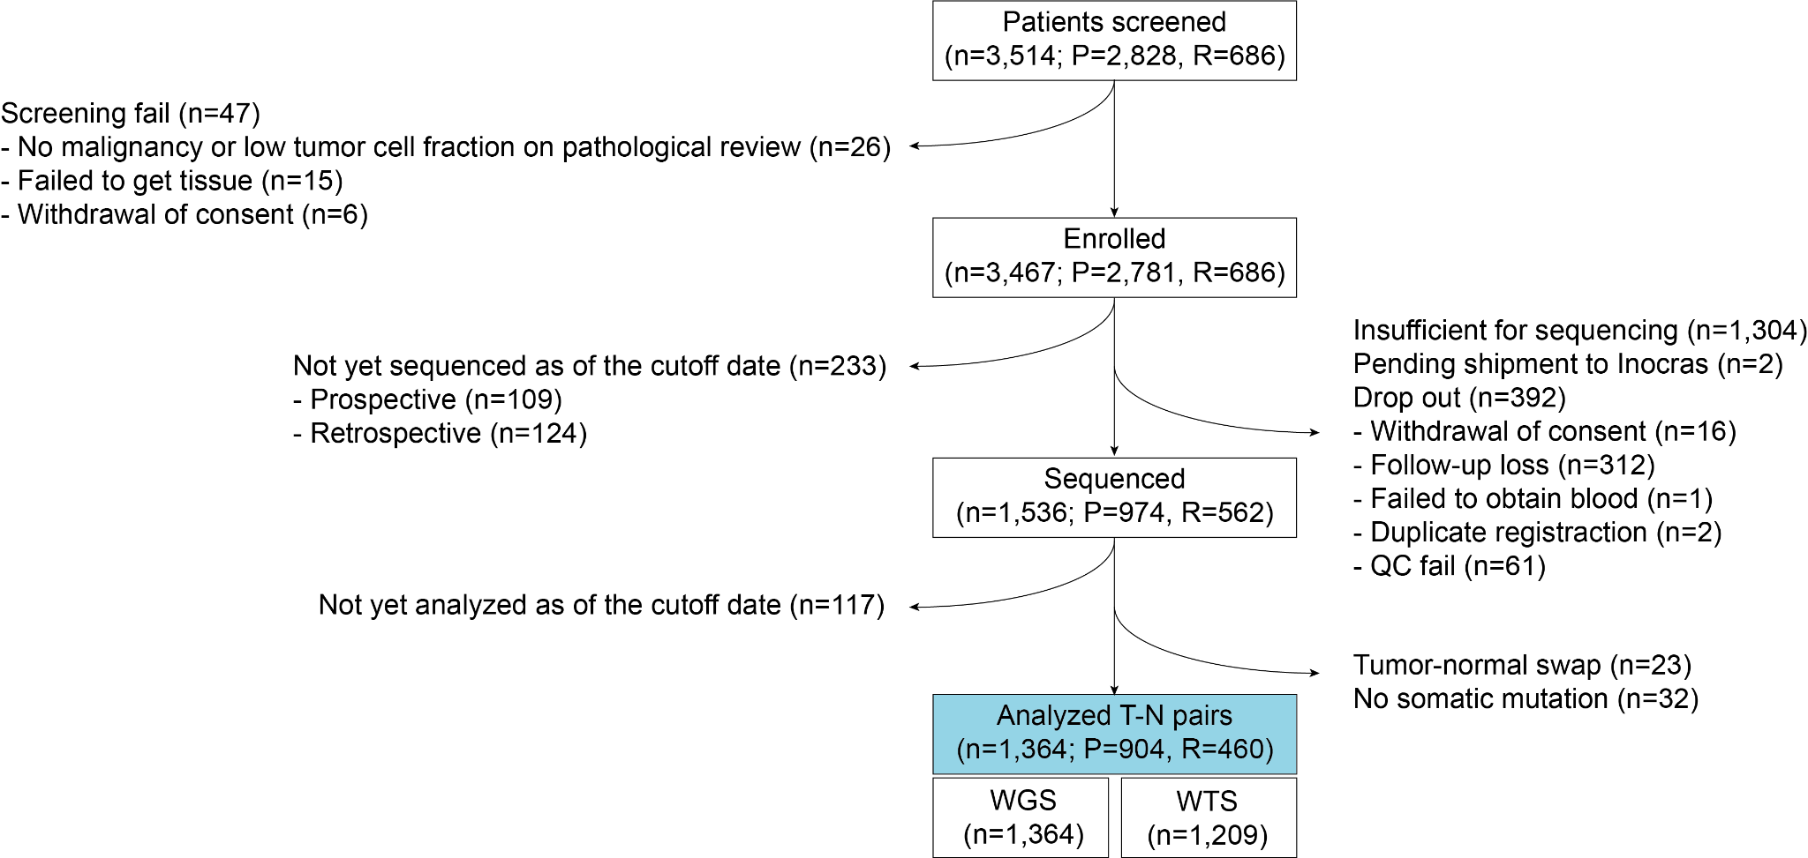

Supplementary Fig. 1. CONSORT diagram of the study cohort.
This flowchart depicts the study’s patient enrollment, sequencing, and analysis pipeline, categorizing participants into prospective (P) and retrospective (R) cohorts.

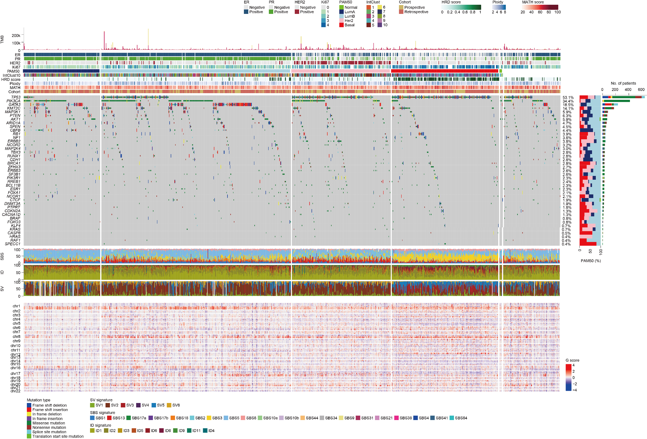

Supplementary Fig. 2. Comprehensive overview of the genomic and molecular characteristics of 1,364 breast cancer samples sorted by PAM50 subtype.
Samples are sorted by PAM50 subtype, enabling comparisons of genomic alterations within established PAM50 subtypes of breast cancer. Rows represent driver genes identified by seven different driver gene detection algorithms: SMRegions, OncodriveFML, OncodriveCLUSTL, MutPanning, HotMAPS, dNdScv, and CBaSE, providing a robust and integrative approach to detecting candidate driver mutations.
Abbreviations: TMB, tumor mutational burden; ER, estrogen receptor; PR, progesterone receptor; HRD, homologous recombination deficiency; MATH, mutant-allele tumor heterogeneity; SBS, single base substitution; ID, indel; SV, structural variation.
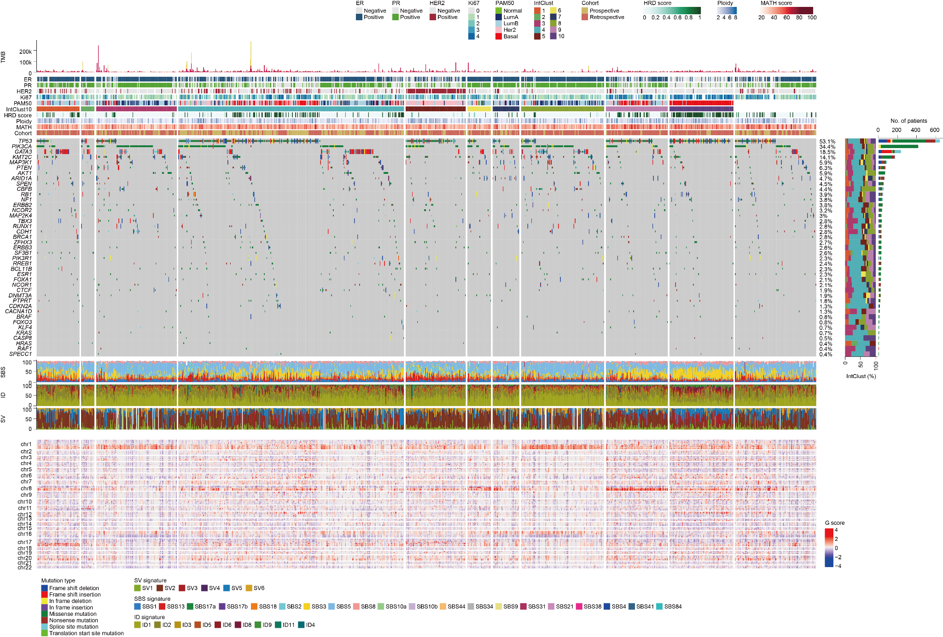

Supplementary Fig. 3. Comprehensive overview of the genomic and molecular characteristics of 1,364 breast cancer samples sorted by IntClust subtype.
Samples are sorted by IntClust subtype, enabling comparisons of genomic alterations within established IntClust subtypes of breast cancer. Rows represent driver genes identified by seven different driver gene detection algorithms: SMRegions, OncodriveFML, OncodriveCLUSTL, MutPanning, HotMAPS, dNdScv, and CBaSE, providing a robust and integrative approach to detecting candidate driver mutations.
Abbreviations: TMB, tumor mutational burden; ER, estrogen receptor; PR, progesterone receptor; HRD, homologous recombination deficiency; MATH, mutant-allele tumor heterogeneity; SBS, single base substitution; ID, indel; SV, structural variation.
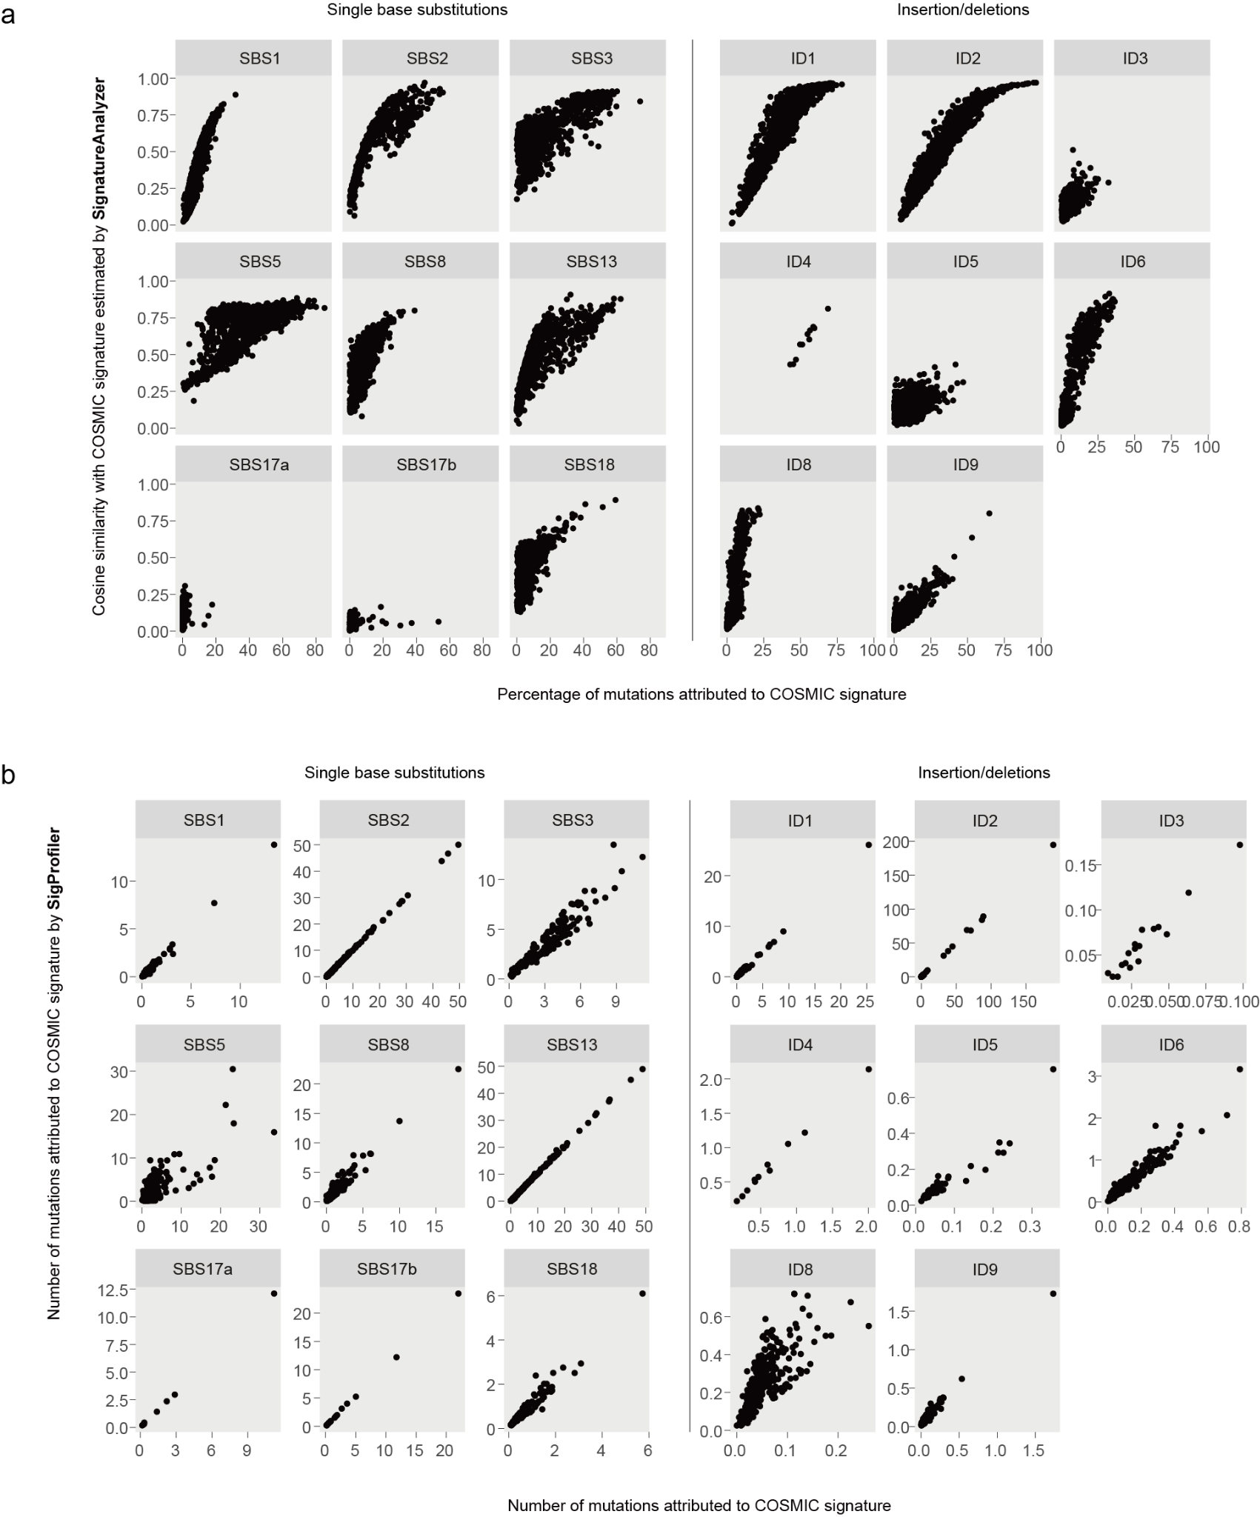

Supplementary Fig. 4. Comparison of mutational signature contributions estimated by our method, SigProfiler, and SignatureAnalyzer.
a. Scatter plots comparing cosine similarity with COSMIC signatures, as estimated by SignatureAnalyzer, and the percentage of mutations attributed to each COSMIC signature, as estimated by our method. b. Scatter plots comparing the number of mutations attributed to each COSMIC signature by our method versus SigProfiler. The strong correlations observed in both panels highlight the consistency between our method, SignatureAnalyzer, and SigProfiler, reinforcing the robustness of our approach in mutational signature estimation.
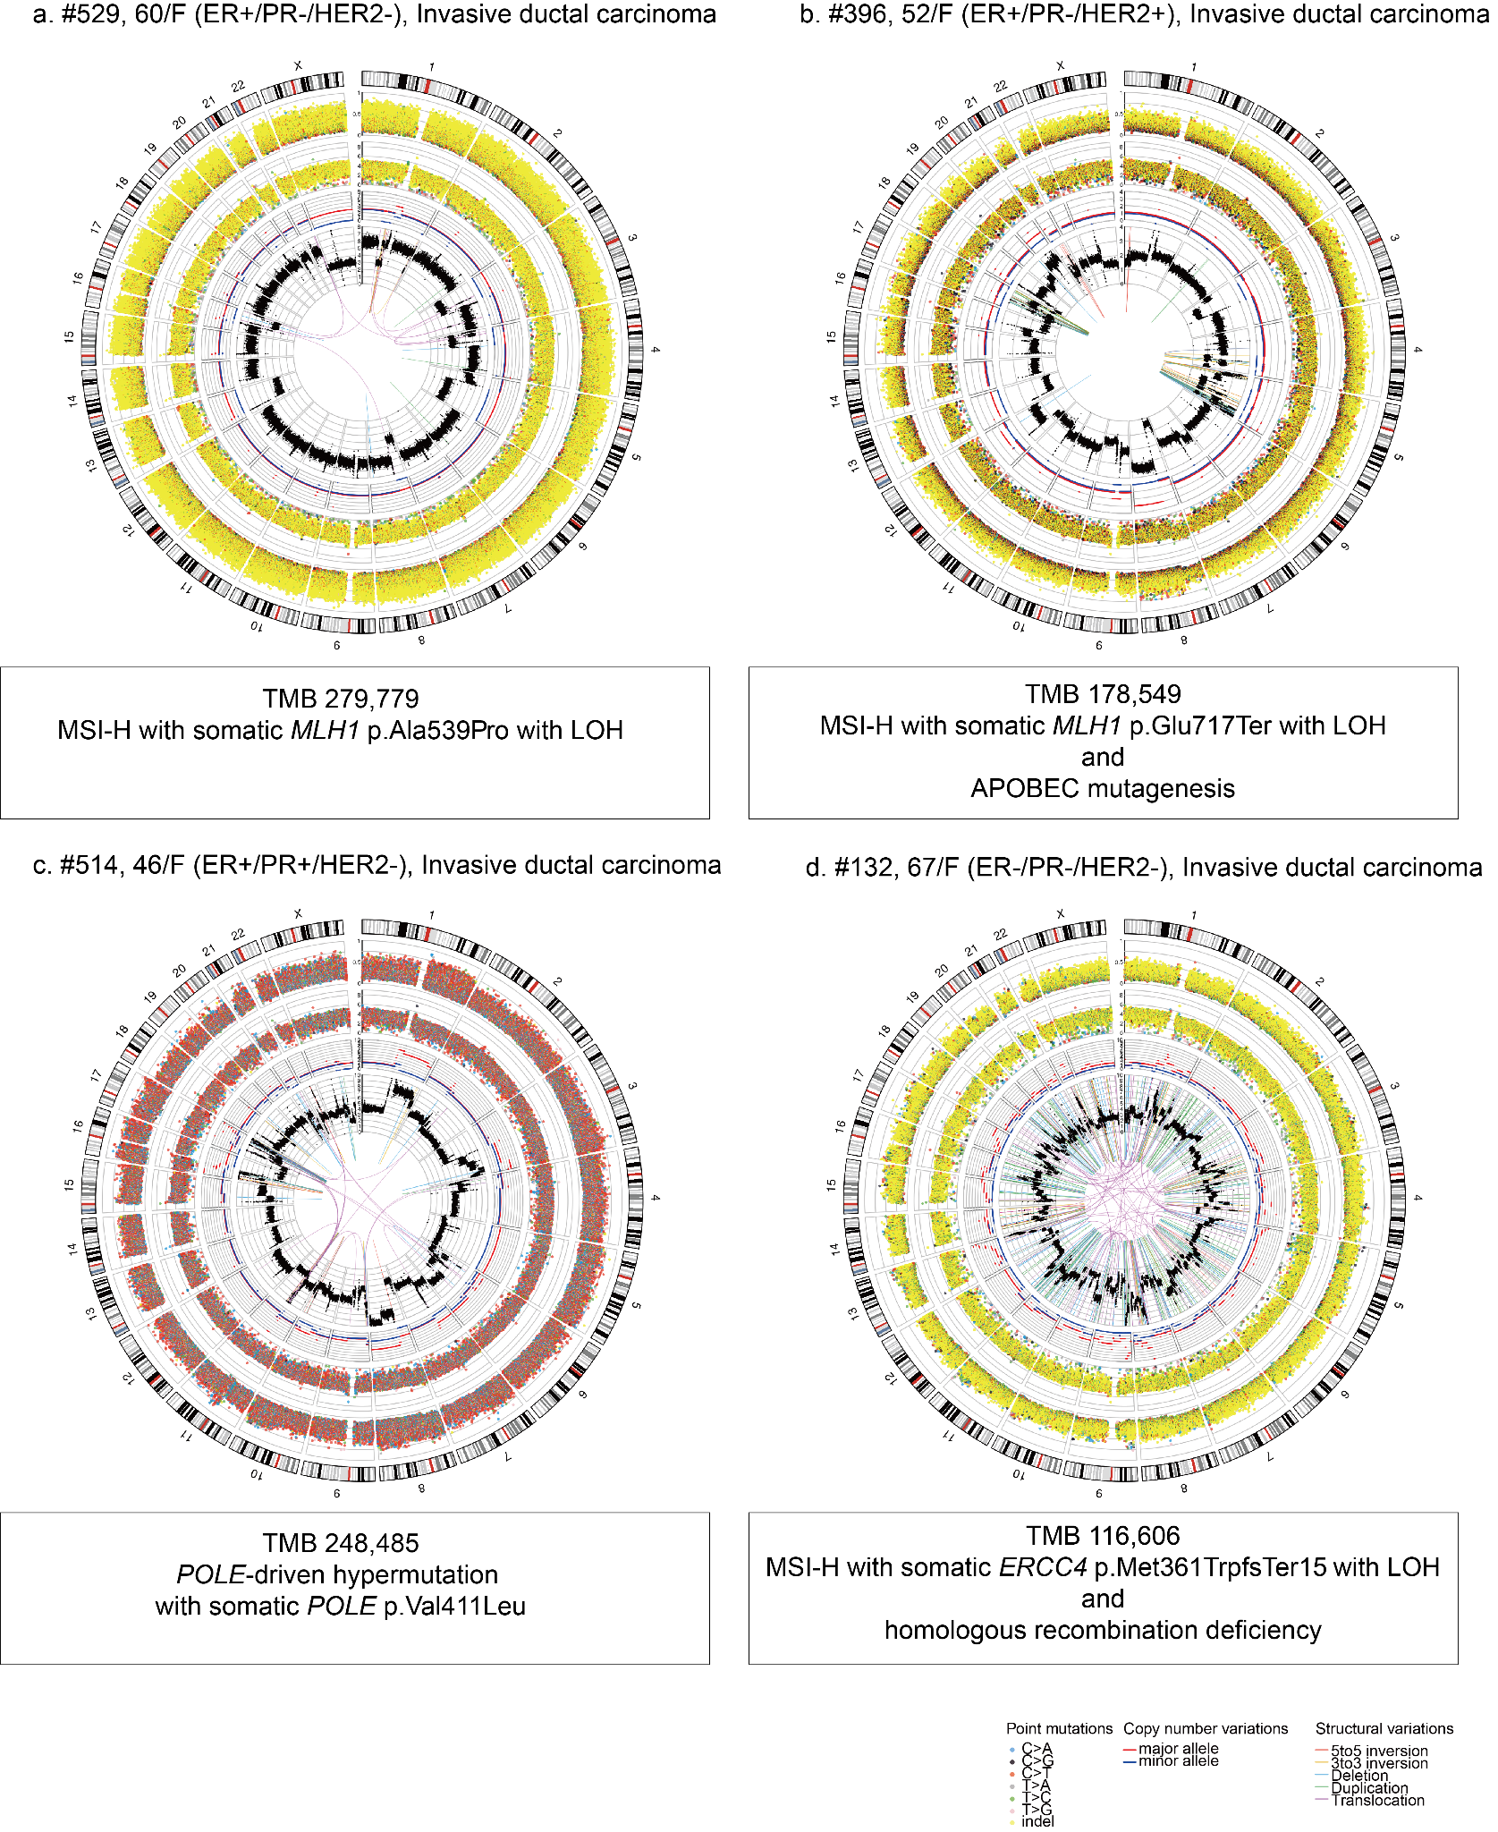

Supplementary Fig. 5. Circos plots of tumors with extremely high tumor mutational burden (TMB).
From the outer to inner circles, the Circos plot displays the ideogram, point mutations with their variant allele frequencies, distances between adjacent point mutations, major (red line) and minor (blue line) allelic copy numbers, total segmented copy number, and structural variations.
Abbreviations: MSI-H, microsatellite instability-high; LOH, loss of heterozygosity; APOBEC, apolipoprotein B mRNA editing catalytic polypeptide.
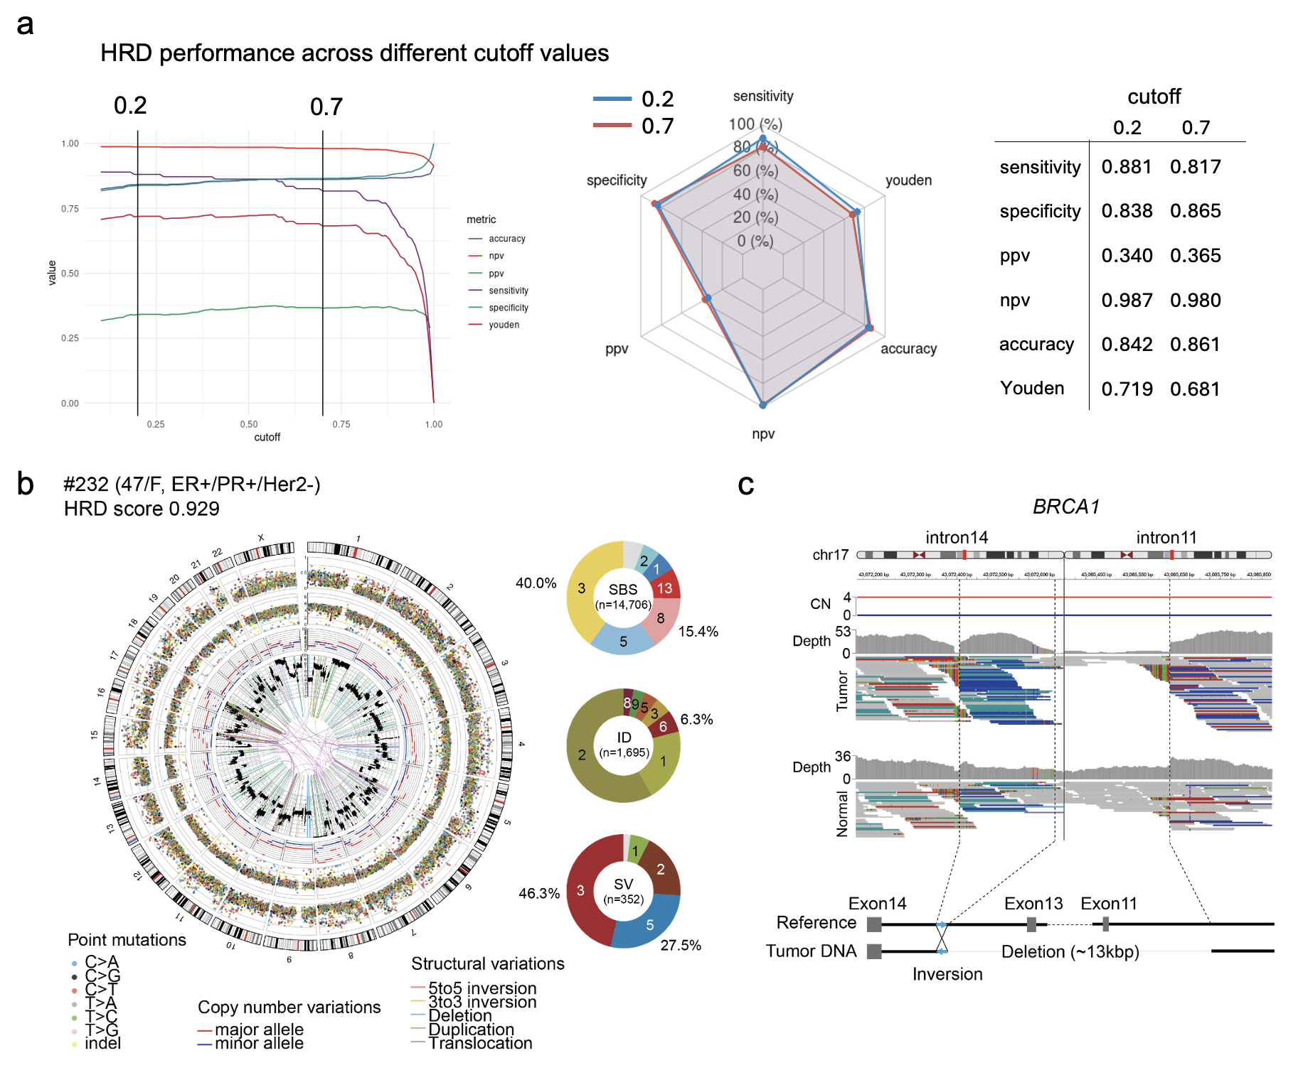

Supplementary Fig. 6. Whole-genome sequencing for homologous recombination deficiency (HRD) and a representative case.
a. As the distribution of our WGS-based HRD scores is nearly dichotomous, with very few samples falling between 0.2 and 0.7 (Fig. 2c), any cutoff within this range yields similar performance for classifying HRD and non-HRD samples. A cutoff of 0.2 provides the highest sensitivity, whereas a cutoff of 0.7 yields the highest specificity. npv, negative predictive value; ppv, positive predictive value. b. Circos plot demonstrating the characteristic HRD features. Outer to inner: ideogram, point mutations and their variant allele frequencies, distances between adjacent point mutations (single base substitutions [SBSs] and short indels [IDs]), major (red line) and minor (blue line) allelic copy number copy number, total segmented copy number and structural variations (SVs). Mutational signatures associated with HRD are shown in pie graphs. c. Integrative genome viewer snapshot of a germline SV disrupting the BRCA1 gene, a composite of large deletion and short inversion.
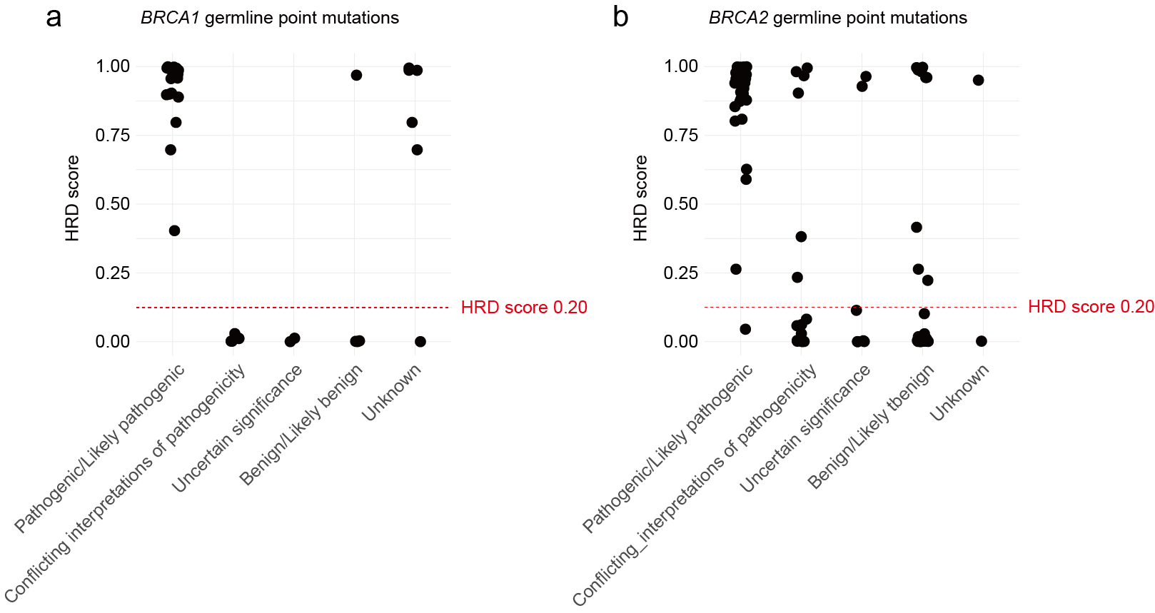

Supplementary Fig. 7. BRCA1/2 germline point mutations identified in whole-genome sequencing (WGS)-based homologous recombination-deficient (HRD) samples.
This figure displays BRCA1 (a) and BRCA2 (b) germline mutations identified in samples classified as HRD-positive (HRD score ≥ 0.20). The samples included in this analysis harbored loss of heterozygosity (LOH) in BRCA1/2 but did not have additional mutations in other HRD-related genes. The x-axis represents the ClinVar annotation of each BRCA1/2 germline mutation, categorized as Pathogenic/Likely Pathogenic, Conflicting Interpretations of Pathogenicity, Uncertain Significance, Benign/Likely Benign, and Unknown. The y-axis represents the HRD score, with a red dashed line indicating the HRD threshold (0.20). This figure highlights that some samples classified as HRD-positive carry BRCA1/2 germline mutations that are annotated in ClinVar as VUS (variants of uncertain significance) or even benign/likely benign, suggesting that certain variants not currently classified as pathogenic may still contribute to HRD-associated genomic instability.
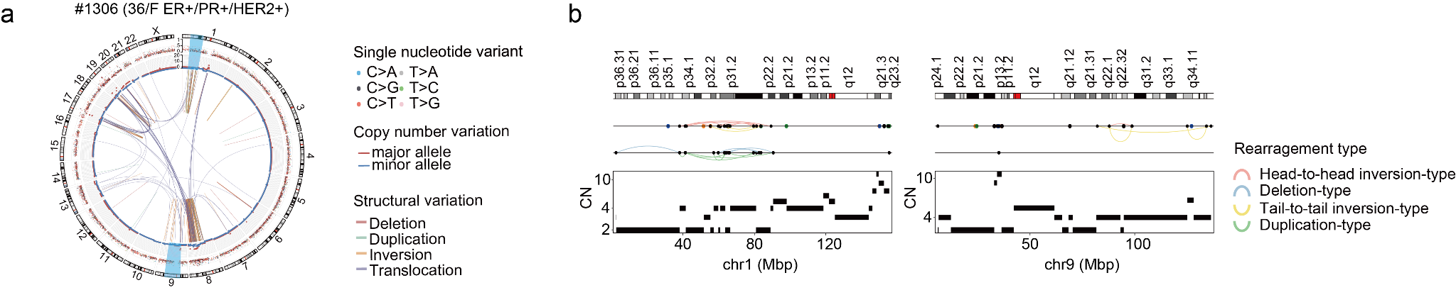

Supplementary Fig. 8. Chromothripsis in a HER2-positive breast cancer patient.
a. Circos plot illustrating the genomic landscape of a 38-year-old female patient (ER+/PR+/HER2+). Structural variations are depicted along with copy number alterations (major and minor alleles) and single nucleotide variants. Two chromothripsis events were detected in chr1 and chr9 using ShatterSeek³¹. b. Detailed view of chromothripsis regions on chr1 (left) and chr9 (right). The upper panel displays chromosomal ideograms and structural rearrangements, color-coded by type. The lower panel shows copy number (CN) segmentation, revealing highly fragmented genomic architecture consistent with chromothripsis.
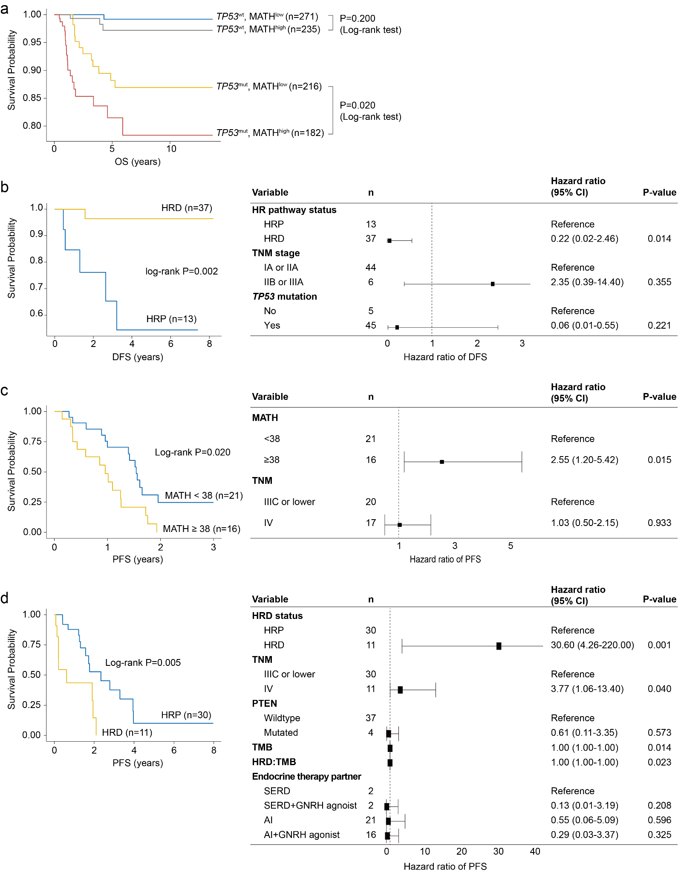

Supplementary Fig. 9. Sensitivity analyses of survival outcomes in prospective cohorts.
a, Kaplan-Meier survival curves of overall survival (OS) stratified by TP53 mutation status and MATH score. b, Disease-free survival (DFS) according to homologous recombination deficiency (HRD) status in triple-negative breast cancer patients treated with adjuvant anthracycline-cyclophosphamide chemotherapy. c, Progression-free survival (PFS) by MATH score in HER2-positive patients receiving anti-HER2 therapy, with MATH^{high} and MATH^{low} groups defined by the cohort median. d, PFS by HRD status in hormone receptor–positive patients treated with CDK4/6 inhibitors. Note: The error bars represent 95% confidence intervals, centered on the hazard ratio. In all panels, “n” refers to the number of patients.

Supplementary Table Legends
Supplementary Table 1. Clinicopathological characteristics of 1,364 patients with breast cancer included in this study. The cohort comprises 904 patients from a prospective cohort and 460 from a retrospective cohort. Values are presented as n (%) unless otherwise indicated. Subgroup characteristics used for specific analyses are also shown, including patients with triple-negative breast cancer treated with adjuvant AC chemotherapy, HER2-positive disease treated with neoadjuvant TCHP, basal-like tumours with or without 9p23 amplification, HER2-positive disease treated with first-line HER2-targeted therapy, and hormone receptor-positive disease treated with first-line CDK4/6 inhibition.
Supplementary Table 2. BRCA1/2 germline point mutations Identified in WGS-based homologous recombination-deficient (HRD) samples. This table presents BRCA1/2 germline point mutations identified in breast cancer samples that were classified as homologous recombination deficiency (HRD)-positive based on whole-genome sequencing (WGS)-derived HRD scores. These samples exhibited loss of heterozygosity (LOH) in BRCA1/2 but did not harbor additional mutations in other HRD-related genes. The primary aim of this analysis is to highlight ClinVar variants of uncertain significance (VUS) or variants with unclear pathogenicity that were found in HRD-positive samples, suggesting that some of these variants may have functional relevance to HRD-associated genomic instability. This table provides insights into the potential contribution of uncertain BRCA1/2 germline variants to HRD, emphasizing the importance of further research to determine their clinical and biological significance.
Supplementary Table 3. Clinicopathological characteristics of 89 triple-negative breast cancer patients who received adjuvant chemotherapy containing anthracycline-cyclophosphamide. P-values were estimated using a two-sided Student’s t-test for age, and a two-sided chi-square test for other variables. Values are presented as n (%) unless otherwise specified.
Supplementary Table 4. Clinicopathological characteristics of 75 HER2-positive breast cancer patients treated with neoadjuvant TCHP chemotherapy. P-values were estimated using a two-sided Student’s t-test for age, and a two-sided Fisher’s exact test for other variables. Values are presented as n (%) unless otherwise specified.
Supplementary Table 5. Clinicopathological characteristics of 252 basal-like breast cancer patients with or without 9p23 amplification. P-values were estimated using a two-sided Student’s t-test for age, and a two-sided Fisher’s exact test for other variables. Values are presented as n (%) unless otherwise specified.
Supplementary Table 6. Clinicopathological characteristics of 330 triple-negative breast cancer patients in the METABRIC cohort with or without 9p23 amplification. P-values were estimated using a two-sided Student’s t-test for age, and a two-sided Fisher’s exact test for other variables. Values are presented as n (%) unless otherwise specified.
Supplementary Table 7. Clinicopathological characteristics of 45 HER2-positive breast cancer patients treated with first-line HER2-targeted therapy, stratified by high and low mutant allele tumor heterogeneity (MATH) scores. The cutoff of 40 corresponds to the median value of MATH score in this cohort. P-values were estimated using a two-sided Wilcoxon rank-sum test for age, ERBB2 TPM, and follow-up duration, and a two-sided Fisher’s exact test for other variables. Values are presented as n (%) unless otherwise specified.
Supplementary Table 8. Clinicopathological characteristics of 57 hormone receptor-positive breast cancer patients treated with a first-line CDK4/6 inhibitor (CDK4/6i), stratified by homologous recombination DNA repair pathway status. P-values were estimated using a two-sided Wilcoxon rank-sum test for age, tumor mutational burden (TMB), and follow-up duration, and a two-sided Fisher’s exact test for other variables. Values are presented as n (%) unless otherwise specified.
Supplementary Table 9. Summary of findings in this study.
Supplementary Table 10. Quality assessments of study samples.
Supplementary Table 11. Summary of 14 external datasets used to validate the presence of driver mutations. The table provides detailed information on each dataset, including cohort size, tumor type, sequencing platform, and reference study. These datasets were selected to assess the recurrence and clinical relevance of the identified driver mutations across independent breast cancer cohorts.
Supplementary Table 12. Clinical and survival data of 1,364 breast cancer patients.

Supplementary references
1. Yap, Y.-S. et al. Insights into breast cancer in the east vs the west: A review. JAMA Oncol. 5, 1489–1496 (2019).
2. Sung, H. et al. Female breast cancer incidence among Asian and Western populations: more similar than expected. J Natl Cancer Inst 107, (2015).
3. Lee, S. K. et al. Is the high proportion of young age at breast cancer onset a unique feature of Asian breast cancer? Breast Cancer Res. Treat. 173, 189–199 (2019).
4. Kan, Z. et al. Multi-omics profiling of younger Asian breast cancers reveals distinctive molecular signatures. Nat. Commun. 9, 1725 (2018).
5. Hirko, K. A. et al. The impact of race and ethnicity in breast cancer-disparities and implications for precision oncology. BMC Med. 20, 72 (2022).
6. Alexandrov, L. B., Nik-Zainal, S., Wedge, D. C., Campbell, P. J. & Stratton, M. R. Deciphering signatures of mutational processes operative in human cancer. Cell Rep. 3, 246–259 (2013).
7. Nik-Zainal, S. et al. Landscape of somatic mutations in 560 breast cancer whole-genome sequences. Nature 534, 47–54 (2016).
8. Kasar, S. et al. Whole-genome sequencing reveals activation-induced cytidine deaminase signatures during indolent chronic lymphocytic leukaemia evolution. Nat. Commun. 6, 8866 (2015).
9. Kim, J. et al. Somatic ERCC2 mutations are associated with a distinct genomic signature in urothelial tumors. Nat. Genet. 48, 600–606 (2016).
10. Haradhvala, N. J. et al. Distinct mutational signatures characterize concurrent loss of polymerase proofreading and mismatch repair. Nat. Commun. 9, 1–9 (2018).
11. Pujol, P. et al. Clinical practice guidelines for BRCA1 and BRCA2 genetic testing. Eur. J. Cancer 146, 30–47 (2021).
12. Chrysafi, P. et al. Prevalence of variants of uncertain significance in patients undergoing genetic testing for hereditary breast and ovarian cancer and lynch syndrome. Cancers (Basel) 15, (2023).
13. Caminsky, N. G. et al. Prioritizing variants in complete hereditary breast and ovarian cancer genes in patients lacking known BRCA mutations. Hum. Mutat. 37, 640–652 (2016).
14. Jimenez-Sainz, J. & Jensen, R. B. Imprecise Medicine: BRCA2 Variants of Uncertain Significance (VUS), the Challenges and Benefits to Integrate a Functional Assay Workflow with Clinical Decision Rules. Genes 12, (2021).
15. Glodzik, D. et al. Comprehensive molecular comparison of BRCA1 hypermethylated and BRCA1 mutated triple negative breast cancers. Nat. Commun. 11, 3747 (2020).
16. Polyak, K. Heterogeneity in breast cancer. J. Clin. Invest. 121, 3786–3788 (2011).
17. Hodder, A. et al. Benefits for children with suspected cancer from routine whole-genome sequencing. Nat. Med. 30, 1905–1912 (2024).
18. Kim, R. et al. Clinical application of whole-genome sequencing of solid tumors for precision oncology. Exp. Mol. Med. (2024) doi:10.1038/s12276-024-01288-x.
19. Lau, L. M. S. et al. Precision-guided treatment in high-risk pediatric cancers. Nat. Med. 30, 1913–1922 (2024).
20. Duncavage, E. J. et al. Genome sequencing as an alternative to cytogenetic analysis in myeloid cancers. N. Engl. J. Med. 384, 924–935 (2021).
21. Watkins, J. A. et al. Introduction and impact of routine whole genome sequencing in the diagnosis and management of sarcoma. Br. J. Cancer 131, 860–869 (2024).
22. Zhang, Y., Chen, B., Zhang, R., Wu, J. & Chen, C. Cyclin-dependent kinase 4/6 inhibitor resistance mechanisms and strategies for subsequent treatment in breast cancer: A comprehensive review. TD 0, 7107 (2025).
23. Park, Y. H. et al. Longitudinal multi-omics study of palbociclib resistance in HR-positive/HER2-negative metastatic breast cancer. Genome Med. 15, 55 (2023).
24. Rugo, H. S. et al. Effect of palbociclib plus endocrine therapy on time to chemotherapy across subgroups of patients with hormone receptor‒positive/human epidermal growth factor receptor 2‒negative advanced breast cancer: Post hoc analyses from PALOMA-2 and PALOMA-3. Breast 66, 324–331 (2022).
25. Dawood, S., Broglio, K., Buzdar, A. U., Hortobagyi, G. N. & Giordano, S. H. Prognosis of women with metastatic breast cancer by HER2 status and trastuzumab treatment: an institutional-based review. J. Clin. Oncol. 28, 92–98 (2010).
26. Modi, S. et al. Trastuzumab Deruxtecan in Previously Treated HER2-Low Advanced Breast Cancer. N. Engl. J. Med. 387, 9–20 (2022).
27. Giugliano, F. et al. Unlocking the Resistance to Anti-HER2 Treatments in Breast Cancer: The Issue of HER2 Spatial Distribution. Cancers (Basel) 15, (2023).
28. Sajjadi, E., Venetis, K., Ivanova, M. & Fusco, N. Improving HER2 testing reproducibility in HER2-low breast cancer. Cancer Drug Resist. 5, 882–888 (2022).
29. Mazzagatti, A., Engel, J. L. & Ly, P. Boveri and beyond: Chromothripsis and genomic instability from mitotic errors. Mol. Cell 84, 55–69 (2024).
30. Schukken, K. M. et al. Altering microtubule dynamics is synergistically toxic with spindle assembly checkpoint inhibition. Life Sci. Alliance 3, (2020).
31. Cortés-Ciriano, I. et al. Comprehensive analysis of chromothripsis in 2,658 human cancers using whole-genome sequencing. Nat. Genet. 52, 331–341 (2020).

