Supplementary Information

Cross-regulation of [2Fe-2S] cluster synthesis by Ferredoxin-2 and Frataxin
Kristian Want,¹ Hubert Gorny,^{1,3} Ema Turki,^{2,3} Magali Noiray,¹ Beata Monfort,¹ Rémi Mor-Gautier,¹ Thibault Tubiana,¹ Estelle Jullian,² Véronique Monnier,^{2*} Benoit D’Autréaux^{1*}

¹Université Paris-Saclay, CEA, CNRS, Institute for Integrative Biology of the Cell (I2BC), 91198, Gif-sur-Yvette, France
²Université Paris Cité, CNRS, Unit of Functional and Adaptive Biology (BFA), UMR 8251, F-75013, Paris, France.
³ These authors equally contributed: Hubert Gorny, Ema Turki.
*corresponding authors: benoit.dautreaux@i2bc.paris-saclay.fr, veronique.monnier@u-paris.fr

Supplementary Fig. 1| Optimization of the ARBS assays.
a, ARBS assays of persulfide transfer between NFS1 and ISCU2. Lane 1: molecular weight ladder. Lane 2: control experiment of a mixture containing 7.5 µM of ISCU2 and NIA without the mal-dPEG alkylating agent showing bands corresponding to non-alkylated proteins. Lane 3-4: ARBS assays of reaction mixtures containing 7.5 µM of ISCU2 and NIA before (lane 3) and after (lane 4) incubation with L-cysteine. The alkylated species are indicated for fully alkylated NFS1 (NFS1+7), fully alkylated ISCU2 (ISCU+4), and ISCU2 with 3 cysteines alkylated (ISCU +3). b-c, Lane 1: molecular weight ladder. Lane 2-9: Alkylation assays of either 7.5 µM FDX2 (b) or 7.5 µM ISCU2 (c) in the presence a 5-fold molar ratio of Mal-dPEG, a 2.5-fold molar ratio of EDTA, and a titration of SDS as indicated. d, Lane 1: Molecular weight ladder. Lane 2: ARBS assays of persulfide transfer reaction between NFS1 and ISCU2 in the presence of 1 eq. FDX2 and 0.08 % SDS. Lane 3: NFS1 in the presence of 1 eq. FDX2 and 0.08% SDS. Lane 4: ARBS assays of persulfide transfer reaction between NFS1 and ISCU2 in the presence of 10 eq. FDX2 and 0.08 % SDS. Lane 5: NFS1 in the presence of 10 eq. FDX2 and 0.08% SDS.

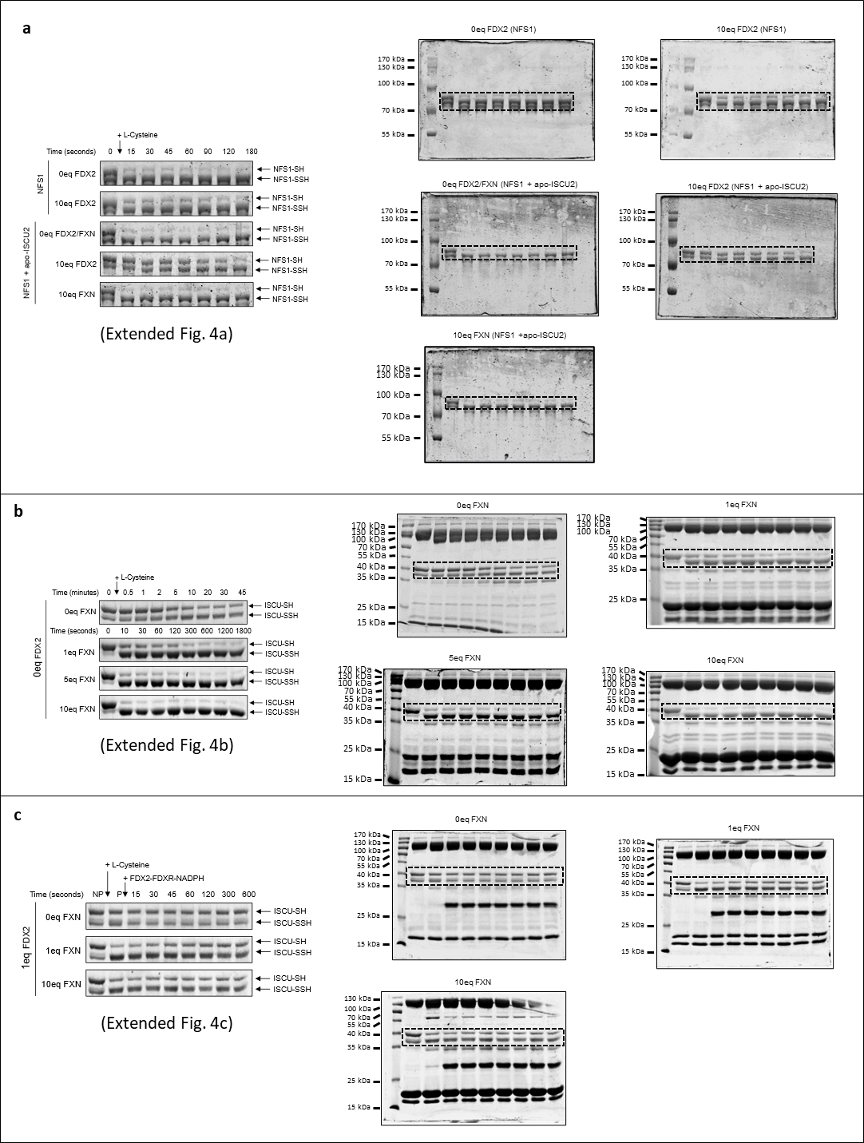
Supplementary Fig. 2| Uncropped gels from data in extended Fig. 4
a-c, Uncropped gels of ARBS assays from extended Fig.4: (a) Fig. 4a, (b) Fig. 4b, (c) Fig. 4c.

Supplementary Fig. 3| Uncropped gels from data in extended Fig. 4
a-c, Uncropped gels of ARBS assays from extended Fig.4: (a) Fig. 4d, (b) Fig. 4e and (c) Fig. 4f.
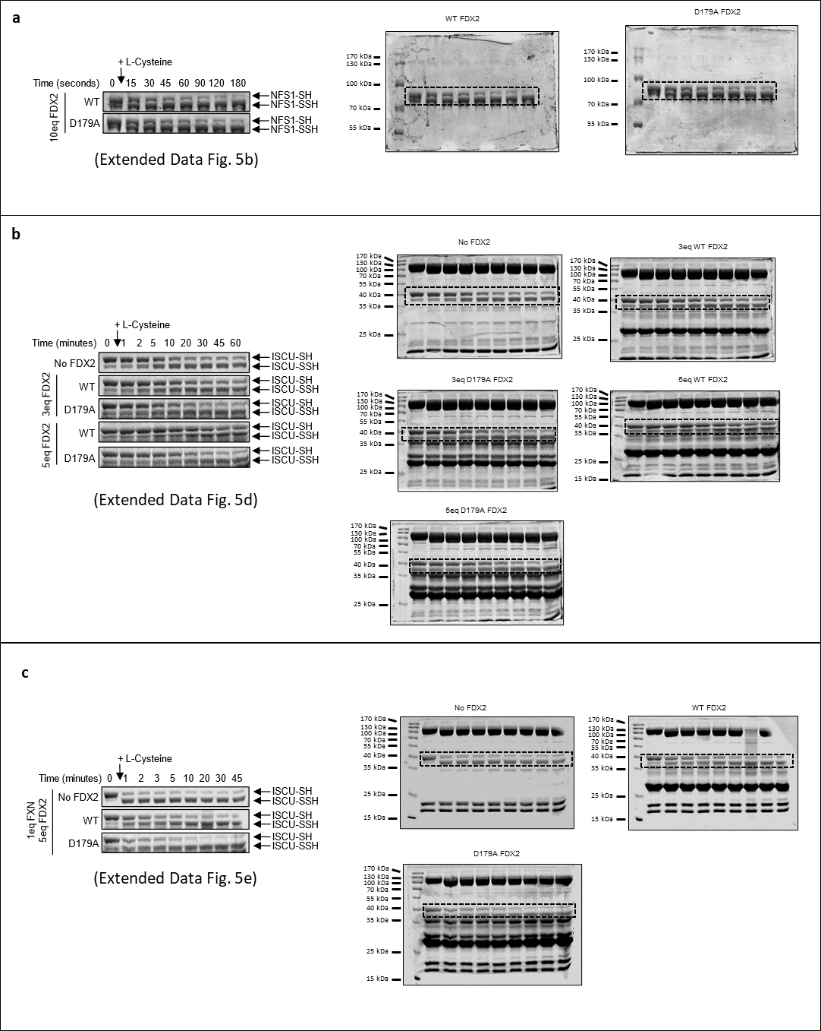

Supplementary Fig. 4| Uncropped gels from data in extended Fig. 5
a-c, Uncropped gels of ARBS assays from extended Fig.5: (a) Fig. 5b, (b) Fig. 5d and (c) Fig. 5f.

Supplementary Equation 1| FIDA - Competitive binding model

The competitive binding model is used to identify the displacement of the indicator, I, protein from the analyte, A, binding partner upon the introduction of a non-fluorescent competing partner, B, protein/ligand for the same binding site.
Take the individual binding equilibrium models of the indicator and competing partner with the analyte:
A + I ⇌ AI
B + A ⇌ BA

 | $$K_{D1}=\frac{\left[A\right]\left[I\right]}{\left[AI\right]}$$ | (1)
 | $$K_{D2}=\frac{\left[B\right]\left[A\right]}{\left[BA\right]}$$ | (2)
The unbound fraction of the indicator, $x$, can be calculated with equation (3), and the bound fraction of the indicator, $y$, can be calculated with equation (4):

 | $$x=\frac{\left[I\right]}{\left[I\right]+\left[AI\right]}=\frac{\left[I\right]}{\left[I\right]+\frac{\left[A\right]\left[I\right]}{K_{D1}}}=\frac{1}{1+\frac{\left[A\right]}{K_{D1}}}$$ | (3)
 | $$y=\frac{\left[AI\right]}{\left[I\right]+\left[AI\right]}$$ | (4)
 | where $x+y=1$ | (5)
Under conditions that $\left[I\right]$ << $\left[A\right]$, the total concentration of the analyte, $c_{A}$, and the total concentration of the competing partner, $c_{B}$, can be described:

 | $$c_{A}=\left[A\right]+\left[BA\right]$$ | (6)
 | $$c_{B}=\left[B\right]+\left[BA\right]$$ | (7)

Equation (6) can be rearranged to solve for the unbound concentration of analyte, $\left[A\right]$:

 | $$c_{A}=\left[A\right]+\left[BA\right]=\left[A\right]+\frac{\left[B\right]\left[A\right]}{K_{D2}}=\left[A\right]∙\left(1+\frac{\left[B\right]}{K_{D2}}\right)$$  $$\left[B\right]=\left[A\right]+ c_{B}-c_{A}$$  $$c_{A}=\left[A\right]∙\left(1+\frac{\left[A\right]+c_{B}-c_{A} }{K_{D2}}\right)$$  $${\left[A\right]}^{2}∙\left(\frac{1}{K_{D2}}\right)+\left[A\right]∙\left(1+\frac{c_{B}-c_{A}}{K_{D2}}\right)-c_{A}=0$$  $$\left[A\right]=-\frac{1}{2}(K_{D2}+\left(c_{B}-c_{A}\right))±\frac{1}{2}∙K_{D2}\sqrt{{\left(1+\frac{c_{B}-c_{A}}{K_{D2}}\right)}^{2}+4∙\frac{c_{A}}{K_{D2}}}$$ | (8)

Where, since [A] > 0, we take the positive:
 | $$\left[A\right]=-\frac{1}{2}\left(K_{D2}+\left(c_{B}-c_{A}\right)\right)+\frac{1}{2}∙K_{D2}\sqrt{{\left(1+\frac{c_{B}-c_{A}}{K_{D2}}\right)}^{2}+4∙\frac{c_{A}}{K_{D2}}}$$ | (9)
Combining equation (3) with (9) yields:
 | $$x=\frac{1}{1+\frac{1}{K_{D1}}∙\left(-½∙\left(K_{D2}+\left(c_{B}-c_{A}\right)\right)+½∙K_{D2}\sqrt{{\left(1+\frac{c_{B}-c_{A}}{K_{D2}}\right)}^{2}+4∙\frac{c_{A}}{K_{D2}}}\right)}$$ | (10)

The binding curve is fit to:
 | $$R_{app}={\left(\frac{1}{R_{I}}∙x+\frac{1}{R_{AI}}∙(1-x)\right)}^{-1}$$ | (11)
Where $R_{app}$, $R_{I}$, and $R_{AI}$ corresponds to the apparent hydrodynamic radius, the hydrodynamic radius of the indicator, and the hydrodynamic radius of the indicator-analyte complex, respectively.

Substitution of equation (10) into (11) yields the competitive binding model between the indicator and the non-fluorescent competing protein/ligand for the same binding site on the analyte. During data analysis, the y-axis corresponds to the R_{app} measured by FIDA, and the x-axis corresponds to the concentration of the competing partner (C_{B}) titrated into the indicator-analyte complex.

