Supplementary Information for
Comprehensive Echocardiogram Evaluation with View Primed Vision Language AI
Milos Vukadinovic^{1,2}, I-Min Chiu^{1,3}, Xiu Tang⁴, Neal Yuan⁵, Tien-Yu Chen^{6,} Paul Cheng⁴, Debiao Li⁷, Susan Cheng¹, Bryan He^{8,}*, David Ouyang^{1,9,}*
- Department of Cardiology, Smidt Heart Institute, Cedars-Sinai Medical Center, Los Angeles, CA
- Department of Bioengineering, University of California Los Angeles, Los Angeles, CA
- Department of Emergency Medicine, Kaohsiung Chang Gung Memorial Hospital, Kaohsiung, Taiwan
- Division of Cardiology, Department of Medicine, Stanford University, Palo Alto, CA
- Department of Medicine, University of California, San Francisco, CA; Division of Cardiology, San Francisco Veterans Affairs Medical Center, San Francisco, CA
- Division of Cardiology, Department of Medicine, Kaohsiung Chang Gung Memorial Hospital, Kaohsiung, Taiwan
- Biomedical Imaging Research Institute, Cedars-Sinai Medical Center, Los Angeles, CA
- Department of Computer Science, Stanford University, Stanford, CA
- Division of Research, Kaiser Permanente Northern California, Pleasanton, CA

This Supplementary Information file includes:
Supplementary Tables 1-11 Pages 2-12
Supplementary Figures 1-2 Pages 13-14
Supplementary Video 1 Page 15

Supplemental Tables
Supplementary Table 1 Performance of foundation models for biomedical imaging on Cedars-Sinai test set
Cedars-Sinai test set
 | PubMedCLIP | PMC-CLIP | BioMedCLIP | EchoCLIP | EchoPrime | PanEcho
LV ejection fraction (R²) | -0.32 (-0.40--0.25) | -0.38 (-0.46--0.31) | -2.60 (-3.00--2.20) | 0.62 (0.59-0.65) | 0.83 (0.81-0.85) | 0.52 (0.50-0.54)
LV ejection fraction (MAE) | 14.7 (14.3-15.1) | 14.0 (13.6-14.5) | 26.93 (26.4-27.4) | 7.00 (6.7-7.3) | 4.8 (4.6-5.0) | 7.46 (7.16-7.78)
Pacemaker | 0.50 (0.50-0.50) | 0.51 (0.47-0.54) | 0.58 (0.55-0.62) | 0.88 (0.85-0.91) | 0.85 (0.82-0.88) | -
RV systolic function | 0.50 (0.49-0.51) | 0.53 (0.48-0.58) | 0.64 (0.59-0.69) | 0.89 (0.86-0.92) | 0.93 (0.91-0.95) | 0.89 (0.87-0.92)
RV dilation | 0.50 (0.45-0.56) | 0.59 (0.50-0.67) | 0.58 (0.52-0.64) | 0.88 (0.83-0.92) | 0.89 (0.83-0.95) | 0.86 (0.79-0.91)
LA dilation | 0.50 (0.50-0.50) | 0.57 (0.48-0.65) | 0.66 (0.58-0.74) | 0.93 (0.89-0.96) | 0.91 (0.86-0.96) | 0.89 (0.86-0.92)
RA dilation | 0.50 (0.50-0.50) | 0.58 (0.47-0.68) | 0.67 (0.59-0.75) | 0.90 (0.82-0.97) | 0.90 (0.82-0.97) | 0.93 (0.89-0.96)
Mitraclip | 0.50 (0.50-0.50) | 0.49 (0.43-0.55) | 0.70 (0.63-0.76) | 0.95 (0.92-1.00) | 0.99 (0.99-1.00) | -
Mitral annular calcification | 0.50 (0.46-0.55) | 0.59 (0.54-0.64) | 0.63 (0.58-0.68) | 0.95 (0.93-0.96) | 0.96 (0.95-0.97) | -
Mitral stenosis | 0.50 (0.50-0.50) | 0.55 (0.44-0.66) | 0.70 (0.61-0.79) | 0.96 (0.91-0.99) | 0.96 (0.91-0.99) | 0.96 (0.93-0.98)
Mitral regurgitation | 0.50 (0.50-0.50) | 0.59 (0.55-0.63) | 0.66 (0.63-0.69) | 0.89 (0.87-0.91) | 0.92 (0.91-0.94) | 0.86 (0.84-0.89)
TAVR | 0.50 (0.50-0.51) | 0.51 (0.46-0.55) | 0.54 (0.50-0.57) | 0.86 (0.83-0.89) | 1.00 (0.99-1.00) | -
Bicuspid AV | 0.50 (0.50-0.50) | 0.51 (0.47-0.60) | 0.52 (0.51-0.53) | 0.72 (0.58-0.85) | 0.83 (0.67-0.96) | 0.95 (0.89-0.98)
Aortic stenosis | 0.50 (0.50-0.52) | 0.48 (0.42-0.55) | 0.55 (0.53-0.57) | 0.83 (0.79-0.87) | 0.98 (0.96-0.99) | 0.93 (0.90-0.95)
Aortic regurgitation | 0.50 (0.50-0.50) | 0.50 (0.41-0.58) | 0.54 (0.53-0.55) | 0.68 (0.60-0.76) | 0.88 (0.83-0.93) | 0.77 (0.71-0.83)
Tricuspid regurgitation | 0.49 (0.45-0.53) | 0.57 (0.51-0.63) | 0.69 (0.64-0.74) | 0.91(0.89-0.93) | 0.95 (0.93-0.97) | 0.91 (0.88-0.94)
Pericardial effusion | 0.54 (0.45-0.62) | 0.50 (0.42-0.57) | 0.68 (0.59-0.77) | 0.92 (0.89-0.95) | 0.98 (0.95-0.99) | 0.93 (0.89-0.96)
Aortic root dilation | 0.50 (0.50-0.50) | 0.44 (0.35-0.55) | 0.50 (0.49-0.51) | 0.76 (0.63-0.88) | 0.91 (0.83-0.98) | 0.66 (0.56-0.76)
Dilated IVC | 0.50 (0.50-0.51) | 0.53 (0.50-0.56) | 0.49 (0.47-0.50) | 0.81 (0.79-0.83) | 0.84 (0.82-0.86) | -
PA pressure (R²) | -0.59 (-0.74--0.46) | -0.83 (-1.07--0.62) | -0.19 (-0.24 - -0.14) | 0.35 (0.29-0.41) | 0.43 (0.39-0.47) | 0.27 (0.23-0.30)
PA pressure (MAE) | 11.3 (10.0-12.6) | 13.7 (13.0-14.3) | 10.6 (10.1-11.12 | 7.8 (7.5- 8.2) | 7.3 (7.0-7.7) | 8.27 (7.88-8.68)

Supplementary Table 2 Performance of foundation models for biomedical imaging on Stanford dataset
Stanford Dataset
 | BioMedCLIP | EchoCLIP | EchoPrime | PanEcho
LV ejection fraction (R²) | -3.50 (-4.15- -3.03) | 0.48 (0.40-0.55) | 0.79 (0.76-0.82) | 0.39 (0.36-0.42)
LV ejection fraction (MAE) | 23.00 (22.68-23.79) | 6.23 (5.89-6.44) | 4.14 (3.94-4.34) | 6.41 (6.03-6.79)
Pacemaker | 0.64 (0.60-0.68) | 0.90 (0.88-0.93) | 0.84 (0.81-0.87) | -
RV systolic function | 0.59 (0.02-0.92) | 0.89 (0.73-1.00) | 0.94 (0.88-1.00) | 0.93 (0.80-0.99)
RV dilation | 0.53 (0.49-0.58) | 0.84 (0.79-0.89) | 0.85 (0.80-0.90) | 0.87 (0.83-0.90)
LA dilation | 0.57 (0.55-0.60) | 0.67 (0.65-0.70) | 0.73 (0.70-0.75) | 0.81 (0.79-0.83)
RA dilation | 0.56 (0.52-0.59) | 0.72 (0.69-0.75) | 0.77 (0.74-0.81) | 0.84 (0.81-0.87)
Mitraclip | 0.79 (0.78-0.81) | 0.81 (0.44-1.00) | 0.98 (0.94-1.00) | -
Mitral annular calcification | 0.66 (0.56-0.76) | 0.94 (0.90-0.97) | 0.96 (0.94-0.98) | -
Mitral stenosis | 0.72 (0.63-0.81) | 0.84 (0.75-0.92) | 0.92 (0.86-0.98) | 0.96 (0.94-0.98)
Mitral regurgitation | 0.67 (0.57-0.71) | 0.86 (0.82-0.90) | 0.91 (0.89-0.93) | 0.85 (0.79-0.90)
TAVR | 0.52 (0.47-0.69) | 0.95 (0.93-0.97) | 0.97 (0.90-1.00) | ---
Bicuspid AV | 0.50 (0.47-0.54) | 0.63 (0.53-0.73) | 0.82 (0.73-0.90) | 0.73 (0.64-0.82)
Aortic stenosis | 0.52 (0.48-0.55) | 0.81 (0.73-0.89) | 0.96 (0.92-0.99) | 0.97 (0.95-0.98)
Aortic regurgitation | 0.53 (0.48-0.61) | 0.67 (0.54-0.80) | 0.89 (0.80-0.97) | 0.83 (0.74-0.90)
Tricuspid regurgitation | 0.61 (0.55-0.66) | 0.80 (0.75-0.85) | 0.88 (0.86-0.91) | 0.85 (0.81-0.88)
Pericardial effusion | 0.75 (0.60-0.66) | 0.89 (0.78-0.98) | 0.89 (0.77-0.98) | 0.87 (0.73-0.96)
Aortic root dilation | 0.52 (0.50-0.56) | 0.71 (0.62-0.79) | 0.97 (0.94-0.99) | 0.80 (0.73-0.85)
Dilated IVC | 0.46 (0.42-0.51) | 0.75 (0.66-0.82) | 0.86 (0.81-0.91) | -
PA pressure (R²) | -0.25(-0.34- -0.17) | 0.22 (0.13-0.30) | 0.36 (0.30-0.42) | 0.07 (0.00-0.14)
PA pressure (MAE) | 10.92 (10.00-11.86) | 8.80 (8.08-9.52) | 7.97 (7.35-8.66) | 9.12 (8.32-9.96)

Supplementary Table 3 Performance of foundation models for biomedical imaging on MIMIC dataset
MIMIC Dataset
 | BioMedCLIP | EchoCLIP | EchoPrime | PanEcho
LV ejection fraction (R²) | -2.48 (-3.26--1.85) | 0.27 (0.13-0.40) | 0.74 (0.66-0.80) | 0.25 (0.20-0.30)
LV ejection fraction (MAE) | 26.96 (25.31-28.58) | 10.37 (9.30-11.51) | 6.21 (5.54-6.92) | 10.95 (9.91-12.01)
Pacemaker | 0.53 (0.39-0.68) | 0.79 (0.66-0.90) | 0.86 (0.80-0.92) | -
RV systolic function | 0.58 (0.02-0.90) | 0.95 (0.89-0.99) | 0.98 (0.97-0.99) | 0.85 (0.78-0.93)
RV dilation | - | - | - | -
LA dilation | 0.56 (0.52-0.59) | 0.67 (0.64-0.71) | 0.72 (0.68-0.75) | 0.68 (0.65-0.71)
RA dilation | 0.51 (0.47-0.54) | 0.63 (0.59-0.67) | 0.65 (0.61-0.69) | 0.70 (0.66-0.73)
Mitraclip | 0.53 (0.29-0.99) | 0.96 (0.86-1.00) | 0.99 (0.99-1.00) | -
Mitral annular calcification | 0.56 (0.51-0.60) | 0.81 (0.77-0.85) | 0.88 (0.85-0.91) | -
Mitral stenosis | 0.65 (0.48-0.98) | 0.93 (0.80-1.00) | 0.96 (0.95-0.98) | 0.85 (0.66-0.99)
Mitral regurgitation | 0.55 (0.52-0.58) | 0.74 (0.71-0.76) | 0.81 (0.79-0.83) | 0.73 (0.71-0.76)
TAVR | 0.52 (0.44-0.60) | 0.85 (0.79-0.90) | 0.96 (0.94-0.98) | -
Bicuspid AV | 0.49 (0.46-0.56) | 0.51 (0.42-0.61) | 0.65 (0.52-0.78) | 0.66 (0.50-0.81)
Aortic stenosis | 0.51 (0.48-0.54) | 0.68 (0.64-0.73) | 0.88 (0.84-0.91) | 0.80 (0.77-0.84)
Aortic regurgitation | 0.55 (0.49-0.61) | 0.61 (0.54-0.67) | 0.81 (0.75-0.86) | 0.69 (0.63-0.76)
Tricuspid regurgitation | 0.55 (0.52-0.58) | 0.76 (0.73-0.78) | 0.84 (0.82-0.86) | 0.76 (0.73-0.78)
Pericardial effusion | 0.66 (0.61-0.72) | 0.76 (0.70-0.81) | 0.87 (0.83-0.92) | 0.80 (0.75-0.86)
Aortic root dilation | 0.41 (0.40-0.42) | 0.40 (0.39-0.40) | 0.98 (0.96-0.99) | 0.60 (0.29-0.91)
Dilated IVC | 0.53 (0.44-0.63) | 0.52 (0.40-0.64) | 0.59 (0.49-0.69) | -
PA pressure (R²) | - | - | - | -
PA pressure (MAE) | - | - | - | -

Supplementary Table 4 Performance of foundation models for biomedical imaging on CGMH dataset
CGMH Dataset
 | BioMedCLIP | EchoCLIP | EchoPrime | PanEcho
LV ejection fraction (R²) | -8.31 (-9.74--7.06) | 0.02 (-0.13-0.15) | 0.51 (0.44-0.57) | 0.12 (0.04-0.19)
LV ejection fraction (MAE) | 32.64 (31.89-33.38) | 9.15 (8.75-9.54) | 6.46 (6.19-6.74) | 9.02 (8.69-9.35)
Pacemaker | 0.67 (0.56-0.80) | 0.78 (0.59-0.92) | 0.78 (0.63-0.92) | -
RV systolic function | 0.57 (0.41-0.72) | 0.89 (0.84-0.94) | 0.90 (0.79-0.98) | 0.93 (0.86-0.98)
RV dilation | 0.43 (0.30-0.61) | 0.84 (0.65-0.97) | 0.87 (0.69-0.97) | 0.69 (0.50-0.87)
LA dilation | 0.50 (0.47-0.53) | 0.63 (0.60-0.65) | 0.65 (0.62-0.67) | 0.72 (0.69-0.76)
RA dilation | 0.56 (0.47-0.64) | 0.74 (0.65-0.83) | 0.75 (0.67-0.84) | 0.87 (0.81-0.92)
Mitraclip | - | - | - | -
Mitral annular calcification | 0.55 (0.40-0.70) | 0.85 (0.69-0.97) | 0.88 (0.75-0.96) | -
Mitral stenosis | 0.61 (0.48-0.79) | 0.71 (0.51-0.92) | 0.79 (0.59-0.98) | 0.88 (0.79-0.95)
Mitral regurgitation | 0.56 (0.50-0.63) | 0.81 (0.76-0.86) | 0.86 (0.82-0.89) | 0.76 (0.70-0.82)
TAVR | 0.63 (0.50-0.77) | 0.91 (0.83-0.97) | 1.00 (1.00-1.00) | -
Bicuspid AV | 0.66 (0.43-1.00) | 0.48 (0.35-0.77) | 0.67 (0.45-1.00) | 0.47 (0.20-0.80)
Aortic stenosis | 0.56 (0.43-0.71) | 0.74 (0.59-0.88) | 0.99 (0.98-1.00) | 0.92 (0.86-0.97)
Aortic regurgitation | 0.58 (0.50-0.66) | 0.61 (0.53-0.69) | 0.78 (0.70-0.84) | 0.77 (0.70-0.83)
Tricuspid regurgitation | 0.55 (0.49-0.61) | 0.87 (0.83-0.91) | 0.93 (0.90-0.95) | 0.88 (0.84-0.91)
Pericardial effusion | 0.35 (0.16-0.65) | 0.90 (0.69-1.00) | 0.96 (0.91-1.00) | 0.99 (0.98-1.00)
Aortic root dilation | 0.46 (0.39-0.62) | 0.64 (0.41-0.86) | 0.98 (0.97-1.00) | 0.72 (0.58-0.84)
Dilated IVC | 0.38 (0.37-0.39) | 0.83 (0.50-1.00) | 0.98 (0.94-1.00) | -
PA pressure (R²) | - | - | - | -
PA pressure (MAE) | - | - | - | -

Supplementary Table 5 Performance of foundation models for biomedical imaging on Kaiser-Permanente dataset
KP Dataset
 | BioMedCLIP | EchoCLIP | EchoPrime | PanEcho
LV ejection fraction (R²) | -8.31 (-9.74--7.09) | 0.09 (-0.04-0.21) | 0.66 (0.62-0.71) | 0.28 (0.23-0.33)
LV ejection fraction (MAE) | 29.67 (29.09-30.25) | 7.26 (6.89-7.64) | 4.51 (4.30-4.72) | 6.66 (6.37-6.97)
Pacemaker | 0.57 (0.52-0.61) | 0.85 (0.81-0.88) | 0.84 (0.81-0.87) | ---
RV systolic function | 0.62 (0.55-0.68) | 0.85 (0.80-0.90) | 0.92 (0.88-0.95) | 0.86 (0.82-0.90)
RV dilation | 0.56 (0.51-0.62) | 0.78 (0.72-0.84) | 0.78 (0.73-0.83) | 0.77 (0.72-0.82)
LA dilation | 0.61 (0.59-0.63) | 0.72 (0.70-0.74) | 0.77 (0.75-0.79) | 0.75 (0.73-0.77)
RA dilation | 0.61 (0.57-0.64) | 0.74 (0.71-0.77) | 0.82 (0.79-0.84) | 0.84 (0.82-0.87)
Mitraclip | 0.61 (0.47-0.74) | 0.95 (0.84-1.00) | 1.00 (1.00-1.00) | -
Mitral annular calcification | 0.58 (0.55-0.62) | 0.84 (0.81-0.87) | 0.89 (0.86-0.91) | -
Mitral stenosis | 0.53 (0.49-0.61) | 0.85 (0.74-0.95) | 0.88 (0.78-0.95) | 0.92 (0.87-0.96)
Mitral regurgitation | 0.62 (0.58-0.66) | 0.85 (0.81-0.88) | 0.89 (0.86-0.91) | 0.76 (0.72-0.80)
TAVR | 0.55 (0.51-0.60) | 0.85 (0.80-0.89) | 0.99 (0.98-0.99) | ---
Bicuspid AV | 0.49 (0.49-0.49) | 0.69 (0.60-0.77) | 0.80 (0.72-0.88) | 0.72 (0.63-0.79)
Aortic stenosis | 0.50 (0.49-0.51) | 0.73 (0.69-0.76) | 0.97 (0.96-0.98) | 0.87 (0.85-0.90)
Aortic regurgitation | 0.49 (0.48-0.51) | 0.74 (0.68-0.80) | 0.87 (0.83-0.92) | 0.73 (0.68-0.78)
Tricuspid regurgitation | 0.64 (0.60-0.68) | 0.87 (0.83-0.90) | 0.91 (0.89-0.93) | 0.87 (0.84-0.90)
Pericardial effusion | 0.84 (0.69-0.95) | 0.93 (0.78-1.00) | 1.00 (0.99-1.00) | 0.98 (0.94-1.00)
Aortic root dilation | 0.50 (0.48-0.52) | 0.67 (0.63-0.72) | 0.81 (0.78-0.85) | 0.58 (0.54-0.63)
Dilated IVC | 0.50 (0.49-0.52) | 0.73 (0.70-0.76) | 0.80 (0.77-0.82) | -
PA pressure (R²) | -0.20 (-0.25--0.14) | 0.17 (0.12-0.21) | 0.31 (0.27-0.35) | 0.16 (0.13-0.19)
PA pressure (MAE) | 9.46 (9.05-9.89) | 8.26 (7.92-8.60) | 7.39 (7.08-7.70) | 8.07 (7.73-8.41)

Supplementary Table 6 Negative predictive values of core tasks across external datasets.
 | CSMC | SHC | MIMIC | CGMH
Pacemaker | 0.96 | 0.95 | 1.00 | 1.00
RV systolic function | 1.00 | 1.00 | 1.00 | 1.00
RV dilation | 1.00 | 0.99 | 1.00 | 1.00
LA dilation | 1.00 | 0.81 | 0.95 | 0.76
RA dilation | 1.00 | 0.95 | 0.95 | 0.99
Mitraclip | 1.00 | 1.00 | 1.00 | -
Mitral annular calcification | 0.99 | 1.00 | 0.99 | 1.00
Mitral stenosis | 1.00 | 1.00 | 1.00 | 1.00
Mitral regurgitation | 0.98 | 1.00 | 0.92 | 0.99
TAVR | 1.00 | 1.00 | 1.00 | 1.00
Bicuspid AV | 1.00 | 0.99 | 0.99 | 1.00
Aortic stenosis | 1.00 | 1.00 | 0.98 | 1.00
Aortic regurgitation | 1.00 | 1.00 | 0.99 | 0.99
Tricuspid regurgitation | 1.00 | 1.00 | 0.94 | 0.99
Pericardial effusion | 1.00 | 1.00 | 0.99 | 1.00
Aortic root dilation | 1.00 | 1.00 | 1.00 | 1.00
Dilated IVC | 0.92 | 1.00 | 0.99 | 1.00

Supplementary Table 7 EchoPrime trained on varying batch sizes
Batch size | 16 | 32 | 50
LV ejection fraction (R²) | 0.81 (0.79-0.83) | 0.83 (0.81-0.85) | 0.80 (0.78-0.82)
LV ejection fraction (MAE) | 4.87 (4.69-5.06) | 4.79 (4.60-4.97) | 4.94 (4.75-5.13)
Pacemaker | 0.85 (0.82-0.87) | 0.85 (0.82-0.88) | 0.87 (0.84-0.89)
RV systolic function | 0.93 (0.90-0.95) | 0.93 (0.91-0.95) | 0.93 (0.90-0.95)
RV dilation | 0.88 (0.82-0.94) | 0.89 (0.83-0.95) | 0.92 (0.87-0.96)
LA dilation | 0.92 (0.87-0.96) | 0.91 (0.86-0.96) | 0.94 (0.90-0.97)
RA dilation | 0.94 (0.88-0.98) | 0.90 (0.82-0.97) | 0.94 (0.88-0.99)
Mitraclip | 0.99 (0.99-1.00) | 0.99 (0.99-1.00) | 0.99 (0.99-1.00)
Mitral annular calcification | 0.96 (0.94-0.97) | 0.96 (0.95-0.97) | 0.95 (0.92-0.97)
Mitral stenosis | 0.91 (0.82-0.97) | 0.96 (0.91-0.99) | 0.92 (0.85-0.99)
Mitral regurgitation | 0.93 (0.92-0.95) | 0.92 (0.91-0.94) | 0.93 (0.92-0.95)
TAVR | 0.99 (0.98-1.00) | 1.00 (0.99-1.00) | 0.99 (0.98-1.00)
Bicuspid AV | 0.83 (0.67-0.96) | 0.83 (0.67-0.96) | 0.83 (0.67-0.96)
Aortic stenosis | 0.98 (0.96-0.99) | 0.98 (0.96-0.99) | 0.98 (0.96-0.99)
Aortic regurgitation | 0.87 (0.82-0.92) | 0.88 (0.83-0.93) | 0.90 (0.85-0.94)
Tricuspid regurgitation | 0.95 (0.94-0.97) | 0.95 (0.93-0.97) | 0.96 (0.94-0.97)
Pericardial effusion | 0.99 (0.98-0.99) | 0.98 (0.95-0.99) | 0.97 (0.93-0.99)
Aortic root dilation | 0.92 (0.83-0.99) | 0.91 (0.83-0.98) | 0.91 (0.82-0.98)
Dilated IVC | 0.83 (0.81-0.85) | 0.84 (0.82-0.86) | 0.83 (0.81-0.85)
PA pressure (R²) | 0.42 (0.37-0.46) | 0.43 (0.39-0.47) | 0.42 (0.38-0.47)
PA pressure (MAE) | 7.31 (6.94-7.68) | 7.30 (6.95-7.67) | 7.26 (6.89-7.62)

Supplementary Table 8 Comparison of mVIT encoder and VideoMAE encoder on core metrics across five datasets
 | CSMC |  | SHC |  | MIMIC |  | CGMH |  | KP
 | mVIT | VideoMAE | mVIT | VideoMAE | mVIT | VideoMAE | mVIT | VideoMAE | mVIT | VideoMAE
LV ejection fraction (R²) | 0.83 | 0.80 | 0.79 | 0.77 | 0.74 | 0.75 | 0.51 | 0.50 | 0.66 | 0.69
LV ejection fraction (MAE) | 4.79 | 4.98 | 4.14 | 4.29 | 6.21 | 6.24 | 6.46 | 6.58 | 4.51 | 4.34
Pacemaker | 0.85 | 0.80 | 0.84 | 0.80 | 0.86 | 0.79 | 0.78 | 0.79 | 0.84 | 0.79
RV systolic function | 0.93 | 0.92 | 0.94 | 0.89 | 0.98 | 0.89 | 0.90 | 0.92 | 0.92 | 0.93
RV dilation | 0.89 | 0.90 | 0.85 | 0.83 | - | - | 0.87 | 0.81 | 0.78 | 0.81
LA dilation | 0.91 | 0.90 | 0.73 | 0.70 | 0.72 | 0.72 | 0.65 | 0.64 | 0.77 | 0.77
RA dilation | 0.90 | 0.92 | 0.77 | 0.77 | 0.65 | 0.62 | 0.75 | 0.72 | 0.82 | 0.76
Mitraclip | 0.99 | 0.93 | 0.98 | 0.98 | 0.99 | 0.99 | - | - | 1.00 | 0.99
Mitral annular calcification | 0.96 | 0.93 | 0.96 | 0.95 | 0.88 | 0.88 | 0.88 | 0.81 | 0.89 | 0.86
Mitral stenosis | 0.96 | 0.96 | 0.92 | 0.88 | 0.96 | 0.99 | 0.79 | 0.79 | 0.88 | 0.88
Mitral regurgitation | 0.92 | 0.90 | 0.91 | 0.94 | 0.81 | 0.81 | 0.86 | 0.87 | 0.89 | 0.90
TAVR | 1.00 | 0.98 | 0.97 | 0.98 | 0.96 | 0.94 | 1.00 | 1.00 | 0.99 | 0.98
Bicuspid AV | 0.83 | 0.70 | 0.82 | 0.75 | 0.65 | 0.61 | 0.67 | 0.66 | 0.80 | 0.69
Aortic stenosis | 0.98 | 0.91 | 0.96 | 0.96 | 0.88 | 0.89 | 0.99 | 0.98 | 0.97 | 0.93
Aortic regurgitation | 0.88 | 0.79 | 0.89 | 0.85 | 0.81 | 0.75 | 0.78 | 0.76 | 0.87 | 0.81
Tricuspid regurgitation | 0.95 | 0.94 | 0.88 | 0.85 | 0.84 | 0.79 | 0.93 | 0.89 | 0.91 | 0.90
Pericardial effusion | 0.98 | 0.96 | 0.89 | 0.82 | 0.87 | 0.84 | 0.96 | 0.98 | 1.00 | 1.00
Aortic root dilation | 0.91 | 0.80 | 0.97 | 0.86 | 0.98 | 0.79 | 0.98 | 0.71 | 0.81 | 0.74
Dilated IVC | 0.84 | 0.83 | 0.86 | 0.76 | 0.59 | 0.50 | 0.98 | 0.79 | 0.80 | 0.76
PA pressure (R²) | 0.43 | 0.40 | 0.36 | 0.30 | - | - | - | - | 0.31 | 0.32
PA pressure (MAE) | 7.30 | 7.38 | 7.97 | 8.15 | - | - | - | - | 7.39 | 7.42

Supplementary Table 9 Retrieval metrics across normal and abnormal studies
 | Videos-To-Text |  |  |  |  | Text-To-Videos
 | Mean  Rank | Median  Rank | Recall  @1 | Recall  @5 | Recall  @10 | Mean  Rank | Median Rank | Recall @1 | Recall @5 | Recall  @10
Full Test (N=2254) | 2.86 | 1 | 70% | 94% | 98% | 3.05 | 1 | 69% | 94% | 97%
Normal Test (N=294) | 6.02 | 1 | 56% | 87% | 94% | 7.21 | 1 | 53% | 89% | 92%
Abnormal Test (N=1173) | 2.38 | 1 | 72% | 95% | 98% | 2.43 | 1 | 71% | 95% | 98%
Supplementary Table 10 Summary of key differences between EchoPrime, PanEcho, and EchoNet-Measurements.
EchoPrime | PanEcho | EchoNet-Measurements
Contrastive Vision-Language Model, both video encoder CNN and text encoder (BERT) | Supervised Training, Convolutional Neural Network | Supervised Training, Convolutional Neural Network
Outputs Natural Language Text Reports | Outputs classifications and numbers | Outputs segmentation annotations and associated numbers
Can do all echo text tasks as it generates natural language report language | Performs 39 specific tasks | Performs 18 specific tasks
Trained on 12M videos | Trained on 1.2M videos | Trained on 887k videos
View informed inference | Not view informed inference | single view inference
External validation at 4 geographically independent sites with comprehensive echo videos from full studies | External validation on 2 public single view datasets (EchoNet-Dynamic, EchoNet-LVH) and one geographically distinct site that include the full echocardiogram studies (RVENet). | External validation at 1 geographically independent site

Supplementary Table 11 Features on which EchoPrime's performance was evaluated. The number of positives indicates a positive case for binary features, and the presence for continuous features. Continuous features are marked with an asterisk (*). Total number of studies in the CSMC internal test set is N=2254, and in the SHC external set is N=1792
# | Feature | Section | Train positives | Internal Test positives | External Test positives
1 | LV ejection fraction* | Left Ventricle | 185,614 | 2,049 | 1,189
2 | Pacemaker | Right Ventricle | 25,286 | 292 | 4
3 | RV function depressed | Right Ventricle | 14,289 | 133 | 15
4 | RV dilation | Right Ventricle | 5,551 | 43 | 80
5 | LA dilation | Left Atrium | 5,376 | 47 | 608
6 | RA dilation | Right Atrium | 2,163 | 27 | 244
7 | Mitraclip | Mitral Valve | 4,474 | 57 | 3
8 | Mitral annular calcification | Mitral Valve | 15,698 | 132 | 77
9 | Mitral stenosis | Mitral Valve | 2,097 | 26 | 32
10 | Mitral regurgitation | Mitral Valve | 9,669 | 95 | 54
11 | TAVR | Aortic Valve | 14,710 | 119 | 19
12 | Bicuspid AV | Aortic Valve | 1,954 | 13 | 31
13 | Aortic stenosis | Aortic Valve | 9,919 | 91 | 39
14 | Aortic regurgitation | Aortic Valve | 3,876 | 37 | 20
15 | Tricuspid valve regurgitation | Tricuspid Valve | 11,800 | 109 | 84
16 | Pericardial effusion | Pericardium | 4,408 | 49 | 14
17 | Aortic root dilation | Aorta | 2,859 | 23 | 43
18 | Dilated inferior vena cava | Inferior vena cava | 47,296 | 460 | 32
19 | PA pressure* | Pulmonary Artery | 149,941 | 1,452 | 635

Supplemental Figures

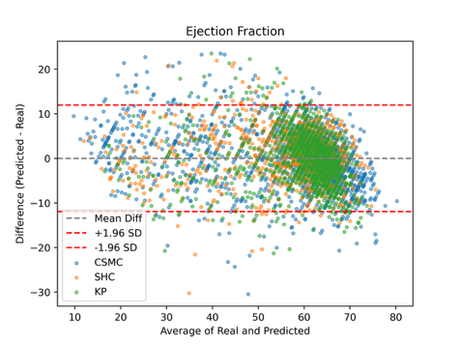 | 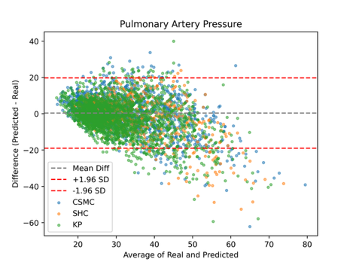 | 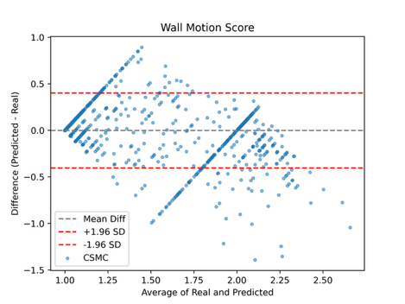
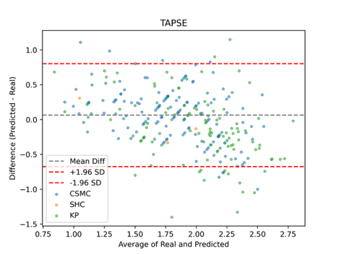 | 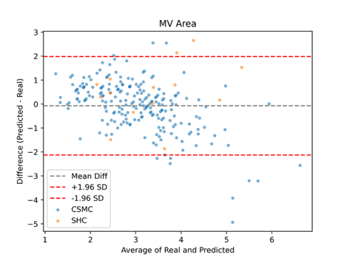 | 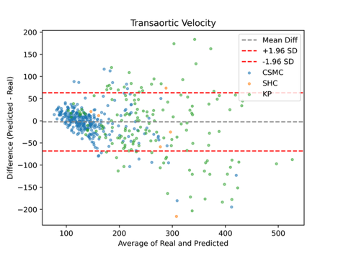
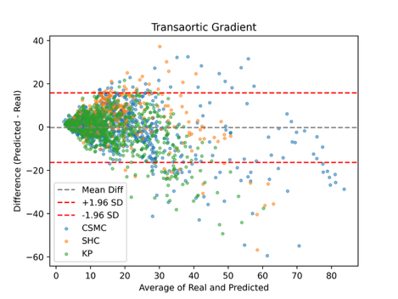 | 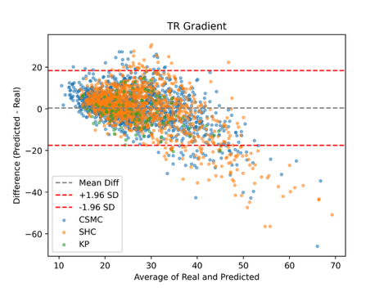 | 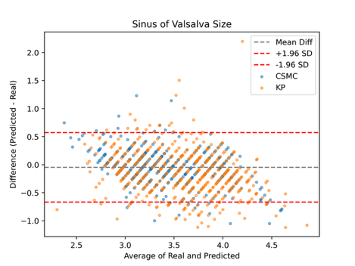
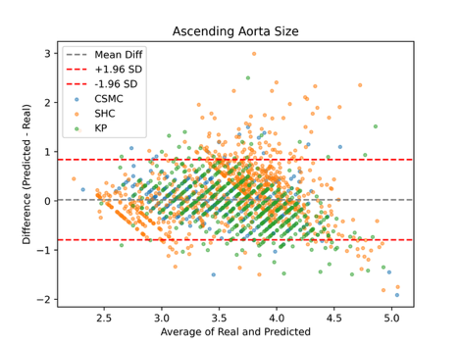 | 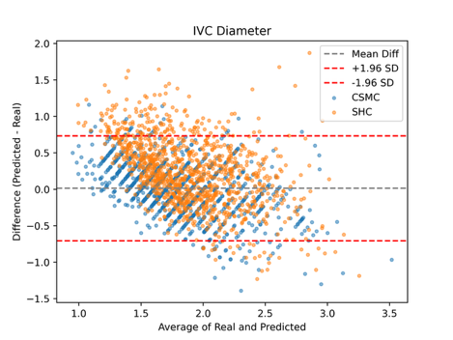
Supplementary Figure 1 Bland-Altman plots demonstrating EchoPrime’s performance on regression tasks across three medical centers
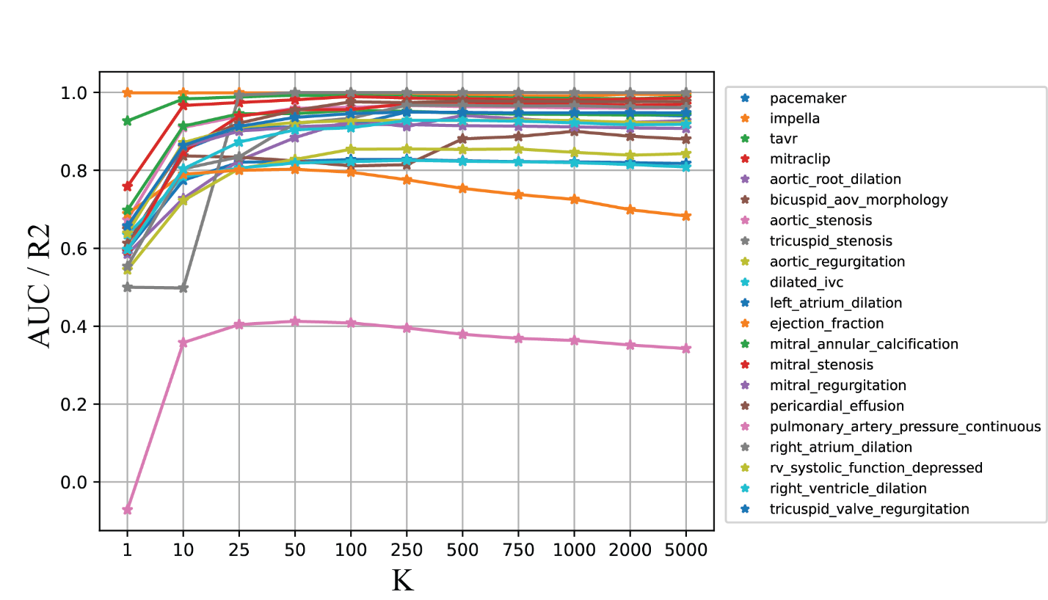
Supplementary Figure 2 Performance of Retrieval Based Interpretation as we increase the number of candidates reports to average across. For binary tasks the metric is AUROC and for regression tasks R2 score.

Supplementary Video 1 | EchoPrime Demo
All videos from a single echocardiography exam are uploaded into the EchoPrime interface, which automatically synthesizes information across all views and generates a complete, structured echocardiography report.

