Supplementary Information (SI) Guide for
Ectopic NMDAR expression in cancer unmasks germline-encoded autoimmunity
Sam O. Kleeman¹, Kevin Michalski^{1,5}, Xiang Zhao^{1,5}, Ruben Steigerwald¹, Miriam Ferrer¹, Llewelyn Levett¹, Ethan Ertel¹, Austin Schultz¹, Noriko Simorowski¹, Pamela Moody¹, Tse-Luen Wee¹, Cristina Valente², Sharon Fox², Mateusz Makuch^{3,4}, Selina Thomsen³, Ruby Harrison⁴, Claire Regan¹, Jonathan Preall¹, Qing Gao¹, Dennis Thomas¹, Jill Habel¹, Rachel Rubino¹, Sarosh Irani^{3,4}, Hiro Furukawa^{1,6,*}, Tobias Janowitz^{1,6,7*}
¹ Cold Spring Harbor Laboratory, Cold Spring Harbor, NY, USA
² Department of Pathology and Laboratory Medicine, Donald and Barbara Zucker School of Medicine at Hofstra/Northwell, Manhasset, NY, USA
³ Departments of Neurology and Neurosciences, Mayo Clinic, Jacksonville, FL, USA
⁴ Oxford Autoimmune Neurology Group, Nuffield Department of Clinical Neurosciences, University of Oxford, Oxford, UK
⁵ These authors contributed equally: Kevin Michalski and Xiang Zhao
⁶ These authors jointly directed the work: Hiro Furukawa and Tobias Janowitz
⁷ Lead contact
*Correspondence: furukawa@cshl.edu (H.F.), janowitz@cshl.edu (T.J.)

Contents
Supplementary Tables 2
Supplementary Table 1, related to Figure 2. 2
Supplementary Table 2, related to Figure 3. 3
Supplementary Table 3, related to Figure 3. 4
Supplementary Table 4, related to Figure 3. 5
Supplementary Table 5, related to Figure 4-5. 6
Supplementary Table 6. 8
Supplementary Notes 9
Supplementary Note 1. 9
Supplementary Figures 11
Supplementary Fig. 1, related to Figure 2c. 11
Supplementary Fig. 2, related to Figure 1. 12
Supplementary Fig. 3, related to Figure 3. 13
Supplementary Fig. 4, related to Figure 3. 14
Supplementary Fig. 5, related to Figure 3. 15
Supplementary Fig. 6, related to Figure 4. 16
Supplementary Fig. 7, related to Figure 4. 17
Supplementary Fig. 8, related to Figure 4. 18
Supplementary Fig. 9, related to Figure 5. 19
Supplementary Fig. 10, related to Figure 6. 20

Supplementary Tables

Supplementary Table 1, related to Figure 2. Grin1-2b insertion breakpoint sites (n=11) identified by targeted sequencing in 4T1-NMDAR clone used in this study, as shown in Fig. S2a. UTR, untranslated region.

Chromosome | Position | Sequence context
1 | 49821844 | Intronic region of unannotated transcript
1 | 163806479 | Intergenic
3 | 129763851 | UTR of annotated transcript
4 | 97661007 | Intergenic
7 | 52631156 | Intergenic
8 | 86611920 | Intronic region of non-canonical transcript, repeat region
8 | 94825511 | UTR of annotated transcript
12 | 3575608 | Intergenic
14 | 95163534 | Intergenic
16 | 27029305 | Repeat region
17 | 46107149 | UTR of unannotated transcript

Supplementary Table 2, related to Figure 3. ELISA binding (optical density/OD at 450 nm) of recombinant antibodies at 10,000ng/ml to BSA and polyspecific targets. All values represent the mean of duplicates with background and blank subtraction. OD <0.1 indicates background-level binding. Positive control results for polyspecific antibody G11 are shown in Extended Data Fig. 4d. mGO53 is a non-binding antibody control. LPS, lipopolysaccharide.

Clonotype | Sequence | OD-BSA | OD-LPS | OD-dsDNA | OD-Insulin
SK3D | Germline | 0.01 | 0.03 | 0.02 | 0.01
SK3D | Matured | 0.00 | 0.07 | 0.06 | 0.01
SK5A | Germline | 0.01 | 0.01 | 0.00 | 0.00
SK5A | Matured | 0.02 | 0.01 | 0.01 | 0.01
SK5B | Germline | 0.00 | 0.00 | 0.00 | 0.00
SK5B | Matured | 0.01 | 0.00 | 0.00 | 0.00
SK5G | Germline | 0.01 | 0.02 | 0.03 | 0.02
SK5G | Matured | 0.01 | 0.05 | 0.00 | 0.00
mGO53 | Control | 0.00 | 0.02 | 0.00 | 0.02

Supplementary Table 3, related to Figure 3. Summary of surface plasmon resonance (SPR) results, including association rate constant (ka), dissociation rate constant (kd) and the equilibrium dissociation constant (KD). Chi-squared value refers to the squared difference between experimental data and the fitted curve.

Clonotype | Sequence | kass | kdiss | KD | chi-squared
SK3D | Germline | 3723.59 | 0.02877209 | 7.73E-06 | 33.54
SK3D | Matured | 16399.08 | 0.00121501 | 7.41E-08 | 159.802
SK5A | Germline | 50088.09 | 0.02303518 | 4.60E-07 | 16.778
SK5A | Matured | 26998.59 | 0.00712607 | 2.64E-07 | 2.404
SK5B | Germline | 1755.961 | 0.00346113 | 1.97E-06 | 1.593
SK5B | Matured | 153118.8 | 0.00089632 | 5.85E-09 | 4.685
SK5G | Germline | 14735.5 | 0.00586057 | 3.98E-07 | 32.276
SK5G | Matured | 51218.01 | 0.00159172 | 3.11E-08 | 0.792

Supplementary Table 4, related to Figure 3. Summary of overall and local cryo-EM refinements generated in this study, annotated with resolutions determined by Fourier shell correlation (FSC) at a threshold of 0.143. All local refinements are C2 symmetry expanded except SK3D-Matured and the minor population of SK5A-Matured. All overall refinements are C1 symmetry-enforced except SK5A-Germline. ATD, amino-terminal domain; LBD, ligand-binding domain. SK5A-Apo refers to the complex of SK5A-Matured with NMDAR that was purified in the absence of glycine and glutamate. No data collection was performed for SK5A-Germline in the absence of glycine and glutamate.
 | Germline |  |  | Matured
Clonotype | Resolution (overall) | Symmetry (overall) | Resolution (local) | Resolution (overall) | Symmetry (overall) | Resolution (local)
SK3D | 3.68 | C1 | 3.72 (ATD-1), 3.72 (ATD-2) | 3.7 | C1 | 3.51 (ATD-1), 3.74 (ATD-2)
SK5A | 4.52 | C2 | 5.3 (ATD) | 4.06 | C1 | 4.03 (ATD-2)
SK5A-Apo |  |  |  | 4.08 | C1 | 4.06 (ATD), 4.00 (LBD)
SK5B | 4.46 | C1 | 5.82 (ATD) | 4.1 | C1 | 4.12 (ATD)
SK5G | 3.76 | C1 | 4.07 (ATD) | 3.09 | C1 | 2.99 (ATD)

Supplementary Table 5, related to Figure 4-5. Cryo-EM data collection and refinement statistics for full models. All antibodies were studied in complex with human GluN1a-GluN2B NMDAR protein. SK5A-Apo refers to the complex of SK5A-Matured with NMDAR that was purified in the absence of glycine and glutamate. All other data collections were performed in the presence of glycine and glutamate.
 |  |  | Matured |  |  |  |  |  | Germline
 |  |  | SK3D | SK5A | SK5A-Apo | SK5B | SK5G | OX1 | SK3D | SK5A | SK5B | SK5G | OX1
Data collection and processing | Magnification |  | x105,000
Data collection and processing | Energy filter slit width (eV) |  | 20
Data collection and processing | Voltage (kV) |  | 300
Data collection and processing | Electron exposure (e–/Å²) |  | 71.7 | 40.8 | 71.7 | 61 | 66.9 | 82.2 | 59.1 | 49 | 56 | 66 | 59.1
Data collection and processing | Defocus range (μm) |  | −0.8 to −2.2
Data collection and processing | Pixel size (Å) |  | 0.856 | 0.827 | 0.856 | 0.861 | 0.861 | 0.856 | 0.861 | 0.827 | 0.846 | 0.861 | 0.827
Data collection and processing | Symmetry imposed |  | C1 | C1 | C1 | C1 | C1 | C1 | C1 | C2 | C1 | C1 | C2
Data collection and processing | Initial particle images (no.) |  | 1.25 million | 1.82 million | 6.96 million | 497,000 | 6.33 million | 1.23 million | 2.63 million | 1.15 million | 7.24 million | 2.34 million | 548,029
Data collection and processing | Final particle images (no.) |  | 130,398 | 87,672 | 114,482 | 66,249 | 352,293 | 87,541 | 66,165 | 24,585 | 52,452 | 259,879 | 61,069
Data collection and processing | 0.143 Fourier shell correlation (FSC) half map masked (Å) |  | 3.7 | 4.06 | 4.08 | 4.1 | 3.09 | 4.2 | 3.76 | 4.72 | 4.57 | 3.81 | 4.55
Data collection and processing | 0.143 FSC half map unmasked (Å) |  | 3.79 | 4.08 | 4.15 | 4.14 | 3.13 | 4.26 | 3.68 | 4.52 | 4.46 | 3.76 | 4.64
Refinement | Initial model used (PDB code) |  | 7saa | 7saa | 7saa | 7saa | 7saa | 7saa | 7saa | 7saa | 7saa | 7saa | 7saa
Refinement | 0.5 FSC model resolution masked (Å) |  | 3.7 | 4 | 4.2 | 4.1 | 2.9 | 4.4 | 3.7 | 4.5 | 4.1 | 3.7 | 4.7
Refinement | 0.5 FSC model resolution unmasked (Å) |  | 3.7 | 4.1 | 4.3 | 4.1 | 3.2 | 4.7 | 3.7 | 4.5 | 4.2 | 3.8 | 4.8
Refinement | Map sharpening B factor (Å²) |  | -83 | -91.6 | -91.6 | -100.2 | -99.7 | -110.5 | -78.4 | -134 | -124.6 | -119.3 | -199.3
Refinement | CC (model vs map, masked) |  | 0.77 | 0.74 | 0.74 | 0.76 | 0.86 | 0.74 | 0.75 | 0.77 | 0.72 | 0.79 | 0.72
Refinement | Model composition | Non-hydrogen atoms | 26181 | 26017 | 26017 | 26391 | 26743 | 26079 | 26155 | 26201 | 24540 | 24916 | 26081
Refinement | Model composition | Protein residues | 3553 | 3537 | 3537 | 3565 | 3589 | 3555 | 3553 | 3537 | 3333 | 3358 | 3555
Refinement | Model composition | Ligands | 0 | 0 | 0 | 0 | 0 | 0 | 0 | 0 | 0 | 0 | 0
Refinement | R.m.s. deviations | Bond lengths (Å) | 0.004 | 0.005 | 0.008 | 0.006 | 0.004 | 0.006 | 0.006 | 0.005 | 0.005 | 0.007 | 0.006
Refinement | R.m.s. deviations | Bond angles (°) | 1.052 | 1.105 | 1.139 | 1.237 | 0.87 | 1.146 | 1.15 | 1.163 | 1.121 | 1.091 | 1.387
Refinement | Validation | MolProbity score | 2.26 | 2.08 | 2.19 | 2.17 | 2.07 | 2.27 | 2.52 | 2.18 | 2.14 | 2.35 | 2.31
Refinement | Validation | Clashscore | 6.63 | 9.53 | 11.94 | 12.52 | 4 | 13.73 | 11.24 | 11.76 | 11.33 | 6.81 | 12.4
Refinement | Validation | Poor rotamers (%) | 3.03 | 0.04 | 0.04 | 0.04 | 3.74 | 0 | 0.03 | 0 | 0.04 | 3.91 | 0
Refinement | Ramachandran plot | Favored (%) | 90.71 | 89 | 87.9 | 89.51 | 93.06 | 86.74 | 90.29 | 88.08 | 89.3 | 90.93 | 82.56
Refinement | Ramachandran plot | Allowed (%) | 8.8 | 10.23 | 11.27 | 9.58 | 6.46 | 12.32 | 8.68 | 11.15 | 10.09 | 8.43 | 15.99
Refinement | Ramachandran plot | Disallowed (%) | 0.48 | 0.77 | 0.83 | 0.91 | 0.48 | 0.94 | 1.02 | 0.77 | 0.61 | 0.63 | 1.45

Supplementary Table 6. Clinicopathological summary of patient samples analyzed in this study. Multiple profiling techniques were applied to individual specimens where indicated by repeated study identifiers. Figure references indicate where data from each sample are presented in the manuscript. NA, not available.

Supplementary Notes
Supplementary Note 1. Description of cryo-EM processing workflow parameters that are indicated in Figure S6-8.
Workflow A
- Movie alignment and CTF estimation in WARP
- Patch motion correction and patch CTF correction in cryoSPARC
- 2D classification with WARP particle picks (BoxNet)
- Select 2D classes -->
  - A1: Template picking in cryoSPARC
    - Diameter 220
  - A2: Select 2D classes -->Train Topaz model (SK5B-Matured) or train ensemble of Topaz models (SK5A-Germline, SK5A-Matured)
    - Downsampling factor: 8 (SK5B-Matured), 9 (SK5A-Matured), 16 (SK5A-Germline)
    - Expected number of particles: 50 (SK5B-Matured), 150 (SK5A-Germline), 200 (SK5A-Matured)
    - Minibatch size: 64
- Particle extraction with 400px box size, Fourier crop to 100px

Workflow B
- Ab initio reconstruction with selected 2D classes
- Multiple rounds (n rounds) of iterative heterogeneous refinement, including NMDAR-like and junk classes
- Particle re-extraction with 400px box size, no Fourier crop

Workflow C
- Non-uniform refinement in cryoSPARC: C1 symmetry
  - Minimize over per-particle scale: true

Workflow C2
- Non-uniform refinement in cryoSPARC: C2 symmetry
  - Minimize over per-particle scale: true
  - Initialize noise model from images: true
  - Number of extra final passes: 5
  - Initial lowpass resolution (A): 15

Workflow D1
- Masked 3D classification in cryoSPARC

Workflow D2
- Symmetry expansion (C2)
- Masked 3D classification in cryoSPARC

Workflow D3
- 3D classification in Relion, using particle diameter 260Å and initial volume generated using relion_reconstruct_mpi command

Workflow E1
- Local refinement (C1)
  - (Except 5G-Matured/Germline) Use pose/shift gaussian prior during alignment: true
    - Standard deviation (deg) of prior over rotation: 3
    - Standard deviation (A) of prior over shifts: 2
  - Number of extra final passes: 3
  - Initial low-pass resolution (A): 8
  - (For SK5A-Matured) Enforce non-negativity: True

Workflow E2
- Symmetry expansion (C2)
- Local refinement (C1)
  - (Except 5G-Matured/Germline) Use pose/shift gaussian prior during alignment: true
    - Standard deviation (deg) of prior over rotation: 3
    - Standard deviation (A) of prior over shifts: 2
  - Number of extra final passes: 3
  - Initial low-pass resolution (A): 8
  - (For SK5B-Germline) Enforce non-negativity: True

Workflow F
- Ab initio reconstruction (n classes)
  - (SK5A-Germline) Center structures in real space: False
  - (m-Germline) Enforce non-negativity: False

Workflow G
- Masked 3D classification (extracellular domain mask) in cryoSPARC using 25Å filter resolution to generate low-resolution bound and unbound volumes
- Heterogenous refinement to segregate bound versus unbound particles using volumes generated in step 1

Supplementary Figures
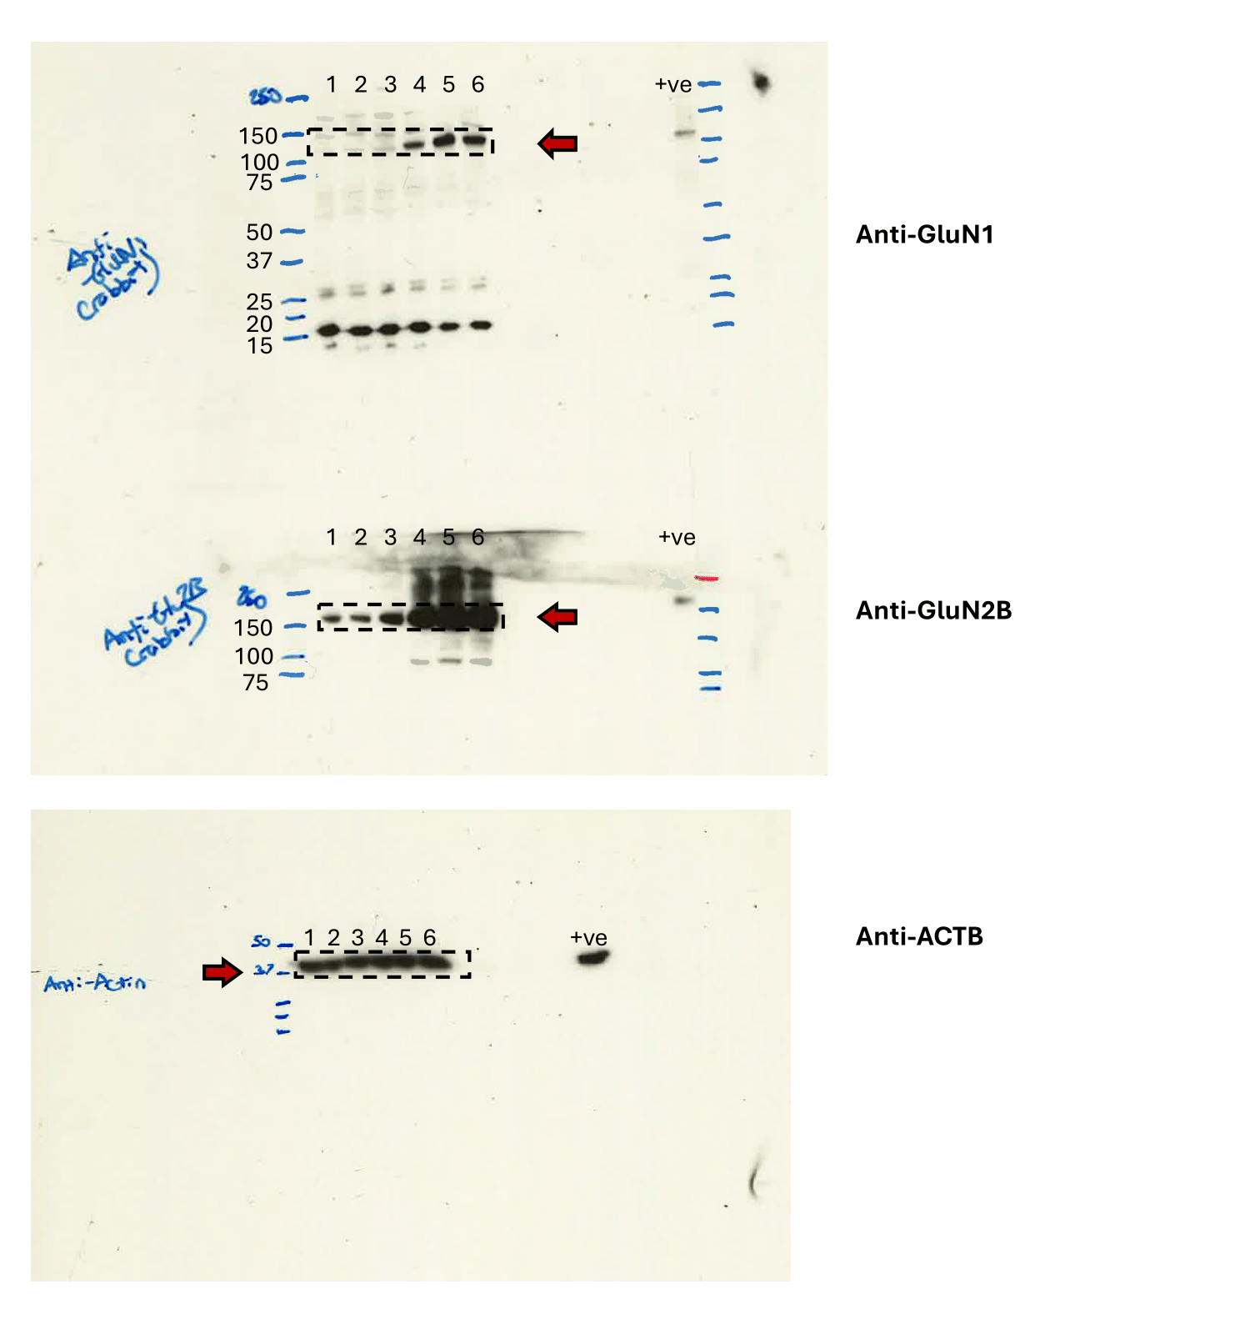

Supplementary Fig. 1, related to Figure 2c. Source data for western blot images. Immunoblots from Figure 2c were generated from whole cell lysates of stably transfected 4T1-NMDAR cells, treated with 0-100ng/ml (0, 1, 5, 10, 50, 100) doxycycline (DOX). Positive control refers to cell lysate from cells recombinantly expressing GluN1-GluN2B heteromers. Expected molecular weight (kDa) of each protein is indicated with a red arrow, ladder is BioRad #1610374. Boxes indicate the areas shown in the final figures. All 6 4T1-NMDAR lysates are derived from the same experiment, and all 3 gels/blots were processed in parallel. Beta-actin immunoblot reflects sample processing control.
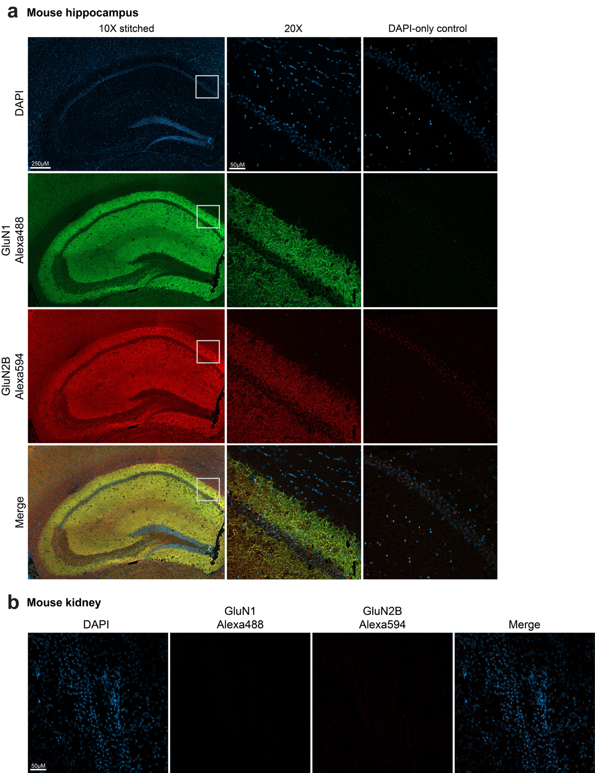
Supplementary Fig. 2, related to Figure 1. a, Immunofluorescence (IF) for GluN1 and GluN2B in mouse hippocampus coronal section. DAPI-only control refers to serial section stained only with DAPI to screen for autofluorescence. b, IF for GluN1 and GluN2B in mouse kidney section.
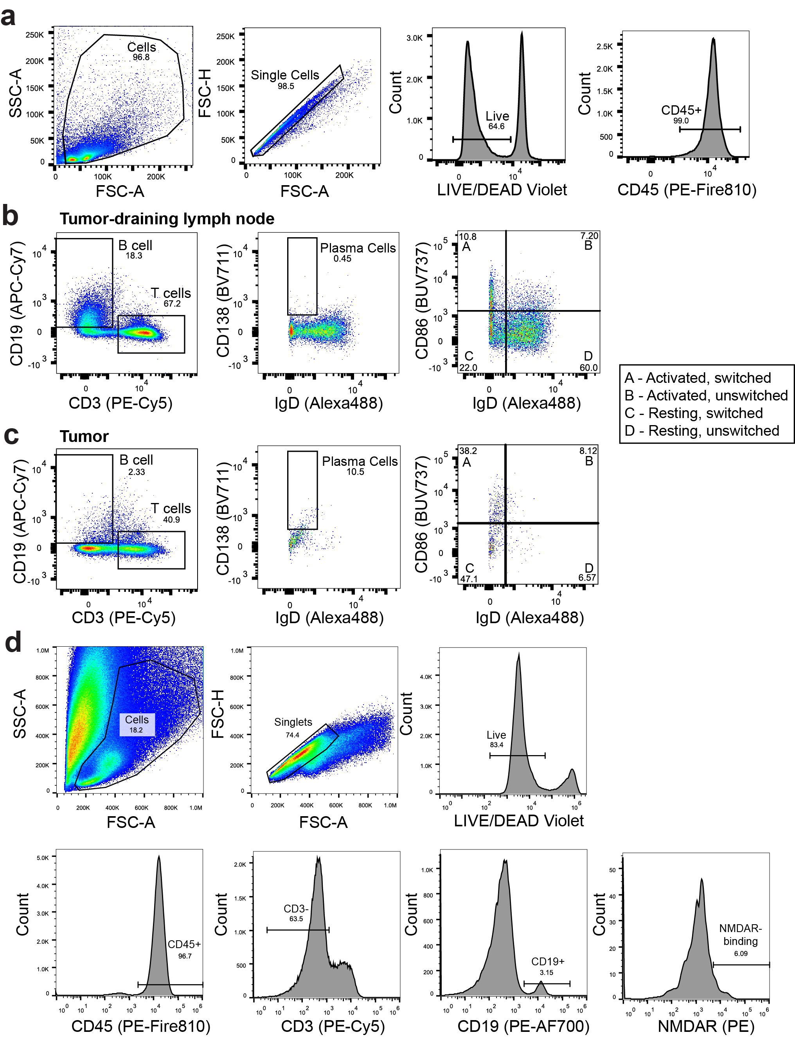
Supplementary Fig. 3, related to Figure 3. a, Representative flow cytometry plots demonstrating the gating strategy for live, singlet, CD45-positive cells. b-c, Flow cytometry analysis of immune cell populations in tumor-draining lymph nodes (b) and tumors (c). Left: proportions of CD19+ B cells and CD3+ T cells. Middle: Class-switched (IgD-) CD138+ plasma cells identified within CD19+ B cell gate. Right: Class-switched (IgD-) and unswitched (IgD+) B cells, further subdivided into activated and resting populations based on CD86 expression levels. d, Representative flow cytometry plots demonstrating the gating strategy for live, CD45-positive, CD3-negative, and CD19-positive cells. Final cell selection is based on high signal in the PE channel, reflecting B cell capture of PE-labeled GluN1-GluN2B NMDAR.
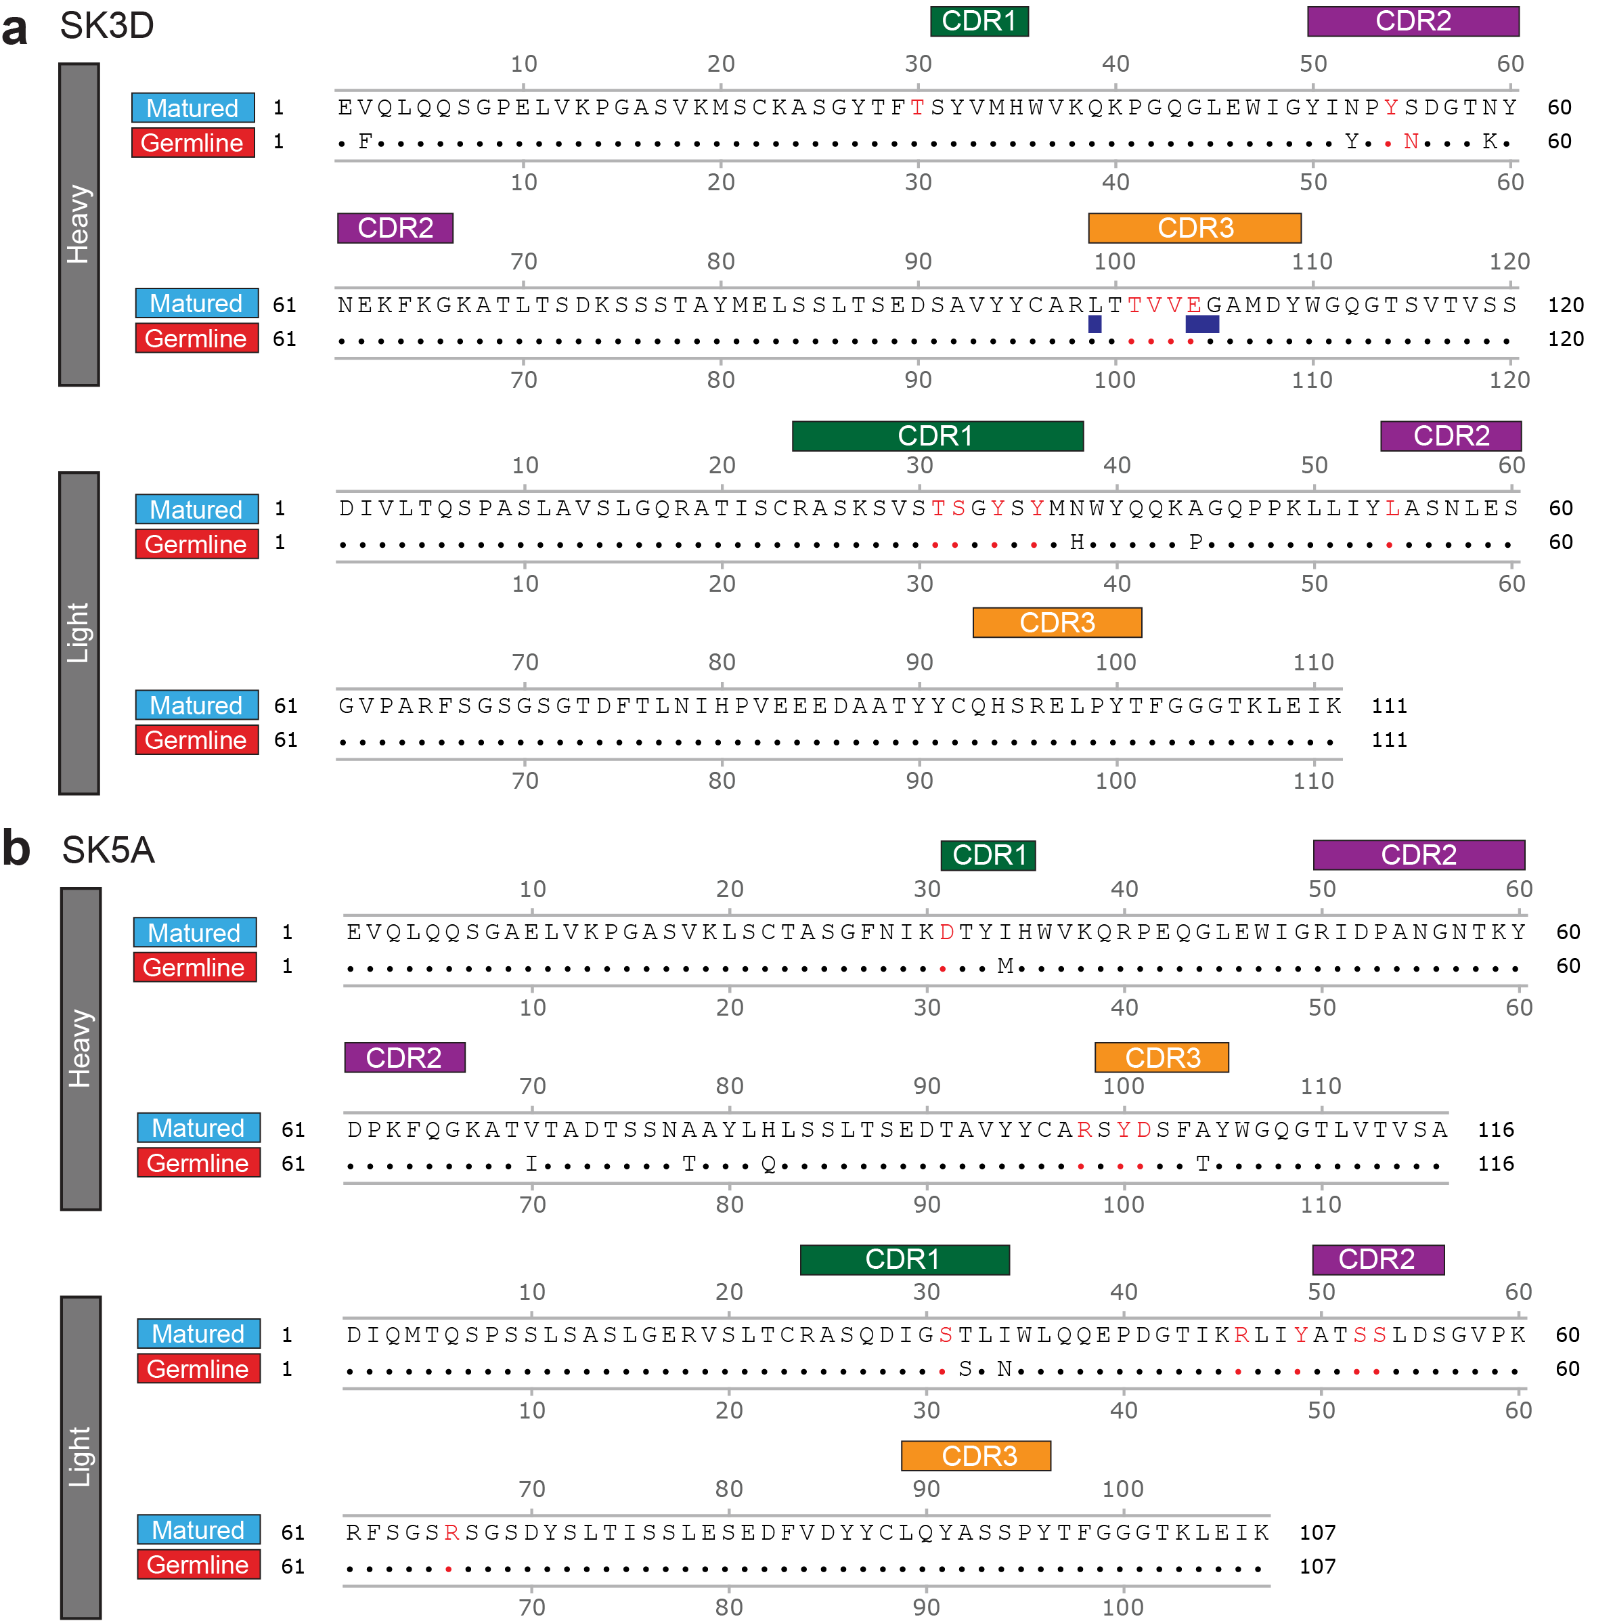
Supplementary Fig. 4, related to Figure 3. a-b, Amino acid alignments of germline and matured heavy and light chain sequences for SK3D (a) and SK5A (b). The matured sequence is shown in full, with any differences between the germline and matured sequence indicated. Red residues are involved in NMDAR binding. Residues highlighted with a blue rectangle are translated from N- or P-nucleotides and so the germline residue cannot be imputed with certainty. In the case of SK5A, a germline sequence was directly detected, so no imputation was performed. CDR1-3 regions, as determined by the Kabat definitions, are annotated.

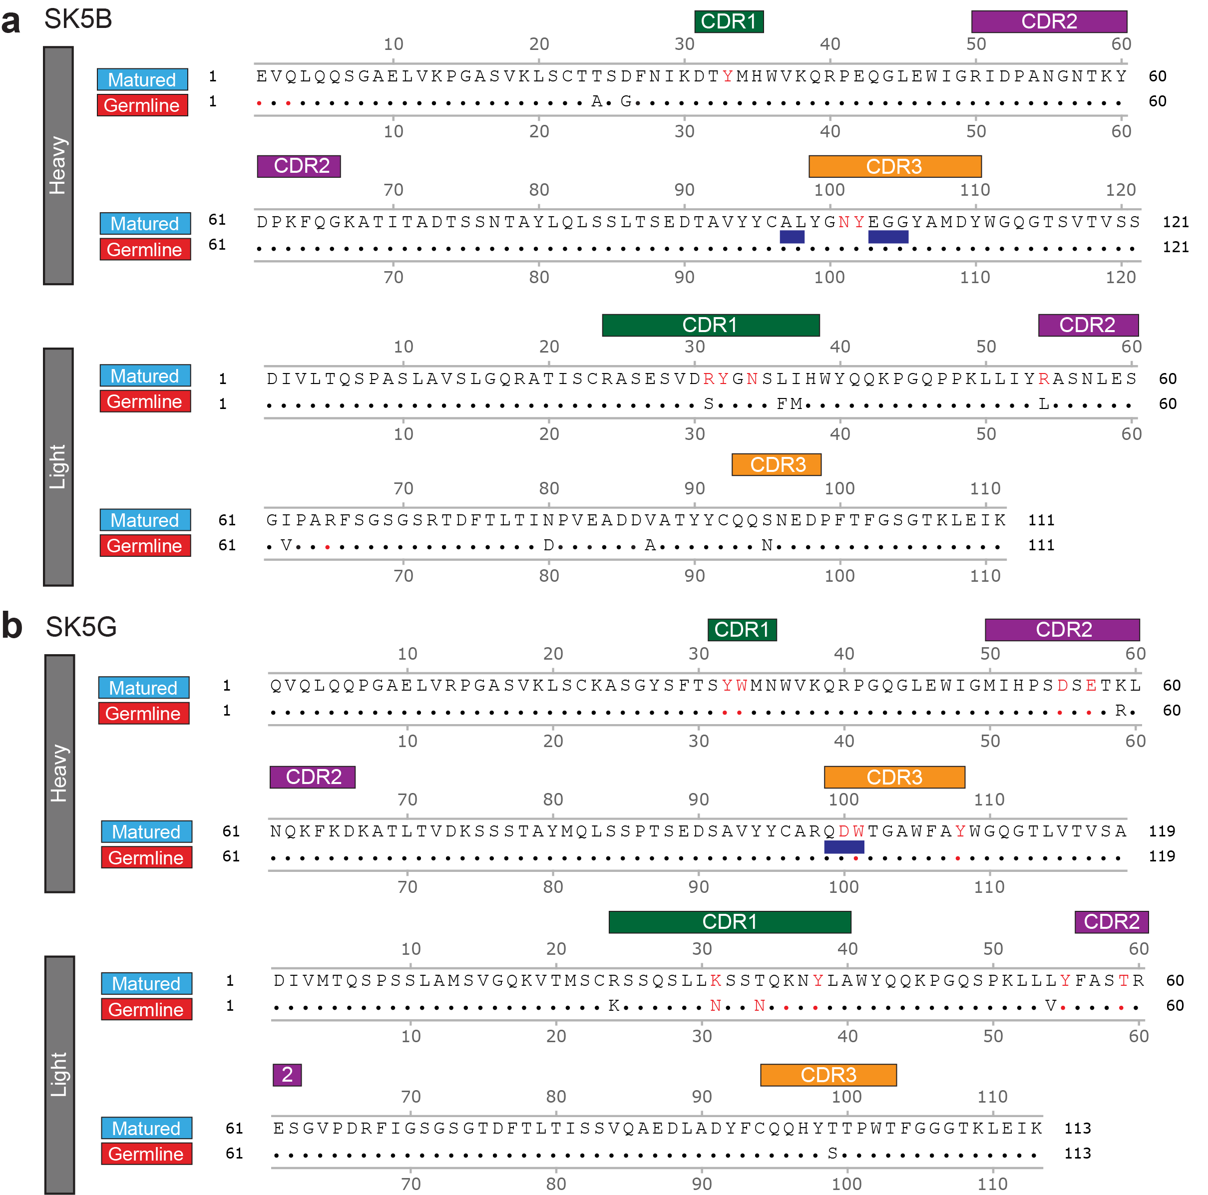
Supplementary Fig. 5, related to Figure 3. a-b, Amino acid alignments of germline and matured heavy and light chain sequences for SK5B (a) and SK5G (b). The matured sequence is shown in full, with any differences between the germline and matured sequence indicated. Red residues are involved in NMDAR binding. Residues highlighted with a blue rectangle are translated from N- or P-nucleotides and so the germline residue cannot be determined with certainty. CDR1-3 regions, as determined by the Kabat definitions, are annotated.

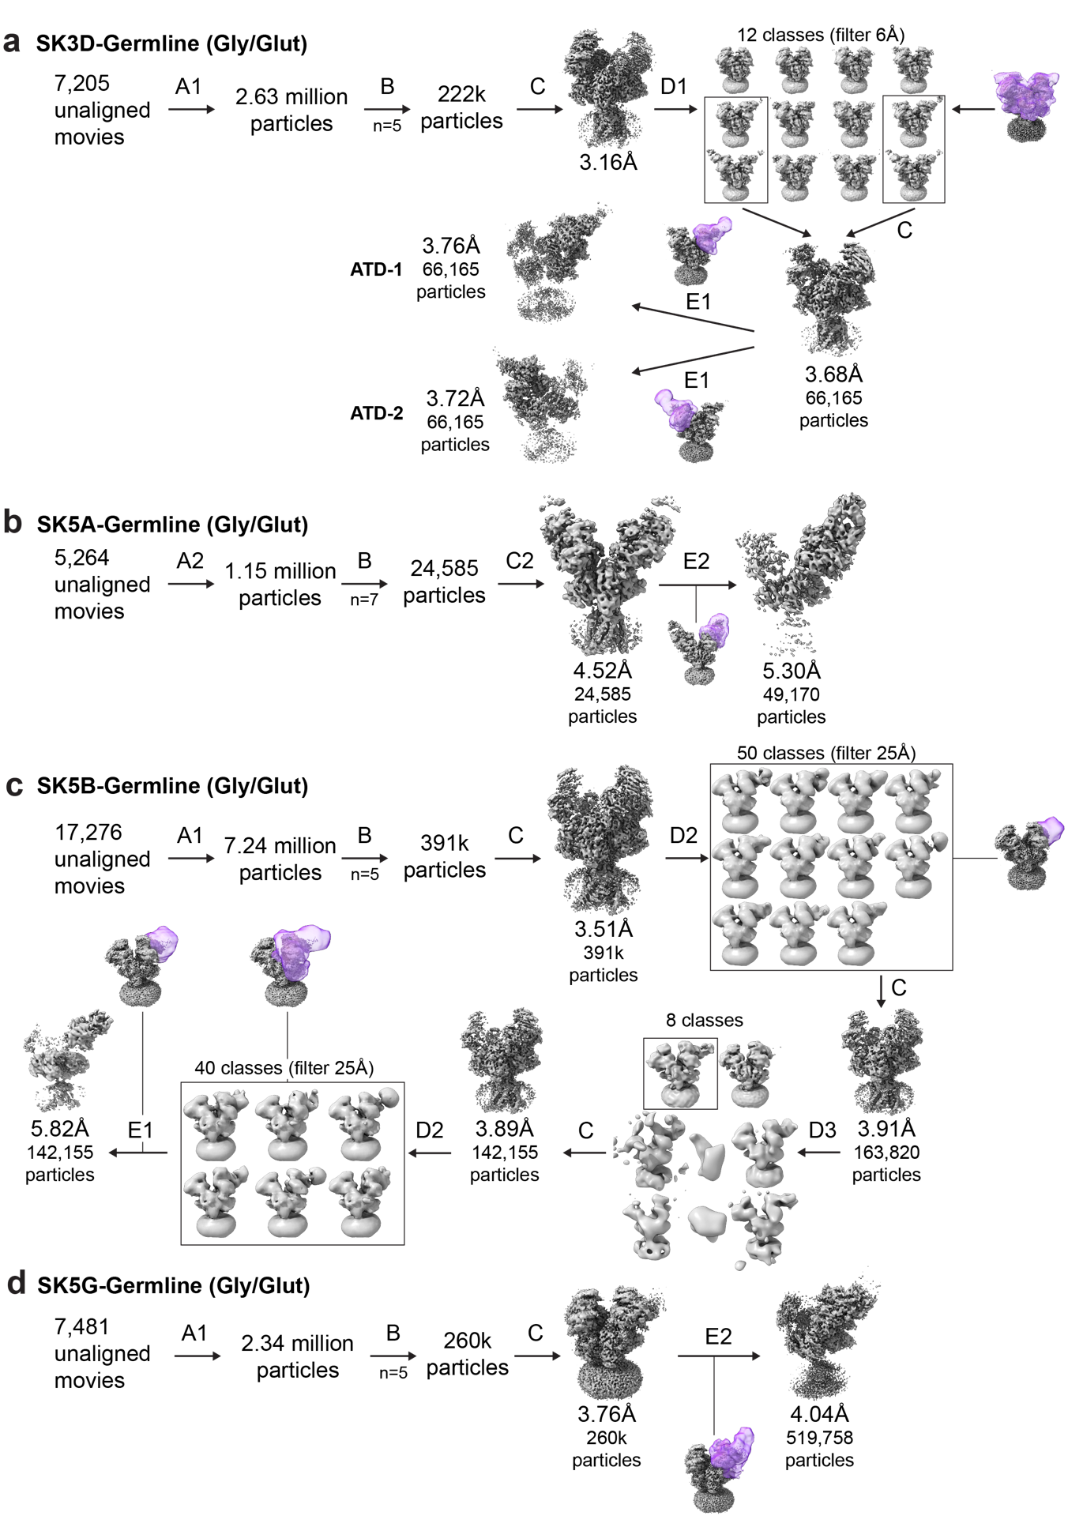
Supplementary Fig. 6, related to Figure 4. a-d, Summary of data processing for germline antibodies: SK3D-Germline (a), SK5A-Germline (b), SK5B-Germline (c), and SK5G-Germline (d). The meaning of each data processing step (A-F) is summarized in Note S1. Masks for focused classification and refinement are shown in purple. The handedness of the final reconstructions was Z-flipped as appropriate.
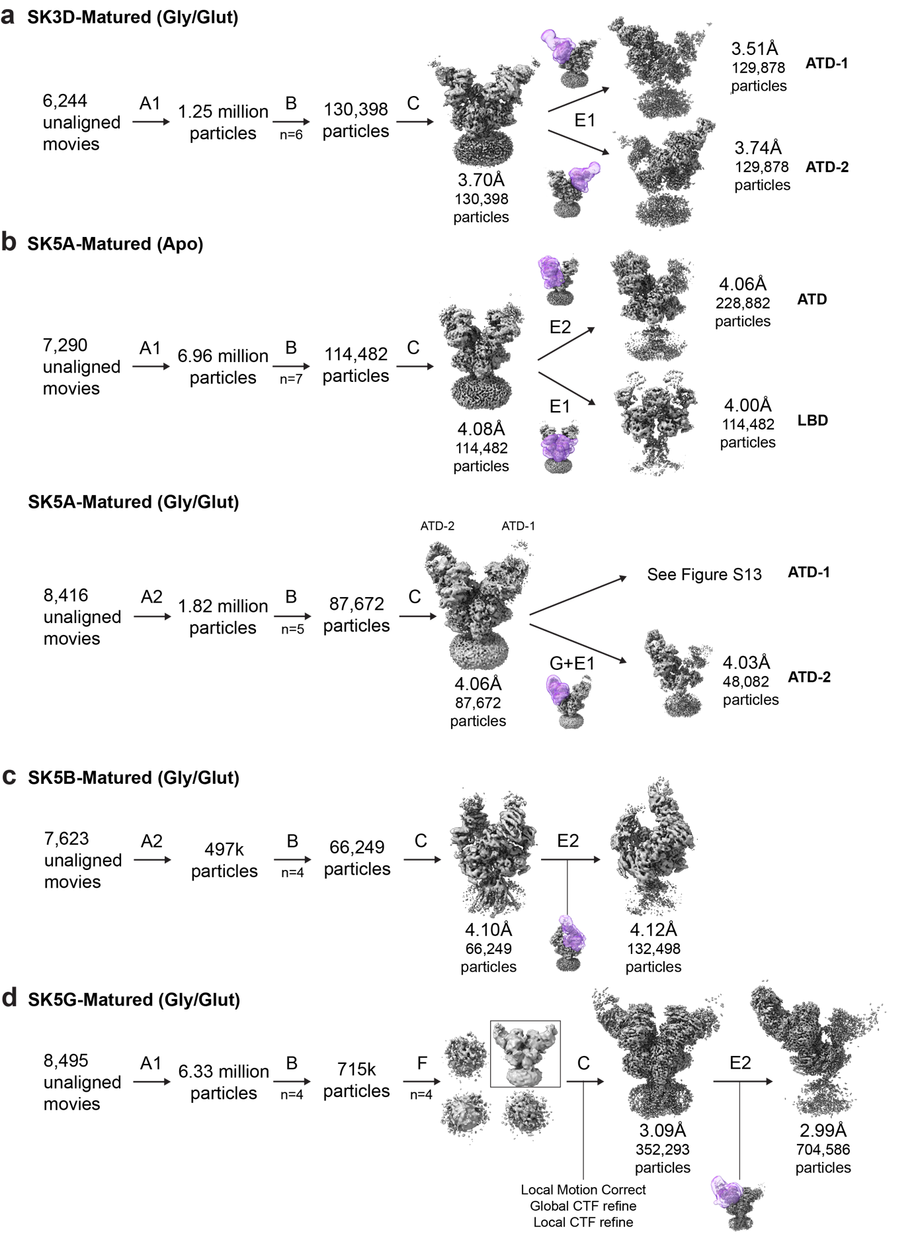
Supplementary Fig. 7, related to Figure 4. a-d, Summary of data processing for germline antibodies: SK3D-Matured (a), SK5A-Matured with and without agonists (b), SK5B-Matured (c), and SK5G-Matured (d). The meaning of each data processing step (A-F) is summarized in Note S1. Masks for focused classification and refinement are shown in purple. The handedness of the final reconstructions was Z-flipped as appropriate.
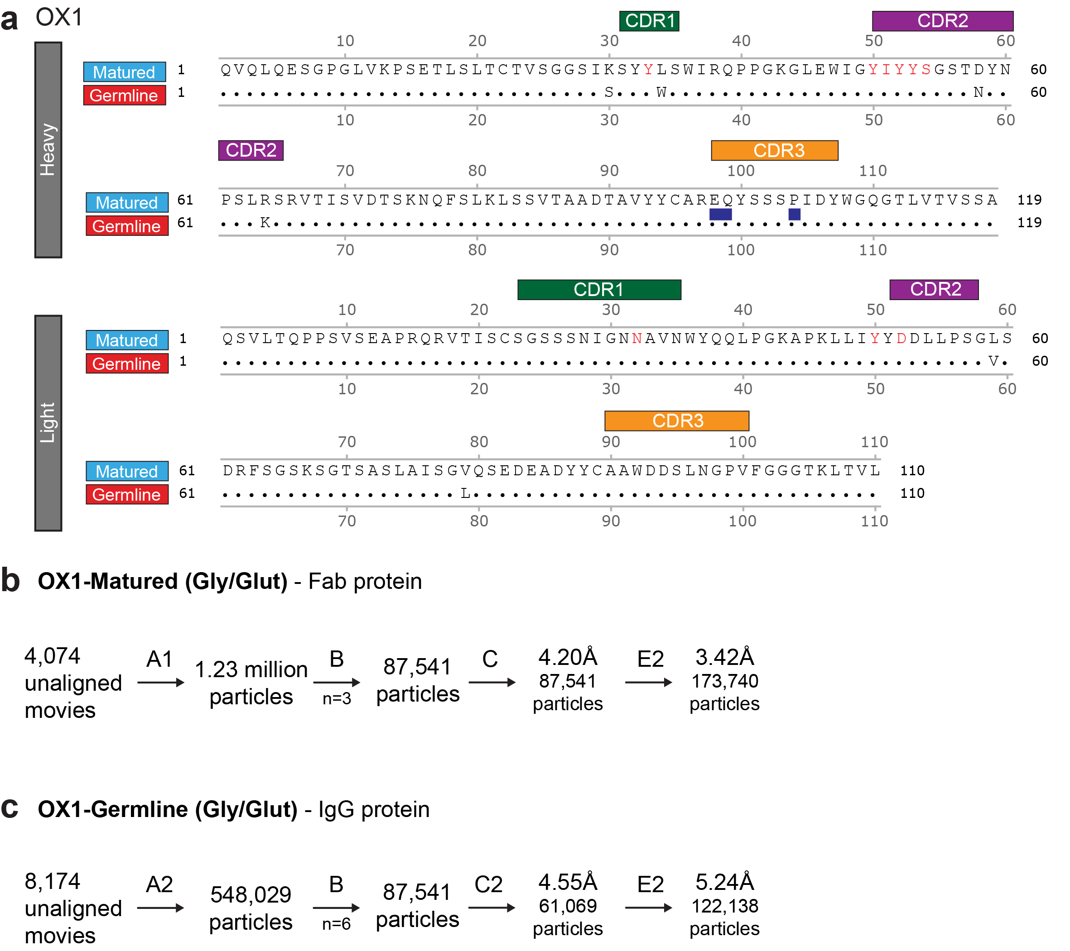
Supplementary Fig. 8, related to Figure 4. a, Amino acid alignments of germline and matured heavy and light chain sequences for OX1. The matured sequence is shown in full, with any differences between the germline and matured sequence indicated. Red residues are involved in NMDAR binding. Residues highlighted with a blue rectangle are translated from N- or P-nucleotides and so the germline residue cannot be determined with certainty. CDR1-3 regions, as determined by the Kabat definitions, are annotated. c-d, Summary of data processing for OX1-Germline (c), and OX1-Matured (d). The meaning of each data processing step (A-E) is summarized in Note S1.

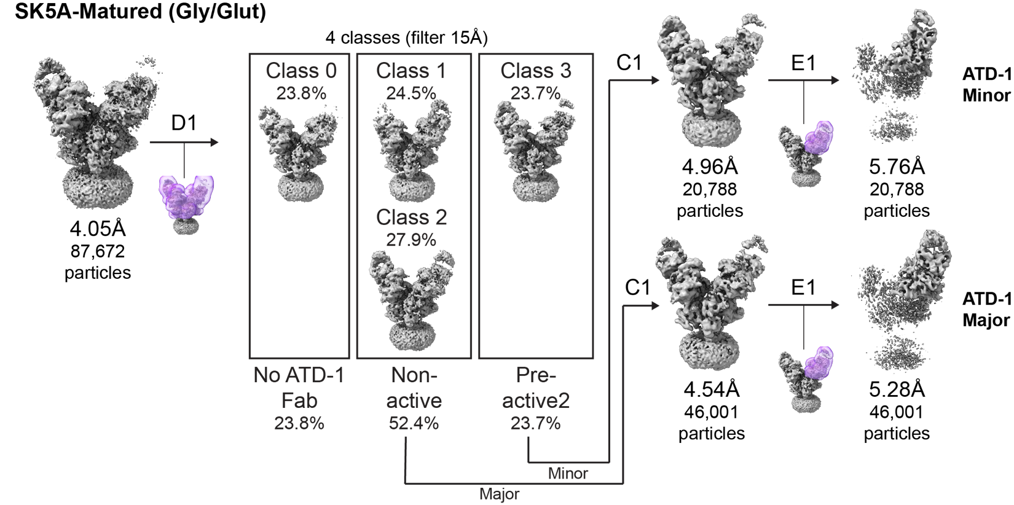
Supplementary Fig. 9, related to Figure 5. Schematic summarizing 3D classification of SK5A-Matured (Glycine/Glutamate) dataset into a major class consistent with the non-active state and a minor class consistent with the pre-active2 state. Non-uniform refinement and local refinement (for ATD-1) are performed for the major and minor particle classes.

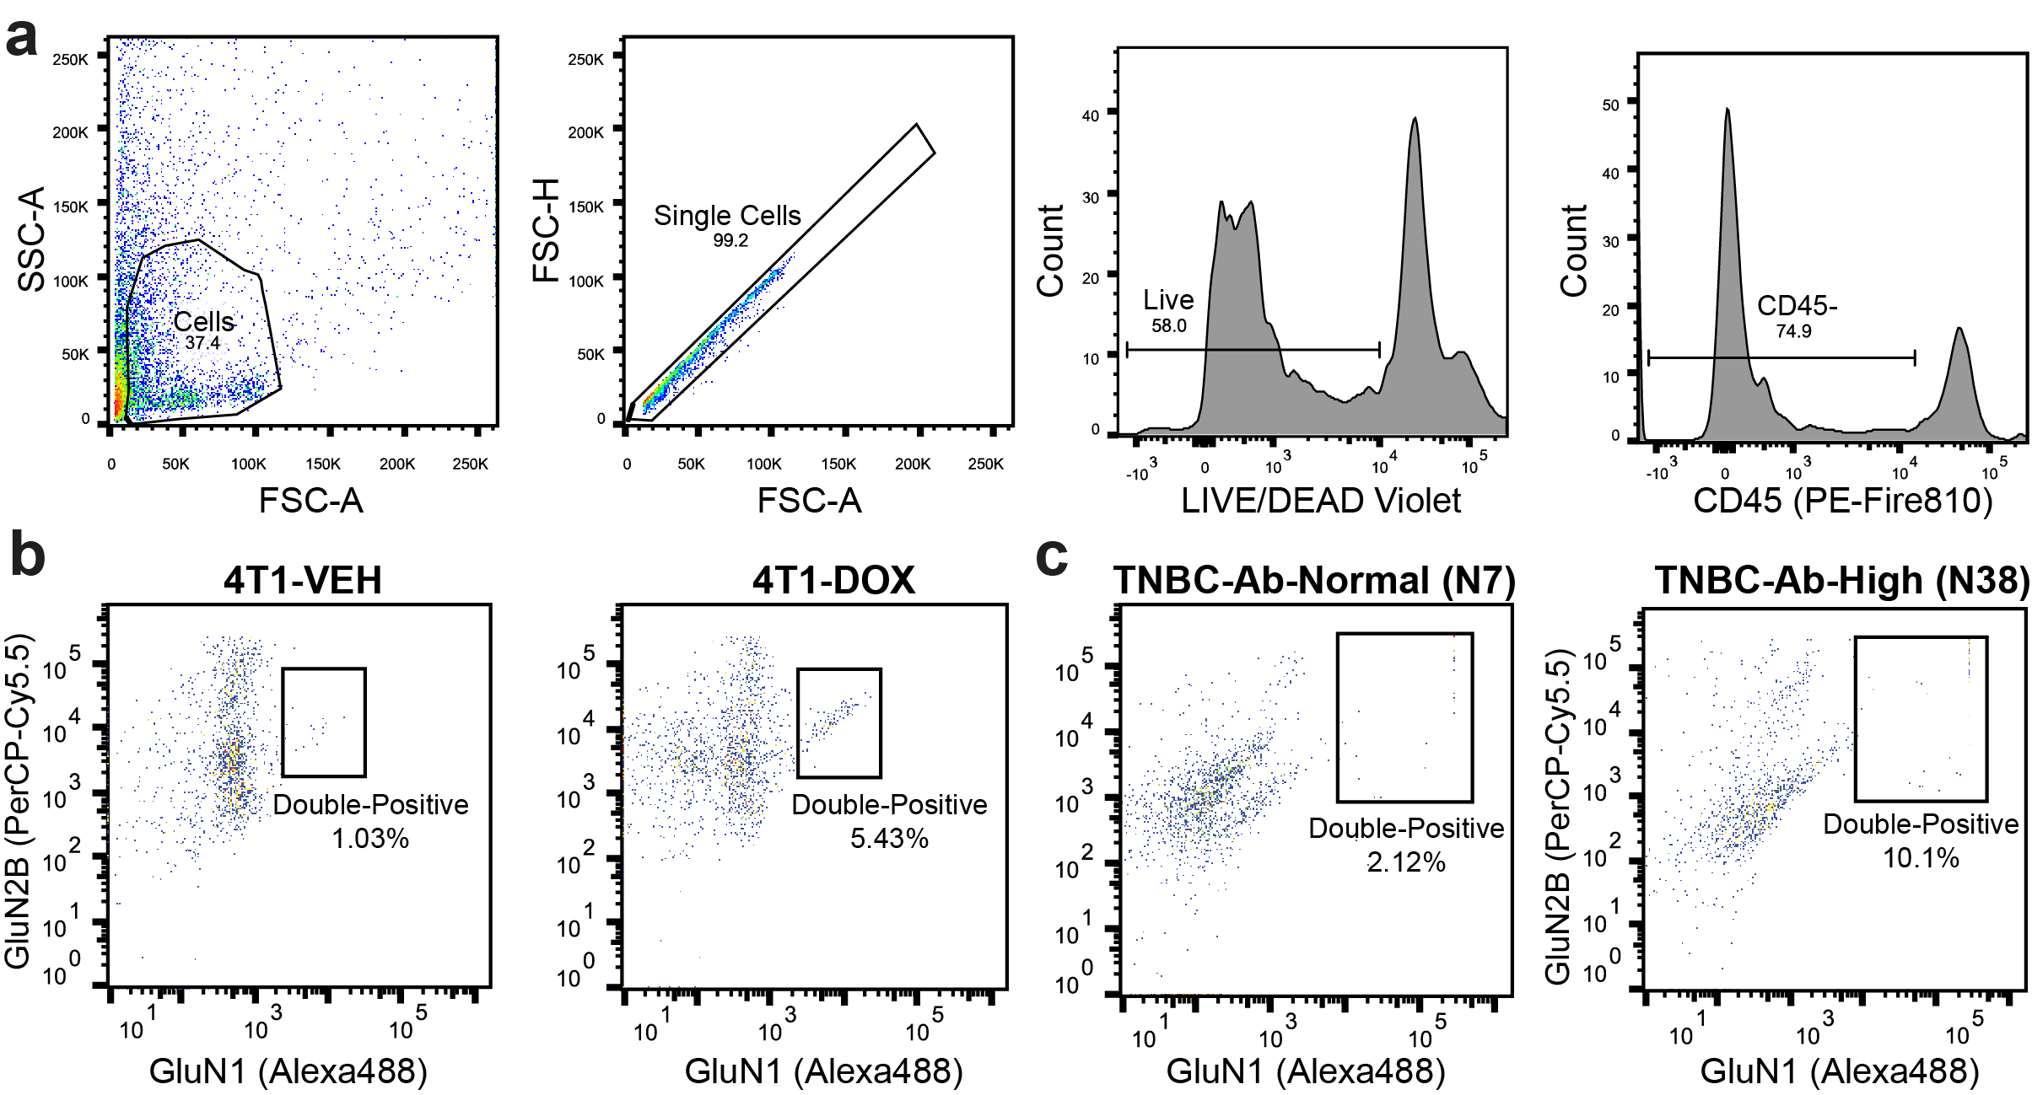
Supplementary Fig. 10, related to Figure 6. a, Representative flow cytometry plots demonstrating the gating strategy for live, singlet, CD45-negative cells isolated from tumor suspensions. b-c, Flow cytometry analysis of GluN1 and GluN2B expression in CD45-negative cells from 4T1-NMDAR tumors in the presence or absence of DOX (b) and human TNBC tumors with normal (N7) and high (N38) anti-NMDAR antibody titers (c). Percentages indicate double-positive cell fractions.

