Supplementary Info

Supplementary Table 1. De novo designed protein binders.

Cancer
Target | Affinity (nM) | Target | Affinity (nM) | Target | Affinity (nM) | Target | Affinity (nM) | Target | Affinity (nM)
ALK | 6 | CKIT | 75 | HRAS | 177 | LTK | 1.7 | pMHC - PRAME | 96
ALK2 | 177 | EA1 | 100 | IGF1R | 860 | Mcl-1 | 0.5 | TGFβ | 113
ALK3 | 0.076 | EED | 0.19 | IL2rb | 19/38 | NRAS | 595 | TGFβR2 | < 1
Bcl-2 | 0.8 | EF1 | 500 | IL2Rα | 0.94 | NRP1 | 193 | Tie2 | 0.258
Bcl-B | 25 | EGFR | 1.2 | Integrin αvβ6 | 0.11 | PDGFR | 82 | TrkA | 1.4
Bcl-w | 1 | FGFR2 | 243 | Integrin αvβ8 | 0.5 | PDGFRA | 4.1
Bcl-xL | 5.6 | Fz4 | 1.4 | KRAS4A | 380 | pMHC-MAGE | 29
BFL-1 | 1 | Fz5 | 0.22 | KRAS4B | 434 | pMHC-Mart-1 | 10.5
Immune modular
Target | Affinity (nM) | Target | Affinity (nM) | Target | Affinity (nM) | Target | Affinity (nM) | Target | Affinity (nM)
4-1BB | 44 | FCRL5 | 27 | IL1R | 2.8 | IL23R | < 0.001 | TNFR1 | <0.001
CD3δ | 612 | GP130 | 3 | IL6Rα | 0.3 | OX40 | 24 | TNFR2 | 0.036
γ_{c} | 97 | IL10Ra | 30 | IL7Rα | 0.31 | PD-L1 | 0.6
CTLA-4 | < 0.1 | IL17 | 0.01 | IL21Rα | 0.1 | PD1 | 100
Diagnostics |  | Infectious Disease |  |  |  | Synthetic biology
Target | Affinity (nM) | Target | Affinity (nM) | Target | Affinity (nM) | Target | Affinity (nM) | Target | Affinity (nM)
CPS | 100 | Abp1D | 3 | SARS-CoV-S | < 0.1 | Bid | 7 | MSLN | <1
GIP | 6.96 | Abp2D | 30 | TcdB | 0.01 | Bim | < 0.5 | VP16 | 35
GLP1 | 68.8 | BHRF1 | 58 | TcsL | 0.02 | CTN20 | 10 | VP48 | 39
glucagon | < 0.5 | CSPN | 360 | VirB8 | 0.51 | FAM21 | 9
NPY | 5.3 | HNV-G | 0.0687 |  |  | G3bp1 | 11
PTH | < 0.5 | InfluenzaHA | 320 |  |  | GRP2 | 42
PYY | 1, 23 | MERS-CoV-S | 8 |  |  | GRP3 | 10
Secretin | 3.95 | pMHC-HIV10 | 5.4 |  |  | Hsp70 | 37.2
Miscellaneous
Target | Application | Affinity (nM) | Target | Application | Affinity (nM) | Target | Application |  | Affinity (nM)
Aβ42 | Brain Disease | 83 | Amylin | Diabetes | 3.8 | CTN4 | Newborn Disease |  | 16
Neurotensin | Brain Disease | 1 | C peptide | Diabetes | 28 | FGFR2 | Tissue Regeneration |  | 0.453
PER2 | Brain Disease | 67 | InsulinR | Diabetes | 2 | Integrin α5β1 | Tissue Regeneration |  | 0.3
prion | Brain Disease | 12 | a-CTX | Anti-toxin | 1.9 | ASGPR | Trafficking/degradation |  | 2700
Angiotensin I R | Cardiac Disease | 77 | alpha-cobratoxin | Anti-toxin | 1.9 | IGF2R | Trafficking/degradation |  | 6.5
Apelin | Cardiac Disease | 92 | BoNT/B | Anti-toxin | 1 | Sortilin | Trafficking/degradation |  | 21
Dynorphin A | Chronic pain | <1 | CTX1 | Anti-toxin | 9 | Transferrin | Trafficking/degradation |  | 20
Dynorphin B | Chronic pain | 9 | short neurotoxin | Anti-toxin | 0.9

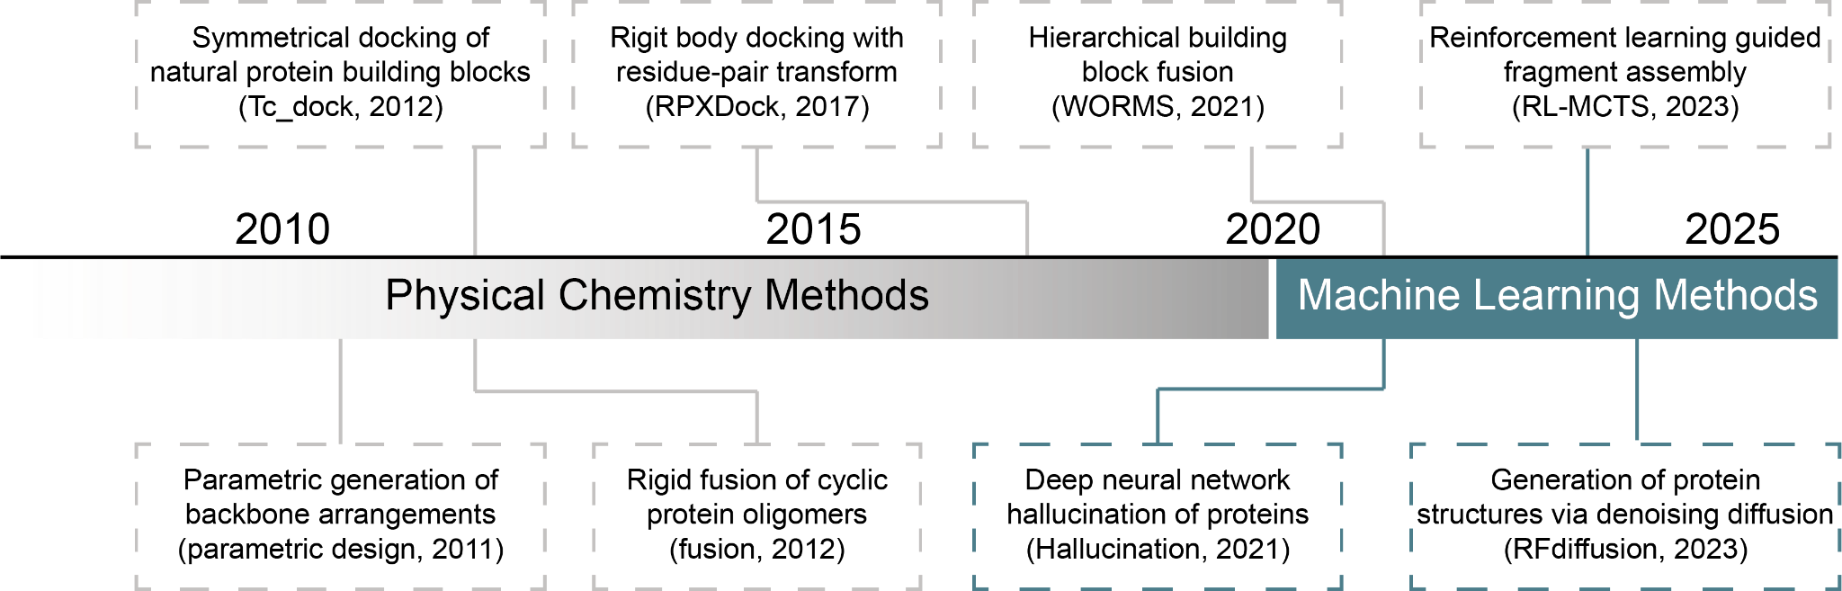
Figure S1. A timeline of selected key milestones in protein assembly methods development.

