Title: Indigenous American Genomes Reveal Unique Diversity and Evolution

Authors: Marcos Araújo Castro e Silva^{1,2,3}†, Kelly Nunes¹†, Maíra R. Ribeiro¹†, Hemanoel Passareli-Araujo⁴, Renan Barbosa Lemes¹, Lilian Kimura¹, Putira Sacuena⁵, Carlos Eduardo G. Amorim⁶, Maria Cátira Bortolini⁷, José Geraldo Mill⁸, João Farias Guerreiro⁵, Chiara Barbieri^{9,10}, Diana Iraíz Hernández-Zaragoza^{11,12}, Antonia Walter¹¹, Trija Nag Chowdhury¹¹, Daniela Herrera-Macías¹², Julio César Lara-Riegos¹³, Oana Del Castillo-Chávez¹⁴, Camilo Zurita¹⁵, Ana María Tito-Álvarez¹⁶, Emilia Vásquez-Domínguez¹⁷, María Ermila Moo-Mezeta¹⁸, Julio César Torres-Romero¹³, Abraham Aguilar-Campos¹⁹, Ricardo Serrano-Osuna²⁰, Maria Laura Parolín²¹, Claudio M. Bravi²², Virgínia Ramallo²³, Graciela Baillet²², Susana Revollo²⁴, José R. Sandoval²⁵, Ricardo Fujita²⁵, Rodrigo Barquera¹¹, Fabrício R. Santos²⁶, David Comas^{2,3}, Tábita Hünemeier^{1,3}*
Affiliations:
¹ Departamento de Genética e Biologia Evolutiva, Instituto de Biociências, Universidade de São Paulo; São Paulo, SP, 05508090, Brazil.
² Departament de Medicina i Ciències de la Vida, Universitat Pompeu Fabra; 08003 Barcelona, Spain.
³ Institut de Biologia Evolutiva (CSIC/Universitat Pompeu Fabra), 08003, Barcelona, Spain.
⁴ Departamento de Bioquímica e Imunologia, Instituto de Ciências Biológicas, Universidade Federal de Minas Gerais, Belo Horizonte, Brazil.
⁵ Laboratório de Genética Humana e Médica, Instituto de Ciências Biológicas, Universidade Federal do Pará, Belém, Brazil.
⁶ School of Human Evolution and Social Change, Arizona State University, Tempe, Arizona, USA.
⁷ Departamento de Genética, Instituto de Biociências, Universidade Federal do Rio Grande do Sul, Porto Alegre, Brazil.
⁸ Departamento de Fisiologia, Universidade Federal do Espírito Santo, Espírito Santo, Brazil.
⁹ Department of Life and Environmental Sciences, University of Cagliari, Cagliari, Italy.
¹⁰ Department of Evolutionary Biology and Environmental Studies, University of Zurich, Zurich, Switzerland.
¹¹ Department of Archaeogenetics, Max Planck Institute for Evolutionary Anthropology (MPI-EVA), Leipzig, Germany.
¹² Escuela Nacional de Antropología e Historia (ENAH), Mexico City, Mexico.
¹³ Chemistry Faculty, Universidad Autónoma de Yucatán (UADY), Mérida, Yucatán, Mexico.
¹⁴ Centro INAH Yucatán, Instituto Nacional de Antropología e Historia (INAH), Mérida, Yucatán, Mexico.
¹⁵ Biomedicine Research Unit, Zurita & Zurita Laboratorios, Quito, Ecuador.
¹⁶ Nursing School, Faculty of Health Sciences, Universidad de las Américas (UDLA), Quito, Ecuador.
¹⁷ Department of Biotechnology, Faculty of Engineering and Applied Sciences, Universidad de las Américas (UDLA), Quito, Ecuador.
¹⁸ Nursing Faculty, Universidad Autónoma de Yucatán (UADY), Mérida, Mexico.
¹⁹ Blood Bank Laboratory, Hospital General de Zona #30, Instituto Mexicano del Seguro Social (IMSS), Mexicali, Baja California, Mexico.
²⁰ Clinical Laboratory, Unidad Médica de Alta Especialidad (UMAE) #2, Instituto Mexicano del Seguro Social (IMSS), Ciudad Obregón, Sonora, Mexico.
²¹ Instituto de Diversidad y Evolución Austral (IDEAus, CCT CONICET-CENPAT), Puerto Madryn, Chubut, Argentina.
²² Laboratorio de Genética Molecular Poblacional, Instituto Multidisciplinario de Biología Celular (IMBICE), CCT- CONICET-La Plata, Argentina.
²³ Instituto Patagónico de Ciencias Sociales y Humanas, Centro Nacional Patagónico, CONICET, Puerto Madryn, U9120, Argentina.
²⁴ Universidad Mayor de San Andrés (UMSA), La Paz, Bolivia.
²⁵ Centro de Genética y Biología Molecular (CGBM), Instituto de Investigación, Facultad de Medicina Humana, Universidad de San Martín de Porres, Lima, Perú.
²⁶ Laboratório de Biodiversidade e Evolução Molecular (LBEM), Instituto de Ciências Biológicas, Universidade Federal de Minas Gerais, Belo Horizonte, Brazil.

†These authors contributed equally to this work.

*Corresponding authors. Email: hunemeier@usp.br.

Supplementary Information

Supplementary Note 1: Data Processing, Ancestry, and Relatedness 3
Supplementary Note 2: Novel and Deleterious Variants, and Ancestral Allele Annotation 6
Supplementary Note 3: Phasing, Local Ancestry Inference, and Masking 6
Supplementary Note 4: Allele Sharing and Spatial Population Structure 8
Supplementary Note 5: ROHs, IBDs, and Demographic Inference 11
Supplementary Note 6: Admixture Graph and Ancestry Modeling 15
Supplementary Note 7: Genome-Wide Selection Scans 17
Supplementary Note 8: Australasian-like Ancestry and Natural Selection 18
Supplementary Note 9: Archaic Introgression 20
Supplementary Note 10: Sample Description, Ethics, and Community Engagement 21
Supplementary Note 11: Lay summary 23
Lay summary (English version) 23
Resumo para leigos (versão em português) 27
Resumen para legos (versión en español) 31
Supplementary References 36

Supplementary Note 1: Data Processing, Ancestry, and Relatedness

We generated novel whole genome sequencing (WGS) data for 128 Indigenous individuals representing 45 ethnic groups and 28 ethnolinguistic groups from eight Latin American countries (Extended Data Fig. 1). Whole genomes were sequenced at the Beijing Genomics Institute (BGI) and Dasa Genômica using BGISEQ-500 and Illumina NovaSeq 6000, and had an average sequencing depth of 44X. Whole genome sequence data pre-processing, variant calling and annotation were performed using the Sarek v.3.5.0 pipeline¹. Specifically, sequence data in fastq format was aligned to the GRCh38 reference genome, and preprocessed according to the GATK Best Practices for germline variant discovery and joint variant calling. Variants in the joint cohort VCF were then normalized and annotated using the Ensembl Variant Effect Predictor (VEP) v.113², incorporating multiple annotation sources.

This dataset was subsequently integrated with publicly available WGS databases, including the 1000 Genomes High Coverage dataset (1KGP) (2,504 individuals from 26 populations)³, the Human Genome Diversity Project (HGDP) (929 individuals from 54 populations)⁴, and the Simons Genome Diversity Project (SGDP) (159 individuals from 80 populations)⁵. Prior to merging, we applied stringent quality control measures, filtering out sites and individuals with more than 5% missing data, retaining only biallelic SNVs, and excluding positions showing significant deviations from Hardy-Weinberg equilibrium (p < 10e–8) or ambiguous variants (A-T and C-G). Quality control and data merging were performed using PLINK v.1.9⁶. The resulting dataset comprises 199 Indigenous individuals from 53 ethnic groups and 31 language families, and a total of 3,710 individuals from 201 worldwide populations, encompassing 5,308,880 high-quality biallelic SNPs (Supplementary Fig. 1–2). Importantly, Principal Component Analysis (PCA) of the complete dataset revealed no evidence of batch effects, with individuals consistently clustering by geographic origin rather than by dataset source (Supplementary Fig. 2).

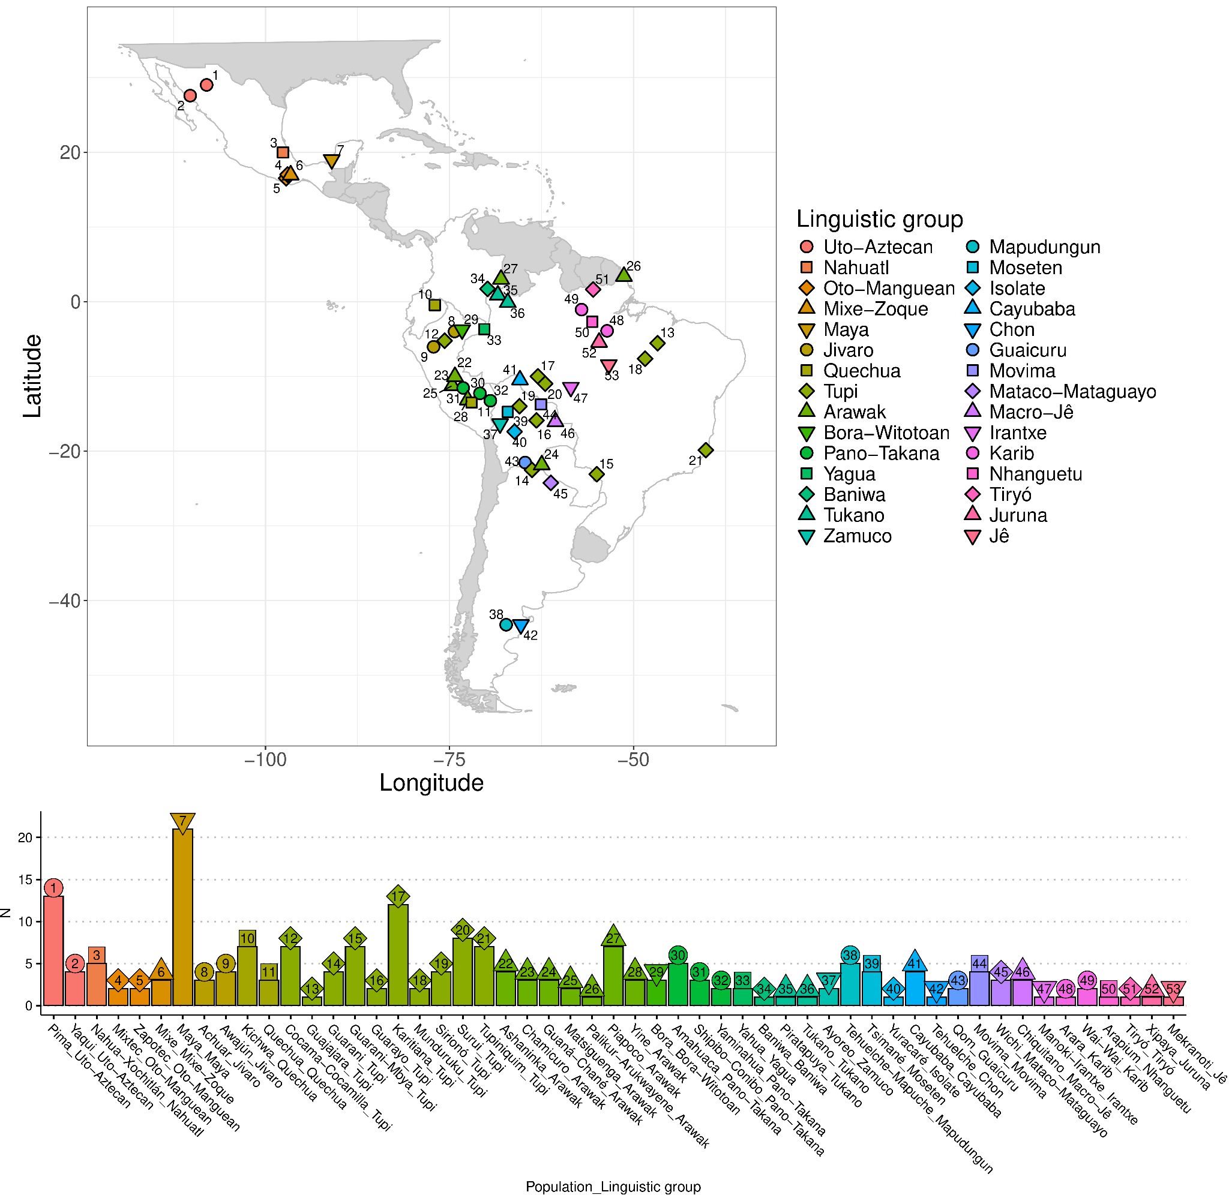
Supplementary Figure 1 - Map of the complete dataset of Indigenous American individuals. The approximate locations of Indigenous American communities included in this study (newly sequenced and publicly available) are shown on a partial map of the Americas. Language families are represented by different symbol shapes and colors, as indicated in the legend. A bar plot below lists ethnic group and linguistic family names (x-axis) and the number of sequenced individuals per community (y-axis), with numbers linking communities between the map and bar plot. Countries with at least one sampled Indigenous community are highlighted in white.

To identify global populations to be used as parental groups for the modern Indigenous populations analyzed in this study, we first performed an unsupervised ADMIXTURE⁷ v.1.9 analysis with K=5 and 100 bootstrap iterations. This analysis included only HGDP populations from Africa, East Asia, Europe, the Americas, and Oceania to isolate individuals without evidence of ancestry from outside their continent of origin. Consensus ancestry estimates across independent runs were generated using CLUMPP⁸ v.1.1.2.

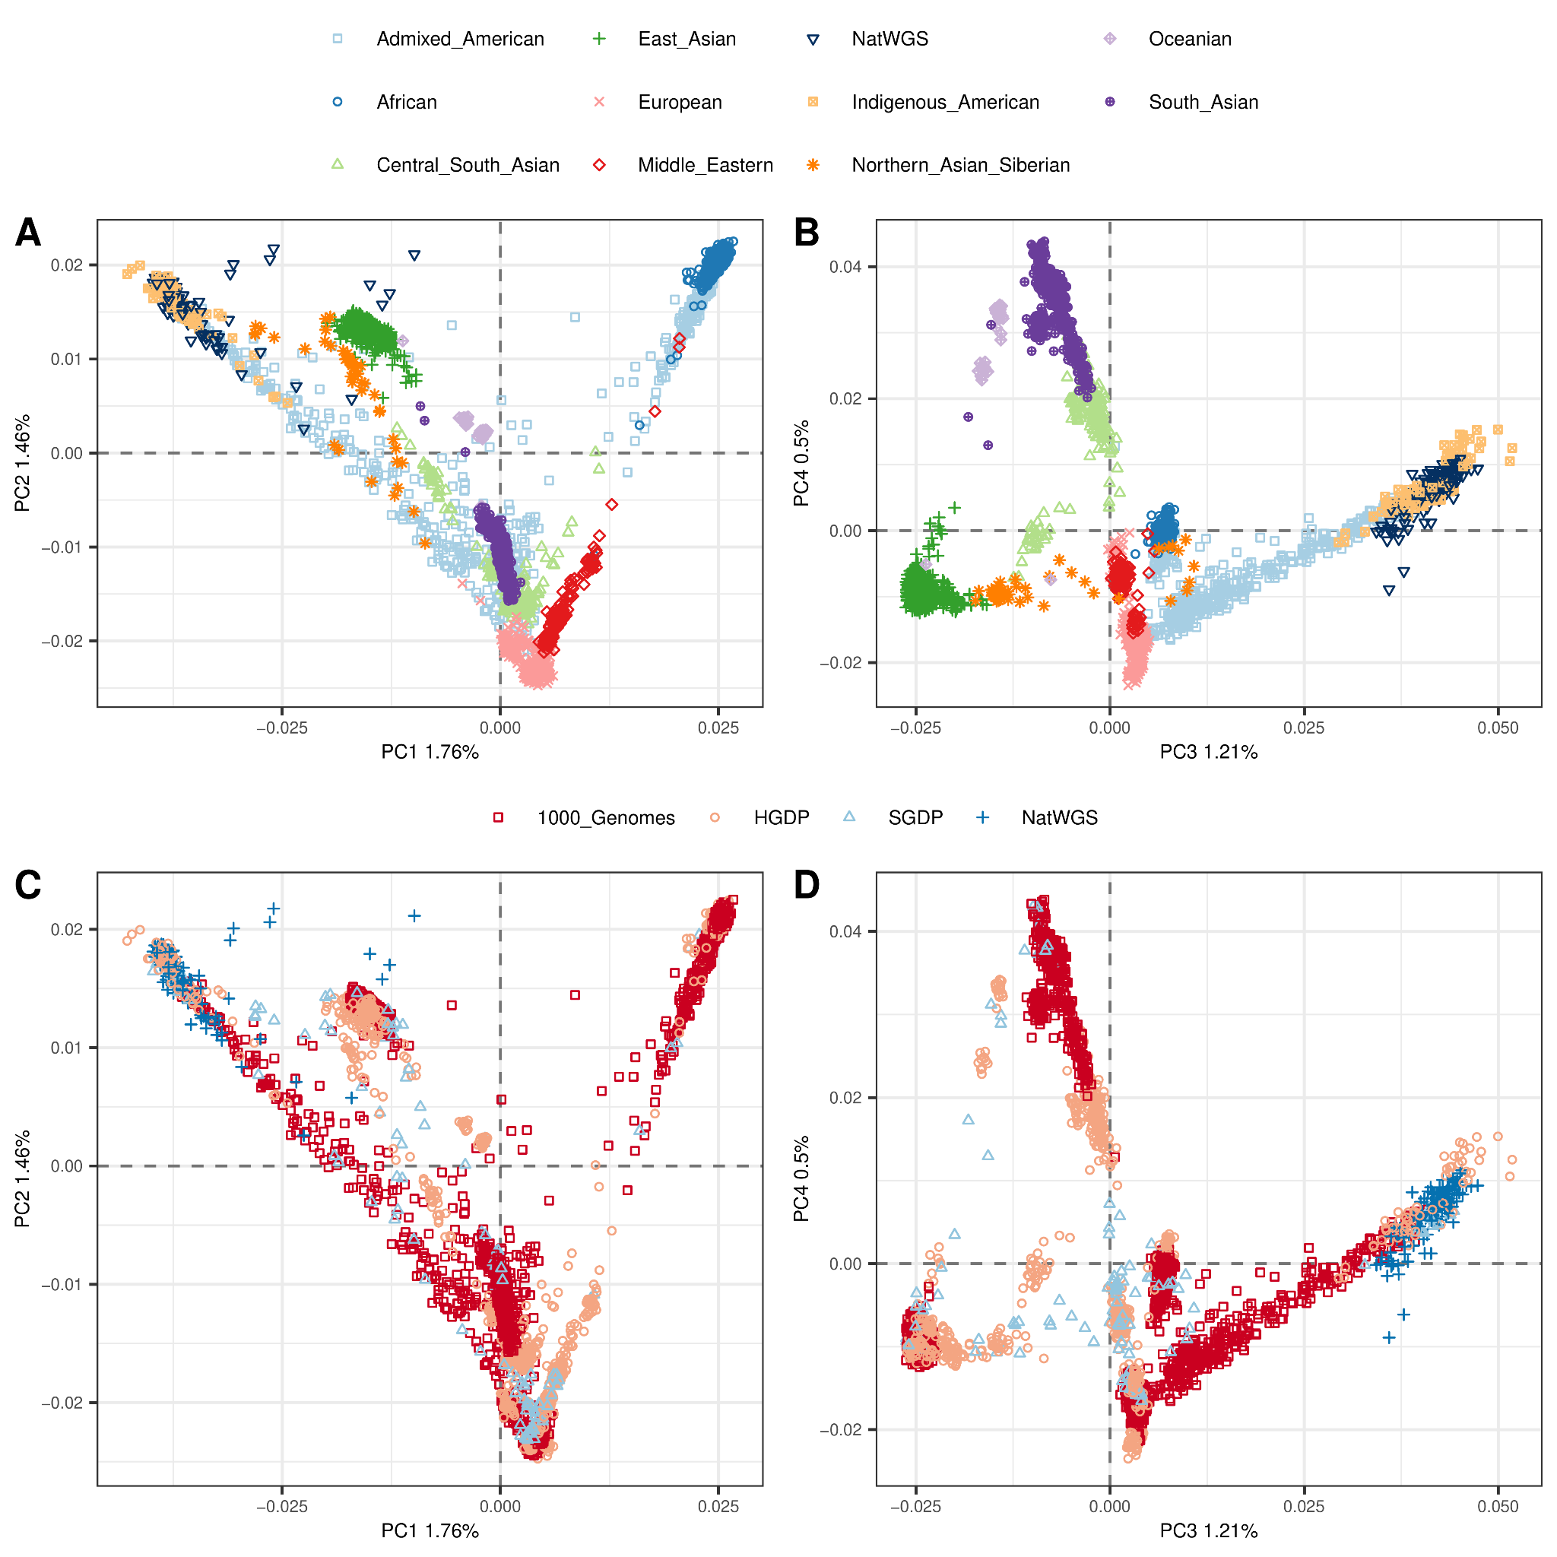
Supplementary Figure 2 - Principal component analysis of contemporary genomic datasets. PCA of newly sequenced and publicly available data (HGDP, SGDP, 1KGP) combined in this study. Panels show: (A, C) PC1 vs. PC2 and (B, D) PC3 vs. PC4. Top panels color-code individuals by continental origin, while bottom panels indicate dataset sources.

The African, European, and Indigenous American parental groups identified in this initial analysis were subsequently used to infer global ancestry proportions for the novel Indigenous American genomes. For this, we conducted a supervised ADMIXTURE⁷ v.1.9 analysis with K=3, running 10 independent iterations with 100 bootstrap replicates per run. The consensus of these independent runs was again estimated using CLUMPP⁸ v.1.1.2, with the results presented in Supplementary Fig. 3.

To minimize bias from close relatives in subsequent analyses, we performed a kinship analysis to identify and remove closely related individuals from the dataset. Using PLINK v.1.9⁶, we estimated identity by descent (IBD) for all pairs of individuals, calculating (PI_HAT = P(IBD=2) + 0.5*P(IBD=1)). Based on these estimates, we identified the largest subset of unrelated individuals by applying a first-degree kinship threshold, using PRIMUS⁹.

Supplementary Note 2: Novel and Deleterious Variants, and Ancestral Allele Annotation
Novel variants were annotated using the Ensembl Variant Effect Predictor (VEP) v.113², incorporating multiple sources, such as dbSNP, ClinVar, PolyPhen, and SIFT. Ancestral allele annotations were retrieved using the Ancestral Allele VEP plugin.
We identified 1,425,436 novel single nucleotide variants (SNV) sites and 1,426,511 novel alleles, of which 84.3% are singletons or doubletons, 4.7% are polymorphic (allele frequency (AF)>1%, n=66,618) and 0.02% are common (AF >5%, n=340). Regarding functional annotation, 45% of novel variants are intronic and 14% are intergenic. In silico pathogenicity prediction of novel variants was accessed using PolyPhen and SIFT, and revealed 3,365 (0.17%) deleterious or deleterious low confidence variants (137 with AF>1%) and 2,402 (0.13%) probably damaging or possibly damaging variants (94 with AF>1%).
Finally, to investigate the evolutionary history of novel alleles in Indigenous Americans, we assessed their ancestral state to determine whether they represent ancestral or derived variants. After annotating the alleles for their ancestral state, we retained only those that had ancestral state information and consisted of simple base substitutions (A, T, C, G). Among the alleles identified as novel in Indigenous Americans, approximately 99.9% of those polymorphic (frequency > 1%) correspond to the derived allele. Notably, all novel common alleles (frequency > 5%) were classified as derived.

Supplementary Note 3: Phasing, Local Ancestry Inference, and Masking

Haplotype phase inference was conducted using SHAPEIT4¹⁰ v.4.2.2, using the 1000 Genomes Project dataset as the reference panel^{10,11} and genetic maps provided by the developers (https://github.com/odelaneau/shapeit4/raw/master/maps/genetic_maps.b38.tar.gz). The analysis was configured with 15 burn-in iterations, 15 pruning iterations, and 100 main iterations, employing the “--sequencing” option to optimize parameters for sequencing data.

Local ancestry inference was performed using RFMix¹² v.1.5.4 with a window size of 0.2 cM and a minimum of five reference haplotypes per tree node. For this analysis, unadmixed Indigenous Americans, Sub-Saharan Africans, and Western Europeans were used as the reference populations.

To leverage the Indigenous American ancestry component in our dataset, we used the inferred local ancestry tracts to mask genomic sites. Genomic segments with a posterior probability of being ancestrally related to Indigenous Americans below 99% were assigned as missing data. Additionally, positions with heterozygous ancestry (where one haplotype originated from Indigenous Americans and the other from a different continental ancestry) were masked by setting both alleles as missing (code to perform local ancestry masking is available at https://github.com/macscastro/lamask). After the local ancestry masking procedure no significant non-Indigenous American ancestry is inferred (Supplementary Fig. 3).

To explore specific aspects of genetic ancestry, two additional datasets were generated. The first was designed to investigate the distribution of excess genetic affinity with Australasian populations and its potential adaptive implications. This dataset merged the combined dataset generated in the previous steps with genomic data from 10 Indigenous Andamanese individuals (6 Onge and 4 Jarawa)¹³. The Andamanese data were subjected to the same quality filters applied before, their genomic coordinates converted from the hg19 to hg38 reference genome, and merged with the previous data, retaining 3,558,958 shared SNPs.

The second was created to infer patterns of genetic continuity and continent-wide population histories of Indigenous Americans. This dataset combined the local ancestry masked dataset with ancient DNA from The Allen Ancient DNA Resource (AADR)¹⁴ and Sambaqui mound builders from Brazil¹⁵, retaining only common variants. The Sambaqui data were genotyped using the 1240k SNP capture platform¹⁶, and the AADR dataset included both ancient individuals genotyped with 1240k SNPs and those with whole-genome data restricted to the 1240k sites. After filtering for high-quality genomes (excluding individuals with >90% missing data), the final dataset included 355 ancient individuals from the Americas, comprising 703,252 genome-wide SNPs.

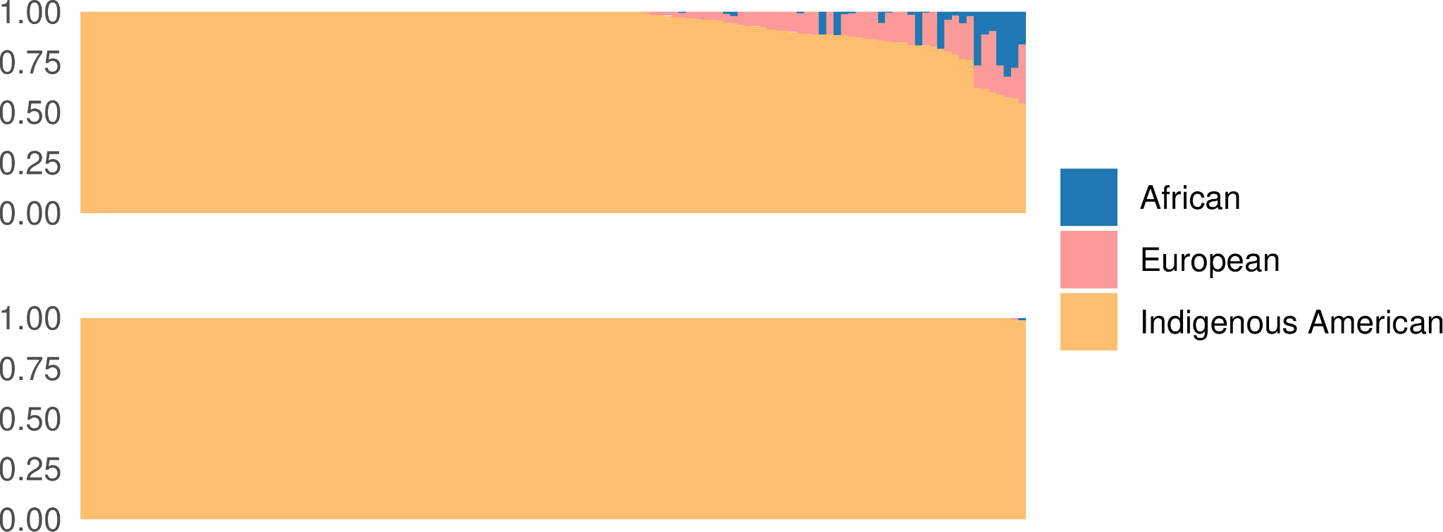
Supplementary Figure 3 - ADMIXTURE analysis before and after local ancestry masking. We performed local ancestry inference using RFMIX to identify genomic segments confidently assigned as Indigenous American ancestry. Genomic regions with a posterior probability below 99% for Indigenous American ancestry were masked as missing data. A supervised ADMIXTURE analysis with K = 3 was then conducted, incorporating a reference panel of African, European, and Indigenous American populations to analyze the newly sequenced genomes. The top panel presents ancestry proportions before local ancestry masking, while the bottom panel shows results after masking. The analysis demonstrates that non-Indigenous American ancestries are virtually absent following the procedure.

Supplementary Note 4: Allele Sharing and Spatial Population Structure

To investigate present-day patterns of genetic similarity among Indigenous American populations, we pre-computed population pairwise f2 statistics using default parameters and estimated outgroup f3 values in the form f3(Mbuti; X, Y), where X and Y represent any two present-day Indigenous American populations. These genetic similarity patterns were visualized through a neighbor-joining (NJ) tree inferred from the matrix of inverted outgroup f3 values (1/outgroup f3), with Pima serving as the outgroup in the NJ tree. Additionally, multidimensional scaling (MDS) was applied to the genetic distances derived from the outgroup f3 values (1–outgroup f3; Extended Data Figure 2; Extended Data Figure 8A–B). To assess the relationship between genetic and geographic distances, we calculated great-circle distances using the R package ‘geosphere’ v.1.5.18¹⁷ and examined their correlation with the genetic distances using Spearman’s correlation coefficient (Supplementary Fig. 4).

This approach was also extended to analyze spatiotemporal patterns of genetic variation, incorporating both contemporary and ancient populations and individuals. Population pairwise f2 statistics were pre-computed, and outgroup f3 values were estimated for all pairs of populations or individuals. The resulting genetic relationships were visualized using an NJ tree based on inverted outgroup f3 values, with the Ancient Beringian individual (USA_Ancient_Beringian.SG) as the outgroup, and an MDS analysis of the genetic distances. Clusters of genetic similarity were identified based on the clustering patterns of populations and individuals within the NJ tree (Figure 4; Extended Data Fig. 8C–D). We also examined the relationship between genetic and geographic distances by calculating great-circle distances using the R package ‘geosphere’ v.1.5.18¹⁷. Additionally, we computed the temporal differences between individuals (in the form |average individual i date – average individual j date|, for all pairs of i and j individuals) and assessed the correlation of both variables with genetic distances using Spearman’s correlation coefficient (Supplementary Fig. 5).

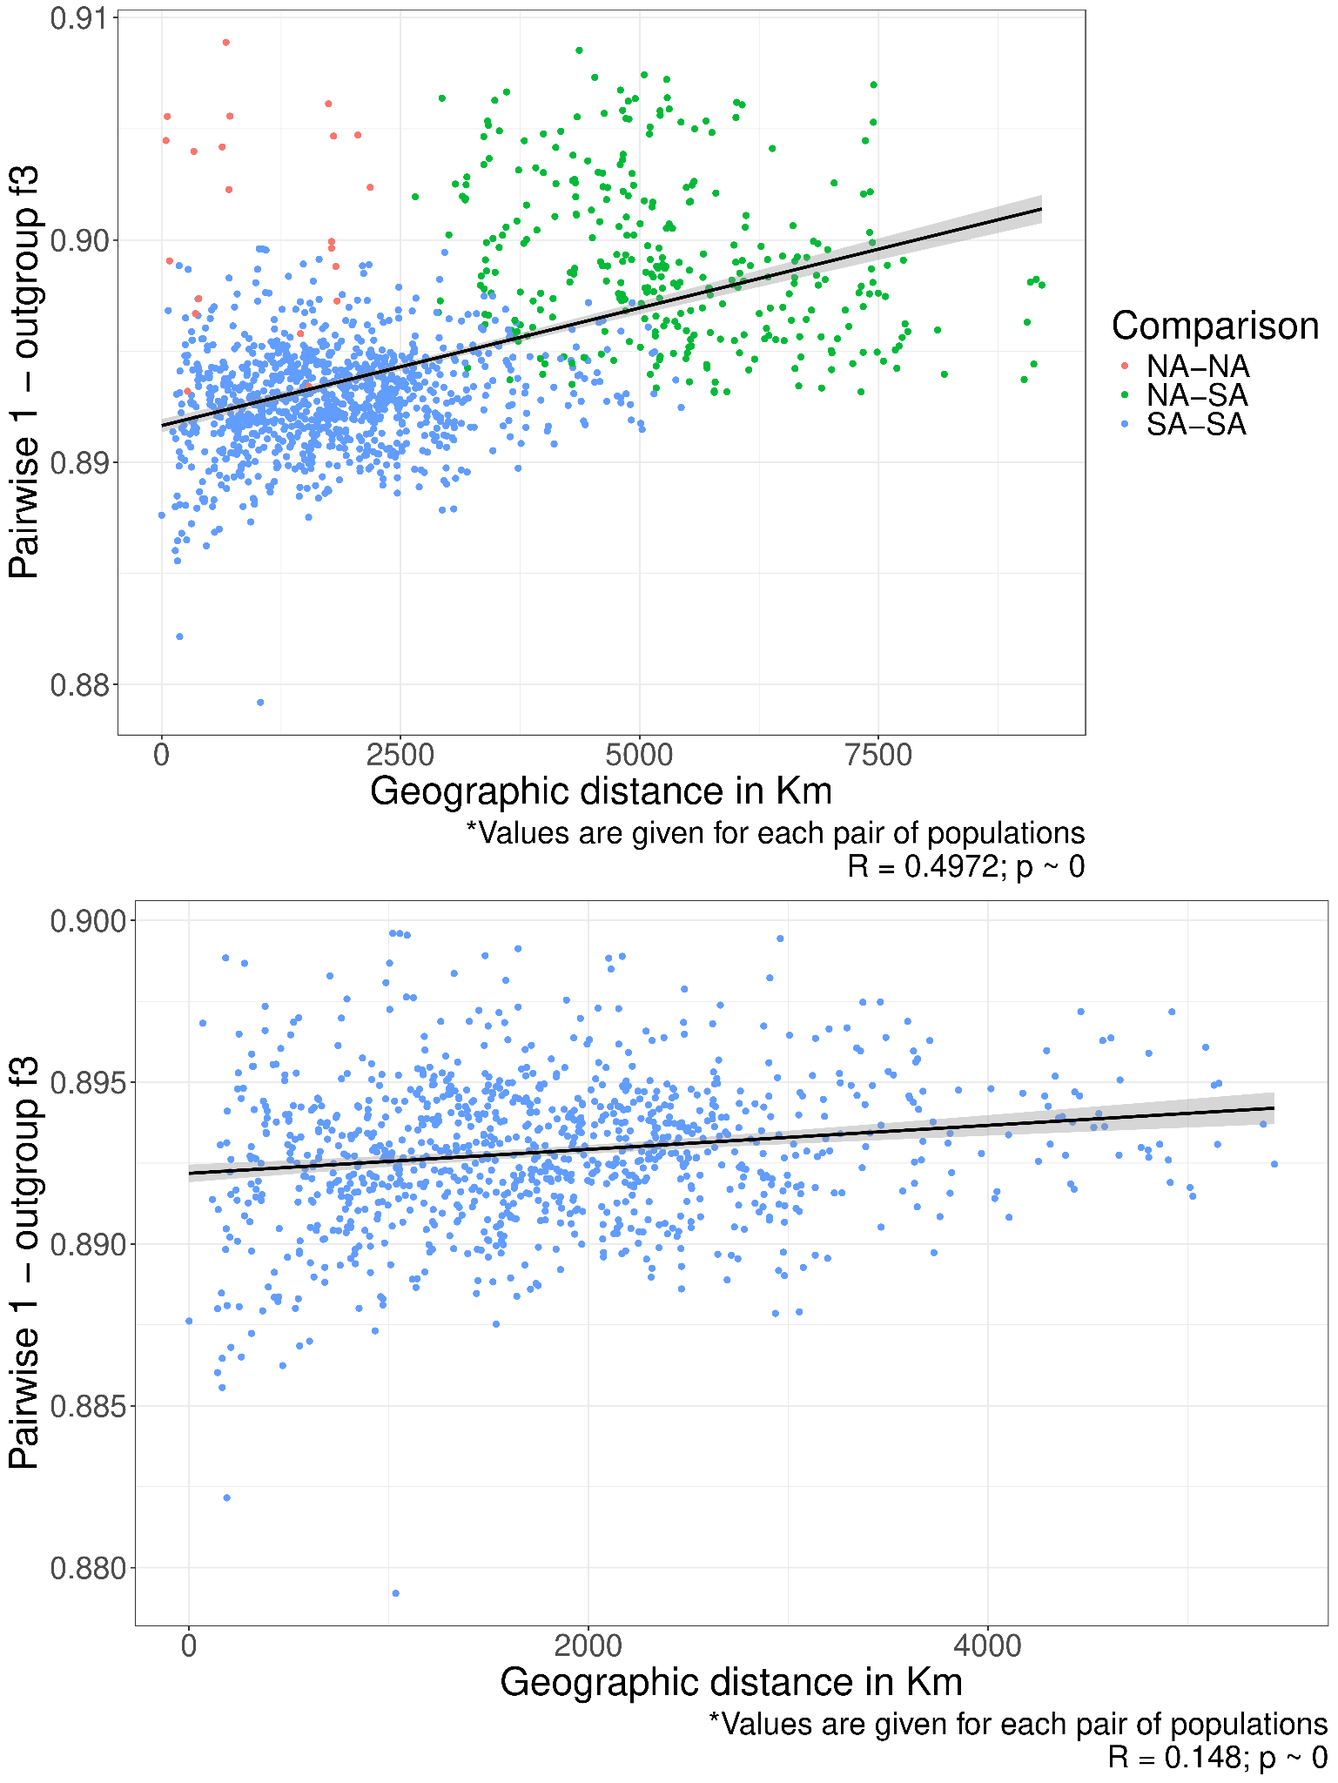
Supplementary Figure 4 - Correlation between genetic and geographic distances in present-day Indigenous Americans. Genetic distances between all pairs of present-day Indigenous American populations were computed as 1–f₃(Mbuti; X, Y). Great-circle geographic distances were also calculated for all population pairs, and their correlation with genetic distances was assessed using Spearman’s correlation coefficient. The top panel displays the inferred correlation coefficient, considering comparisons between populations from North and South America (NA-SA) as well as within these regions (NA-NA and SA-SA). The bottom panel presents the correlation coefficient when only South American population pairs are analyzed.

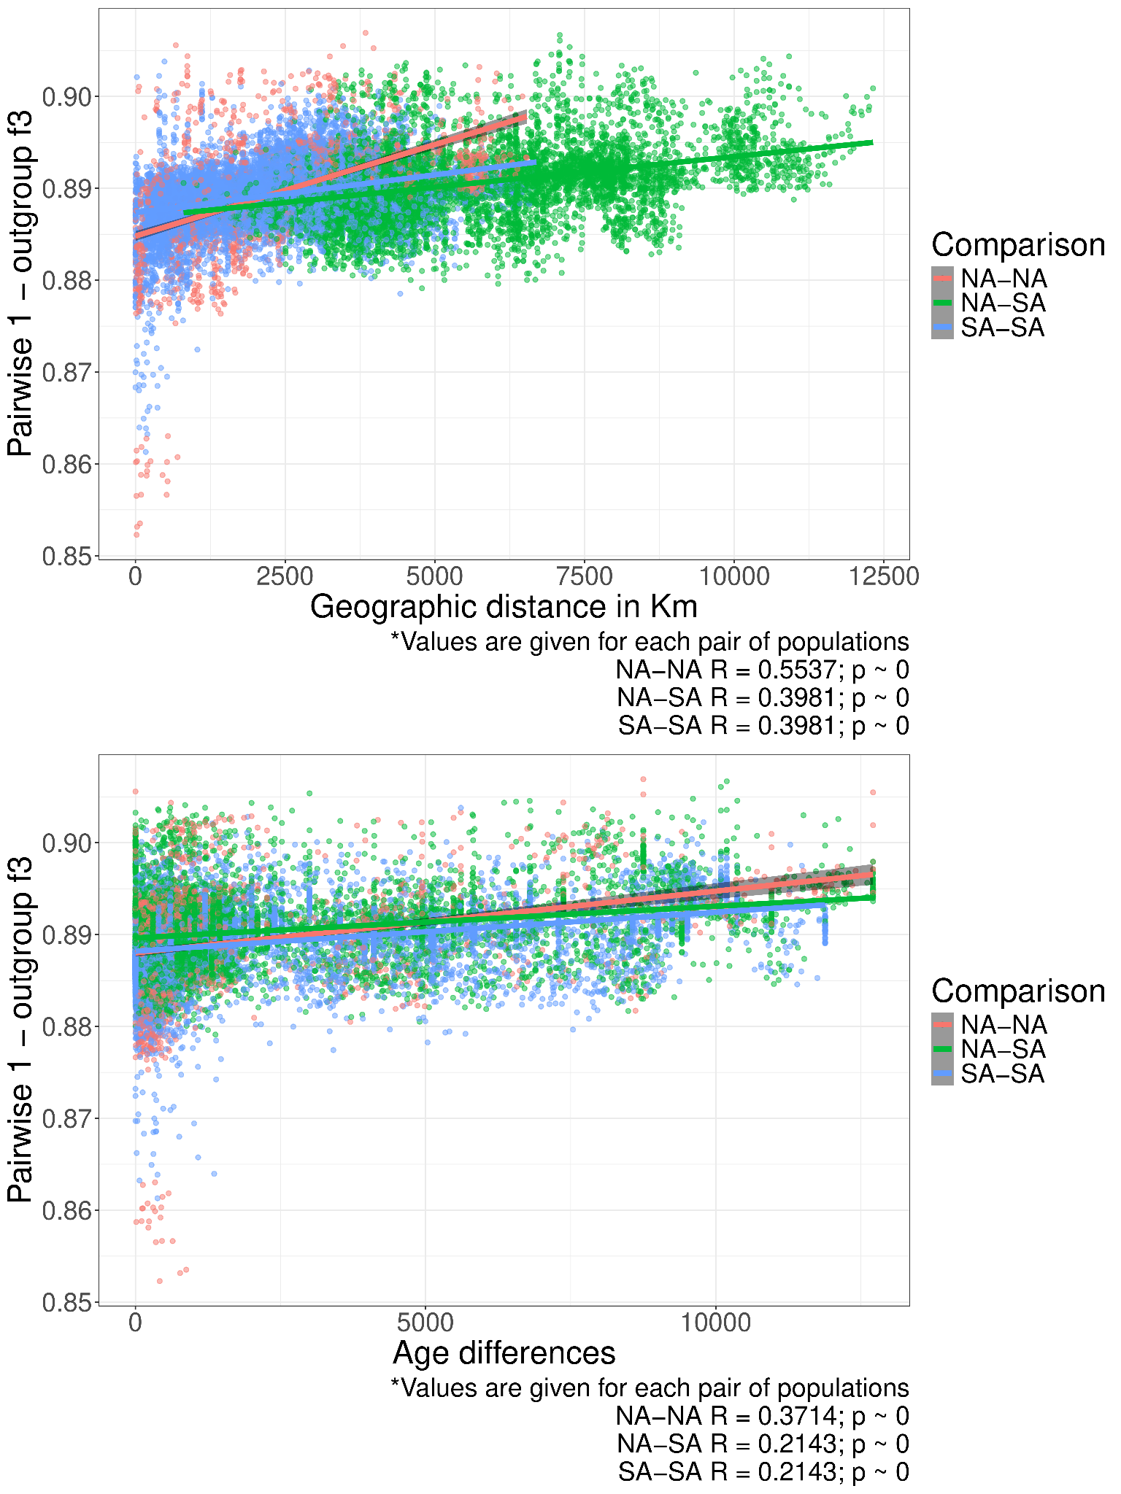
Supplementary Figure 5 - Correlation between genetic distances, geographic distances, and time differences. Genetic distances between all pairs of present-day and ancient non-Arctic Indigenous American populations were computed as 1 - f₃(Mbuti; X, Y). Great-circle geographic distances and temporal differences were also calculated for all population pairs, and their correlation with genetic distances was assessed using Spearman’s correlation coefficient. The top and bottom panels show the inferred correlation coefficients between genetic and geographic distances, and between genetic distances and the age gap between individuals, respectively, pooling pairs where one population is from North America and the other from South America (NA-SA), as well as pairs from the same region (NA-NA or SA-SA).

To investigate patterns of excess genetic affinity between Indigenous American and Australasian populations, we calculated D(Mbuti, Onge; X, Y), where X and Y represent any Indigenous American populations, and the Onge serve as representatives of Australasian ancestry. This analysis was conducted both exclusively for contemporary Indigenous American populations (Extended Data Fig. 12) and by integrating contemporary and ancient populations (Extended Data Fig. 13) to evaluate the presence and distribution of Australasian-like ancestry across space and time. Due to the very limited representation of this genetic component, we sought to avoid false negatives by mitigating potential biases associated with missing data. To this end, we avoided using the local ancestry-masked dataset in the analysis and instead applied the subset of unrelated and unadmixed Indigenous American individuals. This strategy minimizes potential biases introduced by missing data in local ancestry-masked individuals, particularly when combining these individuals with ancient genomes, which are often characterized by higher levels of missing data. We used the ‘admixtools’ v.2.0.10 R package to conduct all f-statistics analysis in this study.

To infer migration and diversity rates among contemporary Indigenous Americans, we applied effective migration surface modeling (https://github.com/dipetkov/eems)¹⁸. The analysis was conducted on two datasets: a subset of unrelated and unadmixed Indigenous Americans (N samples = 116, N SNPs = 3,742,299) and a subset of unrelated Indigenous Americans with local ancestry masking to exclude non-Indigenous American components (N samples = 160, N SNPs = 595,833; Extended Data Fig. 4). All models were configured with 1,200 demes, and the Markov Chain Monte Carlo (MCMC) algorithm was run for 4x10⁶ iterations, including a burn-in period of 2x10⁵ iterations to ensure convergence to a globally optimal posterior probability model. Spatial population structure was visualized by plotting migration rates using the scripts provided by the developers.

Supplementary Note 5: ROHs, IBDs, and Demographic Inference

Runs of homozygosity (ROHs) were inferred for the unrelated and unadmixed subset of contemporary Indigenous Americans using PLINK v.1.9⁶. A sliding window of 50 SNPs was applied, allowing a maximum of one heterozygous site and five missing calls. We set the minimum proportion of overlapping windows required to form a homozygous segment at 5%, with a minimum SNP density of one SNP per 50 Kb and a maximum gap of 100 Kb between consecutive SNPs. Only ROHs with a minimum length of 500 Kb were included. The total and average ROH length per individual were compared across global populations (Supplementary Fig. 6), and the total length of the genome covered by ROH segments of varying length categories was compared between global populations and Indigenous American clusters of genetic similarity identified in Figure 2 (Extended Data Fig. 5; Supplementary Fig. 7).

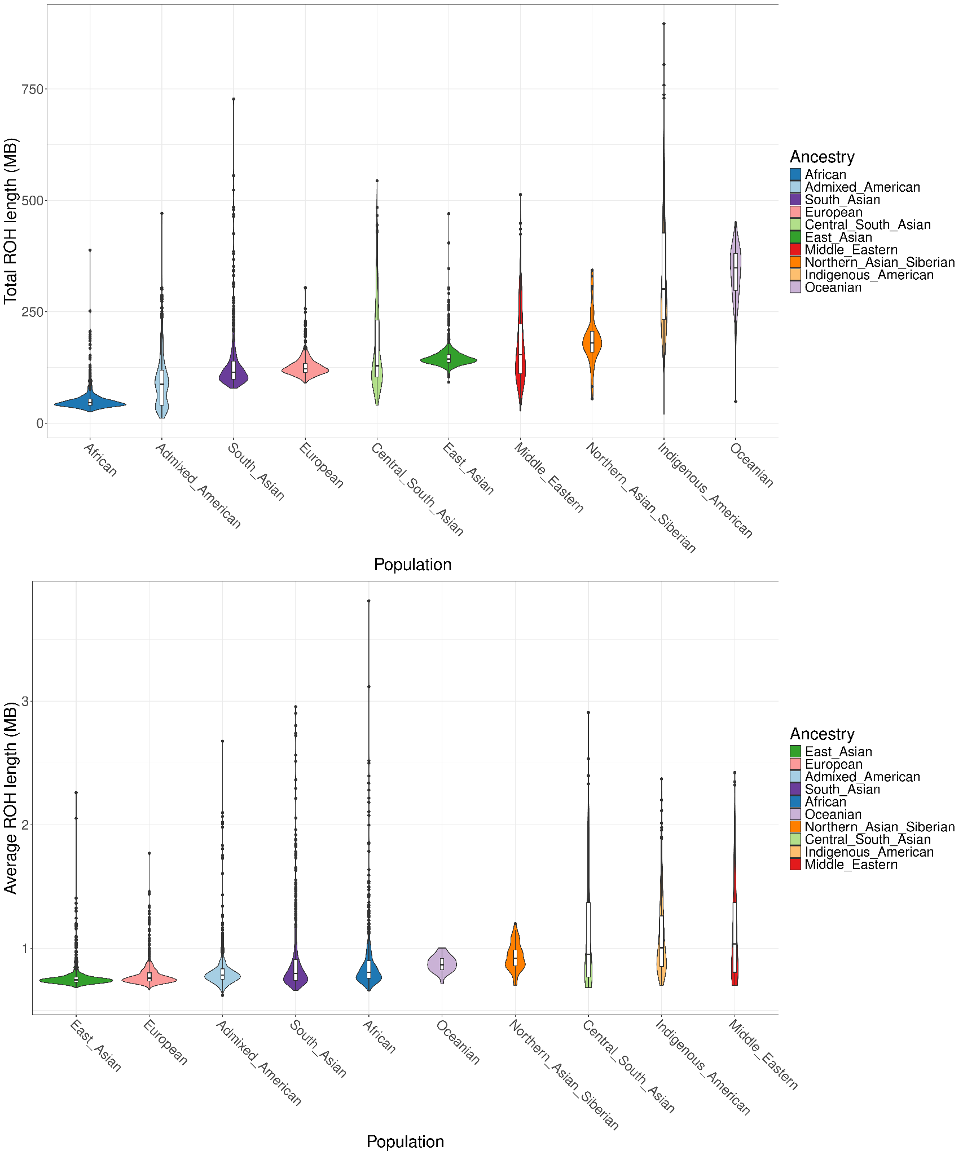
Supplementary Figure 6 - Worldwide total and average ROH length by individual. The top panel presents a violin plot of individual-wise total ROH length across the genome for each continental region. The bottom panel displays a violin plot of the average ROH segment length per individual, also grouped by continental region.

For global populations, we visualized the total number and length of ROH segments per individual, while for Indigenous Americans, we also plotted the population-wise average total number and length of ROH segments (Extended Data Fig. 5). We also estimated the inbreeding coefficient for each individual and calculated the total proportion of the genome covered by ROH segments (F_{ROH} - ROH‑based inbreeding coefficient) for each individual, as well as the average inbreeding coefficient for each population (Extended Data Fig. 3). Additionally, we assessed the correlation between the number of ROH segments and continental ancestry proportions using Spearman’s correlation coefficient (Supplementary Fig. 8). Finally, we identified hotspots of ROH, defined as genomic regions where the number of overlapping ROH segments exceeds the genome-wide average (Supplementary Fig. 9).

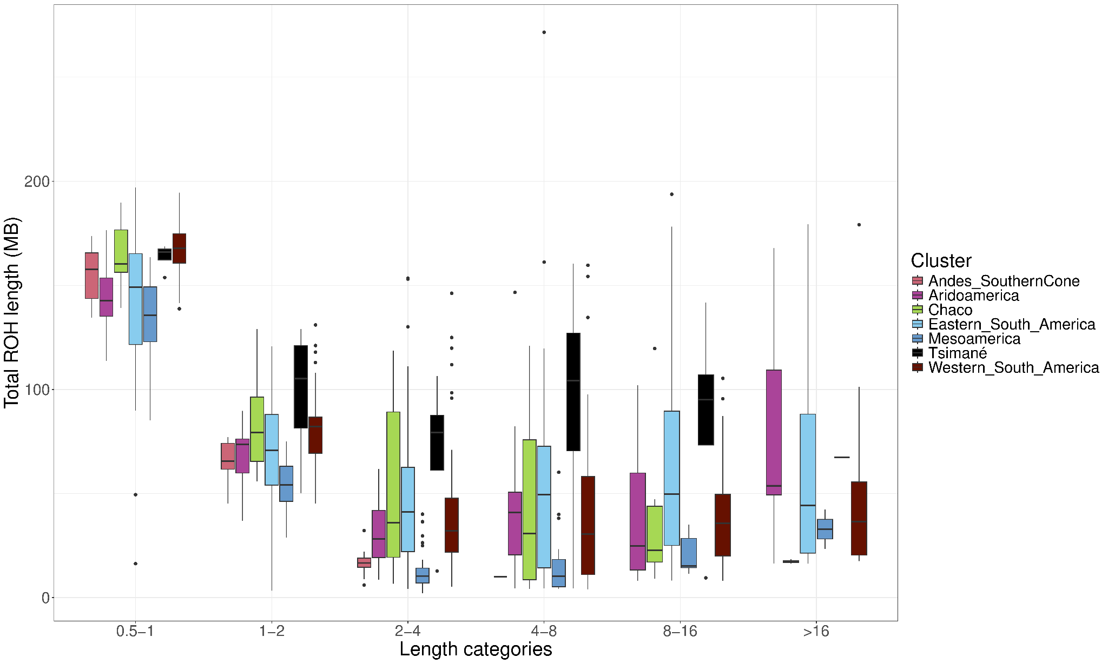
Supplementary Figure 7 - Subcontinental ROH distribution by length categories. This figure displays individual-wise total ROH length across different length categories, grouped by genetic clusters.

We also applied the IBDNe pipeline v.07May18.6a4¹⁹ to analyze the effective population size (N_{e}) history of present-day Indigenous American populations. Identical by descendent (IBD) segments shared between individuals in the complete dataset of contemporary Indigenous American were identified using Refined IBD v.12Jul18.a0b^{19,20}. Additionally, IBD segments with short gaps (maximum gap of 0.6 cM and a maximum of one discordant homozygote) were merged.

To infer the N_{e} history of Indigenous Americans, we pooled data by language families or genetic similarity clusters (as identified in Figure 2), ensuring each group had at least 10 individuals to improve inference confidence. Although none of our individuals met the recommended minimum sample size (np > 100, where n is the number of individuals and p is the ancestry component proportion within the population’s overall ancestry) for optimal IBDNe inference, previous studies have shown that historical Ne trajectories remain robust even with smaller sample sizes²¹. IBD segments longer than 2 cM shared among individuals within language families or genetic clusters were used for Ne history inference. This analysis was conducted using the IBDNe software with default parameters (Extended Data Fig. 7).

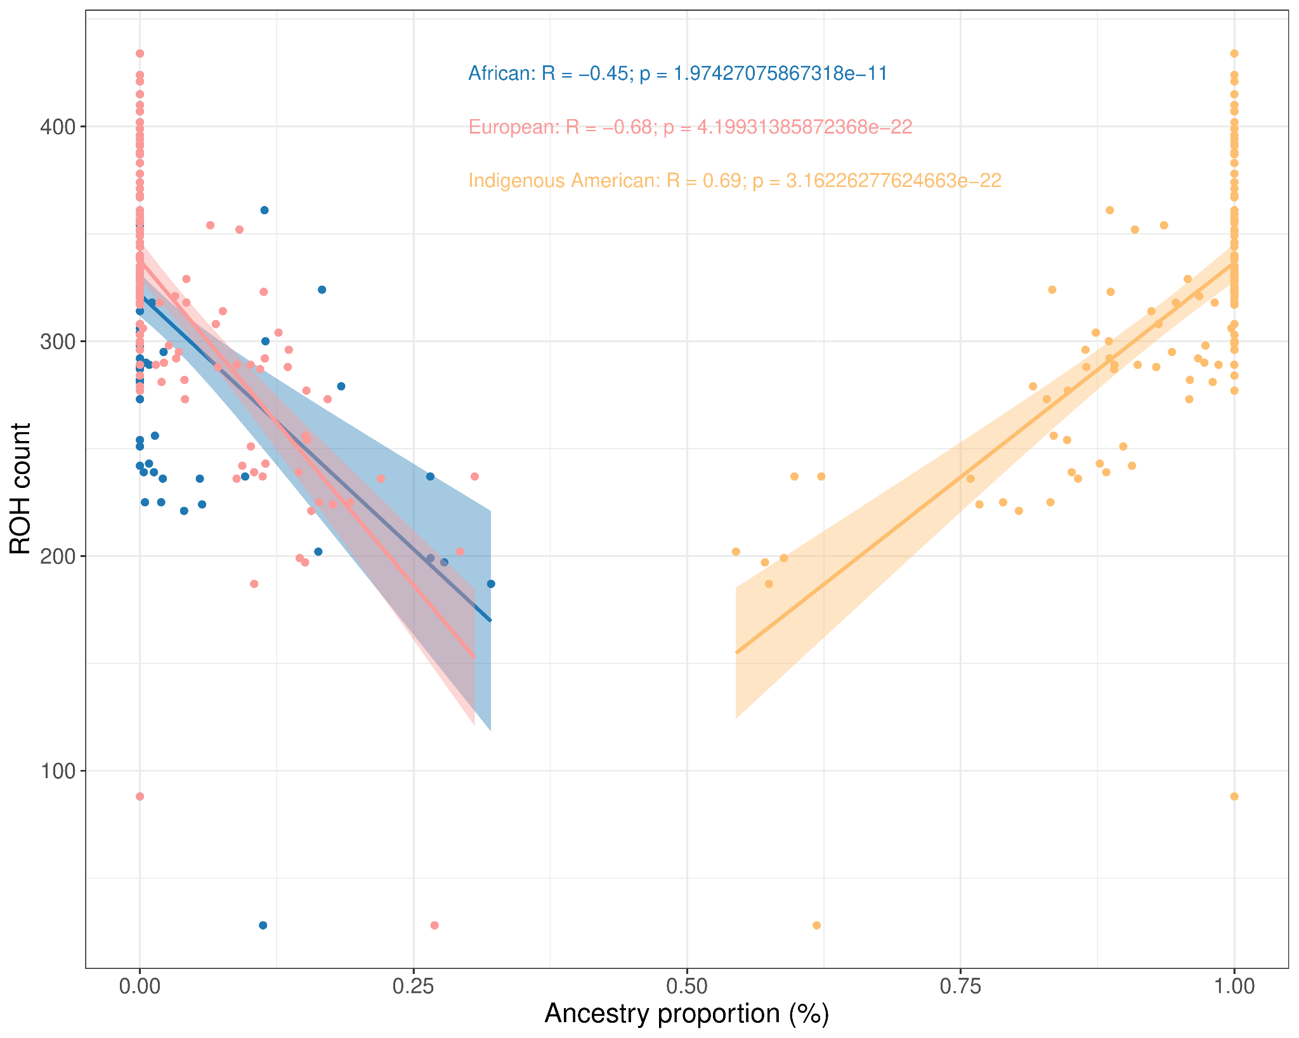
Supplementary Figure 8 - Correlation between ROH count and continental ancestry proportions. This figure presents the individual-wise count of ROH segments in relation to inferred continental ancestry proportions. Spearman’s correlation coefficient was used to assess the relationship, with results for each continental ancestry displayed at the top center of the panel. As before, continental ancestry proportions were inferred using a supervised ADMIXTURE analysis with K = 3, incorporating a reference panel of African, European, and Indigenous American populations.

Patterns of IBD sharing were investigated by analyzing the IBD segments identified in the previous step. We focused on IBD segments shared between individuals from both the same and different populations, categorizing them by length. The length of an IBD segment decreases as the time since individuals share a common ancestor increases, providing a temporal framework for analyzing IBD sharing. This approach allowed us to examine the number of IBD segments shared within and between populations over time and across different groups (Extended Data Fig. 6).

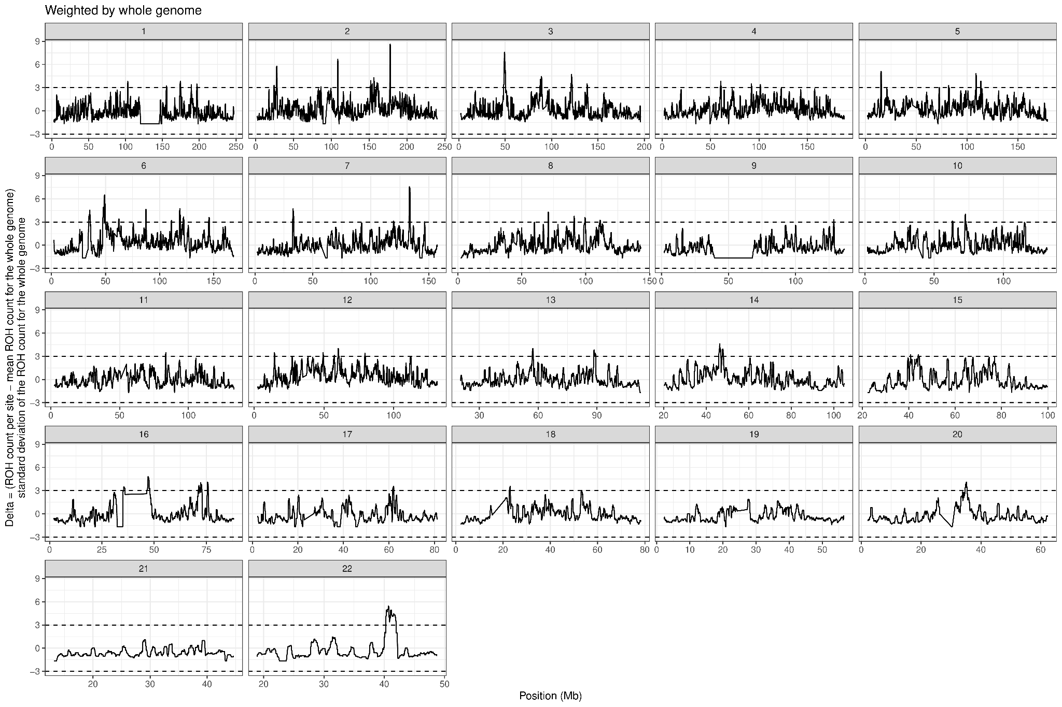
Supplementary Figure 9 - Genome-wide distribution of ROH count deviation from the genome average per position. The number of ROH segments overlapping each genomic position was computed. To standardize the data, we subtracted the genome-wide average ROH count per position from the observed count at each position and scaled it by the standard deviation across the genome. This resulted in a Z-scaled ROH count deviation, allowing the identification of ROH hotspots. Positions with Z-scores greater than 3 (more than three standard deviations above the genome-wide average) are those above the traced line in the panels.

Supplementary Note 6: Admixture Graph and Ancestry Modeling

We applied the fully automated graph exploration function ‘find_graphs’ from ‘admixtools’ v.2.0.10 R package²² to identify plausible models for the population history of contemporary Indigenous American populations. This process began by inferring a tree with no admixture events using 100 iterations. We then used the inferred tree as a starting point for an admixture graph, adding one admixture event at a time and running the algorithm 10 times with 100 iterations each, stopping after 10 iterations without improvement. The best admixture graph for each number of admixture events was selected based on the highest score (Extended Data Fig. 10 presents the best-fitting admixture graph models for each number of admixture events, ranging from zero to five events). These graphs were also inferred using f2 statistics calculated with transversions.

Additionally, we manually created admixture graphs to summarize our new findings and incorporate existing evidence from the literature. We assessed the fit of these models using the ‘qpgraph’ function from ‘admixtools’ v.2.0.10 R package²² and computed confidence intervals for the estimated drift lengths and admixture weights. This was done with the ‘qpgraph_resample_snps’ function, which fits the same graph multiple times using random subsets of SNP blocks. The output was summarized with the ‘summarize_fits’ function to create a data frame containing summaries of the estimated graph parameters (Figure 4; Extended Data Fig. 11). As with the previous analyses, these models were inferred exclusively using transversions.

We used the qpWave²² method to estimate the minimum number of independent ancestral sources contributing to third-dispersal populations (left populations), incorporating all first- and second-dispersal groups, along with ancient individuals from the North American Pacific Coast, as potential sources (right populations).

To explore a broad range of ancestry models and quantify their contributions to present-day Indigenous American populations, we also applied the rotating qpADM approach via the qpadm_rotate function in the admixtools v.2.0.10 R package²². Two analytical frameworks were implemented:

(i) The first analysis evaluated 5,811 models per target population, incorporating representatives from all major genetic clusters: Brazil_Sumidouro_10400BP.SG, Peru_Lauricocha_8600BP, Belize_9400BP, Argentina_ArroyoSeco2_7700BP, Argentina_BeagleChannel_Yamana_1500BP, Brazil_PrePottery_2500BP, Cuba_GuayaboBlanco_Archaic, USA_CA_Early_SanNicolas.SG, Mixe, Amahuaca, Karitiana, Guaná-Chané, Bahamas_Taino.SG.

(ii) The second analysis assessed 218 models per target, excluding present-day Indigenous Americans and Ceramic-period ancient Caribbeans. It included only representatives of the first and second dispersals, as well as the North American Pacific Coast cluster: Brazil_Sumidouro_10400BP.SG, Peru_Lauricocha_8600BP, Belize_9400BP, Argentina_ArroyoSeco2_7700BP, Argentina_BeagleChannel_Yamana_1500BP, Brazil_PrePottery_2500BP, Cuba_GuayaboBlanco_Archaic, USA_CA_Early_SanNicolas.SG.

A fixed set of outgroups (‘rightfix’ populations) was used, including contemporary Mbuti and French, along with an ancient Beringian individual (USA_Ancient_Beringian.SG). Additionally, all sources were tested as potential outgroups (‘leftright’ populations), allowing for the evaluation of all possible combinations of ‘leftright’ populations as either sources or outgroups for each target. Feasible models for each population are reported in Supplementary Table 10.

Supplementary Note 7: Genome-Wide Selection Scans

To identify potential signals of positive selection, we employed two approaches: population differentiation metrics (di statistic²³ and Population Branch Statistic (PBS)²⁴) and extended haplotype homozygosity (EHH)²⁵ (Integrated Haplotype Score (iHS)²⁶ and Cross Population EHH (xpEHH)²⁷). These analyses were conducted exclusively on unrelated individuals, with non-Indigenous American ancestry segments masked (Supplementary Fig. 10).

The di statistic²³ was applied to normalize pairwise F_{ST} values (F_{ST NAMxSIB} and F_{ST NAMxEAS}) in order to identify SNPs with the highest differentiation across the genome. Pairwise F_{ST} values were estimated using PLINK v.1.9²⁸.

The PBS²⁴, a method also based on F_{ST}, was used to identify alleles that have undergone significant frequency changes in Indigenous Americans since the divergence from Siberians and East Asians. In our analysis, we considered Indigenous Americans as the focal population, Siberians as the sister group, and East Asians as the outgroup. The analysis was conducted as implemented in Yi et al., 2010²⁴.

The iHS²⁶ measures the extent of haplotype homozygosity surrounding a specific single nucleotide polymorphism (SNP) within a single population. On the other hand, xpEHH²⁷ compares the haplotype homozygosity around a SNP between two populations, highlighting variants that may have undergone positive selection in one population but not in the other. The default parameters of selscan v.2.0²⁹ were used to calculate de iHS normalized in frequency bins across the entire genome, and xpEHH (xpEHH_{NAMxSIB} e xpEHH_{NAMxEAS}).

For all four statistics we performed a sliding window analysis using 200 SNPs per window with a step size of 50 SNPs. The statistics were ranked and combined using Fisher’s Combined Score (FCS), as implemented by Deschamps et al. (2016)³⁰. We then assessed the genomic distribution of FCS in an empirical genome-wide test for selection, identifying candidate SNPs under selection as those falling within the 99.5th and 99.9th percentiles of the FCS distribution.

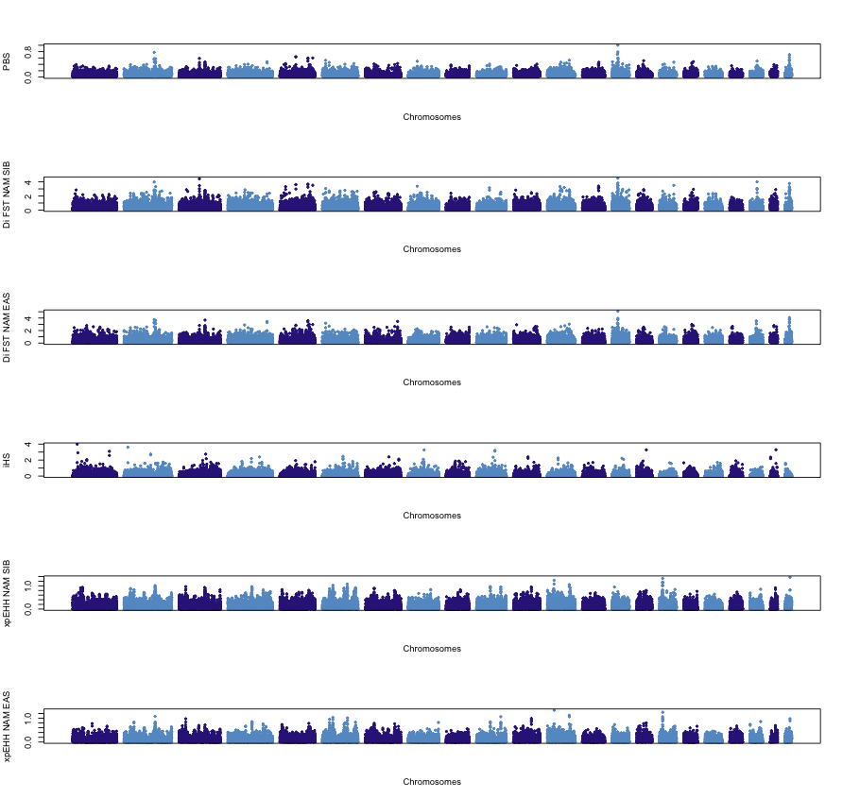
Supplementary Figure 10 - Genome-wide scan for natural selection. Manhattan plot showing the results of the PBS, Di-FST, iHS, and xpEHH approaches. The X-axis represents the positions of each autosomal chromosome, while the Y-axis displays the observed values for each statistic.

Supplementary Note 8: Australasian-like Ancestry and Natural Selection

To identify genomic regions candidate to natural selection with excess Australasian-like (i.e. Ypykuéra) ancestry in contemporary Indigenous Americans, we combined two independent approaches: (i) local ancestry deviation, in which local ancestry was inferred with RFMix¹² using a reference panel including unadmixed Indigenous Americans, Sub-Saharan Africans, Western Europeans, and Australasian populations. For each genomic population, we then calculated a Z-value as (average ancestry proportion at the site - average genome-wide ancestry proportion)/ standard deviation of the genome-wide ancestry proportion; (ii) D-statistic for D(Mbuti, Onge; Mixe, Indigenous Americans). We performed the analysis using 2.5MB sliding windows, with a step size of 0.5Mb, a minimum of 10 SNPs per window and no missing data (maxmiss = 0). Only unrelated and unadmixed individuals were included.

Genomic positions with Z-value >3 for both statistics (local ancestry deviation and D-statistic were classified as Australasian-like. This approach identified 46,205 putative alleles distributed across 24 genomic regions (with nearby regions grouped as a single unit) spanning 17 chromosomes (Supplementary Fig. 11).

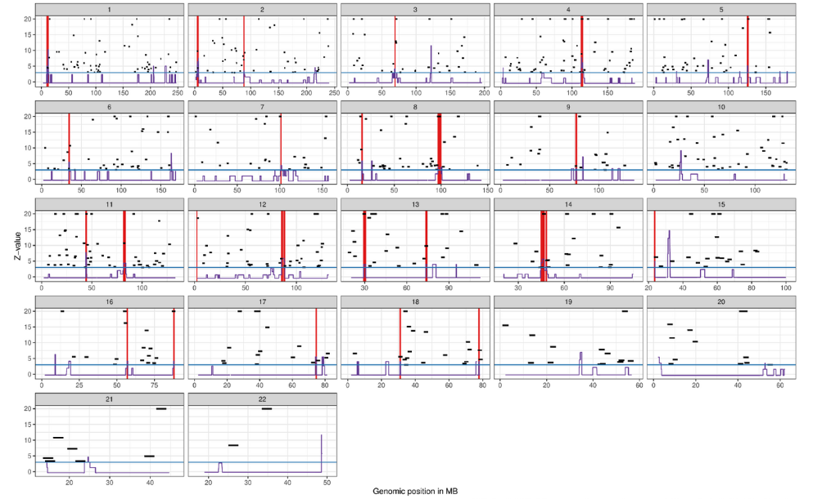

Supplementary Figure 11 - Genomic regions with Australasian-like ancestry. Local ancestry inference was performed for the complete set of Indigenous Americans and here we present (in purple) the Z values for LAD = (average ancestry proportion per site - average genome-wide ancestry proportion) / standard deviation of the genome-wide ancestry proportion. We also present (in black) the Z values for D(Mbuti, Onge; Mixe, unrelated and unadmixed Indigenous Americans) for an overlapping sliding window of 2.5Mb, with a step size of 0.5Mb, a minimum of 10 SNPs per window and no missing data (maxmiss = 0). Positions with Z values above 3 (threshold in blue) for both statistics are highlighted in red. The plots are capped at Z = 20 to improve visualization.

To investigate whether these regions show population-specific differentiation consistent with natural selection, we applied the PBS approach. PBS estimates the amount of population-specific genetic differentiation in a three-population framework, in our case, Indigenous Americans as the focal population, Siberians as the sister group, and East Asians as the outgroup. We estimated PBS values for all variants genome-wide and obtained the empirical distribution, which serves as a demographic baseline control. We then evaluated whether the alleles previously identified as Australasian-like fell within the top 1% and 5% tails of the genome-wide PBS distribution, which would indicate differentiation specific to Indigenous Americans rather than variation shared with Siberians or East Asians, and thus candidate targets of natural selection underlying local adaptation.

Based on the set of putative Australasian-like top 5% alleles within the PBS genome-wide distribution (2,297 genomic positions), the identified variants are predicted to overlap 175 genes and 72 regulatory features, as determined by the Ensembl Variant Effect Predictor (VEP) v.113². Of these, 52% are intronic variants, 31% are non-coding, 5% are upstream gene variants, and 5% are downstream gene variants. Additionally, we also performed an enrichment analysis on these 175 genes using the WEB-based GEne SeT AnaLysis Toolkit (WEB-GESTALT)³¹, focusing on phenotypes and Gene Ontology (GO) categories (Biological Processes, Cellular Components, and Molecular Functions). Redundancy was addressed using the weighted set cover approach, which identifies the minimum subset of gene sets covering all enriched genes, with the weight determined by the p-value. However, no significant results were observed (Supplementary Table 16).

Supplementary Note 9: Archaic Introgression
Putative archaic alleles introgressed into Indigenous American genomes were identified using the method implemented in SPrime³². This tool employs a heuristic scoring approach that detects regions of high linkage disequilibrium (LD) in the target population (e.g., Indigenous American) by comparing them against an unadmixed outgroup, specifically the Mbuti population from Africa. This comparison allows for the identification of candidate introgressed regions by distinguishing segments that exhibit extended LD patterns indicative of archaic ancestry. For these analyses, we used genomic data masked for Native American ancestry.
To improve the robustness and reliability of sites identified as archaic introgressions, we applied a series of filtering steps, following the approach described by Witt et al. (2023)³³. The first step involved selecting only sites with high confidence in archaic genomes. These sites had already undergone quality control filtering based on several criteria, including coverage depth (<10), mapping quality (<25), the presence of tandem repeats, indels, non-biallelic variants, and regions of poor mappability³². The pre-filtered archaic genomes are publicly available at http://cdna.eva.mpg.de/neandertal/Vindija/FilterBed/.
Furthermore, an allele was classified as putatively archaic if it met two conditions: (i) it was present at a low frequency in African populations (<0.01) and (ii) it had a frequency of at least 0.01 in at least one non-African population. This frequency-based criterion ensures that only alleles with plausible introgressed ancestry, rather than common human variation, are retained for further analysis.
For sites that passed all filtering criteria, we classified an archaic match when the archaic genotype carried the putative archaic-specific allele, indicating that the allele was observed in both Neanderthal and Denisovan genomes. Furthermore, introgressed sites were categorized into shared Neanderthal-Denisovan, Neanderthal-specific, and Denisovan-specific groups. A site was classified as Neanderthal-specific if it matched Neanderthal while differing from Denisovan, whereas it was considered Denisovan-specific if it matched Denisovan but differed from Neanderthal. Sites that matched both Neanderthal and Denisovan were categorized as shared archaic. These classifications provide insights into the distinct contributions of archaic hominin groups to the genetic variation observed in Indigenous American populations.
Across the masked Indigenous American genomes, we identified approximately 2.1% of the total sequence, corresponding to 111,408 putative archaic introgressed alleles. After applying quality filters, the number of high-confidence alleles was reduced to 62,773, representing approximately 1.2% of the genome. These high-confidence archaic introgressed alleles are widespread throughout the genome (Supplementary Fig. 12). Based on Variant Effect Predictor (VEP) annotation, 52% of these variants are intronic, and among the coding variants, 40% are missense, while 59% are synonymous.
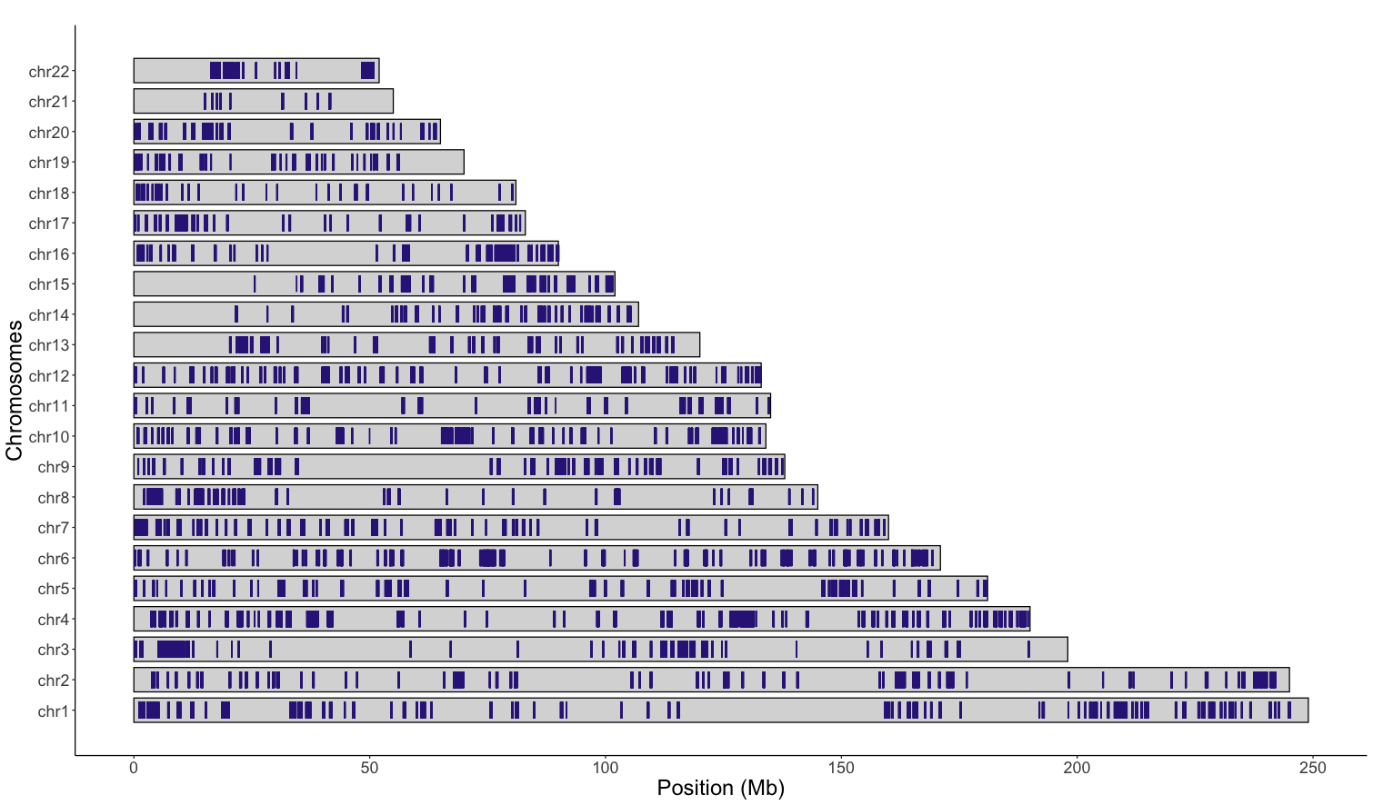
Supplementary Figure 12 - Putative archaic introgressed regions in contemporary Indigenous American genomes. Illustrative haploid autosomal karyogram, with blue bars representing segments identified as introgressed from Neanderthal and/or Denisovan genomes using the SPrime method³² and observed in at least five modern Indigenous American genomes. To improve visualization, each bar has been standardized to a size of 0.1 Mb.

Supplementary Note 10: Sample Description, Ethics, and Community Engagement

Ethical approval for sample collection was provided by the respective local ethics committees in each country: Argentina (Puerto Madryn Zonal Hospital, Resolution No 009/2015; San Carlos de Bariloche Zonal Hospital, Resolution No 1510/2015), Brazil (CONEP, Resolutions No. 763, 4599, 3828655 and 7107656), Bolivia (Universidad Mayor de San Andrés), Ecuador (Universidad de Las Américas; Consejo Nacional de Ciencia y Tecnología—CONACyT, grant # 69856; Instituto Nacional de Ciencias Médicas y de la Nutrición Salvador Zubirán Ref.: 1518), Mexico (Consejo Nacional de Ciencia y Tecnología—CONACyT, grant # 69856; Instituto Nacional de Ciencias Médicas y de la Nutrición Salvador Zubirán Ref.: 1518, CNIC Salud 2013-01-201471; Committee of Ethics and Research, UADY, official notice no. F-FENC-SAC-14/REV: 04; registry no. 09/17) and Peru (Universidad San Martín de Porres). Written informed consent was obtained from all participants prior to sample collection. The ethics committees also approved the oral consent procedure. Logistical support for sample collection in Brazil was provided by the Fundação Nacional do Índio. All sampling was conducted in accordance with the Declaration of Helsinki and the applicable laws and regulations of each country at the time of sampling.

The results of this study were presented to the participating communities. Results were returned to the communities in different ways, depending on the country to which each population belongs. Individual data remain anonymous; therefore, general results for each population were directly communicated to official representatives in Brazil and Argentina. Co-author P. S., a member of the Baré community, acted as a direct interlocutor with Indigenous populations in Brazil. In Mexico, the general results were presented and discussed with the participants and students of junior high and high schools, and one of our coauthors (M.E.M.M.) is part of the Maya communities in which a long-standing collaborative project has been in place (coordinated by J.C.L.R.). In Bolívia, Peru and Ecuador, results were discussed with the populations through their national representatives. The data from this manuscript have been made available to scientific and community representatives. Where possible, clinical tests and medical advice were given to the participant communities (not restricted to participants only) and if needed, follow-up visits were performed to deliver results from both the main research and the clinical tests. In the future, a series of workshops will be organized, along with an accessible version of the manuscript, to be made available to the involved communities.

Supplementary Note 11: Lay summary

Lay summary (English version)

What we wanted to know?

Our species is known to have spread across the world over tens of thousands of years, and America was the final continental landmass to be populated. Indigenous peoples of the American continent have a unique genetic history that began with early migrations from northeastern Asia via a land bridge called Beringia exposed during the last Ice Age by the lower sea levels. However, many details of how these early peoples spread throughout the continent, and how their genes changed over time, remained unclear.

This study aimed to fill those gaps by looking closely at the genomes (the complete set of genetic information) of Indigenous Americans. The researchers wanted to understand how ancient migration, isolation, natural selection (the process by which beneficial traits become more common), and even contact with ancient human relatives (Neanderthals and Denisovans) influenced the genetic diversity of these populations.

What we did?

To answer these questions, the study team generated a new high-quality dataset of whole-genome sequences from 128 Indigenous individuals. These individuals come from 45 different ethnic communities across eight Latin American countries (including Argentina, Bolivia, Brazil, Colombia, Ecuador, Mexico, Paraguay, and Peru). This diverse sample represents 28 different language groups and provides a much broader view of Indigenous genetic diversity than was previously available.

In addition to these new genomes, we used data from ancient individuals and other modern individuals to compare and contrast genetic patterns. We applied a series of genetic analyses to see how the genetic information varies between different present-day and ancient groups and how these differences relate to geography, history, and adaptation.

What we found and what does it mean?

- Indigenous American genetic diversity remains substantially absent from global genomic databases

- Missing genomic variation: We found that more than one million genetic variants present in these 128 Indigenous American individuals have never been observed in populations elsewhere in the world. This genetic diversity reflects their unique population history, while also revealing how Indigenous Americans remain underrepresented in global genomic research. Including a broader range of Indigenous American populations in genetic studies is therefore essential, not only to acknowledge this diversity, but also to ensure that genomic research accurately reflects and benefits humanity as a whole.

- Admixture and the impact of colonization

- Admixture (when people from different populations have children): Because of the European colonization that began five centuries ago, a few Indigenous American genomes also show traces of non-Indigenous ancestry (mainly European and some African). However, by using methods to “mask” or filter out these parts, we focused on the Indigenous genetic information.

- Legacy of isolation: In many groups, the impact of post-colonial population reduction, fragmentation and isolation is evident. In small, isolated populations, there is less gene flow (the exchange of genetic material) with other groups, and increased inbreeding, leading to a reduced genetic diversity in some areas.

- Genetic variation of present-day populations

- Geography leaves a genetic footprint. By comparing genetic similarities across Indigenous American populations, we found that where people lived in the past and the present helps explain how they are genetically related. Broad patterns separate populations from North and South America, but the picture becomes even more detailed within those regions. In South America, we uncovered four major genetic groups that map onto the continent’s geography. These groups span regions such as the Southern Cone in the far south, the Chaco, and the lowlands of western and eastern South America. These patterns show how landscapes and distance have shaped genetic diversity over thousands of years.

- Isolation and inbreeding: Some groups, such as the Karitiana and Suruí, show signs of having been isolated for long periods. This isolation led to more inbreeding (where close relatives have children), which is detectable in their genomes as long stretches where the genetic information is very similar or identical. This kind of pattern helps explain why these populations look more genetically distinct from other groups.

- Multiple human dispersals into South America and long-term genetic continuity

We found evidence for at least three major waves of human dispersal into South America:

- The first wave represents the very earliest settlers found in both the Atlantic and Pacific coasts of South America, which arrived roughly before 9,000 years ago and are most genetically similar to the most ancient individuals of North America.

- The second wave appeared after 9,000 years ago and brought new genetic components into Central and South America, as well as the Caribbean, at least partly replacing the earlier lineage in most regions.

- The third wave is particularly interesting and seems to be linked with groups related to Mesoamerican populations. This third dispersal genetic influence is seen in present-day Indigenous South Americans and even in ancient individuals from the Caribbean.

Together, these findings paint a picture of a continent that was not static but was shaped by multiple migrations over time. Despite these major population movements, most regions in South America exhibit remarkable genetic continuity (the descendants of past populations in a given area have retained a significant portion of their ancestors' genetic makeup over time) stretching from 9,000 years into the present in some regions.

- Signals of genetic adaptation

- Natural selection: We looked for parts of the genome that show strong signs of natural selection, that is, genes that have been favored because they helped people adapt to their environments and generate more descendants. In this way we found candidate regions related to important biological functions like the immune response, metabolism, growth, and even fertility. For example, one gene called LINC00871, which has been linked to the number of children a person might have, showed one of the strongest signals of natural selection.

- Genetic adaptation to local environments: Other genes under selection were involved in responding to infections (vital for surviving in environments with many pathogens), dealing with low oxygen levels (important in high-altitude regions like the Andes), and managing metabolism (which affects how people process food and energy). These signals tell us that as Indigenous Americans settled in diverse environments, from tropical rainforests to high mountain ranges, their bodies adapted to meet new challenges.

- Health-related genes: Understanding these adaptations is not just about history, it can also have implications for modern health. For example, genes that influence how the immune system works or how the body processes sugars and fats could be linked to modern diseases such as diabetes, cardiovascular diseases, or autoimmune conditions. By uncovering these signals, researchers hope to eventually use this knowledge to inform medical research that could benefit both Indigenous communities and worldwide populations.

- Archaic hominin legacy and intriguing connections

- Mixing with ancient relatives: All modern humans carry a small amount of genetic material inherited from archaic hominins such as Neanderthals and Denisovans. In Indigenous Americans, we found that about 1–3% of the genome shows signs of this archaic heritage. Although these amounts are similar to those seen in other parts of the world, the pattern of how these ancient genetic markers are spread across the Indigenous American genomes is unique.

- Selection of variants inherited from archaic hominins: Our study also examined which parts of the genome might have been inherited from ancient human relatives and then selected in Indigenous Americans because they provided some survival benefit. We identified many such regions, some of which involve genes related to immune function and energy metabolism. These adaptations may have helped early settlers survive in new and challenging environments.

- Ypykuéra ancestry: Intriguingly, some Indigenous American groups are known to exhibit a slight genetic affinity with present-day populations from Australasia (such as Australia and New Guinea). The origin of this link has puzzled researchers for years. Current evidence suggests it comes from an ancient Asian population, referred to as Ypykuéra, that contributed to the ancestors of Indigenous Americans. Our study confirms that this affinity is subtle, widely distributed, and likely reflects a very ancient shared ancestry. We also found evidence suggesting that natural selection may have played a role in maintaining at least part of this genetic variation.

Why does it matter?

This study significantly advances our understanding of the genetic history of Indigenous Americans by analyzing a comprehensive dataset of high-quality genomes. Our findings illuminate the complex processes underlying the peopling of the American continent, revealing the impact of multiple dispersal waves, genetic continuity, and demographic shifts in shaping present-day and ancient genetic diversity. Furthermore, we provide evidence of natural selection acting on these populations over millennia, offering novel insights into adaptive evolution.

Beyond its historical and evolutionary implications, this research has important biomedical relevance, as a deeper understanding of genetic diversity and local adaptations can inform studies of diseases that disproportionately affect Indigenous communities, ultimately contributing to more precise and equitable healthcare. By emphasizing their unique genetic heritage, our study underscores the critical need for the inclusion of a diverse set of Indigenous American populations in genomic research to ensure a comprehensive representation of human genetic diversity.

Resumo para leigos (versão em português)

O que queríamos saber?

Nossa espécie se espalhou pelo mundo ao longo de dezenas de milhares de anos, e a América foi o último continente a ser povoado. Os povos indígenas do continente americano possuem uma história genética única que começou com as primeiras migrações a partir do nordeste da Ásia, atravessando uma ponte de terra chamada Beríngia, exposta durante a última Era do Gelo devido aos baixos níveis do mar. No entanto, muitos detalhes sobre como esses primeiros povos se dispersaram pelo continente e como seus genes mudaram ao longo do tempo ainda permanecem incertos.

Este estudo teve como objetivo preencher essas lacunas, analisando de perto os genomas (o conjunto completo de informações genéticas) de indígenas americanos. Nós buscamos entender como a migração antiga, o isolamento, a seleção natural (o processo pelo qual características benéficas se tornam mais comuns) e até mesmo o contato com parentes humanos antigos (Neandertais e Denisovanos) influenciaram a diversidade genética dessas populações.

O que fizemos?

Para responder a essas perguntas, nossa equipe do estudo gerou um novo conjunto de dados de alta qualidade contendo sequências completas do genoma de 128 indivíduos indígenas. Esses indivíduos pertencem a 45 comunidades étnicas diferentes em oito países da América Latina (incluindo Argentina, Bolívia, Brasil, Colômbia, Equador, México, Paraguai e Peru). Essa amostragem diversificada representa 28 diferentes grupos linguísticos e fornece uma visão muito mais ampla da diversidade genética indígena do que os estudos anteriores.

Além desses novos genomas, utilizamos dados de indivíduos antigos e outras amostras modernas para comparar e contrastar padrões genéticos. Aplicamos uma série de análises genéticas para examinar como a informação genética varia entre diferentes grupos do passado e do presente, e como essas diferenças estão relacionadas à geografia, à história e à adaptação genética.

O que encontramos e o que isso significa?

- A diversidade genética dos povos indígenas americanos continua amplamente ausente nas bases de dados genômicos globais

- Variação genômica ausente: Descobrimos que mais de um milhão de variantes genéticas presentes nestes 128 indivíduos indígenas americanos nunca haviam sido observadas em populações de outras partes do mundo. Essa diversidade genética reflete sua história populacional única e, ao mesmo tempo, evidencia como os povos indígenas americanos permanecem sub-representados na pesquisa genômica global. Incluir uma gama mais ampla de populações indígenas americanas nos estudos genéticos é, portanto, essencial, não apenas para reconhecer essa diversidade, mas também para garantir que a pesquisa genômica represente de maneira precisa e beneficie a humanidade como um todo.

- Mistura genética e o impacto da colonização

- Mistura genética (quando pessoas de diferentes populações produzem descendência): Devido à colonização europeia iniciada há cinco séculos, alguns poucos genomas indígenas também apresentam vestígios de ancestralidade não indígena (principalmente europeia e, em menor grau, africana). No entanto, utilizando métodos para “mascarar” ou filtrar essas partes, focamos exclusivamente na informação genética indígena.

- Legado do isolamento: Em muitos grupos, os efeitos da redução populacional pós-colonial, da fragmentação e do isolamento são evidentes. Em populações pequenas e isoladas, há menos fluxo gênico (troca de material genético) com outros grupos e um aumento da endogamia (quando parentes próximos têm filhos), resultando em menor diversidade genética em algumas regiões.

- Variação genética das populações atuais

- La geografía deja una huella genética. Al comparar las similitudes genéticas entre las poblaciones indígenas americanas, encontramos que los lugares donde vivieron las personas, tanto en el pasado como en el presente, ayudan a explicar cómo están genéticamente relacionadas. Los patrones generales separan a las poblaciones de América del Norte y del Sur, pero el panorama se vuelve aún más detallado dentro de esas regiones. En América del Sur, descubrimos cuatro grandes grupos genéticos que se corresponden con la geografía del continente. Estos grupos abarcan regiones como el Cono Sur en el extremo sur, el Chaco y las tierras bajas del oeste y este de Sudamérica. Estos patrones muestran cómo los paisajes y las distancias han moldeado la diversidad genética a lo largo de miles de años.

- Isolamento e endogamia: Alguns grupos, como os Karitiana e os Suruí, apresentam sinais de terem permanecido isolados por longos períodos. Esse isolamento levou a um aumento da endogamia, que pode ser detectado em seus genomas como longos segmentos de DNA com pouca variação. Esse padrão ajuda a explicar por que essas populações parecem geneticamente mais distintas de outros grupos.

- Múltiplas dispersões humanas para a América do Sul e continuidade genética a longo prazo

Encontramos evidências de pelo menos três grandes ondas de dispersão humana para a América do Sul:

- A primeira onda corresponde aos indivíduos mais antigos encontrados tanto na costa do Atlântico quanto na costa do Pacífico da América do Sul, que chegaram há mais de 9.000 anos e apresentam semelhanças genéticas com os indivíduos mais antigos da América do Norte.
- A segunda onda surgiu após 9.000 anos atrás e trouxe novos componentes genéticos para a América Central, América do Sul e Caribe, substituindo parcialmente a linhagem anterior em muitas regiões.

- A terceira onda é particularmente interessante e parece estar associada a grupos relacionados às populações mesoamericanas. Essa influência genética é observada em indígenas sul-americanos atuais e em indivíduos antigos do Caribe.

Juntas, essas descobertas mostram que a formação dos povos nativos do continente não foi estática, mas moldada por múltiplas migrações ao longo do tempo. Apesar dessas movimentações populacionais, a maioria das regiões da América do Sul apresenta uma notável continuidade genética, com algumas populações modernas mantendo uma parte significativa da composição genética de seus ancestrais ao longo de mais de 9.000 anos.

- Sinais de adaptação genética

- Seleção natural: Buscamos regiões do genoma que apresentam sinais fortes de seleção natural, ou seja, genes que foram favorecidos por ajudarem as pessoas a se adaptarem ao ambiente e a deixaram mais descendentes. Identificamos regiões associadas a funções biológicas importantes, como resposta imunológica, metabolismo, crescimento e fertilidade. Por exemplo, um gene chamado LINC00871, relacionado ao número de filhos que uma pessoa pode ter, mostrou um dos sinais mais fortes de seleção natural.

- Adaptação genética a ambientes locais: Outros genes sob seleção estavam envolvidos na resposta a infecções (essencial para a sobrevivência em ambientes com muitos patógenos), na tolerância a baixos níveis de oxigênio (importante para populações que vivem em grandes altitudes, como nos Andes) e no metabolismo (que influencia como o corpo processa alimentos e energia). Esses sinais indicam que, à medida que os indígenas americanos se estabeleceram em ambientes diversos – de florestas tropicais a cadeias montanhosas – seus organismos se adaptaram a novos desafios.

- Genes relacionados à saúde: Compreender essas adaptações não é apenas uma questão histórica, mas pode ter implicações para a saúde das populações modernas. Por exemplo, genes que influenciam o funcionamento do sistema imunológico ou o processamento de açúcares e gorduras podem estar relacionados a doenças contemporâneas, como diabetes, doenças cardiovasculares e condições autoimunes. Esses achados podem contribuir para pesquisas médicas que beneficiem tanto comunidades indígenas quanto populações globais.

- Herança dos hominíneos arcaicos e conexões intrigantes

- Mistura com parentes antigos: Todos os humanos modernos carregam uma pequena quantidade de material genético herdado de hominídeos arcaicos, como os neandertais e os denisovanos. Em indígenas americanos, descobrimos que cerca de 1 a 3% do genoma apresenta sinais dessa herança arcaica. Embora essas quantidades sejam semelhantes às observadas em outras partes do mundo, o padrão de distribuição desses marcadores genéticos antigos nos genomas indígenas americanos é único.

- Ancestralidade Ypykuéra: Curiosamente, alguns grupos indígenas americanos apresentam uma leve afinidade genética com populações atuais da Australásia (como Austrália e Nova Guiné). A origem dessa ligação tem intrigado os pesquisadores por anos. Evidências atuais sugerem que ela vem de uma antiga população asiática, conhecida como Ypykuéra, que contribuiu para os ancestrais dos indígenas americanos. Nosso estudo confirma que essa afinidade é sutil, amplamente distribuída e provavelmente reflete uma ancestralidade compartilhada muito antiga. Também encontramos evidências de que a seleção natural pode ter desempenhado um papel na manutenção de pelo menos parte dessa variação genética.

Por que isso é importante?

Este estudo avança significativamente nossa compreensão da história genética dos indígenas americanos ao analisar um conjunto representativo de genomas de alta qualidade. Nossas descobertas iluminam os processos complexos subjacentes ao povoamento do continente americano, revelando o impacto de múltiplas ondas de dispersão, continuidade genética e mudanças demográficas na formação da diversidade genética atual e antiga. Além disso, fornecemos evidências da seleção natural atuando nessas populações ao longo de milênios, oferecendo novas perspectivas sobre a evolução adaptativa.

Além de suas implicações históricas e evolutivas, esta pesquisa tem relevância biomédica importante, pois uma compreensão mais profunda da diversidade genética e adaptações locais pode ajudar estudos sobre doenças que afetam desproporcionalmente as comunidades indígenas, contribuindo, em última análise, para uma assistência médica mais precisa e equitativa. Ao enfatizar sua herança genética única, nosso estudo ressalta uma urgente necessidade da inclusão de um conjunto diversificado de populações indígenas americanas na pesquisa genômica para garantir uma representação abrangente da diversidade genética humana.

Resumen para legos (versión en español)

¿Qué queríamos saber?

Nuestra especie se ha expandido por el mundo durante decenas de miles de años, y América fue la última gran masa continental en ser poblada. Los pueblos indígenas del continente americano tienen una historia genética única que comenzó con las primeras migraciones desde el noreste de Asia a través de un puente terrestre llamado Beringia, expuesto durante la última Edad de Hielo debido al descenso del nivel del mar. Sin embargo, muchos detalles sobre cómo estos primeros pueblos se dispersaron por el continente y cómo sus genes cambiaron con el tiempo seguían sin estar claros.

Este estudio tenía como objetivo llenar esas lagunas examinando de cerca los genomas (el conjunto completo de información genética) de los indígenas americanos. Los investigadores querían comprender cómo la migración antigua, el aislamiento, la selección natural (el proceso por el cual los rasgos beneficiosos se vuelven más comunes) e incluso el contacto con parientes humanos antiguos (neandertales y denisovanos) influyeron en la diversidad genética de estas poblaciones.

¿Qué hicimos?

Para responder a estas preguntas, nuestro equipo generó un nuevo conjunto de datos de alta calidad con secuencias de genomas completos de 128 individuos indígenas. Estos individuos provienen de 45 comunidades étnicas diferentes de ocho países latinoamericanos (Argentina, Bolivia, Brasil, Colombia, Ecuador, México, Paraguay y Perú). Esta muestra diversa representa 28 grupos lingüísticos distintos y proporciona una visión mucho más amplia de la diversidad genética indígena de la que se tenía previamente.

Además de estos nuevos genomas, utilizamos datos de individuos antiguos y otras muestras modernas para comparar y contrastar los patrones genéticos. Aplicamos una serie de análisis genéticos para ver cómo varía la información genética entre diferentes grupos actuales y antiguos, y cómo estas diferencias se relacionan con la geografía, la historia y la adaptación.

¿Qué encontramos y qué significa?

- La diversidad genética de los pueblos indígenas americanos sigue estando ampliamente ausente en las bases de datos genómicos globales

- Variación genómica faltante: Descubrimos que más de un millón de variantes genéticas presentes en estos 128 individuos indígenas americanos nunca se habían observado en poblaciones de otras partes del mundo. Esta diversidad genética refleja su historia poblacional única y, al mismo tiempo, evidencia cómo los pueblos indígenas americanos continúan estando subrepresentados en la investigación genómica global. Incluir una gama más amplia de poblaciones indígenas americanas en los estudios genéticos es, por lo tanto, esencial, no solo para reconocer esta diversidad, sino también para garantizar que la investigación genómica refleje de manera precisa y beneficie a toda la humanidad.

- Mestizaje y el impacto de la colonización

- Mestizaje (cuando personas de diferentes poblaciones tienen descendencia): Debido a la colonización europea que comenzó hace cinco siglos, algunos pocos genomas indígenas también muestran rastros de ascendencia no indígena (principalmente europea y en algunos casos africana). Sin embargo, mediante métodos que permiten "enmascarar" o filtrar estas partes, nos enfocamos en la información genética indígena.

- Legado del aislamiento: En muchos grupos, el impacto de la reducción poblacional, la fragmentación y el aislamiento postcolonial es evidente. En poblaciones pequeñas y aisladas hay menos flujo génico (el intercambio de material genético) con otros grupos y un aumento de la endogamia (cuando parientes cercanos tienen descendencia), lo que conduce a una menor diversidad genética en algunas regiones.

- Variación genética de las poblaciones actuales

- A geografia deixa uma marca genética. Ao comparar semelhanças genéticas entre as populações indígenas americanas, descobrimos que os lugares onde as pessoas viveram, tanto no passado quanto no presente, ajudam a explicar como elas estão geneticamente relacionadas. Os padrões gerais separam as populações da América do Norte e do Sul, mas o quadro se torna ainda mais detalhado dentro dessas regiões. Na América do Sul, identificamos quatro grandes grupos genéticos que refletem a geografia do continente. Esses grupos abrangem regiões como o Cone Sul, no extremo sul, o Chaco e as planícies do oeste e leste da América do Sul. Esses padrões mostram como paisagens e distâncias moldaram a diversidade genética ao longo de milhares de anos.

- Aislamiento y endogamia: Algunos grupos, como los Karitiana y los Suruí, muestran signos de haber estado aislados durante largos períodos. Este aislamiento llevó a una mayor endogamia, lo que se detecta en sus genomas como largas secuencias de ADN donde la información genética es muy similar o idéntica. Este patrón ayuda a explicar por qué estas poblaciones son genéticamente más distintas de otros grupos.

- Múltiples dispersiones humanas en América del Sur y continuidad genética a largo plazo

Encontramos evidencia de al menos tres grandes oleadas de dispersión humana en América del Sur:

- Primera ola: Representa a los primeros pobladores, presentes tanto en las costas del Atlántico como del Pacífico de América del Sur. Llegaron hace aproximadamente más de 9,000 años y son genéticamente más similares a los individuos antiguos de América del Norte.
- Segunda ola: Apareció después de hace 9,000 años y trajo nuevos componentes genéticos a América Central y del Sur, así como al Caribe, reemplazando parcialmente el linaje anterior en muchas regiones.
- Tercera ola: Se asocia con grupos relacionados con poblaciones mesoamericanas. Su influencia genética se observa en indígenas sudamericanos actuales y en individuos antiguos del Caribe.

Estos hallazgos revelan que el continente no fue estático, sino moldeado por múltiples migraciones a lo largo del tiempo. A pesar de estos movimientos poblacionales, la mayoría de las regiones en América del Sur muestran una notable continuidad genética (los descendientes de poblaciones antiguas han retenido una gran parte de la composición genética de sus ancestros) desde hace más de 9,000 años hasta el presente en algunas regiones.

- Señales de adaptación genética

- Selección natural: Buscamos regiones del genoma con señales fuertes de selección natural, es decir, genes favorecidos porque ayudaron a las personas a adaptarse a su entorno y a dejar más descendencia. Identificamos regiones relacionadas con funciones biológicas importantes como la respuesta inmune, el metabolismo, el crecimiento e incluso la fertilidad. Por ejemplo, el gen LINC00871, asociado con la cantidad de hijos que una persona podría tener, mostró una de las señales más fuertes de selección natural.

- Adaptación genética a entornos locales: Otros genes bajo selección están involucrados en la respuesta a infecciones (clave para la supervivencia en ambientes con muchos patógenos), la adaptación a bajos niveles de oxígeno (importante en regiones de gran altitud como los Andes) y la regulación del metabolismo (que afecta cómo las personas procesan los alimentos y la energía). Estos hallazgos indican que, al asentarse en entornos diversos, desde selvas tropicales hasta altas montañas, los cuerpos de los indígenas americanos se adaptaron a nuevos desafíos.

- Genes relacionados con la salud: Comprender estas adaptaciones no es solo una cuestión histórica; también tiene implicaciones para la salud moderna. Genes que influyen en el sistema inmunológico o en el procesamiento de azúcares y grasas podrían estar relacionados con enfermedades actuales como la diabetes, enfermedades cardiovasculares o autoinmunes. Identificar estas señales podría ayudar en futuras investigaciones médicas que beneficien tanto a las comunidades indígenas como a la población global.

- Legado de homininos arcaicos y conexiones intrigantes

- Mezcla con parientes antiguos: Todos los humanos modernos llevan una pequeña cantidad de material genético heredado de homínidos arcaicos, como los neandertales y los denisovanos. En los indígenas americanos, encontramos que aproximadamente entre el 1 % y el 3 % del genoma muestra señales de esta herencia arcaica. Aunque estas cantidades son similares a las observadas en otras partes del mundo, el patrón de cómo estos marcadores genéticos antiguos se distribuyen a lo largo de los genomas indígenas americanos es único.

- Selección de variantes heredadas de homínidos arcaicos: Algunas variantes heredadas de estos antiguos parientes parecen haber sido seleccionadas en los indígenas americanos porque ofrecieron ventajas de supervivencia. Muchas de ellas están relacionadas con la función inmune y el metabolismo energético.

- Ascendencia Ypykuéra: Curiosamente, se sabe que algunos grupos indígenas americanos muestran una ligera afinidad genética con poblaciones actuales de Australasia (como Australia y Nueva Guinea). El origen de este vínculo ha desconcertado a los investigadores durante años. La evidencia actual sugiere que proviene de una población asiática antigua, conocida como Ypykuéra, que contribuyó a los antepasados de los indígenas americanos. Nuestro estudio confirma que esta afinidad es sutil, está ampliamente distribuida y probablemente refleja una ascendencia compartida muy antigua. También encontramos indicios de que la selección natural pudo haber jugado un papel en la conservación de al menos parte de esta variación genética.

¿Por qué es importante?

Este estudio mejora significativamente nuestra comprensión de la historia genética de los indígenas americanos mediante el análisis de un conjunto representativo de datos genómicos de alta calidad. Nuestros hallazgos arrojan luz sobre los complejos procesos que subyacen al poblamiento del continente americano, revelando el impacto de múltiples olas de dispersión, la continuidad genética y los cambios demográficos en la conformación de la diversidad genética actual y antigua. Además, proporcionamos evidencia de la selección natural que actúa sobre estas poblaciones a lo largo de milenios, ofreciendo nuevas perspectivas sobre la evolución adaptativa.

Más allá de sus implicaciones históricas y evolutivas, esta investigación tiene una importante relevancia biomédica, ya que una comprensión más profunda de la diversidad genética y las adaptaciones locales puede fundamentar los estudios de enfermedades que afectan desproporcionadamente a las comunidades indígenas, contribuyendo en última instancia a una atención médica más precisa y equitativa. Al enfatizar su herencia genética única, nuestro estudio subraya la necesidad crítica de la inclusión de un conjunto diverso de poblaciones indígenas americanas en la investigación genómica para garantizar una representación integral de la diversidad genética humana.

Supplementary References
1. Hanssen, F. et al. Scalable and efficient DNA sequencing analysis on different compute infrastructures aiding variant discovery. NAR Genom Bioinform 6, lqae031 (2024).
2. McLaren, W. et al. The Ensembl Variant Effect Predictor. Genome Biol 17, 122 (2016).
3. Byrska-Bishop, M. et al. High-coverage whole-genome sequencing of the expanded 1000 Genomes Project cohort including 602 trios. Cell 185, 3426–3440.e19 (2022).
4. Bergström, A. et al. Insights into human genetic variation and population history from 929 diverse genomes. Science 367, (2020).
5. Mallick, S. et al. The Simons Genome Diversity Project: 300 genomes from 142 diverse populations. Nature 538, 201–206 (2016).
6. Zheng, X. et al. A high-performance computing toolset for relatedness and principal component analysis of SNP data. Bioinformatics 28, 3326–3328 (2012).
7. Alexander, D. H., Novembre, J. & Lange, K. Fast model-based estimation of ancestry in unrelated individuals. Genome Res 19, 1655–1664 (2009).
8. Jakobsson, M. & Rosenberg, N. A. CLUMPP: a cluster matching and permutation program for dealing with label switching and multimodality in analysis of population structure. Bioinformatics 23, 1801–1806 (2007).
9. Staples, J., Nickerson, D. A. & Below, J. E. Utilizing graph theory to select the largest set of unrelated individuals for genetic analysis. Genet. Epidemiol. 37, 136–141 (2013).
10. Delaneau, O., Zagury, J.-F., Robinson, M. R., Marchini, J. L. & Dermitzakis, E. T. Accurate, scalable and integrative haplotype estimation. Nat. Commun. 10, 5436 (2019).
11. 1000 Genomes Project Consortium et al. A global reference for human genetic variation. Nature 526, 68–74 (2015).
12. Maples, B. K., Gravel, S., Kenny, E. E. & Bustamante, C. D. RFMix: a discriminative modeling approach for rapid and robust local-ancestry inference. Am J Hum Genet 93, 278–288 (2013).
13. Mondal, M. et al. Genomic analysis of Andamanese provides insights into ancient human migration into Asia and adaptation. Nat Genet 48, 1066–1070 (2016).
14. Mallick, S. & Reich, D. The Allen Ancient DNA Resource (AADR): A curated compendium of ancient human genomes. Harvard Dataverse https://doi.org/10.7910/DVN/FFIDCW (2023).
15. Ferraz, T. et al. Genomic history of coastal societies from eastern South America. Nat Ecol Evol 7, 1315–1330 (2023).
16. Fu, Q. et al. An early modern human from Romania with a recent Neanderthal ancestor. Nature 524, 216–219 (2015).
17. Hijmans, R. J. geosphere: Spherical Trigonometry. CRAN: Contributed Packages The R Foundation https://doi.org/10.32614/cran.package.geosphere (2010).
18. Petkova, D., Novembre, J. & Stephens, M. Visualizing spatial population structure with estimated effective migration surfaces. Nat Genet 48, 94–100 (2016).
19. Browning, S. R. et al. Ancestry-specific recent effective population size in the Americas. PLoS Genet. 14, e1007385 (2018).
20. Browning, B. L. & Browning, S. R. Improving the accuracy and efficiency of identity-by-descent detection in population data. Genetics 194, 459–471 (2013).
21. Mooney, J. A. et al. Understanding the Hidden Complexity of Latin American Population Isolates. Am J Hum Genet 103, 707–726 (2018).
22. Maier, R. et al. On the limits of fitting complex models of population history to -statistics. Elife 12, (2023).
23. Akey, J. M. et al. Tracking footprints of artificial selection in the dog genome. Proc Natl Acad Sci U S A 107, 1160–1165 (2010).
24. Yi, X. et al. Sequencing of 50 human exomes reveals adaptation to high altitude. Science 329, 75–78 (2010).
25. Sabeti, P. C. et al. Detecting recent positive selection in the human genome from haplotype structure. Nature 419, 832–837 (2002).
26. Voight, B. F., Kudaravalli, S., Wen, X. & Pritchard, J. K. A map of recent positive selection in the human genome. PLoS Biol 4, e72 (2006).
27. Sabeti, P. C. et al. Genome-wide detection and characterization of positive selection in human populations. Nature 449, 913–918 (2007).
28. Chang, C. C. et al. Second-generation PLINK: rising to the challenge of larger and richer datasets. Gigascience 4, 7 (2015).
29. Szpiech, Z. A. selscan 2.0: scanning for sweeps in unphased data. Bioinformatics 40, (2024).
30. Deschamps, M. et al. Genomic Signatures of Selective Pressures and Introgression from Archaic Hominins at Human Innate Immunity Genes. Am J Hum Genet 98, 5–21 (2016).
31. Elizarraras, J. M. et al. WebGestalt 2024: faster gene set analysis and new support for metabolomics and multi-omics. Nucleic Acids Res 52, W415–W421 (2024).
32. Browning, S. R., Browning, B. L., Zhou, Y., Tucci, S. & Akey, J. M. Analysis of Human Sequence Data Reveals Two Pulses of Archaic Denisovan Admixture. Cell 173, 53–61.e9 (2018).
33. Witt, K. E., Funk, A., Añorve-Garibay, V., Fang, L. L. & Huerta-Sánchez, E. The Impact of Modern Admixture on Archaic Human Ancestry in Human Populations. Genome Biol Evol 15, (2023).

