Supplementary Note 1. Site information of Zhoukoudian, Hexian, and Sunjiadong

The Zhoukoudian site
The Zhoukoudian site is located in Fangshan District, Beijing, northern China. ~ 200 hominin fossils were recovered from Locality 1 during 1921-1923, 1927-1937, 1949-1966, representing over 40 individuals of various ages ¹⁻⁹. Notable discoveries include the first calotte (Skull III) of Peking Man found in 1929 ¹⁰ and three additional calottes (Skulls X, XI, and XII) uncovered in 1936 ⁶. Currently, only 15 original Peking Man fossils are preserved, including 11 specimens (two cranial fragments belonging to Skull V, one mandible, two limb bones, 6 isolated teeth housed at the Institute of Vertebrate Paleontology and Paleoanthropology, Chinese Academy of Sciences, in Beijing, China, and 4 isolated teeth stored at Uppsala University, Sweden ^{3,4,7,11,12}. Multiple dating methods, including fission track, uranium-series, thermoluminescence, electron spin resonance, thermal ionization mass spectrometry, and cosmogenic burial, indicated that the Peking Man from Locality 1 lived between 0.78 - 0.3 Ma ¹³⁻¹⁹. A new species, Sinanthropus penkinensis, was created for this population in 1927 ²⁰, which later was reclassified with fossils from Indonesia as H. erectus ^{21,22}.

The Hexian site
The Hexian site is situated at Taodian Village, Hexian County, Anhui Province, in southern China. During the 1980-1981 excavations, 15 hominin specimens were found, including a fairly complete calotte, two cranial fragments, one left mandibular corpus with two isolated teeth, and 11 other teeth, representing around 3 individuals ^{23,24}. Combined U-series and electron spin resonance (ESR) analysis estimated the Hexian hominins to ~ 0.41 Ma ²⁵. Initially, the Hexian hominins were considered a more derived form of H. erectus due to their less robust features compared to the Zhoukoudian specimens ²³. However, recent studies suggest that they are actually more primitive, aligning with Indonesian Early Pleistocene H. erectus in both cranial and dental morphology ^{26,27}. The Penghu 1 hominin, recently confirmed as Denisovan through paleoproteomic data ²⁸, was shown to display robust and primitive dentognathic features more similar to the Hexian hominins than to other penecontemporaneous fossil records ²⁹.

The Sunjiadong site
The Sunjiadong site is situated in Luanchuan County, Henan Province, central China. During the 2012 excavation, six teeth were recovered, two of which were attached to a small jawbone ^{30,31}. These fossils were linked to three individuals: a child (6-7 years old), an adolescent (11-12 years old), and an adult, based on the developmental profile of recent H. sapiens ³¹. In this study, we include two teeth (12SJD1#10-42 and 12SJD1#10-45) from layer four and one tooth (12SJD1#14-22) from layer five, corresponding to these three individuals. The associated faunal remains suggest a Middle Pleistocene age, with subsequent dating estimating the hominin fossils to 0.4 Ma ^{30,31}. Both the crown size and dental morphologies of the Sunjiadong hominins closely resemble those from Zhoukoudian ³¹.
Supplementary Note 2. Chlorination and dichlorination of Y residues in Hexian samples
We detected some unexpected mass shifts, +33.96, +35.96, +67.92, +69.92, and +71.92, on tyrosine (Y) residues in both Hexian H. erectus samples. We identified them in PEAKS PTM, pFind Open Search, and MaxQuant dependent peptides (no +71.92 in MaxQuant) as post-translational modifications (PTMs). After a manual check to rule out the possibility of any PTMs and mutations with similar mass shifts, these detected mass shifts were classified as chlorination (+33.96, +35.96) or dichlorination (+67.92, +69.92, +71.92) at the ortho position of the phenolic hydroxyl group in the side chain of a Y residue based on their isotope patterns. These PTMs were further validated with additional PEAKS and pFind searches, including all possible PTMs on Y residues in the variable modification list, which prevents these halogenation PTMs on Y residues from being identified as any other PTM.
Additional mass shifts were identified in PEAKS PTM that could be classified as a single bromine substitution (bromination, +77.91 and +79.91) on each residue, as a byproduct of the aryl chlorination reaction. These mass shifts appeared in only a few peptides in our results and were not present in the pFind and MaxQuant results. Moreover, the ⁸¹Br substitution is more likely to be a phosphorylation (+79.97). Therefore, we only considered it a minor side reaction PTM and did not include it in our second-round search.
In the pFind search, chlorinated Y residues are primarily found in AMEL (>98%), with fewer in AMBN and ENAM. For Hexian S1, over 98.5% of Y residues were chlorinated or di-chlorinated (Cl-Y 24.1%, diCl-Y 74.4%). For Hexian S2, 32.1% of Y residues were chlorinated, with some dehydrated Y residues. The PEAKS and MaxQuant results were similar, confirming the accuracy of chlorinated Y identification.
We conducted experiments to eliminate the possibility that these PTMs originated externally after burial. First, these PTMs were not introduced during the experiment, since no chlorine was added during protein extraction, and there was no evidence of chlorination or dichlorination in the blank extraction or positive control groups. Additionally, since none of these modifications were found as a major modification on Y residues in enamel samples from Hexian fauna from the same layer (one giant panda, Ailuropoda melanoleuca, and one wolf, Canis lupus), it is unlikely that they resulted from the taphonomy process either. Therefore, we concluded that these PTMs are probably endogenous, since there have been reports ^{32,33} of chlorinated and dichlorinated Y in peptides from inflamed tissues. A possible mechanism for the endogenous origin of halogenated Y in Hexian H. erectus samples is that, during inflammatory reactions, myeloperoxidase (MPO)—an enzyme produced by neutrophils—oxidizes chloride ions (Cl⁻) to produce hypochlorous acid (HOCl). This HOCl acts as an electrophile in aryl chlorination, chlorinating the electron-rich phenolic hydroxyl group in the Y side chain. Bromination may also occur as a side reaction. These processes could happen during enamel formation, as chlorinated Y residues are found in the main enamel proteins.
Previous research ³⁴ on morphology and pathology indicated the presence of cranial wounds on Hexian H. erectus. These injuries and subsequent infections may have contributed to inflammation. However, as no direct evidence has yet established a connection between the cranial wounds and enamel growth, and considering that chlorination was not identified as a major post-translational modification (PTM) on Y residues in other archaeological human enamel proteomes associated with inflammation and immune response ³⁵, the specific mechanisms of chlorination and its physiological effects warrant further investigation.

Supplementary Note 3. The comparisons of Pleistocene teeth and blank controls
Our ancient samples showed significantly different characteristics from blank controls, including fragment patterns, peptide length distributions, PSM counts and assignments, amino acid composition and peptide acidity, and PTMs. Among the sites, samples from Zhoukoudian, Sunjiadong, and Harbin were similar. They had similar average peptide pI values (6.32-6.56), and preserved higher PSM counts than the Hexian samples (HX-S1, HX-S2), indicating better preservation (Supplementary Table 1). The additional PTM on Y residues in the 2 Hexian samples also suggested a higher level of degradation and a distinct taphonomic process. Although Hexian samples differed slightly, the proteomes of all samples from the 3 sites showed clear ancient enamel features, including elevated deamidation levels of N/Q residues and a higher percentage of P residues (Supplementary Table 3).

- Fragment characteristics, PSM number, and assignment
Many more PSMs were identified in the sample fractions than in the blank controls (Supplementary Table 1). No PSM or peptide matched common microbial contaminants. And no PSM or peptide from enamel protein was detected in blank controls using either the “Hominidae enamel database” or a larger database search (SwissProt). Notably, all blank controls showed very high tryptic rates, a fragment characteristic of lab contaminants. On the contrary, all our ancient samples showed similar fragment characteristics, with high non-tryptic rates (85.1-87.1%), close to the random (unspecific) cleavage rate during degradation.

- Peptide length distribution:
The new ancient samples showed different peptide-length distributions from the blank controls. Both the percentage and count of peptides in our ancient samples decreased with increasing peptide length, while the blank controls showed a count peak at 11-16, with no clear pattern in peptide percentage (Supplementary Figs. 1 and 2). And this pattern was quite similar in all sites.

- Amino acid composition and peptide isoelectric point (pI, Acidity):
All samples had an average peptide isoelectric point (pI) above 6.32 and fell within the range of ancient and modern human enamels (5.90-7.41), while all blank controls were below 5.73 (5.15-5.73). Additionally, all enamel samples exhibited the same amino acid composition pattern, such as the significantly elevated level of P in enamel samples (>19.3% and >20.0% in new samples) compared to all blank controls, which were less than 3.6% (Supplementary Table 3). Lower levels of Q and higher percentages of A, D, T, and V were also observed in all blank controls (Supplementary Table 3). The new samples showed a lower G percentage than the modern enamel samples, consistent with the two published ancient samples, suggesting an ancient origin.

- PTMs:
All ancient samples had elevated deamidation N/Q levels (>91%), while all blank controls were nearly 0, and the modern enamel sample was between 40% and 50%. (Supplementary Table 6). Other PTMs, such as biological-related Phosphorylation S/Y, high-level Oxidation/Dioxidation M, and degradation-related PTMs on W and R residues, further authenticate the ancient enamel proteome.

- Comparison of the results of two different labs:
Across two labs, the PSMs identified from the Orbitrap Exploris 480 at Fudan University (FD) fractions were a subset of those identified from the Orbitrap Fusion Lumos at Capital Medical University (SY) fractions (Supplementary Table 2), except for a few contaminant PSMs and 1 PSM from SERPINC1. This is expected since we used the same peptide extraction but different data-acquisition gradients and repetitive runs: 65 minutes at FD for one run and 120 minutes at SY for two or three runs. Results from the two labs also showed similar fragment characteristics (Supplementary Table 5), peptide length distributions (Supplementary Fig. 3), and deamidation N/Q rates (Supplementary Table 7), and only showed a systematic difference in average peptide acidity (Supplementary Table 4, pI_{FD} - pI_{SY} = 0.20-0.70), possibly due to different chromatographic conditions, as SY used a relatively longer gradient at the lower organic buffer ratio (11-28% B for 88 min). Thus, a longer data acquisition time with repetitive runs could help acquire more PSM identifications while maintaining stability in most peptide characteristics.

Supplementary Note 4. Corrections on H. erectus AMELY consensus sequences
AMELY-179+180 is an 'LR' in modern humans (about 7.8% 'LQ' in East Asians and significantly fewer ‘LT’ in East Asians and Europeans), Neanderthals, and Denisovans. It is an 'MR' in Pan and Gorilla, and an 'MQ' (=AMELX) in Pongo and other Hominid species. Furthermore, ATD6-92, Homo antecessor ³⁶, was identified here as an 'MR', supported by numerous high-quality peptides (>30 PSMs) demonstrating comprehensive y/b ion coverage on 179M (≥3).
In our H. erectus data, however, there were significantly fewer peptides containing AMELY-179+180 MR, and their y/b ion coverage on 179M (≤2) was not as comprehensive as that of the peptides identified in ATD6-92. Specifically, no peptides containing AMELY-179 with 180 were detected in the two Hexian samples. In ZKD, SJD10M, and SJD14M, five to nine peptides (11-15 PSMs; maximum y/b ion coverage of one at the terminal, or two not at the terminal) carrying AMELY-179M+180R were identified, with one to two peptides (one to two PSMs; maximum y/b ion coverage of one at the terminal, or one not at the terminal) containing 179L in the PEAKS analysis. Additionally, an extended search specific to AMEL revealed the presence of another five to nine peptides carrying unexpected amino acids at position AMELY-179. This indicates that other amino acids might coexist with M at AMELY-179. Since each human genome typically has only 0 or 1 allele for AMELY, a heterozygous AMELY-179 is nearly impossible. Additionally, AMELY-179M could not be confirmed in MaxQuant analyses: only SJD10M had 179M+180R peptides (but with no y/b ion coverage), and a 179L peptide was found in SJD14M.
Therefore, a consensus on AMELY-179M is not sufficiently supported (180R is acceptable). This may indicate poor conservation at this amino acid position. Consequently, we marked AMELY-179+180 as an 'XR' in our H. erectus consensus sequences when these sites were identified.

Supplementary Note 5. The detection and confirmation of the new SAP AMBN-253G
During the initial search, AMBN-253A was not detected across all software platforms. However, there was coverage at the amino acid sites between AMBN-249 and 260. As a result, we suspected the possible presence of an SAP. We analyzed the peptides with mutations using pFind, and the mutation at AMBN-253 was an A-to-G substitution. For each H. erectus sample, the AMBN-253G variant was detectable in both PEAKS de novo and MaxQuant dependent peptides. On average, approximately 50 spectra were observed in raw data from the Sunjiadong and Zhoukoudian samples within PEAKS de novo, with similar spectral counts—around 50—for each sample within MaxQuant dependent peptides. In Hexian samples, fewer spectra containing AMBN-253G were detected, corresponding with their poorer preservation. According to gnomAD and UniProt, AMBN-253 A->G is a novel SAP that does not exist in the modern human population or other animals, and is thus a derived SAP in only observed in the H. erectus samples.
Following the inclusion of the sequence with AMBN-253G into our database, subsequent second-round searches consistently identified AMBN-253G, but not 253A, across all six Homo erectus samples, using all software platforms. Supported by numerous high-quality peptides corroborating this SAP (see Supplementary Fig. 1 and Table 1), a G at position 253 in the AMBN protein existed across all six H. erectus samples.

Supplementary Note 6. Phylogenetic reconstruction
For the phylogenetic analysis, we reconstructed the consensus sequences of endogenous proteins from each sample, covering 332 to 599 amino acid positions in enamel-related proteins that overlap in PEAKS Online, pFind, and MaxQuant. (Methods). We then estimated phylogenetic trees using a Bayesian framework ⁴¹ for these six sample consensus sequences, along with the translated protein sequences from previously published high-coverage genomes, including a gorilla ²⁴, a chimpanzee ²⁴, Denisova 3 ⁴², two Neanderthals (Altai, Vindija33.19) ^{43,44}, an African, and an Oceanian carrying the AMBN-273V mutation ²⁵.
All Homo individuals group together with 100% posterior probability support (Extended Data Fig. 3). All six Middle Pleistocene H. erectus samples from Zhoukoudian, Hexian, and Sunjiadong also form a strongly supported monophyletic group (posterior probability 100%, Extended Data Fig. 3). This is confirmed by the SAP described in the main text, which is exclusive to these samples (AMBN-253G). Further phylogenetic relationships within the Homo group are unable to be resolved due to the limited number of informative sites and the fact that most of the branches are supported by one or several SAPs, especially the AMBN-273V mutation, which is present in all six Middle Pleistocene H. erectus samples, as well as in Denisova 3 and a modern human from Oceania (posterior probabilities of 43%, 43%, and 54%, respectively, Extended Data Fig. 3). Although this allele is likely shared through introgression, due to the limited amount of data, it is not possible to directly incorporate introgression signals into the phylogenetic tree using the nuclear genomic method.

Supplementary Table 1 ｜ PSM and peptide counts of the proteins of the ancient samples of this study and related blank controls.
Sample | PSM |  |  | Peptide |  |  | Non-tryptic peptides (%, C-terminal)
Sample | All | Endogenous | Exogenous | All | Endogenous | Exogenous | Non-tryptic peptides (%, C-terminal)
ZKD | 22107 | 21865 | 242 | 2201 | 2134 | 67 | 87.1
SJD10M | 15467 | 15466 | 1 | 2809 | 2808 | 1 | 87
SJD10A | 12520 | 12509 | 11 | 2015 | 2013 | 2 | 87.1
SJD14M | 15547 | 15541 | 6 | 2721 | 2720 | 1 | 87
HX-S1 | 4097 | 4094 | 3 | 652 | 650 | 2 | 87.3
HX-S2 | 5182 | 5181 | 1 | 821 | 820 | 1 | 85.1
Harbin | 17852 | 17814 | 38 | 3476 | 3457 | 19 | 85.5
ZKD_BK | 642 | 0 | 642 | 148 | 0 | 148 | 0.7
SJD_BK | 26 | 0 | 26 | 21 | 0 | 21 | 28.6
HX_BK | 29 | 0 | 29 | 22 | 0 | 22 | 0
ZKD-BK-SP | 9362 | 0 | 9362 | 2029 | 0 | 2029 | 0
SJD-BK-SP | 75 | 0 | 75 | 73 | 0 | 73 | 4.1
HX-BK-SP | 1389 | 0 | 1389 | 989 | 0 | 989 | 0
*SP=SwissProt database.

Supplementary Table 2｜ Peptide numbers identified in fractions from the 2 labs.
Sample | SY-specific Peptide | Peptide in both labs | FD-specific Peptide
ZKD | 913 | 1253 | 35 (all contaminant)
SJD10M | 2392 | 417 | 0
SJD10A | 1692 | 322 | 1 (SERPINC1)
SJD14M | 2188 | 533 | 0
HX-S1 | 448 | 202 | 1 (contaminant)
HX-S2 | 433 | 388 | 0

Supplementary Table 3 ｜ Amino acid composition and average peptide acidity of ancient samples and blanks of the current study, compared with published samples.
Amino acid | ZKD | SJD10M | SJD10A | SJD14M | HX-S1 | HX-S2 | Harbin | ZKD-BK | SJD-BK | HX-BK | Penghu1 | Atapuerca | MH
A | 2.8 | 2.4 | 2.2 | 2.4 | 1.5 | 0.9 | 3 | 8 | 7.7 | 5.3 | 2.6 | 2.2 | 5.5
C | 0 | 0 | 0 | 0 | 0 | 0 | 0 | 0.4 | 0 | 0 | 0 | 0 | 0
D | 3 | 2.6 | 2.7 | 2.6 | 2.3 | 1.6 | 2.3 | 6.2 | 5.1 | 7 | 2.7 | 2.8 | 1.4
E | 7.8 | 7.6 | 8 | 7.6 | 5.1 | 3.9 | 6.7 | 8.3 | 12.8 | 9 | 7.4 | 7.2 | 4.8
F | 4.6 | 4.7 | 5 | 4.5 | 4.3 | 3.1 | 4.8 | 3 | 0.5 | 6.3 | 4.2 | 5 | 2.9
G | 5.2 | 5.4 | 4.8 | 5.4 | 3.3 | 3.1 | 7.2 | 9.8 | 2.1 | 10 | 5.9 | 4 | 17.5
H | 2.6 | 3.1 | 3 | 3.1 | 4.1 | 3.1 | 2.7 | 2 | 0.5 | 1.7 | 3.9 | 1.3 | 3
I | 3.1 | 3.7 | 3.3 | 3.8 | 4.6 | 4.7 | 3.2 | 6.6 | 11.3 | 5.6 | 3.7 | 2.4 | 2.7
K | 3.6 | 3.1 | 3.8 | 3.3 | 3.3 | 4.2 | 2.6 | 4.6 | 5.1 | 3.7 | 5.2 | 2.9 | 3
L | 9.7 | 10.3 | 9.4 | 10.2 | 10.7 | 12.2 | 10.6 | 9.8 | 17.4 | 14.3 | 9.6 | 11.3 | 7.7
M | 4.5 | 5.1 | 4.4 | 4.6 | 4.7 | 3.5 | 5.1 | 2.5 | 0 | 1.7 | 2.7 | 6.8 | 2
N | 2.1 | 2.6 | 2.3 | 2.5 | 1.8 | 1.7 | 2.5 | 7.5 | 6.2 | 3.7 | 1.9 | 1.8 | 2
P | 23.8 | 20 | 23.2 | 20 | 27.7 | 26 | 20.4 | 2 | 3.6 | 1 | 19.3 | 26.5 | 19.3
Q | 6.9 | 5.6 | 6.1 | 5.6 | 7.9 | 6.7 | 6 | 4.5 | 7.7 | 2.3 | 5.5 | 8.5 | 4.8
R | 3.3 | 3.9 | 3.1 | 3.9 | 3.1 | 3.6 | 4 | 3.7 | 2.6 | 4 | 3.5 | 2.3 | 5
S | 4.2 | 5.5 | 4.4 | 5.6 | 3.1 | 3.9 | 5.2 | 8.2 | 5.6 | 5.6 | 5.3 | 3.9 | 4.9
T | 3.2 | 3.4 | 3.2 | 3.5 | 2.7 | 3.8 | 3.4 | 5 | 3.1 | 6.3 | 4 | 3 | 2.8
V | 3.4 | 3.4 | 3.4 | 3.4 | 4.7 | 4.1 | 3.2 | 5.8 | 7.7 | 9 | 3.7 | 2.9 | 3.3
W | 1.3 | 1.3 | 1.5 | 1.5 | 0.4 | 2.7 | 1.1 | 0.1 | 0 | 1.3 | 2.2 | 1.1 | 1.5
Y | 4.8 | 6.3 | 6.4 | 6.7 | 4.4 | 7.2 | 5.9 | 2.2 | 1 | 2.3 | 6.6 | 4.2 | 5.8
Average peptide pI | 6.33 | 6.51 | 6.56 | 6.56 | 6.79 | 7.14 | 6.32 | 5.73 | 5.31 | 5.15 | 6.61 | 5.9 | 7.41

Supplementary Table 4｜ Average peptide acidity (pI) of the fractions from the 2 labs.
Sample | ZKD | SJD10M | SJD10A | SJD14M | HX-S1 | HX-S2
SY | 6.26 | 6.43 | 6.25 | 6.47 | 6.69 | 7.08
FD | 6.50 | 7.12 | 6.95 | 7.07 | 7.19 | 7.28
ΔpI | 0.24 | 0.69 | 0.70 | 0.60 | 0.51 | 0.20

Supplementary Table 5｜ non-tryptic cleavage percentage of the fractions from the 2 labs.
Sample | ZKD | SJD10M | SJD10A | SJD14M | HX-S1 | HX-S2
SY | 87.1 | 87.0 | 87.1 | 87.0 | 87.3 | 85.1
FD | 85.8 | 88.0 | 86.7 | 87.8 | 83.7 | 86.1

Supplementary Table 6 ｜ PTMs in ancient samples and blanks of the current study, compared with published samples.
Sample | N->D | Q->E | PTM on W | PTM on M | R->Orn | PTM on Y | PTM on S
ZKD | 94.88% | 92.27% | Oxidation 9.83%; Dioxidation 2.85%; W->Kynurenin 1.01%; | Oxidation 82.05%; Dioxidation 0.23%; | 0.20% | Phosphorylation 0.49%; Dehydrated 0.09%; | Phosphorylation 21.13%; Dehydrated 0.46%;
SJD10M | 91.87% | 93.09% | Oxidation 5.51%; Dioxidation 1.67%; W->Kynurenin 0.54%; W->oxolactone 0.16%; | Oxidation 52.26%; Dioxidation 0.11%; | 0.07% | Phosphorylation 0.56%; Dehydrated 0.10%; | Phosphorylation 29.03%; Dehydrated 0.56%;
SJD10A | 92.93% | 93.53% | Oxidation 11.73%; Dioxidation 2.78%; W->Kynurenin 0.43%; | Oxidation 61.72%; Dioxidation 0.27%; | 0.23% | Phosphorylation 0.40%; Dehydrated 0.20%; | Phosphorylation 26.12%; Dehydrated 0.42%;
SJD14M | 92.85% | 93.71% | Oxidation 5.76%; Dioxidation 1.94%; W->Kynurenin 0.74%; | Oxidation 57.50%; Dioxidation 0.21%; | 0.15% | Phosphorylation 0.58%; Dehydrated 0.14%; | Phosphorylation 27.77%; Dehydrated 0.53%;
HX-S1 | 96.52% | 95.55% | Oxidation 58.54%; Dioxidation 2.44%; W->oxolactone 39.02%; | Dioxidation 66.12%; Oxidation 1.47%; | 14.95% | Dichlorination 61.55%; Chlorination 31.15%; Dehydrated 2.00%; Phosphorylation 0.16%; | Phosphorylation 17.99%; Dehydrated 1.19%;
HX-S2 | 95.23% | 96.73% | Oxidation 85.99%; Dioxidation 4.72%; W->oxolactone 5.28%; W->Kynurenin 2.56%; | Dioxidation 68.99%; Oxidation 2.05%; | 6.10% | Chlorination 28.56%; Phosphorylation 0.51%; Dichlorination 0.48%; Dehydrated 0.24%; | Phosphorylation 25.09%; Dehydrated 1.39%;
Harbin | 91.33% | 92.53% | Oxidation 1.87%; Dioxidation 0.41%; | Oxidation 49.37%; | <0.01% | Phosphorylation 0.31%; Dehydrated 0.06%; | Phosphorylation 15.61%; Dehydrated 0.44%;
ZKD-BK | 6.24% | 5.08% | NO | Oxidation 1.01%; | NO | NO | NO
SJD-BK | 0.00% | 0.00% | NO | NO | NO | NO | NO
HX-BK | 0.00% | 0.00% | NO | NO | NO | NO | NO
Penghu1 | 91.07% | 96.10% | Oxidation 2.20%; Dioxidation 1.62%; W->Kynurenin 0.53%; | Oxidation 89.11%; | 0.62% | Phosphorylation 0.03%; Dehydrated 0.01%; | Phosphorylation 12.69%; Dehydrated 0.56%;
Atapuerca | 94.90% | 95.33% | Oxidation 27.46%; Dioxidation 17.41%; W->Kynurenin 4.27%; | Oxidation 84.51%; Dioxidation 2.53%; | 1.03% | Phosphorylation 1.10%; Dehydrated 0.11%; Chlorination 0.01%; | Phosphorylation 27.38%; Dehydrated 0.55%;
MH | 47.73% | 40.46% | Oxidation 2.45%; Dioxidation 0.87%; W->Kynurenin 0.42%; | Oxidation 77.57%; Dioxidation 0.28%; | NO | Phosphorylation 0.40%; Dehydrated 0.48%; | Phosphorylation 10.75%; Dehydrated 2.47%;

Supplementary Table 7｜ deamidation N/Q rates of the fractions from the 2 labs.
Sample |  | ZKD | SJD10M | SJD10A | SJD14M | HX-S1 | HX-S2
N->D | SY | 94.9% | 91.9% | 92.9% | 92.9% | 96.5% | 95.2%
N->D | FD | 88.8% | 11.6% | 95.1% | 97.3% | 88.1% | 94.4%
Q->E | SY | 92.3% | 93.1% | 93.5% | 93.7% | 95.6% | 96.7%
Q->E | FD | 91.2% | 94.0% | 94.3% | 92.3% | 98.9% | 96.8%

Supplementary Table 8 | The details of SAPs within Homo identified in six Middle Pleistocene H. erectus specimens and the Harbin individual with 5 ppm and 10 ppm of the precursor mass tolerance.
SAP assignment |  |  | Homo erectus (New) |  | Denisovan-related |  | Confirmation
Protein (UniProt Accession) |  |  | AMBN (Q9NP70)
Position |  |  | 253 |  | 273 |  | PEAKS | pFind
Data | Sample | Age (Ma) | 5ppm | 10ppm | 5ppm | 10ppm
New | ZKD | 0.42 | G (109;17)* | G (124;21) | V (249;54) | V (252;52) | √ | √
New | SJD10M | 0.4 | G (190;40) | G (191;39) | V (222;80) | V (219;75) | √ | √
New | SJD10A | 0.4 | G (17;9) | G (24;9) | V (79;45) | V (87;46) | √ | √
New | SJD14M | 0.4 | G (139;36) | G (145;35) | V (216;72) | V (211;69) | √ | √
New | HX-S1 | 0.41 | G (3;2) | G (3;2) | V (2;2) | V (4;3) | √ | √
New | HX-S2 | 0.41 | G (10;6) | G (9;4) | V (3;3) | V (8;6) | √ | √
New | Harbin | >0.146 | A (275;58) | A (276;58) | V(216;79):M(46;38) | V(211;79):M(49;38) | √ | √

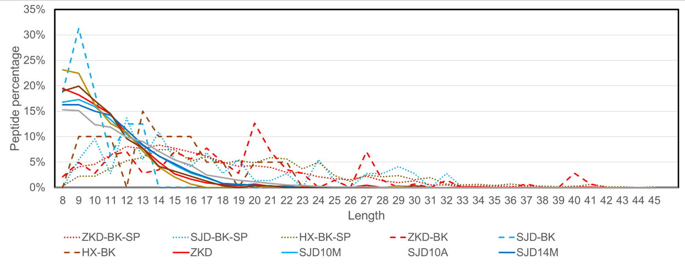
Supplementary Fig. 1｜The percentage of Peptide lengths for all 6 H. erectus samples and blanks. ‘-SP’ indicates the database was changed to SwissProt.

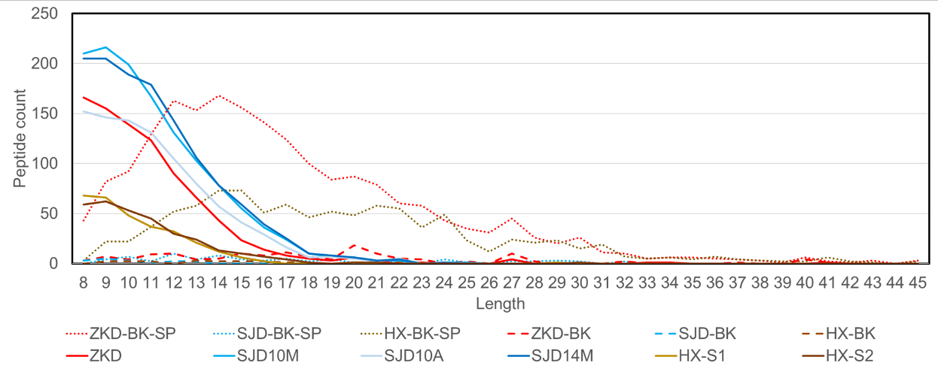
Supplementary Fig. 2｜ The counts of Peptide lengths for all 6 H. erectus samples and blanks. ‘-SP’ indicates the database was changed to SwissProt.

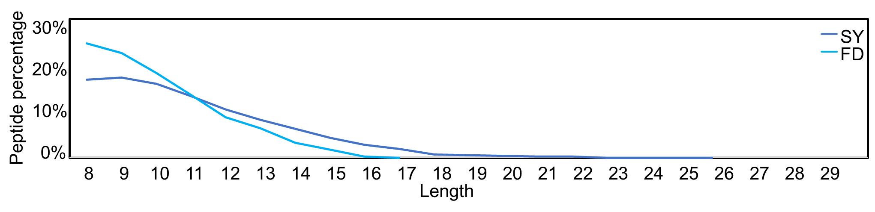
Supplementary Fig. 3｜ peptide length distributions in fractions from the 2 labs.
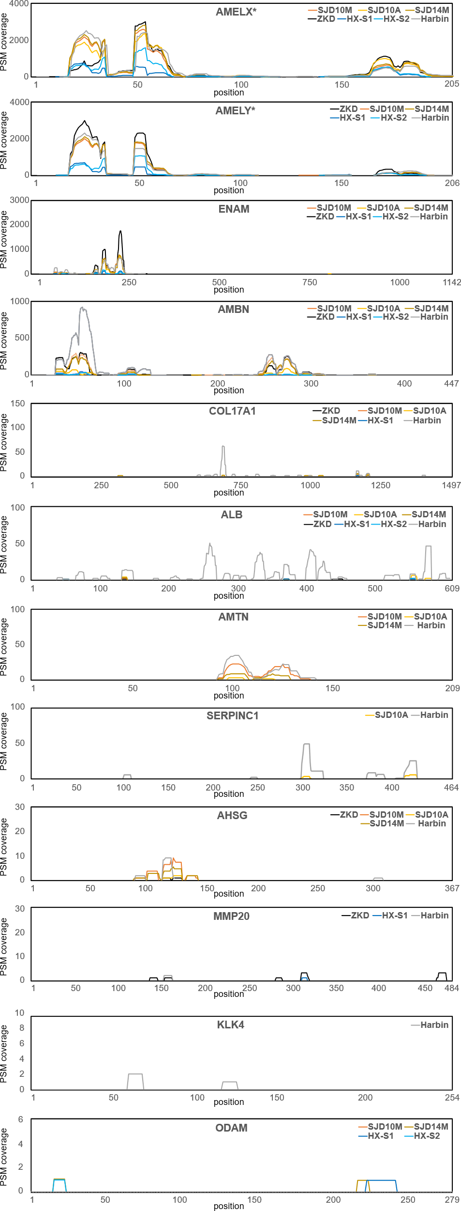
Supplementary Fig. 4｜ PSM coverage of all proteins.

Other supplementary materials for this study include:
Supplementary Data 1.
Dentin and enamel results of the animals from the Zhoukoudian, Sunjiadong, and Hexian sites.

Supplementary Data 2.
Fasta file containing consensus sequences of endogenous proteins generated from the six H. erectus samples and the Harbin individual. Note that the amino acid consensus in the fasta sequence requires coverage by at least two peptides; thus, single-peptide supported positions were represented by X.

Supplementary Data 3.
DNA sequence divergence between 2 phased diploid African genomes compared to diploid Altai Neanderthal and Denisova 3 genomes over the 200 kb region of chromosome 4 flanking the rs564905233 SNP, calculated over 20 kb windows with 2 kb steps. Windows containing rs564905233 are highlighted in blue.

References

1 Zdansky, O. Preliminary notice on two teeth of a hominid from a cave in Chihli (China). Bulletin of the Geological Society of China 5, 281-284, doi:https://doi.org/10.1111/j.1755-6724.1926.mp53-4007.x (1926).
2 Zdansky, O. A new tooth of Sinanthropus pekinensis Black. Acta Zool 33, 189–191 (1952).
3 Woo, J.-k. & Chia, L. New discoveries of Sinanthropus pekinensis in Choukoutien. Acta Palaeontologica Sinica 2, 267-288 (1954).
4 Qiu, Z. L., Gu, Y. M., Zhang, Y. Y. & Zhang, S. S. The new hominin fossils and cultural relics from Zhoukoudian. Vertabrata Palasiatica 11, 109-131 (1973).
5 Weidenreich, F. The dentition of Sinanthropus pekinensis: a comparative odontography of the hominids. Palaeontol. Sin. Series D I, 1–180 (1937).
6 Weidenreich, F. The skull of Sinanthropus pekinensis: a comparative study on a primitive hominid skull. Paleontologia Sinica, Series D 10, 96-157 (1943).
7 Woo, J.-k. & Chao, T.-k. u. New discovery of Sinanthropus mandible from Choukoutien. Paleovertebrata et Paleoanthropologia 1, 155-158 (1959).
8 Weidenreich, F. The mandibles of Sinanthropus pekinensis: a comparative study. Palaeontologia Sinica Series D 1 (1936).
9 Weidenreich, F. The extremity bones of Sinanthropus pekinensis: a comparative odontography of the hominids. Palaeontologia Sinica Series D 5 (1941).
10 Pei, W. C. An account of the discovery of an adult Sinanthropus skull in the Chou Kou Tien deposit. Bulletin of the Geological Society of China 8, 203-205, doi:https://doi.org/10.1111/j.1755-6724.1929.mp8003003.x (1929).
11 Zanolli, C. et al. Inner tooth morphology of Homo erectus from Zhoukoudian. New evidence from an old collection housed at Uppsala University, Sweden. Journal of Human Evolution 116, 1–13, doi:10.1016/j.jhevol.2017.11.002 (2018).
12 Kundrát, M., Liu, W., Ebbestad, J. O. R., Ahlberg, P. & Tong, H. New tooth of Peking Man recognized in the Museum of Evolution of Uppsala University. Acta Anthropologica Sinica 34, 131–136 (2015).
13 Huang, P.-H. et al. Study of ESR dating for burying age of the first skull of Pekinig Man and chronological scale of the cave deposit in Zhoukoudian site Loc. 1. Acta Anthropological Sinica 10, 107-115 (1991).
14 Yuan, S., Chen, T., Gao, S. & Hu, Y. Study on Uranium series dating of fossil bones and teeth from Zhoukoudian site. Acta Anthropological Sinica 10, 189-193 (1991).
15 Shen, G., Ku, T.-L., Gahleb, B. & Yuan, Z.-x. Preliminary results on U-series dating of Peking Man Site with high precision TIMS. Acta Anthropological Sinica 15, 210-217 (1996).
16 Guo, S. et al. Fission track dating of 4th layer of the Peking Man Site. Acta Anthropological Sinica 10, 73-77 (1991).
17 Shen, G., Gao, X., Gao, B. & Granger, D. E. Age of Zhoukoudian Homo erectus determined with 26Al/10Be burial dating. Nature 458, 198-200, doi:10.1038/nature07741 (2009).
18 Pei, J. & Sun, J. Thermoluminescence ages of Quartz in ash materials from Homo erectus Pekinosis site and its geological implication. Chinese Science Bulletin, 849 (1979).
19 Grün, R. et al. ESR analysis of teeth from the palaeoanthropological site of Zhoukoudian, China. Journal of Human Evolution 32, 83-91, doi:https://doi.org/10.1006/jhev.1996.0094 (1997).
20 Black, D. On a lower molar hominid tooth from the Chou Kou Tien deposit. Palaeontologica Sinica Series D 7, 1-28 (1927).
21 Mayr, E. On the concepts and terminology of vertical subspecies and species. National Research Council Committee on Common Problems of Genetics, Paleontology, and Systematics Bulletin 2 (1944).
22 Mayr, E. Taxonomic categories in fossil hominids. Cold Spring Harbor Symposia on Quantitative Biology 15, 109-118, doi:10.1101/sqb.1950.015.01.013 (1950).
23 Wu, J.-K. & Dong, X. Preliminary study of Homo erectus remains from Hexian, Anhui. Acta Anthropologica Sinica 1, 2-13 (1982).
24 Huang, W., Fang, D. & Ye, Y. Preliminary studyon the fossil hominid skull and fauna of Hexian, Anhui. Vertabrata Palasiatica 20, 248-256 (1982).
25 Grün, R. et al. ESR and U-series analyses of teeth from the palaeoanthropological site of Hexian, Anhui Province, China. Journal of Human Evolution 34, 555-564, doi:https://doi.org/10.1006/jhev.1997.0211 (1998).
26 Xing, S. et al. Middle Pleistocene hominin teeth from Longtan Cave, Hexian, China. PloS one 9, e114265, doi:10.1371/journal.pone.0114265 (2014).
27 Cui, Y. & Wu, X. A geometric morphometric study of a Middle Pleistocene cranium from Hexian, China. Journal of Human Evolution 88, 54–69 (2015).
28 Tsutaya, T. et al. A male Denisovan mandible from Pleistocene Taiwan. Science 388, 176-180, doi:doi:10.1126/science.ads3888 (2025).
29 Chang, C.-H. et al. The first archaic Homo from Taiwan. Nature Communications 6, 6037, doi:10.1038/ncomms7037 (2015).
30 Zhang, Y., Zhang, S., Gu, X. & Li, X. A study on the perforated bone from Sunjiadong site in Henan Province. Acta Anthropological Sinica 36, 457-464 (2017).
31 Zhao, L. et al. Middle Pleistocene hominins from the Sunjiadong site, Luanchuan county, Henan Province, Central China. Acta Anthropologica Sinica 37, 192-205 (2018).
32 Fu, S., Wang, H., Davies, M. & Dean, R. Reactions of hypochlorous acid with tyrosine and peptidyl-tyrosyl residues give dichlorinated and aldehydic products in addition to 3-chlorotyrosine. J Biol Chem 275, 10851-10858, doi:10.1074/jbc.275.15.10851 (2000).
33 Kettle, A. J. Neutrophils convert tyrosyl residues in albumin to chlorotyrosine. FEBS Lett 379, 103-106, doi:10.1016/0014-5793(95)01494-2 (1996).
34 Wu, X. J., Bae, C. J., Guo, X. C. & Liu, W. Neurocranial abnormalities in the Middle Pleistocene Homo erectus fossils from Hexian, China. International Journal of Osteoarchaeology 31, 285-292, doi:10.1002/oa.2950 (2021).
35 Buonasera, T. et al. Immune proteins recovered in tooth enamel as a biochemical record of health in past populations: Paleoproteomic analysis of Mission Period Native Californians. Journal of Archaeological Science 171, doi:10.1016/j.jas.2024.106069 (2024).
36 Welker, F. et al. The dental proteome of Homo antecessor. Nature 580, 235-238, doi:10.1038/s41586-020-2153-8 (2020).

