Supplementary Information
“Over 20,000 pre-colonial earthworks in the Southwest Amazonia” (Martti Pärssinen et al.)
Supplementary Note 1
- The name of the Aquiry civilization
The name Aquiry originally referred to the Acre River, as named and explored by W. Chandless (1866)57. It flows from Peru and Bolivia to the Brazilian state of Acre. Passing through the heart of the ancient civilization that built the geoglyphs, it joins the Purus River in the Brazilian state of Amazonas as a major tributary. The Aquiry name probably comes from the Apurinã (Arawakan) word “kaikyry”, meaning “caiman” – hence the “River of Caimans”18. We use the term 'civilization' to describe this seemingly multicultural complex society1. They shared a socio-cosmology, which is reflected in their geometric monumental enclosures with road systems. This is somewhat similar to the manifestation of multicultural Christian civilization through cathedrals and churches, or of multicultural Islamic civilization through mosques. Both have their own iconography and many shared social practices, as seen also in the Andean Chavín civilization, for example. For more information on the origin of the concept of civilization and its use in the context of South American archaeology and anthropology, see Ranzi & Pärssinen (2021, 19-64)2.
- Radiocarbon chronology
So far, 16 geoglyph sites and 19 ditched and embanked structures (i.e. geoglyphs) have been dated using 82 out of a total 162 radiocarbon samples obtained from three sub-regions: eastern Acre, southern Amazonas, and northern Bolivia (Supplementary Tables 1a-b). Furthermore, 16 mound village and roundish embankment sites were dated using 44 samples, all but one of which appear to be from later periods than the geoglyphs. Additionally, three samples not directly associated with earthwork structures but with nearby agricultural fields were dated to the Aquiry period. Finally, 31 samples from seven earthwork sites appear to predate the structures themselves, suggesting earlier human activity at these sites58.
Current studies on climate dynamics have revealed a significant influx of air masses and moisture from the Northern Hemisphere over southwestern Amazonia during the South American Summer Monsoon (SASM). Therefore, when calibrating ¹⁴C raw data, it is recommended54 that in SW Amazonia one uses a mixed SHCal20 curve for the Southern Hemisphere55 and an IntCal20 curve for the Northern Hemisphere56. In this article, we therefore use a 50/50% mixed calibration curve. All dates are presented in Supplementary Tables 1a-b.
Many SW Amazonian earthworks were constructed on sites with a deep human history. On various geoglyph sites, charcoal and ash began to accumulate at the onset of the Holocene era, c. 8,000 BC58, and persisted periodically until the emergence of monumental earthworks in the first millennium BC (Supplementary Table 1a). Furthermore, the presence of earlier charcoal in sites such as Los Angeles, Ramal do Capatará, and Severino Calazans has led to supposition that the geometric earthwork tradition started c. 1,200-900 BC59-60. However, further analysis and radiocarbon dating in Severino Calazans, Tequinho, Eletronorte I, and Piçarreira indicate that the earliest embankments and ditches were constructed after 750 calBC and that older dates are indicative of earlier activities at the same sites (Supplementary Table 1a). Even at the Los Angeles site, most dates (8/10) seem to fall within the period between 540 BC - 722 AD. However, in this study, the radiocarbon beginning and ending boundaries of the entire Aquiry phase were analysed using Bayesian modelling to address the tendency to overestimate the length of archaeological phases due to uncertainties caused by old wood and calibration probabilities, among others. Furthermore, the Aquiry period and its three sub-regions have been summarised using a Kernel density estimate (KDE) phase modelling.
Bayesian modelling results in mean values of the beginning and end boundaries of the Aquiry phase as 560 ± 40 BC and 810 ± 40 AD, respectively. Considering 40 years of one sigma uncertainty, the entire modelled Aquiry period can therefore be tentatively dated to c. 600 BC–850 AD (Extended Data Figures 2a-b). Furthermore, it appears that most sites were occupied for 200 years or more, with some being occupied for over 1,000 years (Extended Data Figure 7).
In addition, the OxCal 4.4.4 KDE_Model function54 was used to estimate the relative intensity of human activity. This identified a local maximum of the Aquiry period in the calendar-year probability distribution of 250 BC – 400 AD (Extended Data Figure 6). This suggests that the construction of dated structures belonging to the Aquiry cultural phase was at its peak during this period, indicating intense human activity. In fact, judging by the ratio of the KDE distribution sums during the peak and full periods, as well as the associated uncertainties in the KDE plot, the peak corresponds to 61% ± 20% of the full KDE distribution. Since the dates were derived directly from the structures, it can be estimated that approximately 60% of them were constructed during the peak period.
This model illustrates the relative intensity of the entire Aquiry phase. However, it does not fully account for the fact that at least two centres from the first peak period (Los Angeles and Severino Calazans) were still in use during the main second peak, nor the fact that several centres in use in c. 200 AD, when the peak was at its highest (Extended Data Figures 7-8), were built one or two centuries earlier. The KDE model function estimates that 25% of construction activities date to the period 100–300 AD. Therefore, it is also important to examine how many earthworks were in use and how many were cleaned and maintained during this period, according to ¹⁴C dates. It should also be noted that there currently seems to be a consensus that the construction of these earthworks was based on the area's bamboo-dominated forests and their massive die-off every 27–28 years3,6,45,46. This allowed people to burn forest openings for few months and create geometric enclosures, wide roads, and agricultural fields in these areas four times every hundred years. Furthermore, our archaeological excavations and more than a hundred test pits have demonstrated that the enclosures were regularly cleared of vegetation and maintained for at least 200 years after construction, with no evidence of burning. Where more than one layer of use was observed with a break, the other layers were also in use for hundreds of years, with no evidence of additional abandonment or forest burning. Typically, a cultural layer associated with the use of a geoglyph on flat ground varies in depth from 20 to 45 cm (e.g., Supplementary Figure 5B). In only a few cases, it has reached a depth of up to 70 cm9,21. Instead, if older cultural layers were discovered below those stratums associated with geometric enclosures, signs of periodic burning episodes were regularly observed58.

Examining the overlap of the radiocarbon dates of all sites using KDE-modelled summaries (Extended Data Figure 7) reveals that approximately 60% of the dated centres were used simultaneously with considerably high probability around 200 ± 100 AD. All the radiocarbon dates related to ceremonial activities from Amazonas (n = 4) and Bolivia (n = 3) date to this period, as do around 60% of Acrean geoglyphs. Hence, considering all uncertainties, we estimate that the most likely probability of simultaneous use of all earthworks in 100–300 AD is 25% - 60%, with a strong preference towards the upper limit.
In any case, our current radiocarbon dates indicate that ceremonial activity continued after the main peak at the well-dated Tequinho site, but afterwards the inner ditch of the main geoglyph (pit 18) was no longer kept clean and open8. Instead, the cleaned earth of the enclosure piled up in the ditch between calAD 420 and 650, and after this the site was eventually abandoned (Supplementary Table 1a). At the Severino Calazans site, the ditched enclosure was abandoned after the main peak, but a strong human activity continued outside the geoglyph in the north around calAD 405-640. However, radiocarbon dates from the Balneário Quinauá site show that new ceremonial centres were also built and used soon after the main peak.
Finally, the Severino Batista, Fazenda Colorada and Jacó Sá sites show that various sites were reused, and new ones were built between AD 600 and 850. After this period, the construction of geometrically planned, ditched ceremonial centres appears to have ceased. However, some of them, such as Fazenda Colorada, Fazenda Iquiri II, Las Palmeras and Três Vertentes, were reused for later mound settlements; and some roundish embanked enclosures (without ditches) also give late post-geoglyph dates in our study area. In summary, our tentative chronology of earthworks for our study area is as follows:
1. First (I) or Initial Geoglyph Period, c. 600-250 BC, when the first geometrically planned earthworks were constructed and used at sites such as Severino Calazans and Eletronorte I.
2. Second (II) or Main Geoglyph Period, c. 250 BC - 400 AD, when most of the ditched earthworks were built. In particular, in our list of 16 dated geoglyph sites, up to 60% were in use at the same time in c. 200 AD. The beginning of maize and squash cultivation37, as well as the known use of early polychrome pottery18, corresponds to this period. Interestingly, the expansion of manioc and peach palm farming is also said to be associated with the expansion of polychrome ceramics61.
3. Third (III) or First Intermediate Period, c. AD 400-600, when several ditched earthworks were abandoned, but some new earthworks, such as the Balneario Quinauá, were constructed.
4. Fourth (IV) or Final Geoglyph Period, c. AD 600-850, when some earlier ditched enclosures were reused, such as Fazenda Colorada and Severino Batista, and new ones were built, such as Jacó Sá.
5. Fifth (V) or Second Intermediate Period, c. AD 850-1200, when earlier ditched enclosures were almost completely abandoned without the construction of new ones. Nevertheless, it is possible that some circular embankments and mound settlements were built during this period.
6. Sixth (VI) or Pre-Colonial Mound Settlement Period, c. AD 1200 - 1500, when new types of mound settlements appeared as a new boom in the core of our study area. Nine out of fourteen dated mound settlements (c. 65%) belong only to this period, and three (c. 22%) belong both to this and the following Colonial period. In particular, in our list of 14 mound settlements, 11 (c. 79%) were in use simultaneously in AD 1425, and a roundish embanked enclosure at Campo Esperança is also dated to this period.
7. Seventh (VII) or Colonial Mound Settlement Period, c. 1500 - 1808/1825. During this period, two dated mound settlements (c. 15%) were constructed and three (c. 22%) mound settlements constructed in earlier chronological phases continued to be used. In addition, a later roundish embanked enclosure (Tênue) belongs to this period (Supplementary Tables 1a-b).
- The size and contemporaneity of the Aquiry earthworks in three sub-regions: a comparison
As mentioned, around 60% of the dated geoglyph type earthworks appear to have been constructed during the main peak period from 250 BC to 400 AD. Most of the dates in the Acre region originate from the terra firme area located between the Acre and Abunã rivers (Fig. 1) to the north-east and south-west of the capital, Rio Branco. Those from Amazonas come from the south-east of Boca do Acre, near the main channel of the Purus River. The Bolivian dates originate from an area near the confluence of the Madre de Dios and the Beni rivers, to the east and south of Riberalta (Extended Data Figure 8). Boca do Acre is approximately 300 km from Riberalta as the crow flies, and Riberalta is 240 km from Los Angeles, the easternmost dated geoglyph in the Rio Branco sub-region. Thus, the core area of the Aquiry civilization is represented.
In this particular comparison, we measured the interior size of the dated geoglyphs to make them comparable with our database of satellite imagery obtained from the same blocks 1, 2 and 5. In this database, all geoglyph sizes refer to interior space, because each ditch of a geoglyph is situated inside the exterior embankment, creating a natural and easily detectable shadow. Later, when we compare our LiDAR data to the mound settlements, we will use exterior embankments and mounds in our size calculation. According to our tests of 24 LiDAR geoglyph images (Block 1), in which both exterior and interior sizes were calculated, the difference between interior and exterior sizes was 24 ±9% in the 0.2–1.75 hectares category, 18 ±12% in the 1.76–6.0 hectares category, and 12 ±6% in the 6.01–16.0 hectares category.
In Acre, the smallest dated geoglyph is a 0.35-hectare interior circle (Balneario Quinauá), connected by a road to a 1.2-hectare (interior) rhombus geoglyph with rounded corners. The second-smallest dated geoglyph, measuring around 0.55 hectares, is a rectangular structure with rounded corners and sides (Severino Batista). The largest and one of the oldest dated geoglyphs in Acre, Eletronorte I:1, has an 8.5-hectare octagonal plaza with five radiating roads (Supplementary Figure 4A). The rest of the Acrean earthworks range in size from 1.15 to 5.2 hectares. In the state of Amazonas, one site has been dated using four samples. This site, known as Cruzeirinho8, contains an older quadrilateral structure with a plaza covering around 15.6 hectares. This plaza is partially obscured by a newer square geoglyph covering around 9.4 hectares. This newer structure is connected by a road to a smaller 3.1-hectare square which has been dated. Finally, in Bolivia, two geoglyphs were dated: Las Palmeras, which features a drop-shaped geoglyph with a 6.5-hectare plaza, and Tumichucua, which features a circular geoglyph plaza spanning nearly 50 hectares (the largest known). An embanked, drop-shaped enclosure (Estancia Giese, 3.7 hectares) in Bolivia also appears to belong to the geoglyph period.
The dated geoglyphs appear to be largest in Bolivia and the state of Amazonas, while the smallest were found in the state of Acre. This reflects the fact that the earthworks detected in satellite imagery were also larger in Bolivia and the Amazonas region than in Acre, particularly in the varzea of the Madre de Dios, the Beni, and the Purus. According to our database, of the 343 earthworks detected with satellite imagery in Block 1 of Acre (Extended Data Table 2), 276 are geoglyphs (80%) ranging in size from 0.193 to 19.269 hectares (interior), with an average size of 2.363 hectares. In Block 2 of the Amazonas region, the interior size of 169 geoglyphs varies from 0.441 to 15.660 hectares, with an average size of 3.723 hectares. In Bolivia (Block 5), where only around 5% of the land has been deforested, the interior size of 11 geoglyphs ranges from 1.853 to 49.718 hectares, averaging 8.320 hectares. Even when the largest geoglyph, Tumichucua, is excluded, the average size is still 4.180 hectares. Therefore, the average size of geoglyphs in the Amazonas and Bolivian regions seems to be c. 58% and 77% larger than in Acre, respectively.
It is also important to note that while most sites have only one earthwork, some of the more interesting sites have two or more earthworks close together, often connected by a road. This suggests that they were used simultaneously, although one or two of these may be slightly older. For instance, the smaller circular geoglyphs in Fazenda Atlântica and Balneario Quinaua appear to predate the square ones. However, in both instances, these two structures were connected by a road and were utilised concurrently following the construction of the squares62. Superposition does occur, too, but this is a rare phenomenon (in less than 2% of our LiDAR sample) and can indicate either renovation (e.g. Cruzeirinho) or the later use of an earlier structure (e.g. Fazenda Colorada).
Finally, three to five Aquiry structures have been established around an embankment at two sites in our LiDAR sample. A later mound settlement may also be located inside or outside the same conglomerate (see Extended Data Figure 4a), but it does not affect the calculations for the Aquiry earthworks. This relatively rare conglomerate type only exists in the vicinity of Rio Branco. Unfortunately, we do not have any radiocarbon dates for this type of earthwork conglomerate. Only one date exists for a later mound settlement inside Dois Circulos: Estrutura IV63. In summary, both the largest and smallest geoglyphs seem to belong to the main peak period, and in general, our radiocarbon dates suggest a 60% probability match with the Aquiry earthworks contemporaneity in these sites with multiple structures.
- A comparison of the population size of ceremonial centres and mound villages
In order to estimate how many people lived in an average mound village when these settlements appeared in the former Aquiry core area in the second millennium, we used the recent data by Iriarte et al.19 for 20 circular mound villages with information about the diameter of each central plaza and the number of mounds arranged clockwise around it. The average diameter of the plaza in these 20 cases is 90.65 m, and according to satellite images, the mounds, which are between 6 and 10 metres (average 8 m) wide, extend from 15 to 35 metres (average 25 m) outside the plaza. In general, mounds are much bigger than 100 m² and can be classified as multifamily maloca longhouses36,38. Therefore, the original average exterior diameter of these settlements is approximately 140.65 metres, equivalent to 1.55 hectares, and the average number of longhouses in these villages is 12.6. The same authors also provided information on rectangular mound villages, although they did not provide exact data on their sizes19. Nevertheless, we managed to calculate the size of eight of these settlements using satellite imagery. Their average exterior size is 0.6 ha, and they contain an average of 9.65 mounds per village (Supplementary Table 3). Combining this information from circular and rectangular villages and assuming that the average pre-colonial family size in the area was five, as in the pre-colonial Central Andes23,64, and that an average longhouse was occupied by at least five families38, we arrived at 235 people per hectare and an average village size of 1.28 hectares housing 300 people. However, if we assume that the original houses in all mound villages were single-family homes rather than multifamily maloca longhouses and that these homes extended 6–9 metres (on average 7.5 metres) outside the plaza, then the area would have extended outward as families grew or houses were rebuilt. Hence, we would arrive at 47 people per hectare and 60 people (12 families) per average village. Nevertheless, multifamily houses have always been extremely common in the Amazon region. Even the earliest descriptions of northern Bolivian and Acrean villages, following catastrophic demographic declines caused by European diseases, mention villages with between 17 and 62 families surrounded by agricultural plantations65-66,57. Considering that these kinds of villages correspond to the archaeological remains of roundish and rectangular mound settlements, with an average of around 12 house foundations per site, the multifamily supposition is much more plausible.
In sum, the sizes of villages and earlier ceremonial centres in hectares seem not to be comparable 1:1, because ceremonial centres were also constructed for visitors from other areas, not just for the people who inhabited the nearby surrounding area. More time and labour were devoted to the construction of geoglyphs and embanked structures, so it is a question of the size of the communities rather than the size of the structures. Therefore, communities with a population of around 60 families and 300 people may have constructed much bigger and more monumental earthworks than was the case with later mound villages.
- Methods for processing LiDAR Digital Surface and Terrain Models
Recently, laser scanner systems have significantly improved in terms of accuracy and spatial resolution, enabling ALS systems to map difficult-to-access areas, such as forests, without causing environmental damage. Laser scanning technology uniquely provides 3D data collection and representation of tree structures, as the laser beam has high penetrability through the canopy, which is not possible with passive satellite images. This capability has been extensively demonstrated in previous studies across various forest types, including the detection of geoglyphs under forests. More specifically, detecting and measuring geoglyphs under tropical forests presents a unique challenge due to the dense canopy that can limit the laser bean penetrability. As a result, careful planning for data acquisition in the research area and further data processing was essential, particularly given the varying forest densities in the area that range from open areas without forest cover to regions with very high tree density. Here, we describe data processing methods used to detect the geoglyph-building Aquiry civilization, their earthworks, and to estimate the pre-colonial population in SW Amazonia.
Full-waveform laser data processing was performed with RiProcess software (RIEGL Gmbh, Austria). The GNSS/IMU navigation data and direct georeferencing were processed using the Applanix/PosPAC MMS 7.0 software. The GNSS/IMU data were integrated in the pre-processing to generate georeferenced laser point cloud (UTM 19 S/ SIRGAS 2000 [ESPG 31979] and UTM 20 S/ SIRGAS 2000 [EPSG:31980]).
The Digital Terrain Model (DTM) and Digital Surface Model (DSM) were generated using LASTools (RapidLasso GmbH, Germany). The digital models processing pipeline included point cloud classification, noise and spike removal, and interpolation to a target resolution of 50 cm for ALS point clouds and 10 cm for UAV-ALS point clouds, which was found to be sufficient for the geoglyph detection. To optimize processing time, the total of 2,254 ALS point cloud tiles of c. 2 km² were processed recursively by dividing each into square subset-tiles (400 m tile size with a 30 m buffer) and utilizing four cores for parallel computing. The buffer size defines an additional area around each subset-tile in all directions, ensuring overlap between adjacent subset-tiles. This overlap prevents data gaps and minimizes preprocessing artifacts. A flag is assigned to the buffer area during tile generation. Similarly, a total of 50 UAV-ALS point cloud tiles were processed with 200 m subset-tile size. The georeferenced point cloud tiles were classified into ground points (Class 2) and non-ground points (Class 0) to enable the generation of both the Digital Terrain Model (DTM) and Digital Surface Model (DSM). During this process, the buffer area was excluded.
After point cloud classification, a Delaunay triangulation can be applied to generate the digital models67. More specific regarding DSM processing, the DSM was also created by using the spike-free algorithm68-69, which systematically prevents spike formation during TIN construction to accurately represent the uppermost layer of the forest canopy. A spike parameter of 1 m was applied to 99.9% of the point clouds, both for ALS and UAV-ALS point clouds. However, three ALS point cloud tiles (LT03_0056, LT03_0123, and LT09_0041) required customized spike parameters between 1.5 and 2.5, while one ALS point cloud tile (LT03_0093) was removed from the dataset due to its limited coverage in the edge of the research area.
The final DSM and DTM were converted into GeoTIFFs, with interpolated height and hillshade values as pixels, using the BLAST tool in LASTools. The hillshading technique enables a greyscale 3D representation of the terrain surface to be generated considering the relative position of the sun for shading, which highlights the terrain's slope and aspect based on light source direction67. The BLAST tool was selected due to its efficient performance when processing billions of LiDAR points from LAS/LAZ files, triangulating them into a seamless TIN, and rasterizing the TIN into a digital raster image. The resulting datasets were then combined into a single raster image using the GDAL library52 for further spatial analysis.
- Earthwork sensitivity analysis from the Airborne LiDAR point clouds and the upper limit of the detectable earthworks within the acquired LiDAR data
We evaluated the sensitivity of earthwork detection in our airborne LiDAR point clouds by estimating the required point density for reliable detection within the scanned area. The sensitivity analysis was conducted in four steps:
First, we selected a total of twelve (12) test areas (tiles of approximately 2 km²) with detected geoglyphs both in open (6 areas) and in forest-covered (6 areas) areas. We then randomly downsampled the number of points in each tile, starting from 90% down to 10% of the original spatial resolution in 10% intervals and resulting in nine resampled point clouds for each original point cloud. Additionally, downsampling was performed using smaller intervals, generating two extracted point clouds with 5% and 2.5% of the original resolution. A total of 11 downsampled point cloud versions were created from each original file (132 modelled point cloud images in total) to be used in the sensitivity study.
Second, we computed the Digital Terrain Model (DTM) creation to every downsampled point cloud. The DTMs were generated using LASTools (RapidLasso GmbH, Germany). The digital models processing pipeline included point cloud classification (only ground points are used), noise and spike removal, and interpolation to a target resolution of 50 cm for ALS point clouds, which was found to be sufficient for the earthwork detection. More details are described in the earlier Methods section (Supplementary Note 1e). Hillshaded terrain models were computed similarly for every test tile, aiming to verify each point where the earthworks cannot no longer be visually detected.
Third, we visually assessed the earthwork visibility for every hillshaded terrain model to determine the downsampling level where earthworks were no longer resolvable from the terrain model (Supplementary Figure 1). Based on the visual assessment of the test tiles without forest coverage (on Supplementary Figure 1A), the effective earthwork detection threshold in the Amazonas and Acre region was approximately 0.3 ground points per square metre, corresponding to fewer than 20,000,000 ground points within 2 km². In contrast, Supplementary Figure 1B shows that this threshold is reached at less than 10% of the original resolution when considering ground and non-ground points per square metre acquired at dense forest areas, as the penetration of laser beams is limited. This result is in line with the earlier studies70-71, and the experiences obtained in Boreal forests72-73.
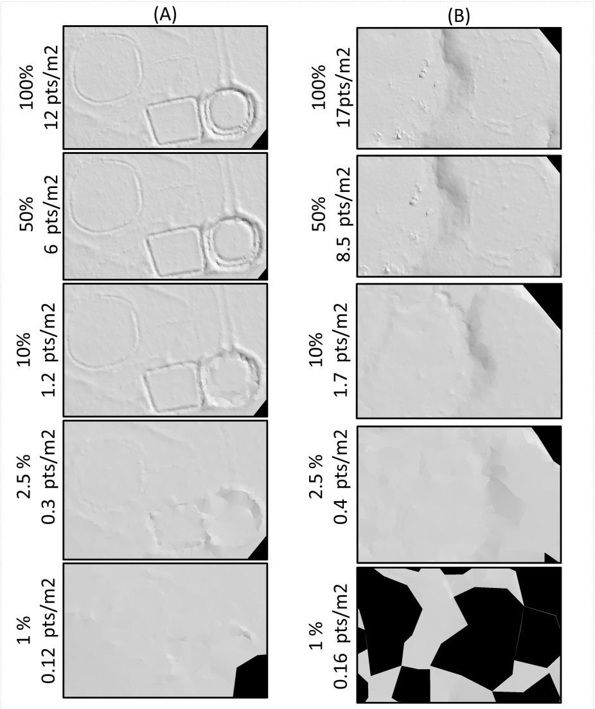
Supplementary Figure 1. Comparison of hillshaded digital terrain models (DTMs) of earthworks. A. Open-area earthworks. Hillshaded DTMs derived from the full point cloud (12 ground pts/m²), compared with DTMs generated from progressively downsampled data—10% (1.2 ground pts/m²), 2.5% (0.3 ground pts/m²), and 1% (0.12 ground pts/m²). B. Forested-area earthwork. Hillshaded DTMs from the full point cloud (17 ground pts/m²), followed by downsampled versions—50% (8.5 ground pts/m²), 10% (1.7 ground pts/m²), 2.5% (0.4 ground pts/m²), and 1% (0.16 ground pts/m²). Note that under forest cover, the 1% dataset cannot be properly triangulated, resulting in gaps where triangles with edge lengths exceeding 100 m are excluded from DTM computation.

Fourth, based on the previous analysis, the ground point density was systematically checked across all 2,254 tiles using a 3 x 3 m² aggregation window, and all areas with a ground point density lower than the threshold of 0.3 ground points per m² were labelled. The size of the aggregation window was selected based on the typical widths of the edges of the detected earthworks. A uniform 3 × 3 grid was generated, and only the raster grid cells (pixels) within the main area were considered. The main area was delineated using a two-dimensional alpha-shape algorithm applied to each point cloud tile. This procedure was implemented to exclude empty regions that were attributable to the grid configuration itself rather than to limitations in laser scanning penetrability. In total, 46.6% of the 3 x 3 m² raster cells in the scanned area had a ground point density below the effective earthwork detection threshold, corresponding to an area of 2,093.82 km² of the 4,496.98 km² verified. Furthermore, the result shows that the Lábrea region (FUSO 20) with denser forest cover than the Rio Branco region (FUSO 19) had on average 10% less LiDAR penetration to the ground. In the FUSO 20 regions (situated east of the 66W longitude), 54.5% of the 3 x 3 m² raster cells in the scanned area had a ground point density below the effective earthwork detection threshold, while for FUSO 19 (west of the 66W longitude) the percentile was 41.9%.
However, this result only indicates the proportion of the raster cells with ground point density below the detection threshold in the study area. The result does not indicate how these raster cells are spatially aggregated, which can affect the analysis regarding the regions where earthworks could be undetectable due to point cloud density.
Exact estimation of the below-the-threshold raster cells on earthwork detection is challenging. The estimation depends on several factors in addition to the ground points resolution. These factors include the geoglyph area, the earthwork edge height variance, and the ground point density of neighbouring raster cells. Thus, while the number of ground points per square metre provides a useful indication, it alone cannot guarantee whether earthworks can be detected or not in a certain region. For instance, Supplementary Figure 2 illustrates the 'salt-and-pepper' effect that emerges when 3×3 raster cells are classified in binary terms as below threshold (grey) or above threshold (white) for the same tiles as presented on Supplementary Figure 1. Therefore, further analyses were required to understand better the extension and aggregation of regions with less than 0.3 ground points per m². We can clearly see that, even if raster cells with a ground point density under the threshold exist, the distribution of such raster cells and their neighbourhoods can still enable the detection of the earthworks due to their extensive size.
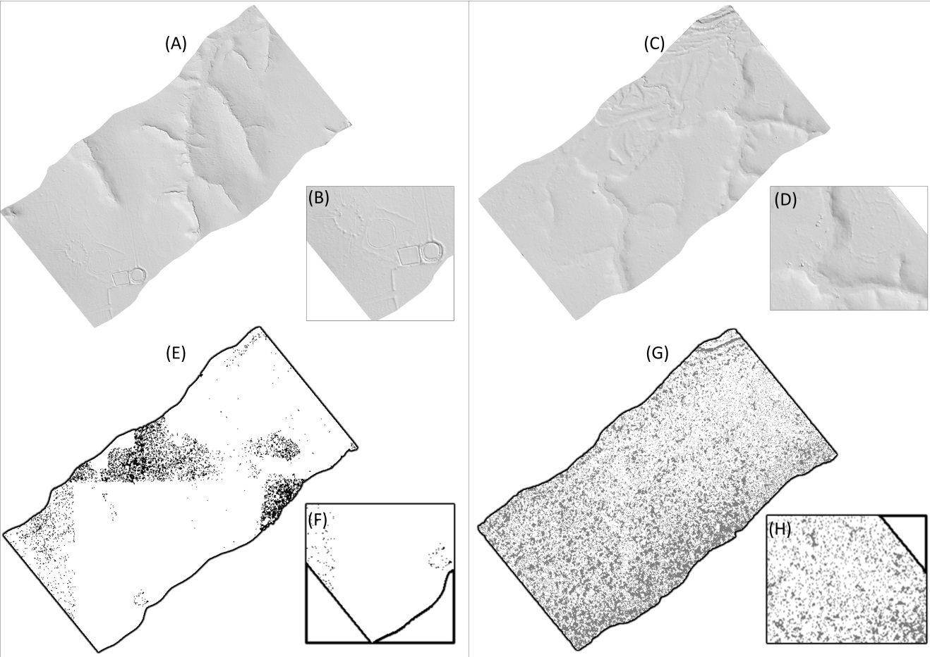
Supplementary Figure 2. Example of earthwork detection in hillshaded DTM images for open (A–B) and forested (C–D) areas: The corresponding labelled areas shown in panels E–F (open) and G–H (forested). On E to H panels, the white indicates 3 × 3 m² raster cells with the ground point density above the threshold of 0.3 points per square metre, while dark grey represents raster cells that have ground point density below the threshold. The results show that, although low-resolution areas are present within these tiles, the non-uniform point distribution still enables the detection of earthworks.

Therefore, we conducted a subsequent analysis using image processing techniques to aggregate raster cells classified as above or below the threshold. Connected-component labelling was applied with 8-connectivity to group adjacent raster cells into coherent regions, followed by the use of morphological operators to refine region boundaries and remove noise. Supplementary Figure 3 illustrates examples of this aggregation. In this analysis, we considered that only regions larger than 1 hectare (1111 empty raster cells aggregated) composed of raster cells below the threshold would hinder the detection of earthworks. Panel A shows an example of a clear open area that still contains regions where the presence of earthworks remains uncertain at tiles located at Fuso 19. Panel B depicts a mixed open and forested area, in which the uncertain regions are also labelled according to the 1-hectare threshold in the Fuso 20 region.
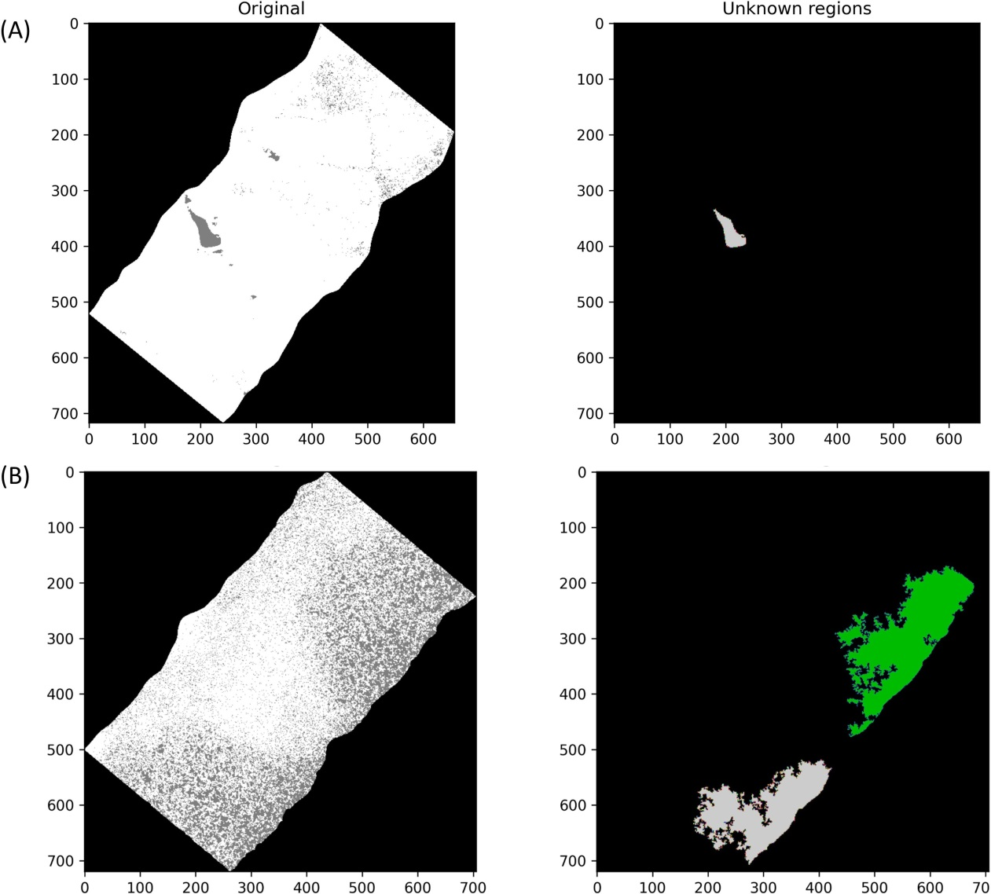
Supplementary Figure 3. Examples of results from the aggregation of raster cells with the ground point density below the threshold (0.3 pts per square metre) using the labelling connectivity method. A. Detection of low-resolution regions within a predominantly high-resolution tile in an open area. B. Detection of unknown regions within a tile containing both open and forested areas. It is important to note that forested areas are not entirely unknown; rather, these results highlight the specific regions with reduced penetrability that may interfere with earthworks detection.

By estimating only the areas in which the number of aggregated raster cells below the threshold (0.3) exceeds 1 hectare, we conclude that 13.7% of the area can be considered unknown. Penetrability is higher in Fuso 19, with only 11.3% of the area classified as unknown. In contrast, penetrability in Fuso 20 is less effective, with 17.8% of the area remaining unknown, indicating that further studies should place greater focus on this region. The sensitivity analysis result gives an upper limit for the potential areas in the study region that may still have undetected earthworks under the forest cover, based on where the available point density is not sufficient to resolve the underlying earthwork structure. Furthermore, it is clear that geoglyphs measuring one hectare or more, with deep ditches and high embankments, are easier to detect than eroded earthworks with embankments only. Therefore, the impenetrable areas in the Fuso 19 region may fluctuate between 11.3 and 41.9%, and in Fuso 20 between 17.8 and 54.5%, depending on various conditions of the forest and earthwork structures.

Supplementary Table 1. Radiocarbon dates of earthworks located in the study area. a. Geoglyph sites. b. Mound settlements and roundish embanked enclosures
a. GEOGLYPH SITES

Lab. No. Pit Depth (cm) Material δ¹³C ‰ VPDB B.P. date Calibrated with 2 sigma

ACRE
Severino Calazans (Acre)58 coordinates -10.0252 -67.5081
Ua–59605 19B 134 charcoal –26.0 8932±37 8250 – 7955 BC
Ua–59604 19A 134 charcoal –25.9 8849±40 8210 – 7780 BC
Ua–50106 12 150 charcoal –26.4 8391±59 7585 – 7205 BC
Ua–50102 7F 85 charcoal –26.5 7050±53 6030 – 5795 BC
Ua–66034 19B 111 charcoal –25.0 6027±33 5010 – 4800 BC
Ua–66032 19A 120 charcoal –25.6 5308±32 4250 – 4000 BC
Ua–50105 12 90 charcoal –27.6 4086±36 2865 – 2490 BC
Ua–37237 3 50 charcoal –28.2 3990±40 2625 – 2345 BC
Ua–66033 19B 90 charcoal –26.4 3976±30 2580 – 2350 BC
Ua–58150 13D 232 charcoal – 3960±109 2870 – 2145 BC
Ua–52903 12 105 charcoal –27.6 3740±32 2285 – 2030 BC
Ua–59603 19A 85 charcoal –26.9 3105±31 1440 – 1275 BC
Ua–50103 7D 400–410 charcoal –28.0 2964±35 1370 – 1045 BC
Ua–37238 5 45 charcoal –25.3 2915±35 1225 – 1005 BC
ditched enclosure
Ua–59599 20A 120 charcoal –29.2 2465±31 765 – 415 BC
Ua–59601 20A 145 charcoal –28.1 2429±31 750 – 400 BC
Ua–59602 20A 156 charcoal –28.8 2422±31 750 – 400 BC
Ua–59600 20A 133 charcoal –29.3 2406±32 745 – 395 BC
Ua–37265 6B 50–60 charcoal –27.8 2275±35 405 – 205 BC
Ua–58153 13C 150 charcoal –28.3 2147±32 355 – 50 BC
Ua–58151 13D 383 charcoal –26.6 2078±30 175 BC – AD 10
Ua–66031 19A 23 charcoal –30.2 2074±30 175 BC – AD 10
Ua–58152 13D 405 charcoal –27.4 2063±30 165 BC – AD 15
Ua–37264 3 20–30 charcoal –24.2 2050±35 170 BC – AD 60
Ua–50104 12 60 charcoal –28.3 1970±35 50 BC – AD 130
Ua–58149 13D 155 charcoal –27.7 1936±30 AD 15 – 205
Ua–58146 13D 95 charcoal –26.2 1715±30 AD 250 – 415

Test pits situated 100–500 meters toward north of the geoglyph of Severino Calazans58
Ua–58155 14 67 charcoal –26.4 4173±32 2885 – 2630 BC
Ua-58156 14 80 charcoal –26.1 4035±33 2830 – 2465 BC
Ua–58157 14 97 charcoal –26.7 3410±31 1875 – 1615 BC
Ua–58159 17 48 charcoal –27.6 3121±31 1495 –1290 BC
Ua–58160 18 40 charcoal –28.1 1620±30 AD 405 – 545
Ua–58158 15 60 charcoal –25.5 1526±30 AD 430 – 605
Ua–58154 14 48 charcoal –25.4 1512±30 AD 435 – 640

Severino Batista (Acre)58 -10.0313 -67.5128
ditched enclosure
Ua–58147 1 110 charcoal –27.2 1771±30 AD 215 – 365
Ua–58146 1 95 macrofossil –26.5 1295±30 AD 655 – 775

Tequinho (Acre)8 -9.89774 -67.4235
Ua–72290* 16 180–190 charcoal –25.0 9937±38 9660 – 9290 BC
Ua–48320 9C 90 charcoal –24.7 4120±42 2875 – 2570 BC
Ua–72287* 12 90–100 charcoal –27.2 3710±32 2205 – 1980 BC
Ua–72286* 12 70–80 charcoal –28.4 3682±32 2195 – 1955 BC
ditched enclosure
Ua–72289* 16 130–140 charcoal –26.8 2328±31 515 – 230 BC
Ua–72293* 18 320–350 charcoal –26.1 2089±32 200 BC – AD 5
Ua–72288* 16 100–110 charcoal –28.1 2082±31 195 BC – AD 10
Ua–48319 9D 120 charcoal –27.2 2011±43 150 BC – AD 125
Ua–72284* 11 80–90 charcoal –26.8 1995±31 50 BC – AD 120
Ua–48327 9I 210 charcoal –26.1 1968±33 45 BC – AD 130
Ua–48326 9H 55 charcoal –27.3 1966±35 50 BC – AD 155
Ua–48321 9A 185 charcoal –28.0 1964±40 50 BC – AD 205
Ua–48322 9A 130 charcoal –27.8 1963±39 45 BC – AD 205
Ua–48329 9A 160 charcoal –26.8 1956±34 45 BC – AD 205
Ua–72285* 11 120–130 charcoal –26.8 1956±31 45 BC – AD 205
Ua–48328 9I 150 charcoal –25.5 1935±33 AD 10 – 210
Ua–50107 9L 70–80 charcoal –24.4 1910±32 AD 25 – 220
Ua–48323 9A 100 charcoal –26.5 1879±39 AD 60 – 245
Ua–48325 9H 110 charcoal –26.1 1874±33 AD 75 – 240
Ua–48324 9H 160 charcoal –28.3 1841±34 AD 120 – 325
Ua–72291* 18 40–50 charcoal –27.5 1569±31 AD 420 – 570
Ua–72283* 18 210–230 macrofossil –25.8 1560±31 AD 425 – 575
Ua–72281* 11 40–50 macrofossil –25.8 1557±31 AD 425 – 580
Ua–72292* 18 165 charcoal –26.8 1525±31 AD 430 – 635
Ua–72282* 18 90–100 macrofossil –26.4 1479±31 AD 545 – 645
Ua–50108 18 145 charcoal –27.2 1476±34 AD 545 – 650
------
*New ¹⁴C dating

Eletronorte I:1 (Acre)* -10.589 -67.9691
Ua-66022 2 100 charcoal –25.9 7300±36 6230 – 6075 BC
ditched enclosure
Ua-66021 1 200 charcoal –27.6 2466±30 765 – 415 BC
Ua-66019 1 140 charcoal –26.8 2455±30 755 – 410 BC
Ua-66023 2 174 macrofossil –25.2 2427±30 750 – 400 BC
Ua-66018 1 100 charcoal –26.5 2419±31 750 – 400 BC
Ua-66020 1 168 charcoal –25.6 2409±32 745 – 395 BC
Ua-66017 1 70 charcoal –28.0 2323±30 465 – 230 BC
------
*New ¹⁴C dating (Supplementary Fig. 4). All samples have been pre-treated according to current recommendations74 as a "standard protocol" by the Ångström Laboratory at Uppsala University in Sweden.

Piçarreira (Acre)* -10.6565 -68.0945
Ua-66026 1 180 charcoal –25.9 8874±41 8235 – 7825 BC
Ua-66025 1 158 charcoal –26.2 8808±38 8185 – 7725 BC
Ua-66030 4 70 charcoal –26.0 5619±38 4540 – 4355 BC
ditched enclosure ?
Ua-66028 2 150 charcoal –26.2 2638±35 900 – 770 BC
ditched enclosure
Ua-66027 2 98 charcoal –26.0 2095±30 200 BC – AD 5
Ua-66024 1 100 charcoal –26.3 2069±30 170 BC – AD 10
Ua-66029 2 260 charcoal –28.6 1859±31 AD 80 – 245
------
*New ¹⁴C dating (Supplementary Fig. 5). All samples have been pre-treated according to current recommendations74 as a "standard protocol" by the Ångström Laboratory at Uppsala University in Sweden.

Los Angeles (Acre) 59 -10.7133 -68.1793
- bottom of wall - 50 - - 3078** 1495 – 1130 BC
- 12 30 - - 2825±95 1260 – 805 BC
ditched enclosure?
- exterior - - - - 2490** 785 – 415 BC
- ditched enclosure
- wall - - - - 2256** 415 – 150 BC
- ditch - 180-190 - - 2200** 395 – 60 BC
- ditch 4 180-190 - - 2050** 345 BC – AD 120
- - 10-20 - - 1869** AD 15 – 335
- - 30-40 - - 1728** AD 205 – 535
- 10 25-30 - - 1410** AD 540 – 775
- near wall - 10-40/45 - - 1228** AD 660 – 960

------
**Estimated values ±60 used for calibration.

Fazenda Colorada (Acre)9 -9.87786 -67.5356
ditched enclosure
Ua-37235 7 150-160 charcoal –24.1 1865±65 AD 5 – 345
Ua-37256 12 90 charcoal –25.5 1820±30 AD 130 – 330
Ua-37567 9 218 charcoal –26.7 1775±35 AD 210 – 380
Ua-37236 10 70–80 charcoal –23.2 1340±35 AD 640 – 775
Ua-37255 10 67 charcoal –28.8 1275±30 AD 660 – 825

Jacó Sá (Acre)9 -9.96378 -67.4978 (IVB - 8) and -9.9608 -67.4983 (1)
ditched enclosures (N.=2)
Ua-37259 IVB 10-20 charcoal –25.4 1485±35 AD 535 – 650
Ua-37258 8 80-90 charcoal –27.6 1205±30 AD 700 – 945
Ua-37257 1 47 charcoal –27.8 1195±30 AD 705 – 950

JK (Acre)60 -9.73209 -67.0616
ditched enclosure
Beta-294310 5 170 charcoal –26.5 1830±30 AD 125 – 320
Beta-294309 5 158 charcoal –26.6 1710±30 AD 250 – 420

Ramal do Capatará (Acre)60 -10.3656 -67.7189
Beta-288234 ditch 79 charcoal –25.9 3310±40 1730 – 1500 BC
ditched enclosure
Beta-288233 ditch 170 charcoal –25.5 1990±30 50 BC – AD 120
Beta-288232 ditch 130-140 charcoal –27.9 1850±40 AD 80 – 325

Fazenda Iquiri II (Acre)10 -10.0713 -67.4103
ditched enclosure
Ua-49945 13 30 charcoal –26.5 1741±34 AD 240 – 405

Fazenda Atlântica (Acre)62 -10.0777 -67.5754 (7) and -10.0793 -67.5728 (4-5)
ditched enclosures (N.=2)
Ua-37253 7 55 charcoal –27.2 2110±35 345 – 1 BC
Ua-37251 4 40 charcoal –30.6 1905±35 AD 25 – 225
Ua-37252 5 110 charcoal –25.6 1855±30 AD 85 – 245

Balneário Quinauá (Acre)62 -10.0581 -67.6176 (3-6) and -10.0549 -67.6167 (11-16)
ditched enclosures (N.=2)
Ua-37261 6 50 charcoal –27.5 1760±35 AD 230 – 405
Ua-37260 3 160-170 soot on sherd –13.1 1585±30 AD 415 – 550
Ua-37262 11 42 charcoal –26.9 1570±35 AD 420 – 570
Ua-37263 16 230 charcoal –26.9 1565±35 AD 420 – 575

AMAZONAS
Cruzeirinho (Amazonas)8 -8.84358 -67.259
ditched enclosure
Ua-48333 U2 20-30 charcoal –29.1 1846±40 AD 80 – 325
Ua-48331 U2 80 charcoal –30.0 1813±40 AD 125 – 345
Ua-48330 U2 105 charcoal –28.3 1781±34 AD 210 – 375
Ua-48332 U2 60 charcoal –26.1 1705±42 AD 245 – 425

BOLIVIA
Tumichucua (Bolivia)75 -11.1455 -66.1601
ditched enclosure
Ua-24932 6 60 charcoal –27.5 2045±65 345 BC – AD 125
Hela-702 1 40 charcoal –26.5 1905±40 AD 25 – 235

Las Palmeras (Bolivia)75 -10.9883 -66.0119
ditched enclosure
Ua-24930 3 60 charcoal –25.8 1850±40 AD 80 – 325

b. MOUND SETTLEMENTS AND ROUNDISH EMBANKED ENCLOSURES

Lab. No. Pit Depth (cm) Material δ¹³C ‰ VPDB B.P. date Calibrated with 2 sigma

ACRE
Fazenda Colorada (Acre)76 -9.87786 -67.5356
Hela-616 mound - 25 charcoal –26.6 750±35 AD 1220 – 1300

Fazenda Iquiri II (Acre)10 -10.0713 -67.4103
embankment near mounds
Ua-49946 13 50 charcoal –27.6 706±31 AD 1260 – 1390
mounds
Ua-49944 7 140 charcoal –27.0 476±30 AD 1405 – 1460
Ua-49943 3 27 charcoal –26.9 285±31 AD 1495 – 1795

Coqueiral (Acre)10 -9.90216 -67.3503
mounds
Ua-48334 4 135 charcoal –27.6 534±40 AD 1315 – 1450
Ua-48335 4 100 charcoal –26.4 512±39 AD 1320 – 1455
Ua-48336 3 60 charcoal –27.8 404±39 AD 1430 – 1635

Três Vertentes (Acre)* -9.74145 -67.0699
mounds on the south-eastern corner of a ditched enclosure
Ua-50109 1 45 charcoal –26.7 264±31 AD 1505 – 1800
Ua-50110 1 50-60 charcoal –27.3 241±32 AD 1520 – …
------
*New ¹⁴C dating. All samples have been pretreated according to current recommendations74 as a "standard protocol" by the Ångström Laboratory at Uppsala University in Sweden.

Sol de Maio (Acre)77 -10.0028 -67.4085
mounds
Ua-44351 2 40-50 soot on sherd –27.7 644±32 AD 1280 – 1400
Ua-44353 4 90 charcoal –29.3 644±31 AD 1280 – 1400
Ua-44350 1 71 charcoal –28.7 612±32 AD 1295 – 1405
Ua-44352 3 63 macrofossil –26.3 516±31 AD 1325 – 1450

Sol de Campinas (Acre)77-78 -10.0579 -67.3091
mounds?
Beta-408406 11 190-210 charcoal –27.2 1000±30 AD 990 – 1155
mounds
Beta-408407 11 170-190 charcoal –25.7 740±30 AD 1225 – 1300
Beta-408409 11 150 charcoal –24.8 660±30 AD 1275 – 1395
Beta-408410 11 130 charcoa l –28.6 590±30 AD 1300 – 1415
Beta-408412 11 50 charcoal –29.2 510±30 AD 1325 – 1450

Fonte Boa: Estrutura II (Acre)77 -10.0752 -67.3193
mounds
Ua-59659 - 120 charcoal –26.4 576±27 AD 1305 – 1420

Caboquinho (Acre)63 -9.81029 -67.1737
mounds
Beta-500928 1 145 charcoal - 770±30 AD 1220 – 1285
Beta-500922 1 78 charcoal - 740±30 AD 1225 – 1300
Beta-500927 1 135 charcoal - 660±30 AD 1275 – 1395
Beta-500920 1 48 charcoal - 640±30 AD 1285 – 1400
Beta-500925 1 ca.115 charcoal - 580±30 AD 1300 – 1420
Beta-500921 1 58 charcoal - 540±30 AD 1320 – 1440
Beta-500923 1 98 charcoal - 510±30 AD 1325 – 1450
Beta-500926 1 125 charcoal - 490±30 AD 1400 – 1455
Beta-500924 1 ca.108 charcoal - 470±30 AD 1405 – 1460

Fazenda Tocantins (Acre)63 -9.89541 -67.1794
mounds
Beta-500911 1 ca. 60 charcoal - 620±30 AD 1295 – 1400

Boa Esperança (Acre) 63 -9.84025 -67.1695
mounds
Beta-500913 2 ca. 65 charcoal - 540±30 AD 1320 – 1440

Dois Circulos: Estrutura IV (Acre)63 -10.2084 -67.6552
Mounds
Beta-500914 1 ca. 50 charcoal - 610±30 AD 1295 – 1405

Dois Circulos: Estrutura V (Acre)63 -10.205 -67.6507
mounds
Beta-500919 6 ca. 40 charcoal - 570±30 AD 1305 – 1425
Beta-500918 5 ca. 30 charcoal - 520±30 AD 1325 – 1445
Beta-500917 4 ca. 35 charcoal - 500±30 AD 1395 – 1450

Campo Esperança (Acre)10 -10.4384 -67.7062
roundish embanked enclosure
Ua-49941 11 80 charcoal –25.2 544±31 AD 1320 – 1440

Tênue (Acre)10 -10.4573 -67.6801
roundish embanked enclosure
Ua-49942 5 90 charcoal –30.2 204±31 AD 1640 – …

BOLIVIA
Estancia Giese (Bolivia)75 -10.9761 -66.0177
Hela-707 1 80 charcoal - 10355±80 10650 – 9930 BC
embanked roundish enclosure
Hela-708 4 40 charcoal –24.4 1815±45 AD 125 – 340
Hela-709 6 60 charcoal –24.4 1695±40 AD 245 – 435

Las Palmeras (Bolivia)75 -10.9884 -66.0123
mounds
Ua-24076 1 96 charcoal –26.1 285±35 AD 1490 – 1795

El Circulo (Bolivia)75 -11.0361 -66.1282
Hela-570 2 50-60 ceramic temper –23.0 1790±75 AD 75 – 420
circular embanked enclosure with attached mounds
Poz-9426 7 40-50 soot on sherd - 715±30 AD 1230 – 1390
Poz-9428 10 100-110 macrofossil - 685±30 AD 1270 – 1390
Poz-9523 7 20 charcoal - 680±30 AD 1275 – 1390
Poz-9427 8 80 charcoal - 660±30 AD 1275 – 1395
Poz-9524 6 53 charcoal - 650±30 AD 1280 – 1395
Poz-9429 10 120-130 soot on sherd - 645±30 AD 1280 – 1400
Hela-4585 1 85 charcoal –26.7 600±60 AD 1280 – 1425

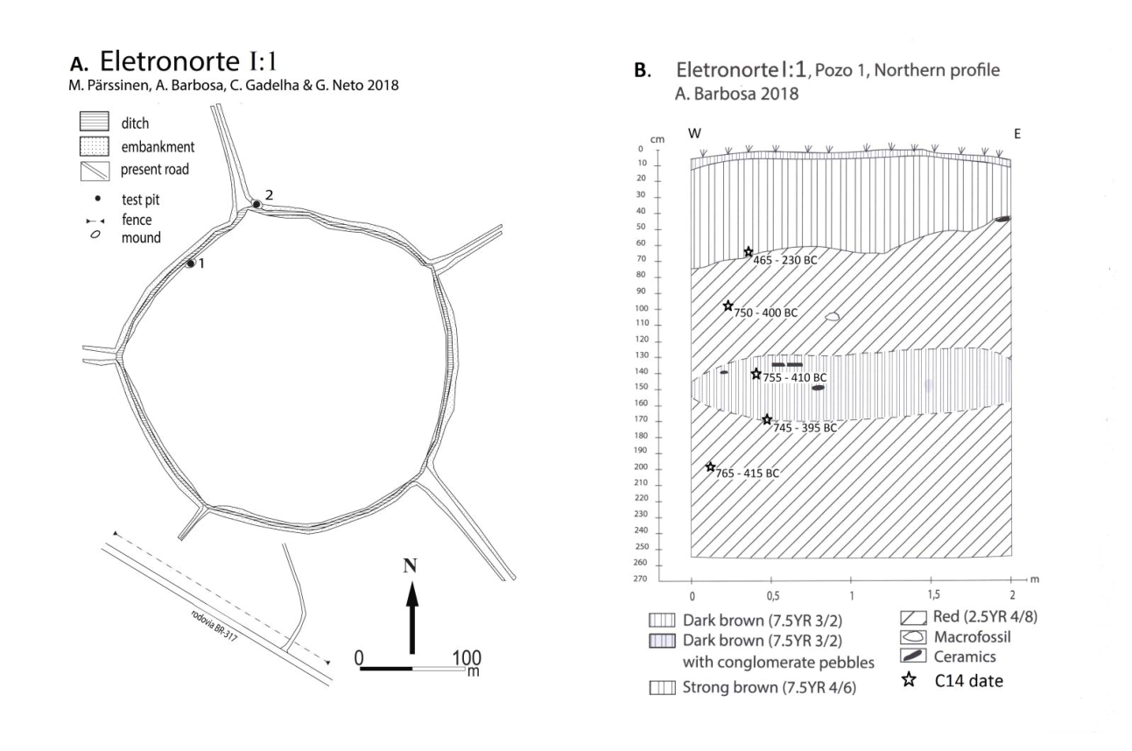
Supplementary Figure 4. Archaeological site of Eletronorte I:1. A. A map of Eletronorte I:1. B. The northern profile of Pit 1, made into a small mound associated with the ditch.
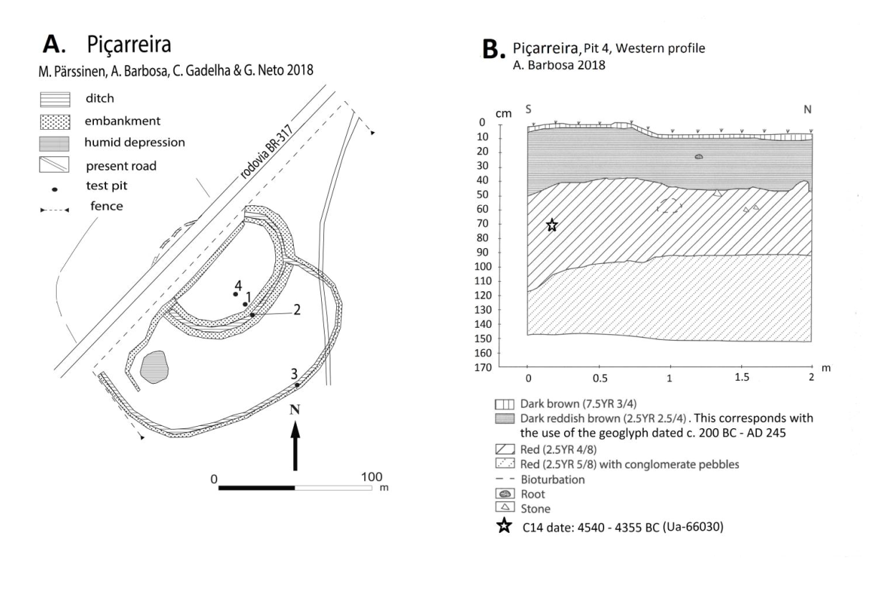
Supplementary Figure 5. Archaeological site of Piçarreira. A. A map of Piçarreira. B. Western profile of the Pit 4 made into the interior plaza of the geoglyph.

Supplementary Table 2. List of earthworks discovered in the ALS data. Coordinates are presented in decimal degrees, but discoveries in Indigenous territories are not included. Aquiry indicates whether the earthwork meets the definition of an Aquiry structure: yes (y), no (n), and accuracy indicates the clarity of outline recognition in size measurements, classified as good (g) or somewhat good (s)3. * refers earthwork that only partially (<50%) intersect the LiDAR swath.

No | ºS | ºW | Name in our data | Aquiry | Size (ha) | Accuracy
1 | -9.692 | -67.276 | acre40 | y | 1.51 | s
2 | -9.828 | -67.738 | acrq31 | y | 2.26 | g
3 | -9.745 | -67.060 | acrs42 | y | 4.91 | g
4 | -9.849 | -67.901 | Aeroporto - Estructura I | y | 8.75 | g
5 | -9.844 | -67.900 | Aeroporto - Estructura II | n | 3.21 | g
*6 | -9.175 | -66.939 | amae16 - Estructura III | y | 1.31 | s
7 | -9.300 | -66.508 | amag4 | y | 0.84 | g
*8 | -9.273 | -66.487 | amao9 | y | 0.83 | g
9 | -9.268 | -66.478 | amap9 - Estructura I | y | 5.53 | g
10 | -9.306 | -66.524 | amaq22 | y | 1.42 | g
11 | -9.344 | -66.567 | amaq36 | y | 3.58 | g
12 | -9.160 | -67.496 | amas10 | y | 0.73 | g
13 | -9.582 | -67.282 | amas4 - Estructura II | y | 3.23 | g
14 | -9.427 | -67.246 | amas8 | y | 2.90 | g
15 | -9.987 | -67.499 | Califórnia - Estrutura I | y | 2.89 | g
16 | -9.986 | -67.498 | Califórnia - Estrutura II | y | 2.79 | g
17 | -9.204 | -66.973 | endig1 | y | 1.40 | g
18 | -9.840 | -67.170 | Fazenda Boa Esperança - Estructura I | n | 0.97 | g
19 | -9.840 | -67.169 | Fazenda Boa Esperança - Estructura II | n | 0.51 | g
20 | -9.236 | -67.010 | G.Ch. 4 - 89 | y | 4.22 | g
21 | -8.757 | -67.307 | itaur | y | 1.53 | g
22 | -8.777 | -65.880 | Lid24_L01_101a | y | 1.55 | s
23 | -8.795 | -65.890 | Lid24_L01_102a | n | 4.05 | s
24 | -8.912 | -66.034 | Lid24_L01_112a | y | 2.36 | s
25 | -8.994 | -66.141 | Lid24_L01_119a | y | 3.80 | g
26 | -9.037 | -66.192 | Lid24_L01_123a | y | 4.41 | g
27 | -9.107 | -66.272 | Lid24_L01_129a | n | 0.80 | s
28 | -9.121 | -66.291 | Lid24_L01_130a | y | 2.33 | s
29 | -9.179 | -66.367 | Lid24_L01_135a | y | 1.97 | g
30 | -9.199 | -66.381 | Lid24_L01_137a | y | 1.46 | s
31 | -9.250 | -66.455 | Lid24_L01_142a | n | 3.62 | s
32 | -9.271 | -66.479 | Lid24_L01_143a | n | 12.80 | s
33 | -9.268 | -66.471 | Lid24_L01_143b | y | 3.31 | g
*34 | -9.264 | -66.476 | Lid24_L01_143c | y | 2.60 | s
35 | -9.282 | -66.486 | Lid24_L01_144a | n | 0.51 | g
36 | -9.289 | -66.502 | Lid24_L01_145a | n | 5.80 | s
37 | -9.290 | -66.498 | Lid24_L01_145b | n | 2.43 | g
38 | -9.290 | -66.501 | Lid24_L01_145c | y | 2.54 | s
39 | -9.312 | -66.523 | Lid24_L01_147b | y | 0.50 | s
40 | -9.322 | -66.532 | Lid24_L01_147c | y | 0.43 | g
41 | -9.319 | -66.536 | Lid24_L01_147d | n | 5.52 | g
42 | -9.324 | -66.537 | Lid24_L01_148b | y | 0.27 | g
43 | -9.322 | -66.540 | Lid24_L01_148d | n | 6.17 | g
44 | -9.322 | -66.545 | Lid24_L01_148e | y | 6.58 | s
45 | -9.335 | -66.556 | Lid24_L01_149b | n | 0.45 | g
46 | -9.340 | -66.558 | Lid24_L01_149e | n | 1.26 | s
*47 | -9.340 | -66.568 | Lid24_L01_150a | y | 7.17 | g
48 | -9.348 | -66.566 | Lid24_L01_150c | y | 2.43 | g
49 | -9.346 | -66.569 | Lid24_L01_150d | y | 3.58 | g
50 | -9.347 | -66.565 | Lid24_L01_150e | n | 0.56 | g
51 | -9.348 | -66.573 | Lid24_L01_150g | n | 0.50 | g
52 | -9.348 | -66.575 | Lid24_L01_150h | y | 1.96 | g
53 | -9.350 | -66.576 | Lid24_L01_150j | n | 0.84 | g
54 | -9.358 | -66.575 | Lid24_L01_151a | n | 4.67 | s
55 | -9.360 | -66.583 | Lid24_L01_151b | n | 0.53 | g
56 | -9.358 | -66.576 | Lid24_L01_151c | n | 0.46 | g
57 | -9.386 | -66.620 | Lid24_L01_153a | n | 4.21 | s
58 | -9.390 | -66.621 | Lid24_L01_154a | n | 0.43 | g
59 | -9.391 | -66.626 | Lid24_L01_154b | n | 0.38 | s
60 | -9.392 | -66.624 | Lid24_L01_154e | y | 2.25 | g
61 | -9.455 | -66.703 | Lid24_L01_159a | n | 1.07 | g
62 | -9.455 | -66.700 | Lid24_L01_159b | n | 0.72 | s
63 | -9.456 | -66.705 | Lid24_L01_159c | y | 1.74 | g
64 | -9.462 | -66.708 | Lid24_L01_160a | n | 1.80 | g
65 | -9.485 | -66.731 | Lid24_L01_162a | y | 6.40 | s
66 | -9.485 | -66.735 | Lid24_L01_162b | y | 1.16 | s
67 | -9.483 | -66.733 | Lid24_L01_162c | n | 0.82 | s
68 | -9.517 | -66.777 | Lid24_L01_165a | y | 3.64 | g
69 | -9.520 | -66.778 | Lid24_L01_165b | y | 2.68 | g
70 | -9.517 | -66.782 | Lid24_L01_165c | n | 0.69 | s
71 | -9.534 | -66.795 | Lid24_L01_166a | y | 0.54 | g
72 | -9.592 | -66.866 | Lid24_L01_171a | y | 3.81 | g
73 | -9.598 | -66.869 | Lid24_L01_171b | y | 2.12 | s
74 | -9.704 | -67.004 | Lid24_L01_181a | n | 4.73 | s
75 | -9.715 | -67.018 | Lid24_L01_182a | y | 2.99 | g
76 | -9.743 | -67.049 | Lid24_L01_184a | y | 3.33 | g
77 | -9.749 | -67.064 | Lid24_L01_185c | y | 3.15 | g
78 | -9.749 | -67.062 | Lid24_L01_185d | y | 3.17 | g
79 | -9.752 | -67.071 | Lid24_L01_185e | y | 7.61 | s
80 | -9.862 | -67.206 | Lid24_L01_195a | y | 0.63 | g
81 | -9.865 | -67.208 | Lid24_L01_195b | y | 0.93 | g
82 | -9.960 | -67.323 | Lid24_L01_203a | y | 2.66 | g
83 | -9.960 | -67.319 | Lid24_L01_203b | n | 0.16 | g
84 | -9.962 | -67.322 | Lid24_L01_203c | n | 1.55 | g
85 | -9.962 | -67.320 | Lid24_L01_203d | y | 1.61 | g
86 | -9.962 | -67.320 | Lid24_L01_203e | y | 3.87 | g
87 | -9.963 | -67.319 | Lid24_L01_203f | y | 0.84 | g
88 | -9.961 | -67.317 | Lid24_L01_203g | n | 1.10 | g
89 | -9.965 | -67.319 | Lid24_L01_203h | y | 5.10 | g
90 | -9.963 | -67.318 | Lid24_L01_203i | y | 1.06 | g
91 | -9.959 | -67.324 | Lid24_L01_203j | n | 0.62 | s
92 | -9.986 | -67.349 | Lid24_L01_205a | n | 2.47 | g
93 | -10.024 | -67.398 | Lid24_L01_209a | y | 0.49 | g
94 | -10.024 | -67.397 | Lid24_L01_209b | n | 0.39 | s
95 | -10.133 | -67.529 | Lid24_L01_218a | y | 0.98 | s
96 | -10.172 | -67.578 | Lid24_L01_222a | y | 0.29 | g
97 | -10.173 | -67.578 | Lid24_L01_222b | y | 0.22 | g
98 | -10.181 | -67.594 | Lid24_L01_223a | n | 1.01 | g
99 | -7.661 | -64.521 | Lid24_L01_3a | n | 3.88 | s
100 | -8.121 | -65.072 | Lid24_L01_43a | y | 3.48 | s
101 | -8.143 | -65.105 | Lid24_L01_45a | n | 4.32 | g
102 | -8.832 | -66.077 | Lid24_L02_114a | y | 2.17 | s
103 | -8.800 | -66.040 | Lid24_L02_116a | n | 10.19 | s
104 | -9.994 | -67.502 | Lid24_L02_12a | y | 0.35 | g
105 | -9.984 | -67.495 | Lid24_L02_13c | y | 5.26 | s
106 | -9.960 | -67.468 | Lid24_L02_15a | n | 0.88 | g
107 | -9.958 | -67.467 | Lid24_L02_15b | n | 2.19 | s
108 | -9.962 | -67.465 | Lid24_L02_15c | n | 1.13 | g
109 | -9.948 | -67.443 | Lid24_L02_16a | n | 1.05 | g
110 | -8.071 | -65.159 | Lid24_L02_179a | y | 0.93 | s
111 | -9.875 | -67.359 | Lid24_L02_23a | y | 0.56 | s
112 | -9.818 | -67.292 | Lid24_L02_27a | y | 0.85 | g
113 | -9.702 | -67.148 | Lid24_L02_38a | y | 3.10 | g
114 | -9.651 | -67.081 | Lid24_L02_42a | y | 2.41 | g
115 | -9.623 | -67.054 | Lid24_L02_44a | y | 1.93 | g
116 | -9.583 | -66.999 | Lid24_L02_48a | y | 5.46 | g
117 | -9.573 | -66.991 | Lid24_L02_49a | y | 3.46 | s
118 | -9.567 | -66.979 | Lid24_L02_49b | n | 5.11 | g
119 | -9.565 | -66.978 | Lid24_L02_50a | y | 0.70 | g
120 | -9.560 | -66.976 | Lid24_L02_50b | y | 1.55 | s
*121 | -9.541 | -66.942 | Lid24_L02_52a | y | 2.81 | s
122 | -9.514 | -66.915 | Lid24_L02_54a | n | 5.75 | g
123 | -9.509 | -66.913 | Lid24_L02_54b | n | 5.12 | s
124 | -9.491 | -66.894 | Lid24_L02_56a | y | 5.46 | s
125 | -9.486 | -66.882 | Lid24_L02_56b | n | 3.34 | s
126 | -9.469 | -66.864 | Lid24_L02_58a | y | 4.27 | s
127 | -9.455 | -66.841 | Lid24_L02_59a | y | 8.53 | g
128 | -9.454 | -66.839 | Lid24_L02_59b | y | 1.46 | g
129 | -9.446 | -66.837 | Lid24_L02_60a | y | 1.11 | g
130 | -9.415 | -66.793 | Lid24_L02_63a | y | 3.15 | g
131 | -9.381 | -66.759 | Lid24_L02_65a | n | 6.82 | s
132 | -10.058 | -67.589 | Lid24_L02_6a | n | 4.42 | s
133 | -9.330 | -66.690 | Lid24_L02_70a | y | 7.51 | g
134 | -9.308 | -66.661 | Lid24_L02_72a | n | 7.16 | g
135 | -9.276 | -66.621 | Lid24_L02_75a | y | 9.87 | g
136 | -9.274 | -66.619 | Lid24_L02_75b | y | 8.22 | g
137 | -9.266 | -66.612 | Lid24_L02_76a | n | 4.81 | g
138 | -9.252 | -66.591 | Lid24_L02_77a | n | 5.69 | s
139 | -9.242 | -66.580 | Lid24_L02_78a | n | 12.51 | s
140 | -9.237 | -66.576 | Lid24_L02_78b | y | 8.41 | s
141 | -10.054 | -67.578 | Lid24_L02_7a | y | 0.37 | g
142 | -10.051 | -67.579 | Lid24_L02_7b | n | 4.62 | s
143 | -10.054 | -67.578 | Lid24_L02_7c | y | 0.25 | s
144 | -9.214 | -66.548 | Lid24_L02_80a | n | 6.77 | s
145 | -9.150 | -66.477 | Lid24_L02_85a | y | 5.28 | s
146 | -9.138 | -66.454 | Lid24_L02_87a | y | 1.80 | g
147 | -10.039 | -67.563 | Lid24_L02_8a | n | 1.07 | g
148 | -8.869 | -66.276 | Lid24_L03_104a | y | 2.48 | s
149 | -9.952 | -67.596 | Lid24_L03_10a | y | 1.59 | g
150 | -8.520 | -65.845 | Lid24_L03_134a | y | 0.65 | s
151 | -9.914 | -67.544 | Lid24_L03_13a | y | 0.42 | g
152 | -9.914 | -67.544 | Lid24_L03_13b | y | 0.42 | g
153 | -8.314 | -65.597 | Lid24_L03_152a | y | 2.31 | g
154 | -7.890 | -65.082 | Lid24_L03_189a | n | 1.88 | g
155 | -7.885 | -65.077 | Lid24_L03_189b | n | 2.32 | g
156 | -9.733 | -67.332 | Lid24_L03_29a | y | 3.30 | s
157 | -9.696 | -67.288 | Lid24_L03_32a | y | 1.08 | s
158 | -9.697 | -67.287 | Lid24_L03_32b | y | 0.29 | g
159 | -9.697 | -67.285 | Lid24_L03_32c | n | 2.52 | s
160 | -9.694 | -67.284 | Lid24_L03_32d | y | 2.25 | g
161 | -9.693 | -67.281 | Lid24_L03_32e | y | 0.93 | s
162 | -9.694 | -67.282 | Lid24_L03_32f | n | 0.23 | s
*163 | -9.696 | -67.290 | Lid24_L03_32g | y | 2.48 | g
164 | -9.693 | -67.280 | Lid24_L03_32h | n | 0.17 | g
165 | -9.693 | -67.282 | Lid24_L03_32i | n | 0.46 | g
166 | -9.691 | -67.274 | Lid24_L03_33a | y | 0.37 | s
167 | -9.690 | -67.274 | Lid24_L03_33b | n | 0.20 | s
168 | -9.690 | -67.273 | Lid24_L03_33c | y | 3.18 | s
169 | -9.690 | -67.273 | Lid24_L03_33d | n | 0.32 | s
170 | -9.689 | -67.270 | Lid24_L03_33f | n | 0.37 | s
171 | -9.680 | -67.267 | Lid24_L03_33g | n | 1.49 | s
172 | -9.657 | -67.235 | Lid24_L03_35a | n | 5.08 | g
173 | -9.661 | -67.235 | Lid24_L03_35b | y | 1.43 | s
174 | -9.651 | -67.230 | Lid24_L03_36a | y | 4.75 | g
175 | -9.653 | -67.231 | Lid24_L03_36b | y | 3.18 | g
176 | -9.641 | -67.214 | Lid24_L03_37a | n | 1.17 | s
177 | -9.555 | -67.111 | Lid24_L03_44a | y | 6.97 | g
178 | -9.555 | -67.112 | Lid24_L03_44b | y | 1.42 | s
179 | -9.556 | -67.108 | Lid24_L03_44c | y | 2.73 | s
180 | -9.552 | -67.104 | Lid24_L03_45a | y | 3.18 | g
181 | -9.551 | -67.107 | Lid24_L03_45b | n | 0.64 | s
182 | -9.550 | -67.097 | Lid24_L03_45c | y | 4.97 | g
183 | -9.550 | -67.107 | Lid24_L03_45d | n | 0.63 | s
184 | -9.545 | -67.091 | Lid24_L03_45e | y | 2.69 | s
185 | -9.518 | -67.067 | Lid24_L03_47a | n | 3.89 | s
186 | -9.514 | -67.063 | Lid24_L03_48a | y | 1.38 | g
187 | -9.500 | -67.047 | Lid24_L03_49a | y | 0.75 | s
188 | -9.501 | -67.048 | Lid24_L03_49b | n | 2.17 | g
189 | -9.504 | -67.053 | Lid24_L03_49c | n | 1.06 | s
190 | -9.457 | -66.982 | Lid24_L03_53a | y | 1.56 | s
191 | -9.325 | -66.828 | Lid24_L03_64a | y | 1.77 | s
192 | -9.325 | -66.827 | Lid24_L03_64b | y | 0.87 | s
193 | -9.321 | -66.822 | Lid24_L03_65a | y | 0.89 | s
194 | -9.300 | -66.796 | Lid24_L03_67a | y | 1.95 | s
195 | -9.298 | -66.796 | Lid24_L03_67b | y | 4.47 | g
196 | -9.272 | -66.767 | Lid24_L03_69a | y | 3.15 | s
197 | -9.086 | -66.529 | Lid24_L03_85a | y | 2.01 | s
198 | -9.010 | -66.447 | Lid24_L03_92a | y | 2.56 | g
199 | -9.007 | -66.443 | Lid24_L03_92b | y | 2.01 | g
200 | -9.003 | -66.436 | Lid24_L03_92c | y | 1.54 | g
201 | -9.012 | -66.442 | Lid24_L03_92d | y | 2.27 | s
202 | -8.828 | -66.367 | Lid24_L04_101a | y | 6.84 | g
203 | -8.806 | -66.335 | Lid24_L04_103a | y | 3.08 | s
204 | -8.628 | -66.121 | Lid24_L04_119a | y | 0.96 | g
205 | -9.857 | -67.628 | Lid24_L04_12a | y | 2.36 | s
206 | -8.167 | -65.559 | Lid24_L04_159a | y | 0.67 | s
207 | -9.796 | -67.549 | Lid24_L04_17a | n | 0.59 | g
208 | -9.797 | -67.545 | Lid24_L04_17b | n | 0.61 | s
209 | -9.727 | -67.462 | Lid24_L04_23a | y | 0.62 | g
210 | -9.728 | -67.462 | Lid24_L04_23b | n | 4.01 | g
211 | -9.727 | -67.458 | Lid24_L04_23c | n | 4.67 | s
*212 | -9.719 | -67.447 | Lid24_L04_24a | y | 2.82 | g
213 | -9.692 | -67.414 | Lid24_L04_27a | y | 5.71 | s
214 | -9.668 | -67.398 | Lid24_L04_28a | n | 14.45 | s
215 | -9.670 | -67.397 | Lid24_L04_28b | n | 1.39 | g
216 | -9.671 | -67.398 | Lid24_L04_28c | y | 0.61 | g
217 | -9.672 | -67.394 | Lid24_L04_28d | y | 0.58 | s
218 | -9.664 | -67.392 | Lid24_L04_28e | y | 0.55 | s
219 | -9.668 | -67.393 | Lid24_L04_28f | y | 0.28 | s
220 | -9.668 | -67.394 | Lid24_L04_28g | n | 0.44 | s
221 | -9.670 | -67.394 | Lid24_L04_28h | n | 3.01 | s
222 | -9.675 | -67.394 | Lid24_L04_28i | n | 1.27 | s
223 | -9.676 | -67.394 | Lid24_L04_28j | n | 1.10 | s
224 | -9.663 | -67.383 | Lid24_L04_29a | y | 1.69 | s
225 | -9.656 | -67.381 | Lid24_L04_29b | y | 0.95 | s
226 | -9.648 | -67.362 | Lid24_L04_30a | y | 9.28 | s
227 | -9.643 | -67.362 | Lid24_L04_30b | y | 1.15 | s
228 | -9.631 | -67.351 | Lid24_L04_31a | y | 1.77 | s
229 | -9.643 | -67.361 | Lid24_L04_31b | y | 3.45 | s
230 | -9.587 | -67.297 | Lid24_L04_35a | y | 0.76 | g
231 | -9.589 | -67.292 | Lid24_L04_35b | y | 0.66 | g
232 | -9.572 | -67.272 | Lid24_L04_37a | y | 0.55 | g
233 | -9.573 | -67.271 | Lid24_L04_37b | y | 3.28 | s
234 | -9.543 | -67.232 | Lid24_L04_39a | y | 5.43 | g
235 | -9.525 | -67.213 | Lid24_L04_41a | y | 1.20 | g
236 | -9.462 | -67.133 | Lid24_L04_46a | y | 0.24 | g
237 | -9.422 | -67.082 | Lid24_L04_50a | y | 2.12 | s
238 | -9.411 | -67.079 | Lid24_L04_51a | y | 1.70 | g
239 | -9.394 | -67.051 | Lid24_L04_52a | y | 0.51 | s
240 | -9.355 | -67.002 | Lid24_L04_56a | y | 11.45 | g
241 | -9.353 | -67.000 | Lid24_L04_56b | y | 7.76 | g
242 | -9.346 | -66.992 | Lid24_L04_57a | y | 4.97 | g
243 | -9.320 | -66.960 | Lid24_L04_59a | y | 7.20 | g
244 | -9.321 | -66.960 | Lid24_L04_59b | y | 2.34 | g
245 | -9.313 | -66.952 | Lid24_L04_59c | y | 4.96 | s
246 | -9.315 | -66.952 | Lid24_L04_59d | y | 2.75 | g
247 | -9.308 | -66.955 | Lid24_L04_59e | y | 6.37 | s
248 | -9.321 | -66.967 | Lid24_L04_59f | y | 0.60 | g
249 | -9.300 | -66.943 | Lid24_L04_60b | y | 1.69 | g
250 | -9.270 | -66.907 | Lid24_L04_63a | y | 6.42 | s
251 | -9.254 | -66.881 | Lid24_L04_65a | y | 6.52 | g
252 | -9.184 | -66.802 | Lid24_L04_70a | y | 4.73 | s
253 | -9.185 | -66.796 | Lid24_L04_71a | y | 1.59 | g
254 | -9.107 | -66.703 | Lid24_L04_77a | y | 2.59 | g
255 | -9.099 | -66.701 | Lid24_L04_78a | y | 0.60 | s
256 | -8.710 | -66.366 | Lid24_L05_106a | y | 7.07 | g
257 | -8.705 | -66.359 | Lid24_L05_106b | y | 1.07 | g
258 | -8.609 | -66.243 | Lid24_L05_114a | y | 1.74 | s
259 | -8.060 | -65.566 | Lid24_L05_162a | n | 15.59 | s
260 | -8.051 | -65.560 | Lid24_L05_163a | y | 1.02 | g
261 | -9.741 | -67.626 | Lid24_L05_16a | y | 1.23 | s
262 | -7.633 | -65.053 | Lid24_L05_199a | n | 4.35 | g
263 | -7.638 | -65.057 | Lid24_L05_199b | n | 9.38 | g
264 | -7.617 | -65.032 | Lid24_L05_201a | n | 4.12 | g
265 | -7.619 | -65.030 | Lid24_L05_201b | n | 3.54 | s
266 | -9.588 | -67.433 | Lid24_L05_29a | y | 0.83 | s
267 | -9.589 | -67.437 | Lid24_L05_29b | y | 0.39 | s
268 | -9.553 | -67.402 | Lid24_L05_32a | y | 0.69 | s
269 | -9.557 | -67.401 | Lid24_L05_32b | n | 3.21 | g
*270 | -9.561 | -67.398 | Lid24_L05_32c | n | 0.76 | s
271 | -9.560 | -67.405 | Lid24_L05_32d | n | 1.10 | s
272 | -9.492 | -67.320 | Lid24_L05_38a | y | 1.97 | g
273 | -9.893 | -67.808 | Lid24_L05_3a | n | 3.65 | g
274 | -9.461 | -67.285 | Lid24_L05_40a | y | 0.66 | s
275 | -9.460 | -67.284 | Lid24_L05_40b | y | 7.27 | g
276 | -9.434 | -67.252 | Lid24_L05_42a | y | 8.46 | g
277 | -9.444 | -67.262 | Lid24_L05_42b | y | 0.70 | s
278 | -9.428 | -67.238 | Lid24_L05_43a | y | 5.72 | g
279 | -9.424 | -67.239 | Lid24_L05_43b | y | 8.05 | g
280 | -9.431 | -67.242 | Lid24_L05_43d | n | 2.25 | g
281 | -9.420 | -67.229 | Lid24_L05_44a | y | 8.07 | g
282 | -9.415 | -67.230 | Lid24_L05_44b | y | 0.78 | s
283 | -9.408 | -67.211 | Lid24_L05_45a | y | 1.20 | s
284 | -9.213 | -66.978 | Lid24_L05_62b | y | 3.71 | s
285 | -9.182 | -66.943 | Lid24_L05_64a | y | 4.68 | g
286 | -9.184 | -66.940 | Lid24_L05_64b | y | 3.89 | g
287 | -9.184 | -66.943 | Lid24_L05_64c | n | 1.40 | s
288 | -9.181 | -66.941 | Lid24_L05_65a | y | 6.42 | g
289 | -9.140 | -66.889 | Lid24_L05_68a | n | 0.55 | s
290 | -9.116 | -66.858 | Lid24_L05_70a | y | 2.12 | g
291 | -9.122 | -66.865 | Lid24_L05_70b | y | 2.70 | s
292 | -9.098 | -66.836 | Lid24_L05_72a | n | 7.49 | g
293 | -9.097 | -66.836 | Lid24_L05_72b | y | 8.23 | s
294 | -9.084 | -66.825 | Lid24_L05_73a | y | 2.72 | g
295 | -9.057 | -66.790 | Lid24_L05_75a | y | 1.42 | g
296 | -9.040 | -66.761 | Lid24_L05_77a | y | 7.36 | g
297 | -9.041 | -66.772 | Lid24_L05_77b | y | 5.08 | g
298 | -9.042 | -66.771 | Lid24_L05_77c | y | 1.37 | s
299 | -8.978 | -66.685 | Lid24_L05_83a | y | 1.42 | s
300 | -8.970 | -66.680 | Lid24_L05_83b | y | 5.61 | g
301 | -8.970 | -66.678 | Lid24_L05_83c | y | 3.29 | s
302 | -8.973 | -66.685 | Lid24_L05_83d | y | 1.14 | s
303 | -8.938 | -66.636 | Lid24_L05_86a | y | 4.02 | s
304 | -8.899 | -66.590 | Lid24_L05_89a | y | 1.14 | g
305 | -8.848 | -66.529 | Lid24_L05_94a | y | 1.35 | g
306 | -8.830 | -66.512 | Lid24_L05_95a | y | 1.64 | s
307 | -8.818 | -66.495 | Lid24_L05_96a | y | 0.60 | g
308 | -8.808 | -66.476 | Lid24_L05_97a | y | 0.92 | s
309 | -8.435 | -66.173 | Lid24_L06_124a | y | 6.80 | g
310 | -9.725 | -67.744 | Lid24_L06_12a | y | 0.37 | g
311 | -8.253 | -65.948 | Lid24_L06_139a | y | 4.12 | g
312 | -9.846 | -67.884 | Lid24_L06_1a | y | 1.20 | g
313 | -7.495 | -65.031 | Lid24_L06_205a | n | 12.12 | s
314 | -7.282 | -64.783 | Lid24_L06_223a | y | 1.14 | s
315 | -9.555 | -67.544 | Lid24_L06_26a | n | 13.80 | g
316 | -9.552 | -67.535 | Lid24_L06_26b | y | 0.28 | s
317 | -9.541 | -67.526 | Lid24_L06_27a | y | 0.57 | s
318 | -9.363 | -67.309 | Lid24_L06_43a | y | 0.28 | g
319 | -9.356 | -67.290 | Lid24_L06_44a | y | 4.84 | g
320 | -9.200 | -67.101 | Lid24_L06_57a | y | 1.99 | g
321 | -9.194 | -67.101 | Lid24_L06_57b | n | 2.47 | g
322 | -9.158 | -67.048 | Lid24_L06_61a | y | 6.68 | g
323 | -9.152 | -67.050 | Lid24_L06_61b | y | 4.27 | g
324 | -9.145 | -67.032 | Lid24_L06_62a | y | 2.76 | g
*325 | -9.106 | -66.981 | Lid24_L06_66a | n | 9.01 | s
326 | -9.039 | -66.906 | Lid24_L06_71a | y | 2.90 | s
327 | -9.037 | -66.906 | Lid24_L06_71b | y | 4.60 | g
328 | -9.027 | -66.897 | Lid24_L06_72a | y | 5.28 | g
329 | -9.031 | -66.902 | Lid24_L06_72b | y | 6.85 | s
330 | -8.994 | -66.851 | Lid24_L06_75a | n | 0.92 | s
331 | -8.905 | -66.745 | Lid24_L06_83a | y | 11.60 | g
332 | -8.888 | -66.722 | Lid24_L06_84a | y | 0.51 | g
333 | -8.880 | -66.719 | Lid24_L06_85a | y | 0.74 | s
334 | -8.853 | -66.677 | Lid24_L06_87a | y | 1.35 | g
335 | -8.784 | -66.597 | Lid24_L06_93a | y | 4.43 | g
336 | -8.775 | -66.586 | Lid24_L06_94a | y | 11.83 | g
337 | -8.773 | -66.578 | Lid24_L06_94b | y | 3.14 | s
338 | -7.299 | -64.751 | Lid24_L07_179a | y | 2.00 | g
339 | -7.298 | -64.753 | Lid24_L07_179b | y | 2.89 | g
340 | -7.299 | -64.748 | Lid24_L07_179c | y | 0.71 | s
341 | -7.307 | -64.747 | Lid24_L07_180a | y | 1.95 | g
342 | -7.439 | -64.635 | Lid24_L07_185a | y | 1.42 | g
343 | -7.487 | -64.593 | Lid24_L07_189a | y | 1.79 | g
344 | -7.842 | -66.795 | Lid24_L08_147a | y | 9.79 | g
345 | -7.846 | -66.799 | Lid24_L08_147b | y | 3.00 | g
346 | -8.734 | -68.962 | Lid24_L08_18a | y | 0.39 | S
347 | -8.722 | -68.936 | Lid24_L08_18b | y | 0.46 | s
348 | -4.900 | -66.911 | Lid24_L09_1a | y | 1.73 | s
349 | -4.898 | -66.908 | Lid24_L09_1b | y | 5.55 | g
350 | -4.895 | -66.907 | Lid24_L09_1Ba | y | 0.23 | s
351 | -4.896 | -66.907 | Lid24_L09_1Bb | y | 0.20 | s
352 | -4.899 | -66.906 | Lid24_L09_1c | y | 0.26 | s
353 | -4.899 | -66.906 | Lid24_L09_1d | y | 0.23 | s
354 | -8.757 | -67.309 | Lid24_L09_215a | y | 3.94 | g
355 | -9.085 | -67.460 | Lid24_L09_235a | y | 5.23 | g
356 | -9.239 | -67.545 | Lid24_l09_245a | y | 1.15 | g
357 | -9.257 | -67.556 | Lid24_L09_246a | y | 3.78 | s
358 | -9.262 | -67.555 | Lid24_L09_246b | y | 2.46 | g
359 | -9.259 | -67.555 | Lid24_L09_246c | y | 4.97 | s
360 | -9.262 | -67.558 | Lid24_L09_246d | y | 5.14 | g
361 | -9.262 | -67.556 | Lid24_L09_246e | y | 7.45 | s
362 | -9.561 | -67.726 | Lid24_L09_265a | y | 1.20 | g
363 | -9.557 | -67.716 | Lid24_L09_265b | y | 0.92 | g
364 | -9.576 | -67.731 | Lid24_L09_266a | y | 3.84 | g
365 | -9.585 | -67.740 | Lid24_L09_267a | y | 0.99 | s
366 | -9.584 | -67.740 | Lid24_L09_267b | y | 1.57 | g
367 | -9.603 | -67.742 | Lid24_L09_268a | y | 3.55 | s
368 | -9.602 | -67.745 | Lid24_L09_268b | y | 5.92 | s
369 | -9.622 | -67.754 | Lid24_L09_269a | y | 4.06 | g
370 | -9.614 | -67.757 | Lid24_L09_269b | y | 1.18 | g
371 | -9.659 | -67.781 | Lid24_L09_272a | y | 1.38 | g
372 | -9.710 | -67.805 | Lid24_L09_275a | y | 2.68 | g
373 | -8.973 | -69.147 | Lid24_L10_10a | n | 2.57 | s
374 | -10.061 | -67.727 | Lid24_L10_111a | n | 0.68 | g
375 | -10.066 | -67.720 | Lid24_L10_111b | n | 1.98 | s
376 | -10.085 | -67.708 | Lid24_L10_112a | n | 0.51 | s
377 | -10.156 | -67.649 | Lid24_L10_117a | n | 0.26 | s
378 | -10.172 | -67.638 | Lid24_L10_119a | n | 4.01 | g
379 | -10.174 | -67.636 | Lid24_L10_119b | n | 0.61 | s
380 | -10.202 | -67.617 | Lid24_L10_120a | n | 0.38 | g
381 | -10.202 | -67.616 | Lid24_L10_120b | n | 0.53 | g
382 | -10.202 | -67.616 | Lid24_L10_120c | n | 0.77 | g
383 | -10.203 | -67.617 | Lid24_L10_120d | n | 0.25 | g
384 | -10.195 | -67.614 | Lid24_L10_120e | n | 1.14 | g
385 | -10.190 | -67.614 | Lid24_L10_120f | n | 0.77 | s
386 | -9.270 | -68.869 | Lid24_L10_32a | n | 0.86 | s
387 | -9.590 | -68.510 | Lid24_L10_59a | n | 1.51 | g
388 | -9.592 | -68.521 | Lid24_L10_59b | n | 4.66 | g
389 | -9.630 | -68.433 | Lid24_L10_64a | n | 2.28 | g
390 | -9.668 | -68.343 | Lid24_L10_69a | n | 0.99 | g
391 | -9.756 | -68.134 | Lid24_L10_82a | n | 1.56 | g
392 | -9.760 | -68.120 | Lid24_L10_83a | n | 4.48 | s
393 | -9.934 | -67.569 | Lidar.Ac.1 - Estructura VI | y | 1.25 | g
394 | -9.202 | -67.101 | MP.Am.17 - Estructura I | y | 6.57 | g
395 | -9.373 | -67.318 | MP.Am.30 | y | 5.67 | g
396 | -9.574 | -67.273 | MP.Am.36 - Estructura I | y | 2.22 | g
*397 | -9.577 | -67.272 | MP.Am.36 - Estructura II | y | 1.82 | s
398 | -9.968 | -67.469 | Nakahara 108 - Estructura I | y | 0.76 | g
399 | -9.967 | -67.469 | Nakahara 108 - Estructura II | y | 0.32 | g
*400 | -9.676 | -67.392 | Nakahara 185 | y | 2.14 | s
401 | -9.668 | -67.392 | Nakahara 186 | y | 2.38 | g
*402 | -9.663 | -67.250 | Nakahara 188 | y | 6.67 | s
403 | -9.953 | -67.595 | Nakahara 23 - Estrutura II-muretas | y | 3.88 | g
404 | -9.796 | -67.544 | Nakahara AC 209 | n | 1.17 | s
*405 | -9.749 | -67.197 | Oco do Mundo | y | 4.67 | g
406 | -9.621 | -67.759 | Vila do V | y | 6.38 | g

Supplementary Table 3. Size of rectangular mound settlements in SW Amazonia. The list is based on Iriarte et al. 202019, and the sizes are measured by us using satellite imagery. The number of mounds in Nakahara 174 Estrutura I is based on our own observations.
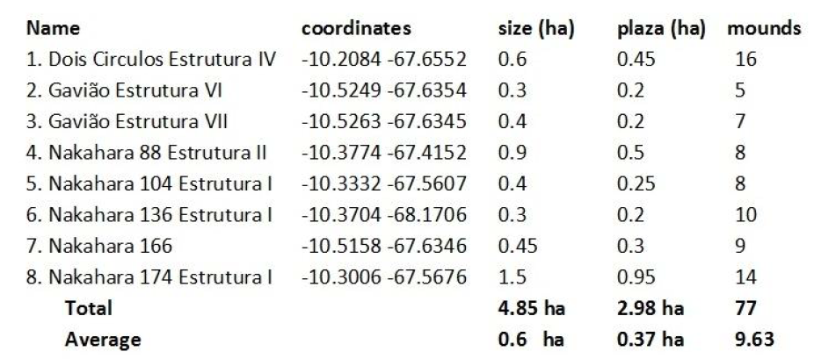

Supplementary References
- Chandless, W. Notes on the River Aquiry, the principal Affluent of the River Purȗs. Journal of the Royal Geographical Society of London 36, 119-126 (1866).
- Pärssinen, M, Balée, W., Ranzi, A. & Barbosa, A.D. The geoglyph sites of Acre, Brazil: 10 000-year-old land-use practices and climate change in Amazonia. Antiquity 94, 1538-1556 (2020).
- Dias, O. As Estruturas Arqueológicas de Terra no Estado do Acre - Amazônia Ocidental, Brasil. Um caso de resiliência? in Estudos Contemporâneos de Arqueologia (eds. Dias, O, Carvalho, E. & Zimmermann, M.) 59-168 (Palmas: Unitins, IAB, 2006).
- Saunaluoma, S. & Schaan, D. Monumentality in Western Amazonian formative societies: geometric ditched enclosures in the Brazilian state of Acre. Antiqua 2:e1 (2012).
- Neves, E.G. Ecology, Ceramic Chronology and Distribution. Long-Term History and Political Change in the Amazonian Floodplain, in Handbook of South American Archaeology (eds. Silvermann, H., & Isbell, W.) 359-379 (New York: Springer, 2008).
- Saunaluoma, S. Geometric Earthworks in the State of Acre, Brazil: Excavations at the Fazenda Atlântica and Quinauá sites. Lat. Am. Antiq. 23, 565-583 (2012).
- Iriarte, J., de Souza, J.G., Robinson, M.E., Barbosa, A.D. & da Silva, F. Refining the Chronology and Occupation Dynamics of the Mound Villages of South-eastern Acre, Brazil. Amazônica, Revista de Antropologia 13, 153-176 (2021).
- Cook, N. D. Demographic Collapse: Indian Peru 1520-1620. (Cambridge: Cambridge University Press, 1981).
- Mercier, V, Diario de una Expedición del Madre de Dios al Acre. La Paz: Imprenta La Tribuna 1894. Colección de folletos bolivianos de Hoy 3, 1-16, Facsimilar (La Paz, Octubre 1981).
- Labre, C.A.R.P. Colonel Labre’s Explorations in the Region between the Beni and Madre de Dios Rivers and the Purus. Proceedings of the Royal Geographical Society and Monthly Record of Geography 11, 496–502 (1889).
- Kraus, K., & Pfeifer, N. Advanced DTM generation from LIDAR data. International Archives Of Photogrammetry Remote Sensing and Spatial Information Sciences 34(3/W4), 23-30 (2001).
- Khosravipour, A., Skidmore, A.K., Isenburg, M. & Wang, T.J. Development of an algorithm to generate pit-free Digital Surface Models from LiDAR, Proceedings of SilviLaser 2015, 247-249 (2015).
- Khosravipour, A., Skidmore, A. K., & Isenburg, M. Generating spike-free digital surface models using LiDAR raw point clouds: A new approach for forestry applications. International Journal of Applied Earth Observation and Geoinformation 52, 104-114 (2016).
- Sithole, G. & Vosselman, G. Experimental comparison of filter algorithms for bare-Earth extraction from airborne laser scanning point clouds. ISPRS Journal of Photogrammetry and Remote Sensing 59, 85-101 (2004). https://doi.org/10.1016/j.isprsjprs.2004.05.004
- Cățeanu, M. & Ciubotaru, A. The Effect of LiDAR Sampling Density on DTM Accuracy for Areas with Heavy Forest Cover. Forests 12, 265 (2021). https://doi.org/10.3390/f12030265
- Hyyppä, J. et al. Review of methods of small‐footprint airborne laser scanning for extracting forest inventory data in boreal forests. International Journal of Remote Sensing 29, 1339-1366 (2008). https://doi.org/10.1080/01431160701736489
- Ahokas, E., Hyyppä, J., Yu, X., Holopainen, M. Transmittance of Airborne Laser Scanning Pulses for Boreal Forest Elevation Modeling. Remote Sensing 3, 1365-1379 (2011). https://doi.org/10.3390/rs3071365
- Wood, R. From revolution to convention: the past, present and future of radiocarbon dating. J. Archaeol. Sci. 56, 61-72 (2015).
- Saunaluoma, S. Pre-Columbian Earthworks in the Riberalta Region of the Bolivian Amazon. Amazônica, Revista de Antropologia 2, 86-111 (2010).
- Pärssinen, M., Ranzi, A., Saunaluoma, S. & Siiriäinen, A. Geometrically patterned ancient earthworks in the Rio Branco Region of Acre, Brazil: New evidence of ancient chiefdom formations in Amazonian interfluvial terra firme environment, in Western Amazonia - Amazônia Ocidental. Multidisciplinary Studies on Ancient Expansionistic Movements, Fortifications and Sedentary Life (eds. Pärssinen, M. & Korpisaari, A.) 97-133 (Helsinki: Renvall Institute Publications, University of Helsinki, 2003).
- Saunaluoma, S., Moat, J., Pugliese, F. & Neves, E.G. Patterned Villagescapes and Road Networks in Ancient Southwestern Amazonia. Lat. Am. Antiq. 32, 173-187 (2021).
- Neves, E. G. et al. Pesquisa e Formação nos Sítios Arqueológicos Espinhara e Sol de Campinas do Acre – PESC: Relatório Final. Universidade de São Paulo. Manuscript (2016). DOI:10.13140/RG.2.2.27534.72006

