Supplementary Information for
Superconducting 2D cuprate with a single CuO₂ plane

Hengsheng Luo, Dongjoon Song, Yijun Yu, Liguo Ma, Peng Cai, Ruidan Zhong, Yiwen Chen, Lin Zhao, Jian Shen, Dan Shahar, Xingjiang Zhou, Zhengyu Weng, Xian Hui Chen*, Wei Ruan*, Yuanbo Zhang*

*Correspondence should be addressed to Y.Z. (zhyb@fudan.edu.cn) and W.R. (weiruan@fudan.edu.cn) and X.H.C (chenxh@ustc.edu.cn).

Contents

Supplementary Figures
S1 | Characterization of atomically-thin Bi-2201 flakes
S2 | Mapping the pseudogap in monolayer Bi-2201
S3 | Temperature-dependent pseudogap and superconducting gap in monolayer Bi-2201
S4 | Quasiparticle interference (QPI) analysis with contaminant-mask method
S5 | Energy-dependent quasiparticle interference in monolayer Bi-2201
S6 | Mapping the Fermi surface of monolayer Bi-2201
S7 | Quasi-particle interference and the evolution of the Fermi surface in monolayer Bi-2201
S8 | Doping dependence of filtered $Λ\left(q\right)$ map
S9 | The charge ordered state in monolayer Bi-2201
S10 | Measuring the diffusion barrier of the interstitial oxygen in monolayer Bi-2201
S11 | Thickness-dependent $T_{c}$ of optimally-doped Bi-2201
S12 | Thickness-dependent $T_{c}$ of optimally-doped Bi-2201 determined by various methods
S13 | Effect of vacuum/ozone annealing on the optimal $T_{c}$
S14 | Finite-size scaling analysis of monolayer sample B across different temperature windows
S15 | Layer dependence of CDW correlation in Bi-2201
S16 | Cluster and correlation analysis of underdoped monolayer Bi-2201
S17 | Power-law divergence of the critical exponent $νz$ under different choices of temperature windows
S18 | Determination of $T_{c,onset}$ and $T_{SIT}$
S19 | Phase diagram of monolayer Bi-2201 based on $d(ln⁡|R| )/dT$ as a function of temperature and doping level
S20 | Representative $I-V$ characteristics of monolayer Bi-2201 and threshold currents at base temperature
S21 | RF noise filtering in the sub-Kelvin transport measurement setup
S22 | Comparison of low-temperature electronic transport in monolayer Bi-2201 with and without RC filters
S23 | Superconducting transitions of monolayer and bulk Bi-2201 near optimal doping
S24 | Superconducting transitions of Bi-2201 fitted with the Halperin−Nelson (HN) formula
S25 | Superconducting transition in a monolayer Bi-2201 sample probed by $I-V$ measurements
Supplementary Figure 1 | Characterization of atomically-thin Bi-2201 flakes. a, Optical image of few-layer Bi-2201 flakes exfoliated on a silicon substrate with 285 nm SiO₂. Scale bar: $10 μm$. b, AFM topograph of the area marked by the black square in a. Scale bar: $5 μm$. c, Schematic atomic structure of monolayer Bi-2201. A monolayer refers to a half unit cell in the out-of-plan direction, which contains a single CuO₂ plane. d, Cross-sectional profiles of the optical contrast and AFM height at the same location (along the red line in a and blue line in b). The two profiles agree well with each other, and the two steps in the profiles reflect the step edges of monolayer terraces.

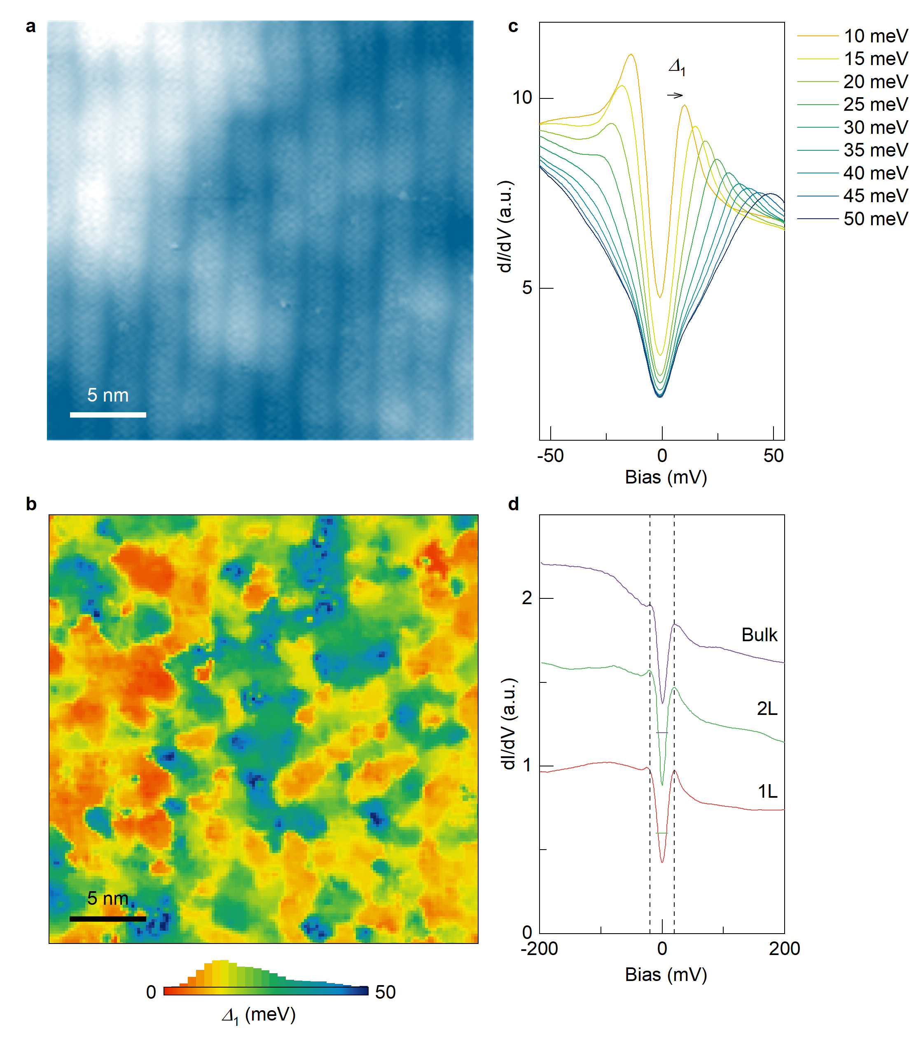
Supplementary Figure 2 | Mapping the pseudogap in monolayer Bi-2201. a, STM topograph of optimally-doped monolayer Bi-2201. The image was obtained at a sample bias $V_{s}=-200 mV$ and a tunnelling current $I_{t}=20 pA$. b, Pseudogap map $∆_{1}\left(r\right)$ acquired on the same area shown in a. The map was extracted from differential conductance ($dI/dV$) spectra taken on a $150×150$ grid. The spectra were taken at a tunnelling setpoint of $V_{s}=-200 mV$, $I_{t}=100 pA$, with a modulation voltage of $V_{mod}=2 mV$. The average value of the pseudogap is $∆_{1}=20.3 9.5 meV$. c, Spatially-averaged $dI/dV$ spectra sorted by size of the pseudogap. The curves are colour-coded to match the colour of the area in b, over which the spatial average is performed. d, Spatially-averaged $dI/dV$ spectra obtained on monolayer (“1L”), bilayer (“2L”), and bulk Bi-2201. All spectra were taken at a tunnelling setpoint of $V_{s}=-200 mV$, $I_{t}=100 pA$, with a modulation voltage of $V_{mod}=2 mV$. Dashed lines at $V_{s}=±20 meV$ mark the edges of the pseudogap. Curves are offset for clarity, with horizontal bars indicating the zero level of each spectrum.
Supplementary Figure 3 | Temperature-dependent pseudogap and superconducting gap in monolayer Bi-2201. a, Temperature-dependent spatially-averaged $dI/dV$ spectra of optimally-doped monolayer Bi-2201, showing a smooth transition from the superconducting state to the pseudogap state. Dashed lines represent the edges of the pseudogap. b, The same $dI/dV$ spectra in a, normalized to the spectrum at $T=46 K$. Dashed lines represent the edges of the superconducting gap at $±13 meV$. All spectra were taken at a tunnelling setpoint of $V_{s}=-200 mV$, $I_{t}=100 pA$, with a modulation voltage of $V_{mod}=5 mV$.

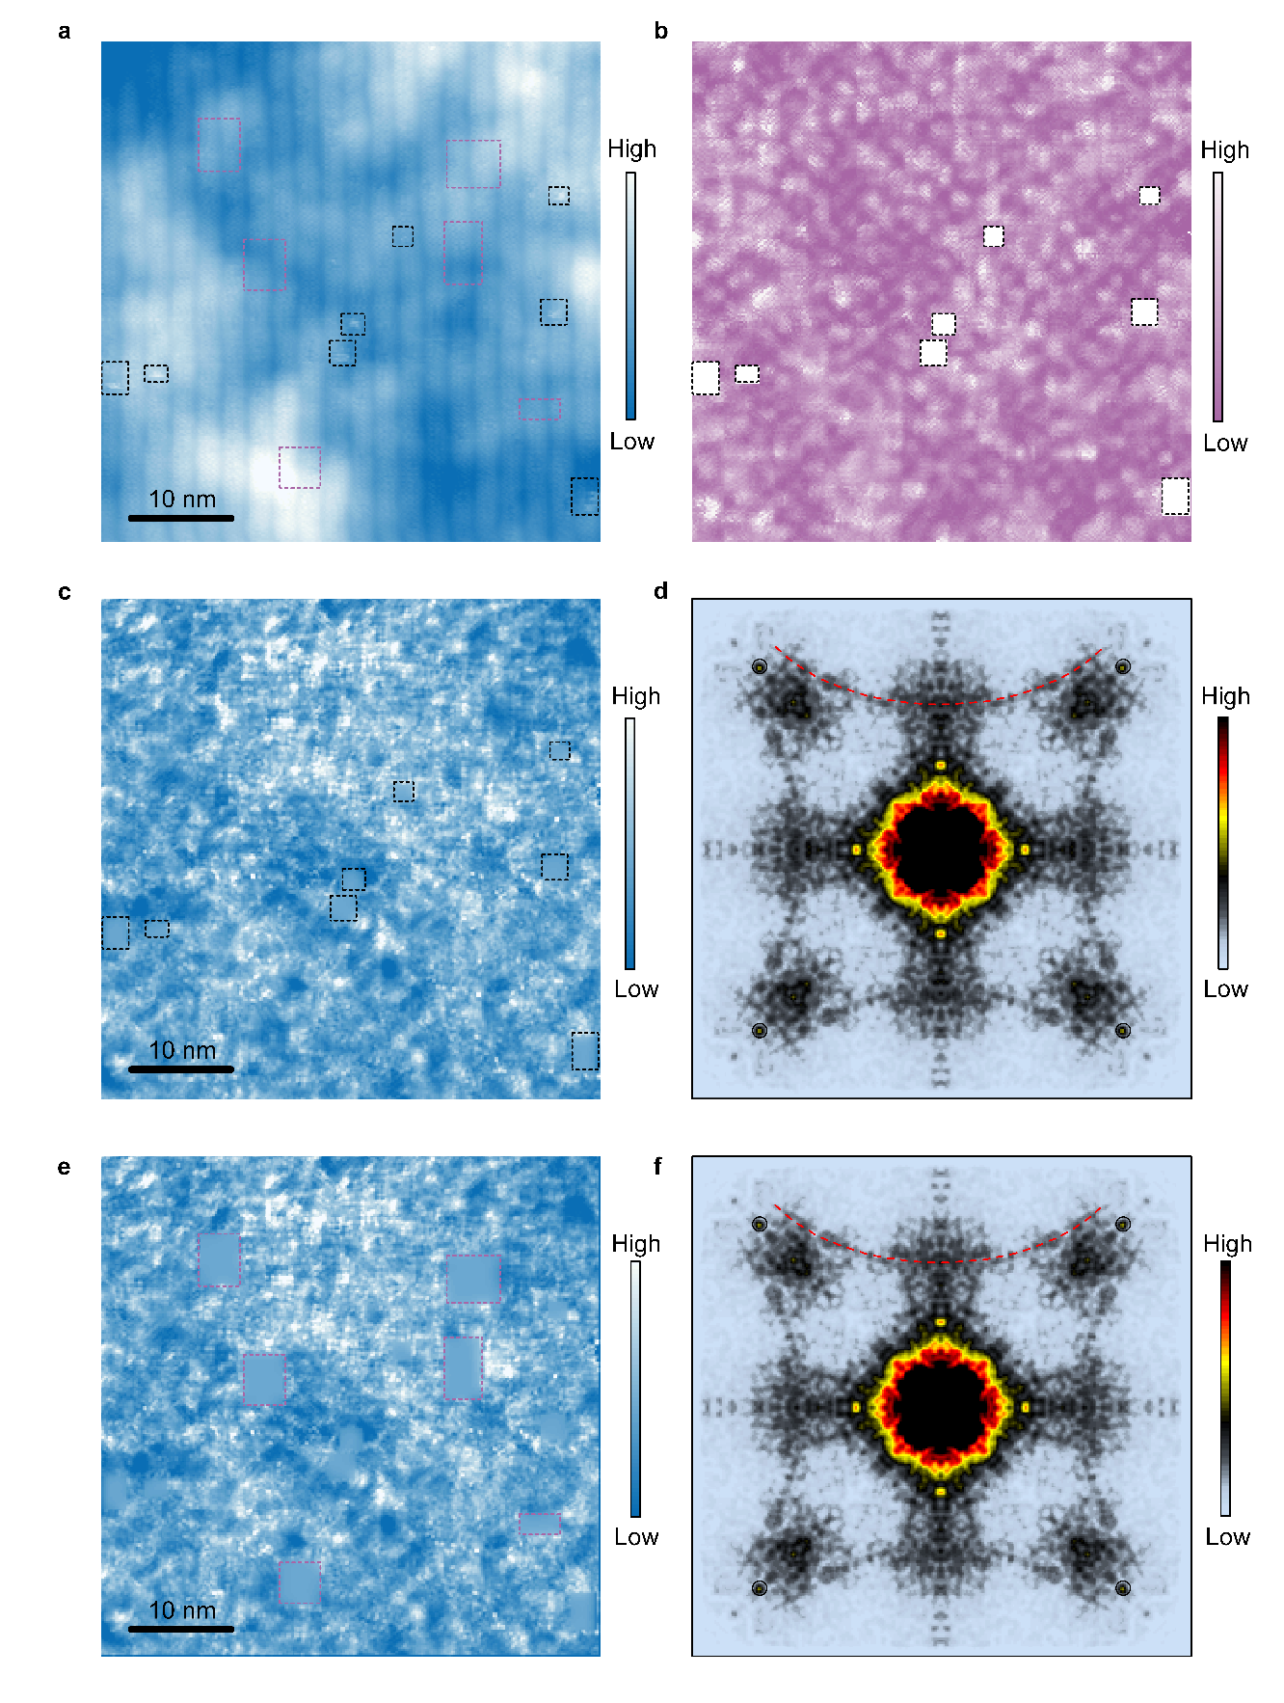
Supplementary Figure 4 | Quasiparticle interference (QPI) analysis with contaminant-mask method. a, STM topograph of optimally-doped monolayer Bi-2201. The image was obtained at a sample bias $V_{s}=-200 mV$ and a tunnelling current $I_{t}=20 pA$. b, Differential conductance map $g_{0}\left(r,E=8 meV\right)$ of the same area in a. Contaminants are visible on the surface in a (bright spots in black rectangles in a). These contaminants may damage the tip during subsequent spectroscopy measurements. To avoid tip damage, we have developed an STS measurement technique, referred to as “contaminant-mask” method, which masks the contaminants during spectroscopic mapping. To start with, we first survey the surface to locate all the contaminants. We then design a mask $Ω_{m}$ as indicated by the black rectangles. A program was implemented to move the tip around the mask area during STS measurement, yielding a conductance map $g_{0}\left(r,E\right)$ with the values within the mask set to zero. To mitigate artefacts introduced by such a mask, we added a mask map ${\tilde{g}}_{m}\left(r,E\right)$ to $g_{0}\left(r,E\right)$, where ${\tilde{g}}_{m}\left(r,E\right)$ is the map
$$\begin{aligned}g_{m}\left(r,E\right)=\left\{\begin{aligned}0, &r∉Ω_{m}, \\ \overline{g}\left(E\right), & r∈Ω_{m},\end{aligned}\right.\#\left(1\right)\end{aligned}$$
Gaussian blurred with a radius of $σ$ ~ 3 pixels. Here $\overline{g}\left(E\right)$ is the spatial average of $g_{0}\left(r,E\right)$ outside of the mask area. The resulting conductance map $g\left(r,E\right)=g_{0}\left(r,E\right)+{\tilde{g}}_{m}\left(r,E\right)$ is used for subsequent spectral analyses. c, Differential conductance ratio map $Z\left(r, E= 8 meV\right)$ of the same area in a. d, Fourier transform of $Z\left(r, E= 8 meV\right)$, showing the $q_{4}$ trajectory (red dashed arc). The atomic-lattice Bragg peaks are circled in black. e, The same differential conductance ratio map in c, with additional, randomly-chosen masks (pink dashed rectangles). f, Fourier transform of the conductance ratio map in e. The close agreement between d and f verifies that the contaminant mask method does not distort the QPI analysis results.

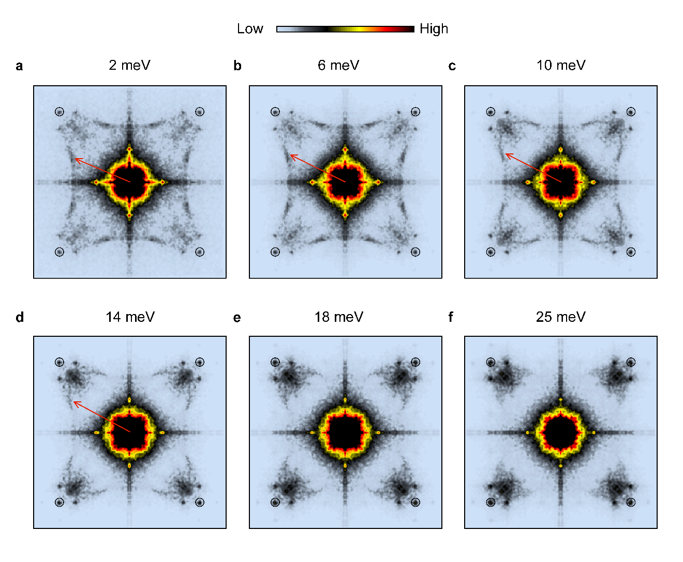
Supplementary Figure 5 | Energy-dependent quasiparticle interference in monolayer Bi-2201. a-f, Energy-dependent conductance ratio map $Z\left(q, E\right)$ of optimally-doped monolayer Bi-2201. Data were acquired on a $600 Å \text{×} 600 Å$ area at a tunnelling setpoint of $V_{s}=-100 mV$, $I_{t}=100 pA$, with a modulation voltage of $V_{mod}=5 mV$. $q_{4}$ (red arrows) exhibits dispersion within the superconducting gap (a-d), and disappears beyond the energy (e-f). The atomic-lattice Bragg peaks are circled in black.

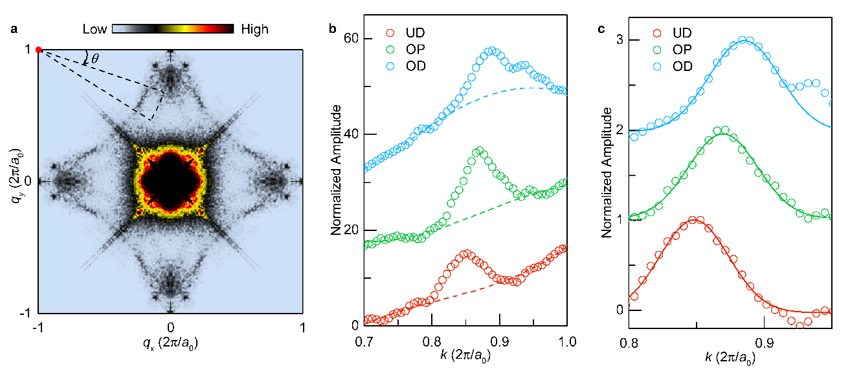
Supplementary Figure 6 | Mapping the Fermi surface of monolayer Bi-2201. a, QPI signal of optimally-doped monolayer Bi-2201, from which the Fermi surface is obtained using a method described in ref. ¹. b, Radial dependence of the Fourier intensity as a function of $k$, the distance from the wavevector $q_{π,π}=(-2π/a_{0},2π/a_{0})$ (red dot in a). Data points are obtained by averaging 50 Fourier intensity line profiles along the radial directions away from $q_{π,π}$ with the azimuthal angle 𝜃 evenly spaced over the range from $0.1π$ to $0.18π$ (indicated by the dashed sector in a; the range is chosen so as to avoid other QPI wavevector signals than $q_{4}$). Dashed lines are third-order polynomial fits to the background over the ranges $0.7×2π/a_{0}<k<0.8×2π/a_{0}$ and $0.96×2π/a_{0}<k<2π/a_{0}$. The red, green, and blue open circles represent data from under-doped (UD), optimally-doped (OP), and over-doped (OD) monolayer Bi-2201, respectively. c, Fourier intensity line profiles in b with the fitted background subtracted. The radial position of the $q_{4}$ wavevector is obtained by Gaussian fit of the peaks (solid lines), which is then used to construct the Fermi surface of monolayer Bi-2201 using the octet model¹.

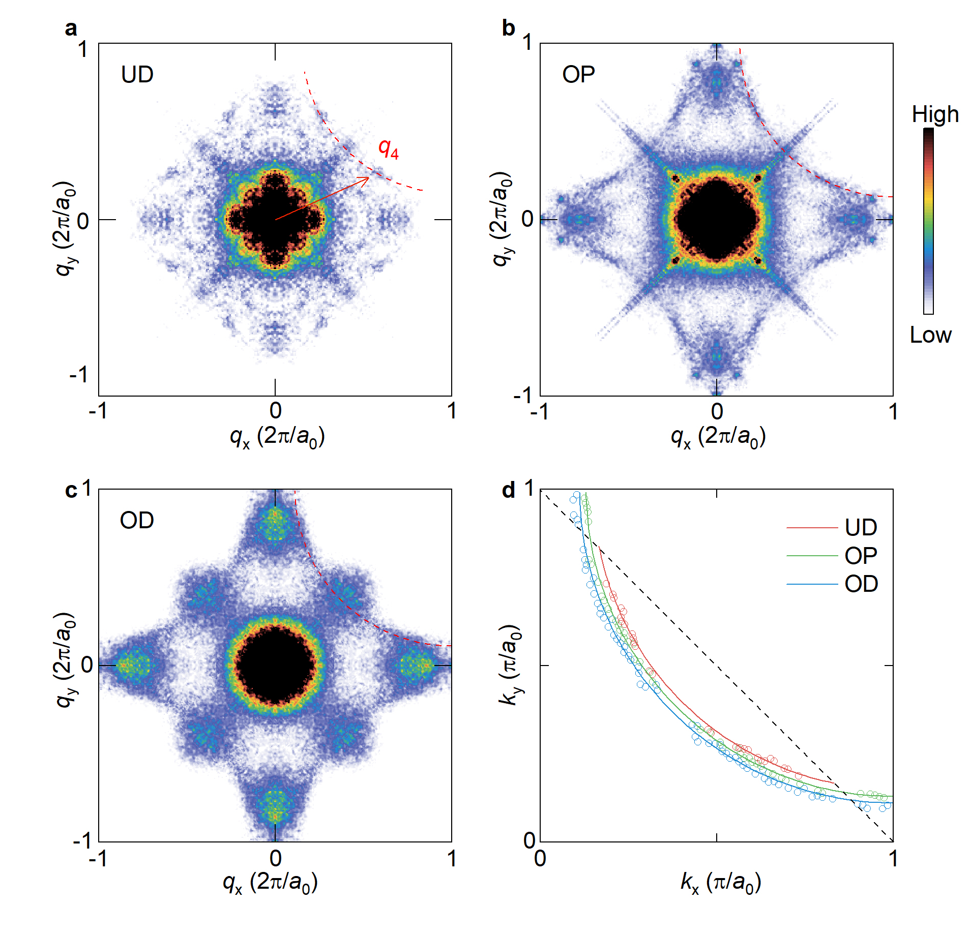
Supplementary Figure 7 | Quasi-particle interference and the evolution of the Fermi surface in monolayer Bi-2201. a-c, Integrated Fourier transform of conductance ratio maps $Λ(q)$ acquired in monolayer Bi-2201 at various doping levels. Red dashed lines trace the $q_{4}$ trajectories. The optimally-doped monolayer (marked “OP”) in a was exfoliated from optimally-doped Bi₂Sr_{1.6}La_{0.4}CuO_{6+δ} bulk crystal. The underdoped monolayer (marked “UD”) in b was obtained by annealing the OP monolayer in vacuum. The overdoped monolayer (marked “OD”) in c was exfoliated from overdoped Bi_{1.8}Pb_{0.4}Sr_{0.8}CuO_{6+δ} bulk crystal with $T_{c} = 7 K$. The momenta $q_{x}$ and $q_{y}$ are expressed in units of $2π/a_{0}$, where $a_{0}$ is the lattice constant. d, Doping-dependent Fermi surface of monolayer Bi-2201 determined from the $q_{4}$ trajectories^{2,3} shown in a-c.

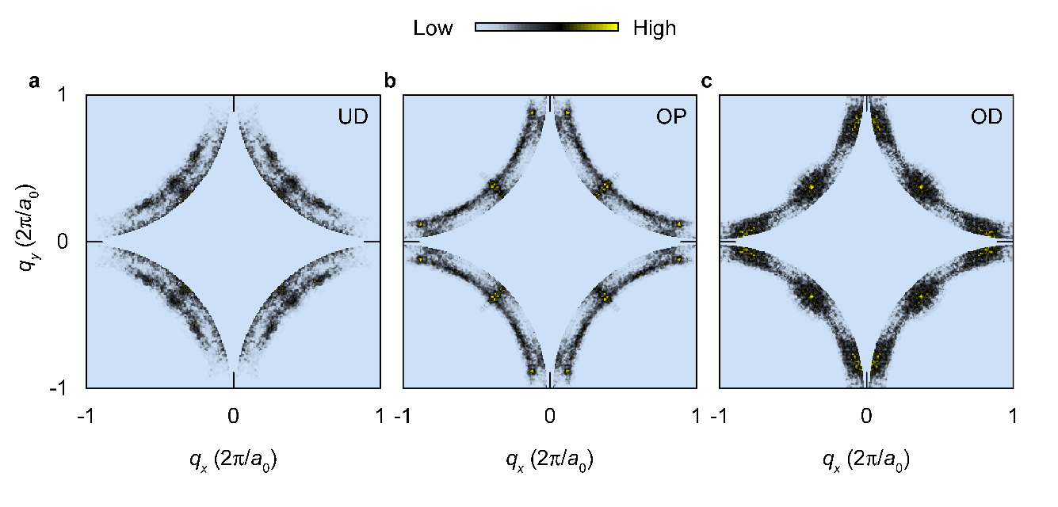
Supplementary Figure 8 | Doping dependence of filtered $Λ\left(q\right)$ map. To suppress unwanted contributions from other Bogoliubov quasiparticle scattering wavevectors and to enhance the $q_{4}$ trajectory, a radial filter as described in ref. ³ is applied to the Fourier-transform of integrated conductance ratio map, $Λ\left(q\right)$. The panels display the filtered $Λ\left(q\right)$ maps of under-doped (UD, a), optimally-doped (OP, b), and over-doped (OD, c) monolayer Bi-2201. The transition from four short Fermi arcs to a complete hole pocket is evident in the filtered $Λ\left(q\right)$ maps.

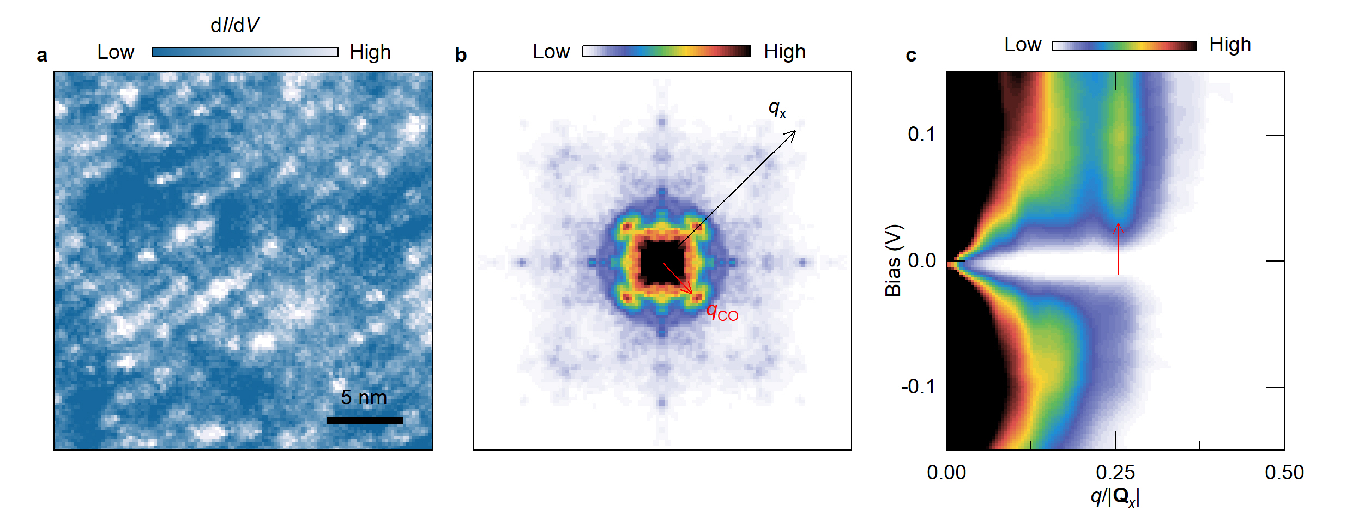
Supplementary Figure 9 | The charge ordered state in monolayer Bi-2201. a, Differential conductance map $g (r,E)$ at $E=60 meV$ showing the checkerboard pattern of the charge order. b, Fourier transform of the differential conductance map in a. The lattice Bragg wavevector and charge order wavevector are marked by black and red arrows, respectively. c, Fourier intensity plotted as a function of sample bias and wavevector along the reciprocal lattice vector $Q_{x}$ (black arrow in b). The charge order wavevector is located at $(0.26, 0)×2π/a_{0}$ along the $Q_{x}$ direction, and is static as a function of energy (red arrow).

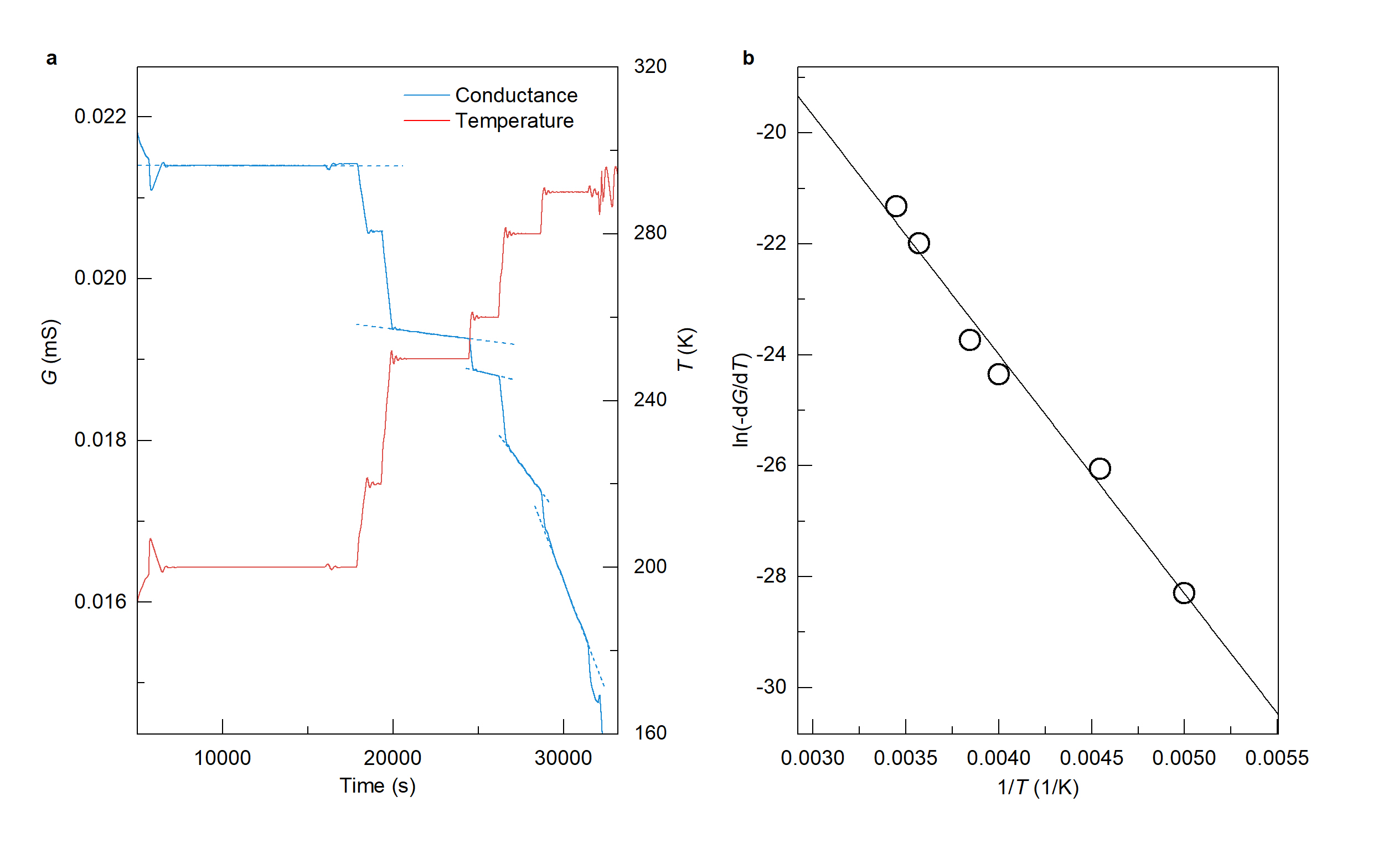
Supplementary Figure 10 | Measuring the diffusion barrier of the interstitial oxygen in monolayer Bi-2201. a, Sample conductance G (blue) and annealing temperature (red) during the vacuum annealing process plotted as a function of time. As the annealing temperature increases, the rate of conductance drop also increases. The dashed lines are line fits to conductance drop at fixed temperatures. b, Logarithm of the conductance plotted against inverse temperature. According to Fick's law of atomic diffusion, we have $\ln\left(-\frac{dG}{dt}\right)=-\frac{ΔE}{k}\frac{1}{T}+ln{D_{0}∆n}$, where $ΔE$ is the diffusion barrier, $D_{0}$ is diffusion coefficient, and $∆n$ is the difference of oxygen concentration between sample and environment. A diffusion barrier of $ΔE=0.37 eV$ is obtained from the line fit of the data points.

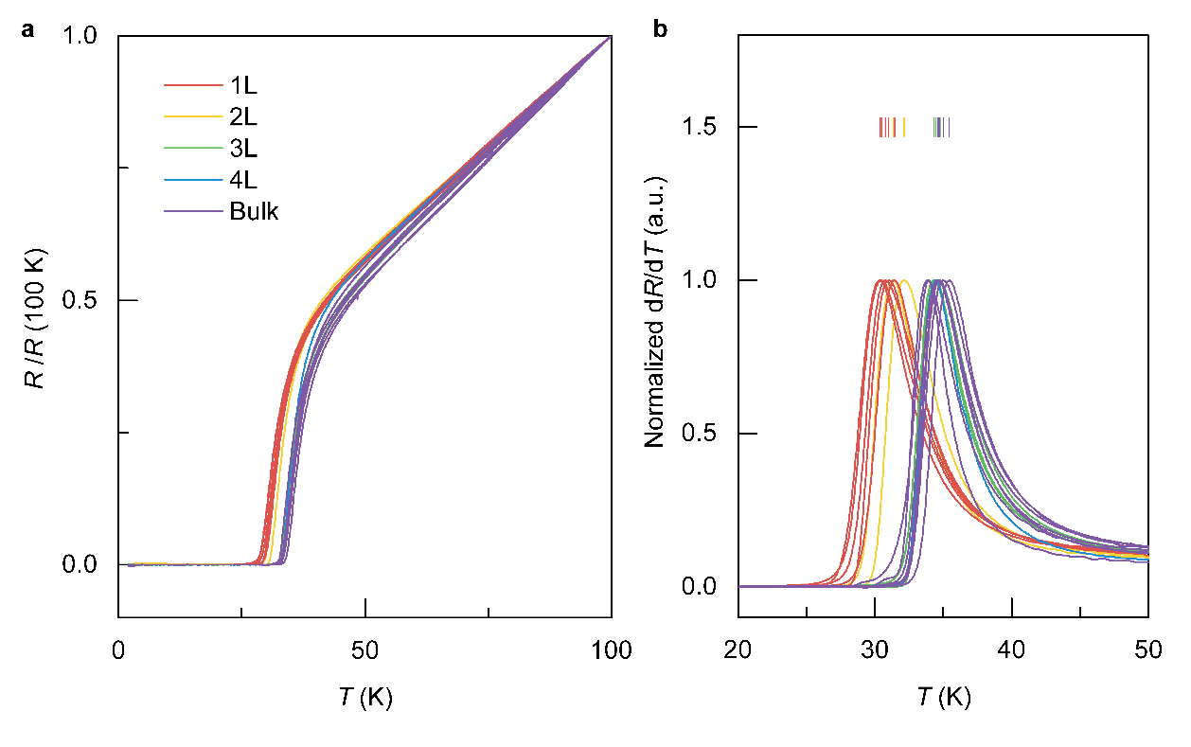
Supplementary Figure 11 | Thickness-dependent $T_{c}$ of optimally-doped Bi-2201. a, Temperature-dependent sample resistance $R\left(T\right)$, normalized to its value at $100 K$, for optimally-doped Bi-2201 with varying thicknesses. b, First-order derivative of the $R\left(T\right)$ curves in a. The superconducting transition temperature is determined from the peaks in $dR(T)/dT$. The vertical bars denote the peak positions of the curves, which we assigned as $T_{c}$.

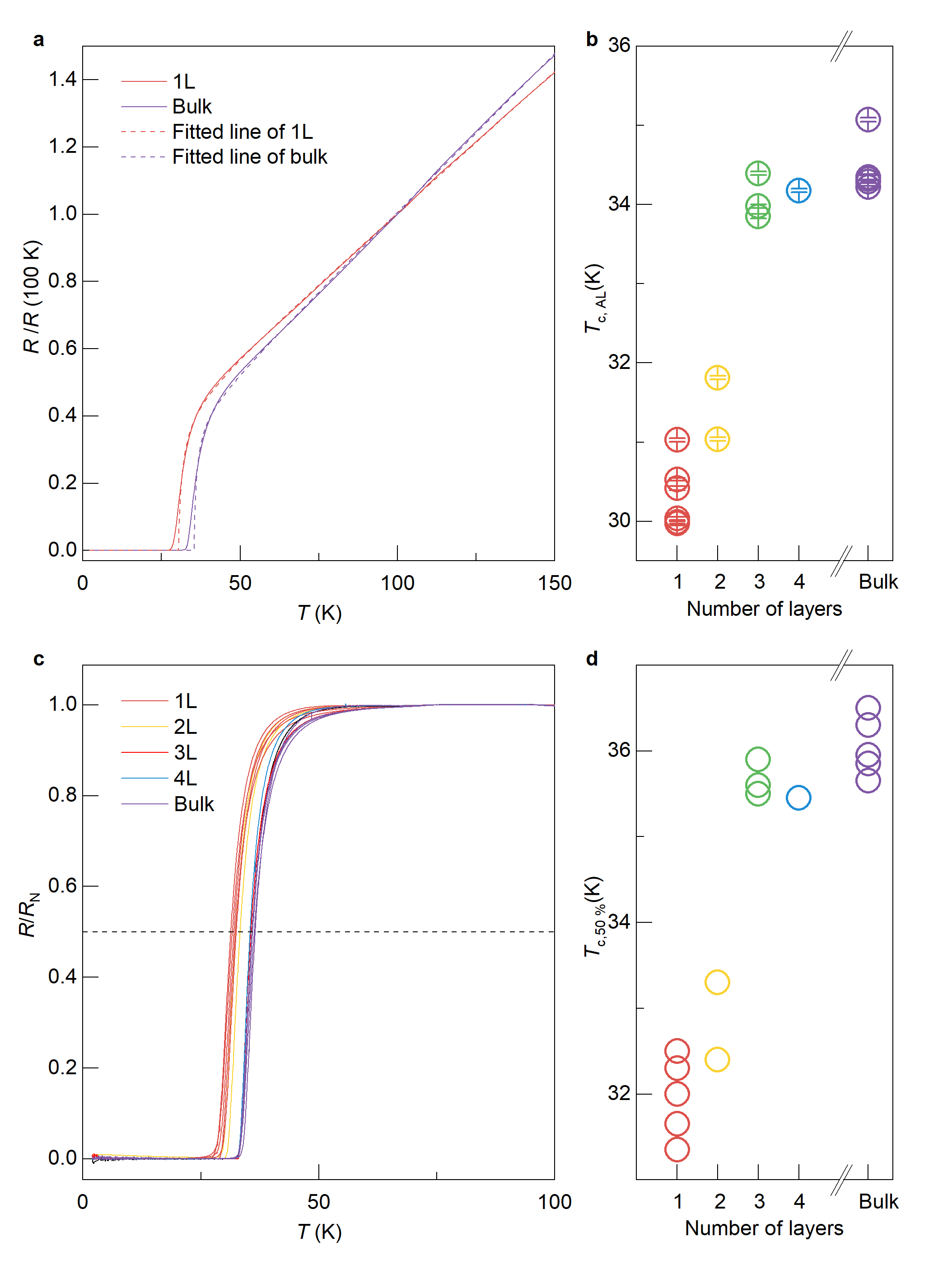
Supplementary Figure 12 | Thickness-dependent $T_{c}$ of optimally-doped Bi-2201 determined by various methods. a, Temperature-dependent sample resistance $R\left(T\right)$ fitted by the Aslamasov-Larkin paraconductivity model, $R\left(T\right)={\left(bT+c\right)\left(T-T_{c,AL}\right)}/{\left(T-T_{c,AL}+a\right)}$^{4,5}. The superconducting transition temperature $T_{c,AL}$ is extracted from the fits. Monolayer and bulk data are shown as examples. b, Thickness-dependent $T_{c,AL}$ of optimally-doped Bi-2201. c, Normalized $R\left(T\right)$ curves of Bi-2201 with varying thicknesses. The normalization factor $R_{N}\left(T\right)$ is the linear fit of $R\left(T\right)$ in the temperature range $70 K≤T≤100 K$. The dashed line represents $R/R_{N} =50\%$. The temperatures at which the dashed line intersect the $R(T)/R_{N}(T)$curves are defined as $T_{c,50\%}$. d, Thickness-dependent $T_{c,50\%}$of optimally-doped Bi-2201. The results in b and d, together with those in Fig. 2d, indicate that the dimensionality effect on $T_{c}$ is consistent regardless of the method used to determine $T_{c}$.

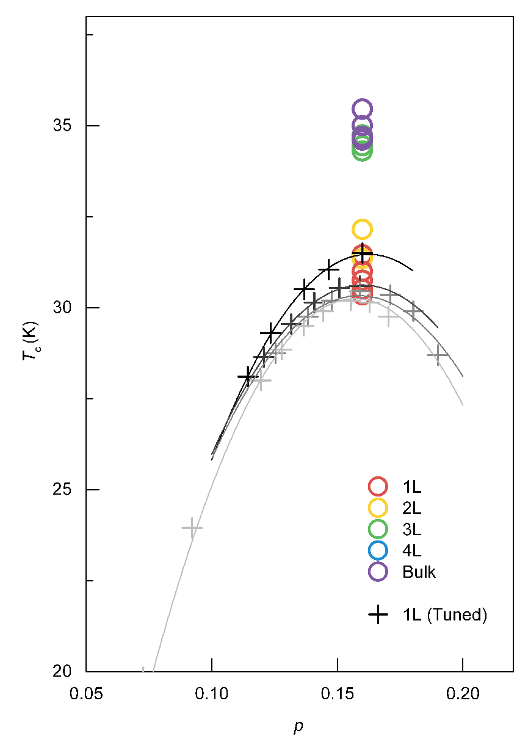
Supplementary Figure 13 | Effect of vacuum/ozone annealing on the optimal $T_{c}$. We measured the $T_{c}$ of monolayer Bi-2201 as its doping level was repeatedly tuned back and forth within a range encompassing optimal doping. The $T_{c}$ values obtained during the vacuum annealing process are indicated by “$+$” symbols. Colored circles represent the optimal $T_{c}$ of other samples with various thicknesses for comparison. Although vacuum/ozone annealing cycles reduce the optimal $T_{c}$ of the monolayer Bi-2201, the magnitude of this reduction is significantly smaller than the $T_{c}$ drop caused by dimensionality effects.

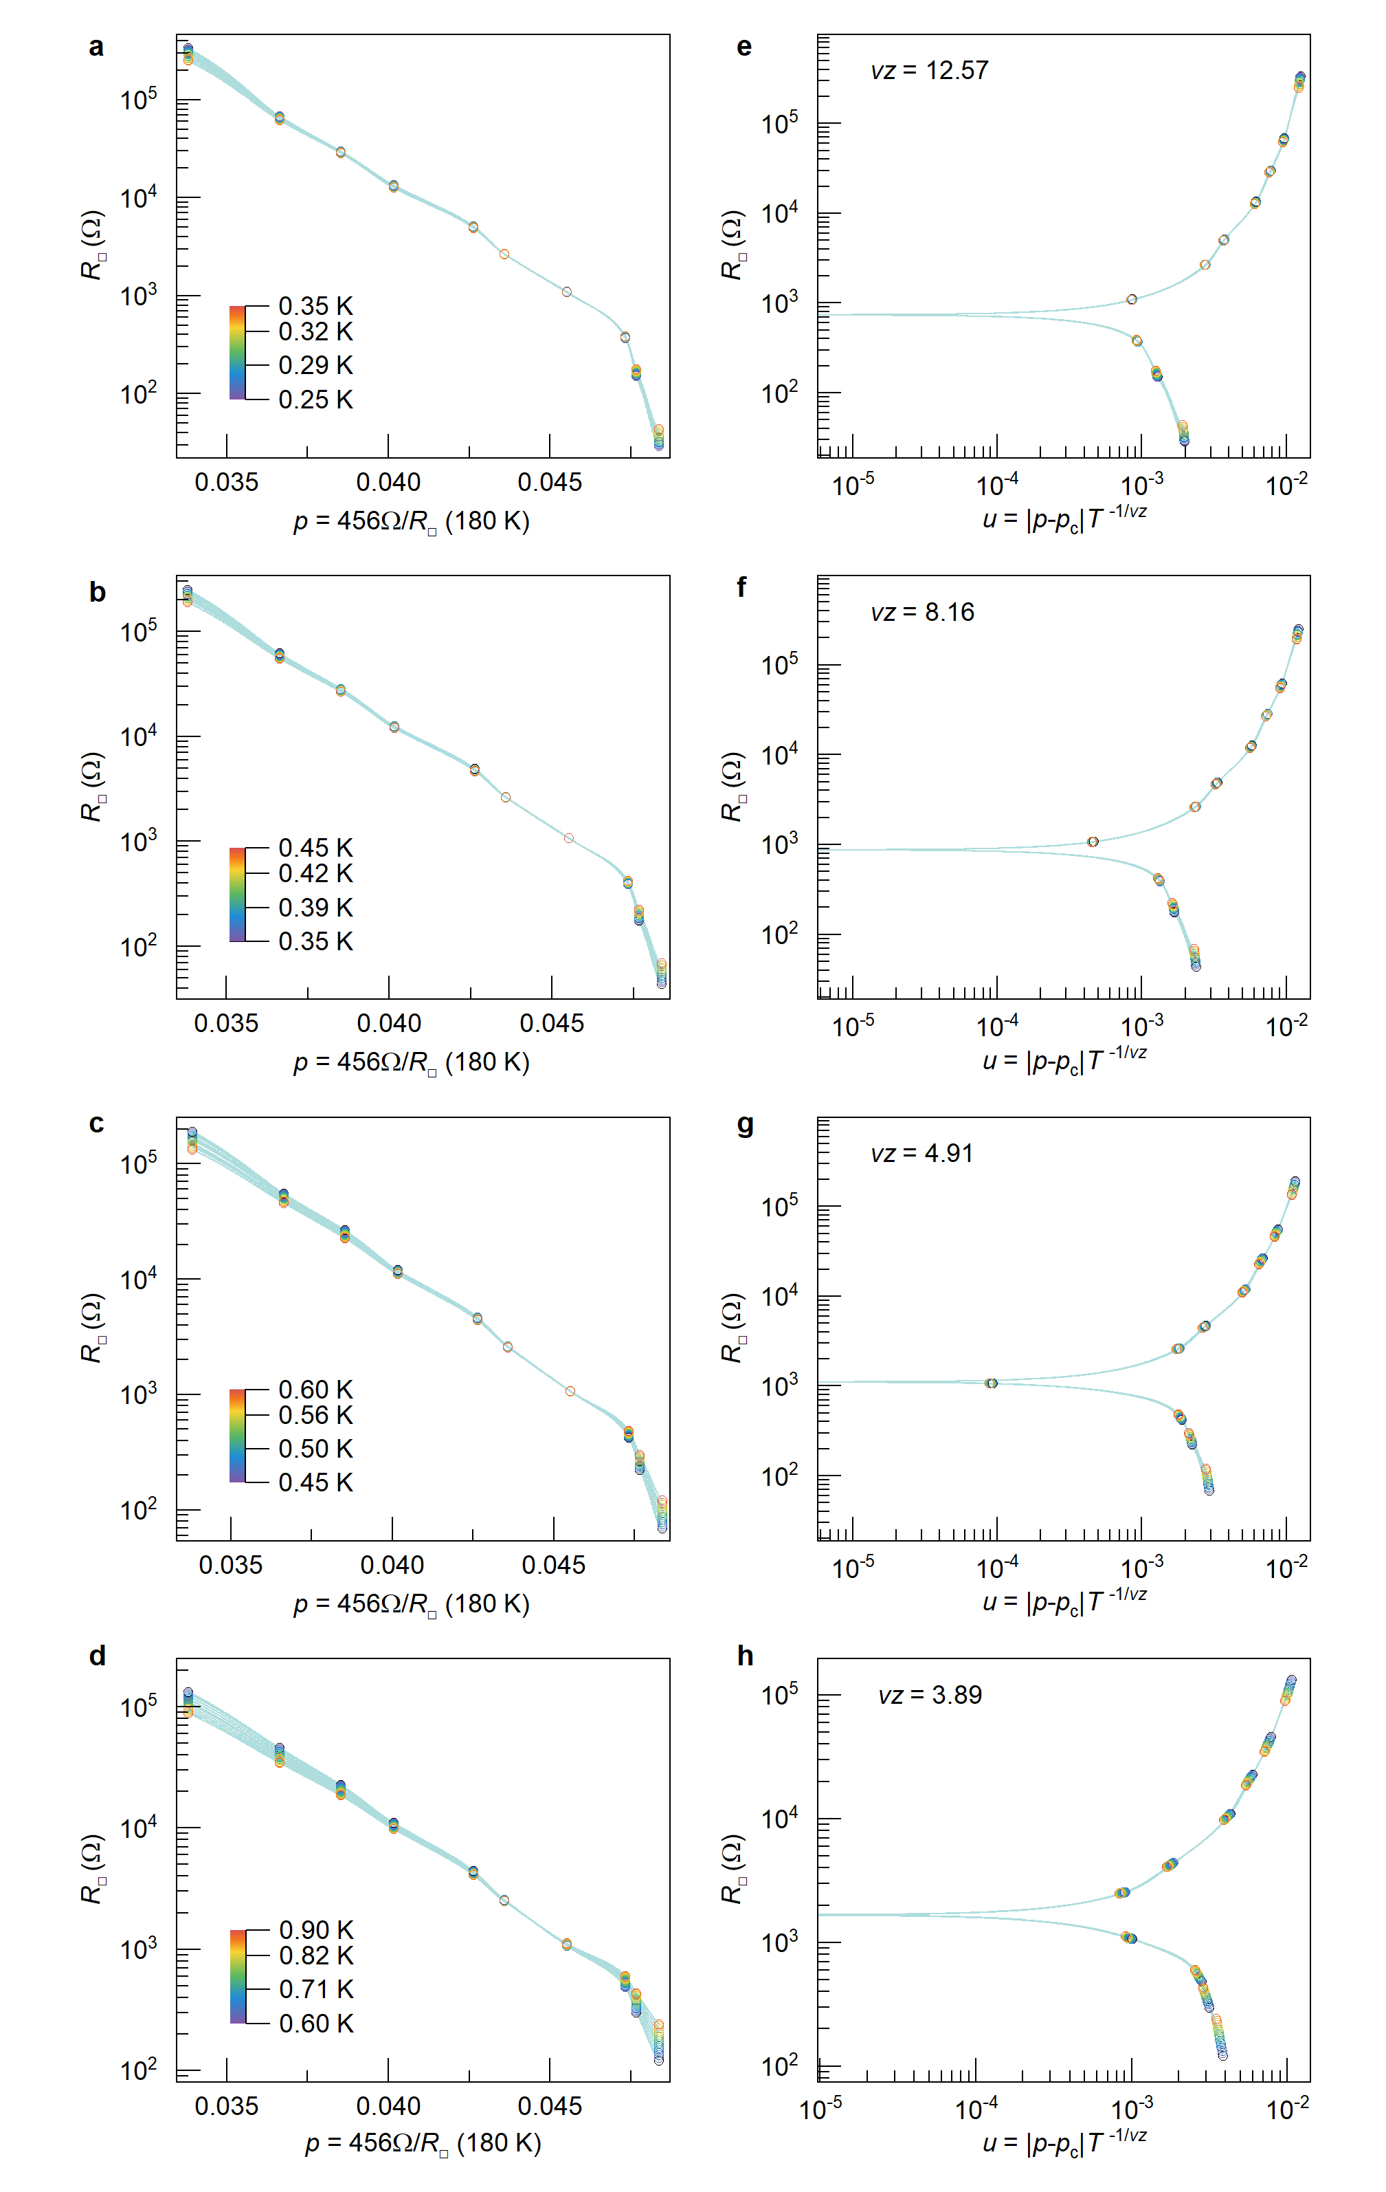
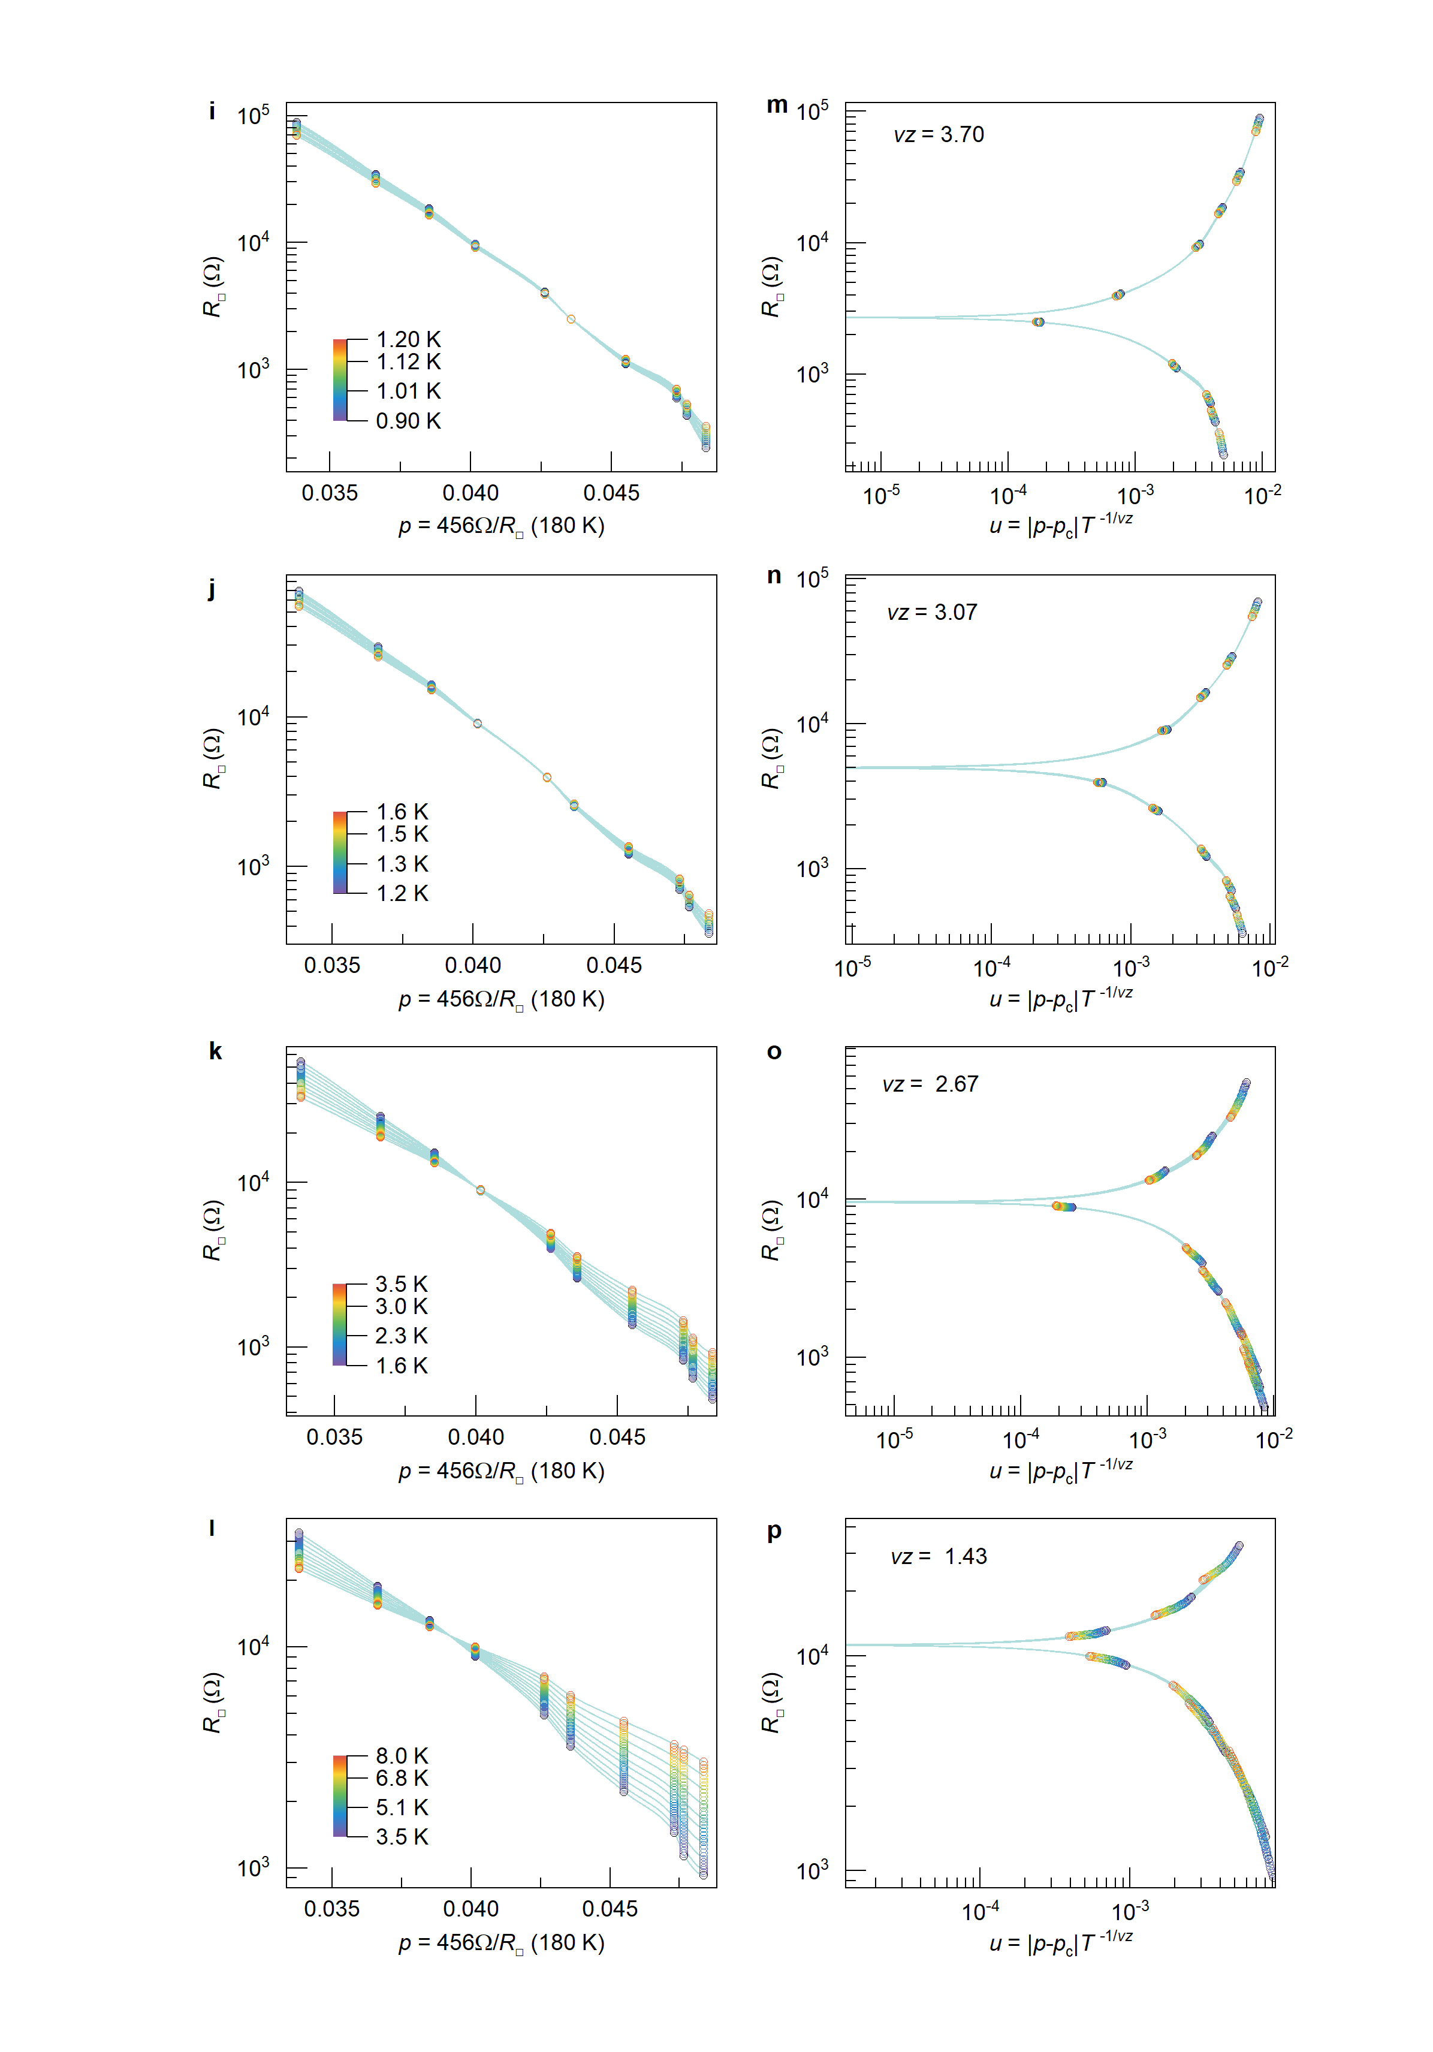
Supplementary Figure 14 | Finite-size scaling analysis of monolayer sample B across different temperature windows. a-d and i-l, Sheet resistivity isotherms as a function of doping level in the temperature windows $[0.25 K, 0.35 K]$, $[0.35 K, 0.45 K]$, $[0.45 K, 0.6 K]$, $[0.6 K, 0.9 K]$, $[0.9 K, 1.2 K]$, $[1.2 K, 1.6 K]$, $[1.6 K, 3.5 K]$, and $[3.5 K, 8 K]$. e-h and m-p, Finite-size scaling analysis of the corresponding data sets from a-d and i-l, respectively. All data sets collapse onto single curves when the sheet resistivity is plotted as a function of $u=\left|p-p_{c}\right|t\left(T\right)$, where $t\left(T\right)=T^{-1/vz}$. The critical exponent $vz$ values obtained from this scaling analysis are presented in Fig. 4b.

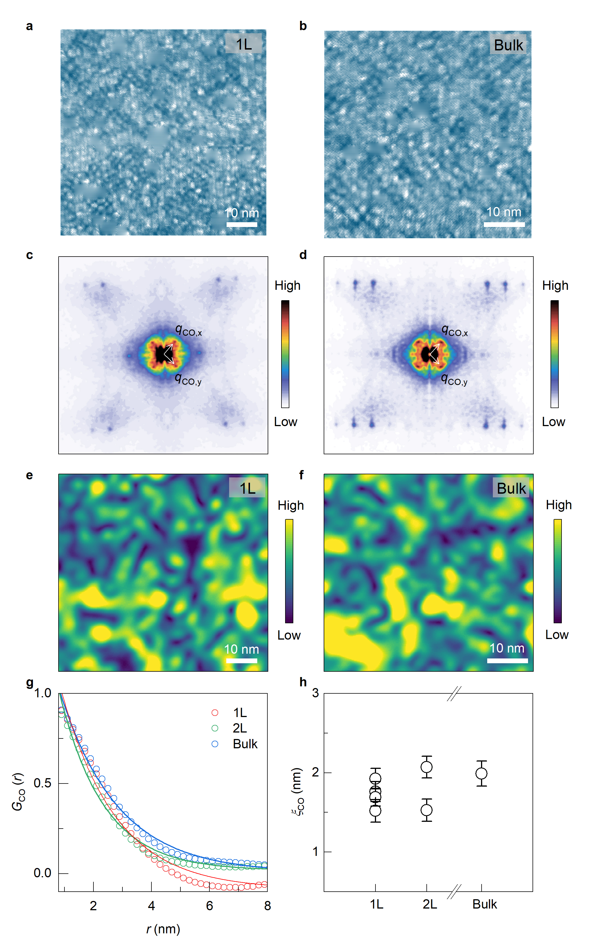
Supplementary Figure 15 | Layer dependence of CDW correlation in Bi-2201. a, b, Differential conductance maps $g(r, 10 meV)$ of monolayer and bulk Bi-2201, respectively. c, d, Fourier transforms of the differential conductance maps shown in a and b. e, f, Spatial maps of the CDW amplitude at wavevector $q_{CO}$ for optimally doped monolayer (1L; panel a) and bulk (panel b) Bi-2201. The CDW amplitude $\left|A\left(r,q=q_{CO}\right)\right|$ is extracted from the differential conductance maps $g(r, 10 meV)$ using the Fourier-filtering method described in ref. ⁶. g, Radially averaged CDW correlation function $G_{CO}\left(r\right)$ for optimal doped monolayer (1L), bilayer (2L), and bulk Bi-2201. Solid lines denote fits to an exponential decay; fitting is performed for distances larger than the Fourier filter size $L=0.7 nm$. h, CDW correlation length $ξ_{CO}$ for 1L, 2L, and bulk samples, extracted by fitting $G_{CO}\left(r\right)=G_{0}e^{-r/ξ_{CO}}$.
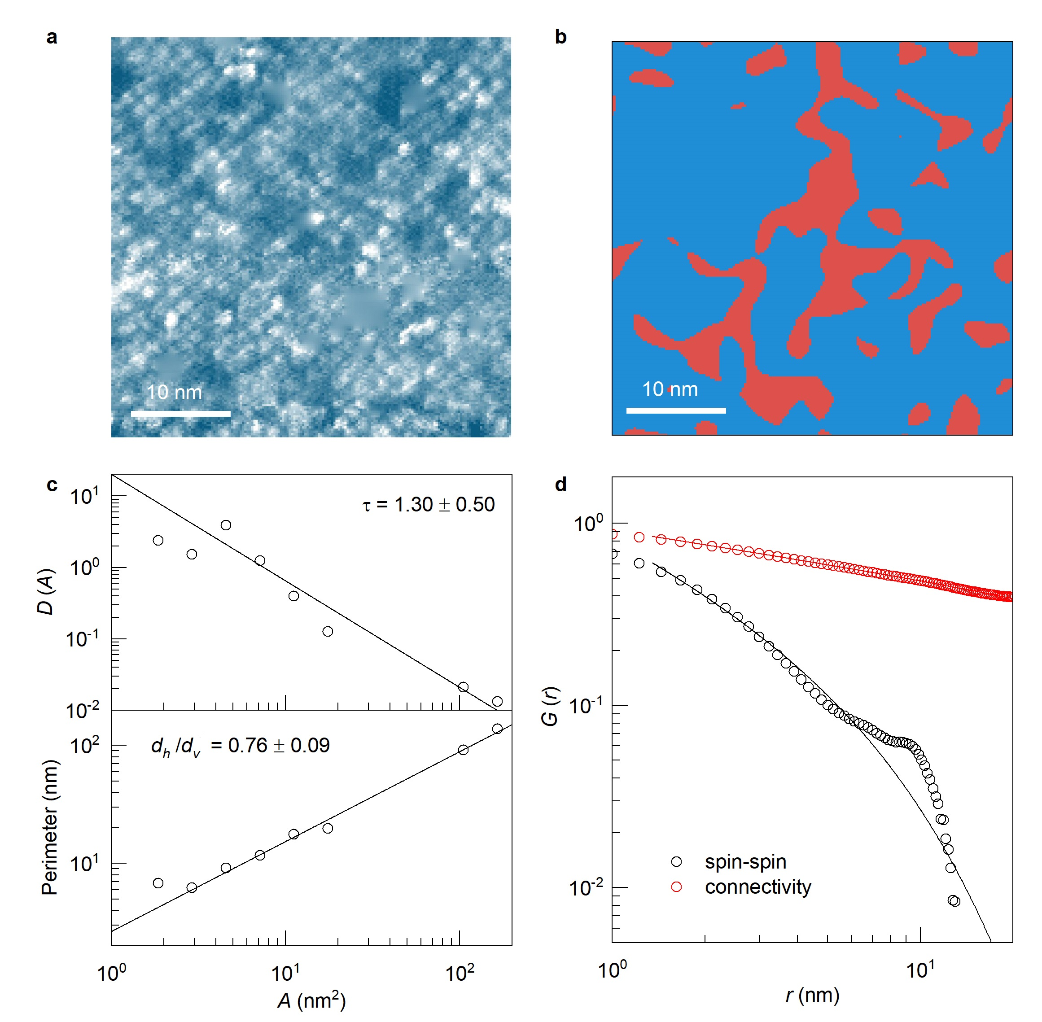
Supplementary Figure 16 | Cluster and correlation analysis of underdoped monolayer Bi-2201. a, Differential conductance map $g (r,E)$ at $E=80 meV$. b, Ising field map $S(r)$, defined as $S\left(r\right)=+1$ if the modulation amplitude at $q_{CO,x}$ exceeds that at $q_{CO,y}$ (i.e. $\left|A_{x}\right|>\left|A_{y}\right|$), and $S\left(r\right)=-1$ otherwise. The modulation amplitude maps $A_{x}$ and $A_{y}$ are extracted using the Fourier-filtering method described in ref. ⁶. c, Log-log plots of the cluster-size distribution and cluster perimeter versus cluster area after logarithm binning. Linear fits yield a cluster size exponent $τ=1.30±0.50$ and fractal dimension ratio $d_{h}/d_{v}=0.76±0.09$, consistent with values reported for bulk samples. d, Spin-spin correlation function $G_{spin}\left(r\right)$ and pair-connectivity correlation function $G_{conn}\left(r\right)$. Solid lines represent fits to a power law with an exponential cut-off, $G\left(r\right)=G_{0}r^{-α}e^{-r/ξ}$, following the procedure described in ref. ⁷. While $G_{spin}\left(r\right)$ does not exhibit power-law behaviour, $G_{conn}\left(r\right)$ is well described by a power law, yielding $d-2+η_{conn}=0.26±0.02$, consistent with bulk Bi-2201 results⁸. Fits are performed for distances larger than the Fourier filter size $L=0.7nm$.

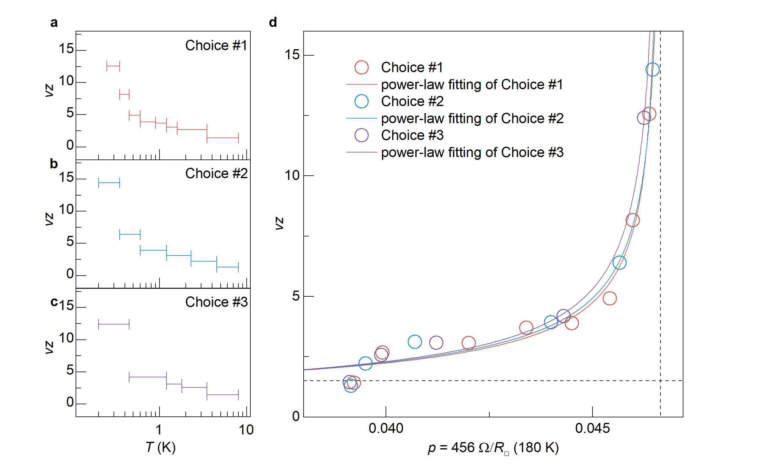
Supplementary Figure 17 | Power-law divergence of the critical exponent $νz$ under different choices of temperature windows. a-c, Three representative choices of temperature windows used in the scaling analysis, along with the corresponding $νz$ values obtained for each window. d, Doping dependence of the critical exponent $νz$ extracted from the three window choices shown in a–c. All data sets follow the activated scaling relation $νz \sim {\left|p-p_{c}^{*}\right|}^{-νψ}$. The fitted $νψ$ values are 0.54, 0.57, and 0.60, and the corresponding $p_{c}^{*}$ values are 0.4665, 0.4672, and 0.4665, respectively. The horizontal dashed line at $νz=1.5$ marks the value associated with the superconductor–insulator transition (SIT) obtained in the same device at higher temperatures.

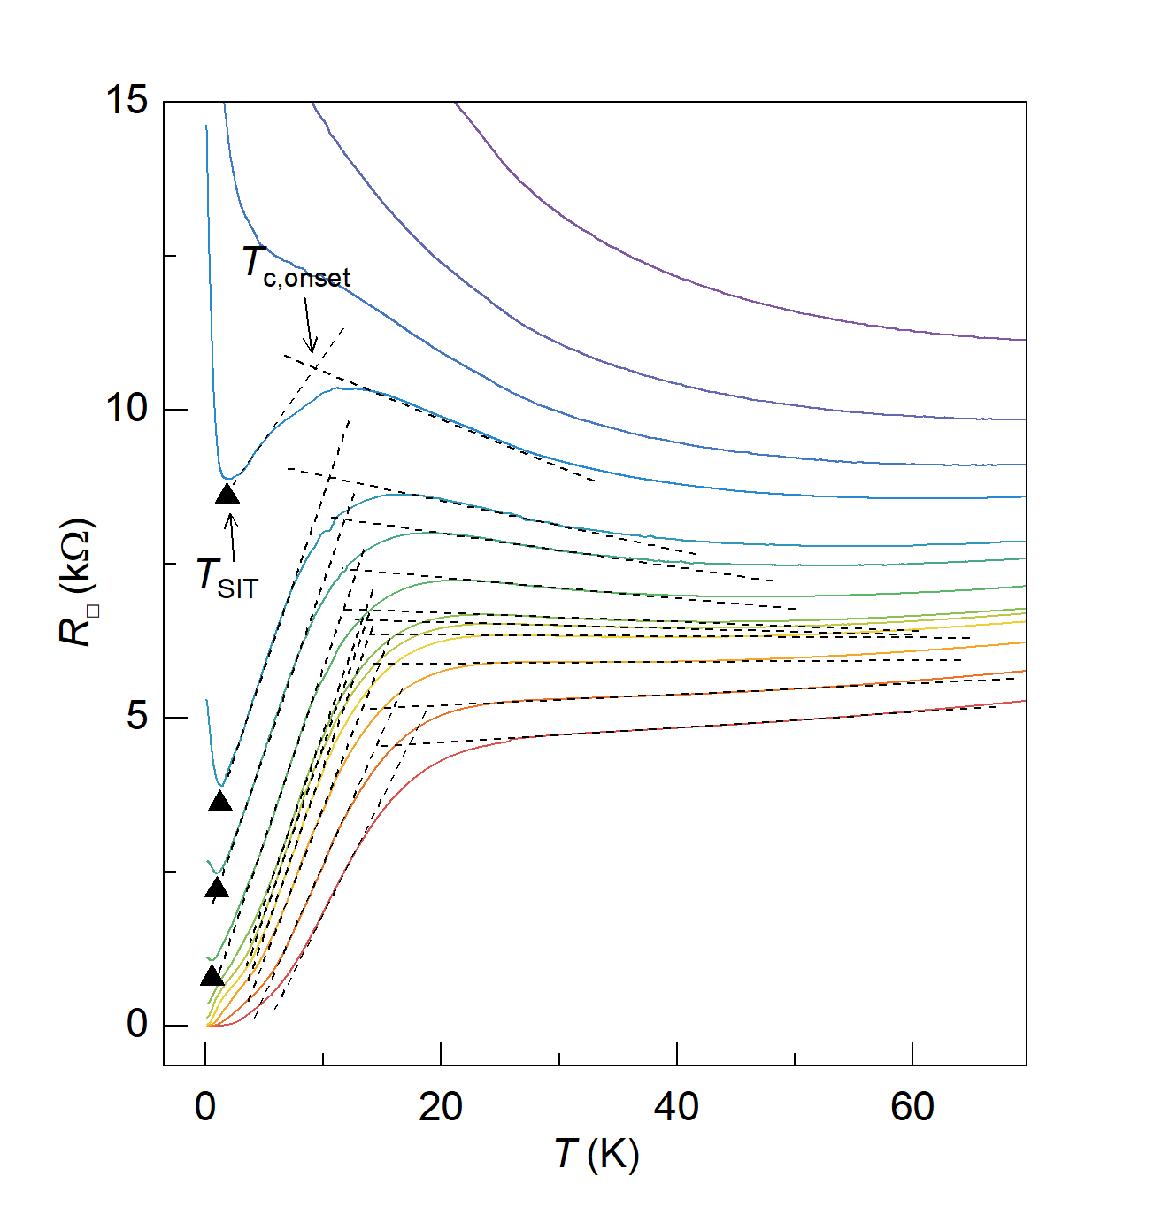
Supplementary Figure 18 | Determination of $T_{c,onset}$ and $T_{SIT}$. Temperature-dependent sheet resistivity measured at various doping levels for Sample B. $T_{c,onset}$ is defined as the temperature at which the linear extrapolations of the sheet resistivity above and below the onset of superconductivity intersect. The linear extrapolations are shown as dashed lines. $T_{SIT}$, indicated by solid triangles, is defined as the turning points at low temperatures that separate regions where $dR_{□}/dT<0$ and $dR_{□}/dT>0$.

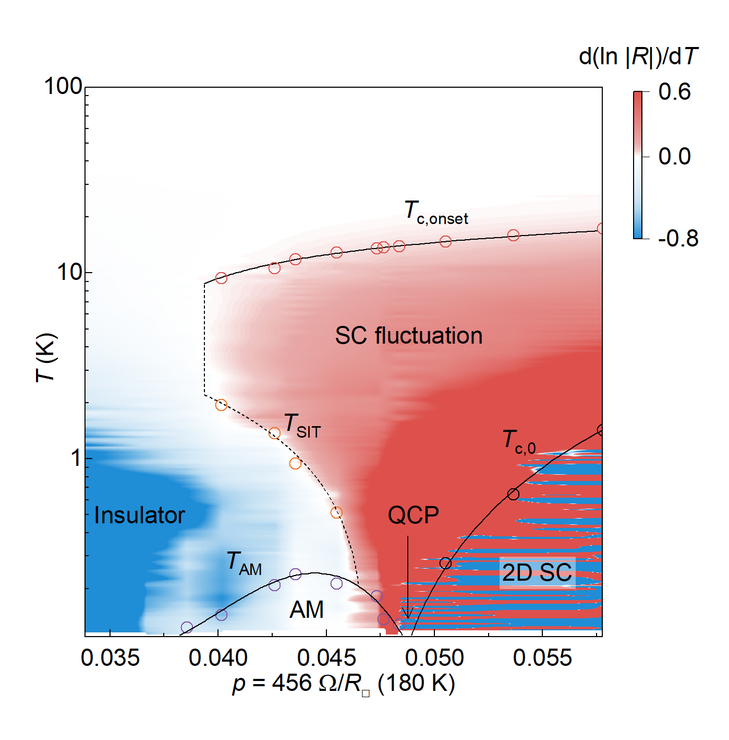
Supplementary Figure 19 | Phase diagram of monolayer Bi-2201 based on $d(ln⁡|R| )/dT$ as a function of temperature and doping level. The superconducting and insulating phases are separated by the separatrix $T_{SIT}(p)$. The superconductivity onset $T_{c,onset}(p)$, the zero-resistance superconducting transition $T_{c,0}(p)$, and the onset of the anomalous metal phase $T_{AM}(p)$ are also displayed. These curves align closely with the corresponding features in the plot.

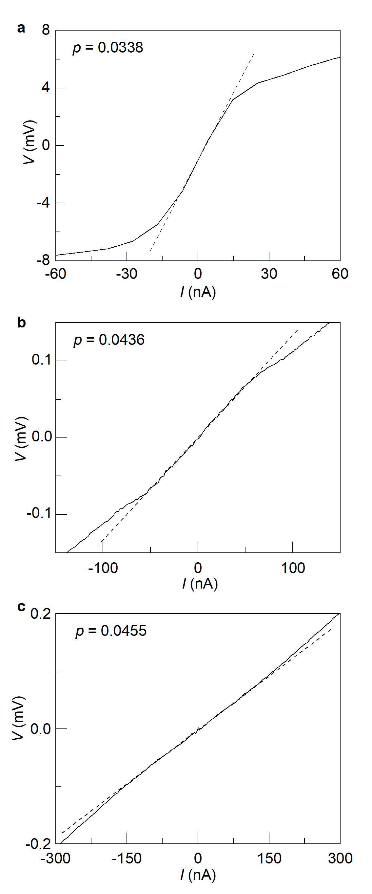
Supplementary Figure 20 | Representative $I-V$ characteristics of monolayer Bi-2201 and threshold currents at base temperature. a, $I-V$ characteristics at a doping level of $p=0.0338$. Deviations from linearity appears at a threshold current of $\sim 15 nA$, above which current-induced heating becomes significant. Subsequent temperature-dependent resistance measurements at this doping level were performed using an excitation current of $2 nA$, well below the heating threshold. b, $I-V$ characteristics at $p=0.0436$. The onset of heating effect occurs at a threshold current of $\sim 50 nA$. Subsequent temperature-dependent resistance measurements at this doping level were performed using an excitation current of $10 nA$. c, $I-V$ characteristics at $p=0.0455$. The threshold current is $\sim 150 nA$, and an excitation current of $50 nA$ was used for subsequent temperature-dependent resistance measurements. All measurements shown in Fig. 5a and 5b were performed using sufficiently low excitation currents to ensure that the resistance remained within the linear regime of the $I-V$ characteristics.

Supplementary Figure 21 | RF noise filtering in the sub-Kelvin transport measurement setup. a, Schematic diagram of the filtering implementation in the measurement setup. Silver-epoxy filters (SEF) are mounted on the mixing chamber plate of the dilution refrigerator, while the in-line RC filters are used at room temperature. b and c, Photos of the silver-epoxy filter and RC filter, respectively. d, Circuit diagram of the RC filter. e, The attenuation characteristics of the silver-epoxy filter and the RC filter. f, Arrhenius plot of the temperature-dependent sample resistance for a superconducting InO_{x} thin film, with the magnetic field varied from $3 T$ to $10.6 T$ to suppress superconductivity. The thermally-activated behavior of the resistance indicates that RF heating in the system is sufficiently reduced, ensuring accurate electron temperatures down to $100 mK$ (ref. ⁹).

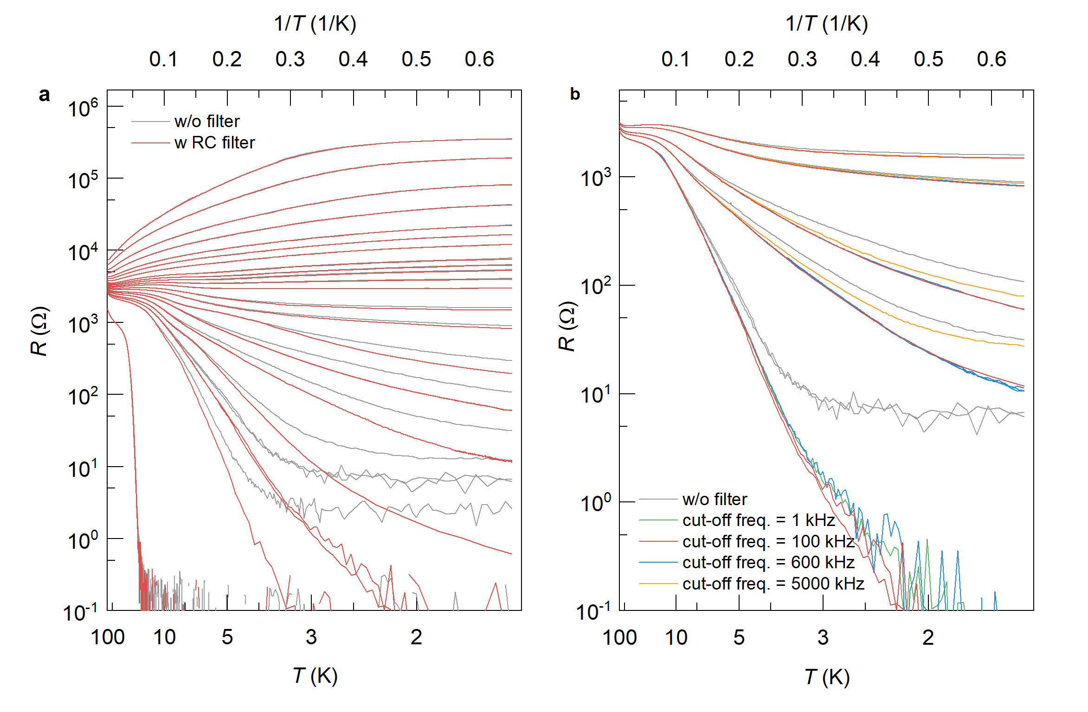
Supplementary Figure 22 | Comparison of low-temperature electronic transport in monolayer Bi-2201 with and without RC filters. a, Arrhenius plot of the sample resistance for monolayer Bi-2201. The red (gray) curves represent data sets acquired with (without) RC filter in the measurement circuit. The filter used is a fifth-order RC filter with a cutoff frequency of $100 KHz$. b, Arrhenius plot of the sample resistance measured with RC filters of various cut-off frequencies, compared with data taken without filters. The cut-off frequencies of the filters are indicated in the figure.

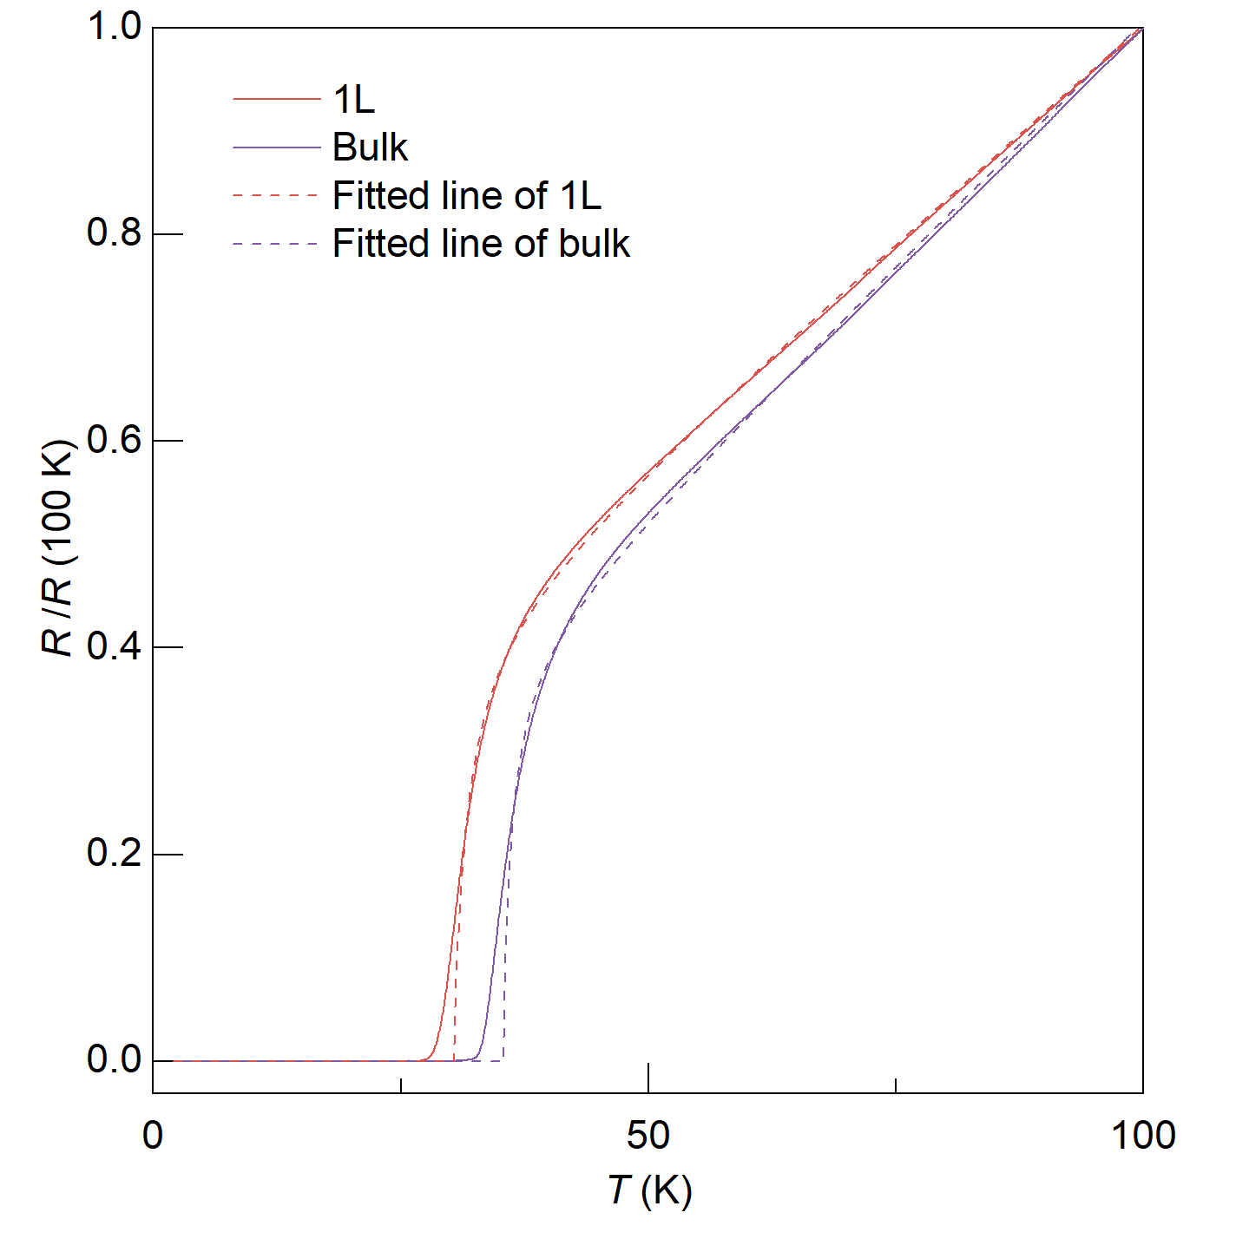
Supplementary Figure 23 | Superconducting transitions of monolayer and bulk Bi-2201 near optimal doping. Temperature-dependent sample resistance $R\left(T\right)$, normalized by its value at $T=100 K$, is fitted with the Aslamasov-Larkin paraconductivity model, $R\left(T\right)=\frac{\left(bT+c\right)\left(T-T_{c,AL}\right)}{\left(T-T_{c,AL}+a\right)}$, where $a$, $b$, and the superconducting transition temperature $T_{c,AL}$ are fitting parameters. Both monolayer and bulk Bi-2201 show a pronounced tail deviating from the AL model, indicative of strong superconducting fluctuations near the transition.

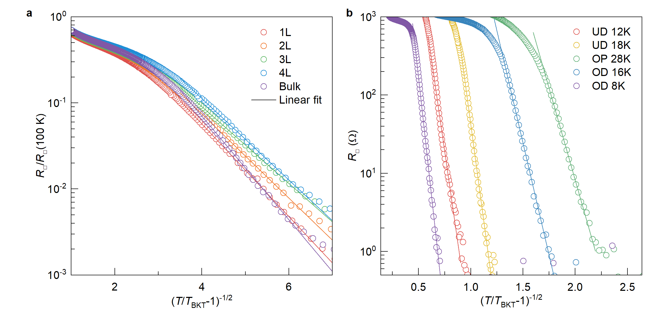
Supplementary Figure 24 | Superconducting transitions of Bi-2201 fitted with the Halperin−Nelson (HN) formula. a, Temperature-dependent resistivity $R_{□}\left(T\right)$, normalized to its value at $T=100 K$, for Bi-2201 samples of different thicknesses, plotted as a function of reduced temperature on a on logarithmic scale. Solid lines are fits to the HN formula, $R=R_{0}\exp\left[-\frac{b}{{\left(T-T_{BKT}\right)}^{1/2}}\right]$. b, HN fits to the superconducting transitions of a monolayer Bi-2201 sample at various doping levels. The excellent agreement demonstrates that phase fluctuations dominate across all thicknesses and persists over a wide doping range.

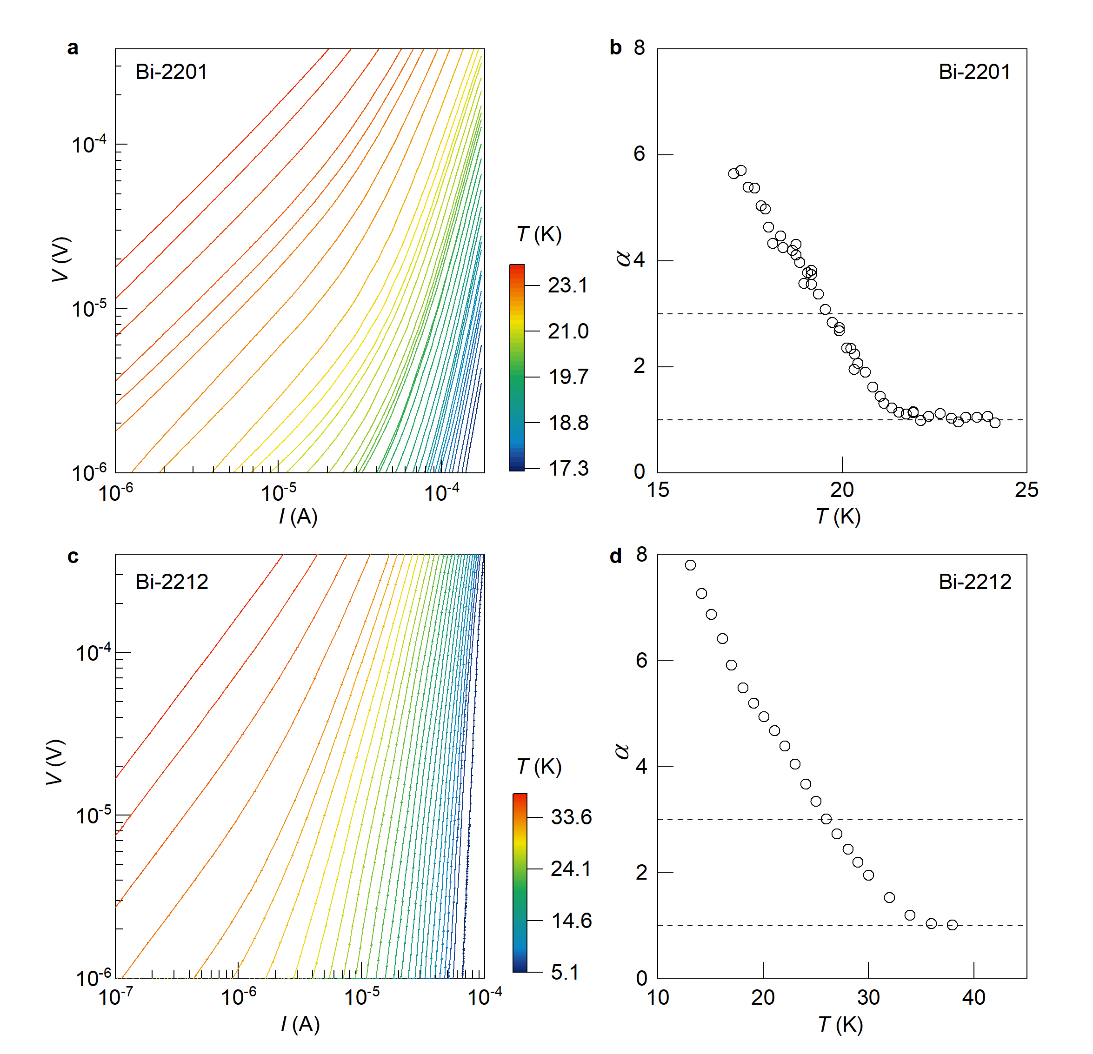
Supplementary Figure 25 | Superconducting transition in a monolayer Bi-2201 and Bi-2212 sample probed by $I-V$ measurements. a, c, $I-V$ characteristics of underdoped monolayer Bi-2201 (a) and Bi-2212 (c) measured at various temperatures spanning the superconducting transition, plotted on a logarithmic scale. b, d, Temperature dependence of the exponent $α$, extracted by fitting the linear region of the $I-V$ curves in a and c to the relation $V\sim I^{α}$. The BKT temperature of monolayer Bi-2201 and Bi-2212 is determined to be $19.8 K$ and $25.9 K$, where $α$ crosses 3.

References
1. Webb, T. A. et al. Density wave probes cuprate quantum phase transition. Phys. Rev. X 9, 21021 (2019).
2. He, Y. et al. Fermi surface and pseudogap evolution in a cuprate superconductor. Science 344, 608-611 (2014).
3. Fujita, K. et al. Simultaneous transitions in cuprate momentum-space topology and electronic symmetry breaking. Science 344, 612-616 (2014).
4. Aslamasov, L. G. & Larkin, A. I. The influence of fluctuation pairing of electrons on the conductivity of normal metal. Phys. Lett. A 26, 238-239 (1968).
5. Yu, Y. et al. High-temperature superconductivity in monolayer Bi₂Sr₂CaCu₂O_{8+δ}. Nature 575, 156-163 (2019).
6. Hamidian, M. H. et al. Atomic-scale electronic structure of the cuprate d-symmetry form factor density wave state. Nat. Phys. 12, 150-156 (2016).
7. Fratini, M. et al. Scale-free structural organization of oxygen interstitials in La₂CuO_{4+y}. Nature 466, 841-844 (2010).
8. Song, C. et al. Critical nematic correlations throughout the superconducting doping range in Bi_{2-z}Pb_{z}Sr_{2-y}La_{y}CuO_{6+x}. Nat. Commun. 14, 2622 (2023).
9. Tamir, I. et al. Sensitivity of the superconducting state in thin films. Sci. Adv. 5, eaau3826 (2019).

