Supplementary Information corresponding to “Learning millisecond protein dynamics from what is missing in NMR spectra”
Hannah K. Wayment-Steele, Gina El Nesr, Ramith Hettiarachchi, Adedolapo M. Ojoawo, Hasindu Kariyawasam, Sergey Ovchinnikov, Dorothee Kern

- Supplementary Fig. 1: Data corresponding to RelaxDB dataset
- Supplementary Fig. 2: Adjusting logits for class imbalance
- Thorough evaluation of reported NMR relaxation data and corresponding publications increases Dyna-1 performance

- Data corresponding to RelaxDB dataset
Below we depict ¹⁵N R₂/R₁ data and labels for all 133 proteins in RelaxDB and the 30 which were initially curated but excluded from final evaluation set for various reasons (see Methods). Calculated R₂/ R₁ from HYDRONMR^{51,52} for rigid tumbling is depicted by grey line. Colors used are the same as in Fig. 1. Title for each is RelaxDB entry ID followed by normalized RMSD.
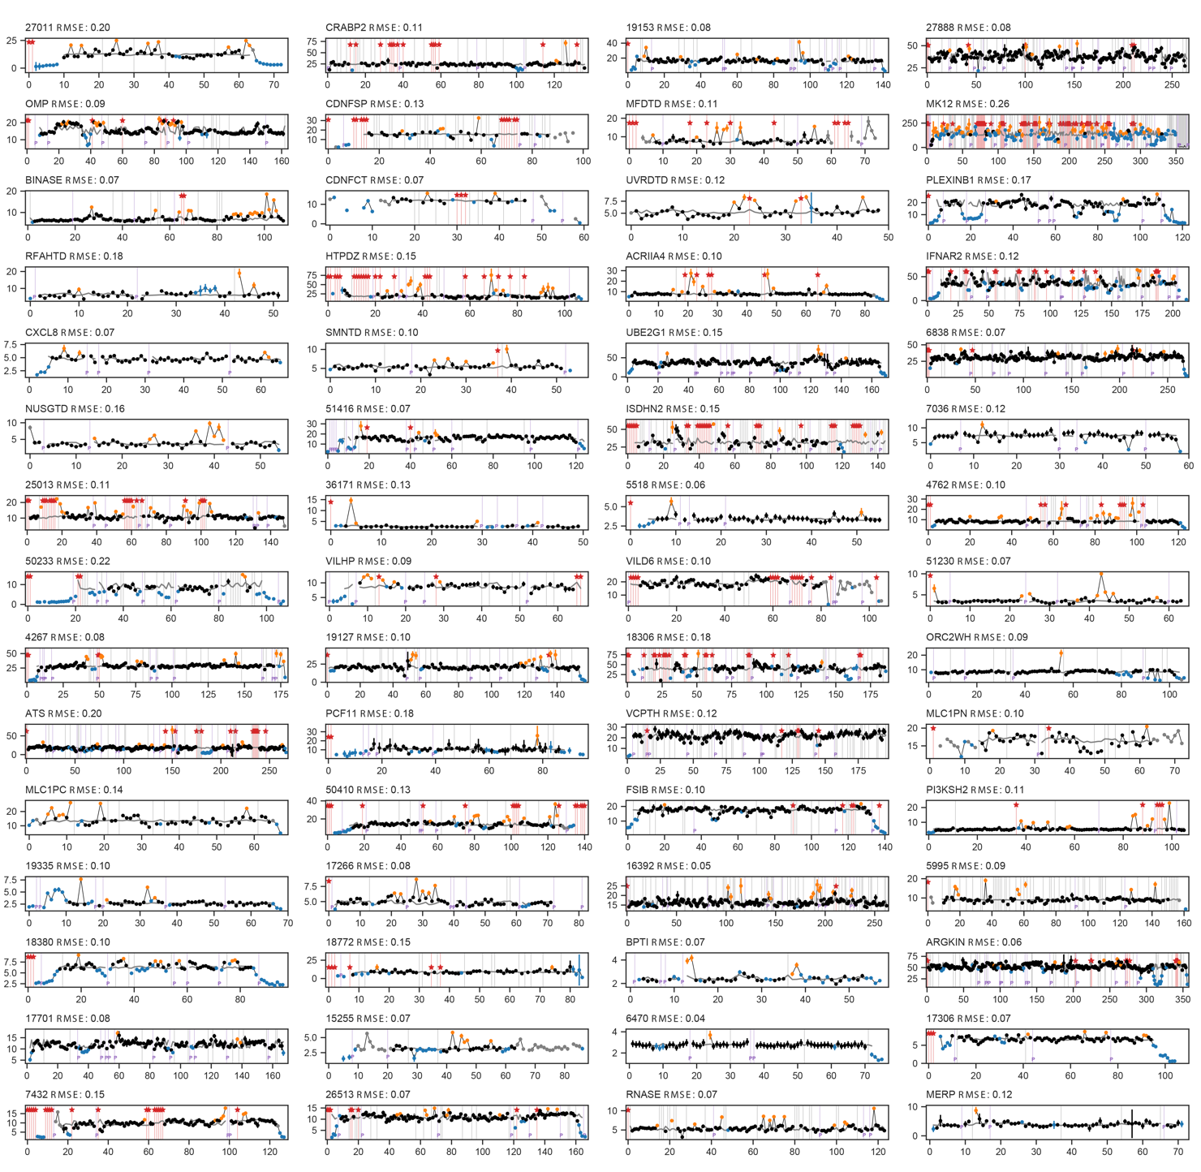

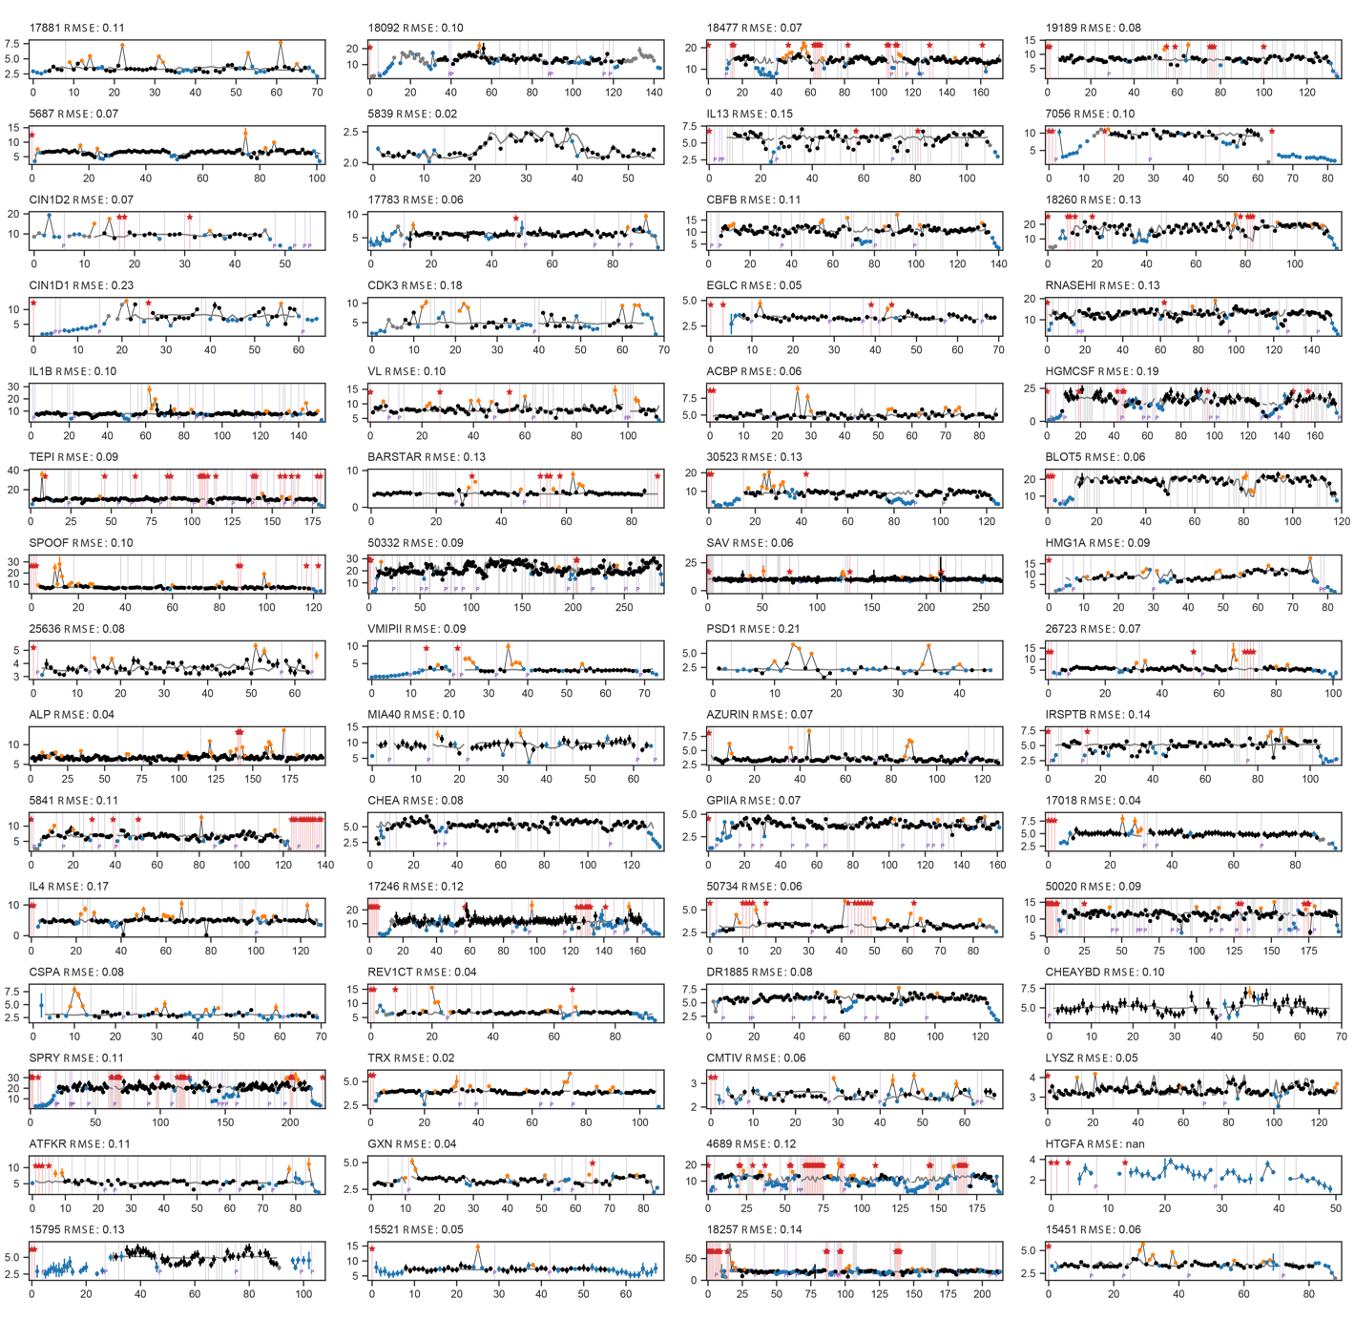

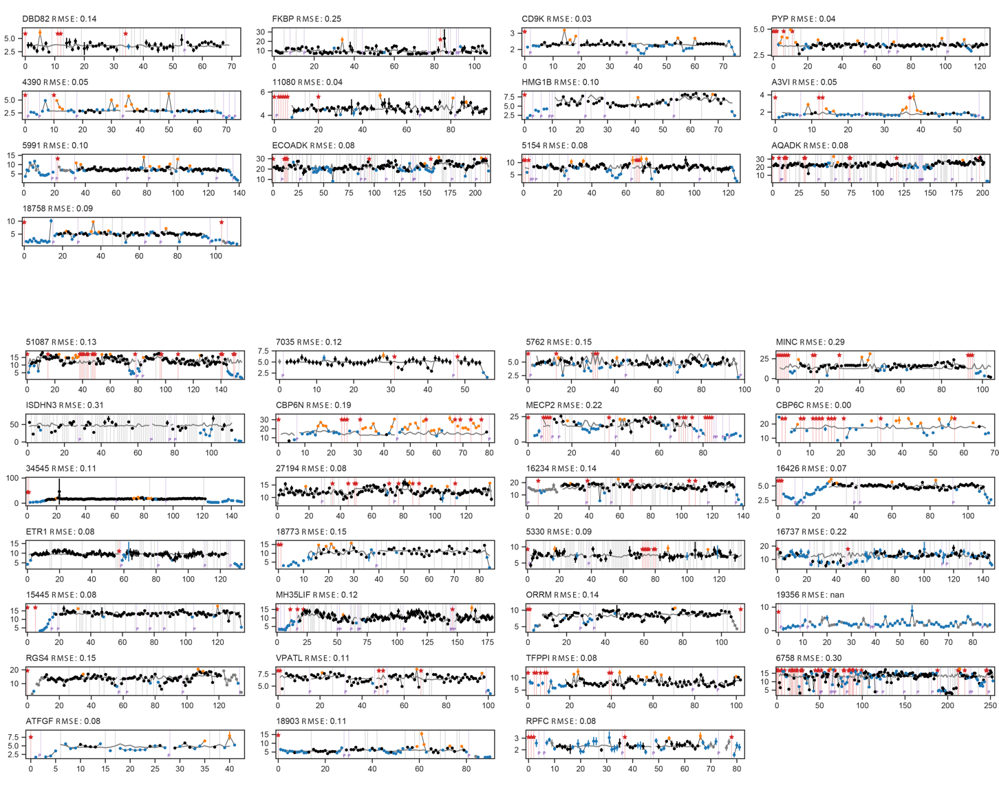
Initially curated, but excluded
Supplementary Fig. 1. Calculated R₂/ R₁ from HYDRONMR^{51,52} for rigid tumbling is depicted by grey line. Colors used are the same as in Fig. 1. Title for each is RelaxDB entry ID followed by normalized RMSD.

- Adjusting logits to account for class imbalance.
When converting from logits to probabilities, we adjusted the raw logit outputs predicted by the model to account for the significant class imbalance in the problem following the practice in ref. ⁸¹ (cf. Supplementary Fig. 2). This practice seeks probabilities that minimizes the “balanced error”, the prediction error averaged over all classes. In brief, for data x labelled with classes y, the native posterior probability P(y | x) is proportional to the prior probability of class y, $π\left(y\right)$:
$P\left(y | x\right)∝π\left(y\right)P(x|y)$.

In seeking to minimize the balanced error, the balanced class-probability function instead implicitly becomes
$P^{bal}\left(y | x\right)∝P(x|y)$,
where L is the number of classes (L=2 in our binary classification context).

Menon et al. describe how $P^{bal}\left(y | x\right)$ is a Bayes-optimal scorer for minimizing the balanced error. For a Bayes-optimal scorer, the accuracy of any given class is not proportional to its degree of representation in the training data, which is desirable in our context.

Consider our model to be a scoring function $\hat{s}$, with learned class probabilities $\hat{P}\left(y | x\right)∝e^{\hat{s}(x)}$. Via the definition of $P^{bal}$, we can approximate the Bayes-optimal scorer using our given scorer by using an adjusted scorer $s'$:
$$P^{bal}\left(y | x\right)≈e^{s^{'}\left(x\right)}=\frac{\hat{P}\left(y | x\right)}{π\left(y\right)}=\frac{e^{\hat{s}\left(x\right)}}{π\left(y\right)}.$$

Accordingly, the adjusted logits may be written as $s^{'}\left(x\right)=s^{'}\left(x\right)-\log{π(y)}$.

In the context of our binary classification problem, let $π^{m}$ be the fraction missing in the training data set and let l(x) be the raw logit output given input x. Dyna-1 is structured to just predict one logit, the logit of the “missing” class, hence the logit predicted for the “not missing” class is always zero. We calculate our probability P(missing) as

$P\left(missing|x\right)= \frac{p(missing|x)}{p(present|x)+p(missing|x)}=\frac{e^{l\left(x\right)-\log{π^{m}}}}{{e^{-\log{(1-π^{m})}}+e}^{l\left(x\right)-\log{π^{m}}}}=\frac{e^{l(x)}}{\frac{π^{m}}{1-π^{m}}+e^{l(x)}}$.
This can be rewritten in terms of the sigmoid function $σ\left(x\right)={\left(1+e^{-x}\right)}^{-1}$, which is typically used to convert logits to probabilities:
$P\left(missing | x\right)=σ(x-\log{\frac{π_{m}}{1-π_{m}})}$.
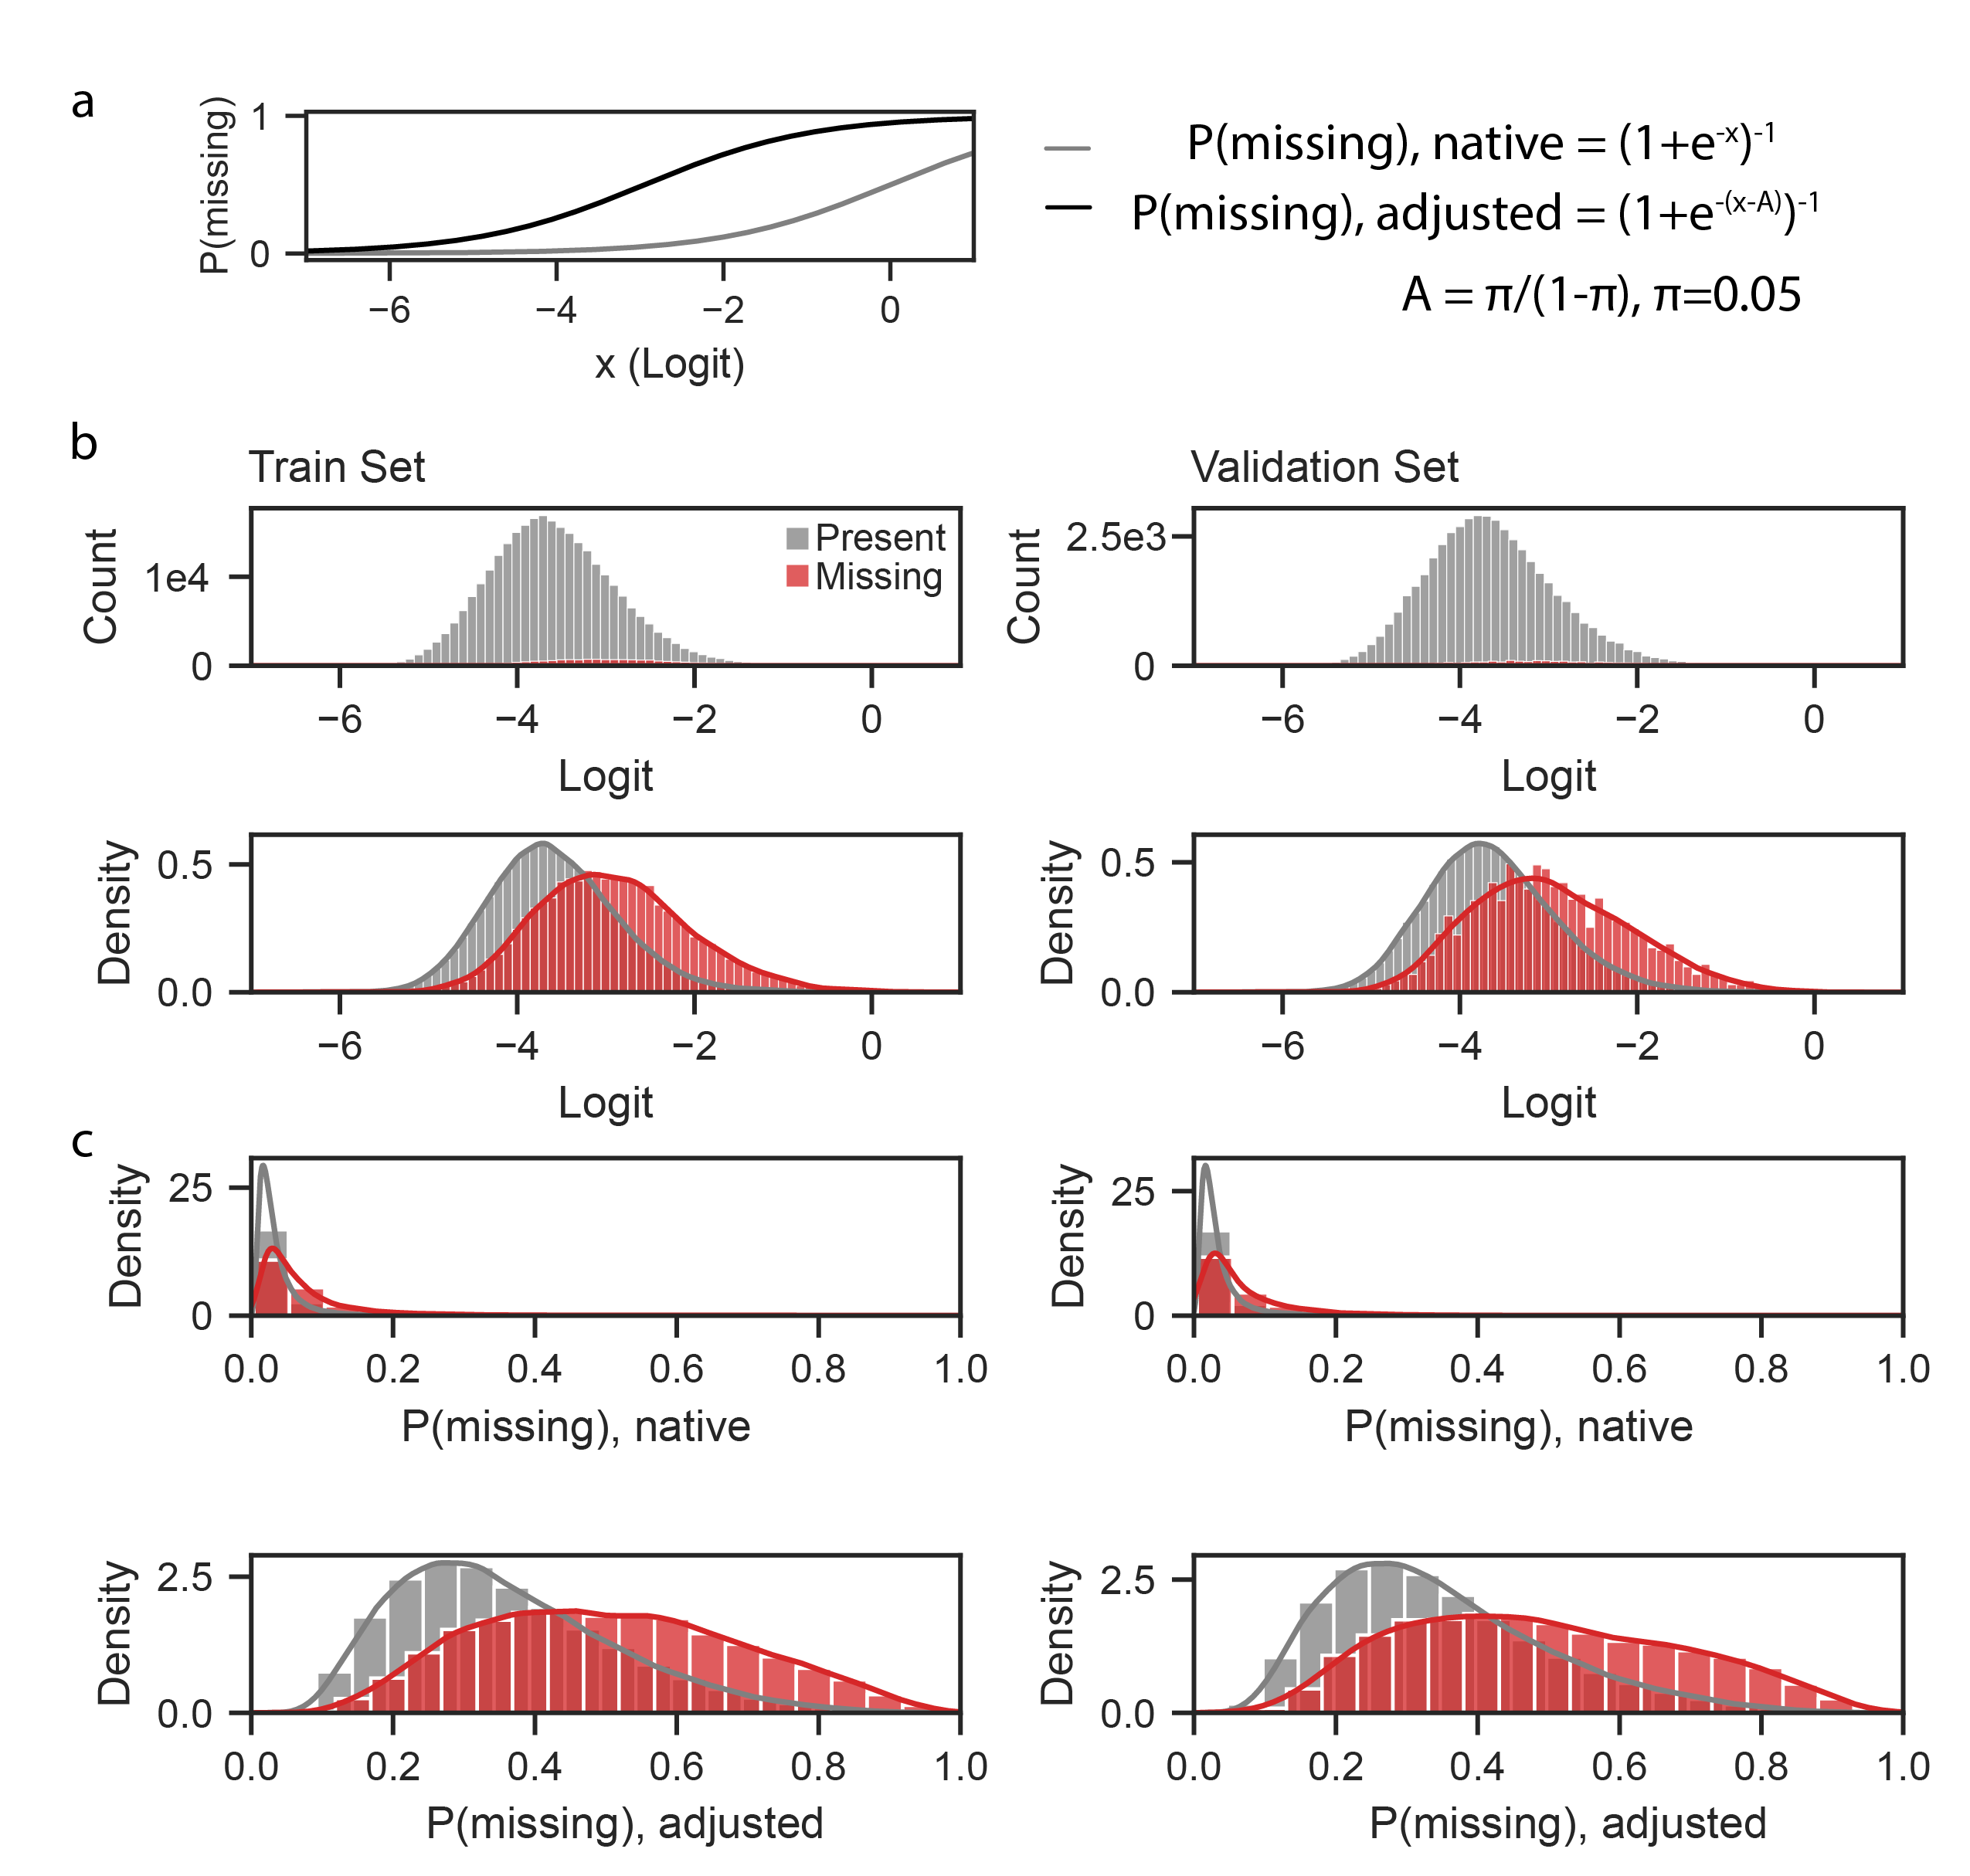
Supplementary Fig. 2: Adjusting native logits from Dyna-1 to account for class imbalance. (a) We adjusted probabilities calculated from logits to maximize the “balanced accuracy”, i.e. accuracy averaged across both classes, rather than accuracy averaged over all datapoints (see Methods). We set our prior for the missing class based on the training data, π, as 5%. Comparing the adjusted curve (black) to the probability densities in (b) demonstrates how this intuitively matches where a discriminator between the two classes should be (at x ~ -3). (b) Histograms and probability densities of logits predicted for residues labeled as “present” and “missing” over train and validation sets. (c) Densities of resulting p(missing) if calculated using native logits or adjusted logits.

- Thorough evaluation of reported NMR relaxation data and corresponding publications increases Dyna-1 performance
While inspecting predictions for other proteins, we noticed that Dyna-1 predicted high p(exchange) for some residues with reported assignments but no relaxation data. This prompted us to revisit our initial curation of experimental data. For instance, in reduced Mercuric Transport protein (MerP)⁷⁸, Thr13 predicts high p(exchange), but has no relaxation data. Ref. ⁷⁸ notes that the peak for Thr13 is very weak, which indicates exchange-broadening and we posit prohibited the authors from fitting R₁ and R₂. Though Ala15 was not labeled by our automated labeling scheme, it also has elevated exchange and a large error in R₂/R₁ (orange arrow, Fig. 4c). Adjusting the experimental label for both residues increases Dyna-1 AUROC from 0.98 to 1.
Another example is the Tudor domain of Survival of Motor Neuron protein (SMNTD)⁷⁹, some of the highest p(exchange) from Dyna-1 were in two residues that were assigned yet had no relaxation data reported: Glu104 and Tyr130 (depicted in black, Fig. 4c). The amide hydrogen of Glu104 was assigned at 4.9 ppm, which is a highly unlikely value for an amide hydrogen. We posit that for this small domain and given the well-resolved spectra that the authors report, this residue is more likely exchange-broadened with an incorrect assignment reported. For Tyr130, no R₁ value was reported, yet the authors categorized it as fitting to “model 4” from the model-free formalism⁷⁹, which is a model containing R_{ex} and requires an R₁ value. If we consider both residues as having evidence of exchange, Dyna-1’s AUROC increases from 0.67 to 0.75.
In the NtrC receiver domain, Dyna-1 achieved an AUROC of 0.57. We revisited the 10 residues that were assigned yet had no relaxation data. We found that 2/10 had been erroneously assigned in chemical shift depositions corresponding to ref. ⁸⁰ despite being exchange-broadened. 5/10 had very small peaks, indicative of exchange-broadening, and the remaining 3/10 were unanalyzable due to peak overlap. Taking these into account increases Dyna-1’s AUROC to 0.60. Dyna-1 missed predicting exchange in Tyr101 posited to be from ring-flipping. This is exemplary of what we found more broadly across all of RelaxDB, that Dyna-1 is weakest at predicting exchange in beta-sheets (Fig. 4d).
Another example is Tyrosine-phosphatase A from M. tuberculosis (MptpA)³⁶. Dyna-1 has high p(exchange) in loops containing residues with differing orientations between the determined apo and holo structures (apo: 2LUO, holo: 1U2P) and which are postulated to be involved in regulating enzyme specificity³⁶. Some of Dyna-1’s high p(exchange) is in the P-loop of MptpA, which our curation indicated had been assigned (BMRB:18533) yet had no relaxation data (BMRB: 26513). However, the authors noted, “Due to exchange broadening the P-loop, residues Cys11–Gly13 and Ile15–Ser18 were not detectable”³⁶. If we consider these labels, the AUROC for MptpA increases from 0.55 to 0.63.

References
Reference numbers below continue from the main-text reference list (refs. 1–77). References already cited in the main text (refs. 36, 51,52) are not reprinted here.

78 Steele, R. A. & Opella, S. J. Structures of the reduced and mercury-bound forms of MerP, the periplasmic protein from the bacterial mercury detoxification system. Biochemistry 36, 6885-6895 (1997). https://doi.org:10.1021/bi9631632
79 Kawale, A. A. & Burmann, B. M. Inherent backbone dynamics fine-tune the functional plasticity of Tudor domains. Structure 29, 1253-1265 e1254 (2021). https://doi.org:10.1016/j.str.2021.06.007
80 Volkman, B. F., Lipson, D., Wemmer, D. E. & Kern, D. Two-state allosteric behavior in a single-domain signaling protein. Science 291, 2429-2433 (2001). https://doi.org:10.1126/science.291.5512.2429
81 Menon, A. K. et al. Long-tail learning via logit adjustment. arXiv preprint arXiv:2007.07314 (2020).

