Supplementary Information
Denisovans from southwestern China and their subsistence strategies
Qijun Ruan^{1,2,23}, Hao Li^{1,3,23*}, Song Xing^{4,5,23}, Keliang Zhao^{4,23}, Jianhui Liu², Clément Zanolli⁶, Luc Doyon^{7,8}, Davide Delpiano⁹, Marco Peresani^{9,10}, Francesco d’Errico^{6,11}, Fabrice Demeter^{12,13}, Jean-Jacques Hublin¹⁴, Peiyuan Xiao^{1,15}, Yuqing Wang^{1,15}, Zhenxiu Jia¹, Qingjiang Yang¹⁶, Qiaomei Fu⁴, Qiyahui Sun^{4,15}, Yuhao Zhao¹⁷, Sungui Lin^{4,15}, Anchuan Fan¹⁸, Youping Wang¹⁷, Qingfeng Shao^{19,20,3*}, Bo Li^{21,22*}, Fahu Chen^{3,1*}
¹State Key Laboratory of Tibetan Plateau Earth System, Environment and Resources, Institute of Tibetan Plateau Research, Chinese Academy of Sciences, Beijing, 100101, China.
²Yunnan Provincial Institute of Cultural Relics and Archaeology, Kunming, 650206, China.
³MOE Key Laboratory of Western China’s Environmental System, Center for Excellence in Archaeological Science and Cultural Heritage, Lanzhou University, Lanzhou, 730000, China.
⁴Key Scientific Research Base on Paleolithic Human Evolution and Paleogenetics, Institute of Vertebrate Paleontology and Paleoanthropology, Chinese Academy of Sciences, Beijing, 100044, China.
⁵Centro Nacional de Investigación sobre la Evolución Humana (CENIEH), Paseo Sierra de Atapuerca 3, 09002 Burgos, Spain.
⁶Univ. Bordeaux, CNRS, MCC, PACEA, UMR 5199, F-33600 Pessac, France.
⁷IKERBASQUE, Basque Foundation for Science, Bilbao, 48009, Spain.
⁸Universidad del Pais Vasco/Euskal Herriko Unibersitatea, Vitoria-Gasteiz, 01003, Spain.
⁹Department of Human Studies, Prehistoric and Anthropological Science Unit, University of Ferrara, Ferrara, 44121, Italy.
¹⁰CNR-Institute of Environmental Geology and Geoengineering, Lab. of Palynology and Palaeoecology, Research Group on Vegetation, Climate and Human Stratigraphy, Milan, 20126, Italy.
¹¹SFF Centre for Early Sapiens Behaviour (SapienCE), University of Bergen, Bergen, Norway.
¹²GeoGenetics Centre, Globe Institute, University of Copenhagen, Copenhagen, Denmark.
¹³Eco-anthropologie (EA), Muséum national d’Histoire naturelle, CNRS, Université de Paris, Musée de l’Homme 17 place du Trocadéro, Paris, 75016, France.
¹⁴Collège de France-CNRS/UMR 7241-Inserm U1050, Paris, France.
¹⁵University of Chinese Academy of Sciences, Beijing, 100049, China.
¹⁶College of Resources and Environment, Chengdu University of Information Technology, Chengdu, 610225, China.
¹⁷School of Archaeology and Museology, Peking University, Beijing, 100871, China.
¹⁸Department for the History of Science and Scientific Archaeology, University of Science and Technology of China, Hefei, 230026, China.
¹⁹School of Geography, Nanjing Normal University, Nanjing, China
²⁰Key Laboratory of Virtual Geographic Environment, Ministry of Education, Nanjing Normal University, Nanjing, China
²¹School of Science, University of Wollongong, Wollongong, Australia.
²²Environmental Futures Research Centre, University of Wollongong, Wollongong, Australia.

²³These authors contributed equally: Qijun Ruan, Hao Li, Song Xing, Keliang Zhao.

Corresponding Authors:
Hao Li, lihao@itpcas.ac.cn;
Qingfeng Shao, qingfengshao@njnu.edu.cn;
Bo Li, bli@uow.edu.au;
Fahu Chen, fhchen@itpcas.ac.cn.

This PDF file includes:

Supplementary Information A: Site and Stratigraphy 4
Supplementary Information B: Chronology 7
Supplementary Information C: Pollen Analysis 18
Supplementary Information D: Hominin Fossils 22
Supplementary Information E: Stone and Bone Artefacts 32
Supplementary Information F: Faunal Assemblages and Taphonomy 43
Supplementary References 52
Supplementary Figures 1–45 59
Supplementary Tables 1–30 104

Supplementary Information A: Site and Stratigraphy

Site setting and excavation history
Bianfu Cave site (26°27′43.65″ N, 100°09′55.45″ E; 2,370 m above sea level) is located on the southern edge of the Hengduan Mountains in the southeastern Tibetan Plateau, approximately 10 km south of Heqing County, Dali Prefecture, northwestern Yunnan Province, China. The cave is developed in the upper section of the Middle Triassic Beiya Formation, which consists of limestone, dolomitic limestone, and dolomite¹. The site lies about 2 km north of the Yinhe river, a secondary tributary of the Yangtze River (Fig. 1).
Originally a complete cave, Bianfu Cave’s roof, entrance, and frontal section were severely damaged by early quarrying blasts. The site was discovered in April 2019 during an ecological restoration project in an abandoned mining area. A joint archaeological excavation of the remaining cave deposits was led by the Yunnan Provincial Institute of Cultural Relics and Archaeology in the second half of 2019. Due to the damage caused by the extensive quarrying activities, the cave’s original spatial structure, the complete stratigraphic sequence, and site formation processes cannot be accurately reconstructed. However, based on field surveys, observations of the preserved sections and related accounts from local villagers, we have attempted to reconstruct the cave’s approximate morphology: the entrance faced southeast, with a height and width exceeding ~5 m; the internal cave height remains unknown. Excavation area was likely within ~20–30 m from the entrance and has a width of ~3–5 m.

Stratigraphy
Three trenches have been excavated at the cave, while hominin fossils and cultural remains were exclusively revealed from Trench 2 (T2). The T2 excavation unit reached a depth of ~4 m (Fig. 1d). From top to bottom the deposits can be broadly divided into three major units (Units I–III) based on archaeological findings and a total of 18 stratigraphic layers (Layers 18–1) based on the sediment features.
Unit I comprises the modern deposits on the top (total thickness ~80–120 cm), including quarry rubble in Layer 1 and recent disturbed deposit in Layer 2.
Unit II presents undisturbed cultural layers (Layers 3–12; total thickness ~230 cm), which can be further subdivided into two parts, i.e., the upper part from Layer 3 to Layer 6, featured by sandy clay with a thickness of ~85 cm, and the lower part from Layer 7 to Layer 12, consisting of alternating cemented breccia and sandy clay with a depth of ~145 cm.
Unit III includes sterile sediments from Layer 13 to Layer 18 and consists of sandy clay with a thickness of ~70 cm.
Detailed description of individual layers is provided below.
- Layer 1 (70–100 cm thick): Quarry-derived rubbles.
- Layer 2 (10–20 cm thick): Disturbed deposits, comprising recent ashes and remains.
- Layer 3 (0–27 cm thick): Compact yellowish-brown sandy clay, with flowstone coverage on the top of the layer and in situ developed stalagmites. Containing abundant limestone rocks of 1–20 cm long, lithics, and animal fossils.
- Layer 4 (4–10 cm thick): Compact reddish-brown sandy clay with limestone fragments of 2–15 cm in size, and a few lithics and faunal remains.
- Layer 5 (15–38 cm thick): Compact brownish-red sandy clay with abundant clasts of 1–15 cm in size, and a few lithics and faunal remains.
- Layer 6 (5–18 cm thick): Loose and soft reddish-brown sandy clay with sparse clasts of 1–15 cm in size, and rare lithics and faunal remains.
- Layer 7 (15–35 cm): Cemented bluish-grey limestone breccia, with diameters of 2–30 cm, minimally matrix-supported, some areas developed flowstone and stalagmites. Six hominin fossils, consisting of four isolated teeth, one cranial fragment and one partial radius, as well as lithics and abundant faunal remains were recovered from this layer.
- Layer 8 (10–20 cm thick): Soft brownish-red sandy clay, containing a small number of clasts 2–20 cm in size and a few lithics and faunal remains.
- Layer 9 (10–25 cm thick): Cemented bluish-grey breccia of 2–30 cm in size, some areas developed flowstone and stalagmites. This layer yielded one hominin cranial fragment as well as lithics and rich faunal remains.
- Layer 10 (3–7 cm thick): Loose brownish-red sandy clay with abundant rocks fragments 2–20 cm long and a small number of artefacts.
- Layer 11 (20–35 cm thick): Hard and cemented bluish-grey breccia of 2–30 cm in size, along with in situ developed flowstone and stalagmites. Lithics and rich faunal remains were unearthed from this layer.
- Layer 12 (5–18 cm thick): Friable brownish-yellow sandy clay, with thin laminated flowstone and abundant rock fragments of 2–15 cm in size; containing rich lithics and faunal remains.
- Layer 13–18 (total thickness ~70 cm): Sterile sandy clay layers.

Supplementary Information B: Chronology

Optical dating

Modelling gamma dose rate
Estimation of the gamma dose rate for the samples from Bianfu Cave is less straightforward, given the highly heterogeneous composition of the deposits, especially for the Layers 7–11 (see the description of Stratigraphy; Extended Data Fig. 1) and the fact that gamma rays can penetrate ~30 cm in typical sediments and rocks. The best way to estimate gamma dose rates for such context is in-situ measurement using portable gamma spectrometer. However, since the excavation of the site was conducted in a short period of time with the aims to rescue and preserve the cultural remains before the large-scale engineering and construction work in the area, the team had no opportunity to conduct in-situ gamma dose measurements. Fortunately, the lateral continuity and integrity of the stratigraphy at the site allow the modelling of the gamma dose rate by constructing a gamma-dose-rate gradient for the sediment profile. We first estimated the average gamma dose rate for each layer by assuming that the radioactivity measures for the OSL samples are representative of their corresponding layers. Since the U, Th and K concentrations were measured based on the fine clasts of the layers only, corrections were needed for the presence of larger clasts in the deposits. Considering that the composition of the rock fragments in the deposits is predominantly limestones, which has negligible radioactivity compared to fine sediments, we estimated the average gamma dose rates of the layers by multiplying those obtained from the fine clasts by a correction factor defined as:
$φ=\frac{ρ_{s}(1−f_{c})}{ρ_{s}\left(1−f_{c}\right)+ρ_{c}f_{c}}$
where $f_{c}$ is the volume fraction of limestone fragments in the layer, $ρ_{s}$ and $ρ_{c}$ are the densities of fine clasts and limestones, respectively. The density of typical sediments of 1.8 ± 0.1 g/cm³ is taken as the value of $ρ_{s}$, and a value of 2.5 g/cm³ is taken for limestone ($ρ_{c}$). The value of $f_{c}$ for each layer is based on field observations and stratigraphic analysis; the value ranges from 0 for the deeper layers (Layer 14 and below) to ~90% for the layers 7, 9 and 11 (Supplementary Table 1). The contribution of gamma dose rate from each layer to the other layers was then calculated using the method described by Aitken². The modelled gamma dose rates are plotted against depth in Supplementary Fig. 1. The values corresponding to the sampling depths of the OSL samples were adopted for age calculation (Supplementary Table 2).
Both the gamma and beta dose rates were corrected for attenuation by water using the measured in situ water content for each layer. A relative standard error of 25% are assumed for the water content to capture possible fluctuation of water content in the past. Attenuation of the beta dose rate as a function of grain size was corrected using the coefficient factors proposed by Brennan³. The dosimetry results are summarized in Supplementary Table 2. The beta dose rates fall within a small range comprised between 1.0 to 1.3 Gy/ka. The modelled gamma dose rate ranges from 0.2 Gy/ka for layer 7 to 1.1 Gy/ka for layer 14. The low gamma dose rates for Layers 7–10 are due to the large fraction of limestones present in the layers (Supplementary Table 1; Extended Data Fig. 1d).

D_{e} and age determination
To select the most reliable D_{e} results, several quality-assurance rejection criteria were adopted. Grains were rejected if they exhibited one or more of the following properties.
(1) The initial intensity of test-dose signal (T_{n}) was below the instrument detection limit, defined as 3σ below the background intensity, and/or has a relative standard error more than 25%.
(2) The ratio between the L_{x}/T_{x} values of the duplicate regenerative doses (i.e., recycling ratio) is outside the range of 0.9–1.1.
(3) The ratio between the L_{x}/T_{x} values of the zero dose and the largest regenerative dose is more than 5%.
(4) Poor dose response curve (e.g., the L_{x}/T_{x} values are too scattered to allow a suitable fitted function). The goodness-of-fit was assessed using the figure-of-merit (FOM) and reduced chi-square (RCS)⁴ with upper limits of 10% for the FOM and 5 for the RCS.
(5) Natural signals (L_{n}/T_{n}) are ‘saturated’, e.g., L_{n}/T_{n} is statistically (at 2σ) equal to or greater than the saturation level of the corresponding DRC.
The quartz OSL signals of all the samples are generally bright and fast-component dominant. Supplementary Fig. 2a-c shows typical OSL decay curves of the T_{n} signals of several grains from three samples (BFD-OSL2, -OSL7 and -OSL10). The OSL signal decay to a negligible background level within the first 0.5 s stimulation, although the intensity of the signal varies significantly (from a few tens of counts to several thousand of counts per 0.1 s). The accumulative light sum of the T_{n} net OSL signals shows that about 20% of the grains contribute to ~80% of total OSL signals (Supplementary Fig. 2a-c).
We evaluated the performance of SAR procedure based on a series of ‘dose recovery’ tests using different preheat conditions and given doses. In the tests, grains from three samples (BFD-OSL6, -OSL8 and -OSL10) were first bleached using blue LEDs at room temperature for 500 s. The grains were then stored at room temperature for 3 hours before another bleaching of 500 s using blue LEDs at room temperature. The bleached grains were then given different known doses (150, 200, 300 and 500 Gy, respectively) and then measured using the SAR procedure with different preheat temperatures (180, 200, 220, 240 and 260 °C for 10 s). For all the tests, we kept the same preheat of 160 °C for 5 s for all the test doses. To evaluate the performance of the dose recovery test, we used the signal recovery ratio^{5,6}, which is calculated as the ratio between the ‘L_{n}/T_{n}’ of the given dose and the L_{x}/T_{x} of the regenerative dose of the same size. The results are plotted against the preheat temperature in Supplementary Fig. 2d. The signals generated from known laboratory doses can be successfully recovered (within 5%) with a preheat temperature in the range from 200 to 240 °C. The weighted mean of all the signal recovery ratios obtained in this temperature range is 1.01 ± 0.01. We, therefore, adopted a preheat temperature of 220 °C for all the subsequent samples.
Depending on the availability, from 300 to 1,200 quartz grains were measured for each sample. The measured grains were analysed using the rejection criteria outlined above. Number of grains rejected by each of the criteria is summarized in Supplementary Table 3. From 24% to 56% of grains are rejected due to dim T_{n} signals. Among the grains that yielded sufficient T_{n} signals, 8% to 29% of them are rejected due to poor recycling ratios. A low numbre of grains (n=10 or less) was rejected because of recuperation greater than 5%. A significant proportion ranging between 14% and 46% of the remaining grains is further rejected owing to poor goodness-of-fit. Consequently, from 19% to 60% of the totally measured grains per sample are considered to have reliable dose response curves and are suitable for D_{e} determination. Among these grains, however, a significant proportion (from 21% to 58%) has natural L_{n}/T_{n} value that are consistent with the saturation level of the corresponding DRCs, which entails that finite D_{e} values cannot be obtained.
The single-grain D_{e} values for each sample are shown in radial plots in Supplementary Fig. 3. We calculated the over-dispersion (OD) values for each sample based on the central age model⁷. The OD values range from 32% (BFD-OSL2) to 116% (BFD-OSL7) (Supplementary Fig. 3). The relatively large and variable OD values for the samples can be explained either by the presence of a small proportion of young grains for some samples (BDF-OSL4, -OSL7 and -OSL9), or the saturation of a significant proportion of grains, ranging between ~20% (BFD-OSL8) and ~60% (BFD-OSL12). It was suggested that a large proportion of saturated grains can give rise to increased OD values because the presence of small D_{e} values may come from the lower tail of the D_{e} distribution of the early-saturated grains, even though their palaeodoses are much higher⁸. Therefore, we expect that conventional D_{e} estimation based on SAR D_{e} values may be substantially underestimated owing to the truncation of the D_{e} distributions⁹.
To overcome the issue caused by the saturation of grains, we applied the L_{n}T_{n} and the standardized growth curve (SGC) method to determine the D_{e} values for all the samples. This method allows the incorporation of all the saturated grains into statistical analysis and, thus, enables reliable D_{e} determination based on full and untruncated distribution⁸. The method involves grouping all the grains passed the above-mentioned rejection criteria 1–4 based on the shape of their DRCs and then establishing SGC for each group using the method described in Li et al.¹⁰. We first calculated the ratios of the L_{x}/T_{x} values at two regenerative doses (250 Gy and 50 Gy, respectively) based on the best-fit DRCs for individual grains. These ratios are then analysed using a finite mixture model (FMM)^{11,12} to identify the number of groups that have statistically consistent ratios. We then applied the least-square normalization (LS-normalization) procedure to establish SGC for each group based on a general-order kinetics (GOK) function¹³. From 5 to 9 SGC groups were identified for our samples (Supplementary Figs. 4–15). The reliability of grouping and SGCs was verified by comparing the D_{e} values obtained from their individual SAR DRCs and the corresponding group SGCs. For all the samples, nearly all the grains yielded SGC D_{e} consistent with the SAR D_{e} at 2σ (Supplementary Figs. 4–15), confirming that the SGCs established here are reliable.
Supplementary Figs. 4–15 show the distributions of LS-normalised L_{n}/T_{n} values for different groups of all the samples. Unlike the wide distributions of SAR D_{e} values (Supplementary Fig. 3), the LS-normalised L_{n}/T_{n} values appear to be mostly clustered in the centre of the distribution with occasionally a few outliers (mostly younger grains). This distribution suggests that all the samples are well bleached and remained undisturbed after deposition. For this reason, we applied the central age model based on the Bayesian Hierarchical Age Model (BHAM-central)⁶ to estimate the D_{e} and ages for our samples.
BHAM is suitable to analyse data from samples whose natural signals are close to saturation. In addition, it is designed to detect and reject outliers from the distribution, thus improving the ease of identifying samples that were likely subjected to post-depositional disturbance. Furthermore, it incorporates various parameters that can contribute to the observed variability in the LS-normalised L_{n}/T_{n} values as priors, including:
- Gamma dose rate ($\dot{D_{γ}}$).
- Mean beta dose rate ($\dot{D_{β}}$).
- Relative standard deviation of beta dose rate ($σ_{β}$), which is assumed to be 0.25 ± 0.05 and is similar to the range of values reported for different sediments from different contexts¹⁴. We also assume that the distribution of beta dose rates follows a lognormal distribution^{15,16}.
- Best-fit SGC parameters for each group and the goodness-of-fit of each SGC; the latter is based on the deviation of the individual LS-normalised regenerative-dose signals (L_{x}/T_{x}) and the corresponding SGCs.
- Intrinsic scatter in the natural signal ($σ_{m}=0.1$). This estimate is based on the OD value of signal recovery tests.
- Prior distribution for the age. A non-informative prior (i.e., a uniform distribution between 0 and 1,000 ka, $t \sim U(0, 1000)$) was assumed for all samples.
- Outlier probability. Outlier detection is achieved using two parameters in the model, the outlier probability (q) of the sample and the offset scale ($δ_{ij}$); the former is the prior probability to find outliers in the sample (e.g., q=0 means no outliers and q=0.5 means half of the grains being outliers) and the latter is the offset needed to move an outlier so that it cannot be distinguished from the target population. Since our samples are dominant by a single population (according to the patterns of L_{n}/T_{n} distributions; Supplementary Figs. 4–15) with only a small percentage of outliers, we applied a non-informative prior for q ($q \sim Uniform(0, 1$)) so that the model is allowed to find the optimum posterior value for it. The offset scale ($δ_{ij}$) is modelled using a normal distribution: $δ_{ij} \sim N\left(0,\max\left(L_{N,ij}\right)−\min\left(L_{N,ij}\right)\right)$.
Finally, the LS-normalised L_{n}/T_{n} values and associated uncertainties were used as input data; the latter were calculated based on counting statistics and instrumental irreproducibility of the reader used.
The posterior distributions of all the parameters (including the ages and D_{e} values) are approximated using Markov chains using the Metropolis-within-Gibbs sampler for MCMC simulation. The model is set up using JAGS¹⁷ and implemented in R⁶. A total of 3 MCMC chains each containing 10,000 iterations were used for both burn-in and sampling without any thinning of samples (i.e., thinning = 1). Trace plots of the MCMC samples of D_{e} values shows that convergence was achieved (Supplementary Figs. 4–15).
The BHAM provided an estimation of the probabilities of individual outlier grains. This is illustrated as colour code of the data points in the radial plots of the LS-normalised L_{n}/T_{n} values (Supplementary Figs. 4–15), in which the outlier probability is distributed into 20 intervals, equally spaced from 0 to 1 (i.e., 0-0.05, 0.05-0.10…, 0.95-1.00), with negligible outlier probability (<5%) shown in blue and high outlier probability (>95%) shown in red. Probabilities ranging between these two extremes are shown in purple. All our samples are dominant with a single population (blue points) with only a small proportion of outliers (red points). We estimated the probability of grains belonging to the target population (p₀) by subtracting 1 from the average outlier probabilities of all grains from each sample (Supplementary Table 4). Except BFD-OSL7, whose p₀ is 0.86, the p₀ values for the other samples are all higher than 0.9, confirming that our samples are dominant by a single population.
The final estimates of D_{e} and ages are provided in Supplementary Table 4. The ages of the two uppermost samples (BFD-OSL2 and -OSL3) from Layer 4 are ~70 ka. There is a significant age increase for the lower samples, indicating a hiatus between Layers 5 and 4. The ages of the lower layers range from ~120 ka to ~180 ka. The ages appear to follow stratigraphic order, with only one exception observed for BFD-OSL9, which yielded an age of ~122 ka that is out of the sequence and significantly younger than the ages of the other samples immediately above it. This sample was collected from the Layer 10 near the slope of the profile (Extended Data Fig. 1), which was probably not intact. Furthermore, the gamma dose rate of this sample cannot be verified since its 30-cm gamma irradiation field was lost. Therefore, we consider that this age estimate is unreliable and should be treated as an outlier. The BHAM OSL ages of sediments and the U-series ages of in situ flowstones are plotted against their corresponding layers in Fig. 2. It is shown that both OSL and U-series dating produced coherent results and follow the stratigraphic sequence, further confirming the reliability of both techniques. There appears to be a significant gap (~50 ka) between the ages for samples from Layers 5 and 4, indicating the existence of a sedimentation hiatus. Hiatus is commonly seen in cave sediments, which could result from erosion by rills during raining seasons or bioturbation activities in the cave. Unfortunately, given the limited area of excavation and the low spatial resolution of our sampling, it is impossible to assess whether this hiatus is widespread across the entire cave or is simply a localized feature.

Bayesian age model
We established a chronological framework by combining the OSL and U-series dating results based on Bayesian modelling using OxCal (version 4.4.4)¹⁸. The model uses the stratigraphic relationship between the samples as priors. We assume that the deposition of the sediments and flowstones follows the law of superposition (i.e., the samples from a lower layer must be older than those from an upper layer); the stratigraphic order of each sample was input using the Sequence function in OxCal. Samples collected from different excavation areas but from the same layers (e.g., the flowstone samples) were modelled using the Phase function because it is difficult to determine their relative depositional order. Each Phase was bracketed by a start and an end Boundary to estimate the start and end ages of each phase of interest (e.g., the layers where human fossils were extracted). We inserted an Interval between the Layers 5 and 4, based on the difference between the measured ages of the two layers. We also applied the general t-type outlier model to deal with outliers¹⁹. We assigned a prior outlier probability of 5% for all the dates. The CQL codes of the model are provided in Supplementary Table 5.
The 95.4% probability ranges of the age estimates (likelihoods) and their corresponding posterior age estimates are listed in Supplementary Table 6. The generated probability distribution function (PDF) for each of the samples are shown in Fig. 2b. Most of the posterior age estimates (modelled age), except BFD-OSL9 and BF-F1, are consistent with the likelihoods at 95% probability range, supporting that the model is reasonably supported by the data. Both low-agreement samples BFD-OSL9 and BF-F1 have yielded high posterior outlier probability (0.93 and 0.81, respectively), whereas the rest have negligible posterior outlier probabilities (< 0.1). Most of the samples (18 out of 22) have individual agreement indices (A) greater than the recommended lower threshold of 60%¹⁸. We noted that the overall and model agreement indices are 31% and 27%, respectively, which are substantially lower than the recommended threshold of 60%. However, this low model agreement index is a mathematical consequence of the high-precision U-series ages mixed with low-precision OSL ages within the same sequence confined with high informative stratigraphic order. The stratigraphic constraints and the U-series data significantly truncate the broad OSL likelihoods, leading to a low overlap ratio despite no evidence of stratigraphic inversion or significant discrepancy between the results of the two techniques (see Fig. 2b). Given the model shows excellent convergence (> 95%) and the posterior distributions remain coherent with the original age estimates for most samples, we conclude that the age model provides a reliable and high-precision geochronological framework for the site.
The Bayesian age model suggests that the Layer 12 corresponding to earliest hominin occupation of the cave started at 197–183 ka at 95% probability range (the same probability range is provided below). The human-fossil-bearing layers (Layers 9 and 7) started from 167–161 ka to 142–134 ka. The top of the Layer 3, corresponding to the latest evidence of hominin occupation at the cave, is dated to 72–64 ka. The time gap of the hiatus between Layers 5 and 4 was modelled to be 26,700–51,100 years (95% probability) (Fig. 2b; Supplementary Fig. 16).

U-series dating

U-series dating of speleothems
Ten in situ formed flowstone samples were analysed (Supplementary Fig. 17). Their U-concentrations varied from ~70 to 174 ppb, which are on average ~30 times higher than the Th-concentrations (~1–19 ppb). The measured ²³⁰Th/²³²Th activity ratios ranged from ~16 to 230, with an average of 90, indicating that these samples were not significantly contaminated by sedimentary Th. The results show that the ²³⁴U/²³⁸U activity ratios were clustered in the range of ~1.137 to 1.193, except for a high value of ~1.272 for the sample BFD7-F1 from Layer 7. The two samples from Layer 3 (BFD3-F1 and -F2) displayed the ²³⁰Th/²³⁸U activity ratios around 0.589, substantially lower than the other samples, which had an average of 0.942. The in-situ formed flowstones from Layer 3 to 11 yielded U-series ages consistent with the stratigraphic order, ranging from 71 ± 0.7 ka to 185 ± 2 ka (i.e. from the beginning of MIS 4 to the beginning of MIS 6) (Supplementary Table 7).
The six broken fragments of speleothems incorporated in the sediments showed a wide variation in U-concentration (47–913 ppb) and in ²³⁴U/²³⁸U activity ratios (1.010 – 1.282). The ²³⁰Th/²³²Th activity ratios were all >20 and the ²³⁰Th/²³⁸U activity ratios were all higher than unity (~1.01–1.17). The derived U-series ages ranged from 217 ± 1 ka to >600 ka, indicating that the sedimentation of Layer 7 started sometime after 217 ka (i.e. MIS 7), in agreement with the U-series ages of the in-situ formed flowstones.

Direct U-series dating of human fossils
The directly dated human teeth and bones from the Layers 7 and 9 displayed U-concentrations of ~5400 to 22679 ppb (Supplementary Table 7), substantially higher than the analysed speleothems. The high U/Th elemental ratios (~30–400), and ²³⁰Th/²³²Th activity ratios (~116–1011) demonstrate that the human fossils were virtually free from the contamination by sedimentary Th. These human fossils had ²³⁴U/²³⁸U activity ratios of ~1.167–1.189, overlapping with those of analysed flowstones, suggesting a stable U-source in the local ground water. Their ²³⁰Th/²³⁸U activity ratios, ~0.650–0.836, were systematically lower than the flowstones, which can be explained by delayed U-uptake processes. Therefore, the obtained U-series ages of ~127–86 ka represent the minimum ages of these human fossils.

Supplementary Information C: Pollen Analysis
A total of eight samples of 100 g were selected for pollen analysis. They originate from Layers 3, 4, 5, 6, 7, 8, 12 and 15. Pollen was extracted using 10% HCl-40% HF, heavy liquid separation, and then further treated by acetolysis²⁰. A total of 75 pollen taxa was identified including trees, shrubs, herbs, ferns, bryophytes and Concentricystes. The pollen assemblages are dominated by tree pollens mainly including Pinus, Abies, Picea, Tsuga, Juglans, Quercus, Ulmus and Platanaceae. Shrub pollens mainly include Ericaceae, Lonicera, Ligustrum and Gardenia. Herb taxa are dominated by Poaceae, Amaranthaceae, Asteraceae, Artemisia, Taraxacum-type, Aster-type, Polygonaceae and Caryophyllaceae. The ferns are dominated by Selaginella, Pteris, Polypodium, Microlepia. The pollen percentages were calculated based on the total pollen sums from trees, shrubs and herbs. The percentage pollen diagram with CONISS was obtained using Tilia (see Supplementary Fig. 18). A cluster analysis using the pollen records allowed to subdivide the pollen records into four zones. Standard biomization procedures assigned pollen taxa to one or more plant functional types (PFTs) based on ecological factors such as plant life forms and phenology²¹. Biomes were then further defined through combinations of these PFTs. Each sample was assigned to the biome exhibiting the highest affinity with pollen taxa. The affinity score was calculated using formula:
where, represents the affinity score of pollen sample k for biome i; is an indicator variable (0 or 1) denoting whether taxon j is present in the “biome-pollen” matrix corresponding to biome i; denotes the percentage of taxon j in sample k; is a threshold (typically 0.5%) established to eliminate errors caused by factors such as long-distance dispersal and re-deposition of foreign pollen or misidentification of rare taxa^{21,22}. The formula sums up all taxa j. The biomization scheme in Bianfudong designates 24 PFTs and 18 biomes based on the criteria established by Sun and collaborators²³ (Supplementary Tables 8, 9).
The results of pollen analysis and biome reconstruction for the sampled layers are described as bellow.
Layer 15‌: The pollen assemblages are dominated by Pinus (54.7%), with broadleaved tree Juglans (3.7%), Quercus (1.9%) and Ulmus (4.7%). It also contains some herb taxa such as Poaceae (3.7%), Amaranthaceae (10.3%) and Artemisia (6.5%). The biomation results for this layer suggest a vegetation biome dominated by north subtropical mixed forest (WAMF) (Supplementary Fig. 19), thus indicating a relatively warm climate for this period.
Layer 12/8/7: The proportion of cold-tolerant species Abies (average 7.4%) and Picea (11.2%) increases significantly in these three layers. A similar trend is also observed for Pinus (65.8%), which suggests vegetation dominated by coniferous forest. In the layer 8, the proportion of Picea pollen rises to 25.1%, while Abies reaches 8.9%. Although the proportions of Abies (2.7%) and Picea (9.5%) decease in the layer 7, the coniferous forest still contains high proportions of Picea. In all three layers, the dominant vegetation biome corresponds to a cold-temperate evergreen conifer forest (CLEC), which entails cooler climatic conditions compared to layer 15.
‌Layer 6: The pollen assemblage is dominated by Pinus (58.3%), Abies (2.9%), Picea (7.9%), Tsuga (18.7%), Carpinus (0.7%), Ulmus (1.4%) and Platanaceae (2.2%). The percentage of herb taxa (7.9%) remains low while we notice a substantial increase in ferns species in this layer. The proportion of Pteris (61.2%), Polypodium (176.3%) reach a peak in this layer compared to the remainder of the sequence. These results indicate a dominant vegetation biome characterised as middle subtropical broadleaf evergreen forest (WTFO). However, the scores for other two biomes, i.e., cold-temperate evergreen conifer forest (CLEC: 11.866) and cool-temperate mixed forest (COMX: 11.761) is very close to WTFO (11.868). Considering the high representation of Tsuga pollens and the abundant ferns species identified in this sample, a WTFO biome appears more plausible, which would correspond to the most humid phase in the Bianfu cave sediment sequence.
Layer 5‌: The pollen assemblage is also dominated by tree pollens (80.4%) including Pinus (71.8%), Abies (1.1%), Picea (2.8%), Ulmus (0.8%) and Platanaceae (1.1%). The proportion of Tsuga pollens (1.1%) decreases to level like that recorded for Layer 7. The proportion of herb pollens increases slightly while the ferns decrease substantially compared to Layer 6. This pattern suggests a dominant vegetation biome characterised as COMX for this layer, which indicates a decrease in humidity for the area surrounding the Bianfu Cave.
‌Layers 4: In this layer, we notice the concomitant decrease of tree pollens (62.3%) and the increase of shrub (6.2%) and herb (31.4%) pollens. The tree pollens are still dominated by Pinus (49.9%), Abies (2.1%) and Picea (8.3%). Ericaceae (4.4%), Asteraceae (4.2%), Aster-type (20.3%) and Caryophyllaceae (2.3%) pollens are found in higher proportions. As for the case of Layers 12, 8 and 7, Layer 4 appears to record cooling climatic conditions with a dominant vegetation biome corresponding to CLEC.
Layer 3‌: The pollen assemblage for this layer is dominated by Pinus (38.8%), Picea (1.4%), evergreen Quercus (3.5%), Taraxacum-type (6.5%) and Aster-type (32.2%). The proportion of herb pollens (52.8%) exceeds that recorded for tree species (45.8%). Together, this change in vegetation cover conforms to a dominant vegetation biome typical of cool-temperate steppe (STEP) and a secondary vegetation biome typical of cool-temperate forest steppe (TEFS). It is likely that topographic variations in the vicinity of Bianfu cave allowed for the coexistence of both biomes, which imply cooler and drier climatic conditions compared to the previous layers.
Overall, the Pinus, Abies, Picea and Tsuga pollen taxa appear in every layer except layer 15. In the seven cultural layers (12, 8, 7, 6, 5, 4, 3), four of them (layers 12, 8, 7, 4) dominated by CLEC biome. CLEC is also the second vegetation biome in layers 6 and 5. These records indicate that the landscape around the cave was mostly CLEC during the period when hominin inhabitation.
The vegetation reconstructions at the Bianfu Cave are consistent with other pollen records in the Heqing Basin. The pollen records from Heqing core indicate that the Pinus forest was present in low altitude areas since 2.78 Ma²⁴. It also suggests that the Pinus forest and evergreen broad-leaved forest are the main vegetation landscape of the mountain area for most of the time since ca. 252 ka²⁴. High Tsuga pollen appeared in the warm, interglacial period in the area²⁵. These results support our observation in the pollen records from Bianfu Cave that the vegetation was dominated by conifer forest from layers 12 to 3, and that layer 6 would likely reflect vegetational changes associated with an interglacial period.

Supplementary Information D: Hominin Fossils

Morphological description and comparisons

All seven hominin specimens can be assigned to specific excavation pits. Specifically, six were recovered from spit 2 of Layer 7: one premolar (P₄) from square 13, one incisor (I₂) from square 1, two molars (M₂) from square 13 and square 8, respectively, one fragmentary parietal bone from square 8, and one fragmentary radius from square 10. Additionally, one fragmentary parietal bone was recovered from spit 2 of Layer 9 in square 8. The teeth from Bianfu Cave were mainly described here and compared with East Asian/Southeast Asian Homo erectus, East Asian late Middle Pleistocene Homo, Homo heidelbergensis, early and late Neanderthals, and fossil/recent Homo sapiens (Extended Data Figs. 5-7; Supplementary Figs. 20, 21; Supplementary Tables 10-17).

Lower left lateral incisor (YHB-3513)

Morphological description
The crown is complete, without any occlusal or interproximal wear (Fig. 3; Extended Data Fig. 4; Supplementary Table 10). Only a small segment of root remains in the lingual aspect. It lacks occlusal wear and preserves at least one-quarter of whole root length, likely represents a child aged 5.5-7.3 years at death based on the modern human developmental standards^{26,27}. In the absence of associated deciduous teeth or permanent first molars, which preserve developmental markers related to birth, it is currently not possible to estimate the age at death of the Bianfu Cave Denisovans using taxon-specific developmental criteria. We therefore rely on modern human dental developmental standards as the best available comparative framework. This approach is supported by previous work indicating that the Xujiayao hominins exhibit dental developmental patterns broadly comparable to those of modern humans²⁸. Xujiayao represents an appropriate comparison because these East Asian Middle Pleistocene archaic hominins are slightly older than the Bianfu Cave individuals and display similarly mosaic dental morphology²⁹⁻³¹. Nevertheless, because the dental growth and developmental patterns of Denisovans remain poorly documented, the age estimates presented here should be regarded as approximate until additional comparative data become available.
Viewed buccally or lingually, the mesial and distal margins are moderately flared. Occlusally, there is no labial convexity or double shoveling (Grade 0, ASUDAS³²). Both mesial and distal marginal ridges are developed, forming moderate shoveling (Grade 3, ASUDAS³²). The lingual basal eminence is weakly developed, and no ridge-like structures are present (Grade 0 of tuberculum dentale, ASUDAS³²).

Morphological comparison
- Shoveling: Zhoukoudian Homo erectus typically exhibits weak shoveling (Grade 2), while Sangiran 7-18 and 7-50 from Indonesia varies from faint (Grade 1) to moderate (Grade 3). Early Neanderthals are characterized by faint to moderate shoveling, whereas late Neanderthals ranging from absent to weak³³. Fossil and recent Homo sapiens generally displays faint shoveling if present³³, while the Holocene specimens from central China exhibit more pronounced shoveling (Grade 0-3). In this feature, the Bianfu tooth exceeds most H. erectus, late Neanderthals, fossil H. sapiens, and recent H. sapiens from Europe and Africa, but aligns with the variation of early Neanderthals and East Asian recent H. sapiens.
- Labial convexity: H. erectus from Zhoukoudian and Indonesia are generally characterized by moderate or pronounced labial convexity. Homo heidelbergensis, early Neanderthals, and late Neanderthals varies from trace to pronounced in this trait³³. In contrast, over half of fossil and recent H. sapiens lack convex labial surface³³. In this trait, the Bianfu tooth resembles H. sapiens more closely than H. erectus, H. heidelbergensis, and Neanderthals.

Lower left fourth premolar (YHB-3518)

Morphological description
The crown is complete, but the root is broken, with both buccal and lingual cusps displaying minor occlusal wear (Grade 2, Molnar’s scoring system³⁴) (Fig. 3; Extended Data Fig. 4; Supplementary Table 10). No distal interproximal wear facet is present. The minor occlusal wears on this tooth indicate that it was already in functional occlusion, indicating that this individual was around 10 years old based on the modern human developmental standards^{26,27}. Viewed occlusally, the crown outline is approximately round with a relatively larger buccolingual dimension. The buccal and lingual cusps are completely separated by the central groove and there is no transverse crest. The talonid, comprising of two small tubercles, is well-developed and extends buccally. The lingual half consists of a metaconid and small distal tubercle (Lingual cusps variation of lower premolars, Grade 2, ASUDAS³²). Apart from the essential crest, only one distal accessory ridge is present on the buccal cusp. The mesial and distal vertical groove on the buccal surface is faintly and moderately developed, respectively. Although the root morphology is incomplete, the exposed root canal is single.
Morphological comparison
(1) Lingual cusps variation: Zhoukoudian and Indonesian H. erectus typically exhibits three or more lingual cusps or tubercles (Grade 4-5), with the metaconid apex positioned mesially. The lingual cusps of H. heidelbergensis, early Neanderthal, and late Neanderthals varies from two to more than three (Grade 3-5)³³, with metaconid apex generally being mesially located. Most fossil H. sapiens display one to three lingual cusps or tubercles, though some lacks this feature³³. 76.8% of the recent H. sapiens published by Martínon-Torres³³ varies from absent to one lingual cusp and a ridge or platform (Grade 0-2). The lingual side of the lower fourth premolar from Hualongdong is comprising one mesially-located metaconid and three distal ridges or tubercles³⁵. In the lingual cusps variation, the Bianfu Cave premolar is more derived than the complex morphology of H. erectus, H. heidelbergensis, Neanderthals, and late Middle Pleistocene Homo from Hualongdong, and lumps into the variation of H. sapiens.
(2) Talonid: H. erectus from Zhoukoudian^{36,37} and Indonesian³⁸ generally have a well-developed talonid extending buccally, corresponding a clear distal vertical groove on the buccal surface and a mesially-displaced protoconid apex. The talonid in Hualongdong tooth is also very large and extends buccally, although the distal vertical groove is not well-developed on the buccal surface³⁵. In contrast, H. heidelbergensis, Neanderthals, and H. sapiens tend to lack a buccally extended talonid and their buccal surfaces are typically smooth³³. In this feature, i.e., buccally extended talonid, the Bianfu Cave and Hualongdong teeth retain the primitive states as in H. erectus, differing from Neanderthals and H. sapiens.
(3) Transverse crest: The transverse crest in most H. erectus from Zhoukoudian and Indonesian is absent or notched by the central groove. 80% of H. heidelbergensis, 95% of early Neanderthals, and 80.7% of late Neanderthals have a completely or partially continuous transverse crest³³. Comparatively, 45.8% of fossil H. sapiens and 81.7% of recent H. sapiens lack transverse crest³³. Hualongdong tooth doesn’t exhibit a continuous transverse crest³⁵. The absence of a transverse crest in Bianfu tooth reflects a common state as in H. erectus and H. sapiens, but distinct from H. heidelbergensis and Neanderthals.
(4) Crown outline shape: The lower fourth premolar of H. erectus generally exhibits an asymmetrical crown outline because of the well-developed talonid and the most protruded location of the buccal contour being mesially displaced. This pattern is also present in East Asian late Middle Pleistocene Homo from Hualongdong³⁵. Neanderthals tend to display an asymmetrical contour with the distolingual corner being pronouncedly protruded and the buccal contour being approximately symmetrical along the buccolingual axis. The P₄ of H. sapiens tend to exhibit symmetrical round/elliptical crown, despite asymmetrical type with the distolingual corner being protruded is also present in some cases. As a very derived form, some H. sapiens P₄s exhibit some approximately round or elliptical crown contour with the distolingual corner being constricted. The Bianfu Cave P₄’s crown contour is approximately round, very close to the H. sapiens, distinct from the different asymmetrical types in H. erectus and Neanderthals.

Lower right second molars (YHB-2890 and YHB-3075)

Morphological description
There are two lower right second molars, YHB2890 and YHB3075. The YHB2890 is represented by a nearly complete crown without any occlusal or interproximal wear (Fig. 3; Extended Data Fig. 3; Supplementary Table 10). It shows no occlusal wear, suggesting that the tooth was not erupted yet, corresponding to an age younger than 11.4 years, the clinical emergence age for modern human M₂^{26,27}. However, the broken root and pulp cavity preclude any further age assessment. Viewed occlusally, the crown outline is elliptical with a relatively longer mesiodistal dimension. The buccolingual dimension of the trigonid and talonid is similar. The five main cusps are well-developed, with the protoconid and entoconid in contact, forming an “X” pattern. The hypoconulid is small (Grade 2), and the entoconulid (C6) is large (Grade 3). No metaconulid or C7, deflecting wrinkle, and protostylid is present. The anterior fovea is linear and deep (Grade 2), with a partially notched middle-trigonid crest distal to it, intersected by the central groove.
The YHB3075 is represented by a complete crown and partial root (Fig. 3; Extended Data Fig. 3; Supplementary Table 10). It displays minor occlusal wear on the protoconid, metaconid, and entoconid (Grade 2 of Molar’s scoring system³⁴), indicating it had erupted into the oral cavity for a while, and more than 3/4 of the roots is formed (but broken apically) indicating a minimum age at death of 12.5 years according to modern standards²⁶. The mesial interproximal wear facet is elliptical and there is no distal interproximal wear facet. The crown contour is ellipse-like with a relatively larger mesiodistal dimension. The five main cusps are well developed, with the protoconid and entoconid in contact, forming an “X” pattern. The hypoconulid is small (Grade 2), the entoconulid or C6 is medium-sized (Grade 2), and the metaconulid or C7 is a small (Grade 2). No deflecting wrinkle is present. The anterior fovea is linear and deep (Grade 2), with a middle trigonid crest notched by the central groove distal to it. A weak vertical groove near the occlusal surface on the buccal protoconid indicates a protostylid of Grade 3. The remaining root fragments suggest at least one mesial and one distal branch, bifurcating 4.6 mm from the cervical line.

Morphological comparison
- Hypoconulid size: The hypoconulid varies from medium-sized to very large in H. erectus from Zhoukoudian and Indonesia. Comparatively, H. heidelbergensis and Neanderthals typically have a small to very large hypoconulid, though it is absent in 28.6% of early Neanderthals and 14.2% of late Neanderthals³³. The absence frequency increases to 64% in fossil H. sapiens and 74.5% in recent H. sapiens³³. The lower second molars of East Asian late Middle Pleistocene Homo from Hualongdong and Denisovans from Xiahe and Tam Ngu Hao 2 exhibit medium-sized to large hypoconulid^{35,39,40}. The small hypoconulid in Bianfu Cave is smaller than those in H. erectus, East Asian late Middle Pleistocene Homo from Hualongdong, and Denisovan from Xiahe and Tam Ngu Hao 2, falling into the variation of later Homo members, but not showing derived state of absence such as in Neanderthals and H. sapiens.
- Entoconulid (C6): Entoconulid or C6 in H. erectus from Zhoukoudian, Hexian, Xichuan, Yiyuan, and Indonesia varies from absent to large^{36,38,41,42}. All three teeth from Hualongdong have medium-sized C6, while the Xiahe Denisovan lacks a C6 and the Tam Ngu Hao 2 Denisovan has only a enamel wrinkle-like C6^{35,39,40}. H. heidelbergensis varies from absent to large in the C6 size. C6 is absent in 57.1% of early Neanderthals, 45.8% of late Neanderthals, 79.2% of fossil H. sapiens, and 94.7% of recent H. sapiens, with the remaining cases vary from enamel wrinkle to a large cusp³³. C6 absence is a derived trend and its frequency increases from H. erectus to later Homo members, especially in H. sapiens. Therefore, with a medium-sized or large C6, Bianfu Cave molars remain a relatively primitive state.
- Metaconulid or C7: The metaconulid or C7 is rare in H. erectus from East Asian, with only one tooth (ZKD 44) from Zhoukoudian and one tooth (PA 839) from Hexian displaying a medium-sized and large C7, respectively^{36,42}. The C7 frequency increases in Indonesian H. erectus, varying from faint to medium-sized. All three teeth from Hualongdong exhibit a small or medium-sized C7, and it is even larger in Xiahe Denisovan, but there is no C7 in the Tam Ngu Hao 2 Denisovan^{35,39,40}. C7 is present in 50% of H. heidelbergensis, 96% of early Neanderthals, and 69.6% of late Neanderthals, varying from faint to large. Comparatively, 76% of fossil H. sapiens and 89.7% of recent H. sapiens lacks C7³³. Comparatively, only one Bianfu Cave molar exhibits a very small cusp-like C7.
- Occlusal groove pattern: Other than a few specimens that has a “X” pattern of main occlusal grooves arrangement (e.g., ZKD 45, ZKD 52, Sangiran 7-63/64/65), H. erectus from Zhoukoudian, Hexian, Xichuan, Yiyuan and Indonesia generally exhibit a “Y” pattern^{36,38,41,42}. All three teeth from Hualongdong have an “X” pattern, Xiahe Denisovan a “Y” pattern, and Tam Ngu Hao 2 Denisovan a “+” pattern^{35,39,40}. Non-Y pattern occurs in 55.5% of H. heidelbergensis, 59.1% of early Neanderthals, 29.2% of late Neanderthals, 65.4% of fossil H. sapiens, and 73.5% of recent H. sapiens³³. With a “X” pattern, the Bianfu Cave molars are distinct from most H. erectus and Xiahe Denisovan, similar to Hualongdong and some of other later Homo members, representing a derived state in this trait.
- Anterior fovea: The anterior fovea is well-developed in H. erectus from Zhoukoudian and Indonesia, East Asian late Middle Pleistocene Homo from Hualongdong, and Denisovan from Xiahe and Laos, 76.2% of early Neanderthals, 87.5% of H. heidelbergensis, 72.7% of late Neanderthals, 22.7% of fossil H. sapiens, and 5.8% of recent H. sapiens^{33,35,39,40}. The deep and linear anterior fovea in Bianfu Cave molars reflects a primitive state as in H. erectus, East Asian late Middle Pleistocene Homo from Hualongdong, and Denisovan from Xiahe and Tam Ngu Hao 2, exceeding most H. sapiens.
- Middle trigonid crest: Other than Zhoukoudian PA 70, the middle trigonid crest is absent in all the other specimens from Zhoukoudian, Hexian, and Xichuan, but common in Indonesian H. erectus (e.g., Sangiran 9, 7-63, 22)^{38,39,42,43}. It occurs in 100% of early Neanderthals, 87.5% of H. heidelbergensis, 100% of late Neanderthals, but only in 26.1% of fossil H. sapiens and 17.7% of recent H. sapiens³³. One of three Hualongdong teeth and the Tam Ngu Hao 2 Denisovan have a partially connected middle trigonid crest, but Xiahe Denisovan lacks it^{35,39,40}. Both molars from Bianfu Cave have a notched middle trigonid crest, differing from East Asian H. erectus, but similar to Hualongdong and Tam Ngu Hao 2. Middle trigonid crest is a typical feature of Neanderthals, but it is also found in a high frequency in Indonesian H. erectus and Australopithecus, suggesting that it is a primitive trait that expressed in an extremely high frequency in Neanderthals-lineage populations.
- Protostylid: Protostylid is very common in H. erectus from Zhoukoudian, Hexian, Yiyuan, Xichuan, and Indonesia^{36,37,41-43}, sometimes as a shelf-like structure, but absent or weakly expressed in East Asian late Middle Pleistocene Homo from Hualongdong, Denisovan from Xiahe and Tam Ngu Hao 2, H. heidelbergensis, early and late Neanderthals, as well as H. sapiens^{33,35,39,40}. The weak protostylid in one Bianfu Cave molar and its absence in the other reflect a derived state as in other later Homo members.
- Deflecting wrinkle: Deflecting wrinkle is typical in H. erectus from Zhoukoudian, Hexian, Xichuan, and Indonesia^{36,37,42}, while it is absent in 90.5% of early Neanderthals, 77.7% of H. heidelbergensis, 73.9% of late Neanderthals, 78.3% of fossil H. sapiens and 84% of recent H. sapiens³³. There is no deflecting wrinkle in East Asian late Middle Pleistocene Homo from Hualongdong and Denisovan from Xiahe and Tam Ngu Hao 2^{35,39,40}. Its absence in Bianfu Cave distinguishes them from H. erectus.
- Crown outline shape: The crown outline is approximately round in H. erectus from Zhoukoudian, Hexian, and Xichuan. Hualongdong and Bianfu Cvae molars have an elliptical crown contour, with the mesiodistal dimension being obviously larger than the buccolingual dimension. Denisovan from Xiahe also has an approximately round crown, while that from Tam Ngu Hao 2 has a mesiodistally elongated crown^{39,40}. The only difference between Tam Ngu Hao 2 and Bianfu Cave is in its relatively wider talonid compared to the trigonid.

Crown metrics

Lower lateral incisor
In mesiodistal dimension (MD), Bianfu Cave tooth exceeds early and late Neanderthals, falling at the upper end of the range of variation for H. erectus and fossil H. sapiens (Extended Data Fig. 7). In buccolingual dimension (BL), it falls within the range of H. erectus, early Neanderthals, and fossil H. sapiens, and is smaller than late Neanderthals. Considering both MD and BL, the Bianfu hominin could be included by the range of variation for fossil H. sapiens.

Lowe fourth premolar
In MD, the Bianfu Cave tooth lumps within the range of late Neanderthals and fossil H. sapiens, at the upper end of early Neanderthals, and smaller than H. erectus and East Asian late Middle Pleistocene Homo (Extended Data Fig. 7). In BL, the Bianfu tooth is smaller than H. erectus and East Asian late Middle Pleistocene Homo, and can be included into the variation of Neanderthals and H. sapiens. Considering both MD and BL, the Bianfu Cave tooth is distributed around the centre of the range for H. sapiens and late Neanderthals, and at the upper end of the range for early Neanderthals.

Lower second molars
In MD, Bianfu Cave teeth fall within the ranges of H. erectus, East Asian late Middle Pleistocene Homo, late Neanderthals, and fossil H. sapiens, exceeding early Neanderthals but smaller than Denisovan from Penghu and Xiahe, and close to Denisovan from Laos (Extended Data Fig. 7). In BL, it could be included within the range of East Asian late Middle Pleistocene Homo, early Neanderthals, and fossil H. sapiens, but is smaller than H. erectus and Denisovan from Xiahe and Penghu, and close to Denisovan from Laos. Considering both MD and BL, the Bianfu Cave teeth, along with Denisovan from Laos, lie near the outer edge of the range for East Asian late Middle Pleistocene Homo, late Neanderthals, and fossil H. sapiens, away from those of H. erectus, and Denisovans from Penghu⁴⁴ and Xiahe³⁹.

Parietal and radius bones
Parietal bones: Two cranial fragments (YHB-767 and YHB-769) were identified from the Bianfu Cave fossil collection and recognized as two partial parietal bones. YHB-767, measuring 50 mm × 32 mm, represents the anterior part of a right parietal bone. Its centre has a thickness of 7.6 mm. Two grooves on the endocranial surface correspond to branches of the middle meningeal vessels. YHB-769, derived from the lambda region of a right parietal bone, measures 58 mm × 26 mm and is 10 mm thick at the centre. A lamboidal suture is visible on YHB-769 and it shows mininal fusion on the endocranial side, suggesting an age at death of approximately 30 years^{45,46}.
Radius: A radial fragment was also recovered from the Bianfu Cave (~45 mm in length), extending from an incomplete head past a pronounced radial tuberosity. Its neck is elliptical in cross-section, and the radial tuberosity is inferred to be medially oriented.

Supplementary Information E: Stone and Bone Artefacts

Stone artefacts

Lithic components and raw materials
The Bianfu Cave yielded a total of 1,366 stone artefacts, including complete cores (n = 187, 13.7%), core fragments (n = 44, 3.2%), complete flakes (n = 135, 9.9%), incomplete flakes (n = 86, 6.3%), tools (n = 34, 2.5%), and debitage (n = 880, 64.4%) (see Supplementary Table 18 for detailed counts). A breakdown of stone artefact categories by layer is provided in Supplementary Table 19. Sandy mudstone constituted the predominant raw material (n = 912, 66.8%), with other materials being less used: trachyte (n = 247, 18.1%), sandstone (n = 74, 5.4%), limestone (n = 60, 4.4%), granite (n = 46, 3.4%), andesite (n = 16, 1.2%), and siliceous rocks (n = 11, 0.8%) (Supplementary Fig. 22; Supplementary Table 18). Cortex preserved on lithics indicates that all materials except limestone were collected from river cobbles. Field survey along the Yinhe river, which is a secondary tributary of the Yangtze River located approximately 2 km north of the site, indicates that the cobbles were likely sourced from local gravel banks, and that the relative frequencies of raw material types documented in the natural riverbed are broadly consistent with those exploited by hominins at the site (Supplementary Fig. 22). There is no evidence of long-distance transport of exotic raw materials.
To test technological continuity across the sequence, we conducted statistical analyses on layers 9, 7 and 3, each of which yielded sufficient quantities of stone artefacts (> 50 pieces) for robust analysis. Notably, layers 9 and 7 contain hominin fossils, offering an opportunity to test whether the technological characteristics of stone artefacts directly associated with these fossils differ from those of layer 3, which lacks hominin fossils. Given the small number of retouched tools (four in layer 9, seven in layer 7), only cores and flakes were analysed. The results show no statistically significant differences in cores (pseudo-F = 1.759, df = 107, P = 0.1554) and flakes (pseudo-F = 2.148, df = 72, P = 0.1008) across the three layers (Supplementary Figs. 23, 24). Although statistical tests could not be performed on tools, the tool types present in these three primary layers generally reflect a common toolkit, including notches, denticulates, scrapers, choppers and informal tools (Supplementary Table 19). In addition, comparisons of key technological attributes among formally retouched tools from layers 3, 7 and 9 are consistently characterised by a predominance of flake blanks, unifacial single-edge retouching, and low scar-layer and scar-count values (Supplementary Table 20), which further supports the interpretation of technological continuity at the site.

Core reduction strategies

Cores
The Bianfu Cave includes 187 complete cores and 44 core fragments. Based on flake scar patterns and volumetric structures, these cores can be classified into several sub-types, including initial cores, unifacial cores, bifacial cores, multifacial cores, centripetal cores, discoid cores, cores-on-flakes, and bipolar cores (Supplementary Figs. 25, 28-31; Supplementary Table 21).
- Initial cores (n = 10, 5.4%): characterized by the removal of only one flake, reflecting tentative reduction. The average length, width and thickness are 69.3 × 55.4 × 38.9 mm.
- Unifacial cores (n = 90, 48.1%): cores exhibit one flaking surface, usually knapped from a single platform. The flaking pattern is dominated by unidirectional reduction (n = 79), typically along the short axis of narrow surfaces. While most specimens show limited reduction, some examples exhibit intensive exploitation through core rotation. Variants included opposed (n = 7) and orthogonal (n = 4) flaking. The mean number of scars is 4.9 (σ = 2.4), the average platform angle is 82.2° (σ = 63.3°), and the average length, width and thickness are 71.8 × 57.3 × 39.7 mm.
- Bifacial cores (n = 35, 18.7%): exhibit two flaking surfaces, either adjacent or isolated. The mean number of scars is 5.5 (σ = 2.3), the average platform angle is 78.3° (σ = 10.9°), and the average length, width and thickness are 74.3 × 60.6 × 40.6 mm.
- Multifacial cores (n = 20, 10.7%): have at least three flaking surfaces. These cores likely represent later stage of reduction, with irregular morphology. The mean number of scars is 7.7 (σ = 2.6), the average platform angle is 81.0° (σ = 10.4°), and the mean length, width and thickness are 72.6 × 59.9 × 48.2 mm.
- Centripetal cores (n = 17, 9.1%): are dominated by unifacial centripetal flaking (n = 16), with irregular flaking surface and high platform angle variability (x̄ = 72.6°; σ = 16.3°; CV = 0.62). The mean number of scars is 5.2 (σ = 1.2), and the mean length, width and thickness are 64.9 × 58.9 × 34.8 mm.
- Discoidal cores (n = 4, 2.1%): are equally divided (n = 2 each) between unifacial and bifacial flaking. All four cores display clear biconvex structure, along with a lower variability of platform angle (x̄ = 67.5°; σ = 10.3°). The mean number of scars is 7.5 (σ = 1.7), and the mean length, width and thickness are 60.8 × 52.0 × 33.8 mm.
- Cores-on-flakes (n = 8, 4.3%): six specimens were flaked on two surfaces, while two pieces were flaked only on one surface. The mean number of scars is 4.5 (σ = 1.9), the average platform angle is 74.1° (σ = 9.5°), and the mean length, width and thickness are 76.1 × 67.4 × 32.1 mm.
- Bipolar cores (n = 3, 1.6%): were exploited along the two ends of long-axis, this possibly related to split-cobble reduction. The mean length, width and thickness are 75.0 × 48.7 × 30.3 mm.

Flakes
The lithic assemblage comprises 135 complete flakes and 86 incomplete flakes (including 54 flake fragments and 32 split flakes). Complete flakes were classified into different types based on technical attributes such as flaking stage and dorsal scar patterns (Supplementary Figs. 26, 32-37; Supplementary Table 22).
- Cortical flakes (n = 71, 52.6%): exhibit nearly complete dorsal cortex coverage, indicative of early reduction stage. Most cortical flakes retain cortical platform (n = 39). These flakes predominantly exhibit oval morphology, with mean length-to-width ratio of 1.26. The mean platform angle is 114.0° (σ = 12.5°), and the mean length, width and thickness are 67.2 × 54.0 × 23.8 mm.
- Unidirectional flakes (n = 25, 18.5%): preserve unidirectional dorsal scars aligned with the flaking axis, reflecting unidirectional reduction strategy. Platform types include cortical (n = 15), plain (n = 6), multifaceted (n = 3), and linear (n = 1) variants, the latter three types belong to the non-cortical platform, potentially indicating core rotation during reduction procedures. Unidirectional flakes have a mean dorsal scar number of 2.4, a mean platform angle of 109.0° (σ = 13.8°) and the mean length, width and thickness of 65.3 × 53.6 × 22.6 mm.
- Opposed-directional flakes (n = 4, 2.7%): preserve dorsal scars oriented opposite to the flaking axis, with mean dorsal scar number of 2.8, mean platform angle of 122.0° (σ = 3.9°) and mean length, width and thickness of 58.0 × 45.2 × 18.0 mm.
- Orthogonal flakes (n = 15, 11.1%): exhibit lateral dorsal scars perpendicular to the flaking axis. These flakes show mean number of dorsal scars is 2.9, mean platform angle of 119.6° (σ = 12.2°) and mean length, width and thickness of 69.8 × 55.6 × 25.5 mm. The presence of orthogonal and opposed-directional flakes reflects the rotation of striking platforms to continuously exploit a single flaking surface.
- Naturally backed flakes (n = 7, 5.2%): retain a cortical portion of the core edge, forming a natural back. The mean number of dorsal scars is 2.5, the mean platform angle is 112.7° (σ = 11.1°), and the mean length, width and thickness are 65.7 × 46.0 × 8.9 mm.
- Core-edge-removal flakes (n = 2, 1.5%): contain remnants of prior core margins. They originated from the shift in flaking direction to maintain the core reduction, potentially associated with centripetal flaking. The mean number of dorsal scars is 3.0, the mean platform angle is 109.5° (σ = 16.3°), and the mean length, width and thickness are 60.0 × 39.0 × 23.0 mm.
- Kombewa flake (n = 1): produced by exploiting the ventral surface of a previous flake. The specimen’s length, width and thickness are 59.0 × 47.0 × 20.0 mm.
- Bipolar flakes (n = 8, 5.9%): exhibit two opposed impact points along the flaking axis and retain extensive dorsal cortex (90%), consistent with the initial phase of core reduction. The mean length, width and thickness are 77.3 × 55.1 × 22.2 mm.
In addition to above mentioned flake types, two specimens could not be assigned to a specific category owing to obscured scar patterns.
Overall, a variety of reduction strategies co-existed at the Bianfu Cave, while flaking patterns are dominated by expedient types, with limited evidence of structured or formalized reduction strategies.

Tools production
The tool assemblage consists of retouched tools (n = 30) and hammerstones (n = 4). The retouched tools include scrapers (n = 12), denticulates (n = 6), notches (n = 5), choppers (n = 2), and informal tools (n = 5) (Supplementary Figs. 27, 38, 39; Supplementary Table 23). Flakes serve as the primary blank for tool production (n = 26), with only two tools made on chunks. Additionally, two choppers were directly made on cobbles. A comparison of dimensions of flake tools (mean length, width, thickness of 68.8 × 52.4 × 23.2 mm) with unmodified flakes reveals no significant size difference (pseudo-F = 0.179, R² = 0.001, df = 159, P = 0.834), indicating minimal blank reduction and limited tool modification, besides no specific blank selection for tools.
The retouching patterns on flake tools are dominated by inverse (n = 13) and direct (n = 12) types, with only one specimen shows bifacial retouching. Retouching is primarily distributed on the lateral edges (n = 19), with fewer instances on the distal end (n = 6) and proximal end (n = 1). All retouched tools exhibit an average scar count of 1.39 (σ = 0.62), and the Geometric Index of Unifacial Retouch (GIUR) averages 0.39 (σ = 0.23), suggesting low retouch intensity and minimal tool maintenance or prolonged use-life.
Four hammerstones are all adopted from oval cobbles, with concentrated percussion marks located at one end along the long axis of cobbles. The mean length, width and thickness are 84.5 × 71.8 × 47.3 mm, and the average weight is 391.1 g.

Technological behaviour at Bianfu Cave
The entrance area of Bianfu Cave has been extensively destroyed by quarrying, and the salvage excavation was therefore restricted to a relatively narrow interior passage that likely does not correspond to the core activity area of past ancient hominin occupation. Within this spatial and taphonomic context, the lithic assemblage exhibits several consistent technological features: 1) lithic production relied predominantly on locally available river cobbles, procured within a short distance of approximately 2 km; 2) lithic reduction was largely expedient, with little evidence for systematic core preparation; although discoidal cores are present, they are rare and do not constitute a dominant technological strategy; 3) retouched tools are found in small numbers and minimally modified, indicating limited investment in tool shaping and maintenance. Taken together, these observations suggest an expedient technological strategy at the site. It is also worth noting that the limited excavated area inevitably restricts our ability to interpret the Bianfu Cave assemblage as a complete toolkit. Instead, the available lithic record reflects a narrower set of activities, including expedient core reduction and the manufacture of expedient tools for immediate use (e.g., butchery).
Bianfu Cave, together with Baishiya Karst Cave, currently represents the only two sites in China where Denisovan fossils are securely associated with cultural remains. Lithic assemblages from Baishiya Karst Cave were only preliminarily reported, but lithics at this site are dominated by expedient flaking and tool-production strategies. The evidence from Bianfu Cave refines our understanding of this technological pattern among Denisovan populations. It highlights the persistence of expedient lithic strategies in some of the East Asian Middle Palaeolithic sites since the late Middle Pleistocene.
Beyond such expedient technologies, Middle Palaeolithic assemblages with more structured reduction strategies were also documented in the region in recent years, including discoidal technology at Lingjing⁴⁷, Levallois technology at Guanyindong⁴⁸, Quina technology at Longtan⁴⁹. Although the hominin taxonomic affiliations associated with these sites remain unresolved, their presence points to cultural diversity in East Asia since the late Middle Pleistocene. From a broader geographic perspective, Denisova Cave preserves Middle Palaeolithic elements such as discoidal and Levallois cores, indicating technological repertoires that differ from those documented at East Asian Denisovan sites⁵⁰. At Denisova Cave, Denisovans coexisted with Neanderthals, and some technological features may reflect cultural interaction or gene flow between these populations, further complicating taxonomic attribution of cultural layers⁵¹. This regional and interregional variability on lithic technology highlights the behavioural flexibility of Denisovans and underscores their capacity to adapt to diverse ecological and cultural contexts across Eurasia.

Bone artefacts
The bone tools reported here originate from layers 7, 4 and 3. The associated faunal assemblage from layer 7 is generally heavily altered with most remains being decalcified, covered by concretion deposits, fused in breccia, and bearing ferro-manganese staining. These alterations made the recovery of the faunal remains without damaging them extremely difficult, which is evidenced by the high frequency of recent fracture on the specimens originating from this layer. Therefore, the sampling strategy implemented in this context relied on selecting specimens that are longer than 40 mm in length and that preserved at least 70% of intact cortical surface. None of the specimen could be taxonomically identified, and, as a result, they were assigned to mammal size class based on their maximum cortical thickness⁵². In contrast, the fauna from layers 4 and 3 is generally in a better state of preservation; slight weathering, limited concretion deposits and ferro-manganese discoloration were recorded. A total of ten bone tools is reported here (see Supplementary Table 24). They all originate from limb bones of medium to large-sized mammals. Below, a general description is provided for these tools which were grouped into typological categories and layer of origin.

Bone retouchers
Layer 7: Five long bone fragments from medium- to large-sized mammal are attributed to this tool category. All specimens exhibit fresh fractures and measure between 45.42 and 57.88 mm in length. Their cortical surfaces display linear impact marks located on the right side (n = 3), the left side (n = 1) or the distal end (n = 1) of the object. These marks are either dispersed (n = 3) or concentrated (n = 2) on the cortical surface and consistently occur on slightly convex cortical surfaces. The morphology and location of the impact traces are consistent with repeated contact with lithic cutting edges, indicating their use as retouchers. Such tools may have served to initiate retouch on previously unmodified flakes, sharpen unretouched cutting edges, or reshape and rejuvenate flakes that had already been retouched and used. The limited number of impact scars is consistent with the low mean number of scars and geometric index of unifacial retouch documented on the lithic tools from the same layer. Similarly to lithic tools, this pattern conforms to an expedient and opportunistic technological practice, in which faunal fragments with suitable morphological affordance were selected from those available at the site to facilitate rapid and flexible modification of lithic tools.
Layer 3: A large-sized mammal long bone fragment (cortical thickness: 11.4 mm) is assigned to this category. All fractures display signs that the bone was broken while being still fresh. The object measures 144.32 mm in length, 41.5 mm in width, and 15.96 mm in thickness. Its cortical surface bears linear impact marks located on the right side of the object. The marks are dispersed on a surface that is slightly convex. The morphology of the marks is consistent with repeated contact with a lithic cutting edge, indicating its use as a retoucher. As in the case of Layer 7, the limited number of impact scars is to put in relation with the low retouch intensity and minimal maintenance of lithic tools.

Intermediate tool
Layer 7: A single item is attributed to this tool category. It originates from a long bone of a medium- to large-sized mammal and exhibits a cortical thickness of approximately 8.29 mm. The object measures 45.92 mm in length, 32.79 mm in width, and 15.04 mm in thickness. Both the proximal and distal ends display fracture planes indicative of the breakage while the bone was still fresh. The distal end bears nine overlapping flake removal scars ranging from 1.06 to 7.74 mm in breadth. The impacts responsible for these removals systematically originated from the medullar surface and propagated toward the periosteal surface. The number, organization, and orientation of these scars are consistent with deliberate anthropogenic shaping of the active edge^{53–57}. This shaped edge also exhibits localized rounding, suggesting sustained use following its manufacture. The opposite (proximal) end displays several splintered removals on the periosteal surface.
Layer 3: A medium-sized mammal long bone fragment (cortical thickness: 7.44 mm) is attributed to this category. All fracture surfaces are consistent with fresh bone breakage. The specimen measures 69.21 mm in length, 35.83 mm in width, and 15.24 mm in thickness. One end is characterized by continuous and superimposed bifacial flake removal scars, with notably small and overlapping micro-flake removal scars clustered on cortical surface. The edges between the scars display evidence of compression. The opposite end exhibits two fracture planes converging obliquely relative to the bone’s main axis, which likely result from the exertion of an impactful blow while using the fragment as an intermediate tool^{58,59}.

Potential expedient tool
Layer 7: The single object assigned to this category is a fragment of an unidentifiable long bone from a medium-sized mammal, measuring 58.27 mm in length, 25.66 mm in width, and 8.83 mm in thickness. The morphology of the fracture planes indicates that the bone was broken while still fresh. One end of the fragment exhibits localized deformation and edge rounding. Although such modifications could result from a range of natural processes, their spatial association and concentration along a restricted portion of the edge are also consistent with use-related damage, as documented in experimental studies and Middle Palaeolithic archaeological contexts^{60–65}. At present, the anthropogenic origin of these modifications cannot be conclusively established. Further quantitative use wear analyses will be required to test the anthropogenic origin of the deformation and, if micro-wear is preserved, to assess the most likely function of the object.
Layer 4: A single medium- to large-sized mammal long bone fragment with a cortical thickness of 9.12 mm is attributed to this category. The fracture planes on this fragment indicate it was broken while the bone was still fresh. The specimen measures 110.14 mm in length, 40.74 mm in width, and 15.56 mm in thickness. At one end, it displays seven unifacial flake removal scars, ranging from 3.85 mm to 26.01 mm (mean = 10.87 mm). The flakes were all removed by strikes originating from the cortical surface toward the medullary canal. One lateral edge of the object exhibits a series of superimposed flake removal scars. The patterned centripetal orientation of the flake removal scars interrupting the fresh fracture planes exposed when breaking the fresh bone are consistent with intentional modifications of the fragment.

Comparison with Middle Palaeolithic bone technology from Eurasia
The identification of rudimentary bone tools at Bianfu Cave provides further evidence for the selection of butchery and carcass processing by-products for technological purposes. The numerous discoveries reported over the last two decades attest to such behaviour being an integral part of the Neanderthal cultural adaptive systems since at least MIS 9^{53,59,65-75}. The evidence from Bianfu Cave suggests that a similar cultural adaptation was also shared by Denisovans population. Despite the preservation and sample selection biases that may have affected the number of identified specimens in the present study, our results support the idea that bone tools were part of the Denisovans technological system since at least ~145 ka and persisted until the end of the human occupation at the cave ~65 ka. Although preservational constraints (decalcification and concretions) limit the functional analysis of the currently identified bone tools, their typological diversity falls completely within the variation known for the Middle Palaeolithic in Eurasia⁷⁶⁻⁸⁴.
Indeed, retouchers are dominant, although this may be explained by the fact that they are easier to recognise in large faunal assemblages than other unmodified bone fragments used as tools. Alongside retouchers, intermediate tools are also present. The working edge of these tools was either unmodified or rapidly shaped into a bevel by direct percussion, thus using a technique generally associated with lithic knapping to intentionally modify the bone fragments to ensure their shape is adequate for the task at hand. The use of these items as intermediate tool is attested by the compression of the edges between the flake removal scars, the development of overlapping micro-scars, splinters and, in one case from Layer 3, the fracture of the tool. This latter pattern was documented on experimental specimen that were used while the bone was still relatively fresh^{55,63,85}, which further suggests that Denisovans at Bianfu Cave favoured a technological strategy that consisted of selecting fragments with morphology adapted to a given task and rapidly discarded the tool after its initially intended use.
Finally, several specimens from Bianfu Cave bear a high number of flake removal scars that cannot be attributed to the fracturing of the bone to expose the marrow cavity^{53,56}. While the function of these objects as tools remains to be established, the scar pattern they bear suggest an intentional anthropogenic origin that aimed to modify the bone fragment’s outline and shape its working edge.

Supplementary Information F: Faunal Assemblages and Taphonomy

Bianfu Cave faunal assemblage: Fragmentation and sampling strategy
The faunal assemblage recovered from the salvage excavation at Bianfu Cave includes more than 64,000 remains (Supplementary Figs. 40, 41; Supplementary Table 25). The specimens are highly fragmented, in part owing to the cemented nature of Layers 7 to 12, which made their recovery without damage extremely difficult. As a result, only 2.1% of the faunal remains from these layers measure 5 cm in length or more compared to 8.3% in Layers 3, 4 and 6. Layer 5 yielded only nine faunal fragments, all measuring less than 5 cm. Given this high fragmentation, refitting, as proposed by Marean and Kim⁸⁶, was not attempted. Our sampling strategy reflects the key questions we wished to address:
- What are the species represented in each layer and how does the spectra inform us on the palaeoenvironmental contexts of the human occupations?
- Who was (or were) the primary agent(s) responsible for the accumulation of the faunal assemblage?
- What is the evidence for anthropogenic modifications of the faunal remains?
A first sample included all identifiable remains, which mainly comprises isolated teeth and maxillae/mandibles with teeth and amounts to 1,896 specimens. Owing to its good preservation, this sample was used to establish the species represented in the faunal spectrum for each layer, calculate the Minimum Number of Individuals (MNI) and produce mortality profiles. A second sample includes all bone fragments with length greater or equal to 5 cm to estimate the skeletal representation more accurately, and to record bone surface modifications that would allow infer the agent(s) responsible for the accumulation of the assemblage. Generally speaking, the second sample is less well preserved than the first one, which is common in the cave sites in southern China^{87,88}. In most cases, the 5,428 bone fragments included in this second sample could not be taxonomically identified. They were, therefore, assigned to mammal size-class based on their cortical thickness following the method developed by Bunn⁴⁶ (Supplementary Tables 26, 27).
Methods

Species and skeletal element identification
Taxonomic and element identification was achieved via comparisons with the reference collection curated at the Yunan Provincial Institute of Archaeology and atlases of comparative anatomy⁸⁹⁻⁹². The landmark-based approach proposed by Morin et al.⁹³ was also used to assign smaller fragments to specific genera or species, and/or elements.

MNI and mortality profiles
After discarding post-cranial bone fragments, indistinguishable canines and tooth fragments, the total number of identifiable specimens (NISP) amounted to 1,705 teeth. The differential preservation method proposed by Brain⁹⁴ was used to assess whether the skeletal element selected to calculate the MNI was reliable at Bianfu Cave. The sequence of tooth loss and eruption was accounted for the calculation of the MNI by combining deciduous and permanent teeth of the maxillae and mandibles for each species that yielded enough specimens.
The mortality profiles for dominant herbivore species were established based on the dental wear of the third molar in adults (M₃) and the fourth deciduous premolar for young individuals (DP₄). This methodology is justified by the fact that M₃ erupts only after the shedding of DP₄ in larger herbivores, thus allowing to cover the full life cycle of these animals. All DP₄ were assigned to juvenile individuals. For the M₃, the individual age was established by measuring the height of the tooth crown, the sequence of tooth eruption, and the degree of tooth wear. Since Bubalus sp. and Bos (Bibos) gaurus on the one hand, and Cervus elaphus and Cervus (Sika) nippon on the other, share similar body size, sequence of tooth eruption, and enamel wear trajectories, bovids and cervids were combined into two classification units for the analysis. The individual age estimate from dental crown heights of M₃ for Bovids relied on the following formula: AGE=AGE_{pel}-2 (AGE_{pel}-AGE_{e}) (CH/CH_{O}) +(AGE_{pel}-AGE_{e}) (CH²/CH_{O}²), where CH is the variable crown height, CH_{O} is initial (unworn) crown height, AGE_{e} is the age at which M₃ erupts, and AGE_{pel} is the maximum possible age of and individual (=age at potential ecological longevity)⁹⁵. The formula used for Cervids is as follows: AGE=(Y_{pel}-Y_{e})/X_{max} (CROWN HEIHT) +Y_{pel}, Y_{e} is the age at which M₃ erupts, Y_{pel} is the potential lifespan of individuals, and X_{max} is an estimate of unworn crown height⁹⁶. Based on previous studies⁹⁷⁻¹⁰², the relative parameters were defined as follows: CH_{O}=70mm, AGEe=36 months, AGE_{pel}=300 months, Y_{e}=30 months, Y_{pel}=192 months, X_{max}=21mm (for Cervus (Sika) nippon), 25mm (for Cervus elaphus). In Bovids, the thresholds of 3 and 15 years old were used to distinguish between respectively juveniles and prime adults, and prime and old adults. In Cervids, these thresholds were set to 2.5 and 12 years old. Mortality profiles are illustrated using ternary diagrams based on the proportions of each animal’s age following the method proposed by Discamps and Costamagno¹⁰³. To ensure a sufficient sample size to interpret the emerging pattern, layers 3 and 4, on the one hand, and layers 6 to 12, on the other, were merged in this analysis.

Bone breakage and surface modifications
The fracture planes on the fragments were described following the criteria developed by Villa and Mahieu¹⁰⁴. Percussion scars and notches likely resulting from the breakage of long bones to access the marrow were recorded following the nomenclature developed by Vetesse and collaborators¹⁰⁵. Weathering stages were recorded based on the work of Behrensmeyer¹⁰⁶ while rounding followed the stages defined by Cáceres¹⁰⁷. A preliminary assessment of the preservation of the intact cortical surface was done by identifying areas covered by concretions or affected by exfoliation and rounding. Surfaces were then inspected to distinguish between anthropogenic and non-anthropogenic processes based on criteria available in the literature^{108,109}. A particular focus was given to linear marks, e.g., trampling marks and cut marks, as well as bone surface modifications induced by carnivores¹¹⁰⁻¹¹² and rodents^{109,113}. Whenever possible, the location and orientation of cut marks was recorded to establish the most likely carcass processing activity taking place at the site^{114,115}.

Taxonomic and element identification
A total of 1,896 specimens were identified to the genera, or species. Throughout the sequence, Cervus (Sika) nippon dominates the faunal assemblage, except in Layer 8 where Rhinoceros sinensis remains prevail despite the small sample size for this layer, and in Layer 6 where it is found in proportions similar to Bos (Bibos) gaurus. The other herbivores found at Bianfu Cave include the following species: Cervus elaphus, Bubalus sp., Sus sp., Pseudoiss sp., and Capra sp. Carnivores were also found in layers 3, 6, 9,11 and 12 but the number of NISP never surpasses a dozen for all species combined. The carnivore guild is dominated by Crocrocuta Crocuta ultima, followed by Felidae gen. et sp. indet. and Ursus thibetanus (Supplementary Table 27).
The skeletal element representation for the taxonomically identified specimens corresponds to a head-and-foot-dominated skeletal-element pattern, which is best explained by the ease of identifying teeth, antlers, mandibles and long bones preserving an epiphysis compared to post-cranial fragmented remains. However, when including the bone fragments assigned to mammal size-classes, all skeletal portions become represented, with a slight overrepresentation for ribs and appendicular bones (Supplementary Table 26). This entails that the faunal assemblage suffered a limited attrition following its initial accumulation, for instance through the transport of smaller elements by various site formation processes^{116,117}. The MNI calculated from dental remains⁹⁴ suggests that at least 144 individuals are represented in the assemblage: in decreasing order, Cervus (Sika) nippon (n = 93), Bos(Bibos) gaurus (n = 15), Bubalus sp. (n = 14), Cervus elaphus (n = 10), Crocuta Crocuta ultima (n = 4), Capra sp. (n = 3), Pseudois sp. (n = 2), Ursus thibetanus (n = 1), Rhinoceros sinensis (n = 1), and Sus sp. (n = 1) (Supplementary Fig. 42; Supplementary Table 28).
A comparative analysis of large mammal species at Bianfu Cave and their extant relatives at the generic level reveals that most taxa at the site inhabit a mountainous forest environment interspersed with open glades and clearings. Some variations are however noted at a specific level.
Sika deer mainly inhabits mountainous areas with mixed coniferous and broad-leaved forests, forest edges, and mountain grasslands. Red deer mainly lives in high mountain forests, grasslands, mixed forests, as well as shrub and meadow areas. Gaur mainly occupies shrubbery at the edge of forests, grasslands, and under sparse forests. Buffalo inhabits highland forests, primitive lowland forests, water areas of tropical plains, jungles, bamboo forests or reed thickets. Rhinoceroses mainly live in open grasslands, savannas, areas of shrubs, or swamps. Bharal and goat are typical mountain animal. They inhabit the high-altitude areas above the tree line, including plateaus, slopes, bare rocks on mountains, and grasslands in mountainous regions. Black bears are forest-dwelling animals with a capacity to adapt to various environments from the tropical rainforest to the mountainous cold-temperate dark-coniferous forest at an altitude of around 4000 meters. Hyena lives in tropical and subtropical areas with sparse grasslands and deserts. Pig has a strong adaptability to diverse environments such as mountainous areas, hills, deserts, grasslands, forests and other regions.
Overall, fauna at the Bianfu Cave indicates that climate in this region was cool and moderately humid, and the ecological environment encompassed mountainous forest, with interspersed areas of open woodland, shrubbery, grassland, alpine meadows in the vicinity of the site. This is consistent with the surrounding topography and geomorphology, which is encircled by high mountains in the south, west and east and a relatively flat basin, the Heqing Basin, in the north (Extended Data Fig. 1a). The diverse natural environments and abundant resources they contained likely played a role in the recurrent visits by hominins at Bianfu Cave during MIS 6 and 4.
Mortality profiles and bone surface modifications
After eliminating the taxonomically identifiable post-cranial bone fragments, the indistinguishable canines and the tooth fragments, the total number of teeth, including those preserved in maxillae and mandibles, amounts to 1,705 specimens (Supplementary Table 27). Using the differential preservation method proposed by Brain⁹⁴, it becomes clear that these elements are adapted to calculate the MNI and mortality profiles at Bianfu Cave. The scores obtained for the bovids and cervids, i.e., the most represented herbivores at the site, are as follow: Cervus (Sika) nippon 97.4%; Cervus elaphus 85.9%; Bos(Bibos) gaurus 92.6%; Bubalus sp. 98.4% (see Supplementary Table 27). For both bovids and cervids, the mortality profiles suggest a pattern where prime adults dominate the assemblage, albeit with a slightly higher proportion of juvenile bovids in layers 6-12 (Supplementary Fig. 43; Supplementary Tables 28, 29). It is worth noting, however, that in these layers, the proportion of juveniles never exceed 20%.
These mortality profiles reflect, to some extent, the hunting strategies of the predators¹⁰³. Among common carnivorous species, ambush hunting by lions and tigers results in catastrophic mortality profiles where there are more juveniles than prime or old individuals. Predators such as hyenas and wolves generally resort to long-distance running, tracking and attacking vulnerable individuals such as juveniles and old individuals, thereby forming an attritional mortality profile dominated by these two groups. At Bianfu Cave, the overrepresentation of prime adults suggests a targeted hunt aimed at individuals that could yield higher return rate, a behaviour usually associated with hominin hunting strategies.
The taphonomic analysis of the Bianfu Cave faunal assemblage was conducted to further evaluate the main agent(s) responsible for its accumulation and processing (see Supplementary Table 30). The results presented here must be understood while keeping in mind the differential preservation of the remains. While dental remains show good preservation, the surfaces legibility of bone and antler fragments ranges from poor to moderate across the sequence, which reflects the complex post-depositional processes that affected their fossilization (see Supplementary Fig. 41; Supplementary Table 30). Many specimens retain only limited portions of the original cortical surface, and surface observation is further reduced by concretion deposits, evidence of sediment compaction, ferromanganese staining, decalcification, exfoliation, and other abrasive post-depositional alterations. In the recorded assemblage, almost two-third of the specimens preserve less than 60% of their cortical surface. Generally, specimens from layers 3 and 4 are better preserved than those at the bottom of the sequence, a pattern that is correlated with the heavy cementation of the layers 7 to 12.
Ferromanganese staining is the most widespread alteration, affecting about 92.7% of the bone remains, followed by decalcification, which is present on 76.8% of the assemblage. In these lower layers, decalcification is much more extensive, the bone surfaces appear chalky, powdery, and whitish. At a microscopic level, the original anatomical features of bone, e.g., vascular openings, are completely altered, and surface exfoliation is more pronounced. Trampling traces are also common and were recorded on 45.2% of the specimens. Root etching, however, is rare, and affects less than 0.5% of the remains. No evidence of abrasion or heavy rounding usually attributed to water erosion^{118,119} or the occupation of the cave by carnivore^{120,121} was observed on the assemblage.
Among the better-preserved specimens, several characteristic bone surface modifications were identified (Supplementary Table 30). Carnivore and rodent modifications are present but remain minor in frequency. Carnivore-related traces were recorded on 34 specimens (0.6%), including pits, punctures, furrows, gnawing, and few digestion traces. Rodent gnawing, mainly attributing to porcupines, was observed on 37 specimens (0.7%). Most bone surface modifications were attributed to anthropogenic activities. Evidence of percussion to access the marrow cavity was identified on 366 specimens, including 259 scars and 107 notches, which represent 6.7% of our sample. Cut marks were recorded on 63 specimens (1.2%). Collectively, when accounting for specimens that bear two or more of these traces, 7.53% of the faunal sample considered here bear clear evidence of anthropogenic activities. While this proportion appears relatively low, it is explained by the poor preservation of the cortical surfaces in general, and the sampling strategy focusing on specimens measuring more than 5 cm in length. This frequency should, therefore, be considered a minimum value.
On long bones and scapulae, cut marks are preferentially oriented obliquely relative to the bone’s main axis. Cut marks oriented transversely are also present while those parallel to the bone’s main axis are rare. On metapodials, cut marks obliquely and transversely oriented relative to the main axis were likewise observed. Overall, the cut marks are concentrated on long bone diaphysis (n = 57/63, 90.5%) and measure on average 7.3 mm in length (Supplementary Fig. 44). Comparison with experimental and ethnographic data supports that this pattern is consistent with carcass defleshing and the breakage of fresh bones to extract marrow. The cut mark pattern observed on metapodial fragments could also entail that the skinning of the preys occurred at the site^{114,122,123}.
Spatial distribution analysis of the lithic and the faunal assemblages from layers 3, 7, 9, 11 and 12, all of which yielded sufficient specimens for analysis, reveals small shifts in concentrations along a southeast-northwest cline between layers 11 and 12 on the one hand, and layers 7 and 3 on the other (Supplementary Fig. 45). Nevertheless, this result should be interpreted with caution given the limited excavated area at Bianfu Cave. We therefore err on the side of caution and restrict our interpretation of possible variation when considering the site’s occupation and formation history.
In conclusion, the poor preservation of many cortical surfaces probably resulted in an underestimation of bone surface modifications, and the contribution of other taphonomic agents cannot be completely excluded. However, the zooarchaeological and taphonomic evidence converges toward an interpretation according to which, hominins are the main agent for the accumulation of the faunal assemblage and its initial transformation. This hypothesis is supported by (1) an overrepresentation of herbivore throughout the sequence, (2) the targeting of prime adults with high yield rates, (3) the larger number of appendicular elements, (4) the abundance of fresh fractures on long bones, (5) the presence of cut marks (albeit in frequency likely underrepresented owing to the taphonomic processes that affected the preservation of the cortical surface of the bones), percussion marks, scars and notches attesting to anthropogenic interaction with the carcasses, and (6) the low frequency of carnivore and rodent modifications recorded on the assemblage. Together, this evidence suggests hominins introduced medium- and large-size mammal carcasses in the site and processed them by removing their skin, extracting the meat and accessing the bone marrow. The faunal remains abandoned by the visitors at Bianfu Cave appear to have occasionally attracted carnivores and rodents. However, the extent of their modification of the assemblage appears relatively limited considering the presence of several intact long bone epiphyses and the low frequencies of traces attributed to these agents. While we cannot exclude that some individuals could have been introduced in the cave by carnivores or other means, such introduction appears marginal in comparison to the anthropogenic origin.

Supplementary References
1. Ma, L. Atlas of Geology of China. (Geological Publishing House, Beijing, 2002).
2. Aitken, M. J. Thermoluminescence Dating. (Academic press, 1985).
3. Brennan, B. J. Beta doses to spherical grains. Radiat. Meas. 37, 299–303 (2003).
4. Peng, J. & Li, B. Single-aliquot Regenerative-Dose (SAR) and Standardised Growth Curve (SGC) Equivalent Dose Determination in a Batch Model Using the R Package ‘numOSL’. Anc. TL 35, 32–53 (2017).
5. Zhang, D. et al. Denisovan DNA in Late Pleistocene sediments from Baishiya Karst Cave on the Tibetan Plateau. Science 370, 584–587 (2020).
6. Li, B., Jacobs, Z. & Roberts, R. G. A Bayesian hierarchical age model for optical dating of single grains of quartz. Quat. Geochronol. 77, 101455 (2023).
7. Roberts, R. G. et al. Optical Dating of Single and Multiple Grains of Quartz from Jinmium Rock Shelter, Northern Australia: Part Ii, Results and Implications. Archaeometry 41, 365–395 (1999).
8. Li, B., Jacobs, Z. & Roberts, R. G. Validation of the LnTn method for De determination in optical dating of K-feldspar and quartz. Quat. Geochronol. 58, 101066 (2020).
9. Li, B. et al. Variability in quartz OSL signals caused by measurement uncertainties: Problems and solutions. Quat. Geochronol. 41, 11–25 (2017).
10. Li, B., Jacobs, Z. & Roberts, R. G. Investigation of the applicability of standardised growth curves for OSL dating of quartz from Haua Fteah cave, Libya. Quat. Geochronol. 35, 1–15 (2016).
11. Galbraith, R. F. & Green, P. F. Estimating the component ages in a finite mixture. Int. J. Radiat. Appl. Instrum. Part Nucl. Tracks Radiat. Meas. 17, 197–206 (1990).
12. Roberts, R. G. et al. Distinguishing dose populations in sediment mixtures: a test of single-grain optical dating procedures using mixtures of laboratory-dosed quartz. 32, 459–465 (2000).
13. Guralnik, B. et al. Radiation-induced growth and isothermal decay of infrared-stimulated luminescence from feldspar. Radiat. Meas. 81, 224–231 (2015).
14. Fu, X. et al. Beta dose heterogeneity in sediment samples measured using a Timepix pixelated detector and its implications for optical dating of individual mineral grains. Quat. Geochronol. 68, 101254 (2022).
15. Guérin, G. et al. Modelling dose rate to single grains of quartz in well-sorted sand samples: The dispersion arising from the presence of potassium feldspars and implications for single grain OSL dating. Quat. Geochronol. 27, 52–65 (2015).
16. Nathan, R. P. et al. Environmental dose rate heterogeneity of beta radiation and its implications for luminescence dating: Monte Carlo modelling and experimental validation. Radiat. Meas. 37, 305–313 (2003).
17. Plummer, M. JAGS: A Program for Analysis of Bayesian Graphical Models using Gibbs Sampling. 3rd International Workshop on Distributed Statistical Computing (DSC 2003). Vienna Austria 124, (2003).
18. Ramsey, C. B. Bayesian Analysis of Radiocarbon Dates. Radiocarbon 51, 337–360 (2009).
19. Ramsey, C. B. Dealing with Outliers and Offsets in Radiocarbon Dating. Radiocarbon 51, 1023–1045 (2009).
20. Faegri, K. & Iversen, J. Textbook of Pollen Analysis. (John Wiley and Sons, New York, 1989).
21. Prentice, C. et al. Reconstructing biomes from palaeoecological data: a general method and its application to European pollen data at 0 and 6 ka. Clim. Dyn. 12, 185–194 (1996).
22. Ni, J. et al. Palaeovegetation in China during the late Quaternary: Biome reconstructions based on a global scheme of plant functional types. Palaeogeogr. Palaeoclimatol. Palaeoecol. 289, 44–61 (2010).
23. Sun, A. et al. An updated biomization scheme and vegetation reconstruction based on a synthesis of modern and mid-Holocene pollen data in China. Glob. Planet. Change 192, 103178 (2020).
24. Xiao, X. et al. Palynological evidence for vegetational and climatic changes from the HQ deep drilling core in Yunnan Province, China. Sci. China Ser. Earth Sci. 50, 1189–1201 (2007).
25. An, Z. et al. Glacial-Interglacial Indian Summer Monsoon Dynamics. Science 333, 719–723 (2011).
26. AlQahtani, S. J., Hector, M. P. & Liversidge, H. M. Brief communication: The London atlas of human tooth development and eruption. Am. J. Phys. Anthropol. 142, 481–490 (2010).
27. Haavikko, K. The formation and the alveolar and clinical eruption of the permanent teeth: an orthopantomographic study. Suomen Hammaslaakariseuran toimituksia 66, 103–170 (1970).
28. Xing, S. et al. First systematic assessment of dental growth and development in an archaic hominin (genus, Homo) from East Asia. Sci. Adv. 5, eaau0930 (2019).
29. Xing, S. et al. Hominin teeth from the early Late Pleistocene site of Xujiayao, Northern China. Am. J. Phys. Anthropol. 156, 224–240 (2015).
30. Wu, X. & Bae, C. J. Xujiayao Homo: A new form of large brained hominin in eastern Asia. PaleoAnthropology 2, 356–369 (2025).
31. Shao, Q. et al. New U-series and coupled ESR/U-series dating of Xujiayao (northern China), the type site for Homo juluensis. Quat. Sci. Rev. 373, 109742 (2026).
32. Turner, C. G., Nichol, C. R. & Scott, G. R. in Advances in Dental Anthropology (Eds Mark A. Kelley & Clark Spencer Larsen) 13–31 (Wiley-Liss, 1991).
33. Martinón-Torres, M. et al. Morphological description and comparison of the dental remains from Atapuerca-Sima de los Huesos site (Spain). J. Hum. Evol. 62, 7–58 (2012).
34. Molnar, S. Human tooth wear, tooth function and cultural variability. Am. J. Phys. Anthropol. 34, 175–189 (1971).
35. Wu, X. et al. Archaic human remains from Hualongdong, China, and Middle Pleistocene human continuity and variation. Proc. Natl. Acad. Sci. 116, 9820–9824 (2019).
36. Xing, S., Martinón-Torres, M. & Bermúdez de Castro, J. M. The fossil teeth of the Peking Man. Sci. Rep. 8, 2066 (2018).
37. Weidenreich, F. The Dentition of Sinanthropus Pekinensis: A Comparative Odontography of the Hominids. vol. Palaeontol. Sin. Series D I (1937).
38. Grine, F. E. & Franzen, J. L. Fossil hominid teeth from the Sangiran dome (Java, Indonesia). Cour Forsch Inst Senckenberg 171, 75–103 (1994).
39. Chen, F. et al. A late Middle Pleistocene Denisovan mandible from the Tibetan Plateau. Nature 569, 409–412 (2019).
40. Demeter, F. et al. A Middle Pleistocene Denisovan molar from the Annamite Chain of northern Laos. Nat. Commun. 13, 2557 (2022).
41. Xing, S. et al. Hominin teeth from the Middle Pleistocene site of Yiyuan, Eastern China. J. Hum. Evol. 95, 33–54 (2016).
42. Xing, S. et al. Middle Pleistocene Hominin Teeth from Longtan Cave, Hexian, China. PLoS ONE 9, e114265 (2014).
43. Kaifu, Y. et al. Taxonomic affinities and evolutionary history of the early Pleistocene hominids of Java: Dentognathic evidence. Am. J. Phys. Anthropol. 128, 709–726 (2005).
44. Tsutaya, T. et al. A male Denisovan mandible from Pleistocene Taiwan. Science 388, 176–180 (2025).
45. Acsádi, G., Nemeskéri, J. & Balás, K. History of human life span and mortality. Akademiai Kiado. 113–135 (1970).
46. Todd, T. W. & Lyon, D. W. Endocranial suture closure. Its progress and age relationship. Part I.—Adult males of white stock. Am. J. Phys. Anthropol. 7, 325–384 (1924).
47. Li, H. et al. Technological behavior of the early Late Pleistocene archaic humans at Lingjing (Xuchang, China). Archaeol. Anthropol. Sci. 11, 3477–3490 (2019).
48. Hu, Y. et al. Late Middle Pleistocene Levallois stone-tool technology in southwest China. Nature 565, 82–85 (2019).
49. Ruan, Q. et al. Quina lithic technology indicates diverse Late Pleistocene human dynamics in East Asia. Proc. Natl. Acad. Sci. U. S. A. 122, e2418029122 (2025).
50. Shunkov, M. V., Kozlikin, M. B. & Derevianko, A. P. Dynamics of the Altai Paleolithic industries in the archaeological record of Denisova Cave. Quat. Int. 559, 34–46 (2020).
51. Brown, S. et al. The earliest Denisovans and their cultural adaptation. Nat. Ecol. Evol. 6, 28–35 (2022).
52. Bunn, H. T. Meat-Eating and Human Evolution: Studies on the Diet and Subsistence Patterns of Plio-Pleistocene Hominids in East Africa. (University of California, Berkeley, 1982).
53. Doyon, L. et al. A 115,000-year-old expedient bone technology at Lingjing, Henan, China. PLOS ONE 16, e0250156 (2021).
54. De La Torre, I. et al. Systematic bone tool production at 1.5 million years ago. Nature 640, 130–134 (2025).
55. Mateo-Lomba, P., Ollé, A. & Cáceres, I. Experimental bone toolmaking: A proposal of technological analytical principles to knapped bones. J. Lithic Stud. 10, (2023).
56. R. Backwell, L. & d’Errico, F. The first use of bone tools: a reappraisal of the evidence from Olduvai Gorge, Tanzania. Palaeontol. Afr. 40, 95–158 (2005).
57. Vincent, A. L’outillage Osseux Au Paléolithique Moyen: Une Nouvelle Approche. (Paris, 1993).
58. Tartar, E. The recognition of a new type of bone tools in Early Aurignacian assemblages: implications for understanding the appearance of osseous technology in Europe. J. Archaeol. Sci. 39, 2348–2360 (2012).
59. Burke, A. & d’Errico, F. A Middle Palaeolithic bone tool from Crimea (Ukraine). Antiquity 82, 843–852 (2008).
60. Doyon, L. et al. A bone tool used by neanderthal for flaying carcasses at the Abri du Maras (France).Sci. Rep. https://doi.org/10.1038/s41598-025-30264-2 (2025)
61. Ma, S. et al. Disentangling carcass processing activities and the state of worked hide from use-wear patterns on expedient bone tools: A preliminary experiment. J. Archaeol. Sci. Rep. 49, 104027 (2023).
62. Ma, S. et al. Beyond formal implements: How expedient bone tools shaped winter survival strategies at Shuidonggou Locality 12. J. Archaeol. Sci. 185, 106431 (2026).
63. Mateo-Lomba, P. et al. Knapped bones used as tools: experimental approach on different activities. Quat. Int. 569–570, 51–65 (2020).
64. Marinelli, F., Moncel, M.-H. & Lemorini, C. The use of bones as tools in Late Lower Paleolithic of Central Italy. Sci. Rep. 14, 11666 (2024).
65. Kozlikin, M. B. et al. Unshaped Bone Tools from Denisova Cave, Altai. Archaeol. Ethnol. Anthropol. Eurasia 48, 16–28 (2020).
66. Daujeard, C. et al. Middle Paleolithic bone retouchers in Southeastern France: Variability and functionality. Quat. Int. 326–327, 492–518 (2014).
67. Daujeard, C. et al. A reappraisal of Lower to Middle Palaeolithic bone retouchers from Southeastern France (MIS 11 to 3). In The Origins of Bone Tool Technologies (Eds Hutson, J. M., Noack, E. S., Turner, E., Villaluenga, A. & Gaudzinski-Windheuser, S.) 93–131 (RGZM, 2018).
68. Gaudzinski, S. Middle Palaeolithic Bone Tools from the Open-Air Site Salzgitter-Lebenstedt (Germany). J. Archaeol. Sci. 26, 125–141 (1999).
69. Jéquier, C. et al. The De Nadale Cave, a single layered Quina Mousterian site in the North of Italy. Quartär-Int. Jahrb. Zur Erforsch. Eiszeitalt. Steinzeit 7-21 Seiten (2021)
70. Baumann, M. et al. Middle Paleolithic bone industry in Central Asia, first evidence from Obi-Rakhmat Grotto (Uzbekistan). J. Archaeol. Sci. Rep. 61, 104961 (2025).
71. Baumann, M. et al. On the Quina side: A Neanderthal bone industry at Chez-Pinaud site, France. PLOS ONE 18, e0284081 (2023).
72. Baumann, M. et al. The Neandertal bone industry at Chagyrskaya cave, Altai Region, Russia. Quat. Int. 559, 68–88 (2020).
73. Baumann, M. et al. Not so unusual Neanderthal bone tools: new examples from Abri Lartet, France. Archaeol. Anthropol. Sci. 14, 200 (2022).
74. Doyon, L. et al. Further evidence of organic soft hammer percussion and pressure retouch from Lingjing (Xuchang, Henan, China). Lithic Technol. 44, 100–117 (2019).
75. Doyon, L. et al. Discovery of circa 115,000-year-old bone retouchers at Lingjing, Henan, China. PLOS ONE 13, e0194318 (2018).
76. Abrams, G. et al. Earliest evidence of Neanderthal multifunctional bone tool production from Cave Lion (Panthera spelaea) remains. Sci. Rep. 15, 24010 (2025).
77. Chase, P. G. Tool-making tools and Middle Paleolithic behavior. Curr. Anthropol. 31, 443–447 (1990).
78. Kolobova, K. et al. The application of geometric-morphometric shape analysis to Middle Paleolithic bone retouchers from the Altai Mountains, Russia. Quat. Int. 559, 89–96 (2020).
79. Ma, S. & Doyon, L. Animals for tools: The origin and development of bone technologies in China. Front. Earth Sci. 9, 1138 (2021).
80. Martellotta, E. F. et al. The use of bone retouchers in a Mousterian context of discoid lithic technology. Archaeol. Anthropol. Sci. 12, 228 (2020).
81. Moncel, M.-H., Moigne, A.-M. & Combier, J. Towards the Middle Palaeolithic in Western Europe: The case of Orgnac 3 (southeastern France). J. Hum. Evol. 63, 653–666 (2012).
82. Romandini, M., Cristiani, E. & Peresani, M. A retouched bone shaft from the late Mousterian at Fumane Cave (Italy). Technological, experimental and micro-wear analysis. C. R. Palevol 14, 63–72 (2015).
83. Romero, A. J. et al. Neanderthal use of animal bones as retouchers at the level XV of the Sopeña Rock Shelter (Asturias, Northern Spain). Int. J. Osteoarchaeol. 33, 1064–1079 (2023).
84. Téllez, E. et al. Middle Paleolithic bone technology at the Abri Suard site (Charente, France). J. Paleolith. Archaeol. 9, 17 (2026).
85. Mateo Lomba, P. Huesos tallados del Pleistoceno medio y superior en Europa. Estudio interdisciplinar de la cadena operativa en Galería y Gran Dolina-TD10.1 (Atapuerca), Castel di Guido (Lazio) y Abric Romaní (Barcelona). TDX (Tesis Doctorals en Xarxa) (Universitat Rovira i Virgili, 2024).
86. Marean, C. W. & Kim, S. Y. Mousterian large-mammal remains from Kobeh Cave behavioral implications for Neanderthals and early modern humans. Curr. Anthropol. 39, S79–S114 (1998).
87. Zhang, S. et al. Ma'anshan cave and the origin of bone tool technology in China. J. Archaeol. Sci. 65, 57–69 (2016).
88. Schepartz, L. A. & Miller-Antonio, S. Taphonomy, life history, and human exploitation of Rhinoceros sinensis at the Middle Pleistocene site of Panxian Dadong, Guizhou, China. Int. J. Osteoarchaeol. 20, 253–268 (2010).
89. Pales, L., Lambert, C. & Garcia, M.-A. Atlas ostéologique pour servir à l'identification des mammifères du Quaternaire. Editions du Centre national de la recherche scientifique, Paris (1971).
90. O'Connor, T. The archaeology of animal bones. Texas A&M University Press, College Station (2000).
91. Reitz, E. J. & Wing, E. S. Zooarchaeology. 2nd ed. Cambridge University Press, Cambridge (2008).
92. France, D. L. Comparative bone identification: Human subadult to nonhuman. CRC Press, Boca Raton (2017).
93. Morin, E. et al. The number of distinct elements: Extending a landmark-based counting unit to other taxa. J. Archaeol. Sci. Rep. 24, 773–784 (2019).
94. Brain, C. K. The hunters or the hunted? An introduction to African cave taphonomy. University of Chicago Press, Chicago (1981).
95. Klein, R. G & Cruz-Uribe, K. The computation of ungulate age (mortality) profiles from dental crown heights. Paleobiology, 9, 70–78 (1983).
96. Klein, R. G. et al. The use of dental crown heights for constructing age profiles of red deer and similar species in archaeological samples. J. Archaeol. Sci. 8, 1–31 (1981).
97. Liu, B. et al. Hunting behavior of Hualongdong hominid based on the teeth of gaur. Acta Anthropol. Sin. 44, 862–873 (2025).
98. Jones, G. G. & Sadler, P. A review of published sources for age at death in cattle. Environ. Archaeol. 17, 1–10 (2012).
99. Wang, X. Assessing the age at death of large Bovine from archaeological sites using isolated teeth. In Proceedings of the Seventeenth Annual Meeting of the Chinese Society of Vertebrate Paleontology (eds Dong, W. & Zhang, Y.) 113–130 (China Ocean Press, Beijing, 2021).
100. Azorit, C. et al. Teeth eruption pattern in red deer (Cervus elaphus hispanicus) in southern Spain. Anales de Biología 24, 107–114 (2002).
101. Guo, Y. et al. Death age of large cervidae from the Weijiadong site in Guizhou Province. J. Archaeol. Sci. 44, 674–687 (2025).
102. Bowen, F. et al. Dama dentition: A new tooth eruption and wear method for assessing the age of Fallow Deer (Dama dama). Int. J. Osteoarchaeol. 26, 1–10 (2016).
103. Discamps, E. & Costamagno, S. Improving mortality profile analysis in zooarchaeology: A revised zoning for ternary diagrams. J. Archaeol. Sci. 58, 62–76 (2015).
104. Villa, P. & Mahieu, E. Breakage patterns of human long bones. J. Hum. Evol. 21, 27–48 (1991).
105. Vettese, D. et al. A way to break bones? The weight of intuitiveness. PLoS ONE 16, e0259136 (2021).
106. Behrensmeyer, A. K. Taphonomic and ecologic information from bone weathering. Paleobiology 4, 150–162 (1978).
107. Cáceres, I. Tafonomía de yacimientos antrópicos en karst. Complejo Galería (Sierra de Atapuerca, Burgos), Vanguard cave (Gibraltar y Abric Romani (Capellades, Barcelona). PhD dissertation, Universitat Rovira i Virgili, Tarragona (2002).
108. Lyman, R. L. Vertebrate taphonomy. Cambridge University Press (1994).
109. Fernández-Jalvo, Y. & Andrews, P. Atlas of taphonomic identifications. Springer (2016).
110. Selvaggio, M. M. & Wilder, J. Identifying the involvement of multiple carnivore taxa with archaeological bone assecmblages. J. Archaeol. Sci. 28, 465–470 (2001).
111. Pobiner, B. Paleoecological information in predator tooth marks. J. Taphonomy 6, 373–397 (2008).
112. Andrés, M. et al. A study of dimensional differences of tooth marks (pits and scores) on bones modified by small and large carnivores. Archaeol. Anthropol. Sci. 4, 209–219 (2012).
113. Pei, W.C. The Upper Cave fauna of Choukoutien. Palaeontol. Sin. Ser. C 10, 1–96 (1940).
114. Soulier, M.C. & Costamagno, S. Let the Cutmarks Speak! Experimental Butchery to Reconstruct Carcass Processing. J. Archaeol. Sci. Rep. 11, 782–802 (2017).
115. Costamagno, S. et al. Le référentiel de stries de boucherie. Palethnologie. Archéol. Sci. Hum. 10, 10 (2019).
116. Bertran, P. et al. Composition granulométrique des assemblages lithiques: Application à l’étude taphonomique des sites paléolithiques. Paléo 18, 7–36 (2006).
117. Coard, R. One bone, two bones, wet bones, dry bones: Transport potentials under experimental conditions. J. Archaeol. Sci. 26, 1369–1375 (1999).
118. Griffith, S. J. et al. Experimental abrasion of water submerged bone: The influence of bombardment by different sediment classes on microabrasion rate. J. Archaeol. Sci. Rep. 10, 15–29 (2016).
119. Thompson, C. E. L. et al. The abrasion of modern and archaeological bones by mobile sediments: the importance of transport modes. J. Archaeol. Sci. 38, 784–793 (2011).
120. Koby, F. E. Le charriage à sec des ossements dans les cavernes. Ecologae Geologicae Helvetiae. 34, 319 (1938).
121. Koby, F. E. Les soi-disant instruments osseux du Paléolithique alpin et le charriage à sec des ours des cavernes. Verhandlung Deer Naturforschenden Gesellschaft in Basel. 54, 54–95 (1943).
122. Binford, L. R. Bones: Ancient Men and Modern Myths. Academic Press, (1981).
123. Nilssen, P. J. An Actualistic Butchery Study in South Africa and Its Implications for Reconstructing Hominid Strategies of Carcass Acquisition and Butchery in the Upper Pleistocene and Plio-Pleistocene. PhD thesis, University of Cape Town, (2000).

Supplementary Figures

Supplementary Fig. 1 | Modelled gamma dose rate gradient for the sediment profile where the OSL samples were collected. The blue line is the mean gamma dose rate and the grey band shows 95% confidence interval.

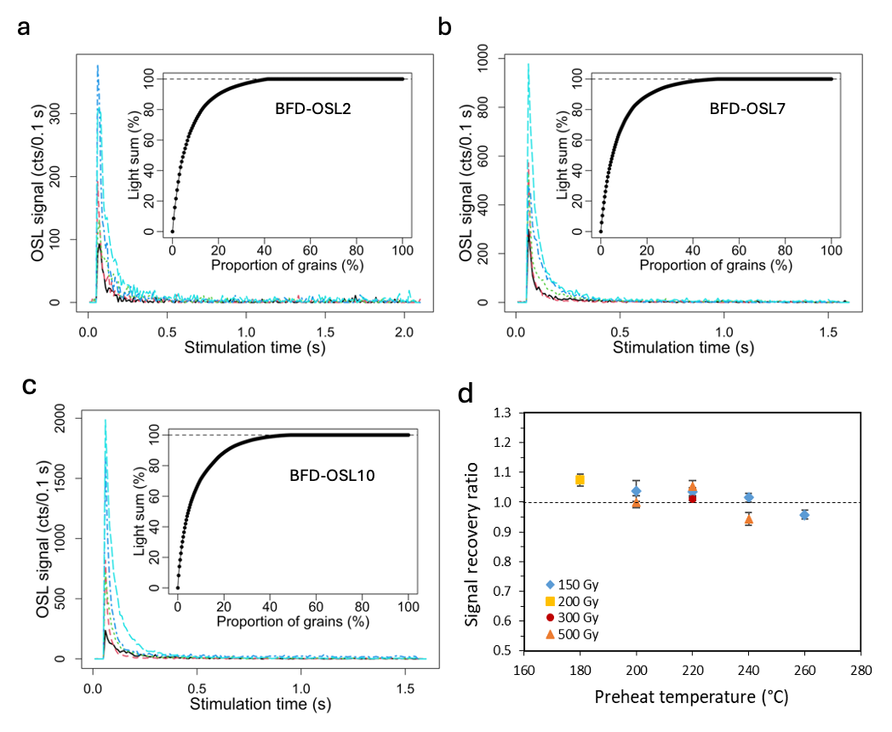

Supplementary Fig. 2 | Quartz OSL characteristics and dose recovery results. a–c, Typical OSL decay curves of 5 grains from samples BFD-OSL2, -OSL7 and -OSL10, respectively. The insets show the accumulative light sum of the T_{n} intensities for all the grains for each sample. d, Signal recovery ratios obtained at different preheat temperatures.
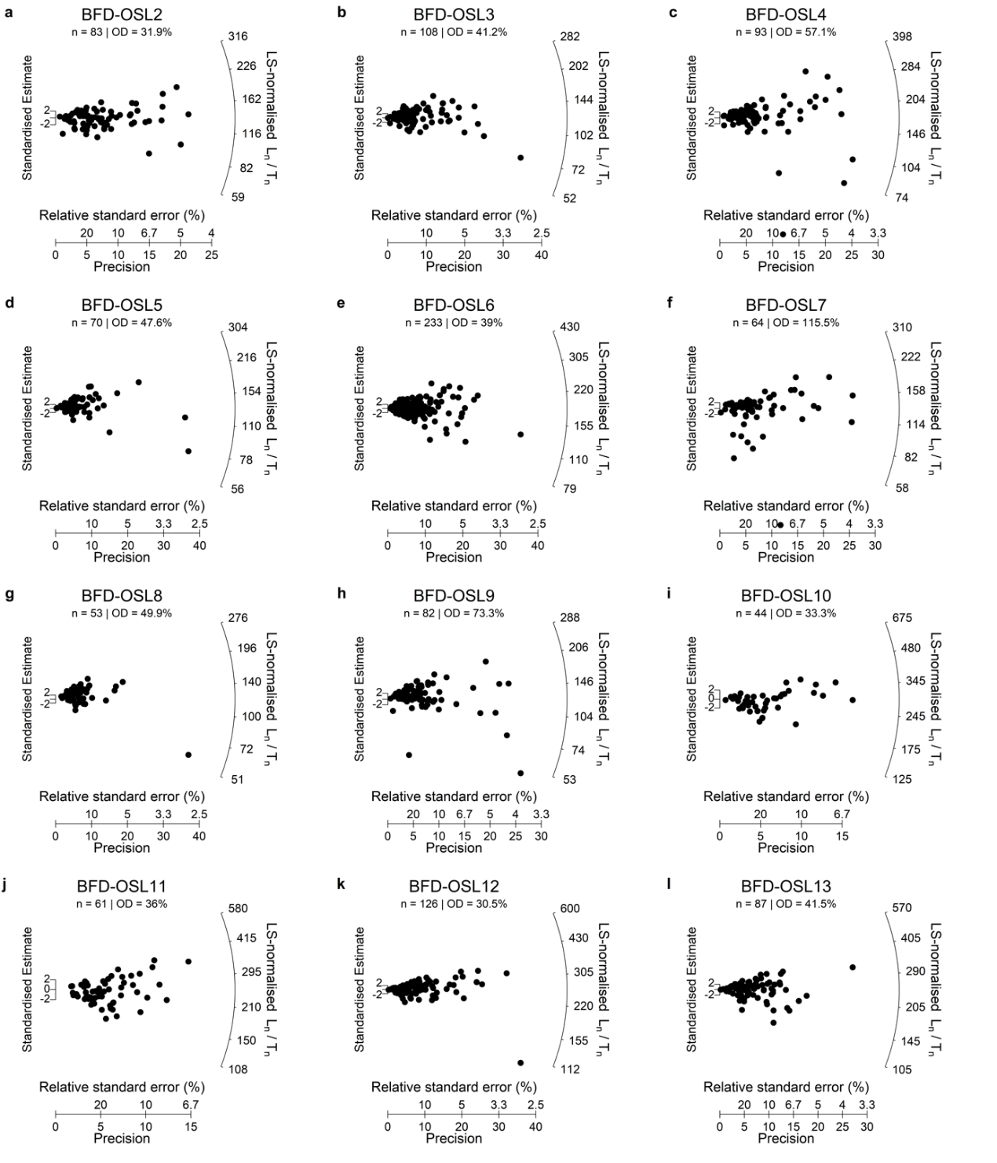

Supplementary Fig. 3 | SAR D_{e} distribution of the accepted grains of different samples. Note that zero or negative values cannot be shown in the plots due to the logarithm scale in D_{e}, so the number shown in the plot does not necessarily reflect the true number of accepted grains.

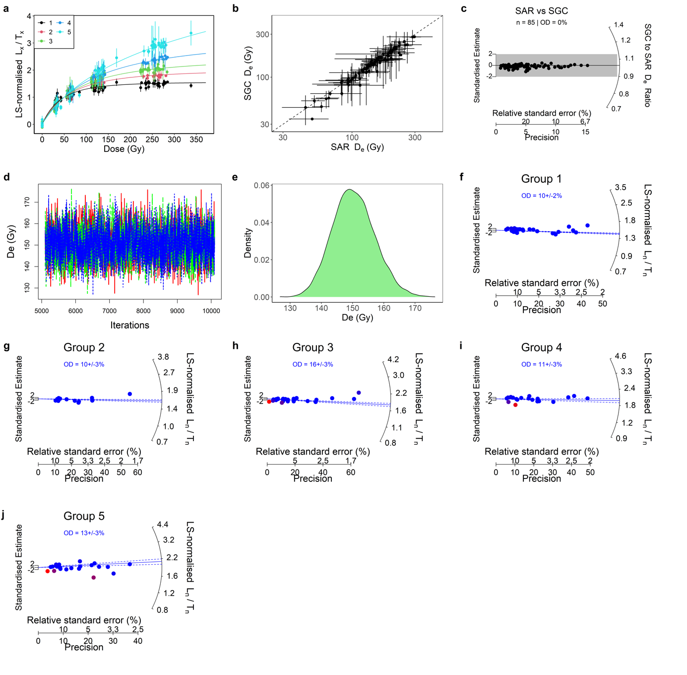

Supplementary Fig. 4 | Single-grain L_{n}/T_{n} distributions and BHAM results for sample BFD-OSL2. a, LS-normalised L_{x}/T_{x} values and best-fit SGCs (solid lines) for each group. b, Comparison of the SAR and SGC D_{e} values. c, Distribution of the ratios between SAR and SGC D_{e} values. d, traceplot showing the MCMC samples of D_{e} values from BHAM analysis. Three parallel chains are shown in different colours. e, Density distribution of the MCMC samples of D_{e} values from BHAM analysis. f–j, Distributions of LS-normalised L_{n}/T_{n} for each group. The colour represents the corresponding posterior outlier probabilities for individual grains estimated using the BHAM. The blue dashed lines represent the 95% HPD intervals for the BHAM L_{n}/T_{n} estimate for each group, and the full line represents the 50% quantile of the posterior probability of the L_{n}/T_{n} estimate. The data points are colour-coded based on their mean outlier probabilities. Grains with negligible outlier probability (<5%) are shown in blue and those have extremely high outlier probability (>95%) are shown in red.
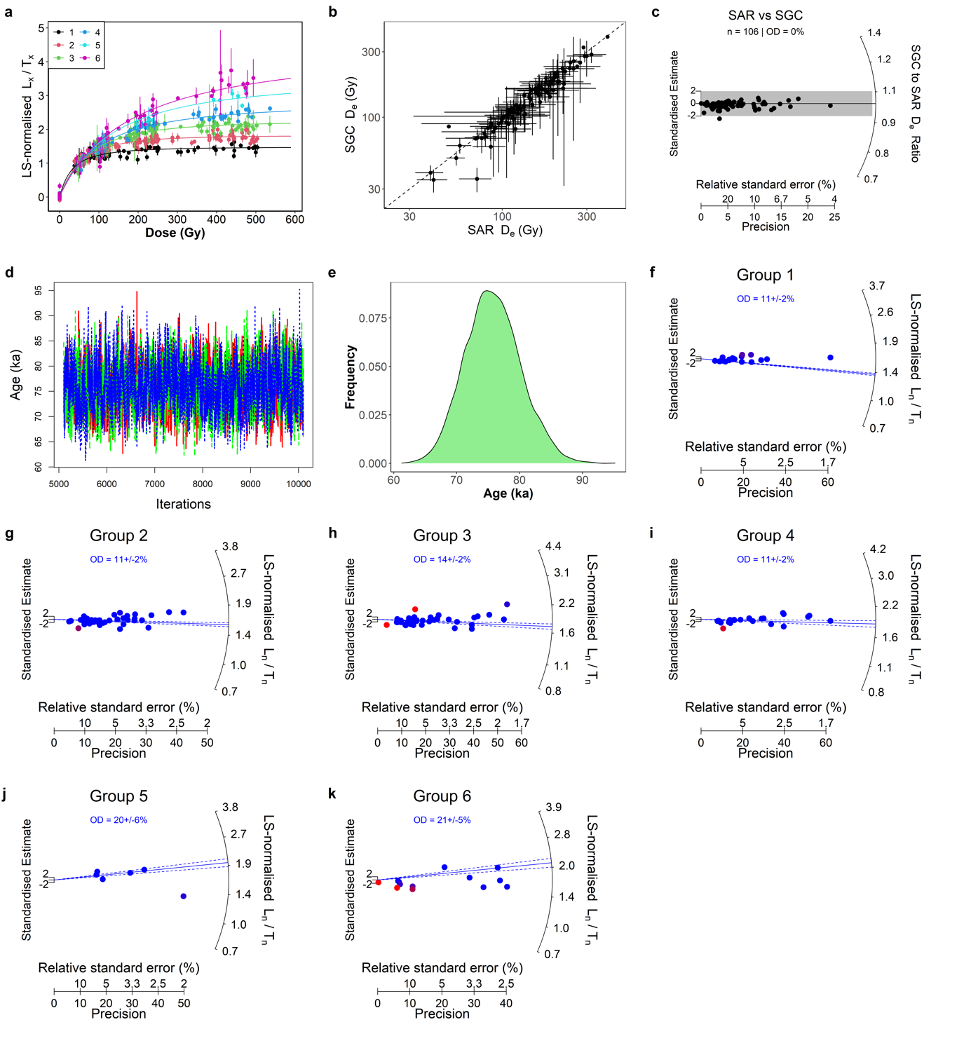

Supplementary Fig. 5 | Quartz OSL SGC results and L_{n}/T_{n} distributions for BFD-OSL3. See caption for Supplementary Fig. 4.

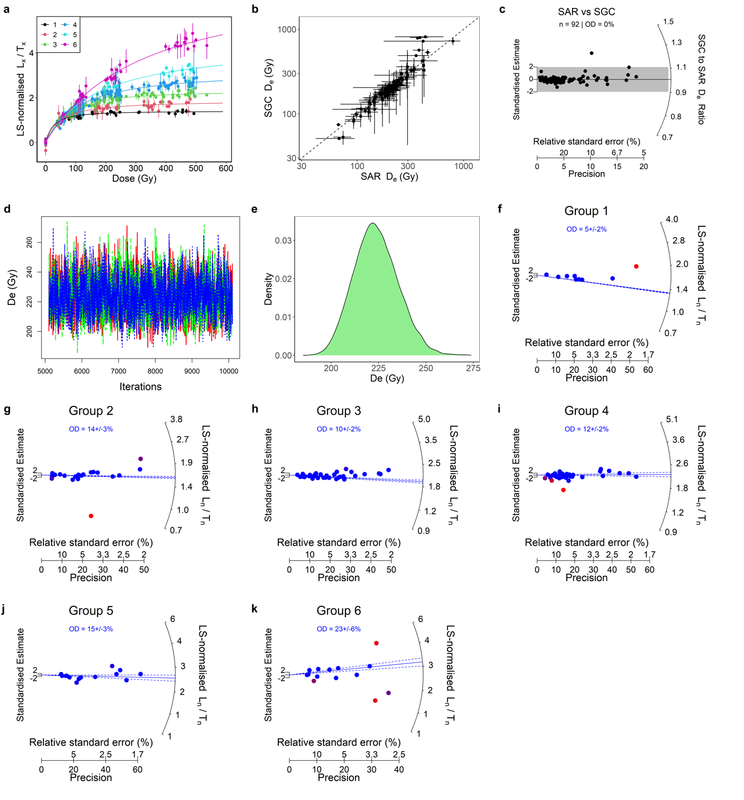

Supplementary Fig. 6 | Quartz OSL SGC results and L_{n}/T_{n} distributions for BFD-OSL4. See caption for Supplementary Fig. 4.

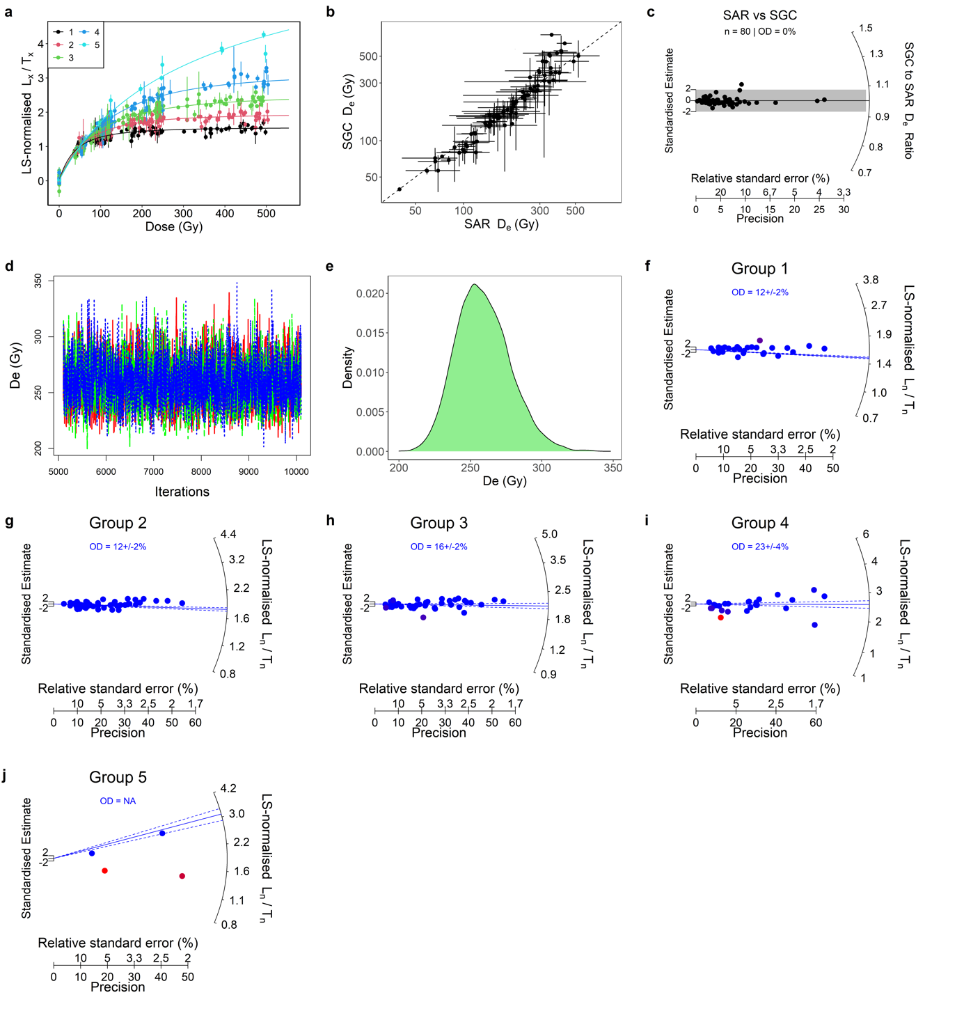

Supplementary Fig. 7 | Quartz OSL SGC results and L_{n}/T_{n} distributions for BFD-OSL5. See caption for Supplementary Fig. 4.

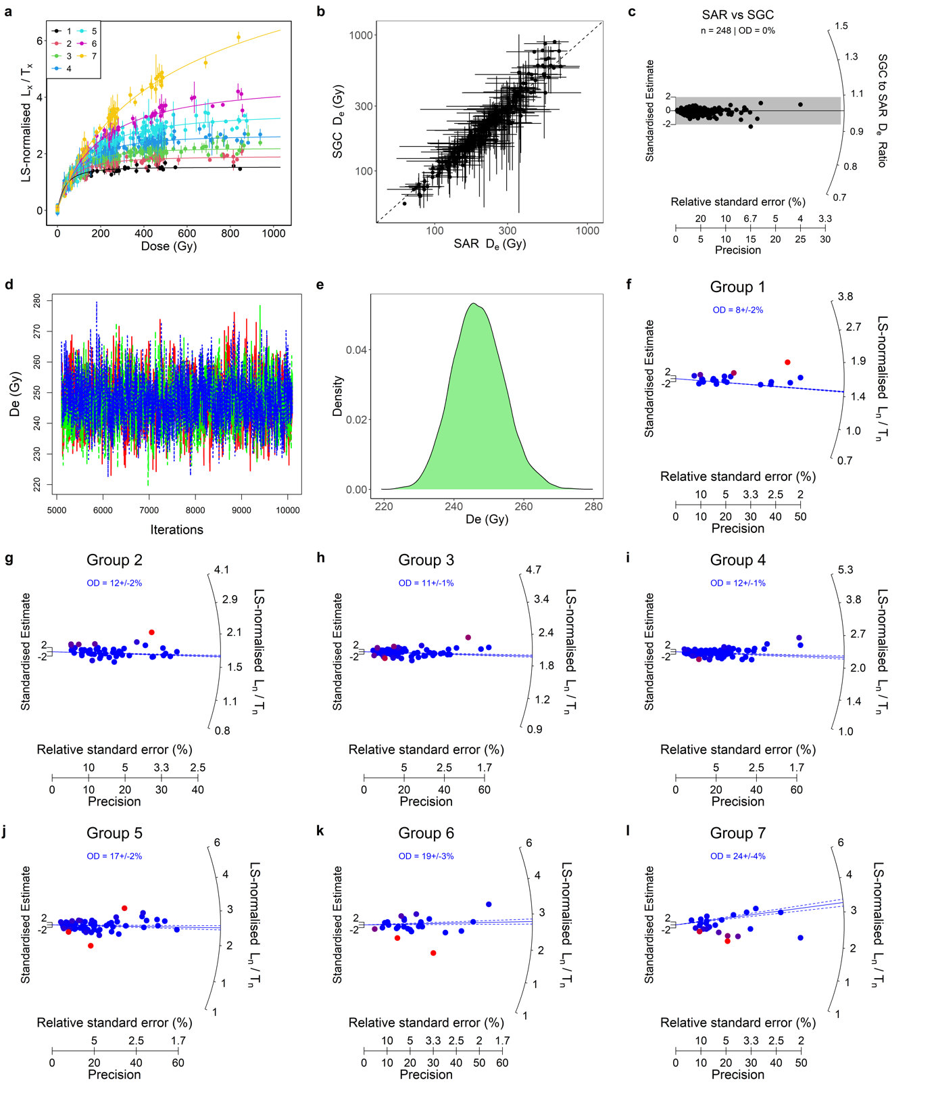

Supplementary Fig. 8 | Quartz OSL SGC results and L_{n}/T_{n} distributions for BFD-OSL6. See caption for Supplementary Fig. 4.

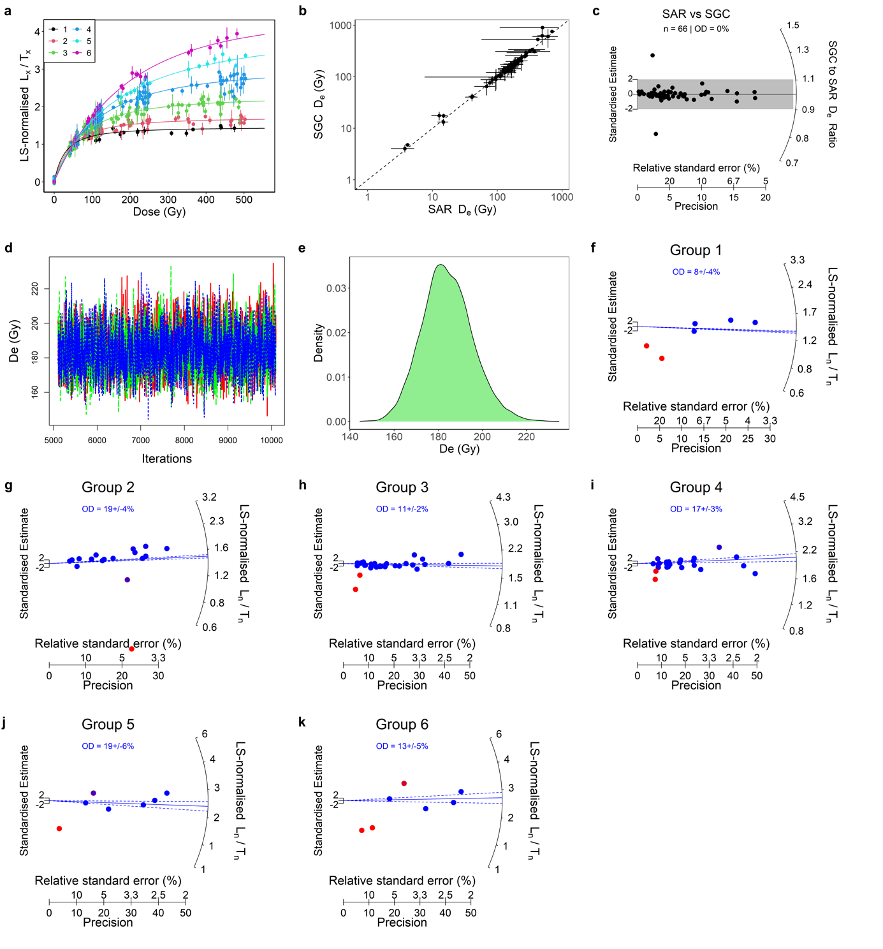

Supplementary Fig. 9 | Quartz OSL SGC results and L_{n}/T_{n} distributions for BFD-OSL7. See caption for Supplementary Fig. 4.

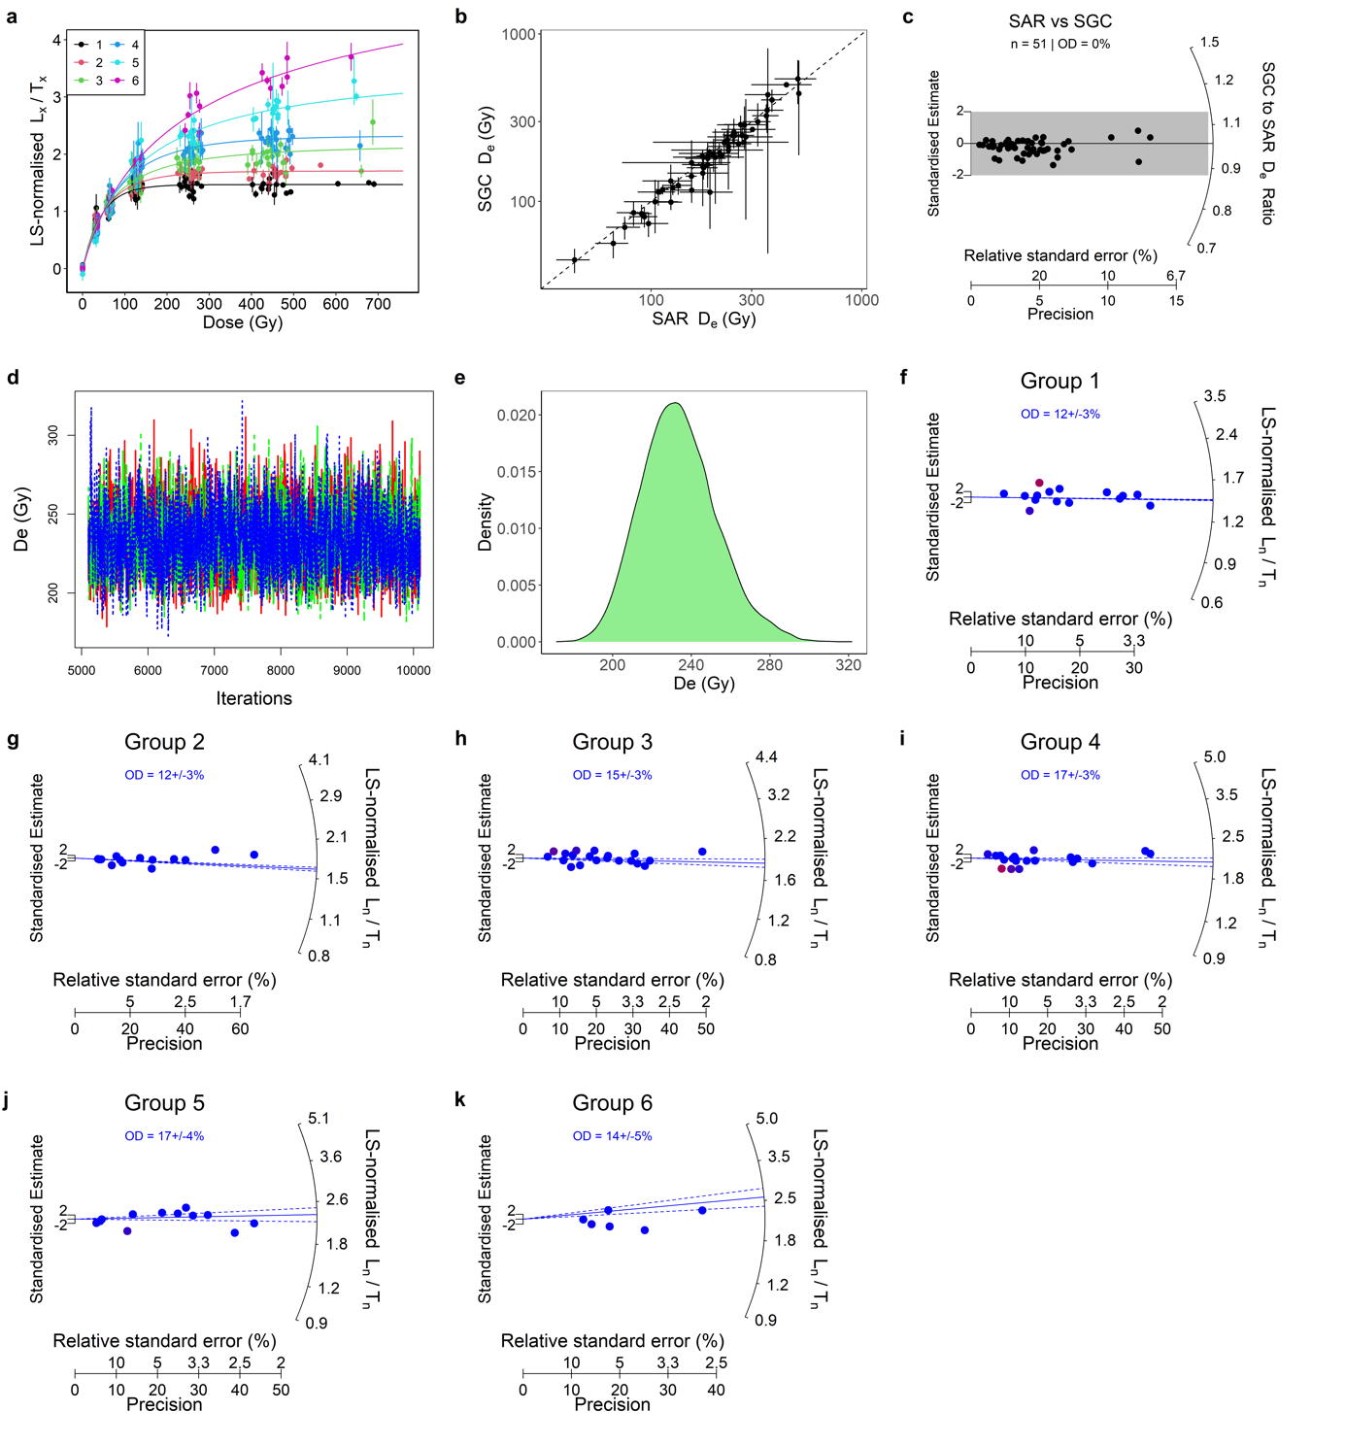

Supplementary Fig. 10 | Quartz OSL SGC results and L_{n}/T_{n} distributions for BFD-OSL8. See caption for Supplementary Fig. 4.

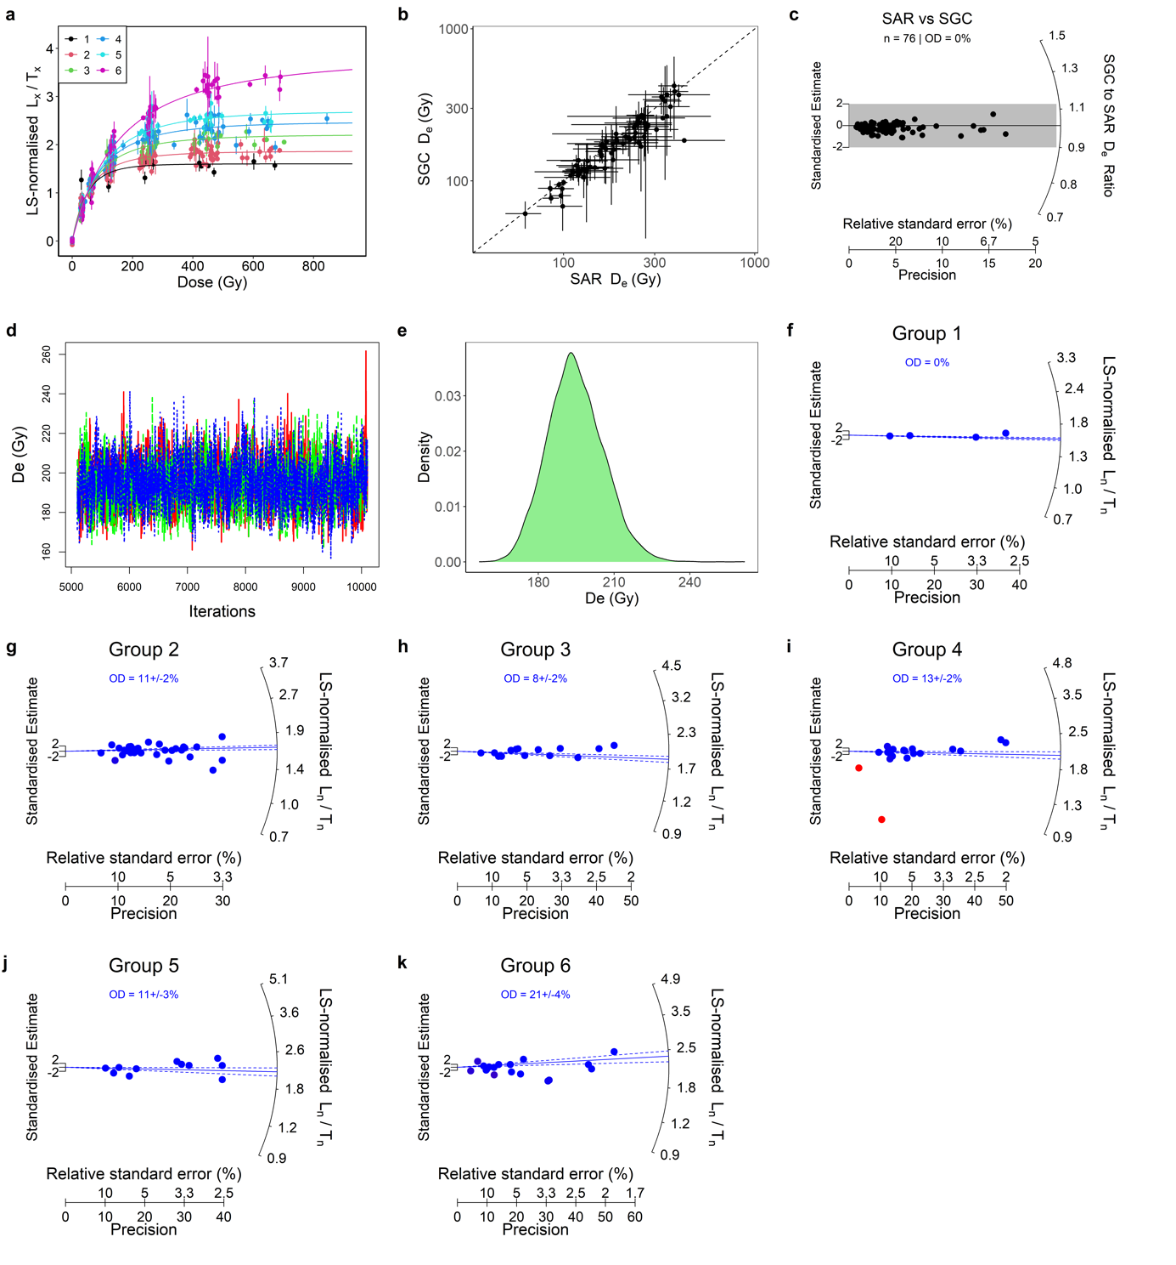

Supplementary Fig. 11 | Quartz OSL SGC results and L_{n}/T_{n} distributions for BFD-OSL9. See caption for Supplementary Fig. 4.

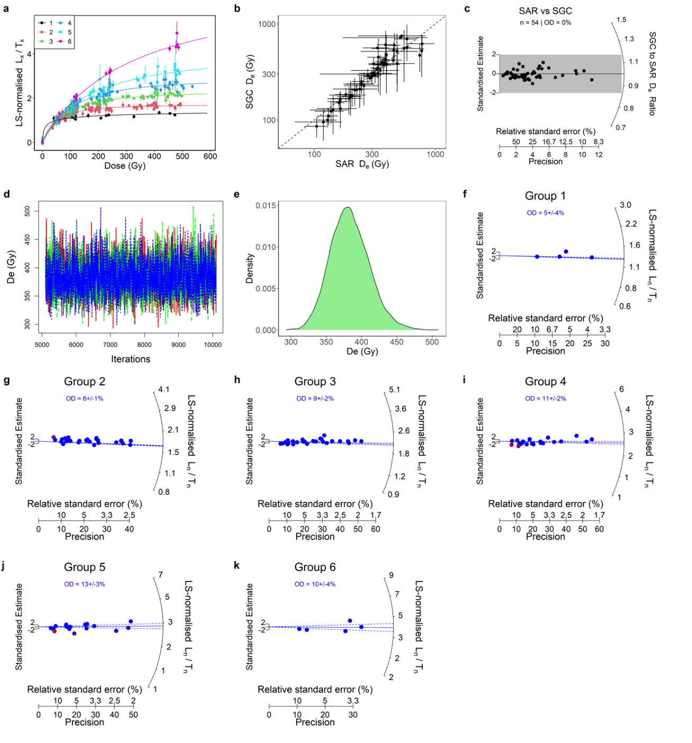

Supplementary Fig. 12 | Quartz OSL SGC results and L_{n}/T_{n} distributions for BFD-OSL10. See caption for Supplementary Fig. 4.

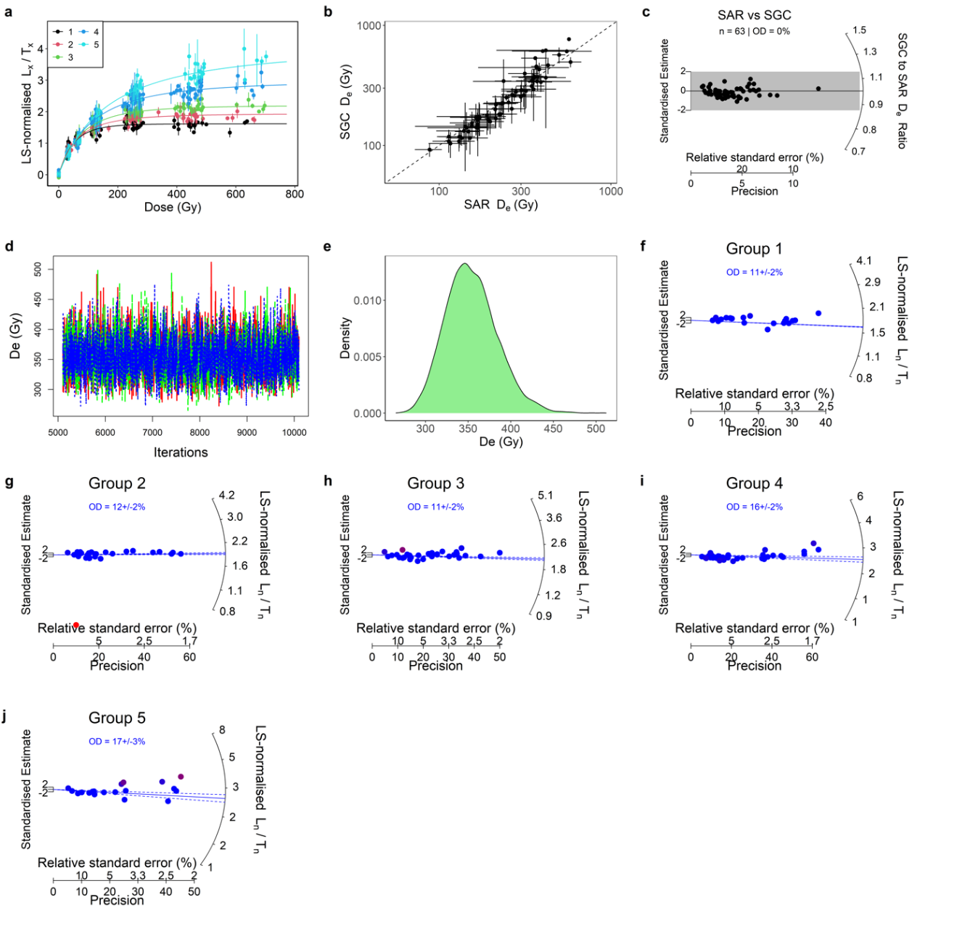

Supplementary Fig. 13 | Quartz OSL SGC results and L_{n}/T_{n} distributions for BFD-OSL11. See caption for Supplementary Fig. 4.

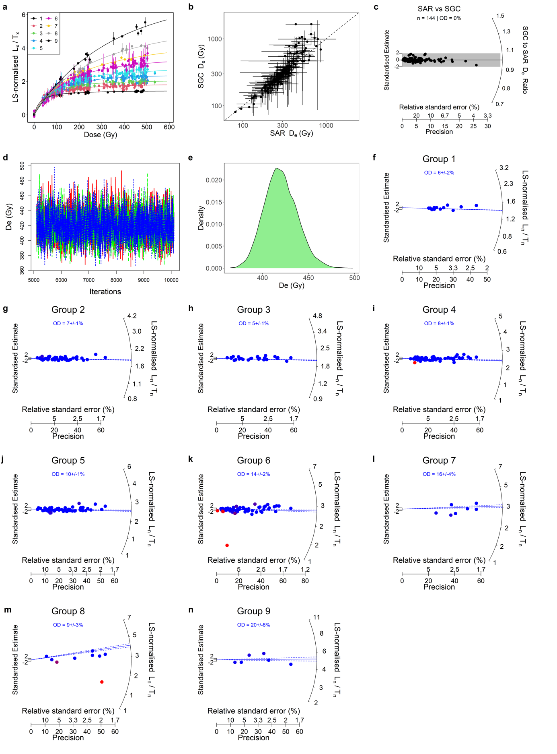

Supplementary Fig. 14 | Quartz OSL SGC results and L_{n}/T_{n} distributions for BFD-OSL12. See caption for Supplementary Fig. 4.

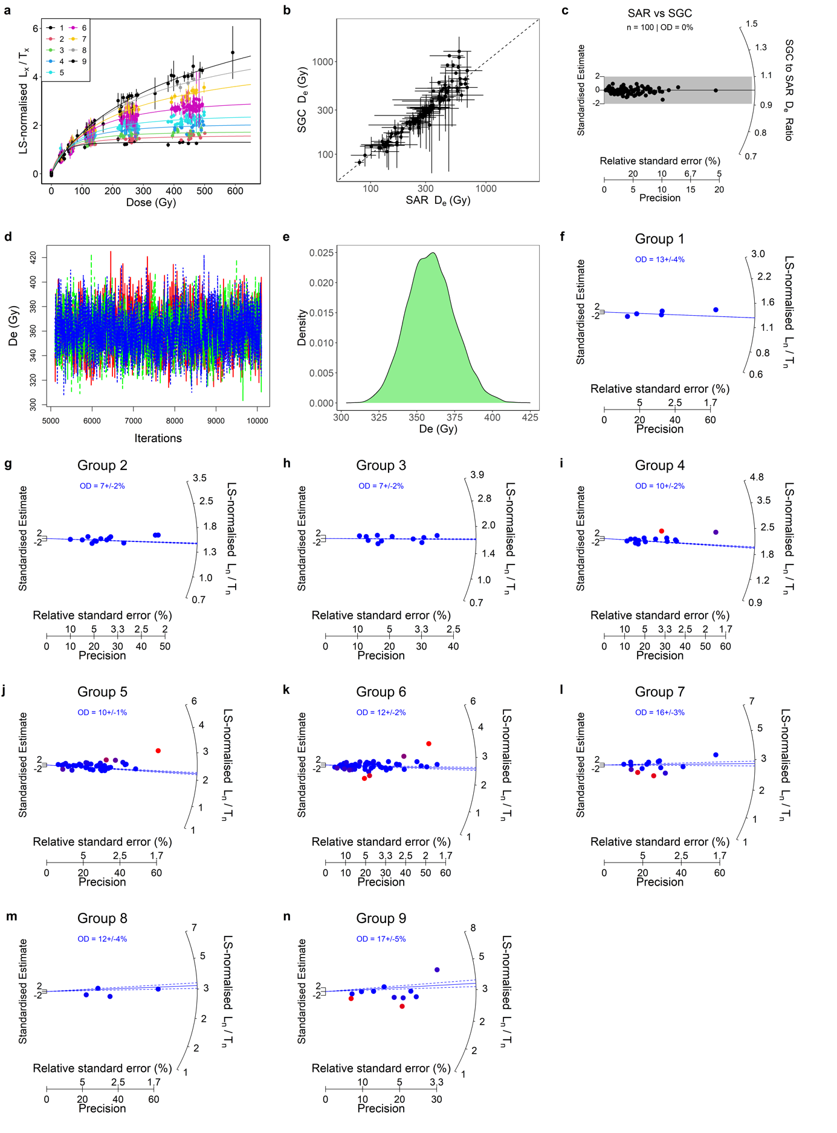

Supplementary Fig. 15 | Quartz OSL SGC results and L_{n}/T_{n} distributions for BFD-OSL13. See caption for Supplementary Fig. 4.

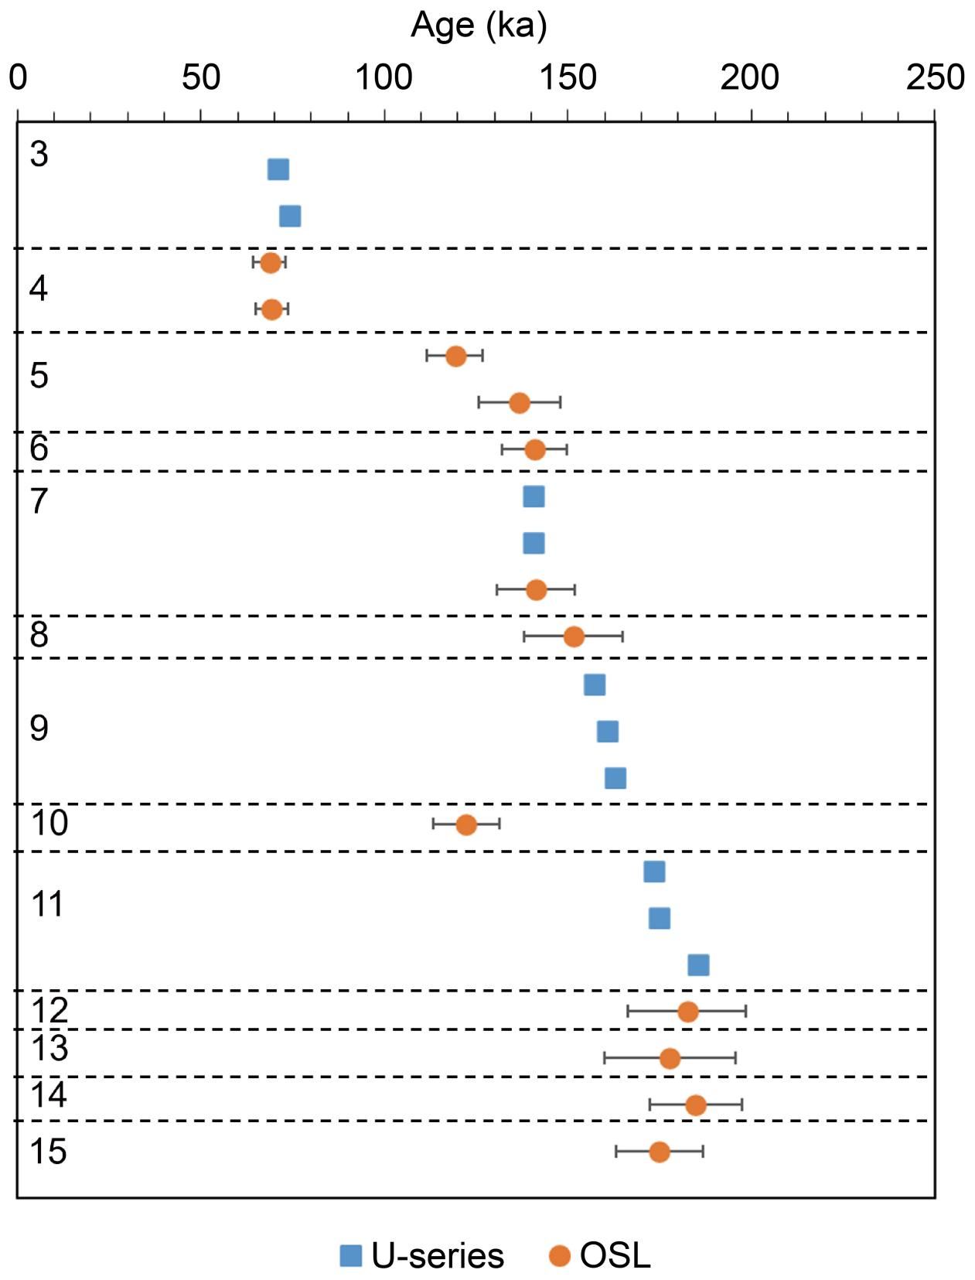

Supplementary Fig. 16 | Comparison of the OSL and U-series ages. The ages are ranked according to their stratigraphic layers (shown as numbers on the left of the plot). The dashed lines represent the boundaries between different layers. The error bars represent 1σ uncertainty. The error bars for U-series ages are too small to show.

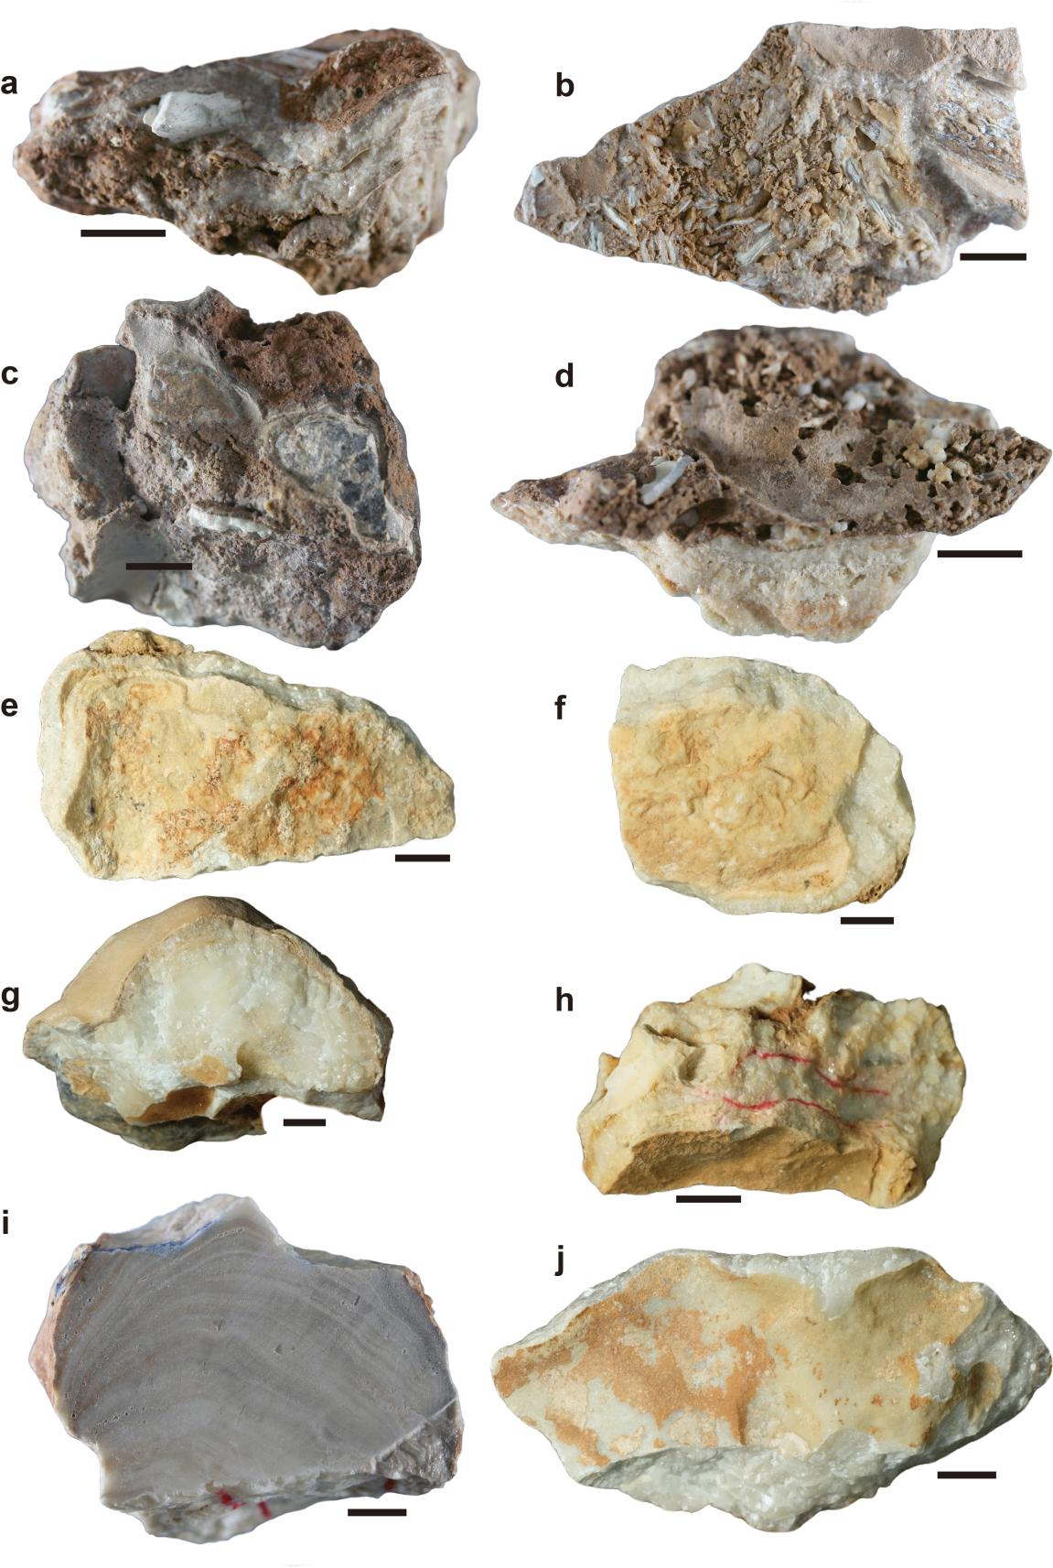
Supplementary Fig. 17 | Photos of the flowstone samples for U-series dating. a, BFD3-F1. b, BFD3-F2. c, BFD7-F1. d, BFD7-F2. e, BFD9-F1. f, BFD9-F2. g, BFD9-F4. h, BFD11-F1. i, BFD11-F2. j, BFD11-F3. The bars indicate 1 cm length.

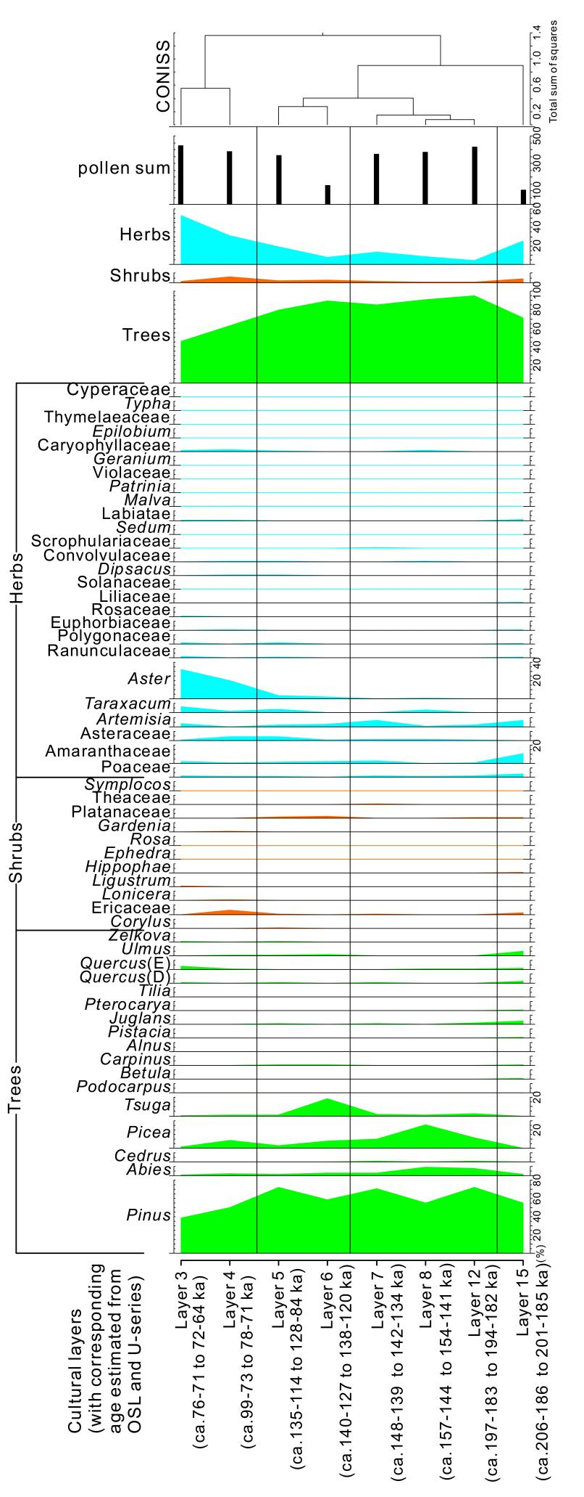
Supplementary Fig. 18 | The pollen percentages diagram in the Bianfu Cave.
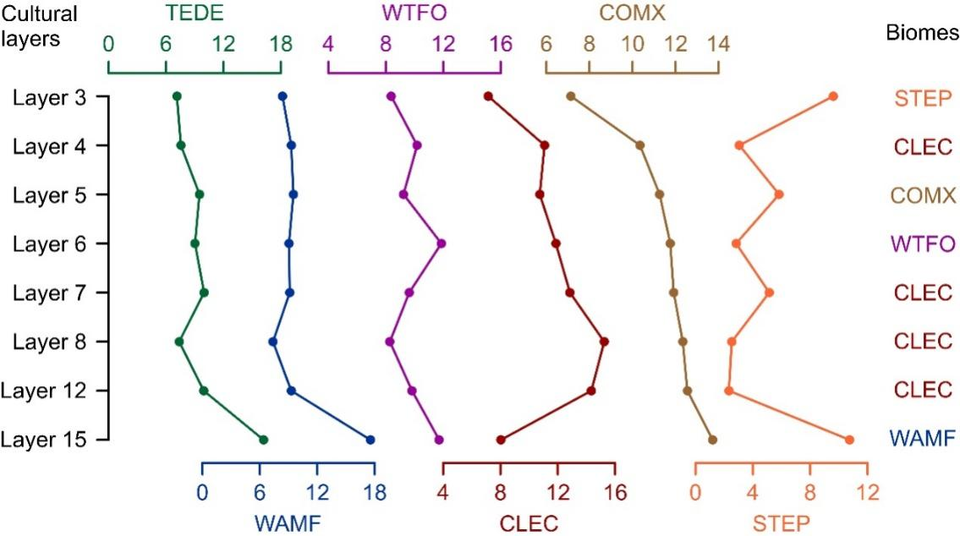
Supplementary Fig. 19 | Biome affinity scores of the Bianfu cave profile and vegetation reconstruction results (TEDE: Warm-temperate mixed forest; WAMF: North subtropical mixed forest; WTFO: Middle subtropical broadleaf evergreen forest; CLEC: Cold-temperate evergreen conifer forest; COMX: Cool-temperate mixed forest; STEP: Cool-temperate steppe).

Supplementary Fig. 20 | Bivariate plot of the canonical variate analyses (CVA) of the P₄ EDJ shape of Bianfu Cave and other taxonomic groups.

Supplementary Fig. 21 | Bivariate plot of the canonical variate analyses (CVA) of the M₂ EDJ shape of Bianfu Cave and other taxonomic groups.

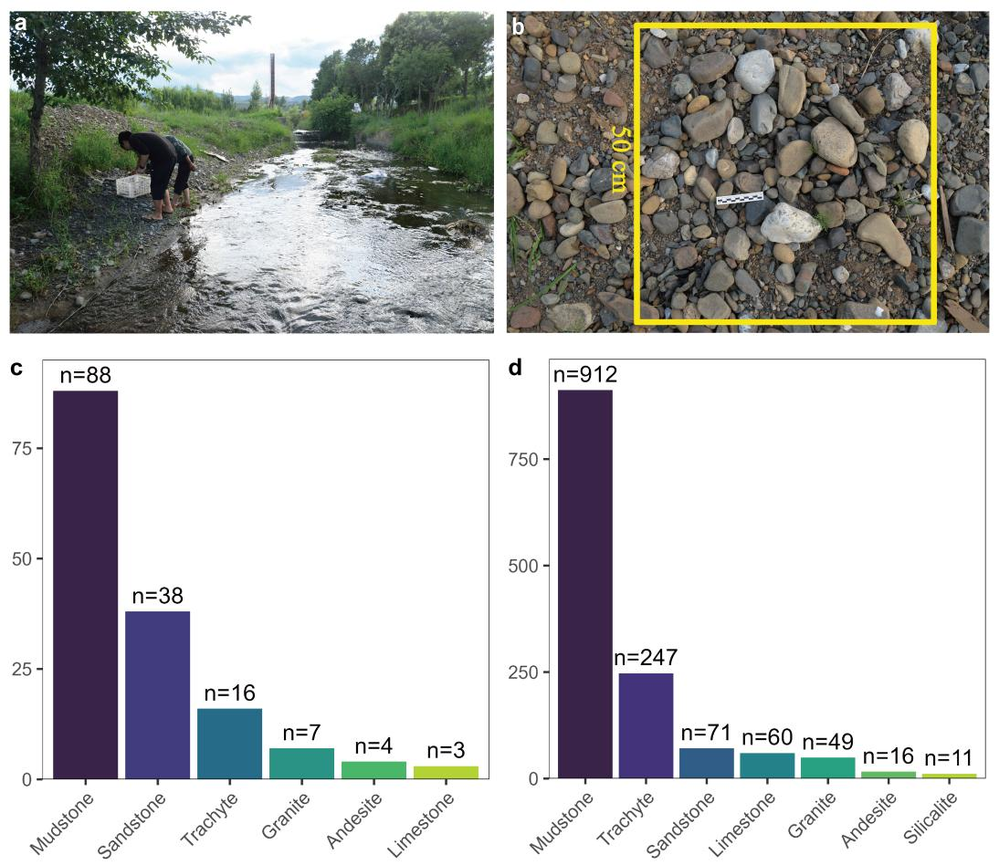

Supplementary Fig. 22 | Raw material exploitation in the Bianfu Cave lithic assemblage. a, Raw material survey along the Yinhe River; b, Close-up view of the sampled area (50×50 cm) used for raw material documentation; c, Number of the different rock types recorded in the natural riverbed, note that only cobbles with a maximum length larger than 3 cm were recored; d, Number of the different raw material types in the archaeological assemblage.
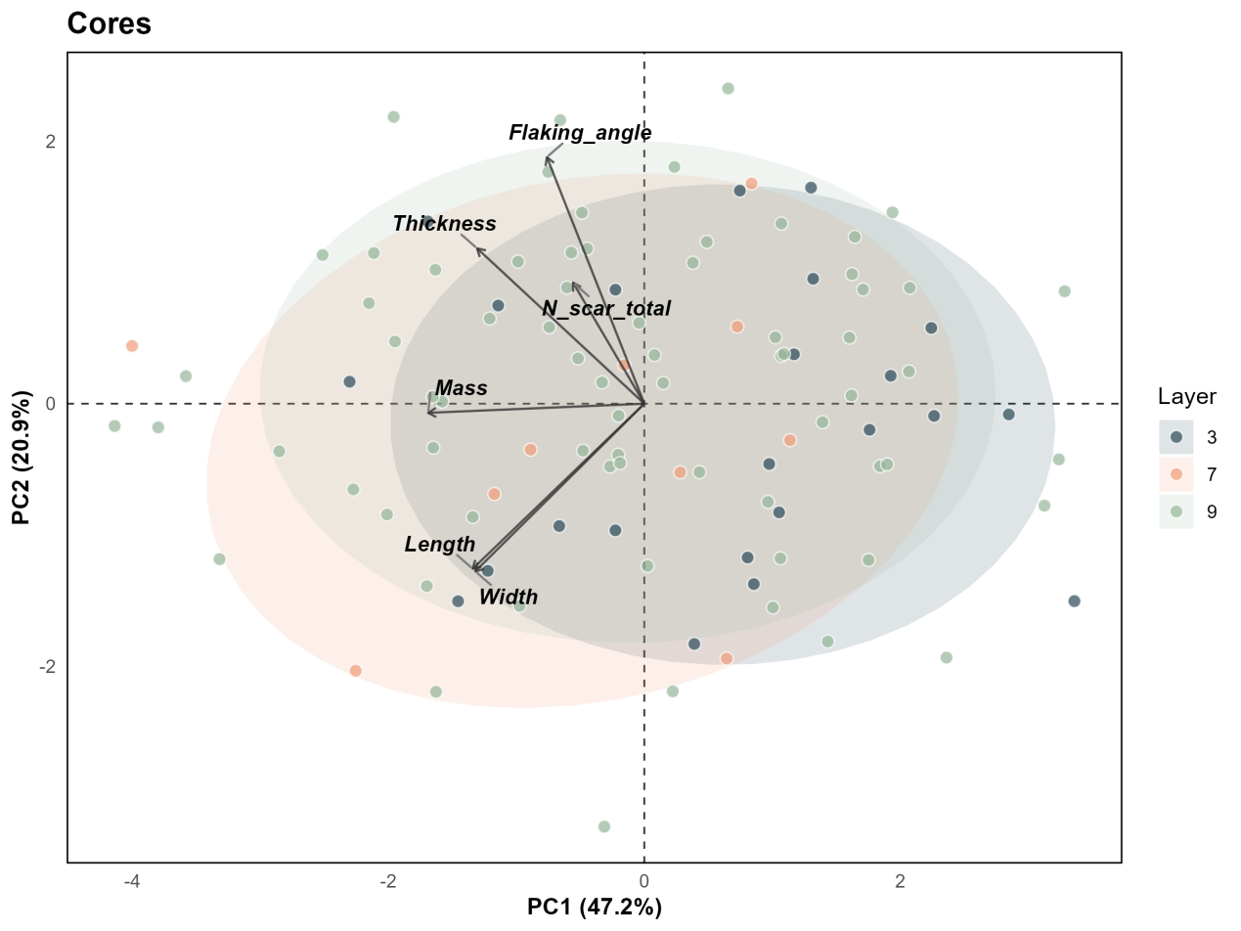

Supplementary Fig. 23 | A quantitative analysis of the technological and morphological attributes of complete cores (see Supplementary Table 21) from layers 3, 7 and 9. Result shows no statstical difference aross layers.

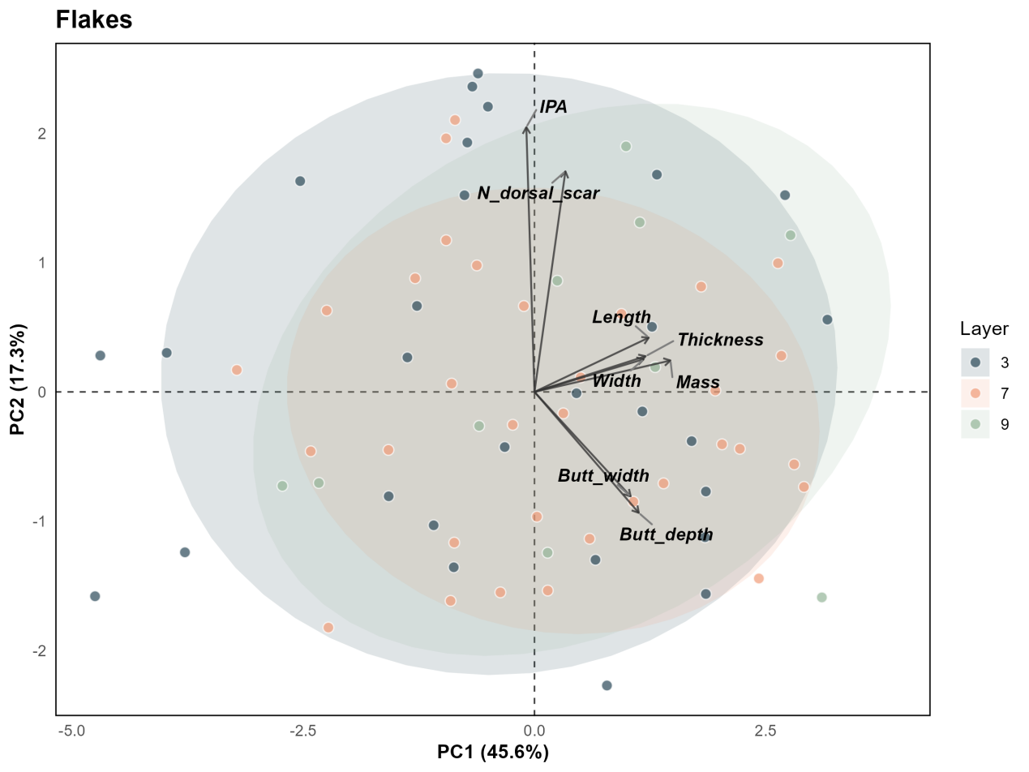

Supplementary Fig. 24 | A quantitative analysis of the technological and morphological attributes of complete flakes (see Supplementary Table 22) from layers 3, 7 and 9. Result shows no statstical difference aross layers.

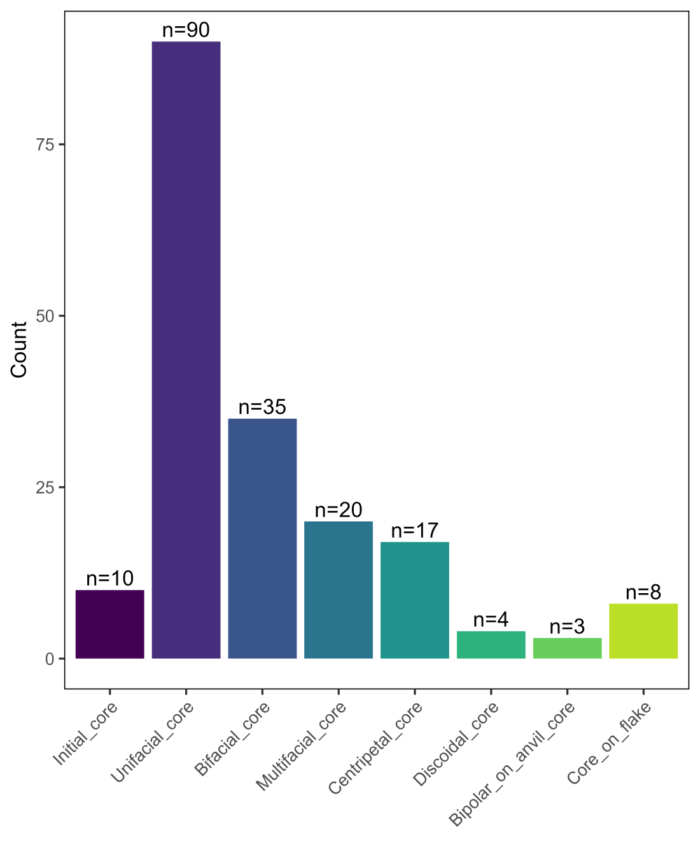

Supplementary Fig. 25 | Frequency of core types in the Bianfu Cave lithic assemblage.
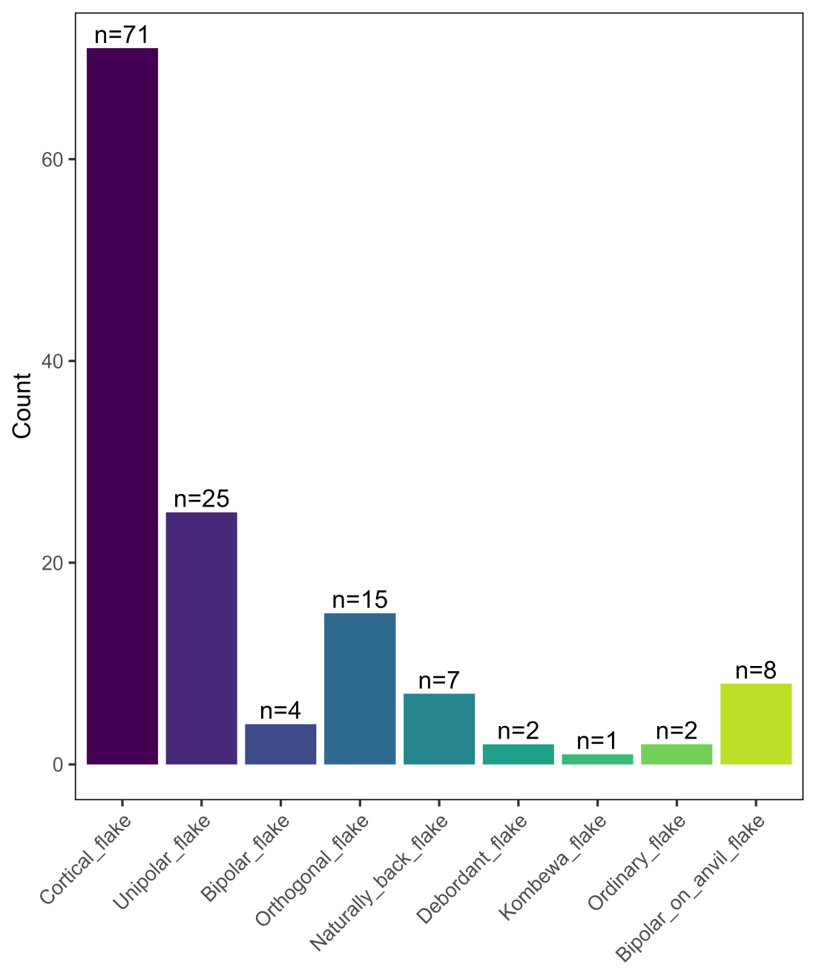

Supplementary Fig. 26 | Frequency of flake types in the Bianfu Cave lithic assemblage.
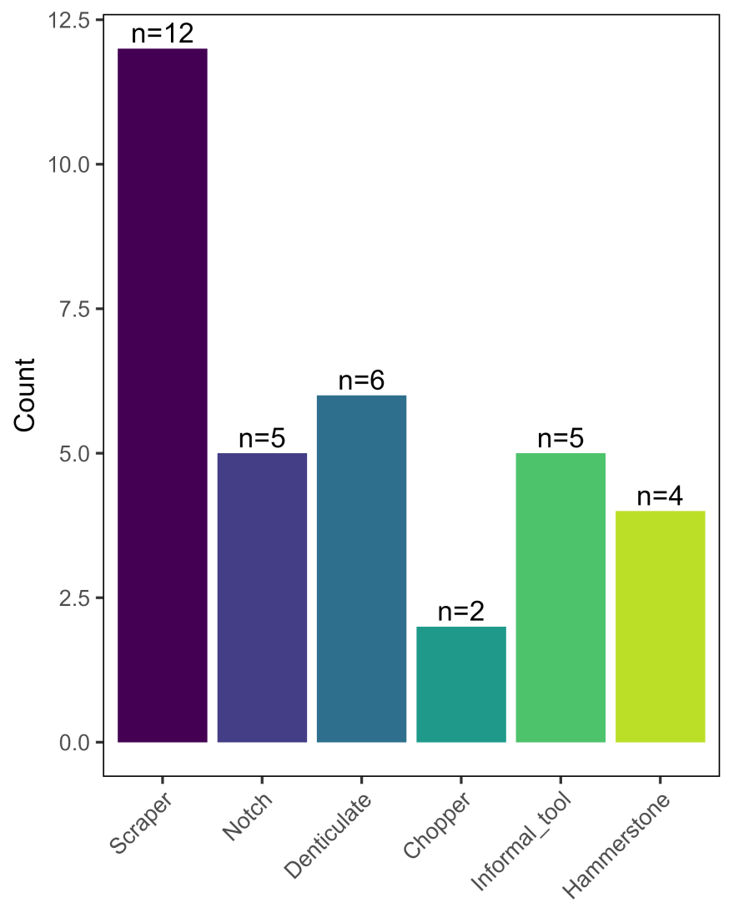

Supplementary Fig. 27 | Frequency of tool types in the Bianfu Cave lithic assemblage.
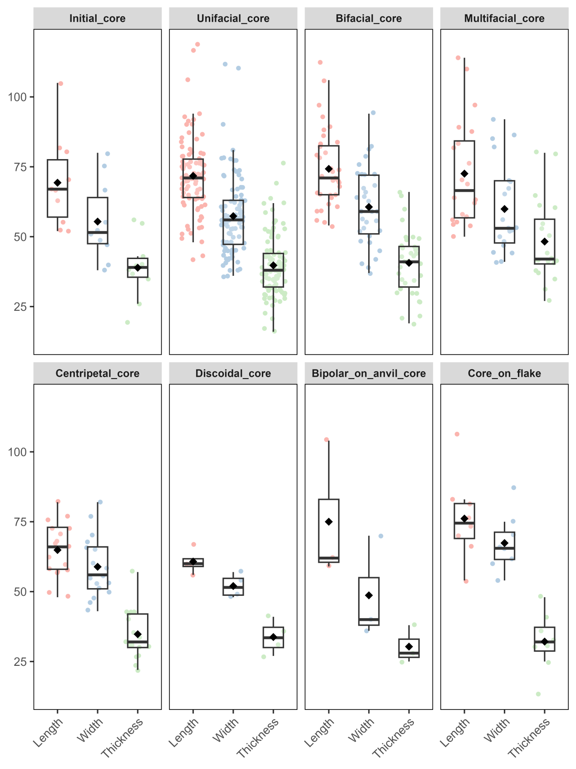

Supplementary Fig. 28 | Boxplots of length, width, and thickness distributions across core types in the Bianfu Cave lithic assemblage.
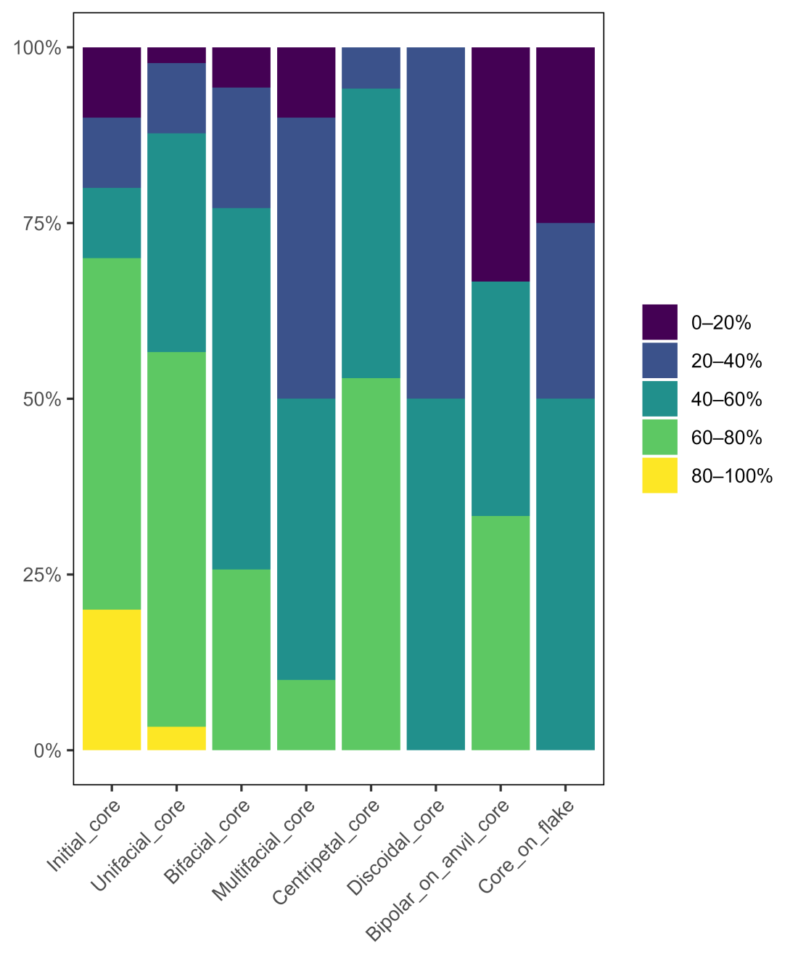

Supplementary Fig. 29 | Percentage composition of cortex on cores in the Bianfu Cave lithic assemblage. Raw data for individual specimen cortex percentages are available in the online Excel file at https://doi.org/10.17605/OSF.IO/PFWNR.
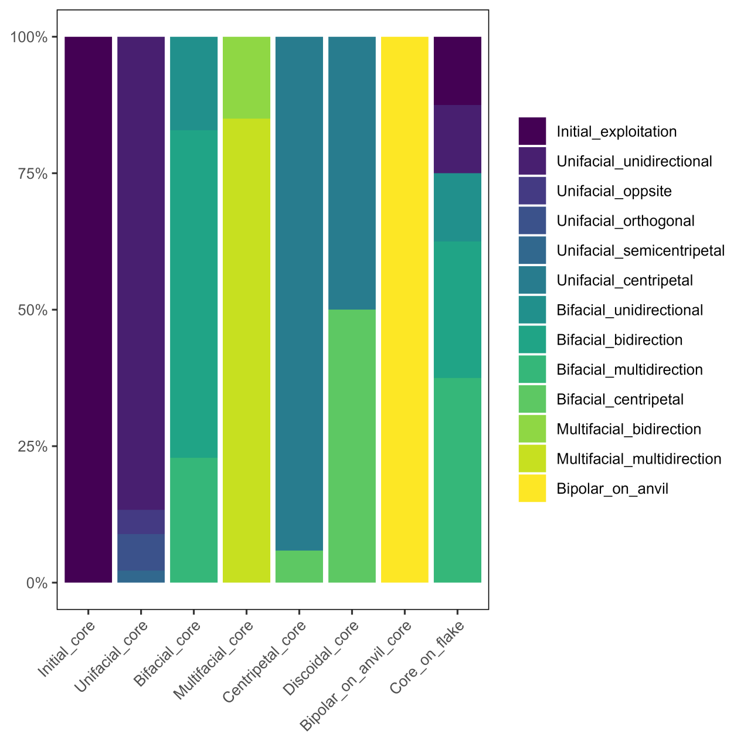

Supplementary Fig. 30 | Percentage composition of flaking patterns on cores in the Bianfu Cave lithic assemblage.

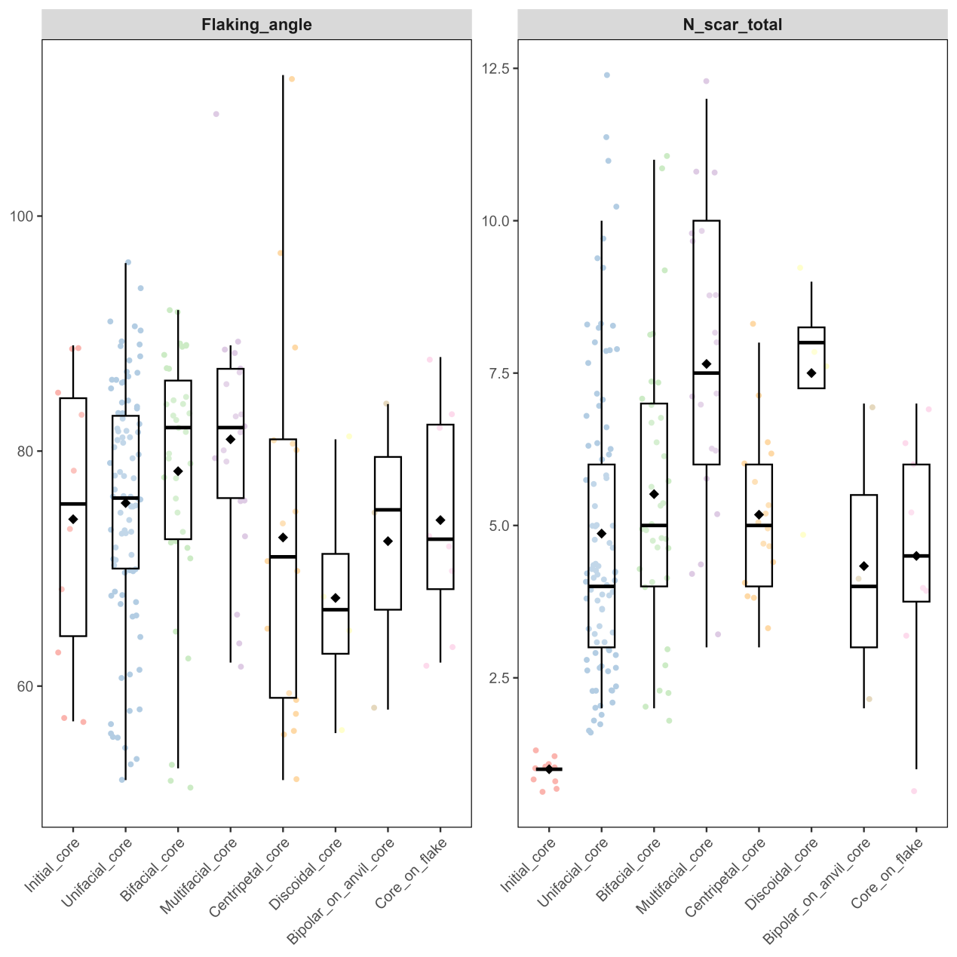

Supplementary Fig. 31 | Boxplots of platform angle and scar number across core types in the Bianfu Cave lithic assemblage.
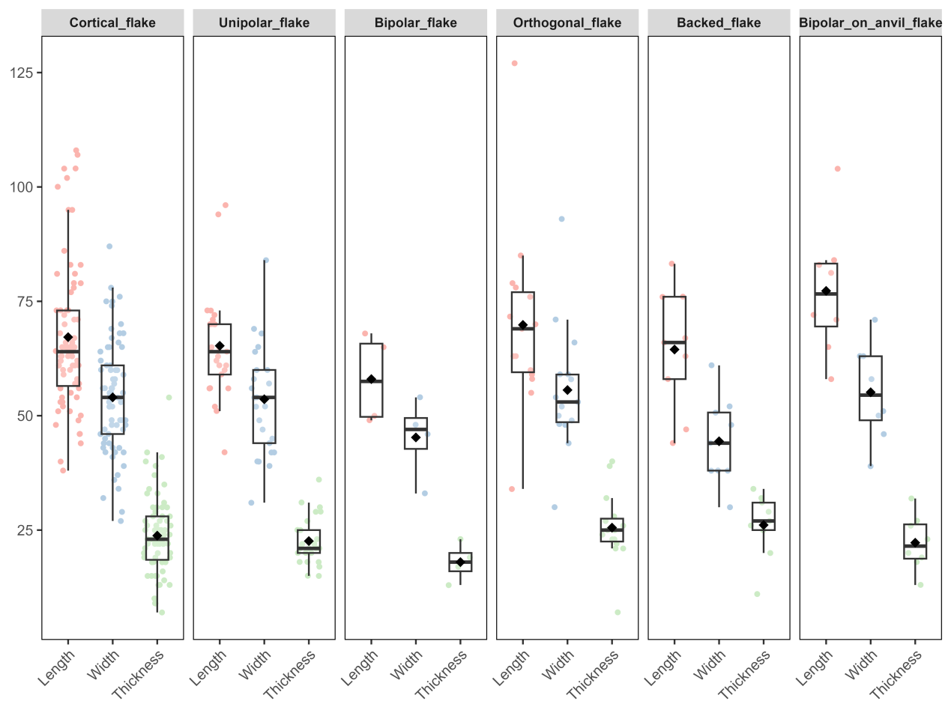

Supplementary Fig. 32 | Boxplots of length, width, and thickness distributions across flake types in the Bianfu Cave lithic assemblage.
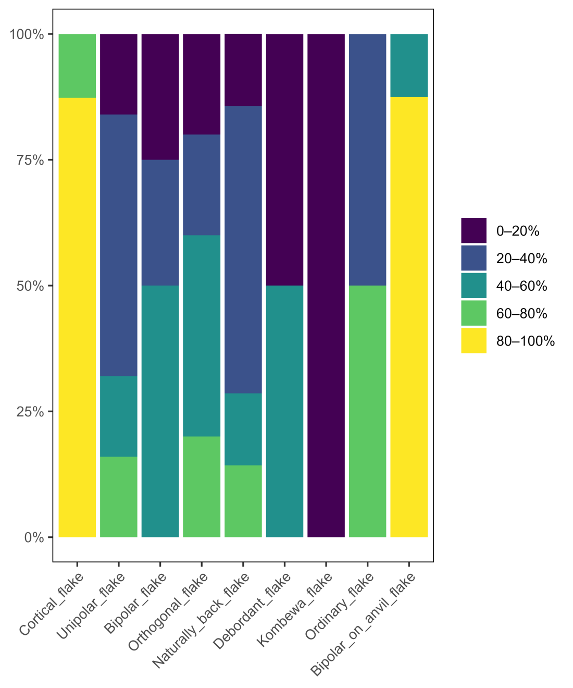

Supplementary Fig. 33 | Percentage composition of cortex on flakes in the Bianfu Cave lithic assemblage.

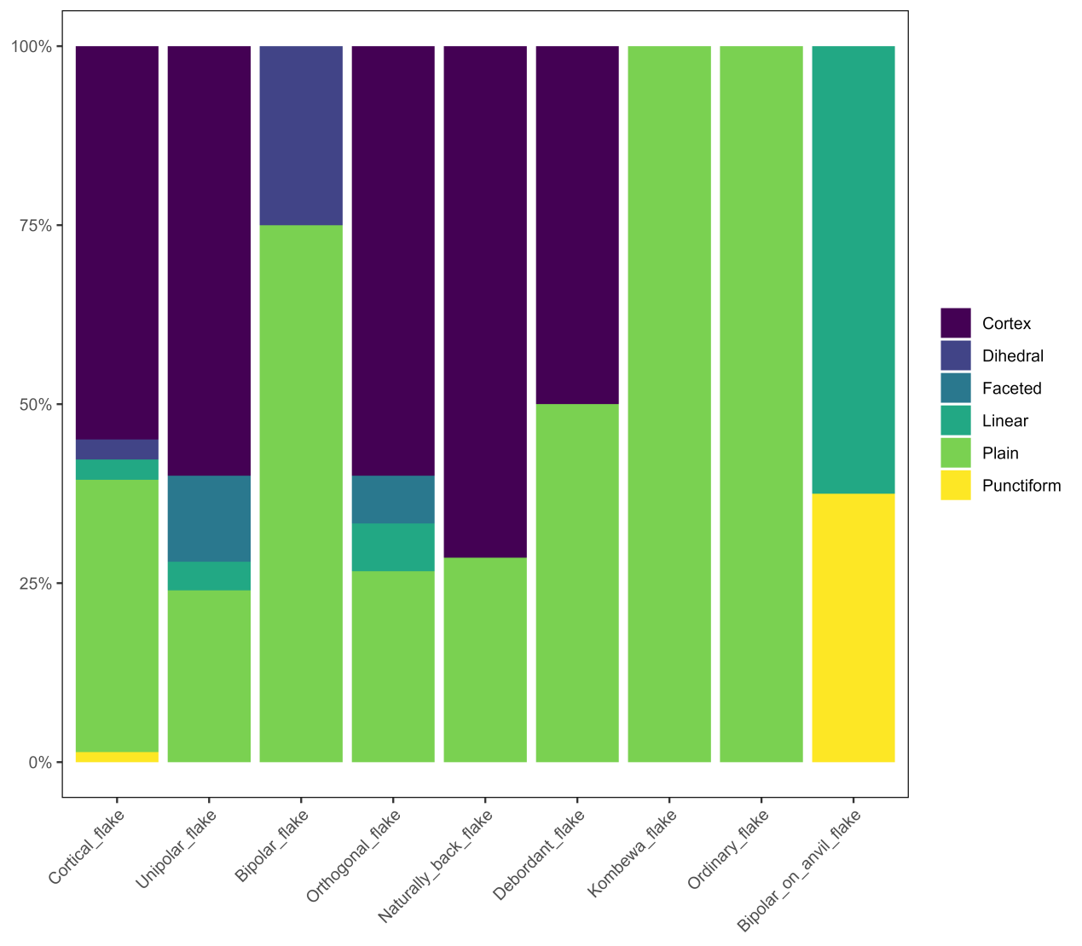

Supplementary Fig. 34 | Percentage composition of platform types on flakes in the Bianfu Cave lithic assemblage.

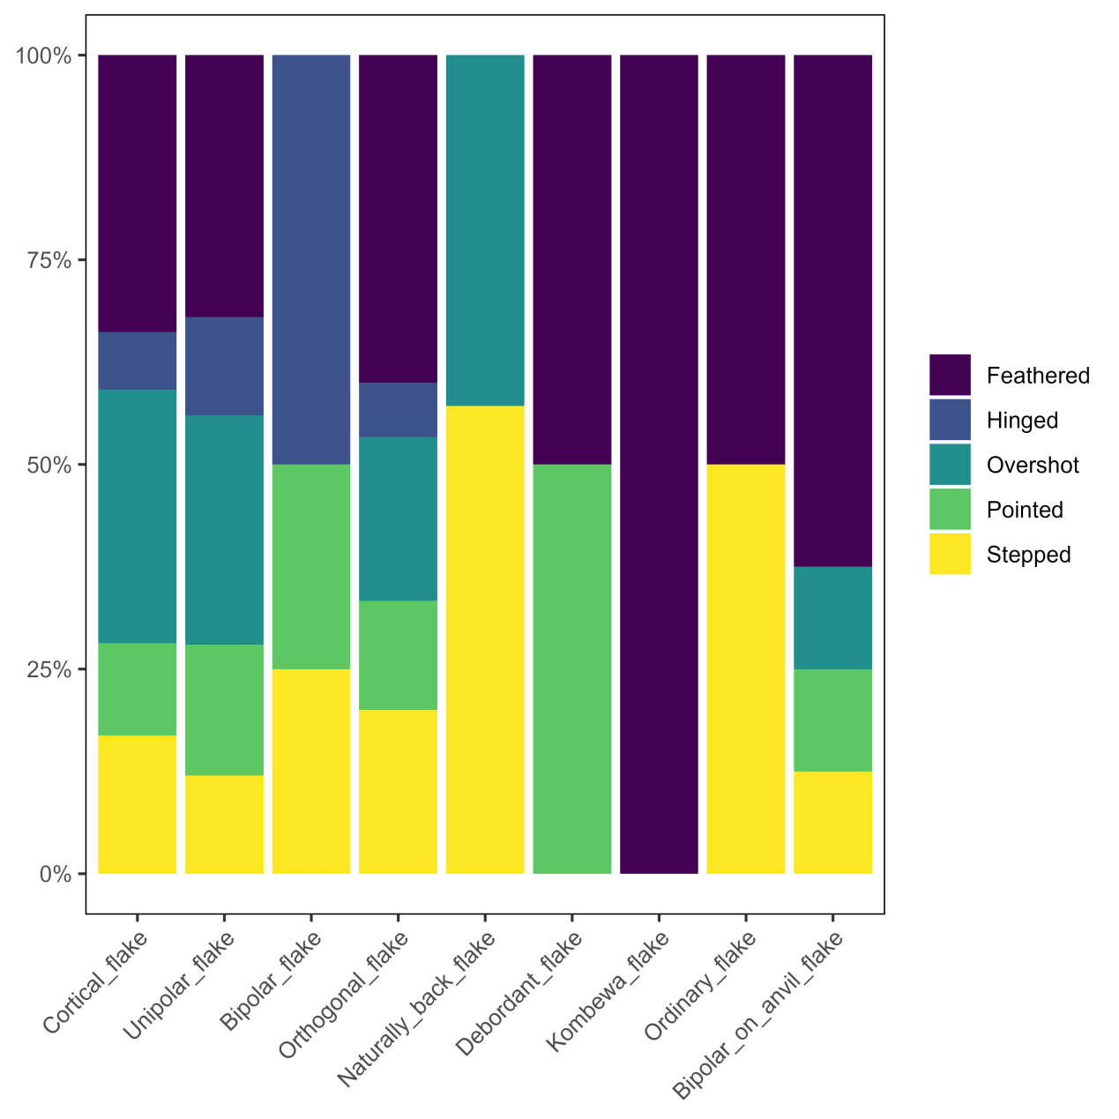

Supplementary Fig. 35 | Percentage composition of termination morphology of flakes in the Bianfu Cave lithic assemblage.

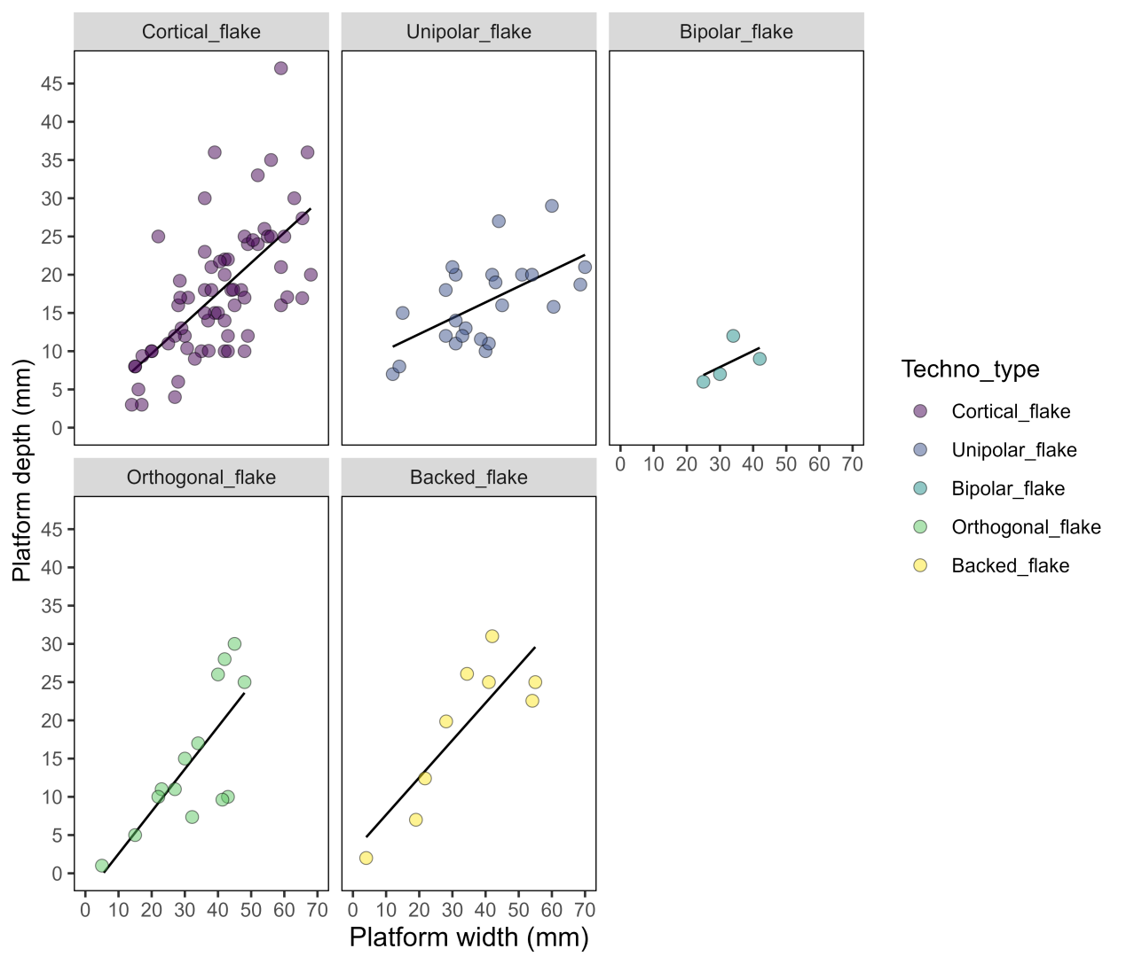

Supplementary Fig. 36 | Platform size (width and depth) of flakes in the Bianfu Cave lithic assemblage.
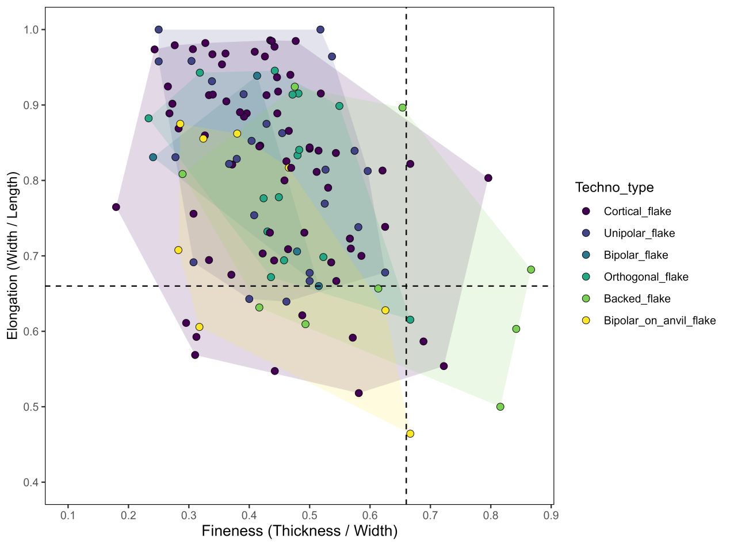

Supplementary Fig. 37 | Elongation and fineness indices for different types of flakes in the Bianfu Cave lithic assemblage.

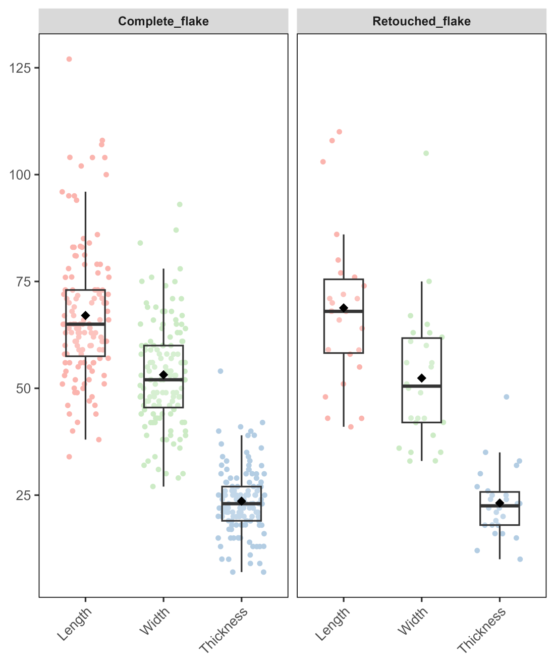

Supplementary Fig. 38 | Boxplots of length, width, and thickness for complete flakes and tools made on flake blank (retouched flakes) in the Bianfu Cave lithic assemblage.

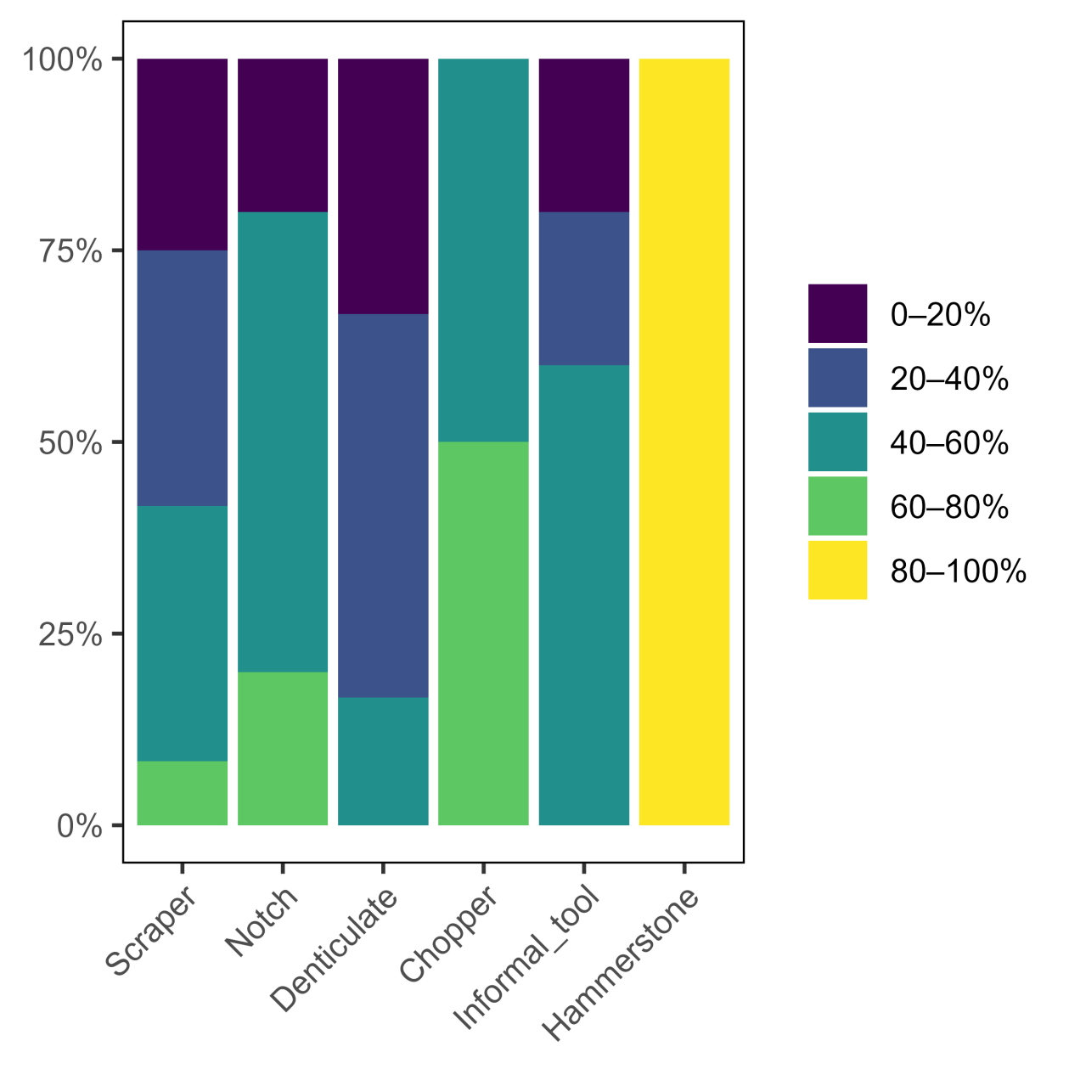

Supplementary Fig. 39 | Percentage composition of cortex on retouched tools and hammerstones in the Bianfu Cave lithic assemblage.

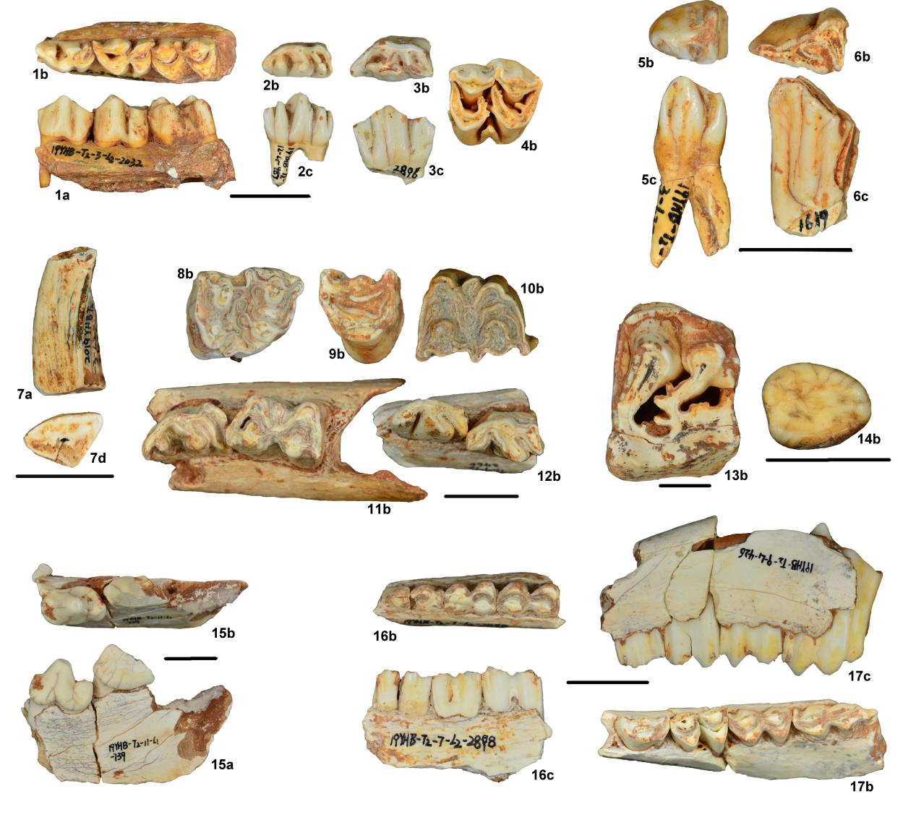
Supplementary Fig. 40 | Faunal remains excavated from the Bianfu Cave. 1. Left lower mandible with p3-m1 of Cervus (Sika) nippon; 2. Right lower p3 of Cervus elaphus; 3. Right lower p4 of Cervus elaphus; 4. Left upper M1 or M2 of Cervus elaphus; 5. Right lower p2 of Bos (Bibos) gaurus; 6. Right lower p2 of Bubalus sp.; 7. Left lower c of Sus sp. 8. Left upper M3 of Bubalus sp.; 9. Right upper P4 of Bubalus sp.; 10. Right upper M3 of Bos (Bibos) gaurus; 11. Right lower mandible with p4 and m1 of Bubalus sp.; 12. Right lower mandible with p3 and p4 of Bos (Bibos) gaurus; 13. Right upper M1 of Rhinoceros sinensis; 14. Right lower m3 of Ursus thibetanus; 15. Left lower mandible with p4 and m1 of Crocuta crocuta ultima; 16. Right lower mandible with p3-m2 of Pseudois sp.; 17. Left lower mandible with p4-m3 of Capra sp.. a, buccal view; b, occlusal views; c, lingual view; d, fracture surface view. All black scale bars represent 2 cm.

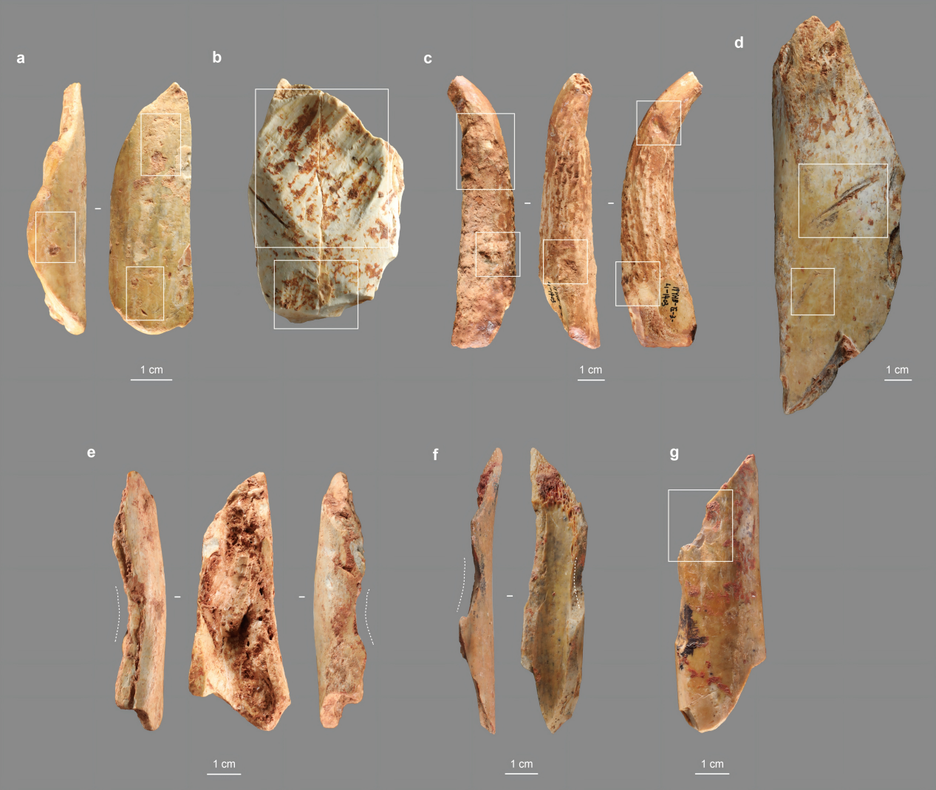
Supplementary Fig. 41 | Natural and anthropogenic modification on bone and antler surfaces. a, Sediment compression pits; b, Rodent gnawing; c, Carnivor pits and gnawing; d, Carnivor furrow; e, Psuedo-notch likely by rock falling; f, Percussion notch; g, Percussion scar.

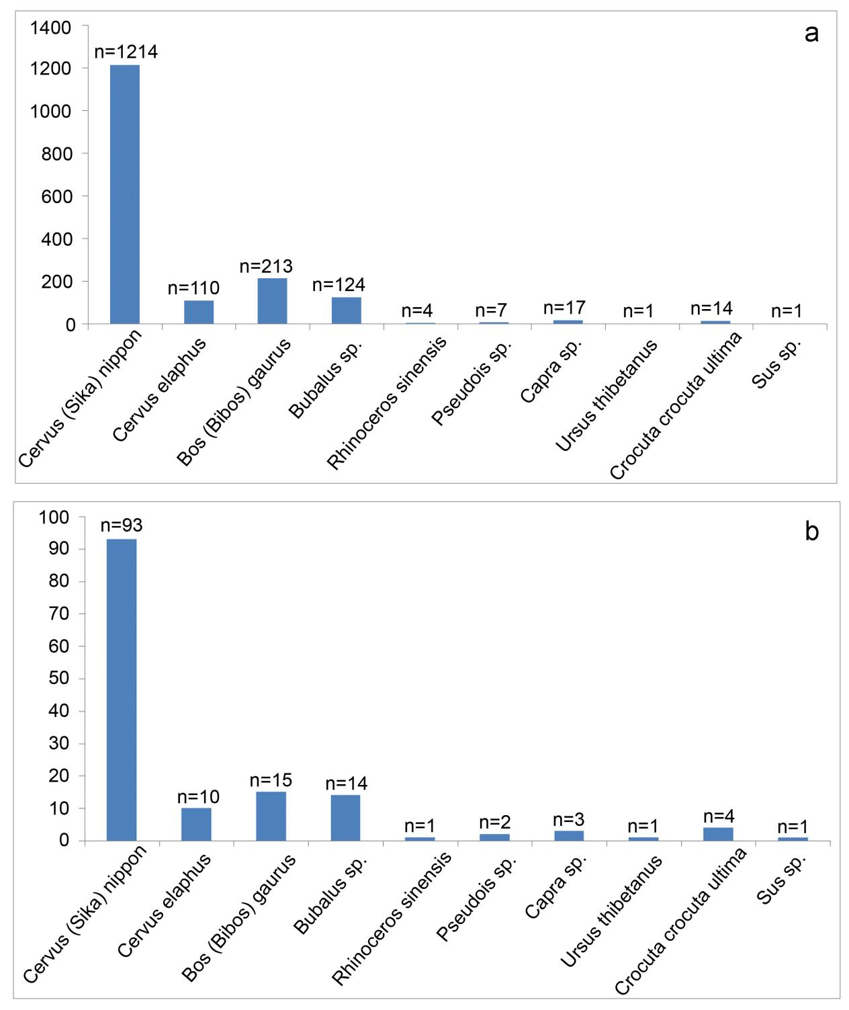

Supplementary Fig. 42 | The teeth number (a) and the minimum number of individuals (MNI) (b) of the large mammal fossil species in Bianfu Cave faunal assemblages.

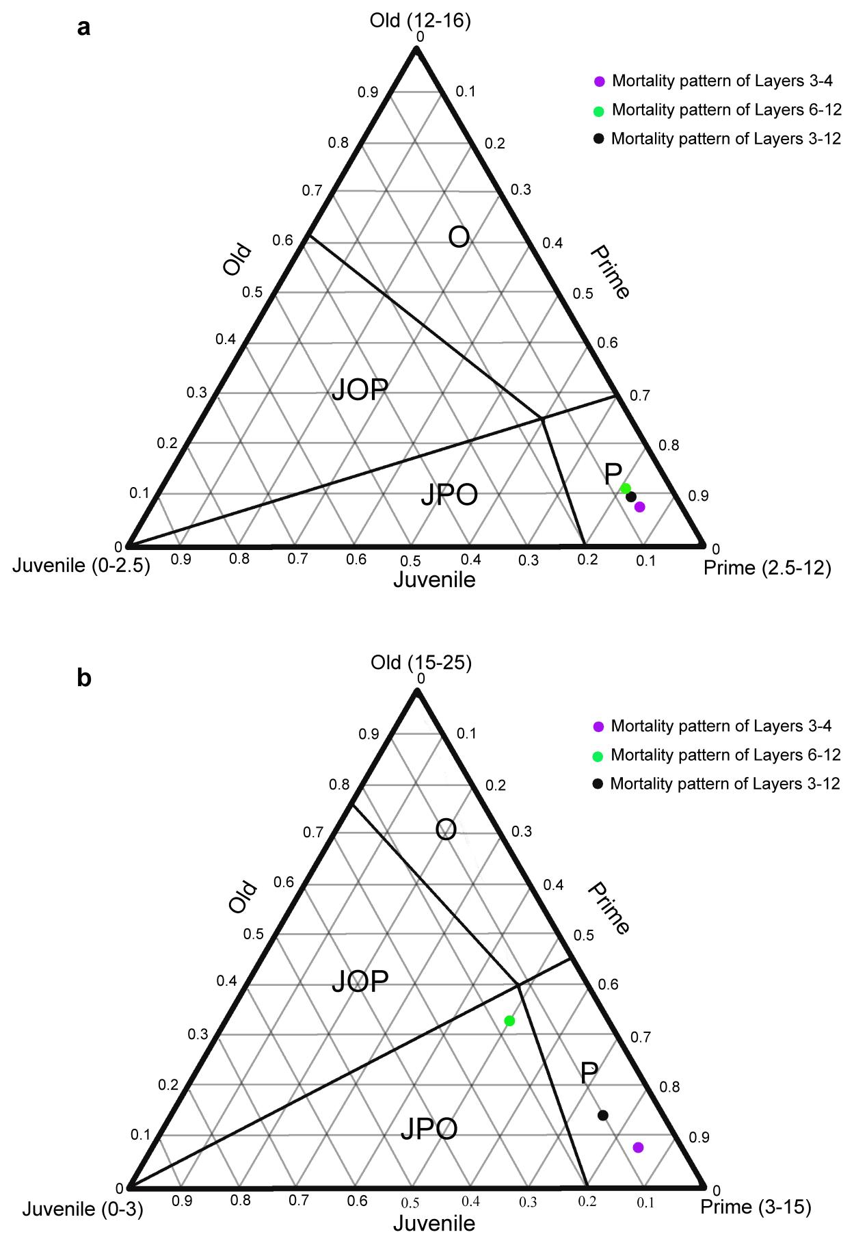
Supplementary Fig. 43 | Mortality profile zones of ternary diagrams of large herbivore from the Bianfu Cave. a, Cervidae; b, Bovidae.

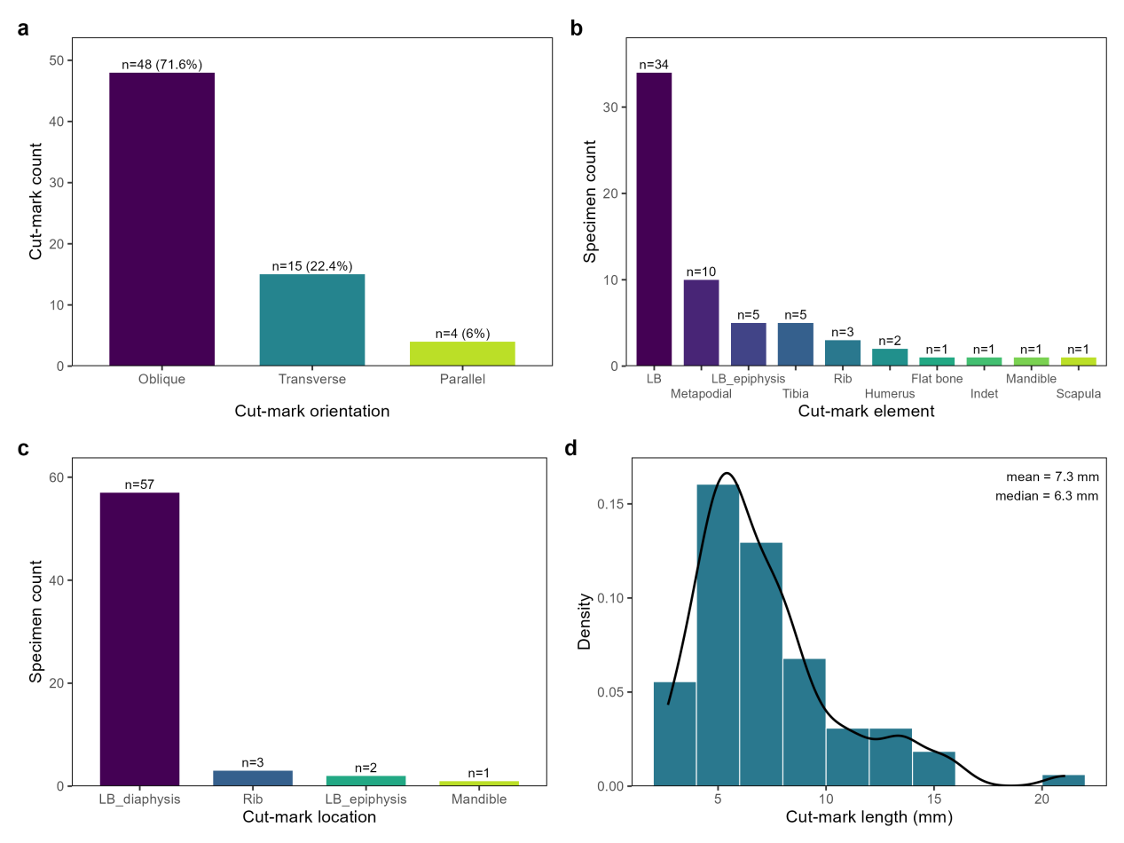

Supplementary Fig. 44 | Synthetic data on cut marks orientation (a), frequency by element (b), location (c), and length (d).
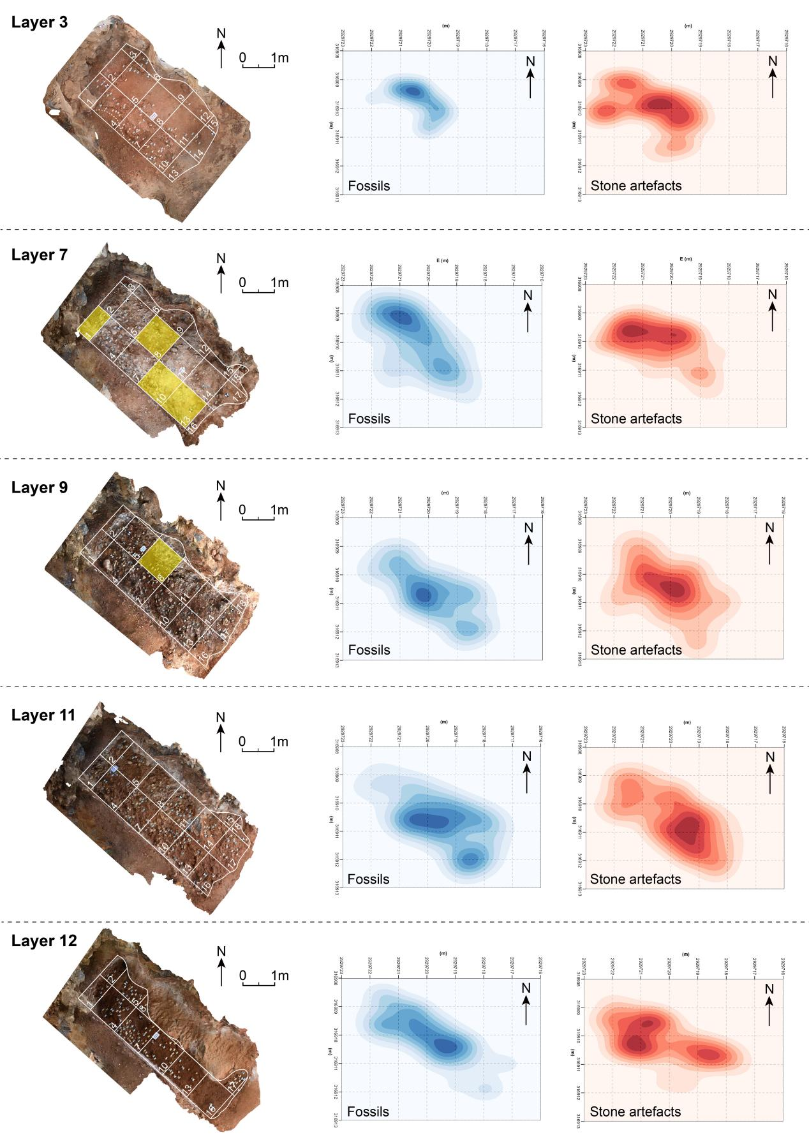

Supplementary Fig. 45 | Heat maps showing the spatial distribution of fossils and stone artefacts for layers 3, 7, 9, 11, and 12, together with the 3D reconstructed excavation plans for each layer. The light yellow squares in layers 7 and 9 show the location where hominin fossils were recovered.

Supplementary Tables

Supplementary Table 1 | Data used for estimating the gamma dose rate gradient.
Layer | Thickness (cm) | Fraction of limestones | U (ppm) | Th (ppm) | K (%) | Water (%)
3 | 30 | 0.30 ± 0.05 | 4.66 ± 0.09 | 14.14 ± 0.71 | 1.00 ± 0.05 | 20 ± 4
4 | 15 | 0.20 ± 0.05 | 5.20 ± 0.09 | 14.00 ± 0.71 | 1.04 ± 0.02 | 23 ± 5
5 | 30 | 0.20 ± 0.05 | 4.55 ± 0.09 | 8.70 ± 0.41 | 0.82 ± 0.02 | 15 ± 3
6 | 10 | 0.05 ± 0.05 | 5.10 ± 0.10 | 10.62 ± 0.53 | 0.96 ± 0.02 | 40 ± 8
7 | 20 | 0.90 ± 0.05 | 2.80 ± 0.06 | 9.60 ± 0.50 | 0.89 ± 0.02 | 15 ± 3
8 | 15 | 0.05 ± 0.05 | 3.51 ± 0.07 | 8.05 ± 0.40 | 0.79 ± 0.02 | 17 ± 3
9 | 10 | 0.90 ± 0.05 | 3.66 ± 0.07 | 9.29 ± 0.47 | 0.89 ± 0.01 | 40 ± 8
10 | 7 | 0.20 ± 0.05 | 4.68 ± 0.09 | 10.23 ± 0.51 | 0.99 ± 0.02 | 40 ± 8
11 | 28 | 0.90 ± 0.05 | 3.66 ± 0.07 | 9.29 ± 0.47 | 0.89 ± 0.01 | 40 ± 8
12 | 12 | 0.01 ± 0.01 | 5.67 ± 0.11 | 12.61 ± 0.63 | 1.10 ± 0.02 | 37 ± 7
13 | 13 | 0.20 ± 0.05 | 5.59 ± 0.11 | 11.99 ± 0.60 | 0.97 ± 0.02 | 40 ± 8
14 | 21 | 0 | 6.73 ± 0.13 | 16.21 ± 0.81 | 0.84 ± 0.02 | 48 ± 10
15 | 24 | 0 | 6.31 ± 0.13 | 12.46 ± 0.62 | 0.68 ± 0.01 | 44 ± 9
16 | 50 | 0 | 6.31 ± 0.13 | 12.46 ± 0.62 | 0.68 ± 0.01 | 44 ± 9

Supplementary Table 2 | Summary of dosimetry data for the OSL samples.
 |  |  |  |  |  |  |  | Dose rate (Gy/ka)
Sample | Layer | Depth (m) | Grain size (µm) | U (ppm) | Th (ppm) | K (%) | Water (%) | Beta | Gammaª | Total
BFD-OSL2 | 4 | 0.40 | 150 - 250 | 4.66 ± 0.09 | 14.14 ± 0.71 | 1.07 ± 0.02 | 23 ± 6 | 1.32 ± 0.08 | 0.85 ± 0.05 | 2.17 ± 0.09
BFD-OSL3 | 4 | 0.32 | 150 - 250 | 5.31 ± 0.11 | 13.87 ± 0.69 | 1.02 ± 0.02 | 25 ± 6 | 1.33 ± 0.08 | 0.83 ± 0.05 | 2.16 ± 0.09
BFD-OSL4 | 5 | 0.52 | 150 - 250 | 4.55 ± 0.09 | 8.24 ± 0.41 | 0.81 ± 0.02 | 15 ± 4 | 1.14 ± 0.05 | 0.74 ± 0.05 | 1.88 ± 0.07
BFD-OSL5 | 5 | 0.71 | 150 - 250 | 4.74 ± 0.09 | 9.17 ± 0.46 | 0.84 ± 0.02 | 16 ± 4 | 1.18 ± 0.05 | 0.71 ± 0.04 | 1.89 ± 0.07
BFD-OSL6 | 6 | 0.81 | 150 - 250 | 5.10 ± 0.10 | 10.62 ± 0.53 | 0.96 ± 0.02 | 40 ± 10 | 1.07 ± 0.09 | 0.68 ± 0.04 | 1.75 ± 0.10
BFD-OSL7 | 7 | 0.90 | 150 - 250 | 2.80 ± 0.06 | 9.60 ± 0.50 | 0.89 ± 0.02 | 15 ± 5 | 1.09 ± 0.04 | 0.22 ± 0.03 | 1.31 ± 0.06
BFD-OSL8 | 8 | 1.23 | 150 - 250 | 3.51 ± 0.07 | 8.05 ± 0.40 | 0.79 ± 0.02 | 17 ± 4 | 1.01 ± 0.04 | 0.54 ± 0.03 | 1.54 ± 0.05
BFD-OSL9 | 10 | 1.30 | 150 - 250 | 4.68 ± 0.09 | 10.23 ± 0.51 | 0.99 ± 0.02 | 36 ± 9 | 1.20 ± 0.07 | 0.39 ± 0.03 | 1.59 ± 0.08
BFD-OSL10 | 12 | 1.72 | 150 - 250 | 5.67 ± 0.11 | 12.61 ± 0.63 | 1.1 ± 0.02 | 37 ± 9 | 1.25 ± 0.10 | 0.85 ± 0.04 | 2.10 ± 0.11
BFD-OSL11 | 13 | 1.82 | 150 - 250 | 5.59 ± 0.11 | 11.99 ± 0.6 | 0.97 ± 0.02 | 40 ± 10 | 1.15 ± 0.09 | 0.85 ± 0.05 | 1.99 ± 0.11
BFD-OSL12 | 14 | 1.99 | 150 - 250 | 6.73 ± 0.13 | 16.21 ± 0.81 | 0.84 ± 0.02 | 48 ± 12 | 1.16 ± 0.1 | 1.11 ± 0.06 | 2.27 ± 0.12
BFD-OSL13 | 15 | 2.23 | 150 - 250 | 6.31 ± 0.13 | 12.46 ± 0.62 | 0.68 ± 0.01 | 44 ± 11 | 1.03 ± 0.09 | 1.02 ± 0.05 | 2.05 ± 0.10

a The gamma dose rates are based on the modelled gamma gradient (Supplementary Fig. 1).

Supplementary Table 3 | Number of single quartz grains measured, rejected and accepted for each sample, together with the reasons for their rejection.
Sample | Total | Dim T_{n} | Poor recycling | Recuperation > 5% | Poor DRC | Saturated | Rejected | Accepted
BFD-OSL2 | 500 | 268 | 37 | 2 | 79 | 31 | 417 | 83
BFD-OSL3 | 400 | 199 | 25 | 4 | 33 | 30 | 291 | 109
BFD-OSL4 | 400 | 194 | 29 | 1 | 44 | 38 | 306 | 94
BFD-OSL5 | 1,200 | 670 | 52 | 20 | 162 | 156 | 1,060 | 140
BFD-OSL6 | 1,000 | 310 | 109 | 1 | 216 | 131 | 767 | 233
BFD-OSL7 | 300 | 148 | 14 | 4 | 43 | 24 | 233 | 67
BFD-OSL8 | 500 | 267 | 67 | 0 | 73 | 39 | 446 | 54
BFD-OSL9 | 500 | 229 | 67 | 10 | 90 | 22 | 418 | 82
BFD-OSL10 | 300 | 153 | 13 | 0 | 28 | 62 | 256 | 44
BFD-OSL11 | 500 | 222 | 59 | 0 | 80 | 77 | 438 | 62
BFD-OSL12 | 500 | 119 | 29 | 4 | 47 | 173 | 372 | 128
BFD-OSL13 | 400 | 64 | 62 | 1 | 103 | 83 | 313 | 87

Supplementary Table 4 | Summary of the BHAM D_{e} and age results. N refers to the total number of grains used for analysis; p₀ is the proportion of the target population.
 |  |  | D_{e} (Gy) |  |  | Age (ka)
Sample | N | p0 | Mean ± 1σ | 2.5% CI | 97.5%CI | Mean ± 1σ | 2.5% CI | 97.5%CI
BFD-OSL2 | 109 | 0.93 | 150.4 ± 6.8 | 137.4 | 163.7 | 69.3 ± 4.3 | 60.9 | 77.8
BFD-OSL3 | 139 | 0.93 | 148.3 ± 7 | 135.0 | 162.0 | 68.7 ± 4.4 | 60.1 | 77.4
BFD-OSL4 | 132 | 0.92 | 223.7 ± 11.7 | 201.9 | 247.2 | 119.3 ± 7.6 | 104.8 | 134.5
BFD-OSL5 | 145 | 0.96 | 259 ± 19 | 223.5 | 296.7 | 136.7 ± 11.2 | 115.5 | 158.9
BFD-OSL6 | 361 | 0.93 | 247 ± 7.4 | 232.0 | 260.9 | 140.8 ± 8.9 | 123.1 | 158.4
BFD-OSL7 | 91 | 0.86 | 184.2 ± 11.5 | 162.5 | 207.5 | 141.1 ± 10.6 | 120.6 | 162.6
BFD-OSL8 | 88 | 0.94 | 233.8 ± 19.2 | 198.0 | 273.1 | 151.4 ± 13.5 | 125.9 | 179.1
BFD-OSL9 | 98 | 0.96 | 194.7 ± 11.1 | 173.1 | 216.3 | 122.2 ± 9.1 | 104.4 | 140.0
BFD-OSL10 | 106 | 0.95 | 383.3 ± 27.7 | 330.7 | 439.4 | 182.4 ± 16.1 | 151.3 | 214.8
BFD-OSL11 | 137 | 0.96 | 353.9 ± 30.5 | 296.1 | 413.4 | 177.8 ± 18 | 143.1 | 213.1
BFD-OSL12 | 300 | 0.96 | 419.8 ± 17.8 | 385.6 | 454.8 | 184.8 ± 12.6 | 160.0 | 209.9
BFD-OSL13 | 170 | 0.91 | 359.4 ± 15.7 | 330.5 | 391.7 | 174.9 ± 11.8 | 152.2 | 198.7

Supplementary Table 5 | CQL codes for the Bayesian age model.
Plot(){
Outlier_Model("General",T(5),U(0,4),"t");
Sequence(){
Boundary("Start Layer 15");
C_date("BFD-OSL13", calBP(174800), 11400, 11900)
{
Outlier(0);
};
C_date("BFD-OSL12", calBP(184700), 12400, 12500)
{
Outlier(0);
};
C_date("BFD-OSL11", calBP(177700), 17300, 17700)
{
Outlier(0);
};
Boundary("End Layer 13");
Boundary("Start Layer 12");
C_date("BFD-OSL10", calBP(182300), 15600, 16200)
{
Outlier(0);
};
Boundary("End Layer 12");
Boundary("Start Layer 11");
Phase("Layer 11")
{
C_date("BF11-F1", calBP(185300), 1700)
{
Outlier(0);
};
C_date("BF11-F3", calBP(174900), 1800)
{
Outlier(0);
};
C_date("BF11-F2", calBP(173400), 1000)
{
Outlier(0);
};
};
Boundary("End Layer 11");
Boundary("Start Layer 10");
C_date("BFD-OSL9", calBP(122200), 8900, 8900)
{
Outlier(1);
};
Boundary("End Layer 10");
Boundary("Start Layer 9");
Phase("Layer 9")
{
C_date("BF9-F2", calBP(162700), 1000)
{
Outlier(0);
};
C_date("BF9-F4", calBP(160500), 600)
{
Outlier(0);
};
C_date("BF9-F1", calBP(157100), 700)
{
Outlier(0);
};
};
Boundary("End Layer 9");
Boundary("Start Layer 8");
C_date("BFD-OSL8", calBP(151400), 12800, 13800)
{
Outlier(0);
};
Boundary("End Layer 8");
Boundary("Start Layer 7");
Phase("Layer 7")
{
C_date("BF8-F2", calBP(140400), 1200)
{
Outlier(0);
};
C_date("BFD-OSL7", calBP(141000), 10200, 10800)
{
Outlier(0);
};
C_date("BF7-F1", calBP(140400), 1600)
{
Outlier(0);
};
};
Boundary("End Layer 7");
Boundary("Start Layer 6");
C_date("BFD-OSL6", calBP(140800), 8900, 8800)
{
Outlier(0);
};
Boundary("End Layer 6");
Boundary("Start Layer 5");
Phase("Layer 5")
{
C_date("BFD-OSL5", calBP(136600), 10600, 11100)
{
Outlier(0);
};
C_date("BFD-OSL4", calBP(119200), 7200, 7600)
{
Outlier(0);
};
};
Boundary("End Layer 5");
Boundary("Start Layer 4");
Phase("Layer 4")
{
C_date("BFD-OSL2", calBP(69200), 4200, 4300)
{
Outlier(0);
};
C_date("BFD-OSL3", calBP(68600), 4300, 4300)
{
Outlier(0);
};
};
Boundary("End Layer 4");
Boundary("Start Layer 3");
Phase("Layer 3")
{
C_date("BF3-F1", calBP(71000), 700)
{
Outlier(0);
};
C_date("BF3-F2", calBP(74000), 1400)
{
Outlier(0);
};
};
Boundary("End Layer 3");
};
};

Supplementary Table 6 | OSL and U-series ages (shown as ‘Unmodelled age ranges’) and corresponding Bayesian age model estimates (‘Modelled age ranges’), obtained using the OxCal 4.4.4 platform. All ages are given in years before 1950 CE.
Sample / Stratigraphic layer | Unmodelled age ranges (years) |  | Modelled age ranges (years) |  | Outlier probabilities |  | Convergence values (%) | Agreement (%)
Sample / Stratigraphic layer | 95.4% probability |  | 95.4% probability |  |  |  | Convergence values (%) | Agreement (%)
Sample / Stratigraphic layer | from | to | from | to | prior | posterior
End Layer 3 |  |  | 72200 | 64000 |  |  | 88.2
BF3-F2 | 71200 | 76800 | 74400 | 70200 | 0 | 0 | 99.3 | 56.2
BF3-F1 | 69600 | 72400 | 72600 | 69900 | 0 | 0 | 99.5 | 98.7
Start Layer 3 |  |  | 75700 | 70700 |  |  | 99.1
End Layer 4 |  |  | 77800 | 71400 |  |  | 99
BFD-OSL3 | 59900 | 77400 | 79600 | 72000 | 0 | 0 | 99 | 49.6
BFD-OSL2 | 60700 | 77900 | 79800 | 72000 | 0 | 0 | 99 | 58.6
Start Layer 4 |  |  | 99300 | 72600 |  |  | 85.4
End Layer 5 |  |  | 128000 | 83900 |  |  | 84.6
BFD-OSL4 | 104100 | 134400 | 130500 | 108400 | 0 | 0 | 97.9 | 112.6
BFD-OSL5 | 114300 | 159000 | 132100 | 110400 | 0 | 0 | 97.3 | 58.1
Start Layer 5 |  |  | 135200 | 114400 |  |  | 96.7
End Layer 6 |  |  | 138400 | 120500 |  |  | 97.2
BFD-OSL6 | 123100 | 158600 | 139400 | 124900 | 0 | 0 | 98.9 | 99
Start Layer 6 |  |  | 140400 | 127200 |  |  | 98.4
End Layer 7 |  |  | 141700 | 134100 |  |  | 98.1
BF7-F1 | 137200 | 143600 | 142800 | 138200 | 0 | 0 | 99.5 | 114.7
BFD-OSL7 | 119800 | 162400 | 144500 | 137000 | 0 | 0 | 99.5 | 139.5
BF8-F2 | 138000 | 142800 | 142500 | 138400 | 0 | 0 | 99.5 | 107.6
Start Layer 7 |  |  | 147600 | 139300 |  |  | 97.6
End Layer 8 |  |  | 154200 | 140900 |  |  | 98
BFD-OSL8 | 124400 | 178500 | 155500 | 142400 | 0 | 0 | 99 | 134.7
Start Layer 8 |  |  | 156800 | 143700 |  |  | 98.1
End Layer 9 |  |  | 158300 | 149900 |  |  | 99
BF9-F1 | 155700 | 158500 | 158800 | 156000 | 0 | 0 | 99.1 | 94.8
BF9-F4 | 159300 | 161700 | 161600 | 159300 | 0 | 0 | 99.3 | 100.7
BF9-F2 | 160700 | 164700 | 164000 | 160100 | 0 | 0 | 98.9 | 87.6
Start Layer 9 |  |  | 167300 | 160800 |  |  | 99.3
End Layer 10 |  |  | 170800 | 161800 |  |  | 98.7
BFD-OSL9 | 104100 | 140400 | 171800 | 162600 | 1 | 1 | 99.1 | 65.6
Start Layer 10 |  |  | 173100 | 163300 |  |  | 98.3
End Layer 11 |  |  | 174600 | 166700 |  |  | 99.2
BF11-F2 | 171400 | 175400 | 175700 | 171800 | 0 | 0 | 98.9 | 98.1
BF11-F3 | 171300 | 178500 | 178600 | 172100 | 0 | 0 | 98.6 | 104.3
BF11-F1 | 181900 | 188700 | 186800 | 179900 | 0 | 0 | 97.5 | 71.5
Start Layer 11 |  |  | 189900 | 180700 |  |  | 99.2
End Layer 12 |  |  | 193800 | 181900 |  |  | 98.4
BFD-OSL10 | 150200 | 214600 | 195400 | 182600 | 0 | 0 | 99 | 130.6
Start Layer 12 |  |  | 197300 | 183100 |  |  | 97.8
End Layer 13 |  |  | 200500 | 184500 |  |  | 95.4
BFD-OSL11 | 141800 | 213700 | 201300 | 185000 | 0 | 0 | 97.4 | 100.7
BFD-OSL12 | 159600 | 210000 | 202400 | 185400 | 0 | 0 | 97 | 111.3
BFD-OSL13 | 151400 | 198400 | 203800 | 185800 | 0 | 0 | 95.8 | 45.6
Start Layer 15 |  |  | 206300 | 186100 |  |  | 33.4

Supplementary Table 7 | MC-ICP-MS U-series dating results on the samples from the Bianfu cave, with ± 2σ absolute uncertainties.
Sample | Layer | Material | ²³⁸U (ppb) | ²³²Th (ppb) | (²³⁴U/²³⁸U) | (²³⁰Th/²³⁸U) | (²³⁰Th/²³²Th) | Age (ka)ª | Corr. Age (ka)^{b} | (²³⁴U/²³⁸U)_{i}^{c}
BF3-F1 | 3 | flowstone | 173.5 ± 0.1 | 6.31 ± 0.04 | 1.162 ± 0.002 | 0.570 ± 0.003 | 47.9 ± 0.4 | 72.0 ± 0.5 | 71 ± 0.7 | 199 ± 2
BF3-F2 | 3 | flowstone | 165.6 ± 0.1 | 19.3 ± 0.1 | 1.187 ± 0.001 | 0.609 ± 0.001 | 16.0 ± 0.1 | 76.6 ± 0.2 | 74 ± 1.4 | 231 ± 2
BF7-F1 | 7 | flowstone | 77.8 ± 0.1 | 7.50 ± 0.04 | 1.272 ± 0.004 | 0.964 ± 0.003 | 30.5 ± 0.2 | 142.5 ± 1.3 | 140.4 ± 1.6 | 405 ± 6
BF7-F2 | 7 | flowstone | 118.9 ± 0.1 | 2.17 ± 0.02 | 1.167 ± 0.003 | 0.868 ± 0.003 | 145 ± 1 | 140.8 ± 1.2 | 140.4 ± 1.2 | 247 ± 5
BF9-F1 | 9 | flowstone | 70.47 ± 0.02 | 1.77 ± 0.01 | 1.193 ± 0.001 | 0.941 ± 0.002 | 114 ± 1 | 157.7 ± 0.6 | 157.1 ± 0.7 | 301 ± 2
BF9-F2 | 9 | flowstone | 70.40 ± 0.02 | 3.87 ± 0.02 | 1.193 ± 0.001 | 0.958 ± 0.002 | 53.2 ± 0.3 | 163.9 ± 0.7 | 162.7 ± 1.0 | 305 ± 2
BF9-F4 | 9 | flowstone | 102.99 ± 0.03 | 1.26 ± 0.01 | 1.172 ± 0.001 | 0.930 ± 0.001 | 232 ± 2 | 160.8 ± 0.6 | 160.5 ± 0.6 | 270 ± 2
BF11-F1 | 11 | flowstone | 87.28 ± 0.04 | 4.97 ± 0.03 | 1.137 ± 0.002 | 0.957 ± 0.003 | 51.4 ± 0.3 | 186.7 ± 1.6 | 185.3 ± 1.7 | 232 ± 4
BF11-F2 | 11 | flowstone | 102.46 ± 0.02 | 2.10 ± 0.01 | 1.150 ± 0.001 | 0.942 ± 0.002 | 140.2 ± 0.9 | 173.8 ± 0.9 | 173.4 ± 1.0 | 245 ± 2
BF11-F3 | 11 | flowstone | 89.8 ± 0.1 | 3.59 ± 0.02 | 1.143 ± 0.003 | 0.940 ± 0.003 | 71.7 ± 0.4 | 175.9 ± 1.8 | 174.9 ± 1.8 | 234 ± 4
BF3-S1 | 3 | speleothem | 154.4 ± 0.1 | 2.20 ± 0.02 | 1.178 ± 0.001 | 1.129 ± 0.002 | 242 ± 2 | 272 ± 3 | 271.8 ± 2.5 | 384 ± 4
BF7-S1 | 7 | speleothem | 46.72 ± 0.02 | 3.98 ± 0.02 | 1.129 ± 0.002 | 1.077 ± 0.003 | 38.6 ± 0.2 | 279 ± 4 | 277.0 ± 4.3 | 281 ± 5
BF7-S2 | 7 | speleothem | 218.5 ± 0.1 | 0.97 ± 0.01 | 1.282 ± 0.001 | 1.168 ± 0.002 | 803 ± 10 | 217 ± 1 | 216.8 ± 1.2 | 520 ± 2
BF7-S3 | 7 | speleothem | 265.7 ± 0.1 | 0.25 ± 0.01 | 1.010 ± 0.001 | 1.012 ± 0.002 | 3298 ± 134 | 665 ± 111 | 665 ± 111 | 65 ± 21
BF7-S4 | 7 | speleothem | 450.4 ± 0.2 | 2.89 ± 0.02 | 1.146 ± 0.001 | 1.131 ± 0.002 | 539 ± 4 | 322 ± 3 | 321.9 ± 3.4 | 362 ± 4
BF11-S1 | 11 | speleothem | 912.6 ± 0.6 | 1.80 ± 0.01 | 1.040 ± 0.001 | 1.058 ± 0.001 | 1639 ± 10 | >600 | - | -
BF7-H1 | 7 | human tooth | 7257 ± 2 | 26 ± 1 | 1.167 ± 0.001 | 0.650 ± 0.001 | 556 ± 12 | 86.5 ± 0.3 | 86.4 ± 0.3 | 213 ± 2
BF7-H2 | 7 | human tooth | 5406 ± 7 | 105 ± 1 | 1.186 ± 0.003 | 0.736 ± 0.002 | 116 ± 1 | 102.1 ± 0.7 | 101.6 ± 0.7 | 247 ± 4
BF7-H3 | 7 | human limb bone | 22679 ± 6 | 57 ± 1 | 1.182 ± 0.001 | 0.836 ± 0.002 | 1011 ± 13 | 127.5 ± 0.5 | 127.5 ± 0.5 | 261 ± 1
BF9-H1 | 9 | human skull fragment | 13273 ± 3 | 458 ± 3 | 1.189 ± 0.001 | 0.814 ± 0.002 | 72.1 ± 0.4 | 120.1 ± 0.5 | 119.3 ± 0.6 | 265 ± 2

a Ages reported as ka before present (BP), where the present is defined as the year 1950 CE.
b U-series ages were corrected with assumption of the initial 230Th/232Th atomic ratio of 4.4 ± 2.2×10-6, a value for a material at secular equilibrium, with the bulk earth 232Th/238U value of 3.8 and with an assumed error of 50%.
c The back calculated initial 234U/238U activity ratio.

Supplementary Table 8 | The assignment of pollen taxa to PFTs.
Abbr. | Plant functional type | Pollen taxa
te | tropical evergreen | Ericaceae, Euphorbiaceae
stme | south subtropical evergreen broadleaf | Euphorbiaceae, Symplocos, Theaceae
wte | subtropical evergreen | Alnus, Ericaceae, Euphorbiaceae, Ligustrum, Pistacia, Quercus (deciduous), Quercus (evergreen), Symplocos, Theaceae
ts | subtropical summergreen tree | Betula, Carpinus, Corylus, Juglans, Pterocarya, Ulmus, Zelkova
wtc | subtropical conifer | Tsuga
ts3 | subtropical summergreen shrub | Ligustrum, Rosa
tef | tropical and subtropical evergreen forbs | Convolvulaceae, Euphorbiaceae, Poaceae
wt2 | subtropical schlerophyllous shrub | Ericaceae
ts1 | warm-temperate summergreen | Alnus, Carpinus, Corylus, Hippophae, Juglans, Pterocarya, Quercus (deciduous), Rosa, Tilia, Ulmus, Zelkova
bts | cool-temperate summergreen broadleaf | Betula, Carpinus, Dipsacus, Juglans, Lonicera, Quercus (deciduous), Rosaceae, Tilia, Ulmus, Zelkova
tbs | cool-temperate summergreen shrub | Ulmus, Zelkova
ctc | cool-temperate evergreen conifer | Picea
bs | boreal summergreen | Betula, Corylus, Ericaceae, Lonicera, Quercus (deciduous)
bec | Boreal evergreen conifer | Abies, Picea, Pinus
ctm | cool-temperate meadow forb | Caryophyllaceae, Convolvulaceae, Epilobium, Euphorbiaceae, Geranium, Lamiaceae, Liliaceae, Ranunculaceae, Violaceae
g | grass | Poaceae
tf | cool-temperate steppe forb | Amaranthaceae (Chenopodiaceae), Artemisia, Caryophyllaceae, Convolvulaceae, Euphorbiaceae, Lamiaceae, Liliaceae, Patrinia, Polygonaceae, Ranunculaceae, Scrophulariaceae, Solanaceae, Taraxacum, Violaceae
dsf | cool-temperate desert forb | Artemisia, Caryophyllaceae, Liliaceae, Scrophulariaceae, Violaceae
tds | cool-temperate desert shrub | Amaranthaceae (Chenopodiaceae), Caryophyllaceae, Ephedra
aa | arctic-alpine dwarf shrub | Betula, Corylus, Ericaceae, Rosaceae, Ulmus
am | alpine meadow forb | Cyperaceae, Geranium, Liliaceae, Ranunculaceae
af | arctic-alpine forb | Aster, Asteraceae, Caryophyllaceae, Lamiaceae, Liliaceae, Ranunculaceae
ads | alpine desert shrub | Amaranthaceae (Chenopodiaceae), Ephedra
ec | eurythermic conifer | Pinus

Supplementary Table 9 | Defining biomes using PFTs after Sun et al.²³.
Code | Biome | Plant functional types
TRFO | Tropical rain forest | te, wte
TSFO | Tropical seasonal forest | tr, te, stme
TDFO | Tropical dry forest | ts3, wt2
TEDE | Warm-temperate mixed forest | ts1, g, ec
WAMF | North subtropical mixed forest | wte, ts, ts3, ec
MTFO | Middle subtropical broadleaf evergreen forest | wte, wtc, ts3, ec
STFO | South subtropical broadleaf evergreen | stme, wte, wtc
COMX | Cool-temperate mixed forest | bts, ctc, ec
CLDC | Cold-temperate summergreen conifer forest | bs, ec
CLEC | Cold-temperate evergreen conifer forest | bec, ec
XERO | Scarsed woods/scrub | wt2
DESE | Desert | tds, ads
TEDS | Cool-temperate desert steppe | g, dsf
STEP | Cool-temperate steppe | g, tf
TEME | Cool-temperate meadow steppe | g, ctm
TEFS | Cool-temperate forest steppe | tbs, tf
ALME | Alpine meadow | aa, am
ALST | Alpine steppe | am, af

Supplementary Table 10 | The categories, occlusal wear degrees, meisodistal and buccolingual dimensions of teeth from Bianfu Cave*.
 | Category | Occlusal wear | Mesiodistal dimension (MD) in millimeter | Buccolingual dimension (BL) in millimeter
2019YHB-T2-7-L2: 3513 | Left I₂ | 1 | 7.51 | 7.05
2019YHB-T2-7-L2: 3518 | Left P₄ | 2 | 8.01 | 8.96
2019YHB-T2-7-L2: 2890 | Right M₂ | 1 | 12.51 | 10.43
2019YHB-T2-7-L2: 3075 | Right M₂ | 2 | 13.07 | 11.07
* Molnar’s grading system was followed to score the occlusal wear (Molnar, S. 1971. Human tooth wear, tooth function and cultural variability. Am. J. Phys. Anthropol. 34, 175–189).

Supplementary Table 11 | The comparative samples used in the morphological comparisons.
 | I₂ | P₄ | M₂
Southeast Asian Early Pleistocene Homo erectus | Sangiran (n=3) | Sangiran, Trinil (n=7) | Sangiran (n=15)
East Asian mid-Middle Pleistocene Homo erectus | Zhoukoudian (n=10) | Zhoukoudian, Xichuan (n=9) | Zhoukoudian, Hexian, Yiyuan (n=12)
East Asian Late Middle Pleistocene archaic Homo | - | Hualongdong (n=1) | Hualongdong (n=3)
Homo heidelbergensis | Mauer (n=1) | Arago, Mauer (n=3) | Arago, Mauer (n=5)
Denisovans | - | - | Xiahe, Cobra Cave (n=2)
Late Neanderthals | Regourdou, St. Césaire, Subalyuk, Krapina (n=12) | Regourdou, La Quina, Hortus, St. Césaire, Subalyuk, Krapina (n=17) | Regourdou, La Quina, Hortus, Gibraltar, St. Césaire, Krapina (n=13)
Fossil Homo sapiens | Qafzeh (n=4) | Qafzeh (n=4) | Qafzeh (n=4)

Supplementary Table 12 | The comparative samples used in the comparisons of crown metrics.
 | I₂ | P₄ | M₂ | Data source
Southeast Asian Early Pleistocene Homo erectus | Sangiran (n=1) | Sangiran (n=5) | Sangiran (n=10) | 1-3
East Asian mid-Middle Pleistocene Homo erectus | Zhoukoudian (n=9) | Zhoukoudian, Changyang (n=6) | Zhoukoudian, Hexian, Yiyuan (n=11) | 4-7
East Asian Late Middle Pleistocene archaic Homo | - | Hualongdong (n=1) | Hualongdong (n=3) | 8
Denisovans | - | - | Xiahe, Penghu, Tam Ngu Hao 2 (n=3) | 9-11
Early Neanderthals | Atapuerca Sima de los Huesos (n=31) | Atapuerca Sima de los Huesos (n=37) | Atapuerca Sima de los Huesos (n=41) | 12
Late Neanderthals | Ehringsdorf, Le Moustier, Regourdou, Shanidar, Tabun, Krapina (n=23) | Ehringsdorf, La Ferrassie, La Quina, Le Moustier, Regourdou, Shanidar, Spy, Tabun, Monsempron, Subalyuk, Krapina (n=36) | Ehringsdorf, La Quina, Le Moustier, Regourdou, Shanidar, Spy, Tabun, Krapina (n=35) | 13,14
Fossil Homo sapiens | Dar es-Soltan, Contrebandiers, Fish Hoek, Skhul, Wajak, Předmostí, Le Rois (n=15) | Dar es-Soltan, Contrebandiers, El Haroura, Klasies River Mouth, Fish Hoek, Skhul, Wajak, Předmostí, Dolní Vĕstonice, Le Rois, Dushan Cave (n=20) | Mumba, Dar es-Soltan, Contrebandiers, El Haroura, Klasies River Mouth, Skhul, Předmostí, Dolní Vĕstonice, Le Rois, Baojiyan, Chuandong, Fusui (n=48) | 13,15-23
- Grine, F. & Franzen, J. Fossil hominid teeth from the Sangiran Dome (Java, Indonesia). Cour. Forsch. Inst. Senckenberg 171, 75–103 (1994).
- Kaifu, Y. et al. Taxonomic affinities and evolutionary history of the Early Pleistocene hominids of Java: dentognathic evidence. Am. J. Phys. Anthropol. 128, 709–726 (2005).
- Tobias, P. V. & Koenigswald, G. v. A comparison between the Olduvai hominines and those of Java and some implications for hominid phylogeny. Nature 204, 515–518 (1964).
- Weidenreich, F. The dentition of Sinanthropus pekinensis: a comparative odontography of the hominids. Palaeontol. Sin. Series D I, 1–180 (1937).
- Xing, S. et al. Middle Pleistocene hominin teeth from Longtan Cave, Hexian, China. PloS One 9, e114265 (2014).
- Xing, S. et al. Hominin teeth from the Middle Pleistocene site of Yiyuan, Eastern China. J. Hum. Evol. 95, 33–54 (2016).
- Chia, L. Notes on the human and some other mammalian remains from Changyang, Hupei. Vertabrata Palasiatica 1, 179–190 (1957).
- Wu, X. J. et al. Archaic human remains from Hualongdong, China, and Middle Pleistocene human continuity and variation. PNAS 116, 9820–9824 (2019).
- Chen, F. et al. A late Middle Pleistocene Denisovan mandible from the Tibetan Plateau. Nature 569, 409–412 (2019).
- Chang, C. H. et al. The first archaic Homo from Taiwan. Nature Commun. 6, 6037 (2015).
- Demeter, F. et al. A Middle Pleistocene Denisovan molar from the Annamite Chain of northern Laos. Nature Commun. 13 (2022).
- Martinón-Torres, M., Bermúdez de Castro, J. M., Gómez-Robles, A., Prado-Simón, L. & Arsuaga, J. Morphological description and comparison of the dental remains from Atapuerca-Sima de los Huesos site (Spain). J. Hum. Evol. 62, 7–58 (2012).
- Wolpoff, M. H. Metric trends in hominid dental evolution, University of Illinois, (1969).
- Wolpoff, M. H. The Krapina dental remains. Am. J. Phys. Anthropol. 50, 67–113 (1979).
- Liu, W. et al. Huanglong Cave: A Late Pleistocene human fossil site in Hubei Province, China. Quatern. Int. 211, 29–41 (2010).
- Liao, W. et al. Mosaic dental morphology in a terminal Pleistocene hominin from Dushan Cave in southern China. Sci. Rep. 9, 2347 (2019).
- Liu, W. et al. The earliest unequivocally modern humans in southern China. Nature 526, 696–670 (2015).
- Hublin, J. J. et al. in Modern Origins: A North African Perspective (eds Jean-Jacques Hublin & Shannon P. McPherron) 189–204 (Springer Netherlands, 2012).
- Bräuer, G. & Mehlman, M. J. Hominid molars from a middle stone age level at the Mumba Rock Shelter, Tanzania. Am. J. Phys. Anthropol. 75, 69–76 (1988).
- Bae, C. J. et al. Modern human teeth from Late Pleistocene Luna Cave (Guangxi, China). Quatern. Int. 354, 169–183 (2014).
- Rightmire, G. P. & Deacon, H. J. Comparative studies of Late Pleistocene human remains from Klasies River Mouth, South Africa. J. Hum. Evol. 20, 131–156 (1991).
- Wang, L., Peng, S. & Chen, Y. On the human fossils and stone artifacts found in Baojiyan Cave, Guilin. Acta Anthropological Sinica 1, 30–35 (1982).
- Wang, W. & Mo, J. Human fossil teeth newly discovered in Nanshan Cave of Fusui, Guangxi. Acta Anthropological Sinica 23, 130–137 (2004).

Supplementary Table 13 | The comparative samples used in the diffeomorphic surface matching.
 | P₄ | M₂
Southeast Asian Early Pleistocene Homo erectus | Sangiran (n=2) | Sangiran (n=4)
East Asian mid-Middle Pleistocene Homo erectus | Zhoukoudian, Xichuan, Changyang (n=4) | Zhoukoudian, Xichuan, CA808, MA93 (n=4)
African Middle Pleistocene Homo erectus | Tighenif (n=1) | Tighenif (n=1)
East Asian Late Middle Pleistocene Homo | Hualongdong (n=1) | Hualongdong (n=3)
Denisovans | - | Xiahe, Cobra Cave (n=2)
Neanderthals | La Chaise, Krapina, Regourdou (n=12) | La Chaise, Krapina, Regourdou, Fossellone, La Quina, Scladina, Montmaurin (n=13)
Pre-modern Homo sapiens | Jebel Irhoud (n=3) | Jebel Irhoud (n=3)
Fossil Homo sapiens | Contrebandiers, El Haroura (n=3) | Qafzeh, Dar es-Soltan, Contrebandiers, El Haroura, Daoxian (n=9)
Recent Homo sapiens | East Asia (n=11), Africa (n=8) | East Asia (n=15), Africa (n=5)

Supplementary Table 14 | The classification frequencies of cross-validated between-group principal component analyses (bgPCA) and canonical variate analyses (CVA) of the P₄ EDJ shape of the comparative taxa.
Species | bgPCA | CVA
H. erectus | 7/7 | 6/7
Neanderthals | 7/12 | 7/12
H. sapiens | 18/25 | 20/25
* The overall classification accuracy of bgPCA and CVA is 72.7% and 75.0%, respectively.

Supplementary Table 15 | The typicality probability (do not sum up to 1) of Bianfu Cave P₄ assigned to different taxonomic groups using between-group principal component analyses (bgPCA) and canonical variate analyses (CVA) of the EDJ shape.
Species | bgPCA | CVA
H. erectus | 0.001 | 0.014
Neanderthals | 0.246 | 0.446
H. sapiens | 0.762 | 0.644

Supplementary Table 16 | The classification frequencies of cross-validated between-group principal component analyses (bgPCA) and canonical variate analyses (CVA) of the M₂ EDJ shape of the comparative taxa.
Species | bgPCA | CVA
H. erectus | 8/9 | 6/9
East Asian late Middle Pleistocene Homo and Denisovans | 2/5 | 3/5
Neanderthals | 11/13 | 12/13
H. sapiens | 23/32 | 23/32
* The overall classification accuracy of bgPCA and CVA is 74.6% and 74.6%, respectively.

Supplementary Table 17 | The typicality probability (do not sum up to 1) of Bianfu Cave M₂s assigned to different taxonomic groups using between-group principal component analyses (bgPCA) and canonical variate analyses (CVA) of the EDJ shape.
 |  | H. erectus | East Asian late Middle Pleistocene Homo and Denisovans | Neanderthals | H. sapiens
bgPCA | YHB2890 | 0.2483 | 0.5941 | 0.0017 | 0.0004
bgPCA | YHB3075 | 0.7453 | 0.1455 | 0.0013 | 0.0724
CVA | YHB2890 | 0.1395 | 0.2966 | 0.0016 | 0.0026
CVA | YHB3075 | 0.5953 | 0.2620 | 0.0048 | 0.1531

Supplementary Table 18 | Statistics of raw materials and types of stone artefacts.
Category | Techno-typology | Sandy hydromica-  mudstone |  | Sandstone |  | Silicalite |  | Limestone |  | Trachyte |  | Andesite |  |  | Granite |  | Total
 |  | n | % | n | % | n | % | n | % | n | % | n | % | n |  | % | n | %
Cores | Initial core | 5 | 0.4% | 3 | 0.2% | - | - | 1 | 0.1% | 1 | 0.1% | - | - | - |  | - | 10 | 0.7%
(n=231) | Unifacial core | 72 | 5.3% | 9 | 0.7% | - | - | 3 | 0.2% | 5 | 0.4% | - | - | 1 |  | 0.1% | 90 | 6.6%
 | Bifacial core | 22 | 1.6% | 5 | 0.4% | 1 | 0.1% | 3 | 0.2% | 2 | 0.1% | 1 | 0.1% | 1 |  | 0.1% | 35 | 2.6%
 | Multifacial core | 12 | 0.9% | 5 | 0.4% | - | - | 1 | 0.1% | 1 | 0.1% | - | - | 1 |  | 0.1% | 20 | 1.5%
 | Centripetal core | 10 | 0.7% | 5 | 0.4% | - | - | 1 | 0.1% | - |  | - | - | 1 |  | 0.1% | 17 | 1.2%
 | Discoid core | 2 | 0.1% | 1 | 0.1% | - | - | - | - | - |  | - | - | 1 |  | 0.1% | 4 | 0.3%
 | Bipolar-on-anvil core | 3 | 0.2% | - |  | - | - | - | - | - |  | - | - | - |  |  | 3 | 0.2%
 | Core-on-flake | 7 | 0.5% | 1 | 0.1% | - | - | - | - | - |  | - | - | - |  |  | 8 | 0.6%
 | Fragmental core | 29 | 2.1% | 6 | 0.4% | - | - | 1 | 0.1% | 5 | 0.4% | 1 | 0.1% | 2 |  | 0.1% | 44 | 3.2%
Flakes | Cortical flake | 53 | 3.9% | 9 | 0.7% | - | - | 1 | 0.1% | 6 | 0.4% | 1 | 0.1% | 1 |  | 0.1% | 71 | 5.2%
(n=221) | Unipolar flake | 14 | 1.0% | 3 | 0.2% | - | - | 2 | 0.1% | 5 | 0.4% | - | - | 1 |  | 0.1% | 25 | 1.8%
 | Bipolar flake | 3 | 0.2% | 1 | 0.1% | - | - | - | - | - |  | - | - | - |  |  | 4 | 0.3%
 | Orthogonal flake | 13 | 1.0% | 1 | 0.1% | - | - | 1 | 0.1% | - |  | - | - | - |  |  | 15 | 1.1%
 | Naturally backed flake | 5 | 0.4% | 1 | 0.1% | - | - | - | - | - |  | - | - | 1 |  | 0.1% | 7 | 0.5%
 | Core-edge flake | 2 | 0.1% | - |  | - | - | - | - | - |  | - | - | - |  |  | 2 | 0.1%
 | Kombewa flake | 1 | 0.1% | - |  | - | - | - | - | - |  | - | - | - |  |  | 1 | 0.1%
 | Indeterminate flake | 1 | 0.1% | - |  | - | - | 1 | 0.1% | - |  | - | - | - |  |  | 2 | 0.1%
 | Bipolar-on-anvil flake | 4 | 0.3% | 2 | 0.1% | - | - | - | - | 2 | 0.1% | - | - | - |  |  | 8 | 0.6%
 | Fragmental flake | 40 | 2.9% | 7 | 0.5% | - | - | 1 | 0.1% | 3 | 0.2% | - | - | 3 |  | 0.2% | 54 | 4.0%
 | Siret flake | 21 | 1.5% | 3 | 0.2% | - | - | - | - | 6 | 0.4% | - | - | 2 |  | 0.1% | 32 | 2.3%
Tools | Scraper | 9 | 0.7% | 2 | 0.1% | - | - | - | - | 1 | 0.1% | - | - | - |  |  | 12 | 0.9%
(n=34) | Notch | 3 | 0.2% | 2 | 0.1% | - | - | - | - | - |  | - | - | - |  |  | 5 | 0.4%
 | Denticulate | 5 | 0.4% | - |  | - | - | - | - | 1 | 0.1% | - | - | - |  |  | 6 | 0.4%
 | Chopper | 1 | 0.1% | - |  | - | - | - | - | 1 | 0.1% | - | - | - |  |  | 2 | 0.1%
 | Infomal tool | 4 | 0.3% | - |  | - | - | - | - | 1 | 0.1% | - | - | - |  |  | 5 | 0.4%
 | Hammerstone | 2 | 0.1% | - |  | - | - | - | - | - |  | 2 | 0.1% | - |  |  | 4 | 0.3%
Debris (n=880) |  | 569 | 41.7% | 8 | 0.6% | 10 | 0.7% | 44 | 3.2% | 207 | 15.2% | 11 | 0.8% | 31 |  | 2.3% | 880 | 64.4%
Total |  | 912 | 66.8% | 74 | 5.4% | 11 | 0.8% | 60 | 4.4% | 247 | 18.1% | 16 | 1.2% |  | 46 | 3.4% | 1366 | 100%

Supplementary Table 19 | Statistics of the number of complete core, complete flakes, and retouched tools for each layer.
Category | Techno-typology | Layer 3 | Layer 4 | Layer 5 | Layer 6 | Layer 7 | Layer 8 | Layer 9 | Layer 10 | Layer 11 | Layer 12 | Total
Complete  Cores (n=187) | Initial core | 2 | 0 | 0 | 0 | 0 | 1 | 3 | 0 | 2 | 2 | 10
Complete  Cores (n=187) | Unifacial core | 4 | 1 | 0 | 0 | 5 | 1 | 47 | 7 | 15 | 10 | 90
Complete  Cores (n=187) | Bifacial core | 6 | 2 | 0 | 1 | 5 | 2 | 14 | 1 | 4 | 0 | 35
Complete  Cores (n=187) | Multifacial core | 4 | 2 | 0 | 0 | 2 | 0 | 7 | 0 | 4 | 1 | 20
Complete  Cores (n=187) | Centripetal core | 4 | 0 | 0 | 0 | 2 | 1 | 6 | 1 | 0 | 3 | 17
Complete  Cores (n=187) | Discoid core | 1 | 0 | 0 | 1 | 0 | 0 | 2 | 0 | 0 | 0 | 4
Complete  Cores (n=187) | Bipolar-on-anvil core | 1 | 0 | 0 | 0 | 1 | 0 | 1 | 0 | 0 | 0 | 3
Complete  Cores (n=187) | Core-on-flake | 1 | 1 | 0 | 1 | 0 | 0 | 3 | 0 | 1 | 1 | 8
Complete  Flakes  (n=135) | Cortical flake | 20 | 6 | 0 | 2 | 24 | 2 | 12 | 0 | 2 | 3 | 71
Complete  Flakes  (n=135) | Unipolar flake | 6 | 4 | 1 | 1 | 5 | 1 | 2 | 0 | 4 | 1 | 25
Complete  Flakes  (n=135) | Bipolar flake | 1 | 1 | 0 | 2 | 0 | 0 | 0 | 0 | 0 | 0 | 4
Complete  Flakes  (n=135) | Orthogonal flake | 6 | 1 | 0 | 0 | 5 | 0 | 2 | 0 | 1 | 0 | 15
Complete  Flakes  (n=135) | Naturally backed flake | 0 | 0 | 0 | 1 | 2 | 1 | 1 | 0 | 1 | 1 | 7
Complete  Flakes  (n=135) | Core-edge flake | 0 | 1 | 0 | 0 | 1 | 0 | 0 | 0 | 0 | 0 | 2
Complete  Flakes  (n=135) | Kombewa flake | 0 | 1 | 0 | 0 | 0 | 0 | 0 | 0 | 0 | 0 | 1
Complete  Flakes  (n=135) | Bipolar-on-anvil flake | 3 | 1 | 0 | 0 | 2 | 0 | 0 | 0 | 2 | 0 | 8
Complete  Flakes  (n=135) | Indeterminate flake | 0 | 0 | 0 | 0 | 1 | 0 | 0 | 0 | 1 | 0 | 2
Retouched  Tools  (n=30) | Scraper | 5 | 1 | 0 | 0 | 3 | 1 | 1 | 0 | 1 | 0 | 12
Retouched  Tools  (n=30) | Notch | 2 | 0 | 0 | 0 | 3 | 0 | 0 | 0 | 0 | 0 | 5
Retouched  Tools  (n=30) | Denticulate | 3 | 0 | 0 | 0 | 0 | 0 | 1 | 0 | 1 | 1 | 6
Retouched  Tools  (n=30) | Chopper | 0 | 0 | 0 | 0 | 0 | 0 | 0 | 0 | 1 | 1 | 2
Retouched  Tools  (n=30) | Informal tool | 2 | 0 | 0 | 0 | 1 | 0 | 2 | 0 | 0 | 0 | 5
Total |  | 71 | 22 | 1 | 9 | 62 | 10 | 104 | 9 | 40 | 24 | 352

Supplementary Table 20 | Comparisons of key technological attributes of formally retouched tools (scraper, notch, and denticulate).
Technological attribute |  | Layer 3 |  |  | Layer 7 |  |  | Layer 9
 |  | n | % | n |  | % | n |  | %
Blank | flake | 10 | 100 | 5 |  | 83.3 | 1 |  | 50
Blank | chunk | 0 | 0 | 1 |  | 16.7 | 1 |  | 50
Retouching direction | unifacial | 10 | 100 | 5 |  | 83.3 | 1 |  | 50
Retouching direction | bifacial | 0 | 0 | 1 |  | 16.7 | 0 |  | 0
Retouching direction | indeterminate | 0 | 0 | 0 |  | 0 | 1 |  | 50
Edge number | 1 | 9 | 90 | 6 |  | 100 | 2 |  | 100
Edge number | 2 | 1 | 10 | 0 |  | 0 | 0 |  | 0
Scar layer | 1-2 | 9 | 90 | 6 |  | 100 | 2 |  | 100
Scar layer | 3-4 | 1 | 10 | 0 |  | 0 | 0 |  | 0
Scar number | 1-3 | 1 | 10 | 1 |  | 16.7 | 0 |  | 0
Scar number | 4-6 | 6 | 60 | 3 |  | 50 | 1 |  | 50
Scar number | ≥7 | 3 | 30 | 2 |  | 33.3 | 1 |  | 50

Supplementary Table 21 | Statistics of core attributes.
 | Length (mm) |  | Width (mm) |  | Thickness (mm) |  | Mass (g) |  | Flaking angle (°) |  | Flaking scar
 | x̅ | σ | x̅ | σ | x̅ | σ | x̅ | σ | x̅ | σ | x̅ | σ
Initial core | 69.3 | 16.3 | 55.4 | 14.2 | 38.9 | 11.3 | 210.4 | 152.2 | 74.2 | 12.5 | 1.0 | 0.0
Unifacial core | 71.8 | 13.7 | 57.3 | 14.3 | 39.7 | 11.3 | 230.4 | 190.1 | 75.6 | 10.4 | 4.9 | 2.4
Bifacial core | 74.3 | 14.0 | 60.6 | 13.6 | 40.6 | 11.5 | 235.9 | 161.7 | 78.3 | 10.9 | 5.5 | 2.3
Multifacial core | 72.6 | 19.2 | 59.9 | 16.2 | 48.3 | 14.7 | 298.3 | 259.7 | 81.0 | 110.4 | 7.7 | 2.6
Centripetal core | 64.9 | 9.7 | 58.9 | 11.0 | 34.8 | 8.9 | 147.4 | 62.1 | 72.7 | 16.3 | 5.2 | 1.2
Discoid core | 60.8 | 4.6 | 52.0 | 4.2 | 33.8 | 6.1 | 120.9 | 53.1 | 67.5 | 10.3 | 7.5 | 1.7
Bipolar-on-anvil core | 75.0 | 25.2 | 48.7 | 18.6 | 30.3 | 6.8 | 121.1 | 55.2 | 72.3 | 13.2 | 4.3 | 2.5
Core-on-flake | 76.1 | 15.1 | 67.4 | 10.1 | 32.1 | 10.5 | 197.0 | 104.7 | 74.1 | 9.5 | 4.5 | 1.9

Supplementary Table 22 | Statistics of flake attributes.
 | Length (mm) |  | Width (mm) |  | Thickness (mm) |  | Mass (g) |  | Platform width (mm) |  | Platform depth (mm) |  | IPA (°) |  | Dorsal scar
 | x̅ | σ | x̅ | σ | x̅ | σ | x̅ | σ | x̅ | σ | x̅ | σ | x̅ | σ | x̅ | σ
Cortical flake | 67.2 | 16.2 | 54.0 | 12.1 | 23.8 | 8.6 | 107.9 | 85.5 | 40.5 | 14.3 | 17.8 | 8.7 | 113.5 | 12.5 | 0.7 | 0.9
Unipolar flake | 65.3 | 11.8 | 53.6 | 12.1 | 22.6 | 5.3 | 84.7 | 52.6 | 39.4 | 15.8 | 16.3 | 5.6 | 108.8 | 13.8 | 2.4 | 1.0
Bipolar flake | 58.0 | 9.9 | 45.3 | 8.9 | 18.0 | 4.2 | 39.9 | 16.0 | 32.8. | 7.2 | 8.5 | 2.7 | 122.5 | 3.9 | 2.8 | 1.0
Orthogonal flake | 69.9 | 20.1 | 55.6 | 14.1 | 25.5 | 7.8 | 118.8 | 106.7 | 32.0 | 12.5 | 14.7 | 9.1 | 119.6 | 7.5 | 2.9 | 1.1
Naturally backed flake | 65.7 | 11.8 | 46.0 | 8.9 | 27.0 | 7.7 | 93.2 | 38.0 | 31.0 | 17.2 | 18.4 | 11.1 | 112.7 | 11.1 | 2.5 | 0.8
Core-edge-removal flake | 60.0 | 22.6 | 39.0 | 12.7 | 23.0 | 4.2 | 50.5 | 30.4 | 41.1 | 18.4 | 21.2 | 1.9 | 109.5 | 16.3 | 3.0 | 4.2
Kombewa flake | 59.0 | - | 47.0 | - | 20.0 | - | 46.2 | - | 11.9 | - | 5.3 | - | 131.0 | - | 4.0 | -
Ordinary flake | 56.0 | 0.0 | 49.5 | 5.0 | 21.5 | 3.5 | 64.3 | 11.0 | 24.7 | 9.5 | 7.3 | 4.7 | 124.0 | 4.2 | 2.0 | 2.8
Bipolar-on-anvil flake | 77.3 | 14.1 | 55.1 | 10.5 | 22.2 | 6.0 | 111.9 | - | - | - | - | - | - | - | 0.5 | 0.8

Supplementary Table 23 | Statistics of tool attributes.
 | Length (mm) |  | Width (mm) |  | Thickness (mm) |  | Mass (g) |  | Scar layer |  | Edge angle (°) |  | GIUR
 | x̅ | σ | x̅ | σ | x̅ | σ | x̅ | σ | x̅ | σ | x̅ | σ | x̅ | σ
Scraper | 70.0 | 18.6 | 56.5 | 18.6 | 24.8 | 10.4 | 132.8 | 165.4 | 1.7 | 0.7 | 67.0 | 7.5 | 0.5 | 0.3
Notch | 62.4 | 19.6 | 48.6 | 11.4 | 24.8 | 7.5 | 70.1 | 45.1 | 1.6 | 0.9 | 67.4 | 6.4 | 0.4 | 0.2
Denticulate | 68.5 | 16.2 | 46.2 | 10.0 | 21.5 | 8.9 | 79.0 | 70.3 | 1.0 | 0.0 | 53.6 | 7.5 | 0.4 | 0.2
Chopper | 68.0 | 11.3 | 50.5 | 7.8 | 29.5 | 13.4 | 133.9 | 12.9 | 2.0 | 0.0 | 68.0 | 2.8 | - | -
Informal tool | 82.8 | 21.7 | 55.4 | 17.6 | 24.4 | 2.1 | 115.6 | 67.4 | 1.0 | 0.0 | 57.2 | 10.7 | 0.2 | 0.1
Hammerstone | 84.5 | 7.9 | 71.8 | 15.7 | 47.3 | 10.8 | 391.1 | 214.8 | - | - | - | - | - | -

Supplementary Table 24 | Detailed information for individual bone tools from Layers 7, 4 and 3 of Bianfu Cave.
Tool ID | Layer | Element | Completeness | Animal Size | Max Length (mm) | Max Width (mm) | Max Thickness (mm) | Natural modif. ª | Human modif. | Tool Type
19YHB-T2-3-L2:2051 | 3 | long bone | complete | large | 144.32 | 41.5 | 15.96 | wea-1, con, fm, | li; fl | retoucher
19YHBT2-3-L2:2060 | 3 | long bone | complete | medium | 69.21 | 35.83 | 15.24 | wea-1, con, fm, | cut; fl | intermediate tool
19YHBT2-4-L1:2826 | 4 | femur? | complete | medium-large | 110.14 | 40.74 | 15.56 | wea-1, con, fm, | cut; fl | potential expedient tool
19YHB-T2-7-L3:01 | 7 | long bone | incomplete | medium | 56.55 | 26.52 | 12.81 | wea-0, con, fm, de | li | retoucher
19YHB-T2-7-L3:02 | 7 | rib? | incomplete | medium-large | 50.15 | 33.58 | 12.03 | wea-1, con, fm, de | li | retoucher
19YHB-T2-7-L2:03 | 7 | radius-distal-anterior-right | incomplete | medium | 45.42 | 27.29 | 19.39 | wea-0, con, fm, de | li | retoucher
19YHB-T2-7-L2:04 | 7 | long bone | incomplete | medium | 50.24 | 19.84 | 9.96 | wea-1, con, fm, de | li | retoucher
19YHB-T2-7-L3:05 | 7 | long bone | complete | medium-large | 45.92 | 32.79 | 15.04 | wea-1, con, fm, de | fl; ro | intermediate tool
19YHB-T2-7-L2:06 | 7 | long bone | complete | medium | 58.27 | 25.66 | 8.83 | wea-0, con, fm | fra; ro | potential expedient tool
19YHB-T2-7-L2:07 | 7 | metapodial | incomplete | medium-large | 57.88 | 21.62 | 16.46 | wea-1, con, fm, de | li | retoucher
ª wea-n = weathering (level n); con = concretion; fm = ferro-manganese; de = decalcification; li = linear impacts; fra = fracture; fl = flaking; ro = rounding; cut = cut mark.

Supplementary Table 25 | Size distribution and density of faunal remains by stratigraphic layer at Bianfu Cave.
Layer | 0-3cm | % | 3-5cm | % | 5-10cm | % | ＞10cm | % | Total | Density(obj./m³)
3 | 16861 | 35.0 | 7220 | 54.5 | 2011 | 68.5 | 16 | 55.2 | 26108 | 11351.3
4 | 2937 | 6.1 | 1527 | 11.5 | 420 | 14.3 | 9 | 31.0 | 4893 | 7516.1
5 | 6 | 0.0 | 3 | 0.0 | 0 | 0.0 | 0 | 0.0 | 9 | 3.9
6 | 20 | 0.0 | 14 | 0.1 | 2 | 0.1 | 1 | 3.4 | 37 | 30.2
7 | 8841 | 18.4 | 1454 | 11.0 | 156 | 5.3 | 0 | 0.0 | 10451 | 2642.5
8 | 148 | 0.3 | 81 | 0.6 | 6 | 0.2 | 0 | 0.0 | 235 | 139.9
9 | 8968 | 18.6 | 1089 | 8.2 | 116 | 4.0 | 0 | 0.0 | 10173 | 4028.9
10 | 910 | 1.9 | 337 | 2.5 | 56 | 1.9 | 0 | 0.0 | 1303 | 2580.2
11 | 5879 | 12.2 | 910 | 6.9 | 101 | 3.4 | 1 | 3.4 | 6891 | 1857.4
12 | 3603 | 7.5 | 606 | 4.6 | 67 | 2.3 | 2 | 6.9 | 4278 | 5166.7
Total | 48173 | 100.0 | 13241 | 100.0 | 2935 | 100.0 | 29 | 100.0 | 64378 | 3267.4

Supplementary Table 26 | Statistical summary of faunal remains from Bianfu Cave by layer, taxon, and anatomical element.
Layer | Taxon | Anatomical Element
Layer | Taxon | Deer antler | Skull | Mandible | Maxillae | Isolated teeth | Vertebrae | Scapula | Humerus | Radius | Ulna | Rib | Pelvis | Femur | Tibia | Astragalus | Calcaneum | Carpals/  Tarsals | Metacarpal | Metatarsal | Metapodial | Phalange | Long Bone | Long Bone epiphysis | Flat Bone | Indet | Total
3 | Cervus (Sika) nippon, Cervus elaphus, Bos(Bibos) gaurus, Bubalus sp., Rhinoceros sinensis, Sus sp., Crocuta Crocuta ultima, Felidae gen. et sp. Indet. | 14 | 1 | 68 | 9 | 908 | 20 | 40 | 53 | 8 | 6 | 50 | 3 | 17 | 109 | 21 | 4 | 39 | 10 | 8 | 311 | 13 | 2020 | 57 | 16 | 64 | 3869
4 | Cervus (Sika) nippon, Cervus elaphus, Bos(Bibos) gaurus, Bubalus sp., Rhinoceros sinensis, Pseudois sp. | 7 | 0 | 13 | 1 | 115 | 2 | 5 | 5 | 4 | 4 | 16 | 1 | 4 | 19 | 2 | 0 | 2 | 1 | 3 | 54 | 1 | 301 | 7 | 1 | 7 | 575
6 | Cervus (Sika) nippon, Cervus elaphus, Bos(Bibos) gaurus, Felidae gen. et sp. Indet. | 0 | 0 | 0 | 1 | 5 | 0 | 0 | 2 | 0 | 0 | 0 | 0 | 0 | 2 | 0 | 0 | 0 | 0 | 0 | 1 | 1 | 4 | 0 | 0 | 0 | 16
7 | Cervus (Sika) nippon, Cervus elaphus, Bos(Bibos) gaurus, Bubalus sp., Pseudois sp. | 2 | 2 | 37 | 0 | 108 | 1 | 5 | 19 | 1 | 0 | 11 | 0 | 3 | 22 | 1 | 0 | 0 | 0 | 0 | 51 | 1 | 677 | 35 | 5 | 101 | 1082
8 | Cervus (Sika) nippon, Bos(Bibos) gaurus, Bubalus sp., Rhinoceros sinensis | 0 | 0 | 0 | 0 | 18 | 0 | 2 | 3 | 2 | 1 | 0 | 0 | 0 | 1 | 2 | 0 | 1 | 0 | 0 | 3 | 0 | 43 | 9 | 0 | 4 | 89
9 | Cervus (Sika) nippon, Cervus elaphus, Bos(Bibos) gaurus, Bubalus sp., Rhinoceros sinensis, Capra sp., Crocuta Crocuta ultima | 1 | 0 | 22 | 0 | 200 | 4 | 24 | 20 | 0 | 1 | 21 | 0 | 8 | 51 | 3 | 0 | 1 | 1 | 0 | 40 | 1 | 503 | 39 | 13 | 83 | 1036
10 | Cervus (Sika) nippon, Cervus elaphus, Bos(Bibos) gaurus, Bubalus sp. | 1 | 0 | 1 | 1 | 27 | 0 | 1 | 2 | 0 | 0 | 0 | 0 | 0 | 6 | 0 | 0 | 0 | 0 | 0 | 6 | 1 | 36 | 5 | 2 | 1 | 90
11 | Cervus (Sika) nippon, Cervus elaphus, Bos(Bibos) gaurus, Bubalus sp., Rhinoceros sinensis, Crocuta Crocuta ultima | 4 | 0 | 9 | 0 | 93 | 1 | 6 | 2 | 0 | 0 | 2 | 0 | 1 | 9 | 1 | 0 | 0 | 2 | 0 | 11 | 0 | 134 | 18 | 6 | 16 | 315
12 | Cervus (Sika) nippon, Cervus elaphus, Bos(Bibos) gaurus, Bubalus sp., Rhinoceros sinensis, Ursus thibetanus, Crocuta Crocuta ultima | 1 | 0 | 1 | 3 | 171 | 2 | 0 | 3 | 0 | 0 | 0 | 0 | 0 | 10 | 0 | 0 | 1 | 2 | 0 | 4 | 0 | 40 | 9 | 2 | 2 | 251
Total |  | 30 | 3 | 151 | 15 | 1645 | 30 | 83 | 109 | 15 | 12 | 100 | 4 | 33 | 229 | 30 | 4 | 44 | 16 | 11 | 481 | 18 | 3758 | 179 | 45 | 278 | 7323

Supplementary Table 27 | Taxonomic distribution of animal teeth by stratigraphic layer (NISP and %) as well as the size class distribution of faunal remains by layer at the Bianfu Cave.
Taxon | Layer 3 |  | Layer 4 |  | Layer 6 |  | Layer 7 |  | Layer 8 |  | Layer 9 |  | Layer 10 |  | Layer 11 |  | Layer 12 |  | Total
Taxon | NISP | % | NISP | % | NISP | % | NISP | % | NISP | % | NISP | % | NISP | % | NISP | % | NISP | % | Total
Cervus (Sika) nippon | 739 | 80.8 | 83 | 68.6 | 2 | 28.6 | 59 | 57.3 | 1 | 5.9 | 92 | 46.7 | 16 | 55.2 | 35 | 37.2 | 83 | 48.5 | 1110
Cervus elaphus | 54 | 5.9 | 3 | 2.5 | 1 | 14.3 | 6 | 5.8 | 0 | 0.0 | 6 | 3.0 | 5 | 17.2 | 7 | 7.4 | 23 | 13.5 | 105
Bos(Bibos) gaurus | 43 | 4.7 | 14 | 11.6 | 2 | 28.6 | 16 | 15.5 | 4 | 23.5 | 55 | 27.9 | 5 | 17.2 | 25 | 26.6 | 47 | 27.5 | 211
Bubalus sp. | 57 | 6.2 | 17 | 14.0 | 1 | 14.3 | 18 | 17.5 | 3 | 17.6 | 18 | 9.1 | 3 | 10.3 | 7 | 7.4 | 13 | 7.6 | 137
Rhinoceros sinensis | 11 | 1.2 | 3 | 2.5 | 0 | 0.0 | 0 | 0.0 | 9 | 52.9 | 5 | 2.5 | 0 | 0.0 | 7 | 7.4 | 2 | 1.2 | 37
Sus sp. | 1 | 0.1 | 0 | 0.0 | 0 | 0.0 | 0 | 0.0 | 0 | 0.0 | 0 | 0.0 | 0 | 0.0 | 0 | 0.0 | 0 | 0.0 | 1
Pseudois sp. | 0 | 0.0 | 1 | 0.8 | 0 | 0.0 | 3 | 2.9 | 0 | 0.0 | 0 | 0.0 | 0 | 0.0 | 0 | 0.0 | 0 | 0.0 | 4
Capra sp. | 0 | 0.0 | 0 | 0.0 | 0 | 0.0 | 1 | 1.0 | 0 | 0.0 | 11 | 5.6 | 0 | 0.0 | 2 | 2.1 | 0 | 0.0 | 14
Ursus thibetanus | 0 | 0.0 | 0 | 0.0 | 0 | 0.0 | 0 | 0.0 | 0 | 0.0 | 0 | 0.0 | 0 | 0.0 | 0 | 0.0 | 1 | 0.6 | 1
Crocuta Crocuta ultima | 4 | 0.4 | 0 | 0.0 | 0 | 0.0 | 0 | 0.0 | 0 | 0.0 | 10 | 5.1 | 0 | 0.0 | 11 | 11.7 | 2 | 1.2 | 27
Felidae gen. et sp. Indet. | 6 | 0.7 | 0 | 0.0 | 1 | 14.3 | 0 | 0.0 | 0 | 0.0 | 0 | 0.0 | 0 | 0.0 | 0 | 0.0 | 0 | 0.0 | 7
Total | 915 | 100.0 | 121 | 100.0 | 7 | 100.0 | 103 | 100.0 | 17 | 100.0 | 197 | 100.0 | 29 | 100.0 | 94 | 100.0 | 171 | 100.0 | 1654
Size Class
Size 2 (50-250 kg) | 17 | 0.6 | 2 | 0.5 | 0 | 0.0 | 0 | 0.0 | 0 | 0.0 | 4 | 0.5 | 0 | 0.0 | 1 | 0.5 | 0 | 0.0 | 24
Size 2-3 | 17 | 0.6 | 1 | 0.2 | 0 | 0.0 | 2 | 0.2 | 0 | 0.0 | 0 | 0.0 | 0 | 0.0 | 2 | 0.9 | 0 | 0.0 | 22
Size 3 (250-750 kg) | 2297 | 82.3 | 291 | 66.3 | 6 | 66.7 | 595 | 62.0 | 26 | 39.4 | 493 | 59.9 | 33 | 55.0 | 101 | 47.9 | 29 | 41.4 | 3871
Size 3-4 | 61 | 2.2 | 22 | 5.0 | 1 | 11.1 | 22 | 2.3 | 0 | 0.0 | 8 | 1.0 | 0 | 0.0 | 0 | 0.0 | 1 | 1.4 | 115
Size 4 (750-2000 kg) | 398 | 14.3 | 123 | 28.0 | 2 | 22.2 | 341 | 35.5 | 40 | 60.6 | 318 | 38.6 | 27 | 45.0 | 107 | 50.7 | 40 | 57.1 | 1396
Total | 2790 | 100.0 | 439 | 100.0 | 9 | 100.0 | 960 | 100.0 | 66 | 100.0 | 823 | 100.0 | 60 | 100.0 | 211 | 100.0 | 70 | 100.0 | 5428

Supplementary Table 28 | The numbers of each tooth type of lage mammal species and the minimum number of individuals (MNI).
Species | Numbers of each tooth type |  |  |  |  |  |  |  |  |  |  |  |  |  |  |  | Number of upper and lower teeth | Total | MNI | Differential preservation
Cervus (Sika) nippon | DP² |  | DP³ |  | DP⁴ |  | P² |  | P³ |  | P⁴ |  | M¹ M² |  | M³ |  | Upper teeth | 1214 | 93 | 97.4﹪
Cervus (Sika) nippon | L | R | L | R | L | R | L | R | L | R | L | R | L | R | L | R
Cervus (Sika) nippon | 1 | 3 | 1 | 3 | 1 | 1 | 7 | 7 | 24 | 28 | 27 | 28 | 94 | 108 | 67 | 80 | 480 | 1214 | 93 | 97.4﹪
Cervus (Sika) nippon | DP₂ |  | DP₃ |  | DP₄ |  | P₂ |  | P₃ |  | P₄ |  | M₁ M₂ |  | M₃ |  | Lower teeth | 1214 | 93 | 97.4﹪
Cervus (Sika) nippon | L | R | L | R | L | R | L | R | L | R | L | R | L | R | L | R
Cervus (Sika) nippon | 0 | 1 | 0 | 1 | 1 | 4 | 11 | 9 | 40 | 39 | 55 | 57 | 173 | 173 | 89 | 81 | 734 | 1214 | 93 | 97.4﹪
Cervus elaphus | DP² |  | DP³ |  | DP⁴ |  | P² |  | P³ |  | P⁴ |  | M¹ M² |  | M³ |  | Upper teeth | 110 | 10 | 85.9﹪
Cervus elaphus | L | R | L | R | L | R | L | R | L | R | L | R | L | R | L | R
Cervus elaphus | 0 | 1 | 0 | 1 | 1 | 0 | 2 | 1 | 7 | 6 | 7 | 4 | 7 | 6 | 10 | 4 | 57 | 110 | 10 | 85.9﹪
Cervus elaphus | DP₂ |  | DP₃ |  | DP₄ |  | P₂ |  | P₃ |  | P₄ |  | M₁ M₂ |  | M₃ |  | Lower teeth | 110 | 10 | 85.9﹪
Cervus elaphus | L | R | L | R | L | R | L | R | L | R | L | R | L | R | L | R
Cervus elaphus | 0 | 0 | 0 | 0 | 1 | 1 | 2 | 4 | 4 | 3 | 5 | 4 | 9 | 8 | 9 | 3 | 53 | 110 | 10 | 85.9﹪
Bos(Bibos) gaurus | DP² |  | DP³ |  | DP⁴ |  | P² |  | P³ |  | P⁴ |  | M¹ M² |  | M³ |  | Upper teeth | 213 | 15 | 92.6﹪
Bos(Bibos) gaurus | L | R | L | R | L | R | L | R | L | R | L | R | L | R | L | R
Bos(Bibos) gaurus | 1 | 0 | 0 | 1 | 0 | 0 | 2 | 5 | 3 | 11 | 5 | 7 | 21 | 32 | 7 | 13 | 108 | 213 | 15 | 92.6﹪
Bos(Bibos) gaurus | DP₂ |  | DP₃ |  | DP₄ |  | P₂ |  | P₃ |  | P₄ |  | M₁ M₂ |  | M₃ |  | Lower teeth | 213 | 15 | 92.6﹪
Bos(Bibos) gaurus | L | R | L | R | L | R | L | R | L | R | L | R | L | R | L | R
Bos(Bibos) gaurus | 0 | 1 | 1 | 1 | 0 | 1 | 8 | 5 | 9 | 7 | 11 | 10 | 16 | 11 | 14 | 10 | 105 | 213 | 15 | 92.6﹪
Bubalus sp. | DP² |  | DP³ |  | DP⁴ |  | P² |  | P³ |  | P⁴ |  | M¹ M² |  | M³ |  | Upper teeth | 124 | 14 | 98.4﹪
Bubalus sp. | L | R | L | R | L | R | L | R | L | R | L | R | L | R | L | R
Bubalus sp. | 0 | 0 | 0 | 1 | 0 | 0 | 2 | 1 | 3 | 4 | 4 | 3 | 15 | 16 | 7 | 6 | 62 | 124 | 14 | 98.4﹪
Bubalus sp. | DP₂ |  | DP₃ |  | DP₄ |  | P₂ |  | P₃ |  | P₄ |  | M₁ M₂ |  | M₃ |  | Lower teeth | 124 | 14 | 98.4﹪
Bubalus sp. | L | R | L | R | L | R | L | R | L | R | L | R | L | R | L | R
Bubalus sp. | 0 | 0 | 1 | 0 | 1 | 0 | 0 | 2 | 7 | 4 | 4 | 4 | 4 | 14 | 13 | 8 | 62 | 124 | 14 | 98.4﹪
Rhinoceros sinensis | DP² |  | DP³ |  | DP⁴ |  | P² |  | P³ |  | P⁴ |  | M¹ M² |  | M³ |  | Upper teeth | 4 | 1
Rhinoceros sinensis | L | R | L | R | L | R | L | R | L | R | L | R | L | R | L | R
Rhinoceros sinensis | 0 | 0 | 0 | 0 | 0 | 0 | 0 | 1 | 0 | 1 | 0 | 0 | 2 | 0 | 0 | 0 | 4 | 4 | 1
Rhinoceros sinensis | DP₂ |  | DP₃ |  | DP₄ |  | P₂ |  | P₃ |  | P₄ |  | M₁ M₂ |  | M₃ |  | Lower teeth | 4 | 1
Rhinoceros sinensis | L | R | L | R | L | R | L | R | L | R | L | R | L | R | L | R
Rhinoceros sinensis | 0 | 0 | 0 | 0 | 0 | 0 | 0 | 0 | 0 | 0 | 0 | 0 | 0 | 0 | 0 | 0 | 0 | 4 | 1
Pseudois sp. | DP² |  | DP³ |  | DP⁴ |  | P² |  | P³ |  | P⁴ |  | M¹ M² |  | M³ |  | Upper teeth | 7 | 2
Pseudois sp. | L | R | L | R | L | R | L | R | L | R | L | R | L | R | L | R
Pseudois sp. | 0 | 0 | 0 | 0 | 0 | 0 | 0 | 0 | 0 | 0 | 0 | 0 | 0 | 0 | 0 | 0 | 0 | 7 | 2
Pseudois sp. | DP₂ |  | DP₃ |  | DP₄ |  | P₂ |  | P₃ |  | P₄ |  | M₁ M₂ |  | M₃ |  | Lower teeth | 7 | 2
Pseudois sp. | L | R | L | R | L | R | L | R | L | R | L | R | L | R | L | R
Pseudois sp. | 0 | 0 | 0 | 0 | 0 | 0 | 0 | 0 | 0 | 1 | 0 | 1 | 1 | 2 | 2 | 0 | 7 | 7 | 2
Pseudois sp. | L | R | L | R | L | R | L | R | L | R | L | R | L | R | L | R |  | 7 | 2
Pseudois sp. | 0 | 0 | 0 | 0 | 0 | 0 | 0 | 0 | 3 | 0 | 0 | 0 | 2 | 3 | 1 | 3 | 12 | 7 | 2
Pseudois sp. | DP₂ |  | DP₃ |  | DP₄ |  | P₂ |  | P₃ |  | P₄ |  | M₁ M₂ |  | M₃ |  | Lower teeth | 7 | 2
Pseudois sp. | L | R | L | R | L | R | L | R | L | R | L | R | L | R | L | R
Pseudois sp. | 0 | 0 | 0 | 0 | 0 | 0 | 0 | 0 | 0 | 0 | 2 | 0 | 2 | 0 | 1 | 0 | 5 | 7 | 2
Ursus thibetanus | DP² |  | DP³ |  | DP⁴ |  | P² |  | P³ |  | P⁴ |  | M¹ M² |  | M³ |  | Upper teeth | 1 | 1
Ursus thibetanus | L | R | L | R | L | R | L | R | L | R | L | R | L | R | L | R
Ursus thibetanus | 0 | 0 | 0 | 0 | 0 | 0 | 0 | 0 | 0 | 0 | 0 | 0 | 0 | 0 | 0 | 0 | 0 | 1 | 1
Ursus thibetanus | DP₂ |  | DP₃ |  | DP₄ |  | P₂ |  | P₃ |  | P₄ |  | M₁ M₂ |  | M₃ |  | Lower teeth | 1 | 1
Ursus thibetanus | L | R | L | R | L | R | L | R | L | R | L | R | L | R | L | R
Ursus thibetanus | 0 | 0 | 0 | 0 | 0 | 0 | 0 | 0 | 0 | 0 | 0 | 0 | 0 | 0 | 0 | 1 | 1 | 1 | 1
Crocuta Crocuta ultima | DP² |  | DP³ |  | DP⁴ |  | P² |  | P³ |  | P⁴ |  | M¹ M² |  | M³ |  | Upper teeth | 14 | 4
Crocuta Crocuta ultima | L | R | L | R | L | R | L | R | L | R | L | R | L | R | L | R
Crocuta Crocuta ultima | 0 | 0 | 0 | 0 | 0 | 0 | 1 | 0 | 0 | 3 | 0 | 0 | 0 | 0 | 0 | 0 | 4 | 14 | 4
Crocuta Crocuta ultima | DP₂ |  | DP₃ |  | DP₄ |  | P₂ |  | P₃ |  | P₄ |  | M₁ M₂ |  | M₃ |  | Lower teeth | 14 | 4
Crocuta Crocuta ultima | L | R | L | R | L | R | L | R | L | R | L | R | L | R | L | R
Crocuta Crocuta ultima | 0 | 0 | 0 | 0 | 0 | 0 | 1 | 1 | 4 | 0 | 2 | 0 | 2 | 0 | 0 | 0 | 10 | 14 | 4
Crocuta Crocuta ultima | L |  |  |  |  |  |  |  |  |  |  |  |  |  |  |  |  | 14 | 4
Crocuta Crocuta ultima | 1
Total |  |  |  |  |  |  |  |  |  |  |  |  |  |  |  |  |  | 1705 | 144

Supplementary Table 29 | Use dental crown heights and dental wear pattern of M₃ for assessing the age at death of large herbivor.
NO. | Specimen number | Dental Crown Heights analysis |  | Dental Wear pattern analysis |  | Age group
NO. | Specimen number | Crown Heights(mm) | Age(months) | Tooth wear stage | Age(months) | Age group
Cervus elaphus
1 | 2019YHBT2③-L1:1383 | 19.67 | 64.5 | f | 61-183 | Prime adult
2 | 2019YHBT2③-L2:3309 | 21.18 | 54.8 | e | 44-147 | Prime adult
3 | 2019YHBT2③-L2:3038 | 13.82 | 102.5 | i | ﹥118-189 | Old adult
4 | 2019YHBT2③-L2:3265 | 16.64 | 84.2 | g | 118-189 | Prime adult
5 | 2019YHBT2⑥-L1:160 | 23.34 | 40.8 | d | 33-54 | Prime adult
6 | 2019YHBT2⑫-L1:1049 | 16.1 | 87.7 | h | ﹥118-189 | Prime adult
Cervus (Sika) nippon
1 | 2019YHBT2③-L1:1384 | 17.02 | 60.8 | f | 61-183 | Prime adult
2 | 2019YHBT2③-L2:1444 | 16.37 | 65.8 | e | 44-147 | Prime adult
3 | 2019YHBT2③-L2:1505 | 15.25 | 74.4 | f | 61-183 | Prime adult
4 | 2019YHBT2③-L2:1512 | 17.58 | 56.5 | d | 33-54 | Prime adult
5 | 2019YHBT2③-L2:1519 | 18.32 | 50.8 | d | 33-54 | Prime adult
6 | 2019YHBT2③-L2:1532 | 5.8 | 147.3 | j | ﹥118-189 | Old adult
7 | 2019YHBT2③-L2:1540 | 13.28 | 89.6 | g | 118-189 | Prime adult
8 | 2019YHBT2③-L2:1574 | 16.43 | 65.3 | d | 33-54 | Prime adult
9 | 2019YHBT2③-L2:1615 | 9.31 | 120.2 | i | ﹥118-189 | Old adult
10 | 2019YHBT2③-L2:1627 | 14.9 | 77.1 | f | 61-183 | Prime adult
11 | 2019YHBT2③-L2:1751 | 14.66 | 79 | f | 61-183 | Prime adult
12 | 2019YHBT2③-L2:1805 | 5.78 | 147.4 | j | ﹥118-189 | Old adult
13 | 2019YHBT2③-L2:1851 | 8.08 | 129.7 | i | ﹥118-189 | Old adult
14 | 2019YHBT2③-L2:1945 | 13.35 | 89.1 | g | 118-189 | Prime adult
15 | 2019YHBT2③-L2:1980 | 16.88 | 61.9 | f | 61-183 | Prime adult
16 | 2019YHBT2③-L2:1990 | 19.28 | 43.4 | d | 33-54 | Prime adult
17 | 2019YHBT2③-L2:1999 | 13.76 | 85.9 | g | 118-189 | Prime adult
18 | 2019YHBT2③-L2:2007 | 19.76 | 39.7 | d | 33-54 | Prime adult
19 | 2019YHBT2③-L2:2038 | 12.85 | 92.9 | f | 61-183 | Prime adult
20 | 2019YHBT2③-L2:2086 | 15.21 | 74.4 | f | 61-183 | Prime adult
21 | 2019YHBT2③-L2:2662 | 16.32 | 66.2 | e | 44-147 | Prime adult
22 | 2019YHBT2③-L2:2964 | 15.08 | 75.7 | f | 61-183 | Prime adult
23 | 2019YHBT2③-L2:3021 | 15.63 | 71.5 | f | 61-183 | Prime adult
24 | 2019YHBT2③-L2:3202 | 12.35 | 96.8 | g | 118-189 | Prime adult
25 | 2019YHBT2③-L2:3209 | 19.79 | 39.4 | d | 33-54 | Prime adult
26 | 2019YHBT2③-L2:3211 | 19.22 | 43.8 | d | 33-54 | Prime adult
27 | 2019YHBT2③-L2:3249 | 16.12 | 67.7 | f | 61-183 | Prime adult
28 | 2019YHBT2③-L2:3257 | 18.24 | 51.4 | d | 33-54 | Prime adult
29 | 2019YHBT2③-L2:3311 | 19.86 | 38.9 | d | 33-54 | Prime adult
30 | 2019YHBT2③-L2:3312 | 16.88 | 61.9 | f | 61-183 | Prime adult
31 | 2019YHBT2③-L2:3362 | 11.95 | 99.9 | f | 61-183 | Prime adult
32 | 2019YHBT2③-L2:3374 | 13.72 | 86.3 | f | 61-183 | Prime adult
33 | 2019YHBT2③-L2:69 | 20.14 | 36.7 | d | 33-54 | Prime adult
34 | 2019YHBT2④-L1:2227 | 19.83 | 39.1 | d | 33-54 | Prime adult
35 | 2019YHBT2④-L1:2794 | 16.64 | 63.7 | e | 44-147 | Prime adult
36 | 2019YHBT2④-L1:2801 | 16.11 | 67.8 | f | 61-183 | Prime adult
37 | 2019YHBT2④-L1:2825 | 20.28 | 35.6 | c | 33-54 | Prime adult
38 | 2019YHBT2④-L1:2836 | 17.72 | 55.4 | e | 44-147 | Prime adult
39 | 2019YHBT2④-L1:2864 | 18.89 | 46.4 | e | 44-147 | Prime adult
40 | 2019YHBT2⑦-L1:209 | 18.35 | 50.5 | d | 33-54 | Prime adult
41 | 2019YHBT2⑦-L2:2899 | 17.45 | 57.5 | e | 44-147 | Prime adult
42 | 2019YHBT2⑦-L2:292 | 14.15 | 82.9 | f | 61-183 | Prime adult
43 | 2019YHBT2⑦-L2:312 | 16.25 | 66.7 | f | 61-183 | Prime adult
44 | 2019YHBT2⑦-L2:319 | 17.05 | 60.5 | e | 44-147 | Prime adult
45 | 2019YHBT2⑨-L1:424 | 17.22 | 59.2 | e | 44-147 | Prime adult
46 | 2019YHBT2⑨-L2:2285 | 15.03 | 76.1 | f | 61-183 | Prime adult
47 | 2019YHBT2⑨-L2:2309 | 14.27 | 82 | g | 118-189 | Prime adult
48 | 2019YHBT2⑨-L2:2473 | 11.81 | 100.9 | i | ﹥118-189 | Old adult
49 | 2019YHBT2⑨-L2:3467 | 19.59 | 41 | b | 20-33 | Juvenile
50 | 2019YHBT2⑨-L2:3472 | 15.31 | 74 | f | 61-183 | Prime adult
51 | 2019YHBT2⑨-L2:3486 | 13.52 | 87.8 | g | 118-189 | Prime adult
52 | 2019YHBT2⑨-L2:547 | 17.76 | 55.1 | d | 33-54 | Prime adult
53 | 2019YHBT2⑩-L1:2354 | 15.01 | 76.3 | f | 118-189 | Prime adult
54 | 2019YHBT2⑩-L1:653 | 17.28 | 58.8 | e | 44-147 | Prime adult
55 | 2019YHBT2⑪-L1:2381 | 15.63 | 71.5 | e | 44-147 | Prime adult
56 | 2019YHBT2⑪-L2:2402 | 17.46 | 57.4 | f | 61-183 | Prime adult
57 | 2019YHBT2⑪-L2:827 | 16.89 | 61.8 | f | 61-183 | Prime adult
58 | 2019YHBT2⑫-L1:1012 | 14.28 | 81.9 | f | 61-183 | Prime adult
59 | 2019YHBT2⑫-L1:1042 | 5.71 | 148 | k | ﹥118-189 | Old adult
60 | 2019YHBT2⑫-L1:1061 | 14.11 | 83.2 | g | 118-189 | Prime adult
61 | 2019YHBT2⑫-L1:2413 | 21.16 | 28.9 | d | 33-54 | Prime adult
62 | 2019YHBT2⑫-L1:974 | 16.02 | 68.5 | f | 61-183 | Prime adult
63 | 2019YHBT2⑫-L2:1113 | 14.82 | 77.7 | f | 61-183 | Prime adult
64 | 2019YHBT2⑫-L2:1156 | 14.79 | 78 | g | 118-189 | Prime adult
Bubalus sp.
1 | 2019YHBT2③-L2:2738 | 47.89 | 65 | j | 82-93 | Prime adult
2 | 2019YHBT2⑦-L2:297 | 59.27 | 41 | d | 37-48 | Prime adult
3 | 2019YHBT2⑦-L3:2911 | 54.93 | 53 | j | 82-93 | Prime adult
4 | 2019YHBT2⑨-L2:550 | ? |  | j | 82-93 | Prime adult
5 | 2019YHBT2⑨-L2:554 | 50.71 | 60 | j | 82-93 | Prime adult
6 | 2019YHBT2⑨-L2:597 | 50.19 | 55 | j | 82-93 | Prime adult
7 | 2019YHBT2⑨-L2:602 | ? |  | g | 53-70 | Prime adult
8 | 2019YHBT2⑪-L1:2389 | 35.38 | 100 | j | 82-93 | Prime adult
9 | 2019YHBT2⑪-L2:832 | ? |  | k | 99-159 | Prime adult
10 | 2019YHBT2⑪-L1:733 | 51.43 | 52 | k | 99-159 | Prime adult
Bos(Bibos) gaurus
1 | 2019YHBT2③-L2:1466 | 58.77 | 43 | e | 50 | Prime adult
2 | 2019YHBT2③-L2:2498 | 41.41 | 80 | j | 82-93 | Prime adult
3 | 2019YHBT2③-L2:71 | 22.37 | 157 | k | 99-159 | Old adult
4 | 2019YHBT2④-L1:2873 | 21.82 | 162 | k | 99-159 | Old adult
5 | 2019YHBT2⑦-L1:3394 | 49.41 | 57 | k | 99-159 | Prime adult
6 | 2019YHBT2⑨-L1:414 | 63.72 | 38 | d | 37-48 | Prime adult
7 | 2019YHBT2⑨-L1:429 | 48.81 | 59 | j | 82-93 | Prime adult
8 | 2019YHBT2⑨-L2:598 | 54.49 | 49 | e | 50 | Prime adult
9 | 2019YHBT2⑪-L1:737 | 32.95 | 110 | k | 99-159 | Old adult

Supplementary Table 30 | Statistic of taphonomic factors by layers at the Bianfu Cave. The total number of observed specimens is 5428.
Taphonomic Factor | Layer 3 |  | Layer 4 |  | Layer 6 |  | Layer 7 |  | Layer 8 |  | Layer 9 |  | Layer 10 |  | Layer 11 |  | Layer 12 |  | Total | %
Taphonomic Factor | NISP | % | NISP | % | NISP | % | NI  SP | % | NISP | % | NI  SP | % | NISP | % | NISP | % | NISP | % | Total | %
Intact cortical surface
0-20% | 624 | 22.37 | 134 | 30.52 | 2 | 22.22 | 498 | 51.88 | 36 | 54.55 | 385 | 46.78 | 30 | 50.00 | 111 | 52.61 | 21 | 30.00 | 1841 | 33.92
20-60% | 863 | 30.93 | 136 | 30.98 | 3 | 33.33 | 275 | 28.65 | 14 | 21.21 | 229 | 27.83 | 19 | 31.67 | 66 | 31.28 | 25 | 35.71 | 1630 | 30.03
60-80% | 830 | 29.75 | 103 | 23.46 | 4 | 44.44 | 133 | 13.85 | 10 | 15.15 | 157 | 19.08 | 5 | 8.33 | 29 | 13.74 | 17 | 24.29 | 1288 | 23.73
80-100% | 473 | 16.95 | 66 | 15.03 | 0 | 0.00 | 54 | 5.63 | 6 | 9.09 | 52 | 6.32 | 6 | 10.00 | 5 | 2.37 | 7 | 10.00 | 669 | 12.32
Total | 2790 | 100.00 | 439 | 100.00 | 9 | 100.00 | 960 | 100.00 | 66 | 100.00 | 823 | 100.00 | 60 | 100.00 | 211 | 100.00 | 70 | 100.00 | 5428
Ferromanganese | 2495 | 89.43 | 400 | 91.12 | 9 | 100.00 | 920 | 95.83 | 64 | 96.97 | 804 | 97.69 | 58 | 96.67 | 211 | 100.00 | 70 | 100.00 | 5031 | 92.69
Decalcification | 1803 | 64.62 | 209 | 47.61 | 4 | 44.44 | 927 | 96.56 | 66 | 100.00 | 821 | 99.76 | 60 | 100.00 | 211 | 100.00 | 70 | 100.00 | 4171 | 76.84
Root-Etching | 16 | 0.57 | 7 | 1.59 | 0 | 0.00 | 3 | 0.31 | 0 | 0.00 | 0 | 0.00 | 0 | 0.00 | 0 | 0.00 | 0 | 0.00 | 26 | 0.48
Trampling | 1424 | 51.04 | 277 | 63.10 | 7 | 77.78 | 259 | 26.98 | 20 | 30.30 | 345 | 41.92 | 15 | 25.00 | 71 | 33.65 | 37 | 411.11 | 2455 | 45.23
Carnivore
Pit | 6 | 0.22 | 3 | 0.68 | 0 | 0.00 | 1 | 0.10 | 0 | 0.00 | 2 | 0.24 | 0 | 0.00 | 0 | 0.00 | 0 | 0.00 | 12 | 0.22
Puncture | 2 | 0.07 | 0 | 0.00 | 0 | 0.00 | 0 | 0.00 | 0 | 0.00 | 0 | 0.00 | 0 | 0.00 | 0 | 0.00 | 0 | 0.00 | 2 | 0.04
Furrow | 10 | 0.36 | 3 | 0.68 | 0 | 0.00 | 3 | 0.31 | 0 | 0.00 | 1 | 0.12 | 0 | 0.00 | 0 | 0.00 | 0 | 0.00 | 17 | 0.31
Gnawing | 1 | 0.04 | 1 | 0.23 | 0 | 0.00 | 0 | 0.00 | 0 | 0.00 | 0 | 0.00 | 0 | 0.00 | 0 | 0.00 | 0 | 0.00 | 2 | 0.04
Digestion | 0 | 0.00 | 0 | 0.00 | 1 | 11.11 | 0 | 0.00 | 0 | 0.00 | 0 | 0.00 | 0 | 0.00 | 0 | 0.00 | 0 | 0.00 | 1 | 0.02
Total | 19 | 0.68 | 7 | 1.59 | 1 | 11.11 | 4 | 0.42 | 0 | 0.00 | 3 | 0.36 | 0 | 0.00 | 0 | 0.00 | 0 | 0.00 | 34 | 0.63
Rodent Gnawing | 17 | 0.61 | 4 | 0.91 | 2 | 22.22 | 7 | 0.73 | 1 | 1.52 | 4 | 0.49 | 0 | 0.00 | 0 | 0.00 | 2 | 2.86 | 37 | 0.68
Cutmark
Oblique | 31 | 1.11 | 9 | 2.05 | 0 | 0.00 | 3 | 0.31 | 1 | 1.52 | 0 | 0.00 | 1 | 11.11 | 0 | 0.00 | 2 | 2.86 | 47 | 0.87
Transverse | 6 | 0.22 | 4 | 0.91 | 0 | 0.00 | 1 | 0.10 | 0 | 0.00 | 1 | 0.12 | 1 | 11.11 | 0 | 0.00 | 0 | 0.00 | 13 | 0.24
Parallel | 2 | 0.07 | 0 | 0.00 | 0 | 0.00 | 0 | 0.00 | 0 | 0.00 | 0 | 0.00 | 1 | 11.11 | 0 | 0.00 | 0 | 0.00 | 3 | 0.06
Total | 39 | 1.40 | 13 | 2.96 | 0 | 0.00 | 4 | 0.42 | 1 | 1.52 | 1 | 0.12 | 3 | 33.33 | 0 | 0.00 | 2 | 2.86 | 63 | 1.16
Percussion
Scar | 170 | 6.09 | 54 | 12.30 | 2 | 22.22 | 13 | 1.35 | 3 | 4.55 | 8 | 0.97 | 4 | 44.44 | 1 | 0.47 | 4 | 5.71 | 259 | 4.77
Notch | 80 | 2.87 | 18 | 4.10 | 0 | 0.00 | 5 | 0.52 | 0 | 0.00 | 3 | 0.36 | 0 | 0.00 | 0 | 0.00 | 1 | 1.43 | 107 | 1.97
Total | 250 | 8.96 | 72 | 16.40 | 2 | 22.22 | 18 | 1.88 | 3 | 4.55 | 11 | 1.34 | 4 | 44.44 | 1 | 0.47 | 5 | 7.14 | 366 | 6.74

