Supplementary Note 1: Synthetic procedures
Plasticity in binding confers selectivity in ligand induced protein degradation

Radosław P. Nowak^{1,2}, Stephen L. DeAngelo¹, Dennis Buckley^{3, §}, Zhixiang He^{1,2}, Katherine A. Donovan^{1,2}, Jian An^{1,2}, Nozhat Safaee^{1,2}, Mark Jedrychowski^{4,5}, Charles M. Ponthier¹, Mette Ishoey³, Tinghu Zhang^{1,2}, Joseph D. Mancias⁴, Nathanael S. Gray^{1,2}, James E. Bradner^{3, §}, Eric S. Fischer^{1,2,*}

¹ Department of Cancer Biology, Dana-Farber Cancer Institute, Boston, MA 02215, USA.
² Department of Biological Chemistry and Molecular Pharmacology, Harvard Medical School, Boston, MA 02115, USA.
³ Department of Medical Oncology, Dana-Farber Cancer Institute, Boston, MA 02215, USA.
⁴ Division of Genomic Stability and DNA Repair, Department of Radiation Oncology, Dana-Farber Cancer Institute, Boston, MA 02215, USA

⁵ Department of Cell Biology, Harvard Medical School, Boston, MA 02115, USA
§ Present address: Novartis Institutes for Biomedical Research, Cambridge, MA, USA.

*Correspondence and request for materials to eric_fischer@dfci.harvard.edu (E.S.F.)

Synthetic chemistry methods for compounds in this study:

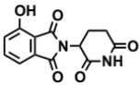
2-(2,6-dioxopiperidin-3-yl)-4-hydroxyisoindoline-1,3-dione (17)
3-Hydroxyphthalic anhydride (1.641 g, 10 mmol, 1 eq) and 3-aminopiperidine-2,6-dione hydrochloride (1.646 g, 10 mmol, 1 eq) were dissolved in pyridine (40 mL, 0.25 M) and heated to 110 °C. After 14 hours, the mixture was cooled to room temperature and concentrated under reduced pressure. Purification by column chromatography (ISCO, 24 g silica column, 0-10% MeOH/DCM) gave the desired product as a tan solid (2.424 g, 8.84 mmol, 88%).
¹H NMR (400 MHz, DMSO-d₆) δ 11.08 (s, 2H), 7.65 (dd, J = 8.4, 7.2 Hz, 1H), 7.36 – 7.28 (m, 1H), 7.25 (dd, J = 8.4, 0.6 Hz, 1H), 5.07 (dd, J = 12.8, 5.4 Hz, 1H), 2.88 (ddd, J = 17.3, 14.0, 5.4 Hz, 1H), 2.63 – 2.50 (m, 2H), 2.08 – 1.95 (m, 1H).

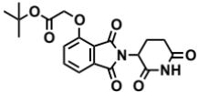
tert-butyl 2-((2-(2,6-dioxopiperidin-3-yl)-1,3-dioxoisoindolin-4-yl)oxy)acetate (18)
2-(2,6-dioxopiperidin-3-yl)-4-hydroxyisoindoline-1,3-dione (1.568 g, 5.71 mmol, 1 eq) was dissolved in DMF (57 mL, 0.1 M) at room temperature. Potassium carbonate (1.19 g, 8.58 mmol, 1.5 eq) and tert-butyl bromoacetate (0.843 mL, 5.71 mmol, 1 eq) were then added. After 2 hours, the mixture was diluted with EtOAc and washed once with water then twice with brine. The organic layer was dried over sodium sulfate, filtered and concentrated under reduced pressure. Purification by column chromatography (ISCO, 24 g silica column, 0-100%EtOAc/hexanes, 21 minute gradient) gave the desired product as a cream colored solid (2.06 g, 5.30 mmol, 93%).
¹H NMR (500 MHz, Chloroform-d) δ 7.94 (s, 1H), 7.67 (dd, J = 8.4, 7.3 Hz, 1H), 7.52 (d, J = 6.8 Hz, 1H), 7.11 (d, J = 8.3 Hz, 1H), 4.97 (dd, J = 12.3, 5.3 Hz, 1H), 4.79 (s, 2H), 2.95 – 2.89 (m, 1H), 2.85 – 2.71 (m, 2H), 2.14 (dtd, J = 10.2, 5.0, 2.7 Hz, 1H), 1.48 (s, 9H).

LCMS 389.33 (M+H).

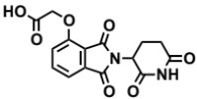
2-((2-(2,6-dioxopiperidin-3-yl)-1,3-dioxoisoindolin-4-yl)oxy)acetic acid (19)
tert-butyl 2-((2-(2,6-dioxopiperidin-3-yl)-1,3-dioxoisoindolin-4-yl)oxy)acetate (2.06 g, 5.30 mmol, 1 eq) was dissolved in TFA (53 mL, 0.1M) at room temperature. After 4 hours, the solution was diluted with DCM and concentrated under reduced pressure. The resultant cream colored solid (1.484 g, 4.47 mmol, 84%) was deemed sufficiently pure and carried onto the next step without further purification.
¹H NMR (500 MHz, DMSO-d₆) δ 11.11 (s, 1H), 7.79 (dd, J = 8.4, 7.4 Hz, 1H), 7.48 (d, J = 7.2 Hz, 1H), 7.39 (d, J = 8.6 Hz, 1H), 5.10 (dd, J = 12.8, 5.4 Hz, 1H), 4.99 (s, 2H), 2.93 – 2.89 (m, 1H), 2.63 – 2.51 (m, 2H), 2.04 (ddd, J = 10.5, 5.4, 3.1 Hz, 1H).

LCMS 333.25 (M+H).

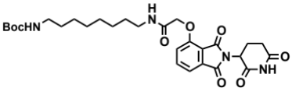
tert-butyl (8-(2-((2-(2,6-dioxopiperidin-3-yl)-1,3-dioxoisoindolin-4-yl)oxy)acetamido)octyl)carbamate (20)
Boc-1,8-diaminooctane (2.10 g, 8.59 mmol, 1.1 eq) was dissolved in DMF (86 mL). In a separate flask, 2-((2-(2,6-dioxopiperidin-3-yl)-1,3-dioxoisoindolin-4-yl)oxy)acetic acid (2.60 g, 7.81 mmol, 1 eq) was dissolved in DMF (78 mL). The solution of Boc-1,8-diaminooctane in DMF was then added, followed by DIPEA (4.08 mL, 23.4 mmol. 3 eq) and HATU (2.97 g, 7.81 mmol, 1 eq). The mixture was stirred for 19 hours at room temperature, then diluted with EtOAc (600 mL). The organic layer was washed sequentially with 200 mL of half saturated sodium chloride, 200 mL 10% citric acid (aq.), 200 mL of half saturated sodium chloride, 200 mL of saturated sodium bicarbonate (aq.), 200 mL water and twice with 200 mL brine. The organic layer was dried over sodium sulfate, filtered and concentrated under reduced pressure. Purification by column chromatography (ISCO, 40 g column, 0-5% MeOH/DCM, 35 minute gradient) gave the desired product as a white solid (3.53 g, 6.32 mmol, 81%).
¹H NMR (500 MHz, Chloroform-d) δ 8.49 (s, 1H), 7.74 (dd, J = 8.3, 7.4 Hz, 1H), 7.55 (d, J = 7.2 Hz, 1H), 7.39 (t, J = 5.3 Hz, 1H), 7.19 (d, J = 8.4 Hz, 1H), 4.97 (dd, J = 12.4, 5.3 Hz, 1H), 4.63 (d, J = 2.2 Hz, 2H), 4.59 (d, J = 10.0 Hz, 1H), 3.36 (q, J = 6.9 Hz, 2H), 3.12 – 3.03 (m, 2H), 2.95 – 2.72 (m, 3H), 2.16 (ddt, J = 10.3, 5.2, 2.7 Hz, 1H), 1.59 (p, J = 7.1 Hz, 2H), 1.37 (d, J = 67.6 Hz, 19H).

LCMS 559.47 (M+H).

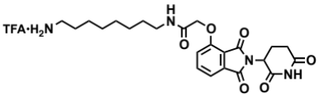
N-(8-aminooctyl)-2-((2-(2,6-dioxopiperidin-3-yl)-1,3-dioxoisoindolin-4-yl)oxy)acetamide trifluoroacetate (21)
tert-butyl (8-(2-((2-(2,6-dioxopiperidin-3-yl)-1,3-dioxoisoindolin-4-yl)oxy)acetamido)octyl)carbamate (3.53 g, 6.32 mmol, 1 eq) was dissolved in TFA (63 mL, 0.1M) and heated to 50 °C. After 1 hour, the mixture was cooled to room temperature, diluted with MeOH and concentrated under reduced pressure. The crude material was triturated with diethyl ether and dried under vacuum to give a white solid (2.93 g, 5.12 mmol, 81%).
¹H NMR (500 MHz, Methanol-d₄) δ 7.82 (dd, J = 8.4, 7.4 Hz, 1H), 7.55 (d, J = 7.2 Hz, 1H), 7.44 (d, J = 8.4 Hz, 1H), 5.14 (dd, J = 12.5, 5.5 Hz, 1H), 4.76 (s, 2H), 3.33 (dd, J = 6.8, 1.8 Hz, 1H), 3.30 (s, 1H), 2.94 – 2.85 (m, 3H), 2.80 – 2.69 (m, 2H), 2.19 – 2.11 (m, 1H), 1.60 (dq, J = 24.8, 7.0 Hz, 4H), 1.37 (s, 8H).

LCMS 459.45 (M+H).

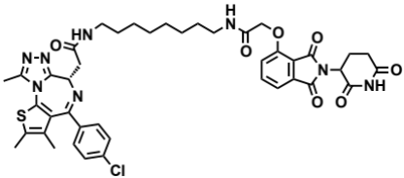
dBET6 (4)
(S)-2-(4-(4-chlorophenyl)-2,3,9-trimethyl-6H-thieno[3,2-f][1,2,4]triazolo[4,3-a][1,4]diazepin-6-yl)acetic acid (JQ-acid) (0.894 g, 2.23 mmol, 1 eq) and N-(8-aminooctyl)-2-((2-(2,6-dioxopiperidin-3-yl)-1,3-dioxoisoindolin-4-yl)oxy)acetamide trifluoroacetate (1.277 g) were dissolved in DMF (22.3 mL, 0.1M) at room temperature. DIPEA (1.17 mL, 6.69 mmol, 3 eq) was added, followed by HATU (0.848 g, 2.23 mmol, 1 eq). The mixture was stirred for 23 hours, and then diluted with EtOAc. The organic layer was washed with saturated sodium bicarbonate, water and three times with brine. The organic layer was then dried under sodium sulfate, filtered and concentrated under reduced pressure. Purification by column chromatography (ISCO, 40 g column, 4-10% MeOH/DCM, 35 minute gradient) gave dBET6 as a cream colored solid (1.573 g, 1.87 mmol, 84%).
¹H NMR (500 MHz, Methanol-d₄) δ 7.80 (dd, J = 8.3, 7.5 Hz, 1H), 7.53 (d, J = 7.3 Hz, 1H), 7.46 – 7.37 (m, 5H), 5.11 (ddd, J = 12.6, 8.2, 5.5 Hz, 1H), 4.75 (s, 2H), 4.63 (dd, J = 9.0, 5.2 Hz, 1H), 3.41 (ddd, J = 14.9, 9.0, 2.2 Hz, 1H), 3.30 – 3.14 (m, 5H), 2.86 (ddt, J = 19.8, 14.6, 5.2 Hz, 1H), 2.78 – 2.66 (m, 5H), 2.44 (s, 3H), 2.13 (ddq, J = 15.3, 7.7, 4.8, 3.8 Hz, 1H), 1.69 (s, 3H), 1.61 – 1.51 (m, 4H), 1.35 (s, 8H).
¹³C NMR (126 MHz, MeOD) δ 174.49, 172.65, 171.30, 169.80, 168.28, 167.74, 166.18, 157.03, 156.24, 152.18, 138.19, 138.08, 137.97, 134.92, 133.52, 133.23, 132.02, 131.99, 131.33, 129.76, 121.65, 119.30, 117.94, 69.36, 55.27, 50.57, 40.49, 40.13, 38.84, 32.19, 30.49, 30.34, 30.31, 30.22, 27.92, 27.82, 23.64, 14.42, 12.92, 11.60.

LCMS 841.48 (M+H).

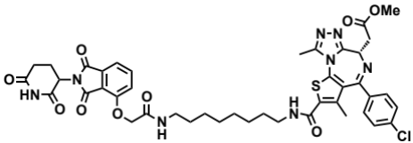
dBET23 (3)
A 0.1 M solution of N-(8-aminooctyl)-2-((2-(2,6-dioxopiperidin-3-yl)-1,3-dioxoisoindolin-4-yl)oxy)acetamide trifluoroacetate in DMF (220 microliters, 0.0220 mmol, 1 eq) was added to (S)-4-(4-chlorophenyl)-6-(2-methoxy-2-oxoethyl)-3,9-dimethyl-6H-thieno[3,2-f][1,2,4]triazolo[4,3-a][1,4]diazepine-2-carboxylic acid (9.87 mg, 0.0220 mmol, 1 eq) at room temperature. DIPEA (11.5 microliters, 0.0660 mmol, 3 eq) and HATU (8.4 mg, 0.0220 mmol, 1 eq) were added. The mixture was then stirred for 21 hours, then diluted with EtOAc and washed with saturated sodium bicarbonate, water and brine. The organic layer was dried over sodium sulfate, filtered and concentrated under reduced pressure. Purification by column chromatography (ISCO, 4 g silica column, 0-10% MeOH/DCM, 25 minute gradient) gave the desired product as a white solid (8.84 mg, 0.00998 mmol, 45%).
¹H NMR (400 MHz, Methanol-d₄) δ 7.81 (dd, J = 8.4, 7.4 Hz, 1H), 7.53 (d, J = 7.3 Hz, 1H), 7.50 – 7.39 (m, 5H), 5.12 (dd, J = 12.6, 5.4 Hz, 1H), 4.75 (s, 2H), 4.68 (t, J = 7.2 Hz, 1H), 3.76 (s, 3H), 3.54 (d, J = 7.2 Hz, 2H), 3.39 – 3.32 (m, 3H), 3.29 (s, 1H), 2.90 – 2.83 (m, 1H), 2.79 – 2.68 (m, 5H), 2.14 (dd, J = 8.9, 3.7 Hz, 1H), 1.99 (s, 3H), 1.65 – 1.53 (m, 4H), 1.36 (d, J = 6.5 Hz, 8H).
¹³C NMR (126 MHz, DMSO-d₆) δ 175.4, 173.7, 172.5, 169.4, 169.3, 168.2, 165.6, 163.6, 157.7, 157.3, 153.0, 139.6, 139.2, 139.1, 138.1, 137.8, 135.7, 133.0, 132.9, 132.6, 131.2, 123.0, 119.5, 118.7, 74.9, 70.3, 62.9, 56.1, 54.3, 51.5, 41.0, 38.8, 33.6, 31.6 (d, J = 4.0 Hz), 31.3 (d, J = 3.3 Hz), 29.0, 28.9, 24.6, 18.7, 14.0.

LCMS 885.47 (M+H).

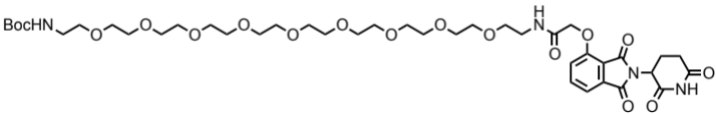
tert-butyl (1-((2-(2,6-dioxopiperidin-3-yl)-1,3-dioxoisoindolin-4-yl)oxy)-2-oxo-6,9,12,15,18,21,24,27,30-nonaoxa-3-azadotriacontan-32-yl)carbamate (22)
tert-butyl (29-amino-3,6,9,12,15,18,21,24,27-nonaoxanonacosyl) carbamate (422.53 mg, 0.759 mmol, 1eq) as a solution in 15.18 ml DMF (0.1 M) was added to 2-((2-(2,6-dioxopiperidin-3-yl)-1,3-dioxoisoindolin-4-yl)oxy) acetic acid (252.26 mg, 0.759, 1eq). DIPEA (376.45 µl, 2.277 mmol, 3eq) was added, followed by HATU (288.6 mg, 0.759 mmol, 1eq). The mixture was stirred for 17 hours at room temperature. The mixture was then diluted with EtOAc and washed with saturated sodium bicarbonate, water then brine. The organic layer was dried over sodium sulfate, filtered and condensed to give a white solid (255.8 mg, 39 % yield). The crude material was purified by column chromatography (ISCO, 12 g silica column, 0 to 10% MeOH/DCM 25 minute gradient) to give a white solid (105.3 mg, 16 % yield).
¹H NMR (500 MHz, Methanol-d₄) δ 7.80 (dd, J = 8.4, 7.3 Hz, 1H), 7.50 (dd, J = 7.3 Hz, 1H), 7.43 (dd, J = 8.5 Hz, 1H), 5.12 (dd, J = 12.8, 5.5 Hz, 1H), 3.61 (m, J = 8.2, 5.6, 2.6 Hz, 36H), 3.50 (dd, J = 5.6, 1.9 Hz, 4H), 3.22 (q, J = 5.5 Hz, 2H), 2.90 (ddd, J = 17.5, 13.9, 5.3 Hz, 1H), 2.80 – 2.70 (m, 2H), 2.17 (m, J = 13.1, 5.8, 2.8 Hz, 1H), 1.43 (s, 9H).

LCMS 871.35 (M+H)

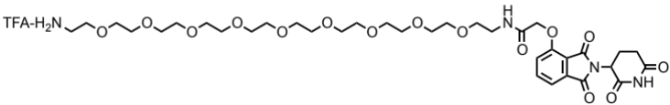
N-(29-amino-3,6,9,12,15,18,21,24,27-nonaoxanonacosyl)-2-((2-(2,6-dioxopiperidin-3-yl)-1,3-dioxoisoindolin-4-yl)oxy)acetamide trifluoroacetate salt (23)
tert-butyl (1-((2-(2,6-dioxopiperidin-3-yl)-1,3-dioxoisoindolin-4-yl)oxy)-2-oxo-6,9,12,15,18,21,24,27,30-nonaoxa-3-azadotriacontan-32-yl)carbamate (105.3 mg, 0.121mmol, 1eq) was added to 1.21 ml TFA (0.1M) and was stirred for 2 hours at 50º C. The mixture was diluted with methanol and condensed to give a white solid (104.28, 97 % yield) with no further purification.
¹H NMR (500 MHz, DMSO-d₆) δ 11.11 (s, 1H), 8.00 (s, J = 5.8 Hz, 1H), 7.82 (dd, J = 7.9 Hz, 1H), 7.75 – 7.71 (s, 2H), 7.50 (dd, J = 7.3 Hz, 1H), 7.40 (dd, J = 8.6 Hz, 1H), 5.11 (dd, J = 12.8, 5.4 Hz, 1H), 4.79 (s, 2H), 3.91 – 3.41 (m, 36H), 3.32 (t, J = 5.7 Hz, 2H), 2.98 (m, J = 5.5 Hz, 2H), 2.90 (ddd, J = 18.1, 14.0, 5.3 Hz, 1H), 2.63 – 2.54 (m, 2H), 2.05 (dd, J = 12.3, 6.1 Hz, 1H).

LCMS 771.80 (M+H)

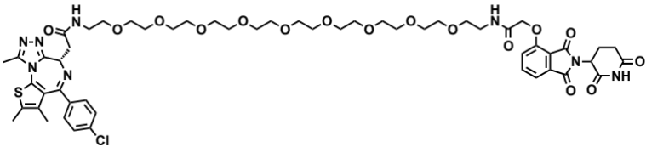
dBET55 (6)
A 0.1 M solution of N-(29-amino-3,6,9,12,15,18,21,24,27-nonaoxanonacosyl)-2-((2-(2,6-dioxopiperidin-3-yl)-1,3-dioxoisoindolin-4-yl)oxy)acetamide trifluoroacetate in DMF (200 microliters, 0.020 mmol, 1 eq) was added to JQ-acid (8.0 mg, 0.020 mmol, 1 eq) at room temperature. DIPEA (10.5 microliters, 0.060 mmol, 3 eq) and HATU (7.6 mg, 0.020 mmol, 1 eq) were added. After 18 hours the mixture was diluted with EtOAc and washed with saturated sodium bicarbonate, water and brine. The combined organic layer was dried over sodium sulfate, filtered and concentrated under reduced pressure. Purification by column chromatography (ISCO, 4 g silica column, 0-10% MeOH/DCM, 25 minute gradient) gave the desired product (10.55 mg, 0.00914 mmol, 46%).
¹H NMR (500 MHz, Methanol-d₄) δ 7.82 (dd, J = 8.4, 7.4 Hz, 1H), 7.55 (d, J = 7.0 Hz, 1H), 7.49 – 7.41 (m, 5H), 5.13 (dd, J = 12.6, 5.5 Hz, 1H), 4.80 (s, 2H), 4.65 (dd, J = 9.1, 5.1 Hz, 1H), 3.68 – 3.58 (m, 36H), 3.53 – 3.44 (m, 5H), 2.94 – 2.86 (m, 1H), 2.81 – 2.70 (m, 5H), 2.46 (s, 3H), 2.19 – 2.13 (m, 1H), 1.74 – 1.69 (m, 3H).
¹³C NMR (126 MHz, DMSO-d₆) δ 175.4, 172.5, 172.3, 169.5, 169.4, 168.1, 165.6, 157.8, 157.6, 152.4, 139.6, 139.4, 137.9, 135.7, 134.9, 132.8, 132.5, 132.2, 131.1, 123.0, 119.4, 118.7, 72.4 (d, J = 4.0 Hz), 72.3, 71.9, 71.5, 70.1, 65.7, 62.9, 56.5, 51.5, 41.3, 41.1, 40.1, 33.6, 24.6, 16.7, 15.3, 13.9.

LCMS 1153.59 (M+H).
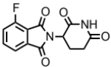
2-(2,6-dioxopiperidin-3-yl)-4-fluoroisoindoline-1,3-dione (24)
3-fluorophthalic anhydride (1.66g, 10 mmol, 1 eq) and 3-aminopiperidine-2,6-dione hydrochloride salt (1.81 g, 11 mmol, 1.1 eq) were dissolved in AcOH (25 mL) followed by potassium acetate (3.04 g, 31 mmol, 3.1 eq). The mixture was fitted with an air condenser and heated to 90 °C. After 16 hours, the mixture was diluted with 100 mL water and cooled over ice. The slurry was then centrifuged (4000 rpm, 20 minutes, 4 °C) and decanted. The remaining solid was then resuspended in water, centrifuged and decanted again. The solid was then dissolved in MeOH and filtered through a silica plug (that had been pre-wetted with MeOH), washed with 50% MeOH/DCM and concentrated under reduced pressure to yield the desired product as a grey solid (2.12 g, 7.68 mmol, 77%).
¹H NMR (500 MHz, DMSO-d₆) δ 11.13 (s, 1H), 7.98 – 7.91 (m, 1H), 7.79 (d, J = 7.3 Hz, 1H), 7.74 (t, J = 8.8 Hz, 1H), 5.16 (dd, J = 12.9, 5.4 Hz, 1H), 2.89 (ddd, J = 17.2, 14.0, 5.5 Hz, 1H), 2.61 (ddd, J = 17.1, 4.4, 2.4 Hz, 1H), 2.57 – 2.50 (m, 1H), 2.06 (dtd, J = 13.0, 5.4, 2.3 Hz, 1H).

LCMS 277.21 (M+H).

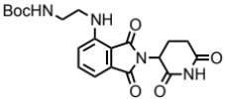
tert-butyl (2-((2-(2,6-dioxopiperidin-3-yl)-1,3-dioxoisoindolin-4-yl)amino)ethyl)carbamate (25)
A stirred solution of 2-(2,6-dioxopiperidin-3-yl)-4-fluoroisoindoline-1,3-dione (174 mg, 0.630 mmol, 1 equiv) in DMF (6.3 mL, 0.1 M) was added DIPEA (220 L, 1.26 mmol, 2 equiv) and 1-Boc-ethylendiamine (110 L, 0.693 mmol, 1.1 equiv). The reaction mixture was heated to 90 ºC overnight, whereupon it was cooled to room temperature and taken up in EtOAc (30 mL) and water (30 mL). The organic layer was washed with brine (3x20 mL), dried over Na₂SO₄ and concentrated in vacuo. The residue was purified by flash column chromatography on silica gel (0→10% MeOH in CH₂Cl₂) to give the title compound as a yellow solid (205 mg, 79%).
¹H NMR (500 MHz, CDCl₃) δ 8.08 (bs, 1H), 7.50 (dd, J = 8.5, 7.1 Hz, 1H), 7.12 (d, J = 7.1 Hz, 1H), 6.98 (d, J = 8.5 Hz, 1H), 6.39 (t, J = 6.1 Hz, 1H), 4.96 – 4.87 (m, 1H), 4.83 (bs, 1H), 3.50 – 3.41 (m, 2H), 3.41 – 3.35 (m, 2H), 2.92 – 2.66 (m, 3H), 2.16 – 2.09 (m, 1H), 1.45 (s, 9H).

LCMS 417.58 (M+H).

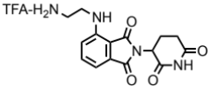
4-((2-aminoethyl)amino)-2-(2,6-dioxopiperidin-3-yl)isoindoline-1,3-dione trifluoroacetate salt (26)
A stirred solution of tert-butyl (2-((2-(2,6-dioxopiperidin-3-yl)-1,3-dioxoisoindolin-4-yl)amino)ethyl)carbamate (205 mg, 0.492 mmol, 1 equiv) in dichloromethane (2.25 mL) was added trifluoroacetic acid (0.250 mL). The reaction mixture was stirred at room temperature for 4 h, whereupon the volatiles were removed in vacuo. The title compound was obtained as a yellow solid (226 mg, >95%), that was used without further purification.
¹H NMR (500 MHz, MeOD) δ 7.64 (d, J = 1.4 Hz, 1H), 7.27 – 7.05 (m, 2H), 5.10 (dd, J = 12.5, 5.5 Hz, 1H), 3.70 (t, J = 6.0 Hz, 2H), 3.50 – 3.42 (m, 2H), 3.22 (t, J = 6.0 Hz, 1H), 2.93 – 2.85 (m, 1H), 2.80 – 2.69 (m, 2H), 2.17 – 2.10 (m, 1H).

LCMS 317.53 (M+H).

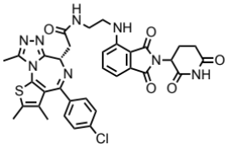
dBET57 (7)
JQ-acid (8.0 mg, 0.0200 mmol, 1 eq) and 2-((2-(2,6-dioxopiperidin-3-yl)-1,3-dioxoisoindolin-4-yl)amino)ethan-1-aminium 2,2,2-trifluoroacetate (8.6 mg, 0.0200 mmol, 1 equiv) were dissolved in DMF (0.200 mL, 0.1 M) at room temperature. DIPEA (17.4 L, 0.100 mmol, 5 equiv) and HATU (7.59 mg, 0.0200 mmol, 1 equiv) were then added and the mixture was stirred at room temperature overnight. The reaction mixture was taken up in EtOAc (15 mL), and washed with satd. NaHCO₃ (aq) (15 mL), water (15 mL) and brine (3x15 mL). The organic layer was dried over Na₂SO₄ and concentrated in vacuo. The residue was purified by flash column chromatography on silica gel (0→10% MeOH in CH₂Cl₂, R_{f} = 0.3 (10% MeOH in CH₂Cl₂)) to give the title compound as a bright yellow solid (11.2 mg, 80%).
¹H NMR (400 MHz, CDCl₃)  8.49 (bs, 0.6H), 8.39 (bs, 0.4H), 7.51 – 7.43 (m, 1H), 7.38 (d, J = 7.8 Hz, 2H), 7.29 (dd, J = 8.8, 1.7 Hz, 2H), 7.07 (dd, J = 7.1, 4.9 Hz, 1H), 6.97 (dd, J = 8.6, 4.9 Hz, 1H), 6.48 (t, J = 5.9 Hz, 1H), 6.40 (t, J = 5.8 Hz, 0.6H), 4.91 – 4.82 (m, 0.4H), 4.65 – 4.60 (m, 1H), 3.62 – 3.38 (m, 6H), 2.87 – 2.64 (m, 3H), 2.63 (s, 3H), 2.40 (s, 6H), 2.12 – 2.04 (m, 1H), 1.67 (s, 3H), rotamers;
¹³C NMR (126 MHz, DMSO-d₆) δ 172.8, 170.2, 170.0, 168.6, 167.3, 163.1, 155.1, 149.8, 146.3, 136.7, 136.2, 135.2, 132.22 (d, J = 5.9 Hz), 130.7, 130.1, 129.8, 129.5, 128.4, 117.2, 110.6, 109.3, 53.7, 48.5, 37.6, 31.0, 29.0, 22.1, 14.0, 12.7, 11.3.

LCMS 700.34 (M+H).

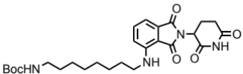
tert-butyl (8-((2-(2,6-dioxopiperidin-3-yl)-1,3-dioxoisoindolin-4-yl)amino)octyl)carbamate (27)
2-(2,6-dioxopiperidin-3-yl)-4-fluoroisoindoline-1,3-dione (552.4 mg, 2.0 mmol, 1 eq) and tert-butyl (8-aminooctyl)carbamate (537.6 mg, 2.2 mmol, 1.1 eq) were dissolved in NMP (10 mL). DIPEA (697 microliters, 4.0 mmol, 2 eq) was added and the mixture was heated to 90 °C. After 21 hours the mixture was cooled to room temperature and diluted with EtOAc. The organic layer was washed with 10% citric acid (aq), brine, saturated sodium bicarbonate (aq), water, and three times with brine. The organic layer was then dried over sodium sulfate, filtered and concentrated under reduced pressure. The material was purified by column chromatography (ISCO, 12 g column, 0-5% MeOH/DCM, 25 minute gradient) to give the desired product as a yellow solid (0.62 g, 1.24 mmol, 62%).
¹H NMR (500 MHz, Chloroform-d) δ 8.51 (s, 1H), 7.49 – 7.44 (m, 1H), 7.06 (d, J = 7.1 Hz, 1H), 6.86 (d, J = 8.6 Hz, 1H), 6.22 (t, J = 5.4 Hz, 1H), 4.91 (dd, J = 12.2, 5.3 Hz, 1H), 4.56 (s, 1H), 3.24 (q, J = 6.7 Hz, 2H), 3.07 (t, J = 12.7 Hz, 2H), 2.89 – 2.67 (m, 3H), 2.11 (dq, J = 10.3, 3.6, 2.7 Hz, 1H), 1.64 (p, J = 7.0 Hz, 2H), 1.36 (d, J = 61.0 Hz, 19H).
¹³C NMR (126 MHz, CDCl₃) δ 171.47, 169.60, 168.68, 167.73, 156.06, 147.06, 136.15, 132.57, 116.71, 111.39, 109.91, 79.11, 48.95, 42.68, 40.66, 31.49, 30.09, 29.25, 29.20, 28.51, 26.89, 26.75, 22.89.

LCMS 501.39 (M+H).

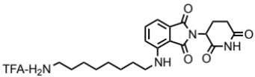
4-((8-aminooctyl)amino)-2-(2,6-dioxopiperidin-3-yl)isoindoline-1,3-dione trifluoroacetate salt (28)
tert-butyl (8-((2-(2,6-dioxopiperidin-3-yl)-1,3-dioxoisoindolin-4-yl)amino)octyl)carbamate (0.55 g, 1.099 mmol, 1 eq) was dissolved in TFA (11 mL) and heated to 50 °C. After 40 minutes, the mixture was concentrated under reduced pressure, triturated with Et₂O, and dried under high vacuum to yield a yellow residue (523 mg, 1.016 mmol, 93%) that was used without further purification.
¹H NMR (500 MHz, Methanol-d₄) δ 7.59 – 7.51 (m, 1H), 7.04 (dd, J = 7.9, 1.7 Hz, 2H), 5.06 (dd, J = 12.4, 5.5 Hz, 1H), 3.34 (d, J = 7.0 Hz, 2H), 2.95 – 2.81 (m, 3H), 2.79 – 2.66 (m, 2H), 2.15 – 2.08 (m, 1H), 1.67 (tt, J = 12.2, 7.2 Hz, 4H), 1.43 (d, J = 22.2 Hz, 8H).

LCMS 401.39 (M+H).

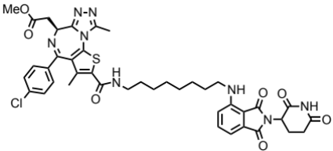
dBET70 (5)
(S)-4-(4-chlorophenyl)-6-(2-methoxy-2-oxoethyl)-3,9-dimethyl-6H-thieno[3,2-f][1,2,4]triazolo[4,3-a][1,4]diazepine-2-carboxylic acid (201 mg, 0.452 mmol, 1 eq) and 4-((8-aminooctyl)amino)-2-(2,6-dioxopiperidin-3-yl)isoindoline-1,3-dione trifluoroacetate salt (232.5 mg, 0.452 mmol, 1 eq) were dissolved in DMF (4.5 mL). DIPEA (236 microliters, 1.355 mmol, 3 eq) and HATU (171.9 mg, 0.452 mmol, 1 eq) were added and the mixture was stirred for 18 hours at room temperature. The mixture was then diluted with EtOAc, and washed three times with 1M HCl (aq), then once with brine, saturated sodium bicarbonate, water and brine. The organic layer was then dried over sodium sulfate, filtered and concentrated under reduced pressure. Purification by column chromatography (ISCO, 24 g silica column, 0-6% MeOH/DCM, 35 minute gradient) to give the desired product as a yellow solid (224.92 mg, 0.2719 mmol, 60%).
¹H NMR (500 MHz, Methanol-d₄) δ 7.54 – 7.50 (m, 1H), 7.45 (d, J = 8.5 Hz, 2H), 7.42 – 7.38 (m, 2H), 7.00 (dd, J = 7.8, 2.9 Hz, 2H), 5.00 (ddd, J = 12.8, 5.4, 3.1 Hz, 1H), 4.66 (t, J = 7.1 Hz, 1H), 3.75 (s, 3H), 3.53 (d, J = 7.3 Hz, 2H), 3.37 (dq, J = 15.7, 8.3, 7.7 Hz, 2H), 3.29 (d, J = 6.9 Hz, 2H), 2.85 (ddd, J = 18.3, 13.9, 5.1 Hz, 1H), 2.77 – 2.64 (m, 5H), 2.11 – 2.05 (m, 1H), 1.97 (s, 3H), 1.64 (dq, J = 20.8, 6.8 Hz, 4H), 1.41 (d, J = 21.1 Hz, 8H).
¹³C NMR (126 MHz, MeOD) δ 174.60, 173.08, 171.59, 170.79, 169.25, 165.54, 163.65, 156.83, 152.44, 148.25, 138.20, 137.94, 137.86, 137.81, 137.22, 133.86, 132.42, 131.84, 131.26, 129.89, 117.96, 111.73, 110.94, 54.89, 52.47, 50.16, 43.37, 41.25, 37.13, 32.21, 30.29, 30.22, 30.17, 27.87, 27.78, 23.79, 16.57, 11.68.

LCMS 827.60 (M+H)

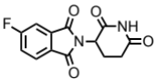
2-(2,6-dioxopiperidin-3-yl)-5-fluoroisoindoline-1,3-dione (29)
4-fluorophthalic anhydride (3.32 g, 20 mmol, 1 eq) and 3-aminopiperidine-2,6-dione hydrochloride salt (3.620 g, 22 mmol, 1.1 eq) were dissolved in AcOH (50 mL) followed by potassium acetate (6.08 g, 62 mmol, 3.1 eq). The mixture was fitted with an air condenser and heated to 90 °C. After 16 hours, the mixture was diluted with 200 mL water and cooled over ice. The slurry was then centrifuged (4000 rpm, 20 minutes, 4 °C) and decanted. The remaining solid was then resuspended in water, centrifuged and decanted again. The solid was then dissolved in MeOH and filtered through a silica plug (that had been pre-wetted with MeOH), washed with 50% MeOH/DCM and concentrated under reduced pressure to yield the desired product as a grey solid (2.1883 g, 7.92 mmol, 40%).
¹H NMR (500 MHz, DMSO-d₆) δ 11.13 (s, 1H), 8.01 (dd, J = 8.3, 4.5 Hz, 1H), 7.85 (dd, J = 7.4, 2.2 Hz, 1H), 7.72 (ddd, J = 9.4, 8.4, 2.3 Hz, 1H), 5.16 (dd, J = 12.9, 5.4 Hz, 1H), 2.89 (ddd, J = 17.2, 13.9, 5.5 Hz, 1H), 2.65 – 2.51 (m, 2H), 2.07 (dtd, J = 12.9, 5.3, 2.2 Hz, 1H).

LCMS 277.22 (M+H).

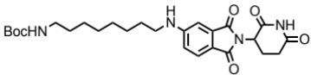
tert-butyl (8-((2-(2,6-dioxopiperidin-3-yl)-1,3-dioxoisoindolin-5-yl)amino)octyl)carbamate (30)
2-(2,6-dioxopiperidin-3-yl)-5-fluoroisoindoline-1,3-dione (294 mg, 1.06 mmol, 1 eq) and tert-butyl (8-aminooctyl)carbamate (286 mg, 1.17 mmol, 1.1 eq) were dissolved in NMP (5.3 mL). DIPEA (369 microliters, 2.12 mmol, 2 eq) was added and the mixture was heated to 90 °C. After 19 hours the mixture was cooled to room temperature and diluted with EtOAc. The organic layer was washed with water and three times with brine. The organic layer was then dried over sodium sulfate, filtered and concentrated under reduced pressure. The material was purified by column chromatography (ISCO, 12 g column, 0-10% MeOH/DCM, 30 minute gradient) to give the desired product as a brown solid (0.3345 g, 0.6682 mmol, 63%).
¹H NMR (500 MHz, Chloroform-d) δ 8.12 (s, 1H), 7.62 (d, J = 8.3 Hz, 1H), 7.02 (s, 1H), 6.81 (d, J = 7.2 Hz, 1H), 4.93 (dd, J = 12.3, 5.3 Hz, 1H), 4.51 (s, 1H), 3.21 (t, J = 7.2 Hz, 2H), 3.09 (d, J = 6.4 Hz, 2H), 2.90 (dd, J = 18.3, 15.3 Hz, 1H), 2.82 – 2.68 (m, 2H), 2.16 – 2.08 (m, 1H), 1.66 (p, J = 7.2 Hz, 2H), 1.37 (d, J = 62.3 Hz, 20H).

LCMS 501.41 (M+H).

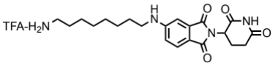
5-((8-aminooctyl)amino)-2-(2,6-dioxopiperidin-3-yl)isoindoline-1,3-dione trifluoroacetate salt (31)
tert-butyl (8-((2-(2,6-dioxopiperidin-3-yl)-1,3-dioxoisoindolin-5-yl)amino)octyl)carbamate (334.5 mg, 0.668 mmol, 1 eq) was dissolved in TFA (6.7 mL) and heated to 50 °C. After 50 minutes, the mixture was cooled to room temperature, diluted with DCM and concentrated under reduced pressure, triturated with Et₂O, and dried under high vacuum to yield a dark yellow foam (253 mg, 0.492 mmol, 74%) that was used without further purification.
¹H NMR (500 MHz, Methanol-d₄) δ 7.56 (d, J = 8.4 Hz, 1H), 6.97 (d, J = 2.1 Hz, 1H), 6.83 (dd, J = 8.4, 2.2 Hz, 1H), 5.04 (dd, J = 12.6, 5.5 Hz, 1H), 3.22 (t, J = 7.1 Hz, 2H), 2.94 – 2.88 (m, 2H), 2.85 – 2.68 (m, 3H), 2.09 (ddd, J = 10.4, 5.4, 3.0 Hz, 1H), 1.70 – 1.61 (m, 4H), 1.43 (d, J = 19.0 Hz, 8H).

LCMS 401.36 (M+H).

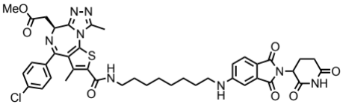
dBET72 (14)
5-((8-aminooctyl)amino)-2-(2,6-dioxopiperidin-3-yl)isoindoline-1,3-dione trifluoroacetate salt (10.3 mg, 0.020 mmol, 1 eq) in DMF (200 microliters) was added to (S)-4-(4-chlorophenyl)-6-(2-methoxy-2-oxoethyl)-3,9-dimethyl-6H-thieno[3,2-f][1,2,4]triazolo[4,3-a][1,4]diazepine-2-carboxylic acid (8.9 mg, 0.020 mmol, 1 eq) at room temperature. DIPEA (10.5 microliters, 0.060 mmol, 3 eq) was added, followed by HATU (7.6 mg, 0.020 mmol, 1 eq). After 27 hours, the mixture was diluted with EtOAc then washed with saturated sodium bicarbonate, water and brine. The organic layer was dried over sodium sulfate, filtered and concentrated under reduced pressure. . The mixture was purified by column chromatography (ISCO, 4 g column, 0-10% MeOH/DCM, 25 minute gradient) to give the desired product as a yellow solid (4.98 mg, 0.00602 mmol, 30%).
¹H NMR (500 MHz, Methanol-d₄) δ 7.54 (d, J = 8.4 Hz, 1H), 7.49 – 7.40 (m, 4H), 6.96 (d, J = 2.1 Hz, 1H), 6.82 (dd, J = 8.4, 2.1 Hz, 1H), 5.02 (dd, J = 12.7, 5.5 Hz, 1H), 4.67 (t, J = 7.1 Hz, 1H), 3.76 (s, 3H), 3.54 (d, J = 7.2 Hz, 2H), 3.41 – 3.33 (m, 2H), 3.20 (t, J = 7.0 Hz, 2H), 2.85 (ddd, J = 19.2, 14.0, 5.3 Hz, 1H), 2.77 – 2.65 (m, 5H), 2.11 – 2.04 (m, 1H), 1.99 (s, 3H), 1.64 (dt, J = 19.3, 7.1 Hz, 4H), 1.43 (d, J = 21.8 Hz, 8H).
¹³C NMR (126 MHz, DMSO-d₆) δ 175.5, 173.7, 172.8, 170.4, 169.8, 165.6, 163.6, 157.3, 157.1, 153.0, 139.2, 139.1, 138.1, 137.8, 136.8, 133.1, 132.9, 132.6, 131.2, 127.7, 118.4, 75.1, 72.4, 65.7, 56.1, 54.3, 51.3, 45.1, 38.8, 33.6, 30.9, 29.1, 29.0, 24.9, 18.8, 14.0.

LCMS 827.46 (M+H).

(S)-4-(4-chlorophenyl)-6-(2-methoxy-2-oxoethyl)-3,9-dimethyl-6H-thieno[3,2-f][1,2,4]triazolo[4,3-a][1,4]diazepine-2-carboxylic acid (36) was synthesized at ChemPartner from (S)-JQ1 using the following procedures:
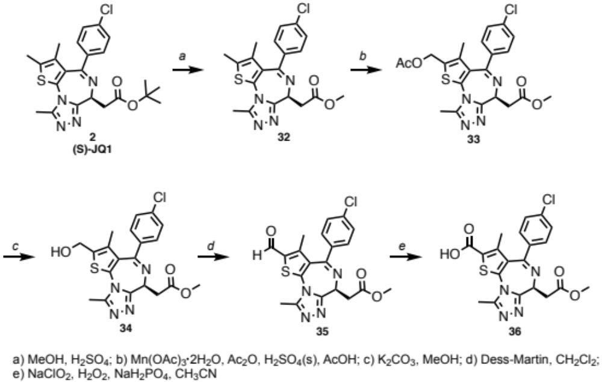

Compound 32
(S)-JQ1 (4.57 g, 10 mmol) was dissolved in MeOH (0.25 M). conc.H₂SO₄ (50 drops) was added to the solution. The mixture was refluxed overnight. The mixture was concentrated in vacuo, poured into water, extracted with AcOEt, and washed with brine. The organic layer was dried over Na₂SO₄, filtered, and concentrated in vacuo. The residue was purified by flash column chromatography (AcOEt/MeOH) to give title compound 3.93 g (95 %).

Compound 33
To a mixture of acetic acid (52 mL) and acetic anhydride (30 mL) was added dropwise concentrated sulfuric acid (8 mL). Compound 33 (6.04 g, 14.6 mmol) was added, and manganese acetate (III)*dihydrate (8 g, 29.4 mmol) was further added. The mixture was stirred at room temperature for 3 days. The reaction mixture was poured into ice water, and extracted twice with ethyl acetate (300 mL). The organic layer was washed twice with saturated brine (300 mL). The residue was dried over Na₂SO₄, and the solvent was evaporated to give an oil (5 g), which was used without further purification.

Compound 34
Compound 33 (6.0 g, 12.7 mmol) and K₂CO₃ (1.2 eq) were suspended in MeOH (0.1 M). The mixture was stirred at room temperature for 2 hours. The mixture was neutralized with 1N HCl, then concentrated in vacuo. The residue was poured into water, and extracted with DCM. The organic layer was dried over Na₂SO₄, filtrated, and concentrated in vacuo. The residue was purified with flash column chromatography (AcOEt/MeOH) to give title compound 2 g (32 % over 2 steps).

Compound 35
Compound 34 (867 mg, 2.01 mmol) was dissolved in DCM (20 mL). Dess-Martin periodinane (1.2 eq) was added to the solution at 0 ºC. The mixture was stirred at room temperature for 2 hours. The mixture was diluted with DCM, washed with saturated NaHCO₃ solution, dried over Na₂SO₄, and concentrated in vacuo to give an oil (850 mg). The crude product was used directly without further purification.

Compound 36
Compound 35 (850 mg, 1.98 mmoL) was suspended in CH₃CN (8 mL). Sodium phosphate monobasic (0.97 eq) in H₂O (3 mL) solution was added to the suspension. Hydrogen peroxide (5 eq) was added to the solution dropwise. Sodium chlorite (1.4 eq) in H₂O (2 mL) solution was added to the suspension. The mixture was stirred for 3 hours. The mixture was diluted with EtOAc, quenched with Na₂S₂O₃ aq, then, acidified with 1N HCl (pH<4). The mixture was extracted with EtOAc, washed with brine. The organic layer was dried over Na₂SO4, filtered, and concentrated in vacuo. The residue was purified by prep-HPLC to give compound 5 (667 mg, 75 %).
¹H NMR (400 MHz, Methanol-d₄) δ 7.44 (q, J = 8.8 Hz, 4H), 4.68 (t, J = 7.2 Hz, 1H), 3.76 (s, 3H), 3.54 (d, J = 7.2 Hz, 2H), 2.74 (s, 3H), 2.09 (s, 3H).

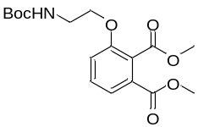
dimethyl 3-(2-((tert-butoxycarbonyl)amino)ethoxy)phthalate (37)
tert-butyl (2-bromoethyl)carbamate (280 mg, 1.25 mmol, 1 eq) and dimethyl 3-hydroxyphthalate (263 mg, 1.25 mmol, 1 eq) were dissolved in DMF (6.25 mL, 0.2 M) followed by potassium carbonate (345 mg, 2.5 mmol, 2 eq). The mixture was stirred at 50°C. After the reaction completed, the mixture was cooled down to room temperature, diluted with EtOAc and washed once with water then twice with brine. The organic layer was dried over sodium sulfate, filtered and concentrated under reduced pressure. Purification by column chromatography (ISCO, 12 g silica column, 0-40% EtOAc/hexane) gave the desired product as a white solid (268 mg, 61%).
LCMS 354 (M+H).

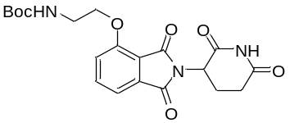
tert-butyl (2-((2-(2,6-dioxopiperidin-3-yl)-1,3-dioxoisoindolin-4-yl)oxy)ethyl)carbamate (38)
dimethyl 3-(2-((tert-butoxycarbonyl)amino)ethoxy)phthalate (268 mg, 0.76 mmol, 1 eq) was dissolved in EtOH (3.8 mL, 0.2 M) followed by aqueous 3M NaOH (760 μL, 2.28 mmol, 3 eq), then the mixture was heated to 80°C for 4 hours. The mixture was then cooled down to room temperature, diluted with 14 ml DCM and 5.5 ml 0.5M HCl. The layers were separated and the organic layer was washed with 7 mL water. The aqueous layers were combined and extracted three times with 14 mL chloroform. The combined organic layers were dried over sodium sulfate, filtered and condensed to give the material that was carried forward without further purification. LCMS 326.

The resultant material and 3-aminopiperidine-2,6-dione hydrochloride (125 mg, 0.76 mmol, 1 eq) were dissolved in pyridine (3.8 mL, 0.2 M) and heated to 110°C overnight. Then the mixture was cooled to room temperature and concentrated under reduced pressure, purified by column chromatography (ISCO, 12 g silica column, 0-6% MeOH/DCM) to give the desired product (152 mg, 48% for two steps).
LCMS 417.

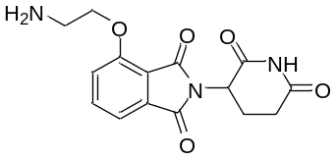
4-(2-aminoethoxy)-2-(2,6-dioxopiperidin-3-yl)isoindoline-1,3-dione (39)
tert-butyl (2-((2-(2,6-dioxopiperidin-3-yl)-1,3-dioxoisoindolin-4-yl)oxy)ethyl)carbamate (152 mg, 0.37 mmol) was dissolved in TFA (3.7 mL, 0.1 M) and heated to 50 °C for 3 hours. The mixture was cooled to room temperature, diluted with Methanol and concentrated under reduced pressure. The material was purified by column chromatography (ISCO, 4 g silica column, 0-20% 1.75N NH₃•MeOH/DCM) to give the free base product (101 mg, 86%).
LCMS 317 (M+H).

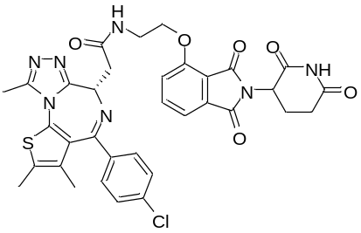

ZXH-2-42 (16)
(S)-2-(4-(4-chlorophenyl)-2,3,9-trimethyl-6H-thieno[3,2-f][1,2,4]triazolo[4,3-a][1,4]diazepin-6-yl)acetic acid (24 mg, 0.06 mmol, 1 eq) was dissolved in 1 mL DMF followed by 4-(2-aminoethoxy)-2-(2,6-dioxopiperidin-3-yl)isoindoline-1,3-dione (19 mg, 0.06 mmol, 1 eq), and then DIEA (30 μL, 0.18 mmol, 3 eq), HATU (27 mg, 0.072 mmol, 1.2 eq) were added. The mixture was stirred at room temperature overnight and then purified by HPLC to give the product as TFA salt (3.8 mg, 8%).
1H NMR (500 MHz, DMSO-d₆) δ 11.10 (s, 1H), 8.51 (s, 1H), 7.83 (t, J = 7.8 Hz, 1H), 7.59 (d, J = 8.6 Hz, 1H), 7.51 – 7.48 (m, 1H), 7.45 – 7.39 (m, 4H), 5.09 (s, 1H), 4.57 – 4.49 (m, 1H), 4.30 (t, J = 5.8 Hz, 2H), 3.35 (s, 3H), 3.18 – 3.13 (m, 2H), 2.86 (s, 1H), 2.60 (s, 3H), 2.42 (s, 2H), 1.62 (s, 3H), 1.27 (s, 2H).
¹³C NMR (201 MHz, DMSO-d₆) δ 173.3, 170.7, 170.4, 167.3, 165.7, 163.5, 155.5, 150.3, 137.6, 135.6, 132.7, 131.2, 130.6, 130.0, 128.9, 120.7, 120.0, 116.1, 115.5, 54.2, 42.3, 37.9, 31.4, 22.5, 18.5, 17.2, 14.5, 12.9, 11.8.
LCMS 700 (M+H).

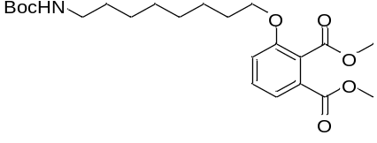
dimethyl 3-((8-((tert-butoxycarbonyl)amino)octyl)oxy)phthalate (40)
tert-butyl (8-bromooctyl)carbamate (308 mg, 1 mmol, 1 eq) and dimethyl 3-hydroxyphthalate (210 mg, 1 mmol, 1 eq) were dissolved in DMF (5 mL, 0.2 M) followed by potassium carbonate (276 mg, 2 mmol, 2 eq). The mixture was stirred at 50°C. After the reaction completed, the mixture was cooled down to room temperature, diluted with EtOAc and washed once with water then twice with brine. The organic layer was dried over sodium sulfate, filtered and concentrated under reduced pressure. Purification by column chromatography (ISCO, 12 g silica column, 0-25% EtOAc/hexane) gave the desired product as a white solid (315 mg, 72%).
LCMS 438 (M+H).

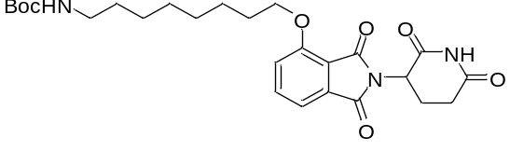
tert-butyl (8-((2-(2,6-dioxopiperidin-3-yl)-1,3-dioxoisoindolin-4-yl)oxy)octyl)carbamate (41)
dimethyl 3-((8-((tert-butoxycarbonyl)amino)octyl)oxy)phthalate (315 mg, 0.72 mmol, 1 eq) was dissolved in EtOH (3.6 mL, 0.2 M) followed by aqueous 3M NaOH (720 μL, 2.16 mmol, 3 eq), then the mixture was heated to 80°C for 4 hours. The mixture was then cooled down to room temperature, diluted with 13 mL DCM and 5 mL 0.5M HCl. The layers were separated and the organic layer was washed with 6.5 mL water. The aqueous layers were combined and extracted three times with 13 mL chloroform. The combined organic layers were dried over sodium sulfate, filtered and condensed to give the material that was carried forward without further purification. LCMS 410.

The resultant material and 3-aminopiperidine-2,6-dione hydrochloride (118 mg, 0.72 mmol, 1 eq) were dissolved in pyridine (3.6 mL, 0.2 M) and heated to 110°C overnight. Then the mixture was cooled to room temperature and concentrated under reduced pressure, purified by column chromatography (ISCO, 12 g silica column, 0-5% MeOH/DCM) to give the desired product (217 mg, 54% for two steps). LCMS 502.

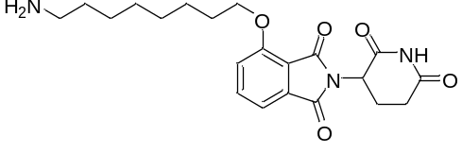
4-((8-aminooctyl)oxy)-2-(2,6-dioxopiperidin-3-yl)isoindoline-1,3-dione (42)
tert-butyl (8-((2-(2,6-dioxopiperidin-3-yl)-1,3-dioxoisoindolin-4-yl)oxy)octyl)carbamate (217 mg, 0.43 mmol) was dissolved in TFA (4.3 mL, 0.1 M) and heated to 50°C for 3 hours. The mixture was cooled to room temperature, diluted with MeOH and concentrated under reduced pressure. The material was purified by column chromatography (ISCO, 4 g silica column, 0-20% 1.75N NH₃•MeOH/DCM) to give the free base product (152 mg, 88%).
LCMS 402 (M+H).

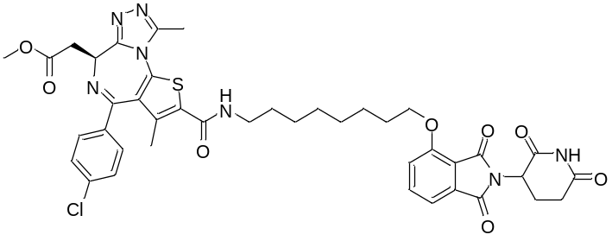

ZXH-2-43 (15)
(S)-4-(4-chlorophenyl)-6-(2-methoxy-2-oxoethyl)-3,9-dimethyl-6H-thieno[3,2-f][1,2,4]triazolo[4,3-a][1,4]diazepine-2-carboxylic acid (20 mg, 0.045 mmol, 1 eq) was dissolved in 1 mL DMF followed by 4-((8-aminooctyl)oxy)-2-(2,6-dioxopiperidin-3-yl)isoindoline-1,3-dione (19 mg, 0.045 mmol, 1 eq), and then DIEA (23 μL, 0.14 mmol, 3 eq), HATU (21 mg, 0.05 mmol, 1.2 eq) were added. The mixture was stirred at room temperature overnight and then purified by HPLC, then by column chromatography (ISCO, 4 g silica column, 0-8% 1.75 N NH₃ in Methanol/DCM) to give the free base product (22.1 mg, 59%).
¹H NMR (500 MHz, DMSO-d₆) δ 11.10 (s, 1H), 8.30 (t, J = 5.7 Hz, 1H), 7.80 (dd, J = 8.5, 7.2 Hz, 1H), 7.51 (d, J = 2.6 Hz, 1H), 7.50 (d, J = 2.7 Hz, 2H), 7.48 – 7.43 (m, 3H), 5.08 (dd, J = 12.8, 5.5 Hz, 1H), 4.58 (dd, J = 7.7, 6.6 Hz, 1H), 4.20 (t, J = 6.4 Hz, 2H), 3.68 (s, 3H), 3.47 (qd, J = 16.6, 7.2 Hz, 2H), 3.34 (s, 1H), 3.29 – 3.20 (m, 2H), 2.89 (ddd, J = 16.9, 13.9, 5.4 Hz, 1H), 2.65 (s, 3H), 2.06 – 1.99 (m, 1H), 1.91 (s, 3H), 1.76 (p, J = 6.6 Hz, 2H), 1.50 (dt, J = 33.3, 7.3 Hz, 4H), 1.33 (s, 6H).
¹³C NMR (126 MHz, DMSO-d₆) δ 175.4, 173.7, 172.6, 169.5, 168.0, 165.6, 163.6, 158.7, 157.3, 153.0, 139.7, 139.2, 139.1, 138.1, 137.8, 135.9, 133.0, 132.9, 132.6, 131.2, 122.4, 118.9, 117.8, 71.4, 56.1, 54.3, 51.4, 38.8, 33.6, 31.6, 31.3, 31.2, 31.0, 29.0, 27.9, 24.6, 18.7, 14.0.
LCMS 828 (M+H).

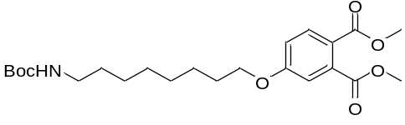
dimethyl 4-((8-((tert-butoxycarbonyl)amino)octyl)oxy)phthalate (43)
tert-butyl (8-bromoethyl)carbamate (182 mg, 0.87 mmol, 1 eq) and dimethyl 4-hydroxyphthalate (267 mg, 0.87 mmol, 1 eq) were dissolved in DMF (4.4 mL, 0.2 M) followed by potassium carbonate (239 mg, 1.73 mmol, 2 eq). The mixture was stirred at 50°C. After the reaction completed, the mixture was cooled down to room temperature, diluted with EtOAc and washed once with water then twice with brine. The organic layer was dried over sodium sulfate, filtered and concentrated under reduced pressure. Purification by column chromatography (ISCO, 12 g silica column, 0-30% EtOAc/hexane) gave the desired product as a white solid (296 mg, 78%).
LCMS 438 (M+H).

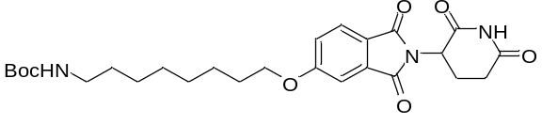
tert-butyl (8-((2-(2,6-dioxopiperidin-3-yl)-1,3-dioxoisoindolin-5-yl)oxy)octyl)carbamate (44)
dimethyl 4-((8-((tert-butoxycarbonyl)amino)octyl)oxy)phthalate (296 mg, 0.68 mmol, 1 eq) was dissolved in EtOH (3.4 mL, 0.2 M) followed by aqueous 3M NaOH (680 μL, 2.04 mmol, 3 eq), then the mixture was heated to 80°C for 4 hours. The mixture was then cooled down to room temperature, diluted with 12 mL DCM and 4.7 mL 0.5 M HCl. The layers were separated and the organic layer was washed with 6.2 mL water. The aqueous layers were combined and extracted three times with 12 mL chloroform. The combined organic layers were dried over sodium sulfate, filtered and condensed to give the material that was carried forward without further purification. LCMS 410.

The resultant material and 3-aminopiperidine-2,6-dione hydrochloride (112 mg, 0.68 mmol, 1 eq) were dissolved in pyridine (3.4 mL, 0.2 M) and heated to 110°C overnight. Then the mixture was cooled to room temperature and concentrated under reduced pressure, purified by column chromatography (ISCO, 12 g silica column, 0-7% Methanol/DCM) to give the desired product (170 mg, 50% for two steps). LCMS 502.

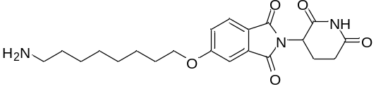
5-((8-aminooctyl)oxy)-2-(2,6-dioxopiperidin-3-yl)isoindoline-1,3-dione (45)
tert-butyl (8-((2-(2,6-dioxopiperidin-3-yl)-1,3-dioxoisoindolin-5-yl)oxy)octyl)carbamate (170 mg, 0.34 mmol, 1 eq) was dissolved in TFA (3.4 mL, 0.1 M) and heated to 50 °C for 3 hours. The mixture was cooled to room temperature, diluted with MeOH and concentrated under reduced pressure. The material was purified by column chromatography (ISCO, 4 g silica column, 0-20% 1.75N NH3•MeOH/DCM) to give the free base product (111 mg, 82%).
LCMS 402 (M+H).

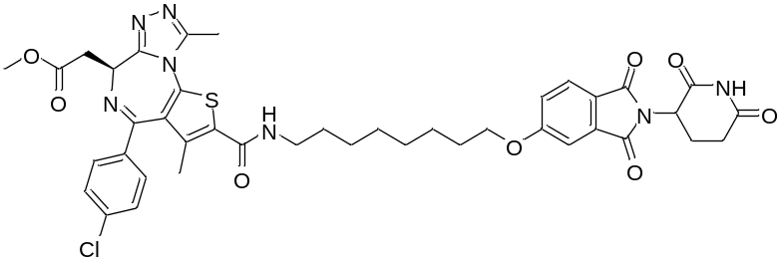

ZXH-2-45 (13)
(S)-4-(4-chlorophenyl)-6-(2-methoxy-2-oxoethyl)-3,9-dimethyl-6H-thieno[3,2-f][1,2,4]triazolo[4,3-a][1,4]diazepine-2-carboxylic acid (24 mg, 0.054 mmol, 1 eq) was dissolved in 1 mL DMF followed by 5-((8-aminooctyl)oxy)-2-(2,6-dioxopiperidin-3-yl)isoindoline-1,3-dione (22 mg, 0.054 mmol, 1 eq), and then DIEA (27 μL, 0.16 mmol, 3 eq), HATU (25 mg, 0.065 mmol, 1.2 eq) were added. The mixture was stirred at room temperature overnight and then purified by HPLC to give the product as TFA salt (18.3 mg, 36%).
¹H NMR (500 MHz, DMSO-d₆) δ 11.11 (s, 1H), 8.33 (t, J = 5.7 Hz, 1H), 7.82 (d, J = 8.3 Hz, 1H), 7.50 (d, J = 8.8 Hz, 2H), 7.46 (d, J = 8.6 Hz, 2H), 7.41 (d, J = 2.2 Hz, 1H), 7.34 (dd, J = 8.4, 2.3 Hz, 1H), 5.12 (dd, J = 12.8, 5.4 Hz, 1H), 4.58 (dd, J = 7.7, 6.6 Hz, 1H), 4.17 (t, J = 6.5 Hz, 2H), 3.68 (s, 3H), 3.47 (qd, J = 16.6, 7.3 Hz, 2H), 3.25 (dq, J = 17.2, 6.7 Hz, 2H), 3.17 (s, 1H), 2.90 (ddd, J = 16.8, 13.8, 5.4 Hz, 1H), 2.65 (s, 3H), 2.09 – 2.01 (m, 1H), 1.91 (s, 3H), 1.75 (p, J = 6.8 Hz, 2H), 1.53 (t, J = 6.9 Hz, 2H), 1.42 (q, J = 7.0 Hz, 2H), 1.33 (d, J = 3.8 Hz, 6H).
¹³C NMR (126 MHz, DMSO-d₆) δ 172.8, 171.0, 169.9, 166.8 (d, J = 9.5 Hz), 164.1, 163.0, 160.9, 157.9, 157.7, 154.6, 150.3, 136.5 (d, J = 7.1 Hz), 135.4, 135.1, 133.9, 130.4, 130.2, 130.0, 128.5, 125.3, 122.8, 120.7, 118.5, 116.1, 108.8, 68.8, 53.4, 51.6, 48.9, 36.2, 30.9, 28.9, 28.6, 28.3, 26.3, 25.3, 22.1, 16.1, 11.3.
LCMS 828 (M+H).

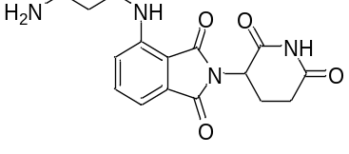
4-((3-aminopropyl)amino)-2-(2,6-dioxopiperidin-3-yl)isoindoline-1,3-dione (46)
A stirred solution of 2-(2,6-dioxopiperidin-3-yl)-4-fluoroisoindoline-1,3-dione (277 mg, 1 mmol, 1 eq) in DMF (5 mL) was added DIPEA (330 μL, 2 mmol, 2 equiv) and tert-butyl (3-aminopropyl)carbamate (191 mg, 1.1 mmol, 1.1 equiv). The reaction mixture was heated to 90 ℃ overnight. Cooled to room temperature, the mixture was diluted with EtOAc and washed once with water then twice with brine, dried over Na₂SO₄ and concentrated in vacuo and then carried forward without further purification. LCMS 431 (M+H).

The resultant material (1 mmol, 1 eq) was dissolved in DCM (6 mL) and then added TFA (2 mL), stirred at room temperature until the reaction completed. And then the mixture was concentrated under reduced pressure, purified by column chromatography (ISCO, 12 g silica column, 0-15% 1.75N NH₃•MeOH/DCM) to give the free base product (236 mg, 72% for 2 steps). LCMS 331 (M+H).

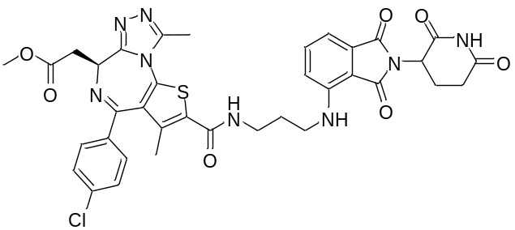

ZXH-2-147 (9)
(S)-4-(4-chlorophenyl)-6-(2-methoxy-2-oxoethyl)-3,9-dimethyl-6H-thieno[3,2-f][1,2,4]triazolo[4,3-a][1,4]diazepine-2-carboxylic acid (25 mg, 0.056 mmol, 1 eq) was dissolved in DMF (1 mL), followed by 4-((3-aminopropyl)amino)-2-(2,6-dioxopiperidin-3-yl)isoindoline-1,3-dione (19 mg, 0.056 mmol, 1 eq), and then HATU (25 mg, 0.067 mmol, 1.2 eq), DIPEA (28 μL, 0.168 mmol, 3 eq) were added. The mixture was stirred at room temperature overnight and then purified by HPLC to give the product as TFA salt (3.5 mg, 8%).
¹H NMR (500 MHz, DMSO-d₆) δ 11.09 (s, 1H), 8.43 – 8.36 (m, 1H), 7.61 – 7.44 (m, 5H), 7.17 – 7.11 (m, 1H), 7.06 (dd, J = 20.6, 7.8 Hz, 1H), 6.73 (d, J = 19.8 Hz, 1H), 5.06 (dd, J = 12.7, 5.5 Hz, 1H), 4.58 (ddd, J = 8.0, 6.6, 1.3 Hz, 1H), 4.53 – 4.48 (m, 1H), 3.68 (s, 3H), 3.50 – 3.44 (m, 3H), 3.34 (d, J = 11.6 Hz, 2H), 2.93 – 2.84 (m, 1H), 2.66 (s, 3H), 2.59 (d, J = 19.8 Hz, 1H), 2.42 – 2.36 (m, 1H), 2.31 – 2.25 (m, 2H), 2.03 (d, J = 7.0 Hz, 1H), 1.93 (s, 3H), 1.82 (p, J = 6.8 Hz, 2H).
¹³C NMR (126 MHz, DMSO-d₆) δ 175.5, 175.2, 173.7, 172.7, 172.0, 170.4, 170.0, 165.6, 163.9, 157.3, 153.0, 148.9, 148.7, 139.2 (d, J = 4.6 Hz), 138.1, 135.3, 132.9, 131.2, 119.8, 119.2, 113.1, 112.8, 112.6, 111.8, 56.1, 54.3, 53.9, 39.7, 38.8, 33.6, 33.2, 24.8, 18.8, 14.0.
LCMS 757 (M+H).

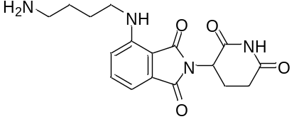
4-((4-aminobutyl)amino)-2-(2,6-dioxopiperidin-3-yl)isoindoline-1,3-dione (47)
A stirred solution of 2-(2,6-dioxopiperidin-3-yl)-4-fluoroisoindoline-1,3-dione (277 mg, 1 mmol, 1 eq) in DMF (5 mL) was added DIPEA (330 μL, 2 mmol, 2 equiv) and tert-butyl (4-aminopropyl)carbamate (207 mg, 1.1 mmol, 1.1 equiv). The reaction mixture was heated to 90 ℃ overnight. Cooled to room temperature, the mixture was diluted with EtOAc and washed once with water then twice with brine, dried over Na₂SO₄ and concentrated in vacuo and then carried forward without further purification. LCMS 445 (M+H).

The resultant material (1 mmol, 1 eq) was dissolved in DCM (6 mL) and then added TFA (2 mL), stirred at room temperature until the reaction completed. And then the mixture was concentrated under reduced pressure, purified by column chromatography (ISCO, 12 g silica column, 0-20% 1.75N NH₃•MeOH/DCM) to give the free base product (224 mg, 65% for 2 steps). LCMS 345 (M+H).

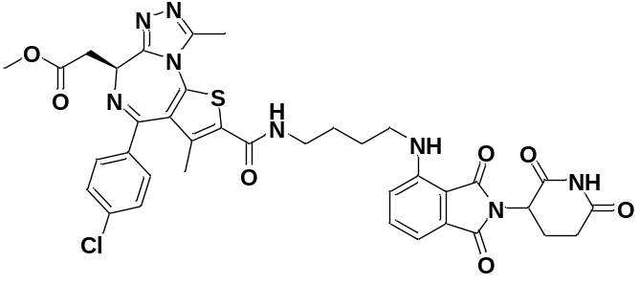

ZXH-2-184 (11)
(S)-4-(4-chlorophenyl)-6-(2-methoxy-2-oxoethyl)-3,9-dimethyl-6H-thieno[3,2-f][1,2,4]triazolo[4,3-a][1,4]diazepine-2-carboxylic acid (37 mg, 0.08 mmol, 1 eq) was dissolved in DMF (1 mL), followed by 4-((4-aminobutyl)amino)-2-(2,6-dioxopiperidin-3-yl)isoindoline-1,3-dione (28 mg, 0.08 mmol, 1 eq), and then HATU (37 mg, 0.1 mmol, 1.2 eq), DIPEA (40 μL, 0.24 mmol, 3 eq) were added. The mixture was stirred at room temperature overnight and then purified by HPLC to give the product as TFA salt (4.8 mg, 7%).
¹H NMR (500 MHz, DMSO-d₆) δ 11.09 (s, 1H), 8.37 (t, J = 5.7 Hz, 1H), 7.56 (dd, J = 8.6, 7.1 Hz, 1H), 7.51 (d, J = 8.7 Hz, 2H), 7.46 (d, J = 8.6 Hz, 2H), 7.12 (d, J = 8.6 Hz, 1H), 7.01 (d, J = 7.0 Hz, 1H), 6.59 (t, J = 6.1 Hz, 1H), 5.05 (dd, J = 12.8, 5.5 Hz, 1H), 4.58 (dd, J = 7.7, 6.6 Hz, 1H), 3.68 (s, 3H), 3.47 (qd, J = 16.5, 7.2 Hz, 2H), 3.31 (d, J = 5.6 Hz, 2H), 2.89 (ddd, J = 17.0, 13.8, 5.4 Hz, 1H), 2.64 (s, 3H), 2.59 (ddd, J = 17.0, 4.4, 2.4 Hz, 1H), 2.03 (ddd, J = 10.0, 6.2, 2.2 Hz, 1H), 1.90 (s, 3H), 1.61 (q, J = 2.8, 2.4 Hz, 4H), 1.24 (s, 2H).
¹³C NMR (126 MHz, DMSO-d₆) δ 175.5, 173.7, 172.7, 171.5, 169.9, 165.6, 163.7, 157.3, 153.0, 149.0, 139.2 (d, J = 2.5 Hz), 138.9, 138.1, 137.9, 134.8, 132.9, 132.6, 131.2, 119.9, 113.0, 111.7, 56.1, 54.3, 51.2, 44.1, 38.8, 33.6, 29.1, 28.8, 24.8, 18.7, 14.0.
LCMS 771 (M+H).

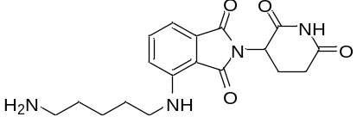
4-((5-aminopentyl)amino)-2-(2,6-dioxopiperidin-3-yl)isoindoline-1,3-dione (48)
A stirred solution of 2-(2,6-dioxopiperidin-3-yl)-4-fluoroisoindoline-1,3-dione (219 mg, 0.8 mmol, 1 eq) in DMF (4 mL) was added DIPEA (264 μL, 1.6 mmol, 2 equiv) and tert-butyl (5-aminopropyl)carbamate (177 mg, 0.88 mmol, 1.1 equiv). The reaction mixture was heated to 90 ℃ overnight. Cooled to room temperature, the mixture was diluted with EtOAc and washed once with water then twice with brine, dried over Na₂SO₄ and concentrated in vacuo and then carried forward without further purification. LCMS 458 (M+H).

The resultant material (0.8 mmol, 1 eq) was dissolved in DCM (6 mL) and then added TFA (2 mL), stirred at room temperature until the reaction completed. And then the mixture was concentrated under reduced pressure, purified by column chromatography (ISCO, 12 g silica column, 0-20% 1.75N NH₃•MeOH/DCM) to give the free base product (194 mg, 68% for 2 steps). LCMS 359 (M+H).

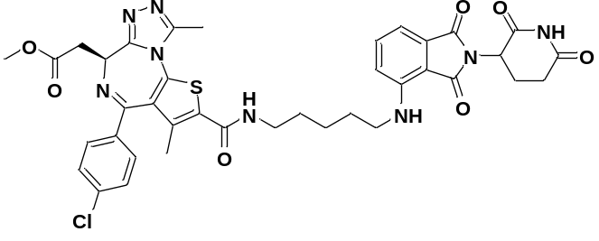

ZXH-3-26 (10)
(S)-4-(4-chlorophenyl)-6-(2-methoxy-2-oxoethyl)-3,9-dimethyl-6H-thieno[3,2-f][1,2,4]triazolo[4,3-a][1,4]diazepine-2-carboxylic acid (62 mg, 0.14 mmol, 1 eq) was dissolved in DMF (1 mL), followed by 4-((5-aminopentyl)amino)-2-(2,6-dioxopiperidin-3-yl)isoindoline-1,3-dione (50 mg, 0.14 mmol, 1 eq), and then HATU (64 mg, 0.168 mmol, 1.2 eq), DIPEA (70 μL, 0.42 mmol, 3 eq) were added. The mixture was stirred at room temperature overnight and then purified by HPLC to give the product as TFA salt (18.4 mg, 15%).
¹H NMR (500 MHz, DMSO-d₆) δ 11.09 (s, 1H), 8.32 (t, J = 5.7 Hz, 1H), 7.57 (dd, J = 8.6, 7.1 Hz, 1H), 7.51 (d, J = 8.8 Hz, 2H), 7.46 (d, J = 8.6 Hz, 2H), 7.10 (d, J = 8.6 Hz, 1H), 7.02 (d, J = 7.0 Hz, 1H), 6.55 (t, J = 6.0 Hz, 1H), 5.04 (ddd, J = 12.8, 5.5, 1.1 Hz, 1H), 4.58 (dd, J = 7.7, 6.6 Hz, 1H), 3.68 (s, 3H), 3.47 (qd, J = 16.6, 7.3 Hz, 2H), 3.31 – 3.23 (m, 4H), 2.89 (ddd, J = 16.9, 13.8, 5.5 Hz, 1H), 2.65 (s, 3H), 2.59 (ddd, J = 17.0, 4.4, 2.5 Hz, 1H), 2.05 – 1.99 (m, 1H), 1.90 (s, 3H), 1.60 (dp, J = 21.6, 7.2 Hz, 4H), 1.40 (h, J = 7.4, 6.5 Hz, 2H).
¹³C NMR (126 MHz, DMSO-d₆) δ 172.8, 171.0, 170.1, 168.9, 167.3, 163.0, 161.0, 154.7, 150.3, 146.4, 136.5 (d, J = 5.6 Hz), 136.2, 135.4, 135.2, 132.2, 130.3, 130.2, 130.0, 128.5, 117.2, 110.4, 109.0, 53.4, 51.6, 48.6, 48.5, 41.7, 36.2, 31.0, 28.7, 28.4, 23.7, 22.1, 16.1, 11.3.
LCMS 785 (M+H).

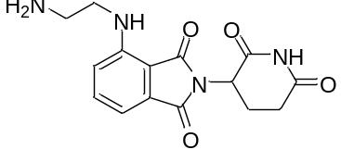
4-((2-aminoethyl)amino)-2-(2,6-dioxopiperidin-3-yl)isoindoline-1,3-dione (49)
A stirred solution of 2-(2,6-dioxopiperidin-3-yl)-4-fluoroisoindoline-1,3-dione (180 mg, 0.65 mmol, 1 eq) in DMF (4 mL) was added DIPEA (214 μL, 1.3 mmol, 2 equiv) and tert-butyl (2-aminopropyl)carbamate (114 mg, 0.72 mmol, 1.1 equiv). The reaction mixture was heated to 90 ℃ overnight. Cooled to room temperature, the mixture was diluted with EtOAc and washed once with water then twice with brine, dried over Na₂SO₄ and concentrated in vacuo and then carried forward without further purification. LCMS 417 (M+H).

The resultant material (0.65 mmol, 1 eq) was dissolved in DCM (6 mL) and then added TFA (2 mL), stirred at room temperature until the reaction completed. And then the mixture was concentrated under reduced pressure, purified by column chromatography (ISCO, 12 g silica column, 0-15% 1.75N NH₃•MeOH/DCM) to give the free base product (100 mg, 49% for 2 steps). LCMS 317 (M+H).

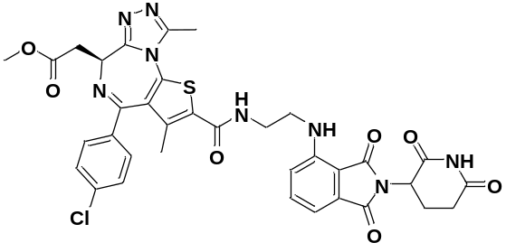

ZXH-3-27 (12)
(S)-4-(4-chlorophenyl)-6-(2-methoxy-2-oxoethyl)-3,9-dimethyl-6H-thieno[3,2-f][1,2,4]triazolo[4,3-a][1,4]diazepine-2-carboxylic acid (44 mg, 0.1 mmol, 1 eq) was dissolved in DMF (1 mL), followed by 4-((2-aminoethyl)amino)-2-(2,6-dioxopiperidin-3-yl)isoindoline-1,3-dione (31 mg, 0.1 mmol, 1 eq), and then HATU (46 mg, 0.12 mmol, 1.2 eq), DIPEA (50 μL, 0.3 mmol, 3 eq) were added. The mixture was stirred at room temperature overnight and then purified by HPLC to give the product as TFA salt (6.6 mg, 8%).
¹H NMR (500 MHz, DMSO-d₆) δ 11.09 (s, 1H), 8.49 (dt, J = 5.7, 2.9 Hz, 1H), 7.61 (ddd, J = 8.6, 7.0, 1.6 Hz, 1H), 7.54 – 7.48 (m, 2H), 7.45 (d, J = 8.4 Hz, 2H), 7.24 (d, J = 8.6 Hz, 1H), 7.04 (d, J = 7.1 Hz, 1H), 6.83 (t, J = 6.0 Hz, 1H), 5.05 (ddd, J = 12.8, 5.5, 1.4 Hz, 1H), 4.58 (ddd, J = 7.6, 6.6, 0.9 Hz, 1H), 3.68 (s, 3H), 3.57 – 3.42 (m, 6H), 2.89 (ddd, J = 17.8, 13.9, 5.4 Hz, 1H), 2.64 (d, J = 1.1 Hz, 3H), 2.59 (ddd, J = 15.0, 4.7, 2.4 Hz, 1H), 2.01 (dtd, J = 12.5, 5.2, 2.2 Hz, 1H), 1.90 (d, J = 2.6 Hz, 3H).
¹³C NMR (126 MHz, DMSO-d₆) δ 172.8, 171.0, 170.0, 168.7, 167.3, 162.9, 161.6, 154.6, 150.3, 146.3, 136.7, 136.5, 136.2, 135.8, 135.4, 132.2, 130.2, 130.0, 129.7, 128.5, 117.2, 110.6, 109.3, 53.4, 51.6, 48.5, 41.1, 36.2, 31.0, 22.1, 16.1, 11.3.
LCMS 743 (M+H).

