Supplementary Note
Compound synthesis protocols and characterization
A multicolor riboswitch-based platform for imaging of RNA in live mammalian cells

1. General Information 2
2. Synthesis of cobalamin azide 2
2.1 Cbl-N₃ (20) 2
2.2 Cbl-C6-N₃ (21) 3
2.3 Cbl-1xPEG-N₃ (22) 3
2.4 Cbl-2xPEG-N₃ (24) 3
2.5 Cbl-3xPEG-N₃ (25) 5
2.6 Cbl-5xPEG-N₃ (27) 5
2.7 Cbl-4xGly-N₃ (31) 6
3. Synthesis of Cbl conjugates with various dyes 9
3.1 Cbl-FAM (12) 9
3.2 Cbl-C6-FAM (2) 10
3.3 Cbl-1xPEG-FAM (13) 12
3.4 Cbl-2xPEG-FAM (14) 13
3.5 Cbl-3xPEG-FAM (10) 14
3.6 Cbl-C6-ATTO 488 (3) 15
3.7 Cbl-ATTO 590 (7) 16
3.8 Cbl-C6-ATTO 590 (4) 17
3.9 Cbl-5xPEG-ATTO 590 (8) 18
3.10 Cbl-4xGly-ATTO 590 (9) 19
3.11 Cbl-Cy5 (6) 20
3.12 Cbl-ATTO 633 (15) 21
3.13 Cbl-C6-ATTO 633 (5) 22
4. NMR spectra 24
4.1 NMR spectra of Cbl-2xPEG-N₃ (24) recorded for CD₃OD 24
4.2 NMR spectra of Cbl-5xPEG-N₃ (27) recorded for CD₃OD 26
4.3 NMR spectra of Cbl-4xGly-OH (29) recorded forD₂O 28
4.4 NMR spectra of Cbl-4xGly-N₃ (31) recorded for CD₃OD 31
4.5 NMR spectra of Cbl-FAM (12) recorded for CD₃OD 33
4.6 NMR spectra of Cbl-C6-FAM (2) recorded for CD₃OD 35
4.7 NMR spectra of Cbl-1xPEG-FAM (13) recorded for CD₃OD 37
4.8 NMR spectra of Cbl-2xPEG-FAM (14) recorded for CD₃OD 39
4.9 NMR spectra of Cbl-3xPEG-FAM (10) recorded for CD₃OD 41
5. MS spectra 43
5.1 MS spectrum of Cbl-ATTO 633 (15) 43
5.2 MS spectrum of Cbl-C6-ATTO 633 (5) 44

General Information

Commercially available reagents and solvents were used as received. 6-FAM alkyne and sulfo-Cyanine5 alkyne were purchased from Lumiprobe and ATTO propargylamides were obtained from ATTO-TEC. As supplied ATTO 590 consists of a mixture of two isomers with practically identical absorption and fluorescence (para and meta isomer). The structure of ATTO 633 alkyne was not provided by the producer, hence it is not included on schemes.
¹H and ¹³C NMR spectra were recorded on a Bruker 500 MHz or Varian 500 MHz spectrometer with the residual solvent peak used as an internal standard. Data are reported as follows: chemical shift [ppm], multiplicity (s = singlet, bs = broad singlet, d = doublet, t = triplet, q = quartet, m = multiplet), coupling constant and integration. HRMS spectra were recorded on a spectrometer with TOF mass analyzer.
The scale of the reactions with ATTO and Cyanine dyes did not provide sufficient amount of products for NMR analyses thus the HPLC and MS analyses were performed to characterize those compounds. During the synthesis of Cbl conjugates, the conversion of a substrate to a product was estimated based on a dye as the vitamin B₁₂ derivative was used in excess and was calculated using the integration of a signal coming from the dye in RP-HPLC analysis. All reactions described in Section 3 proceeded with the conversion >99% (on the HPLC chromatograms only signals corresponding to the desired conjugate and the remaining azide were observed. For Cbl-1xPEG-FAM (13), Cbl-2xPEG-FAM (14) and Cbl-3xPEG-FAM (10) signals in ¹H NMR spectra recorded in CD₃OD were much broader comparing to Cbl-FAM (12) and Cbl-C6-FAM (2) and subtle structure of multipletes or integrations could not be fully distinguished. Compounds 4,7-9 were obtained as a mixture of isomers (para and meta of ATTO 590 part).
Preparative chromatography was performed using LiChroprep® RP-18 gel (Merck) with redistilled water and HPLC grade MeCN as eluents. Progress of the reactions was monitored using RP-HPLC techniques. HPLC measurement conditions: column, Eurospher II 100-5, C18, 250 mm × 4.6 mm with a precolumn or Kromasil C18 5 µm 250 mm × 4.0 mm; detection, UV/vis; pressure, 10 MPa; temperature, 30°C; flow rate, 1mL/min; wavelengths and HPLC methods are listed for each compound. Abbreviations: CDT – 1,1′-Carbonyl-di-(1,2,4-triazole); RP HPLC – Reverse-phase high-performance liquid chromatography; TBTA – Tris[(1-benzyl-1H-1,2,3-triazol-4 yl)methyl]amine; TEA – Triethylamine

Synthesis of cobalamin azide

Cbl-N₃(20)
Compound 20 was synthesized according to the procedure described in Chem. Eur. J.,19, 5141 – 5148 (2013). All spectra matched that reported in the literature.

Cbl-C6-N₃(21)
Compound 21 was synthesized according to the procedure described in J. Porphyrins Phthalocyanines, 17,110-117 (2013). All spectra matched those reported in the literature.

Cbl-1xPEG-N₃(22)
Compound 22 was synthesized according to the procedure described in J. Porphyrins Phthalocyanines,17, 110-117 (2013). All spectra matched those reported in the literature.

Cbl-2xPEG-N₃(24)

Cbl-2xPEG-N₃: Cobalamin (1) (0.075 mmol, 100 mg) was dissolved in dry DMSO (2.5 mL) at 40 °C under an argon atmosphere. To a stirring solution under argon solid CDT (50 mg, 0.30 mmol) was added. When full consumption of the substrate (monitored by the RP HPLC) was observed (approx. 1.5h), heating bath was removed and 2-[2-(2-azidoethoxy)ethoxy]-ethanamine (23) (100 µL) was added in one portion. The resulting solution was stirred overnight, then the reaction mixture was poured into AcOEt (50 mL), and centrifuged. The precipitate was washed twice with Et₂O (2 x 15mL). After drying it was dissolved in water and purified by RP column chromatography (80 mL) with a mixture of MeCN and H₂O as eluents (10% v/v). The desired compound 24 was obtained as a red powder; yield: 66% (0.0495 mmol, 77 mg).¹H NMR (500 MHz, CD₃OD) δ 7.25 (s, 1H), 7.15 (s, 1H), 6.58 (s, 1H), 6.23 (d, J = 2.6 Hz, 1H), 6.04 (s, 1H) 4.66 (d, J = 9.9 Hz, 1H), 4.51 (d, J = 8.2 Hz, 1H), 4.40 – 4.32 (m, 1H), 4.24 – 4.20 (m, 2H), 4.17 (dd, J = 12.2, 2.4 Hz, 1H), 4.13 (d, J = 11.5 Hz, 1H), 3.60 – 3.67 (m, 7H), 3.54 (t, J = 5.6 Hz, 2H), 3.36 (t, J = 5.6 Hz, 2H), 2.93 – 2.85 (m, 2H), 2.59 (s, 3H), 2.58 (s, 3H), 2.67 – 2.42 (m, 12H), 2.41 – 2.34 (m, 2H), 2.29 (s, 3H), 2.28 (s, 3H), 2.21 – 2.14 (m, 1H), 2.12 – 1.96 (m, 4H), 1.94 – 1.82 (m, 3H), 1.89 (s, 3H), 1.77 – 1.70 (m, 1H), 1.47 (m, 3H), 1.39 (s, 3H), 1.39 –1.37 (m, 2H), 1.37 (s, 3H), 1.30 –1.26 (m, 1H), 1.25 (d, J = 6.3 Hz, 3H), 1.19 (s, 3H), 1.16 – 1.08 (m, 1H), 0.47 (s, 3H).¹³C NMR (126 MHz, CD₃OD) δ 180.1, 178.7, 176.1, 176.0, 175.9, 175.1, 174.1, 174.1, 173.8, 173.2, 172.6, 165.7, 165.5, 157.2, 141.9, 136.8, 134.2, 132.5, 129.9, 116.5, 111.0, 107.3, 103.8, 94.2, 86.8, 85.0, 79.9, 74.9, 73.7, 72.0, 72.0, 70.1, 70.0, 69.7, 69.6, 69.1, 62.8, 58.9, 56.2, 55.5, 53.6, 51.1, 50.3, 45.2, 42.5, 41.6, 40.4, 38.7, 34.8, 33.7, 31.8, 31.5, 31.2, 30.9, 30.9, 28.1, 26.0, 25.9, 19.5, 19.1, 19.0, 18.9, 18.7, 18.7, 18.5, 16.1, 15.7, 14.9, 14.7.UV/vis (H₂O) λ_{max} (nm) (ε, L mol⁻¹ cm⁻¹) 551 (7.8 × 10³), 522 (6.8 × 10³), 361 (2.4 × 10⁴), 278 (1.3 × 10⁴), 222 (4.2 × 10⁴). HRMS (ESI) m/z [M + Na]⁺ calcd for C₇₀H₁₀₀N₁₈O₁₇PCoNa 1577.6481, found 1577.6455. Anal. calcd for C₇₀H₁₀₀N₁₈O₁₇PCo·6H₂O: C, 50.54; H, 6.79; N, 15.15. Found: C, 50.62; H, 7.03; N, 14.95.

HPLC Method:
Time [min] | H₂O+0.5‰TFA [%] | MeCN[%] | λ [nm] | R_{t}[min]
Initial | 99 | 1 | 361 | 10.88
15 | 30 | 70 | 361 | 10.88

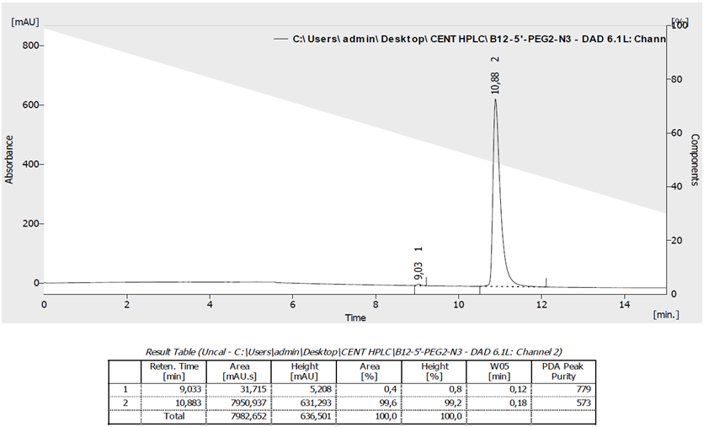

Cbl-3xPEG-N₃(25)
Compound 25 was synthesized according to the procedure described in J. Porphyrins Phthalocyanines, 17, 110-117 (2013). All spectra matched those reported in the literature.

Cbl-5xPEG-N₃(27)

Cbl-5xPEG-N₃: Cobalamin (1) (0.146 mmol, 200 mg) was dissolved in dry DMSO (5 mL) at 40 °C under an argon atmosphere. To a stirring solution under argon solid CDT (100 mg, 0.609 mmol) was added. When full consumption of the substrate (monitored by the RP HPLC) was observed (approx. 1.5h), heating bath was removed and 2-[2-[2-[2-[2-(2-azidoethoxy)ethoxy]ethoxy]ethoxy]ethoxy]-ethanamine in the form of TFA salt (26) (100 mg) was added in one portion. Subsequently TEA (80 µL) was added and the resulting solution was stirred overnight. Then the reaction mixture was poured into AcOEt (50 mL) and centrifuged. The precipitate was then washed twice with Et₂O (2 x 15mL). After drying it was dissolved in water and purified by RP column chromatography (80 mL) with a mixture of MeCN and H₂O as eluents (gradually from 10 to 15% v/v). The desired compound 27 was obtained as a red powder; yield: 43% (0.063 mmol, 106 mg). ¹H NMR (500 MHz, CD₃OD) δ 7.24 (s, 1H), 7.14 (s, 1H), 6.57 (s, 1H), 6.22 (d, J = 2.6 Hz, 1H), 6.03 (s, 1H), 4.92 (m,1H), 4.65 (d, J = 10.5 Hz, 1H), 4.49 (d, J = 8.8 Hz, 1H), 4.41 – 4.30 (m, 1H), 4.26 – 4.08 (m, 4H), 3.67 – 3.56 (m, 23H), 3.52 (t, J = 5.4, 2H), 3.37 – 3.32 (m, 2H), 3.27 (m, 1H), 2.95 – 2.81 (m, 2H), 2.70 – 2.31 (m, 8H), 2.58 (s, 3H), 2.57 (s, 3H), 2.28 (s, 3H), 2.27 (s, 3H), 2.22 – 1.93 (m, 6H), 1.92 – 1.80 (m, 3H), 1.88 (s, 3H), 1.80 – 1.57 (m, 1H), 1.46 (s, 3H), 1.38 (s, 3H), 1.36 (s, 3H), 1.31 – 1.20 (m, 2H), 1.24 (d, J = 6.3 Hz, 3H), 1.18 (s, 3H), 1.14 – 1.05 (m, 1H), 0.46 (s, 3H).¹³C NMR (126 MHz, CD₃OD) δ 181.6, 180.2, 177.6, 177.426, 177.4, 176.6, 176.4, 175.6, 175.5, 175.3, 174.6, 167.2, 166.9, 143.4, 138.3, 135.7, 134.0, 131.4, 117.9, 112.5, 108.8, 105.3, 95.7, 88.3, 86.4, 76.4, 73.4, 71.6, 71.6, 71.6, 71.3, 71.1, 71.0, 70.6, 60.3, 57.7, 57.0, 55.1, 52.6, 51.8, 49.6, 48.4, 46.6, 44.0, 43.0, 41.8, 40.1, 36.2, 35.1, 33.3, 33.0, 32.6, 32.4, 32.3, 29.5, 27.4, 27.4, 20.3, 20.6, 20.5, 20.3, 20.2, 20.0, 17.5, 17.1, 16.4, 16.2.UV/vis (H₂O) λ_{max} (nm) (ε, L mol⁻¹ cm⁻¹) 549 (5.8 × 10³), 520 (5.2 × 10⁴), 361 (1.8 × 10⁴), 277 (1.1 × 10⁴), 220 (3.3 × 10⁴). HRMS (ESI) m/z [M + Na]⁺ calcd for C₇₆H₁₁₂N₁₈O₂₀PCoNa 1709.7268, found 1709.7219. Anal. calcd for C₇₆H₁₁₂N₁₈O₂₀PCo·7H₂O: C, 50.33; H, 7.00; N, 13.90. Found: C, 50.22; H, 6.76; N, 14.22.
HPLC Method:
Time [min] | H₂O+0.5‰TFA [%] | MeCN [%] | λ [nm] | R_{t} [min]
Initial | 99 | 1 | 361 | 11.07
15 | 30 | 70 | 361 | 11.07

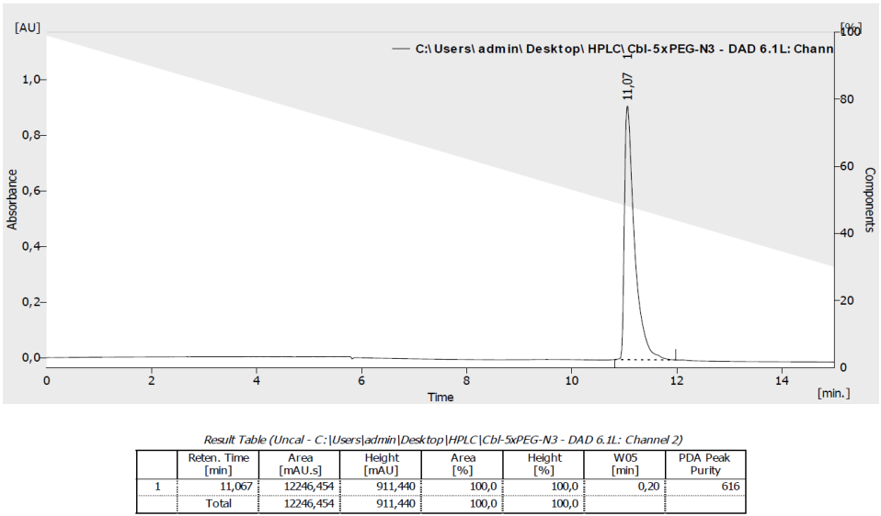

Cbl-4xGly-N₃(31)

STEP 1: HO-4xGly-alkyne (28) was synthesized manually by Fmoc chemistry on a 0.124 mmol scale of Fmoc-Gly attached to the Wang resin (Fmoc-Gly-Wang resin),4-fold molar excess of the Fmoc-Gly-Gly-Gly-OH and 5-fold molar excess of 4-pentynoic acid. Fmoc deprotection was performed with 20% piperidine in DMF (1.5 mL, 1-2 h) and coupling with the use of HBTU (6 equiv.) and DIPEA (6 equiv.) in DMF (2 mL). After final coupling the resin was washed with DMF (5 x 1 mL), DCM (5 x 1 mL) and dried. Cleavage from the resin was carried with the use of a TFA/DCM (25%, v/v) with the catalytic amount of anisole for 2.5 h. Obtained product 28 was precipitated with Et₂O and centrifuged. LRMS (ESI) m/z [M + Na]⁺ calcd for C₁₃H₁₈N₄O₆Na 349.12, found 349.20.
STEP 2: Cbl-N₃ (20) (0.068 mmol, 94 mg) and HO-4xGly-alkyne (0.062 mmol, 20 mg) was dissolved in DMF/H₂O mixture (5:3 v/v, Σ = 4 mL). Catalyst – CuI (0.032 mmol, 6 mg) and TBTA (0.057 mmol, 30 mg) mixed in 2 mL of DMF for 20 min – was added and the resulting solution was stirred for 16 h at 40°C. The reaction mixture was diluted with MeOH (5 mL) and poured into Et₂O (60 mL). The resulting precipitate was filtered through a cotton wool, washed with AcOEt (2 x 10 mL) and Et₂O (2 x 10 mL). After drying, the resulting solid was dissolved in MeOH and concentrated in vacuo. The crude was dissolved in water and purified by RP column chromatography with a mixture of MeCN/H₂O (10% v/v) as an eluent. The desired compound 29 was obtained as a red powder, yield: 59% (0.073 mmol, 124 mg).¹H NMR spectra were recorded for D₂O at rt and at 80°C but the signals were very broad and subtle structure of multipletes or integrations could not be fully distinguished (see part NMR spectra).¹³C NMR (126 MHz, D₂O) δ 182.5, 181.4, 180.2, 180.0, 179.4, 179.4, 178.2, 178.1, 177.5, 177.2, 176.0, 175.1, 174.6, 174.2, 168.4, 167.8, 144.3, 139.0, 137.7, 135.6, 132.4, 119.0, 113.8, 110.0, 106.7, 97.4, 89.0, 87.6, 81.3, 77.3, 76.8, 75.6, 71.1, 61.6, 58.7, 58.2, 56.2, 53.9, 50.5, 49.7, 47.6, 45.4, 45.2, 45.1, 41.8, 41.5, 37.4, 37.0, 36.6, 34.4, 34.3, 34.7, 34.0, 33.8, 30.1, 28.9, 28.5, 28.4, 27.1, 26.9, 22.3, 21.9, 21.8, 21.7, 21.5, 21.5, 19.3, 18.3, 17.8, 17.7. UV/vis (H₂O) λ_{max} (nm) (ε, L mol⁻¹ cm⁻¹) 549(5.8 × 10³), 520 (5.2 × 10³), 361 (1.8 × 10⁴), 276 (1.0 × 10⁴), 222 (3.5 × 10⁴).HRMS (ESI) m/z [M + Na]⁺ calcd for C₇₆H₁₀₅N₂₁O₁₉PCoNa 1728.6863, found 1728.6897.

HPLC Method:
Time [min] | H₂O+0.2‰TFA [%] | MeCN [%] | λ [nm] | R_{t} [min]
Initial | 90 | 10 | 361 | 6.63
15 | 30 | 70 | 361 | 6.63

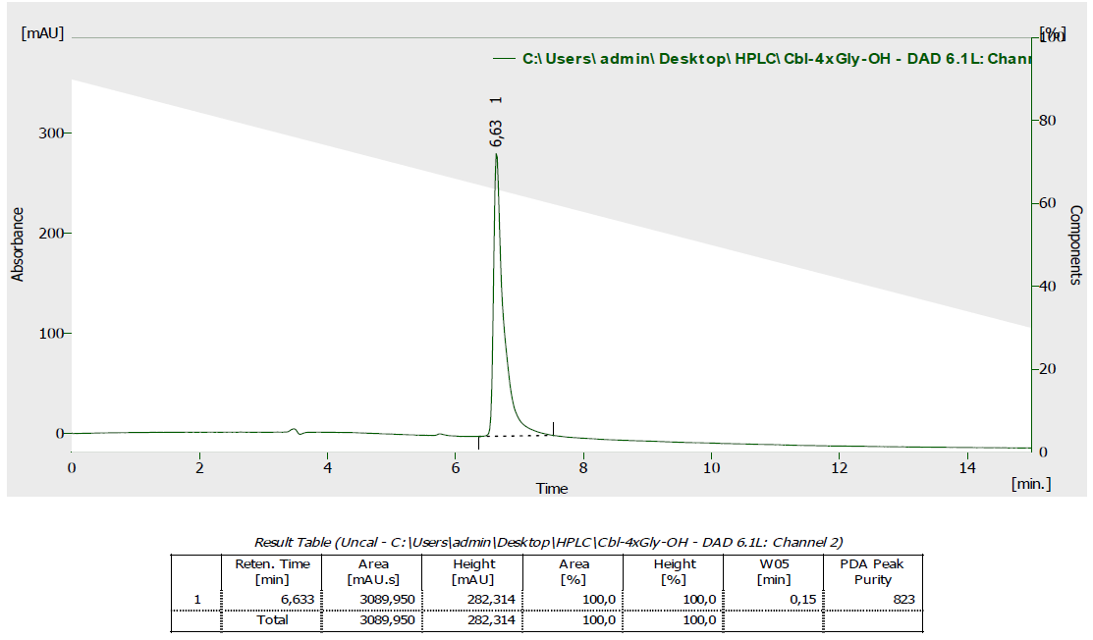
STEP 3: Cbl-4xGly-OH (29) (80 mg, 0.047 mmol) and 2-(2-azidoethoxy)ethanamine (30)
(300 µL) was dissolved in DMF (5 mL). EDC (90 mg, 0.470 mmol), HOBt (127 mg, 0.940 mmol) and DIPEA (0.470, 82 µL) were added. The resulting solution was stirred at rt for 1 h. Desired product, the product lacking CN ligand and the unreacted substrate were present in the reaction mixture in the approx. ratio 2.3 : 2.5 : 1 (according to RP-HPLC). The reaction mixture was diluted with MeOH (5 mL) and poured into Et₂O (60 mL). The resulting precipitate was filtered through a cotton wool, washed with AcOEt (2 x 10 mL) and Et₂O (2 x 10 mL). After drying, the resulting solid was dissolved in MeOH and concentrated in vacuo. Desired compound was purified by RP column chromatography with a mixture of MeCN/H₂O (gradually from 8% to 40% v/v). Order of elution: substrate, desired product, product lacking CN ligand. The solvent was concentrated in vacuo and the product was obtained as a red solid. Yield of desired product 31 (with CN ligand): 41% (0.019 mmol, 35 mg), yield of product 31 without CN ligand (L=H₂O): 14% (0.007 mmol, 12 mg). ¹H NMR (500 MHz, CD₃OD) δ 8.18 (s, 1H), 7.19 (s, 1H), 7.15 (s, 1H), 6.56 (s, 1H), 6.06 (s, 1H), 5.90 (d, J = 2.9 Hz, 1H), 5.02 (dd, J = 14.7, 3.5 Hz, 1H), 4.86 – 4.82 (m, 1H), 4.54 (td, J = 8.4, 4.0 Hz, 1H), 4.49 (d, J = 8.7 Hz, 1H), 4.44 – 4.33 (m, 2H), 4.13 (d, J = 11.3 Hz, 1H), 4.09 – 4.04 (m, 1H), 4.02 – 3.81 (m, 8H), 3.69 (d, J = 13.9 Hz, 1H), 3.66 – 3.60 (m, 3H), 3.55 (t, J = 5.7 Hz, 2H), 3.38 – 3.34 (m, 4H), 3.25 (d, J = 10.5 Hz, 1H), 3.09 – 3.06 (m, 2H), 2.90 – 2.85 (m, 2H), 2.73 – 2.31 (m, 19H), 2.27 (s, 3H), 2.24 (s, 3H), 2.22 – 1.97 (m, 5H), 1.96 – 1.80 (m, 3H), 1.89 (s, 3H), 1.77 – 1.68 (m, 1H), 1.49 (s, 3H), 1.380 (s, 3H), 1.375 (s, 3H), 1.32 – 1.24 (m, 1H), 1.28 (d, J = 6.2 Hz, 3H), 1.20 (s, 3H), 1.15 – 1.07 (m, 1H), 0.44 (s, 3H). ¹³C NMR (126 MHz, CD₃OD) δ181.6, 180.1, 177.5, 177.3, 177.2, 176.6, 176.0, 175.6, 175.5, 175.3, 174.6, 174.2, 173.0, 172.7, 172.2, 171.7, 167.8, 166.9, 147.3, 143.3, 138.2, 135.8, 134.0, 131.3, 126.0, 117.8, 112.6, 108.8, 105.2, 95.8, 87.9, 86.4, 80.9, 80.7, 76.4, 75.0, 73.7, 73.6, 70.9, 70.4, 70.3, 66.9, 60.3, 57.7, 57.0, 55.5, 52.6, 51.8, 50.6, 46.8, 44.3, 44.0, 43.9, 43.5, 43.1, 40.4, 40.1, 36.2, 35.9, 35.4, 33.4, 32.9, 32.8, 32.6, 32.4, 32.3, 29.5, 27.4, 22.4, 20.9, 20.5, 20.4, 20.3, 19.9, 17.5, 17.1, 16.4 16.1, 15.4.UV/vis (H₂O) λ_{max} (nm) (ε, L mol⁻¹ cm⁻¹) 548 (8.0 × 10³), 520 (7.0 × 10³), 361 (2.5 × 10⁴), 279 (1.3 × 10⁴), 222 (4.5 × 10⁴). HRMS (ESI) m/z [M + Na]⁺ calcd for C₈₀H₁₁₃N₂₅O₁₉PCoNa 1840.7612, found 1840.7611.
HPLC Method:
Time [min] | H₂O+0.2‰TFA [%] | MeCN [%] | λ [nm] | R_{t} [min]
Initial | 90 | 10 | 361 | 8.37
15 | 30 | 70 | 361 | 8.37
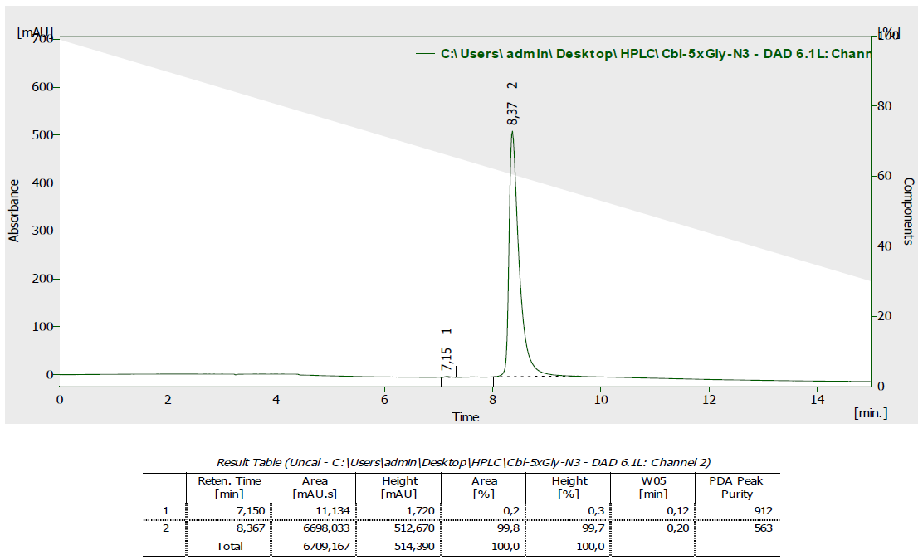

Synthesis of Cbl conjugates with various dyes

Cbl-FAM (12)

Cbl-FAM: CuI (1 mg, 5 µmol) and TBTA (5 mg, 10 µmol) were dissolved in DMF/H₂O (1 mL, 3:1 v/v) and stirred for 20 min. Subsequently Cbl-N₃ (20) (24 mg, 17.4 µmol) and 6-FAM alkyne (11) (6 mg, 14.5 µmol) were added and the reaction mixture was stirred overnight. Then it was diluted with DMF (1 mL), poured into AcOEt (15 mL) and the precipitate was centrifuged and dried. The crude solid was dissolved in MeOH (1 mL), precipitated with Et₂O (15 mL), and then centrifuged. The dried solid was then dissolved in H₂O, loaded onto RP column (30 mL) and purified gradually with MeCN/H₂O from 10 to 20% v/v yielding 1 as an orange solid. ¹H NMR (500 MHz, CD₃OD) δ 8.21 (s, 1H), 8.20 (s, 1H), 8.11 (d, J = 7.6 Hz, 1H), 7.74 (s, 1H), 7.14 (s, 1H), 7.10 (s, 1H), 6.75 (bs, 2H), 6.71 – 6.64 (m, 2H), 6.59 (m, 2H), 6.56 (s, 1H), 6.03 (s, 1H), 5.95 (d, J = 2.3, 1H), 4.98 (d, J = 13.0 Hz, 1H), 4.62 (bs, 2H), 4.53 (bs, 1H), 4.49 (d, J = 8.6 Hz, 1H), 4.41 – 4.35 (m, 1H), 4.31 (bs, 1H), 4.13 (d, J = 11.4 Hz, 1H), 4.06 (m, 1H), 3. 63 (dd, J= 5.1, 10.7 Hz, 1H), 3.57 (d, J = 13.8 Hz, 1H), 3.21 (d, J = 10.1 Hz, 1H), 2.88 – 2.81 (m, 1H), 2.78 (dd, J = 9.2, 13.7 Hz, 1H), 2.68 – 2.43 (m, 8H), 2.58 (s, 3H), 2.55 (s, 3H), 2.41 – 2.31 (m, 2H), 2.27 (s, 3H), 2.21 (s, 3H), 2.14 – 1.95 (m, 6H), 1.95 – 1.83 (m, 2H), 1.89 (s, 3H), 1.82 – 1.65 (m, 2H), 1.42 (s, 3H), 1.38 (s, 3H), 1.35 (s, 3H), 1.30 – 1.20 (m, 2H), 1.23 (d, J = 5.7 Hz, 3H), 1.20 – 1.07 (m, 1H), 1.18 (s, 3H), 0.42 (s, 3H).¹³C NMR (126 MHz, CD₃OD) δ 181.6, 180.1, 177.6, 177.35, 177.2, 176.5, 175.6, 175.5, 175.3, 174.6, 174.2, 167.2, 166.9, 143.2, 138.2, 135.8, 134.0, 131.3, 130.6, 117.9, 114.5, 112.4, 108.8, 105.1, 103.6, 95.7, 87.9, 86.4, 81.2, 76.3, 75.8, 70.4, 60.3, 57.7, 57.0, 55.4, 52.6, 43.9, 43.1, 40.1, 36.2, 35.4, 33.5, 33.1, 32.9, 32.4, 32.3, 29.3, 27.4, 20.9, 20.5, 20.30, 20.26, 20.2, 19.9, 17.5, 17.1, 16.4, 16.2. HRMS (ESI) m/z [M + 2Na]²⁺ calcd for C₈₇H₁₀₂CoN₁₈O₁₉PNa₂, 919.3211; found, 919.3182.

HPLC Method:
Time [min] | H₂O+0.5‰TFA [%] | MeCN [%] | λ [nm] | R_{t}[min]
Initial | 99 | 1 | 361 | 12.08
20 | 15 | 85 | 361 | 12.08
40 | 15 | 85 | 361 | 12.08

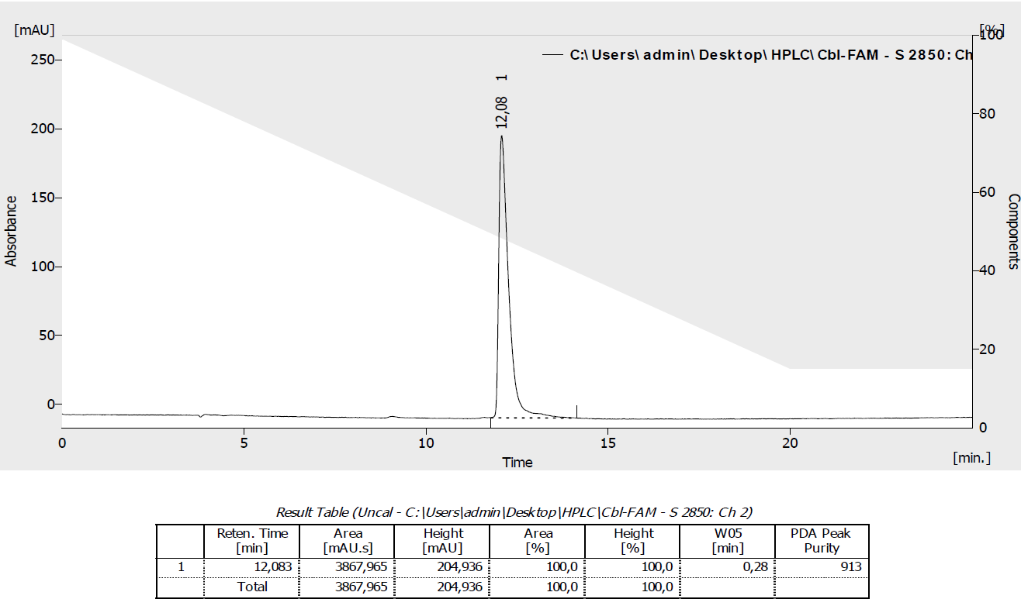

Cbl-C6-FAM (2)
Cbl-C6-FAM: CuI (1 mg, 5 µmol) and TBTA (5 mg, 10 µmol) were dissolved in DMF/H₂O (1 mL, 3:1 v/v) and stirred for 20 min. Subsequently Cbl-C6-N₃ (21) (27 mg, 17.7 µmol) and 6-FAM alkyne (11) (6 mg, 14.5 µmol) were added and the reaction mixture was stirred overnight. Then it was diluted with DMF (1 mL), poured into AcOEt (15 mL) and the precipitate was centrifuged and dried. The crude solid was dissolved in MeOH (1 mL), precipitated with Et₂O (15 mL) and then centrifuged. The dried solid was then dissolved in H₂O (small amount of MeOH was added for better dissolution), loaded onto RP column (30 mL) and purified gradually with MeCN/H₂O from 15 to 30% v/v yielding 2 as an orange solid. ¹H NMR (500 MHz, CD₃OD) δ 8.13 (s, 2H), 7.88 (s, 1H), 7.68 (s, 1H), 7.18 (s, 1H), 7.13 (s, 1H), 6.79 (bs, 2H), 6.68 (s, 2H), 6.61 – 6.49 (m, 3H), 6.18 (bs, 1H), 6.03 (s, 1H), 4.92 (m, 1H), 4.66 – 4.47 (m, 6H), 4.42 – 4.28 (m, 1H), 4.33 (t, J = 6.8 Hz, 2H), 4.20 (bs, 2H), 4.16 – 4.07 (m, 2H), 3.67 – 3.57 (m, 2H), 3.29 (m, 1H), 3.06 – 2.92 (m, 2H), 2.94 – 2.82 (m, 2H), 2.68 – 2.42 (m, 8H), 2.58 (s, 6H), 2.41 – 2.31 (m, 2H), 2.28 (s, 3H), 2.23 (s, 3H), 2.20 – 1.78 (m, 8H), 1.88 (s, 3H), 1.77 – 1.68 (m, 1H), 1.48 – 1.40 (m, 2H), 1.44 (s, 3H), 1.38 (s, 3H), 1.36 (s, 3H), 1.33 – 1.20 (m, 8H), 1.24 (d, J = 6.1 Hz, 3H), 1.18 (s, 3H), 1.16 – 1.07 (m, 1H), 0.46 (s, 3H).¹³C NMR (126 MHz, CD₃OD) δ 181.6, 180.1, 177.6, 177.5, 177.4, 176.7, 175.5, 175.3, 174.6, 174.1, 168.3, 167.2, 166.9, 143.3, 140.1, 138.2, 136.8, 135.6, 133.9, 131.3, 131.2, 131.1, 130.1, 117.9, 112.4, 108.7, 105.2, 103.8, 95.6, 88.2, 86.4, 81.4, 76.4, 75.2, 73.5, 70.5, 64.2, 60.3, 57.7, 56.9, 55.0, 52.6, 51.3, 49.9, 46.6, 43.9, 43.0, 41.6, 40.1, 36.3, 36.2, 35.2, 33.3, 33.1, 32.7, 32.4, 32.3, 31.0, 30.8, 30.6, 29.5, 27.4, 27.0, 20.9, 20.5, 20.4, 20.2, 19.9, 17.5, 17.1, 16.4, 16.2.HRMS (ESI) m/z [M + Na]⁺· calcd for C₉₄H₁₁₆CoN₁₉O₂₁P, 1959.7560; found, 1959.7555.
HPLC Method:
Time [min] | H₂O+0.5‰TFA [%] | MeCN [%] | λ [nm] | R_{t} [min]
Initial | 90 | 10 | 361 | 9.55
15 | 30 | 70 | 361 | 9.55

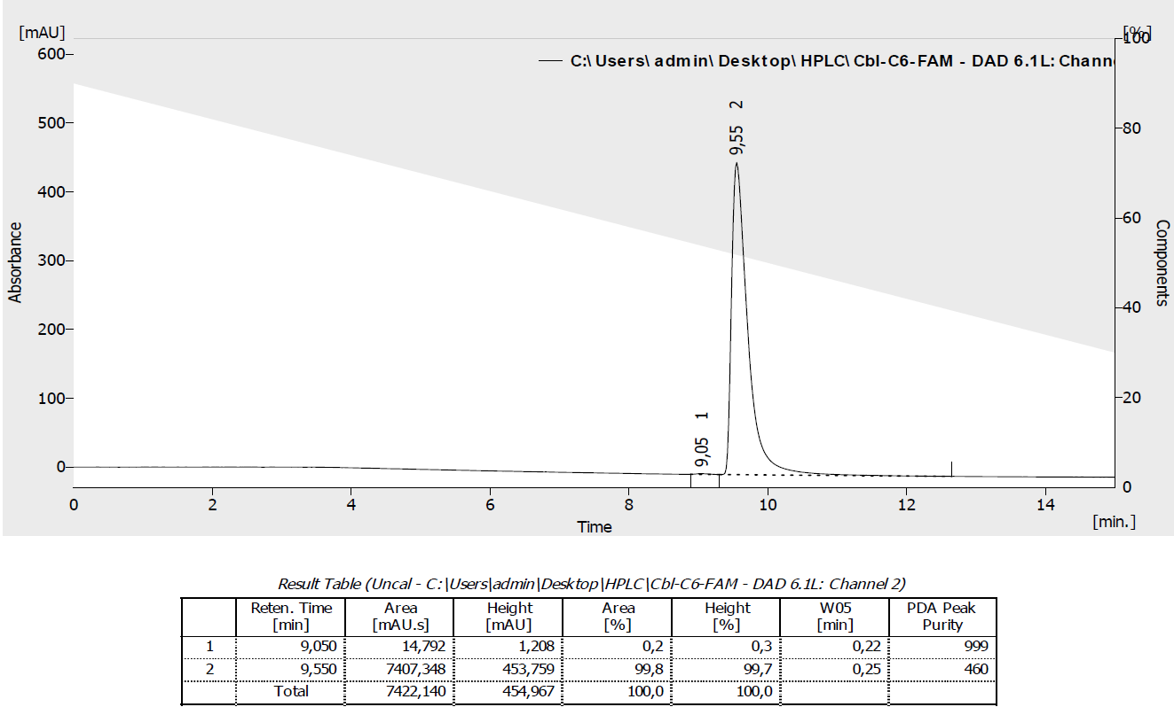

Cbl-1xPEG-FAM (13)

Cbl-1xPEG-FAM: CuI (1 mg, 5 µmol) and TBTA (5 mg, 10 µmol) were dissolved in DMF/H₂O (1 mL, 3:1 v/v) and stirred for 20 min. Subsequently Cbl-1xPEG-N₃ (22) (27 mg, 17.9 µmol) and 6-FAM alkyne (11) (6 mg, 14.5 µmol) were added and the reaction mixture was stirred overnight. Then it was diluted with DMF (1 mL), poured into AcOEt (15 mL) and the precipitate was centrifuged and dried. The crude solid was dissolved in MeOH (1 mL), precipitated with Et₂O (15 mL) and then centrifuged. The dried solid was then dissolved in H₂O, loaded onto RP column (30 mL) and purified gradually with MeCN/H₂O from 10 to 20% v/v yielding 13 as an orange solid. ¹H NMR (500 MHz, CD₃OD) δ 8.22 (bs, 1H), 8.19 – 8.13 (m, 2H), 7.76 (bs, 1H), 7.11 (s, 1H), 7.13 (s, 1H), 6.87 (d, J = 4.0 Hz, 2H), 6.84 – 6.77 (m, 2H), 6.72 (s, 1H), 6.70 (s, 1H), 6.57 (s, 1H), 6.28 (bs, 1H), 6.02 (s, 1H), 4.98 (bs, 1H), 4.60 (bs, 1H), 4.55 – 4.44 (m, 3H), 4.40 (bs, 1H), 4.28 (bs, 1H), 4.22 (bs, 1H), 4.14 (d, J = 11.2 Hz, 1H), 4.05 (bs, 1H), 3.78 (bs, 2H), 3.71 – 3.58 (m, 2H), 3.46 – 3.36 (m, 2H), 3.27 (d, J = 10.7 Hz, 1H), 3.13 – 3.02 (m, 2H), 2.92 – 2.82 (m, 2H), 2.72 – 2.44 (m, 10H), 2.58 (s, 6H), 2.43 – 2.32 (m, 3H), 2.27 (s, 3H), 2.19 (s, 3H), 2.15-1.67 (m, 8H), 1.89 (s, 3H), 1,40 (s, 3H), 1.38 (s, 3H), 1.37 (s, 3H), 1.33 – 1.22 (m, 2H), 1.25 (bs, 3H), 1.17 (s, 3H), 1.20 – 1.08 (m, 1H), 0.45 (s, 3H).¹³C NMR (126 MHz, CD₃OD) δ 181.6, 180.1, 177.6, 177.4, 176.7, 175.6, 175.5, 175.4, 174.6, 174.3, 167.2, 166.9, 158.3, 143.3, 138.3, 135.7, 134.0, 131.3, 131.2, 130.7, 117.9, 115.7, 112.5, 108.7, 105.2, 103.7, 95.6, 88.3, 86.4, 81.3, 76.3, 75.4, 74.7, 70.7, 70.6, 69.9, 64.1, 60.3, 57.7, 57.0, 55.2, 52.5, 46.6, 43.0, 41.6, 40.1, 36.2, 33.5, 33.3, 33.0, 32.3, 29.5, 27.5, 27.4, 20.9, 20.53, 20.45, 20.3, 20.1, 19.9, 17.5, 17.1, 16.4, 16.1. HRMS (ESI) m/z [M + H + Na]²⁺ calcd for C₉₂H₁₁₂CoN₁₉O₂₂PNa, 973.8593; found, 973.8585.
HPLC Method:
Time [min] | H₂O+0.5‰TFA [%] | MeCN [%] | λ [nm] | R_{t} [min]
Initial | 99 | 1 | 361 | 11.78
15 | 30 | 70 | 361 | 11.78

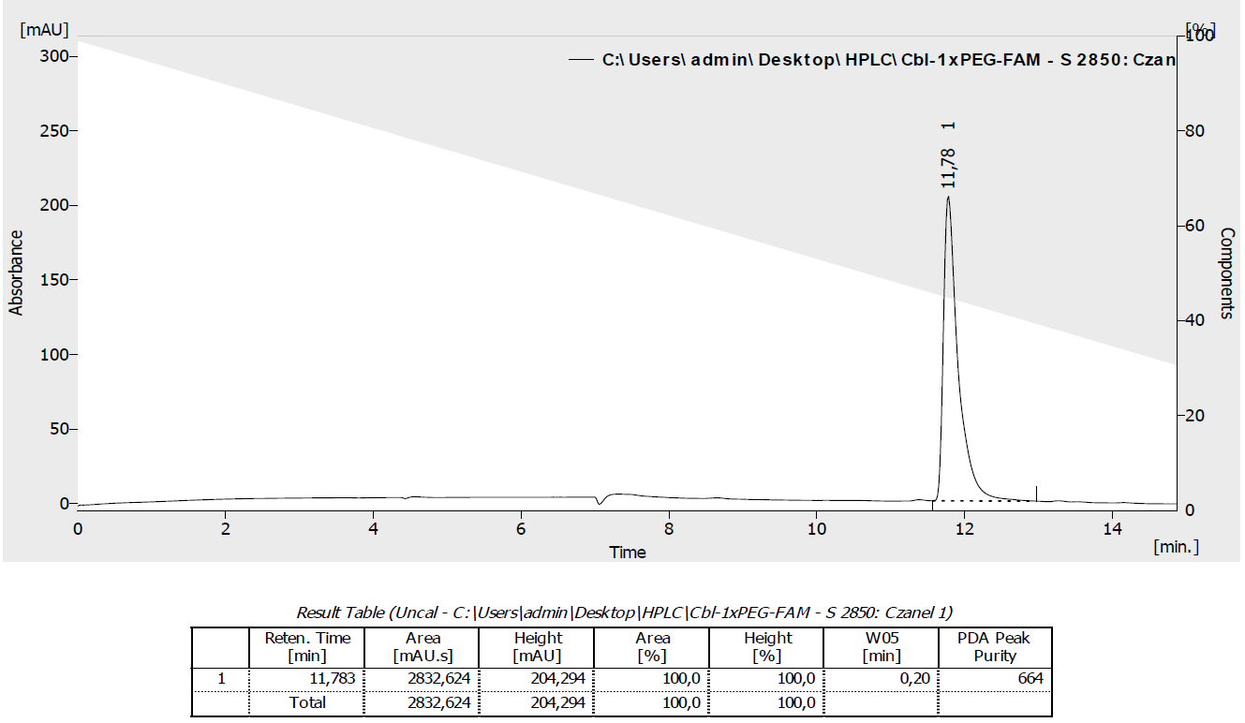

Cbl-2xPEG-FAM (14)

Cbl-2xPEG-FAM: CuI (1 mg, 5 µmol) and TBTA (5 mg, 10 µmol) were dissolved in DMF/H₂O (1 mL, 3:1 v/v) and stirred for 20 min. Subsequently Cbl-2xPEG-N₃ (24) (27 mg, 17.4 µmol) and 6-FAM alkyne (11) (6 mg, 14.5 µmol) were added and the reaction mixture was stirred overnight. Then it was diluted with DMF (1 mL), poured into AcOEt (15 mL) and the precipitate was centrifuged and dried. The crude solid was dissolved in MeOH (1 mL), precipitated with Et₂O (15 mL), and then centrifuged. The dried solid was then dissolved in H₂O, loaded onto RP column (30 mL) and purified gradually with MeCN/H₂O from 10 to 20% v/v yielding 14 as an orange solid. ¹H NMR (500 MHz, CD₃OD) δ 8.20 (bs, 1H), 8.19 – 8.12 (m, 2H), 7.72 (bs, 1H), 7.18 (s, 1H), 7.13 (s, 1H), 6.84 (s, 2H), 6.82 – 6.76 (m, 2H), 6.71 – 6.64 (m, 2H), 6.56 (s, 1H), 6.24 (bs, 1H), 6.02 (s, 1H), 4.93 (bs, 1H), 4.68 – 4.55 (m, 2H), 4.55 – 4.44 (m 3H), 4.41 (bs, 1H), 4.23 (bs, 2H), 4.13 (d, J = 11.1 Hz, 2H), 3.82 (s, 2H), 3.71 – 3.57 (m, 2H), 3.50 (bs, 2H), 3.43 (bs, 2H), 3.34 – 3.29 (m, 4H), 3.27 (d, J = 10.7, 1H), 3.10 (bs, 2H), 2.93 – 2.78 (m, 2H), 2.69 – 2.44 (m, 9H), 2.58 (s, 6H), 2.42 – 2.31(m, 3H), 2.27 (s, 3H), 2.21 (s, 3H), 2.16 – 1.70 (m, 6H), 1.89 (s, 3H), 1.41 (s, 3H), 1.38 (s, 3H), 1.36 (s, 3H), 1.33 – 1.21 (m, 2H), 1.26 (bs, 3H), 1.17 (s, 3H), 1.19 – 1.06 (m, 1H), 0.45 (s, 3H).¹³C NMR (126 MHz, CD₃OD)181.6, 180.1, 177.6, 177.4, 176.7, 175.6, 175.5, 175.4, 174.6, 174.3, 169.8, 167.2, 166.9, 143.3, 138.3, 135.7, 134.1, 131.3, 131.1, 130.6, 117.9, 115.3, 112.4, 112.2, 108.7, 105.2, 103.6, 95.6, 88.3, 86.4, 81.3, 76.3, 75.4, 74.6, 71.3, 71.2, 70.8, 70.5, 70.2, 64.1, 60.3, 57.7, 57.0, 55.2, 52.5, 51.7, 46.6, 44.0, 43.0, 41.8, 40.1, 36.2, 33.5, 33.2, 33.0, 32.3, 29.5, 27.5, 27.4, 20.9, 20.53, 20.45, 20.3, 20.0, 19.9, 17.5, 17.0, 16.4, 16.1.HRMS (ESI) m/z [M + 2Na]²⁺ calcd for C₉₄H₁₁₅CoN₁₉O₂₃PNa₂, 1006.8634; found, 1006.8627.
HPLC Method:
Time [min] | H₂O+0.5‰TFA [%] | MeCN [%] | λ [nm] | R_{t} [min]
Initial | 99 | 1 | 361 | 11.87
15 | 30 | 70 | 361 | 11.87

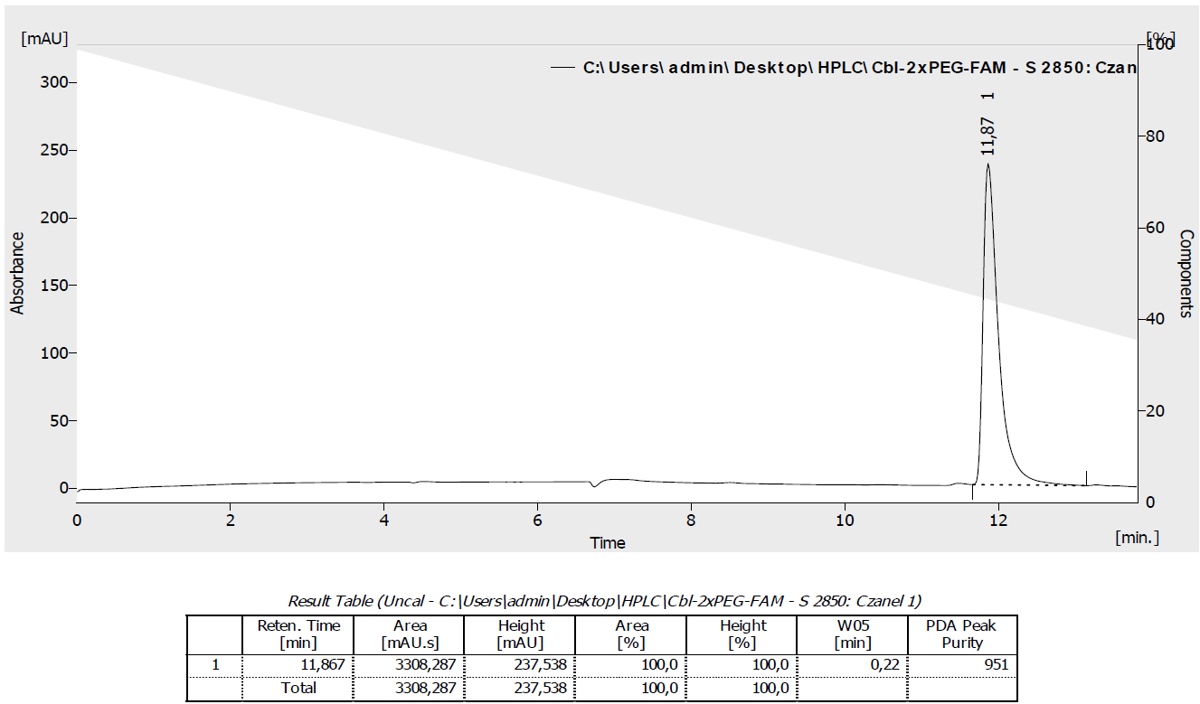

Cbl-3xPEG-FAM (10)

Cbl-3xPEG-FAM: CuI (1 mg, 5 µmol) and TBTA (5 mg, 10 µmol) were dissolved in DMF/H₂O (1 mL, 3:1 v/v) and stirred for 20 min. Subsequently Cbl-3xPEG-N₃ (25) (28 mg, 17.5 µmol) and 6-FAM alkyne (11) (6 mg, 14.5 µmol) were added and the reaction mixture was stirred overnight. Then it was diluted with DMF (1 mL), poured into AcOEt (15 mL) and the precipitate was centrifuged and dried. The crude solid was dissolved in MeOH (1 mL), precipitated with Et₂O (15 mL), and then centrifuged. The dried solid was then dissolved in H₂O, loaded onto RP column (30 mL) and purified gradually with MeCN/H₂O from 10 to 20% v/v yielding 10 as an orange solid. ¹H NMR (500 MHz, CD₃OD) δ 8.25 (bs, 1H), 8.11 (s, 1H), 7.75 (bs, 2H), 7.20(s, 1H), 7.14 (s, 1H), 6.70 (s, 2H), 6.61 (s, 2H), 6.58 – 6.45 (m, 3H), 6.23 (bs, 1H), 6.02 (s, 1H), 4.65 – 4.44 (m, 5H), 4.32 – 4.17 (m, 3H), 4.17 – 4.06 (m, 2H), 3.87 (bs, 2H), 3.70 – 3.65 (m, 2H), 3.65 – 3.58 (m, 2H), 3.52 – 3.36 (m, 12H), 3.28 (m, 1H), 3.25 – 3.14 (m, 2H), 2.95 – 2.82 (m, 2H), 2.71 – 2.41(m, 8H), 2.58 (s, 6H), 2.42 – 2.32 (m, 2H), 2.28 (s, 3H), 2.22 (s, 3H), 2.17 – 1.79 (m, 6H), 1.88 (s, 3H), 1.79 – 1.70 (m, 1H), 1.42(s, 3H), 1.38 (s, 3H), 1.36 (s, 3H), 1.33 – 1.20 (m, 5H), 1.17 (s, 3H), 1.14-1.05 (m, 1H), 0.46 (s, 3H). ¹³C NMR (126 MHz, CD₃OD) δ181.6, 180.2, 177.6, 177.4, 176.6, 175.2, 175.3, 167.2, 166.9, 154.0, 143.4, 138.3, 135.7, 134.0, 131.4, 130.3, 117.9, 112.5, 110.9, 108.7, 105.2, 103.7, 95.6, 86.4, 76.4, 71.4, 71.37, 71.32, 71.2, 71.1, 70.9, 60.3, 57.7, 56.9, 55.2, 52.5, 51.9, 43.0, 41.8, 40.1, 33.3, 32.3, 29.5, 27.5, 27.4, 20.9, 20.6, 20.6, 20.3, 19.9, 17.5, 17.1, 16.4, 16.1.HRMS (ESI) m/z [M + H + Na]²⁺ calcd for C₉₆H₁₂₀CoN₁₉O₂₄PNa, 1017.8855; found, 1017.8862.
HPLC Method:
Time [min] | H₂O+0.5‰TFA [%] | MeCN [%] | λ [nm] | R_{t}[min]
Initial | 99 | 1 | 361 | 11.98
15 | 30 | 70 | 361 | 11.98

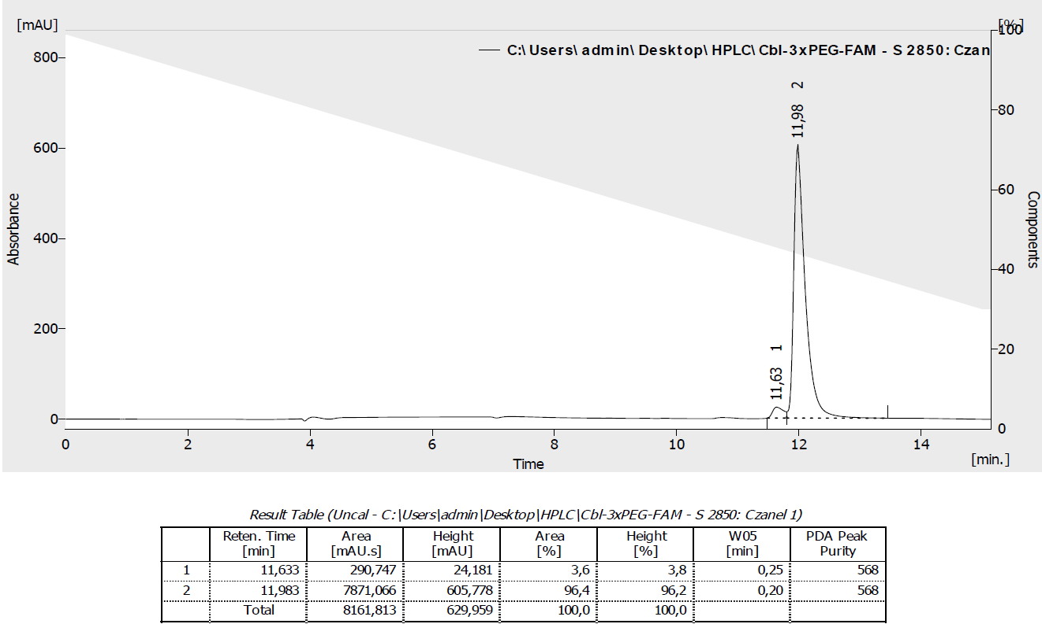

Cbl-C6-ATTO 488 (3)
Cbl-C6-ATTO 488: Preparation of a catalyst solution: CuI (1 mg, 5 µmol) and TBTA (5 mg, 10 µmol) were dissolved in DMF (2 mL) and stirred for 20 min. Cbl-C6-N₃ (21) (3 mg, 1.97 µmol) and ATTO 488 alkyne (16) (0.5 mg, 0.68 µmol) were dissolved in DMF/H₂O (200 µL, 1:1, v/v) and subsequently freshly prepared catalyst solution (300 µL) was added and the reaction mixture was stirred overnight. Then it was diluted with DMF (1 mL), poured into AcOEt (10 mL) and the precipitate was centrifuged and dried. The crude solid was dissolved in MeOH (1 mL), precipitated with Et₂O (10 mL), and then centrifuged. The dried solid was then dissolved in H₂O, loaded onto RP column (10 mL) and purified gradually with MeCN/H₂O from 10 to 20% v/v yielding 3 as an orange solid. HRMS (ESI) m/z [M + 2Na]²⁺ calcd for C₉₈H₁₂₆CoN₂₂O₂₄PS₂Na₂²⁺, 1097.3805; found, 1097.3818.
HPLC Method:
Time [min] | H₂O+0.2‰TFA [%] | MeCN [%] | λ [nm] | R_{t}[min]
Initial | 99 | 1 | 488 | 9.07
15 | 30 | 70 | 488 | 9.07
20 | 30 | 70 | 488 | 9.07
30 | 5 | 95 | 488 | 9.07

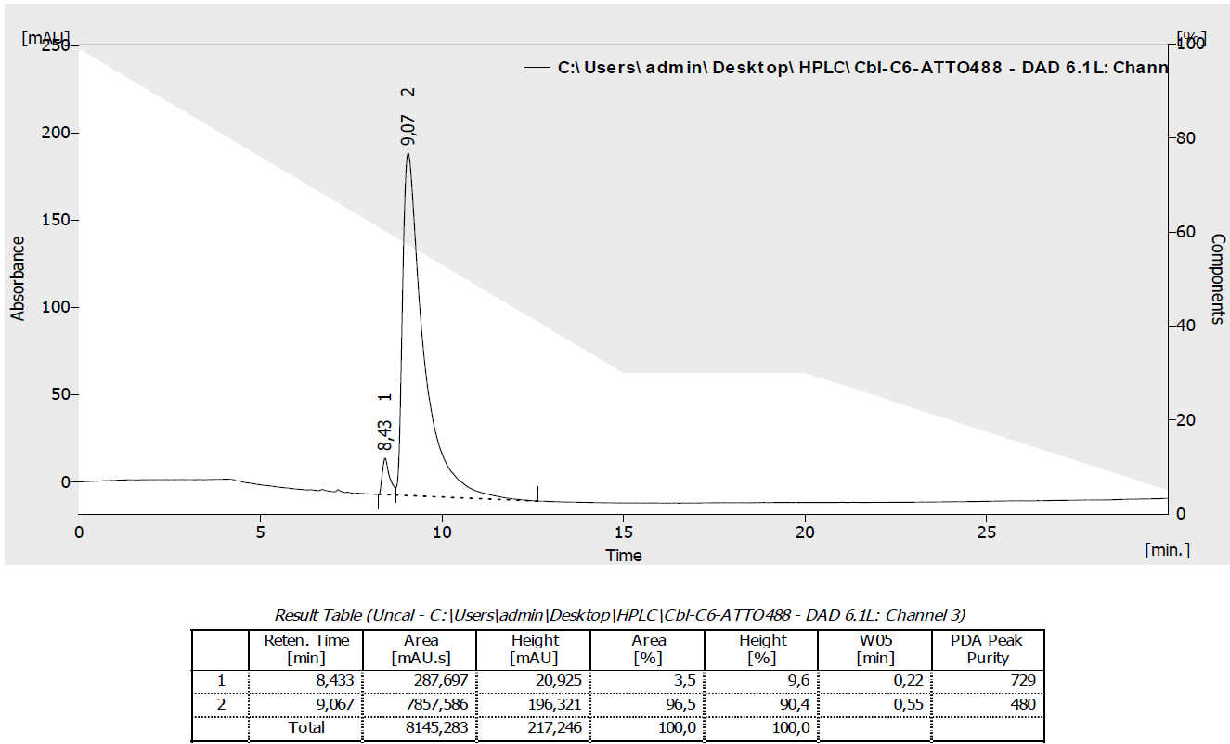

Cbl-ATTO 590 (7)

Cbl-ATTO 590: Preparation of a catalyst solution: CuI (1 mg, 5 µmol) and TBTA (5 mg, 10 µmol) were dissolved in DMF (2 mL) and stirred for 20 min. Cbl-N₃ (20) (3 mg, 2.20 µmol) and ATTO 590 alkyne (17) (0.5 mg, 0.68 µmol) were dissolved in DMF/H₂O (200 µL, 1:1, v/v) and subsequently freshly prepared catalyst solution (300 µL) was added and the reaction mixture was stirred overnight. Then it was diluted with DMF (1 mL), poured into AcOEt (10 mL) and the precipitate was centrifuged and dried. The crude solid was dissolved in MeOH (1 mL), precipitated with Et₂O (10 mL), and then centrifuged. The dried solid was then dissolved in H₂O, loaded onto RP column (10 mL) and purified gradually with MeCN/H₂O from 15 to 30% v/v yielding 7 as a violet solid. HRMS (ESI) m/z [M + H]²⁺ calcd for C₁₀₃H₁₃₀CoN₂₀O₁₇P⁺, 1004.4491; found, 1004.4499.
HPLC Method:
Time [min] | H₂O+0.2‰TFA [%] | MeCN [%] | λ [nm] | R_{t} [min]
Initial | 99 | 1 | 590 | 12.50
15 | 30 | 70 | 590 | 12.50
20 | 30 | 70 | 590 | 12.50
30 | 5 | 95 | 590 | 12.50

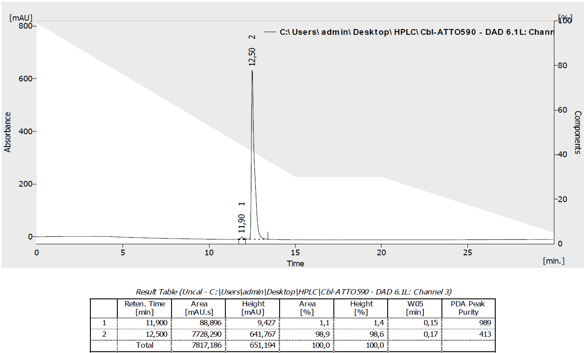

Cbl-C6-ATTO 590 (4)

Cbl-C6-ATTO 590: Preparation of a catalyst solution: CuI (1 mg, 5 µmol) and TBTA (5 mg, 10 µmol) were dissolved in DMF (2 mL) and stirred for 20 min. Cbl-C6-N₃ (21) (3 mg, 1.97 µmol) and ATTO 590 alkyne (17) (0.5 mg, 0.68 µmol) were dissolved in DMF/H₂O (200 µL, 1:1, v/v) and subsequently freshly prepared catalyst solution (300 µL) was added and the reaction mixture was stirred overnight. Then it was diluted with DMF (1 mL), poured into AcOEt (10 mL) and the precipitate was centrifuged and dried. The crude solid was dissolved in MeOH (1 mL), precipitated with Et₂O (10 mL), and then centrifuged. The dried solid was then dissolved in H₂O, loaded onto RP column (10 mL) and purified gradually with MeCN/H₂O from 15 to 40% v/v yielding 4 as a violet solid. HRMS (ESI) m/z [M + H]²⁺ calcd for C₁₁₀H₁₄₃CoN₂₁O₁₉P⁺, 1075.9964; found, 1075.9967.
HPLC Method:
Time [min] | H₂O+0.2‰TFA [%] | MeCN[%] | λ [nm] | R_{t}[min]
Initial | 99 | 1 | 590 | 13.22
15 | 30 | 70 | 590 | 13.22
20 | 30 | 70 | 590 | 13.22
30 | 5 | 95 | 590 | 13.22

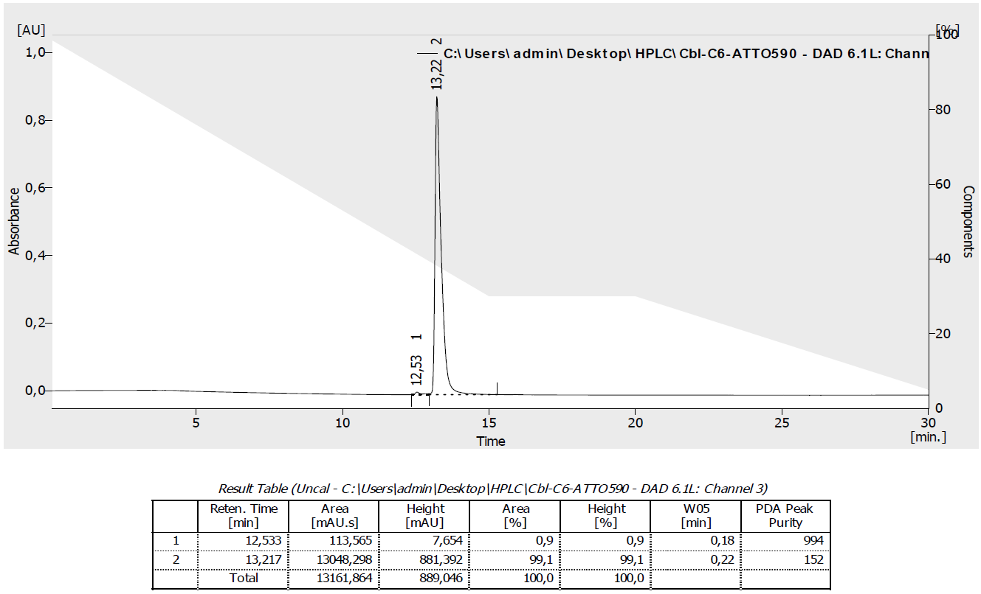

Cbl-5xPEG-ATTO 590 (8)
Cbl-5xPEG-ATTO 590: Preparation of a catalyst solution: CuI (1 mg, 5 µmol) and TBTA (5 mg, 10 µmol) were dissolved in DMF (2 mL) and stirred for 20 min. Cbl-5xPEG-N₃ (27) (3 mg, 1.78 µmol) and ATTO 590 alkyne (17) (0.5 mg, 0.68 µmol) were dissolved in DMF/H₂O (200 µL, 1:1, v/v) and subsequently freshly prepared catalyst solution (300 µL) was added and the reaction mixture was stirred overnight. Then it was diluted with DMF (1 mL), poured into AcOEt (10 mL) and the precipitate was centrifuged and dried. The crude solid was dissolved in MeOH (1 mL), precipitated with Et₂O (10 mL), and then centrifuged. The dried solid was then dissolved in H₂O, loaded onto RP column (10 mL) and purified gradually with MeCN/H₂O from 15 to 30% v/v yielding 8 as a violet solid. HRMS (ESI) m/z [M + Na]²⁺ calcd for C₁₁₆H₁₅₄CoN₂₁O₂₄PNa⁺, 1169.0216; found, 1169.0219
HPLC Method:
Time [min] | H₂O+0.5‰TFA [%] | MeCN [%] | λ [nm] | R_{t} [min]
Initial | 99 | 1 | 590 | 12.73
15 | 30 | 70 | 590 | 12.73
20 | 30 | 70 | 590 | 12.73
30 | 5 | 95 | 590 | 12.73

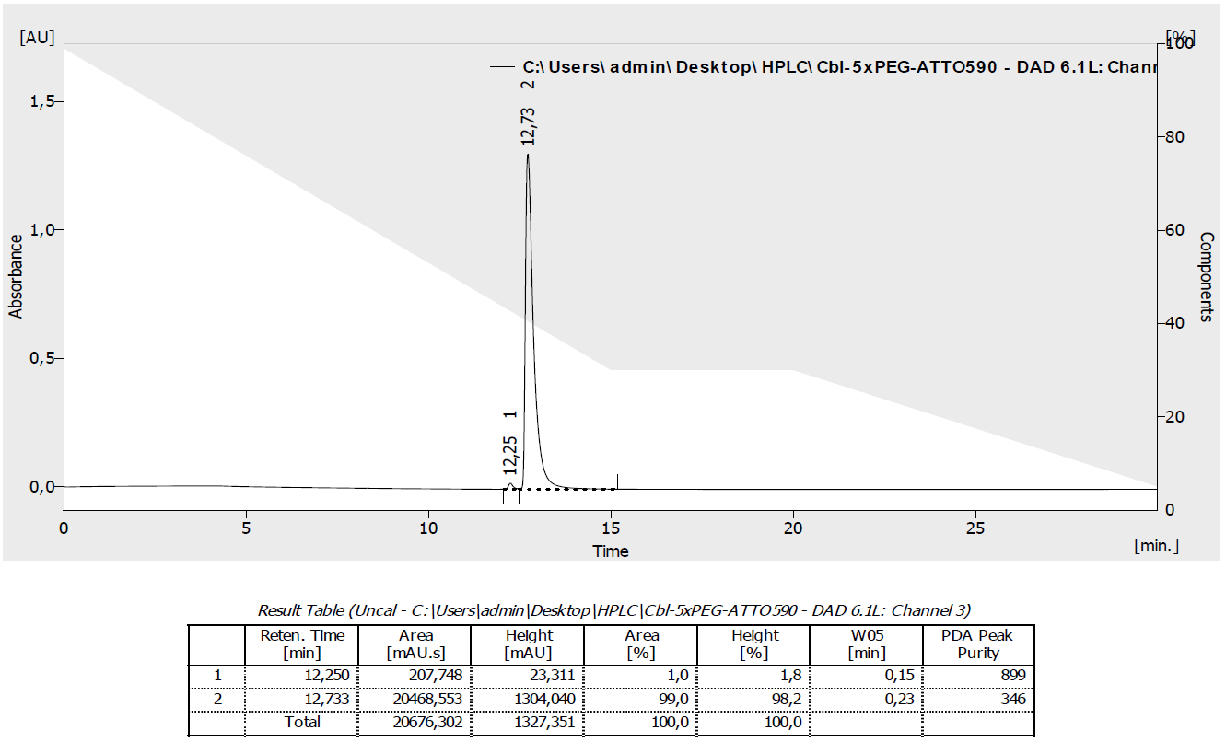

Cbl-4xGly-ATTO 590 (9)

Cbl-4xGly-ATTO 590: Preparation of a catalyst solution: CuI (1 mg, 5 µmol) and TBTA (5 mg, 10 µmol) were dissolved in DMF (2 mL) and stirred for 20 min. Cbl-4xGly-N₃ (31) (4 mg, 2.20 µmol) and ATTO 590 alkyne (17) (0.5 mg, 0.68 µmol) were dissolved in DMF/H₂O (400 µL, 3:1, v/v) and subsequently freshly prepared catalyst solution (300 µL) was added and the reaction mixture was stirred overnight. Then it was diluted with DMF (1 mL), poured into AcOEt (10 mL) and the precipitate was centrifuged and dried. The crude solid was dissolved in MeOH (1 mL), precipitated with Et₂O (10 mL), and then centrifuged. The dried solid was then dissolved in H₂O, loaded onto RP column (10 mL) and purified gradually with MeCN/H₂O from 15 to 40% v/v yielding 9 as a violet solid. HRMS (ESI) m/z [M + H]²⁺ calcd for C₁₂₀H₁₅₆CoN₂₈O₂₃P⁺, 2447.0957; found, 2447.0932.
HPLC Method:
Time [min] | H₂O+0.5‰TFA [%] | MeCN [%] | λ [nm] | R_{t} [min]
Initial | 99 | 1 | 590 | 12.58
15 | 30 | 70 | 590 | 12.58
20 | 30 | 70 | 590 | 12.58
30 | 5 | 95 | 590 | 12.58

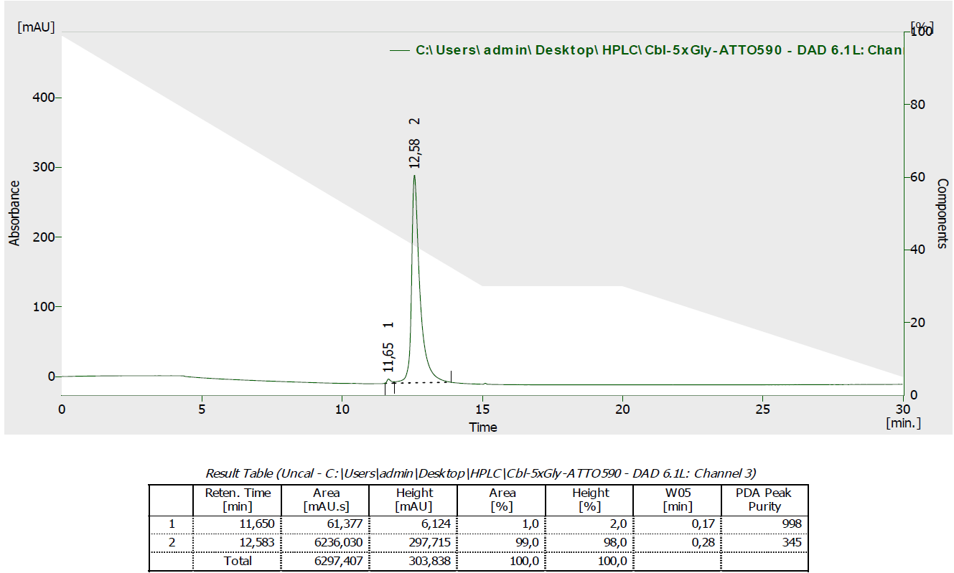

Cbl-Cy5 (6)

Cbl-Cy5: Preparation of a catalyst solution: CuI (1 mg, 5 µmol) and TBTA (5 mg, 10 µmol) were dissolved in DMF (2 mL) and stirred for 20 min. Cbl-N₃ (20) (3 mg, 2.20 µmol) and sulfo-Cyanine5 alkyne (19) (0.5 mg, 0.72 µmol) were dissolved in DMF/H₂O (200 µL, 1:1, v/v) and subsequently freshly prepared catalyst solution (300 µL) was added and the reaction mixture was stirred overnight. Then it was diluted with DMF (1 mL), poured into AcOEt (10 mL) and the precipitate was centrifuged and dried. The crude solid was dissolved in MeOH (1 mL), precipitated with Et₂O (10 mL), and then centrifuged. The dried solid was then dissolved in H₂O, loaded onto RP column (10 mL) and purified gradually with MeCN/H₂O from 10 to 20% v/v yielding 6 as a blue solid. HRMS (ESI) m/z [M + 2Na]²⁺ calcd for C₉₈H₁₂₇CoN₂₀O₂₀PS₂Na₃, 1063.3864; found, 1063.3871.

HPLC Method:
Time [min] | H₂O+0.5‰TFA [%] | MeCN[%] | λ [nm] | R_{t}[min]
Initial | 99 | 1 | 646 | 11.30
15 | 30 | 70 | 646 | 11.30

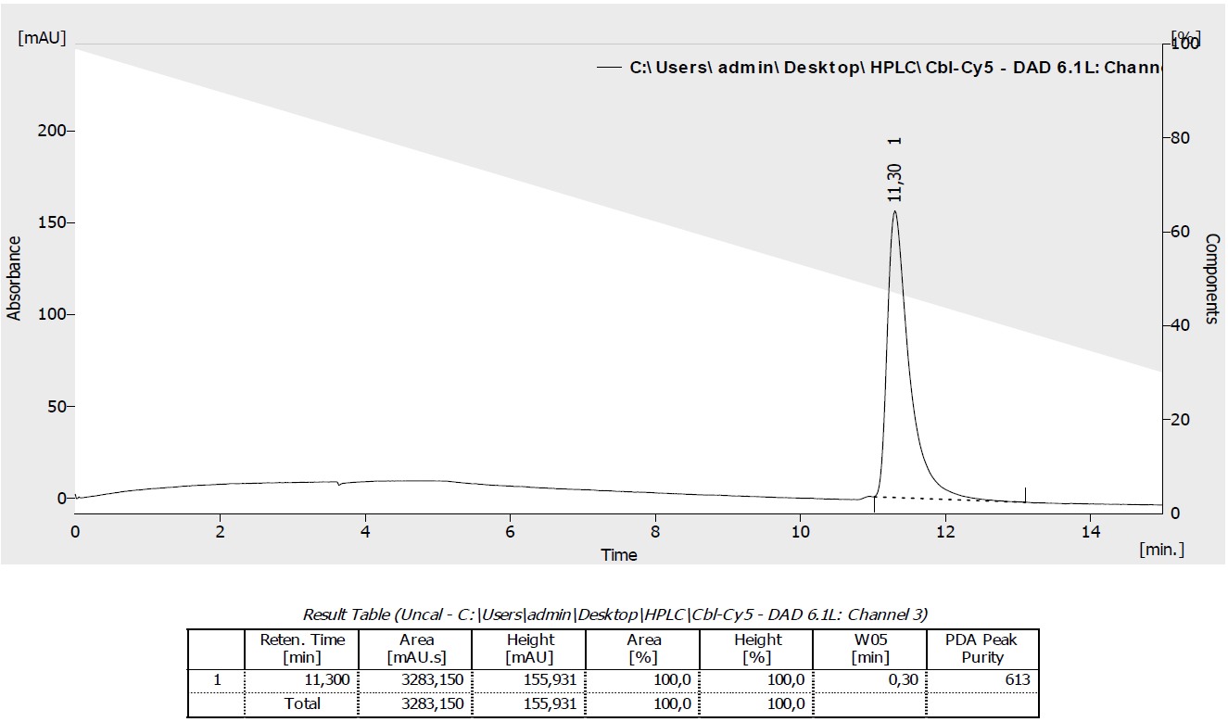

Cbl-ATTO 633 (15)

Cbl-ATTO 633: Preparation of a catalyst solution: CuI (1 mg, 5 µmol) and TBTA (5 mg, 10 µmol) were dissolved in DMF (2 mL) and stirred for 20 min. Cbl-N₃ (20) (3 mg, 2.20 µmol) and ATTO 633 alkyne (18) (0.5 mg, 0.72 µmol) were dissolved in DMF/H₂O (200 µL, 1:1, v/v) and subsequently freshly prepared catalyst solution (300 µL) was added and the reaction mixture was stirred overnight. Then it was diluted with DMF (1 mL), poured into AcOEt (10 mL) and the precipitate was centrifuged and dried. The crude solid was dissolved in MeOH (1 mL), precipitated with Et₂O (10 mL), and then centrifuged. The dried solid was then dissolved in H₂O, loaded onto RP column (10 mL) and purified by RP column chromatography gradually with MeCN/H₂O from 15 to 40% v/v yielding 15 as a blue solid. LRMS (ESI) m/z [M + Na + H]²⁺ found, 995.96.
HPLC Method:
Time [min] | H₂O+0.2‰TFA [%] | MeCN [%] | λ [nm] | R_{t} [min]
Initial | 99 | 1 | 633 | 12.63
15 | 30 | 70 | 633 | 12.63
20 | 30 | 70 | 633 | 12.63
30 | 5 | 95 | 633 | 12.63

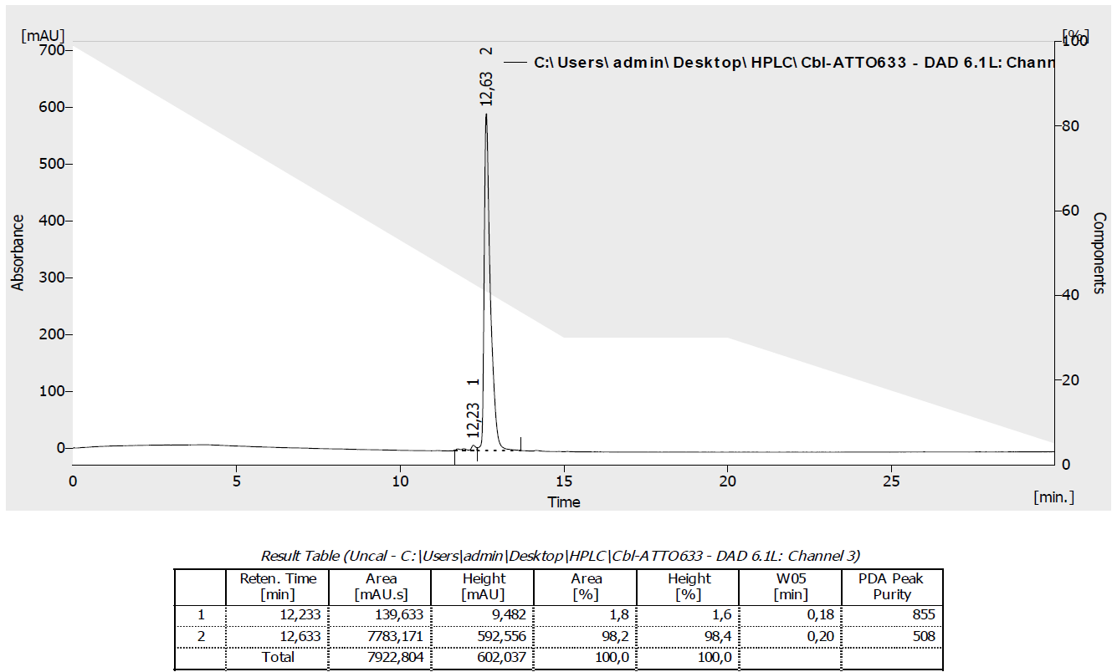

Cbl-C6-ATTO 633 (5)

Cbl-C6-ATTO 633: Preparation of a catalyst solution: CuI (1 mg, 5 µmol) and TBTA (5 mg, 10 µmol) were dissolved in DMF (2 mL) and stirred for 20 min. Cbl-C6-N₃ (21) (3 mg, 1.97 µmol) and ATTO 633 alkyne (18) (0.5 mg, 0.72 µmol) were dissolved in DMF/H₂O (200 µL, 1:1, v/v) and subsequently freshly prepared catalyst solution (300 µL) was added and the reaction mixture was stirred overnight. Then it was diluted with DMF (1 mL), poured into AcOEt (10 mL) and the precipitate was centrifuged and dried. The crude solid was dissolved in MeOH (1 mL), precipitated with Et₂O (10 mL), and then centrifuged. The dried solid was then dissolved in H₂O, loaded onto RP column (10 mL) and purified crude product was purified by RP column chromatography gradually with MeCN/H₂O from 20 to 50% v/v yielding 5 as a blue solid. LRMS (ESI) m/z [M + Na + H]²⁺ found, 1067.51.

HPLC Method:
Time [min] | H₂O+0.2‰TFA [%] | MeCN[%] | λ [nm] | R_{t}[min]
Initial | 99 | 1 | 633 | 12.68
15 | 30 | 70 | 633 | 12.68
20 | 30 | 70 | 633 | 12.68
30 | 5 | 95 | 633 | 12.68

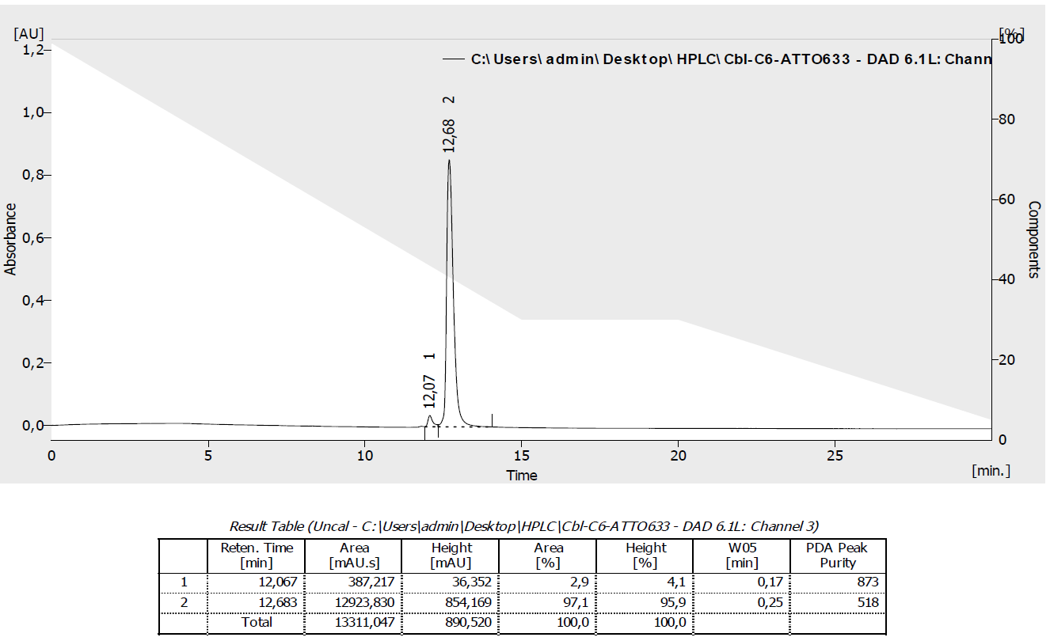

NMR spectra

NMR spectra of Cbl-2xPEG-N₃(24) recorded for CD₃OD
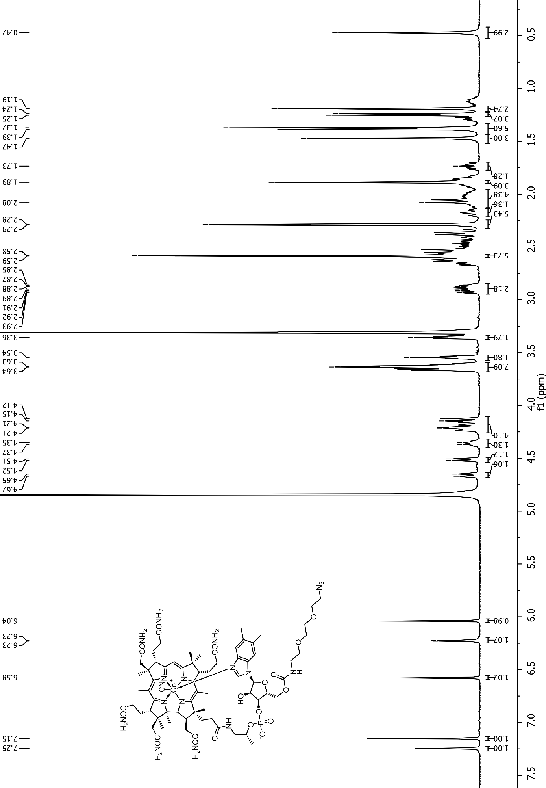
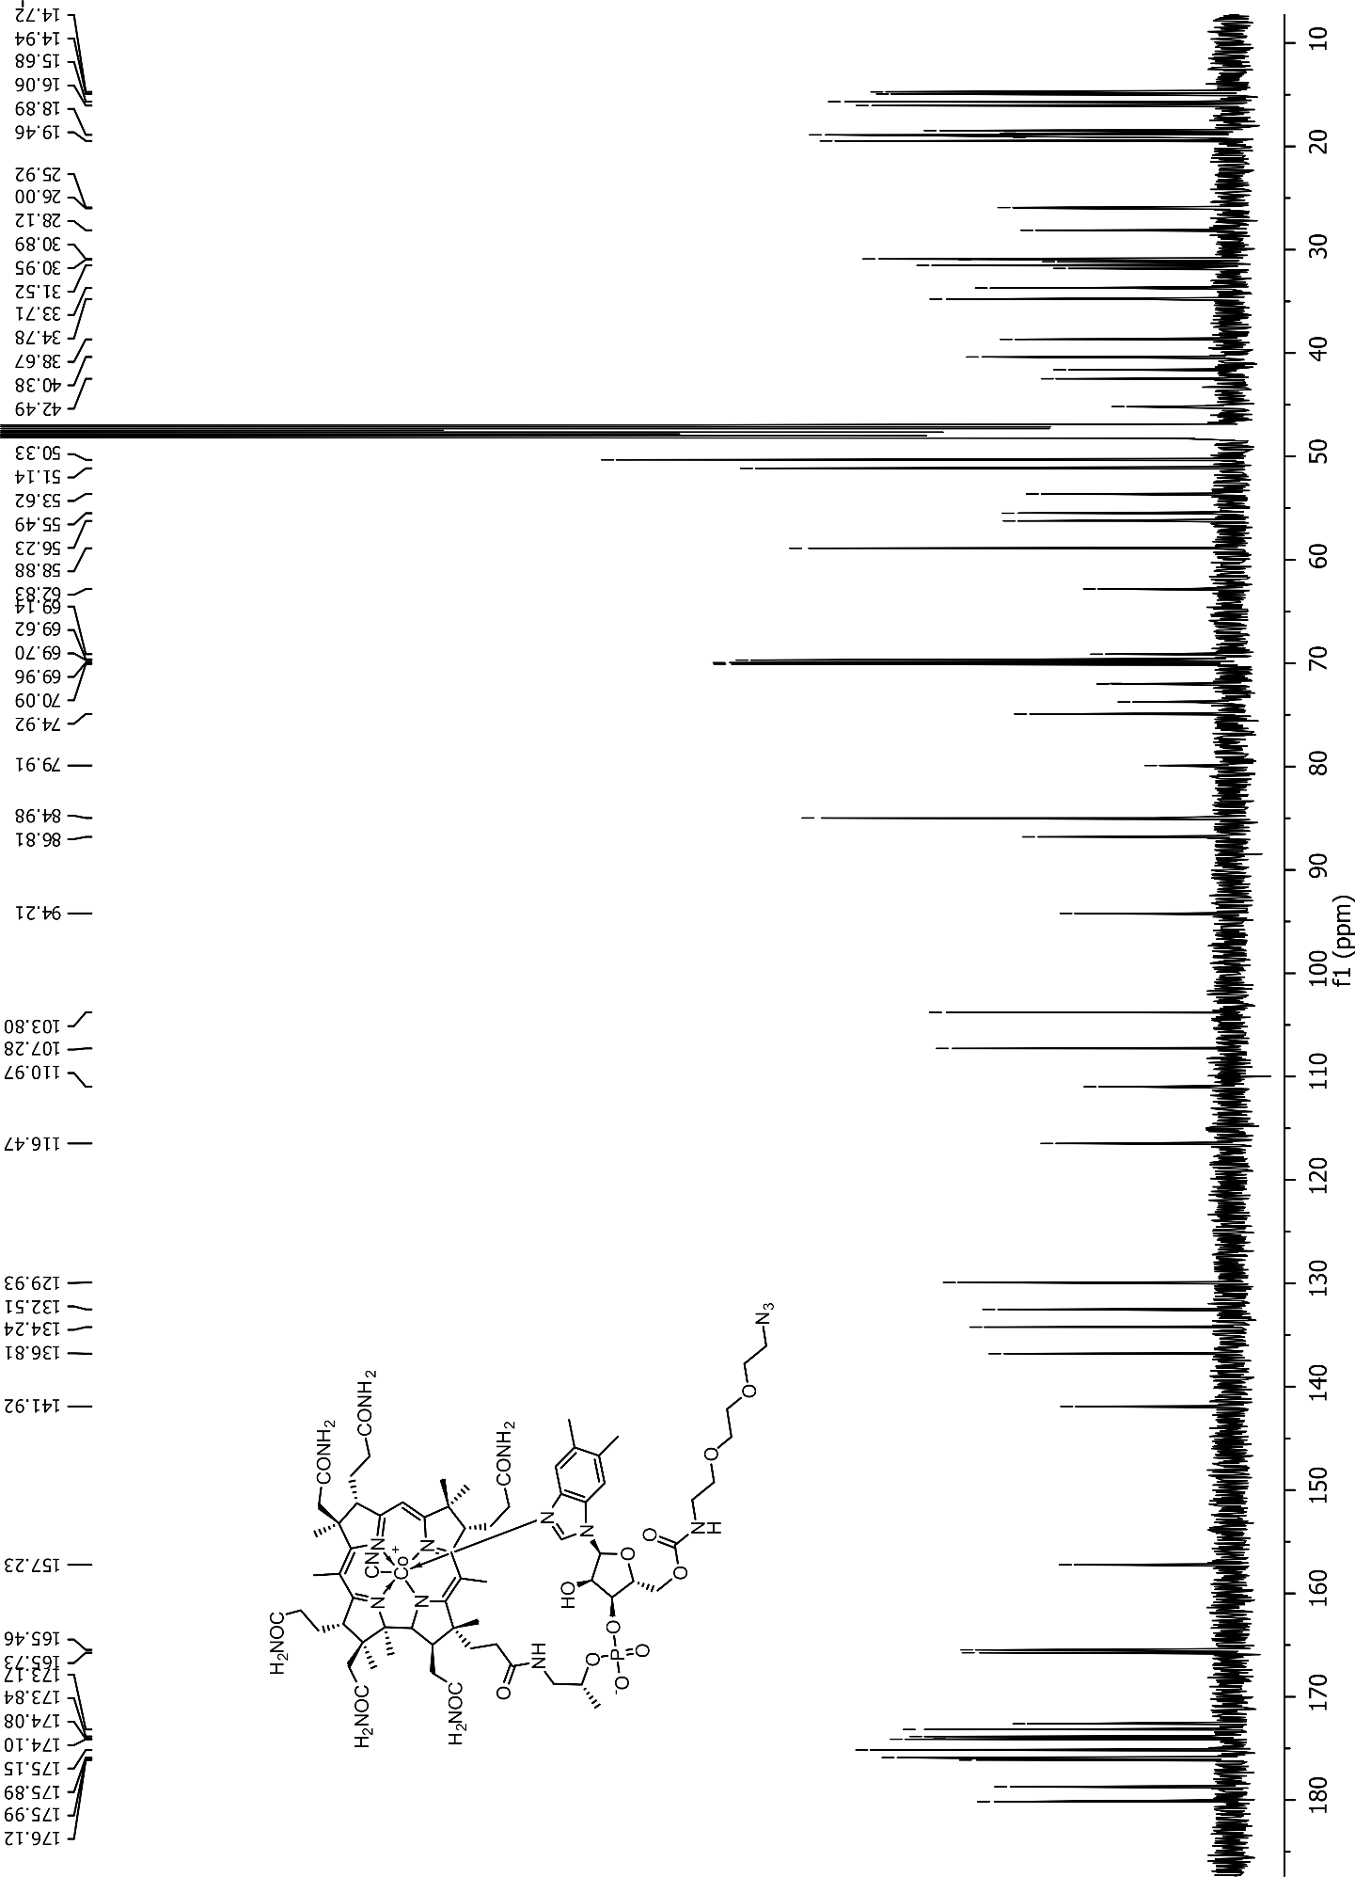

NMR spectra of Cbl-5xPEG-N₃(27) recorded for CD₃OD
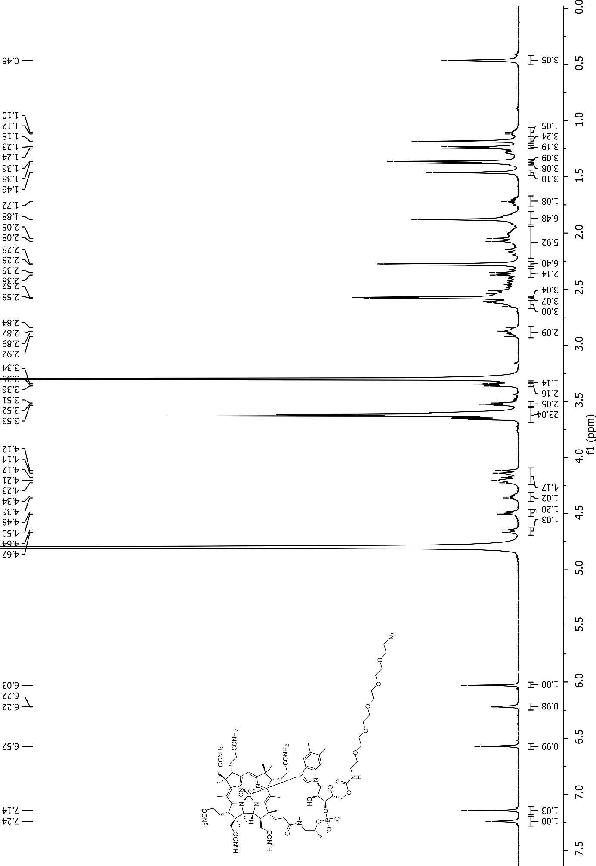
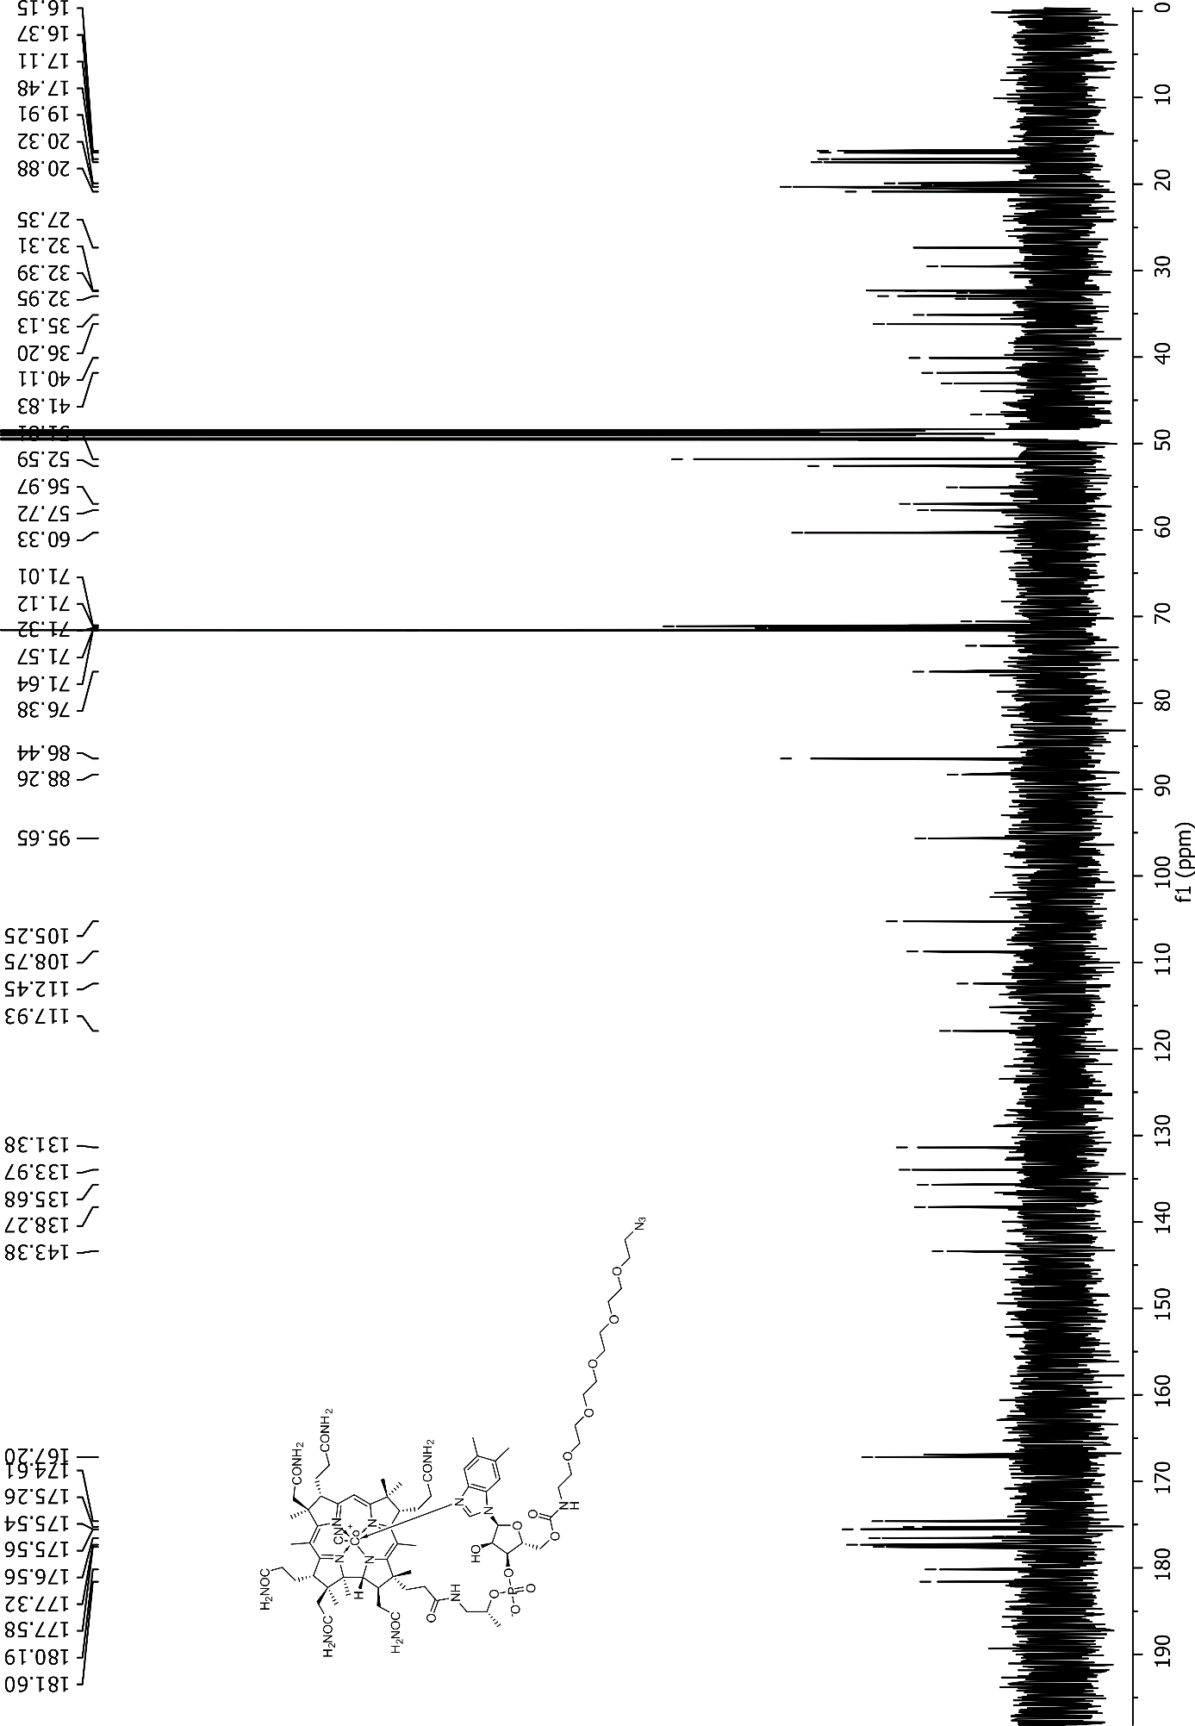

NMR spectra of Cbl-4xGly-OH (29) recorded forD₂O
Note: Water signal was suppressed using presaturation (presat)
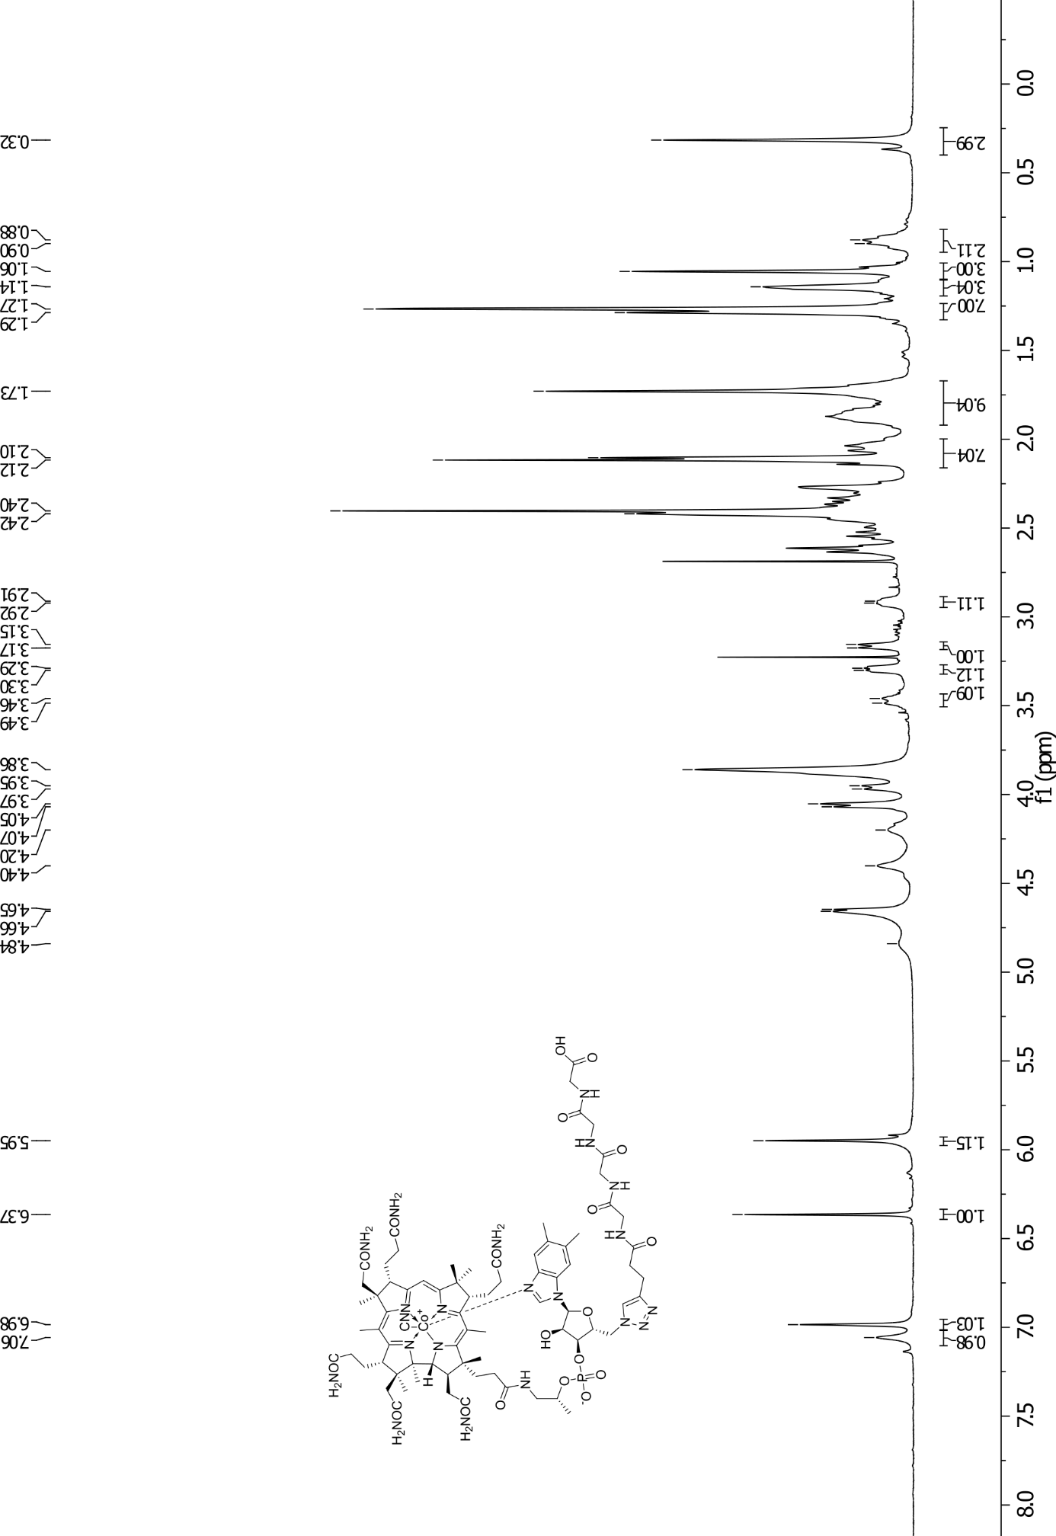
Note: Water signal was suppressed using presaturation, the spectrum was recorded at 80°C
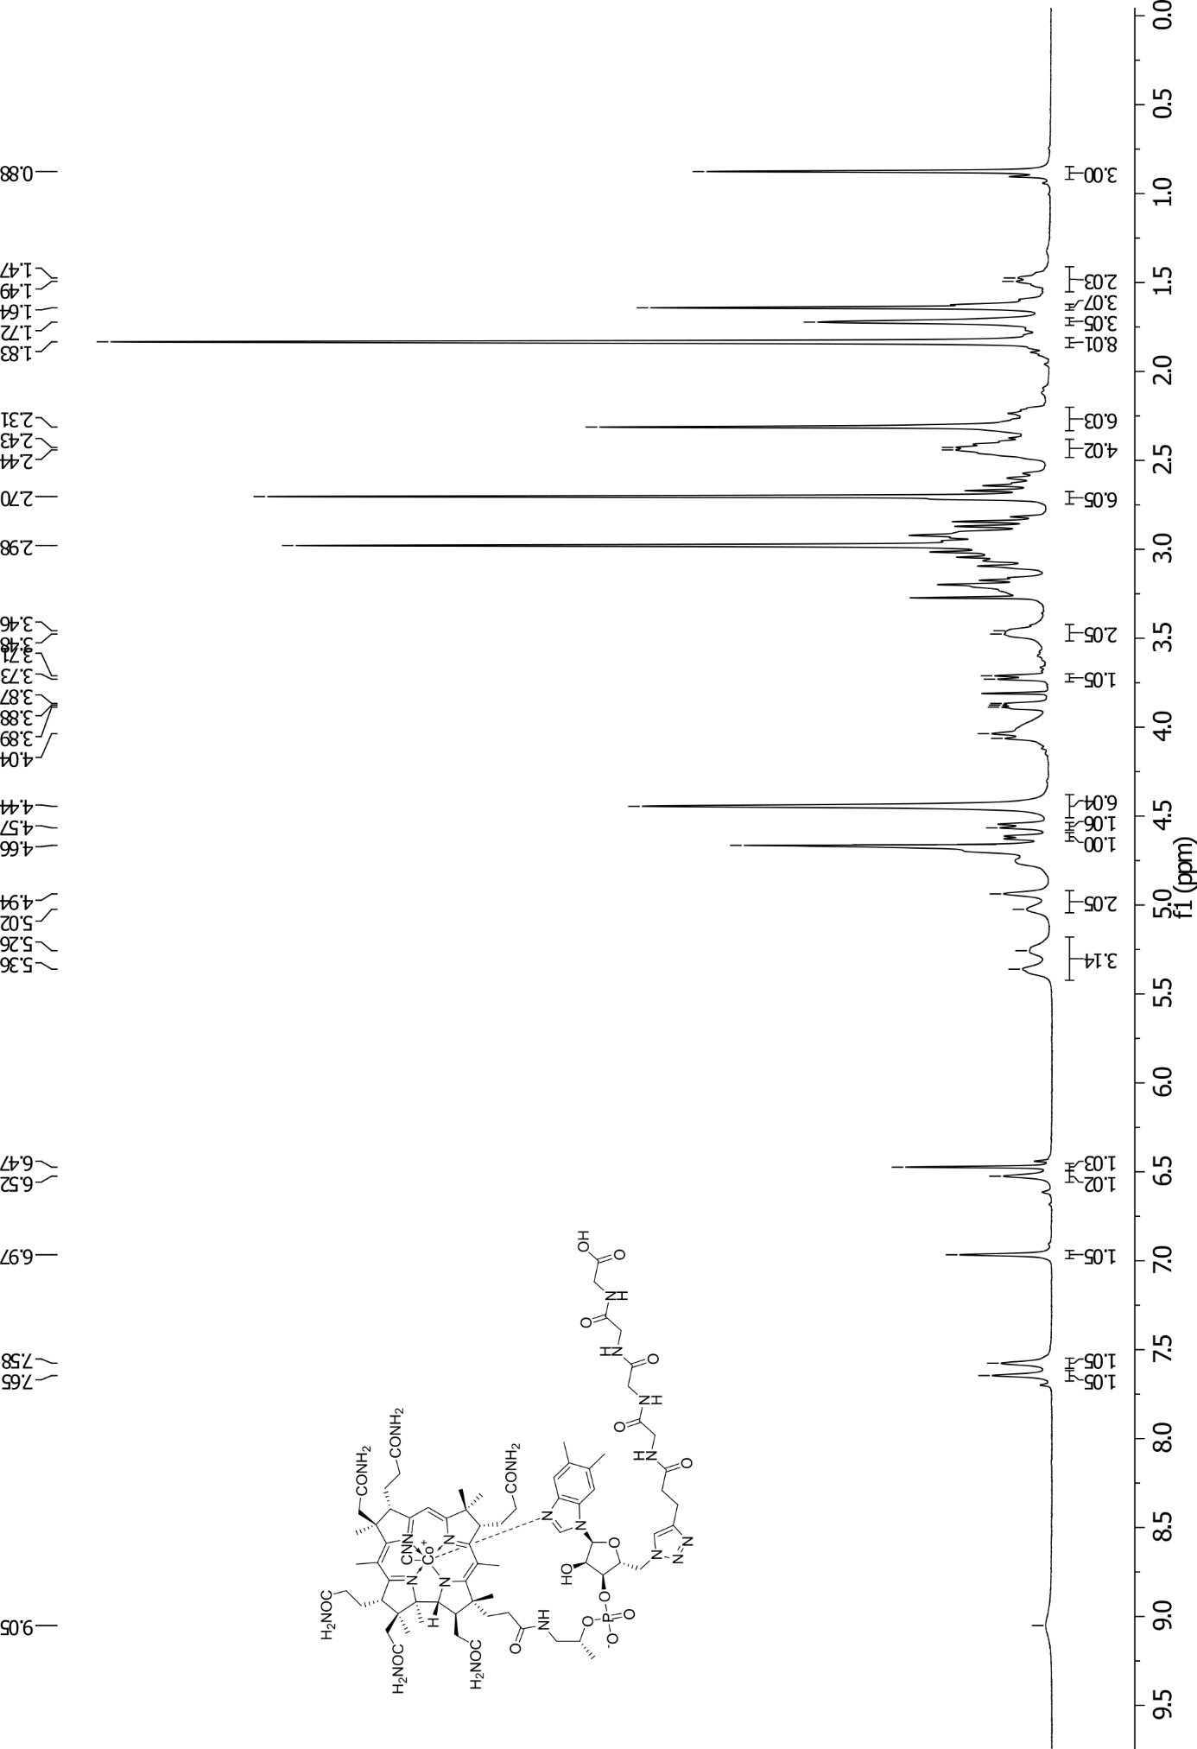
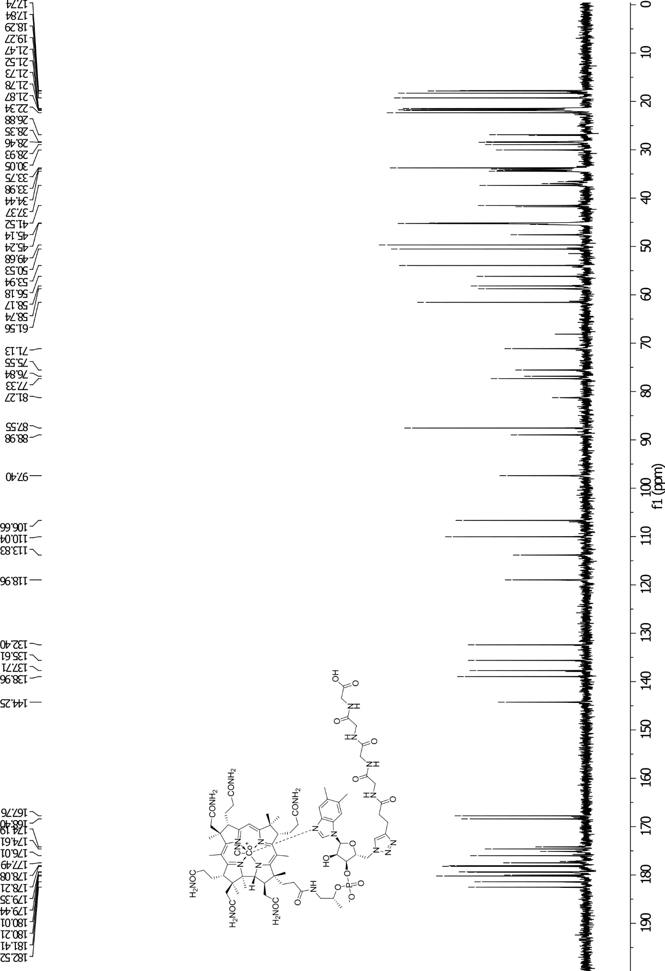

NMR spectra of Cbl-4xGly-N₃(31) recorded for CD₃OD
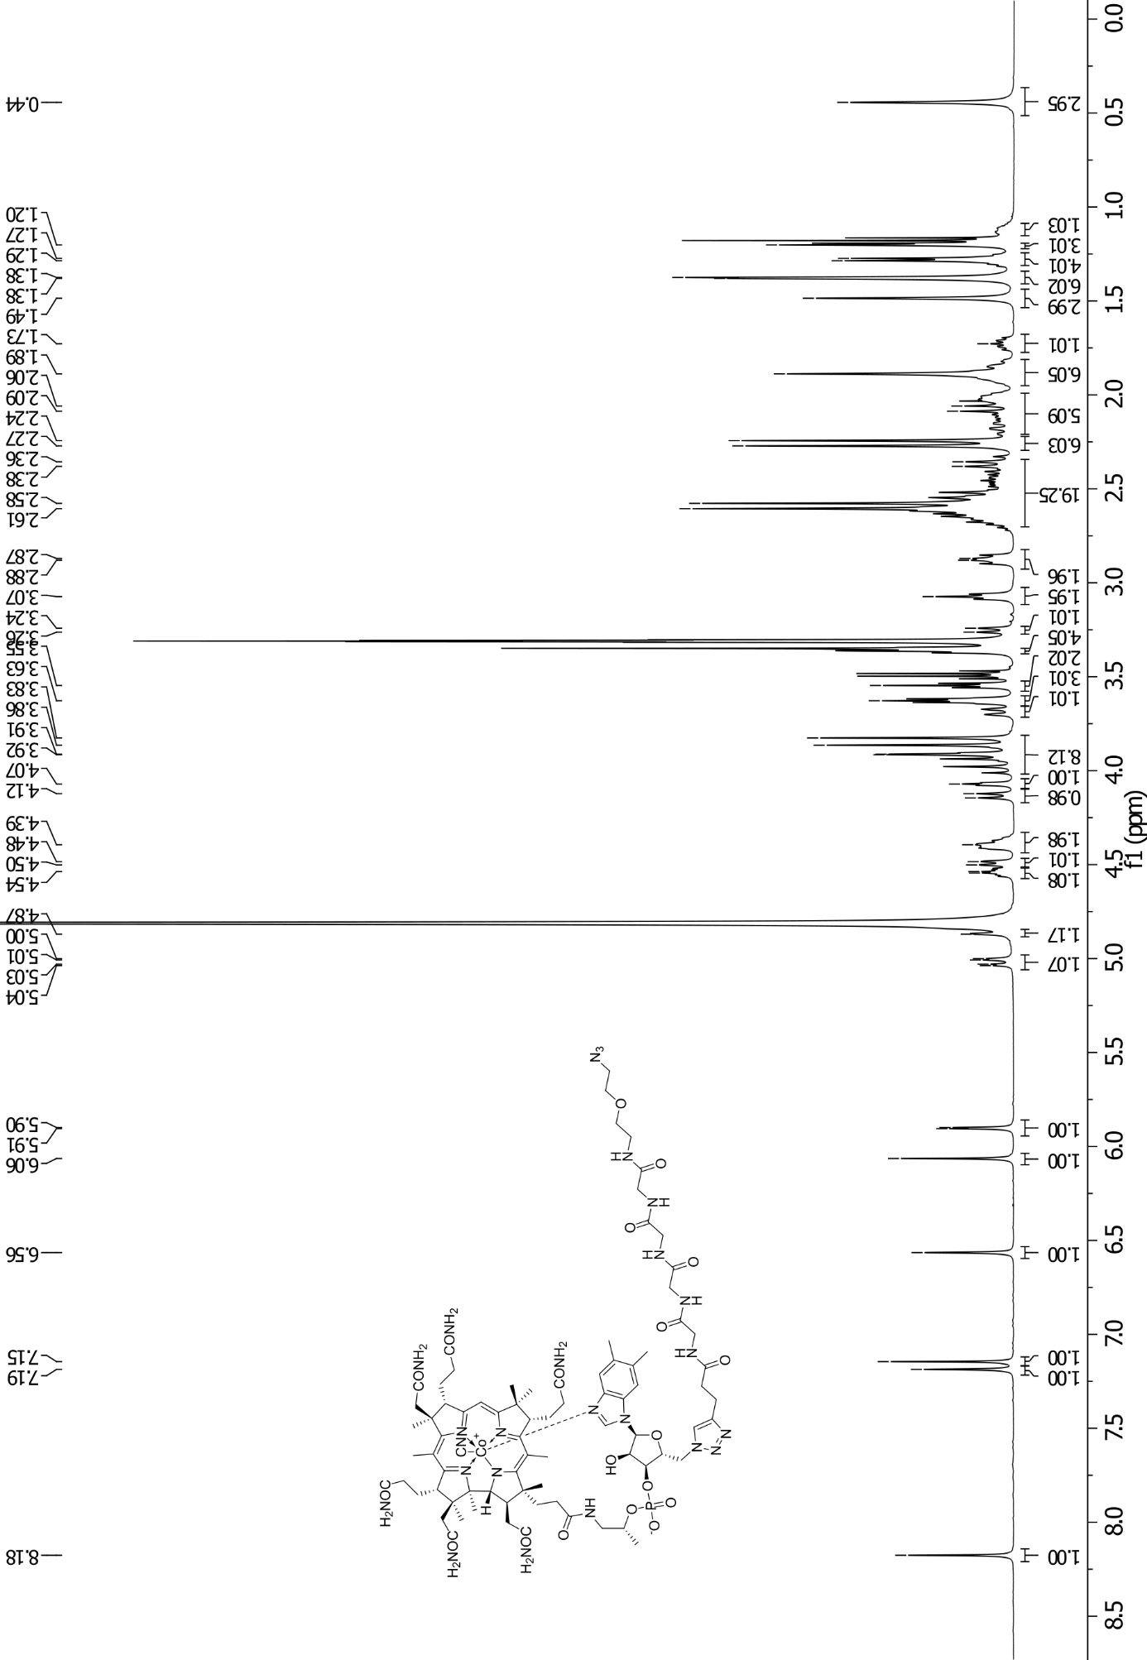
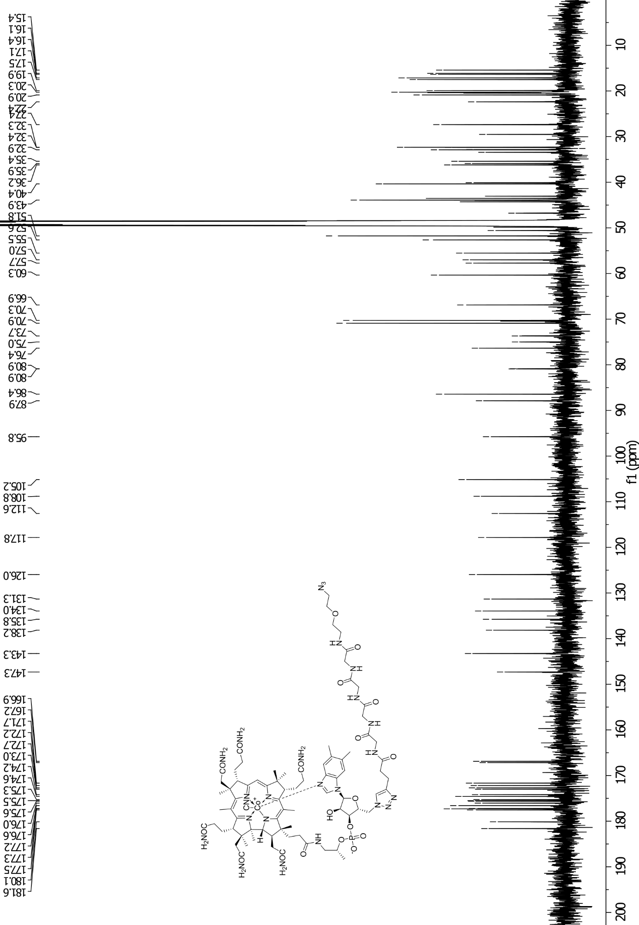

NMR spectra of Cbl-FAM (12) recorded for CD₃OD

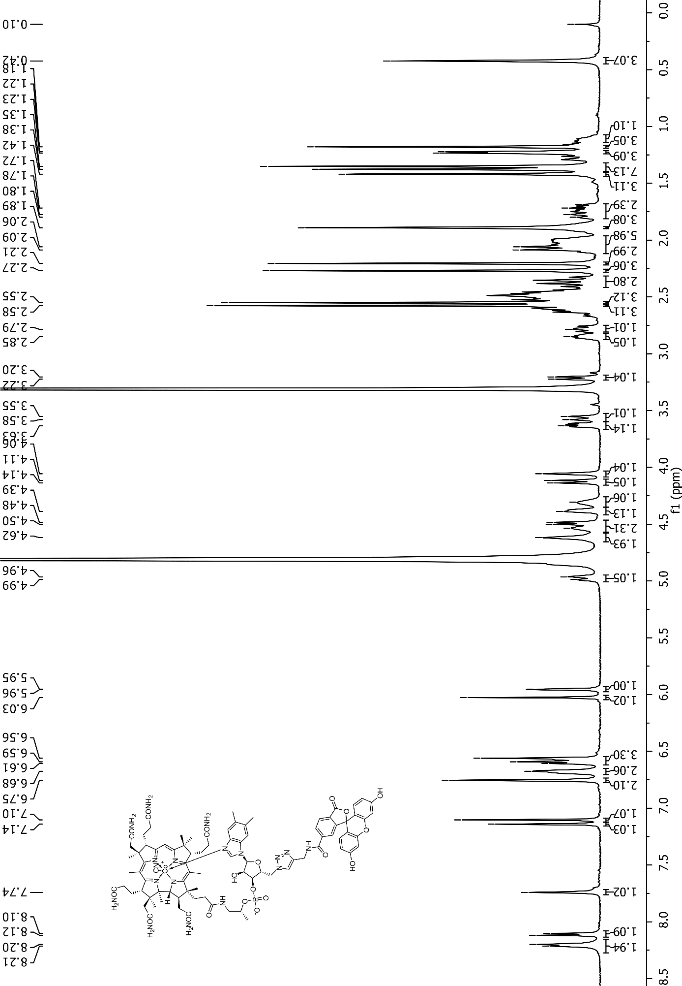

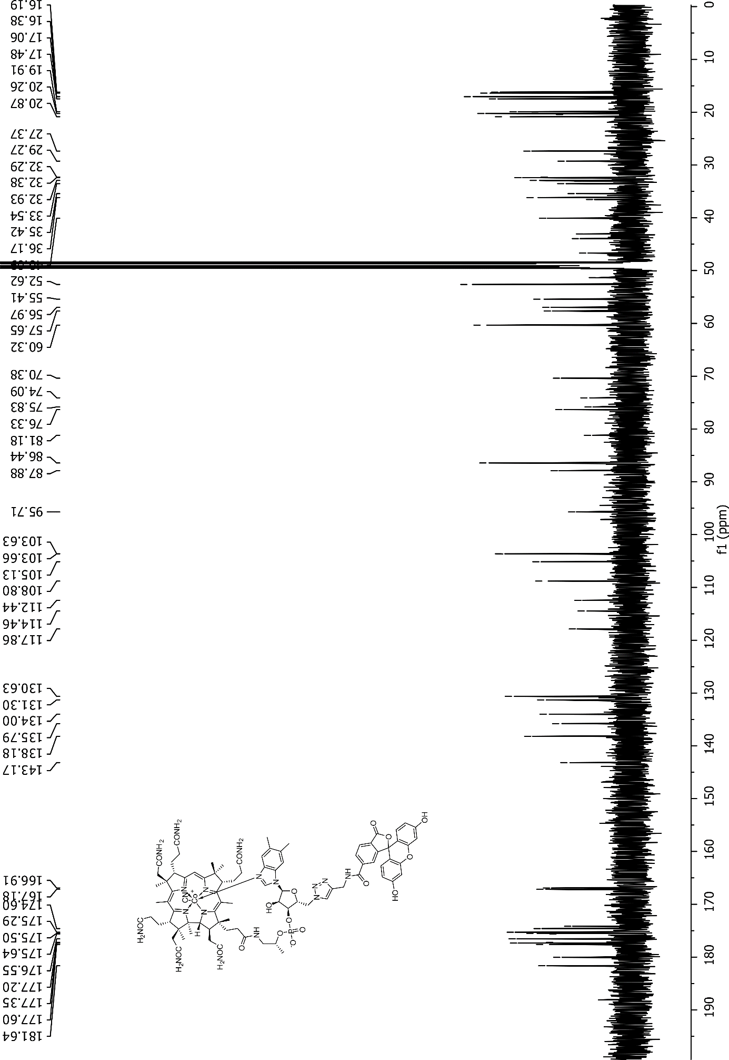

NMR spectra of Cbl-C6-FAM (2) recorded for CD₃OD
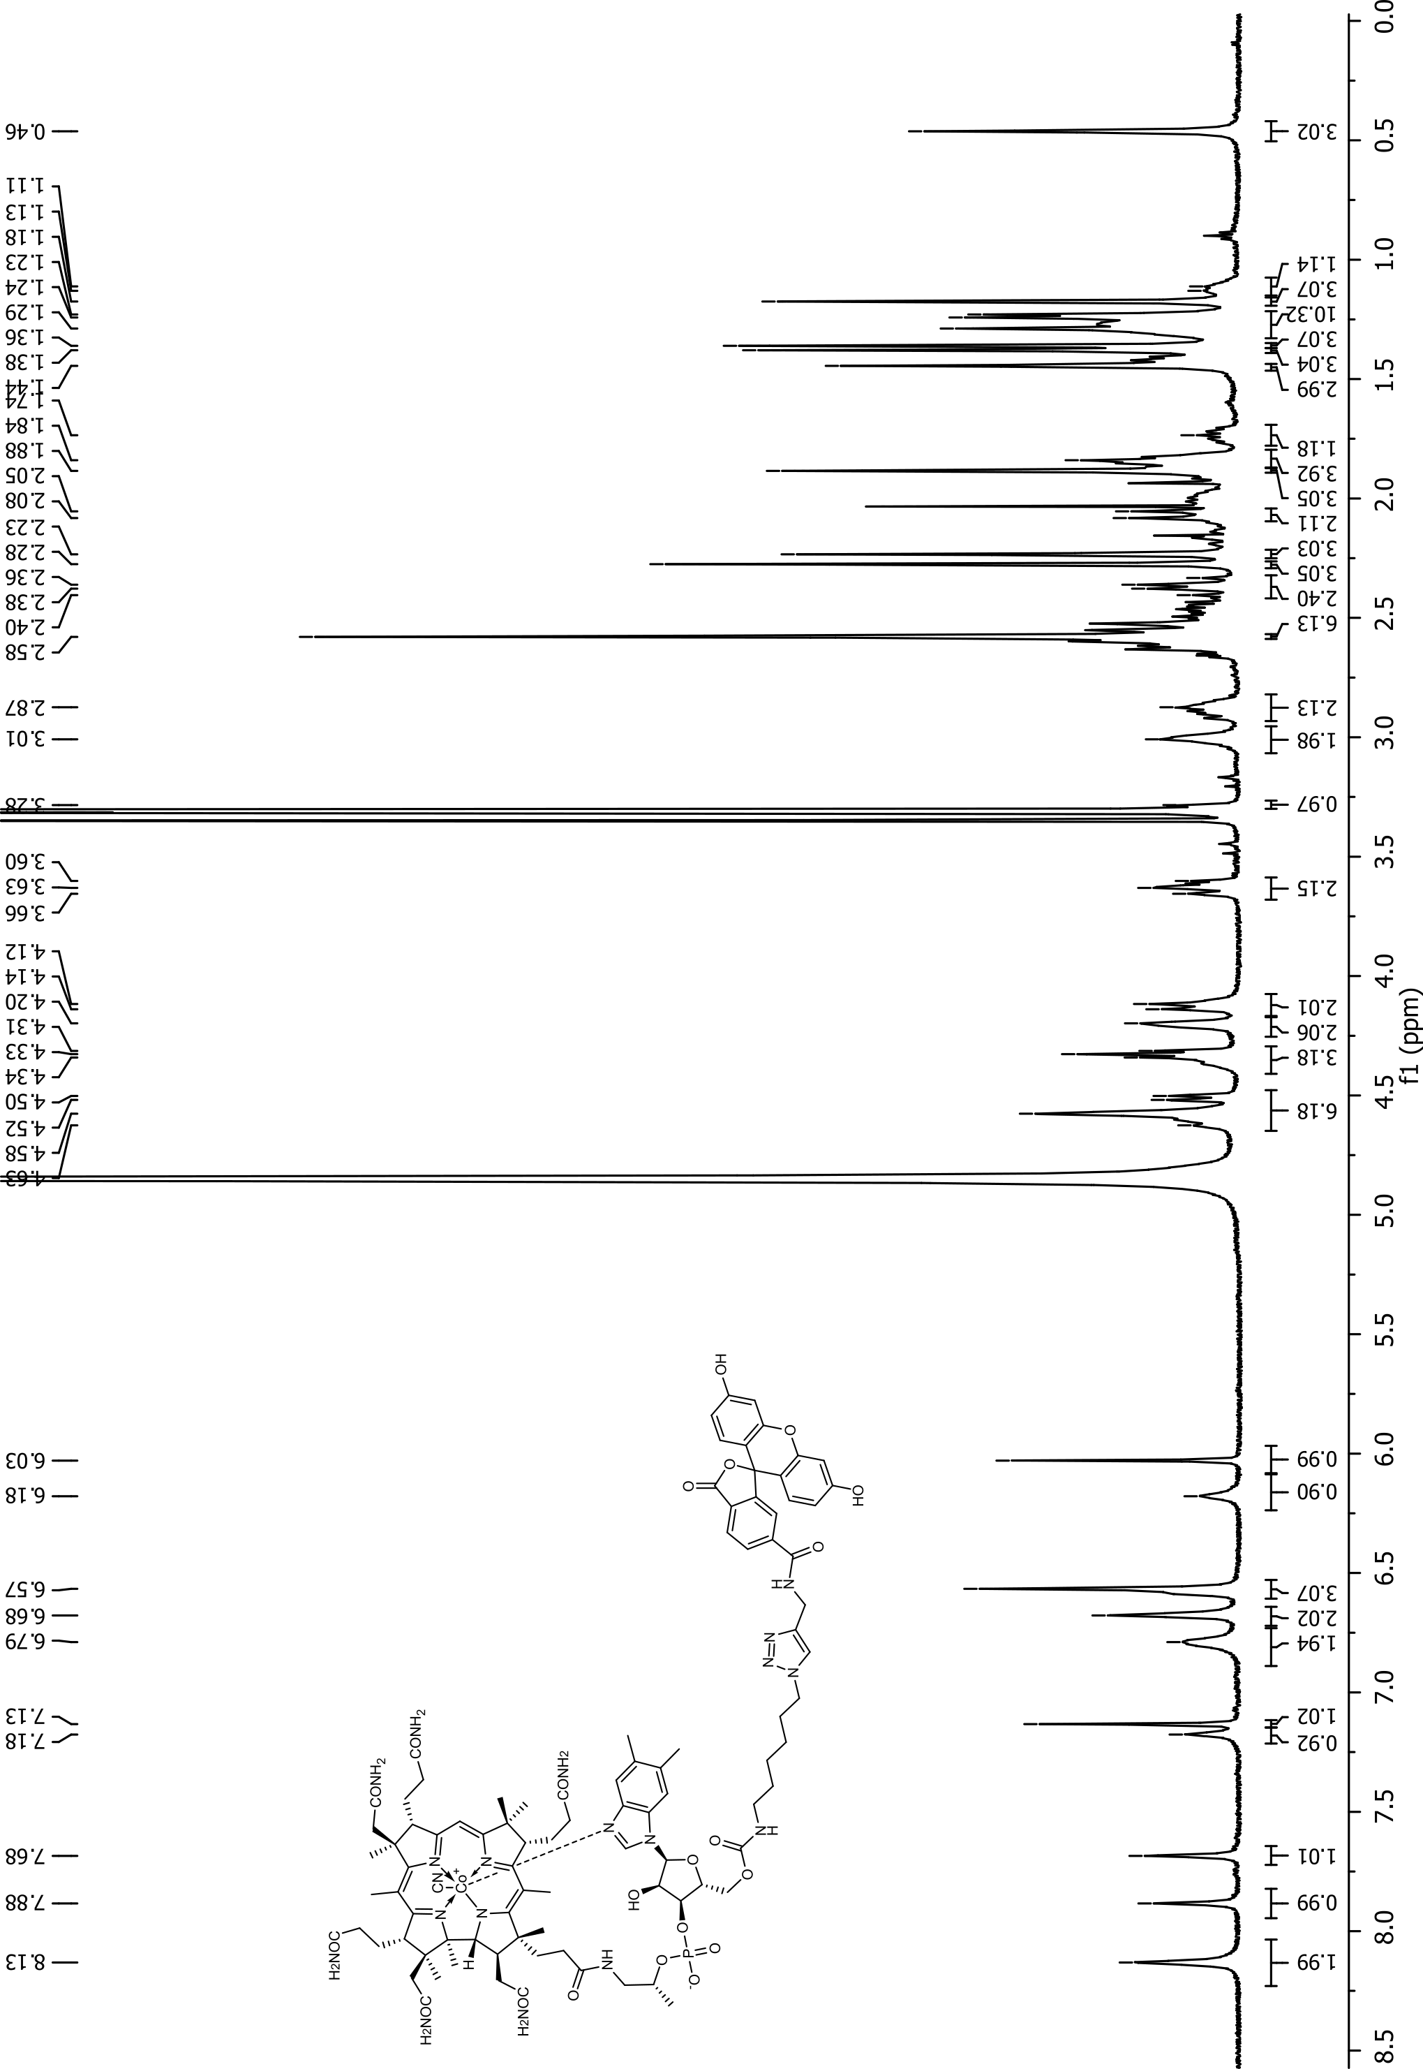
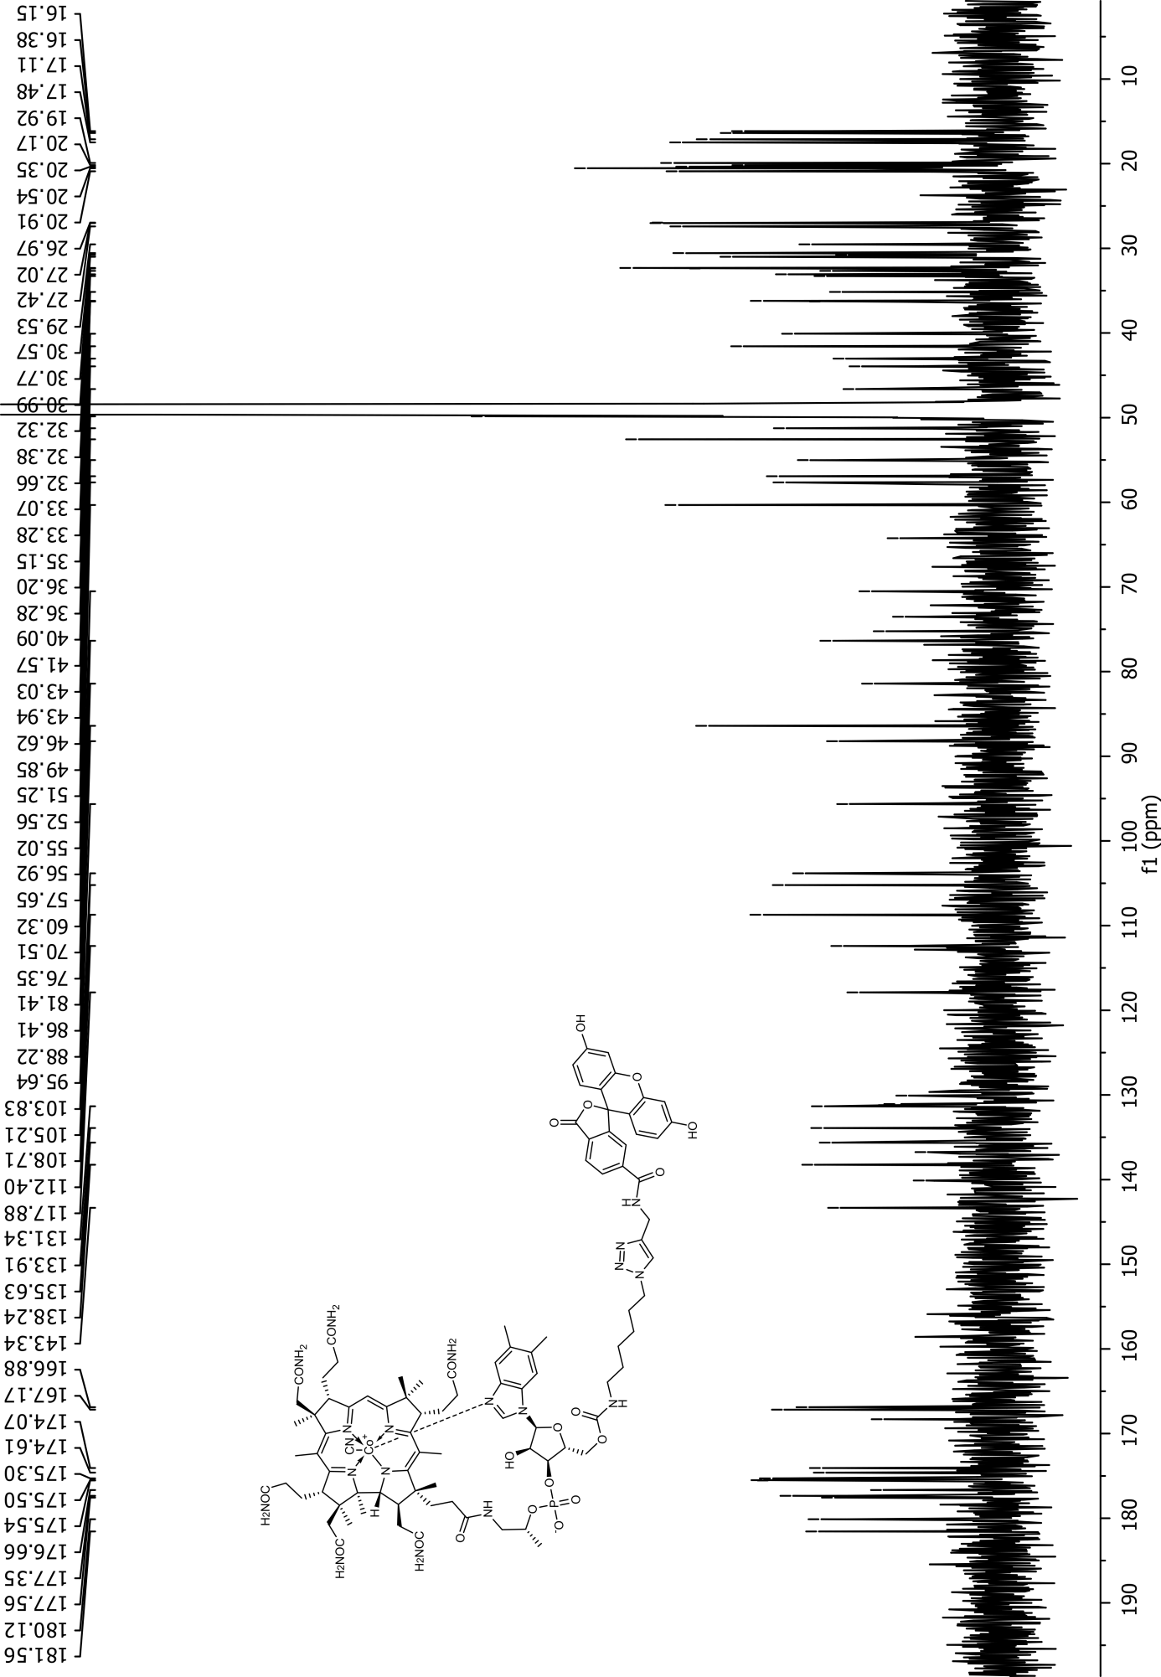

NMR spectra of Cbl-1xPEG-FAM (13) recorded for CD₃OD
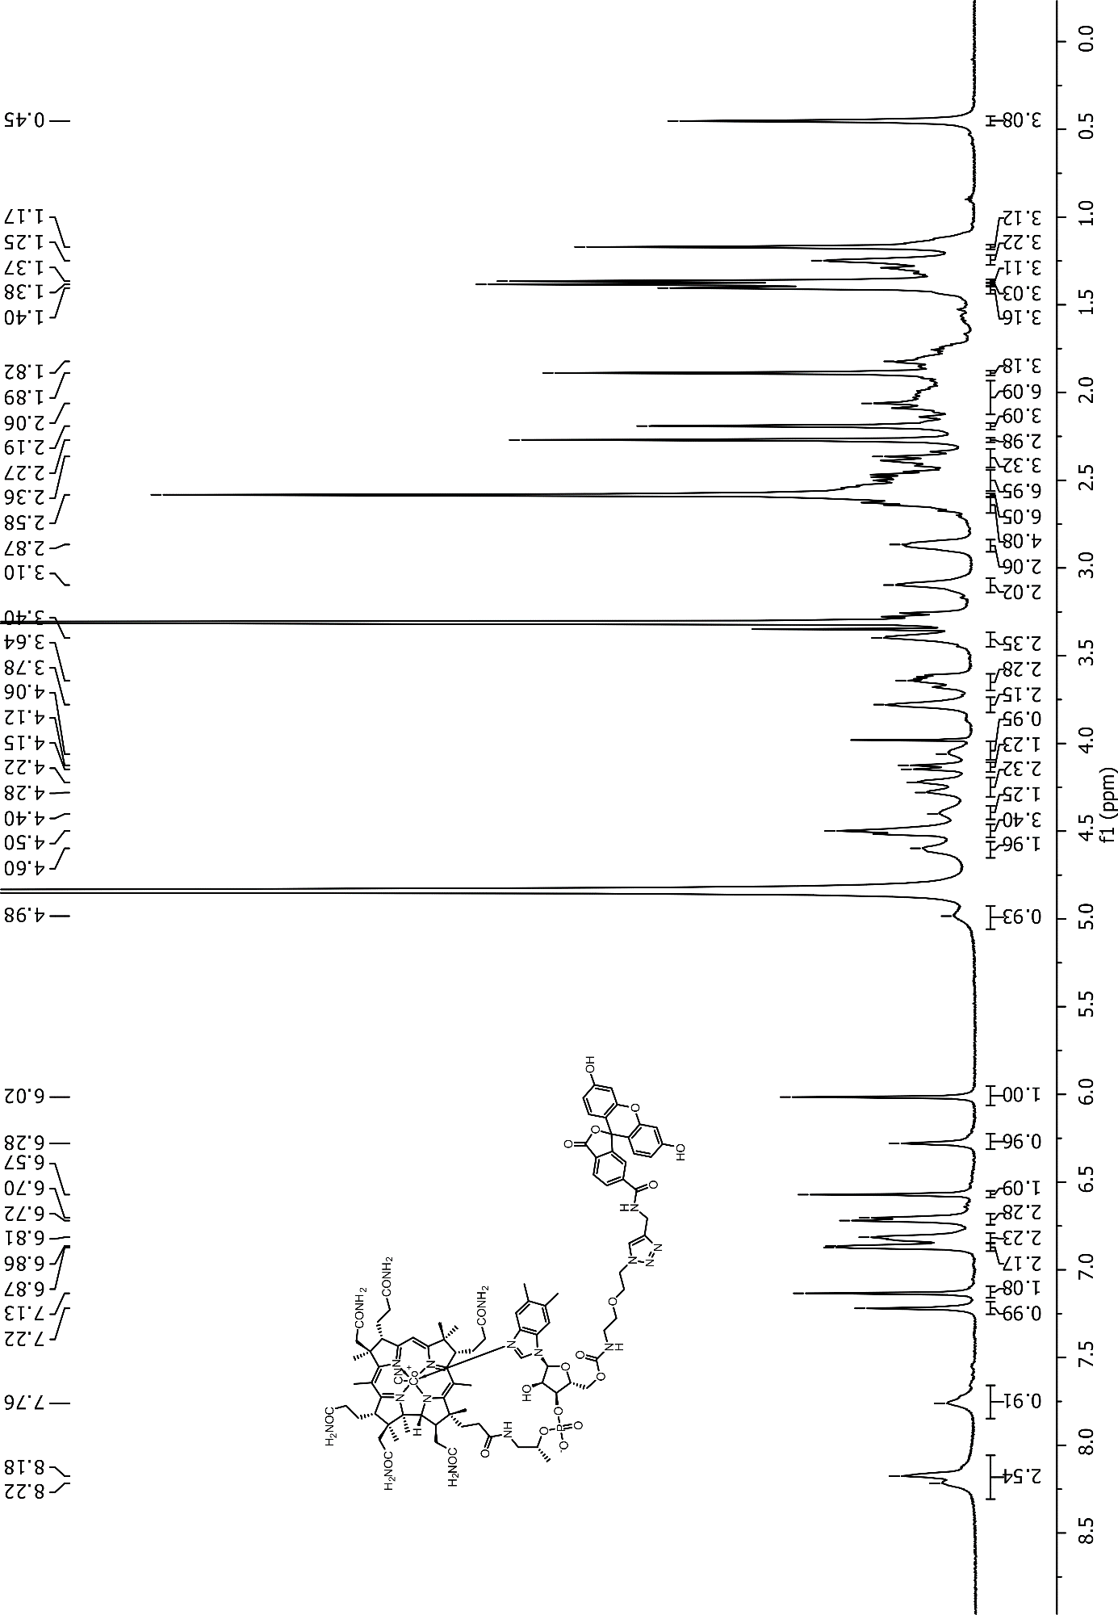
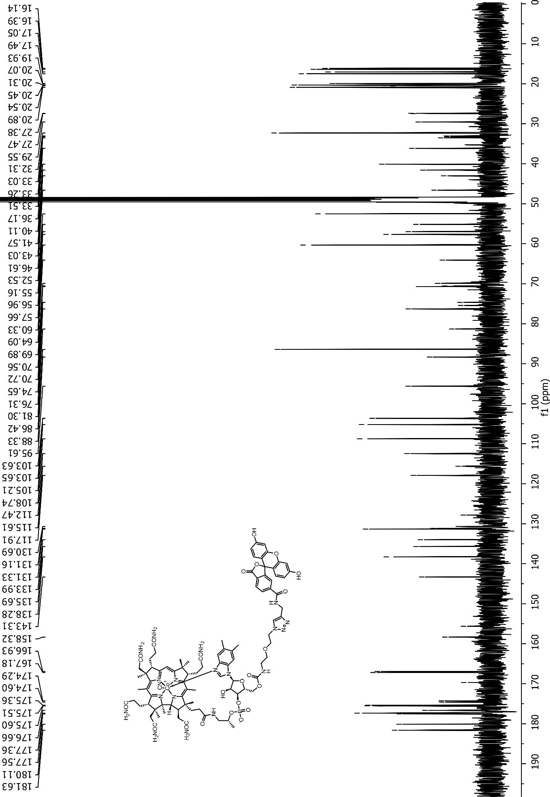

NMR spectra of Cbl-2xPEG-FAM (14) recorded for CD₃OD
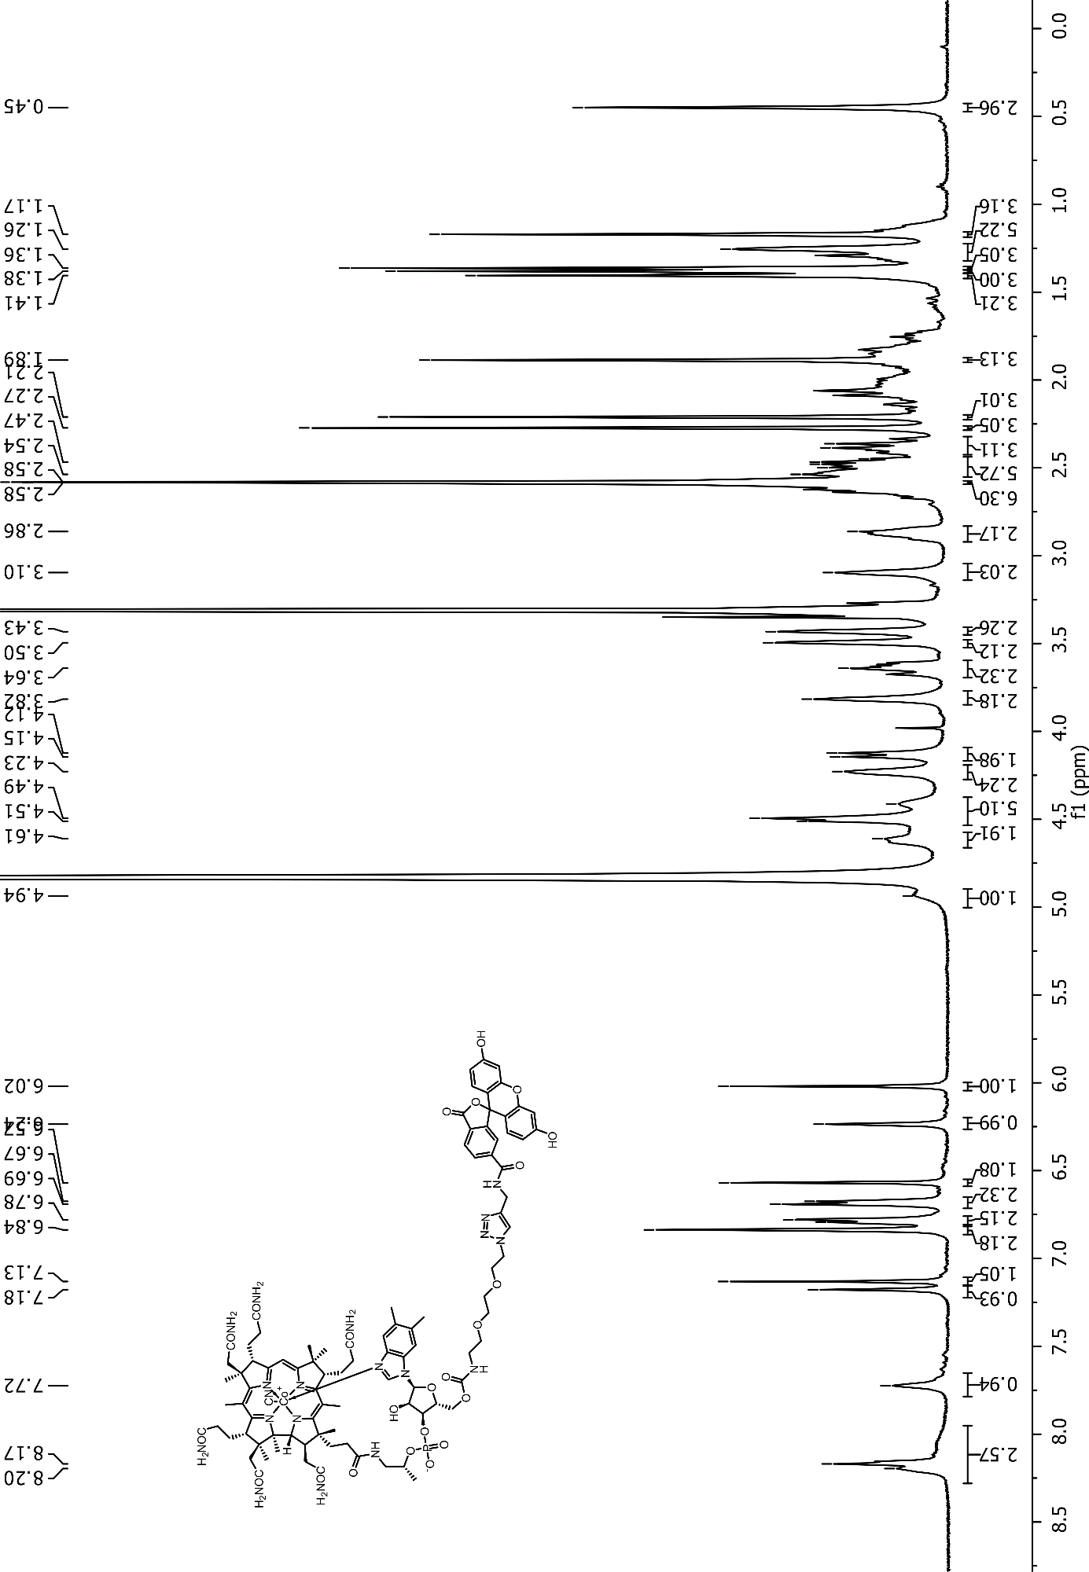
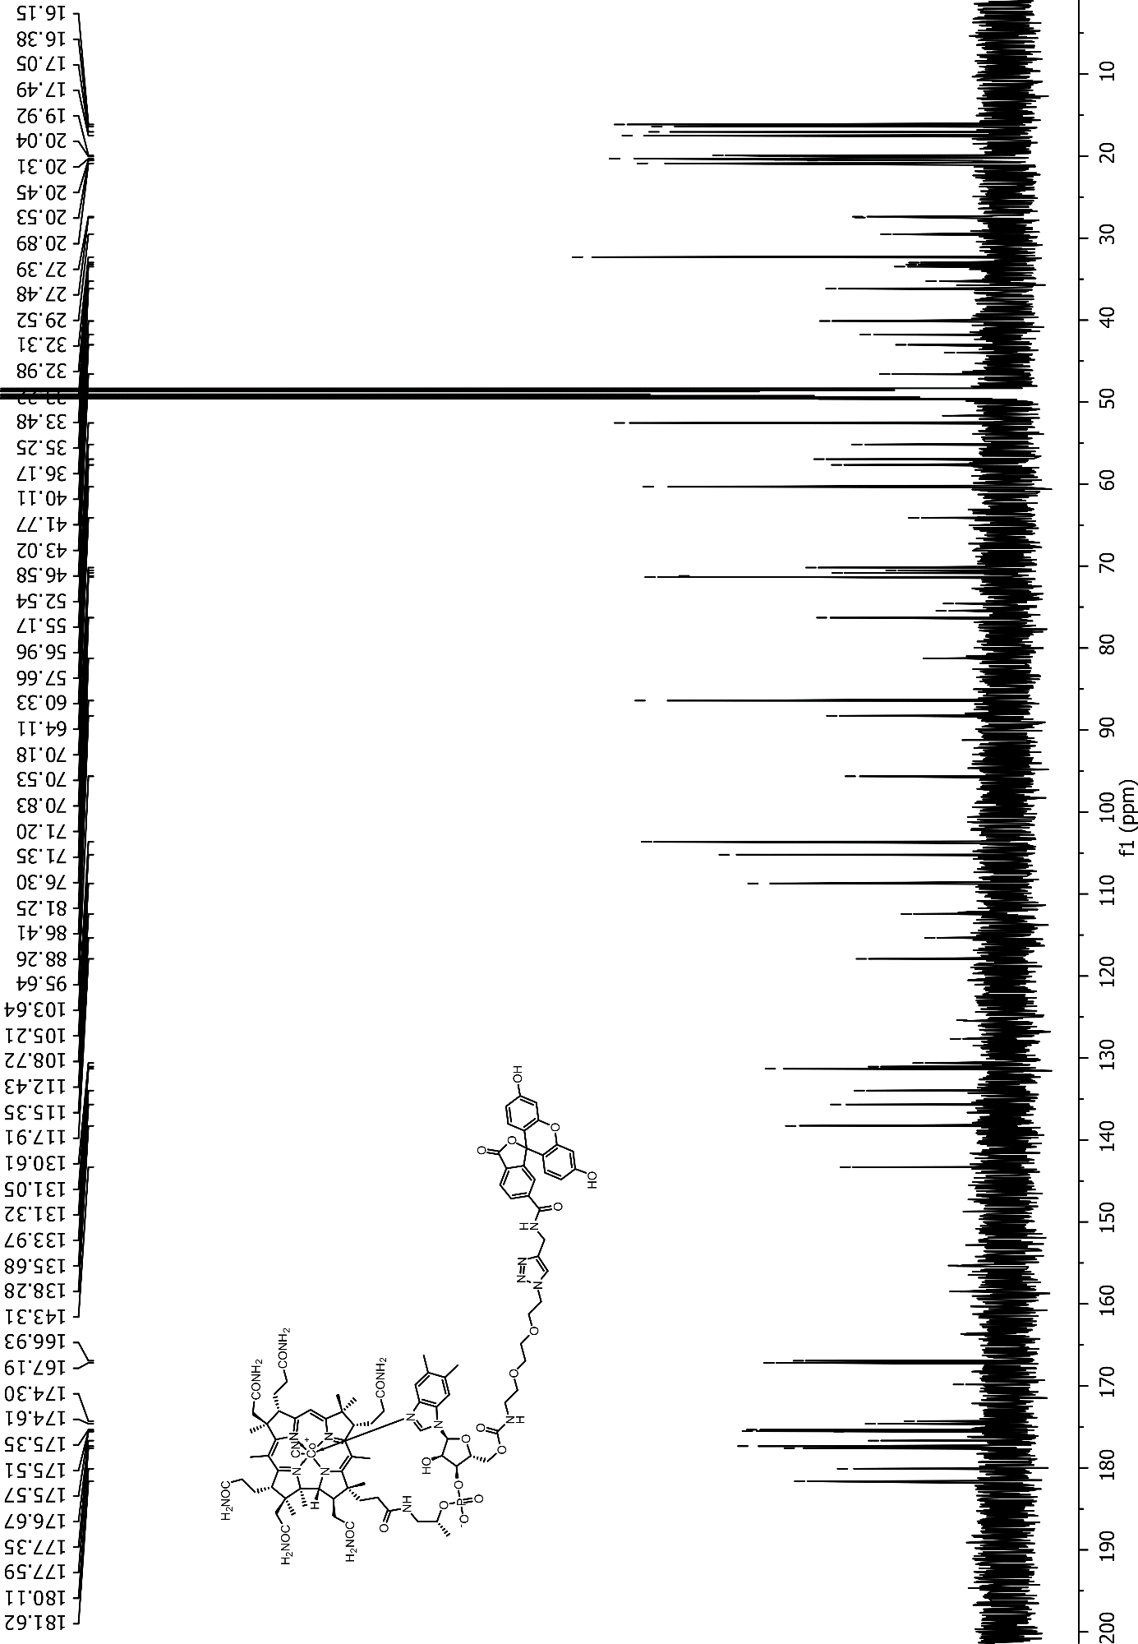

NMR spectra of Cbl-3xPEG-FAM (10) recorded for CD₃OD
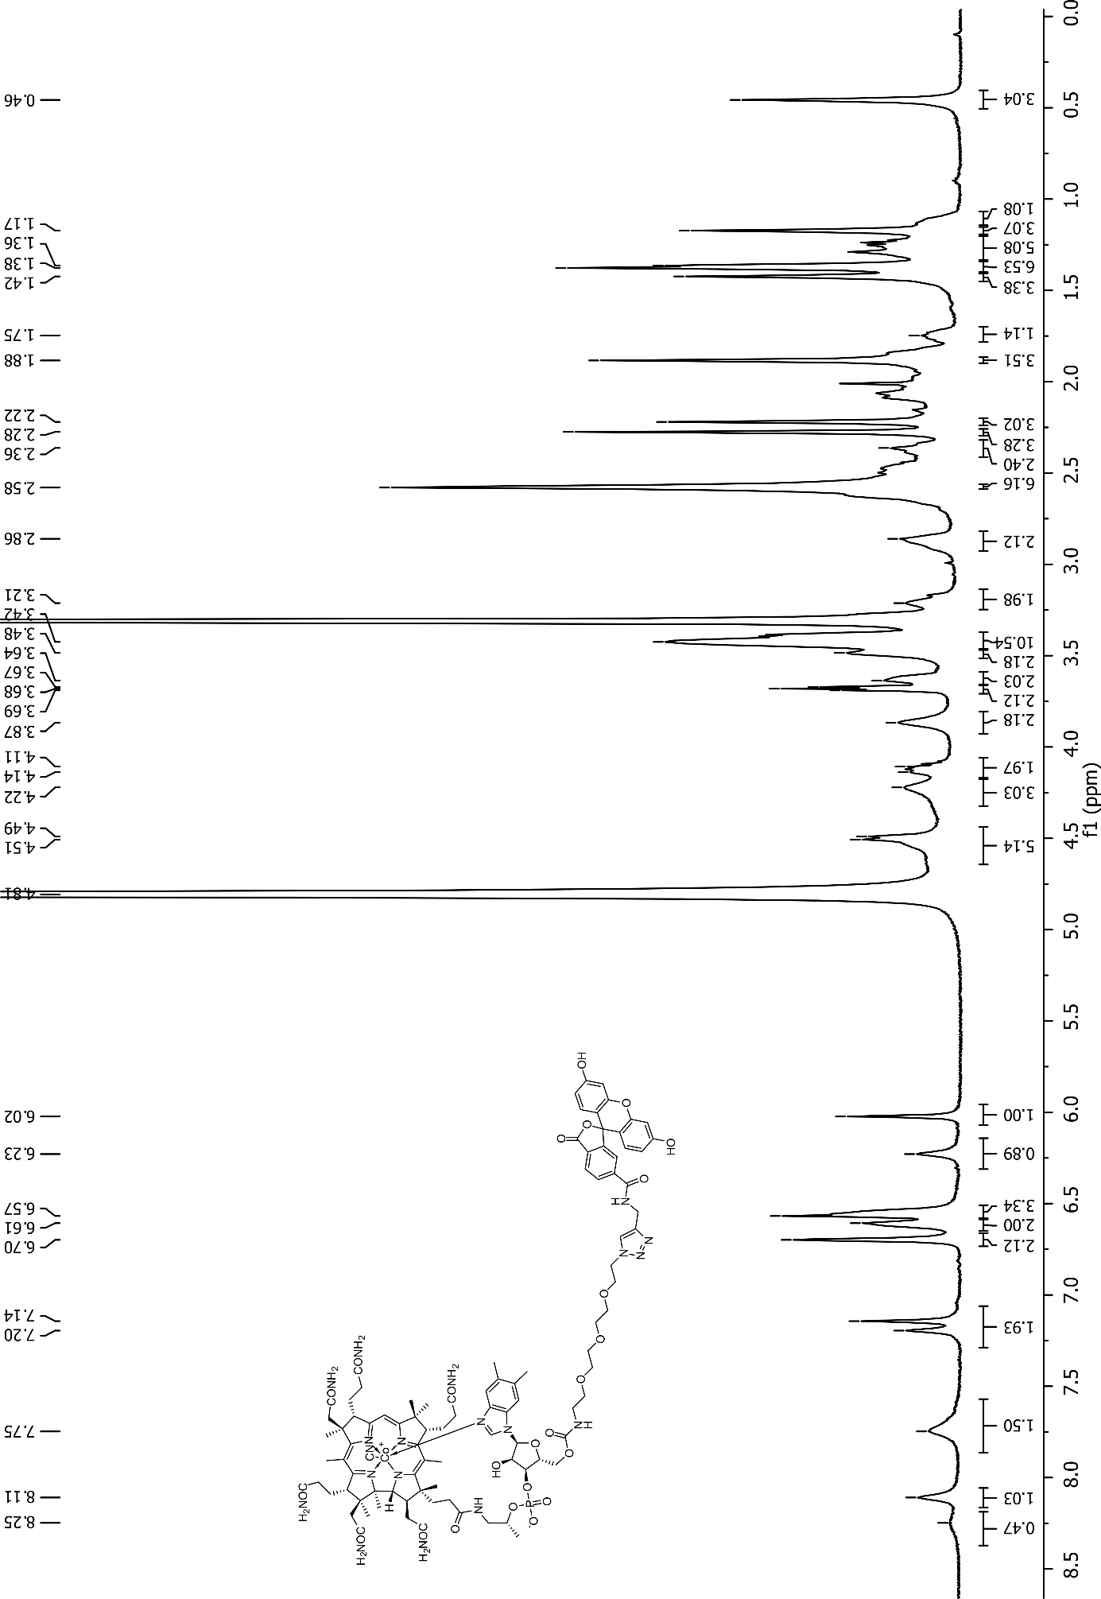
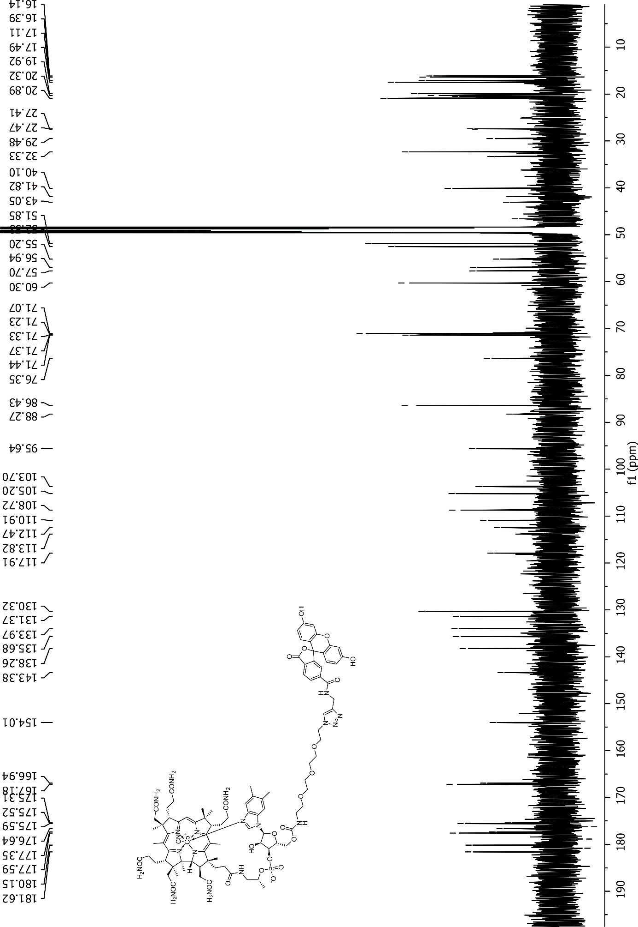

MS spectra

MS spectrum of Cbl-ATTO 633 (15)

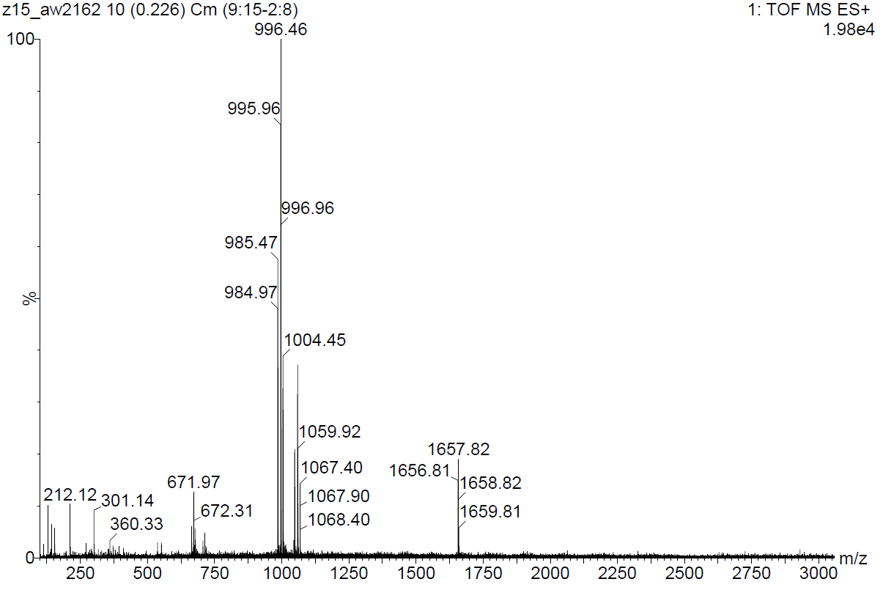
[M+Na+H]²⁺

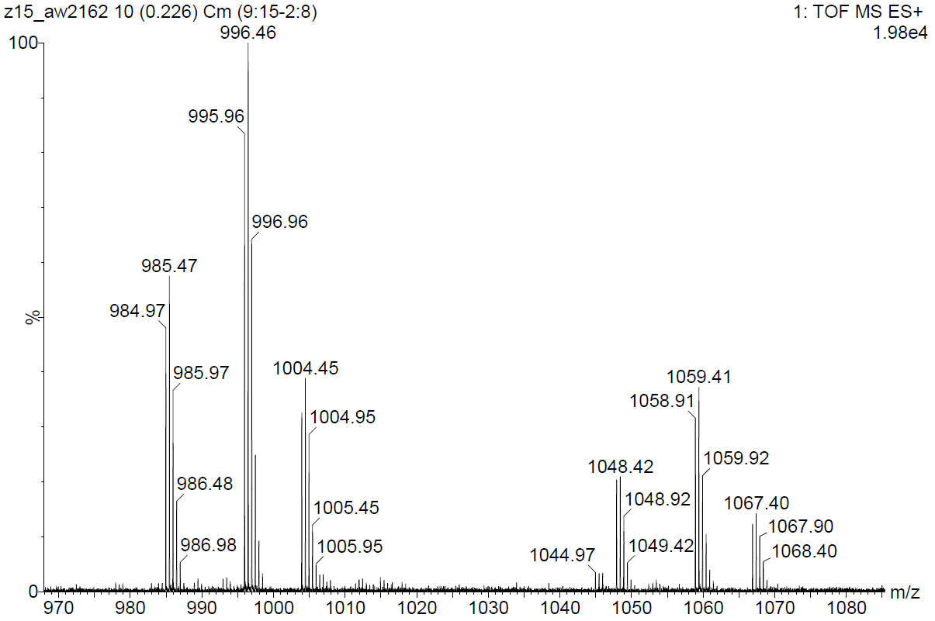
[M+K+H]²⁺
[M+Na+H]²⁺
[M+2H]²⁺

MS spectrum of Cbl-C6-ATTO 633 (5)

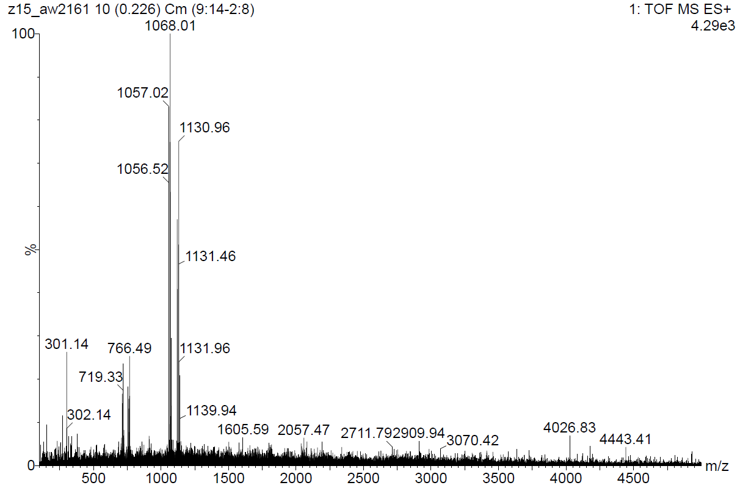
[M+Na+H]²⁺
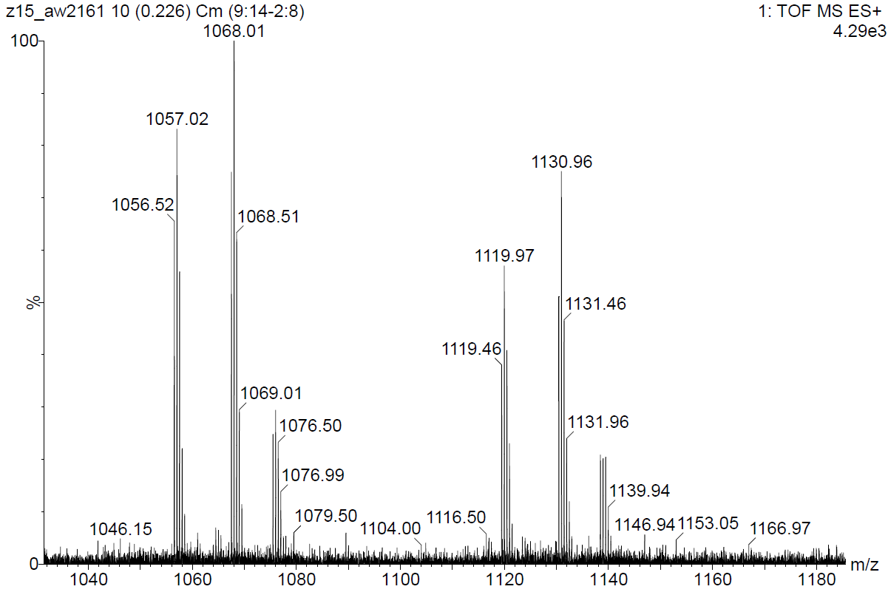
[M+K+H]²⁺
[M+Na+H]²⁺
[M+2H]²⁺

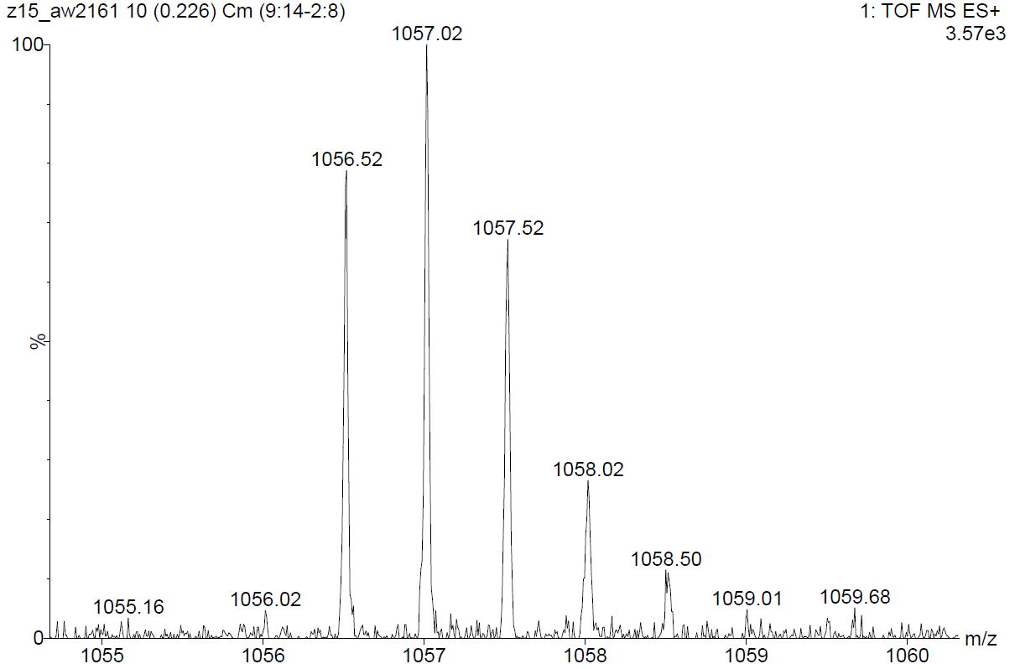
[M+2H]²⁺

