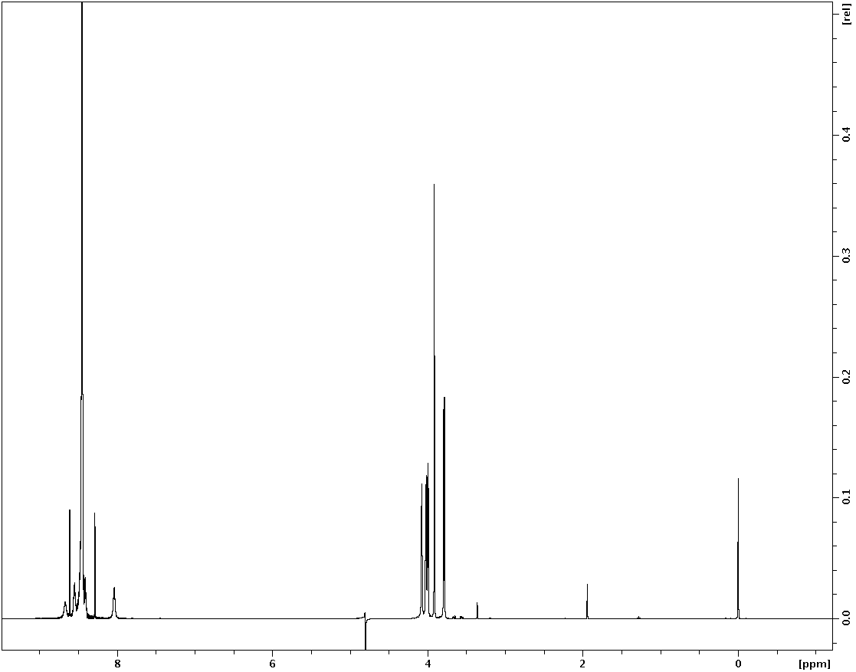
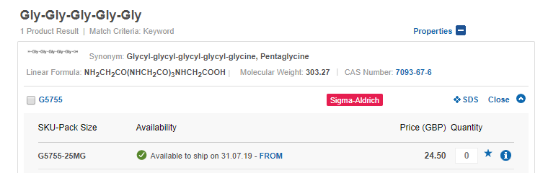
¹H-NMR
G5

TSP

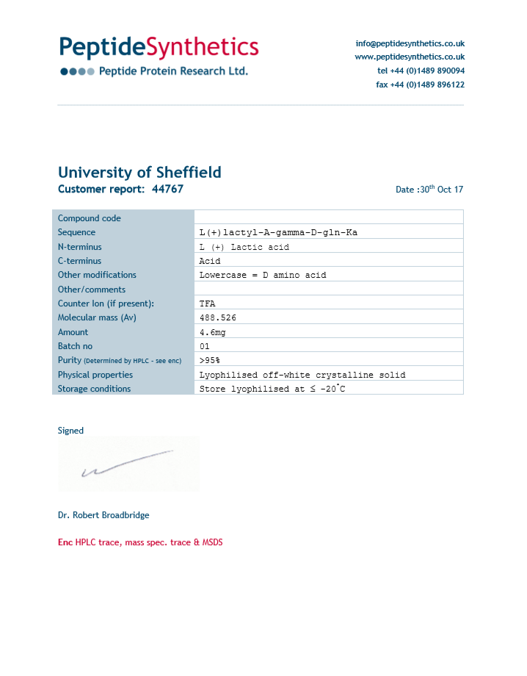
P4

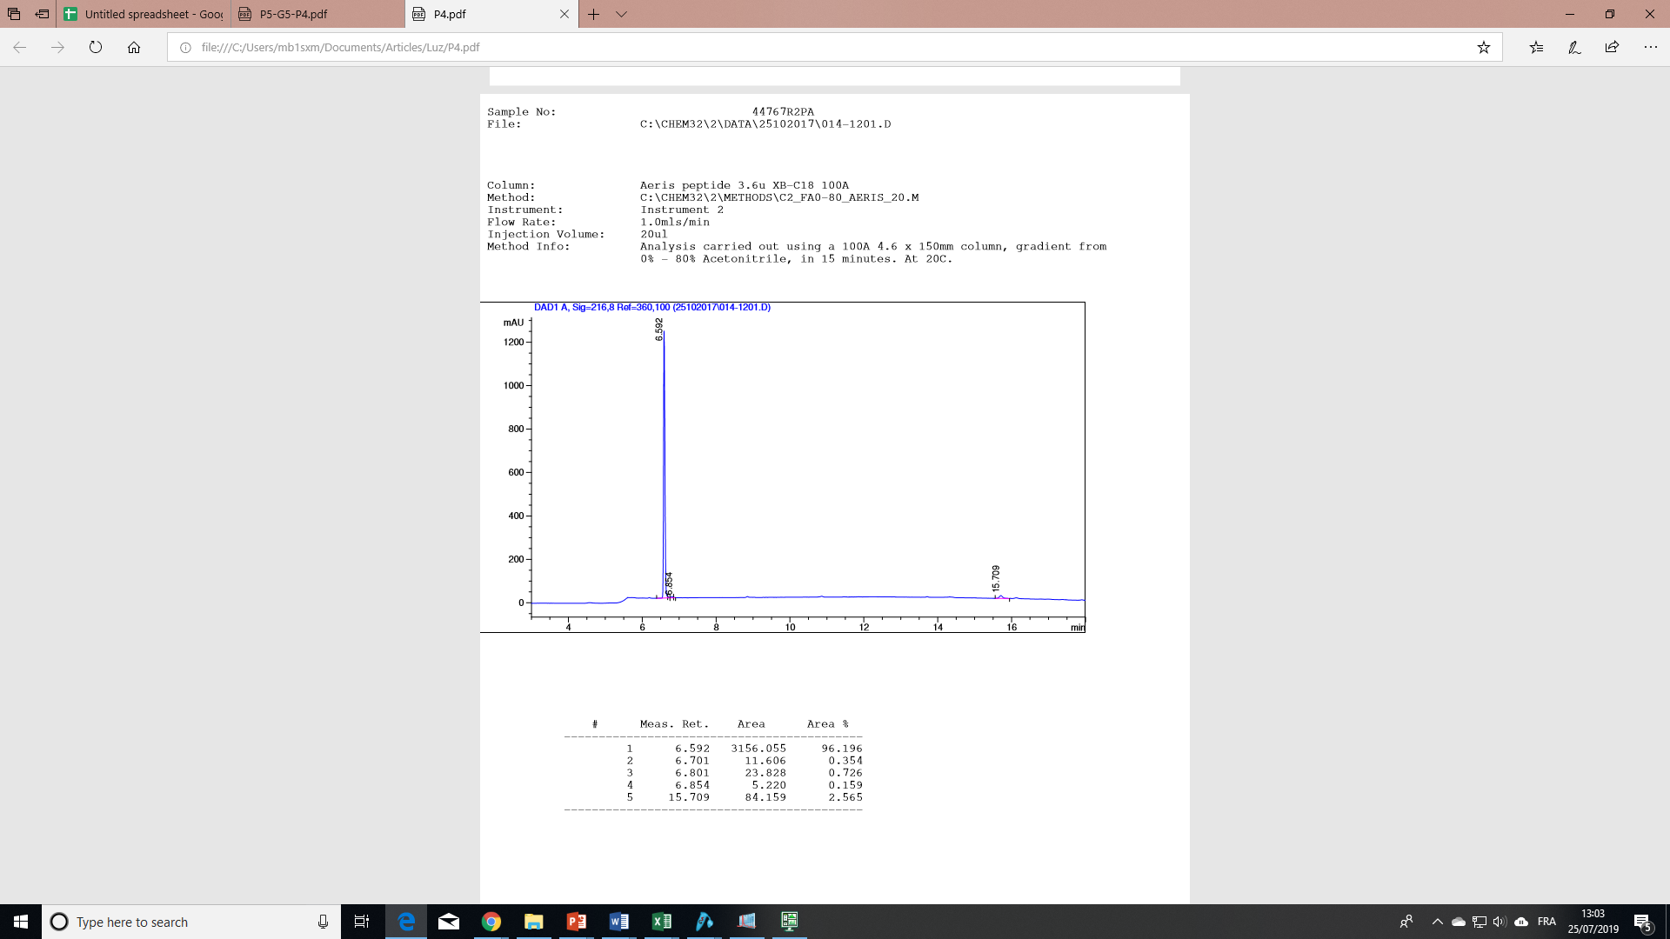
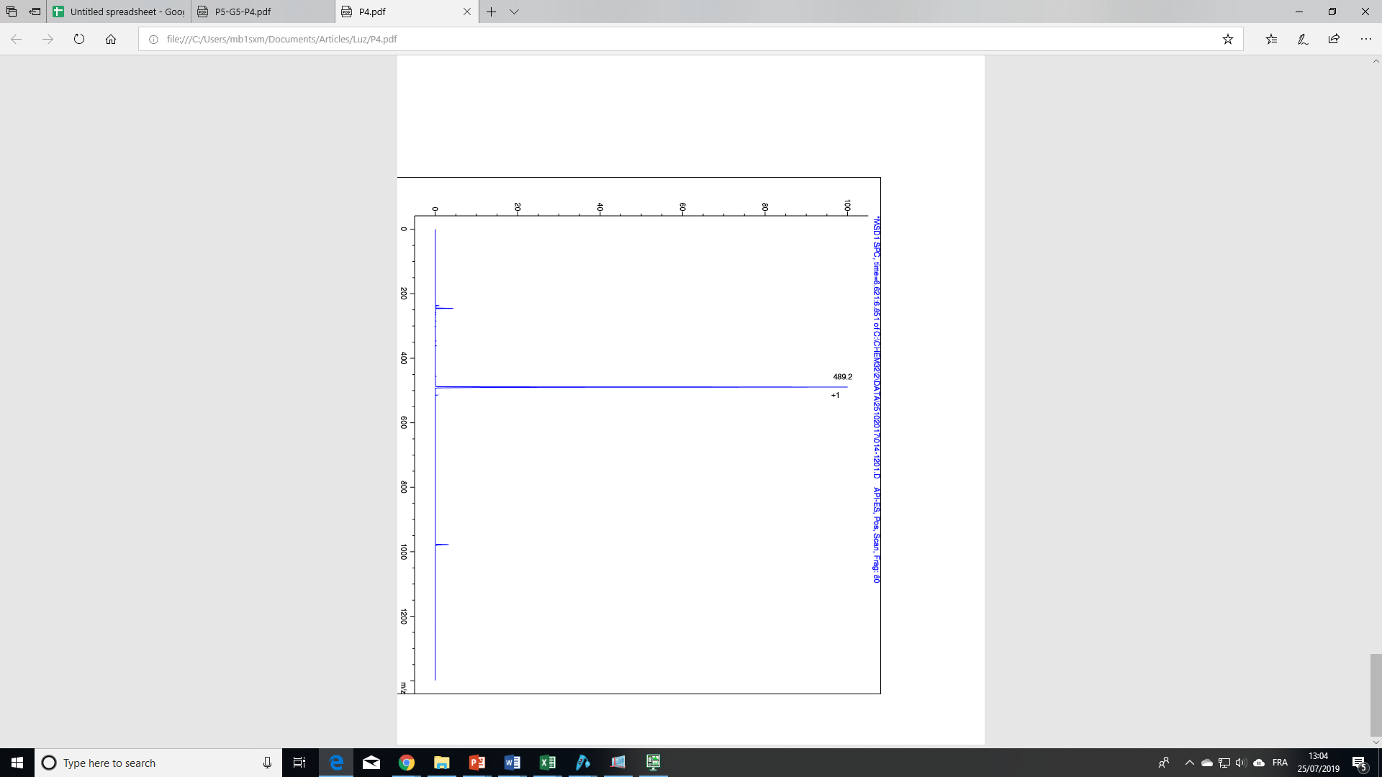

^{TIC}
^{HPLC}

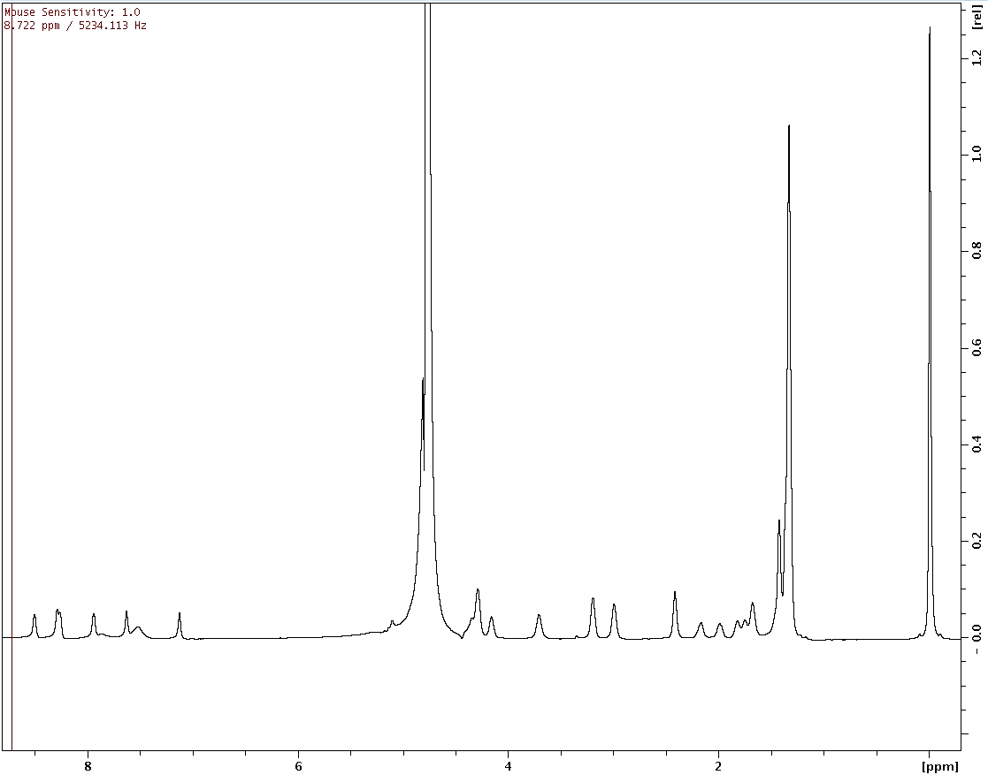
TSP

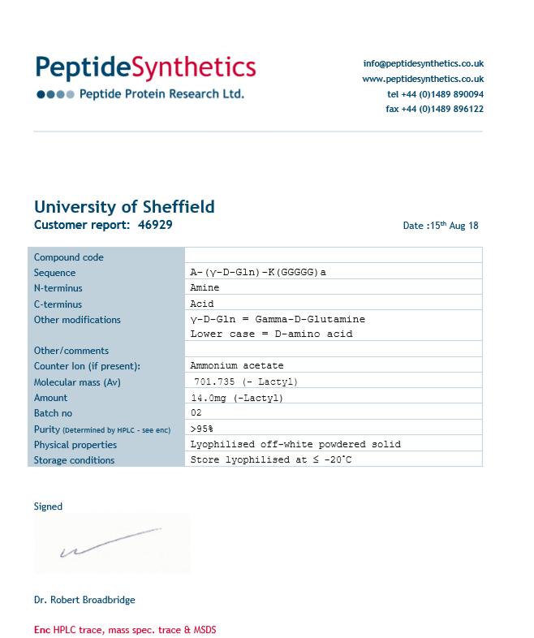
P4-G5

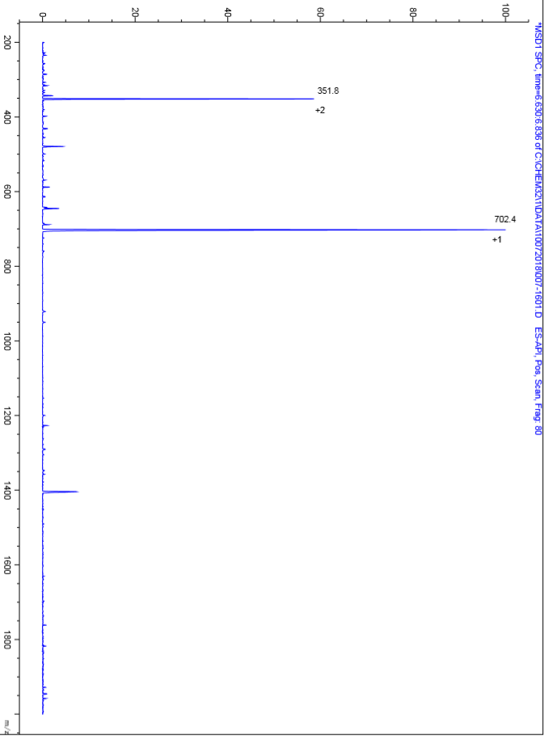
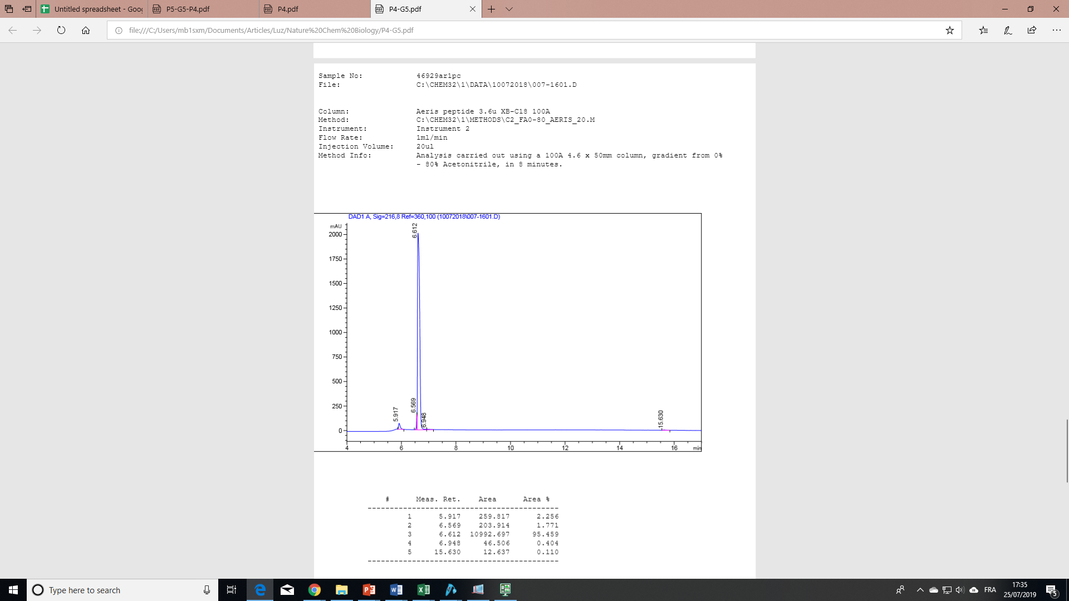
^{HPLC}
^{TIC}

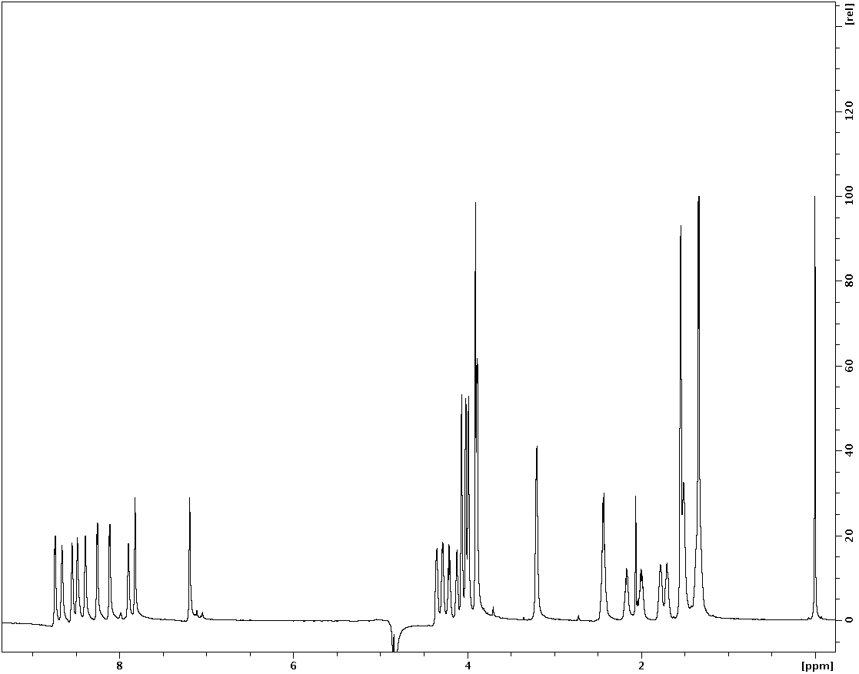
¹H-NMR

TSP

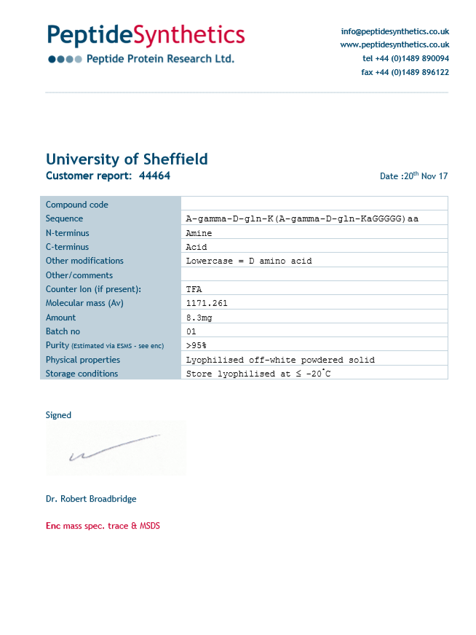
P4-G5-P4

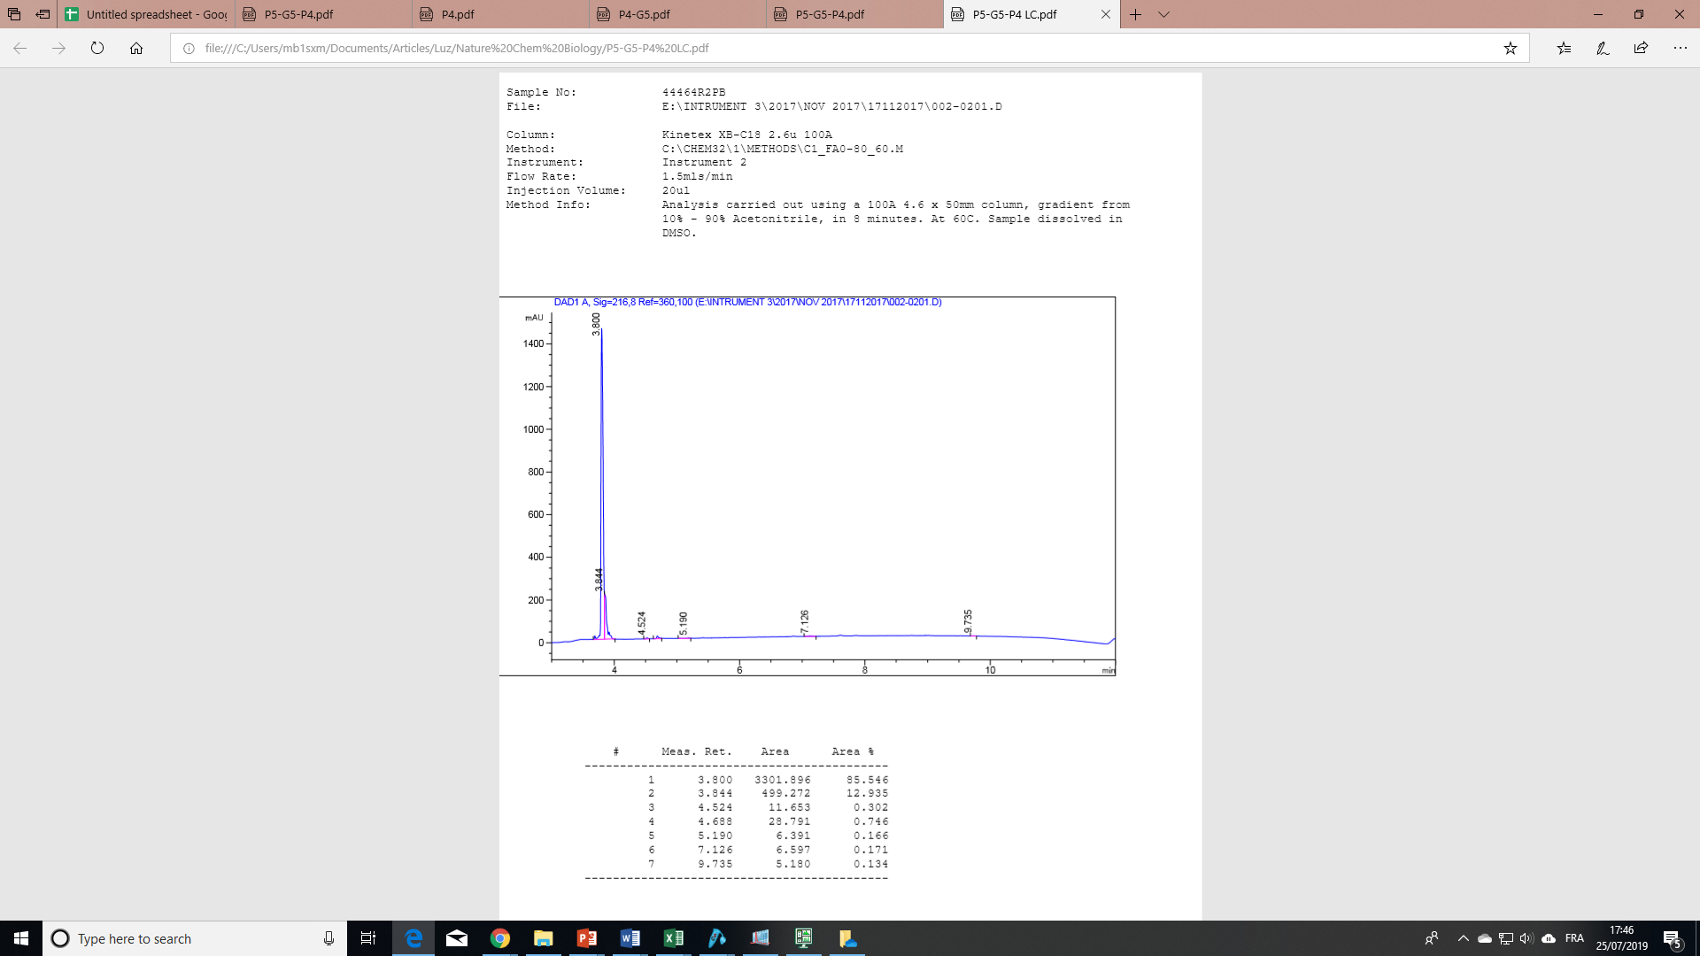
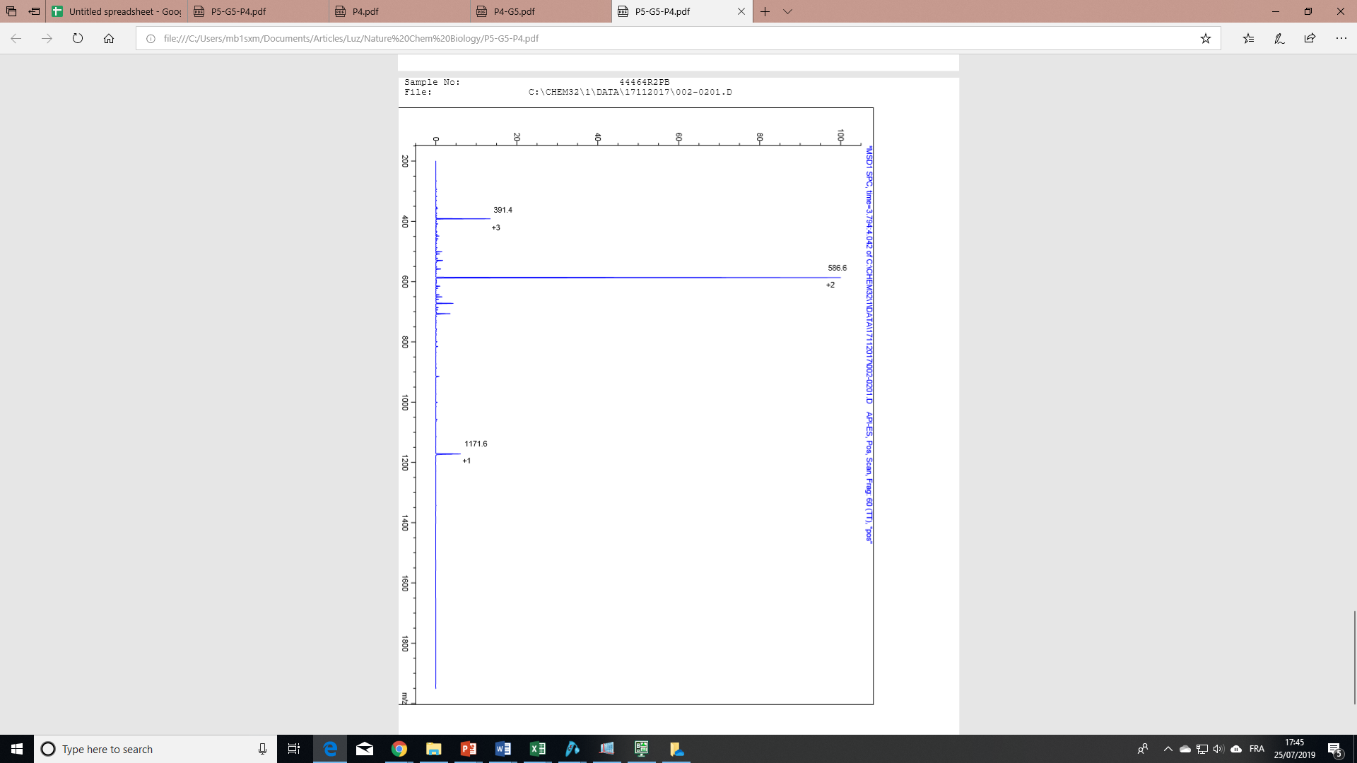
^{TIC}
^{HPLC}
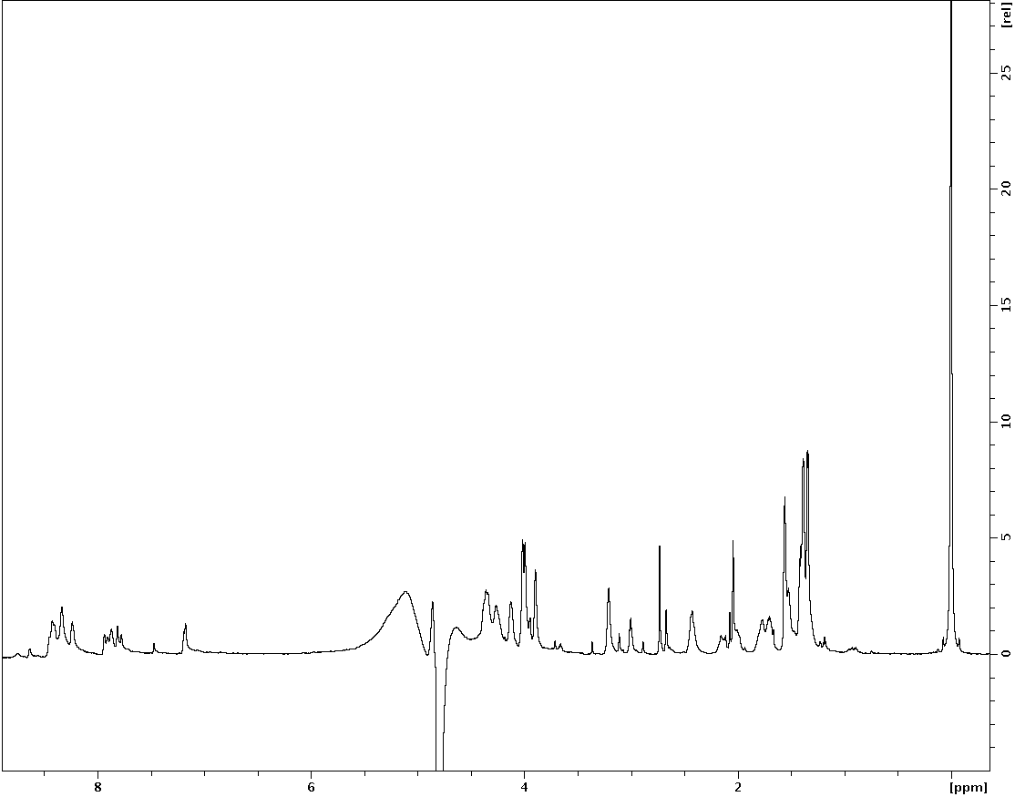
TSP
¹H-NMR


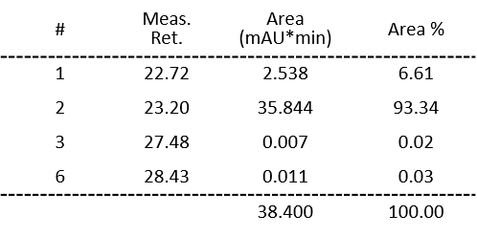
Column: Hypersil GoldaQ C18 column (1.9µm, 2.1 x 200mm).
Flow Rate: 0.300ml/min
Injection Volume: 40ul
Method Info: Analysis carried out using a 1.9µm, 2.1 x 200mm column, gradient from 0% - 80% Acetonitrile, in 39 minutes. At 60°C.
GM-P5-G5-GM-P4-G5
GM-P5-G5-GM-P4-G5
(20416.0613 Da)
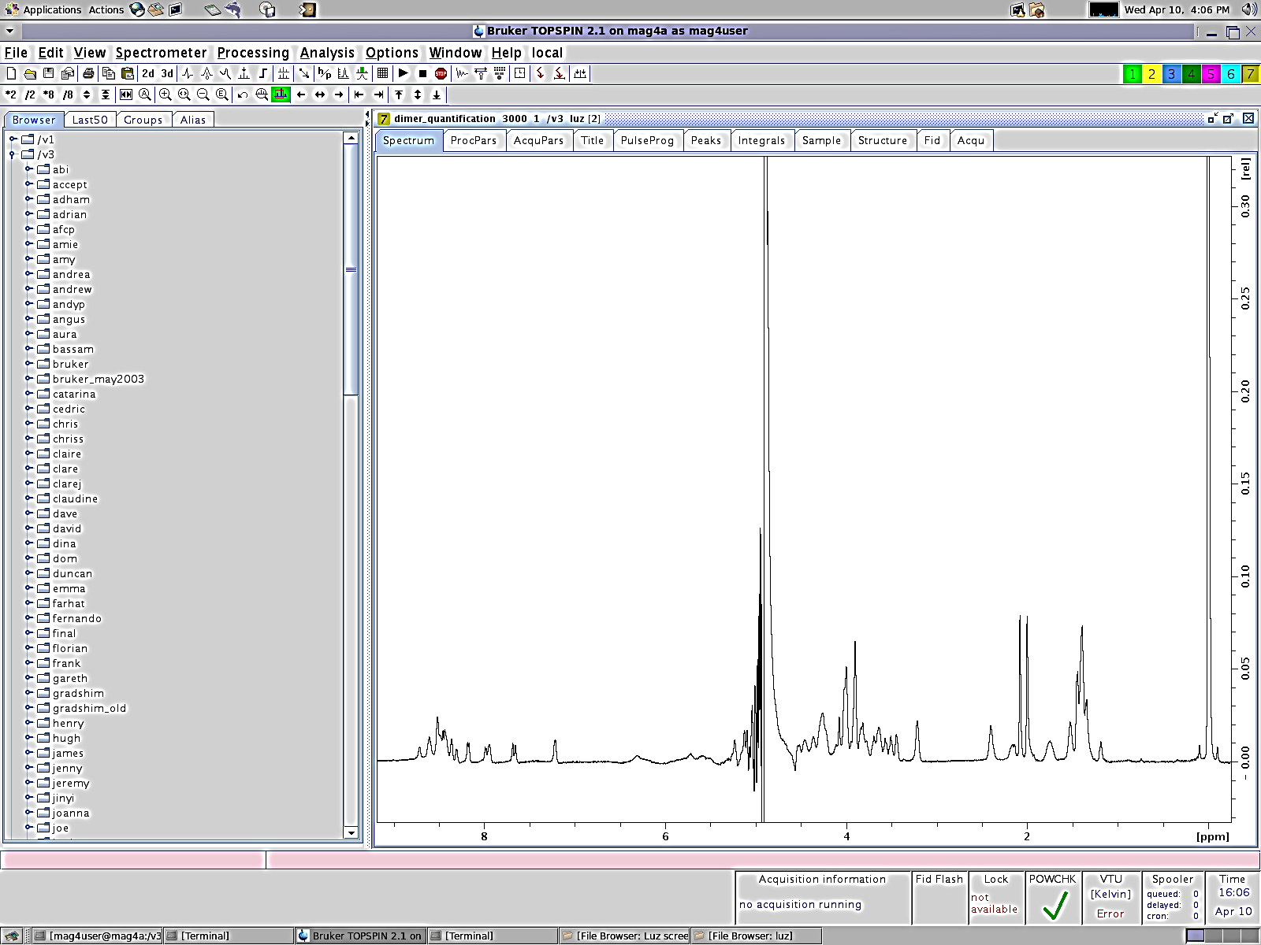
[M+3H]³⁺
[M+2H]²⁺
TIC
[M-GlcNAc+2H]²⁺
¹H-NMR
TSP
H₂O
[M+H]⁺
GMGM
(1016.4173 Da)
TIC
1
3
2
-O-Allyl
1
2
3
-O-Allyl
-O-Allyl
-O-Allyl
[M+2H]²⁺
[M+H]⁺
-O-Allyl
-O-Allyl
-O-Allyl
-O-Allyl

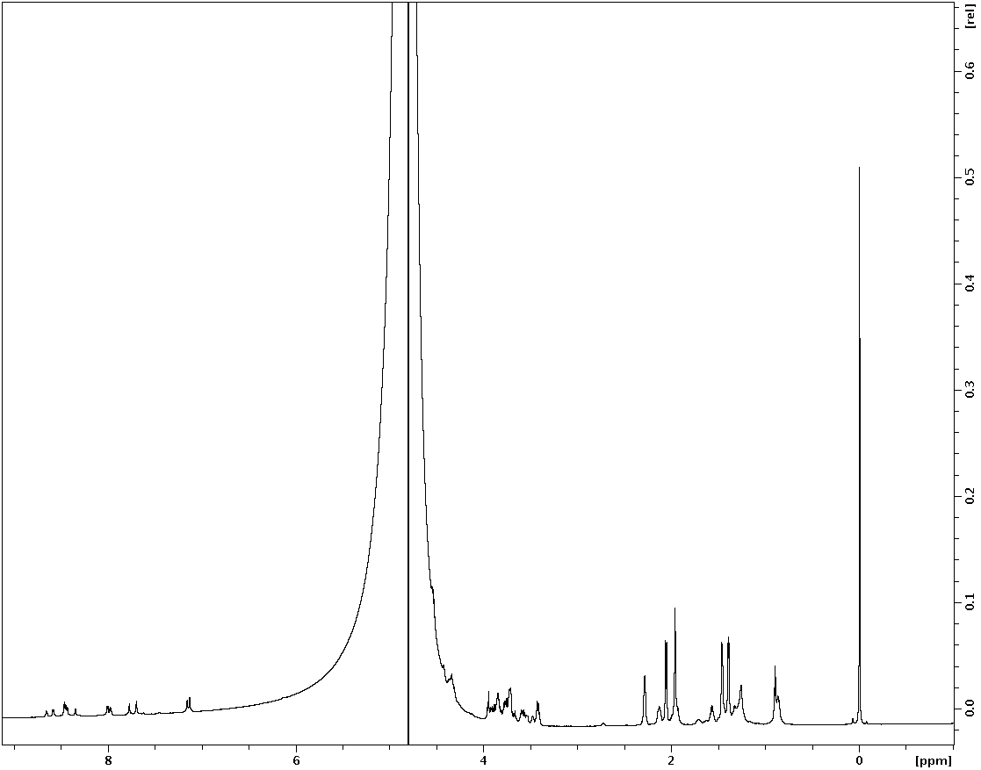
¹H-NMR
H₂O
TSP

