Supplemental Note – Synthetic Procedures
Chemical synthesis materials. Materials were obtained from commercial suppliers and used as received, or prepared according to standard procedures unless otherwise noted. L-Phenylalanine was purchased from Sigma Aldrich and was greater than 98% pure, D-phenylalanine was purchased from Sigma Aldrich as was 98% pure, methyl 2,4-dihydroxybenzoate was purchased from Sigma Aldrich and was 97% pure, 11 was purchased from Sigma Aldrich and was 90% pure. All reactions were conducted under an inert atmosphere of dry nitrogen. Analytical thin-layer chromatography (TLC) was performed on Kieselgel 60 F254 (250 μm silica gel) glass plates and compounds were visualized with ultraviolet light 254 nm. Flash column chromatography was performed using Kieselgel 60 (230‐400 mesh) silica gel with ethyl acetate/hexanes as eluent unless indicated otherwise. JTE-607 (1) is commercially available from several vendors and can be readily converted to compound 2 as described below.
General spectroscopic methods. ¹H NMR spectra were measured at 400 MHz on a Bruker Avance instrument and reported in parts per million (δ, ppm) and are referenced to the residual solvent peaks (7.26 ppm for CDCl₃, 2.50 ppm for DMSO-d6) or solvents with internal TMS (0 ppm) standard. Coupling constants (J values) were reported in Hertz (Hz), with multiplicity reported following usual convention: s = singlet, d = doublet, t = triplet, q = quartet; dd = doublet of doublets; m = multiplet; br = broad. ¹³C NMR spectra were completely hetero-decoupled and measured at 100 MHz. Residual solvent peaks (77.02 ppm for CDCl₃ and 39.52 ppm for DMSO-d6) were used as an internal reference. Preparative high-performance liquid chromatography was performed using Waters Autopurification system with PDA detector. All tested compounds were found to be >95% pure (unless stated otherwise) as determined by LC-UV/ESI-MS, recorded using an Acquity G2 Xevo OTof mass spectrometer (accuracy <5 ppm) with an electrospray ionization source and Acquity ultra performance liquid chromatograph (condition: Acquity UPLC BEH C18 1.7 μm 2.1 x 50 mm column, solvent A: water + 0.1% formic acid, solvent B: acetonitrile + 0.1% formic acid, gradient: from 2 to 98% B in 4.4 min, 1.0 ml/min flow rate, 50 °C). Chiral HPLC analyses were performed on Waters SFC Investigator System using supercritical fluid chromatography. Where indicated in the text, some purifications involved converting the salt of an amine-containing product to the corresponding free base using catch and release methodology utilizing strong cation exchange (SCX). Benzene sulfonic acid (BSA) silica based SCX cartridges were purchased from Agilent (Bond Elut SCX).
Preparation of compound 1
Preparation of 8: To a solution of methyl 2,4-dihydroxybenzoate (4.01 g, 23.13 mmol) in Et₂O (250 mL) at room temperature was added sulfuryl chloride (4.2 mL, 50.1 mmol). The mixture was heated under reflux for 4 hours and then stirred at room temperature overnight. Analysis of the reaction mixture indicated that the starting material had been consumed and a 9:1 ratio of di-chlorinated to mono-chlorinated product was observed by LC/MS. Additional sulfuryl chloride (2 mL, 24.60 mmol) was added and the reaction mixture was heated under reflux for 3 hours. After this time the reaction mixture was cooled to room temperature and then slowly quenched with water (100 mL) then extracted with Et₂O (200 mL). The combined organic layers were washed with brine (100 mL), dried over MgSO₄, filtered and concentrated to dryness. The resultant off-white solid was triturated with DCM/heptane then filtered and washed with heptane. The filtrate was concentrated to dryness and the resulting residue was triturated with DCM/heptane. The resulting mixture was filtered and the resulting solid was washed with heptanes to afford 8 as an off-white solid (5.30g, 89% yield); ¹H NMR (400 MHz, Chloroform-d) δ 11.48 (s, 1H), 7.80 (s, 1H), 6.33 (s, 1H), 3.96 (s, 3H); m/z (EI) 235.0 (M-H). LC-UV/ESI-MS retention time: 1.12 min.
Preparation of 9: To a solution of 8 (5.30 g, 20.57 mmol) in THF (160 mL) at room temperature was added triphenylphosphine (7.64 g, 29.1 mmol). A solution of diisopropylazodicarboxylate (DIAD, 4.53 mL, 23.39 mmol) in THF (40 mL) was then added dropwise via addition funnel (approximately 1 drop / 3 seconds). The reaction mixture was stirred at room temperature overnight prior to addition of NaOH (100 mL, 10 mmol) and heating at 85 ºC for 2.5 hours. After this time the reaction mixture was cooled to room temperature and then acidified to approximately pH 2 using concentrated HCl acid. The resultant brown solution was absorbed onto a water conditioned SCX column (70g). The column was washed with THF (400 mL) then eluted with 2N NH₃/MeOH (350 mL). The basic solution was concentrated in vacuo to give a brown oil. The oil was triturated with MeOH /Et₂O (1:2) and the mixture was filtered, washing with Et₂O and then dried under high vacuum. The resultant brown solid 9 (3.87 g, 57 % yield), was used in the next step without further purification; ¹H NMR (400 MHz, DMSO-d6) δ 9.38 (br. s., 1H), 7.58 (s, 1H), 4.06 (t, J = 5.3 Hz, 2H), 3.32 (br. s., 3H), 2.94-3.27 (m, 4H), 2.86 (br. s., 3H), 2.73 (br. s., 4H); m/z (EI) 349.0 (M+H). LC-UV/ESI-MS retention time: 0.66 min.
Preparation of 10:
HCl gas was bubbled through a suspension of L-phenylalanine (10.5 g, 63.6 mmol) in EtOH (120 mL) until the suspension became homogeneous (approximately 3 minutes). The resultant solution was then heated under reflux overnight. The reaction mixture was then cooled to room temperature prior to careful addition of thionyl chloride (2.5 mL, 34.3 mmol). The mixture was then heated at 100 ºC for an additional 3 hours and then cooled to room temperature prior to concentrating in vacuo. The resultant solid was triturated with Et₂O then filtered, washed with Et₂O and dried to give 10 as a white fluffy solid (12.7 g, 87%, HCl salt) which was used in the next step without further purification; ¹H NMR (400 MHz, DMSO-d6) δ 8.41-8.75 (m, 3H), 7.27-7.38 (m, 3H), 7.19-7.27 (m, 2H), 4.20-4.30 (m, 1H), 4.02-4.16 (m, 2H), 3.17 (br. s., 1H), 2.99-3.11 (m, 1H), 1.09 (td, J = 7.1, 2.0 Hz, 3H); m/z (EI) 194.1 (M+H). LC-UV/ESI-MS retention time: 0.75 min.
Compound 1: To a suspension of 9 (3.87g, 11.08 mmol) in DCM (200 mL) at room temperature was added triethylamine (2.2 mL, 15.87 mmol) followed by pyridine (5 mL, 61.8 mmol). The reaction mixture was stirred at room temperature for 5 minutes prior to addition of HBTU (5.46 g, 14.41 mmol). After an additional 5 minutes 10 (3.6 g, 15.67 mmol) was added in a single portion. The reaction mixture was then stirred at room temperature overnight, after which time LC/MS analysis indicated approximately 85% conversion. Additional Et₃N (4 mL, 28.9 mmol) and HBTU (0.8 g, 2.109 mmol) were added and the reaction mixture was stirred at room temperature for an additional 1 hour. After this time the reaction mixture was diluted with DCM (100 mL) then washed with brine (120 mL). The organic layer was then washed with saturated aqueous NaHCO₃ solution (120 mL), dried over MgSO₄, filtered and concentrated in vacuo to affording an orange oil. The oil was dissolved in DCM and purified by flash column chromatography eluting with EtOH/DCM (1:1) then 100% EtOH, to give a yellow amorphous solid. The solid was triturated with EtOH (ca. 50 mL) and the resulting suspension was sonicated for 1 minute. The suspension was filtered, washed with cold EtOH and the resultant white solid was dried under vacuum to give the free base of Compound 1 (2.65 g, 46% yield); ¹H NMR (400 MHz, DMSO-d₆) δ 11.57 (br. s., 1H), 10.17-10.84 (m, 1H), 7.67 (s, 1H), 7.16-7.32 (m, 5H), 4.68 (q, J = 7.0 Hz, 1H), 3.97-4.09 (m, 4H), 2.88-3.13 (m, 6H), 2.82 (t, J = 5.3 Hz, 3H), 2.73 (br. s., 2H), 2.59 (s, 3H), 1.10 (t, J = 7.2 Hz, 3H). ¹³C NMR (100 MHz, DMSO-d6) δ 171.77, 166.70, 164.36, 153.46, 137.23, 129.14, 128.30, 127.22, 126.57, 118.78, 114.81, 70.10, 60.43, 56.37, 53.75, 53.14, 50.54, 43.18, 37.50, 14.04; m/z (EI) 524.4 (M+H). LC-UV/ESI-MS retention time: 1.11 min. This material was converted to the corresponding hydrochloride salt by the following procedure: HCl gas was bubbled through a solution of the free base of Compound 1 (4.75g, 9.06 mmol) in dry dioxane (150 mL) for 5 minutes. The resulting suspension was stirred at room temperature for 1 hour before concentrating to dryness. The residue was triturated with DCM then concentrated to dryness. The solid was collected and washed with Et₂O several times. The resulting white solid was dried under high vacuum to give Compound 1 as the hydrochloride salt (5.20 g, 95% yield, 99% e.e.); ¹H NMR (400 MHz, DMSO-d₆) δ 13.43 (br. s., 1H), 11.33-12.30 (m, 1H), 9.55 (d, J = 7.3 Hz, 1H), 8.28 (s, 1H), 7.25-7.35 (m, 4H), 7.16-7.24 (m, 1H), 4.68-4.79 (m, 1H), 4.45 (br. s., 2H), 4.11 (q, J = 7.2 Hz, 2H), 3.61-3.87 (m, 5H), 3.30-3.54 (m, 4H), 3.10-3.26 (m, 2H), 2.83 (br. s., 3H), 1.13 (t, J = 7.0 Hz, 3H); ¹³C NMR (101 MHz, DMSO-d6) δ 170.79, 168.11, 157.27, 154.31, 137.12, 129.08, 128.39, 126.71, 126.66, 117.25, 116.91, 111.92, 66.38, 61.03, 54.25, 50.12, 48.84, 35.94; HRMS (m/z) [M+H]⁺ calcd. for C₂₅H₃₂Cl₂N₃O₅, 524.1719; found, 524.1704; m/z (EI) 524.1 (M+H). LC-UV/ESI-MS retention time: 1.01 min. Chiral HPLC analysis (column: Phenomenex Lux Cellulose-2 4.6x100mm 5µm + Phenomenex Lux Cellulose-2 4.6x100mm 5µm in series. Eluent: 45% MeOH with 10 mM ammonium hydroxide in CO₂ at 3 mL/min at 210 nm): Enantiopurity of Compound 1: >99% e.e. (t_{R} 4.36 min); Racemic sample for comparison: t_{R} = 3.68 min and 4.38 min.
Preparation of Compound 2
To a stirred solution of Compound 1 (68.5 mg, 0.12 mmol) in EtOH (1 mL) at room temperature was added 1N NaOH (1.2 mL, 1.2 mmol). The reaction mixture was then stirred at room temperature for 1 hour prior to the addition of 1N HCl to adjust the solution to approximately pH 2. The resulting solution was absorbed onto a water conditioned SCX (5g) column. The column was washed several times with water then eluted with 2N NH₃/MeOH (60 mL). The ammonia solution was concentrated to dryness affording a colorless oily film. The film was then triturated with Et₂O and concentrated to dryness affording Compound 2 as an off-white solid (56 mg, 94% yield); ¹H NMR (400 MHz, DMSO-d₆) δ 10.99-11.60 (m, 1H), 7.70 (s, 1H), 7.23-7.29 (m, 4H), 7.16-7.22 (m, 1H), 4.63 (br. s., 1H), 4.02 (t, J = 5.5 Hz, 2H), 3.10-3.18 (m, 2H), 2.87-3.02 (m, 5H), 2.64-2.86 (m, 6H), 2.54 (s, 3H); ¹³C NMR (101 MHz, DMSO-d₆) δ 173.21, 166.89, 153.53, 137.83, 129.14, 128.26, 127.10, 126.42, 118.60, 114.66, 70.15, 56.44, 53.79, 53.17, 50.64, 43.28, 37.27; HRMS (m/z): [M+H] calcd. for C₂₃H₂₈Cl₂N₃O₅, 496.1406; found, 496.1355; m/z (ESI) 496.0 (M+H). LC-UV/ESI-MS retention time: 0.86 min. Chiral HPLC analysis (column: Diacel IC 4.6 X 100mm 5 µM. Eluent: 5-55% EtOH:DCM (7:3) with 10 mM ammonium hydroxide in CO₂ at 5 mL/min at 315 nm). Enantiopurity: 99% e.e (t_{R}= 3.80 min).

Preparation of 16 and 17:
Preparation of 12: To a solution of 8 (1.08 g, 4.56 mmol), 11 (1.18 g, 4.86 mmol) and triphenylphosphine (1.44 g, 5.49 mmol) in THF (30 mL) at room temperature was added diisopropylazodicarboxylate (DIAD, 0.97 mL, 5.01 mmol) in THF (10 mL) via addition funnel (approximately 1drop / 5 seconds). After complete addition, the reaction mixture was stirred at room temperature for 10 minutes and then concentrated to dryness. The resultant residue was then purified by flash column chromatography eluting with 0-5% EtOAc/heptane to give 12 as a colorless oil (1.97 g, 89 % yield); m/z (EI) 437.4 (M+H). LC-UV/ESI-MS retention time: 1.54 min. The material was used in the next step without further purification.
Preparation of 13: To a solution of triphenylphosphine (3.1 g, 11.82 mmol) in DCM (20 mL) at 0 ºC was slowly added bromine (0.61 ml, 11.81 mmol) and the resultant solution stirred at this temperature for 5 minutes before stirring at room temperature for 10 minutes, then addition of a solution of 12 (1.1g, 2.26 mmol) in DCM (10 mL) and stirring at room temperature for 2 hours. The reaction mixture was filtered through Celite, washed with DCM and the filtrate concentrated to dryness to give an orange residue. The residue was purified by flash column chromatography eluting with 1-10% EtOAc/heptane to give 13 as a white solid (935 mg, 95% yield); ¹H NMR (400 MHz, Chloroform-d) δ 11.37 (s, 1H), 7.83 (s, 1H), 4.11 (t, J = 6.3 Hz, 2H), 3.98 (s, 3H), 3.47 (t, J = 6.8 Hz, 2H), 1.95-2.03 (m, 2H), 1.86-1.95 (m, 2H), 1.69-1.77 (m, 2H); m/z (EI) 385.0 (M+H). LC-UV/ESI-MS retention time: 1.11 min. The material was used in the next step without further purification.
Preparation of 14: tert-Butyl piperazine-1-carboxylate (540 mg, 2.81 mmol) was dissolved in acetonitrile (25 mL). NaHCO₃ (450 mg, 5.36 mmol) was added followed by 13 (932 mg, 2.149 mmol) and NaI (266 mg, 1.775 mmol). The reaction mixture was then heated at 40 ºC for 36 hours, cooled and filtered through Celite washing with EtOAc. The filtrate was concentrated to dryness then purified by flash column chromatography eluting with 5-90% EtOAc/heptane to give the corresponding methyl ester of 14 as a colorless oil (750 mg, 71% yield); m/z (EI) 491.3 (M+H). LC-UV/ESI-MS retention time: 1.19 min. The material was used in the next step without further purification. NaOH (10 mL, 10.00 mmol) was added to a room temperature solution of the corresponding methyl ester of 14 (785 mg, 1.597 mmol) in MeOH (10 mL). The reaction mixture was then heated at 70 ºC for 2.5 hours, cooled, concentrated in vacuo to remove MeOH and the resulting aqueous solution was diluted with water (10 mL) then washed with Et₂O (30 mL). The aqueous layer was then carefully acidified to approximately pH 6 using 1N HCl. The resulting cloudy suspension was extracted with EtOAc (3 x 50 mL). The combined organic layers were dried over MgSO₄, filtered, and concentrated to dryness affording 14 as a white amorphous solid (687 mg, 87% yield); m/z (EI) 477.2 (M+H). LC-UV/ESI-MS retention time: 1.08 min. The material was used in the next step without further purification.
Preparation of 15: To a solution of 14 (589 mg, 1.20 mmol) and NaHCO₃ (704 mg, 8.38 mmol) in DMF (12 mL) at room temperature was added HATU (980 mg, 2.58 mmol). The reaction mixture was then stirred at room temperature for 30 min. 10 (600 mg, 2.61 mmol) was then added and the reaction mixture was stirred at room temperature for 1.5 hours. After this time the reaction mixture was slowly quenched with water (15 mL) then extracted with EtOAc (3 x 30 mL). The combined organic layers were washed with water (3 x 15 mL) then brine (15 mL). The organic layer was then dried over MgSO₄, filtered, and concentrated to dryness. The resulting residue was purified by flash column chromatography eluting with 10-85% EtOAc/heptane to give an oily residue. The residue was then triturated with Et₂O and then filtered. The white solid was washed with Et₂O and dried to give 15 (270 mg, 35% yield); ¹H NMR (400 MHz, Chloroform-d) δ 7.28-7.35 (m, 4H), 7.09-7.16 (m, 2H), 6.97-7.05 (m, 1H), 4.94-5.07 (m, 1H), 4.25 (q, J = 7.3 Hz, 2H), 4.07 (t, J = 6.3 Hz, 2H), 3.44-3.52 (m, 4H), 3.19-3.32 (m, 2H), 2.50 (br. s., 6H), 1.88 (quin, J = 6.7 Hz, 2H), 1.53-1.70 (m, 4H), 1.47 (s, 9H), 1.30 (t, J = 7.2 Hz, 3H); m/z (EI) 652.4 (M+H). LC-UV/ESI-MS retention time: 1.32 min;
Preparation of 16: Trifluoroacetic acid (3 mL, 38.9 mmol) was added to a room temperature solution of 15 (258 mg, 0.395 mmol) in DCM (5 mL). The reaction mixture was stirred at room temperature for 1 hour prior to concentrating to dryness. The resulting residue was absorbed onto an ethanol conditioned SCX (10g) column. The column was washed several times with EtOH then eluted with 2N NH₃/EtOH. Evaporation of the solvent afforded 16 as a pale-yellow solid (190 mg, 83% yield); ¹H NMR (400 MHz, DMSO-d₆) δ 12.18 (br. s., 1H), 8.57 (br. s., 1H), 7.51 (s, 1H), 7.12-7.33 (m, 5H), 4.58-4.72 (m, 1H), 4.02 (q, J = 7.0 Hz, 2H), 3.87 (t, J = 6.3 Hz, 2H), 2.92-3.10 (m, 6H), 2.53 (br. s., 3H), 2.29-2.40 (m, 2H), 1.73 (t, J = 6.3 Hz, 2H), 1.48 (d, J = 3.3 Hz, 4H), 1.09 (t, J = 7.2 Hz, 3H); m/z (EI) 552.6 (M+H). LC-UV/ESI-MS retention time: 1.00 min.
Preparation of 17: To a solution of 16 (110 mg, 0.199 mmol) in MeOH (1 mL) at room temperature was added NaOH (1N, 1 mL) and the reaction mixture was stirred at room temperature for 20 minutes. The reaction mixture was acidified to pH 1 with 1N HCl. The resulting solution was absorbed onto a MeOH conditioned SCX column. The column was washed several times with MeOH then eluted with 2N NH₃/MeOH and concentrated to dryness, then dissolved in minimal water (<1 mL) and concentrated to dryness. The resulting pale-yellow residue was dissolved in MeOH then concentrated to dryness affording 17 as an off-white amorphous solid (105 mg, >98% yield); ¹H NMR (400 MHz, DMSO-d6) δ 11.67 (br. s., 1H), 7.54 (s, 1H), 7.18-7.25 (m, 4H), 7.10-7.17 (m, 1H), 4.49-4.58 (m, 1H), 3.88 (t, J = 6.3 Hz, 3H), 3.17 (s, 1H), 3.10 (dd, J = 13.6, 5.1 Hz, 1H), 2.81-2.99 (m, 5H), 2.41 (br. s., 4H), 2.27 (br. s., 3H), 1.72 (t, J = 5.8 Hz, 2H), 1.45 (br. s., 4H); ¹³C NMR (101 MHz, DMSO-d₆) δ 174.05, 165.71, 152.87, 138.46, 129.11, 127.82, 127.35, 125.85, 119.17, 116.27, 106.35, 71.86, 66.24, 57.52, 54.36, 50.17, 43.16, 38.02, 29.25, 25.40, 23.16; HRMS (m/z): [M+H]⁺ calcd. for C₂₅H₃₂Cl₂N₃O₅, 524.1719; found, 524.1571; m/z (EI) 524.3 (M+H). LC-UV/ESI-MS retention time: 0.96 min.
Preparation of 18 was prepared according to the literature procedure.⁵⁹
Preparation of Compound 7:
HBTU (29 mg, 0.076 mmol) was added to a solution of 18 (16 mg, 0.084 mmol) and Et₃N (0.044 mL, 0.317 mmol) in DMF (1 mL). The reaction mixture was stirred at room temperature for 5 min prior to addition of 16 (35 mg, 0.063 mmol). The reaction mixture was then stirred at room temperature for 1 hour before diluting with DCM (10 mL) then washing with water (5 mL). The aqueous layer was extracted with DCM (10 mL) and the combined organic layers were washed with water (3 x 5 mL), brine (5 mL), dried over MgSO₄, filtered and concentrated to dryness. The resulting residue was purified by flash column chromatography eluting with 1-6% EtOH/EtOAc affording a white solid. The solid was dissolved in DMSO/EtOH (6 mL) then purified by reverse phase HPLC (Column: Sunfire 30x50mm 5µm; 35-60% MeCN/H₂O w/ 0.1% TFA at 75mL/min over 6.5 min with mass triggered collection for 700 amu). The product fractions were collected then absorbed onto a EtOH conditioned SCX column. The column was washed with EtOH then eluted with 2N NH₃/EtOH. Evaporation of the solvent afforded an oil which was triturated with heptane then concentrated to dryness affording Compound 7 as a white amorphous solid (13 mg, 29% yield); ¹H NMR (400 MHz, Chloroform-d) δ 7.29-7.37 (m, 5H), 7.09-7.18 (m, 2H), 6.75 (d, J = 7.1 Hz, 1H), 4.94-5.05 (m, 1H), 4.25 (q, J = 7.2 Hz, 2H), 4.08 (t, J = 6.3 Hz, 2H), 3.63 (br. s., 2H), 3.44 (br. s., 2H), 3.20-3.32 (m, 2H), 2.43 (br. s., 5H), 2.01-2.10 (m, 4H), 1.97-2.01 (m, 1H), 1.83-1.92 (m, 4H), 1.68 (t, J = 7.6 Hz, 2H), 1.59 (br. s., 5H), 1.30 (t, J = 7.1 Hz, 3H); ¹³C NMR (101 MHz, Chloroform-d) δ 171.58, 169.45, 167.80, 158.04, 156.21, 135.45, 129.30, 128.75, 127.43, 124.97, 118.52, 118.38, 111.29, 82.79, 73.79, 69.16, 62.14, 58.37, 53.28, 52.81, 45.30, 41.66, 37.78, 32.53, 29.93, 28.01, 26.89, 26.40, 23.75, 14.14, 13.34; HRMS (m/z): [M+H]⁺ calcd. for C₃₅H₄₄Cl₂N₅O₆, 700.2669; found, 700.2675; m/z (EI) 700.4 (M+H). LC-UV/ESI-MS retention time: 1.31 min.
Preparation of Compound 3:
A similar procedure as that used to generate Compound 1 was followed, except using D-phenylalanine in place of L-phenylalanine. Compound 3: (66 mg, 29% yield, 99% ee); ¹H NMR (400 MHz, Chloroform-d) δ 8.13-8.33 (m, 1H), 7.55 (s, 1H), 7.21-7.31 (m, 5H), 7.09-7.17 (m, 2H), 4.99-5.09 (m, 1H), 4.12-4.26 (m, 4H), 3.17-3.31 (m, 2H), 2.89 (t, J = 5.6 Hz, 2H), 2.77 (br. s., 7H), 2.44 (s, 3H), 1.28 (t, J = 7.1 Hz, 3H); ¹³C NMR (101 MHz, Chloroform-d) δ 172.22, 166.83, 154.59, 136.54, 129.66, 128.55, 128.00, 127.03, 118.92, 70.11, 61.54, 57,34, 54.25, 53.83, 51.36, 44.50, 38.39, 14.27; HRMS (m/z): [M+H]⁺ calcd. for C₂₅H₃₂Cl₂N₃O₅, 524.1719; found, 524.1736; m/z (EI) 524.5 (M+H). LC-UV/ESI-MS retention time: 1.08 min. Chiral HPLC analysis (column: Phenomenex Lux Cellulose-2 4.6x100mm 5µm. Eluent: 45% MeOH with 10 mM ammonium hydroxide in CO₂ at 3 mL/min at 210 nm): Enantiopurity of Compound 3: 99% e.e. (t_{R} 1.53 min); Racemate sample for comparison: t_{R} = 1.52 min and 1.87 min.
Preparation of Compound 4:
A similar procedure as that used to generate Compound 2 was followed, except using D-phenylalanine in place of L-phenylalanine. Compound 4: (94% yield, 97% ee); 1H NMR (400 MHz, DMSO-d6) δ 11.53-12.05 (m, 1H), 7.57 (s, 1H), 7.23-7.31 (m, 4H), 7.14-7.22 (m, 1H), 4.56-4.68 (m, 1H), 3.99 (t, J = 5.6 Hz, 2H), 3.37 (br. s., 5H), 3.10 (dd, J = 13.9, 5.3 Hz, 1H), 2.94 (dd, J = 14.1, 8.6 Hz, 1H), 2.76 (t, J = 5.8 Hz, 2H), 2.59 (br. s., 5H), 2.33 (s, 3H); ¹³C NMR (101 MHz, DMSO-d6) δ 173.22, 166.68, 163.85, 153.45, 137.83, 129.10, 128.17, 127.13, 126.33, 118.61, 114.87, 70.11, 56.49, 53.80, 53.36, 50.90, 43.60, 37.34; HRMS (m/z): [M+H]⁺ calculd. for C₂₃H₂₇Cl₂N₃O₅, 496.1406; found, 496.1422; m/z (EI) 496.5 (M+H). LC-UV/ESI-MS retention time: 0.88 min. Chiral HPLC analysis (column: Diacel IC 4.6X100mm 5 µM. Eluent: 5-55% EtOH:DCM (7:3) with 10 mM ammonium hydroxide in CO₂ at 5 mL/min at 315 nm). Enantiopurity of Compound 4: 97% e.e (t_{R}= 3.94 min); Racemic sample for comparison: t_{R} = 3.56 min and 4.00 min.

Preparation of Compound 5:
Trifluoroacetic acid (500 µL, 6.49 mmol) was added to a solution of 15 (73 mg, 0.082 mmol) in DCM (1 mL) at room temperature. The reaction mixture was stirred at room temperature for 30 min and then concentrated to dryness before diluting with toluene (1 mL). The resulting solution was concentrated to dryness then the crude material was dissolved in THF (1 mL). Triethylamine (45.3 µL, 0.327 mmol) was then added followed by addition of acetic anhydride (54 mg/mL in THF, 220 µL, 0.116 mmol). The reaction mixture was then stirred at room temperature for 1 hour before concentrating to dryness, dissolving in ethanol and purification by reverse phase HPLC (MeCN/H₂O with 0.1% TFA modifier). The fractions containing product were absorbed onto an ethanol conditioned SCX column (5g, BSA) and washed several times with ethanol before eluting with 2N ammonia in ethanol. The basic solution was concentrated to dryness affording a clear film. The film was dissolved in DCM then triturated with heptane. The resulting cloudy solution was concentrated to dryness affording a clear film. The film was dissolved in DCM then triturated with heptane. The resulting cloudy solution was concentrated to dryness affording Compound 5 as a pale yellow solid (24 mg, 0.04 mmol, 48% yield); ¹H NMR (400 MHz, Chloroform-d) δ 7.30 (dd, J = 9.4, 2.3 Hz, 5H), 7.17-7.10 (m, 2H), 6.97 (d, J = 7.4 Hz, 1H), 4.99 (q, J = 6.3, 1H), 4.24 (q, J = 7.1 Hz, 2H), 4.07 (t, J = 6.4 Hz, 2H), 3.69-3.59 (m, 2H), 3.48 (t, J = 5.0, 2H), 3.32-3.17 (m, 2H), 2.43 (ddd, J = 14.5, 9.2, 6.4 Hz, 6H), 2.08 (s, 3H), 1.88 (h, J = 6.6, 2H), 1.59 (dq, J = 8.3, 5.1 Hz, 4H), 1.29 (t, J = 7.3 Hz, 3H); ¹³C NMR (101 MHz, Chloroform-d) δ 171.56, 168.96, 167.83, 157.92, 156.20, 135.47, 129.30, 128.76, 127.43, 124.99, 118.49, 118.47, 111.27, 73.74, 62.13, 58.31, 53.63, 53.20, 46.01, 37.75, 29.88, 26.17, 23.74, 21.31, 14.14; HRMS (m/z): [M+H]⁺ calcd. for C₂₉H₃₈Cl₂N₃O₇, 594.2138; found, 594.2150; m/z (EI) 594.6 (M+H). LC-UV/ESI-MS retention time: 1.08 min.

Proton and carbon NMR spectra for compound 2, 3, 4, 5 and 7:

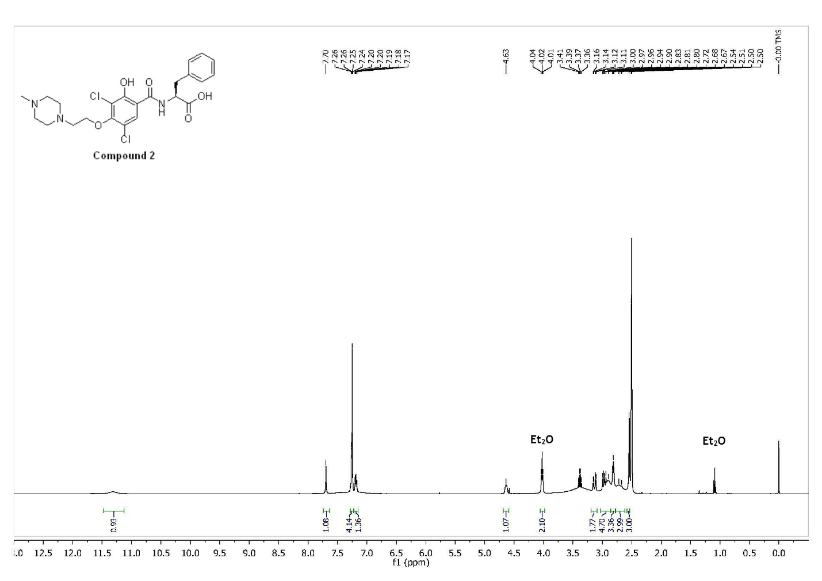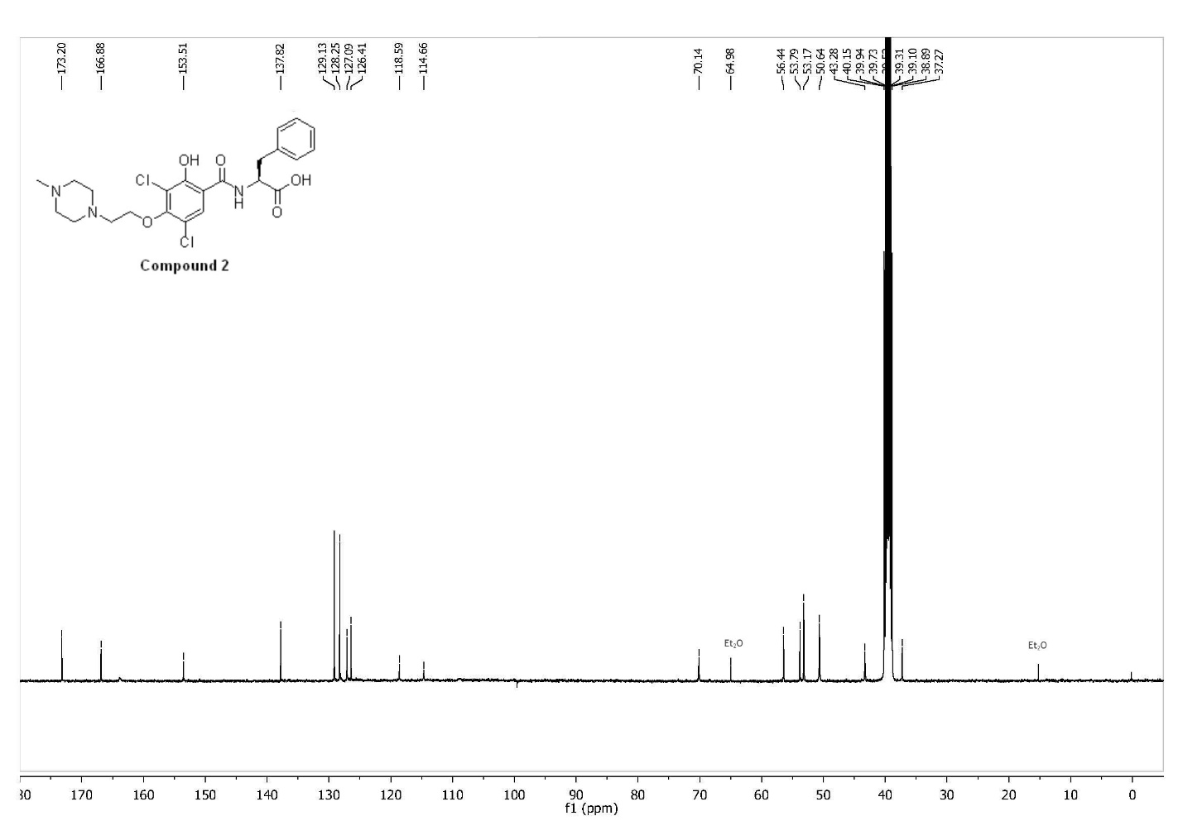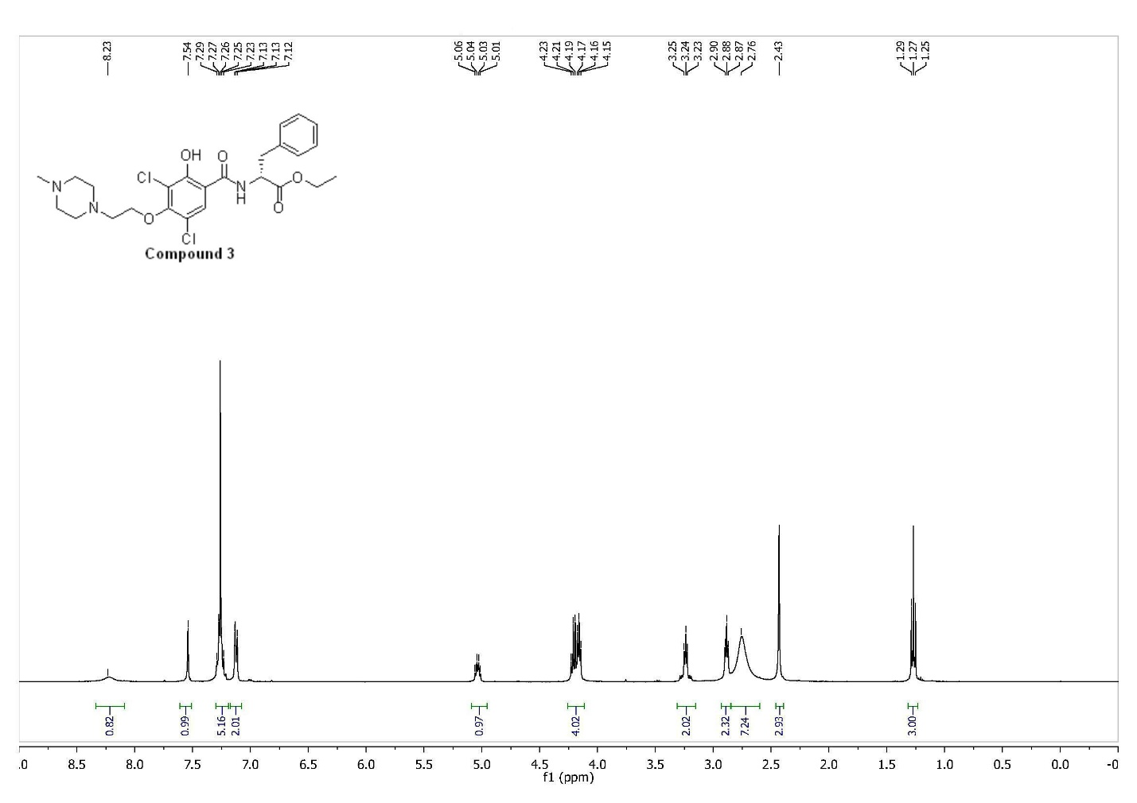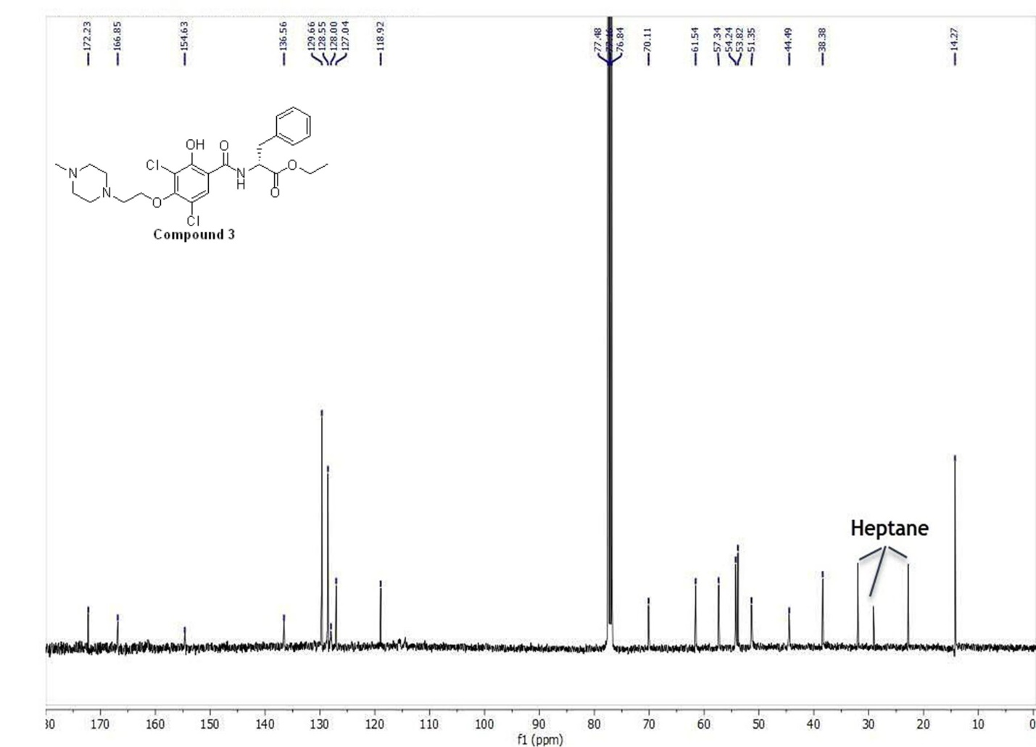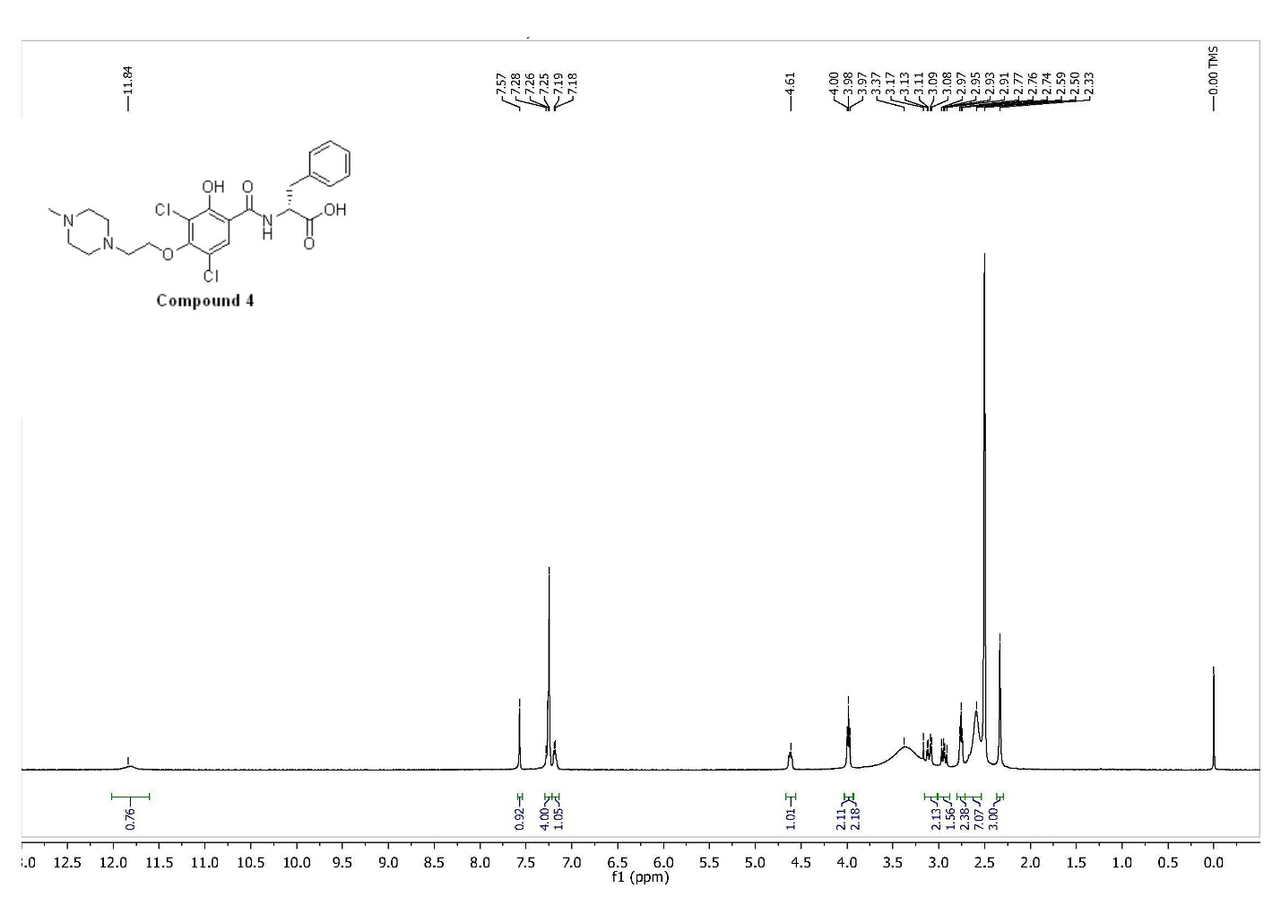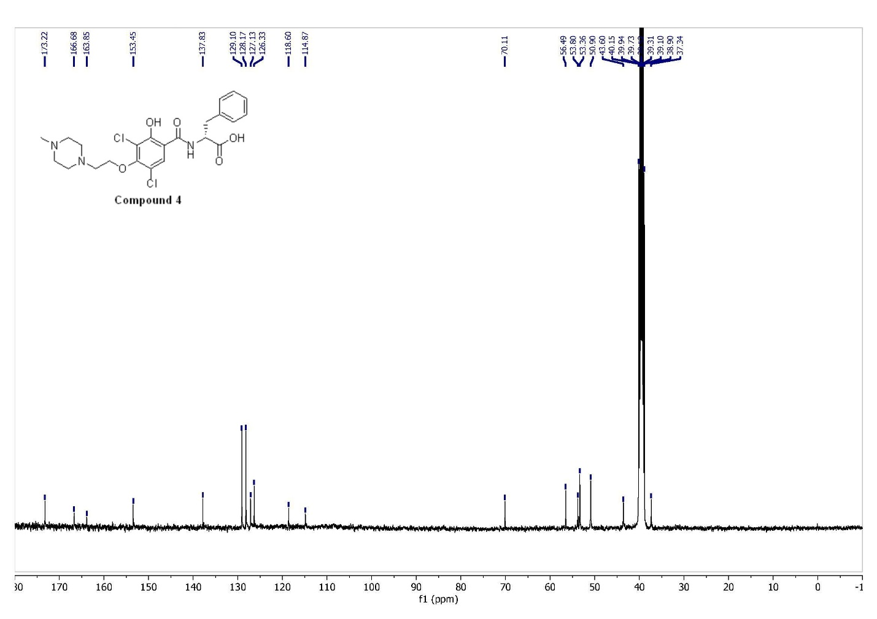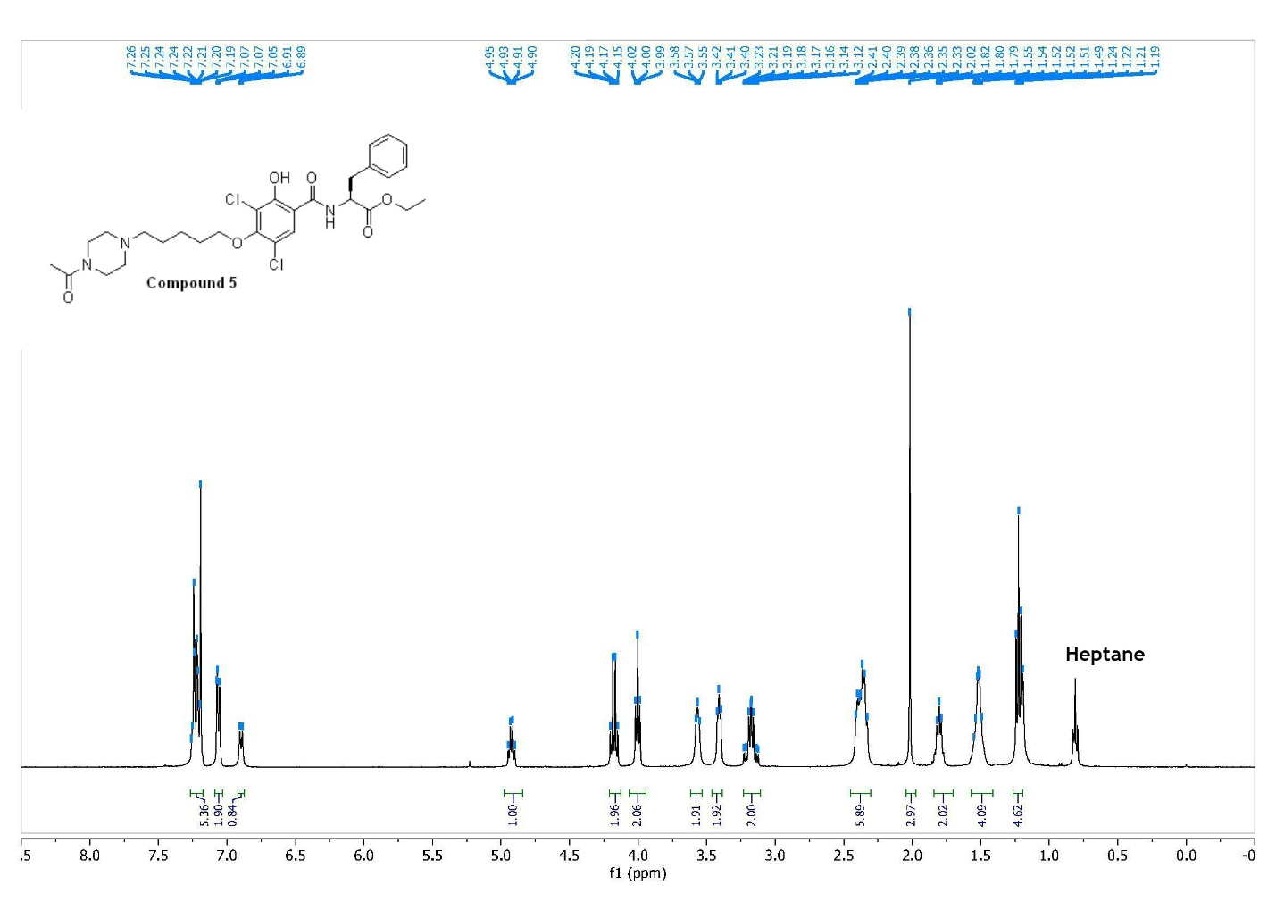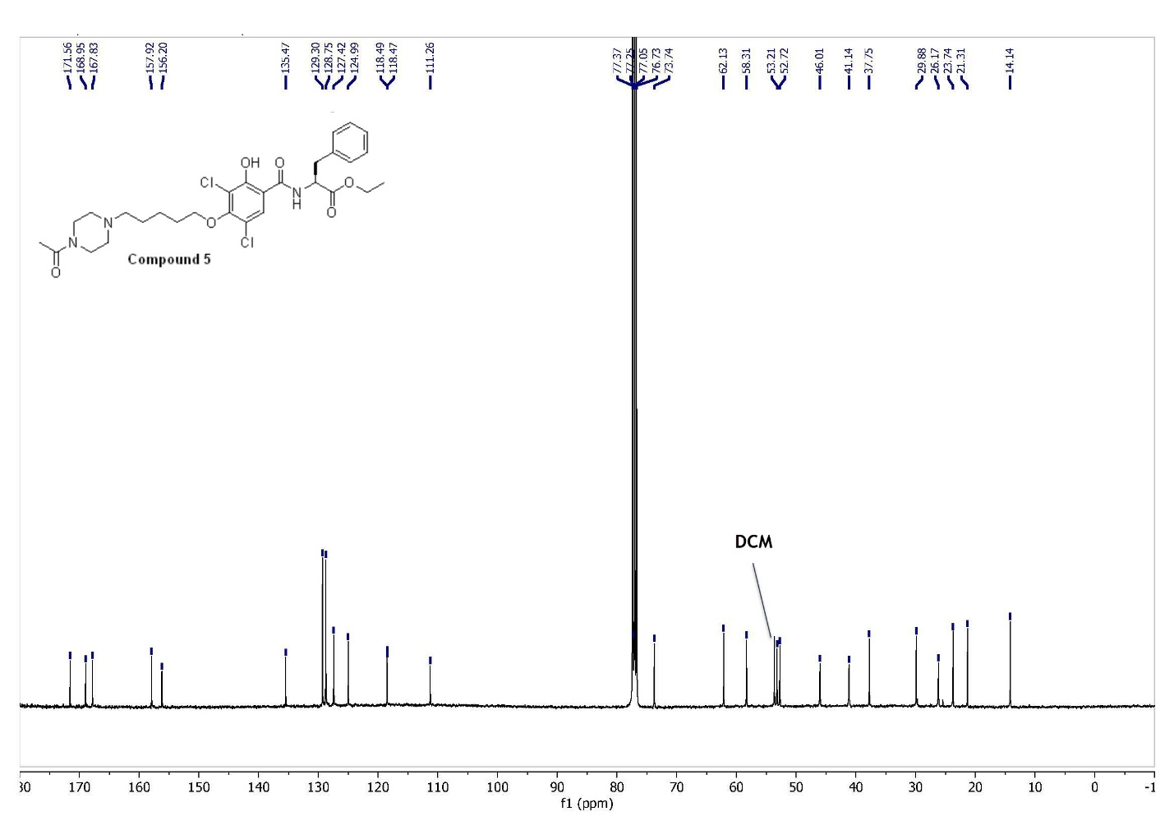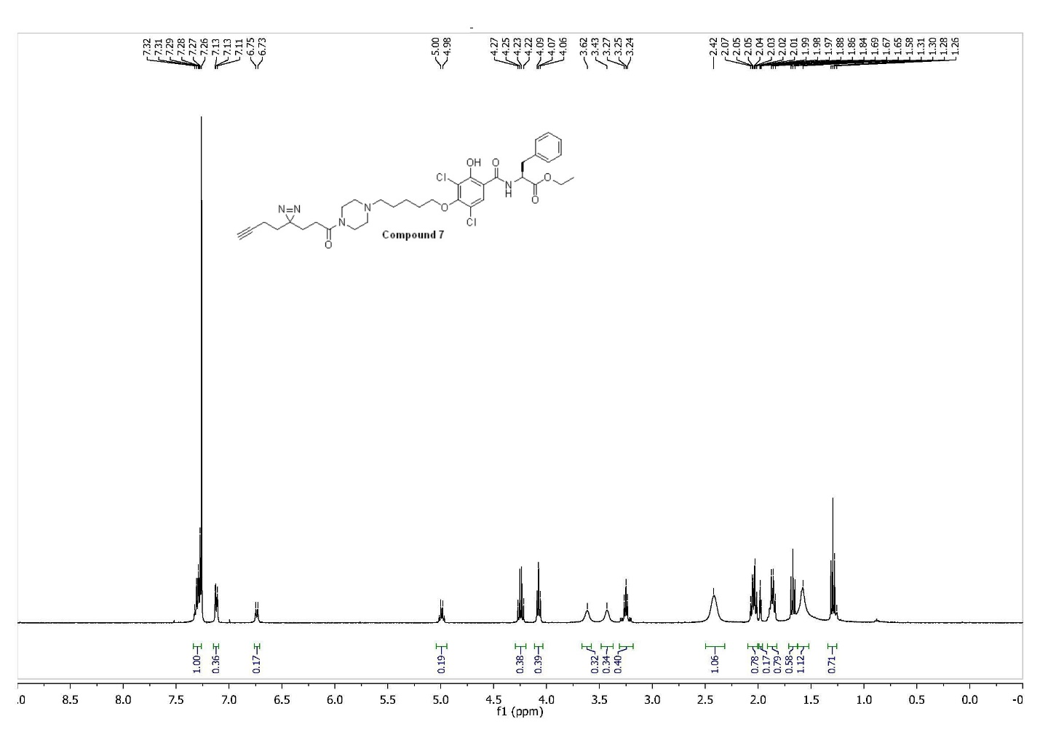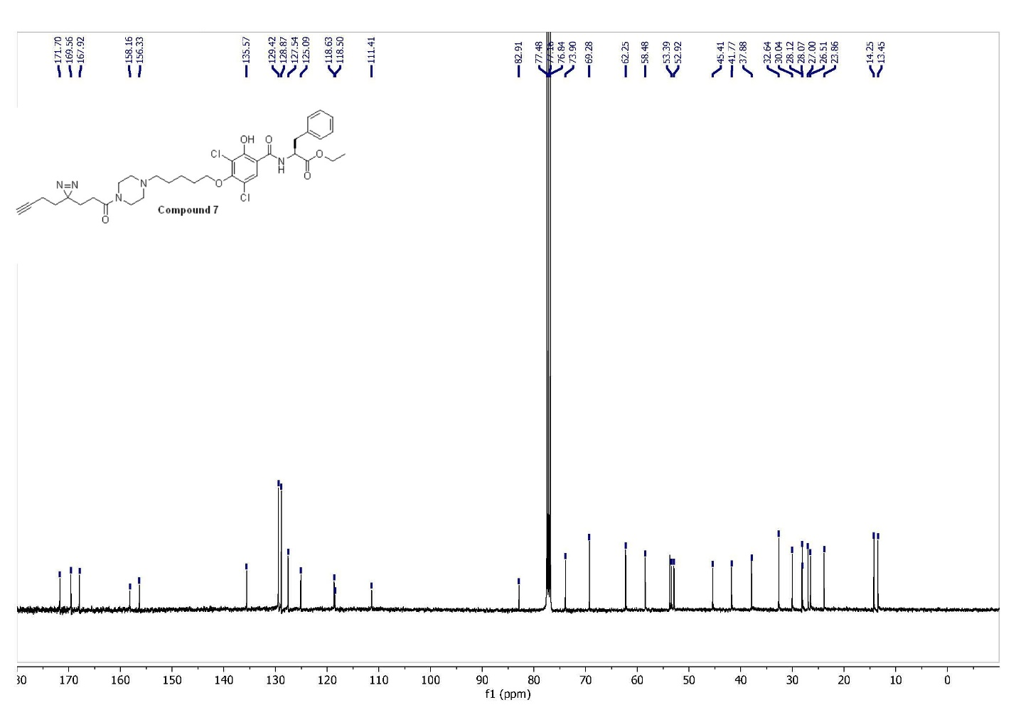
References
59. Li, Z. et al. Design and synthesis of minimalist terminal alkyne-containing diazirine photo-crosslinkers and their incorporation into kinase inhibitors for cell- and tissue-based proteome profiling. Angew. Chem. Int. Ed. Engl. 52, 8551–8556 (2013).

