Supplementary Information for:
Sialic acid-containing glycolipids mediate binding and viral entry of SARS-CoV-2
Linh Nguyen, Kelli A. McCord, Duong T. Bui, Kim M. Bouwman, Elena N. Kitova, Mohamed Elaish, Dhanraj Kumawat, Gour C. Daskhan, Ilhan Tomris, Ling Han, Pradeep Chopra, Tzu-Jing Yang, Steven D. Willows, Andrew L. Mason, Lara K. Mahal, Todd L. Lowary, Lori J. West, Shang-Te Danny Hsu, Tom Hobman, S. Mark Tompkins, Geert-Jan Boons, Robert P. de Vries, Matthew S. Macauley, and John S. Klassen
Supplementary Tables S2
Table 1. Composition of the defined library and the corresponding sub-libraries used for CaR-ESI-MS screening S2
Table 2. Summary of molecular weights of RBD glycoforms measured by ESI-MS S8
Table 3. Summary of reported RBD O-glycosylation S12
Table 4. Summary of glycans identified by HILIC-UHPLC analysis of 2-AB labeled N-glycans released from RBD S13
Supplementary Figures S16
Figure 1. Sub-libraries (A-O) of defined glycan library used for CaR-ESI-MS screening S16
Figure 2. Representative ESI mass spectra of S protein and RBD S17
Figure 3. Chromatogram of 2-AB-labeled N-glycans released from RBD treated with PNGase F acquired using HILIC-UHPLC with fluorescence detection S18
Figure 4. Dissociation constants (K_{d}) of 10 RBD glycoforms S19
Figure 5. Inhibition of glycan binding to RBD by methyl α-sialoside (MeαNeu5Ac). S20
Figure 6. Immunofluorescence staining in 3FNeu5Ac treated Vero-E6 cells. S22
Figure 7. Infection of control lentivirus that does not encode SARS-CoV-2 in HEK293 cells expressing ACE2. S23
Figure 8. Immunofluorescence staining showing RBD binding in neuraminidase treated Vero-E6 cells S24
Figure 9. Removal of glycolipids via endoglycoceramidase decreased RBD binding in Vero cells S25
Figure 10. Immunofluorescence staining showing CTX binding in 1 h or 16 h neuraminidase treated Vero cells S26
Figure 11. RBD binding to ACE2⁺ HEK293 cells is abrogated by treatment with heparanase S27
Figure 12. Structures of gangliosides (GM1, GM2, GM3, GD1a, GD2 and GT1b) and the phospholipid DMPC S28
Figure 13. Influence of collision energy on glycan ligand release in CaR-ESI-MS screening S29
Figure 14. Reproducibility of CaR-ESI-MS glycan library screening data S30
Supplementary Notes – Synthetic Procedures S31
References S37

Supplementary Table 1. Composition of the defined library (composed of purified, free oligosaccharides) and the corresponding sub-libraries used for CaR-ESI-MS screening. Glycan codes, structures and molecular weights (MW) are indicated. The source of each glycan is given in the Materials and Methods (Supplementary Information) section.
Glycan  Code | Structure | Library | MW (Da)
1 | Galβ(1-3)[Fucα(1-4)]GlcNAc | B, G | 529.20
2 | Galβ(1-3)[Fucα(1-4)]GlcNAcβ(1-3)Gal | I | 691.25
3 | Galβ(1-3)[Fucα(1-4)]GlcNAcβ(1-3)Galβ(1-4)[Fucα(1-3)]Glc | C, L | 999.36
4 | GalNAcα(1-3)[Fucα(1-2)]Galβ(1-3)[Fucα(1-4)]GlcNAc | B | 878.39
5 | Galα(1-3)[Fucα(1-2)]Galβ(1-3)[Fucα(1-4)]GlcNAc | B | 837.31
6 | Fucα(1-2)Galβ(1-3)[Fucα(1-4)]GlcNAc | B, F | 675.26
7 | Fucα(1-2)Galβ(1-3)[Fucα(1-4)]GlcNAcβ(1-3)Gal | E | 837.31
8 | Galβ(1-4)[Fucα(1-3)]GlcNAc | D | 529.20
9 | Galβ(1-4)[Fucα(1-3)]GlcNAcβ(1-3)Gal | H | 691.25
10 | Galβ(1-4)[Fucα(1-3)]GlcNAcβ(1-3)Galβ(1-4)[Fucα(1-3)]Glc | B | 999.36
11 | GalNAcα(1-3)[Fucα(1-2)]Galβ(1-4)[Fucα(1-3)]GlcNAc | C | 878.39
12 | Galα(1-3)[Fucα(1-2)]Galβ(1-4)[Fucα(1-3)]GlcNAc | C | 837.31
13 | Fucα(1-2)Galβ(1-4)[Fucα(1-3)]GlcNAc | C, G | 675.26
14 | Fucα(1-2)Galβ(1-4)[Fucα(1-3)]GlcNAcβ(1-3)Gal | D | 837.31
15 | GalNAcα(1-3)[Fucα(1-2)]Galβ(1-3)GlcNAcβ1-O(CH₂)₆CH=CH₂ | F | 842.39
16 | GalNAcα(1-3)[Fucα(1-2)]Galβ(1-4)GlcNAcβ1-O(CH₂)₆CH=CH₂ | G | 842.39
17 | GalNAcα(1-3)[Fucα(1-2)]Galβ(1-3)GalNAcα1-O(CH₂)₆CH=CH₂ | H | 842.39
18 | GalNAcα(1-3)[Fucα(1-2)]Galβ(1-3)GalNAcβ1-O(CH₂)₆CH=CH₂ | I | 842.39
19 | GalNAcα(1-3)[Fucα(1-2)]Galβ(1-3)Galβ1-O(CH₂)₆CH=CH₂ | F | 801.36
20 | GalNAcα(1-3)[Fucα(1-2)]Galβ1-4Galβ1-O(CH₂)₆CH=CH₂ | G | 801.36
21 | Galα(1-3)[Fucα(1-2)]Galβ1-3GlcNAcβ1-O(CH₂)₆CH=CH₂ | H | 801.36
22 | Galα(1-3)(Fuca1-2)Galβ1-4GlcNAcβ1-O(CH₂)₆CH=CH₂ | I | 801.36
23 | Galα(1-3)(Fuca1-2)Galβ1-3GalNAcα1-O(CH₂)₆CH=CH₂ | J | 801.36
24 | Galα(1-3)[Fucα(1-2)]Galβ(1-3)GalNAcβ1-O(CH₂)₆CH=CH₂ | C | 801.36
25 | Galα(1-3)(Fuca1-2)Galβ1-3Galβ1-O(CH₂)₆CH=CH₂ | F | 760.33
26 | Galα(1-3)(Fuca1-2)Galβ1-4Galβ1-O(CH₂)₆CH=CH₂ | G | 760.33
27 | Fucα(1-2)Galβ1-3GlcNAcβ1-O(CH₂)₆CH=CH₂ | F | 639.31
28 | Fucα(1-2)Galβ1-4GlcNAcβ1-O(CH₂)₆CH=CH₂ | G | 639.31
29 | Fucα(1-2)Galβ1-3GalNAcα1-O(CH₂)₆CH=CH₂ | H | 639.31
30 | Fucα(1-2)Galβ1-3GalNAcβ1-O(CH₂)₆CH=CH₂ | I | 639.31
31 | Fucα(1-2)Galβ(1-3)Galβ1-O(CH₂)₆CH=CH₂ | F | 598.28
32 | Fucα(1-2)Galβ(1-4)Galβ1-O(CH₂)₆CH=CH₂ | G | 598.28
33 | ∆UAβ(1-3)GalNAc4,6S (diE) | A | 539.02
34 | ∆UA2Sβ(1-3)GalNAc4,6S (triS) | A | 618.98
35 | D-GlcAβ(1-4)GlcNAcα(1-4)GlcAβ(1-4)GlcNAc | A | 758.22
36 | D-GlcAβ(1-4)[Glc NAcα(1-4)GlcAβ(1-4)]₄GlcNAc | A | 1895.55
37 | GlcAβ(1-3)Galβ(1-4)Glc | A | 518.15
38 | GlcAβ(1-3)Galβ(1-3)GlcNAcβ(1-3)Galβ(1-4)Glc | A | 883.28
39 | IdoA2Sβ(1-4)GlcNS6Sα(CH₂)₅NH₂ | NA ª | 680.07
40 | (IdoA2Sβ(1-4)GlcNS6S)₂α(CH₂)₅NH₂ | NA ª | 1433.92
41 | (IdoA2Sβ(1-4)GlcNS6S)₃α(CH₂)₅NH₂ | NA ª | 1834.01
42 | GalNAcβ(1-3)GalNAcβ(1-3)Galα(1-4)Galβ(1-4)Glc | E | 910.33
43 | GalNAcβ(1-3)GalNAcβ(1-3)Gal | E | 586.22
44 | GalNAcα(1-3)GalNAcβ(1-3)Galα(1-3)Galβ(1-4)Glc | F | 910.33
45 | Galα(1-3)Galβ(1-4)GlcNAcβ(1-3)Galβ(1-4)Glc | C | 869.30
46 | Galα(1-3)[Galβ(1-4)GlcNAcβ(1-3)]₂Galβ(1-4)Glc | C | 1234.43
47 | Galα(1-3)[Galβ(1-4)GlcNAcβ(1-3)]₃Galβ(1-4)Glc | D | 1599.56
48 | Galα(1-3)[Galβ(1-4)GlcNAcβ(1-3)]₄Galβ1-4Glc | F | 1964.70
49 | Galα(1-3)Galβ(1-3)GlcNAc | D | 545.19
50 | Galα(1-3)Galβ(1-4)[Fucα(1-3)]GlcNAc | J | 691.25
51 | Galα(1-4)Galβ(1-4)Glc | D | 504.17
52 | GalNAcβ(1-3)Galα(1-3)Galβ(1-4)Glc | C | 707.25
53 | Galβ(1-3)GalNAcβ(1-3)Galα(1-3)Galβ(1-4)Glc | D | 869.30
54 | Galβ(1-3)GalNAcβ(1-3)Galα(1-4)Galβ(1-4)Glc | E | 869.30
55 | GalNAcβ(1-3)Galα(1-4)Galβ(1-4)Glc | E | 707.25
56 | Galα(1-4)Galβ(1-4)GlcNAc | G, J | 545.19
57 | Fucα(1-2)Galβ(1-3)GalNAcβ(1-3)Galα(1-4)Galβ(1-4)Glc | D | 1015.36
58 | Galα(1-3)[Fucα(1-2)]Galβ(1-3)GalNAcβ(1-3)Galα(1-4)Galβ(1-4)Glc | D | 1177.41
59 | GalNAcα(1-3)[Fucα(1-2)]Galβ(1-3)GalNAcβ(1-3)Galα(1-4)Galβ(1-4)Glc | D | 1218.44
60 | Neu5Acα(2-3)Galα(1-4)Galβ(1-4)Glc | E | 795.26
61 | Galβ(1-3)GalNAcβ(1-4)Galβ(1-4)Glc | D | 707.25
62 | GalNAcβ(1-4)Galβ(1-4)Glc | E | 545.19
63 | Galβ(1-4)[Neu5Acα(2-3)]Galβ1-4Glc) | D | 795.26
64 | Fucα(1-2)Galβ(1-3)GalNAcβ(1-4)[Neu5Acα(2-3)]Galβ1-4Glc | D | 1144.40
65 | Neu5Acα(2-3)Galβ(1-3)GalNAcβ(1-4)[Neu5Acα(2-3)]Galβ(1-4)Glc | D | 1289.44
66 | Galβ(1-3)GalNAcβ(1-4)[Neu5Acα(2-8)]Neu5Acα(2-3)Galβ(1-4)Glc | E | 1289.44
67 | GalNAcβ(1-4)[Neu5Acα(2-8)Neu5Acα(2-3)]Galβ(1-4)Glc | D | 1127.38
68 | Neu5Acα(2-8)Neu5Acα(2-3)Galβ(1-4)Glc | C | 924.30
69 | Galβ(1-3)GalNAcβ(1-4)[Neu5Acα(2-3)]Galβ(1-4)Glc | D | 998.34
70 | Neu5Acα(2-3)Galβ(1-3)GalNAcβ(1-4)Galβ(1-4)Glc | E | 998.34
71 | GalNAcβ(1-4)[Neu5Acα(2-3)]Galβ(1-4)Glc | I | 836.29
72 | Neu5Acα(2-3)Galβ(1-4)Glc | C, M | 633.21
73 | Neu5Acα(2-8)Neu5Acα(2-3)Galβ(1-3)GalNAcβ(1-4)[Neu5Acα(2-3)]Galβ(1-4)Glc | D | 1580.53
74 | Galβ(1-3)GalNAcβ(1-4)[Neu5Acα(2-8)Neu5Acα(2-8)Neu5Acα(2-3)]Galβ(1-4)Glc | E | 1580.53
75 | GalNAcβ(1-4)[Neu5Acα(2-8)Neu5Acα(2-8)Neu5Acα(2-3)]Galβ1-4Glc | D | 1418.48
76 | Neu5Acα(2-8)Neu5Acα(2-8)Neu5Acα(2-8)Galβ(1-4)Glc | D | 1215.40
77 | Galβ(1-3)Galβ(1-4)Glc | I | 545.19
78 | Galβ(1-4)GlcNAcβ(1-3)Galβ(1-4)GlcNAc | B | 748.27
79 | Galα(1-3)Galβ(1-4)Glc | B, C | 504.17
80 | Galβ(1-3)GlcNAcβ(1-3)Gal | B | 545.19
81 | Galβ(1-4)GlcNAcβ(1-3)Gal | C | 545.19
82 | Galβ(1-4)Glcβ1-1βGal | E | 504.17
83 | Galβ(1-3)Galβ(1-4)Galβ(1-3)Gal | E | 666.22
84 | Galβ(1-3)GalNAcβ(1-3)Gal | F | 545.19
85 | Manα(1-6)[Man α(1-3)]Manα(1-6)[Manα(1-6)]Man | F | 828.27
86 | Manα(1-6)[Man α(1-3)]Manα(1-6)Man | F | 666.22
87 | Galα(1-3)[Fucα(1-2)]Galβ(1-4)[Fucα(1-3)]Glc | B | 796.28
88 | Fucα(1-2)Galβ(1-4)[Fucα(1-3)]Glc | B, L | 634.23
89 | Galα(1-3)Galβ(1-4)[Fucα(1-3)]Glc | C | 650.22
90 | Fucα(1-2)Galβ(1-4)Glcβ(1-1)β[Fucα(1-2)]Gal | C | 796.28
91 | GlcNAcβ(1-4)[Fucα(1-6)]GlcNAc | E | 570.23
92 | Fucα(1-2)Galβ(1-4)[Fucα(1-2)]Glc | E | 634.23
93 | GalNAcα(1-3)[Fucα(1-2)]Galβ(1-4)[Fucα(1-3)]Glc | F | 837.31
94 | Neu5Acα(2-3)Galβ(1-4)[Fucα(1-3)]GlcNAcβ(1-3)Gal | B | 982.35
95 | Neu5Acα(2-3)Galβ(1-4)[Fucα(1-3)]Glc | B | 779.27
96 | Neu5Acα(2-3)Galβ(1-3)GalNAcβ(1-3)Gal | J | 836.29
97 | Neu5Acα(2-3)Galβ(1-4)Glcβ1-1β[Neu5Acα(2-3)]Gal | E | 1086.36
98 | Neu5Acα(2-8)Neu5Acα(2-3)Galβ(1-3)GlcNAcβ(1-3)Gal | E | 1127.38
99 | Neu5Acα(2-3)Galβ(1-3)GalNAcβ(1-3)Galα(1-4)Galβ(1-4)Glc | E | 1160.40
100 | Neu5Acα(2-3)Galβ(1-3)GlcNAcβ(1-3)Gal | G | 836.29
101 | Neu5Acα(2-3)Galβ(1-4)GlcNAcβ(1-3)Gal | H | 836.29
102 | Fucα(1-2)Galβ(1-4)Glc | K | 488.17
103 | GlcNAcβ(1-3)Galβ(1-4)Glc | K | 545.20
104 | GalNAcα(1-3)[Fucα(1-2)]Galβ(1-4)Glc | K | 691.25
105 | Galβ(1-3)GlcNAcβ(1-3)Galβ(1-4) Glc | K | 707.25
106 | Fucα(1-2)Galβ(1-3)GlcNAcβ(1-3)Galβ(1-4)Glc | K | 853.31
107 | Fucα(1-2)Galβ(1-3)[Fucα(1-4)]GlcNAcβ(1-3)Galβ(1-4)Glc | K | 999.36
108 | Galβ(1-4)GlcNAcβ(1-3)[Galβ(1-4)GlcNAcβ(1-3)]Galβ(1-4)Glc | K | 1072.38
109 | GalNAcα(1-3)[Fucα(1-2)]Galβ(1-3)[Fucα(1-4)]GlcNAcβ(1-3)Galβ(1-4)Glc | K | 1202.44
110 | Galβ(1-4)[Fucα(1-3)]GlcNAcβ(1-6)[Fucα(1-2)Galβ(1-3)GlcNAcβ(1-3)]Galβ(1-4)Glc | K | 1364.50
111 | Galβ(1-4)GlcNAcβ(1-3)Galβ(1-4)GlcNAcβ(1-3)Galβ(1-4)GlcNAcβ(1-3)Galβ(1-4)Glc | K | 1437.51
112 | Galβ(1-4)[Fucα(1-3)]Glc | L | 488.17
113 | Galβ(1-4)GlcNAcβ(1-3)Galβ(1-4)Glc | L | 707.25
114 | Galβ(1-3)[Fucα(1-4)]GlcNAcβ(1-3)Galβ(1-4)Glc | L | 853.31
115 | GalNAcα(1-3)[Fucα(1-2)]Galβ(1-3)GlcNAcβ(1-3)Galβ(1-4)Glc | L | 1056.39
116 | Galβ(1-4)GlcNAcβ(1-6)[Galβ(1-4)GlcNAcβ(1-3)]Galβ(1-4)Glc | L | 1072.38
117 | Galβ(1-4)[Fucα(1-3)]GlcNAcβ(1-6)[Galβ(1-3)GlcNAcβ(1-3)]Galβ(1-4)Glc | L | 1218.44
118 | Galβ(1-3)[Fucα(1-4)]GlcNAcβ(1-3)Galβ(1-4)[Fucα(1-3)]GlcNAcβ(1-3)Galβ(1-4)Glc | L | 1364.50
119 | Galβ(1-4)[Fucα(1-3)]GlcNAcβ(1-6)[Fucα(1-2)Galβ(1-3)[Fucα(1-4)]GlcNAcα(1-3)]Galα(1-4)Glc | L | 1510.55
120 | Galβ(1-4)[Fucα(1-3)]GlcNAcβ(1-3)Galβ(1-4)-βGlc | O | 853.31
121 | Galβ(1-4)[Fucα(1-3)]GlcNAcβ(1-3)Galβ(1-4)[Fucα(1-3)]Glc | O | 999.36
122 | Galα(1-4)GlcNAcβ(1-3)Galβ(1-4)GlcNAcβ(1-3)Galβ(1-4)Glc | O | 1072.38
123 | Galβ(1-3)GlcNAcα(1-3)Galβ(1-4)[Fucα(1-3)]Glc | O | 1144.40
124 | Neu5Acα(2-3)Galβ(1-4)GlcNAc | M | 674.24
125 | Neu5Acα(2-3)Galβ(1-3)GlcNAcβ(1-3)Galβ(1-4)Glc | M | 998.34
126 | Neu5Acα(2-3)Galβ(1-3)[Fucα(1-4)]GlcNAc | M | 820.30
127 | Neu5Ac(2-3)Galβ(1-3)[Fucα(1-4)]GlcNAcβ(1-3)Galβ(1-4)Glc | M | 1144.40
128 | Neu5Acα(2-3)Galβ(1-4)GlcNAcβ(1-3)Galβ(1-4)Glc | O | 998.34
129 | Neu5Acα(2-6)Galβ(1-4)Glc | N | 633.21
130 | Neu5Acα(2-6)Galβ(1-4)GlcNAc | N | 674.24
131 | Neu5Acα(2-6)[Galβ(1-3)]GlcNAcβ(1-3)Galβ(1-4)Glc | N | 998.34
132 | Fucα(1-2)Galβ(1-3)[Neu5Acα(2-6)]GlcNAcβ(1-3)Galβ(1-4)Glc | N | 1144.40
133 | Rhaα(1-3)2MeRhaPMP | P^{b,c} | 432.47
134 | Rhaα(1-3)GlcNAcOc | P^{d} | 481.46
135 | 2,4MeFucα(1-3)Rhaα(1-3)RhaPMP | P^{b,c} | 605.20
136 | 2,3,4MeFucα(1-3)Rhaα(1-3)RhaPMP | P^{b,c} | 619.22
137 | 3,6MeGlcβ(1-4)Rhaα(1-2)RhaPMP | P^{b,c} | 621.22
138 | 6MeGlcβ(1-4)2,3MeRhaα(1-2)3MeRhaPMP | P^{b,c} | 649.38
139 | Galfβ(1-5)Galfβ(1-4)Rhaα(1-3)GlcNAcOc | P^{e} | 804.80
140 | Neu5Acα(2-3)Galβ(1-4)GlcNAcβ(1-2)Manα(1-3)][Manα(1-6)]Manβ(1-4)GlcNAcβ(1-4)GlcNAc | NAª | 1566.56
a. NA ≡ not applicable; binding of these glycans to RBD was evaluated by direct ESI-MS analysis.
b. PMP ≡ p-methoxyphenyl. c. Me ≡ methyl. d. Oc ≡ Octyl. e. f ≡ furanose ring.

Supplementary Table 2. Summary of molecular weights (MWs) of RBD glycoforms (P_{x}) measured by ESI-MS performed in positive ion mode on a Q Exactive Orbitrap mass spectrometer.
P_{x} | Measured mass-to-charge ratios (m/z) |  |  | Measured MW (Da)
P_{x} | z = 9 | z = 10 | z = 11 | Measured MW (Da)
P1 | 3447.5 | 3102.8 | 2821.0 | 31018 ± 1
P2 | 3451.8 | 3106.5 | 2824.2 | 31056 ± 2
P3 | 3463.6 | 3117.4 | 2834.1 | 31164 ± 1
P4 | 3467.1 | 3120.8 | 2837.2 | 31202 ± 2
P5 | 3475.4 | 3127.8 | 2843.7 | 31268 ± 1
P6 | 3479.6 | 3132.0 | 2847.4 | 31310 ± 2
P7 | 3483.6 | 3135.3 | 2850.4 | 31343 ± 1
P8 | 3486.0 | 3137.2 | 2852.3 | 31364 ± 2
P9 | 3487.9 | 3139.3 | 2854.2 | 31384 ± 2
P10 | 3491.7 | 3142.6 | 2857.1 | 31416 ± 1
P11 | 3496.0 | 3146.7 | 2860.8 | 31456 ± 2
P12 | 3497.9 | 3148.2 | 2862.1 | 31472 ± 1
P13 | 3499.8 | 3150.0 | 2863.7 | 31490 ± 1
P14 | 3501.5 | 3151.6 | 2865.4 | 31506 ± 2
P15 | 3504.2 | 3154.0 | 2867.3 | 31530 ± 1
P16 | 3506.2 | 3155.6 | 2868.9 | 31547 ± 1
P17 | 3507.9 | 3157.2 | 2870.3 | 31562 ± 1
P18 | 3509.8 | 3158.9 | 2872.0 | 31578 ± 2
P19 | 3512.5 | 3161.2 | 2873.8 | 31602 ± 2
P20 | 3512.6 | 3161.2 | 2873.8 | 31603 ± 2
P21 | 3515.9 | 3164.5 | 2876.9 | 31635 ± 1
P22 | 3518.0 | 3166.3 | 2878.6 | 31653 ± 1
P23 | 3520.3 | 3168.5 | 2880.5 | 31674 ± 1
P24 | 3522.1 | 3170.1 | 2882.0 | 31691 ± 2
P25 | 3524.0 | 3171.9 | 2883.6 | 31709 ± 1
P26 | 3528.5 | 3175.8 | 2887.3 | 31749 ± 1
P27 | 3532.2 | 3179.1 | 2890.2 | 31781 ± 1
P28 | 3536.6 | 3183.2 | 2893.7 | 31821 ± 2
P29 | 3538.4 | 3184.8 | 2895.3 | 31837 ± 1
P30 | 3540.2 | 3186.4 | 2896.9 | 31854 ± 1
P31 | 3542.0 | 3188.1 | 2898.5 | 31871 ± 2
P32 | 3545.1 | 3190.4 | 2900.5 | 31895 ± 2
P33 | 3548.3 | 3193.6 | 2903.4 | 31926 ± 1
P34 | 3550.1 | 3195.6 | 2904.9 | 31944 ± 2
P35 | 3553.2 | 3197.6 | 2907.1 | 31968 ± 2
P36 | 3554.6 | 3199.3 | 2908.5 | 31983 ± 1
P37 | 3556.6 | 3201.0 | 2910.1 | 32000 ± 1
P38 | 3558.4 | 3202.7 | 2911.6 | 32018 ± 1
P39 | 3561.0 | 3205.0 | 2913.6 | 32040 ± 1
P40 | 3564.7 | 3208.3 | 2916.8 | 32073 ± 1
P41 | 3569.4 | 3212.3 | 2920.4 | 32114 ± 2
P42 | 3570.7 | 3213.9 | 2921.8 | 32128 ± 1
P43 | 3572.9 | 3215.6 | 2923.4 | 32147 ± 1
P44 | 3577.2 | 3219.7 | 2927.0 | 32186 ± 1
P45 | 3580.8 | 3222.8 | 2929.9 | 32218 ± 1
P46 | 3582.7 | 3224.5 | 2931.6 | 32236 ± 1
P47 | 3589.0 | 3230.2 | 2936.6 | 32291 ± 1
P48 | 3590.7 | 3232.0 | 2938.3 | 32309 ± 2
P49 | 3593.4 | 3233.9 | 2940.2 | 32330 ± 2
P50 | 3597.1 | 3237.5 | 2943.3 | 32365 ± 1
P51 | 3601.5 | 3241.3 | 2946.8 | 32405 ± 1
P52 | 3605.3 | 3244.8 | 2949.9 | 32438 ± 1
P53 | 3609.6 | 3248.6 | 2953.2 | 32476 ± 2
P54 | 3611.5 | 3250.4 | 2955.1 | 32495 ± 1
P55 | 3613.3 | 3252.1 | 2956.6 | 32511 ± 1
P56 | 3621.3 | 3259.3 | 2963.0 | 32583 ± 1
P57 | 3625.9 | 3263.2 | 2966.7 | 32623 ± 1
P58 | 3629.4 | 3266.7 | 2969.8 | 32656 ± 1
P59 | 3634.0 | 3270.8 | 2973.4 | 32697 ± 1
P60 | 3637.5 | 3274.0 | 2976.4 | 32729 ± 1
P61 | 3645.8 | 3281.3 | 2983.2 | 32803 ± 1
P62 | 3649.9 | 3285.1 | 2986.7 | 32841 ± 2
P63 | 3653.8 | 3288.5 | 2989.5 | 32874 ± 2
P64 | 3658.1 | 3292.6 | 2993.1 | 32914 ± 2
P65 | 3661.7 | 3295.8 | 2996.2 | 32947 ± 1
P66 | 3665.7 | 3299.5 | 2999.4 | 32988 ± 2
P67 | 3670.1 | 3303.2 | 3003.1 | 33023 ± 2
P68 | 3675.0 | 3307.0 | 3006.6 | 33062 ± 2
P69 | 3678.1 | 3310.5 | 3009.6 | 33094 ± 2
P70 | 3686.2 | 3317.8 | 3016.3 | 33167 ± 2
P71 | 3694.3 | 3325.0 | 3022.7 | 33239 ± 2
P72 | 3702.5 | 3332.3 | 3029.5 | 33313 ± 2
P73 | 3707.5 | 3335.8 | 3032.8 | 33353 ± 2
P74 | 3726.7 | 3354.1 | 3049.1 | 33530 ± 2
P75 | 3734.7 | 3361.5 | 3056.2 | 33605 ± 2
P76 | 3766.1 | 3390.6 | 3082.4 | 33894 ± 2
P77 | 3798.7 | 3420.0 | 3108.9 | 34186 ± 2
a. Listed MWs are averages of the values calculated for charge states +9, +10, and +11.
b. Uncertainties correspond to one standard deviation.
Supplementary Table 3. Summary of reported RBD O-glycosylation (at T323 and S325).
O-glycan composition | Shajahan ª | Zhang ^{b} | Sanda ^{c} | Zhao ^{d}
HexNAc₁ | T323 | T323/S325 | N/A | T323/S325
HexNAc₁Hex₁ | T323 | T323/S325 | T323/S325 | T323
HexNAc₁Hex₁Neu5Ac₁ | T323/S325 | T323/S325 | T323/S325 | T323
HexNAc₁Hex₁Neu5Ac₂ | T323 | T323/S325 | T323/S325 | T323
HexNAc₂ | N/A | T323/S325 | N/A | N/A
HexNAc₂Hex₁ | N/A | T323 | N/A | T323
HexNAc₂Hex₂ | N/A | N/A | N/A | T323
HexNAc₂Hex₂Neu5Ac₁ | T323 | N/A | T323/S325 | N/A
HexNAc₂Hex₂Neu5Ac₂ | T323 | N/A | N/A | N/A
a. Reference S1.
b. Reference S2.
c. Reference S3.
d. Reference S4.

Supplementary Table 4. Summary of glycans identified HILIC-UHPLC analysis of 2-AB labeled N-glycans released from RBD.^{a,b}
No. | Glycan composition | Putative  structure | Number of isomers | Relative abundance  (%)
1 | HexNAc₄Hex₅Fuc₁Neu5Ac₁ |  | 6 | 100
2 | HexNAc₄Hex₅Fuc₁Neu5Ac₂ |  | 3 | 57.2
3 | HexNAc₄Hex₅Fuc₂Neu5Ac₁ |  | 5 | 43.2
4 | HexNAc₄Hex₄Fuc₁Neu5Ac₁ |  | 4 | 38.7
5 | HexNAc₄Hex₅Fuc₂ |  | 3 | 30.5
6 | HexNAc₄Hex₅Fuc₁ |  | 1 | 28.3
7 | HexNAc₅Hex₄Fuc₁Neu5Ac₁ |  | 6 | 26
8 | HexNAc₅Hex₃Fuc₁ |  | 3 | 25.4
9 | HexNAc₅Hex₄Fuc₂ |  | 2 | 24.4
10 | HexNAc₄Hex₃Fuc₁ |  | 4 | 23.4
11 | HexNAc₄Hex₄Fuc₂ |  | 3 | 21.9
12 | HexNAc₂Hex₅ |  | 1 | 20.2
13 | HexNAc₅Hex₄Fuc₁ |  | 6 | 18.9
14 | HexNAc₅Hex₆Fuc₁Neu5Ac₁ |  | 5 | 17.9
15 | HexNAc₆Hex₃Fuc₂ |  | 2 | 17.1
16 | HexNAc₅Hex₆Fuc₁Neu5Ac₂ |  | 4 | 14.8
17 | HexNAc₅Hex₆Fuc₁ |  | 1 | 14.7
18 | HexNAc₄Hex₃Fuc₂ |  | 1 | 13.0
19 | HexNAc₅Hex₄Fuc₂Neu5Ac₁ |  | 2 | 12.4
20 | HexNAc₄Hex₄Fuc₁ |  | 3 | 12.3
21 | HexNAc₅Hex₃Fuc₂ |  | 2 | 9.6
22 | HexNAc₆Hex₃Fuc₁ |  | 3 | 9.2
23 | HexNAc₆Hex₃Fuc₁Neu5Ac₁ |  | 1 | 8.1
24 | HexNAc₅Hex₃Fuc₁Neu5Ac₁ |  | 1 | 7.5
25 | HexNAc₆Hex₃Fuc₂Neu5Ac₁ |  | 1 | 7.3
26 | HexNAc₅Hex₆Fuc₂Neu5Ac₁ |  | 4 | 5.2
27 | HexNAc₅Hex₄Fuc₁S₁ |  | 1 | 5.1
28 | HexNAc₅Hex₆Fuc₁Neu5Ac₃ |  | 2 | 4.9
29 | HexNAc₃Hex₃Fuc₁ |  | 2 | 4.8
30 | HexNAc₅Hex₆Fuc₂ |  | 1 | 4.8
31 | HexNAc₆Hex₄Fuc₁Neu5Ac₁ |  | 1 | 4.4
32 | HexNAc₄Hex₅Fuc₄ |  | 1 | 3.8
33 | HexNAc₅Hex₄Fuc₁Neu5Ac₁S₁ |  | 2 | 3.7
34 | HexNAc₆Hex₅Fuc₁Neu5Ac₂ |  | 1 | 3.3
35 | HexNAc₃Hex₄Fuc₁Neu5Ac₁ |  | 2 | 3.2
36 | HexNAc₅Hex₄Fuc₃ |  | 1 | 2.9
37 | HexNAc₆Hex₅Fuc₂ |  | 1 | 2.7
38 | HexNAc₄Hex₅Neu5Ac₁ |  | 2 | 2.3
39 | HexNAc₅Hex₃Fuc₁S₁ |  | 2 | 2.3
40 | HexNAc₆Hex₃Fuc₁S₁ |  | 1 | 2.3
41 | HexNAc₄Hex₅Fuc₃Neu5Ac₁ |  | 2 | 2.0
42 | HexNAc₃Hex₅Fuc₁Neu5Ac₁ |  | 1 | 1.6
43 | HexNAc₆Hex₃Fuc₁S₂ |  | 1 | 1.6
44 | HexNAc₄Hex₅Fuc₂Neu5Ac₂ |  | 2 | 1.5
45 | HexNAc₃Hex₄Fuc₁ |  | 2 | 1.4
46 | HexNAc₅Hex₅Fuc₁Neu5Ac₁ |  | 1 | 1.4
47 | HexNAc₆Hex₅Fuc₁Neu5Ac₁ |  | 1 | 1.4
48 | HexNAc₄Hex₃Fuc₁Neu5Ac₁ |  | 1 | 1.2
49 | HexNAc₅Hex₆Fuc₂Neu5Ac₂ |  | 2 | 1.1
50 | HexNAc₂Hex₃ |  | 1 | 1.0
51 | HexNAc₄Hex₅Fuc₄Neu5Ac₁ |  | 1 | 1.0
52 | HexNAc₅Hex₆Fuc₃ |  | 1 | 0.9
53 | HexNAc₃Hex₃ |  | 1 | 0.8
54 | HexNAc₆Hex₇Fuc₁Neu5Ac₂ |  | 1 | 0.7
55 | HexNAc₅Hex₆Fuc₃Neu5Ac₁ |  | 1 | 0.5
56 | HexNAc₆Hex₇Fuc₁Neu5Ac₁ |  | 1 | 0.5
57 | HexNAc₇Hex₅ |  | 1 | 0.3
58 | HexNAc₂Hex₁Neu5Ac₁ |  | 1 | 0.2
59 | HexNAc₂Hex₃Fuc₁ |  | 1 | 0.1
60 | HexNAc₃Hex₄ |  | 2 | 0.1
61 | HexNAc₃Hex₄Fuc₂ |  | 1 | 0.1
62 | HexNAc₂Hex₄ |  | 1 | 0
63 | HexNAc₂Hex₄Fuc₁ |  | 1 | 0
64 | HexNAc₂Hex₆ |  | 1 | 0
65 | HexNAc₃Hex₃Fuc₂ |  | 1 | 0
66 | HexNAc₃Hex₅Fuc₁ |  | 1 | 0
67 | HexNAc₃Hex₅Fuc₂ |  | 1 | 0
68 | HexNAc₃Hex₆Fuc₁ |  | 1 | 0
69 | HexNAc₃Hex₆P₁ |  | 1 | 0
70 | HexNAc₄Hex₃ |  | 1 | 0
71 | HexNAc₄Hex₃Fuc₁S₁ |  | 1 | 0
72 | HexNAc₄Hex₅ |  | 1 | 0
73 | HexNAc₄Hex₆Fuc₁ |  | 1 | 0
74 | HexNAc₆Hex₇Fuc₁Neu5Ac₃ |  | 1 | 0
a. S indicates sulfate group, P indicates phosphate group.
b. N-glycans may have either core or antennary fucosylation.
Supplementary Figure 1. Sub-libraries (A-O) of defined glycans used for CaR-ESI-MS screening.
Supplementary Figure 2. Representative ESI mass spectra of S protein and RBD. a,b, Representative ESI mass spectra acquired in positive mode for an aqueous ammonium acetate solution (100 mM, pH 6.9, 25 °C) of S protein (5 μM) (a), and RBD (5 μM) (b). c, Expanded region (m/z 3000 to 3400) of the mass spectrum shown in (b).
Supplementary Figure 3. Chromatogram of 2-AB-labeled N-glycans released from SARS-CoV-2 RBD treated with PNGase F obtained using HILIC-UHPLC with fluorescence detection. The relative abundances of principal N-glycan types are shown in the diagram on the top right.

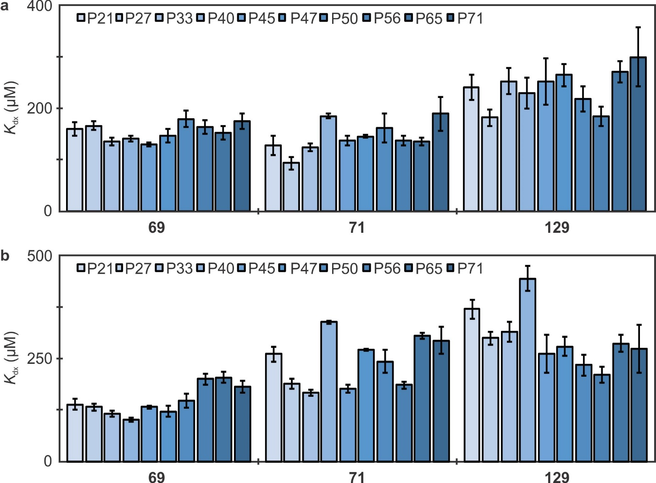
Supplementary Figure 4. Dissociation constants (K_{d}) of 10 RBD glycoforms. The K_{d} of 10 most abundant RBD glycoforms (P21, P27, P33, P40, P45, P47, P50, P56, P65, and P71) in 100 mM ammonium acetate solution (pH 6.9) and RBD (5 μM) at 3 different concentrations of glycans 69, 71, and 129 at 25 °C (a) and 37 °C (b). Means ± s.d., n = 3 independent experiments for each glycan concentration.

Supplementary Figure 5. Inhibition of glycan binding to RBD by methyl α-sialoside (MeαNeu5Ac). a, Representative CaR-ESI-MS mass spectrum obtained for aqueous ammonium acetate solutions (100 mM, pH 6.9, 25 °C) of RBD (10 μM), SNA (P_{ref}, 4 μM), MeαNeu5Ac (500 μM) and Library C (50 nM of each glycan). Ions in the range m/z 3000 – 4000 were subjected to HCD using a collision energy of 50 V. b,c, Ratios of abundances of released glycans to abundance of 71 measured by CaR-ESI-MS for 16 sub-libraries (50 nM of each glycan) in 100 mM aqueous ammonium acetate solutions (pH 6.9, 25 °C) containing RBD (10 μM) with 0 μM (b) and 500 μM (c) MeαNeu5Ac, in which light green (1 – 123), light pink (33 – 132) and grey (133 – 139) represent the neutral and acidic glycans and controls (Library P), respectively. Black-outlined white-filled circles represent data points. Means ± s.d., n = 3 independent experiments. Means ± s.d., n = 3 independent experiments. d, Heat maps of the change of normalized abundances of released glycans (relative to 71) upon addition of MeαSA at 20 and 50 molar ratio MeαNeu5Ac:RBD measured by CaR-ESI-MS (NB ≡ no binding). Decreases and increases in binding (relative to 71) upon addition of MeαNeu5Ac are shown as different shades of red and blue, respectively. No change in binding, relative to 71, is indicated in white.

Supplementary Figure 6. Immunofluorescence staining in 3FNeu5Ac treated Vero-E6 cells. DAPI was used for nuclear staining. a,b, RBD binding (a) and SNA (b) staining decreased with 3FNeu5Ac treatment. c, ECA staining increased with 3FNeu5Ac treatment. d, No changes were seen in ACE2 binding when Vero-E6 cells were treated with 3FNeu5Ac. Scalebars represents 100 μm. Pictures represent data from one representative sample from n = 4 independent repeated experiments.

Supplementary Figure 7. Infection of control lentivirus that does not encode SARS-CoV-2 in HEK293 cells expressing ACE2. a, RP172 lentivirus (10 µL) 1 h infection followed by a 23 h incubation showed no differences when cells are treated with Neu5Ac (300 µM) or 3FNeu5Ac (300 µM). Level of infection quantified by % of mAmetrine+ cells as determined by flow cytometry. b, DMSO or GENZ-123346 (5 µM) treated HEK293 cells expressing ACE2 infected with RP172 lentivirus for 1 h followed by a 23 h incubation. Infection quantified by % of mAmetrine⁺ cells observed using flow cytometry. Error bars represent standard deviations calculated for n = 3 independent experiments. Statistical significance calculated based on two-tailed unpaired Student’s t-test.

Supplementary Figure 8. Immunofluorescence staining showing RBD binding in neuraminidase treated Vero-E6 cells. a, SARS-CoV-2 RBD binding was decreased in Vero-E6 cells treated with Vibrio (Sigma), Arthobacter (Sigma), and Arthrobacter (New England Biolabs, NEB) neuraminidases for 16 h. b, After 1 h of neuraminidase treatment, with Vibrio (Sigma), Arthobacter (Sigma), or Arthrobacter (NEB), significant changes in RBD binding were not observed in Vero-E6 cells. Scalebars represents 100 μm. Pictures represent data from one representative sample from n = 3 independent repeated experiments.

Supplementary Figure 9. Removal of glycolipids via endoglycoceramidase decreased RBD binding in Vero cells. Vero-E6 cells treated with EGCase for 16 h prior to assessing RBD binding. Immunofluorescence staining shows nucleus (blue) and RBD binding (red). Scalebar represents 100 μm. Pictures represent data from one representative sample from n = 3 independent repeated experiments.

Supplementary Figure 10. Immunofluorescence staining showing CTX binding in 1 h or 16 h neuraminidase treated Vero cells. Vero-E6 cells fixed and treated with neuraminidase from Vibrio cholerae for 1 or 16 h prior to assessing Cholera toxin (CTX) binding by immunofluorescence staining. CTX staining fully decreased after 16 h treatment with Vibrio cholerae neuraminidase. Staining shows nucleus (blue) and CTX binding (green). Scalebar represents 100 μm. Pictures represent data from one representative sample from n = 4 independent repeated experiments.

Supplementary Figure 11. RBD binding to ACE2⁺ HEK293 cells is abrogated by treatment with heparanase. ACE2⁺ HEK293 cells were treated with heparanase for 16 h prior to examining staining using fluorescent trimeric SARS-CoV-2 RBD. RBD staining fully decreased after 16 h treatment with heparanase. Staining shows nucleus (blue) and RBD binding (red). Scalebar represents 100 μm. Pictures represent data from one representative sample from n = 3 independent repeated experiments.

Supplementary Figure 12. Structures of the gangliosides (GM1, GM2, GM3, GD1a, GD2 and GT1b; two major isoforms (d18:1-18:0 and d20:1-18:0)), and the phospholipid (DMPC) used in this study.

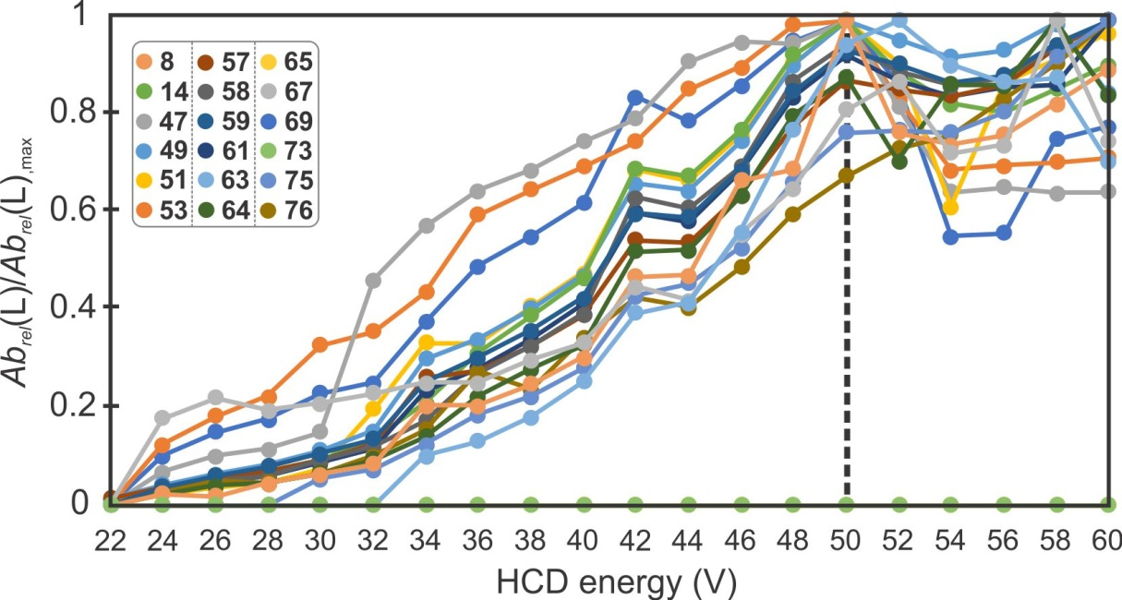
Supplementary Figure 13. Influence of HCD energy (V) on glycan ligand release for CaR-ESI-MS screening of RBD (10 μM) against Library D (50 nM of each glycan) in ammonium acetate (100 mM, pH 6.9) containing SNA (P_{ref}, 4 μM) measured at 25 °C. The abundance of each glycan was normalized according to the maximum, charge-normalized signal detected.

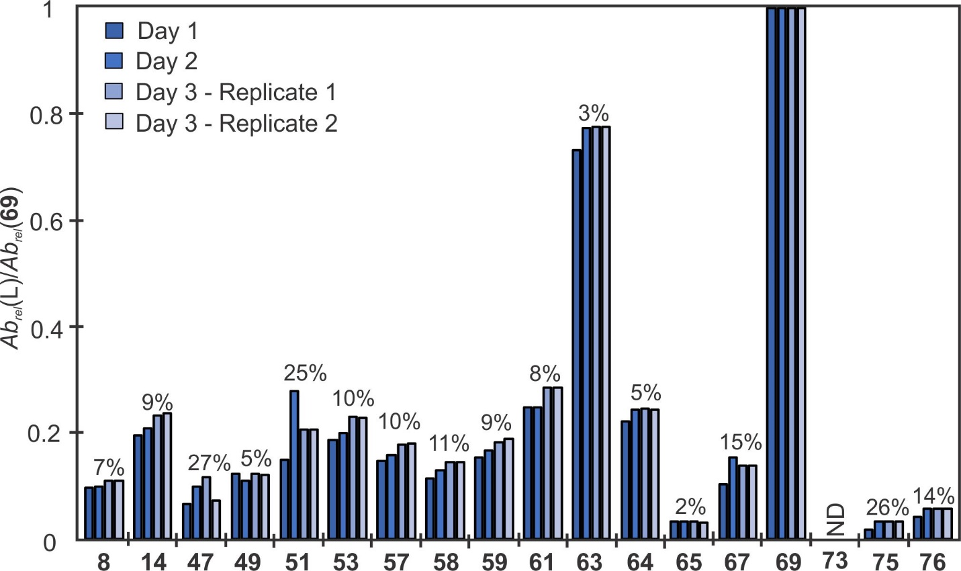
Supplementary Figure 14. Reproducibility of CaR-ESI-MS glycan library screening data. Normalized (to 69) abundances of released ligands measured for aqueous ammonium acetate (100 mM, pH 6.9, 25 °C) solutions of RBD (10 μM), SNA (P_{ref}, 4 μM) and Library D (50 nM of each glycan). HCD was performed using a collision energy 50 V. The percentages shown correspond to the relative standard deviation of the normalized abundances. ND ≡ not detected.

Supplementary Note – Synthetic Procedures
Chemicals and general procedures.
CH₃NO₂, Selectfluor, PPh₃.HBr, AgOTf, MeOH, and anhydrous CH₂Cl₂ were purchased from Sigma-Aldrich, Canada. CDCl₃ (chloroform-D) and D₂O (deuterium oxide) were purchased from Deutero GmbH. Other solvents (analytical and HPLC grade) and reagents were purchased from Aldrich and were used as received. Reactions were monitored by analytical TLC on silica gel 60-F254 (0.25 nm, Silicycle, QC, Canada). Developed TLC plates were visualized under UV lamp (λ max = 254 nm) and charred by heating plates that were dipped in ninhydrin solution in ethanol, and acidified anisaldehyde solution in ethanol. The reaction mixture was purified by silica gel column chromatography (230-400 mesh, Silicyle, Qc, Canada), Sephadex G-100 gel filtration chromatography using CH₂Cl₂/MeOH (dichloromethane/ methanol) or H₂O as the elution solvent. NMR experiments were conducted on a Varian 500 MHz instrument in the Chemistry NMR Facility, University of Alberta. Chemical shifts are reported relative to the deuterated solvent peak or 3-(trimethylsilyl)-propionic-2,2,3,3-d 4 acid sodium salt as an internal standard and are in parts per million (ppm). Coupling constants (J) are reported in Hz and apparent multiplicities were described in standard abbreviations as singlet (s), doublet (d), doublet of doublets (dd), triplet (t), broad singlet (bs), or multiplet (m).

Synthesis of per-O-acetylated 3F_{ax}-Neu5Ac (142).
Synthesis and characterization of N-Acetyl-2,3-didehydro-2-deoxyneuraminic acid (DANA) were previously reported by Cairo and co-workers¹. DANA (350 mg, 0.75 mol) was dissolved in CH₃NO₂ (3.5 mL) and H₂O (500 µL) with Selectfluor (1.1 g, 3.0 mol) and the reaction mixture was stirred at room temperature for 2 d. The reaction was monitored by TLC and after completion, the reaction mixture was quenched with saturated aqueous NaHCO₃. The compound was extracted with EtOAc (2×20 mL) and then crude product was purified by silica column chromatography (EtOAc/Hexane, 7:3) to afford of 141a (125 mg, 38 %) and 141b (100 mg, 30 %). A solution of 141a (100 mg, 0.02 mol) in anhydrous pyridine (2 mL) was stirred with acetic anhydride (1.5 mL) at 0 °C for 5 h under argon atmosphere. The reaction mixture was then warmed to room temperature and stirred overnight (Supplementary Fig. 1a). After the reaction completion, the solution was concentrated and co-evaporated with toluene. The product was then purified with silica column chromatography (EtOAc/ Hexane, 7:3) to afford desired compound 142 (100 mg, 92 %).
¹H NMR (500 MHz, CDCl₃) δ (ppm) 5.59 (ddd, J = 28, 11, 2.5 Hz, 1H), 5.38–5.32 (m, 2H), 5.36 (dt, J = 6.5, 2.5 Hz, 1H), 4.96 (dd, J = 49, 2.5 1H), 4.58 (dd, J = 12.5, 2.5 Hz, 1H), 4.29–4.14 (m, 3H), 3.87 (s, 3H), 2.20 (s, 3H), 2.19 (s, 3H), 2.14 (s, 3H), 2.07 (s, 3H), 2.06 (s, 3H), 1.95 (s, 3H). (Supporting Figure 2)
¹³C NMR (125 MHz, CDCl₃) δ (ppm) 170.62, 170.52, 170.49, 170.24, 167.06, 165.06, 87.49, 71.82, 71.27, 67.98, 62.06, 53.47, 45.76, 31.55, 23.27, 22.61, 20.85, 20.77, 20.63, 20.50, 14.08. (Supporting Figure 3)
HRMS (ESI-MS) calculated for m/z [M+Na]⁺ cald for C₂₂H₃₀FNNaO₁₄: 574.1543, found: 574.1538.

Synthesis of protected derivative of Methyl (5-Acetamido-4,7,8,9-tetra-O-acetyl-2-methoxy-2,3,5-tri-deoxy-D-glycereo-β-D-galacto-2-nonulopyranosid)onate (144).
Synthesis of per-O-acetylated methyl ester glycosyl chloro derivative (143) was achieved in quantitative yield in three-step from the N-acetyl neuraminic acid through following a procedure previously reported². A solution of glycosyl chloride 143 (450 mg, 0.88 mmol) and 4Å powdered molecular sieves (1 mg) in anhydrous MeOH (12 mL) was stirred at room temperature under an argon atmosphere. After 15-20 minutes, AgOTf (453 mg, 1.76 mmol) was added to the reaction mixture and stirred for 4 h in the dark. The crude product was filtered through a ceiling pad and washed with CH₂Cl₂ (3×150 mL), brine (50 mL), water (2×50 mL) and aqueous Na₂S₂O₃ (10%, m/v). The crude product was purified by silica column chromatography (EtOAc/Hexane, 9.5:0.5) to afford of compound 144 (323 mg, 72%) as a colourless solid. TLC: EtOAc:hexane = 9.5:0.5. R_{f}=0.42 (EtOA).
¹H NMR (500 MHz, CDCl₃) δ (ppm) 5.47-5.44 (m, 1H), 5.35 (dd, J = 8.5, 2.5 Hz, 1H), 5.13 (d, J = 9.5 Hz, 1H), 4.91-4.85 (m, 1H), 4.34 (dd, J = 12.5, 2.5 Hz, 1H), 4.16-4.13 (m, 1H), 4.09 (dd, J = 10.5, 5.5 Hz, 1H), 3.83 (s, CO₂Me, 3H), 3.34 (s, OMe, 3H), 2.59 (dd, J₄₋₃eq 5.0, J₃ax₋₃eq 12.5 Hz, 1H, H3_{eq}) 2.17 (s, 3H), 2.16 (s, 3H), 2.06 (s, 3H), 2.05 (s, 3H), 1.96 (dd, J₄₋₃ax = 13.0, 25.5 Hz, 1H, H3_{ax}), 1.90 (s, 3H, NCOCH₃). 1D NMR data matched with previously reported literature³.
¹³C NMR (125 MHz, CDCl₃) δ (ppm) 171.01, 170.66, 170.18, 170.14, 170.02, 168.16, 98.98, 72.47, 69.07, 68.43, 67.32, 62.39, 52.76 (CO₂Me), 52.48 (OMe), 49.51, 37.91, 23.23, 21.13, 20.87, 20.78.
Synthesis of Methyl (5-Acetamido-4,7,8,9-tetra-O-acetyl-2-methoxy-2,3,5-tri-deoxy-D-glycereo-β-D-galacto-2-nonulopyranosid)onate (MeαNeu5Ac, 145).
Chemicals and general procedure. Methyl 5-acetamido-3,5-dideoxy-D-glycero-α-D-galacto-2-onulopyranose (144) (100 mg, 0.19 mmol) was dissolved in dry MeOH (10 mL), then NaOMe was added to the solution and pH of the reaction mixture was adjusted to 9.0-9.5. The mixture was left stirring at room temperature for overnight under an Ar atmosphere. Solvent was evaporated under reduced pressure. The crude product was subjected to de-esterification dissolving in 2N NaOH (2 mL) and stirred for 24 h at room temperature. Reaction mixture was neutralized with addition of amberlite IR-120 resin (H⁺), filtered and lyophilized. The crude product was dissolved in H₂O (0.5 mL) and purified by BioGel P-2 column eluted with water to compound 145 as a colourless solid after lyophilization. Yield: (56.9 mg, 89%). TLC: EtOAc:acetic acid:MeOH:H₂O = 6:1:2:1. Rf = 0.25.
¹H NMR (500 MHz, D₂O) δ (ppm) 3.86 (ddd, 1H), 3.84 (dd, J = 9.5, 2.0 Hz, 1H), 3.78 (dd, J = 20.0, 10.0 Hz, 1H), 3.68 (dd, J = 9.5, 2.0 Hz, 1H), 3.65-3.64 (m, 1H), 3.62 (dd, J = 12.5, 6.5 Hz, 1H), 3.56 (dd J = 9.5, 2.0 Hz, 1H), 3.31 (s, OMe, 3H), 2.69 (dd, J₄₋₃eq 4.5, J₃ax₋₃eq 12.5 Hz, 1H, H3_{eq}), 2.01 (s, 3H, NCOCH₃) 1.60 (dd, J₄₋₃ax = 12.5, 24.5 Hz, 1H, H3_{ax}) (Supporting Figure 4). 1D NMR data matched with previously reported literature⁴.
¹³C NMR (125 MHz, D₂O) δ (ppm) 174.29, 171.58, 101.50, 73.44, 72.51, 69.08 (2C), 63.47, 52.72, 52.48 (OMe), 40.22, 23.30 (Supporting Figure 5).
Supporting Figures.
Supporting Figure 1. Synthesis scheme of per-O-acetylated 3F_{ax}-Neu5Ac (142) (a), and MeαNeu5Ac (145) (b).

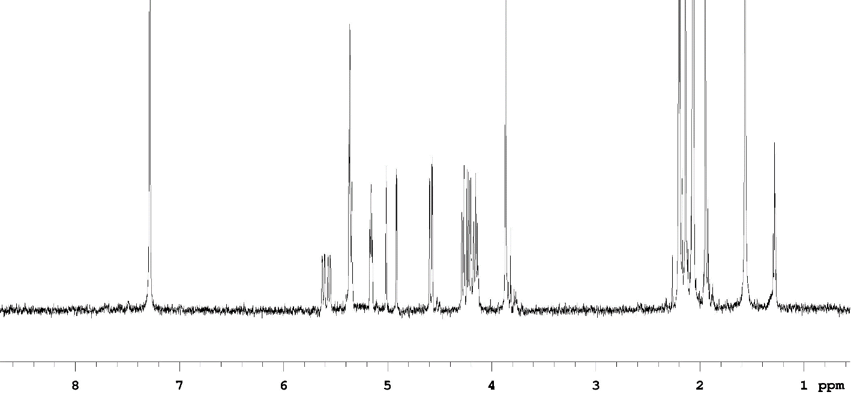
Supporting Figure 2. ¹H NMR spectrum of per-O-acetylated 3Fax-Neu5Ac (142) (600 MHz, D₂O) 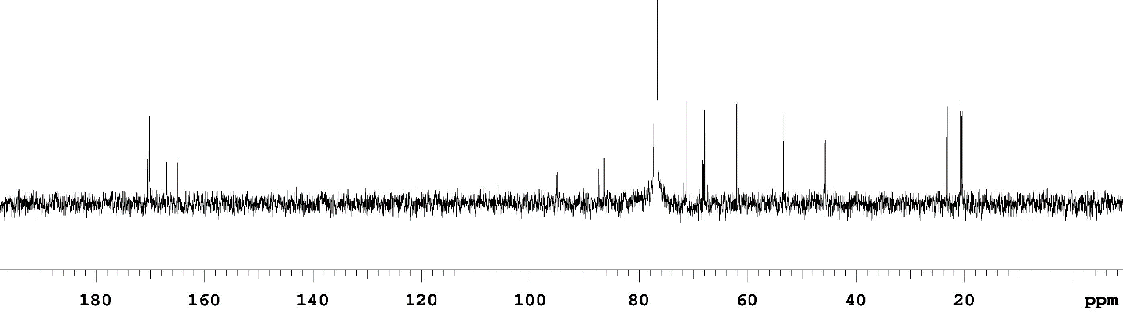
Supporting Figure 3. ¹³C NMR spectrum of per-O-acetylated 3Fax-Neu5Ac (142) (125 MHz, D₂O)

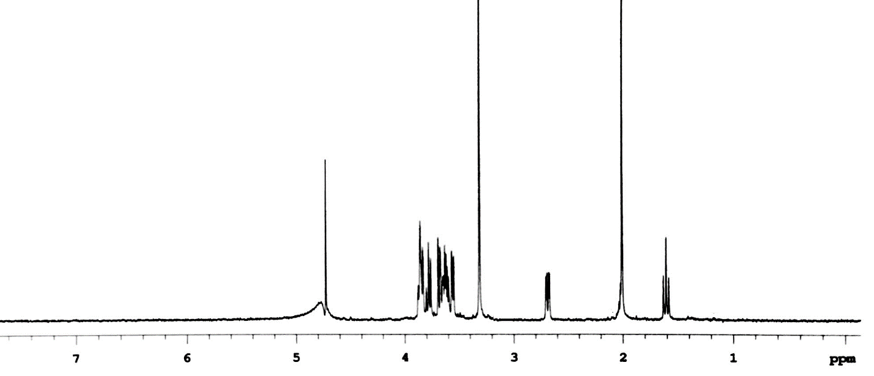
Supporting Figure 4. ¹H NMR spectrum of MeαNeu5Ac (145) (500 MHz, D₂O).

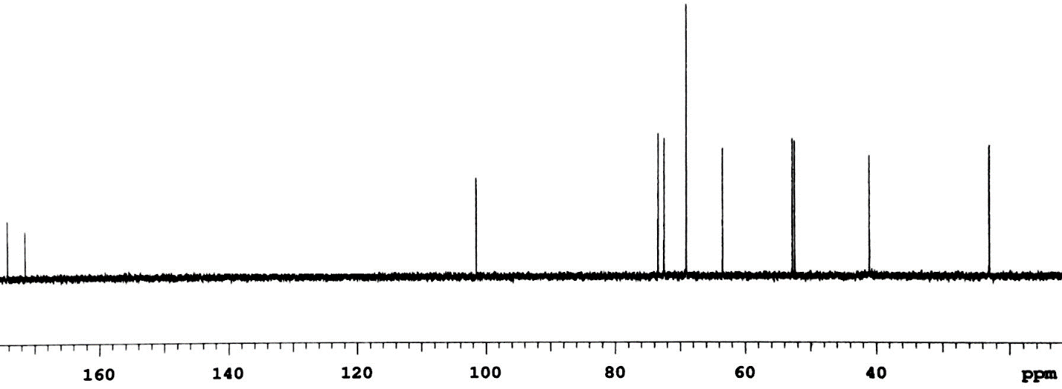
Supporting Figure 5. ¹³C NMR spectrum of MeαNeu5Ac (145) (125 MHz, D₂O).

Supporting References
1. Sabesian, S., Bock, K. & Lemieux, R.U. Can. J. Chem. 62, 1034-1045 (1984).
2. Shajahan, A., Supekar, N.T., Gleinich, A.S. & Azadi, P. Deducing the N- and O-glycosylation profile of the spike protein of novel coronavirus SARS-CoV-2. Glycobiology 30, 981-988 (2020).
3. Zhang, Y. et al. Mucin-type O-glycosylation landscapes of SARS-CoV-2 spike proteins. Preprint at https://www.biorxiv.org/content/10.1101/2020.07.29.227785v1 (2020).
4. Sanda, M., Morrison, L. & Goldman, R. N- and O-Glycosylation of the SARS-CoV-2 Spike Protein. Anal. Chem. 93, 2003-2009 (2021).
5. Zou, Y., Albohy, A., Sandbhor, M. & Cairo, C.W. Inhibition of human neuraminidase 3 (NEU3) by C9-triazole derivatives of 2,3-didehydro-N-acetyl-neuraminic acid. Bioorg. Med. Chem. Lett. 20, 7529-33 (2010).
6. Daskhan, G.C., Pifferi, C. & Renaudet, O. Synthesis of a new series of sialylated homo- and heterovalent glycoclusters by using orthogonal ligations. ChemistryOpen 5, 477-484 (2016).
7. Gregar, T.Q. & Gervay-Hague, J. Synthesis of oligomers derived from amide-linked neuraminic acid analogues. J. Org. Chem. 69, 1001-9 (2004).

