High-throughput screening platform for solid electrolytes
combining hierarchical ion-transport prediction algorithms
Bing He¹, Shuting Chi¹, Anjiang Ye¹, Penghui Mi¹, Liwen Zhang², Bowei Pu², Zheyi Zou², Yunbing Ran²,
Qian Zhao³, Da Wang², Wenqing Zhang⁴, Jingtai Zhao⁵, Stefan Adams⁶, Maxim Avdeev^{7,8}, Siqi Shi^{2,3,*}
¹School of Computer Engineering and Science, Shanghai University, Shanghai 200444, China
²State Key Laboratory of Advanced Special Steel, School of Materials Science and Engineering,
Shanghai University, Shanghai 200444, China
³Materials Genome Institute, Shanghai University, Shanghai 200444, China
⁴Department of Physics and Shenzhen Institute for Quantum Science and Technology, Southern University of Science and Technology, Shenzhen, Guangdong 518055, China
⁵School of Materials Science and Engineering, Guilin University of Electronic Technology, Guilin 541004, China
⁶Department of Materials Science and Engineering, National University of Singapore, Singapore 117579, Singapore
⁷Australian Nuclear Science and Technology Organisation, Locked Bag 2001, Kirrawee DC NSW 2232, Australia
⁸School of Chemistry, The University of Sydney, Sydney 2006, Australia
*corresponding author: Siqi Shi (sqshi@shu.edu.cn)

Preliminary screening of solid electrolytes
In total, 5,192 Li- and Na-containing compounds from our materials database are identified as potential solid electrolyte candidates through preliminary screening for E_{a} 1.2 eV values in one-dimensional migration paths. The ion-transport properties of 32 solid electrolyte candidates are summarized in Table S1, including the radii of the largest free sphere in three directions produced by CAVD and the energy barrier values of three dimensional migration paths calculated using BVSE. Moreover, the GII (Global Instability Index)¹⁻² is a plausibility check for the crystal structure model. We can find that the GII of Li₂O and Li₃N are both greater than 0.2 which means the structural model of BVSE may not suitable for these structures. Among these 32 candidates, the disordered structure β-Li₃PS₄ with space group of Pnma (no. 62) has three different Wyckoff positions for lithium ions: Li1 (8d), Li2 (4b), and Li3 (4c). The Li1 site is fully occupied, and the Li2 and Li3 sites have occupancies of 70% and 30%, respectively. Here, we perform CAVD and BVSE calculations in β-Li₃PS₄-b, which has 100% occupancy of the b site.
Table S1. Ion-transport properties of 32 solid electrolyte candidates. “RLFS” represents the radii of the largest free sphere calculated by CAVD. “Custom” in the identifier indicates that the structure is obtained from a custom CIF file. The Global Instability Index, i.e. here serves as a plausibility check for the crystal structure model.
No | Identifier | Compound | Space group | GII | RLFS (Å) |  |  | E_{a} by BVSE (eV)
 |  |  |  |  | a | b | c | 1D | 2D | 3D
1 | ICSD_201935 | LiZr₂(PO₄)₃ | R-3c | 0.120 | 0.974 | 0.974 | 0.974 | 0.391 | 0.391 | 0.391
2 | ICSD_171375 | LiBF₄ | P3₁21 | 0.022 | 0.724 | 0.724 | 0.798 | 0.146 | 0.186 | 0.186
3 | ICSD_108886 | Li₂O | R-3m | 0.481 | 0.723 | 0.723 | 0.723 | 0.127 | 0.127 | 0.127
4 | ICSD_173175 | Li₃N | P6/mmm | 0.473 | 1.342 | 1.342 | 0.789 | 0.195 | 0.195 | 0.205
5 | ICSD_414242 | β-LiI | P6₃mc | 0.016 | 0.537 | 0.537 | 0.546 | 0.254 | 0.254 | 0.254
6 | ICSD_054396 | Li₂S | Fm-3m | 0.135 | 0.652 | 0.652 | 0.652 | 0.293 | 0.293 | 0.293
7 | ICSD_009082 | Li₅GaO₄ | Pbca | 0.142 | 0.691 | 0.691 | 0.688 | 0.440 | 0.440 | 0.469
8 | ICSD_035277 | LiAlCl₄ | P2₁/c | 0.044 | 0.578 | 0.553 | 0.529 | 0.332 | 0.332 | 0.352
9 | ICSD_062137 | Li₆ZnO₄ | P4₂/nmc | 0.176 | 0.594 | 0.594 | 0.594 | 0.371 | 0.381 | 0.381
10 | ICSD_016229 | Li₅AlO₄ | Pmmn | 0.113 | 0.634 | 0.640 | 0.577 | 0.371 | 0.508 | 0.518
11 | ICSD_421083 | Li₆PS₅I | Cc | 0.157 | 0.517 | 0.517 | 0.513 | 0.332 | 0.342 | 0.361
12 | ICSD_002929 | LiAlSiO₄ | P6₄22 | 0.064 | 0.852 | 0.852 | 0.896 | 0.293 | 0.645 | 0.645
13 | ICSD_095979 | LiTi₂(PO₄)₃ | R-3c | 0.106 | 0.757 | 0.757 | 0.757 | 0.752 | 0.752 | 0.752
14 | ICSD_157654 | Li₇P₃S₁₁ | P-1 | 0.217 | 0.642 | 0.642 | 0.642 | 0.342 | 0.410 | 0.410
15 | ICSD_020208 | γ-Li₃PO₄ | Pnma | 0.043 | 0.611 | 0.621 | 0.611 | 0.479 | 0.479 | 0.820
16 | ICSD_073217 | Li₆FeCl₈ | Fm-3m | 0.027 | 0.461 | 0.461 | 0.461 | 0.488 | 0.488 | 0.488
17 | ICSD_246817 | Li₇La₃Zr₂O₁₂ | I4₁/acd | 0.184 | 0.560 | 0.560 | 0.563 | 0.459 | 0.576 | 0.576
18 | ICSD_062244 | Li₃Fe₂(PO₄)₃ | P2₁/c | 0.055 | 0.686 | 0.686 | 0.672 | 0.596 | 0.596 | 0.664
19 | ICSD_074950 | Li₇TaO₆ | P3 | 0.098 | 0.625 | 0.625 | 0.596 | 0.439 | 0.439 | 0.527
20 | Custom_400005 | β-Li₃PS₄-b | Pnma | 0.086 | 0.556 | 0.666 | 0.611 | 0.273 | 0.293 | 0.420
21 | ICSD_100403 | Li₂GeO₃ | Cmc2₁ | 0.097 | 0.614 | 0.614 | 0.629 | 0.283 | 0.576 | 1.143
22 | ICSD_001180 | Li₈SnO₆ | R-3 | 0.165 | 0.588 | 0.588 | 0.583 | 0.557 | 0.557 | 0.645
23 | ICSD_065177 | Li₄GeO₄ | Cmcm | 0.081 | 0.626 | 0.605 | 0.741 | 0.527 | 0.703 | 0.703
24 | ICSD_008222 | Li₄SiO₄ | P2₁/m | 0.086 | 0.592 | 0.650 | 0.582 | 0.557 | 0.791 | 0.801
25 | Custom_400004 | Li₁₀GeP₂S₁₂ | P4₂mc | 0.099 | 0.641 | 0.641 | 0.641 | 0.537 | 0.557 | 0.557
26 | Custom_300100 | Li₆PO₅Cl | F-43m | 0.196 | 0.391 | 0.391 | 0.391 | 0.645 | 0.645 | 0.645
27 | ICSD_019002 | Li₃VO₄ | Pmn2₁ | 0.046 | 0.606 | 0.589 | 0.624 | 0.605 | 0.615 | 1.328
28 | ICSD_050420 | Li₃Sc₂(PO₄)₃ | P2₁/c | 0.223 | 0.720 | 0.720 | 0.650 | 0.605 | 0.723 | 0.762
29 | ICSD_165579 | LiClO₄ | Pnma | 0.028 | 0.616 | 0.677 | 0.616 | 1.162 | 1.465 | 1.621
30 | ICSD_020740 | Na₃Sc₂(PO₄)₃ | R-3c | 0.041 | 0.992 | 0.992 | 0.991 | 0.977 | 0.977 | 0.986
31 | ICSD_000467 | NaZr₂(PO₄)₃ | R-3c | 0.048 | 1.001 | 1.000 | 1.000 | 1.045 | 1.045 | 1.055
32 | ICSD_015970 | Na₂O(Al₂O₃)₁₁ | P6₃/mmc | 0.164 | 1.271 | 1.271 | 0.326 | 0.117 | 0.117 | -

Non-equivalent migration paths of Li₇La₃Zr₂O₁₂
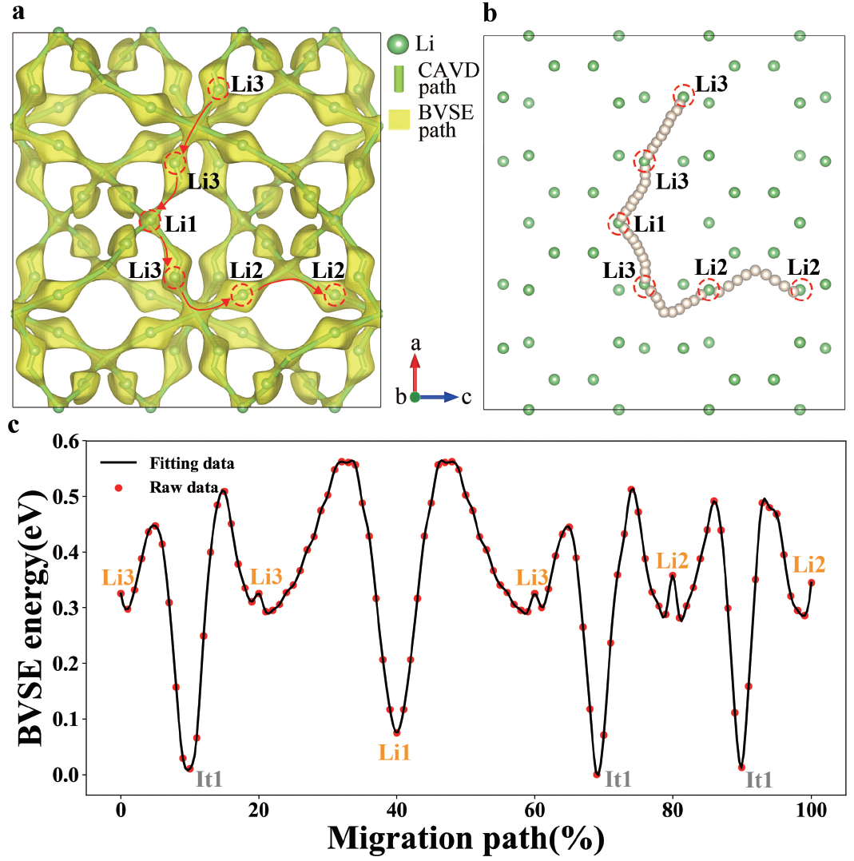
Figure S1. The ion migration paths of a LLZO calculated using CAVD and BVSE are shown in green cylinders and yellow isosurfaces, respectively. The endpoints of migration paths are highlighted by the red dotted circles. b Approximate MEPs and c migration energy profiles of Li1–Li3, Li2–Li3, Li2–Li2, and Li3–Li3 in LLZO; Li3-Li1 is equivalent to Li1-Li3.
In tetragonal Li₇La₃Zr₂O₁₂, E_{a} of the three-dimensional migration paths is 0.576 eV and the threshold parameter related to the radius of Li⁺ is 0.563 Å (Figure S1a). There are four types of non-equivalent migration paths: Li1–Li3, Li2–Li2, Li2–Li3, and Li3–Li3. Among them, Li2–Li2, Li2–Li3, and Li3–Li3 all pass through the same interstitial site it1. The MEPs and energy profiles are shown in Figure S1b and Figure S1c, respectively.
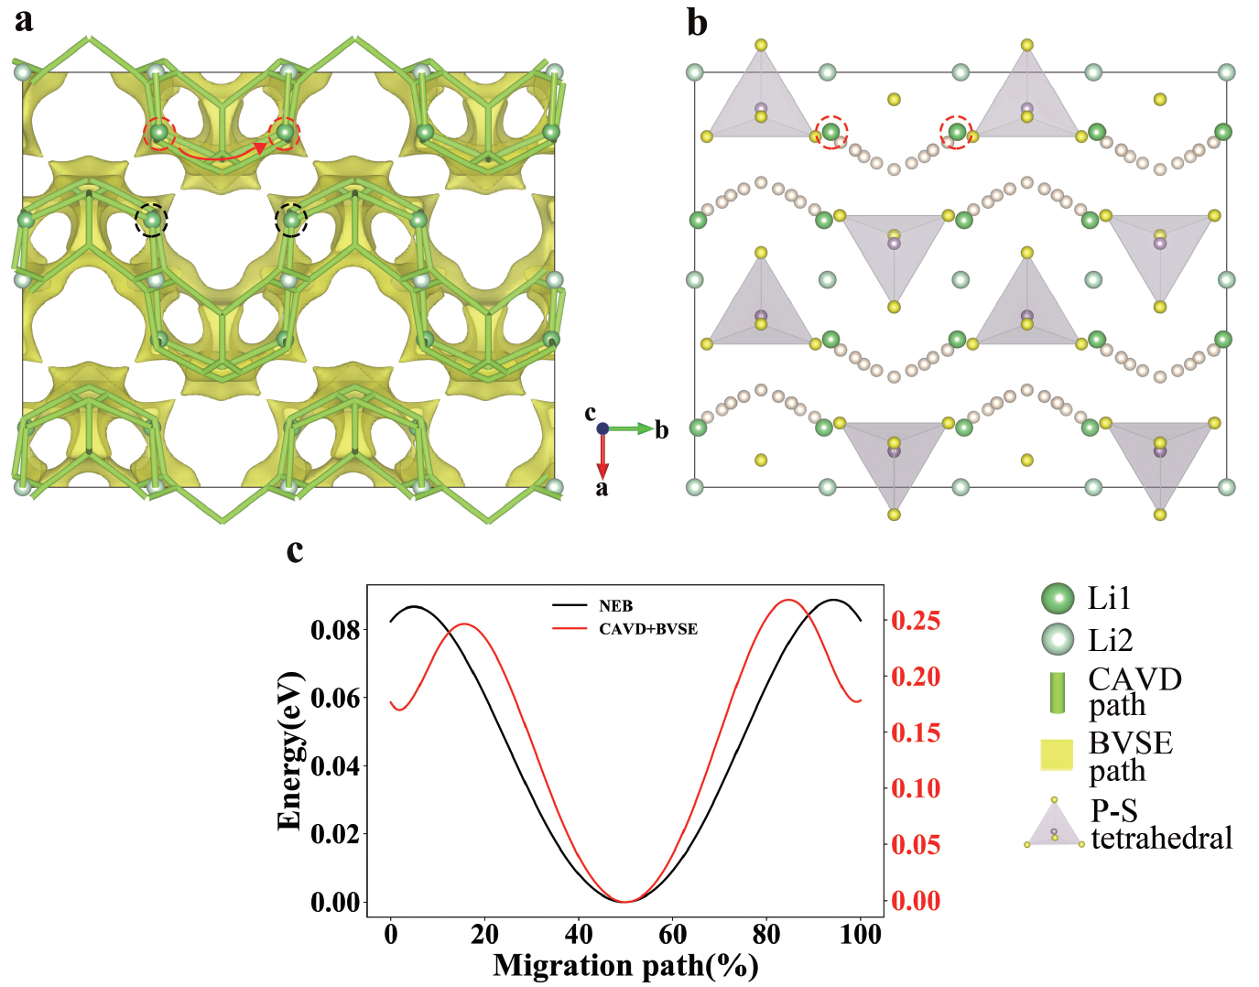
Figure S2. a The green cylinders represents the ion-transport network of β-Li₃PS₄-b calculated using CAVD with the threshold parameter related to radius of Li⁺ to be 0.563 Å. The yellow isosurfaces of β-Li₃PS₄-b are calculated using BVSE with E_{a} of 0.42 eV. The endpoints of the path are highlighted by red dotted circles. b An approximate MEP of endpoints generates other equivalent paths in the super cell. c Energy profiles are calculated using FP-NEB and CAVD + BVSE methods, respectively.

Equivalent paths of β-Li₃PS₄-b
The approximate MEP of Li1–Li1 in β-Li₃PS₄-b calculated by hierarchical calculation is shown in Figure S2. The path passes through two bottlenecks and one interstice. We created two vacancies along the path to eliminate the Coulomb repulsion between Li ions in a 1×2×2 super cell (the two vacancies are highlighted by the black dotted circles in Figure S2a). In this case, the energy profile calculated using the FP-NEB method is virtually consistent with that calculated using the BVSE + CAVD method (Figure S2c).

References
- Thangadurai, V., Adams, S. & Weppner, W. Crystal Structure Revision and Identification of Li⁺ -Ion Migration Pathways in the Garnet-like Li₅La₃M₂O₁₂(M = Nb, Ta) Oxides. Chem. Mater. 16, 2998–3006 (2004).
- Salinas-Sanchez, A., Garcia-Muñoz, J., Rodriguez-Carvajal, J., Saez-Puche, R. & Martinez, J. Structural characterization of R₂BaCuO₅ (R = Y, Lu, Yb, Tm, Er, Ho, Dy, Gd, Eu and Sm) oxides by X-ray and neutron diffraction. J. Solid State Chem. 100, 201–211 (1992).

