Table S1: Summary statistics of lake area, basin climate, and basin human population variables for lakes that increased at least 1% in area for all buffer sizes and years assessed (i.e., 1995, 2000, 2005, 2010, 2015).

Variable | Min. | 1st Qu. | Median | Mean | 3rd Qu. | Max.
total_precip_mm | 0.88 | 455.92 | 613.25 | 704.47 | 773.66 | 7523.79
mean_monthly_precip_mm | 0.08 | 38.20 | 51.32 | 58.94 | 64.66 | 683.98
mean_annual_temp_k | 252.88 | 262.30 | 266.60 | 270.91 | 272.77 | 304.01
pop_sum | 0 | 7.63 | 66.87 | 1.32E+05 | 420.07 | 5.27E+08
seasonal_km2 | 0.00 | 0.00 | 0.01 | 0.07 | 0.05 | 4.08
permanent_km2 | 0.00 | 0.02 | 0.14 | 0.17 | 0.24 | 6.23
total_km2 | 0.00 | 0.09 | 0.19 | 0.24 | 0.30 | 9.01

Table S2: Summary statistics of interannual comparisons for each lake contained in the GLCP with the same lake’s area as defined in HydroLAKES. A value less than one indicates the JRC-derived area as less than the HydroLAKES reported area, whereas a value greater than one indicates the JRC-derived area as greater than the HydroLAKES area. Slightly higher mean deviations are observed in the mid-to-late 1990s in comparison to those after 2000, likely as a result of sparse satellite coverage. Even with these deviations, the data are consistent from year-to-year, giving confidence in interannual consistency for included lakes.
Year | Min. | 1st Qu. | Median | Mean | 3rd Qu. | Max.
1995 | 0.000 | 0.452 | 0.884 | 0.716 | 0.981 | 4.208
1996 | 0.000 | 0.000 | 0.876 | 0.685 | 0.977 | 5.385
1997 | 0.000 | 0.007 | 0.863 | 0.676 | 0.969 | 5.508
1998 | 0.000 | 0.716 | 0.897 | 0.786 | 0.992 | 4.400
1999 | 0.000 | 0.794 | 0.920 | 0.867 | 1.012 | 5.413
2000 | 0.000 | 0.813 | 0.924 | 0.915 | 1.026 | 4.769
2001 | 0.000 | 0.824 | 0.930 | 0.918 | 1.025 | 5.369
2002 | 0.000 | 0.822 | 0.930 | 0.909 | 1.021 | 4.830
2003 | 0.000 | 0.800 | 0.916 | 0.881 | 1.003 | 4.408
2004 | 0.000 | 0.828 | 0.935 | 0.916 | 1.030 | 5.731
2005 | 0.000 | 0.832 | 0.937 | 0.923 | 1.032 | 4.579
2006 | 0.000 | 0.835 | 0.939 | 0.926 | 1.034 | 5.714
2007 | 0.000 | 0.830 | 0.937 | 0.926 | 1.037 | 5.335
2008 | 0.000 | 0.827 | 0.935 | 0.916 | 1.031 | 5.558
2009 | 0.000 | 0.834 | 0.940 | 0.929 | 1.040 | 5.722
2010 | 0.000 | 0.822 | 0.933 | 0.917 | 1.031 | 5.287
2011 | 0.000 | 0.825 | 0.938 | 0.923 | 1.040 | 5.740
2012 | 0.000 | 0.760 | 0.892 | 0.868 | 0.996 | 5.665
2013 | 0.000 | 0.838 | 0.940 | 0.932 | 1.038 | 5.740
2014 | 0.000 | 0.842 | 0.943 | 0.938 | 1.042 | 5.636
2015 | 0.000 | 0.836 | 0.939 | 0.926 | 1.032 | 5.667

Table S3: Summary statistics of interannual comparisons for each lake area contained within the GLCP. A value less than one indicates the latter year’s area as greater than the former year’s area, whereas a value greater than one indicates the latter year’s area as less than the former year’s area. Slightly higher mean deviations are observed in the mid-to-late 1990s in comparison to those after 2000, suggesting remnants from sparse satellite coverage. Even with sparse satellite coverage, the data are consistent from year-to-year, giving confidence in interannual consistency for included lakes.
year:year | Min. | 1st Qu. | Median | Mean | 3rd Qu. | Max.
1995:1996 | 0.000 | 0.973 | 1.000 | 2.059 | 1.026 | 99236.252
1996:1997 | 0.000 | 0.977 | 1.003 | 2.109 | 1.034 | 99831.287
1997:1998 | 0.000 | 0.926 | 0.993 | 1.272 | 1.022 | 55846.619
1998:1999 | 0.000 | 0.926 | 0.989 | 1.875 | 1.013 | 187756.835
1999:2000 | 0.000 | 0.957 | 1.005 | 1.163 | 1.046 | 19800.238
2000:2001 | 0.000 | 0.965 | 0.997 | 1.519 | 1.020 | 40847.822
2001:2002 | 0.000 | 0.975 | 1.000 | 1.832 | 1.021 | 96708.661
2002:2003 | 0.000 | 0.985 | 1.003 | 1.972 | 1.044 | 53962.583
2003:2004 | 0.000 | 0.948 | 0.992 | 1.347 | 1.008 | 26219.437
2004:2005 | 0.000 | 0.982 | 1.000 | 1.325 | 1.019 | 37402.580
2005:2006 | 0.000 | 0.980 | 1.000 | 1.280 | 1.015 | 35725.069
2006:2007 | 0.000 | 0.985 | 1.000 | 1.278 | 1.020 | 52901.691
2007:2008 | 0.000 | 0.984 | 1.000 | 1.562 | 1.023 | 46028.962
2008:2009 | 0.000 | 0.975 | 0.998 | 1.187 | 1.014 | 15288.290
2009:2010 | 0.000 | 0.988 | 1.002 | 1.299 | 1.028 | 16393.431
2010:2011 | 0.000 | 0.975 | 0.998 | 1.330 | 1.013 | 34720.477
2011:2012 | 0.000 | 1.005 | 1.035 | 1.621 | 1.101 | 44756.699
2012:2013 | 0.000 | 0.905 | 0.963 | 1.179 | 0.992 | 13833.978
2013:2014 | 0.000 | 0.988 | 1.000 | 1.064 | 1.007 | 3376.273
2014:2015 | 0.000 | 0.993 | 1.000 | 1.257 | 1.015 | 21168.566

Table S4: Summary statistics of percent differences in GLCP values when created de novo. Despite being created from the same data and source code, floating decimal values may vary due to heterogeneities in processor architecture.
Variable | Min. | 1st Qu. | Median | Mean | 3rd Qu. | Max.
total_precip_mm | -2.26E-13 | 0 | 0 | -2.01E-19 | 0 | 0
mean_monthly_precip_mm | -2.89E-13 | 0 | 0 | -2.37E-20 | 0 | 0
mean_annual_temp_k | -3.53E-13 | 0 | 0 | 3.06E-21 | 0 | 3.94E-13
pop_sum | -8.54E-13 | 0 | 0 | 9.04E-19 | 0 | 8.05E-13
seasonal_km2 | -9.63E-13 | 0 | 0 | -8.31E-20 | 0 | 9.59E-13
permanent_km2 | -7.76E-13 | 0 | 0 | 5.07E-20 | 0 | 9.62E-13
total_km2 | -9.88E-13 | 0 | 0 | -1.37E-20 | 0 | 9.57E-13

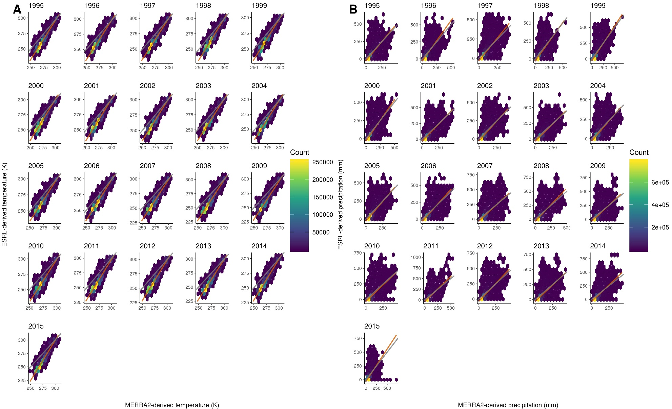
Figure S1: Comparison of basin-level MERRA2-derived climate data with University of Delaware Air Temperature and Precipitation (UDATP)-derived climate data. Each comparison plot contains a grey 1:1 line, an orange linear regression line, and hexbins colored by number of basins. Comparisons for temperature data (A) demonstrate greater congruence between the two datasets at higher temperatures as opposed to lower temperatures. Throughout the time series, discrepancies between UDATP- and MERRA2-derived temperature values remain consistent. Differences between precipitation values (B) vary more than temperature values. Despite precipitation comparisons deviating from the 1:1 line more markedly than temperature, a linear regression line is broadly consistent with the 1:1 line.

