Supplementary information to: EU-Trees4F, a dataset of the future distribution of European tree species

Supplementary material:

- Table S1
- Figure S1
- Table S2
- Figure S2
- Table S3
- Figure S3

Species name | 26 | 28 | 66 | 3106 | MDD
Abies alba | 70.5 | wind.special | n.a. | 68 | 800
Acer campestre | 64.5 | wind.special | 1.1 | 25 | 175
Acer opalus | 77.5 | wind.special | n.a. | 20 | 153
Acer platanoides | 124.3 | wind.special | 1.0 | 35 | 482
Acer pseudoplatanus | 90.6 | wind.special | 1.0 | 40 | 5000
Alnus glutinosa | 1.8 | wind.special | 2.4 | 40 | 500
Alnus incana | 1.2 | wind.special | n.a. | 30 | 494
Arbutus unedo | 4.0 | animal | n.a. | 12 | 1761
Aria_edulis | 61.7 | animal | n.a. | 25 | 949
Betula pendula | 0.3 | wind.special | 0.8 | 30 | 475
Betula pubescens | 0.2 | wind.special | 0.8 | 30 | 475
Borkhausenia_intermedia | 78.7 | animal | n.a. | 15 | 727
Carpinus betulus | 47.3 | wind.special | 1.2 | 30 | 425
Carpinus orientalis | 14.8 | wind.special | n.a. | 20 | 232
Castanea sativa | 2,692.8 | animal | n.a. | 35 | 480
Celtis australis | 195.8 | animal | n.a. | 25 | 1777
Ceratonia siliqua | 196.8 | animal | n.a. | 16 | 648
Corylus avellana | 1192.3 | animal | n.a. | 6 | 15000
Cormus domestica | 22.1 | animal | n.a. | 30 | 1296
Cupressus sempervirens | 7.7 | wind.special | n.a. | 35 | 60
Fagus sylvatica | 208.0 | animal | n.a. | 50 | 32
Fraxinus angustifolia | 56.6 | wind.special | n.a. | 30 | 149
Fraxinus excelsior | 60.2 | wind.special | n.a. | 43 | 725
Fraxinus ornus | 29.9 | wind.special | n.a. | 20 | 146
Juglans regia | 9,071.6 | animal | n.a. | 50 | 498
Juniperus thurifera | 30.5 | animal | n.a. | 20 | 1381
Larix decidua | 6.3 | wind.special | 0.8 | 56 | 171
Laurus nobilis | 374.8 | animal | n.a. | 20 | 1777
Malus sylvestris | 23.4 | animal | n.a. | 19 | 1060
Olea europaea | 249.4 | animal | n.a. | 20 | 1331
Ostrya carpinifolia | 10.6 | animal | n.a. | 20 | 250
Picea abies | 6.4 | wind.special | 1.2 | 70 | 1500
Pinus brutia | 43.6 | wind.special | n.a. | 35 | 376
Pinus cembra | 256.5 | animal | n.a. | 50 | 12000
Pinus halepensis | 20.6 | wind.special | n.a. | 27 | 402
Pinus nigra | 20.1 | animal | n.a. | 50 | 7780
Pinus pinaster | 54.8 | animal | n.a. | 40 | 5615
Pinus pinea | 653.0 | animal | n.a. | 30 | 2814
Pinus sylvestris | 7.9 | wind.special | 0.7 | 50 | 646
Pistacia lentiscus | 20.8 | animal | n.a. | 8 | 1777
Pistacia terebinthus | 37.8 | animal | n.a. | 10 | 1777
Populus alba | 0.1 | wind.special | n.a. | 40 | 1043
Populus nigra | 0.8 | wind.special | 0.3 | 58 | 789
Populus tremula | 0.1 | animal | 0.1 | 40 | 15745
Prunus avium | 183.5 | animal | n.a. | 40 | 2220
Prunus padus | 91.4 | animal | n.a. | 19 | 774
Pyrus communis | 31.0 | animal | n.a. | 30 | 1198
Quercus cerris | 3,683.5 | animal | n.a. | 40 | 472
Quercus coccifera | 1,856.6 | animal | n.a. | 12 | 337
Quercus faginea | 1,805.7 | animal | n.a. | 25 | 1777
Quercus frainetto | 2,309.1 | animal | n.a. | 40 | 1777
Quercus ilex | 1,740.8 | animal | n.a. | 25 | 546
Quercus petraea | 1,523.1 | animal | 6.5 | 45 | 300
Quercus pubescens | 894.0 | animal | n.a. | 25 | 539
Quercus pyrenaica | 1,305.7 | animal | n.a. | 30 | 532
Quercus robur | 3,001.2 | animal | n.a. | 60 | 584
Quercus suber | 3,621.9 | animal | n.a. | 25 | 546
Robinia pseudoacacia | 19.0 | animal | 5.7 | 30 | 1441
Salix alba | 0.1 | wind.special | n.a. | 35 | 984
Sorbus aucuparia | 7.1 | animal | 4.1 | 27 | 1613
Taxus baccata | 58.1 | animal | 5.6 | 29 | 1777
Tilia cordata | 38.4 | wind.none | 1.3 | 43 | 373
Tilia platyphyllos | 97.2 | wind.none | 1.7 | 40 | 373
Torminalis_glaberrima | 74.8 | animal | n.a. | 33 | 907
Ulmus glabra | 10.9 | wind.none | 0.5 | 48 | 350
Ulmus laevis | 6.9 | wind.none | n.a. | 35 | 350
Ulmus minor | 7.0 | wind.none | n.a. | 40 | 350
Table S1. Functional traits used to compute maximum distance dispersal (MDD) as described in Tamme et al. (2014)¹ (see main text for more details). Column field names correpond to “Traits ids” as used in the TRY database² from which the data were collected: 26: seed dry mass; 28: dispersal syndrome, 66: Seed terminal velocity; 3106: plant vegetative height.
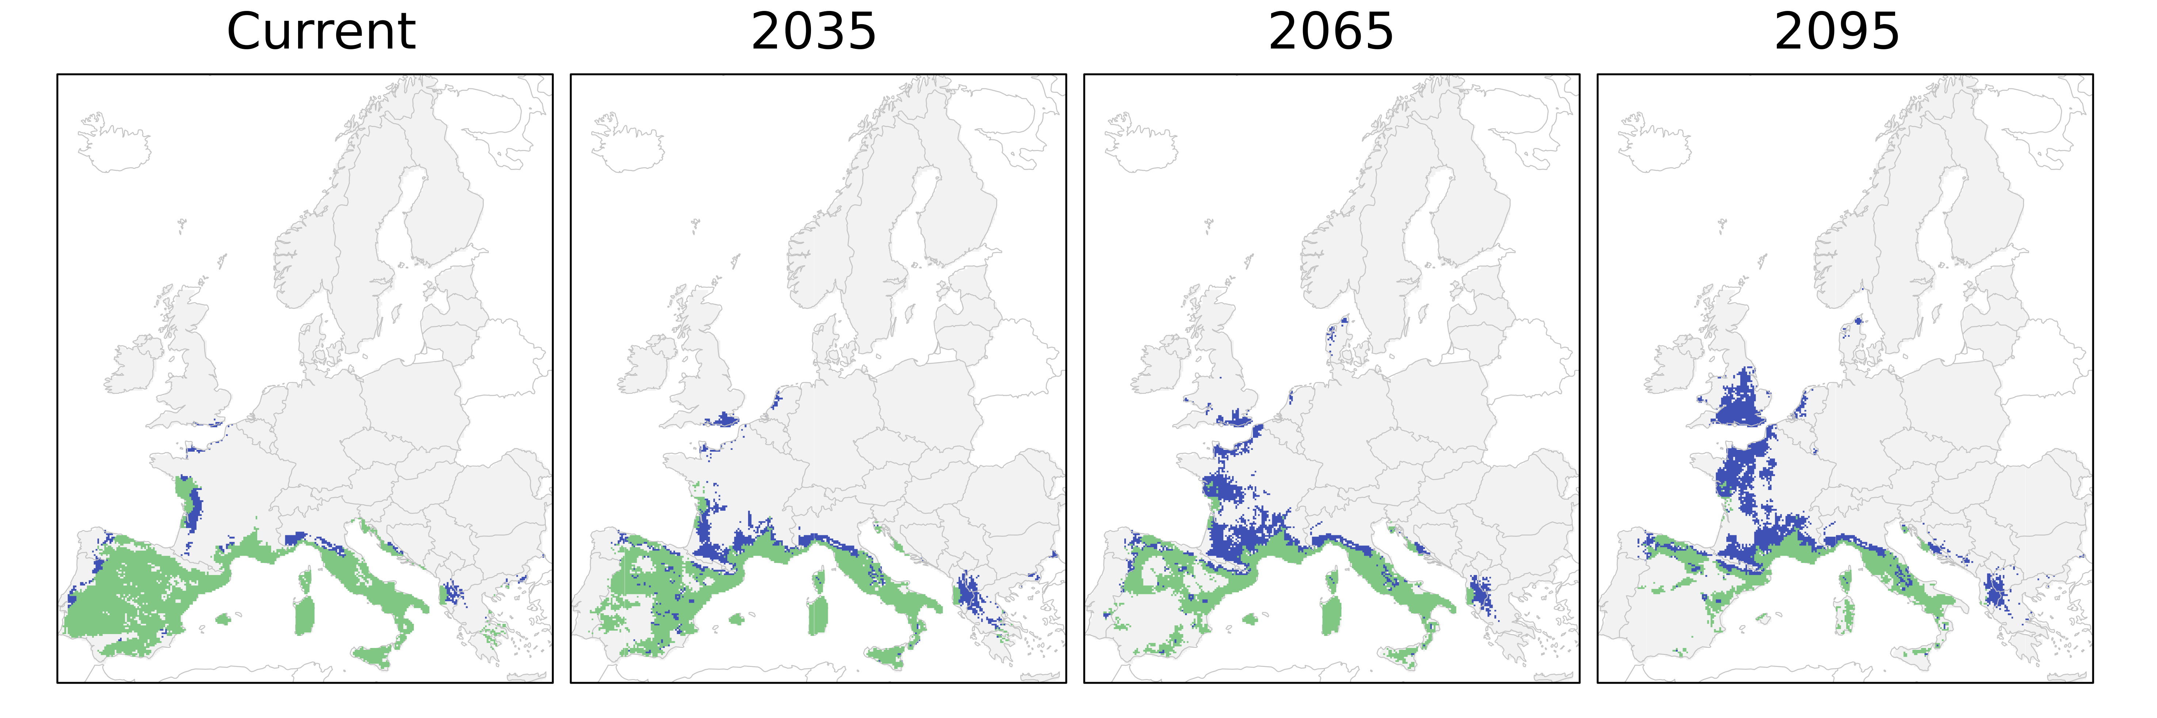
Figure S1. Comparison between the Querus ilex potential suitable range (according to ensemble SDM projections, green + blue) and the expected distribution as simulated using a dispersal model (Migclim, green). The blue area represents the potential suitable range that is not occupied by Quercus ilex due to dispersal limitations. The current distribution is modelled based on Worldclim V1.4 climatology, and future distributions based on EURO-CORDEX data for the scenario RCP 8.5. The targeted species (Quercus ilex) was arbitrarily chosen from the full set of tree species.

Climatic parameters | Meaning
Winter Temperature (tw*) | Mean precipitation of December-January-February
Summer Temperature (ts) | Mean precipitation of June-July-August
Winter Precipitation (pw) | Sum precipitation of December-January-February
Summer Precipitation (ps) | Sum precipitation of June-July-August
Mean Annual Temperature (bio1) | Mean Annual Temperature
Mean Tempearature of the Coldest Month (bio6*) | Mean temperature of the coldest month of the year
Total Annual Precipitation (bio12) | Total Annual Precipitation
Precipiation seasonality (bio15) | Precipitaton seasonality (Coefficient of variation)
Continentality (ci) | Average temperature of the warmest month – average temperature of the coldest month
Climatic Moisture Index (Mi*) | This is the ratio between annual evaportraspiration and potential evapotranspiration
Growing Degree Days above 5°C (GDD5*) | Sum of the mean monthly temperature greater than 5°C, multiplied by the number of days
Soil pH (pH) | Soil pH measured in the top 15 cm of the soil
Organic Carbon Content (occ) | Organic Carbon Content measured in the top 15 cm of the soil
Table S2. Climatic parameters used to drive the species distribution models. See methods for further details. The values with an astheriscs are the environmental parameters excluded after multi collinearity analysis (Figure S2).

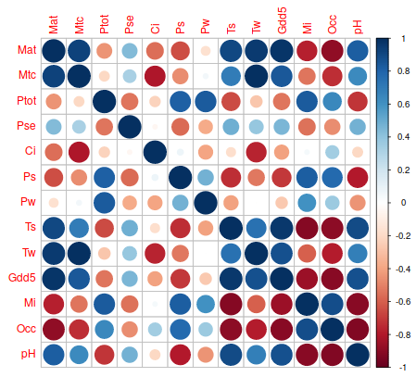
Figure S2. Correlation matrix showing the pairwise Spearman’s correlation coefficient among the environmental parameters considered in the study. Mat = Mean Annual Temperature, Mtc = Mean Tempearature of the Coldest Month*, Ptot = Total Annual Precipitation, Pse = Precipiation seasonality, Ci = Continentality, Ps = Summer precipitation, Pw = Winter precipitation, Ts = Summer temperature*, Tw = Winter temperature, Gdd5 = Growing Degree Days above 5°C*, Mi = Climatic Moisture Index*, Occ = Organic Carbon Content, Ph = Soil pH. The values with an astheriscs are the environmental parameters excluded after multi collinearity analysis.

Institute | RCM | Driving GCM
CLM-Community | CCLM4-8-17 | CNRM-CERFACS-CNRM-CM5
CLM-Community | CCLM4-8-17 | ICHEC-EC-EARTH
CLM-Community | CCLM4-8-17 | MPI-M-MPI-ESM-LR
DMI | HIRHAM5 | ICHEC-EC-EARTH
IPSL-INERIS | WRF331F | IPSL-IPSL-CM5A-MR
KNMI | RACMO22E | ICHEC-EC-EARTH
SMHI | RCA4 | CNRM-CERFACS-CNRM-CM5
SMHI | RCA4 | ICHEC-EC-EARTH
SMHI | RCA4 | IPSL-IPSL-CM5A-MR
SMHI | RCA4 | MOHC-HadGEM2-ES
SMHI | RCA4 | MPI-M-MPI-ESM-LR
Table S3. Regional climate models (RCMs) used to project the species distribution model into the future. The driving Global Circulation Model (GCM) is indicated for each RCM in the right-hand column.

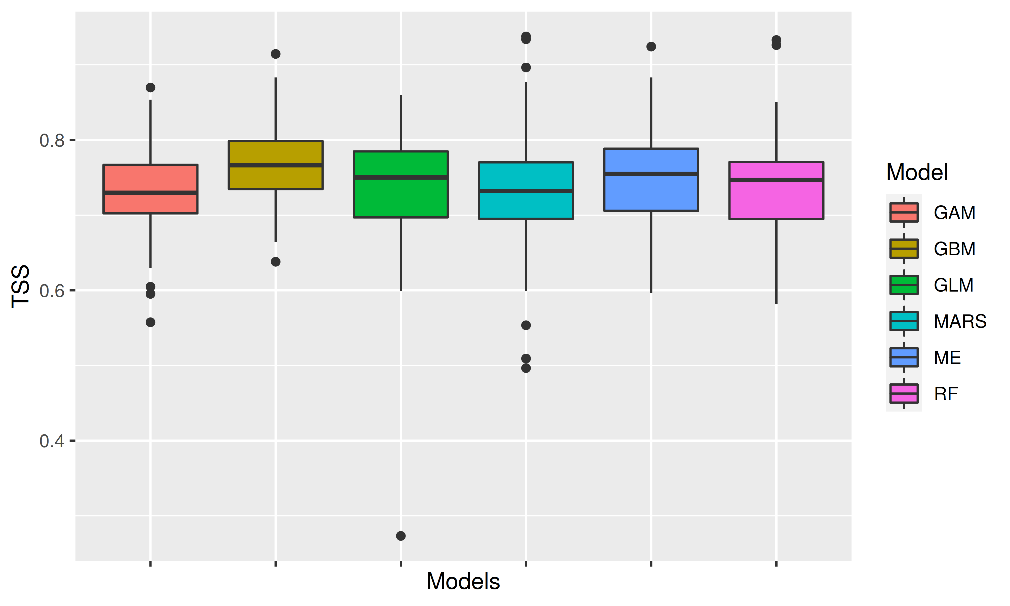
Figure S3. True skills statistics (TSS) scores for the species distribution models used to calculate the consensus ensemble projection: Generalized Additive Model (GAM), Generalized Boosting Model (GBM), Generalized Linear Models (GLM), Multiple Adaptive Regression Splines (MARS), Maximum Entropy - Maxent (ME), Random Forest (RF). Results are shown for the entire pool of tree species.

References

1. Tamme, R. et al. Predicting species’ maximum dispersal distances from simple plant traits. Ecology 95, 505–513 (2014).
2. Kattge, J. et al. TRY plant trait database–enhanced coverage and open access. Glob. Change Biol. 26, 119–188 (2020).

