Supplementary information of The China plant trait database version 2

Supplementary Tables 1-5
Supplementary Figures 1-4

Supplementary Table 1: Photosynthetic traits
Field name | Definition | Units | Number of observations | Min | Median | Max
Sample id | unique identifier for each sample | NA | 1505
Amax_Photo | rate of photosynthesis under light and CO2 saturation | umol/m2/s | 826 | 0.98 | 14.73 | 58.55
Amax_Gs | stomatal conductance to water at which Amax was measured | mol/m2/s | 826 | 0.0043 | 0.10 | 2.44
Amax_Ci:Ca | ratio of internal to external CO2 when Amax was measured | unitless | 826 | 0.14 | 0.84 | 0.99
Amax_E | transpiration rate when Amax was measured | mmol/m2/s | 826 | 0.00057 | 1.57 | 12.66
Amax_VPD | the vapour pressure deficit at which Amax was measured | kpa | 826 | 0.12 | 1.23 | 3.01
Amax_Tleaf | the temperature at which Amax was measured | ˚C | 826 | 11.88 | 24.92 | 36.00
Amax_CO2 | the CO2 level at which Amax was measured | ppm | 826 | 1454.80 | 1957.73 | 2002.79
Asat_Photo | rate of photosynthesis under light saturation | umol/m2/s | 1020 | 0.20 | 7.19 | 47.13
Asat_Gs | stomatal conductance to water at which Asat was measured | mol/m2/s | 801 | 0.0049 | 0.14 | 2.46
Asat_Ci:Ca | ratio of internal to external CO2 when Asat was measured | unitless | 801 | 0.24 | 0.78 | 0.99
Asat_E | transpiration rate when Asat was measured | mmol/m2/s | 801 | 0.28 | 1.97 | 13.33
Asat_VPD | the vapour pressure deficit at which Amax was measured | kpa | 801 | 0.14 | 1.20 | 3.02
Asat_Tleaf | the temperature at which Asat was measured | ˚C | 977 | 11.17 | 25.00 | 33.27
Asat_CO2 | the CO2 level at which Asat was measured | ppm | 976 | 371.70 | 393.96 | 404.69
Vcmax | the maximum capacity of carboxylation | umol/m2/s | 981 | 0.43 | 31.21 | 174.63
Jmax | the maximum capacity of electron-transport | umol/m2/s | 826 | 5.11 | 69.62 | 462.46
Fv:Fm | potential rate of photosynthetic electron transport as measured by chlorophyll fluorescence | unitless | 475 | 0.50 | 0.79 | 0.87
QY | actual rate of photosynthetic electron transport as measured by chlorophyll fluorescence | umol/m2/s | 477 | 0.14 | 0.73 | 0.82
flagged | traits with some potential problems or unrealistic values for each sample

Supplementary Table 2: Morphometric traits
Field name | Definition | Category | Number of observations
Sample ID | unique identifier for each sample | NA | 2415
Leaf texture | description of the texture of a leaf, particularly as related to flexibility and/or toughness as distinct from surface characteristics | fleshy | 2336
Leaf texture |  | papery | 2336
Leaf texture |  | malacophyll | 2336
Leaf texture |  | leathery | 2336
Leaf texture |  | coriaceous | 2336
Leaf texture |  | rigidly coriaceous | 2336
Leaf colour -adaxial | the colour of the upper surface of the leaf, i.e. the surface facing the stem | bright green | 2356
Leaf colour -adaxial |  | green | 2356
Leaf colour -adaxial |  | dark green | 2356
Leaf colour -adaxial |  | mottled green | 2356
Leaf colour -adaxial |  | pale green | 2356
Leaf colour -adaxial |  | glaucous | 2356
Leaf colour -adaxial |  | yellow-green | 2356
Leaf colour -adaxial |  | grey-green | 2356
Leaf colour -adaxial |  | yellow | 2356
Leaf colour -adaxial |  | silvery-grey | 2356
Leaf colour - abaxial | the colour of the lower surface of the leaf, i.e. the surface not facing the stem | bright green | 2357
Leaf colour - abaxial |  | green | 2357
Leaf colour - abaxial |  | dark green | 2357
Leaf colour - abaxial |  | mottled green | 2357
Leaf colour - abaxial |  | pale green | 2357
Leaf colour - abaxial |  | brown-green | 2357
Leaf colour - abaxial |  | glaucous | 2357
Leaf colour - abaxial |  | yellow-green | 2357
Leaf colour - abaxial |  | grey-green | 2357
Leaf colour - abaxial |  | brown | 2357
Leaf colour - abaxial |  | yellow-brown | 2357
Leaf colour - abaxial |  | pale brown | 2357
Leaf colour - abaxial |  | purple | 2357
Leaf colour - abaxial |  | reddish-green | 2357
Leaf colour - abaxial |  | white | 2357
Leaf colour - abaxial |  | yellow | 2357
Leaf colour - abaxial |  | silvery-grey | 2357
Leaf size | categorical classification of typical leaf size as estimated using the modified CLAMP scheme | pico | 2330
Leaf size |  | lepto | 2330
Leaf size |  | nano | 2330
Leaf size |  | micro | 2330
Leaf size |  | noto | 2330
Leaf size |  | meso | 2330
Leaf size |  | macro | 2330
Leaf thickness | categorical classification of typical leaf thickness, approximately measured | thick (>2mm) | 2274
Leaf thickness |  | medium (0.5-2mm) | 2274
Leaf thickness |  | thin (<0.5mm) | 2274
Leaf orientation | categorical description of the angle of the individual leaf with respect to the stem | erect | 2316
Leaf orientation |  | semi-erect | 2316
Leaf orientation |  | patent | 2316
Leaf orientation |  | pendulous | 2316
Leaf orientation |  | reclinate | 2316
Leaf display | organisation of leaves within the individual plant canopy | 2D | 2303
Leaf display | organisation of leaves within the individual plant canopy | 3D | 2303
Leaf shape | description of the shape of the leaf blade (or leaflet in the case of compound leaves) shape | acicular | 2204
Leaf shape |  | cordate | 2204
Leaf shape |  | deltoid | 2204
Leaf shape |  | elliptic | 2204
Leaf shape |  | falcate | 2204
Leaf shape |  | hastate | 2204
Leaf shape |  | lanceolate | 2204
Leaf shape |  | linear | 2204
Leaf shape |  | lyrate | 2204
Leaf shape |  | obcordate | 2204
Leaf shape |  | oblanceolate | 2204
Leaf shape |  | oblong | 2204
Leaf shape |  | obovate | 2204
Leaf shape |  | orbicular | 2204
Leaf shape |  | oval | 2204
Leaf shape |  | ovate | 2204
Leaf shape |  | reniform | 2204
Leaf shape |  | runcinate | 2204
Leaf shape |  | sagittate | 2204
Leaf shape |  | spatulate | 2204
Leaf shape |  | cordate-lanceolate | 2204
Leaf shape |  | triangular | 2204
Leaf shape |  | elliptic-lanceolate | 2204
Leaf shape |  | linear-lanceolate | 2204
Leaf shape |  | ovate-lanceolate | 2204
Leaf shape |  | obovate-lanceolate | 2204
Leaf shape |  | ovate-bipinnate | 2204
Leaf shape |  | fishtail | 2204
Leaf shape |  | palmate | 2204
Leaf shape |  | palmatifid | 2204
Leaf shape |  | pinnatifid | 2204
Leaf shape |  | rhomboid | 2204
Leaf shape |  | tulip-shaped | 2204
Leaf shape |  | trilobite | 2204
Leaf shape |  | quinquelobate | 2204
Leaf shape |  | septemlobate | 2204
Leaf margin | description of the nature of the margin of the leaf of leaflet | entire | 2277
Leaf margin |  | finely toothed | 2277
Leaf margin |  | toothed | 2277
Leaf margin |  | crenate | 2277
Leaf margin |  | crenulate | 2277
Leaf margin |  | lobed | 2277
Leaf margin |  | dissected | 2277
Leaf margin |  | highly dissected | 2277
Leaf margin |  | incised | 2277
Leaf hairs | indication of presence or absence of hairs on the leaf; if hairs are present, the location is also recorded | adaxial | 2260
Leaf hairs |  | abaxial | 2260
Leaf hairs |  | on midrib or veins | 2260
Leaf hairs |  | marginal | 2260
Leaf hairs |  | basal | 2260
Leaf hairs |  | no | 2260
Leaf pubescence | indication of presence or absence of very fine hairs or pubescence on the leaf; if present, the location is also recorded | adaxial | 2260
Leaf pubescence |  | abaxial | 2260
Leaf pubescence |  | on midrib or veins | 2260
Leaf pubescence |  | marginal | 2260
Leaf pubescence |  | no | 2260
Leaf pruinosity | indication of presence or absence of a bloom or powdery secretion that can be removed mechanically on the leaf; if present, the location is also recorded | adaxial | 2260
Leaf pruinosity |  | abaxial | 2260
Leaf pruinosity |  | on midrib or veins | 2260
Leaf pruinosity |  | no | 2260
Leaf rugose | indication of presence or absence of surface roughness caused by surface protrusions on a leaf; if present, the location is also recorded | adaxial | 2282
Leaf rugose |  | abaxial | 2282
Leaf rugose |  | on midrib or veins | 2282
Leaf rugose |  | no | 2282
Leaf waxy | indication of whether there is a continuous waxy deposit on the surface of the leaf. A distinction was made in the field between waxy and glossy surfaces, presumed to reflect differences in the structure of this epicuticular layer | yes | 2282
Leaf waxy |  | glossy | 2282
Leaf waxy |  | no | 2282
Leaf hypostomatic | indication of whether stomata were present only on the abaxial side of the leaf | yes | 2282
Leaf hypostomatic |  | no | 2282
Leaf revolute | indication of whether the leaf margin was curled downwards toward the underside of the leaf. A distinction was made between leaves that showed slight or pronounced curling | yes | 2282
Leaf revolute |  | slightly | 2282
Leaf revolute |  | no | 2282
Leaf involute | indication of whether the leaf margin was curled toward the upperside of the leaf. A distinction was made between leaves that showed slight or pronounced curling | yes | 2282
Leaf involute |  | slightly | 2282
Leaf involute |  | no | 2282
Leaf aromatic | indication of whether the leaves contain aromatic compounds, assessed from the smell of the leaves when broken in the field | yes | 2282
Leaf aromatic |  | no | 2282
Leaf fetid | indication of whether the leaves have a rank or unpleasant smell when broken in the field | yes | 2282
Leaf fetid |  | no | 2282
Leaf driptip | presence of an elongated, downward oriented extension at the tip of the leaf or leaflet blade, assumed to relate to removal of excess water | yes | 2282
Leaf driptip |  | no | 2282
Leaf terminal notch | presence of a notch or narrow cleft at the tip of the leaf or leaflet blade | Yes | 2282
Leaf terminal notch |  | no
Leaf surface patterning | leaves with marked surface structures | yes | 2282
Leaf surface patterning | leaves with marked surface structures | no | 2282
Leaf surface patterning | leaves with marked surface structures | slight | 2282
Leaf succulence | indication of whether the leaf stores water, assessed from whether the leaves are thick and fleshy and whether water is released when the leaf is broken. A distinction is made in the field between slightly succulent (swollen) leaves and truly succulent leaves | yes | 2282
Leaf succulence |  | no | 2282
Leaf spines | presence of leaf spines; if spines are present, the location is also recorded | no | 2284
Leaf spines |  | adaxial | 2284
Leaf spines |  | abaxial | 2284
Leaf spines |  | on midrib or veins | 2284
Leaf spines |  | marginal | 2284
Leaf spines |  | terminal | 2284
Leaf thorns | presence of leaf thorns | no | 2284
Leaf thorns | presence of leaf thorns | yes | 2284
Stem form | description of the appearance of the stem, in terms of shape, and/or the presence of protuberances, attachments, or markings | non-distinctive | 2153
Stem form |  | triangular | 2153
Stem form |  | quadrangular | 2153
Stem form |  | hectangular | 2153
Stem form |  | winged | 2153
Stem form |  | ridged | 2153
Stem form |  | corky | 2153
Stem form |  | leaves attached directly | 2153
Stem form |  | deciduous sheath | 2153
Stem form |  | white lines | 2153
Stem form |  | white spots | 2153
Stem colour | description of the base colour of the stem | black | 2152
Stem colour | description of the base colour of the stem | dark brown | 2152
Stem colour | description of the base colour of the stem | brown | 2152
Stem colour | description of the base colour of the stem | pale brown | 2152
Stem colour | description of the base colour of the stem | green-brown | 2152
Stem colour | description of the base colour of the stem | grey-brown | 2152
Stem colour | description of the base colour of the stem | red-brown | 2152
Stem colour | description of the base colour of the stem | purple-brown | 2152
Stem colour | description of the base colour of the stem | dark green | 2152
Stem colour | description of the base colour of the stem | green | 2152
Stem colour | description of the base colour of the stem | pale green | 2152
Stem colour | description of the base colour of the stem | green-purple | 2152
Stem colour | description of the base colour of the stem | yellow-green | 2152
Stem colour | description of the base colour of the stem | red-green | 2152
Stem colour | description of the base colour of the stem | glaucous | 2152
Stem colour | description of the base colour of the stem | silver-grey | 2152
Stem colour | description of the base colour of the stem | grey | 2152
Stem colour | description of the base colour of the stem | yellow | 2152
Stem colour | description of the base colour of the stem | purple | 2152
Stem colour | description of the base colour of the stem | red | 2152
Stem photo | indication of whether the stem is photosynthetic or not | yes | 2153
Stem photo | indication of whether the stem is photosynthetic or not | no | 2153
Stem hairy | indication of presence of hairs on the stem; if present, the density is also recorded | yes | 2152
Stem hairy |  | no | 2152
Stem hairy |  | finely | 2152
Stem pubescent | indication of presence of very fine hairs or pubescence on the stem; if present, the density is also records | yes | 2151
Stem pubescent |  | no | 2151
Stem pubescent |  | finely | 2151
Stem pruinose | indication of presence of a bloom or powdery secretion that can be removed mechanically on the leaf | yes | 2152
Stem pruinose |  | no | 2152
Stem rugose | indication of presence of a rough surface caused by protuberances | yes | 1860
Stem rugose |  | no | 1860
Stem succulent | indication of presence of water-retention in the stem | yes | 2152
Stem succulent | indication of presence of water-retention in the stem | no | 2152
Stem spines | presence of spines on the stem | yes | 2152
Stem spines | presence of spines on the stem | no | 2152
Stem thorns | presence of thorns on the stem | yes | 2152
Stem thorns | presence of thorns on the stem | no | 2152
Bark deciduous | indication of whether the bark is shed on a regular basis; bark shedding as a result of specific damage (e.g. insect attack, fire damage) is not taken into consideration. If the bark is deciduous, the way in which bark is detached is recorded | non-deciduous | 984
Bark deciduous |  | chunk | 984
Bark deciduous |  | strip | 984
Bark deciduous |  | fissured | 984
Spines elsewhere | presence of spines on the trunk or major branches | yes | 2142
Spines elsewhere | presence of spines on the trunk or major branches | no | 2142

Supplementary Table 3: High-resolution climate
Field name | Definition | Units
Site ID | unique identifier for each site | NA
Lat_grid | latitude of the extracted 1 km gridded cell | decimal degrees
Lon_grid | longitude of the extracted 1 km gridded cell | decimal degrees
Temp Jan | mean January temperature as obtained from the 1 km gridded climatology | ˚C
Temp Feb | mean February temperature as obtained from the 1 km gridded climatology | ˚C
Temp Mar | mean March temperature as obtained from the 1 km gridded climatology | ˚C
Temp April | mean April temperature as obtained from the 1 km gridded climatology | ˚C
Temp May | mean May temperature as obtained from the 1 km gridded climatology | ˚C
Temp June | mean June temperature as obtained from the 1 km gridded climatology | ˚C
Temp July | mean July temperature as obtained from the 1 km gridded climatology | ˚C
Temp Aug | mean August temperature as obtained from the 1 km gridded climatology | ˚C
Temp Sep | mean September temperature as obtained from the 1 km gridded climatology | ˚C
Temp Oct | mean October temperature as obtained from the 1 km gridded climatology | ˚C
Temp Nov | mean November temperature as obtained from the 1 km gridded climatology | ˚C
Temp Dec | mean December temperature as obtained from the 1 km gridded climatology | ˚C
Prec Jan | mean January precipitation as obtained from the 1 km gridded climatology | mm
Prec Feb | mean February precipitation as obtained from the 1 km gridded climatology | mm
Prec Mar | mean March precipitation as obtained from the 1 km gridded climatology | mm
Prec April | mean April precipitation as obtained from the 1 km gridded climatology | mm
Prec May | mean May precipitation as obtained from the 1 km gridded climatology | mm
Prec June | mean June precipitation as obtained from the 1 km gridded climatology | mm
Prec July | mean July precipitation as obtained from the 1 km gridded climatology | mm
Prec Aug | mean August precipitation as obtained from the 1 km gridded climatology | mm
Prec Sep | mean September precipitation as obtained from the 1 km gridded climatology | mm
Prec Oct | mean October precipitation as obtained from the 1 km gridded climatology | mm
Prec Nov | mean November precipitation as obtained from the 1 km gridded climatology | mm
Prec Dec | mean December precipitation as obtained from the 1 km gridded climatology | mm
Sunh Jan | mean January sunshine hours as obtained from the 1 km gridded climatology and expressed as a percentage of total possible sunshine hours | %
Sunh Feb | mean February sunshine hours as obtained from the 1 km gridded climatology and expressed as a percentage of total possible sunshine hours | %
Sunh Mar | mean March sunshine hours as obtained from the 1 km gridded climatology and expressed as a percentage of total possible sunshine hours | %
Sunh April | mean April sunshine hours as obtained from the 1 km gridded climatology and expressed as a percentage of total possible sunshine hours | %
Sunh May | mean May sunshine hours as obtained from the 1 km gridded climatology and expressed as a percentage of total possible sunshine hours | %
Sunh June | mean June sunshine hours as obtained from the 1 km gridded climatology and expressed as a percentage of total possible sunshine hours | %
Sunh July | mean July sunshine hours as obtained from the 1 km gridded climatology and expressed as a percentage of total possible sunshine hours | %
Sunh Aug | mean August sunshine hours as obtained from the 1 km gridded climatology and expressed as a percentage of total possible sunshine hours | %
Sunh Sep | mean September sunshine hours as obtained from the 1 km gridded climatology and expressed as a percentage of total possible sunshine hours | %
Sunh Oct | mean October sunshine hours as obtained from the 1 km gridded climatology and expressed as a percentage of total possible sunshine hours | %
Sunh Nov | mean November sunshine hours as obtained from the 1 km gridded climatology and expressed as a percentage of total possible sunshine hours | %
Sunh Dec | mean December sunshine hours as obtained from the 1 km gridded climatology and expressed as a percentage of total possible sunshine hours | %
MTCO | mean temperature of the coldest month | ˚C
MAT | mean annual temperature | ˚C
MI | ratio of annual actual evapotranspiration to annual precipitation | unitless
alpha | ratio of actual to equilibrium evapotranspiration | unitless
GDD0 | growing degree days above a baseline of 0°C | ˚C days
mGDD0 | daily mean temperature during the growing season when temperatures are >0°C | ˚C
PAR0 | total annual photosynthetically active radiation | mol photon m^{–2}
mPAR0 | daily mean photosynthetically active radiation during the growing season when temperatures are >0°C | mol photon m^{–2}
Prec timing | the timing of peak precipitation, expressed as a vector where January 1st is arbitrarily set to an angle of 0° | unitless
Prec season | the seasonality of precipitation, where 0 means that precipitation is equally distributed in every month of the year and 1 means that precipitation is concentrated in one month of the year | unitless
MMP | mean monthly precipitation | mm
MAP | mean annual precipitation | mm

Supplementary Table 4: Gongga local climate

Field name | Definition | Units
Site ID | unique identifier for each site | NA
Temp Jan | mean January temperature obtained by extrapolating from local meteorological stations and flux sites | ˚C
Temp Feb | mean February temperature as obtained from the 1 km gridded climatology | ˚C
Temp Mar | mean March temperature obtained by extrapolating from local meteorological stations and flux sites | ˚C
Temp April | mean April temperature obtained by extrapolating from local meteorological stations and flux sites | ˚C
Temp May | mean May temperature obtained by extrapolating from local meteorological stations and flux sites | ˚C
Temp June | mean June temperature obtained by extrapolating from local meteorological stations and flux sites | ˚C
Temp July | mean July temperature obtained by extrapolating from local meteorological stations and flux sites | ˚C
Temp Aug | mean August temperature obtained by extrapolating from local meteorological stations and flux sites | ˚C
Temp Sep | mean September temperature obtained by extrapolating from local meteorological stations and flux sites | ˚C
Temp Oct | mean October temperature obtained by extrapolating from local meteorological stations and flux sites | ˚C
Temp Nov | mean November temperature obtained by extrapolating from local meteorological stations and flux sites | ˚C
Temp Dec | mean December temperature obtained by extrapolating from local meteorological stations and flux sites | ˚C
Prec Jan | mean January precipitation obtained by extrapolating from local meteorological stations and flux sites | mm
Prec Feb | mean February precipitation obtained by extrapolating from local meteorological stations and flux sites | mm
Prec Mar | mean March precipitation obtained by extrapolating from local meteorological stations and flux sites | mm
Prec April | Mean April precipitation obtained by extrapolating from local meteorological stations and flux sites | mm
Prec May | mean May precipitation obtained by extrapolating from local meteorological stations and flux sites | mm
Prec June | mean June precipitation obtained by extrapolating from local meteorological stations and flux sites | mm
Prec July | mean July precipitation obtained by extrapolating from local meteorological stations and flux sites | mm
Prec Aug | Mean August precipitation obtained by extrapolating from local meteorological stations and flux sites | mm
Prec Sep | mean September precipitation obtained by extrapolating from local meteorological stations and flux sites | mm
Prec Oct | mean October precipitation obtained by extrapolating from local meteorological stations and flux sites | mm
Prec Nov | mean November precipitation obtained by extrapolating from local meteorological stations and flux sites | mm
Prec Dec | mean December precipitation obtained by extrapolating from local meteorological stations and flux sites | mm
Sunh Jan | mean January sunshine hours obtained by extrapolating from local meteorological stations and flux sites and expressed as a percentage of total possible sunshine hours | %
Sunh Feb | mean February sunshine hours obtained by extrapolating from local meteorological stations and flux sites and expressed as a percentage of total possible sunshine hours | %
Sunh Mar | mean March sunshine hours obtained by extrapolating from local meteorological stations and flux sites and expressed as a percentage of total possible sunshine hours | %
Sunh April | mean April sunshine hours obtained by extrapolating from local meteorological stations and flux sites and expressed as a percentage of total possible sunshine hours | %
Sunh May | mean May sunshine hours obtained by extrapolating from local meteorological stations and flux sites and expressed as a percentage of total possible sunshine hours | %
Sunh June | mean June sunshine hours obtained by extrapolating from local meteorological stations and flux sites and expressed as a percentage of total possible sunshine hours | %
Sunh July | mean July sunshine hours obtained by extrapolating from local meteorological stations and flux sites and expressed as a percentage of total possible sunshine hours | %
Sunh Aug | mean August sunshine hours obtained by extrapolating from local meteorological stations and flux sites and expressed as a percentage of total possible sunshine hours | %
Sunh Sep | mean September sunshine hours obtained by extrapolating from local meteorological stations and flux sites and expressed as a percentage of total possible sunshine hours | %
Sunh Oct | mean October sunshine hours obtained by extrapolating from local meteorological stations and flux sites and expressed as a percentage of total possible sunshine hours | %
Sunh Nov | mean November sunshine hours obtained by extrapolating from local meteorological stations and flux sites and expressed as a percentage of total possible sunshine hours | %
Sunh Dec | mean December sunshine hours obtained by extrapolating from local meteorological stations and flux sites and expressed as a percentage of total possible sunshine hours | %
MTCO | mean temperature of the coldest month | ˚C
MAT | mean annual temperature | ˚C
MI | ratio of annual actual evapotranspiration to annual precipitation | unitless
alpha | ratio of actual to equilibrium evapotranspiration | unitless
GDD0 | growing degree days above a baseline of 0°C | ˚C days
mGDD0 | daily mean temperature during the growing season when temperatures are >0°C | ˚C
PAR0 | total annual photosynthetically active radiation | mol photon m^{–2}
mPAR0 | daily mean photosynthetically active radiation during the growing season when temperatures are >0°C | mol photon m^{–2}
Prec timing | the timing of peak precipitation, expressed as a vector where January 1st is arbitrarily set to an angle of 0° | unitless
Prec season | the seasonality of precipitation, where 0 means that precipitation is equally distributed in every month of the year and 1 means that precipitation is concentrated in one month of the year | unitless
MMP | mean monthly precipitation | mm
MAP | mean annual precipitation | mm

Supplementary Table 5 The crib sheet used for recording leaf morphological traits in the field
Site No: | Site name:
Elev: | Lat: |  |  | Long:
Species:
Gymnosperm yes/no |  | Monocot yes/no
Life form | tree, small tree,  low to high shrub, erect dwarf shrub, prostrate dwarf shrub, trailing shrub, liana, climber,  forb, cushion forb, rosette forb, graminoid, bamboo,  cycad, geophyte, stem succulent, succulent,  pteridophyte, epiphyte, parasite
Plant phenology | annual, biennial, perennial
Leaf type | aphyllous, broad, needle, scale
Leaf phenology  (only woody plants) | evergreen, deciduous, semi-deciduous, leaf-exchanger
Leaf texture | fleshy, papery, malacophyll, leathery, coriaceous, rigidly coriaceous
Leaf colour- adaxial  (upper surface) | bright green, green, dark green, mottled green, pale green,  glaucous, yellow-green, yellow, silvery-grey, grey-green
Leaf colour- abaxial  (lower surface) | bright green, green, dark green, mottled green, pale green, brown-green, reddish-green, glaucous, yellow-green, yellow-brown, pale brown, brown, purple, white, yellow, silvery-grey, grey-green
Leaf size | pico (<5mm²), lepto (5-25mm²), nano (25-250mm²), micro (250-2000mm²), noto (2000-4500mm²), meso (4500-20000mm²), macro (20000-150000mm²)
Leaf thickness | Thick, medium, thin
Leaf orientation | erect, semi-erect, patent, pendulous, reclinate
Leaf display | 2D, 3D
Leaf shape  (nb describes overall outline of leaf) | Acicular, cordate, deltoid, elliptic, falcate, hastate, lanceolate, linear, lyrate, obcordate, oblanceolate, oblong, obovate, orbicular, oval, ovate, reniform, runcinate, sagittate, spatulate, triangular  cordate-lanceolate, elliptic-lanceolate, linear-lanceolate, ovate-lanceolate, ovate-bipinnate,  obovate-lanceolate, fishtail,  palmate, palmatifid, pinnatifid, rhomboid, tulip-shaped, trilobate, quinquelobate, septemlobate
Leaf margin | entire, finely toothed, toothed, crenate, crenulate, lobed, dissected,  highly dissected, incised
Leaf hairiness | adaxial, abaxial, midrib/veins, marginal, basal NO
Leaf pubescent | adaxial, abaxial, midrib/veins, marginal NO
Leaf pruinose | adaxial, abaxial, midrib/veins NO
Leaf rugose | adaxial, abaxial, midrib/veins NO
Leaf waxy | Yes No Glossy
Leaf hypostomatic | Yes No
Leaf revolute  (turned. under, ∩) | Yes No Slightly
Leaf involute  (turned upwards, ∪) | Yes No Slightly
Leaf aromatic | Yes No
Leaf fetid | Yes No
Leaf drip-tip | Yes No
Leaf terminal notch | Yes No
Leaf surface patterning | Yes No Slight
Leaf succulence | Yes No
Leaf spines | adaxial, abaxial, midrib/veins, marginal, terminal NO
Leaf thorn | Yes No
Stem form | non-distinctive, triangular, quadrangular, hectangular, winged, ridged, corky, leaves attached directly, deciduous sheath, white lines, white spots
Stem colour | black, dark brown, brown, pale brown, green-brown, grey-brown,  red-brown, dark green, green, pale green, green-purple, yellow-green, purple-brown,  red-green, glaucous, silver-grey, grey, yellow, purple, red
Stem photo | Yes No
Stem hairy | Yes No finely
Stem pubescent | Yes No finely
Stem pruinose | Yes No
Stem succulence | Yes No
Stem spiny | Yes No |  | Spines elsewhere |  | Yes No
Stem thorns | Yes No |  | Thorns elsewhere |  | Yes No
Bark | non-deciduous, chunk, strip, fissured

Supplementary Figure 1: The illustrating examples of leaf marginal types. Noticably, the following types are described in the crib sheet differently: combine serrate, doubly serrate, dentate (= toothed), denticulate and serrulate (= finely toothed), sinuate (= crenate), lacerate (= dissected), laciniate (= highly dissected). Cliniate, involute and involute are not recorded as leaf marginal trait in the crib sheet.
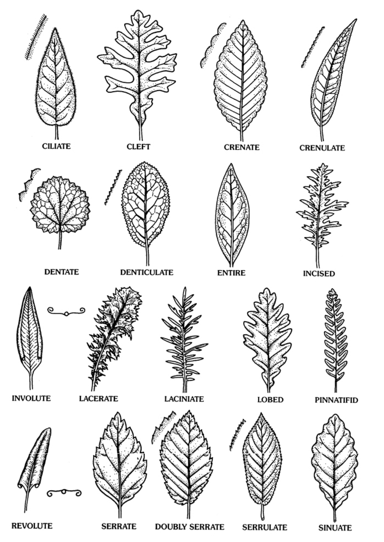
Supplementary Figure 2: The illustrating examples of leaf shape types.
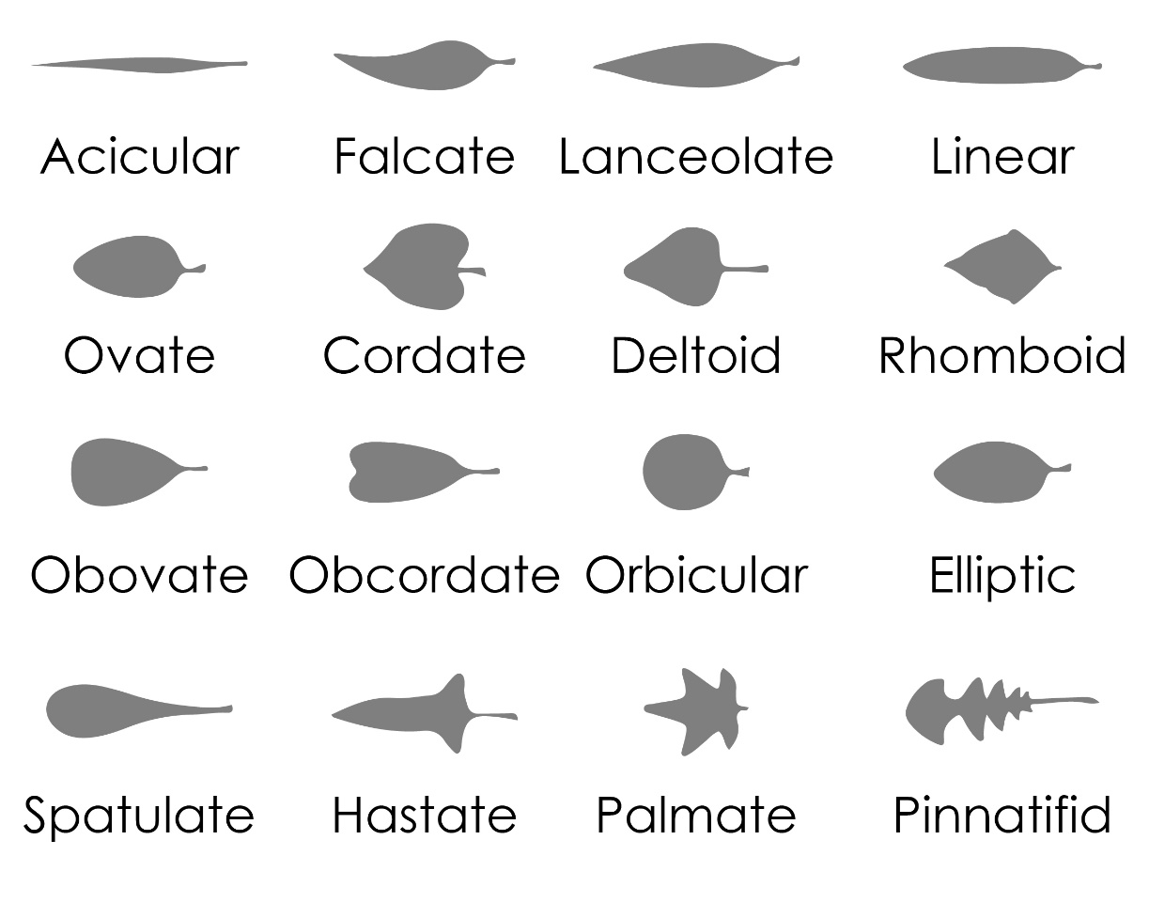

Supplementary Figure 3: The CLAMP leaf size template (http://clamp.ibcas.ac.cn/CLAMP_Leaf_Size.html)
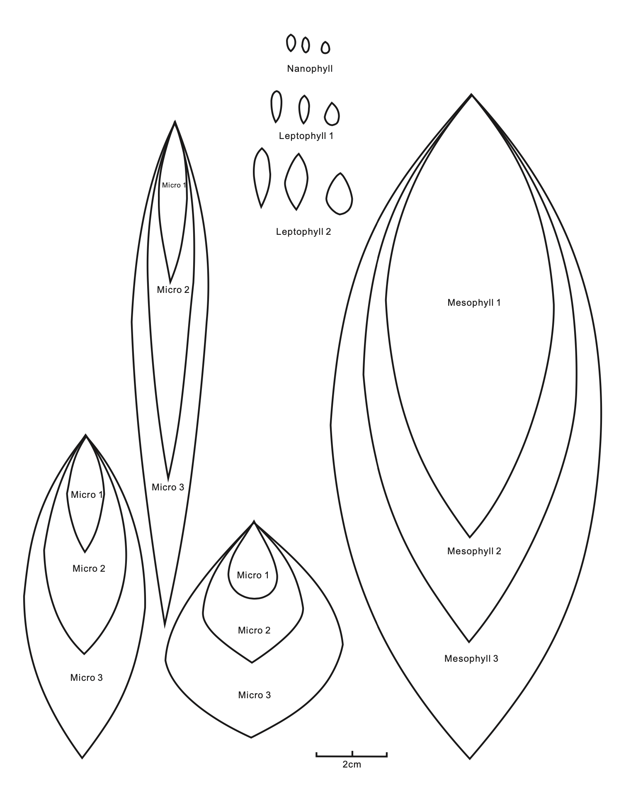

Supplementary Figure 4: The boxplots showing the threshold of outliers flagged as unreliable measurements.

Hard trait:
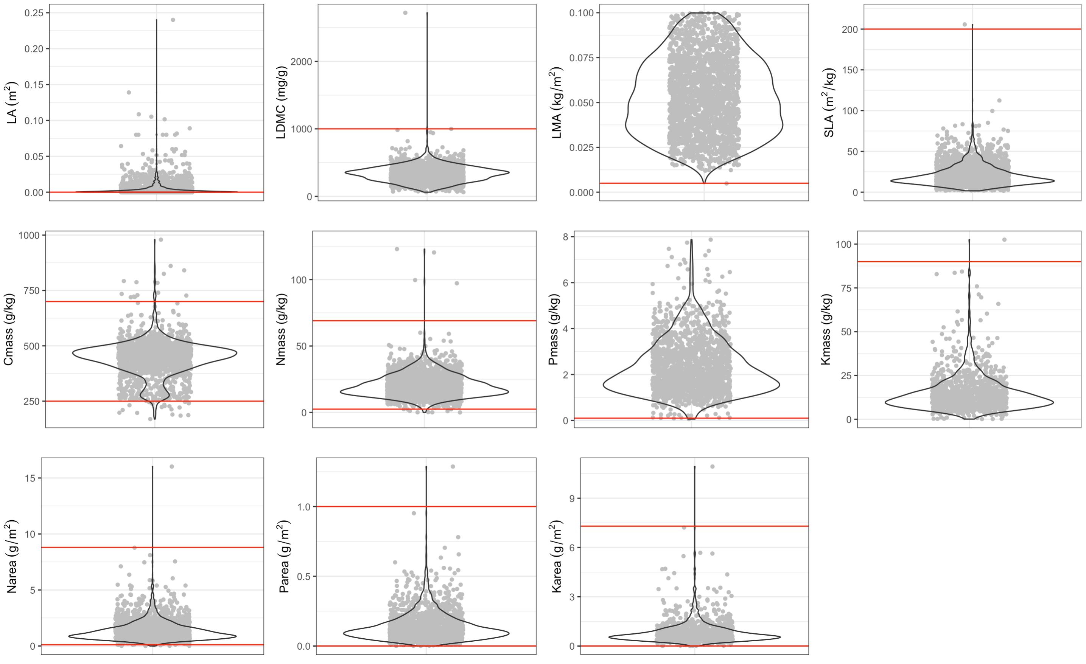
Photo trait:
