Supplementary Information
A subnational reproductive, maternal, newborn, child, and adolescent health and development atlas of India.
Carla Pezzulo¹, Natalia Tejedor-Garavito¹, Ho Man Theophilus Chan¹⁻², Ilda Dreoni¹⁻³, David Kerr¹, Samik Ghosh ⁴, Amy Bonnie¹, Maksym Bondarenko¹, Mihretab Salasibew⁴, Andrew J. Tatem¹
¹WorldPop, School of Geography and Environmental Science, University of Southampton, Highfield Campus, Southampton, SO17 1BJ, UK
²School of Mathematical Sciences, University of Southampton, Southampton, UK
³Social Statistics & Demography, University of Southampton, Highfield Campus, Southampton, SO17 1BJ, UK
⁴Children's Investment Fund Foundation (CIFF), London, UK

Table Of Contents

Table SI.1. Table of geospatial covariates, and their description, assembled for testing when modelling the health and development indicators……………………………………………………………………Page 2

SI.2. An application: producing 5kmx5km high resolution map and uncertainty for the percentage of women who received iron tablets or syrup during antenatal care visits……………………………………Page 4

Table SI.3. Summary statistics of the fitted model for the indicator iron tablets or syrup received during antenatal care visits……………………………………………………………………………………………………….Page 5

Table SI.4. Model validation summary of the fitted model for the indicator iron tablets or syrup received during antenatal care visits..……………………………………………………………………………………….Page 5

SI.5 Prediction map of the percentage of women who received iron tablets or syrup during antenatal care visits………………………………………………………………………………………………………………………………….Page 6

SI.6 Uncertainty map of the percentage of women who received iron tablets or syrup during antenatal care visits…………………………………………………………………………………………………………………..Page 7

SI.7. Summary statistics of the fitted models for each health and development indicator calculated at 5kmx5km high-resolution using INLA………………………………………………………………………………………..Page 8

SI.8. Summary of model validation metrics for each health and development indicator calculated at 5kmx5km high-resolution using INLA…………………………………………………………………………………….Page 13

Table SI.1. Table of geospatial covariates, and their description, assembled for testing when modelling the health and development indicators. All geospatial covariates tested were continuous.
Category | Name | Description | Year | Source
Geographical covariates | Distance to major roads | Distance to major OpenStreetMap roads (km) | 2016 | [Derived from] Open Street Map (2019). OpenStreetMap Contributors www.openstreetmap.org
Geographical covariates | Distance to protected areas | Distance to protected areas as defined by the World Database on protected areas (km) | 2016 | [Derived from] Open Street Map (2019). OpenStreetMap Contributors www.openstreetmap.org
Geographical covariates | Distance to waterways | Distance to OpenStreetMap waterways (km) | 2016 | [Derived from] Open Street Map (2019). OpenStreetMap Contributors www.openstreetmap.org
Geographical covariates | Elevation | Digital elevation model (m) | 2001 | de Ferranti, J. (2017). 'Digital Elevation Data'. Viewfinder Panoramas; based on NASA's Shuttle Radar Topography Mission (SRTM) data.
Geographical covariates | Slope | Shuttle Radar Topography Mission (SRTM) slope (degrees) | 2001 | de Ferranti, J. (2017). 'Digital Elevation Data'. Viewfinder Panoramas; based on NASA's Shuttle Radar Topography Mission (SRTM) data.
Geographical covariates | Travel time | Travel time to major cities (mins) | 2015 | Weiss, D.J. et al. (2018). A global map of travel time to cities to access inequalities in accessibility in 2015. Nature.
Socioeconomic covariates | Cattle density | Cattle density (no./km²) | 2010 | Gilbert, M. et al. (2018) Global Distribution Data for Cattle, Buffaloes, Horses, Sheep, Goats, Pigs, Chickens and Ducks in 2010. Nature Scientific data, 5:180227. doi: 10.1038/sdata.2018.227
Socioeconomic covariates | Net primary production | MODIS net primary production (kg C/ m²) | 2005 | Running et al. (2015) MOD17A3H MODIS/Terra Net Primary Production Yearly L4 Global 500 m SIN Grid V006 [Data set]. NASA EOSDIS Land Processes DAAC.
Socioeconomic covariates | Nighttime lights | Nighttime lights (nano-watts) | 2016 | NOAA – Visible Infrared Imaging Radiometer Suite. https://ngdc.noaa.gov/eog/viirs/index.html
Environmental covariates | Aridity | Mean aridity index (as developed from CGIAR-CSI data) | 1950-2000 | CGIAR-CSI Global-Aridity and Global-PET Database. Available at https://cgiarcsi.community/data/global-aridity-and-pet-database/
Environmental covariates | Evapotranspiration | Average annual potential evapotranspiration (as developed from CGIAR-CSI data) | 1950-2000 | CGIAR-CSI Global-Aridity and Global-PET Database. Available at https://cgiarcsi.community/data/global-aridity-and-pet-database/
Environmental covariates | Precipitation | Precipitation (mm) | 1970-2000 | Fick, S. E., & Hijmans, R. J. (2017). WorldClim 2: new 1‐km spatial resolution climate surfaces for global land areas. International journal of climatology, 37(12), 4302-4315.
Environmental covariates | Temperature | Temperature (degree Celsius x 10) | 2005 | Wan, Z. et al. MOD11C3 MODIS/Terra Land Surface Temperature/Emissivity Monthly L3 Global 0.05Deg CMG Voo6 [Data set]. NASA EOSDIS Land Processes DAAC.

SI.2. An application: producing 5kmx5km high resolution map and uncertainty for the percentage of women who received iron tablets or syrup during antenatal care visits.

We demonstrate the methodology described above with one of the health development indicators considered in this study named “The percentage of women who received iron tablets or syrup during antenatal care visits (ANC)”. For $i=1, …, n$, let $Y(s_{i})$ denote the number of women with a live birth in the five years preceding the survey who received iron tablets or syrup during antenatal care (ANC) visits at survey cluster $s_{i}$. Let $m\left(s_{i}\right)$ denote the total number of women surveyed at survey cluster $s_{i}$. Let ${p(s}_{i})$ denote the proportion of women with a live birth in the five years preceding the survey who received iron tablets or syrup during antenatal care visits at survey cluster $s_{i}$. From the model selection process, we choose net primary production, temperature, distance to protected areas, nighttime lights, and precipitation as the geospatial covariates to model the target indicator. Estimates of the model parameters from INLA are shown in Table SI.3. The estimates show that all covariates were significant predictors except for distance to protected areas and precipitation. Net primary production is shown to have a negative effect on the target indicator, whereas temperature and nighttime lights have a positive effect on the proportion of women who received iron tablets or syrup during ANC visits. The spatial range (3/$ϕ$), spatial variance $σ_{ω}^{2}$ and iid variance $σ_{ϵ}^{2}$ were also significant. The spatial range corresponds to around 341km which indicates spatial correlation residuals in the model. The prediction and uncertainty surfaces are available in the provided datasets and also shown in SI.5-6. Relatively lower predicted proportions of women who received iron tablets and syrup during ANC visits are observed in the northern regions of India. The cross-validation evaluation metrics are given in Table SI.4.

Table SI.3. Summary statistics of the fitted model for the indicator iron tablets or syrup received during antenatal care visits.
 | Mean | SD | 2.5% | 97.5%
(Intercept) | 1.200 | 0.484 | 0.262 | 2.162
Net primary production | -0.112 | 0.020 | -0.151 | -0.073
Temperature | 0.003 | 0.001 | 0.001 | 0.004
log(distance to protected areas) | -0.009 | 0.007 | -0.023 | 0.006
log(nighttime lights) | 0.178 | 0.011 | 0.157 | 0.200
log(precipitation) | 0.094 | 0.090 | -0.083 | 0.269
Spatial range (3/$ϕ$) | 3.081 | 0.348 | 2.491 | 3.853
Spatial variance ($σ_{ω}^{2}$) | 1.116 | 0.139 | 0.880 | 1.424
iid variance ($σ_{ϵ}^{2}$) | 0.709 | 0.017 | 0.676 | 0.742

Table SI.4. Model validation summary of the fitted model for the indicator iron tablets or syrup received during antenatal care visits.
 | Correlation | RMSE | MAE | Bias
In-sample | 0.592 | 0.197 | 0.151 | 0.935
Out-of-sample | 0.569 | 0.200 | 0.154 | 0.935

SI.5 Prediction map of the percentage of women who received iron tablets or syrup during antenatal care visits.
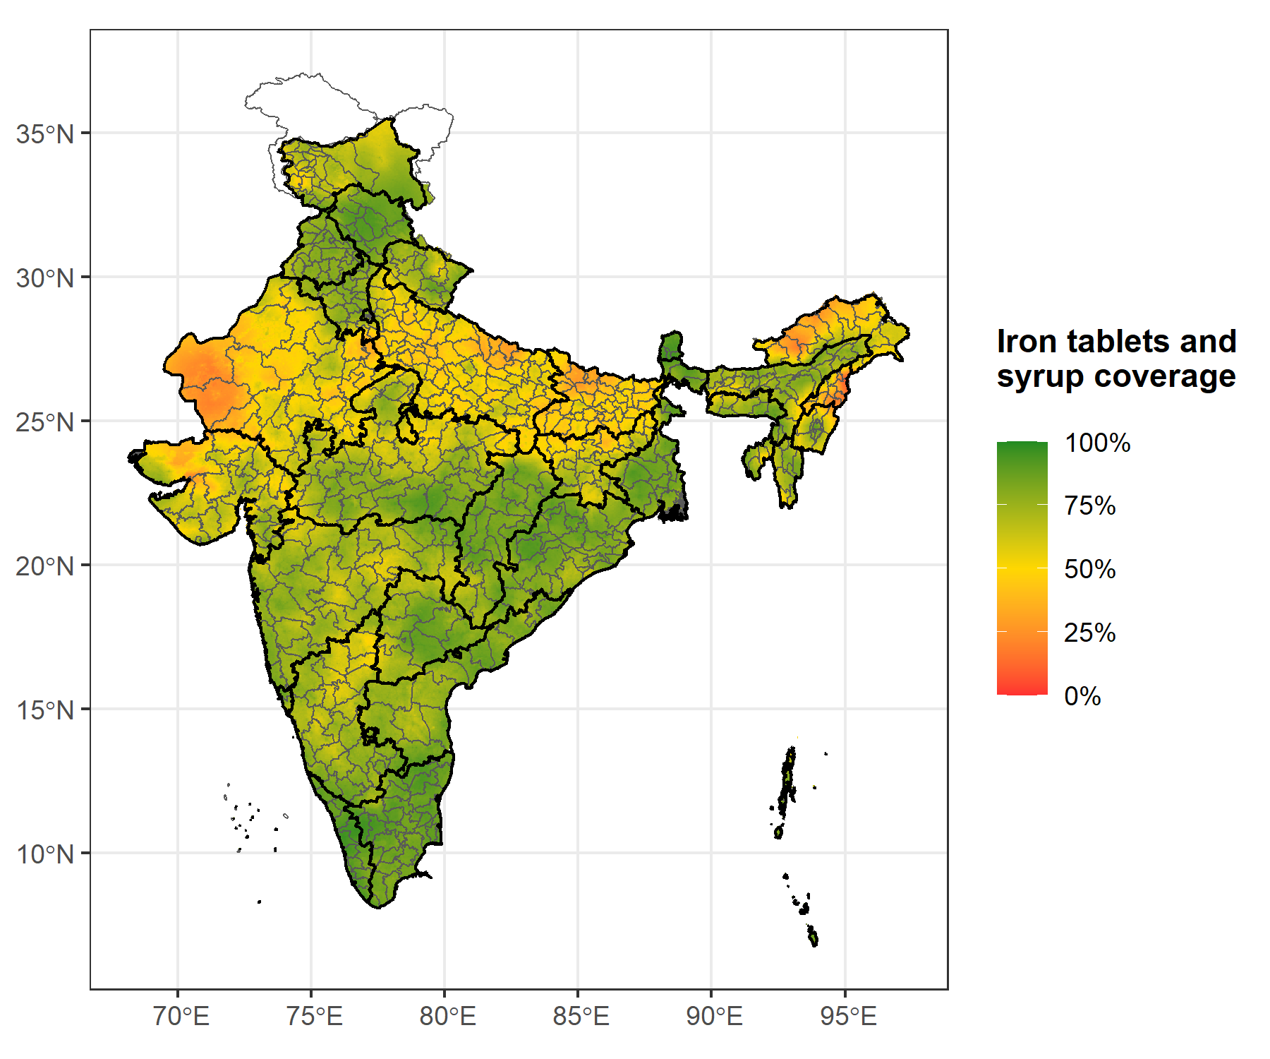

SI.6. Uncertainty map of the percentage of women who received iron tablets or syrup during antenatal care visits.
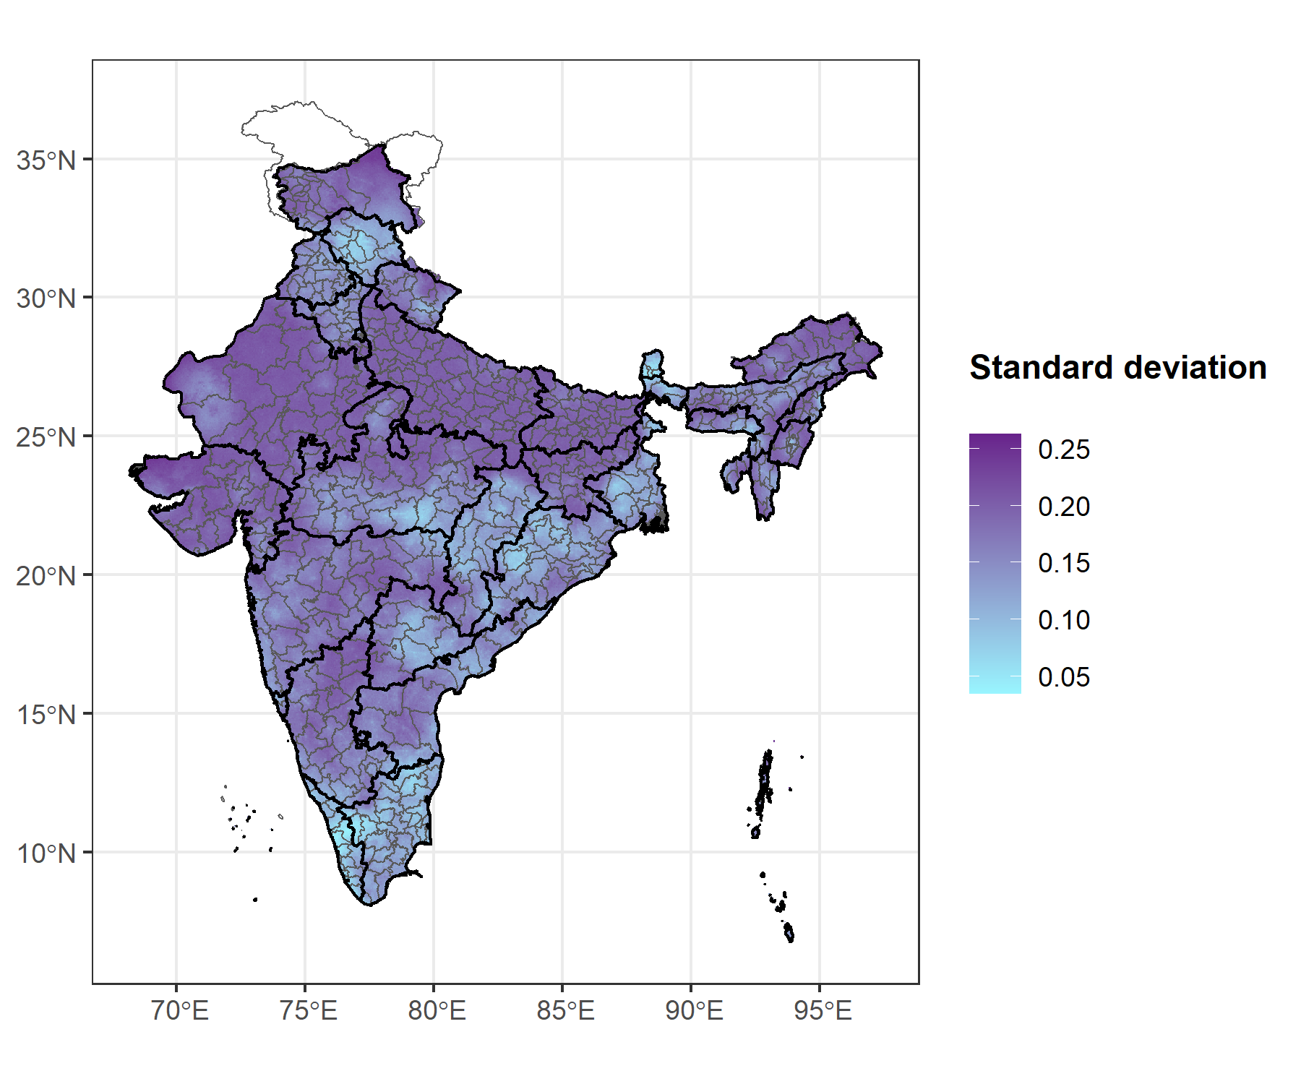

SI.7. Summary statistics of the fitted models for each health and development indicator calculated at 5kmx5km high-resolution using INLA.

Low birth weight
 | Mean | SD | 2.5% | 97.5%
(Intercept) | -3.920 | 1.332 | -6.536 | -1.306
Distance to highways | 0.001 | 0.003 | -0.004 | 0.006
Net primary production | -0.046 | 0.015 | -0.076 | -0.016
Aridity | -0.035 | 0.045 | -0.124 | 0.053
log(nighttime lights) | 0.002 | 0.009 | -0.016 | 0.020
log(evapotranspiration) | 0.308 | 0.180 | -0.045 | 0.660
Spatial range (3/$ϕ$) | 2.644 | 1.001 | 0.915 | 4.507
Spatial variance ($σ_{ω}^{2}$) | 0.151 | 0.023 | 0.110 | 0.199
iid variance ($σ_{ϵ}^{2}$) | 0.257 | 0.011 | 0.235 | 0.278

Use of Contraception
 | Mean | SD | 2.5% | 97.5%
(Intercept) | 3.894 | 4.101 | -4.173 | 12.003
Slope | 0.001 | 0.004 | -0.007 | 0.009
Distance to highways | 0.001 | 0.004 | -0.006 | 0.009
Net primary production | -0.044 | 0.022 | -0.087 | 0.000
Temperature | 0.004 | 0.002 | 0.001 | 0.008
log(nighttime lights) | 0.014 | 0.011 | -0.008 | 0.036
log(precipitation) | -0.293 | 0.105 | -0.494 | -0.085
log(evapotranspiration) | -0.557 | 0.591 | -1.733 | 0.602
Spatial range (3/$ϕ$) | 5.176 | 1.954 | 1.971 | 9.434
Spatial variance ($σ_{ω}^{2}$) | 0.128 | 0.052 | 0.046 | 0.244
iid variance ($σ_{ϵ}^{2}$) | 0.214 | 0.007 | 0.200 | 0.228

Number of antenatal care visits (ANC 4+)
 | Mean | SD | 2.5% | 97.5%
(Intercept) | 0.380 | 0.161 | 0.065 | 0.695
Slope | -0.038 | 0.004 | -0.046 | -0.031
Distance to highways | -0.016 | 0.004 | -0.023 | -0.008
Distance to water sources | 0.005 | 0.002 | 0.002 | 0.009
Net primary production | -0.013 | 0.020 | -0.052 | 0.027
Aridity | 0.468 | 0.077 | 0.317 | 0.620
log(nighttime lights) | 0.267 | 0.012 | 0.243 | 0.291
Spatial range (3/$ϕ$) | 1.925 | 0.089 | 1.777 | 2.125
Spatial variance ($σ_{ω}^{2}$) | 1.248 | 0.065 | 1.136 | 1.391
iid variance ($σ_{ϵ}^{2}$) | 1.06 | 0.018 | 1.022 | 1.092

Timing of antenatal care visits
 | Mean | SD | 2.5% | 97.5%
(Intercept) | 1.106 | 0.352 | 0.416 | 1.796
Slope | -0.020 | 0.003 | -0.027 | -0.014
Distance to highways | -0.018 | 0.003 | -0.025 | -0.012
Distance to water sources | 0.006 | 0.002 | 0.003 | 0.009
Net primary production | -0.040 | 0.018 | -0.075 | -0.004
log(nighttime lights) | 0.183 | 0.011 | 0.162 | 0.204
log(precipitation) | -0.033 | 0.075 | -0.180 | 0.114
Spatial range (3/$ϕ$) | 1.598 | 0.112 | 1.406 | 1.843
Spatial variance ($σ_{ω}^{2}$) | 0.897 | 0.073 | 0.776 | 1.062
iid variance ($σ_{ϵ}^{2}$) | 0.711 | 0.022 | 0.663 | 0.748

Urine sample taken during antenatal care visit
 | Mean | SD | 2.5% | 97.5%
(Intercept) | 17.748 | 9.559 | -0.983 | 36.546
Slope | -0.027 | 0.008 | -0.043 | -0.010
Distance to highways | -0.024 | 0.007 | -0.037 | -0.010
Distance to water sources | 0.004 | 0.004 | -0.004 | 0.012
Net primary production | 0.088 | 0.047 | -0.005 | 0.181
Aridity | -0.157 | 0.161 | -0.473 | 0.159
log(travel time to major cities) | -0.134 | 0.014 | -0.162 | -0.106
log(distance to protected areas) | -0.008 | 0.015 | -0.038 | 0.020
log(evapotranspiration) | -1.601 | 1.285 | -4.130 | 0.918
Spatial range (3/$ϕ$) | 5.020 | 0.712 | 3.849 | 6.633
Spatial variance ($σ_{ω}^{2}$) | 3.428 | 0.646 | 2.396 | 4.918
iid variance ($σ_{ϵ}^{2}$) | 0.267 | 0.036 | 0.202 | 0.344

Blood sample taken during antenatal care visit
 | Mean | SD | 2.5% | 97.5%
(Intercept) | 7.092 | 9.418 | -11.381 | 25.596
Slope | -0.039 | 0.008 | -0.056 | -0.023
Distance to highways | -0.017 | 0.007 | -0.032 | -0.003
Distance to water sources | 0.009 | 0.004 | 0.000 | 0.018
Net primary production | 0.163 | 0.043 | 0.079 | 0.246
Aridity | -0.045 | 0.160 | -0.360 | 0.270
log(distance to protected areas) | -0.017 | 0.015 | -0.047 | 0.011
log(nighttime lights) | 0.278 | 0.024 | 0.231 | 0.324
log(evapotranspiration) | -0.219 | 1.266 | -2.706 | 2.263
Spatial range (3/$ϕ$) | 4.982 | 0.756 | 3.692 | 6.657
Spatial variance ($σ_{ω}^{2}$) | 3.148 | 0.581 | 2.176 | 4.452
iid variance ($σ_{ϵ}^{2}$) | 0.205 | 0.03 | 0.148 | 0.267

Children stunting
 | Mean | SD | 2.5% | 97.5%
(Intercept) | -0.951 | 0.119 | -1.195 | -0.728
Slope | 0.001 | 0.002 | -0.003 | 0.006
Distance to highways | 0.006 | 0.002 | 0.002 | 0.01
Net primary production | 0.006 | 0.012 | -0.018 | 0.031
Aridity | -0.004 | 0.041 | -0.084 | 0.076
log(distance to protected areas) | 0.002 | 0.005 | -0.007 | 0.011
log(nighttime lights) | -0.105 | 0.007 | -0.120 | -0.091
Spatial range (3/$ϕ$) | 4.001 | 0.616 | 2.973 | 5.382
Spatial variance ($σ_{ω}^{2}$) | 0.186 | 0.027 | 0.141 | 0.248
iid variance ($σ_{ϵ}^{2}$) | 0.208 | 0.007 | 0.194 | 0.221

Children wasting
 | Mean | SD | 2.5% | 97.5%
(Intercept) | -10.018 | 1.435 | -12.816 | -7.190
Slope | 0.011 | 0.003 | 0.006 | 0.017
Distance to highways | 0.004 | 0.003 | -0.001 | 0.009
Distance to water sources | -0.001 | 0.001 | -0.003 | 0.001
Net primary production | 0.048 | 0.015 | 0.019 | 0.077
log(nighttime lights) | -0.055 | 0.009 | -0.072 | -0.038
log(evapotranspiration) | 1.138 | 0.195 | 0.753 | 1.518
Spatial range (3/$ϕ$) | 2.128 | 0.359 | 1.428 | 2.812
Spatial variance ($σ_{ω}^{2}$) | 0.194 | 0.020 | 0.158 | 0.236
iid variance ($σ_{ϵ}^{2}$) | 0.280 | 0.010 | 0.261 | 0.299

Net attendance rate for secondary school (girls)
 | Mean | SD | 2.5% | 97.5%
(Intercept) | 1.166 | 0.177 | 0.834 | 1.532
Slope | -0.012 | 0.003 | -0.018 | -0.005
Distance to highways | -0.014 | 0.003 | -0.019 | -0.008
Distance to water sources | 0.001 | 0.001 | -0.001 | 0.004
Net primary production | -0.035 | 0.016 | -0.065 | -0.004
Aridity | 0.115 | 0.057 | 0.003 | 0.227
log(distance to protected areas) | 0.002 | 0.006 | -0.009 | 0.014
log(nighttime lights) | 0.118 | 0.009 | 0.100 | 0.136
Spatial range (3/$ϕ$) | 3.823 | 0.564 | 2.893 | 5.096
Spatial variance ($σ_{ω}^{2}$) | 0.530 | 0.075 | 0.401 | 0.694
iid variance ($σ_{ϵ}^{2}$) | 0.370 | 0.010 | 0.350 | 0.390

Net attendance rate for secondary school (boys)
 | Mean | SD | 2.5% | 97.5%
(Intercept) | 1.384 | 0.154 | 1.088 | 1.691
Slope | -0.005 | 0.003 | -0.011 | 0.001
Distance to highways | -0.010 | 0.003 | -0.015 | -0.004
Distance to water sources | -0.001 | 0.001 | -0.003 | 0.002
Net primary production | -0.091 | 0.014 | -0.119 | -0.063
Aridity | 0.120 | 0.051 | 0.019 | 0.220
log(distance to protected areas) | -0.002 | 0.006 | -0.014 | 0.008
log(nighttime lights) | 0.070 | 0.009 | 0.053 | 0.087
Spatial range (3/$ϕ$) | 4.021 | 0.301 | 3.485 | 4.665
Spatial variance ($σ_{ω}^{2}$) | 0.437 | 0.050 | 0.352 | 0.548
iid variance ($σ_{ϵ}^{2}$) | 0.340 | 0.010 | 0.322 | 0.361

Child marriage (15 years old)
 | Mean | SD | 2.5% | 97.5%
(Intercept) | -4.407 | 1.019 | -6.407 | -2.408
Distance to highways | 0.004 | 0.002 | 0.000 | 0.008
Distance to water sources | -0.001 | 0.001 | -0.003 | 0.001
log(nighttime lights) | -0.060 | 0.005 | -0.069 | -0.051
log(evapotranspiration) | 0.348 | 0.139 | 0.075 | 0.621
Spatial range (3/$ϕ$) | 3.168 | 0.447 | 2.365 | 4.117
Spatial variance ($σ_{ω}^{2}$) | 0.168 | 0.022 | 0.129 | 0.215
iid variance ($σ_{ϵ}^{2}$) | 0.045 | 0.004 | 0.038 | 0.052

Child marriage (18 years old)
 | Mean | SD | 2.5% | 97.5%
(Intercept) | -1.812 | 0.899 | -3.576 | -0.047
Distance to highways | 0.007 | 0.002 | 0.003 | 0.010
Net primary production | -0.067 | 0.009 | -0.084 | -0.050
Aridity | -0.188 | 0.035 | -0.256 | -0.119
log(nighttime lights) | -0.095 | 0.005 | -0.105 | -0.085
log(evapotranspiration) | 0.194 | 0.121 | -0.044 | 0.431
Spatial range (3/$ϕ$) | 4.084 | 0.515 | 3.105 | 5.120
Spatial variance ($σ_{ω}^{2}$) | 0.309 | 0.045 | 0.230 | 0.405
iid variance ($σ_{ϵ}^{2}$) | 0.135 | 0.004 | 0.128 | 0.142

Female labour force participation
 | Mean | SD | 2.5% | 97.5%
(Intercept) | -1.116 | 0.379 | -1.867 | -0.377
Slope | 0.008 | 0.004 | -0.001 | 0.016
Net primary production | 0.005 | 0.027 | -0.048 | 0.058
log(nighttime lights) | -0.222 | 0.015 | -0.252 | -0.192
log(precipitation) | 0.002 | 0.08 | -0.155 | 0.159
Spatial range (3/$ϕ$) | 2.445 | 0.334 | 1.846 | 3.157
Spatial variance ($σ_{ω}^{2}$) | 0.538 | 0.061 | 0.428 | 0.667
iid variance ($σ_{ϵ}^{2}$) | 0.766 | 0.024 | 0.721 | 0.816

Experience of physical violence
 | Mean | SD | 2.5% | 97.5%
(Intercept) | -2.019 | 0.321 | -2.647 | -1.388
Slope | 0.001 | 0.005 | -0.009 | 0.011
Distance to highways | 0.009 | 0.005 | -0.001 | 0.018
Distance to water sources | -0.004 | 0.002 | -0.008 | 0.000
Temperature | 0.004 | 0.001 | 0.001 | 0.006
Aridity | -0.175 | 0.074 | -0.319 | -0.029
log(nighttime lights) | -0.097 | 0.011 | -0.118 | -0.075
Spatial range (3/$ϕ$) | 2.921 | 0.486 | 2.091 | 3.996
Spatial variance ($σ_{ω}^{2}$) | 0.472 | 0.061 | 0.364 | 0.603
iid variance ($σ_{ϵ}^{2}$) | 0.581 | 0.021 | 0.541 | 0.625

Women decision-making on her own health
 | Mean | SD | 2.5% | 97.5%
(Intercept) | 1.239 | 0.152 | 0.946 | 1.542
Distance to highways | -0.012 | 0.004 | -0.019 | -0.004
Aridity | 0.267 | 0.068 | 0.132 | 0.398
log(distance to protected areas) | -0.002 | 0.011 | -0.023 | 0.019
log(nighttime lights) | 0.042 | 0.011 | 0.021 | 0.064
Spatial range (3/$ϕ$) | 2.044 | 0.481 | 1.129 | 2.953
Spatial variance ($σ_{ω}^{2}$) | 0.303 | 0.045 | 0.219 | 0.394
iid variance ($σ_{ϵ}^{2}$) | 0.687 | 0.035 | 0.633 | 0.768

Children receiving vitamin A supplements
 | Mean | SD | 2.5% | 97.5%
(Intercept) | -0.034 | 0.264 | -0.553 | 0.484
Distance to water sources | -0.002 | 0.002 | -0.005 | 0.001
Net primary production | -0.011 | 0.018 | -0.047 | 0.025
Temperature | 0.003 | 0.001 | 0.002 | 0.005
log(distance to protected areas) | -0.008 | 0.009 | -0.026 | 0.010
Spatial range (3/$ϕ$) | 2.659 | 0.438 | 2.033 | 3.717
Spatial variance ($σ_{ω}^{2}$) | 0.559 | 0.059 | 0.454 | 0.683
iid variance ($σ_{ϵ}^{2}$) | 0.613 | 0.035 | 0.538 | 0.671

Comprehensive knowledge of HIV
 | Mean | SD | 2.5% | 97.5%
(Intercept) | 7.841 | 6.019 | -3.860 | 19.747
Distance to highways | -0.007 | 0.011 | -0.029 | 0.015
Net primary production | 0.145 | 0.063 | 0.022 | 0.268
Aridity | 0.099 | 0.139 | -0.170 | 0.375
log(nighttime lights) | 0.103 | 0.032 | 0.040 | 0.166
log(evapotranspiration) | -1.326 | 0.827 | -2.964 | 0.284
Spatial range (3/$ϕ$) | 12.172 | 5.685 | 4.781 | 26.499
Spatial variance ($σ_{ω}^{2}$) | 0.358 | 0.175 | 0.116 | 0.789
iid variance ($σ_{ϵ}^{2}$) | 1.141 | 0.057 | 1.032 | 1.254

SI.8. Summary of model validation metrics for each health and development indicator calculated at 5kmx5km high-resolution using INLA.
In-sample validation | Correlation | RMSE | MAE | Bias
Low birth weight | 0.296 | 0.177 | 0.140 | 0.184
Use of Contraception | 0.574 | 0.123 | 0.099 | 0.984
ANC number of visits (4+) | 0.707 | 0.247 | 0.201 | 1.009
ANC Timing of visits | 0.578 | 0.246 | 0.200 | 0.484
ANC Urine sample taken | 0.542 | 0.116 | 0.061 | 2.022
ANC Blood sample taken | 0.580 | 0.113 | 0.057 | 1.928
Children stunting | 0.416 | 0.211 | 0.169 | 1.522
Children wasting | 0.367 | 0.184 | 0.141 | -1.435
Net attendance rate for secondary school (girls) | 0.492 | 0.214 | 0.171 | 0.165
Net attendance rate for secondary school (boys) | 0.435 | 0.205 | 0.164 | 0.037
Child marriage 15 years | 0.491 | 0.088 | 0.068 | -0.831
Child marriage 18 years | 0.674 | 0.140 | 0.112 | 0.102
Labour force participation (women) | 0.544 | 0.215 | 0.173 | -0.986
Experience of physical violence | 0.525 | 0.204 | 0.163 | -1.062
Decision making on health (women) | 0.421 | 0.194 | 0.155 | 0.112
Children receiving vitamin A supplements | 0.452 | 0.303 | 0.253 | 0.378
HIV Knowledge | 0.362 | 0.194 | 0.151 | -0.716

Out-of-sample validation | Correlation | RMSE | MAE | Bias
Low birth weight | 0.262 | 0.178 | 0.141 | 0.240
Use of Contraception | 0.551 | 0.126 | 0.101 | 1.067
ANC number of visits (4+) | 0.691 | 0.252 | 0.205 | 1.100
ANC Timing of visits | 0.551 | 0.2506 | 0.2044 | 0.5151
ANC Urine sample taken | 0.519 | 0.117 | 0.062 | 2.044
ANC Blood sample taken | 0.560 | 0.115 | 0.058 | 1.950
Children stunting | 0.390 | 0.213 | 0.171 | 1.523
Children wasting | 0.329 | 0.186 | 0.144 | -1.384
Net attendance rate for secondary school (girls) | 0.465 | 0.218 | 0.174 | 0.191
Net attendance rate for secondary school (boys) | 0.407 | 0.208 | 0.166 | 0.012
Child marriage 15 years | 0.455 | 0.090 | 0.069 | -0.859
Child marriage 18 years | 0.657 | 0.143 | 0.115 | 0.082
Labour force participation (women) | 0.485 | 0.224 | 0.180 | -0.832
Experience of physical violence | 0.468 | 0.211 | 0.169 | -0.974
Decision making on health (women) | 0.342 | 0.200 | 0.160 | 0.116
Children receiving vitamin A supplements | 0.412 | 0.309 | 0.259 | 0.372
HIV Knowledge | 0.325 | 0.196 | 0.154 | -0.224

