Supplementary Figures for

A harmonized resource of integrated prostate cancer clinical, -omic, and signature features

Teemu D. Laajala^{1,2}, Varsha Sreekanth², Alex Soupir³, Jordan Creed³, Anni S. Halkola¹, Federico C.F. Calboli^{1,4}, Kalaimathy Singaravelu¹, Michael V. Orman², Christelle Colin-Leitzinger³, Travis Gerke⁵, Brooke L. Fridley^{3,*}, Svitlana Tyekucheva^{6,*}, James C. Costello^{2,7,*}

¹Department of Mathematics and Statistics, University of Turku, Turku, Finland
²Department of Pharmacology, University of Colorado Anschutz Medical Campus, Aurora, CO, USA
³Department of Biostatistics and Bioinformatics, Moffitt Cancer Center, Tampa, FL, USA
⁴Natural Resources Institute Finland (Luke), F-31600, Jokioinen, Finland
⁵Department of Cancer Epidemiology, Moffitt Cancer Center, Tampa, FL, USA
⁶Department of Data Science, Dana-Farber Cancer Institute; Department of Biostatistics, Harvard T.H. Chan School of Public Health, Boston, MA, USA
⁷University of Colorado Cancer Center, University of Colorado Anschutz Medical Campus, Aurora, CO, USA

*These authors jointly supervised this work

Corresponding authors: Teemu D Laajala (teelaa@utu.fi), Svitlana Tyekucheva (svitlana@jimmy.harvard.edu), and James C Costello (james.costello@cuanschutz.edu)

Supplementary Figures
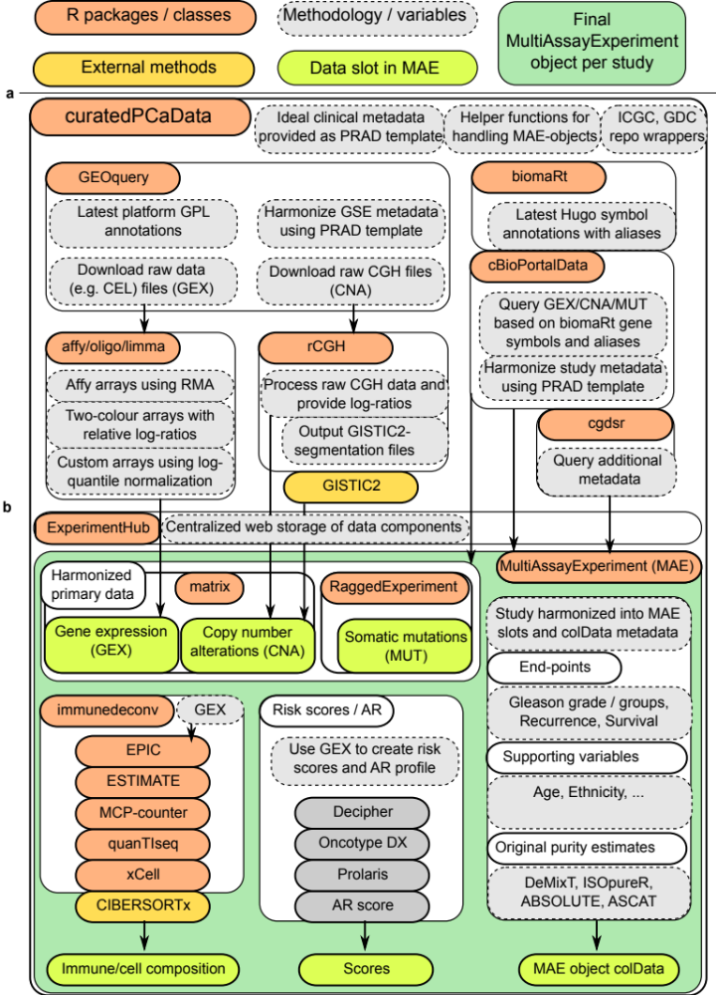
Figure S1: Workflow of the curatedPCaData MultiAssayExperiment-object generation. a) Primary raw data is extracted mainly using the GEOquery and cBioPortalData packages. Raw data are processed according to latest annotations with the help of biomaRt and assay-specific packages, and then processed using affy, oligo, limma, and rCGH packages where appropriate; b) Key data compoents are stored via the ExperimentHub web storage service and downloaded or stored locally. From ExperimentHub, MAE-object is constructed while providing access to the primary data (GEX, CNA, and MUT), offering derived variables (decompositions and scores), and corresponding clinical metadata (MAE colData-slot)

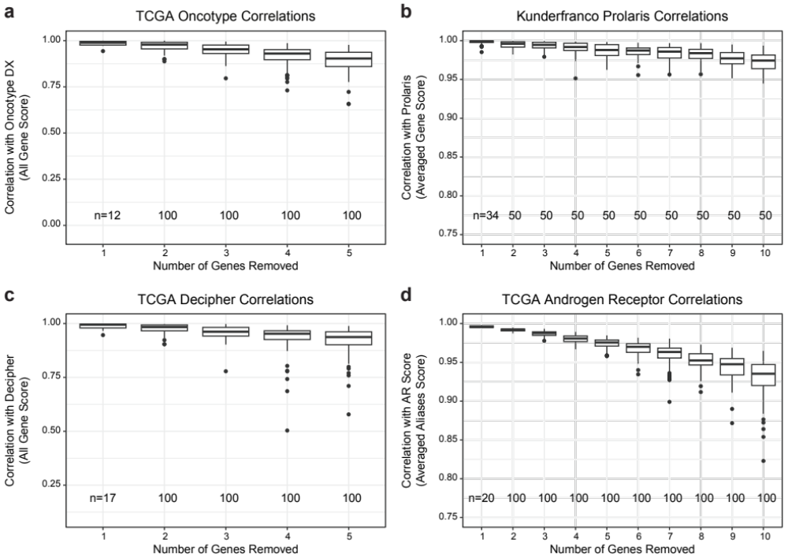
Figure S2: Impact of Gene Missingness on Risk and AR Score Reliability. Prostate risk scores and AR score were benchmarked using datasets from the curatedPCaData package to determine how missing genes impacted their reliability. The number of trials are listed at the bottom of each figure panel. a) TCGA was used to assess Oncotype DX risk score removing between 1 and 5 genes. b) Kunderfranco et al. was used to assess Prolaris risk score by removing between 1 and 10 genes. TCGA was leveraged to assess gene removal for c) Decipher (1-5 genes) and d) Androgen Receptor (1-10 genes).

