A chromosome-level genome assembly of Sesamia inferens

Hongran Li#, Yan Peng#, Chao Wu#, VIGAN Chess-Kadouste#, Kaikai Mao, Jingyun Zhu, Luming Zou, Minghui Jin, Lei Zhang, Yutao Xiao^{1*}

Shenzhen Branch, Guangdong Laboratory of Lingnan Modern Agriculture, Key Laboratory of Gene Editing Technologies (Hainan), Ministry of Agriculture and Rural Affairs, Agricultural Genomics Institute at Shenzhen, Chinese Academy of Agricultural Sciences, Shenzhen, 518116, P. R. China

#These authors contributed equally to this work.
*To whom correspondence should be addressed: Yutao Xiao (xiaoyutao@caas.cn).

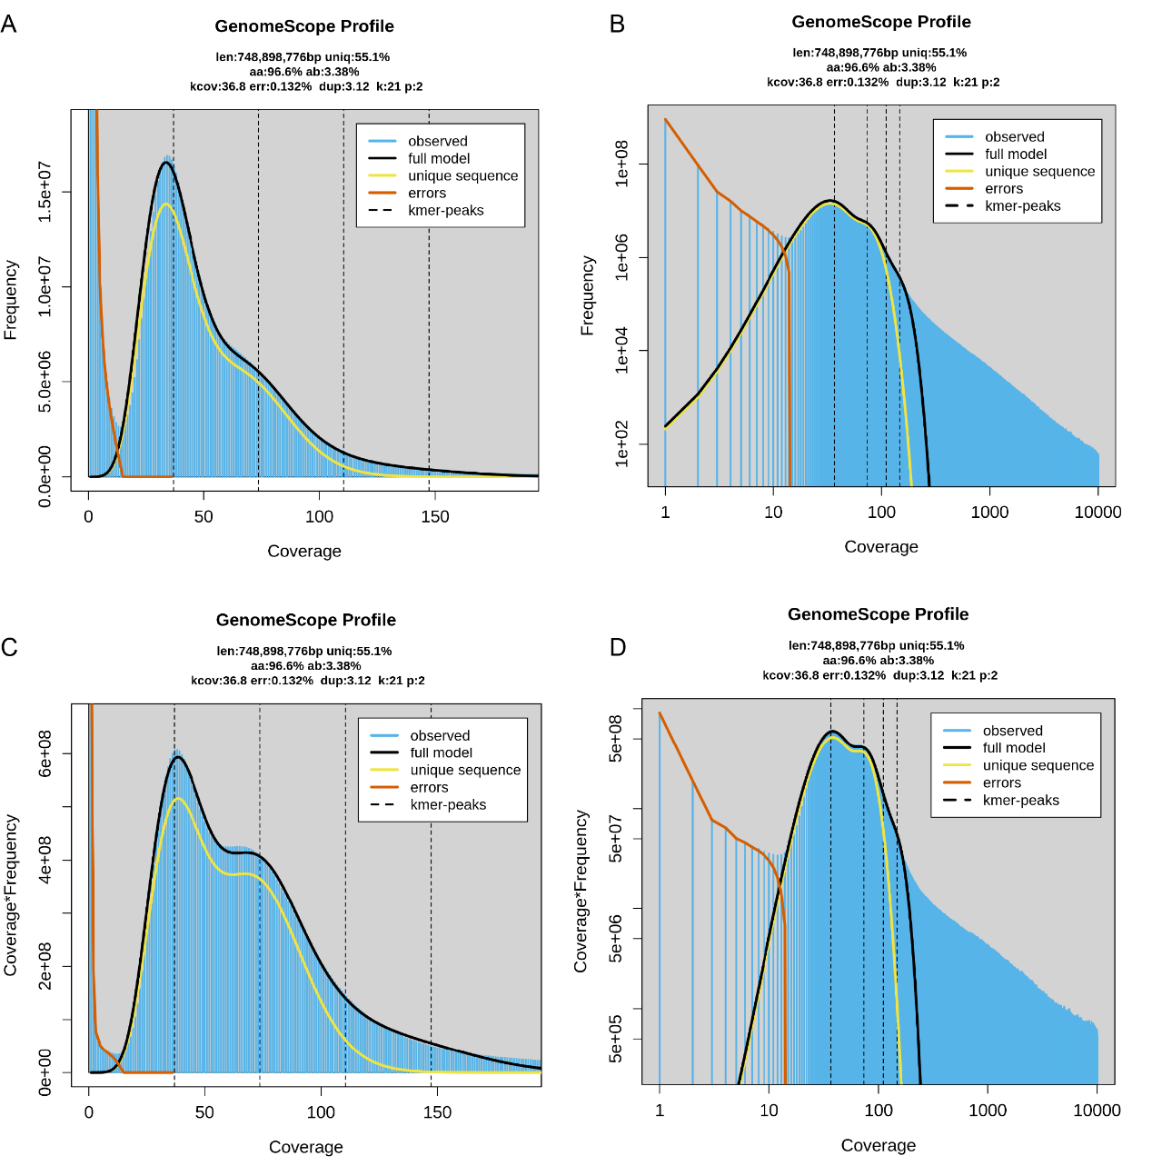
Fig. S1 Genome survey result based on k-mer frequency analysis. K-mer frequency analysis was performed using Jellyfish (k-mer = 21) based on Illumina paired-end sequencing reads of genomic DNA. Genome size, repeat sequence content, and heterozygosity ratio were estimated based on k-mer frequency distribution using GenomeScope 2.0. The estimated genome size was 748.89 Mb.

Table S1 Summary statistics of genome assembly of Sesamia inferens
Item | Scaffold number | Scaffold length
Total Length | 1 | 865044522
Total N Length | 545081 | 0.000629722
Maximum Length | 1 | 39855675
Minimum Length | 1 | 25000
Average Length | - | 12536900
Median Length | - | 271255
N10 Length | 3 | 33498179
N20 Length | 5 | 32992099
N30 Length | 8 | 31317297
N40 Length | 11 | 31001768
N50 Length | 14 | 29986663
N60 Length | 17 | 28575689
N70 Length | 20 | 28013015
N80 Length | 23 | 24984587
N90 Length | 27 | 19422890

Table S2 Statistics of repeat elements of Sesamia inferens
Repeat type | Number of elements | Length occupied (bp) | Percentage of sequence
DNA | 130023 | 44303513 | 5.12
LINE | 484861 | 155759458 | 18.01
SINE | 205095 | 43229393 | 5.00
LTR | 60523 | 31555664 | 3.65
Simple repeat | 121757 | 12146611 | 1.40
Satellite | 880 | 373446 bp | 0.04
unknown | 607638 | 135536991 | 15.67
Total | 1788617 | 459721605 | 53.14

Table S3 Summary statistic of gene functional annotation in Sesamia inferens genome

Item | Annotated genes | Percentage
kegg | 14818 | 71.0423%
Nr | 18686 | 89.5867%
eggNOG | 18805 | 90.1573%
Trembl | 18540 | 88.8868%
total | 18937 | 90.7901%

Table S4 The detailed information of the upload raw data at NCBI in our study

Title | Description | Accession | BioSample | Release Date | SRA. filename
szd1 | HiC data | SRR25638298 | SAMN36950133 | 2023/8/18 | SZD1_S24_L001_R1_001.fastq.gz, SZD1_S24_L001_R2_001.fastq.gz
szd2 | Hifi data | SRR25638299 | SAMN36950132 | 2023/8/18 | SZD2.hifi.fastq.gz
szl | raw data of Larvae transcriptome | SRR25638296 | SAMN36950135 | 2023/8/18 | SZL_1.clean.fq.gz,  SZL_2.clean.fq.gz
szp | raw data of pupal transcriptome | SRR25638295 | SAMN36950136 | 2023/8/18 | SZP_1.clean.fq.gz, SZP_2.clean.fq.gz
sza | raw data of adut transcriptome | SRR25638297 | SAMN36950134 | 2023/8/18 | SZA_1.clean.fq.gz, SZA_2.clean.fq.gz

